Optimizing the Inventory Fulfillment Level of Store Goods from PT. XYZ Warehouse with the Application of Response Surface Methodology

Anggarnis D. Ardyani^{1*}, Dwi S. Donoriyanto²
^{1,2} Department of Industrial Engineering, UPN Veteran Jawa Timur, Surabaya, East Java, Indonesia
* Corresponding author: anggarnisdwi@gmail.com, dwisukama.ti@upnjatim.ac.id

ARTICLE INFO |  | ABSTRACT
Article history  Submission  Revised  Accepted |  | The retail industry continues to grow amidst the challenges of fluctuating customer demand and uncertain supplier lead times. PT XYZ faces problems in managing stock of non-food items, especially toiletries, which often do not meet the demand of sub-branch retail stores. This study uses Response Surface Methodology (RSM) to determine the significant factors that affect stock items. The results showed that the variables of demand for goods, supplier incoming goods, and delivery lead time had a 99.6% influence on the optimization of stock items in the warehouse, with a value (R²) of 0.996. This research is expected to improve warehouse efficiency and reduce logistics costs.
   | This is an open access article under the CC–BY-SA license.
Keywords : Inventory,Optimization, Response Surface, Retail

 https://doi.org/10.22219/oe.2024.v16i1001.

1. Introduction
The retail industry continues to grow by facing many challenges, especially in the current era of industrial revolution (Putri & Dinuka, 2022). Demand from retail businesses is increasing and there are also more and more competitors. Therefore, to compete and survive, stores must be able to provide the goods sought by customers. If you cannot provide the goods you are looking for due to inventory availability, it can reduce the store's reputation (Nurwahyuningsih, Arifin et al., 2021). Determining the amount of inventory is an absolute matter for the company, because inventory has an absolute impact on the company's profitability (Susanti & Hermansyah, 2023). Inventory management becomes difficult due to the large fluctuations in customer demand and the uncertainty of lead times from suppliers to supply goods. Each component leads to ineffective warehouse control (Wang et al., 2020).
Inventory is a resource that is idle and waiting to be further processed to meet current and future demand (Aryanny & Jati, 2021). Inventories are goods that are stored for future use or sale (Ernita et al., 2021). According to (Waters, 2016), whenever a company gets raw materials that must be used immediately, inventory is created. Materials are shipped from suppliers, and stock is held until needed. Inventory control is a way to monitor inventory levels by determining the number of items to be ordered and the timing of orders (Monica & Setiawan, 2019). The problem of managing inventory is very important for retail management operations. Lack of quality in inventory management can result in the accumulation of goods, which is caused by purchases made only based on assumptions without accurate calculations (Nurwahyuningsih, Arifin et al., 2021).
According to (Naomi & Fauziah, 2023), effectiveness in warehouse management involves increasing productivity, reducing costs, optimizing the use of resources, and implementing best practices in organization, stock control, operational efficiency, risk management, and analysis and measurement. If this is done well, it will facilitate the inventory calculation process and support the smooth entry and exit of goods (Rifda, 2023). According to (Aresti, 2021), a well-implemented process in the warehouse is carried out in order to maintain the survival of the company which is very important for the company. Retailing is all activities involved in selling goods or services directly to end consumers for personal and non-business use (Nurwahyuningsih, Arifin et al., 2021).
At the PT XYZ warehouse, there are problems in optimizing the fulfillment of stock items in sub-branch retail stores on non-food items, especially toiletries. The stock of toiletries in the warehouse sometimes has an amount less than the demand for store goods and results in the warehouse not being able to fulfill the entire demand for store goods. It is important to adapt to market changes and companies need to have good inventory management to be able to respond to market demand. Customer demand expects fast and accurate availability of goods.
According to (Wang et al., 2020) a heuristic approach can be used as an alternative to optimization models, enabling a more practical and faster process. This provides a long-term solution that helps leaders save time and resources. In this context, factors such as store item demand, warehouse inventory, lead time, and supplier incoming items are taken into account to determine the significant factors affecting the response using response surface methodology (RSM). Through proper experimental design and analysis, RSM seeks to correlate the response to the level of a number of variables or factors affecting it (Suri et al., 2022). The main goal of RSM is to obtain the best values for the variables that provide optimal response performance. In addition, the method generates a regression model that relates the variables to the process response (Lamidi et al., 2023).
RSM implements DoE in the first stage. The DoE is responsible for experiment planning, data collection, analysis, and interpretation, and ensures that the experiment meets its objectives (Hadiyat et al., 2022). According to (Kumar & Reji, 2023), Design of experiments (DoE) is an approach to determine the correlation between processing parameters and process outputs. DoE seeks to identify design variables that have influence for further investigation. Box-behnken defines three levels for each factor, each of which consists of a specific sub-set of factorial combinations. The impact of various design parameters can be analyzed sequentially with this model if the other elements are kept constant while the first factor is examined.

2. Methods
Response Surface Methodology (RSM) is a technique that combines mathematical and statistical laws to analyze problems where many independent variables affect the response. The relationship between the response and the process parameters is shown visually in this plot. Furthermore, the optimal values for the parameters that affect the performance of the system can be shown visually from these contour images (Lamidi et al., 2023). In this research, it is necessary to identify the research variables that will affect the fulfillment rate of store goods. Referring to the research problem, the dependent variable (response) can be identified, namely warehouse goods stock and independent variables, namely store goods demand, supplier incoming goods, and delivery lead time. Data is taken directly by researchers by making observations in the fulfillment of stock inventory of store goods by the warehouse.
In this study, researchers applied the Response Surface experimental design method. Factors that affect warehouse inventory stock are store goods demand, supplier incoming goods, and delivery lead time. The Response Surface method is applied in optimizing warehouse inventory stock by taking primary data as an indicator of optimization. In the factorial experiment, there are 3 levels used, namely the lowest level given the code (-1), the center point given the code (0), and the highest level given the code (+1). The codes and variables used in the experimental design as well as the level code values can be seen in the following table:
Table 3.1 Code and Level 3 Variables
Independent Variable | Kode
Independent Variable | -1 | 0 | 1
X1 | 0 pcs | 7181 pcs | 14361 pcs
X2 | 12 pcs | 3275 pcs | 6537 pcs
X3 | 2 days | 6 days | 9 days
In this study, researchers conducted 15 experiments where each experiment contained a combination of different levels of each factor. The steps taken in this problem solving stage are:
- Determine the response variable and independent variable
- Experimental design using Box-Behnken Design
- Development of mathematical model
- Optimal point identification
- Response surface analysis

3. Results and Discussion
In this study, researchers applied the Response Surface experimental design method. Factors that affect warehouse inventory stock are store demand, supplier incoming goods, and delivery lead time. The Response Surface method is applied in optimizing warehouse inventory stock by taking primary data as an indicator of optimization.
The influential factors analyzed in this study on warehouse inventory stock are as follows:
- Demand for store goods (pcs)
There are 3 levels used, namely 0 pcs, 7181 pcs, and 14361 pcs.
- Incoming supplier goods (pcs)
There are 3 levels used, namely 0 pcs, 3275 pcs, and 6537 pcs.
- Delivery lead time (days)
There are 3 levels used, namely 2 days, 6 days, and 9 days.
- Design of Experiments using Box-Behnken Design
The Box-Behnken Design can be applied through experiments that have at least three factors. In this study, 3 factors and 3 levels were involved with 12 factorial designs plus 3 center points so that in total there were 15 experiments. Experiments using Box-Behnken design are as follows.
Table 2 Design of Experiment Box-Behnken Design
No. | Demand for store goods (X1) | Incoming supplier goods (X2) | Delivery lead time (X3) | Warehouse Stock
1 | -1 | -1 | 0 | 2032
2 | 1 | -1 | 0 | -7524
3 | -1 | 1 | 0 | 37919,5
4 | 1 | 1 | 0 | 28363,5
5 | -1 | 0 | -1 | 8515
6 | 1 | 0 | -1 | -1041
7 | -1 | 0 | 1 | 31436,5
8 | 1 | 0 | 1 | 21880,5
9 | 0 | -1 | -1 | -2788
10 | 0 | 1 | -1 | 10262
11 | 0 | -1 | 1 | -2704
12 | 0 | 1 | 1 | 56021
13 | 0 | 0 | 0 | 15197,75
14 | 0 | 0 | 0 | 15197,75
15 | 0 | 0 | 0 | 15197,75

- Mathematical Model Development
Analysis of variance (ANOVA) is a method for decomposing the total variance of data into components that measure various variances. ANOVA is used to test whether the means of more than two samples are significantly different or not. The ANOVA for Response Surface design with three factors and three levels is in the following table.
Table 3 ANOVA of Response Surface Design
Source of Variance | db | Sum of Squares | Average Sum of Squares | F-count
Regression | 9 | 4.570.022.935 | 507.780.326 | 176,29
Linear | 3 | 4.023.508.019 | 1.341.169.340 | 465,62
Quadratic | 3 | 10.561.485 | 3.520.495 | 1,22
Interaction | 3 | 535.953.431 | 178.651.144 | 62,02
Residual | 5 | 14.402.025 | 2.880.405
Lack of Fit | 3 | 14.402.025 | 4.800.675 | 0
Pure Error | 2 | 0 | 0
Total | 14 | 4.584.424.960
Furthermore, in determining the model in the response surface method, first determine each coefficient value for the constant, linear coefficient, quadratic coefficient, and interaction coefficient using multiple linear regression equations.
So that the following model is obtained:
$$Y=1531-1,063X_{1}-0,875X_{2}+852X_{3}+0,000081X_{1}X_{2}+0,0000X_{1}X_{3}+1,0000X_{2}X_{3}+0,000018{X_{1}}^{2}+0,000089{X_{2}}^{2}-77,4{X_{3}}^{2}$$

The lack of fit test is used to test the suitability of the model.
The hypothesis in the lack of fit test is:
- H₀ : there is no lack of fit in the model (model fit)
- H₁ : there is a lack of fit in the model (model is not suitable)
In table 3, the F-count value is 0 then 0 < 9.552, which means that H₀ is accepted, meaning that there is no lack of fit (the model is appropriate) so that the estimation of this model is fulfilled.

The simultaneous test aims to determine the influence between the response variable and the selected factor as a whole.
The hypothesis used in the simultaneous test is:
- H₀ = β₁ = β₂ = β₃ = 0, meaning that the independent variables and their interactions have no effect on the response variable.
- H₁ = there is at least one i so that βi ≠ 0; 1 = 1,2,3, meaning that the independent variables and their interactions affect the response variable.
In table 3, the F-count value is 176.29, 176.29> 4.77, which means that H₀ is rejected, meaning that the model can be statistically accepted that store demand for goods, supplier incoming goods, delivery lead time, and their interactions together have a significant effect on the response, namely warehouse stock.

Testing the parameter coefficients individually is intended to test the regression of yi on a certain independent parameter Xi, when parameter Xi is considered constant.
The hypothesis used in the individual test is:
- H₀: βi = 0, meaning that the factor has no effect on the response
- H₁: βi ≠ 0, meaning that the factor affects the response
- i = 1,2,3
Table 4 Individual Test Results
Variable | Coefficient (bi) | Standar Error (Se) of the coefficient | t-count | t-table | Conclusion
$$X_{1}$$ | -3829 | 600 | -6,38 | 1,761 | Has an effect
$$X_{2}$$ | 18892 | 600 | 31,49 | 1,761 | Has an effect
$$X_{3}$$ | 11467 | 600 | 19,10 | 1,761 | Has an effect
$$X_{1}X_{2}$$ | 949 | 883 | 1,07 | 1,761 | Has no effect
$$X_{1}X_{3}$$ | 949 | 883 | 1,07 | 1,761 | Has no effect
$$X_{2}X_{3}$$ | -949 | 883 | -1,07 | 1,761 | Has no effect
$${X_{1}}^{2}$$ | 1898 | 849 | 2,24 | 1,761 | Has an effect
$${X_{2}}^{2}$$ | 0 | 849 | 0,00 | 1,761 | Has no effect
$${X_{3}}^{2}$$ | 11419 | 849 | 13,46 | 1,761 | Has an effect
The individual test is obtained by looking at the t-count value in table 4. If the |t-count| value > t-table, then the factor has a significant effect on the response. If the |t-count| value ≤ t-table, then the factor has an insignificant effect on the response.

The identical test is a test of the significance of each parameter. This test is used to check the residual variance of the model obtained is equal to its distribution (homoscedasticity).
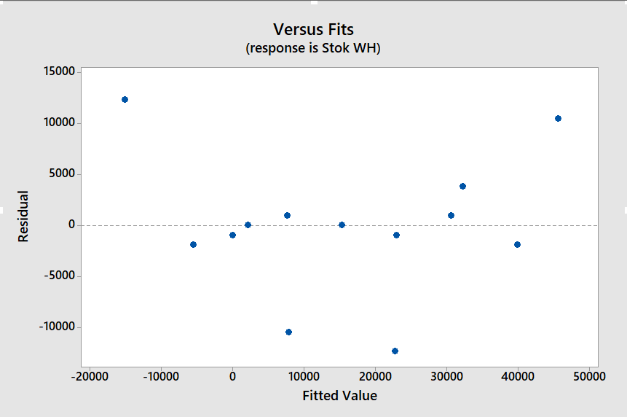
Fig. 1 Residual Versus Fitted Value
The identical assumption can be known from the plot between the residuals and Y. If the plot spreads and does not form a certain pattern, it can be said that the residuals are identical. Fig. 1 shows the relationship of the residual plot with the fitted value. The residuals are spread evenly and do not form a specific pattern. This indicates that the assumption of identical residuals is met.

The normal distribution test is conducted to observe model deviations. The residuals are declared to have followed a normal distribution if on the residual normality plot, the resulting residual points have matched or approached the specified straight line.
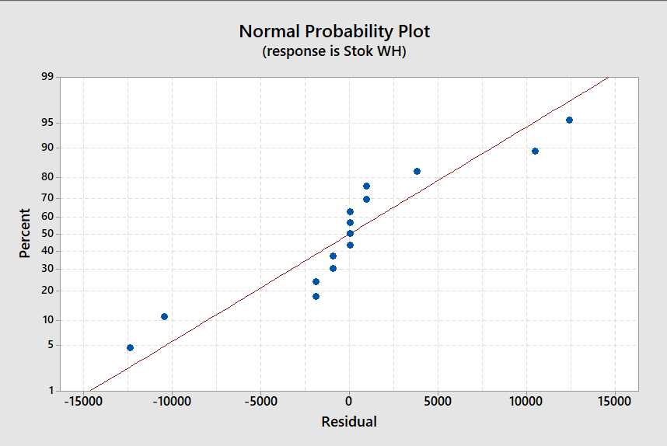
Fig. 2 Normal Probability Plot
The hypothesis used in the normality test is:
H₀ : residual plot is normally distributed.
H₁ : residual plot is not normally distributed.
Fig. 2 shows that the resulting residual points are close to a straight line so that the residual normality test has followed a normal distribution.
The significance test through ANOVA testing aims to determine the effect of the various factors tested on stock in the warehouse. In this study, the value of α (significance level) is determined, indicating that the permissible error is 1-confidence level. The confidence level used is 95% so that the value α = 0.05 is obtained. If the test uses a significance level of 0.05, it means that the research results have a chance or level of importance (confidence interval) to be correct 95% and the chance of getting a maximum error of 5% (error tolerance).
R-squared (R²) or squared R shows the coefficient of determination, ranging from 0 - 1. The smaller the R², the weaker the relationship between the variables, on the other hand, if R² is closer to 1, the stronger the relationship between the dependent variables. The R² value is obtained from:
$$R^{2}=\frac{JK(regresi)}{JKT}=\frac{4.570.022.935}{4.584.424.960}=0,996858488$$
The R² value of 0.996 means that the influence of store goods demand, supplier incoming goods, lead time and stock in the warehouse is 99.6% while 0.4% is influenced by other variables that are not included in the model.
- Optimal Point Identification
Determining the combination of levels of process variables that can produce an optimal response is done with a matrix approach. The input of the matrix is the experimental results of the treatment given in the box-behnken model design. The coefficient of each regression from the model that has been obtained is converted into a matrix. The formation of the matrix and the determination of the optimum point is sought by means of multiplication and inverse matrix.
The linear coefficient values obtained can be arranged as follows:
$b=\left[\begin{matrix}b_{1} \\ b_{2} \\ b_{3}\end{matrix}\right]$
$b=\left[\begin{matrix}-1,063 \\ -0,875 \\ 852\end{matrix}\right]$
The optimal response value can be obtained using the formula:
$$Y=b_{0}+\frac{1}{2}{\left[\begin{matrix}X_{1} \\ X_{2} \\ X_{3}\end{matrix}\right]}^{t}b$$
$$Y=1531+\frac{1}{2}\left[\begin{matrix}(-31974,67) & 1087,51 & 1,52\end{matrix}\right]\left[\begin{matrix}-1,063 \\ -0,875 \\ 852\end{matrix}\right]=18697,27$$
Thus a response value of 18697.27 is obtained.
- Response Surface Analysis
One method to visualize the response surface model is to create a contour plot of the warehouse stock, which is affected by three factors: store demand, supplier incoming goods, and delivery lead time. To display the contour plot results, the response can only be visualized in three dimensions, so the two factors that have the most influence on the response will be selected.
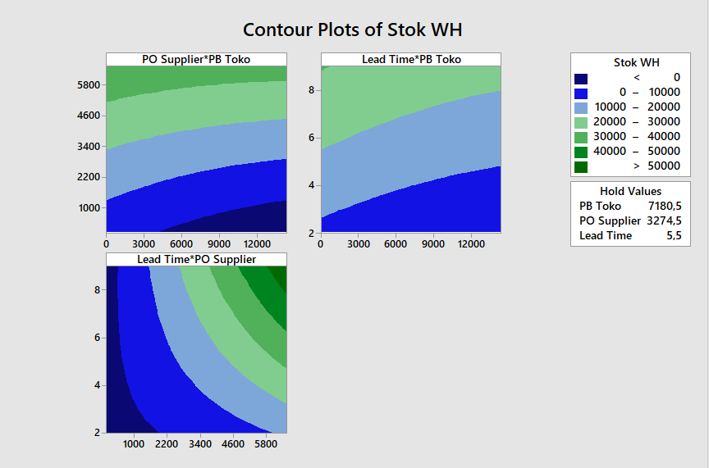
Fig. 3 Contour Plots of Stok Warehouse
Fig. 3 shows a contour plot consisting of several colors with each variation showing the range of the magnitude of the resulting response. The maximum condition for the plot above is in dark green with a warehouse stock value above 50,000 pcs. This range will outline the location of the optimum point of the variable.
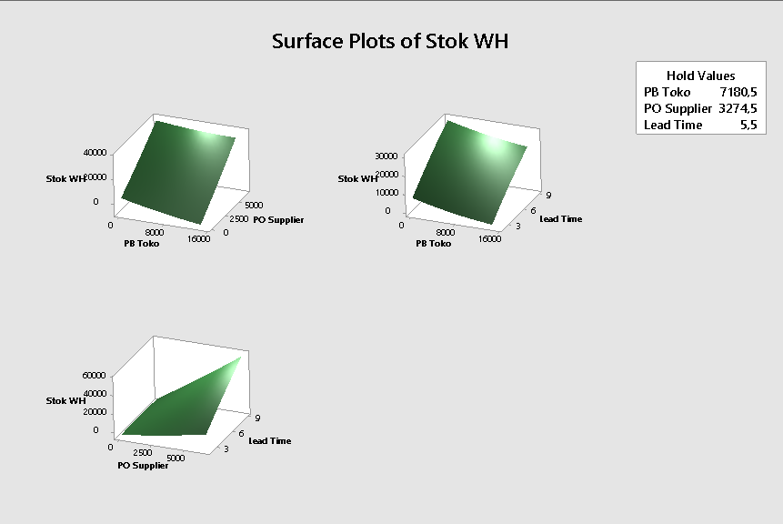
Fig. 4 Surface Plot of Stok Warehouse
After obtaining the optimum conditions of each factor, the determination of the optimum conditions can be proven by the shape of the 3-dimensional curve that forms the optimum peak as shown in Fig. 4.

4. Conclusion
From the research that has been done regarding the optimization of stock of goods in the warehouse of PT XYZ using the Response Surface Methodology experimental design, it is concluded that the factors that influence the optimization of stock of goods in the warehouse are:
- Factor $X_{1}$, which is the demand factor for store goods.
- Factor $X_{2}$, which is the supplier's incoming goods factor.
- Faktor $X_{3}$, which is the delivery lead time factor.
- Quadratic factor ${X_{1}}^{2}$, which is the quadratic factor of demand for store goods.
- Quadratic factor ${X_{3}}^{2}$, which is the quadratic factor of delivery lead time.
The significance test through ANOVA testing aims to determine the effect of the various factors tested on stock in the warehouse. R-squared (R²) or R-squared shows the magnitude of the influence of factors on optimizing the stock of goods in the warehouse. Based on the results of the research that has been carried out, a value (R²) of 0.996 is obtained, which means that the demand for store goods, supplier incoming goods, and delivery lead time has an influence of 99.6% on optimizing stock in the warehouse, while the rest is influenced by other variables.
Based on the results of research that aims to optimize the stock of goods in the warehouse using the Response Surface Methodology (RSM) method, it is able to evaluate and model the complex relationship between several variables that affect inventory. It is recommended that this research consider key variables other than demand for goods from stores, incoming goods from suppliers, and delivery lead time, which can play a more significant role in stock management or with more varied levels to obtain more optimal results. By using RSM, it can identify the optimal combination of these variables to minimize stock shortages or overstock. This research is expected to help improve warehouse operational efficiency and reduce logistics costs.

Acknowledgments
Praise my Gratitude to Allah SWT who has bestowed His Grace and Guidance so that I can complete this research article with the title “Optimizing the Inventory Fulfillment Level of Store Goods from PT. XYZ Warehouse with the Application of Response Surface Methodology”. In the preparation of this article there are many obstacles faced, but thanks to His will so that the author managed to complete the writing of this article. Therefore, with full humility the author would like to thank the parties concerned.

References

Aresti. (2021). Analisis Manajemen Pergudangan pada PT. Beurata Subur Persada. Juremi: Jurnal Riset Ekonomi, 1, 241–246.
Aryanny, E., & Jati, R. K. (2021). Analisa Pengendalian Persediaan Daun Kayu Putih yang Optimal dengan Metode Continous Review System. Tekmapro: Journal of Industrial Engineering and Management, 16(01), 106–117.
Ernita, T., Ervil, R., Meidy, R., Studi, P., Industri, T., Tinggi, S., & Industri, T. (2021). Perencanaan Persediaan Bahan Baku dengan Metode Material Requirement Planning ( MRP ) pada Proses Produksi Bak Mobil Truk di CV . Lursa Abadi Kota. Jurnal Sains DanTeknologi, 21(1), 40–49.
Hadiyat, M. A., Sopha, B. M., & Wibowo, B. S. (2022). Response Surface Methodology Using Observational Data: A Systematic Literature Review. Applied Sciences (Switzerland), 12(20). https://doi.org/10.3390/app122010663
Kumar, R., & Reji, M. (2023). Response surface methodology (RSM): An overview to analyze multivariate data. Indian Journal of Microbiology Research, 9(4), 241–248. https://doi.org/10.18231/j.ijmr.2022.042
Lamidi, S., Olaleye, N., Bankole, Y., Obalola, A., Aribike, E., & Adigun, I. (2023). Applications of Response Surface Methodology (RSM) in Product Design, Development, and Process Optimization. Response Surface Methodology - Research Advances and Applications, December 2023. https://doi.org/10.5772/intechopen.106763
Monica, S., & Setiawan, P. Y. (2019). Analisis Material Requirement Planning Produk Body Scrub Powder pada CV . Denara Duta Mandiri. Jurnal Manajemen, 8(5), 2944–2972.
Naomi, A. C., & Fauziah, L. (2023). Tingkat Efektivitas Dalam Proses Penyimpanan Barang Di Gudang. Jurnal Bisnis, Logistik Dan Supply Chain (BLOGCHAIN), 3(2), 74–78. https://doi.org/10.55122/blogchain.v3i2.919
Nurwahyuningsih, Arifin, N., Sari, R. D., & Fauzi, V. N. (2021). Barang Dagang Berbasis Web Bagi Bisnis Retail. NARATIF(Jurnal Ilmiah Nasional Riset Aplikasi Dan Teknik Informatika), 03(02), 36–40.
Putri, D. K., & Dinuka, V. K. (2022). Pengendalian Internal Persediaan Pada PT. Triniti Perkasa Internasionala. Relawan Jurnal Indonesia, 13(1), 920. https://jurnal.polban.ac.id/ojs-3.1.2/proceeding/article/view/4351
Rifda, Z. (2023). Analisis Efektivitas Penyimpanan Barang di Gudang pada PT. ZYR. Jurnal Bisnis, Logistik Dan Supply Chain (BLOGCHAIN), 3(2), 83–86.
Suri, I., Aprilia, D., & Renaldi, A. (2022). Method of Response Surface untuk Optimalisasi Keuntungan Produksi A Home Industry Kripik Pisang. Journal of Innovation Research and Knowledge, 2(1), 7–14.
Susanti, A. F. O., & Hermansyah, M. (2023). Analisis Pengendalian Persediaan Bahan Baku Tapioca Menggunakan Pendekatan Economic Order Quantity (Eoq). Journal of Scientech Research and Development, 5(2), 42–52. https://doi.org/10.56670/jsrd.v5i2.157
Wang, C. N., Dang, T. T., & Nguyen, N. A. T. (2020). A computational model for determining levels of factors in inventory management using response surface methodology. Mathematics, 8(8). https://doi.org/10.3390/MATH8081210
Waters, D. (2016). Inventory Control & Management 2nd Edition.

