Business Conceptual Design of Photovoltaic Installation for Billboard Lighting
Erico Sofyan Chrissandhi, Christa Dian Pratiwi, dan Tiwik Tri Hastuti, Muhammad Hisjam, Wahyudi Sutopo

Industrial Engineering Master’s Degree Program, Faculty of Engineering, Universitas Sebelas Maret, Surakarta
Corresponding author: wahyudisutopo@staff.uns.ac.id

History: Accepted xx^{th} month, 20xx; Revision xx^{th} month, 20xx, Accepted xx^{th} month, 20xx

Abstract. The usage of advertising as a medium for marketing products/services is used by various businesses to increase profits. The advertising medium mainly used is billboards, which still use fossil energy as an energy source. The Indonesian government's 2060 Net Zero Emission Program promotes using renewable energy (RE) as an energy source, such as photovoltaic (PV) as electrical energy from solar heat. As with RE, the development of PV still has problems in products and business, but PV is ready to be used as an energy source to reduce electricity bill costs. The business idea of PV installation in the advertising company sector emerged to support the government program Net Zero Emission, making advertising companies "green jobs" and absorbing human resources from vocational schools. Business conceptual design with value chains, business model canvas, and lean canvas expected can provide an overview of business opportunities with EBT for Indonesia that are environmentally friendly and energy independent.
Keywords: Billboard, Bussiness Model Canvas, Lean Canvas, Photovoltaic, Value Chain.

Introduction
Outdoor advertising such as billboards, is widely used as a marketing tool for promoting products or services by various companies to enhance their brand reputation. Companies utilizing outdoor advertising encompass various sectors and levels, including small and medium-sized enterprises (Osadolor et al., 2022). Using electricity as a resource for billboards, primarily for lighting, is still prevalent in an era when renewable energy has become commonplace in the electrical grid. Renewable energy (RE) implementation in Indonesia is part of efforts to reduce greenhouse gas emissions in the energy sector. Indonesia holds significant RE potential, with around 3000 gigawatts of potential energy and 24 gigawatts of geothermal energy potential. The substantial geothermal energy potential has motivated Indonesia to establish a Net Zero Emission target by 2060.

The abundant geothermal energy in Indonesia is harnessed as solar energy, with one of its products being Photovoltaic (PV). PV is a product that has emerged due to Market Pull or Demand Pull as a necessity of RE (Hansen et al., 2019). PV products are also influenced to some extent by Technology Push during the early research phase (Hansen et al., 2019). PV products, such as RE, can be utilized by billboard companies to reduce electricity consumption for their lighting, supporting Indonesia's steps toward Net Zero Emissions. In addition to being influenced by Technology Push, Supply Chain performance accelerates the introduction of PV products to the market. Rapid marketing with minimal investment is a component that aids successful product innovation in the market. Research is conducted to intervene in both aspects to develop effective methods, system designs, and approaches, such as technology transfer office (TTO) methods. TTO is used to shorten the time a product enters the market and minimize costs required through early supply chain engineering (Sutopo et al., 2022). In designing this engineering, challenges in product development and innovation, technological innovation challenges, process challenges, and business challenges for the future must be considered.

The implementation of solar energy and PV faces challenges related to the necessary standardization of products, while negotiations on other aspects have progressed (Brenner & Adamovic, 2018). Standardization of intellectual property rights is a vital incentive for research, development, and innovation. Some argue that this standardization is a barrier to technology transfer from PV (Glachant & Dechezleprêtre, 2017; Laajimi & Go, 2021; Pigato et al., 2020). According to Sutopo et al.'s research (Sutopo et al., 2022), referencing lithium battery research, standardization can expedite product implementation through supply chain engineering. Standardization is the foundation for future innovations and ensures that product standards are established and adhered to correctly, involving numerous stakeholders (Sutopo et al., 2022). In previous research (Sutopo et al., 2022), standards resulting from standardization were obtained through R&D activities focused on achieving the required standards. The Standardization Body issues the standards. The Standardization Body has an Accreditation Committee that tests in Testing and Calibration Laboratories. These laboratories can serve as references for constructing production facilities needed for the product manufacturing process. Products that meet the standards will be certified by Product Certification Bodies, essential for building customer trust in the product, in this case, PV.

PV products currently available in the market are commonly utilized as RE in various equipment, including billboard lighting. The PV system converts solar radiation into electricity, and the higher the intensity of sunlight that hits the PV cells, the more electrical power it generates (Al-Ezzi & Ansari, 2022). In a PV system, the amount of electricity generated depends on the weather conditions. During sunny weather, a significant amount of electricity is generated, whereas during cloudy or overcast weather, less electricity is produced. Since electricity is required throughout the day, the surplus electrical power generated during the daytime is stored in batteries, allowing it to be used at any time for various electrical devices. The components required for PV production include solar modules, storage batteries, wiring for electrical current flow to and from the batteries, and circuit breakers to limit electrical current flow.

Solar modules contain PV cells that can be combined to create solar power generators. The efficiency of solar modules depends on the type of PV cell material used, whether crystalline or non-crystalline (thin-film). PV cells are divided into mono-crystalline and poly-crystalline types (thin-film), with conversion efficiencies ranging from approximately 12% to 20% (Kencana et al., 2018). When solar radiation intensity reaches 1000 W/m2, solar modules can produce DC electrical current according to their rating plate, such as 250 Wp. However, actual electricity production is influenced by various factors such as system capacity, solar radiation intensity, module orientation, angle, and other factors. Inverters must convert DC electrical current from solar modules into alternating current (AC). There are two types of battery charging systems in off-grid PV systems: DC or AC switches. The AC voltage system is obtained from inverters that convert DC voltage from PV modules or batteries. String Inverters convert DC voltage into AC voltage directly from PV modules. Battery Inverters, or two-way battery inverters, convert DC voltage from batteries into AC voltage during discharge and vice versa during charging. Battery electrical current can be controlled using a Solar Charge Controller (SCC) or Solar Charge Regulator (SCR), which also prevents overcharging. Deep Discharge Batteries can store 20% of the remaining energy from the battery storage capacity.

The limitations and assumptions used in calculating the electricity needs for billboard lighting are as follows: the most commonly used billboard size is 4 x 6 meters, horizontal, one-sided, using energy-efficient 240W LED high mast floodlights installed with a front lite type for efficiency. The lights are only turned on from 18:00 to 06:00 to conserve energy; billboard management is the company's responsibility. Electricity consumption calculations show that using one 240W lamp for twelve hours a day, the monthly electricity consumption is 86.4 kWh. Based on a 3500 VA power assumption, the monthly electricity cost is Rp 93,000. Furthermore, using PV panels can harness solar radiation with an average of 521.03 W/m2 for 10 hours a day, providing enough electricity to meet the daily billboard lighting needs of 2,880 Wh while storing excess energy. This aligns with previous research findings on the potential energy supply from the sun for billboard lighting. Therefore, PV can be an efficient and sustainable solution for billboard lighting in Indonesia (Lilipaly & Dharmawan, 2021).
Based on the PV's capability calculations, it is highly suitable to support billboard lighting. Advertising companies that optimize this opportunity can increase their workforce absorption in the installation industry in Indonesia. However, the initial capital required for PV procurement can still be considered expensive due to the primary material of PV, silicon, which has high production costs. Some research has been conducted to reconsider alternative materials to reduce production costs, ultimately lowering the initial capital required. Lower capital costs will encourage using PV as a lighting energy source for billboard lighting by advertising companies, demonstrating a commitment to the government's policy on using RE for Indonesia's carbon-free environment.

The PV business concept in advertising companies, particularly billboards, depicted through the value chain, BMC, and Lean Canvas, can provide insights into the optimization that advertising companies can achieve by implementing PV as an energy source for lighting. The designed value chain, BMC, and Lean Canvas also provide an overview of the absorption of human resources (HR) in Indonesia as PV installers for billboard lighting. This HR absorption will have an impact on local and national economic growth. The growing vocational schools in the country support Indonesia's abundant HR. Graduates from vocational schools are expected to be ready to work immediately in their respective fields of concentration. This research aims to design a PV business as a source of RE for billboard lighting, which will provide long-term benefits for advertising companies and serve as a platform for absorbing technician practitioners as PV installers while also contributing to improving Indonesia's HR in advanced technology and RE competencies. The BMC design for PV in advertising companies can be one of the main drivers of empowering higher-quality HR in Indonesia through the transfer of knowledge and advanced technology, leading to the emergence of advertising companies that initiate billboard businesses with PV as an RE source.

The Value Chain, BMC, and Lean Canvas designs for this business concept are created by applying supply chain efficiency strategies. In this business, there is an emphasis on supply chain efficiency strategies because it helps reduce unnecessary costs. This cost reduction is due to the continued high price of PV products, which impacts the company's focus on cost minimization. However, even though the focus is on supply chain efficiency strategies, this business design also applies some responsiveness supply chain strategies used in market research to identify business opportunities for PV installation for billboard lighting (Chopra & Meindl, 2007; Christyono, 2017).

Several previous studies in the field of PV utilization for billboard lighting have provided valuable insights into Indonesia's business development context. Summarizing various research, it is noted that the solar energy potential in Indonesia has not been optimally utilized (Dang, 2017), and there are challenges in the evolution of the PV value chain (Horváth & Szabó, 2018) and PV distribution business models in China (Cai et al., 2019). Additionally, other research has focused on the feasibility studies of PV use in specific areas of Indonesia, such as Lampung (Purwanto, 2020), and evaluated competitive business models for PV installation in Brazil (Rigo et al., 2022). Some studies have also explored innovations, such as using fan-type holograms with solar cells as an alternative source of billboard energy (Lilipaly & Dharmawan, 2021). However, no comprehensive study has integrated the value chain, business model canvas, and lean canvas into a conceptual business design for billboard lighting with PV in Indonesia. Based on this analysis, this research aims to fill the existing research gap and develop a more holistic and efficient solution regarding PV as an RE source for billboard lighting in Indonesia.

Method
The data utilized in this study includes primary data, secondary data, and a qualitative descriptive literature review. The primary data used in this research were gathered through interviews conducted at PUI UNS. PUI UNS has implemented PV as an energy source for office operations and for charging electric bicycles and motorcycles. Secondary data were collected from various sources, including published journals, nationally and internationally, newspapers, Google Scholar, and websites. The obtained data were employed to supplement the required information in formulating the Business Model Canvas concept for PV as an energy source for billboard lighting.

This research begins with a Preliminary Literature Review to understand the background of the research topic and identify relevant research topics. The Preliminary Literature Review includes the role of billboards in advertising, the role of Photovoltaics (PV) in renewable energy, the commercialization of PV, and barriers in the PV supply chain. Then, a literature study was carried out to collect data that supports the Business Model Canvas concept for using PV as an energy source for billboard lighting. The following steps include analyzing PV technology, identifying potential value in the value chain, and creating a Business Model Canvas (BMC) and Lean Canvas according to the context of using PV on billboards. The results of this analysis are then discussed in the Results and Discussion stage to explore the potential for implementing PV in the billboard advertising industry and discuss the obstacles and opportunities that arise. Finally, this research presents the conclusions of the findings and suggestions in the Conclusion and Suggestions stage, which provides insight into the utilization of PV as an energy source in the advertising industry, considers essential factors in the business model, and highlights steps to overcome obstacles in the implementation of this project, to make an essential contribution to the use of renewable energy in the advertising industry. The flow of the research is displayed in a flowchart in Figure 1.

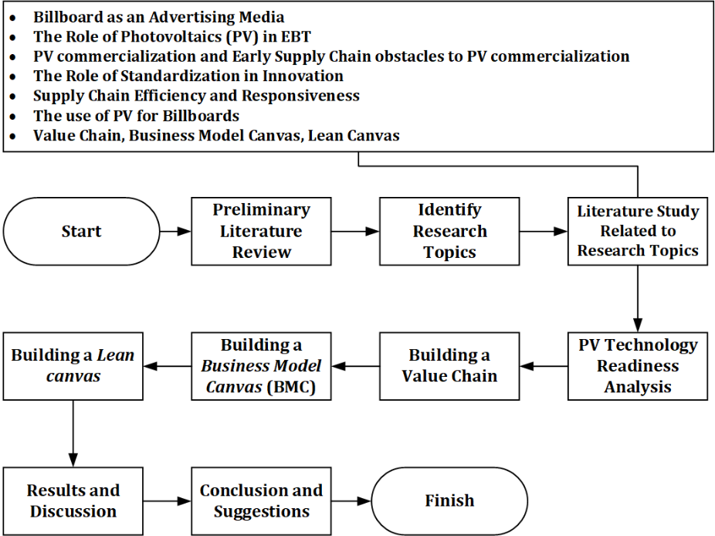
Figure 1. Research Flowchart

Results and Discussion
Technology Readiness and Challenges of PV Technology
The readiness of PV as a renewable energy in product innovation and its readiness to enter the market can be measured using the Technology Readiness Level (TRL). PV products have reached TRL 9, as evidenced by the systems proven to operate in operational environments and have been fully operational, commercialized, and implemented (Jaffe et al., 2019). The whole production chain and all materials are readily available and stable, and the system has been optimized for full-scale production. The practical application of this technology is ready for large-scale production. Integration with other supporting technologies is mature, including materials, manufacturing processes, testing equipment in production, and established practices. After achieving TRL 9 readiness, the system is ready for full-scale implementation, which means that PV energy systems can operate at total capacity with optimal energy output under field conditions. Increased high-volume optimized production, operability, and maintenance have also been proven in the field (Rose et al., 2017).

In the development and commercialization of new technology, there will be challenges. These challenges include Product, Process, Innovation, and Business Challenges (Sutopo et al., 2022). The challenges PV faces as a renewable energy source, based on the stages of new product development and commercialization, are the high cost of the product and the limited comprehensiveness of market education related to PV. These challenges will affect the TRL in meeting market criteria (Chirazi et al., 2019; Hindle & Yencken, 2004; Osawa & Miyazaki, 2006). PV's challenges are related to product (high product cost) and business (uneven use of PV). Even though PV has reached TRL 9, there are still challenges because indicators have not been met in terms of high production cost estimates, making the price of PV products still high. The high production cost is due to using pure silicon in PV, which requires a lot of labour and capital (Ferdous et al., 2018). The business challenge PV faces is that, although it has reached TRL 9, it is only at level 2 or the demonstration stage on the Commercial Readiness Index (CRI) scale (Arena, 2014). Challenges in the technology development and renewable innovation process must be resolved promptly to expedite the introduction of technology to the market and minimize the required costs (Sutopo et al., 2022). However, in the case of PV products, which have reached TRL 9, improvements must continue to strengthen or improve the readiness of PV technology for use as RET, especially in the field of marketing with billboards. The cost or product-related challenges of PV must be addressed by re-evaluating materials and production processes to make PV relatively more cost-effective (Ferdous et al., 2018). PV is also mentioned in some literature studies to have higher installation costs than conventional energy systems but is cost-effective in the long run. As seen from the CRI perspective, business challenges for PV can be addressed by expanding the scale of commercialization until PV can be considered a banking asset, as shown in Figure 2.
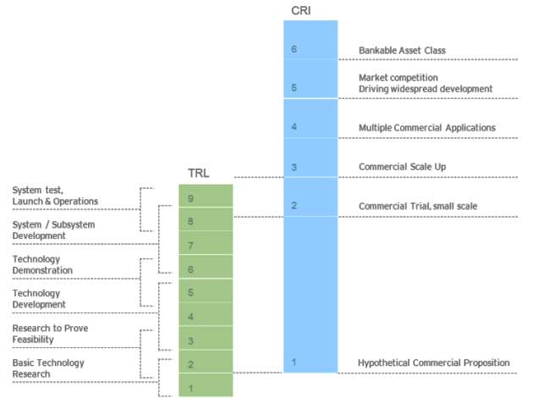
Figure 2. The Relationship between TRL and CRI Levels (Arena, 2014)

PV Value Chain for Billboard Lighting
The function of the PV value chain is to visualize the entire set of activities required for a billboard, from raw materials to the end user. The PV value chain used for billboard lighting starts with raw materials and then goes through manufacturing until it reaches the end user, as illustrated in Figure 3. Business opportunities regarding installing PV as a source of energy for billboard lighting arise, where the target use of PV spans various sectors such as Industrial, Commercial, and Residential. The value chain analysis for the business opportunity of installing PV as a source of energy for billboard lighting is presented in Table 1 and Table 2 with a brief explanation of the value chain design for both primary and support activities.

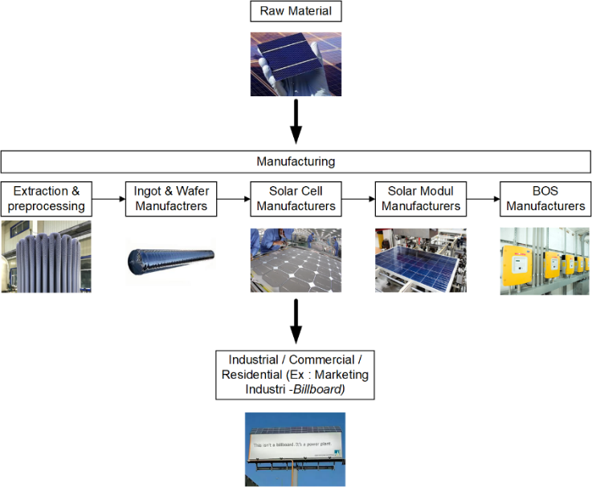
Figure 3. Value Chain Photovoltaic (Modified : (Franco & Groesser, 2021))

Table 1. Support Activities in the PV Business Value Chain for Billboard Lighting
Company Infrastructure
- Completing the company's documents related to business establishment permits and business feasibility.
- Procuring standard operating procedures (SOP) and safety standards for installing PV for billboard lighting.
- Designing financial workflow processes, including purchasing, customer payments, and employee payroll within the company.
Resource Management
- Recruiting competent workforce and providing job-related training.
- Granting rights following each employee's job positions and roles regarding government regulations regarding employment.
- Measuring employee Key Performance Indicators (KPIs) as an evaluation tool.
Technology Development
- Conducting research and development on alternative materials that PV can use.
- Undertaking business development efforts to gain a new market share in PV installation as an energy source.
- Having an Enterprise Resource Planning (ERP) system to integrate various company activities.
Purchasing
- Procuring installation equipment to facilitate the workforce in PV installation.
- Purchasing shelving units for storing PV products to be marketed.
- Procuring transportation modes to support PV distribution.

Table 2. Primary Activities in the PV Business Value Chain for Billboard Lighting
Inbound Logistics | Operations | Outbound Logistics | Marketing and Sales | Service
- Procurement of the primary raw material, PV, which is packed with wood and transported by truck or cargo for delivery. | - PV testing processes are carried out to verify that the product can function correctly. | - Products to be distributed are retrieved from the warehouse with shelving units, including PV products that have undergone testing. | - Promoting PV through online and offline media, emphasizing its value as Renewable Energy to support the government's 2060 NZE program. | - Guiding how to maintain PV systems.  - Monitoring the condition of installed PV systems as part of after-sales service.
Table 2. Primary Activities in the PV Business Value Chain for Billboard Lighting (Continue)
Inbound Logistics | Operations | Outbound Logistics | Marketing and Sales | Service
- Procurement of auxiliary raw materials such as storage batteries and inverters.  - Raw material checking is done with a one hundred percent physical inspection to maintain the quality of raw materials.  - Raw material storage is organized in shelving units to prevent damage from stacking and save space. |  | - PV product distribution will be carried out directly by technicians performing the installation. The transportation used for distribution is a vehicle capable of carrying all equipment, such as a box truck. | - Conducting socialization or seminars on PV as an energy source capable of reducing costs, particularly in billboard advertising. | - Offering maintenance and repair services as a follow-up to after-sales monitoring, with costs separate from PV installation.

PV Business Model Canvas (BMC) for Billboard Lighting.
Osterwalder and Pigneur (2010) introduced a highly structured and detailed model, the Business Model Canvas, which is very comprehensive. For PV, three business models can be developed: the host-owned model, the Third-Party-Owned (TPO) model, and the Energy Management Contract (EMC) model (Cai et al., 2019). EMC is a mechanism for energy-efficient emission reduction based on market-oriented project operations that began in the 1970s and have a medium-term outlook in Western developed countries (Sun et al., 2018). The case study of using PV for billboard lighting can be seen in Figure 4.
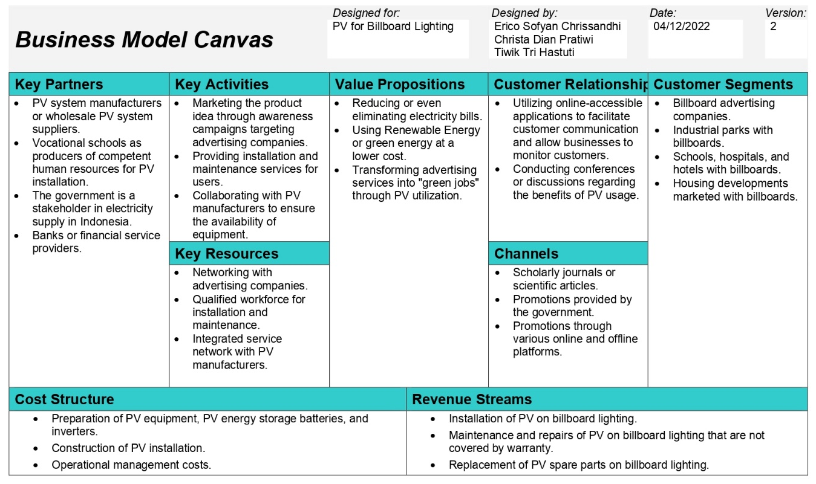
Figure 4. Business Model Canvas (BMC) for PV Installation Business for Billboard Lighting

The conceptual BMC design aims to provide maximum benefits to billboard advertising companies by offering a PV solution for billboard lighting to save on electricity costs and reduce emissions from conventional lighting. The PV installation business is expected to thrive with the increasing use of PV. Therefore, experts in PV installation are in high demand. This BMC concept supports workforce development in Indonesia, not only at the vocational school and vocational college levels but also at the bachelor's degree level. Here is an explanation of each element in the BMC:
- Consumer Segments, the target businesses are focused on advertising companies and entities such as parks, schools, hospitals, and residential areas that use billboard advertising.
- Channels, to market the product or service, academic journals, and scientific articles are used as consumer verification tools. Government promotions are also expected to increase consumer interest. Both online media (Facebook, Instagram, Website, etc.) and offline media (Newspapers, Brochures, Banners, etc.) are used to reach a wider audience.
- Customer Relationship, this is used to interact with consumers and build relationships. An online-accessible application is used for communication with consumers and providing after-sales service.
- Value Proposition, includes offerings such as using PV for billboard lighting to reduce electricity bills, using green energy at a low cost, and making advertising companies "green jobs”.
- Revenue Stream, comes from services such as installation, maintenance, repairs, and replacement of PV components in billboard lighting.
- Key Activities include marketing the product idea, promoting it to advertising companies, installation, and PV maintenance. Collaboration with PV manufacturers is also crucial.
- Key Resources, include networks with advertising companies, a competent workforce for installation, maintenance, and repairs, and resources related to PV manufacturers.
- Key Partners, encompass partners such as PV manufacturers, vocational schools, government agencies, and financial institutions to facilitate transactions and funding.
- Cost Structure, encompasses costs such as PV equipment preparation, installation construction costs, and operational business expenses.

Lean Canvas for PV Billboard Lighting.
In 2010, Ash Maurya introduced Lean Canvas as an adaptation method of the BMC that is streamlined but has the same foundation (Maurya, 2012). However, there are some differences in using Lean Canvas to achieve business targets (Mahendra, 2022). Lean Canvas, which has its basic design from the Business Model Canvas, has the same goal as the conceptual design created in this research. However, Lean Canvas is a streamlined Business Model Canvas model with some different elements in its design. Explanations related to the different elements of the conceptual design of Lean Canvas in Figure 5 are described as follows:
- Consumer Segments - Early Adopters, are the ideal consumers for the business, in this case, advertising companies with billboards, who will use this business's product or service. This element is similar to consumers in the Business Model Canvas, but it is referred to as Early Adopters in Lean Canvas.
- Problem - Existing Alternatives, this represents the problems faced in the business, such as high PV costs and uneven PV usage. To address this problem, the government provides subsidies for PV usage.
- Solution, this is how to solve the problems in the business, such as researching to find cheaper PV raw material alternatives and making PV an asset for banks to increase companies' interest in using PV.
- Key Metric, includes activities that need to be measured, such as the number of billboards using PV, PV repair data, and customer satisfaction measured through questionnaires.
- Unfair Advantage, This is the unique aspect of the business that is difficult to imitate, such as using PV as a source of energy from Renewable Energy and supporting the government's program to achieve Net Zero Emission by 2060.
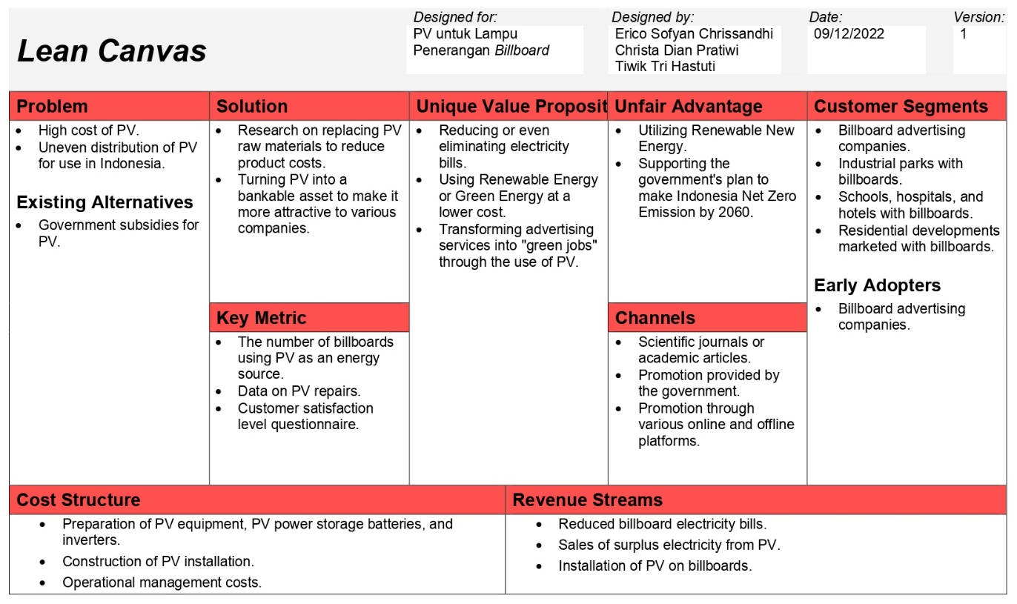
Figure 5. Lean Canvas from PV Installation Business Design for Billboard Lighting

Conclusions and Suggestions
The business related to installing PV as a source of energy for billboard lighting is an added value to support the Indonesian government's program of achieving Net Zero Emissions by 2060. The success of the conceptual PV business design for billboard lighting provides the advantage of minimizing electricity costs for companies using billboards as advertising media. The electricity generated from PV can meet the daily billboard usage, with any excess energy being stored in batteries.
Another benefit of the success of this business is that it helps absorb skilled labour, especially vocational school graduates, to directly enter the workforce as PV installers and perform maintenance and repairs in case of PV damage. The absorption of vocational school graduates into this workforce can contribute to harnessing the demographic boom concerning human resources in Indonesia. Human resources ready to engage in this business opportunity can help expand the PV industry. Significant growth will also drive more extensive innovations in PV technology to address the challenges still in PV technology products.
This research is still in the conceptual design phase, so further examination is needed in techno-economic analysis and technopreneurship in developing the PV installation business as a source of energy for billboard lighting. The development of the PV installation business as a source of energy for billboard lighting is expected to be implemented soon to obtain empirical data from real-world business testing.

Acknowledgement
This research was funded by the Institute for Research and Community Service at Universitas Sebelas Maret through the “Penelitian Hibah Grup Riset” program, grant number 28/UN27.22/PT.01.03/2023, 14th March 2023.

References
Al-Ezzi, A. S., & Ansari, M. N. M. (2022). Photovoltaic Solar Cells: A Review. Applied System Innovation, 5(4), 1–17. https://doi.org/10.3390/asi5040067
Arena. (2014). Commercial Readiness Index for Renewable Energy Sectors. In Australian Renewable Energy Agency. https://arena.gov.au/assets/2014/02/Commercial-Readiness-Index.pdf
Brenner, W., & Adamovic, N. (2018). Standardization as a tool for promoting innovation and commercialization of a circular economy for PV waste - The example of the European H2020 project CABRISS. 2018 41st International Convention on Information and Communication Technology, Electronics and Microelectronics, MIPRO 2018 - Proceedings, 122–127. https://doi.org/10.23919/MIPRO.2018.8400024
Cai, X., Xie, M., Zhang, H., Xu, Z., & Cheng, F. (2019). Business models of distributed solar photovoltaic power of China: The Business Model Canvas perspective. Sustainability (Switzerland), 11(16). https://doi.org/10.3390/su11164322
Chirazi, J., Wanieck, K., Fayemi, P. E., Zollfrank, C., & Jacobs, S. (2019). What do we learn from good practices of biologically inspired design in innovation? Applied Sciences (Switzerland), 9(4). https://doi.org/10.3390/app9040650
Chopra, S., & Meindl, P. (2007). Supply Chain Management. Strategy, Planning & Operation. In Das Summa Summarum des Management. https://doi.org/10.1007/978-3-8349-9320-5_22
Christyono, F. (2017). ANALISIS SUPPLY CHAIN PADA PT . CAHAYA INDO PERSADA Fendy Christyono. AGORA, 5(3), 1–6. https://publication.petra.ac.id/index.php/manajemen-bisnis/article/view/6093
Dang, M.-Q. (2017). Potential of Solar Energy in Indonesia Solar Energy in Indonesia View project Potential of Solar Energy in Indonesia (Issue April). https://www.researchgate.net/publication/324840611
Ferdous, S. M., Moin Oninda, M. A., Maruf, H., Islam, A., & Rahman, F. (2018). Energy Efficiency Constraints in Photovoltaic Power Generation Systems. Journal of Research in Engineering and Applied Sciences, 03(02), 41–47. https://doi.org/10.46565/jreas.2018.v03i02.001
Franco, M. A., & Groesser, S. N. (2021). A systematic literature review of the solar photovoltaic value chain for a circular economy. Sustainability (Switzerland), 13(17), 1–35. https://doi.org/10.3390/su13179615
Glachant, M., & Dechezleprêtre, A. (2017). What role for climate negotiations on technology transfer? Climate Policy, 17(8), 962–981. https://doi.org/10.1080/14693062.2016.1222257
Hansen, E. G., Lüdeke-Freund, F., Quan, X. I., & West, J. (2019). Cross-National Complementarity of Technology Push, Demand Pull, and Manufacturing Push Policies: The Case of Photovoltaics. IEEE Transactions on Engineering Management, 66(3), 381–397. https://doi.org/10.1109/TEM.2018.2833878
Hindle, K., & Yencken, J. (2004). Public research commercialization, entrepreneurship, and new technology-based firms: An integrated model. Technovation, 24(10), 793–803. https://doi.org/10.1016/S0166-4972(03)00023-3
Horváth, D., & Szabó, R. Z. (2018). Evolution of photovoltaic business models: Overcoming the main barriers of distributed energy deployment. Renewable and Sustainable Energy Reviews, 90(July), 623–635. https://doi.org/10.1016/j.rser.2018.03.101
Jaffe, P., Borders, K., Browne, C., DePuma, C., Longbottom, L., Nisar, H., & Simlot, V. (2019). Opportunities and challenges for space solar for remote installations. https://apps.dtic.mil/sti/pdfs/AD1082903.pdf
Kencana, B., Prasetyo, B., Berchmans, H., Agustina, I., Myrasandri, P., Richard, R. B., Panjaitan, R., & Winne. (2018). Panduan Studi Kelayakan Pembangkit Listrik Tenaga Surya (PLTS). In Tetra Tech ES Inc. (Ed.), Indonesia Clean Energy Development II (Issue November). Lembaga Pembangunan Internasional Amerika Serikat.
Laajimi, M., & Go, Y. I. (2021). Energy storage system design for large-scale solar PV in Malaysia: techno-economic analysis. Renewables: Wind, Water, and Solar, 8(1). https://doi.org/10.1186/s40807-020-00064-5
Lilipaly, E. R. M. A. P., & Dharmawan, E. A. (2021). Penggunaan Fan Type Hologram Dengan Solar Cell Sebagai Pilihan Alternatif Billboard Di Kota Ambon. Jurnal Simetrik, 11(1), 422–431. https://doi.org/10.31959/js.v11i1.621
Mahendra, I. P. D. S. (2022). Perbandingan Model Business Model Canvas Dengan Lean Canvas Pada Startup Piecework. JATISI (Jurnal Teknik Informatika Dan Sistem Informasi), 9(3), 2412–2427. https://doi.org/10.35957/jatisi.v9i3.2818
Maurya, A. (2012). Running Lean : A systematic process for iterating your web application from Plan A to a plan that works. https://books.google.com/books?hl=en%5C&lr=%5C&id=4s1gEAAAQBAJ%5C&oi=fnd%5C&pg=PT29%5C&dq=value+based+marketing%5C&ots=o1yL3mcGZx%5C&sig=n1WwH18VS7mYO9xx_8xEg_DaENU
Osadolor, A. O., Olagbegi, P., & Osifo, T. I. (2022). Design and Implementation of a Solar Powered Three Phase Automatic Mini Billboard. Advances in Engineering Design Technology, 4(3), 1–8. https://portal.issn.org/resource/ISSN-L/2682-5848
Osawa, Y., & Miyazaki, K. (2006). An empirical analysis of the valley of death: Large‐scale R&D project performance in a Japanese diversified company. Asian Journal of Technology Innovation, 14(2), 93–116. https://doi.org/10.1080/19761597.2006.9668620
Pigato, M. A., Black, S. J., Dussaux, D., Mao, Z., Mckenna, M., Rafaty, R., & Touboul, S. (2020). Enabling Environments for Sustainable Energy Transitions: The Diffusion of Technology, Innovation and Investment in Low-Carbon Societies In the Book : Technology Transfer and Innovation for Low-Carbon Development. https://openknowledge.worldbank.org/bitstream/handle/10986/33474/9781464815003.pdf?sequence=2
Purwanto, I. (2020). Solar Cell(Photovoltaic/Pv)Solusi Menuju Pulau Mandiri Listrik. Jurnal Penelitian Dan Karya Ilmiah Lembaga Penelitian Universitas Trisakti, 5(2), 117–126. https://doi.org/10.25105/pdk.v5i2.7410
Rigo, P. D., Siluk, J. C. M., Lacerda, D. P., & Spellmeier, J. P. (2022). Competitive business model of photovoltaic solar energy installers in Brazil. Renewable Energy, 181(August 2021), 39–50. https://doi.org/10.1016/j.renene.2021.09.031
Rose, A. De, Buna, M., Strazza, C., Olivier, N., Stevens, T., & Tawil-Jamault, D. (2017). Technology Readiness Level: Guidance Principles for Renewable Energy Technologies - Final Report. In Eur 27988 En. European Commission. https://www.gransking.fo/media/2900/trl-orka.pdf
Sun, M., Zeng, W., Zhang, W., & Li, C. (2018). Study on Operation Mode of Anti-poverty Photovoltaic Project Based on Altruism Preference. IOP Conference Series: Earth and Environmental Science, 146(1). https://doi.org/10.1088/1755-1315/146/1/012033
Sutopo, W., Khofiyah, N. A., Hisjam, M., & Ma’aram, A. (2022). Performance Efficiency Measurement Model Development of a Technology Transfer Office (TTO) to Accelerate Technology Commercialization in Universities. Applied System Innovation, 5(1). https://doi.org/10.3390/asi5010021

