Simulation Optimization of Truck Queue Loading Process Using Discrete Simulation Approach Using Promodel Software at PT. XYZ

Rahandi Ardiansyah^{1*}, Muhammad Ali Akbar², Osep Hijuzaman³
^{1,2,3} Department of Industrial Engineering, Purwakarta, West Java, Indonesia
* Corresponding author: rahandy64@gmail.com

ARTICLE INFO |  | ABSTRACT
Article history  Submission: 21th July 2024  Revised  Accepted |  | Warehouses have an important role for companies, including PT. XYZ located in Karawang. This research aims to optimize truck queues in the loading and loading process at PT. XYZ uses a discrete simulation approach with ProModel software. The problem of long truck queues and high delivery order (DO) waiting times disrupted the operational efficiency of distribution facilities. In this study, 3 simulation scenarios were tested to evaluate the impact of adding loading docks on throughput, waiting time, and resource usage by removing the Delivery Order (DO) waiting time. The data collected includes loading and loading process time, namely truck arrival data, warehouse information data, transport truck information data, and product information data implemented using ProModel software and then validated through replication tests and validity tests using the t-test method. The simulation results show that using scenario 1, the addition of one loading dock increases throughput by 45% and reduces the average wait time from 18 minutes to 9.3 minutes per truck. In addition, the use of resources becomes more optimal, increasing overall productivity. With these results, the study concludes that the addition of loading dock is an effective solution to overcome bottlenecks in the loading process at PT. XYZ, which can be implemented to improve operational efficiency.
   | This is an open access article under the CC–BY-SA license.
Loading, Loading Dock, Truck, Simulation, Time

 https://doi.org/10.22219/oe.2024.v16i1001.

1. Introduction
A warehouse is a place used to store goods in large quantities in anticipation of fluctuating consumer demand. In addition, warehouses also function as temporary storage for finished goods, semi-finished goods, raw materials, spare parts, equipment, and a place to add value to an item, or any goods that support the activities of a company (Zhang et al., 2017). Good warehouse management can reduce losses and costs, as well as improve service speed and operational efficiency. Each warehouse is designed to meet the specific needs of a company's supply chain activities, so its operations can differ from one business to another. In general, the warehouse process includes receiving, storing, ordering, sorting, adding value, and shipping (Rushton, A., Croucher, P., and Baker, 2014).
PT. XYZ is a company that produces culinary products with typical Indonesian flavors and has a warehouse to store these items. However, there are problems that hinder supply chain activities, especially in the process of loading goods in the warehouse loading dock. PT. XYZ uses four types of trucks for distribution, namely CDD, Engkel, Container, and Tronton load trucks, with three active loading docks. The average time of truck service tends to be long, leading to the next truck queue, which can result in cost losses and decreased customer satisfaction due to customer loss.
The research data used is data on the fleet loading time cycle to provide an overview of the performance of the loading process of each fleet. This data presents about the average load time for each fleet or vehicle type, which can help identify the most efficient fleet and which need improvement. This data also shows variations in loading process times between fleets or vehicle types, which can reveal differences in loading process efficiency. This analysis makes it possible to evaluate the loading performance of the fleet based on the type of goods being transported and identify areas where efficiency improvements can be made, including the delay time that occurs in the DO process during loading activities.
This research aims to minimize truck queues in the loading process at the PT. XYZ by decreasing the average time in system by increasing the number of loading docks. A comparison of the performance of the existing system with the proposed scenario shows that the addition of loading docks reduces truck waiting time from an average of 18 minutes to 9.3 minutes, thereby increasing throughput from 22 trucks per day to 32 trucks per day. Operational efficiency has also improved with the reduction of bottlenecks in the loading dock from an average of 114 minutes to 104 minutes. This research is divided into l: introduction which contains problem identification, research methodology, data processing using ProModel 10.6.36, and conclusions based on the results of the research.

2. Methods
The following is a picture of the flow chart in this study:
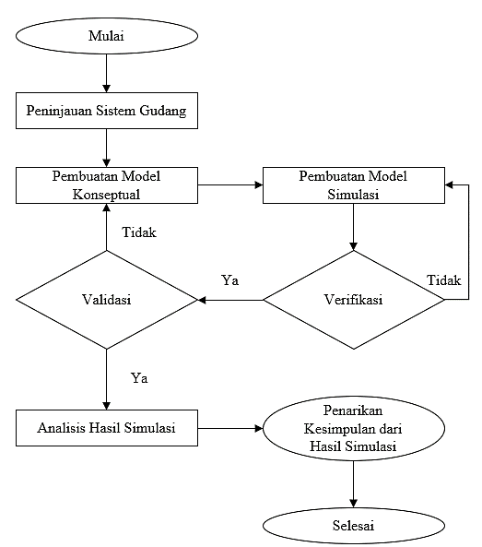
Fig. 1 Research Flow Diagram
The simulation research on truck queue optimization in the loading and loading process using a discrete simulation method with ProModel software aims to improve efficiency in truck queue management during the loading process. The initial step involves an in-depth understanding of the workflow and the factors that affect performance, such as loading capacity and runtime. Through modeling with ProModel, elements such as trucks, loading areas, and process times are integrated into the simulation model. This type of research can be categorized as quantitative research, which involves collecting numerical data that can be statistically analyzed to answer research questions and test hypotheses. In this study, the data collected includes truck arrival data, warehouse information data, transport truck information data, and product information data.
Warehousing not only includes goods storage activities, but also the handling of goods starting from receipt and recording, storage, selection, labeling, to delivery of goods (Warman, 2010:75). Through good warehousing management, transportation distances in distributing goods can be shortened and the frequency of item picking and delivery to customers can be increased. Warehouses are needed in the process of coordinating the distribution of goods due to the imbalance between the supply and demand processes, which encourages the emergence of inventory or inventory that requires temporary storage space. Supply chain management is a series of activities that include planning, managing, and activating products, with an efficient-based cost strategy to increase profits (Jebarus, 2001). The use of information technology, such as software, is indispensable to manage this process.
Queue theory discusses the mathematical study of queues, which occurs when the arrival of customers exceeds the capacity of the service. Simulation is the modeling of real systems based on events that take place over time (R.C. Harrell, 2004). Discrete refers to data or variables that can only take a finite specific value, as opposed to a continuous one. Discrete simulations model a system that evolves according to changes in certain variables under certain conditions, and is suitable for problems with specific time stages. The advantage of discrete simulation is its ability to model wait times that are not clearly known in a system. Simulation-optimization seeks and makes decisions from the results of experiments by verifying, validating, and analyzing data to find optimal conditions (Suprianto et al., 2018).
ProModel is a software used to simulate and analyze production systems of various types and sizes. The software allows the creation of realistic simulation models of the loading and unloading process of trucks, including all variables such as waiting time, loading time, loading capacity, and truck arrival patterns. ProModel provides the flexibility to easily add dock doors to the simulation model, allowing researchers to evaluate the impact of adding the number of loading docks on throughput and operational efficiency. ProModel also supports optimization and sensitivity analysis to examine how parameter changes affect simulation results. Validation and verification of simulation models is important to ensure the accuracy of the model by comparing the simulation results with empirical data or field observations.

3. Results and Discussion
T Optimization of the loading and loading process is a crucial aspect in logistics management, especially for large companies such as PT. XYZ which faces the challenges of truck queuing and dock loading efficiency. This research focuses on data collection and analysis to understand existing obstacles and find optimal solutions through discrete simulations using ProModel software. Here's the discussion.
Table 1 Summary Loading Time of Transporter Fleet with 4 Loading Docks
 | Work Element | Declare (Detik)
 | Work Element | CDD | Ankle | Tronton | Container
Summary | Total Time (In Seconds) | 4581 | 7955 | 9568 | 5164
Summary | Total Time (In Minutes) | 76 | 133 | 159 | 86
Summary | Total Time (In Hours) | 1,3 | 2,2 | 2,7 | 1,4
Summary | FG Withdrawal Time from Production (In Hours) | 2,0 | 2,0 | 2,0 | 2,0
Summary | FG Withdrawal Time from FS (In Hours) | 0,7 | 0,7 | 0,7 | 0,7
Summary | Loading Dock | 3 | 3 | 3 | 3
Summary | Available Time (In Hours) | 11,3 | 11,3 | 11,3 | 11,3
Summary | Maximum Number per Fleet Type | 27 | 15 | 13 | 24
Summary | Loading Portion | 48% | 18% | 18% | 16%
Summary | Maximum Amount per Fleet Type according to Portion | 13 | 3 | 2 | 4
Summary | Hood. Per day | 7 |  | Car/day
Summary | Caps per 3 LD | 22 |  | Car/day
Source: Company Data

The results and discussion sections are one of the challenging sections in your article. The purpose of the Results section is to present the key results of your research. Results and discussions can either be combined into one section or organized as separate sections depending on the journal's requirements to which you are submitting your research paper. Use subsections and subheadings to improve readability and clarity. Number all tables and figures with descriptive titles. Present your results as figures and tables and point the reader to relevant items while discussing the results. This section should highlight significant or interesting findings along with P values for statistical tests. Be sure to include negative results and highlight the potential limitations of the paper. The reviewers will criticize you if you don’t discuss the shortcomings of your research. This often makes up for a great discussion section, so do not be afraid to highlight them.
Your research paper's results and discussion section should include the following: Findings, Comparison with prior studies, Limitations of your work, Casual arguments, Speculations, and Deductive arguments.
3.1 Data Collection and Problems
Data collection is an important stage that determines the success of a study, where researchers gather relevant and accurate information to answer the research questions that have been formulated. In the context of loading and loading, data collection is a solid foundation for understanding the challenges and opportunities associated with this process, as well as helping to develop effective strategies to optimize load performance and efficiency. During the research process at PT. XYZ, data collected from the company and observations in the field. Based on the loading process using one server (checker), the loading process of PT. XYZ is categorized as an M/M/1 type queue, according to the company's data regarding the loading process that has occurred. The researcher collected important data during the loading process to be applied into the ProModel software to align the research objectives, which is to optimize the truck queue during loading by adding one loading dock. The following data was collected:
- Truck Arrival Data
Figure 2. Describes the fluctuation in the number of truck arrivals during the operating hours of the PT. XYZ:

Fig. 2 Truck Arrival Data
- Warehouse Information Data
Table 2 Contains warehouse information of PT. XYZ, which consists of operating hours and warehouse dimensions.
Table 2 Warehouse Information Data
Depot | Operating Hours | Dimensi Warehouse | Loading Dock Size | Pallet Size 100cm x 120cm
 |  |  |  | CDD | Ankle | Container | Tronton
Warehouse | SHIFT 1 (07:00 – 15:00)  SHIFT 2 (15:00 – 23:00) | 30cm x 48cm x 8m | 12m x 6m | 16 Pallet | 45 Pallets | 28 Pallets | 52 Pallets
Source: Field Survey Data
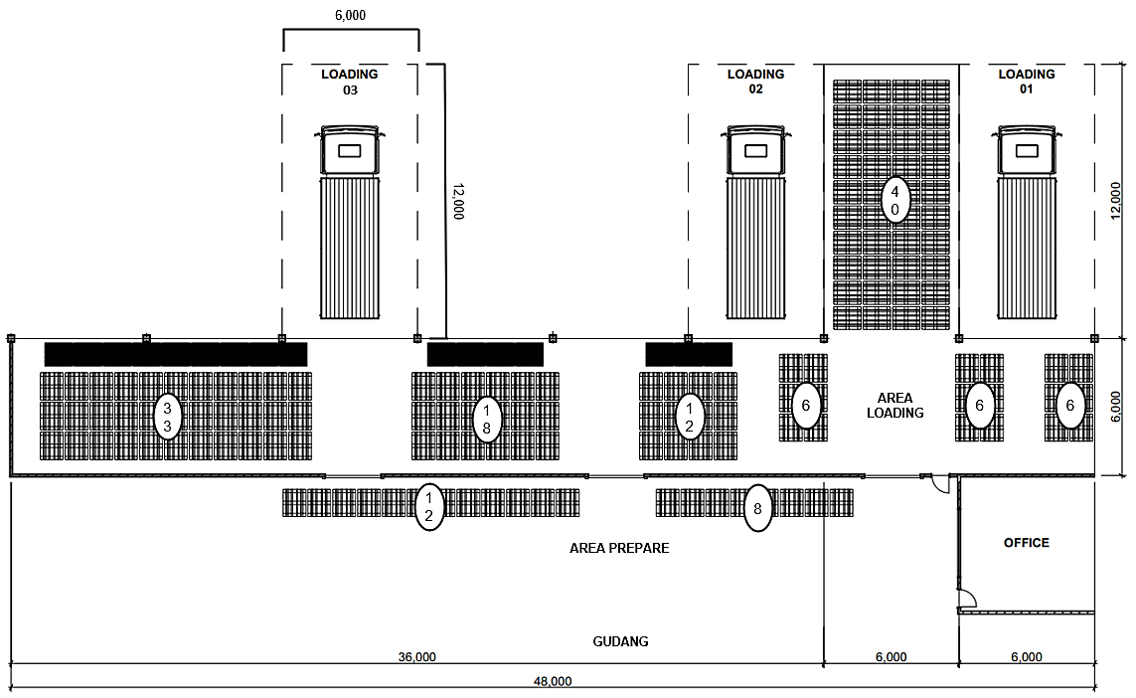
Fig. 3 Existing Loading Dock Layout
- Transport Truck Information Data
The haul truck information is detailed in Table 3, loading size, capacity, loading time, vehicle speed, loading cost, and fix cost of each truck.
Table 3 Transport Truck Information Data
It | Kind | Dimensions (cm) | Capacity (Tons) | Loading Time (seconds/  Ton) | Vehicle Speed (m/h) | Whole Fit Portion  Armada
1 | CDD | 5300 x 2000 x 2100 | 5 Tone | 3981 | 500 - 700 | 48%
2 | Ankle | 2000 x 1500 x 700 | 12 Tone | 7395 | 450 - 650 | 18%
3 | Container | 1219,2 x 243,8 x 259,1 | 10 Ton | 8968 | 400 - 600 | 18%
4 | Tronton | 1200 x 300 x 300 | 20 Ton | 4684 | 400 - 550 | 16%
Source: Field Survey

- Seasoning Information Data
Table 4 explains that each product of PT. XYZ.
Table 4 Seasoning Information Data
Product Name | Size / Timing per Box | Number of Boxes/  pallet | Pallet mass (kg)
Sambal and Tomato Sauce  Source: Company Data | Pet = 135 ml x 48 pcs  Tanggung= 275 ml x 24 pcs  Botol = 335 ML 12  Bag = 8 gr x 504 pcs | 70  70  40  75 | 453.6 kg  462 kg  160.8 kg  302.4 kg
Sambal Rumah  Source: Company Data | Bag = 200 gr x 12 pcs | 88 | 211.2 kg
Kecap  Source: Company Data | Pet = 135 ml x 48 pet  Bear = 275 ml x 24 bear  Sachet = 225 ml x 12 Sachet  Gallon = 5, 7 x 4 pcs  Pack = 520 ml x 12 pack | 70  70  60  20  60 | 453.6 kg  462 kg  162 kg  456 kg  374.4 kg
Special Ready-to-Eat Seasoning  Source: Company Data | Pack = 45 gr x 24 pcs 6 box | 36 | 233.3 kg
Ready to Eat Seasoning – Potatoes  Source: Company Data | Pcs = 25 gr x 20 pcs | 96 | 48 kg
Ready-to-eat Seasoning  Source: Company Data | Packs = 33 gr x 200 packs | 40 | 264 kg
Seasoning  Source: Company Data | Pcs = 250gr x 24 pcs  Pcs = 10 gr x 288 pcs  Cube = 20 gr x 100 | 77  96  120 | 462 kg  276.48 kg  240 kg
Seasoning Flour  Source: Company Data | Sachet = 75 gr 120 packs  Wrap = 210 gr x 24 pcs | 35  54 | 315 kg  272.16 kg
Source: Company Data
  - Development of Existing System Simulation Models
The following are the inputs in creating an existing system simulation model carried out with ProModel software:
- Entities
In the ProModel software, the entities are populated as shown by the following figure:
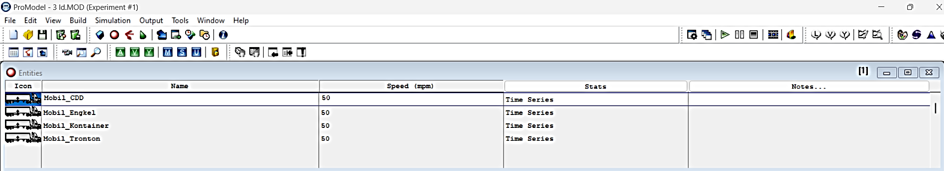
Fig. 4 Existing Entities
- Location
In the ProModel software, the location is filled in as shown in the following figure.
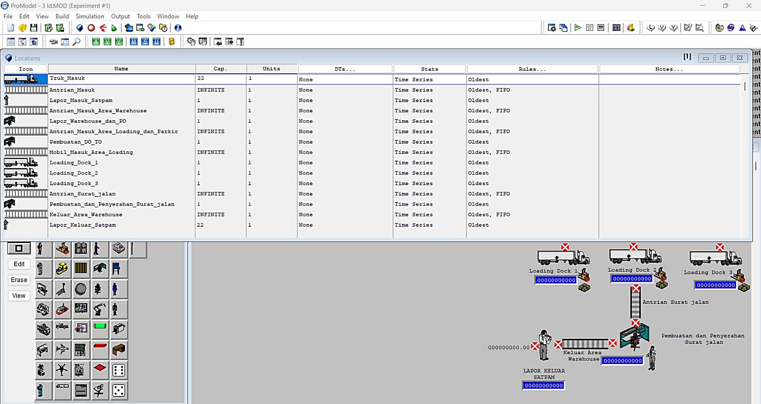
Fig. 5 Existing Location
- User Distribution
In the ProModel software, the user distribution is filled in as shown in the following figure.
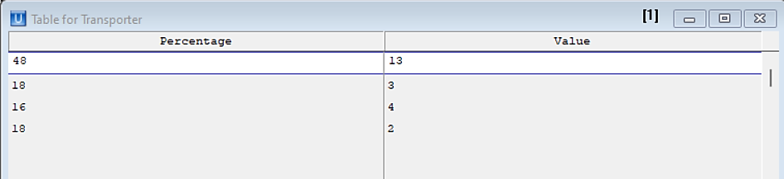
Fig. 6 Existing user distribution
- Arrival Cycle
The ProModel Arrival Cycle software is filled in as shown in the following figure.
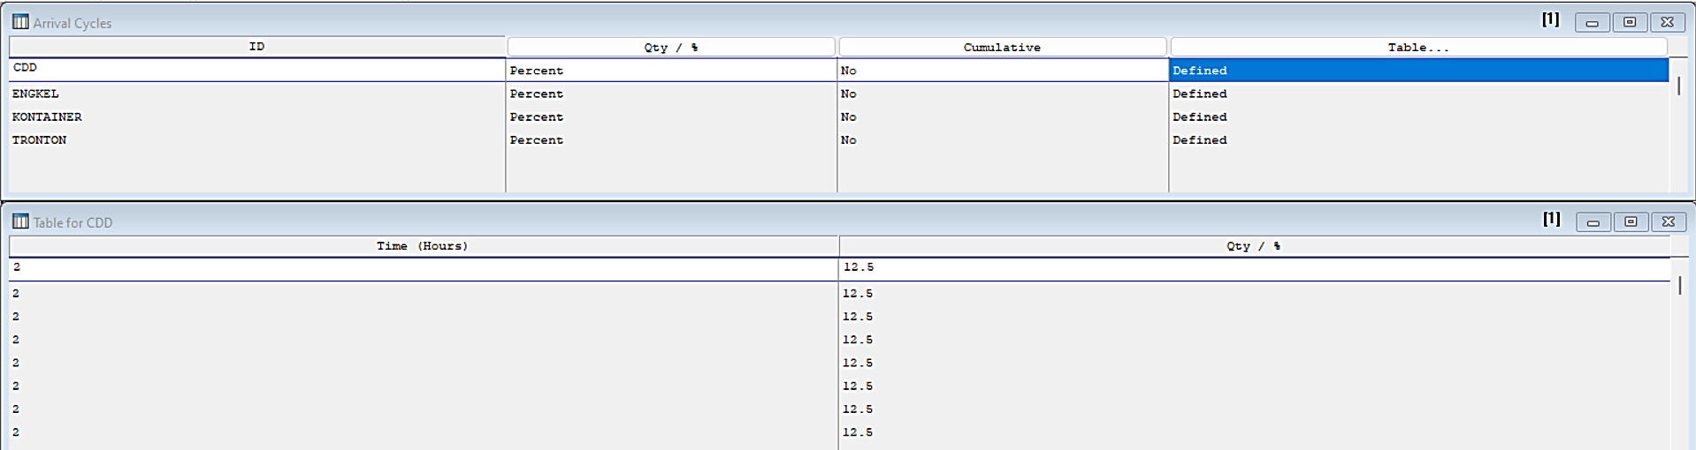
Fig. 7 Existing Arrival Cycle
- Arrival
The ProModel Arrival software is filled in as shown in the following figure.
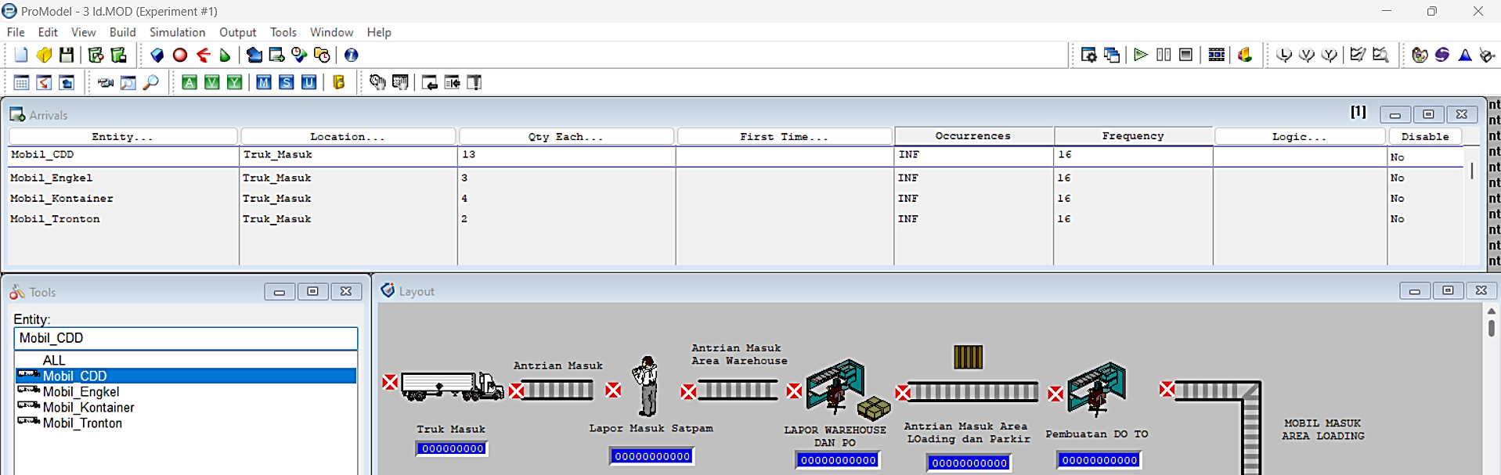
Fig. 8 Existing Arrival Cycle
- Processing
The Processing software is filled in as shown in the following figure.
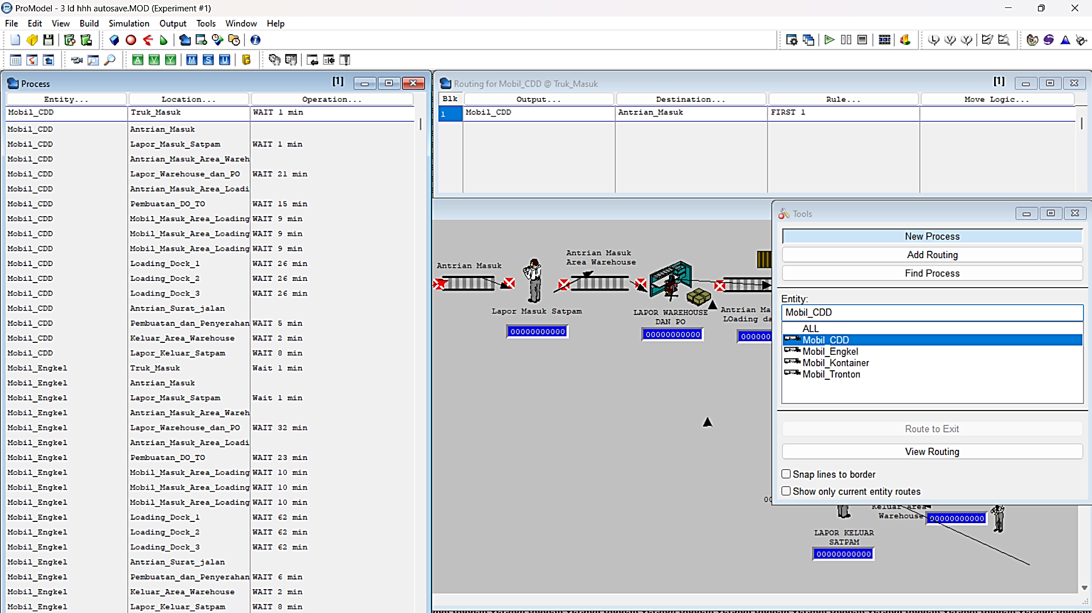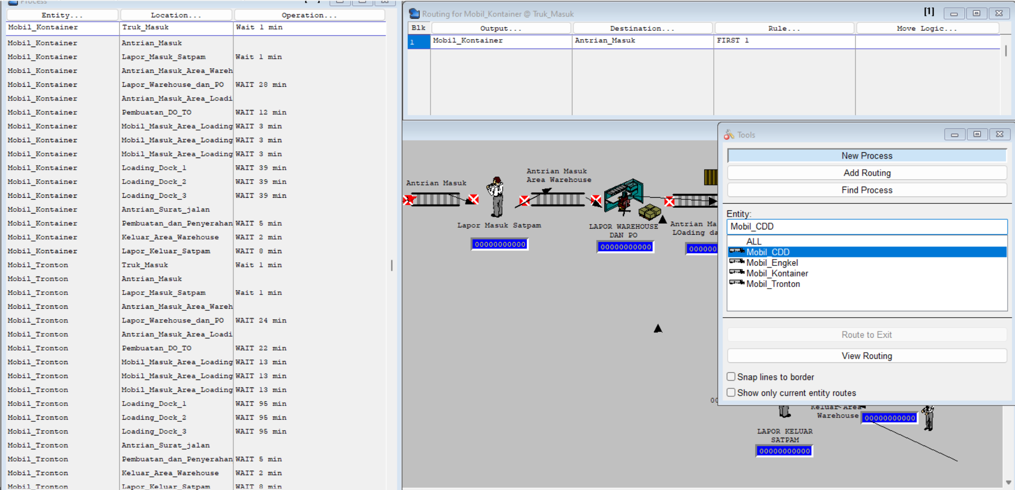
Fig.9 Existing Processing
- Variable
The Processing software is filled as shown by the following figure:
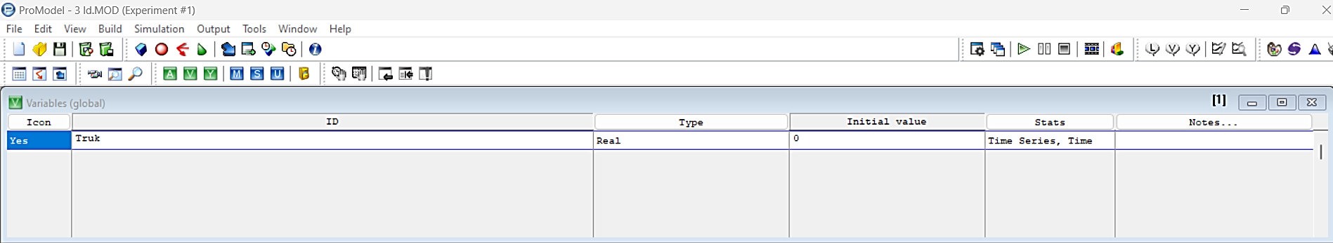
Fig. 10 Existing Variables
- Macros
The Macros software is filled in as shown by the following figure:
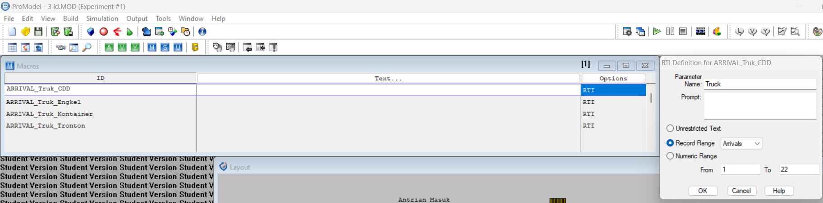
Fig. 11 Existing Macros
- Layout Model
The Layout Model software is filled in as shown in the following image:
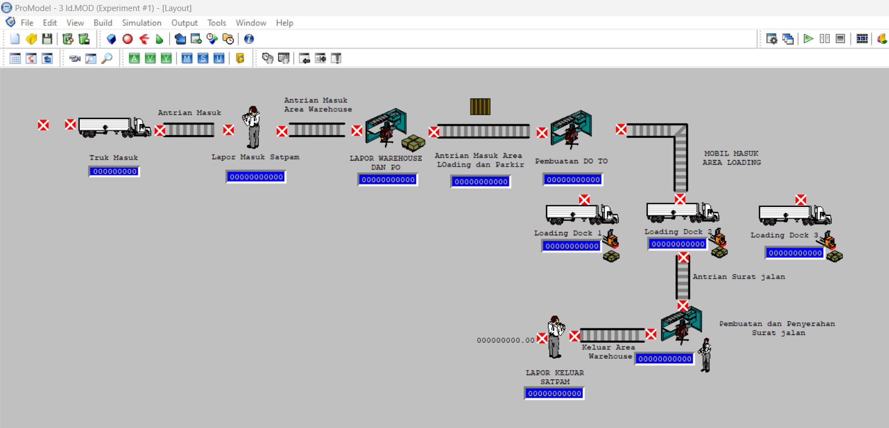
Fig. 12 Existing Model Layout
- Validation Test
This simulation model is valid and able to represent the actual loading and loading system well. This successful validation gives confidence that the model can be used to conduct further simulation experiments to optimize workflows and improve operational efficiency at the facility.
- Summary of Existing Modeling Results

Fig. 13 Summary Scenario 1
From an operational perspective, this study indicates that in order to achieve maximum efficiency improvement, in addition to adding loading docks, it is necessary to make improvements in the administrative process related to the elimination of DO waiting time.
  - Proposed Scenario Simulation Model
The proposed scenario developed is made into 3 Scenarios by looking for 1 Scenario that best suits the purpose of minimizing the number of queues by increasing the number of loading docks available at the PT. XYZ. The range of the number of loading docks that can be added is around 1 loading dock so that the proposed number becomes 4 loading docks with the addition of a prepare table in the warehouse to meet the amount of good finish materials.
The warehouse currently has three loading docks, so there are often queues that result in delays in the delivery order (DO) and loading process. To overcome the problem, eliminating the DO process time can be done so that it has met the target time that has been set by PT. XYZ. So that the summary is obtained as follows:
Table 5 Summary Loading Time Loading Fleet Transporter with 4 Loading Docks
 | Work Element | Declare (Detik)
 | Work Element | CDD | Ankle | Tronton | Container
Summary | Total Time of One Cycle (in seconds) | 3981 | 7395 | 8953 | 4684
Summary | Total Time of One Cycle (in minutes) | 66 | 123 | 149 | 78
Summary | Total Time One Cycle (In Hours) | 1,1 | 2,1 | 2,5 | 1,3
Summary | FG Withdrawal Time from Production (In Hours) | 2,0 | 2,0 | 2,0 | 2,0
Summary | FG Withdrawal Time from FS (In Hours) | 0,7 | 0,7 | 0,7 | 0,7
Summary | Loading Dock | 4 | 4 | 4 | 4
Summary | Available Time (In Hours) | 11,3 | 11,3 | 11,3 | 11,3
Summary | Maximum Number per Fleet Type | 41 | 22 | 18 | 34
Summary | Loading Portion | 48% | 18% | 18% | 16%
Summary | Maximum Amount per Fleet Type according to Portion | 20 | 4 | 3 | 5
Summary | Hood. Per day | 8 |  | Car/day
Summary | Kap per 4 LD | 32 |  | Car/day

- Relayout 4 loading dock
Based on the layout, it can be known how the location and flow of the loading and loading process with the addition of loading docks to 4 loading docks:
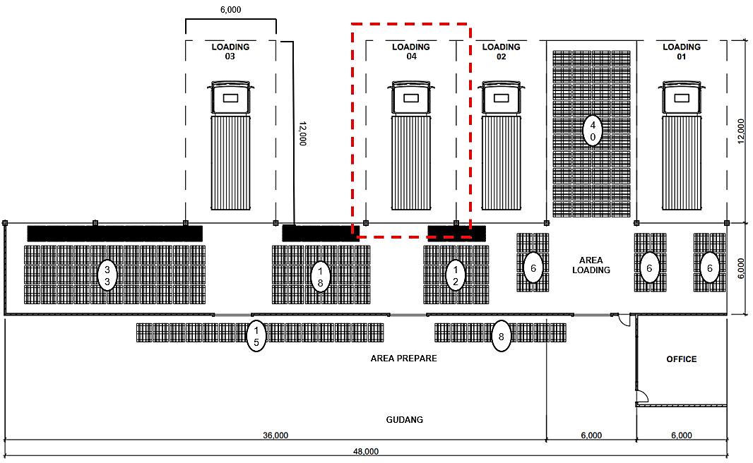
Fig. 14 Relayout 4 Loading Dock
The following is a model of the loading queue process scenario with a total of four loading docks using ProModel software.
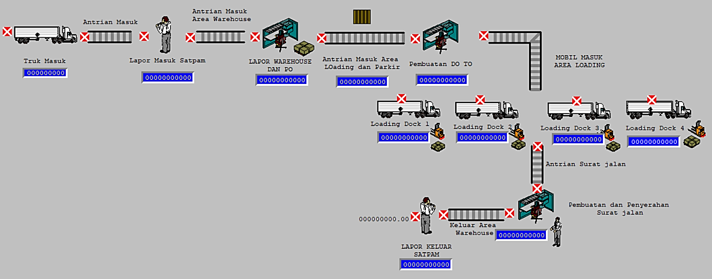
Fig. 15 Relayout of Scenario Simulation Model with 4 Loading Docks
- The Danger of Scenario 1
The following is the result of the Entity States-Baseline Output from the proposal with 4 Loading Docks using ProModel software
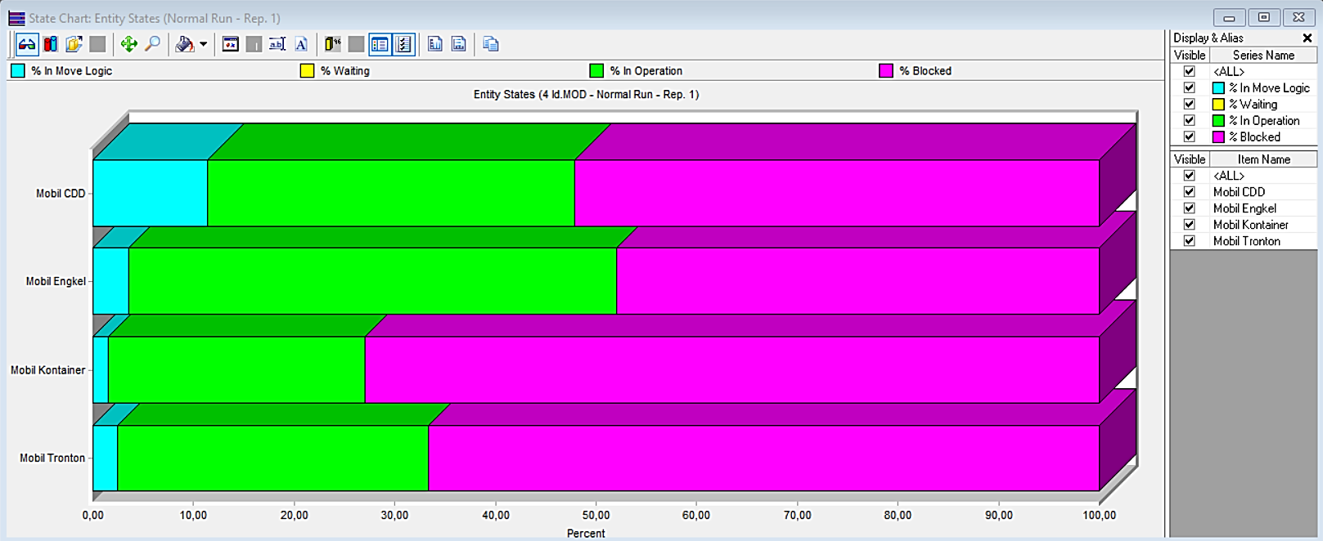
Fig. 16 Diagram Output Entity States-Baseline
The following are the results of the Scoreboard Output of the proposed 4 Loading Dock using ProModel software.
Tabel 6 Output Scoreboare 4 Loading Dock
Name | Total Exits | Average Time In System (Min) | Average Time In Operation (Min)
Mobile CDD | 20 | 367,62 | 133,92
Car Ankle | 3 | 423,08 | 205,33
Container Car | 6 | 671,61 | 171,42
Tronton Car | 3 | 777,41 | 239,93

The results of the Single Capacity Location State–Baseline Output and the Multiple Capacity Location State–Baseline of the proposed 4 Loading Dock using ProModel software.
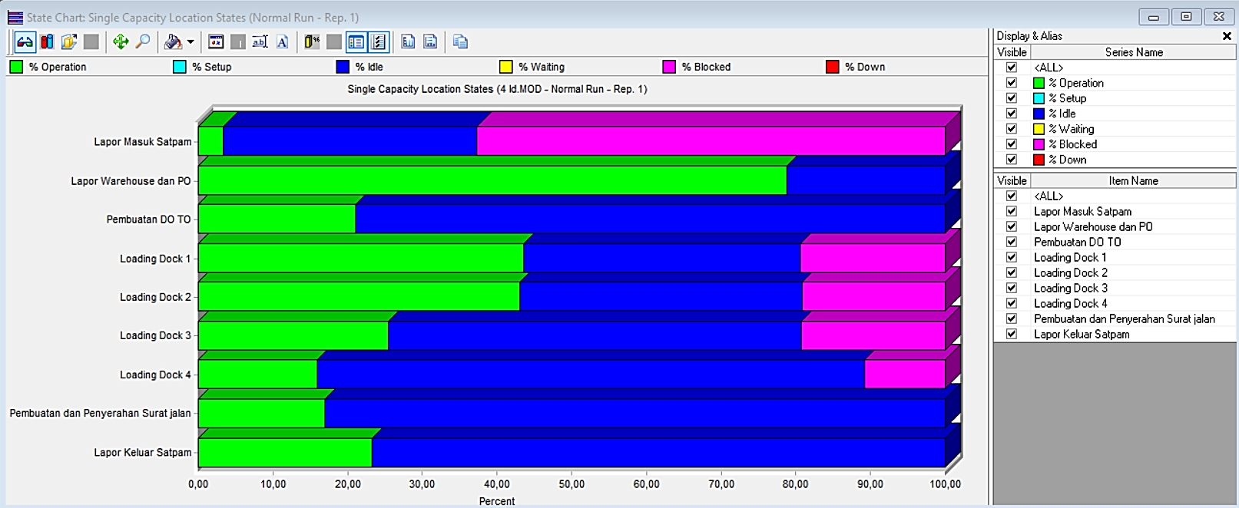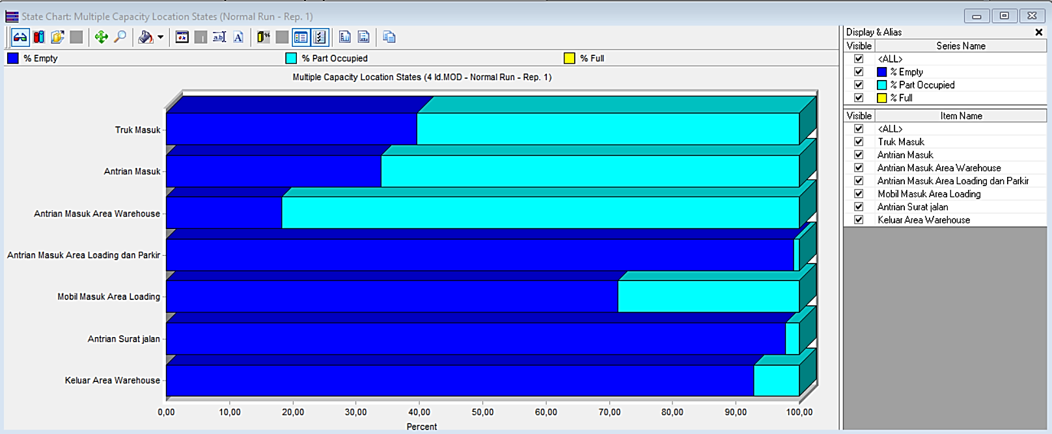
Fig. 17 Diagram Output Single Capacity
After the analysis using the ProModel, here are the summary results from Scenario 1:

Fig. 18 Summary Scenario 1
The scenario has significant results according to the Improve Truck Arrival data on 4 Loading Docks that have been created with a total of 32 trucks/day with a significant reduction in queues on each Loading Dock showing the Exponential distribution flow.
- The Perils of Scenario 2
After the analysis using ProModel, here is a summary of the results of the implementation:

Fig. 19 Summary Scenario 2
Scenario 2 is not significant and does not match the Improve Arrival data of 4 Loading Dock Trucks with a total of only 31 trucks/day in Scenario 2.
- The Devil's Nest 3
After the analysis using the ProModel, here are the summary results from Scenario 3:

Fig. 20 Summary Scenario 3
The scenario has significant results according to the Improve Truck Arrival data on 4 Loading Docks that have been made with a total of 32 trucks/day. However, there is too little loading activity that occurs in Loading Dock 4 so that it is not efficient to propose in depth.
- Validation Test
Based on the results of the three scenarios that have been carried out, Scenario 1 can be used as the most effective proposal and a validity test is carried out.
Based on replication tests
Table 7 Calculation of Many Replication of Loading and Loading Process
Replication | Real System Time (minutes/loading) | (Xi-Xrata)^2
1 | 78,95 | 197,09
2 | 78,50 | 209,93
3 | 121,52 | 813,83
4 | 92,99 | 0,00
Average | 92,99
S. Deviation |  | 352
Lots of Replication |  | 156

Based on the validity test, the following t-stat results of the Loading and Loading Process:
Table 8 T-Stat Validity Test of Loading Process 4 Loading Dock
 | Real Time | ProModel
Mean | 220,8214286 | 220,3730471
Variance | 162976,6399 | 163075,7216
Observations | 7 | 7
Pearson Correlation | 0,999999127
Hypothesized Mean Difference | 0
df | 6
t Stat | 2,166666667
P(T<=t) one-tail | 0,036699328
t Critical one-tail | 1,943180281
P(T<=t) two-tail | 0,073398656
t Critical two-tail | 2,446911851

The table above shows that the t-stat value is smaller than the two-tail critical t-value, which means that H0 is accepted, so the runtime data on the real system in the Loading and Loading process can be said to be valid.
Based on the verification test, it is revealed that the simulation model can accurately describe the variation in truck flow and dock utilization, with stable and reliable simulation results through repeated replication. With this verification, the simulation model is considered valid and can be used as an effective tool to conduct simulation experiments to identify opportunities to improve operational efficiency and optimize the management of loading docks at the facility.

  - Research Results
Through Scenario 1, a simulation was held to understand the effect of adding loading docks on throughput, wait time, and resource usage. The simulation results show that by adding one loading dock, the number of vehicles that can be serviced per day increases significantly, from an average of 22 vehicles to 32 vehicles, which represents a 45% increase in throughput. Vehicle wait times have also been reduced from about 18 minutes to 9.3 minutes, leading to an increase in overall efficiency.
In addition, the validity analysis conducted shows that the simulation model accurately replicates the loading and loading operations that occur in real distribution facilities. Validity tests and statistical tests performed, including t-tests, confirm that the simulated data and the actual data have a good fit, with acceptable differences. The increase in resource usage and the reduction of total cycle time from an average of 114 minutes to 104 minutes shows that the addition of a loading dock not only improves efficiency but also optimizes labor utilization.
Overall, the results of the study confirm that the addition of a loading dock is an effective solution to overcome bottlenecks in the loading and loading process. Investing in adding loading docks has proven to provide great benefits in terms of operational performance, reduced wait times, and increased productivity. By using ProModel as a simulation tool, this study proves that the addition of these facilities can have a significant positive impact on the operational efficiency of distribution facilities.

4. Conclusion
This research aims to optimize truck queues in the loading and loading process at PT. XYZ uses discrete simulations with ProModel. By adding one loading dock to four, the simulation results showed a 45% increase in facility throughput, from 22 trucks/day to 32 trucks/day. Model validation is performed by comparing the simulation output with historical data, showing accurate and reliable results. The simulation also identifies bottlenecks in truck flow and provides an optimal solution to reduce truck wait times from an average of 18 minutes to 9.3 minutes, as well as reduce the total cycle time for loading and unloading from 114 minutes to 104 minutes.
The results reveal that optimization can be achieved through the addition of loading docks and more efficient truck flow management. The implementation of the ProModel simulation model provides valuable insights for PT. XYZ to improve dock loading management, speed up the loading process, and reduce truck waiting time. These findings show that the use of discrete simulation is an effective tool in identifying and overcoming operational problems, so that it can be implemented to improve the efficiency and productivity of loading and unloading facilities at PT. XYZ significantly.
In conclusion, this study successfully shows that the use of discrete simulation with ProModel is an effective tool to identify and overcome problems in the loading and loading process and truck queue process at PT. XYZ. With model validation that shows accurate and reliable results, the recommendations from this simulation can be implemented to improve operational efficiency and optimize the performance of loading facilities. The implementation of suggestions such as the addition of loading docks, bottleneck analysis, and regular workforce training will help PT. XYZ in improving efficiency and productivity, and ensuring continuous operational improvements in the future.

References
Ainul Yaqin, Muhammad, et al, 2018. Survey of open source business process modeling and simulation applications. Journal of Computer Science and Information Technology. Volume 10, No. 2.
Astanti, Yuli Dwi, et al. 2020. Simulation of Outpatient Service Flow (Polyclinic) in Hospitals Using ProModel Software. OPSI Journal Vol 13 No.1
Camerling, B J, and Juan P Manusiwa. 2018. Simulation Model to Analyze the Performance of Tanker Queue System at PT. Pertamina TBBM Wayame Ambon. ‖ 11(1).
Casym, Jeremy Eka Surya, et al. 2020. Simulation of Two-Wheeled Vehicle Queue System at Tanjung Priok Port Entrance Counter with ProModel Application. SAINTEKS Pages 641 – 645.
Cornellia, R. Queue Analysis at the Counter for Electronic ID Card Making Using Promodel Simulation, Jurnal String, Vol. 3, 2018.
D. A. Ramdani, W. Wahyudin, and D. N. Rinaldi, "Queue System Model Using Single Channel-Single Phase Pattern with Promodel in Alfamart Unsika Queue" Tekmapro J. Ind. Eng. Manag., vol. 16, no. 1, pp. 13–24, 2021.
D. Astanti, I. Soejanto, and I. Berlianty, "Simulation of Outpatient Service Flow (Polyclinic) in Hospitals Using ProModel Software," OPSI, vol. 13, no. 1, 2020, doi: 10.31315/option v13i1.3223.
Dewanto and A. Santosa, "Simulation of Outpatient Service System in Hospitals Using Simulation of Discrete Events," Ina. J. Ind. Qual. Eng., vol. 8, no. 1, 2020, doi: 10.34010/iqe v8i1.2725.
Gaspersz, V. (2009). Lean Six Sigma for Manufacturing and Service Industries. PT Gramedia Pustaka Utama.
Gumelar, Gugum, et al. 2021. The application of the queue system with model simulation using Promodel software at PT. Retail Blessings. Patria Artha Technological Journal. Vol. 5 Issue 2.
Harrell, Ghosh, & Bowden. 2004. Simulation Using Promodeln Second Edition- New York: McGraw-Hill.
Hasanuddin, et al. 2023. Analysis of the ticket purchase queue system at the Gorontalo crossing port using the Promodel application. Jambura Journal of Electrical and Electronics Engineering. Volume 5 Number 1
Holy Icun Yunarto dan Martinus Getty Santika. 2005. Bussiness Concept Implementation Series in Inventory Management. Jakarta: Elex Media.
Hawari, Naufal. 2021. Analysis of the Loading and Unloading Process of Expedition Service Companies with a Discrete Simulation Approach to Optimize the Loading and Unloading Process through Scenario Improvement (Case Study: PT Lintas Samudra Jaya). UISI. Vol. 6 No. 2.
Indah Ristanti, Luffi. 2022. Analysis of Teller Queue System Using Promodel Simulation 7.5. Scientifict Journal of Industrial Engineering. Vol. 3 No.1
Indrajaya, D, Cornelia, R. (2018). Analysis of the transaction counter queue model at PT POS Indonesia (Persero) Sawangan Branch Office using Promodel software. Journal of String (Research and Technology Innovation Writing Unit), Vol 3, No 2, Pages 170-175.
J. Titarsole och B. J. Camerling, "Analysis of the Queue System in the Tank Car Parking Area to the Filling Shed Using a Promodel (Case Study at PT Pertamina Terminal BBM Wayame Ambon)," Arika, vol. 11, nr 1, pp. 67-82, 2017.
Feng Y, Spezia M, Huang S, Yuan C, Zeng Z, Zhang L, et al. Breast Cancer Development and Progression: Risk Factors, Cancer Stem Cells, Signaling Pathways, Genomics, And Molecular Pathogenesis. Genes & Diseases. 2018; 5(2):77–106.
K. S. Prawiro and D. Agfazar, "Analysis of Motorcycle Queues at Tanah Merdeka Gas Stations Using Promodel Simulations," Bull. Appl. Ind. Eng. Theory, vol. 1, no. 2, pp. 28–31, 2020.
Kadir, Nurchaerani Kadir. 2019. ―Survey of Open Source Business Process Modeling and Simulation Applications. ‖ MATICS 10(2): 59.
Kurnia, Ismail, et al. 2021. Improving the Transportation System with Promodel Simulation to Increase the Ease of Shipping Goods at PT. XXX. Journal of Science and Technology. Vol. 20, No.1.
M. Hartati, I. H. Zah, F. L. Norhiza och T. Nurainun, "Proposal to Improve the Process of Loading and Unloading Ship Services at PT. X with a Simulation Approach," Journal of Industrial Systems Engineering, vol. 8, nr 2, pp. 113-120, 2019.
Mukhlizar, et al. 2018. ―Simulation of the queue system at petrol station 14.236.100 using a promodel. ‖ Journal of Optimization 2(3): 269–80.
Nurhasanan, Hasna. 2018. Waste Analysis in an Effort to Optimize the Multi Channel Multi Phase Truck Queue System in the Warehouse Department with a Lean Supply Chain Approach Using the Value Stream Mapping Method. Bandung: Telkom University.
Prakoso, Indro, et al. 2023. Simulation of Queues in Service Optimization at Rita Pasaraya Supermarket Engineering Dynamics Vol. 19 No. 1. Thing. 45-51.
Purnama, R. P. Edi, I. 2020. Queue analysis at the MRT counter at Senayan Station using a promodel simulation. Bulletin of Applied Industrial Engineering Theory. Vol. 1 No.2.
Putra, Muhammad Irvan Dwi, et al. 2022. Discrete System Simulation Approach in Reducing Queue Waiting Time by Improving the Appointment Scheduling System. JURTIE Journal. Vol 4 No 2.
Radevito, Arighi. 2018. Discrete Simulation Modeling in the Distribution of Four Fuel Products in the Problem of Three Depots Towards a Single Destination. Semarang: Sepuluh Nopember Institute of Technology.
Rafael, Geraldo. 2023. Relayout of Springbed Production Floor Using the Slp, Corelap and Promodel Simulation Methods, and Flexsim. Scientific Journal of Industrial Engineering. Vol. 11 No. 2.
Alan Rushton, Phil Croucher, Peter Baker. 2014. The Handbook of Logistics & Distribution Management. India: Replika Press Pvt Ltd.
Siregar, Khawarita, et al. 2021. Optimization of the Queue System at Theather XXI Ringroad City Walk. TALENTS. Volume 4 Issue 1.
Tannady, Hendy. 2020. Analysis of Improvements to Queues at Rawalumbu Gas Station. Scientific Journal of Industrial Engineering, 8 (2). Pp. 148-152.
Viana, Novia Atdha. (2019). Analysis of the Queue System in Improving Customer Service at PT. Optima Kurnia is good to use a promodel. (Thesis). Indraprasta University of the Teachers Association of the Republic of Indonesia, Jakarta.
W. Septiani, A.E. Dahana, and S. Adisuwiryo, "Designing a Raw Material Warehouse Layout Model with Class Based Storage Method and Promodel Simulation," Scientific Journal of Industrial Engineering, Vol. 6 No. 2, pp. 106-116, 2018.

