Optimization of the Resistance Spot Welding Process PARAMETER FOR Dissimilar WELDING OF secc-af AND sgcc Galvanized Steel

Sukarman^{1*}, Amri Abdulah¹, Apang Djafar Shieddieque¹, Nana Rahdiana², Khoirudin³
¹Mechanical Engineering Department, Sekolah Tinggi Teknologi Wastukancana
Jl. Cikopak No.53 Sadang, Purwakarta 41151, Indonesia
²Industrial Engineering Department, Universitas Buana Perjuangan Karawang
Jl. H.S Ronggo Waluyo Telukjambe Timur, Karawang 41361, Indonesia
³Industrial Engineering Department, Universitas Buana Perjuangan Karawang
Jl. H.S Ronggo Waluyo Telukjambe Timur, Karawang 41361, Indonesia

*Corresponding Author Email: sukarman@stt-wastukancana.ac.id

Abstract -- This article discusses the conventional resistance spot welding parameters' optimization process using the pneumatic (electrode) force system (PFS) system. This optimization work describes out to joint the dissimilar galvanized steel of SECC-AF (JIS G 3313) and SGCC (JIS G 3302) material. The SECC-AF and SGCC steel sheet are SPCC (JIS 3141) steel sheet plate coated with zinc with a coating film thickness of about 2.5 microns and 12.71 microns. A zinc coating on surfaces of steel sheets will decrease the weldability characteristic of the material. This study aimed to obtain the highest tensile shear strength from the combination of the specified resistance spot welding parameters. This research used the Taguchi method with 4-variables and mixed-experimental levels. The mixed-experimental level, namely 2-experimental levels for the first variable and 3- experimental levels for other variables. The highest tensile shear strength achieved in 5282.13 N. This condition is achieved at a squeezed time of 20 cycles, 27 kA-welding currents, welding time of 0.6 seconds, and holding time of 18 cycles. The S / N ratio analysis shown the welding current had the most significant effect, followed by welding time, squeeze time, and holding time. The delta values of S / N ratio ​​were 0.79, 0.64, 0.26 and 0.07, respectively.

Keywords: Resistance spot welding; Taguchi method; Dissimilar material; S / N Ratio; Galvanized steel

Copyright © 2020 Universitas Mercu Buana. All right reserved.

Received: May 2, 2019 | Revised: May 29, 2019 | Accepted: June 2, 2019

INTRODUCTION
Resistance spot welding (RSW) is a popular joining technology for metal sheet assembly. Resistance spot welding (RSW) is a process in which faying surfaces are joined in one or more spots by the heat-generated by resistance to the flow of electric current through workpieces that are held together under force by electrodes [1]. The pulse heats the contact surface in the area of current concentration (nugget) for a short time at low voltage. A high electric current (ampere) is used to form nuggets so that the welding metal sticks together. When the current flow stops, the electrode force is maintained, while the welding metal cools and hardens rapidly. The electrode is pulled after each welding process, which is usually completed in a fraction of a second [2].
Several welding techniques use resistance systems include Resistance Seam Welding (RSEW), Projection Welding (PW), Flash Welding (FW), Upset Welding (UW), and Resistance Spot Welding (RSW). RSW is the most preferred and widely used method for joining technique of sheet metal in automotive and many other industrial assembly operations [3]. That is understandable because RSW has many advantages. The advantages of the RSW technique include a stronger-connection, easy to use, inexpensive, no filler required, and efficient [4]. In the automobile industry, there have about 5000 points of spot welding on each unit car [5]. In general, spot welding is the most widely used joining technique for the assembly of sheet metal products. It has been extensively used in many industrial fields, such as automotive body-in-white assemblies, domestic appliances, furniture, building products, enclosures, and, to a limited extent, aircraft [1] [6].
Metal welding technique with resistance spot welding (RSW) method is done by providing electrical resistance as a source of heat on two or more metal surfaces until fusion occurs in the welding area [7]. he molten metal in the welding area is formed due to the heat generated by the emergence of contact resistance from the electric current. The connection is made by emphasizing the two surfaces of the plate be connected. The plate pressing process is performed using two electrodes throughout the RSW cycle (before, during, and after using the current). The compression process in RSW aims to prevent deformation of the joint surface, forged of the welded metal after heating and to ensure adequate contact between the welded parts [8] [9]. Welding current flows to both tip of electrodes, caused contact metal surfaces to become melted. The melting process occurs when two adhesive metal surfaces melt together due to electrical resistance [8]. The stages of the welding cycle used in the study are pre-heat time, holding time without providing electricity, welding time, and hold-cooling The RSW cycle are presented in Figure [9].
Figure 1. Spot welding scheme
Welding process resistance occurs when current flows across the electrode tip and the metal pieces to be joined. The base metal's resistance to the flow of electric current results in the joint (the nugget area/welding zone), resulting in the fusion between the two metals to be joined. There are differences in the results of resistance spot welding with GTAW / SMAW. Figure 2 shows the difference between RSW and GTAW / GMAW welding techniques [10][11].

Figure 2. Schematic welding results (a) RSW and (b) GMAW
Several studied on RSW have been conducted include Thakur et al., 2014 [9]. The research was conducted by optimizing RSW parameters using galvanized steel sheets material. The optimization used the Taguchi method with 6-variables and 3-experimental levels. The variables used current heating (kA), squeezing time (cycle), welding current (kA), welding time (cycle), resistance time (cycle), and pressure (MPa.). The significant parameters were analyzed with ANOVA. The ANOVA results showed significant parameters that strongly affect the joint strength are the welding current and welding time. In contrast, the parameters of squeezing time and durability are less significant factors influencing the response variables. [10]. Wan et al. did research on the optimization of resistance spot welding used the titanium steel material. The research was conducted by the Taguchi method using 3-variables and 4-experimental levels. The response variables used were a shear force, displacement in the peak load area, and nugget area. The input variables used are electrode force, welding current, and welding time. The optimum RSW parameter obtained when the electrode force is 209.1 N, welding current in 1.83 kA, and welding time in 11.4 ms [11]. Vignesh et al. also conducted further research about optimization RSW parameters process by joining two different materials, namely 316L austenite stainless steel and 2205 stainless steel. Optimization used the Taguchi method with 3-variables and 3-experiment levels. The variables input is electrode tip diameter (mm), the welding current (kA), and the heating cycle. Significant parameters were analyzed using ANOVA. The welding current is the most significant parameter to the tensile shear strength, followed by the heating cycle and the electrode tip diameter [12].
Li et al. (2018) improved resistance spot welding by adding a ring-shaped permanent magnet to improve austenitic stainless steels weld quality. Magnetically assisted resistance spot welding (MA-RSW) process proposed to improve the quality. The maximal peak force of MA-RSW increased by 8.9% compared to the RSW method. The hardness distribution inside the magnetically assisted weld nugget is more than that of a traditional weld nugget. The failure load of magnetically assisted resistance spot welds is higher and more stable than traditional ones [13]. Kim at al. (2019) conducted RSW for dissimilar spot welding between aluminum alloy (Al 6061-T6) and steel (GA440). The main variables used are electrode force, an 8-12 kA welding current, the tensile shear strength, a 1.9-2.7 kN, and a 180-360 ms welding time. were applied for this experiment. The strength of the dissimilar spot welds decreased with increasing force, and increased in proportion to the weld time and current [14].
Unlike previous RSW process parameter optimization studied, this study was conducted by mapping SECC-AF electro-galvanized material (JIS G 3313) and SGCC galvanized (JIS 3303). It is important because the effect of zinc layer thickness on RSW design parameters is still unclear [9]. This study uses the Taguchi experimental method using four optimization variables/parameters. The optimization parameters to be used are squeeze time (cycle), welding time (cycle), welding current (kA), and holding time (cycle). This study used mixed experimental levels, namely 2-levels, for the first variable and 3-levels for the other variables. This study aims to obtain the highest tensile shear strength test results from the combination of RSW process parameters used.

METHOD
Material Selection
SECC-AF and SGCC steel plate materials with a thickness of 0.8 mm each will be used in this study. Both materials are Zn-coated steel sheet plates that are widely used in the manufacturing industry. SECC-AF (JIS G 3313) material equivalent to ASTM A366-91 standard [15]. The thickness of the zinc layer for the material used in this study was 2.5 microns for SECC-AF and 12.71 microns for the SGCC material. The chemical composition of SECC-AF steel sheet to be used in this study is shown in Table 1:
Table 1. Chemical composition of SECC-AF (%) steel sheet
Parameters | JIS G 3313 [16] | C9AC3360A*
C | 0.15 max. | 0,0177
Mn | 0,06 max. | 0,0190
P | 0,05 max. | 0,0115
S | 0,05 max. | 0,0097
*Mill Test Certificate
Meanwhile, the properties of SECC-AF materials to be used in this study are shown in Table 2:
Table 2. Mechanical properties of SECC-AF steel sheet
SECC-AF | JIS G 3313 [16] |  | C9AC3360A*
YP (N/mm2) | 240 max. | 216
TS (N/mm2) | 370 max. | 316
EL (%) | 30 min. | 41
Coat. weight (gr/m²) | 18 min. | 18,6
Thickness coting (** | 2.5 min | 2.61
*Mill Test Certificate
**Thickness = coating weight/ density, zinc density = 7,14 gr/ cm³

SGCC steel plate specifications according to JIS G 3302 with the chemical composition to be used is presented in Table 3:
Table 3. Chemical composition of SGCC (%) steel sheet
Parameters | JIS G 3302 [17] | CSV4505B*
C | 0.15 max. | 0,0063
Mn | 0,08 max. | 0,1940
P | 0,05 max. | 0,0017
S | 0,05 max. | 0,0043
*Mill Test Certificate
Meanwhile, the properties of SGCC materials to be used in this study are shown in Table 4:
Table 4. Mechanical properties of SGCC steel sheet
Tensile test | JIS G 3302 [17] | CSV4505B*
YP (N/mm²) | 205 min. | 231
TS (N/mm²) | 270 min. | 333
EL (%) | -. | 45
*Mill Test Certificate

Figure 3: Specimen tensile shear strength - all dimensions are in mm [18]

Specimens prepared by the cutting-shear process. At this stage, the 0.8 mm thick SECC-AF will be joined to the 0.8 mm SGCC steel sheet through the RSW process. The overlapping joining method will be used for a 25 x 100 mm coupon, according to ASTM D1002. [18]. The connection method is made overlapping with the dimensions, according to Figure 3.

Tensile shear strength
The tensile shear strength test aims to determine the tensile shear test's value for each parameter tested. The UTM used the Shimadzu AGS-X 10kN STD E200V model with having 10 kN in the capacity. The UTM testing was set and fixed at 35mm / min. The tensile-share strength test process is shown in Figure 4

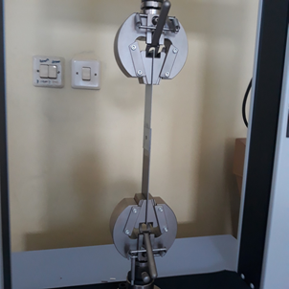
Figure 4. Tensile-shear strength test of the coupon on UTM

Taguchi Experimental Design
RSW machine with a power capacity of 35 kVA will be used in this study. RSW machine is equipped with a pneumatic that controlled at 3.5 MPa. The diameters of the top and bottom electrodes have 5 and 8 mm, respectively. The pneumatic force is used throughout the spot welding cycle. The following equation calculates of pneumatic the compressive force at the end of the electrode [7].
(1)
Where F is the electrode force (N), P is the pressure (N/m²), and A is the cross-sectional area (m²). With the electrode diameter above 5 mm, the force acting on the electrode can be calculated using equation one, and the pneumatic force value is 68.7 N. The RSW machine used is shown in Figure 5.
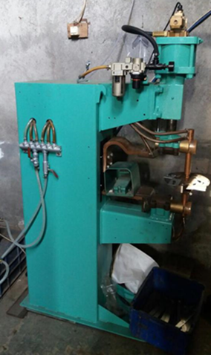
Figure 5. RSW machine 35 kW in capacity
RSW optimization used 4-variables, namely squeeze time in cycles, welding current in kA, welding time in seconds, and hold time in cycles. The mixed practical level design is presented in Table 5:

Table 5. RSW parameters and their value for each level
Code | Weld. parameters | Level experiments
Code | Weld. parameters | I | II | III
A | Squeeze time (cycles) | 20 | 22 | -
B | Weld. Current (kA) | 22 | 25 | 27
C | Weld. Time (detik) | 0.4 | 0.5 | 0.6
D | Hold time (cycles) | 12 | 15 | 18
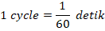
Weldability material
The failure expected model for the RSW method is the pull-out failure model. Pull-out failure indicates that the strength of the connection is higher than the steel sheet connected. Generally, the RSW process has two failure models: pull-out failure mode and interfacial failure mode. The pull-out failure mode happened in two conditions. The first condition is the adequacy of the fusion between the related materials. The second condition is that the diameter of the electrode used must be achieved to minimum nugget diameter. The minimum nugget diameter is the smallest diameter that must be met. During the tensile shear test, the connection in the nugget area experiences a pull-out failure model. The minimum diameter required is determined in the following equation [19] [12].
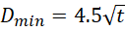 (2)
Where is the thickness of the smallest material to be joined, the SECC-AF and SGCC sheet steel materials have a thickness of 0.8 mm each. Using equation 2, the minimum diameter of the nuggets must be 4.27 mm. Furthermore, to fulfill these requirements, the tensile shear strength coupon will be processed with an electrode with a 5.0 mm diameter.

Signal to Noise Ratio (S / N Ratio)
In the Taguchi experimental technique, the term S / N ratio analysis is very important. The term 'signal' represents the desired value for the output (response variable). The term 'noise' represents the undesirable value for the output. This point indicates that the best parameter which will give the highest or optimal tensile shear strength [20].
The calculation of the S / N ratio depends on the quality characteristics of data being targeted. Taguchi provides the quality characteristics data into three parts, and it can be calculated with Equations 3, 4, and 5 [17] [20] [21] Smaller is better:
S/N ratio =-10 log 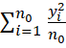 (3)
Larger is better:
S/N ratio =-10 log 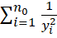 (4)
Nominal is the best:
S/N ratio =-10 log (5)
Where , , and are the number of samples, response factor, mean response factor, and variance of the response factor. This study used the S / N ratio with characteristic data larger is better. A measurable S / N ratio characteristic with a non-negative value with an infinite ideal value. These characteristics can be used to analyze other response data, such as building strength [22], welding strength [23], corrosion resistance [24], and fuel consumption. The S / N ratio for each L18 experiment has been calculated and listed in Table 5.

RESULTS AND DISCUSSION

Tensile-shear strength analysis
Table 5 shows that the highest tensile-shear strength was achieved in 5282.13 N. The optimum parameters achieved in eight experiments with the pull-out failure model. The optimum parameters are squeeze time in 20 cycles, welding current in 27 kA, welding time in 0.6 seconds and holding time in 18 cycles. The graph of tensile shear strength test presented in Figure 6.
Although the electrode diameter has met equation one and the nugget diameter of the RSW process has exceeded the required diameter, there is still an interface mode failure. The strength-shear strength result of 18 samples known that the interface failure was found on the 7th and 10th experiments of the sample. So there are no compounds in the nugget area. The experimental parameters for those failure listed in table 6.

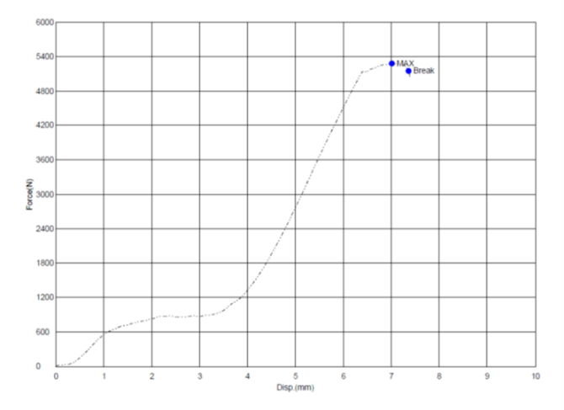
5 mm
5282.13 N
Figure 6. Tensile-shear for 8-experimental
Table 5. L18 orthogonal array of the experiments
Experiment | Parameter RSW |  |  |  | Tensile-shear test (N) | SNRA1 | MEAN1
Experiment | Squee. time | Weld. current | Weld. time | Hold time | Tensile-shear test (N) | SNRA1 | MEAN1
1 | 20 | 22 | 0.4 | 12 | 4,345.21 | 72.76 | 4345.21
2 | 20 | 22 | 0.6 | 15 | 4,477.02 | 73.02 | 4477.02
3 | 20 | 22 | 0.5 | 18 | 4,463.24 | 72.99 | 4463.24
4 | 20 | 25 | 0.4 | 12 | 4,547.20 | 73.15 | 4547.20
5 | 20 | 25 | 0.6 | 15 | 4,725.49 | 73.49 | 4725.49
6 | 20 | 25 | 0.5 | 18 | 4,902.22 | 73.81 | 4902.22
7 | 20 | 27 | 0.4 | 15 | 4,485.42 | 73.04 | 4485.42
8 | 20 | 27 | 0.6 | 18 | 5,282.13 | 74.46 | 5282.13
9 | 20 | 27 | 0.5 | 12 | 4,936.09 | 73.87 | 4936.09
10 | 22 | 22 | 0.4 | 18 | 4,224.74 | 72.52 | 4224.74
11 | 22 | 22 | 0.6 | 12 | 4,626.24 | 73.30 | 4626.24
12 | 22 | 22 | 0.5 | 15 | 4,988.25 | 73.96 | 4988.25
13 | 22 | 25 | 0.4 | 15 | 4,786.88 | 73.60 | 4786.88
14 | 22 | 25 | 0.6 | 18 | 4,899.33 | 73.80 | 4899.33
15 | 22 | 25 | 0.5 | 12 | 4,922.74 | 73.84 | 4922.74
16 | 22 | 27 | 0.4 | 18 | 4,876.82 | 73.76 | 4876.82
17 | 22 | 27 | 0.6 | 12 | 4,989.75 | 73.96 | 4989.75
18 | 22 | 27 | 0.5 | 15 | 5,133.60 | 74.21 | 5133.60

Table 6. Interfacial failure mode parameters
Squee. time | Weld. current | Weld. time | Hold time
20 | 27 | 0.4 | 15
22 | 22 | 0.4 | 18

The mode of interfacial failure that occurred in this study is presented in Figure 7.
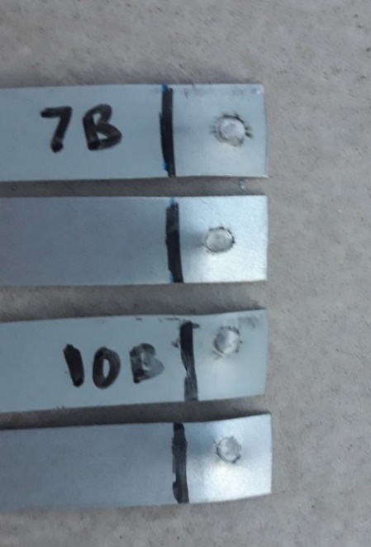
Figure 7. Interfacial Failure Mode

S / N Ratio Analysis
S / N ratio analysis was performed to measure input variables' effect on the response variable's output. The input variables are the parameter process of resistance spot welding. The output or response variable is the tensile shear test. Figure 8 shows the S / N ratio chart with larger is better characteristics that are calculated using equation 5. The highest S / N ratio was achieved in some conditions are the squeeze time in level-2, welding current in level-3, welding time in level-3, and holding time in level-3.
The same condition is found in the S / N ratio table of tensile shear strength. The highest value is achieved at the squeeze time in level-2, the weld current in level-3, welding time in level-3, and hold time in level-3. The chart for the main effect of the mean tensile shear strength is presented in Figure 9. While the parameter that most influences the variable response in the combination of SEECC-AF and SGCC materials using the resistance spot welding method is welding current with a delta value of 0.79. The welding time delta values, squeeze time, and holding time parameters are 0.64, 0.26, and 0.07, respectively. The S / N ratio response table for each of the spot resistance welding parameters is presented in Table 7.

Table 7. Response table for S/N ratios
Level | Squee. time | Weld. current | Weld. time | Holding time
1 | 73.40 | 73.09 | 73.14 | 73.48
2 | 73.66 | 73.62 | 73.67 | 73.55
3 |  | 73.88 | 73.78 | 73.56
Delta | 0.26 | 0.79 | 0.64 | 0.07
Rank | 3 | 1 | 2 | 4

Welding time and welding current have a higher delta value than other parameters. It means both variables have a more significant parameter effect on the response than others. In this case, welding current and welding time are the variables that most influence the output with delta values of 430 and 347. The delta values parameters for squeezing time and holding time are 143 and 47, respectively. The mean response table for tensile shear strength at each RSW parameter is shown in Table 8.

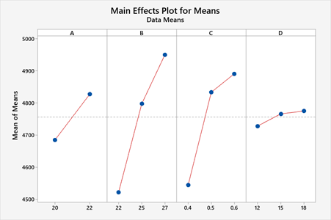
Figure 8. S/N ratio data mean of the tensile shear strength

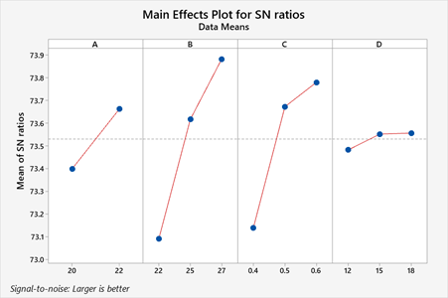
Figure 9. Main effects plot for mean of tensile-shear stress

Table 8. Response table for mean
Level | Squee. time | Weld. current | Weld. time | Holding time
1 | 4685 | 4521 | 4544 | 4728
2 | 4828 | 4797 | 4833 | 4766
3 |  | 4951 | 4891 | 4775
Delta | 143 | 430 | 347 | 47
Rank | 3 | 1 | 2 | 4

ANOVA Analysis
The S / N Ratio analysis provides the significance of a parameter compared to others on the response variable effect. Meanwhile, ANOVA analysis delivers data of significant parameters on the response variable [25]. ANOVA analysis was carried out using statistical software by setting the confidence level at 95%. The parameters with a P-value of equal or less than 5% significantly affect the variable response [20][25]. Although there are still have interfacial mode failures, this study has confirmed the previous studies conducted by Thakur et al. [10], Wan at al. [11], and Vignesh et al. [12] that welding current and welding time are parameters significantly affected to the tensile shear strength. The ANOVA Analysis resulted listed in Table 9.

Table 9. Analysis of Variance
Source | DF | Adj SS | Adj MS | F-Value | P-Value
A | 1 | 91639 | 91639 | 2.94 | 0.117
B | 2 | 569496 | 284748 | 9.12 | 0.006
C | 2 | 413966 | 206983 | 6.63 | 0.015
D | 2 | 7468 | 3734 | 0.12 | 0.889
Error | 10 | 312217 | 31222
Total | 17 | 1394785

Table 10 shows that variable welding current (source B) and welding time (source C) significantly affect the variable response. Meanwhile, the two other variables did not significantly influence the response variable. The P-value of welding current and welding time are 0.006 (0.6%) and 0.015 (1.5%), respectively.

CONCLUSION
Adjustment of the right parameters in the resistance spot welding process involving PFS, especially spots welding for galvanized materials, has proven successful. Welding time and welding current have a significant effect on tensile shear strength. The highest tensile shear strength was achieved in 5282.13 N. For the optimum result, Taguchi suggests the squeeze time parameter in level-2, the weld current in level-3, welding time in level-3, and hold time in level-3. Further research will be carried out by looking at the zinc layer thickness's effect on tensile-shear strength and nugget diameter.

ACKNOWLEDGMENT
Thanks to the "Ministry of Research, Technology & Higher Education Republic of Indonesia" who has fully funded this research through the "Penelitian Dosen Pemula" program with contract number 078 / SP2H / LT-MONO / LL4 / 2020.

REFERENCES
[1] D. L. Olson, S. Thomas A., S. Liu, and G. R. Edwards, ASM Vol 6 WELDING, BRAZING, AND SOLDERING, vol. 6. ASM International, 2019.
[2] Sukarman et al., “Optimization of Tensile-Shear Strength in the Dissimilar Joint of Zn-Coated Steel and Low Carbon Steel,” vol. 3, no. 3, pp. 115–125, 2020.
[3] A. H. Ertas and F. O. Sonmez, “Design optimization of spot-welded plates for maximum fatigue life,” 2011.
[4] M. P. Mubiayi, E. T. Akinlabi, and M. E. Makhatha, Current Trends in Friction Stir Welding (FSW) and Friction Stir Spot Welding (FSSW), vol. 6. 2019.
[5] S. H. M. Anijdan, M. Sabzi, M. Ghobeiti-hasab, and A. Roshan-ghiyas, “Materials Science & Engineering A Optimization of spot welding process parameters in dissimilar joint of dual phase steel DP600 and AISI 304 stainless steel to achieve the highest level of shear-tensile strength,” Mater. Sci. Eng. A, vol. 726, no. April, pp. 120–125, 2018.
[6] B. Xing, Y. Xiao, Q. H. Qin, and H. Cui, “Quality assessment of resistance spot welding process based on dynamic resistance signal and random forest based,” Int. J. Adv. Manuf. Technol., vol. 94, no. 1–4, pp. 327–339, 2018.
[7] Miller Welds Handbook, “HANDBOOK FOR Resistance Spot Welding,” 2012.
[8] P. Muthu, “Optimization of the Process Parameters of Resistance Spot Welding of AISI 316l Sheets Using Taguchi Method,” Mech. Mech. Eng., vol. 23, no. 1, pp. 64–69, 2019.
[9] H. C. Lin, C. A. Hsu, C. S. Lee, T. Y. Kuo, and S. L. Jeng, “Effects of zinc layer thickness on resistance spot welding of galvanized mild steel,” J. Mater. Process. Tech., vol. 251, no. March 2017, pp. 205–213, 2018.
[10] A. G. Thakur and V. M. Nandedkar, “Optimization of the Resistance Spot Welding Process of Galvanized Steel Sheet Using the Taguchi Method,” pp. 1171–1176, 2014.
[11] X. Wan, Y. Wang, and D. Zhao, “Multi-response optimization in small scale resistance spot welding of titanium alloy by principal component analysis and genetic algorithm,” Int. J. Adv. Manuf. Technol., vol. 83, no. 1–4, pp. 545–559, 2016.
[12] K. Vignesh, A. E. Perumal, and P. Velmurugan, “Optimization of resistance spot welding process parameters and microstructural examination for dissimilar welding of AISI 316L austenitic stainless steel and 2205 duplex stainless steel,” pp. 455–465, 2017.
[13] Y. B. Li, Q. X. Zhang, L. Qi, and S. A. David, “Improving austenitic stainless steel resistance spot weld quality using external magnetic field,” Sci. Technol. Weld. Join., vol. 23, no. 7, pp. 619–627, 2018.
[14] Y. G. Kim, D. C. Kim, and S. M. Joo, “Evaluation of tensile shear strength for dissimilar spot welds of Al-Si-Mg aluminum alloy and galvanized steel by delta-spot welding process,” J. Mech. Sci. Technol., vol. 33, no. 11, pp. 5399–5405, 2019.
[15] N. T. Williams and J. D. Parker, “Review of resistance spot welding of steel sheets: Part 1 - Modelling and control of weld nugget formation,” Int. Mater. Rev., vol. 49, no. 2, pp. 45–75, 2004.
[16] Japanese Standards Association, JIS G 3313 Electrolytic zinc-coated steel sheet and coils. 1998, pp. 428–480.
[17] Japanese Industrial Standard, “JIS G 3302 Hot-dip zinc-coated steel sheet and strip.” Japanese Industrial Standard, 2007.
[18] ASTM International, ASTM D1002 Standard Test Method for Apparent Shear Strength of Single-Lap-Joint Adhesively Bonded Metal Specimens by Tension Loading (Metal-to-Metal). 2019.
[19] S. T. Pasaribu, S. Sukarman, A. D. Shieddieque, and A. Abdulah, “Optimasi Parameter Proses Resistance Spot Welding pada Pengabungan Beda Material SPCC,” 2019, no. September.
[20] S. F. Arnold, Design of Experiments with MINITAB, vol. 60, no. 2. 2006.
[21] S. D. Sabdin, N. I. S. Hussein, M. K. Sued, M.S. Ayob, M.A.S.A Rahim, and M.Fadzil, “Effects of ColdArc welding parameters on the tensile strengths of high strength steel plate investigated using the Taguchi approach,” vol. 13, no. 2, pp. 4846–4856, 2019.
[22] C. Jithendra and S. Elavenil, “Influences of Parameters on Slump Flow and Compressive Strength Properties of Aluminosilicate Based Flowable Geopolymer Concrete Using Taguchi Method,” Silicon, vol. 12, no. 3, pp. 595–602, 2020.
[23] A. Abdulah, S. Sukarman, C. Anwar, A. Djafar Shieddieque, and A. Ilmar Ramadhan, “Optimization of yarn texturing process DTY-150D/96F using taguchi method,” Technol. Rep. Kansai Univ., vol. 62, no. 4, pp. 1471–1479, 2020.
[24] A. Farzaneh, M. Ehteshamzadeh, and M. Mohammadi, “Corrosion performance of the electroless Ni-P coatings prepared in different conditions and optimized by the Taguchi method,” J. Appl. Electrochem., vol. 41, no. 1, pp. 19–27, 2011.
[25] E. DEL CASTILLO, Process Optimization A Statistical Approach. Springer New York, 2007.

