THE ABILITY OF THE CONTINUOUSLY VARIABLE TRANSMISSION TO CONTROL THE ENGINE AT MAXIMUM POWER: LITERATURE REVIEW
S. Ariyono¹, B. Supriyo², I. Feriadi³, D.R. Harahap³, N. Akmar⁴
¹Department of Mechanical Engineering, Politeknik Negeri Semarang
²Department of Electrical Engineering, Politeknik Negeri Semarang
³Departement of Mechanical Engineering, Politeknik Manufaktur Negeri Bangka Belitung
⁴Departement of Mechanical Engineering, Universiti Teknologi Malaysia

Abstract  Good ride performance is one of the most important key attribute of a passenger vehicle. One of the methods to achieve this is by using continuously variable transmission (CVT). This is because a CVT has the capability of providing an almost infinite ratio within its limits smoothly and continuously. The flexibility of a CVT allows the driving shaft to maintain a constant angular velocity over a range of output velocities. Currently, new developments in gear reduction and manufacturing have led to ever more robust CVTs, which in turn allow them to be applied in more diverse automotive applications. As CVT development continues, costs will be reduced further and the performance will continue to improve, which in turn make further development and application of the CVT technology desirable. This cycle of improvement will offer CVT a solid foundation in the world's automotive infrastructure. The purpose of this paper is to provide some background and relevant information that is necessary in this study. Specifically, a brief description of CVT, advantages and their brief history are presented. This paper also evaluates the current state of CVT, investigate the technology frontline of drivetrain control and the development of CVT. The step less Transmission is able to maintain the engine running in its maximum power. | Keywords:  CVT Control; Engine Power; Mechatronic CVT; Transmission Control Unit; Rubber Belt CVT  Article History:  Received: May 2, 2019  Revised: May 29, 2019  Accepted: June 2, 2019  Published: June 2, 2019  Corresponding Author:  Sugeng Ariyono  Mechanical Engineering Department, Politeknik Negeri Semarang, Indonesia  Email: sugeng.ariyono@polines.ac.id

INTRODUCTION
A continuously variable transmission (CVT) is a transmission system which can change the transmission ratio steplessly resulting with an infinite number of effective transmission ratios between maximum to minimum values. This contrasts with other mechanical transmissions that only allow a few number of different discrete gear ratios to be selected. The flexibility of a CVT allows the driving shaft to maintain a constant angular velocity over a range of output velocities. With the advent of durable materials, advance manufacturing system, sophisticated electronic controls and improved lubricant, CVT power train systems with innovative ratio shift control strategies becomes more feasible. Currently, new developments in gear reduction and manufacturing have led to ever more robust CVTs, which in turn allow them to be applied in more diverse automotive applications. As CVT development continues, costs will be reduced further and the performance will continue to improve, which in turn make further development and application of the CVT technology desirable. This cycle of improvement will offer CVT a solid foundation in the world's automotive infrastructure.

The purpose of this chapter is to provide some background and relevant information that is necessary in this study. Specifically, a brief description of CVT, advantages and their brief history are presented. This chapter also evaluates the current state of CVT, investigate the technology frontline of drivetrain control and the development of CVT.

BACKGROUND AND BRIEF HISTORY
Leonardo de Vinci sketched his idea of CVT in the year 1490. In automotive applications, the history of CVTs has begun in the early era of car development, and certainly in the same period of conventional automatics. In early 1930s, General Motors had developed a fully toroidal CVT and conducted extensive testing before eventually deciding to implement a conventional stepped-gear automatic due to cost concerns. General Motor Research reworked on CVTs in the 1960s, but none ever saw their production. British manufacturer Austin used a CVT for several years in one of its smaller cars, but it was dropped due to its high cost, poor reliability, and inadequate torque transmission [1].

Many CVTs in the early stage used a simple rubber band and cone system, like the one developed by a Dutch firm, Daf, in 1958. However, the Daf’s CVT could only handle a 0.6 L engine, and severe problem with noise and rough starts eventually to hurt its reputation [2]. In 1962, the Honda company introduced the first mass production hydraulically operated CVT into the market with the Juno, a scooter with a 0.175 liter engine generating 8.8 kW. Honda continued manufacturing small motorcycles with the V-matic in 1977. Until the end of 1996 this company has successfully developed a new generation CVT for Civic series, the 1.6 liter economy car [3]. The electromechanical CVT based on metal belt is not yet available in the market, but in early 90’s electromechanical CVT based on dry hybrid rubber belt has been applied for motor cycle [4]. Now, almost all CVTs in the market use the van Doorne company's steel push belt as the transmission element. This steel pushing belt was first introduced in 1987.

- Advantages and Benefits
The clunking sound of a shifting transmission is familiar to all drivers. By contrast, a CVT is perfectly smooth and naturally changes its ratio discretely such that the driver or passenger feels only steady acceleration. Theoretically, a CVT would cause less engine fatigue and would produce a more reliable transmission, as the harshness of shifts and discrete gears force the engine to run at a less than optimal speed [5].
CVTs offer improved efficiency and performance. Table 1 shows the power efficiency of a typical five speeds automatic, which is the percentage of engine power transmitted through the transmission. This yields an average efficiency of 86%, compared with a typical manual transmission with 97% efficiency [6]. By comparison, Table. 2 shows the efficiency range for several CVT designs.
These CVTs offer improved efficiency over conventional automatic transmission, and their efficiency depends less on driving habit than manual transmission. Since CVT allows an engine to run at its most efficient point virtually independent of the vehicle speed, a CVT equipped vehicle yields fuel economy benefits when compared with a conventional transmission [7]. Testing by ZF Getriebe GmbH for U.S. Environmental Protection Agency City and Highway Cycles several years ago found that the CVT uses at least 10% less fuel than a 4 speed automatic transmission. The CVT was more than one second faster in 0-100 km/h acceleration tests than that of manual transmission [8]
Tabel 1: Efficiency versus gear ratio for automatic transmission [6]

Gear | Efficiency Range
1  2  3  4  5 | 60-85%  60-90%  85-95%  90-95%  85-94%

Tabel 2: Efficiency of various CVT designs [7][9][10].
CVT Mechanism | Efficiency Range
Rubber belts  Steel belts  Toroidal traction  Nutating traction  Variable geometry | 90-95%  90-97%  70-94%  75-96%  85-93%

- Challenges and Limitations
The progress in CVT development has been slowly for a variety of reasons, with much of the delay in its development can be attributed to the lack of demand, while the conventional manual and automatic transmission have long offered sufficient performance and fuel economy. In addition, this problem is also possibly influenced by unsuccessful efforts to develop a CVT that can match the torque capacity, efficiency, size, weight, and manufacturing cost of step-ratio transmission [11].
One of the major complaints with previous CVTs is the slippage in drive belt or rollers. This is caused by the lack of discrete gear teeth, which form a rigid mechanical connection between two gears; friction drives are inherently prone to slip, especially at high torque. For many years, the simple solution to this problem has been by limiting the usage of CVTs only in cars with relatively low torque engine. Another solution is by employing a torque converter, but this reduces the CVT’s efficiency [1].
Figure 1. A typical automatic transmission shift pattern

With the improvements in manufacturing technique, technology material processing, metallurgy, advance electronic control and advance engineering, CVTs can be applied in cars with high torque engine. In the need of a CVT to operate at the optimal transmission ratio at any speed, the selection of the ratio has to be addressed. Manual transmissions have manual controls, where the desired gear ratio totally depends on the driver to shift it and automatic transmissions have relatively simple shifting algorithms as shown in Figure 1 to accommodate between three to five gears. However, CVTs require a more complex algorithm to accommodate an infinite division of speed and transmission ratios.

NEW CVT RESEARCH
Until 1997, CVT research has been focused on the basic issues of drive belt design and power transmission. Now, as belts developed and produced by Van Doorne’s Transmissie (VDT) and other companies are better and reliable, the CVT becomes sufficiently efficient. The research is now focused primarily on control and implementation of CVT. CVT control has recently come to the forefront of research. Although mechanically efficient CVT can be designed, control algorithm is needed for optional performance. Optimal CVT performance demands integrated control, such as the system developed by Nissan to obtain the demand drive torque with optimum fuel economy [12]. The control system determines the desired CVT ratio based on a target torque, vehicle speed, and desired fuel economy. Honda has also developed an integrated control algorithm for its CVTs, considering not only the engine's thermal efficiency but also work loss from drivetrain accessories and the transmission itself [13]. Testing of Honda's algorithm with a prototype vehicle resulted in one percent fuel economy increase compared with a conventional algorithm. Although it is not a significant increase, Honda claimed that its algorithm is fundamental, and thus will become "one of the basic technologies for the next generation's power plant control" .

CVT Ratio Control
CVT control has recently come to the forefront of research and there has been a substantial amount of research publications related to CVT ratio control [14][15][3][16][17]. In almost every publications, the authors present well developed control algorithms to achieve the desired ratio, where the desired ratio is usually chosen to improve fuel efficiency and/or performance [18]. The fuel efficiency target ratio is fairly straightforward and well-defined, while the 'performance' mode is usually some arbitrary function commanding a relatively higher engine speed for all throttle inputs [16]. Vahabzadeh and Linzell (1991) reported a study of drivetrain parameters for an automatic transmission-equipped vehicle [19]. They developed the relationship between engine powers with the throttle pedal. They found that the throttle position is directly proportional to the desired engine power. This result may or may not appear obvious, given that other drivetrain parameters considered include vehicle speed, vehicle acceleration, and drive and engine torques, have not shown good correlation with the throttle input.
Other researchers involved in ratio control are Hyun et al. (2005). They proposed a CVT controller involving four different types of control operations including static shift control, lock up control, shift ratio control, and line pressure control[20]. Static shift control is a forward and reverse direction control according to the shift lever position change. Lock-up control determines the connection or release state of the torque converter on the basis of engine speed and throttle opening angle. In order to optimally maintain maximum fuel consumption and maximum power performance, shift ratio control determines the map data on the basis of throttle opening and vehicle speed. Line pressure control determines the effective line pressure between the primary pulley and the secondary pulley without belt slip for a given shift ratio.

CVT CONTROL STRATEGY
Although CVTs are currently in production, many control issues still need to be addressed [21]. Generally CVT control strategy can be classified into two major topics - classical control and advance control.

- Classical Control
PID (Proportional, Integral and Derivative) controller has been the basis in simple linear control systems. The PID controller is a well known and well–established technique for various industrial control applications. This is mainly due to its simple design, straightforward parameters’ tuning, and robust performance. In the early development of metal pushing V-belt some researchers use PID to control CVT [9] by using some information on the gear-ratio or on the transmitted torque which is then fed back by the PID–type controller. According to Guzzella and Schimd (1995) this approach is not encouraging, because the drivetrain is nonlinear system [22]. They claimed that this approach would work by using a gain-scheduled controller with typically more than 80 different gain points. Later, they introduced linearization control approach to improve the drivetrain control simulation. The results showed that the proposed control scheme is robust and that the closed-loop performance remained acceptable despite the presence of disturbance, but their simulation was based on a wide open throttle opening (WTO) and there were some questions to be solved when the control scheme was simulated at different throttle opening and in the presence of disturbances.
the control strategy that ensures the engine speed is at the maximum engine power can only be achieved using CVT, where the power line saturates at the maximum engine power once the low gear reach the maximum power. The intelligent controller designed and developed in this study is to implement this strategy.
With this control rule, two controller algorithms are proposed as an outer loop controller namely PID controller and a neural network controller. The classical PID controller is used as a benchmark to study the performance of the proposed outer loop controller. Figure 2 shows the control scheme of PID classical control as the outer loop controller.
Figure 2. PID controller used for outer loop drivetrain control.

Figure 3. shows the simulation result of outer loop controller using PID control system. The throttle is set at 80% and road gradient is assumed to be 3, 5, 7, and 10% inclination. The time response is almost similar for the different road gradients, but the overshoot for every road gradient is slightly different as shown in Figure 3(a). The CVT ratio response to keep the engine speed constant at its desired speed is presented in Figure 3(b), where the outputs of outer controller are chattering.
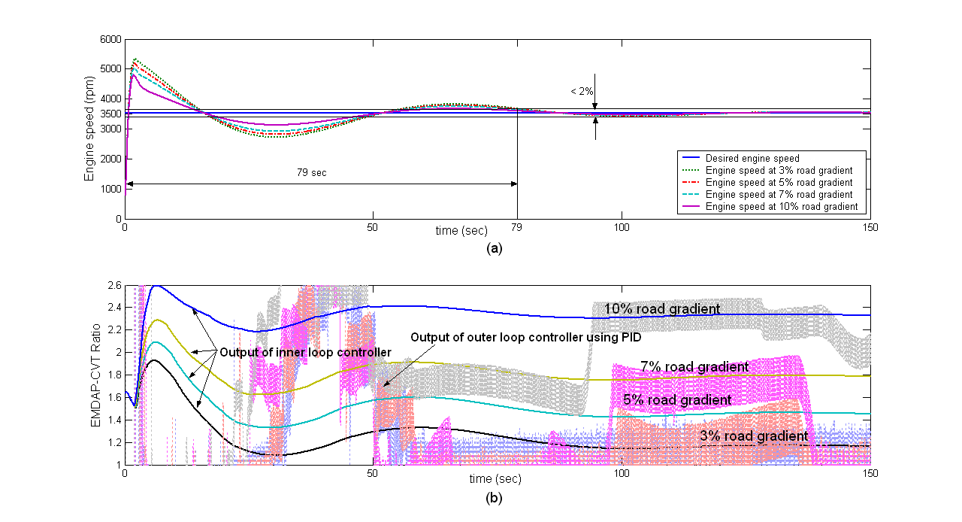
Figure 3. Performance of PID controller as outer loop controller at 80% throttle opening with road gradient variation

Figure 3(b) shows that high inclination road gradient will increase the CVT ratio. As the road gradient increases, the vehicle load will increase. Hence to overcome the increase load the CVT ratio has to be increased. The vehicle load of 10% load gradient is higher than the vehicle load at 7% road gradient, so that the transmission ratio at 10% road gradient is higher than the ratio at 7% road gradient.

- Advance Control
An advance control strategy using LQI control theory in CVT was introduced by [23]. They modified LQR control strategy by adding an integrator to each input. In their study the engine-CVT-load model was developed based on fuel optimization and vehicle dynamic was assumed linear. Relatively good result was obtained; however, it was shown that the engine power should be included in the cost function.
Hongyan et al. (1999) introduced fuzzy controller to keep engine speed at its target by regulating the ratio and changing the throttle opening [24]. The engine speed is important to be maintained at an optimal working condition according to the car’s moving resistance. This can be achieved by using synthesized control. Since the characteristics of the engine and transmission vary with different conditions, it is very difficult to control the ratio and throttle opening to meet such demands. Fuzzy control strategy has been investigated to solve this problem. The simulation results showed that the synthesized controller realized by fuzzy strategy can maintain the engine speed operating at the maximum efficiency point for any power demand level.
Xudong et al. (2006) and Meilan et al. (2006) introduced fuzzy-PID controller for engine equipped with CVT [25][26]. The whole vehicle model including the engine, clutch, CVT and load, and dynamics model of CVT system was developed based on different stages of engaging clutch and studied through simulation, similar study has been carried out by other researchers [27]. They found that a conventional proportional control strategy could not satisfy the control demand for engaging clutch; hence they designed a fuzzy controller for the clutch control and applied self-adjusting PD for the ratio control. The simulation results indicated that the speed ratio controller has good control effect and implements reasonable match between engine and CVT. It demonstrates that the simulation model established is acceptable and reasonable, which can offer theoretical help to devise and develop CVT system.
Zhang et al. (2006) proposed a fuzzy controller to control a tractor equipped with CVT [28]. In a traditional control system the optimum fuel economy or dynamic performance control rules only reflect the tractor working state. On the other hand, the driver’s demand is partially ignored in the control system; therefore the applications are limited. To solve this problem a rule based fuzzy inference of driver’s demand was proposed, with the aim of improving the tractor’s dynamic performance under transient operating conditions and fuel economy during steady state operating conditions. Using a fuzzy inference engine which is introduced to indicate the driver’s demand for tractor dynamic performance based on the rate of change of the accelerator pedal, the tractor dynamic factor was obtained. According to the tractor dynamic factor the intelligent transient dynamic control rule can be worked out by compromising between fuel economy and dynamic performance control rules. After the acceleration process finishes, the transition control rule is adopted to achieve a smooth transition from intelligent transient dynamic rule to the steady fuel economy rule. The simulation results showed that the intelligent control rule enables tractors to reach the optimum comprehensive performance. The works provided a new design method for developing an intelligent tractor equipped with continuously variable transmission.
Deacon et al. (1999) and Brace et al. (1999) studied an integrated powertrain and CVT controller to improve fuel consumption and emission [29][31]. They used two different network controllers to control torque demand and engine speed demand. Measured engine speed is passed to the engine operating point optimiser, which is used to set the corresponding ideal engine torque which is the first torque demand. The second torque demand is the output of network controller 1. These two torque demand are used to drive the vehicle through CVT. The network controller 2 is used to control engine speed demand. By these two novelty network controllers, the vehicle exhaust emission and economic fuel consumption are improved compared with the existing diesel engine controller although these must be achieved without adversely affecting vehicle driveability.
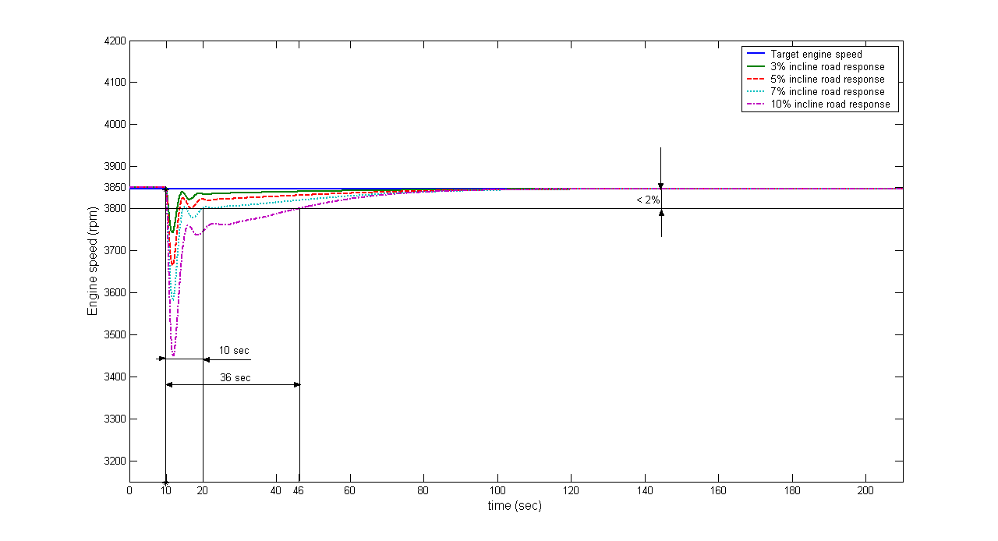
Figure 4. Performance of adaptive ANN controller for constant throttle and various road gradients
Figure 4. shows the simulation results of the effect of constant throttle opening with various road gradients. The road gradients are set to 3, 5, 7 and 10% and the throttle opening is set at 80% where the target engine speed is 3526 rpm. Dorf and Bishop (2008) states that the settling time is defined as the time required for the system to settle within a 2% percent error of output steady-state amplitude [. The graph shows that the outer loop controller is able to reach the target engine speed of about 10 second except for the 10% road gradient. This may due to the performance of the small engine used which has the maximum torque of 43 Nm to overcome the external load caused by the 10% road gradient. Comparing with PID controller for the outer loop control as shown in Figure 3, the actual engine speed oscillate for all road gradient. Thus the adaptive ANN is more suitable for this type of non-linear system.

CONCLUSION
The development of CVT grows tremendously during recent years due to the advent of durable materials, advance manufacturing system, and sophisticated electronic controls. Publications concerning the development, history, advantages, benefits, limitation and current status of CVT research have been presented. Since early development of metal belt, a CVT controller is based on classical control such as PID or some electronic control system. In line with new development of control technology, some researchers develop the CVT control strategy in order to optimise the benefit of CVT. Intelligent control schemes such as fuzzy or neural network combining with classical control such as PID have been studied.
Artificial neural networks (ANN), with their self-organising and learning ability, are now used as promising tools for such purpose. A neural network consists of neuron-like computing elements which are basically nonlinear. These nonlinear properties of neural networks allow the possibility of nonlinear mapping, and thus, ANN control can realise new non linear control scheme such an online ANN technique. A control system consisted of an outer loop using neural network and inner loop using PD controller will be implemented to the drivetrain system equipped with electromechanical CVT. Since the drivetrain and vehicle dynamic are highly non linear, ANN is a suitable control system due to its non-linear characteristic. To meet the research objective which is to design and develop an electromechanical dual acting CVT pulley controller for small size automotive application, intelligent and robust controllers are considered necessary. With this controller the engine RPM can be kept at its desired speed by adjusting the CVT ratio. Adaptive ANN will act as expert driver to control and select proper CVT ratio

ACKNOWLEDGMENTS
We would like to appreciate gratefulness to the ministry of high education for giving research grand. We also would like to appreciate gratefulness to Politeknik Negeri Semarang especially department of mechanical engineering who give us opportunity to use the laboratory to conduct the experiment. Moreover the researcher from Polmanbabel who tries to use CVT in his research.

REFERENCES
- Yamaguchi, J. (2000). Nissan’s Extroid CVT, Automotive Engineering International Online, SAE International, February.
- Birch, S. (2000). Audi Takes CVT From 15th Century to 21st Century. Automotive Engineering International Online. SAE International, January, 3. SAE International.
- Fuchino, M. and Ohsono, K. (1996). Development of Fully Electronic Control Metal Belt CVT. Proceeding of the International Conference on Continuously Variable Power Transmissions. JSAE CVT’96. 11-12 September. Yokohama, 101: 23-32.
- Tsuji, T. and Takeoka, M. (1996). Study of Fuel Consumption Improvement of the Car with the Dry Hybrid Belt CVT. Society of Automotive Engineers of Japan, JSAE Review. 17: 381-385.
- Mori, H., Yamazaki, T., Kobayashi, K. and Hibi, T. (2001). A Study on the Layout and Ratio Change Characteristics of Dual-Cavity Half-Toridal CVT. Society of Automotive Engineers of Japan, JSAE Review. 22:299-303.
- Kluger, M. A. and Fussner, D. R. (1997). An Overview of Current CVT Mechanisms, Forces and Efficiencies, Transmission and Driveline Systems Symposium. SAE Paper No. 970688, in SAE SP-1241: 81-88
- Kluger, M. A. and Long, D. M. (1999). An overview of Current Automatic, Manual and Continuously Variable Transmission Efficiencies and Their Projected Future Improvements. International Congress and Exposition. March 1-4. Detroit, Michigan, 1-6.
- Boos, M. and Mozer, H. (1997). ECOTRONIC - The Continuously Variable ZF Transmission (CVT). Transmission and Driveline Systems Symposium SAE Paper No. 970685. in SAE SP-1241: 61-67.
- Chan, C., Breitweiser, D., Frank, A. and Jamzadah F.S. (1984). System Design and Control Consideration of Automotive Continuously Variable Transmission, SAE Paper 8450048. February, 34-39. SAE Intrenational.
- Yamamoto, T., Matsudaa, K. and Hibib, T. (2001). Analysis of the Efficiency of a Half-Toroidal CVT, Society of Automotive Engineers of Japan, JSAE Review 22: 565–570.
- Broge J. L. (1999). GM Powertrain's Evolving Transmissions. Automotive Engineering International. November, 1.
- Yasuoka, M., Uchida, M., Katakura, S. and Yoshino, T. (1999). An Integrated Control Algorithm for an SI Engine and a CVT. Transmission and Driveline Systems Symposium. SAE Paper No. 1999-01-0752, in SAE SP-1440: 155-160.
- Sakaguchi, S., Kimura, E. and Yamamoto, K. (1999). Development of an Engine-CVT Integrated Control System. Transmission and Driveline Systems Symposium. SAE Paper No. 1999-01-0754, SAE SP-1440: 171-179.
- Fukuba, H. and Morita, S. (1992). Optimization Control of the Fuel Consumption Ratio for an Engine-CVT-Load System using Decoupling Control Theory. JSME International Journal. 35: 442-447.
- Engelsdorf, K., Senger, K. H. and Bolz, M. P. (1996). Electronic CVT Control for Powertrain Optimization. Proceeding of the International Conference on Continuously Variable Power Transmissions. JSAE CVT’96. 11-12 September. Yokohama.: 71-76.
- Funatsu, K., Koyama, H., and Aoki, T. (1996). Electronic Control System of Honda for CVT. Proceeding of the International Conference on Continuously Variable Power Transmissions. JSAE CVT’96. 11-12 September. Yokohama, 43-52.
- Ide, T., Udagawa, A. and Kataoka, R. (1995). Simulation Approach to the Effect of the Ratio Changing Speed of a Metal V-belt CVT on the Vehicle Response, Vehicle System Dynamics. 24: 377-388.
- Luo, N., Beachley N. and Fronczak F. (1986). Fuel Economy Optimization of a Hydrostatic CVT Passenger Automobile. Proceedings of the National Conference on Fluid Power. 11-12 Jan., Roorkee (India), 313-320.
- Vahabzadeh, H. and Linzell, S. M. (1991). Modeling, Simulation, and Control Implementation for a Split-Torque, Geared Neutral, Infinitely Variable Transmission. Tech. Rep. 910409, SAE:34-40
- Hyun, O. W., Lee, J. H., Kwon, H. G., and Yoon, H. J. (2005). Model-Based Development of Automotive Embedded Systems: A Case of Continuously Variable Transmission (CVT). Proceedings of the 11th IEEE International Conference on Embedded and Real-Time Computing Systems and Applications. 154-158
- Miyazawa, T., Fujii, T., Nonaka K. and Takahashi, M. (1999). Power Transmitting Mechanism of a Dry Hybrid V-Belt for a CVT - Advanced Numerical Model Considering Block Tilting and Pulley Deformation. SAE Paper No. 1999-01-0751, in SAE SP-1440, Transmission and Driveline Systems Symposium, SAE: 143-153.
- Guzzella, L. and Schmid, A. (1995). Feedback Linearisation on Spark-Ignition Engines with Continuously Variable Transmission. IEEE Transactions on Control Systems Technology. 3(1): 54-60
- Takiyama, T. and Morita, S. (1999). Engine-CVT Consolidated Control using LQI Control Theory. Society of Automotive Engineers of Japan, JSAE 9930630, 20:251-258
- Hongyan, W., Yunshan, Z., Boying, Z. and Xiding, Q. (1999). Research on Integrated Control Strategy of CVT for Passenger Cars. Proceedings of the American Control Conference. 6-9 September. Arlington, 401-405.
- Xudong, W., Meilan, Z. and Yongqin, Z. (2006). Research on Electronic Control System of a New-type CVT. Proceeding on The 1st International Forum on Strategic Technology, IFOST2006, IEEE. 18-20 October. Uslan,Korea, 289-292.
- Meilan. Z., Xudong. W. and Yongqin, Z. (2006). Modeling and Simulation of Continuously Variable Transmission for Passenger Car. Proceeding on The 1st International Forum on Strategic Technology, IFOST2006, IEEE. 18-20 October, Uslan Korea, 189-192.
- Dongye, S., Datong, Q. and Hongyan W. (2002). Study on Control Strategy of Tract. Clutch Starting for Car with a Metal Pushing Belt-planetary Gear Continuously Variable Transmission System. Chinese Journal of Mechanical Engineering. 15(1):43-47.
- Zhang, Y., Zhou, Z. and Zhou, X. (2006). Intelligent Control Rule for Tractor with Continuously Variable Transmission. Proceedings of the 2006 IEEE International Conference on Mechatronics and Automation. 25–28 June, Luoyang, China, 1712-1716.
- Deacon, M., Brace, C. J., Vaughan, N. D., Burrows, C. R. and Horrocks R. W. (1999). Impact of Alternative Controller Strategies on Exhaust Emission from an Integrated Diesel/Continuously Variable Transmission. Proceding of the Institution of Mechanical Engineers. 213(2):95-107.
- Brace, C. J., Deacon, M., Vaughan, N. D., Burrows, C. R. and Horrocks R. W. (1999). An Operating Point Optimizer for the Design and Calibration of an Integrated Diesel/Continuously Variable Transmission Powertrain, Proceding of the Institution of Mechanical Engineers, ProQuest Science Journal. 213(2): 215-226.
- Dorf R. C. and Bishop R. H. (2008). Modern Control System. Pearson International Edition, 11th edition. Pearson Prentice Hall

