THE INNOVATIVE DESIGN OF AUTOMATIC SPEED LIMITATION DEVICE FOR TRUCK AND BUS BASED ON ROAD LOCATION ANALYSIS

Hadi Pranoto^{1*}, A.M. Leman², Dafit Feriyanto¹, Andi Andriansyah³, Abdi Wahab⁴
¹Department of Mechanical Engineering, Faculty of Engineering, Universitas Mercu Buana
Jl. Raya Meruya Selatan, Kembangan, Jakarta 11650, Indonesia
²Department of Mechanical Engineering, Faculty of Engineering, Universiti Tun Hussein Onn Malaysia
Pagoh Higher Education HUB, 84600 Pagoh, Muar, Johor, Malaysia
³Departement of Electrical Engineering, Faculty of Engineering, Universitas Mercu Buana
Jl. Raya Meruya Selatan, Kembangan, Jakarta 11650, Indonesia
⁴Department of Information System, Faculty of Computer Science, Universitas Mercu Buana
Jl. Raya Meruya Selatan, Kembangan, Jakarta 11650, Indonesia

*Corresponding Author Email: hadi.pranoto@mercubuana.ac.id

Abstract -- The increasing number of vehicles every year has led to the rising potential of vehicle accidents. In 2015, there were 556 fatalities from 6,231 accident cases occurred in Jakarta, through regulation of the Minister of Transportation Republic Indonesia No: 111 in 2015, it has been issued firm vehicle speed restrictions, but there is no positive impact because the speed limit of each vehicle cannot be done automatically by the highway location, so the need for innovation to design a tool that can meet these needs. The method in this research is developing a device that can break the flow of fuel quickly to hold the speed of the vehicle with Global Positioning System (GPS) as a trigger to drive the relay that has been installed on the engine. The results of this study are devices that have been installed in truck and bus engines capable of holding the speed.

Keywords: Road Accident; Safety Device; Speed Limit; GPS

Copyright © 2020 Universitas Mercu Buana. All right reserved.

Received: May 2, 2019 | Revised: May 29, 2019 | Accepted: June 2, 2019

INTRODUCTION
Road accidents contributed a significant percentage of victims as the statistic in 2015 recorded over 85% of the deaths, and close to 90% of the disability cases were caused by road traffic crashes worldwide. However, the highest rate of accidents was found to be significant in number for trucks and buses were mostly caused by human error. Also, there was nearly 150,000 death from road traffic injuries for 2013 in the region of America [1] and almost 85,000 deaths from road traffic injuries in the World Health Organization[2]. The summary of road traffic fatality rates per 100,000 populations divided in each region is shown in Fig. 1, where the highest rate is the Africa region with a value of 26.6%.
Factors that cause traffic accidents were mainly due to disorderly conduct recorded at 27,035 cases, 21,073 cases as a result of carelessness, and 9,278 cases of exceeding the speed limit. Several factors found to cause a traffic accident, such as external (34%), attitude (24%), fatigue (20%), over speed (17%) and technical vehicle (maintenance shortfalls) (5%) as listed in Table 1.2 is based on the National General Safety Plan, (2010). Other factor includes the significant growth of vehicles and industries, which increase the possibility of higher road fatalities [3].

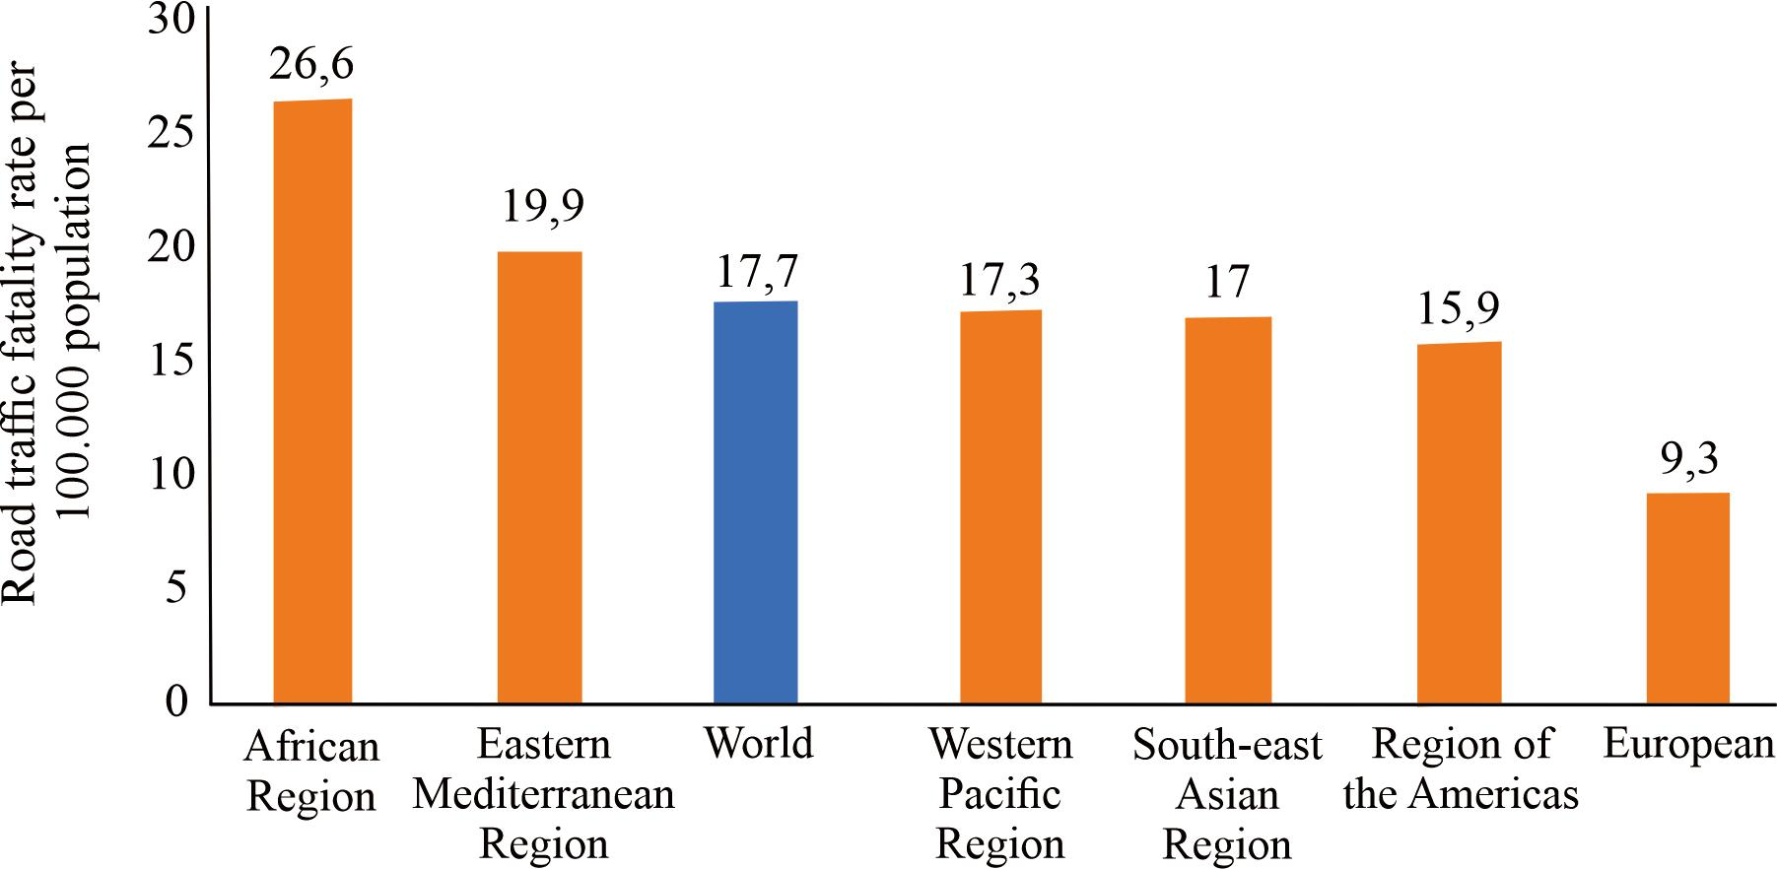Figure 1. Road traffic fatality rates [2]

Table 1. Factor of traffic accidents in Indonesia[4]
The Factor of Traffic Accident | Percentage (%)
Fatigue | 32
Over speed | 15
Attitude | 20
External | 29
Technical vhicle | 5
Vehicle accidents have become a primary concern in many countries of the world, especially in South-East Asia. The increasing number of the vehicle every year has led to the increased potential of vehicle accident, in Indonesia. In 2015, there were 556 fatalities from 6,231 accident cases that occurred in Jakarta. It may cause by drivers reckless or excess speed. At the same time, driving, fatigue, and several other cases related to attitude [5], in Malaysia According to Yusria Darma et al. (2017), road accidents in Malaysia are mainly influenced by the condition of the road.
Based on locality, the number of road traffic deaths in a rural area (66%) is significantly higher compared with that in urban areas (34%), in Thailand In the year 2016, the trend of cars on the road is an upward one, with the fleet registering more vehicles older than ten years, typology of vehicles involved in road accidents variation truck and bus +104.0% (National Institute of Statistics, 2017 and Traffic Police, 2017). According to the data from the National Traffic Safety Committee of Vietnam, by 2015, as of November, there were nearly 21,000 traffic accidents, killing nearly 8,000 people and injuring 19,000. Although the number of deaths from traffic accidents has decreased, the number of injuries and injuries remains high[6]. Brunei Darussalam reported 3,375 road accidents. Road traffic accident and rate of people killed and injured in Brunei Darussalam (2011-2016).
The number of fatalities fell from 151 in 2015 to 141 in 2016. The road traffic fatality rate in Singapore has been declining over the past five years. In 2016, the fatality rate per 100,000 persons fell to 2.51, from 2.73 in 2015. This is the lowest fatality rate since 1981. In Cambodia road fatalities, vulnerable road users (pedestrians, cyclists, and users of motorized two-wheelers) represented 80% of all road fatalities, and this is because unstable due to environmental factors or speed factors in avoiding accidents. In Laos road, accident statistics show a three-fold rise of deaths from road accidents, from 5.4 per 100,000 in 2005 to 15.6 per 100,000 in 2014. One in ten accidents on average resulted in death in 2005, and by 2014, one in around five accidents resulted in death[7].
One out of eight traffic fatalities in 2014 resulted from a collision involving a large truck in 2014 [8]. Several analyses concluded that the majority of truck drivers are safe, with a minority of truck drivers being responsible for a disproportionate number of safety violations and crashes. The analyzed data indicate that the truck driver has a lower crash than light vehicle drivers [9]. Excessive speeding by drivers reduces response time for the driver in an event and may increase risk as a result of speed-related increases in crash exposure. Speeding reduces a driver's ability to steer safely around objects, curves, or intersection in the roadway, extends the distance is required to stop a vehicle, and increases the distance a vehicle travels.
In contrast, the driver reacts to a dangerous situation. Impact forces during a vehicle crash vary with the square of the vehicle speed. Therefore, even small increases in speed have significant and lethal effects on the force at impact [10]. From Table 2.11, it can be seen that at higher speed, there is a higher chance or probability for a fatality to occur, and it is also found that pedestrians are the most high-risk victims of road users. Speed of 50 km/h showed the possibility of a pedestrian being killed reached up to 87 percent at a speed of 80 km/h had been ascertained by a pedestrian who was hit and died, safety driving behavior that is not at high speed will decrease the chances of a deadly accident[11].

Table 2. Effect of vehicle speed against fatality[12]
The current speed bump, (km/h) | Estimates of the risks faced by the various users of vehicles and pedestrians
The current speed bump, (km/h) | a juries car driver who belted | Fatality belted car driver | Fatality pedestrian hit by a car
30 | 0,04 | 0,01 | 0,08
50 | 0,10 | 0,03 | 0,87
80 | 0,42 | 0,21 | 1,00
100 | 0,80 | 0,61 | 1,00
120 | 1,00 | 1,00 | 1,00

Trucks and busses are the primary concern in this research, as both are public transportations used by society. Fuel trucks require safety driving since compliance it distributes fuel, a hazardous material if an accident happens. Base on regulation in the Republic of Indonesia, regarding speed restrictions on the highway by PP N0: 111 of 2015, that for commercial vehicles trucks and buses, the maximum speed on the road is 60km / hour, on the preservation road 30 km/hour and on the alternative highway is 50 km/hour[13]. Research This results in a concept of device speed limiter that can limit the speed of trucks and buses by the regulations referred to by using integrated fuel supply disconnection through trigger longitude and GPS latitude.

METHOD
The preliminary design was consist of calculation, concept verification, parameter determination, and specification of the data sheet component.
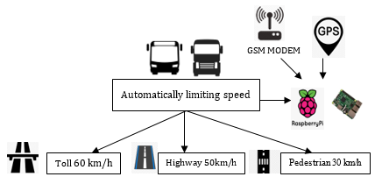
Figure 2. The device design system

The GPS provides input to the new features as a trigger to determine the position of the vehicle when it is on the highway, non-highway, and pedestrian road. GPS also gives instruction and information to the new features for limiting the speed according to government regulation, in Indonesia, the speed is limited if on the toll road (60 km/h), in the pedestrian road (30km/h) and for the highway (50 km/h), in this concept, the restriction is done automatically to follow the location.
The stages of developing new features started from determining the types of trucks and buses to measure the appropriate voltage with its types because the raw data of trucks and buses would be used to limit the speed. Therefore, it is essential to convert the frequency to voltage. In making this device, a somewhat complicated stage is determining which parts of the parameter are. The whole methodology for this research describe in Figure 3.

Voltage Determination
Voltage determination was conducted by calculating the input frequency into the voltage by using Equation 1 to 6. In the development of new features, the most important things are how to resolve the equation to change the input frequency value to the desired output in this system, which was voltage[14]. The result of the output voltage was used to perform a trigger in moving the relay connected to the engine cut-off motor in diesel engines.
I3(avg) = Q/t = (Q Charge + Q discharge)/(1/f) = 2×Q×f = 2×C₁×(V_{cc}/2)×f = C₁×V_{cc} ×f | (1)

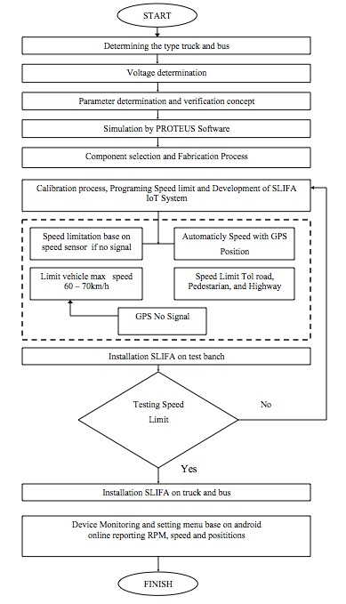
Figure 3. Flowchart of the research

This average current was flown across R1, giving the needed output voltage.
V_{o} = R₁× C₁ × V_{cc} × f | (2)

While the ratio of the output voltage to input frequency was dependent on supply voltage, it was easily adjusted through the combination of one resistor and one capacitor, R1, and C1. The formula for calculating the expected output voltage is in Equation 3.
V_{out}= V_{cc}× f × C₁ × R₁ | (3)

Speed Limit Determination
In the determination of speed reduction, the speed limiter was divided by two inputs based, which was based on GPS and frequency value from the speed sensor, using the formula determining latitude and longitude.
Δψ = ln(tan(π/4 + φ2/2) / tan(π/4 + φ1/2) ) | (4)
The speed obtained from GPS data directly sends a voltage change component. The frequency changes to that voltage are used to provide a trigger to the engine fuel cut-off motor relay that attaches to the position on the side of the engine on the accelerator pedal.
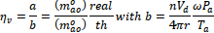 | (5)
The expression of was usually considered as a function of the engine speed and intake manifold pressure[15].
Where was the volumetric efficiency; was the engine speed state; was the cylinder volume displacement; n was the number of cylinders; Pa was pressure, was pi, Ta was the initial temperature, and r was the radius.
The efficiency can be evaluated using the polynomial function [15].
(6)

Safety Device Development
The development process is carried out with several stages after the process of determining parameters in equations 2 to 5 afterward then selecting components with the equation requirements that have been mentioned in the speed determination section, the development stages include;
Simulation of components that will be used in making devices. The electronic components of the new features were designed and simulated using PROTEUS software. PROTEUS was the software used to design PCB, which also came with a simulation at a schematic level before the schematic circuit was upgraded to PCB. Before the PCB was printed, one will know whether the PCB print is correct or not. Two PCB was designed and simulated in this study, the new features microcontroller and Analog to Digital Converter (ADC).
Component selection and main component assembly. The Assembly process of the electronic component was conducted after an electronic simulation component by PROTEUS software. Electronics circuit of the new features was engineered and rafts to control the operation of the engine stop motor and installed in the fuel injection pump. So, if this circuit works on an engine with a control mechanism this circuit acted to resist movement of the accelerator cable, and when installed on engine based electronic control module (ECM), it can compare the different resistant value in accelerator pedal with the resistant value of the speed sensor cable connected to the engine stop the motor.

GPS Development
The development of GPS in this device actually for obtaining the latitude and longitude data where the device is located. The GPS device help to obtain them, and then the data will be translated to address with the help of online maps on the Internet. The address will be used to get the position for the vehicle, and also for determining it in toll road or in the pedestrian road.
The integration held when the address had arrived from GPS; the address data will be used to filter the maximum speed in a different situation based on the device program, such as in toll road, pedestrian road, and on the regular road. If the vehicle passes the maximum limit speed, the device will inform the speed sensor to work, so the speed of the vehicle decreases slowly because of the work of the speed sensor.

RESULTS AND DISCUSSION

Trial and Test Devices
A trial session was conducted to find out the length of success of the device development applied in the truck and bus. Prior to the device used in a real vehicle, the device was tested in a diesel engine stand test bench. This step was needed to minimize potential failure in the device.
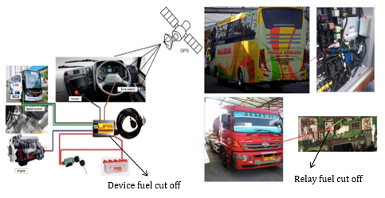
Figure 4. Installation of Speed Limiter Devices on Truck and Bus

The device was connected to the vehicle battery or accumulator as a power supply to the device. The horn switch was connected to the device. The function of the horn switch was as a reset switch of the speed limiter function. The device installation was done by improving the electrical wire, which was placed and connected with the machine. The speed clustering in this study was based on the Indonesia government regulation depending on the urban or highway area, and the device development was adjusted based on that government regulation to fulfill the requirement when the product has been successfully developed. The Schematic diagram of device installation is shown in Figure 5, where it consists of the buzzer, ECU, speed sensor, engine, and the speed limiter control box. The working principle of the device when the vehicle speed exceeds a specified speed limit was as the following. Speed limiting system uses two main inputs based on speed sensor and input based on GPS location, which will send a signal through the Raspberry Pi to be able to send frequence to the fuel cut of relay shown in Figure 2. First, the speed sensor at the transmission output sent the frequency signal to the accelerator pedal and then if based on GPS location.
Then the frequency signal was transformed into a voltage signal at the IC program. The voltage signal was later transformed into the comparators components, forwarded to relay and followed by sound a warning alarm buzzer. When the driver still performed additional speed, the fuel shutoff solenoid reduced the fuel consumption into the engine and automatically reduced the speed/RPM to the average speed (below max. speed). Meanwhile, when the driver decreased the speed, the buzzer alarm stopped and back to the average speed. The truck and bus completed with the location of the device used in this study are as shown in Figure 2 and 4, respectively.

Calibration Test
Before installing a device on the engine truck and bus, speed calibration was necessary to reset the data speed between the speed out of the transmission output via the pulse speed sensor with the value of the voltage available at the speed limiter sensor in the circuit device as shown in Fig. 5.
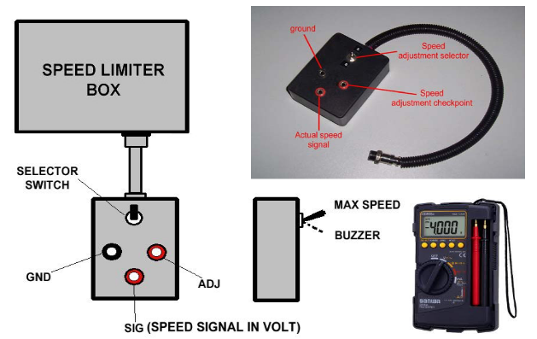
Figure 5. Calibration tools speed limiter device

The result of the calibration test Table 3 was referred for the installation of speed limiters in trucks or buses, so the installation of speed limiters should not require the release of the propeller shaft of the gearbox.

Table 3. Result of calibration test
Calibration Speed to Voltage
No. | Speed (km/h) | No. | Voltage (Volt)
1 | 0 | 1 | 0
2 | 10 | 2 | 1,2
3 | 20 | 3 | 1,8
4 | 30 | 4 | 3,6
5 | 40 | 5 | 5,3
6 | 50 | 6 | 7,1
7 | 60 | 7 | 8,9
8 | 70 | 8 | 10,7
Speed Testing
Fig. 6, mentions the rate of response speed set when the speed limiter worked based on the input value obtained so it can determine the lowest tolerance value in the determination of speed and speed reduction response.
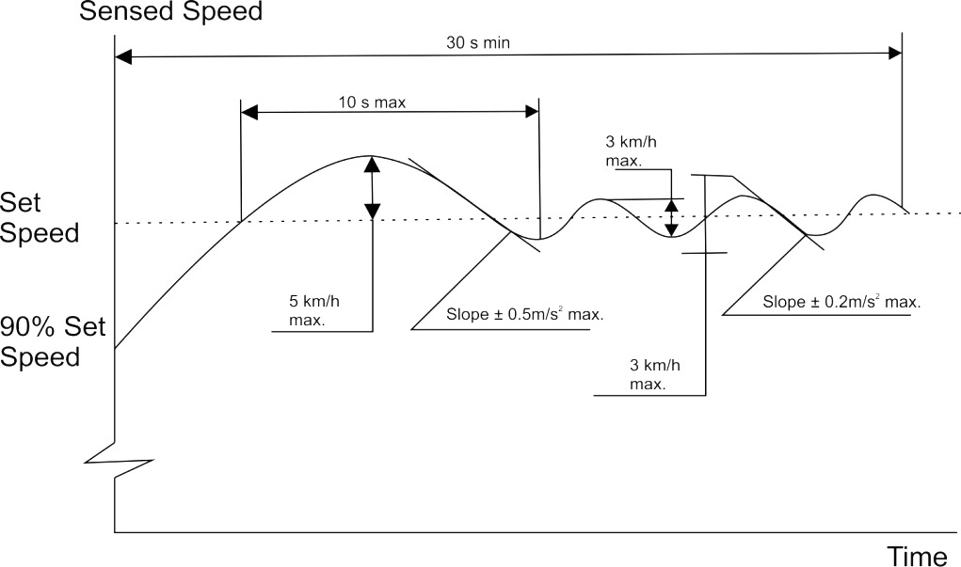
Figure 6. Determine lowest speed tolerance and decrease speed response

From Fig. 6, the speed test results are obtained that when within 30 s/min, the speed at a set speed is 90% the fuel consumption stops within 0.5 min max when the engine is in a fuel cut off condition, the vehicle can glide 30 s/min, and will re-consume fuel normally when the reflex driver presses the throttle.

GPS Testing
The accuracy of GPS in SLIFA device was tested in the real road with the same route and takes the data for three times, and the result position will be compared with data from application of map in Smartphone device. We assumed that data from map application, such as Google Maps [16], in Smartphone is more precise than the GPS SLIFA, because the map application has been released for a long time in the past. To find the accuracy, we transform the GPS data from DD (degree, decimal) format into DMS (degree, minutes, second) format [17]. And the result form the comparison, data from GPS is only difference in under a second. Table 4 shows some example of comparison data between GPS data and data from map application.
Table 4. Comparison of GPS data between SLIFA GPS and Map Application
GPS SLIFA (DMS) |  | Map Application (DMS) |  | Differences
Latitude | Longitude | Latitude | Longitude | Latitude | Longitude
-6° 12' 32.31" | 106° 44' 16.75" | -6° 12' 32.62" | 106° 44' 16.8" | 0.31” | 0.05”
-6° 13' 12.59" | 106° 44' 21.4" | -6° 13' 12.59" | 106° 44' 21.77" | 0.00” | 0.37”
-6° 12' 49.68" | 106° 44' 33.85" | -6° 12' 49.05" | 106° 44' 33.5" | 0.63” | 0.35”

From the result in Table 4, there are a quite little different between data from GPS SLIFA and data from Map Application. The differences of data from the result, from our analysis depends on the processing time occur in SLIFA device, so the GPS late giving the data. For the result of speed for every type of the road will be described in Table 5. We also show the average speed in every time the GPS send data to the server in Fig. 7. The GPS success to limit the speed of the truck and bus with different road types. Therefore the driver meet the requirement of traffic regulation that mention the speed limit in pedestrian, highway and toll road.

Table 5. Result of Average Speed from GPS SLIFA data
GPS SLIFA | Map Application | Road Type | Average Speed (km/h)
-6.208974, 106.737985 | -6.209062, 106.738000 | Pedestrian | 32
-6.220164, 106.739278 | -6,220164, 106.739380 | Highway | 58
-6.213799, 106.742736 | -6.213624, 106.742640 | Toll | 52

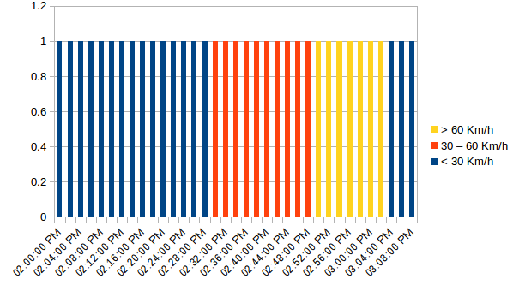
Figure 7. Average speed in every time GPS send data to Server

The blue line in Fig. 7 shows the average speed under 30 Km/h, and this area is a pedestrian area. The situation in pedestrian road a little bit crowded, because the wide of road only for 2 vehicles. And the orange line shows the average speed between 30 – 60 Km/h. The vehicle at that moment is in high way road. The high way road consists of 3-4 rows for vehicle in a same direction, so, there is no crowded in the high way road. Meanwhile the yellow line shows average speed above 60 Km/h. It describes the vehicle in toll road, and the toll road is a road without obstacle, such as traffic light, speed bump, etc. The real route for testing the GPS is shown in Fig. 8. The route consists of three type of road, pedestrian, high way, and toll road.
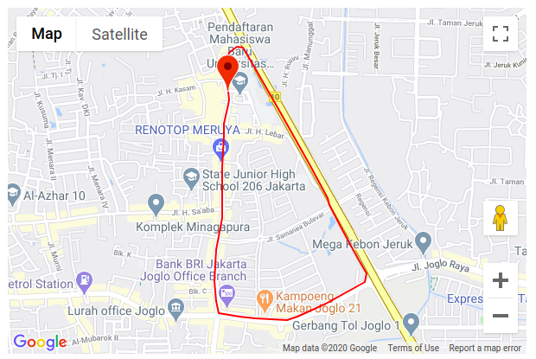
Figure 8. Real route for testing GPS

CONCLUSION
The development and analysis of speed limitation devices were successfully conducted, which started from the development of its system, fabrication, trial test, and installation on truck and bus. Several analyses such us speed testing and GPS accuracy percentage with a fuel cut off the device that is installed on the engine when on a toll road, highway, and pedestrian road has been performed. The monitoring of speed by using GPS shows an effective monitoring and limitation process where the average speed that performed by the truck and bus was 32,58,52 km/h for pedestrian, highway and toll road types, respectively. The GPS system was effective in automatic clustering process based on the location where it automatically changes the speed limit of the truck and bus wen it enter the different location either pedestrian, highway or toll road. It will concluded that this study is very recommended to applied to improve the attitude and driving behavior of the driver to obey the traffic regulation.

ACKNOWLEDGMENT
This research was supported/partially supported by RISTEK-BRIN. We thank our colleagues from RISTEK-BRIN who provided insight and expertise that greatly assisted the research, although they may not agree with all of the interpretations/conclusions of this paper.

REFERENCES

- P. A. Health, "Status of Road Safety in the Region of the Americas" https://www.paho.org/en/documents/status-road-safety-region-americas, June 7, 2019.
- WHO (World Health Organisation), "Global status report on road safety 2018" https://www.who.int/publications-detail/global-status-report-on-road-safety-2018, June 17, 2018.
- H. Pranoto, A. M. Leman, I. Baba, D. Feriyanto, and G. W. Putra, “Improving Road Safety of Tank Truck in Indonesia by Speed Limiter Installation,” in MATEC Web of Conferences, vol. 87, 2016.
- H. Pranoto, A. M. Leman, D. Sebayang, and H. Wahyudi, “Proposed Simple Determining Sleepiness Scale Driver with EAR, MAR and HR the SLIFA devices on Truck and Bus,” IOP Conf. Ser. Mater. Sci. Eng., vol. 453, no. 1, 2018.
- S. Ari Sandhyavitri, Zamri, Sugeng Wiyono, “Three Strategies Reducing Accident Rates at Black Spots and Black Sites Road in Riau Province, Indonesia,” Transp. Res. Procedia, vol. Vol 25, p. pp.2153-2166, 2015.
- Van Huong Dong., “Traffic accidents in Vietnam: Causes and Solutions,” World Wide J. Multidiscip. Res. Dev., vol. 3, no. 5, pp. 40–50, 2017.
- Ministry of Public Work and Transport, “Rad safety status in Lao PDR,” 2016.
- D. Puhkala, J., Sc, M., D, K. K. M. D. P., Aittasalo, M., Ph, D., Mansikkamäki, K. Sc, “Lifestyle counseling in overweight truck and bus drivers - Effects on dietary patterns and physical activity,” Prev Med Re, vol. 4, p. pp.435-440, 2016.
- P. Crizzle, A. M., Bigelow, P., Adams, D., Gooderham, S., Myers, A. M., & Thi, “Health and wellness of long-haul truck and bus drivers : A systematic literature review and directions for future research,” J. Transp. Heal., vol. 7, no. Part A, p. PP 99-109, 2017.
- B. Zheng, Z., Lu, P., & Lantz, “Commercial truck crash injury severity analysis using gradient boosting data mining model,” J. Safety Res., vol. 65, pp. 115–124, 2018.
- S. G. Kate, K., Jeong, K., Tok, A., & Ritchie, “Assessing crash risk considering vehicle interactions with trucks using point detector data,” Transp. Res. Procedia, vol. 78, no. 6, pp. 1–9, 2018.
- S. G. Kate, K., Jeong, K., Tok, A., & Ritchie, “Assessing crash risk considering vehicle interactions with trucks using point detector data,” Accid. Anal. Prev., vol. 130, no. 184, p. pp 1-9, 2019.
- KEMENHUB, “Regulation of the Minister of Transportation of the Republic of Indonesia No: PM 111,” 2015.
- S. A, S. S, and S. G, “Hybrid Evolutionary Algorithms for Frequency and Voltage Control in Power Generating System,” ICTACT J. Soft Comput., vol. 1, no. 2, pp. 88–97, 2010.
- C. Meng, F., Li, S., Cao, L., Peng, Q., Li, M., & Wang, “Designing Fatigue Warning Systems : The perspective of professional drivers.,” Appl. Ergon., vol. 167, no. 14, pp. 1–8, 2015.
- L. N. Thin, L. Y. Ting, N. A. Husna, & M. H. Husin, "GPS System Literature: Inaccuracy Factors and Effective Solutions" International Journal of Computer Network and Communications (IJCNC) Vol. 8, No. 2, March 2016.
- W. K. Setiawati, Haerudin, & Islamiyah, "Analisis Perbandingan Penentuan Titik Kordinat Permukiman Penduduk Menggunakan Metode Interpolasi Linear Dengan Aplikasi Google Maps dan GPS Satellites Viewer" Paper on Prociding Seminar Nasional Ilmu Komputer dan Teknologi Informasi, Vol. 2, No. 2, September 2017.

