EXPERIMENTAL STUDY ON PERFORMANCE OF MULTI-LAYERED BULLETPROOF VEST

Azhari Sastranegara ^{1*}, Edmun Halawa ¹, Lydia Anggraini²
¹Department Mechanical Engineering, Faculty of Engineering, President University

Abstract  As the one of important war equipment, bulletproof vest should have high strength and durability to resist a bullet. However, the cost to create good quality bulletproof vest is expensive. Therefore, research about alternative bulletproof vest with affordable cost and competitive quality is needed. The objective of this research is to review and compare two types of alternative vest with one commercial vest of type IV. Both of alternative vests have similar component except, the second one has additional component of Ultra High Molecular Weight Polyethylene (UHMWPE). The ballistic test shows that this vest is still not enough to resist 5.56 mm bullet, but it has potency to handle 9mm bullet. Furthermore, the influence of UHMWPE to resist 9mm bullet is shown in this research.  This is an open access article under the CC BY-NC license   | Keywords:  bulletproof vest; alternative vest; commercial vest; UHMWPE; ballistic  Article History:  Received:  Revised:  Accepted:  Published:  Corresponding Author:  Azhari Sastranegara  Mechanicall Engineering Department, President University, Indonesia  Email: azhari.sastranegara@president.ac.id

INTRODUCTION
Armor is designed to minimize the injuries due to war. In general, the armor will absorb, reduce, and stop attacks caused by weapons of war. In the current era, the armor is more known as bulletproof vests because currently the armor generally functions to reduce bullet attack [1].
Based on the type, armor can be divided into two categories, namely soft armor and hard armor. Soft armor is categorized as a vest that can absorb bullets up to 500 m/s and the weighs under 4.5 kilograms. Usually, it is composed of multiple layers of fabrics. On the other hand, hard armor is categorized as a vest that can reduce bullets more than 500 m/s [2]. Other than the two types, currently, based on the USA National Institute of Justice (NIJ) the armor is divided into more specific categories, namely Type IIA, Type II, Type III A, Type III, and Type IV, and special [3].
Along with the times, the technology applied to bulletproof vests is increasingly sophisticated and is able to produce lighter and durable vests. However, it makes the cost increase significantly. Therefore, alternative bulletproof vest innovation is needed to create affordable vest cost, but also has competitive performance with the commercial ones.
There are many researches and review about optimization of bullet proof vest [4-6], The researches are using many types material such as, polyethylene [7,8], ceramic composite [9-13], ceramic [14,15], and titanium [16,17].
In this paper, two samples of alternative vests will be tested and the quality will be compared with commercial vest type IV contains Kevlar and Manganese Steel. The alternative vest 1 is contains Titanium and the second one namely alternative vest 2 is the optimization form of alternative vest 1 where some layer is changed with polyethylene. All of vest type will be tested by using 9mm and 5.56 mm bullet. Based on the experimental results, it is hoped that the potential of these vests can be evaluated further.

METHOD
In this journal, the specimen will be tested by ballistic experiment using STI EDGE Pistol and M16. The distance between the weapon and the vest is according to NIJ 0101.06 [3].
Bulletproof Vest Specimen Information
The three types of vests that will be tested are, two alternative vests which provided by PT. Cawisadi Indonesian Aksatriya and the commercial one which is usually was used by the Indonesian National Army.

Table 1. Commercial Vest Information
Material | Thickness | Total
Kevlar | 0.6 mm | 11 layers
Manganese Steel | 6.5 mm | 1 plate

First is commercial vest which is a Type IV bulletproof vest. It has weights of 2.31 kg and about 13 mm thick, a density of 2.7 g/cm3 that consists of 11 Kevlar layers and one manganese steel plate as shown in table1 and figure 1.
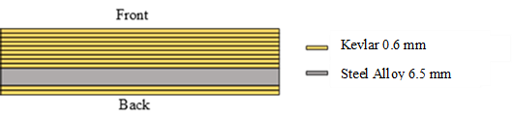
Figure 1. Commercial Vest Overview

Both of them have different main roles. The Kevlar fabric layers at the front is intended to reduce bullet pressure, then the manganese steel plate will absorb kinetic energy of the bullet, and the Kevlar layers at the back has role to stop the shattered steel fragments when the spalling phenomenon occurs [18].
The next description is about the alternative vest 1. This vest has 1.7 kg weight and 14 mm thick. Based on published work, it has 1.91 g/cm3 of density, consists of two main components, namely Ti6Al4V and Soft PVC with a dibutylphthalate plasticizer. This soft PVC act as a damper that can absorb the impact energy of a bullet [19]. Further information regarding these vests is listed in Table 2 below.

Table 2. Alternative Vest 1 Information
Material | Thickness | Total
Ti6Al4V | 1 mm | 5 plates
Soft PVC 1mm | 1 mm | 5 layers
Soft PVC 4mm | 4 mm | 1 layer

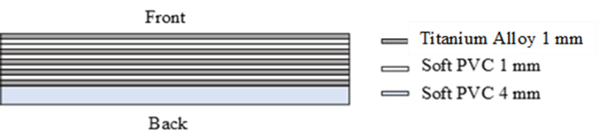
Figure 2. Alternative Vest 1 Overview

The last vest, the alternative vest 2, is the improvement of the alternative vest 1. It has three main components, namely Ti6Al4V, Soft PVC, and UHMWPE fabric. It only has 0.8 kg weights and 8 mm thick with density about 1.34 g/cm3. Further information about this vest is shown Table 3 and Figure 3 below.
Table 3. Alternative Vest 2 Information
Material | Thickness | Total
Polyethylene | 0.4 mm | 5 layers
Ti6Al4V | 1 mm | 2 plates
Soft PVC 1 mm | 1 mm | 1 layer
Soft PVC 3 mm | 4 mm | 1 layer

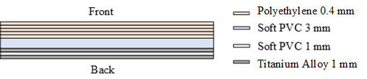
Figure 3. Alternative Vest 2 Overview

Experiment Setup
In order to review the performance of the bulletproof vest, a ballistic test is required. In this evaluation, the vest was fired with 9 mm and 5.56 mm bullets which is arranged as shown in Figure 4.

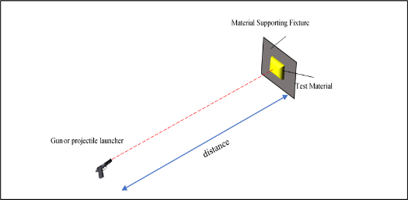
Figure 4. Ballistic Test Setup Overview

This ballistic test was carried out at Indonesian National Army shooting range, Cijantung, Jakarta Timur. The ballistic test followed NIJ 0101.06 standard as shown on Table 4. Furthermore, 9 mm bullets were fired with STI EDGE pistol, whereas 5.56 mm bullets with M16.

Table 4. Weapon Specification
Material | Thickness | Total | Distance
M16 | Bullet | MU5-TJ (5.56mm) | 15mm
M16 | Velocity | 853.44 m/s | 15mm
M16 | Bullet mass | 62 grains | 15mm
M16 | Rotation | 168000 RPM | 15mm
STI EDGE | Bullet | MU1-S (9mm) | 5mm
STI EDGE | Velocity | 365.76 m/s | 5mm
STI EDGE | Bullet mass | 124 grains | 5mm

In this evaluation, only the commercial vest and the alternative vest 1 were tested with these two weapons. The alternative vest 2 was only tested with 9 mm bullets. The test results will then be compared qualitatively based on the level of damage caused by the bullets on each vest.

RESULTS AND DISCUSSION
In this section will be presented ballistic test result using 5.56mm bullet and 9mm bullet to each bulletproof vest.
Ballistic Test with 5.56 mm Bullet
This section will review bulletproof vest performance on 5.56 mm. Bullets are fired using an M16 weapon with a range of 15 meters from the target. The result will be discussed in more detail in the following explanations.
First, we will discuss the commercial vests ballistic test result. The illustration of the event when the bullet hit the vest can be seen in Figure 5. From the figure, it shown that the bullet piercing the entire Kevlar layer and stop when it hit the manganese steel plate.

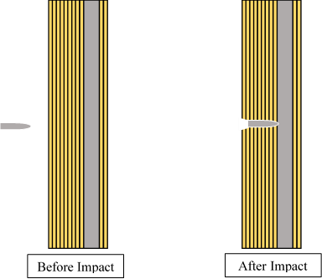
Figure 5. 5.56mm Bullet Impacts Commercial Vest Overview

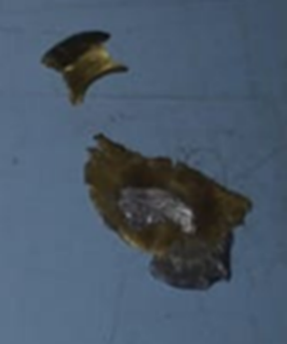
Figure 6. 5.56mm Bullet After Impact Condition

From the experiment test, the bullet created consistent size of holes on Kevlar. This was due to the high velocity of the bullet, so that the Kevlar layer was torn neatly [20], which shows that the effect of Kevlar on the impact caused by the 5.56 mm bullet was insignificant. Subsequently, when the bullet hit the manganese steel plate, it was crushed as shown in Figure 6 and left a distinct mark about 10 mm diameter and 1 mm deep on the plate. To understand more about the actual shape of the impact test, the result can be seen on Figure 7.

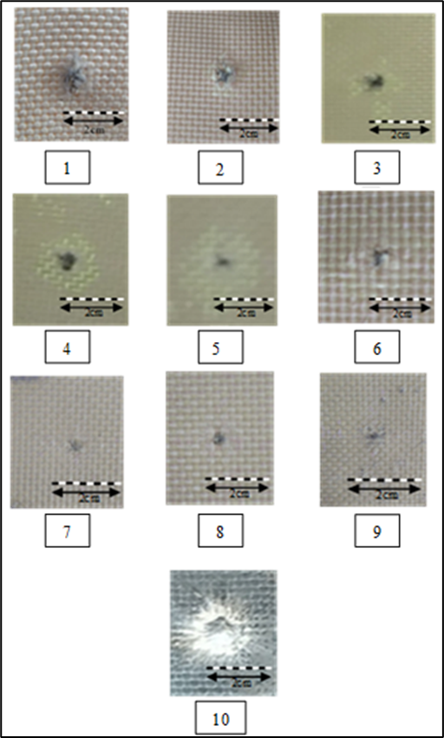
Figure 7. Commercial Vest After Impact Condition By 5.56 Bullet

Next are the results of a ballistic test with a 5.56 mm bullet against the alternative vest 1. As illustrated by Figure 8, the bullet successfully penetrated the entire vest layers. Furthermore, due to the extremely high bullet velocity, each layer of vest forms a consistent bore size similar as the commercial one result [20]. For more clear understanding, the actual results in this trial is presented in Figure 9.

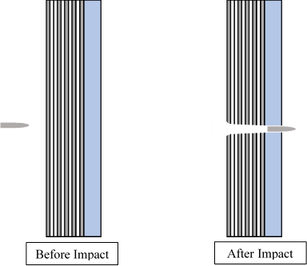
Figure 8. 5.56mm Bullet Impacts Alternative Vest 1 Overview

Figure 9. Alternative Vest 1 Condition After Impact By 5.56 Bullet

Next are the results of a ballistic test with a 5.56 mm bullet against the alternative vest 1. As illustrated by Figure 8, the bullet successfully penetrated the entire vest layers. Furthermore, due to the extremely high bullet velocity, each layer of vest forms a consistent bore size similar as the commercial one result [20]. For more clear understanding, the actual result of this trial is presented in Figure 9.
Based on these two experimental results, it can be concluded that the alternative vest which consists of Ti6Al4V and Soft PVC coating has an inferior quality compared to the commercial vest. The trial show that the alternative vest 1 is not applicable for 5.56 mm bullet caliber.

Ballistic Test with 9mm Bullet
This section will discuss in detail the vests condition after the impact of 9 mm bullet that was fired by the STI EDGE pistol from 5 meters distance. First, the condition of the commercial vest as illustrated in Figure 10. The bullet stopped at the manganese steel plate at the same stop location for as 5.56 mm bullet and 9 mm bullet also destroyed as shown in Figure 11.

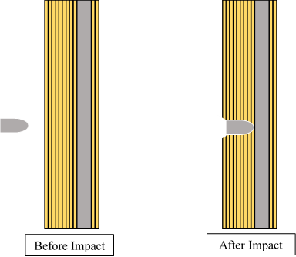
Figure 10. 9mm Bullet Impacts Commercial Vest Overview
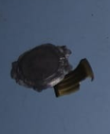
Figure 11. 9mm Bullet After Impact Condition

The deformation caused by 9 mm bullet is presented more clearly in Figure 12. The result shows that on tenth layer namely manganese steel, only small marks leaved. The less mark caused by Kevlar has woven structure which can spread the impact energy as explained on Zawadzka Kinga et al. publication [21].

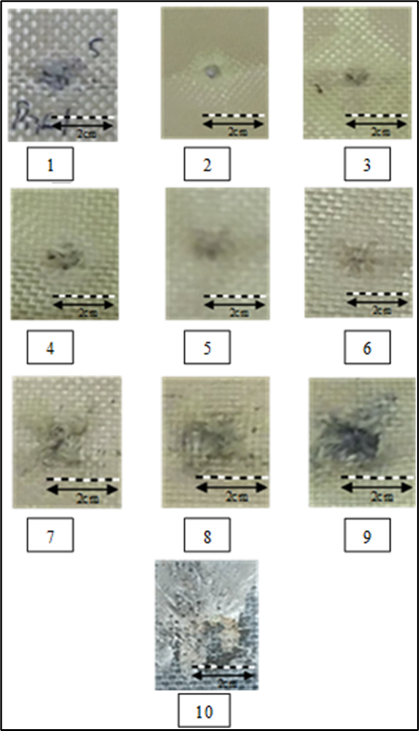
Figure 12. Commercial Vest After Impact Condition By 9mm Bullet

Furthermore, the decreasing of bullet velocity is noticeable from the changing of the hole size occurs on Kevlar layers. This assumption is also supported by the relatively slow velocity and the wider surface of 9 mm bullet [22].

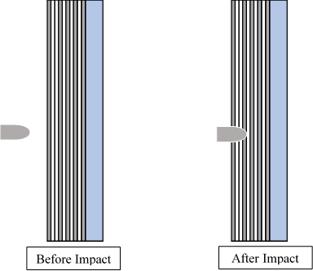
Figure 13. 9mm Bullet Impacts Alternative Vest 1 Overview

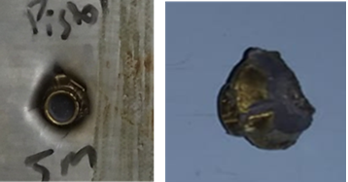
Figure 14. 9 mm bullet after impact condition

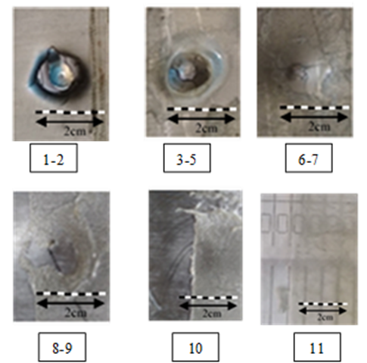
Figure 15. Alternative Vest 1 After Impact Condition By 9mm Bullet

Secondly, the impact result of the alternative vest 1 is shown in Figure 13. The figure illustrates that the bullet was stopped by the vest. In actual conditions the bullet was stuck in the vest and deforms as shown in Figure 14 and Figure 15.
The trial show that the vest can stopped the bullet until it reached the fifth layer. Furthermore, the impact of the bullet also left a big dent on the back side of the vest. This result show that even the vest can stop the bullet, the user still receiving the impact of the bullet. However, this vest still has a potency as an alternative
Last is the alternative vest 2. This vest has 5 layers of UHMWPE on the initial layers of the vest. As illustrated by Figure 16, it can be seen that only UHMPE layer was perforated by the 9 mm bullet and it crushed as shown in Figure 17. This result is surprising, since this vest is the thinnest among the specimens.

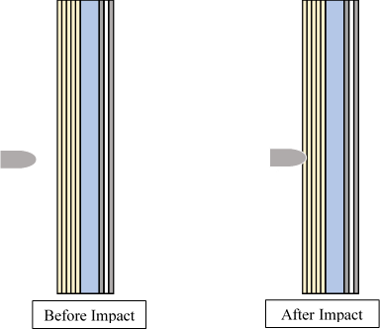
Figure 16. 9mm Bullet Impacts Alternative Vest 2 Overview

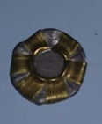
Figure 17. 9mm After Impact Condition

A shown on the Figure 18 the performance of alternative vest is very good. The vest can stop the bullet on UHMWPE layer, it can be seen that the UHMWPE layers has a very significant role in preventing the bullet impact [23]. However, similar with the previous alternative vest, the impact left a big dent on the backside of vest which can injure the user. Beside of the condition, the alternative vest 2 still has high potency to compete the commercial ones. Furthermore, if you look the result closely, the sixth layer, specifically the soft PVC layer with a thickness of 4 mm, a hole was formed even the previous four layers were safe. It was caused by the indirect impact of the 9 mm bullet and UHMWPE fabric structure behavior.

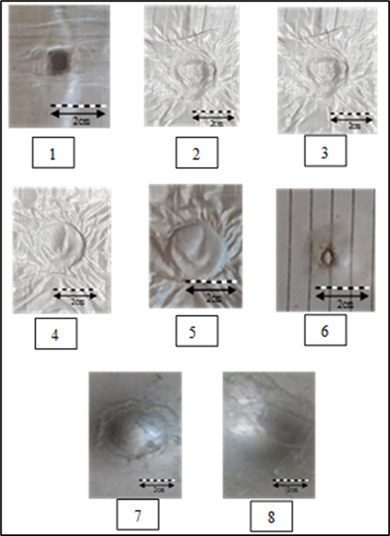
Figure 18. Alternative vest 2 after impact condition by 9mm bullet

CONCLUSION
Based on the experiment results above, it can be concluded that the quality of the commercial vest is indeed better than the two alternative vests. To make it easier to identify damage to the vest, Table 5 summarize the ballistic trials discussed earlier. The summary will include the hole diameter and the condition of each layer.

Table 5. Research Summary
Vest | Layer | Hole Diameter (mm) |  | Condition
Vest | Layer | 5.56mm | 9mm | 5.56mm | 9mm
Commercial | 1 | 4 | 6 | Fail | Fail
Commercial | 2 | 3 | 4 | Fail | Fail
Commercial | 3 | 3 | 6 | Fail | Fail
Commercial | 4 | 3 | 8 | Fail | Fail
Commercial | 5 | 3 | 8 | Fail | Fail
Commercial | 6 | 3 | 9 | Fail | Fail
Commercial | 7 | 2 | 9 | Fail | Fail
Commercial | 8 | 2 | 9 | Fail | Fail
Commercial | 9 | 2 | 11 | Fail | Fail
Commercial | 10 | N/A | N/A | PD | PD
Commercial | 11 | N/A | N/A | ND | ND
Commercial | 12 | N/A | N/A | ND | ND
Alternative 1 | 1 | 7 | 13 | Fail | Fail
Alternative 1 | 2 | 7 | 13 | Fail | Fail
Alternative 1 | 3 | 5 | 15 | Fail | Fail
Alternative 1 | 4 | 7 | N/A (C) | Fail | Crack
Alternative 1 | 5 | 7 | N/A (T) | Fail | Fail*
Alternative 1 | 6 | 7 | N/A (C) | Fail | Crack
Alternative 1 | 7 | 7 | N/A (T) | Fail | Fail*
Alternative 1 | 8 | 8 | N/A | Fail | PD
Alternative 1 | 9 | 8 | N/A | Fail | ED
Alternative 1 | 10 | 8 | N/A | Fail | PD
Alternative 1 | 11 | N/A | N/A | Fail | ED
Alternative 2 | 1 | -- | 6 | -- | Fail
Alternative 2 | 2 | -- | N/A | -- | PD
Alternative 2 | 3 | -- | N/A | -- | PD
Alternative 2 | 4 | -- | N/A | -- | PD
Alternative 2 | 5 | -- | N/A | -- | PD
Alternative 2 | 6 | -- | 4 | -- | Fail*
Alternative 2 | 7 | -- | N/A | -- | PD
Alternative 2 | 8 | -- | N/A | -- | ED
N/A : No hole
Fail : Direct penetrated
PD : Plastic deformation
N/A (C) : Crack only
Fail* : Indirect penetrated
ED : Elastic deformation
N/A (T) : Tear only
ND : No Deformation
-- : Not tested

Based on the experiment results above, it can be concluded that the quality of the commercial vest is indeed better than the two alternative vests. To make it easier to identify damage to the vest, the following is a summary of the ballistic trials discussed earlier. The summary will include the hole diameter and the condition of each layer.

ACKNOWLEDGMENT
This research was supported/partially supported by PT. Cawisadi Indonesia Aksatriya. We thank our colleagues from President University who provided insight and expertise that greatly assisted the research, although they may not agree with all of the interpretations/conclusions of this paper.

REFERENCES
- P. J. Hazell, Armour. CRC Press, 2015.
- A. R. A. Hani, A. Roslan, J. Mariatti, and M. Maziah, “Body armor technology: A review of materials, construction techniques and enhancement of ballistic energy absorption,” Adv. Mat. Res., vol. 488–489, pp. 806–812, 2012.
- National Institute of Justice, Ballistic resistance of body armor nij standard-0101.06. North Charleston, SC: Createspace Independent Publishing Platform, 2014.
- J. Pach, P. Mayer, K. Jamroziak, S. Polak, and D. Pyka, “Experimental analysis of puncture resistance of aramid laminates on styrene-butadiene-styrene and epoxy resin matrix for ballistic applications,” Arch. Civ. Mech. Eng., vol. 19, no. 4, pp. 1327–1337, 2019.
- Clifton, S.; Thimmappa, B.H.S.; Selvam, R.; Shivamurthy, B. Polymer Nanocomposites for High-Velocity Impact Applications—A Review. Compos. Commun. 2020, 17, 72–86.
- Benzait, Z.; Trabzon, L. A Review of Recent Research on Materials Used in Polymer–Matrix Composites for Body Armor Application. J. Compos. Mater. 2018, 52, 3241–3263.
- Karahan, M.; Jabbar, A.; Karahan, N. Ballistic Impact Behavior of the Aramid and Ultra-High Molecular Weight Polyethylene Composites. J. Reinf. Plast. Compos. 2015, 34, 37–48.
- Shtertser, A.A.; Zlobin, B.S.; Kiselev, V.V.; Shemelin, S.D.; Bukatnikov, P.A. Characteristics of Reinforced Ultra-High Molecular Weight Polyethylene During Its Ballistic Penetration. J. Appl. Mech. Tech. Phys. 2020, 61, 471–478.,
- A. Rashed, M. Yazdani, A. A. Babaluo, and P. Hajizadeh Parvin, “Investigation on high-velocity impact performance of multi-layered alumina ceramic armors with polymeric interlayers,” J. Compos. Mater., vol. 50, no. 25, pp. 3561–3576, 2016.
- Da Luz, F.S.; Filho, F.d.C.G.; Oliveira, M.S.; Nascimento, L.F.C.; Monteiro, S.N. Composites with Natural Fibers and Conventional Materials Applied in a Hard Armor: A Comparison. Polymers 2020, 12, 1920.
- Fejdy´s, M.; Ko´sla, K.; Kucharska-Jastrz ˛abek, A.; Łandwijt, M. Influence of Ceramic Properties on the Ballistic Performance of the Hybrid Ceramic–Multi-Layered UHMWPE Composite Armour. J. Aust. Ceram. Soc. 2020
- Kurzawa, A.; Pyka, D.; Jamroziak, K.; Bajkowski, M.; Bocian, M.; Magier, M.; Koch, J. Assessment of the Impact Resistance of a Composite Material with EN AW-7075 Matrix Reinforced with α-Al2O3 Particles Using a 7.62 × 39 mm Projectile. Materials 2020, 13, 769.
- Kurzawa, A.; Pyka, D.; Jamroziak, K.; Bocian, M.; Kotowski, P.; Widomski, P. Analysis of Ballistic Resistance of Composites Based on EN AC-44200 Aluminum Alloy Reinforced with Al2O3 Particles. Compos. Struct. 2018, 201, 834–844.
- Fejdy´s, M.; Ko´sla, K.; Kucharska-Jastrz ˛abek, A.; Łandwijt, M. Hybride Composite Armour Systems with Advanced Ceramics and Ultra-High Molecular Weight Polyethylene (UHMWPE) Fibres. Fibres Text. East. Eur. 2016, 24, 79–89.
- Crouch, I.G. Critical Interfaces in Body Armour Systems. Def. Technol. 2020.
- Chusov, S.Y.; Yankov, V.P. Investigation of Properties of Titanium Alloys with Mechanically Stable Beta-Structure for Body Armor Application. Tech. Wyrob.Włók. 2009, 17, 54–57.
- Cimpoeru, S.J.; Alkemade, S.J.; Szymczak, M.; Rupert, N.L.; Green, W.H.; Wells, J.M. Ballistic Assessment of a Low-Cost Ti-6Al-4V Titanium Alloy. Aust. J. Mech. Eng. 2003, 1, 5–9.
- S. Vignesh, R. Surendran, T. Sekar, and B. Rajeswari, “Ballistic impact analysis of graphene nanosheets reinforced kevlar-29,” Mater. Today, vol. 45, pp. 788–793, 2021.
- S. Orak, “Investigation of vibration damping on polymer concrete with polyester resin,” Cem. Concr. Res., vol. 30, no. 2, pp. 171–174, 2000.
- J. A. Zukas and ARMY BALLISTIC RESEARCH LAB ABERDEEN PROVING GROUND MD, “Impact dynamics: Theory and experiment,” 1980.
- K. Zawadzka, M. Barburski, and J. Rutkowski, “Application of knitted and woven package in the anti-impact vest,” Ugent.be. [Online]. Available: https://ojs.ugent.be/autex/article/download/15601/13204.
- N. H. Farhood, S. Karuppanan, H. H. Ya, and A. N. Mengal, “Effect of low velocity impact on deformation behaviour of metallic pressure vessel,” Arpnjournals.org. [Online]. Available: http://www.arpnjournals.org/jeas/research_papers/rp_2016/jeas_1116_5387.pdf
- D. Hu, Y. Zhang, Z. Shen, and Q. Cai, “Investigation on the ballistic behavior of mosaic SiC/UHMWPE composite armor systems,” Ceram. Int., vol. 43, no. 13, pp. 10368–10376, 2017.

