**COVER LETTER**

Alfian Noviyanto  
Nano Center Indonesia

Email address: a.noviyanto@nano.or.id

Department of Mechanical Engineering,

Mercu Buana University,

January 10, 2022

Dear Prof. Andi Andriansyah

Editor-in-chief of SINERGI

We wish to submit an original research article entitled “high temperature failure of steel boiler tube secondary superheater in a power plant” for consideration by SINERGI.

We confirm that this work is original and has not been published elsewhere, nor is it currently under consideration for publication elsewhere.

In this paper, we report on that:

|  |  |  |
| --- | --- | --- |
| Topic | : | Failure analysis of tube boiler |
| Brief Background | : | Boiler is crucial part of a thermal power plant, and maintaining the performance of boiler is imperative to prevent loss during shutdown of the boiler. |
| Research Problem | : | Investigation of the cause of degradation of tube on a boiler secondary superheater (SSH) unit and to understand the failure mechanisms that resulted in the termination of the operation of the boiler. |
| Overview of Method | : | The ruptured tube used in this study was SA-213 T22, low carbon steel with the addition of 2.25Cr-1Mo (wt.%). For comparison, a new tube was also examined thoroughly as the standard. The burst boiler tube was observed and analyzed at the three different locations (points A, B, C). Point A was located in the wide crack of the burst area, which is known as fish mouth opening failure. Point B was set ± 20 cm from the burst area, 3 cm from the final crack location. Meanwhile, point C was placed in the crack-free area. The tube was cut at points A, B, and C for the microstructural and mechanical properties examinations.  The specimens were successively mounted, mechanically polished, and chemically etched using 5% nital solution for the microstructural analysis. Optical microscope (OM) and scanning electron microscope (SEM, JEOL, 6510LA) observations were performed at points A, B, and C of the ruptured tube and the standard tube. On the other hand, the chemical composition of the specimens was analyzed using energy dispersive spectroscopy (EDS). For mechanical properties analysis, hardness and tensile testing were conducted. The hardness of the specimens was examined using the Hardness Brinell (HB) method (loading of 187.5 kgf, indenter diameter of 2.5 mm); meanwhile, the strength of the specimens was measured using UPM 100 tensile test machine. Moreover, stress analysis was carried out by evaluating the Hoop stress, which is defined as stress that works tangentially towards the slice line of the tube. |
| Significant finding | : | We found the major problem is excessive temperature during operation that cause the increase of hoop stress to 50.71 MPa, which is higher than factor two compared to the allowable stress. Therefore, the brittle of the material increased due to the change in the microstructure from equiaxed to elongated grain. This is also confirmed by the hardness of the ruptured tube, which increased compared to standard tube. The brittleness increased by two reason, the change of microstructure and the formation of a new carbide phase and/or a new oxide phase. |

We have no conflicts of interest to disclose.

Thank you for your consideration of this manuscript.

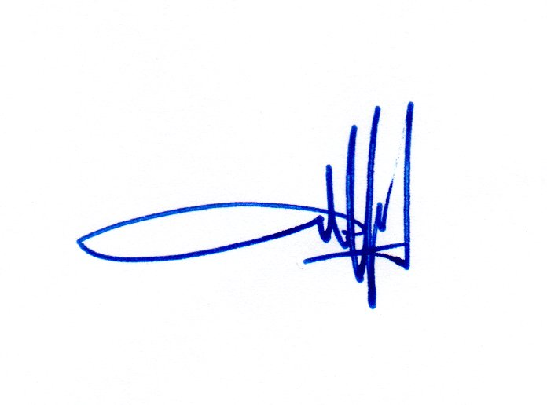

Sincerely,

Alfian Noviyanto

______________________________

**AUTHORSHIP STATEMENT**

We wish to submit an original research article entitled “high temperature failure of steel boiler tube secondary superheater in a power plant” for consideration by SINERGI.

All persons who meet authorship criteria are listed as authors, and all authors certify that they have participated sufficiently in work to take public responsibility for the content, including participation in the concept, design, analysis, writing, or revision of the manuscript.

|  |  |  |
| --- | --- | --- |
| **Author 1** |  |  |
| Name | : | Sulthoni Akbar |
| Affiliation | : | Department of Industrial Engineering, Faculty of Engineering, University of Nahdlatul Ulama Indonesia, Jl. Taman Amir Hamzah No. 5, Jakarta 10430, Indonesia  Nano Center Indonesia, Jl. PUSPIPTEK, South Tangerang, Banten 15314, Indonesia |
| Email Address | : | sulton.akbar@nano.or.id |
|  |  |  |
| **Author 2** |  |  |
| Name | : | Desrilia Nursyifaulkhair |
| Affiliation | : | Nano Center Indonesia, Jl. PUSPIPTEK, South Tangerang, Banten 15314, Indonesia |
| Email Address | : | desrilia@nano.or.id |
|  |  |  |
| **Author 3** |  |  |
| Name | : | Alfian Noviyanto |
| Affiliation | : | Nano Center Indonesia, Jl. PUSPIPTEK, South Tangerang, Banten 15314, Indonesia  Department of Mechanical Engineering, Mercu Buana University, Jl. Meruya Selatan, Kebun Jeruk, Jakarta 11650, Indonesia |
| Email Address | : | a.noviyanto@nano.or.id |
|  |  |  |
| **Author 4** |  |  |
| Name | : | Nurul Taufiqu Rochman |
| Affiliation | : | Research Center for Metallurgy and Materials, National Research and Innovation Agency, PUSPIPTEK, South Tangerang, Banten 15314, Indonesia |
| Email Address | : | nurul@nano.or.id |

**POTENTIAL REVIEWERS**

Please submit 3 (three) potential reviewers (*that have not listed in SINERGI*) to speed up the review process that competent for the topic and has a good reputation in that area.

|  |  |  |
| --- | --- | --- |
| **Reviewer 1** |  |  |
| Name | : | Prof. Sri Harjanto |
| Affiliation | : | Department of Metallurgy and Materials, University of Indonesia |
| Email Address | : | harjanto@metal.ui.ac.id |
|  |  |  |
| **Reviewer 2** |  |  |
| Name | : | Lukman Noerochim, M.Sc., Ph.D. |
| Affiliation | : | Department of Materials Engineering and Metallurgy, Sepuluh Nopember Institute of Technology |
| Email Address | : | lukman@mat-eng.its.ac.id |
|  |  |  |
| **Reviewer 3** |  |  |
| Name | : | Alvian Toto Wibisono, S.T., M.T. |
| Affiliation | : | Department of Materials Engineering and Metallurgy, Sepuluh Nopember Institute of Technology |
| Email Address | : | alviantotow@gmail.com |