IMPLEMENTATION OF BAYESIAN INFERENCE
MCMC ALGORITHM IN PHYLOGENETIC

Mirna Yunita¹, Rachmat Muwardi^{2*}, Zendi Iklima³
¹School of Computer Science and Technology, Beijing Institute of Technology, China
^{2, 3}Department of Electrical Engineering, Faculty of Engineering, Universitas Mercu Buana, Indonesia

Abstract  Dipterocarpaceae is one of the most prominent plant families, with more than 500 members of species. This family mostly used timber plants for housing, making ships, decking, and primary materials for making furniture. In Indonesia, many Dipterocarpaceae species have morphological similarities and are challenging to recognize in the field. This research will analyze the phylogenetic of Dipterocarpaceae based on the chloroplast matK gene. This research aims to use Bayesian inference to analyze the phylogenetics of the Dipterocarpaceae family. This research used the chloroplast matK gene instead of morphological characters. The analysis steps are collecting data, modifying the structure sequence name, sequence alignment, and constructing tree by using Markov Chain Monte Carlo (MCMC) method from Bayesian Inference, evaluating and analyzing the phylogenetic tree. The result showed that the Dipterocarpus genus is not from the Dipterocarpeae tribe.  This is an open access article under the CC BY-NC license   | Keywords:  Dipterocarpaceae;  Phylogenetic;  Bayesian inference;  Markov Chain Monte Carlo;  Article History:  Received: May 2, 2019  Revised: May 29, 2019  Accepted: June 2, 2019  Published: June 2, 2019  Corresponding Author:  Rachmat Muwardi  Electrical Engineering Department, Universitas Mercu Buana, Indonesia  Email: rachmat.muwardi@mercubuana.ac.id

INTRODUCTION
Dipterocarpaceae or Meranti group is one of the leading timber plants from tropical forests [1] [2]. The family member has big size and height until 70-85m. Dipterocarpaceae consist of three subfamilies: Dipterocarpoideae, Pakaraimoideae, and Monotoideae. This family also has 13 genera and 470 [3].
Indonesia's tropical forests have at least nine genera from the Dipterocarpaceae tribe. Among the many genera of Dipterocarpaceae, the genera found in Indonesia are Anisoptera (Mersawa), Cotylelobium, Dipterocarpus (Keruing), Dryobalanops (Kapur), Hopea (Giam), Parashorea, Shorea (Meranti), Vatica (Resak), and Upuna.
Dipterocarpaceae are known as closely related species. It is sometimes morphologically tricky to identify the member of the Dipterocarps family because of its similarity [4]. Each type has a different sequence of DNA bases, but in one type, the sequence is almost unchanged to be used as a unique marker of a particular type. A new way in modern taxonomy is using DNA barcoding. A short-standardized sequence (no more than 800 bp) that is able to delimit species is called DNA barcoding [5]. DNA barcoding is short standardized DNA (no more than 800 bp) used as a new tool to identify species. Moreover, DNA barcoding is about amplifying and sequencing the informative site of the DNA sequences.
The closely related organisms have similar characters that are difficult to differentiate. Dipterocarpaceae is well known for its closely related species, so these family members are difficult to identify by morphological characters. Chloroplast gene such as matK is commonly used to learn the relationship among plant species [6].
Bayesian inference is one of the very popular used in inferring phylogenetic relationships among species [7]. Bayesian estimation of phylogeny has become widely used by evolutionary biologists [8] [9] [10] [11] [7]. This method applies the Markov Chain Monte Carlo (MCMC) analysis to develop the best tree based on prior and posterior probability to strengthen the relationship between the posterior trees [12].
Maulida [13] conducted a phylogenetic study of the Dipterocarpaceae family based on the matK chloroplast gene. She constructed a phylogenetic tree of the Dipterocarpaceae family using another tree construction algorithm, the Neighbor-joining algorithm. In this study, a phylogenetic tree was constructed using another algorithm, namely the Bayesian Inference algorithm.
Another research was also conducted by [14]. The research was conducted using DNA sequences and the MCMC method using the Bayesian inference algorithm. This study carried out the MCMC process to analyze DNA sequences from nine primates and determine the maximum posterior probability value for all possible tree topologies.
Based on the description above, it is needed to analyze the phylogenetic relationship among the Dipterocarpaceae family to determine which species have a very close kinship with the Dipterocarpaceae tribe based on the phylogenetic tree that has been formed.

METHOD
The initial problem identified was that the grouping of the Dipterocarpaceae could not be done based on morphology alone because the morphological form of the tribe had a high degree of similarity between its sub-tribes. Then the algorithm used to build a phylogenetic tree was carried out to classify and see the level of the kinship of the Dipterocarpaceae tribe not based on morphology but based on the DNA sequences contained in each species.

Material
The data used in this study is sequence data from the Dipterocarpaceae sub-tribe, Dipterocarpoideae, which consists of the Dipterocarpaeae clan which has eight genera (Anisoptera, Cotylobeum, Dipterocarpus, Stemonoporus, Upuna, Ateria, Vateriopsis, and Vatica) and the Shorea family, which has five genera (Dryobalan, Hopea, Neobalanocarpus, Parashorea, and Shorea). One other species was taken from a different clan used as an outgroup, namely the Monotoidea.
We search for matK sequence data of the Dipterocarpaceae family from the NCBI database using BLAST (Basic Local Alignment System Tools) by entering one of the tribes from the Dipterocarpaceae tribe, Anisoptera, with the search query 'Anisoptera matK.' The results of this search found 100 sequences similar to the Anisoptera sequence. Next, several types are selected to be used as data. There were 38 Dipterocarpeae sub-family sequences were downloaded from the NCBI database. We put Monotes glaber from subfamily Monotoideae as an outgroup.

Phylogenetic Tree Construction
The phylogenetic tree was constructed using the sequence data. The sequence alignment process is carried out to see similarities between two or more homologous sequences [15]. Sequence alignment was done to get the homolog DNA using Clustal-W [16]. At the time of sequence alignment, gap processes occur, including substitution, deletion, and insertion, which result in sequence separation or what is known as a gap. Then we develop the phylogenetic tree using the alignment sequences by the Bayesian inference algorithm.
The branch length analysis is then calculated using the MCMC analysis method by setting important parameters to support the analysis process.

Bayesian Inference
The Bayesian method is generated from conditional probabilities, with two random parameters ( and ). Both are random variables with the combined density function . All information obtained in an event can be calculated based on the Bayesian formula in Equation 1.
(1)
The sample y observation comes from the density function , identical to the likelihood function in the equation. The likelihood function contains all sample information about . The combined density function Posterior is considered a new possibility that occurs accidentally when taking the probability . However, the posterior is still considered the original condition [12].

So that it is obtained:
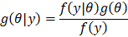
(2)

The Bayesian method has the advantage of updating the probability distribution to be close to the truth. The Bayesian method will find the best tree based on the posterior probability distribution among other trees.
In constructing a phylogenetic tree for the Dipterocarpaceae family, the Bayes method was used to look for new possibilities that could strengthen the possible kinship of 38 types of results from multiple sequence alignment.

MCMC
The MCMC algorithm is a class for sampling probability distribution by building a Markov chain in a particular stationary distribution [17]. This method will calculate the likelihood value in a phylogenetic tree. MCMC integrates the random variable t and the prior parameter. The integration of this method will be more efficient when compared to other numerical integration methods as an integral dimension [18]. The search process in the MCMC method uses the concept regarding the data set, then the trees that are allowed to be in one prospective term will converge (towards the same point) with each other. In other words, the selected group of trees will have a higher probability of explaining the phylogeny of the dataset than the other trees. In the MCMC context, a new tree is instead drawn from a suitable probability distribution over the candidate trees [19].
In the first stage, the Markov chain starts from a tree along with the estimated evolution parameters. The tree can be chosen randomly or made with estimates that describe the data well. In the second stage, a new tree
is proposed to replace . In the third stage, the proposed new tree will be accepted with probabilities in the equation:
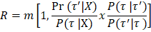

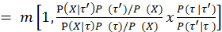
(3)
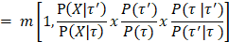

Where is the likelihood ratio,
is the prior ratio, and
is the proposal ratio. The results of the calculation in this third stage determine whether the posterior probability of the new status is better (uphill) or worse (downhill) than the current status.
As the MCMC chain moves following each proposal leading to areas with a high posterior probability value, the likelihood value increases rapidly, as shown in Figure 2. The initial phase of the MCMC chain with a low likelihood value is referred to as the burn-in phase. Samples in this burn-in phase are generally not used in the analysis or removed because the likelihood value is strongly influenced by the starting point of the MCMC chain.

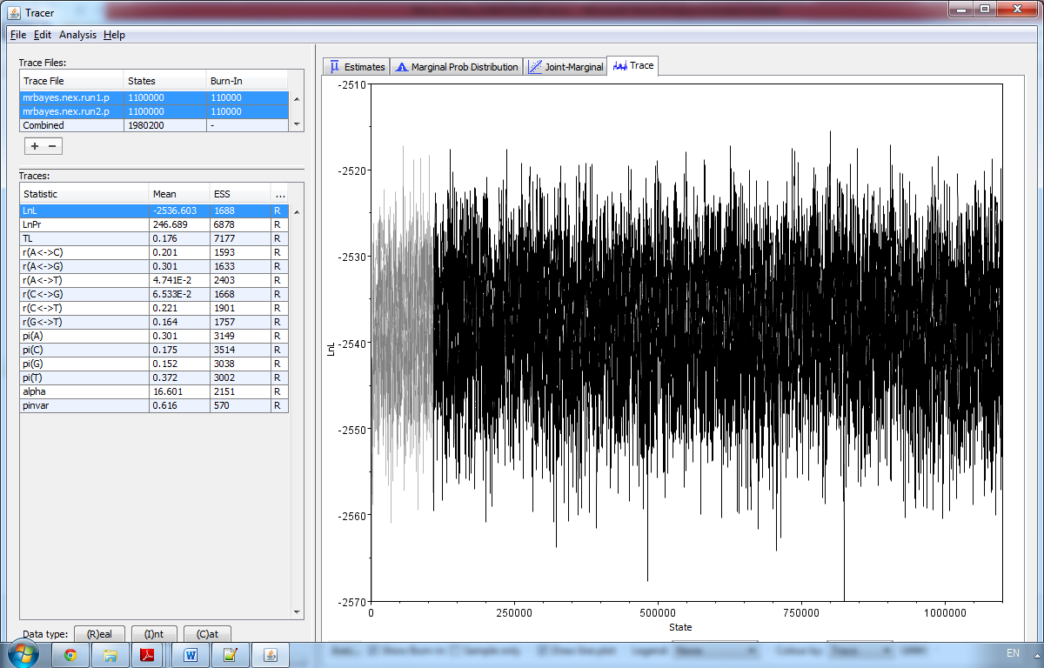
Figure 1. The burn-in phase marked

Figure 2. The burn-in phase marked with faded colors accounted for about 10% of the total posterior sample and was not included in the statistical analysis.
Trace plot graph of the MCMC chain visualized with the TRACER program [20]. The burn-in value that was not included was 25% of the total posterior sample.

RESULTS AND DISCUSSION
We use Mr. Bayes software [21] to generate the tree. Bayesian methods used the accuracy analysis by counting the branch length with MCMC analysis. According to [22], MCMC in the Bayesian method estimates the phylogenetic tree posterior based on the dataset. While using this method, the essential parameters are arranged to determine the prior and posterior and how many generations will be done based on iteration number.
After the likelihood and prior parameters are set, the next step is to set the MCMC parameter begins by setting the number of generations to be performed from the number of iterations, then set the number of samples. The MCMC method will stop analyzing until the review of the standard deviation value approaches the number 0.

Evolutionary relationship of Dipterocarpaceae using Bayesian inference algorithm
The tree construction using the Bayesian algorithm is divided into two monophyletic groups. One group is for tribe Shoreae, and one group is for Dipterocarpeae. However, from the cladogram, we see that the Dipterocarpus genus does not belong to the group of the Dipterocarpeae tribe. Dipterocarpus, based on morphological characters, is the basal group of the Dipterocarpeae tribe. Moreover, the Dipterocarpus genus is known as the basal of the Dipterocarpaceae family therefore the characters in this genus are very specific, and the name Dipterocarpaceae has come from this genus.
Our result is different from the former result based on the morphological characters. Where, in morphological character, Dipterocarpus is allied with the Dipterocarpeae tribe. According to [23], Dipterocarpus belong to the Dipterocarpeae tribe, which has chromosome number 11. The tree accuracy using the Bayesian algorithm can be seen from the branch length value. The branch length showed the evolutionary number of times. The construction time depends on the number of generations arranged from the Markov chain in the MCMC process. The construction results using the Bayesian algorithm can be seen in Figure 2.

Figure 2. Phylogenetic tree with Bayesian Inference algorithm

CONCLUSION
The tree construction result showed that three clades were formed from the phylogenetic tree—the first clade for the Shorea group, the second clade for Dipterocarpeae, and Dipterocarpus genera. The accuracy of the tree is based on the branch length. The most extended branch was for the Hopea genus, and the closest branch length is for the Dipterocarpus genus.
This is very different from the results of phylogenetic trees based on morphology [3]. The Dipterocarpus group does not belong to the Dipterocarpeae genus in bayesian trees.

ACKNOWLEDGMENT
The first special thanks go to Universitas Mercu Buana, Rachmat Muwardi and Zendi Iklima for their help and cooperation during this research. Providing unfailing support and continuous encouragement. Hopefully, the collaboration in publishing papers will continue in further research.

REFERENCES

[1] | Djarwanto, R. Damayanti, J. Balfas, E. Basri, Jasni, I. M. Sulastiningsih, A. Andianto, D. Martono, G. Pari, A. Sopandi, Mardiansyah and Krisdianto, Pengelompokan Jenis Kayu Perdagangan Indonesia, Bogor: Publisher: FORDA Press, 2017.
[2] | R. Hegnauer, Chemotaxonomie Der Pflanzen: Eine Ubersicht Uber Die Verbreitung Und Die Systematische Bedeutung Der Pflanzenstoffe - Band 4 - Dicotyledoneae: Daphniphyllaceae-Lythraceae, Birkhauser Verlag AG, 1966.
[3] | P. S. Ashton, "Flora Malesiana. Series I, Spermatophyta, Flowering plants. Vol. 9, part 2, Dipterocarpaceae," The Netherland, Sijthoff & Noordhoff International Publishers Alphen aan den Rijn, 1982.
[4] | A. B. Rangkuti, A. Susilowati, H. Arinah, L. Irmayanti, I. Z. Siregar and U. J. Siregar, "Identification of Shorea species based on leaf morphological character with multivariate analysis," IOP Conf. Series: Earth and Environmental Science, vol. 912, no. 1, p. 012084, 2021.
[5] | P. D. Hebert, A. Cywinska, S. L. Ball and J. R. deWaard, "Biological identifications through DNA barcodes," Proc Biol Sci, vol. 270, no. 1512, pp. 313-21, 2003.
[6] | C. C. d. M. Moura, F. Brambach, K. J. H. Bado, K. V. Krutovsky, H. Kreft, S. S. Tjitrosoedirdjo, I. Z. Siregar and O. Gailing, "Integrating DNA Barcoding and Traditional Taxonomy for the Identification of Dipterocarps in Remnant Lowland Forests of Sumatra," Plants, vol. 8, no. 11, p. 461, 2019.
[7] | F. F. Nascimento, M. d. Reis and Z. Yang, "A biologist’s guide to Bayesian phylogenetic analysis," Nat Ecol Evol, vol. 1, no. 10, pp. 1446-1454, 2017.
[8] | J. P. Huelsenbeck, F. Ronquist, R. Nielsen and J. P. Bollback, "Bayesian inference of phylogeny and its impact on evolutionary biology," Science, vol. 294, p. 2310–2314, 2001.
[9] | M. T. Holder and P. O. Lewis, "Phylogeny estimation: traditional and Bayesian approaches," Nat. Rev. Genet, vol. 4, p. 275–284, 2003.
[10] | Z. Yang and B. Rannala, "Molecular phylogenetics: principles and practice," Nat. Rev. Genet., vol. 13, p. 303–314, 2012.
[11] | Y. Ziheng, Molecular evolution: a statistical approach, Oxford: UK: Oxford University Press, 2014.
[12] | D. Spiegelhalter and K. Rice, "Bayesian statistics," Scholarpedia, vol. 4, no. 8, p. 5230, 2009.
[13] | U. Maulida, M. Subianto and E. Harnelly, "Phylogenetic Analysis of Dipterocarpaceae Using Neighborjoining Algorithm," in Managing Disaster and Environmental Issues with Sciences and Technologies towards Sustainable Development, In Proceedings of the 2nd International Conference on Natural and Environmental Sciences 2014 (ICONES 2014), Banda Aceh, Indonesia, 2014.
[14] | Z. Yang and B. Rannala, "Bayesian phylogenetic inference using DNA sequences: a Markov Chain Monte Carlo Method," Moleculer Biology and Evolution, vol. 14, no. 7, pp. 717-24, 1997.
[15] | X. Xia, "Sequence alignment," in Bioinformatics and the Cell, Springer, 2018, pp. 33-75.
[16] | M. Larkin, G. Blackshields, N. Brown, R. Chenna, P. McGettigan, H. McWilliam, F. Valentin, I. Wallace, A. Wilm, R. Lopez, J. Thompson, T. Gibson and D. Higgins, "Clustal W and Clustal X version 2.0," Bioinformatics, vol. 23, no. 21, pp. 2947-8, 2007.
[17] | A. Asriadi, "Simulasi Stokastik Menggunakan Algoritma Metropolis Hastings," MAP (Jurnal Matematika dan Pembelajaran) Jurusan Matematika FMIPA UNJ , vol. 6, no. 2, pp. 45-52, 2007.
[18] | F. George, Monte Carlo: Concepts, Algorithms, and Applications (Springer Series in Operations Research and Financial Engineering), New York: Springer-Verlag, 1996.
[19] | C. Zhang, J. P. Huelsenbeck and F. Ronquist, "Using Parsimony-Guided Tree Proposals to Accelerate Convergence in Bayesian Phylogenetic Inference," Systematic Biology, vol. 69, no. 5, p. 1016–1032, 2020.
[20] | A. Rambaut, A. J. Drummond, D. Xie, G. Baele and M. A. Suchard, "Posterior Summarization in Bayesian Phylogenetics Using Tracer 1.7," Syst Biol, vol. 67, no. 5, p. 901–904, 2018.
[21] | F. Ronquist, M. Teslenko, P. v. d. Mark, D. L. Ayres, A. Darling, S. Höhna, B. Larget, L. Liu, M. A. Suchard and J. P. Huelsenbeck, "MrBayes 3.2: efficient Bayesian phylogenetic inference and model choice across a large model space," Syst Bio, vol. 61, no. 3, pp. 539-42, 2012.
[22] | F. Lutzoni, M. Pagel and V. Reeb, "Major fungal lineages are derived from lichen symbiotic ancestors," Nature, vol. 411 , no. 6840, pp. 937-940., 2001.
[23] | S. Indrioko, O. Gailing and R. Finkeldey, "Molecular phylogeny of Dipterocarpaceae in Indonesia based on chloroplast DNA," Plant Systematics and Evolution, vol. 261, pp. 99-115, 2006.

