A FRAMEWORK OF SCOR MODEL IN RETAIL, MANUFACTURING, AND SERVICE INDUSTRIES IN CASE STUDY INDONESIA

Antonius Setyadi¹, Erry Rimawan², Ivan Kristianto³, Farida Elmi⁴, Puspita Eka Rohmah⁵
¹²³⁴⁵Mercu Buana University, Indonesia

Abstract  This article using approach a literature review study sourced from previous research and relevant to this research, namely the Supply Chain Operations Reference model. This study aims to give detailed information related to the Supply Chain Operations Reference model in the retail, manufacturing, and service industries in Indonesia and as a reference to find research gaps in further research. The results of the paper are the framework regarding the application of the Supply Chain Operations Reference model that can be collaborated with Sustainable Supply Chain Management methods, Key Performance Indicators, Analytical Hierarchy Process, Traffic Light System, and Lean Supply Chain. The conclusion of the paper is the Sustainable Supply Chain Management model can be collaborated with other methods. This study gives benefits for further research to add to the literature on the Sustainable Supply Chain Management model, describes supply chain performance for corporates in Indonesia, the use of research variables that are often used in the Sustainable Supply Chain Management model, the priority of attributes recommended for improvement to improve supply chain performance incorporates in Indonesia and a framework for implementing the Sustainable Supply Chain Management model that can be collaborated with other methods.  This is an open access article under the CC BY-NC license   | Keywords:  Literature Review;  Framework; SCOR;  Article History:  Received:  Revised:  Accepted:  Published:  Corresponding Author:  Ivan Kristianto  Magister Teknik Industri, Mercu Buana University, Indonesia  Email: ivan.kristianto16@gmail.com

INTRODUCTION (R: 31, G: 78, B: 121)
Currently, corporates must have the ability to compete in similar industries so that they can grab market share and obtain profits. Competition is viewed from the aspect of how corporates implement processes in producing products or services that are better, faster, and cheaper than their competitors. The way to increase the corporate's competitiveness is through the integration of the corporate's supply chain activities [1].
A supply chain is a network of corporates that work together to create and deliver a product to the end-user. The corporate usually consists of suppliers, manufacturers, distributors, and supporting corporates such as logistics service corporates [2].
Corporates are required to think creatively in implementing competitive strategies through the production of higher quality and cheaper goods or services. Supply chain performance measurement must be implemented to increase competitiveness Supply chain performance measurement is a corporate performance measurement system that can help monitor the applications of supply chain management (SCM) so that they run well [3].
The government makes regulations, namely Law No. 3 the year of 2014 about the industry's obligation to make plans for the use of natural resources starting from product design, production processes, waste treatment, and optimization of product waste. Based on existing regulations and demand levels, then Sustainable Supply Chain Management (SSCM) needs to be applied. SSCM is an integration of sustainable environmental, financial and social aspects in the supply chain [4].
The SCOR (Supply Chain Operations Reference) method is a method for measuring the performance of a corporate’s supply chain. SCOR splits the supply chain process becomes five processes, namely the planning process (plan), procurement process (source), production process (make), delivery process (delivery), and return process (return) [3]. The SCOR model consists of five main performance attributes, namely reliability, responsiveness, agility, cost, and asset management [5].
This article using approach a literature review study sourced from previous research and relevant to this research, namely the Supply Chain Operations Reference model. This article can be used to reference to find research gaps in further research. The systematic literature review in this article was conducted to identify the development of the SCOR (Supply Chain Operations Reference) model in the retail, manufacturing, and service industries in Indonesia.
The difference between this research and previous research is the previous research, have not seen the SCOR model as an interesting thing to collaborate with many methods. This research is interesting and important to do because it informs a framework for the SCOR model that is collaborated with various methods, ranging from methods of measuring company supply chain performance to methods of determining improvement strategies.
This study aims to give detailed information related to the SCOR (Supply Chain Operations Reference) model in the retail, manufacturing, and service industries in Indonesia and as a reference to find research gaps in further research.

METHOD
This article using approach a literature review study to identify the development of the SCOR (Supply Chain Operations Reference) model in the retail, manufacturing, and service industries in Indonesia. Materials and methods contain the number of articles to be reviewed, sources of literature review, the steps of systematic literature review (SLR) were used in this literature review, process of making SCOR model. The following are the material and methods of this research.

Material And Methods
This paper conducts a literature review study sourced from previous research on the SCOR (Supply Chain Operations Reference) model to find research gaps in research. Literature The reviewed review consisted of 50 articles relevant to the SCOR (Supply Chain Operations Reference) model. The 50 articles used were from Google Scholar. The framework of this research can be seen in Figure. 1:

Figure 1. Study Framework of SCOR Model

The steps of systematic literature review (SLR) were used in this literature review. The process flow of SLR is shown in Figure 1. The complete methodology of this study follows six steps that include collecting relevant of the SCOR (Supply Chain Operations Reference) model, reading relevant articles (The SCOR model-based). Classify articles becomes the chart, map of aspect future research framework, and make systematically review the SCOR (Supply Chain Operations Reference) model. The process of making SCOR model can be seen in figure 2.
Figure 2. Process of Making SCOR Model

The process of making SCOR models integrate the well-known concepts of business process reengineering, benchmarking, and process measurement into a cross-functional framework. Business process engineering in essentially captures complex processeswhat is happening now and is defined desired process. Benchmarking activities for get operational performance data from similar companies, internal targets then determined based on best-in-class performance obtained. Best practice analysis choose the best way used to get performance which are expected. Then added one element as the goal of the three that element. Process measurement serves to measure, control and improve supply processes
chain.

RESULTS AND DISCUSSION
The systematic literature review in this article was conducted to identify the development of the SCOR (Supply Chain Operations Reference) model in the retail, manufacturing, and service industries in Indonesia. In this table 1, each manuscript has been analyzed using different factors like paper identity, research object, and result.
Now, The SCOR (Supply Chain Operations Reference) model is widely used across corporates in retail, manufacturing, and services industries in Indonesia. The SCOR model analyzes their supply chain performance systematically, improves communication among members in the supply chain, and designs better supply chain networks. Mapping Project of SCOR can be seen in Table.1
Table 1. Mapping Project of SCOR
No | Paper  Identity | Research  Object | Result
1. | Kusrini et al. [6] | in a Retail in Indonesia | Halal indicators consist of 22 valid performance metrics.  Supply chain performance is included in the excellent category (91.4). The corporate still has to make improvements, especially in terms of flexibility and reliability.
2. | Hasibuan et al. [3] | PT. Shamrock Manufacturing Corpora | The indicator consists of 12 valid performance metrics. Supply chain performance of PT. Shamrock Manufacturing Corpora is included in the good category (50-100). Attribute responsiveness (0.649) is a priority for improvement because it has the highest weight.
3. | E. Kusrini et al. [7] | A Leather SME | The indicator consists of 48 valid performance metrics. The supply chain performance of this corporate is in the average category (54.29). The agility attribute is a priority for improvement because it has the performance lowest value attribute (9,09).
4. | Waaly et al., [8] | A Leather Tanning Industry | The indicator consists of 8 valid performance metrics. This corporate’s supply chain performance is in the marginal category (44.37). the responsiveness attribute is a priority improvement because has the highest weight value (0.257).
5. | Saputra et al., [9] | at Table Tennis Table Manufacturer | The indicator consists of 21 valid performance metrics. The corporate's supply chain performance is in a good category (72.09). The cost attribute is a priority for improvement because it has the lowest attribute performance value (6.93).
6. | Pulansari & Putri, [10] | Steel Corporate | The indicator consists of 16 valid performancemetrics. The corporate's supply chain performance is in the average category (67.73). The reliability attribute becomes a priority for improvement because of the value of its own lowest normalization (38).
7. | Rakhman et al., [11] | Automotive corporate | The indicator consists of 9 valid performance metrics. The supply chain  performance of this corporate is in a good category (76). The cost attribute is a priority for improvement because it has the highest weight value (71).
8. | Wulandari et al., [12] | Producer of Catfish Frozen Food | The indicator consists of 19 valid performance metrics. The corporate's supply chain performance is in the excellent category (91.24). The asset management attribute is a priority for improvement because it has the lowest attribute performance value (0.033).
9. | Djatna et al., [13] | Palm Oil Industry | The indicator consists of 18 valid performance metrics. This corporate's supply chain performance is categorized as poor (64).  The agility attribute becomes  improvement priority because it has the lowest weight value  lowest (4).
10. | Kusrini et al., [14] | In Supermarket | The indicator consists of 28 valid performance metrics. The corporate's supply chain performance is in a good category (80.64). The responsiveness attribute is a priority improvement because it has a normalized value  lowest (50).
11. | Ranggadara & Sfenrianto, [15] | A Fashion Trade Business | The indicator consists of 10 valid performance metrics. The corporate's supply chain performance is in the average category (62.61). The asset management attribute is a priority for improvement because it has the lowest attribute performance value (0.067).
12. | Effendi et al., [16] | Sugar industries | The indicator consists of 17 valid performance metrics. The corporate's supply chain performance is in the average category (56.12) the waste management attribute is a priority for improvement.
13. | Novar et al., [17] | Indonesian Bureau of Logistics | The indicator consists of 17 metrics valid performance. The corporate's supply chain performance is in the average category Industry marginal category (67.56). The reliability attribute becomes a priority for improvement because it has the highest weight value (0.593).
14. | Sutoni et al., [18] | PT. BRS | The indicator consists of 32 valid performance metrics. The supply chain performance of this corporate is in a good category (80.48). the reliability attribute becomes a priority for improvement because it has the lowest attribute performance value (5.42).
15. | Kusrini et al., [19] | SME Producing Sports Clothes | The indicator consists of 27 valid performance metrics. The  corporate's supply chain performance is in a good category (77.89). the cost attribute is a priority for improvement because it has the lowest attribute performance value (40).
16. | Fauziyah et al., [20] | Food and beverage corporates | The indicator consists of 15 metrics valid performance. The corporate’s supply chain performance is in a good category (72.73). The responsiveness attribute is a priority improvement because it has the lowest attribute performance value (70.78).
17. | Immawan & Nugraha, [21] | Oil and gas upstream industry | The indicator consists of 17 metrics valid performance. The corporate's supply chain performance is in a good category. The reliability attribute is a priority for improvement.
18. | Anham et al., [22] | The Maintenance Repair and Overhaul (MRO) Industry | The indicator consists of 35 valid performance metrics. The  corporate's supply chain performance is in a good category (89.23). the agility attribute becomes a priority for improvement because it has the highest weight value (0.363).
19. | Yuniaristanto et al., [23] | The Lithium Battery Factory | The indicator consists of 26 valid performance metrics. The  corporate's supply chain performance is in the average category (65.13). the responsiveness (50) and agility (50) attribute become a priority for improvement because it has the lowest attribute performance value.
20. | Sudrajat et al., [24] | Manufacturers of coated and painted steel | The indicator consists of 28 valid performance metrics. The  corporate's supply chain performance is in a good category (88.14). the responsiveness attribute becomes a priority for improvement because it has the lowest attribute performance value (57).
21. | Makkarenn et al., [25] | Palm Sugar Industry | The indicator consists of 19 valid performance metrics. The  corporate's supply chain performance is in the marginal category (46). the flexibility attribute becomes a priority for improvement because it has the highest weight value (0.194).
22. | Hasibuan & Dzikrillah, [2] | Indonesia Chemical Industry | The indicator consists of 28 valid performance metrics. The supply chain performance of this corporate is in the good category (60-80). responsiveness attribute becomes a priority for improvement because it has the lowest attribute performance value (37).
23. | Defrizal et al., [26] | Rice Milling Unit | The indicator consists of 9 valid performance metrics. The  corporate's supply chain performance is in the average category (64). The reliability attribute becomes a priority for improvement because it has the highest weight value (0.99).
24. | Alfaliansyah & Maswadi, [27] | The Coconut Industry | The indicator consists of 6 valid performance metrics. The  corporate's supply chain performance is in the average category (64). The reliability attribute becomes a priority for improvement.
25. | Handayani & Setyatama, [28] | Green Avenue Apartments of East Bekasi | The indicator consists of 17 valid performance metrics. The  corporate's supply chain performance is in a good category (75.44). The reliability attribute becomes a priority for improvement.
26. | Maulidah et al., [29] | Potato Agro-Industry | The indicator consists of 18 valid performance metrics. The  corporate's supply chain performance is in the average category (55.7). Asset management attributes are a priority for improvement.
27. | Desparita et al., [30] | Large Scale Rice Refineries | The indicator consists of 19 metrics valid performance. The corporate’s supply chain performance is in the average category (53.95). The cost attribute is a priority improvement because it has the lowest attribute performance value (4.10).
28. | Wahyuni et al., [31] | Tempeh crackers | The indicator consists of 15 metrics valid performance. The corporate’s supply chain performance is in the marginal category (45.94). The reliability attribute is a priority improvement because it has the lowest normalized value (0).
29. | Suseno & Sulistyowati, [32] | Produces batteries | The indicator consists of 9 metrics valid performance. The corporate’s supply chain performance is in the average category (69.18). The asset management attribute is a priority improvement because it has the lowest attribute performance value (2.18).
30. | Anthara & Damayanti, [33] | The shoe industry | The indicator consists of 13 valid performance metrics. The supply chain performance of this corporate is in a good category (75). The asset management attribute is a priority for improvement because it has the lowest attribute performance value.
31. | Susanto et al., [34] | A Batik Corporate | The indicator consists of 25 metrics valid performance. The corporate’s supply chain performance is in the average category (69.98). The reliability attribute is a priority improvement because it has the lowest attribute performance value.
32. | Miharja et al., [35] | Borondong Industry SMEs | The indicator consists of 12 metrics valid performance. The corporate’s supply chain performance is in the average category. The asset management attribute is a priority improvement because it has the lowest attribute performance value.
33. | Raga et al., [36] | Pharmaceutical Corporate | The indicator consists of 51 metrics valid performance. The corporate’s supply chain performance is in the excellent category (96.51). The cost attribute is a priority improvement because it has the lowest attribute performance value (25).
34. | Dianawati & Zamzamy, [37] | Automotive corporates | The indicator consists of 29 metrics valid performance. The corporate’s supply chain performance is in the average category (82.14). The reliability attribute is a priority improvement.
35. | Kodrat et al., [38] | Passion fruit agro-industry | The indicator consists of 9 metrics valid performance. The corporate’s supply chain performance is in the average category (78.69). The reliability attribute is a priority improvement because it has the highest weight value (0.38).
36. | Prasetyaningsih et al., [39] | A Plastic Corporate | The indicator consists of 28 metrics valid performance. The corporate’s supply chain performance is in the average category (68.23). The reliability attribute is a priority improvement because it has the lowest attribute performance value (0).
37. | Afianto et al., [40] | The Soybean Agroindustry | The indicator consists of 7 metrics valid performance. The corporate’s supply chain performance is in a good category (85.67). The cost attribute is a priority improvement because it has the highest weight value (0.286).
38. | Putridewi et al., [41] | the Cement Industry | The indicator consists of 18 metrics valid performance. The corporate’s supply chain performance is in a good category (77). The reliability attribute is a priority improvement because it has the lowest attribute performance value (-1.93).
39. | Ramadheena et al., [42] | At SME Tosuka Coffee | The indicator consists of 24 valid performance metrics. The  corporate's supply chain performance is in a good category (86.24). Asset management attributes are a priority for improvement because they have attribute performance values lowest (4).
40. | Henry & Nusraningrum, [43] |  | The indicator consists of 13 metrics valid performance. The corporate’s supply chain performance is in the average category (67.95). The reliability attribute is a priority improvement because it has the lowest attribute performance value (8.92).
41. | Suryaningrat et al., [44] | Ribbed Smoke Sheet Industry | The indicator consists of 24 metrics valid performance. The corporate’s supply chain performance is in a good category (72.03). The reliability and flexibility attribute is a priority improvement because it has the lowest attribute performance value (9.67).
42. | Wibowo et al., [45] | Building construction project | The indicator consists of 4 metrics valid performance. The corporate’s supply chain performance is in the marginal category (49). The reliability and responsiveness attribute is a priority improvement because it has the lowest attribute performance value.
43. | Kuswandi et al., [46] | Leather Tanning Industry | The indicator consists of 13 metrics valid performance. The corporate’s supply chain performance is in a good category (80.09). The cost attribute is a priority improvement because it has the lowest attribute performance value (11).
44. | Taptajani et al., [47] | Business Red Press | The indicator consists of 12 metrics valid performance. The corporate’s supply chain performance is in a good category (74). The asset management attribute is a priority improvement because it has the lowest attribute performance value (60).
45. | Nuraina et al., [48] | a dairy farmer cooperative | The indicator consists of 9 metrics valid performance. The corporate’s supply chain performance is in the excellent category (98.94). The responsiveness attribute is a priority improvement because it has the lowest attribute performance value (11.73).
46. | Permata et al., [49] | Oil Palm Biomass | The indicator consists of 13 metrics valid performance. The corporate’s supply chain performance is in the average category (67.83). The reliability attribute is a priority improvement because it has the lowest attribute performance value (41.4).
47. | Adriant et al., [50] | Defense Corporate | The indicator consists of 19 metrics valid performance. The corporate’s supply chain performance is in a good category (86.54). The reliability attribute is a priority improvement.
48. | Husna et al., [51] | the Skipjack Tuna fishing industry | The indicator consists of 18 valid performance metrics. The corporate's supply chain performance is in the average category (64.2). The cost attribute is a priority for improvement.
49. | Kusrini et al., [52] | Sugar Corporate | The indicator consists of 45 metrics valid performance. The corporate’s supply chain performance is in a good category (70.94). The asset management attribute is a priority improvement.
50. | Asrol et al., [53] | Sugarcane Agroindustry | The indicator consists of 14 metrics valid performance. The corporate’s supply chain performance is in a good category (79.01). The asset management attribute is a priority improvement because it has the highest weight value (1.26).

Figures 3,4,5,6,7,8 and 9 are the results of a review of 50 articles in a graphic form consisting of the year the article was published, the article publisher, the object of research, the level of supply chain performance in industry in Indonesia, research variables, priority performance attributes that need to be improved, and the methods used in previous research.
The year of publication for the 50 articles reviewed consists of 2018-2021 for the country of Indonesia. Article publishers consist of 36 publishers, with the majority coming from IOP Conference Series: Materials Science and Engineering. The research object consists of 3 objects, namely the retail, manufacturing, and service industries. The majority of supply chain performance levels in Indonesia are in a good category.
The research variables consist of 28 variables, with the majority of the 5 variables often used in the SCOR model, namely plan, source, make, deliver, and return. The performance attribute priority that needs to be improved is the reliability attribute. The method used by previous research is 17 methods consisting of Supply Chain Operations Reference (SCOR), AHP (Analytical Hierarchy Process), KPI (Key Performance Indicator), TLS (Traffic Light System), GSCM (Green Supply Chain Management), Fuzzy AHP, Lean Supply Chain, DMAIC, OMAX, SSCM (Sustainable Supply Chain Management), System Dynamics Modeling, Dematel, ANP (Analytical Network Process, IPA (Importance Performance Analysis), Fuzzy HOR, and OWA (Ordered Weighted Average). This method can be used as an illustration to see how the SCOR model can collaborate with other methods.
The application of the SCOR model based on literature review studies in previous studies showed varying results. All industries can find out the description of supply chain performance categories in Indonesia and know the performance attributes that are the priority for improvement as a step to carry out strategies. Improvement strategies can be used to improve supply chain management performance in the corporate.
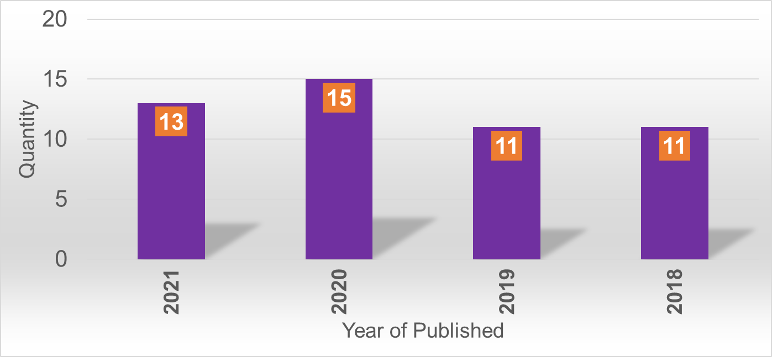
Figure 3. Year of Publisher
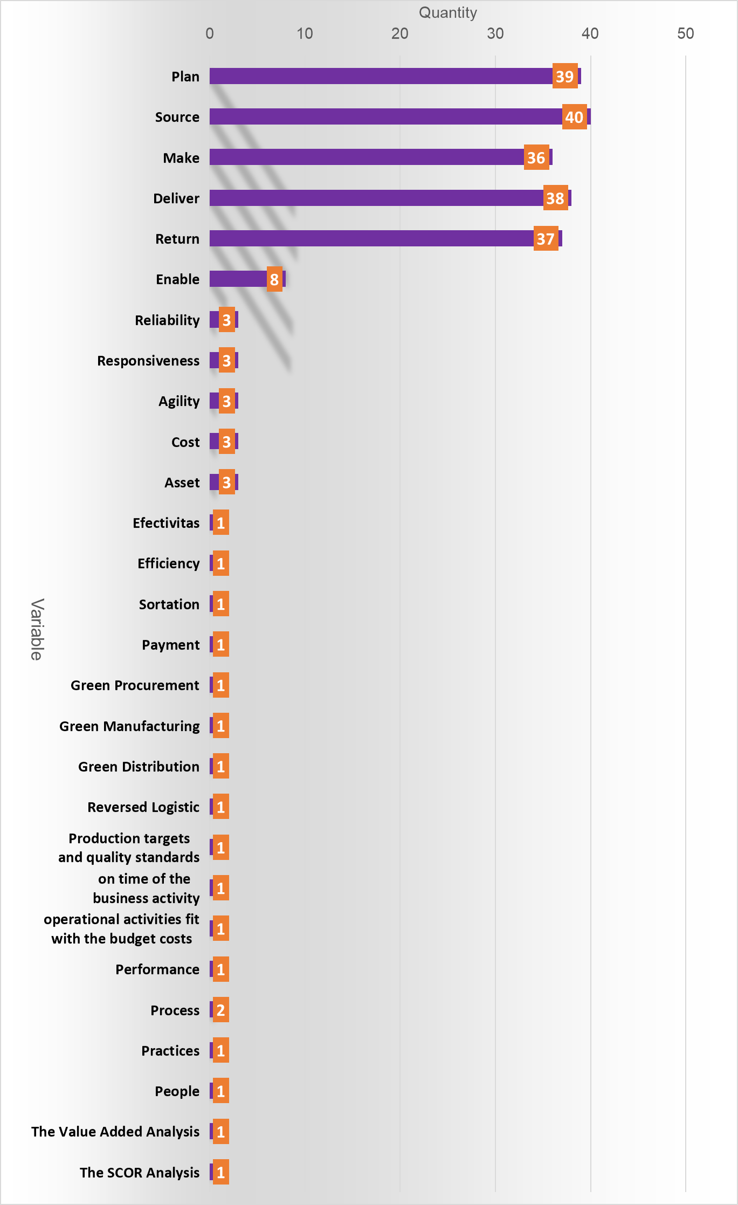
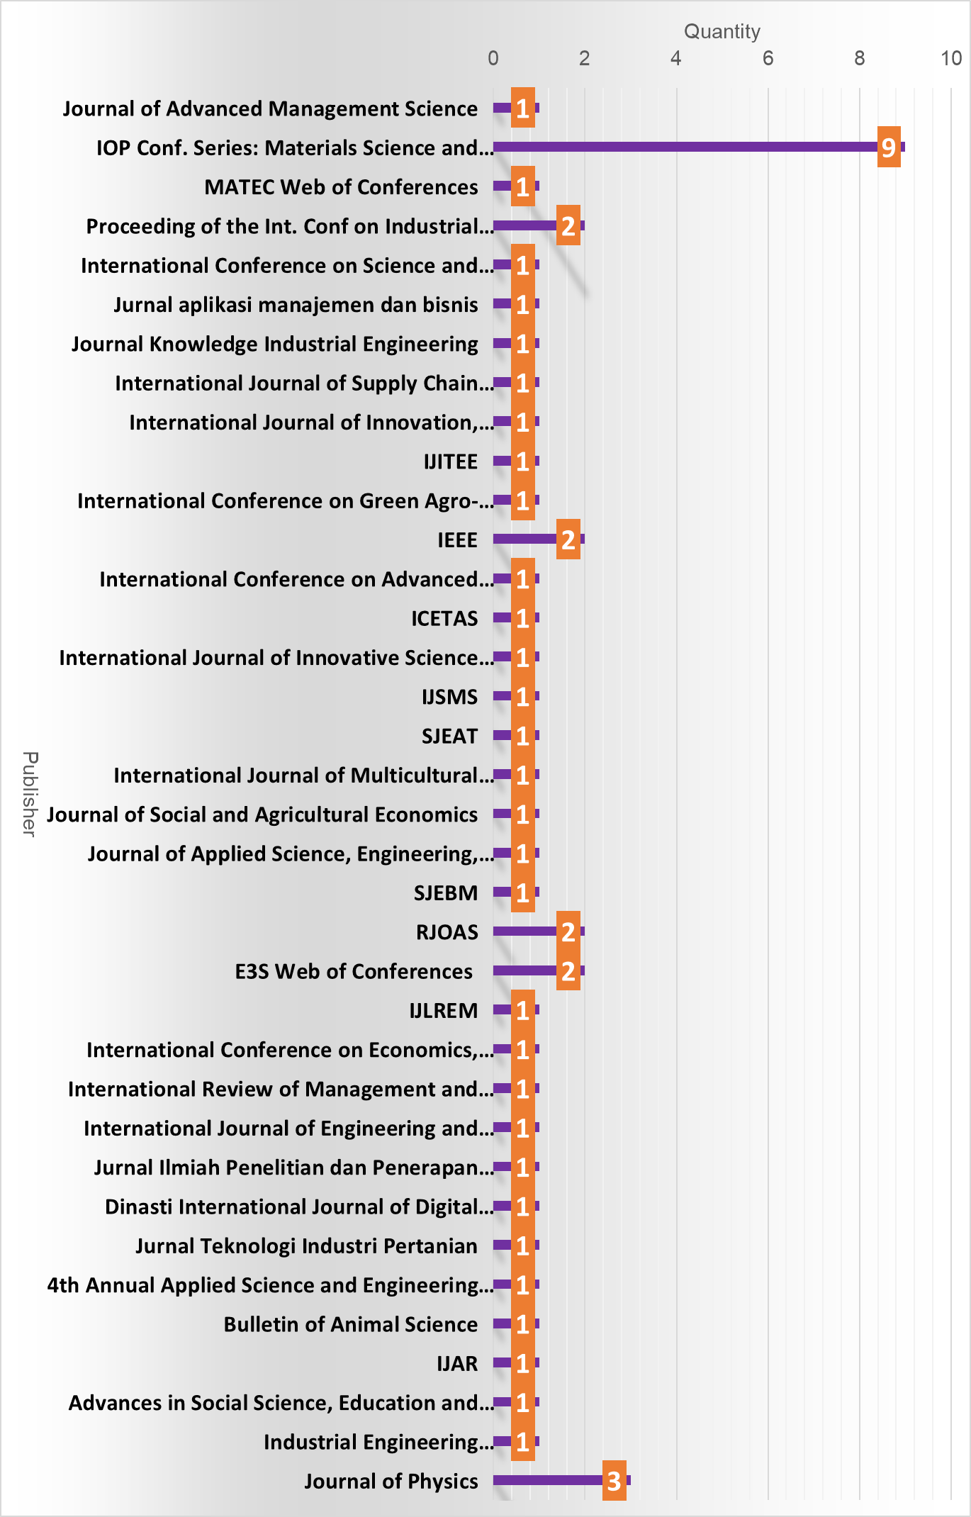

Figure 4. Research of Publisher
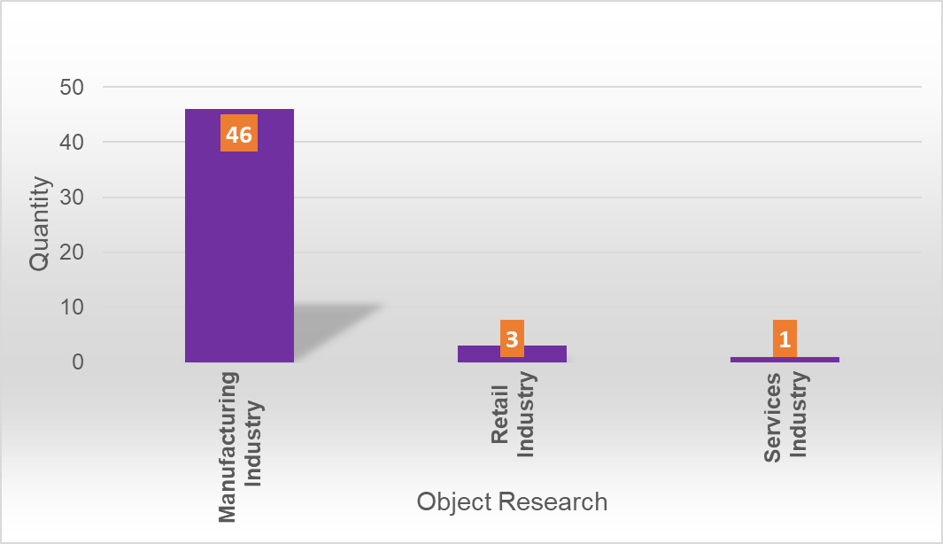Figure 5. Object Research

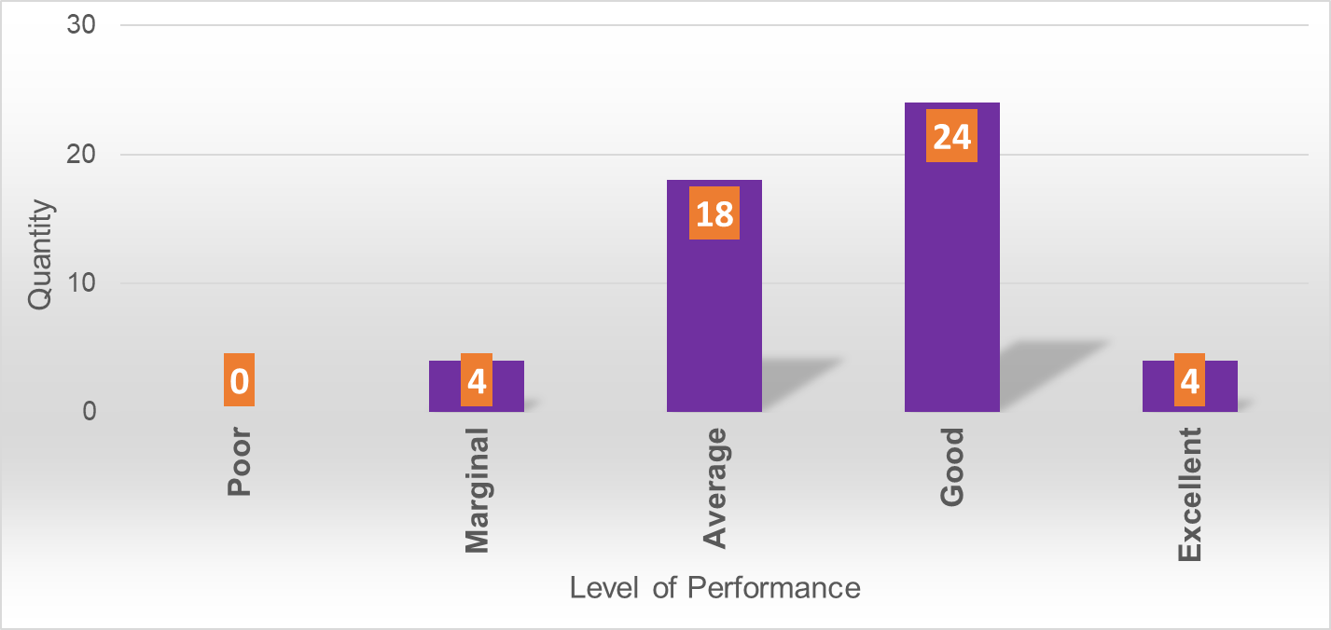
Figure 6. The Level of Performance Supply Chain in Indonesia

Figure 7. Variable Research

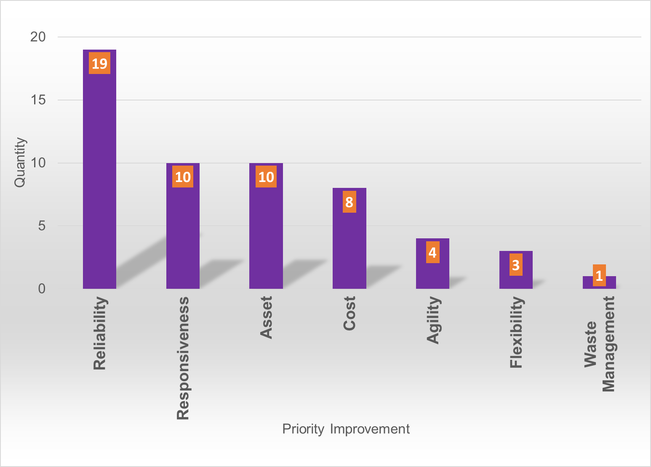

Figure 8. Priority Improvement
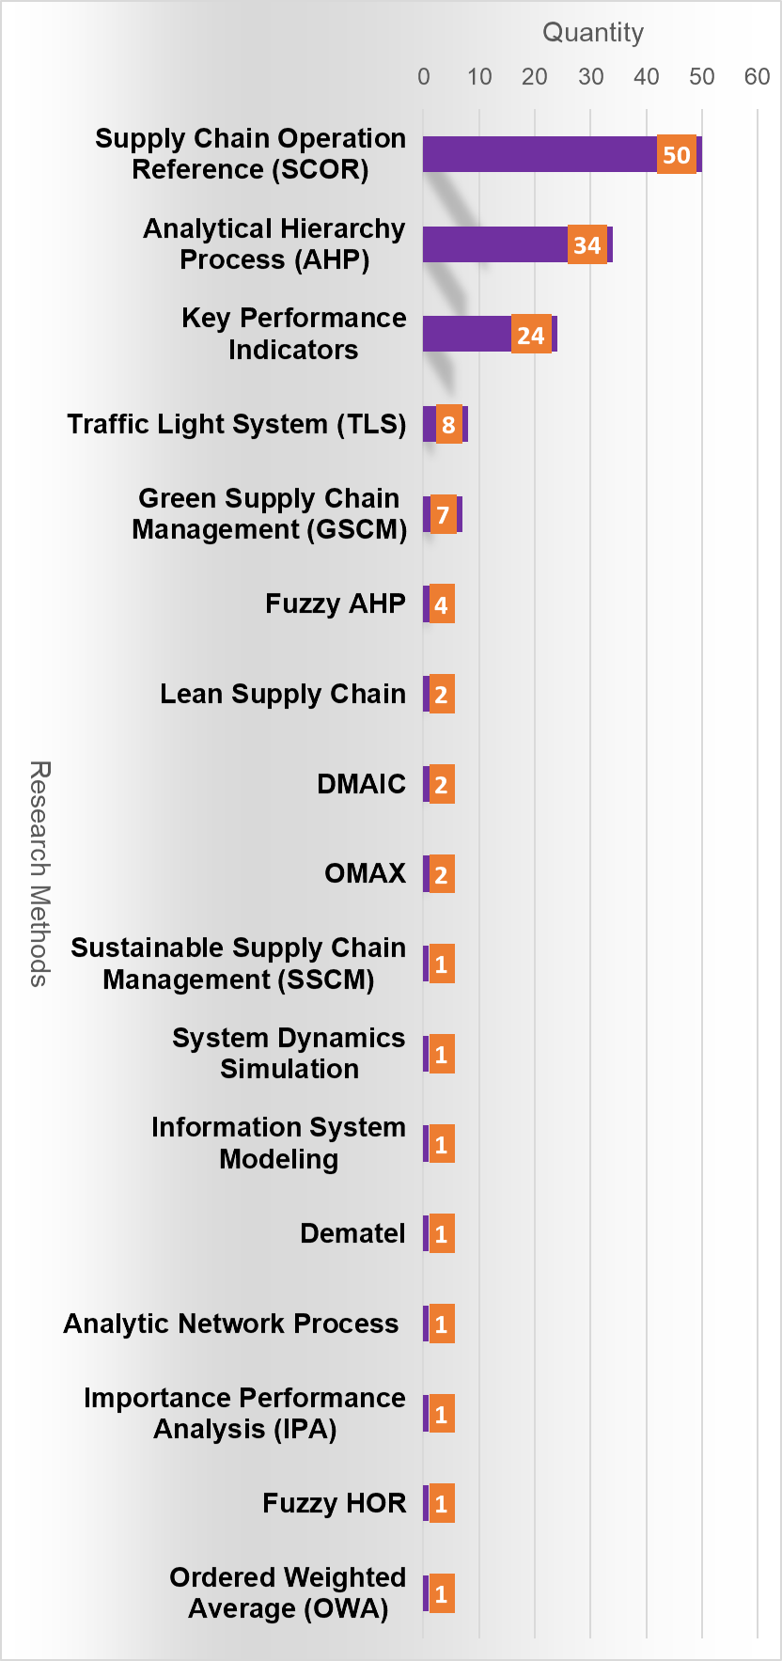

Figure 9. The Method Used in Previous Research

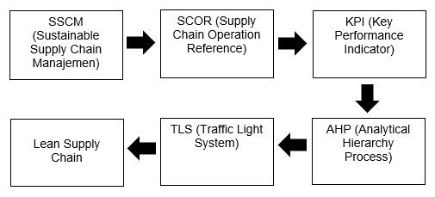
Figure 20. Number and Figure Caption

This study found a research gap that can be used for further research. Results. The research is in the form of a framework regarding the application of the SCOR model that can be collaborated with other methods. The SCOR model can collaborate with SSCM (Sustainable Supply Chain Management). SSCM is the integration of sustainable financial, environmental and social aspects of an organization's achievements through its business processes to improve its economic performance and supply chain [54].
Regulations and changes require the industry to implement aspects of SSCM (Sustainable Supply Chain Management). The application of SSCM requires determining the goals that the corporate wants to achieve for the application of a sustainable supply chain. Stakeholders are tasked with determining the corporate's goals based on the corporate's needs. The SCOR model contains a mapping of three hierarchical levels (considering sustainability aspects), namely level 1 in the form of business processes, level two in the form of attributes, and level 3 in the form of metrics.
The SCOR model produces a sustainable Key Performance Indicator (KPI) to monitor and measure the corporate's performance in sustainable application. Sustainable KPIs are determined to measure the corporate's achievements in implementing sustainable supply chains. Ongoing KPIs are verified to determine Valid and invalid KPIs. A valid sustainable KPI is the KPI that will be used because it is relevant to the corporate's conditions. KPIs that can be applied in the industry are then weighted using the AHP (Analytical Hierarchy Process).
The weighting of KPIs is calculated using Snorm De Boer performance by normalizing each KPI. After knowing the performance of the corporate's supply chain, the TLS (Traffic Light System), is used to identify KPIs that need improvement. The Traffic Light System is green for results above 80 (>80), yellow for results between 60-79, and red for results below 60 (<60). Colored lights the red flag can be used as a benchmark for KPIs that need to be improved [24]. The proposed improvement strategy recommendations are based on Lean Supply Chain principles. Lean can improve production processes not only on the shop floor but also in design and development by applying process rigor [22].

CONCLUSION
The systematic literature review in this article was conducted to identify the development of the SCOR (Supply Chain Operations Reference) model in the retail, manufacturing, and service industries in Indonesia. The results of the paper are the framework regarding the application of the SCOR model that can be collaborated with other methods. The SCOR model can collaborate with SSCM (Sustainable Supply Chain Management)methods, KPI (Key Performance Indicators), AHP (Analytical Hierarchy Process), TLS (Traffic Light System), and Lean Supply Chain.
The application of the SCOR model based on a literature review study showed varying results. All industries can find out how big the corporate's supply chain performance is and know the performance attributes that are priority improvements to improve supply chain performance in industries in Indonesia.
The prospects from this article are gives benefits for further research to add to the literature on the SCOR model, describes supply chain performance for corporates in Indonesia, the use of research variables that are often used in the SCOR model, the priority of attributes recommended for improvement to improve supply chain performance incorporates in Indonesia. , and a framework for implementing the SCOR model that can be collaborated with other methods.

ACKNOWLEDGMENT
This research was supported/partially supported by [Name of Foundation, Grant maker, Donor]. We thank our colleagues from [Name of the supporting institution] who provided insight and expertise that greatly assisted the research, although they may not agree with all of the interpretations/conclusions of this paper.

REFERENCES

