A REVIEW TOWARDS FRICTION STIR WELDING TECHNIQUE: WORKING PRINCIPLE AND PROCESS PARAMETERS

Rikko Putra Youlia^{1*}, Diah Utami², Dedik Romahadi³, Yang Xiawei⁴
^{1,4}Major of Materials Processing Engineering, School of Materials Science and Engineering, Northwestern Polytechnical University
²Department of Industrial Engineering, Faculty of Engineering, Universitas Mercu Buana
³Department of Mechanical Engineering, Faculty of Engineering, Universitas Mercu Buana

Abstract  The friction force has been micro-structurally tested to reformat or transform the inner state of the structure properties (atomic formation) form in a metal since the kinetic energy of friction has been utilizing on one of welding techniques. Right afterwards, the studies reported that the mechanical properties also underwent a significant deformation. As it develops pass through research and applied experiments the branch of friction-based welding discipline can be classified depends on how the mechanism of friction can be producing the finest solid-state joint which suitable to the typical property of a metal and be maximized by joint configuration. Friction Stir Welding is one of friction-based welding techniques that utilizes the stirring tool to generate friction while the work-pieces is stick on the line of FSW joint configuration. In this review, the explanation of working principle and clarification of process parameters are presented. The cited references are selected from creditable and verifiable articles and books in the recent ten years. Expectedly, be able to pioneer a new face of simply and understandable review article.  This is an open access article under the CC BY-NC license   | Keywords:  Friction Stir Welding, Process parameters, Tool design, FSW joint configuration, Positive and negative limitations.  Article History:  Received:  Revised:  Accepted:  Published:  Corresponding Author:  Rikko Putra Youlia  School of Materials Science and Engineering, Northwestern Polytechnical University  Email: rikkoputra@mail.nwpu.edu.cn

INTRODUCTION
Back to the history of FSW was initially identified in 1991 located in the UK, Cambridge, a group of researchers from The Welding Institute (TWI) chaired by Wayne Thomas invented a novel welding technique that strongly unique, because they revealed that the welding process itself does not melt the work-pieces and be able to produce a fine joint with less than 10% of residual defects caused by welding process [1], the welding technique then initially named as Friction Stir Welding (FSW). FSW technique was initially applied to weld aluminum alloys due to its ability that be able to avoid crucial problems of fusion welding technique can make such as hot cracking, porosity, element loss, etc. Since then, FSW becomes a trending discussion that leads an increasing number of its developments and research parallel with its associated novel technologies in many manufacture companies especially in automobile, aeronautics, aerospace, ship-building sectors, research institutes and universities investing heavily and vigorously in the process and many international conference series dedicated and attributed to its study.
Based on the joint product that FSW can be produced, FSW categorized as a solid-state welding technique and a novel friction-based welding. Moreover, FSW is nominated as a green technology [2] due to it process property that reminds energy efficiency and environmentally friendly. Also, no gases are evolved and there are no toxic fumes or smoke produced. In particular, the most distinguished amongst FSW with other friction-based welding is that the friction mediator of FSW utilizes a non-consumable tool that specifically engineered to be able to create thermal and material flow dynamics.
Plenty of creditable paperwork from eligible authors that published in the top-ranked journal have studied and reported multitudinous aspects associated with FSW inter alia the process principle & parameters, the joint performance, techniques technology novelty, numerical analysis & simulation, etc. In this review the emphasis pointed on the actual working principle, a complete process parameter, several of most used types of tools design, common joints configuration with literature method and as the conclusion the outlook remarks is summarized.

THE PROCESS OF FSW
Many of eligible authors in FSW direction have been elaborately revealing the working principle of FSW joining technique from simple up to detail understandings in their written works. R. S. Mishra [3] is one of the best experts in FSW with his colleagues re-explains that the fundamental idea of the FSW mechanism simply divided into 3 phases that are drilling, traversing and retracting. More detailed, the illustration of basic setting-up can be schematically drawn in Figure 1. During the process is conducting the work-pieces then oriented onto 2 sides of perspective which corresponding on the knowledge direction of tool rotation and the travel, where the tool rotation way vertically with the tool travel direction (opposite orientation of atoms flow diffusion) named as advancing side and where the tool rotation is contrary towards the tool travel direction (parallel to the orientation of atoms flow diffusion) named as retreating side.
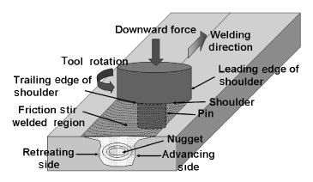
Figure 1. Schematic drawing of the conventional concept of FS processing [3]

Specifically, as the friction mediator has the key role of creating the joint fine and valuable properties is that cylindrical non-consumable tool with a specific engineering design on the shoulder (D) and the probe (d) therewith associated gauge of its geometry and dimension.
According to R. S. Mishra et al. written work the FSW tool possesses three significant functions that are creates the frictional heat without any melting transverses sectional inter-surfaces of work-pieces, drives the atomic deformations flow and keep manages of the heating metal underneath the tool shoulder. The source of heat is created within the work-piece both by kinetic friction between the spinning tool pin and shoulder and by severe plastic deformation of the work-piece. The cross-section area of heating softens material around the pin and, combined with the tool rotation and translation, leads to movement of material structures from the front up to the back of the pin, thus re-filling the hole in the tool wake as the tool moves along the sectional line. The tool shoulder maintains atomic deformation flow to a level equivalent to the shoulder position, that is, approximately to the initial work-piece top side of the surface.
As a result of the tool action and influence on the work-piece, when performed properly, a solid-state joint is produced, that is, no melting point can be observed. Because of various geometrical and dimensional features on the tool designs, material structure movement reach by the pin can be complex, with gradients in strain load, process temperature, and strain velocity. Accordingly, the resulting nugget zone microstructure reflects these different thermomechanical distributions and is not homogeneous on different zones. Can be observed that one of the significant benefits of this solid-state welding technique is the fully recrystallized, equated, fine grain microstructure created in the nugget by the intense plastic deformation at elevated and calculated temperature wherein not reach the melting point of subjected metal. The fine grain microstructure produces excellent mechanical properties, fatigue properties, enhanced formability, and exceptional superb plasticity.
In addition, P. Jayaseelan et al. [4] have a characterized knowledge of understandings FSW principles that can be summarily noted i.e. a. The length of the tool pin should be shorter than or equal to the thickness of the work-pieces; b. Ideally, intermittent heat generation mechanisms due to friction work and plastic dissipation take place because of the transient heat transfer effect and the material ability to regain its strength as heat is lost to the ambiance; c. cyclic heat generation process taking place all over again at each transverse displacement of the tool as encapsulation form that reintroduces the friction work heat generation mechanism prior to the plastic deformation mechanism; d. The pattern of onion rings on the nugget zone is the typical form caused by the conventional geometrical design of the tool. In conclusion, most of the detail of explanation up to effort of understandings are self-explanatory.
T. Singh et al. [5] re-explained the principle operation of FSW, the significant phase during the process is that when the tool traversing along the weld line in a plasticized tubular shaft of metal results in severe solid-state deformation involving dynamic recrystallization of the base metal.

FSW PROCESS PARAMETERS
Technically, the whole process of FSW joining technique is manufactured by the role of FSW machinery hence it is greatly impossible by handcraft of an engineer and can only be conducted on an industrial scale, institute or school. As it is computerized machinery the preferences of process variables are can be modified according to the needs and projects. Based on FSW fundamental process there are three primary parameters which possesses a crucial role viz. rotational speed, transverse speed and plunge force so that lots of research studies were revealing its most appropriate variables or even its associated enhancement methods.
The data of the literature regarding to FSW process parameters are reviewed as the following below:
M. S. Sidhu & S. S. Catha [6] tabulated the main process parameters in FSW and its effect respectively. Tool rotation (v, rpm) and transverse speed (n, mm/min) Higher tool rotation rates generate higher temperature, during traversing, softened material from the leading edge moves to the trailing edge and this transferred material, are consolidated in the trailing edge of the tool by the application of an axial force. Tool tilt and plunge depth, the tool is usually characterized by a small tilt angle (θ), and as it is inserted into the sheets, the blanks material undergoes to a local backward extrusion process up to the tool shoulder, additionally, the target depth is important as well to ensure the distance of the shoulder and top surface maintained in a close appropriate distance. Tool design, in conventional FSW tool it consists of a shoulder and a pin, both are affected the metal flow specifically pin is role of speed distribution and shoulder prevents the plasticized material from escaping from the work-piece. The common tool design for conventional are straight cylindrical, tapered cylindrical, threaded cylindrical, triangular and square pins which depicted in Figure 2.
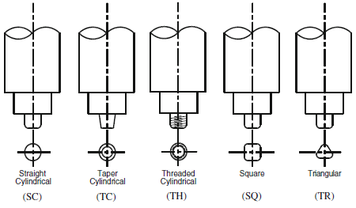
Figure 2. 5 common FSW conventional tool designs [6]

G. C. Jadhav & R. S. Dalu [7] revealed that primary variables that can affect weld properties significantly are tool material including shape and size, tool rotational velocity, welding speed, tool tilt and plunge depth. H13 is the most common material for the tool. In particular, they have been tabulated the process parameters that have been investigated to study every deep effect and its explanation towards FSW process.
S. K. Tiwari et al. [8] re-explained the process parameters of FSW can be divided into two primary segments which classified according to phase of the process viz. tool preparation and during the welding process. Tool geometry design and dimension, an eligible tool have able to give such as performances viz. reducing the welding force, enable easier flow of plasticized material, facilitate the downward auguring effect, and increase the interface between the pin and the plasticized material. the relative dimensional of the pin and shoulder is critical and the most common used of tool’s types are cylindrical threaded pin, truncated cone and concave shoulder for conventional FSW.
P. L. Threadgill et al. [9] have been detail discussed FSW process which revealed the important notes behind the whole process regarding to FSW technology. The correlation of tool design and flow mechanisms, duly noted that Material deformation generates and redistributes heat, producing the temperature field in the weld however the distribution of heat itself has coming back to metal flow and heat affected area. Computational Fluid dynamics (CFD) is used to study the material flow mechanisms and associated to its tool design, which resulted the two-dimensional flow. The ratio of swept volume to the pin volume is that quantified the mixing effect. The modeling of three-dimensional flow offers the expansion of affected parameters it is not just the complexity of the tool features which remains future open research. And the second important note is Heat generation during the process and its regimes. The heat from FSW is a complex mutual combination of function of the process variables (traverse and rotation speeds, and down force), as an analytical estimate Figure 3 shows rate of heat input per second and per mm.
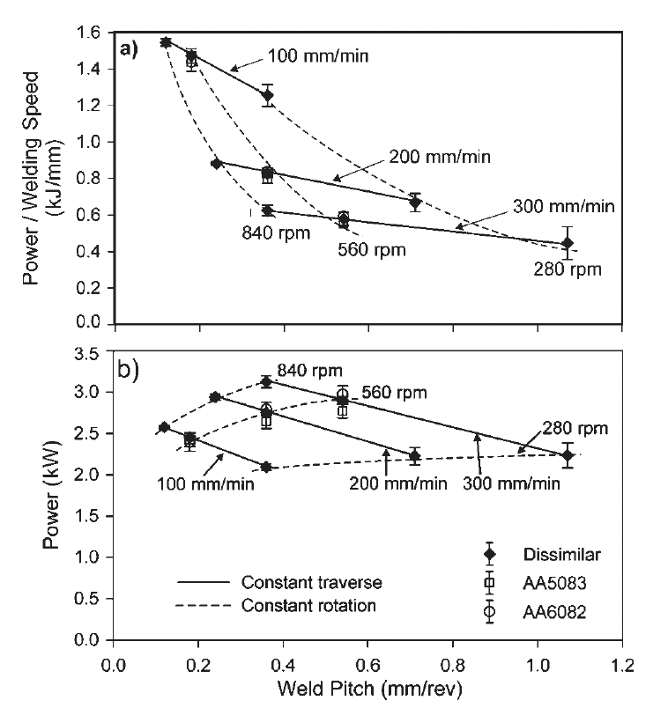
Figure 3. Rate of heat input a per millimeter of weld line and b [9]

Per second for like to like and AA5083/AA6082 welds the form the analysis, assumed that sliding Coulomb friction at the tool/work-piece interface with a coefficient of friction, or sticking friction using an estimate of the limiting shear yield stress, or have inferred contact conditions and/or heat input from measurements of machine torque.
Thermocouple measurements coupled to heat flow analysis also provide a means to infer net power inputs wherein no simple correlation between the temperature and the input power or heat. It is remarking the evidence of correlation between the heat input and the backing plate temperature as well as through the tool. The down force in FSW provides intimate thermal contact between work-piece and backing plate, but this contact evolves with position during the welding process, requiring complex calibration within consideration that by increasing the down force rate pushes the enlargement of process window then can be affected lowering rates of spinning and traveling speeds. CFD modelling has offered a new finding that the sensitivities of the heat generation, tool forces and size of deformation zone as a function of tool design and process conditions. Figure 4 shows a result of analysis of solidus that corresponds to deformation regime and its key note has unveiled in the origin article.
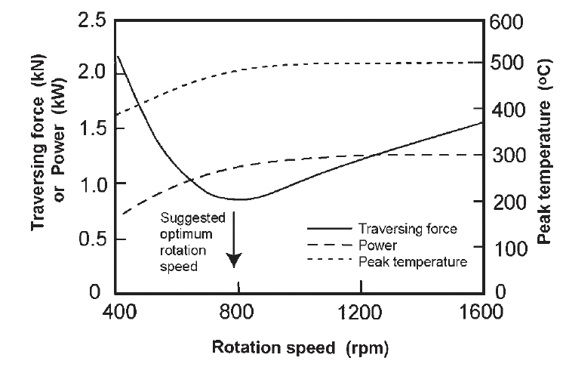
Figure 4. CFD modelling of heat generations affected by the tool [9]

FSW TOOLS DESIGNS
As the generator of friction in FSW mediates and creates from its tool hence the functions and influences regarding to the design of its geometrical and the adaptation of its dimensional to work-pieces are notably considered. Practically, the joint configuration of the work-pieces in FSW empirically affects the selection of the geometrical tool design viz. the pin and the shoulder to outcome the finest macroscopy structure on the weld [10]. At Least, it remains for size adjustments to pin dimension in which appropriate to work-pieces thickness. The variants of the tool designs have engineered and manufactured to be able to fulfill the demands of the work-piece properties and its typical characteristics. Therefore, it is spread to sustainable designs from conventional to its associated novelty technologies on the top of that not a few designs were not commercially produced for the purpose of research projects or specifically engineered to rare metals properties. Technically, TWI has been clarified the fundamental working mechanisms of how can FSW tool can delivers the weld process without breaking down the melting points of the work-pieces and its brief developments [11]. Literature study for FSW tool designs exhibits the recapitulation of used tool designs compilation dedicated to its studies [12]–[37].

FSW JOINT CONFIGURATIONS
The targeted metals or work-pieces ensured to be immobile and firmed on the FSW gantry machine during the welding process is undergoing. Practically, to be able to qualify the motionless settings of the work-pieces the adjustable toughest clamps have to be installed on a few certain points on the work-pieces. Theoretically, the basic form of joint configuration is classified into two types that are butt and lap configurations. From its basics the idea to expand the work-pieces placement settings in FSW has configured [38]–[52] somehow the developed configurations couldn’t be un-referred to its basics. In addition, the comparison between butt and lap has been revealed therewith its typical defects respectively and its summarize [53].

FSW LIMITATIONS
FSW offers and expands more abilities to weld metals from lights up to heavies’ specifications wherein in other joining techniques it’s quite challenging to be conducted. For example, a study from V. Pedro et al. ^{[54]} revealed that FSW possibly be able to produce the same joint quality like the fusion welding could offer in light metals confirmed with the other found advantages.
The advantages, disadvantages and limitations of FSW can be observed from several points of views such as economic sector, welding process limitations, joint defects, procedurals, apparatuses etc. In detail, based on its studies and experiment reports in the past few years FSW advantages and limitations have reported among others are a book edits by Mel Schwartz [55] summarized process and product advantages also limitations, moreover, economic advantages and disadvantages are described, in a book of ﻿Friction Stir Welding: Dissimilar Aluminum Alloys by the creation of N. Z. Khan et al. [56] highlighted the FSW process advantages over fusion welding and its conventional process disadvantages, M. Soron & I. Kalaykov [57] revealed the process advantages of using FSW robot, Z. H. FU et al. [58] written the basic of process advantages of FSW and its common process limitations. Based on the literature review above, it can be identified that the limitations come from process variables gradually reduced concomitants with the developing and sophisticating of FSW technologies and novelties.

SUMMARY OF THE REVIEW
The relevant correlations amongst process parameters and inside its respective adjustable variables are constructed to the finest principles that produced top-grades empirical report to the weld properties.
The literature breakdown for FSW principles and process parameters is re-structured in this review. In conclusion, it is observed that the weld quality of the product of FSW considerably affected by three headings from FSW process viz. tooling associating to pins and shoulders designs, machining referring to the speeds of travel and rotation and outsourcing settings such as work-pieces placement and base metal properties, in particular, duly notes that they are in cause-and-effect correlation.

REFERENCES
- S. Verma, “A Critical Review of Friction Stir Welding Process,” no. January 2015, 2019, doi: 10.2507/daaam.scibook.2015.22.
- A. Zafar and D. Singh, “Friction Stir Welding Process: a Green Technology,” Int. Res. J. Eng. Technol., pp. 1536–1538, 2021, [Online]. Available: www.irjet.net.
- H. R. S. and P. A. Colegrove, “Process Modelling, Chapter 10 in Friction Stir Welding and Processing,” Frict. Stir Weld. Process., pp. 187–217, 2007, doi: 10.1361/fswp2007p001.
- T. V. C. and S. G. P. Jayaseelan, Friction-stir welding: principles and applications. New York: Nova Science Publishers, Inc. New York, 2020.
- T. Singh, S. Ali, K. K. Sharma, and Gurudayal Kumar, “Review on friction stir welding of steels,” Int. Res. J. Eng. Technol., vol. 6, no. 12th December 2019, pp. 1059–1065, 2019, doi: 10.1016/j.matpr.2018.02.313.
- M. S. Sidhu and S. S. Chatha, “Friction Stir Welding – Process and its Variables: A Review,” Int. J. Emerg. Technol. Adv. Eng., vol. 2, no. 12, pp. 275–279, 2012.
- G.C.Jadhav and R.S.Dalu, “Friction Stir Welding Process Parameters: A Review,” Int. J. Creat. Res. Thoughts, vol. 5, no. 3rd September 2017, pp. 123–130, 2017, doi: 10.17577/ijertv6is060029.
- S. K. Tiwari, D. K. Shukla, and R. Chandra, “Friction Stir Welding of Aluminum Alloys: A Review,” Int. J. Mech. Aerospace, Ind. Mechatronics Eng., vol. 7 No. 12, pp. 1315–1320, 2013, doi: 10.1007/bf02838366.
- P. L. Threadgilll, A. J. Leonard, H. R. Shercliff, and P. J. Withers, “Friction stir welding of aluminium alloys,” Int. Mater. Rev., vol. 54, no. 2, pp. 49–93, 2009, doi: 10.1179/174328009X411136.
- W. M. Thomas, D. G. Staines, I. M. Norris, and R. De Frias, “Friction stir welding tools and developments,” Weld. World, vol. 47, no. 11–12, pp. 10–17, 2003, doi: 10.1007/BF03266403.
- “Functions, Designs and Materials of Friction Stir Welding Tools - TWI.” https://www.twi-global.com/technical-knowledge/faqs/friction-stir-welding-tools (accessed Apr. 24, 2022).
- C. D. Sorensen, “Friction Stir Welding Tool Designs,” in ASM Handbook, Volume 06A - Welding Fundamentals and Processes, First edit., Thomas J. Lienert, Sudarsanam Suresh Babu, Thomas A. Siewert, and Viola L. Acoff, Eds. United States of America: ASM International Handbook Committee, 2011, pp. 664–667.
- M. H. El‐Moayed, A. Y. Shash, M. A. Rabou, and M. G. El‐Sherbiny, “A detailed process design for conventional friction stir welding of aluminum alloys and an overview of related knowledge,” Eng. Reports, vol. 3, no. 2, pp. 1–17, 2021, doi: 10.1002/eng2.12270.
- C. A. Widener, D. A. Burford, and S. Jurak, “Effects of tool design and friction stir welding parameters on weld morphology in aluminum alloys,” Mater. Sci. Forum, vol. 638–642, pp. 1261–1266, 2010, doi: 10.4028/www.scientific.net/MSF.638-642.1261.
- D. Burford, P. G. Britos, E. Boldsaikhan, and J. Brown, “Evaluation of Friction Stir Weld Process and Properties for Aerospace Application: e-NDE for Friction Stir Processes,” FAA Jt. Adv. Mater. Struct. Cent. Excell., vol. 6, no. 19th May,2010, pp. 1–27, 2010.
- J. Stephen Leon, G. Bharathiraja, and V. Jayakumar, “Experimental Analysis on Friction Stir Welding using Flat-Faced Pins in AA2024-T3 Plate,” FME Trans., vol. 49, no. 1, pp. 78–86, 2021, doi: 10.5937/FME2101078S.
- F. Gratecap, M. Girard, S. Marya, and G. Racineux, “Exploring material flow in friction stir welding: Tool eccentricity and formation of banded structures,” Int. J. Mater. Form., vol. 5, no. 2, pp. 99–107, 2012, doi: 10.1007/s12289-010-1008-5.
- R. E. Andrews, “Friction stir welding – an alternative method for sealing nuclear waste storage canisters,” Cambridge, The United Kingdom, 2004. [Online]. Available: www.skb.se.
- K. Ullegaddi, V. Murthy, R. N. Harsha, and Manjunatha, “Friction Stir Welding Tool Design and Their Effect on Welding of AA-6082 T6,” Mater. Today Proc., vol. 4, no. 8, pp. 7962–7970, 2017, doi: 10.1016/j.matpr.2017.07.133.
- N. M. Faleh, R. A. Ahmed, and R. M. Fenjan, “Geometrical Design and Optimization of Stirrer for Friction Stir Welding,” Asian J. Appl. Sci., vol. 06, no. 01, pp. 38–52, 2018, [Online]. Available: www.ajouronline.com.
- S. Sharma, A. Handa, and S. S. Singh, “Influencing geometrical parameters of tools in friction stirring technology: A short review,” Strojnícky časopis – J. Mech. Eng., vol. 71, no. 2, pp. 257–290, 2021, doi: 10.2478/scjme-2021-0034.
- Y. X. Huang, L. Wan, S. X. Lv, and J. C. Feng, “Novel design of tool for joining hollow extrusion by friction stir welding,” Sci. Technol. Weld. Join., vol. 18, no. 3, pp. 239–246, 2013, doi: 10.1179/1362171812Y.0000000096.
- K. Raza, M. Shamir, M. K. A. Qureshi, A. S. Shaikh, and M. Zain-ul-abdein, “On the friction stir welding, tool design optimization, and strain rate-dependent mechanical properties of HDPE–ceramic composite joints,” J. Thermoplast. Compos. Mater., vol. 20, no. 10, pp. 1–20, 2018, doi: 10.1177/0892705717697779.
- A. Mishra, A. Tiwari, M. K. Shukla, and A. R. Rose, “Analysis of Tools used in Friction Stir Welding process,” Int. J. Curr. Eng. Technol., vol. 8, no. 6, pp. 1519–1524, 2018, doi: 10.14741/ijcet/v.8.6.2.
- R. Nandan, T. DebRoy, and H. K. D. H. Bhadeshia, “Recent advances in friction-stir welding – Process, weldment structure and properties,” Prog. Mater. Sci., vol. 53, no. 6, pp. 980–1023, 2008.
- R. Rai, A. De, H. K. D. H. Bhadeshia, and T. DebRoy, “Review: Friction stir welding tools,” Sci. Technol. Weld. Join., vol. 16, no. 4, pp. 325–342, 2011, doi: 10.1179/1362171811Y.0000000023.
- D. Bajaj, A. N. Siddiquee, A. K. Mukhopadhyay, and N. Ali, “The Effect of Tool Design on the Friction Stir Welding of Thick Aluminum Alloy AA6082-T651 Extruded Flats,” Metallogr. Microstruct. Anal., vol. 9, no. 6, pp. 841–855, 2020, doi: 10.1007/s13632-020-00696-5.
- Z. C. Nik, M. Ishak, and N. H. Othman, “The Effect of Tool Pin Shape of Friction Stir Welding (FSW) on Polypropylene,” IOP Conf. Ser. Mater. Sci. Eng., vol. 238, no. 1, pp. 1–7, 2017, doi: 10.1088/1757-899X/238/1/012003.
- A. Meilinger and I. Torok, “the Importance of Friction Stir Welding Tool,” Prod. Process. Syst., vol. 6, no. 1, pp. 25–34, 2013.
- D. Venkateswarlu, N. R. Mandal, M. M. Mahapatra, and S. P. Harsh, “Tool design effects for FSW of AA7039,” Weld. J., vol. 92, no. 2, pp. 41–47, 2013.
- R. Terkar and M. Patel, “Analysis of Tool Design parameters for Friction Stir Lap welding of Aluminium and Copper,” Int. J. Res. Eng. Appl. Manag., vol. 04, no. 04, pp. 105–111, 2018, doi: 10.18231/2454-9150.2018.0462.
- M. Aissani, S. Gachi, F. Boubenider, and Y. Benkedda, “Design and optimization of friction stir welding tool,” Mater. Manuf. Process., vol. 25, no. 17th December 2010, pp. 1199–1205, 2010, doi: 10.1080/10426910903536733.
- E. Hoyos and M. C. Serna, “Basic tool design guidelines for friction stir welding of aluminum alloys,” Metals (Basel)., vol. 11, no. 12, 2021, doi: 10.3390/met11122042.
- S. Ji, J. Xing, Y. Yue, Y. Ma, L. Zhang, and S. Gao, “Design of friction stir welding tool for avoiding root flaws,” Materials (Basel)., vol. 6, no. 12, pp. 5870–5877, 2013, doi: 10.3390/ma6125870.
- W. R. Longhurst et al., “Development of Friction Stir Welding Technologies for In-Space Manufacturing,” Clarksville.
- M. K. Sued and D. J. Pons, “Dynamic Interaction between Machine, Tool, and Substrate in Bobbin Friction Stir Welding,” Int. J. Manuf. Eng., vol. 2016, pp. 1–14, 2016, doi: 10.1155/2016/8697453.
- H. Li, J. Gao, Q. Li, A. Galloway, and A. Toumpis, “Effect of friction stir welding tool design on welding thermal efficiency,” Sci. Technol. Weld. Join., vol. 24, no. 2, pp. 156–162, 2019, doi: 10.1080/13621718.2018.1495868.
- D. G. Mohan and Gopi S., “A Review on Friction Stir Welded T-Joint,” IJSTE - Int. J. Sci. Technol. Eng., vol. 2, no. 07, pp. 40–45, 2016, [Online]. Available: www.ijste.org.
- X. He, F. Gu, and A. Ball, “A review of numerical analysis of friction stir welding,” Prog. Mater. Sci., vol. 65, no. August, pp. 1–66, 2014, doi: 10.1016/j.pmatsci.2014.03.003.
- W. Thomas, E. D. Nicholas, D. Staines, P. J. Tubby, and M. F. Gittos, “FSW process variants and mechanical properties,” Weld. World, vol. 49, no. 4, pp. 4–11, 2005.
- J. P. Martin, C. Stanhope, and S. Gascoyne, “NOVEL TECHNIQUES FOR CORNER JOINTS USING FRICTION STIR WELDING,” TMS (The Miner. Met. Mater. Soc., 2011.
- Tiago Azevedo Bento, “Smart Hybrid Friction Stir Welded Joints for Aerospace Design Applications,” no. 11, pp. 1–10, 2018.
- H. Bisadi, M. Tour, and A. Tavakoli, “The Influence of Process Parameters on Microstructure and Mechanical Properties of Friction Stir Welded Al 5083 Alloy Lap Joint,” Am. J. Mater. Sci., vol. 1, no. 2, pp. 93–97, 2011, doi: 10.5923/j.ijvmb.20120101.01.
- A. C. F. Silva, D. F. O. Braga, M. A. V. de Figueiredo, and P. M. G. P. Moreira, “Ultimate tensile strength optimization of different FSW aluminium alloy joints,” Int. J. Adv. Manuf. Technol., vol. 79, no. 5–8, pp. 805–814, 2015, doi: 10.1007/s00170-015-6871-2.
- U. Acharya et al., “A study on the implication of modified joint configuration in friction stir welding,” Soldag. Inspeção, vol. 26, no. 15th September, pp. 1–14, 2021, doi: 10.1590/0104-9224/si26.07.
- K. Nagendra Kumar and M. Manzoor Hussain, “Comparative Study of FSW Strength Versus Plate Overlap,” Int. J. Eng. Res. Technol., vol. 8, no. 05, pp. 645–649, 2019, [Online]. Available: www.ijert.org.
- M. L. Penalva, A. Otaegi, J. Pujana, and A. Rivero, “Development of a new joint geometry for FSW,” AIP Conf. Proc., pp. 1–12, 2009, doi: 10.1063/1.3273630.
- M. M. E.-S. Seleman, M. M. Z. Ahmed, R. M. Ramadan, and Basant A. Zaki, “Effect of FSW Parameters on the Microstructure and Mechanical Properties of T-joints between Dissimilar Al- Alloys,” Int. J. Integr. Eng., vol. 14, no. 1, pp. 1–12, 2022, doi: https://doi.org/10.30880/ijie.2022.14.01.001.
- M. T.S.M. Sai et al., “Experimental Study on Effect of Welding Parameters of Friction Stir Welding (FSW) on Aluminium AA5083 T-joint,” Inf. Technol. J., vol. 15, no. 4, pp. 99–107, 2016, doi: 10.3923/itj.2016.99.107.
- I. Sabry, A. M. El-Kassas, A. H. I. Mourad, D. T. Thekkuden, and J. A. Qudeiri, “Friction stir welding of T-joints: Experimental and statistical analysis,” J. Manuf. Mater. Process., vol. 38, no. 3, pp. 1–23, 2019, doi: 10.3390/jmmp3020038.
- G. Sorger, H. Wang, P. Vilaça, and T. G. Santos, “FSW of aluminum AA5754 to steel DX54 with innovative overlap joint,” Weld World, vol. 61, no. 2, pp. 257–268, 2017, doi: 10.1007/s40194-016-0412-y.
- S. Ciliberto, A. Astarita, and A. Squillace, “FSW of T joints in overlap configuration: Process optimization in joining dissimilar aluminium alloys for the aeronautic application,” Surf. Interface Anal., vol. 45, no. 10, pp. 1631–1637, 2013, doi: 10.1002/sia.5214.
- “Friction Stir Welding: butt & lap comparison - Stirweld.” https://stirweld.com/en/fsw-butt-and-lap-comparison/ (accessed Apr. 25, 2022).
- P. Vilaça, L. Quintino, and J. F. Dos Santos, “ISTIR - Analytical thermal model for friction stir welding,” J. Mater. Process. Technol., vol. 169, no. 3, pp. 452–465, 2005, doi: 10.1016/j.jmatprotec.2004.12.016.
- M. Schwartz, Innovations in Materials Manufacturing, Fabrication, and Environmental Safety, First Edit. Boca Raton: CRC Press Taylor & Francis Group, 2011.
- N. Z. Khan, A. N. Siddiquee, and Zahid A. Khan, Friction Stir Welding: Dissimilar Aluminum Alloys, First Edit. Boca Raton: CRC Press Taylor & Francis Group, 2017.
- M. Soron and I. Kalaykov, “A robot prototype for friction stir welding,” 2006 IEEE Conf. Robot. Autom. Mechatronics, vol. 6, no. 2, 2006, doi: 10.1109/RAMECH.2006.252646.
- F. Zhi-hong, H. Di-qiu, and W. Hong, “Friction Stir Welding of Aluminum Alloys,” J. Wuhan Univ. Technol., vol. 19, no. 1, pp. 61–64, 2004.

