**DESIGN OF MONOPOLE ANTENNA-SHAPED STAR FOR COMMUNICATION ULTRA-WIDEBAND APPLICATIONS**

**M.Darsono1*, Muhammad Rega2**

11Department of Electrical Engineering, Faculty of Engineering, Universitas Darma Persada

Jl. Malaka Selatan, Pondok Kelapa, Jakarta 13450, Indonesia

2Department of Electrical Engineering, Faculty of Engineering, Universitas Darma Persada

Jl. Malaka Selatan, Pondok Kelapa, Jakarta 13450, Indonesia

*Corresponding Author Email: [emdarunsanda@gmail.com](mailto:emdarunsanda@gmail.com)

***Abstract --*** *In this study, the design of a microstrip antenna was developed as a type of monopole that supports Ultra-Wideband communication. The research aims to obtain a minimalist and compact antenna design that works optimally at UWB frequencies. The UWB microstrip antenna design is a planar monopole star patch with increased characteristics bandwidth using Electromagnetic Band Gap (EBG) structure. The design method to obtain bandwidth optimization is done by using a notch band technique in the ground plane and impedance matching of the gap line in the star patch. The type of substrate material used in the microstrip antenna design is the RT DUROID 5880 type. A simulation method was used through the CST studio software application to obtain the dimensions of the antenna design and performance. The results of the simulation show the performance of the antenna parameters, such as 95.87% of fractional bandwidth < -10 dB, VSWR ( 2:1), and maximum directivity the gain and polarization values of the two resonant frequencies obtained are 2.61 dBi and 5.18 dBi. The simulation results of the design dimensions are 40 mm x 40 mm and the achievement of optimization in the C band and X band frequencies.*

***Keywords:*** *Microstrip antenna, Star Patch, Simulation, Ultra-wideband*

***Copyright © 2020 Universitas Mercu Buana. All right reserved.***

|  |  |  |
| --- | --- | --- |
| *Received: …………* | *Revised: ……………* | *Accepted: …………..* |

**INTRODUCTION**

The Antenna is a transducer designed to transmit or receive electromagnetic waves. Microstrip antennas have several advantages over conventional microwave antennas and are therefore widely used in many practical applications. On February 14, 2002, the Federal Communications Commission (FCC) amended the Part 15 rules which govern unlicensed radio devices to include the operation of UWB devices. The FCC also allocated a bandwidth of 7.5GHz, i.e. from 3.1GHz to 10.6GHz to UWB applications, by far the largest spectrum allocation for unlicensed use the FCC has ever granted[1]

The FCC released its Second Report on UWB15 in December 2004[2]. This report gives large systems and devices that just don't meet the definition of UWB technology greater flexibility to be introduced. In accordance with the revised regulations, wide-bandwidth device emission peak power limitations are increased to the same level as UWB devices in the three frequency bands that are previously made available for unlicensed operation, i.e 5925-7250 MHz, 16.2-17.2 GHz, and 23.12-29 GHz. The main problem with UWB antennas is the presence of some services in a narrow band, such as Wireless LAN (WLAN) in the frequency band of 5.15 to 5.85 GHz, X-Band satellite downlink communications in the band of 7.1 to 7.6 GHz, and Direct Broadcast Satellite (DBS) communications in the frequency band of 11.7 to 12.5 GHz, which causes problems with electromagnetic interference in the UWB system[3], [4][5]

Based on the Federal Communication Commission (FCC) as a key component of the UWB system for wireless communication, UWB antennas have their charms and challenges in their design[4]. UWB antennas have design characteristics as an important part of the UWB system and must have a small size, lightweight, omnidirectional radiation pattern, and all other characteristics required for UWB communication. So, it is attracting a lot of interest in the research and development of UWB technology[6].[7], [8][9]

Figure 1 UWB technology is appropriate for a wide range of applications, including communications, geo-location, positioning, and radar or sensor applications. The UWB system has advanced technologically for more than 40 years[4], [10].

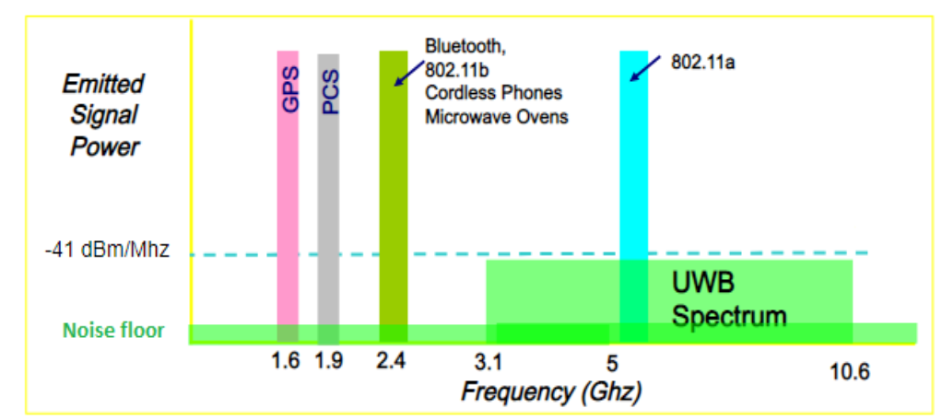

Figure 1. UWB versus other Radio Communication Systems.

According to the Shannon-Hartley theorem, in this system, channel capacity improves linearly as bandwidth increases and drops logarithmically as the signal-to-noise ratio decreases (SNR). The power in UWB technology is extremely modest and very close to the noise floor[11], [12] [9]Therefore, it may be said that the UWB system is power limited rather than band-restricted as in the narrowband situation.

Several designs have been carried out for this antenna analysis approach, such as genetic algorithm, rectangular slot, round diamond, trident shape bait, Quasi-self-free, Vivaldi antipodal, and many others that have been published to obtain the UWB frequency band. Ultra-wideband (UWB), a radio transmission technology that occupies an extremely wide bandwidth exceeding the minimum of 500MHz or at least 20% of the center frequency, is a revolutionary approach for short-range high-bandwidth wireless communication[3], [4], [13]. In recent RF communications and remote sensing applications at radio, microwave, and terahertz frequencies, the design of a small ultra-wideband (UWB) antenna printed on short-range radio devices plays a significant role in modern wireless communications. It is a carrier less short-range communications technology that transmits information in the form of very short pulses[14], [15].

Several papers that have discussed UWB microstrip antennas with the use of star patches as slits or radiating patches have shown good values with the support of certain grounding models. The grounding model or technique is very important to obtain a wide bandwidth[6]. Fractal geometry plays an important role in this requirement. Fractals have non-integral dimensions and the ability to fill space can be used to miniaturize the antenna size. Optimizing the outcomes by the design aim is done utilizing the Method of the Moment analysis technique[6], [16]. Microstrip antenna development that achieves bandwidth optimization can be accomplished using techniques like coupling proximity, Electromagnetic Band Gap (EBG), and Defected Ground Structure (DGS)[3], [17], [18]. The Electromagnetic Band Gap technique, which is most frequently utilized at UWB frequencies, was applied in this study. Acanctromagnetic waves propagate through the EBG, a periodic structure, at a certain frequency range. The notched band approach is used on the ground plane construction, which is situated at the center point. There are numerous ways to obtain notch bands, including[4], [19].

The goal of this antenna design study is to develop a monopole antenna model that is simple, compact, and capable of operating in the UWB frequency band. In order to obtain bandwidth optimization on the results of the antenna design performance using the Defected Ground Structure technique. RT DUROID 5880 substrates from Rogers-Corp with a dielectric constant of 2.2, thickness of 1.57mm, and loss tangent of 0.002[20]. In this study, a simulation model using CST application software was performed to produce results from an overall antenna design. The objective of this project was to create a microstrip antenna prototype that may be used for wireless communication applications. The was designed to be compact and low profile.

**METHODOLOGY**

The planar monopole antenna used in the EBG method's antenna design uses magnetic coupling technology. On the top layer of the substrate material, the patch is constructed in opposition to how the ground plane is shaped. Two equilateral triangular patches are used to create a special star-shaped patch [21], [22]. The star-shaped patch created by fusing two triangles and rotating the angle by 180 degrees is depicted in Figures 1 and 2[23].

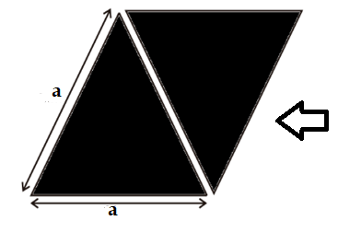

Figure 2. Triangular patch merge direction.



Figure 3. Star Patch.

The basic shape of the star patch is formed by two triangular patches. Crosswise, the two triangular patches are 180 degrees apart. The equilateral triangular patch's shape can be determined by calculating the side lengths of the patch. The dimensional value determines the resonance substrate material's resonance frequency and dielectric constant are order modes in the Transverse Magnetic Wave Propagation (TMmn) dominating mode. To determine the triangle's side length, apply the equation below[21], [22].

${fr,}_{mn}=\frac{2C}{3a\sqrt{ε_{r },μ_{eff}}}\sqrt{\left(n^{2}+nm+m^{2}\right)}$ (1)

Where *fr* is the material's relative dielectric constant, ɛeff is the effective permittivity of the dielectric material, and *fr* is the resonant frequency in gigahertz. *C* is the speed of light (3 x 108 m/s). In the case of the dominant mode, m = 1 and n = 0 (TM01). The second equation is created by reducing the first equation as shown below[24]

$fr=\frac{2C}{3a\sqrt{ε_{r}}}$ (2)

The length of the side of the triangle (*a*) can be obtained by the following equation.

$a=\frac{2C}{{3f}_{r}\sqrt{ε_{r}}}$ (3)

**Design of the Star Patch**

Start with an equilateral triangle-shaped patch to actualize the star patch's dimension value. The operating range of UWB technology is 3.1 GHz to 10.6 GHz, which includes the C band frequency spectrum and the X band frequency spectrum. The resonance frequency or core frequency in this investigation is 6.5 GHz (*fr)*and the material specification of RT DUROID substrate is a thickness (*h*) of 1.57 mm and dielectric constant (*ɛr*) of 2.2. Equation 3 may be used to calculate the side length of the triangular patch, and the result is 20 mm with each side having a 60-degree angle, as illustrated in Figueres 4 [23].

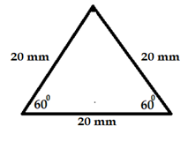

Gambar 4. Design of triangular patch.

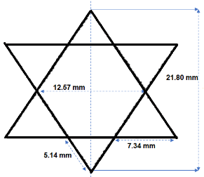

Figure 5. Design of star patch

The size of the star patch created by joining two equilateral triangles is seen in Figure 5. The diagonals of the star angles in the figure's two long sides are 12.57 mm and 21.8 mm. Two sides with lengths of 5.14 mm and 7.34 mm make up the corner of the triangle's junction.

**Transmission Line**

The microstrip transmission line is part of the antenna design element that functions as a power supply. By analyzing the width of the line above the conductor's surface to the thickness of the substrate material, the characteristic impedance of the microstrip transmission line can be calculated. Figure 6 shows a profile of a microstrip transmission line depending on the value of the conductor width (*w*) and the thickness of the substrate layer (*h*) [25].

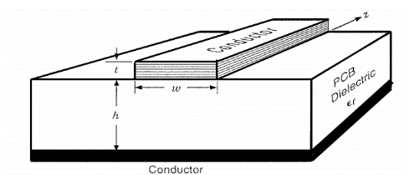

Figure 6. Microstrip line

The requirements in the medium or substrate type define the characteristic impedance (Zo) of a microstrip transmission line. The equation can be used to determine the characteristic impedance of the microstrip line when the line width (*w)* to substrate thickness (*h*) ratio is more than one (w/h > 1) [25][21]

$Z_{0}=\frac{\left[120π\sqrt{ε_{eff}}\right]}{\frac{h}{w}+1,393+0,667ln\left(1,444+\frac{w}{h}\right)}$ (4)

Where *Zo* is the characteristic impedance in Ohms, *ɛeff* is the relative dielectric constant of the material, its substrate thickness in meters, and *w* is the width of the transmission line in meters. By using the calculation of equation 4, we can determine that the width of the transmission line is 4.8 mm when the characteristic impedance (Zo) is 50Ω.

**Design of T-Junction Power Divider**

For this research microwave transmission line as a power supply point to a loaded patch, the T-junction power divider transmission line technique is used. T-junction microstrip is a technique of several types of microstrips in system telecommunication [26]. Tapered microstrip is often found as a power separator or also known as a splitter. The T-Junction power divider circuit shown in Figure 7 is a common design for microstrip antennas, where its performance is comparable to that of the three-port Wilkinson power divider [27]. The impedance value of the circuit is made up of three fundamental components: an input line (Zo), two output lines (Z1), and (Z2). There is no isolation between the output ports so other than at the T junction.

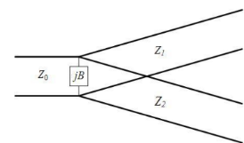

Figure7. T-Junction Power Divider.

The third relationship of the transmission line impedance of the T-junction power divider is as follows [26]:

$\frac{1}{Z_{0}}=\frac{1}{Z_{1}}+\frac{1}{Z_{2}}+jB$ (3)

Where *Z0* is the characteristic impedance of the input line, *Z1* and *Z2* are the characteristic  
impedances of both output lines, and *B* is the reactance created at the junction of the three  
lines. Thus, given an input impedance, the two output impedances can be matched to the  
input impedance. Furthermore, if assuming the value of *B* (imaginary side) is zero, then the value of the characteristic impedance of all becomes real. So that obtained a relationship value of the three impedances of Zo, Z1, and Z2 through the following equation:

$\frac{1}{Z_{0}}=\frac{1}{Z_{1}}+\frac{1}{Z_{2}}$ (4)

If the characteristic impedance (Zo) in equation 4 is 50Ω, then the output line impedances (Z1 and Z2) are 100Ω, respectively. As an outcome, the impedance of Z1 and Z2 has a 1.4 mm line width in the design of the microstrip transmission line.

**Defected Ground Structure**

DGS this technique merely denotes the placement of a "defect," which is often regarded as an approximate representation of an endless, perfectly-conducting current sink, in the plane's ground. Although the additional DGS perturbations change the ground plane's homogeneity, they do not cause it to be flawed. A resonant gap or slot in the ground metal that is positioned directly beneath a transmission line and is oriented for effective coupling to the line is the fundamental component of DGS. DGS can be used as a filter in antennas operating in the UWB spectrum to lessen the effects of interference [19].

As it can decrease sidelobes in phase arrays, enhance the performance of couplers and power dividers, and decrease the response to band signal for both transmit and receive, this is the most typical use of DGS for the antenna. Different dumbbell forms are employed as part of the DGS technique in this study [19][28]. The geometry of the DGS construction using a microstrip antenna's ground plane is depicted in Fig. 7. Lg and Wg are the length and breadth of the ground plane, respectively, on the structure's DGS side. For a notch with the same size as the ground plane's opening (Gp).

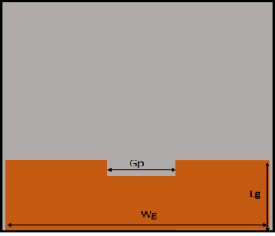

Figure 8. The ground plane's DGS.

**RESULTS AND DISCUSSION**

Results for antenna design were obtained in this work using the simulation method. Two things may be seen from the simulation results: the antenna configuration's form and the antenna's parameters. With a length and width of 40 mm for the first result, the substrate material has the smallest possible dimensions. The investigation of the antenna's performance parameters follows, including measurements of bandwidth, VSWR, input impedance, radiation pattern, gain, and so forth.

Figure 9 shows the front view configuration of the antenna design along with the star patch and transmission line structure. Table 1 displays the results of the antenna design configuration in two components. The radiating patch that is directly connected to the transmission line's power supply is shown in the figure as the modeling design of a small antenna. The substrate material used for antenna modeling is required with a length and width of 40 mm (Ws) x 40 mm (Ls). A transmission line with a characteristic impedance of 50 Ω is designed with a length of 7.4 mm (Lt) and a width of 4.8 mm (Wt). Furthermore, the T-Junction power divider circuit has two output transmission lines with a gap of 11 mm (GD) with a line length of 10 mm (LD) and each has an impedance of 100 Ω(WD).

The lower layer of the ground plane is designed in Figure 10 using the DGS technique, and table 2 provides an explanation of the ground plane's dimensions. The ground plane area is limited to a width of 38 mm (Wg) and a length of 12.2 mm (Lg). The notch field has a slit width of 11 mm (Wn) and a length of 5 mm (Lp), where the width of the slit to the edge of the ground plane is 13.5 mm (W1 = W2) each.

Figures 11 and 12 show the constructed prototype of the monopole antenna's structure and profile. A microstrip antenna of 40mm in length and 40mm in width was constructed on the RT DUROID substrate material. The antenna is joined to the edge of the model with an SMA connector. Figure 11 shows the profile shape of the antenna structure as seen from the front. In this design, a star-shaped patch model is used to connect a monopole antenna to a power divider circuit. Figure 12 shows the DGS structure at the base of the ground plane. Validation is done using measurements once the antenna manufacturing process is finished. To get parameter validation for the simulation results, measurements were made. The measurement in this study is only limited to S11 parameters.

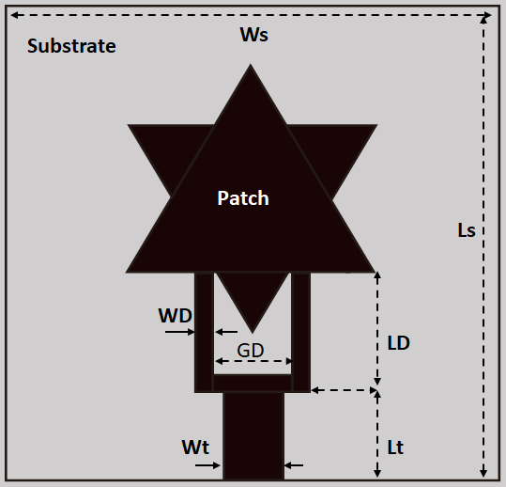

Figure 9. Design of antenna top view.

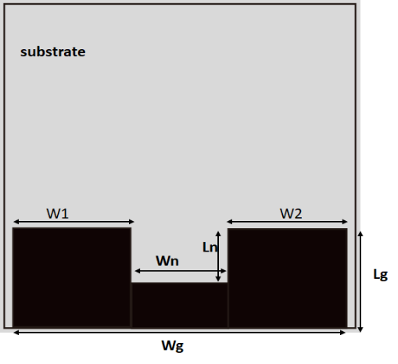

Figure 10. Design of antenna bottom view.

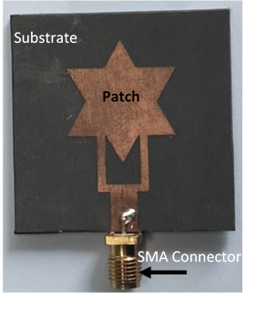

Figure 11. Prototype Antenna Top View.

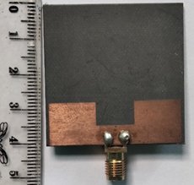

Figure 12. Prototype Antenna Bottom view.

Table 1. Dimension of antenna top view.

| Symbol | Dimension | Size (mm) |
| --- | --- | --- |
| Ws | Width of Substrate | 40 |
| Ls | Length of Substrate | 40 |
| Wt | Width of the transmission line | 4.8 |
| Lt | Length of Transmission line | 7.4 |
| WD | Width of the output line power the power divider | 1.4 |
| GD | Gap of two output line power divider | 11 |
| LD | Length of the output line power divider | 10 |

Table 2. Dimension of antenna bottom view

| Symbol | Dimension | Size (mm) |
| --- | --- | --- |
| Wg | Width of the ground plane | 38 |
| Lg | Length of the ground plane | 12.2 |
| W1=W2 | Size of the ground's void between the left and rig. | 13.5 |
| Wn | Width of notch ground plane | 11 |
| Ln | Length of notch ground plane | 6.5 |

**Antenna Parameters S11**

A graph of the measurement findings for the S11 parameter based on the outcomes of the simulation and measurement approaches is shown in Figures 13 and 14. The simulation's output shows that a cut-off frequency of 2.157 GHz (marker 1) to 8.7616 GHz limits the return loss's bandwidth (marker 4). (95.87%) of UWB is covered by the obtained fractional bandwidth. With a bandwidth improvement of more than 500 MHz or 20%, the wireless system's bandwidth value is Ultra-Wideband. The measuring method's obtained bandwidth ranges from 9,7 GHz (marker 3) to 13,6 GHz, which is resonant in the X band-limited frequency cut-off (marker 4).

A graph of frequency versus VSWR obtained by simulation and measurement is shown in Figures 15 and 16. The VSWR (2:1) resonant frequency in the simulation method is at 5.796 GHz in the C-band (marker 2) and 8.161 GHz in the X-band (marker 3). The C-band measurement result for VSWR (2:1) in Figure 15 is 1.14 (marker 2), and the X-band measurement result is 1.8. (marker 3).

A Smith chart showing the outcomes of the simulation and measurement is shown in Figures 17 and 18. Zin= 0.9945 - j0.008 or Zin= 49.53 are the mismatch impedance values found in the simulation for resonance on the C-band (marker 1), and Zin= 1.096 + j0.102 or Zin= 54.8 are the values obtained for the frequency of the X-band (marker 2). The resulting X-band is 50.49 -j32.88 and the band is 87.38 + j1.43 for the measurement result of mismatch impedance at the resonant frequency on the C- (marker 3).

**Radiation Pattern**

In this study, experimental activities on antenna radiation propagation were only carried out using the simulation method. Fig.18 and fig.19 show the shape of the plane (theta) and angular (phi) radiation patterns normalized at the resonant frequencies of 5.796GHz and 8.161 GHz. The formed radiation obtained the maximum directivity (Gain) values of 2.61dBi and 5.18dBi. Fig.20 and fig.21 The radiation polarization of each frequency takes the form of bidirectional (Main lobe directional) with the angle plane (*phi*) being 1610 and 1560, thus forming an omnidirectional radiation polarity.

The omnidirectional radiation polarization forms the polarization of the two resonant frequencies in the theta plane with two beam width angles. At the frequency of 5.796 GHz, the maximum beam width with a magnitude of magnitude 3dB is 84.5 degrees. Figure 21 shows the beam-width angle at the frequency of 8.161 GHz is 52.90 degrees.

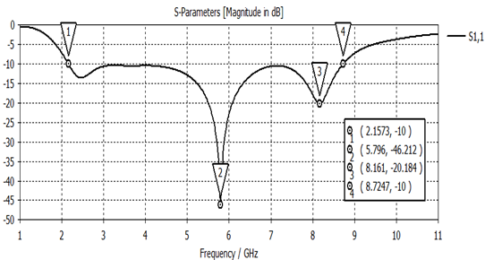

Figure 13. Return loss V.s Frequency of simulation result.

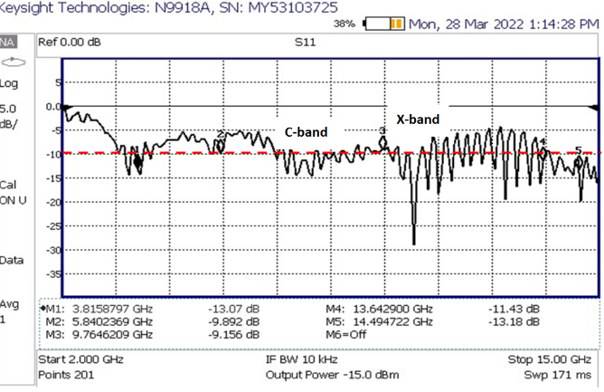

Figure 14. Return loss V.s Frequency of measurement result.

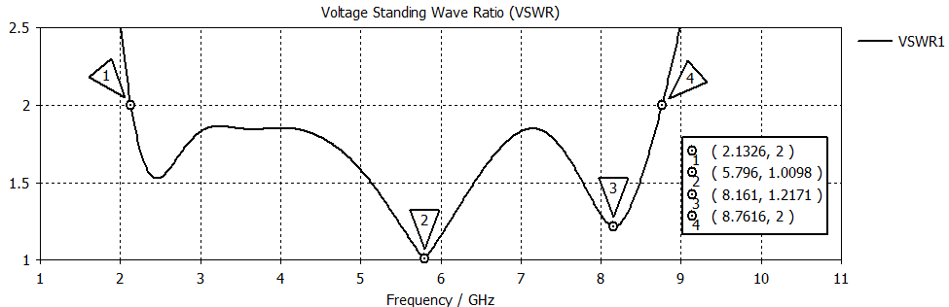

Figure 15. VSWR V.s Frequency of simulation result.

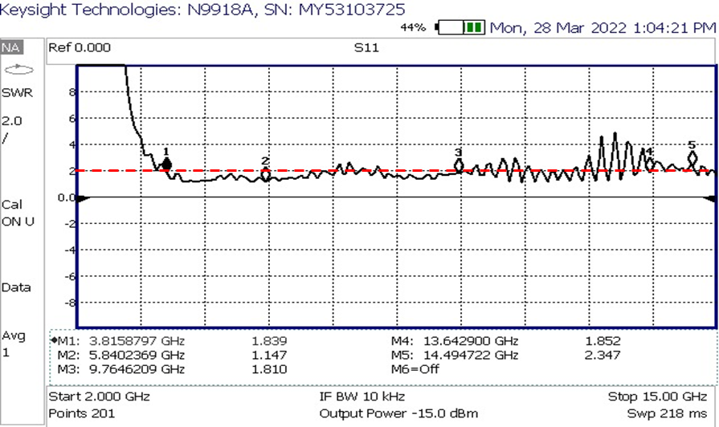Figure 16. VSWR V.s Frequency of measurement result.

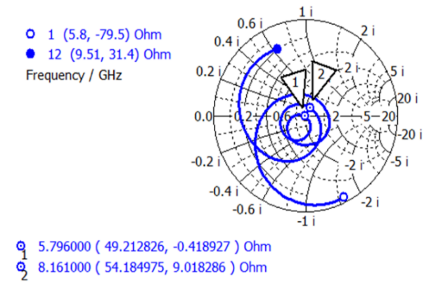

Figure 17. Graph of Smith Chart for impedance.

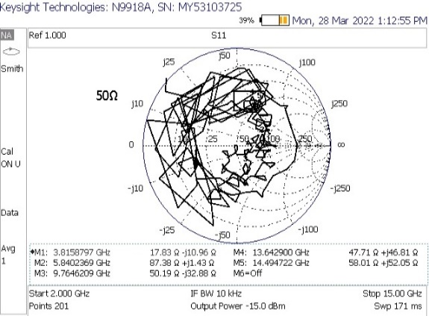

Figure 18. Impedance matching measurement result.

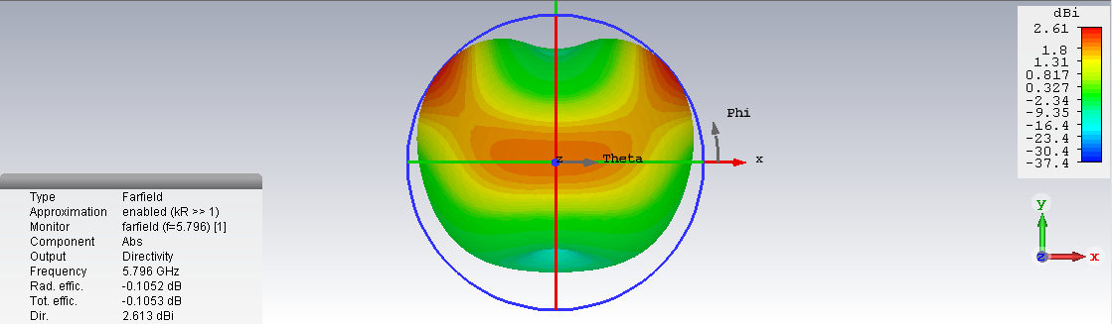

Figure 18. Radiation pattern at a frequency of 5.796 GHz

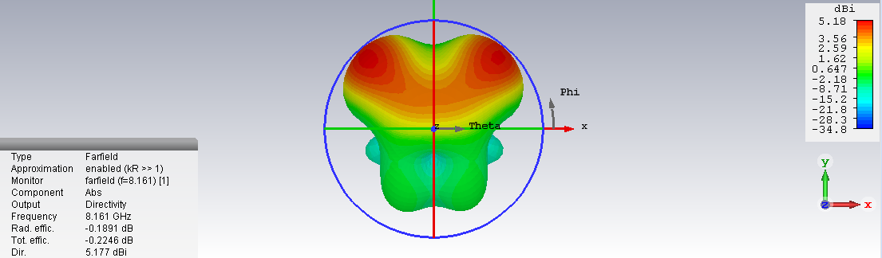

Figure 19. Radiation pattern at a frequency of 8.161 GHz

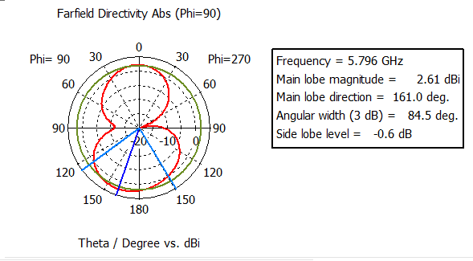

Figure 20. Far-field on the frequency of 5.796 GHz in the theta

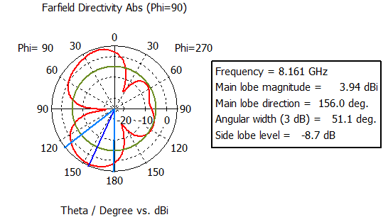

Figure 21. Far-field on the frequency of 8.161 GHz in the theta.

**CONCLUSION**

The results of the fractal type microstrip antenna design show a simple, compact, and minimal structure and design. At C-band and X-band frequencies, the unique star-shaped patch adds value by impedance matching. With respect to boundaries antenna performance, WLAN 802.11a on UWB communication systems is supported by a resonant C-band frequency at 5.8 GHz. Furthermore, the radiation pattern's propagation characteristics have shown the performance of an antenna with omnidirectional features and linear vertical polarization. The development of the research area for wireless communication applications is greatly aided by the prototype antenna's small dimensions, low profile, and low costs of use. With the DGS technique, the concept of fractal types has gained popularity in broadband and wideband bandwidth optimization, enabling high-speed data network access on wireless networks.

**ACKNOWLEDGMENT**

I would like to express my appreciation to the dean of LP2MK Darma Persada University for his support of my research effort. Assistance in the form of funding allocated for study out of the university's financial plan.

**REFERENCES**

[1] “Federal Communications Commission,” 2002. Accessed: Feb. 02, 2022. [Online]. Available: https://transition.fcc.gov/Bureaus/Engineering_Technology/Orders/2002/fcc02048

[2] Itu-r, “Characteristics of ultra-wideband technology.”

[3] M. Shi, L. Cui, H. Liu, M. Lv, and X. Sun, “A New UWB Antenna with Band-Notched Characteristic,” vol. 74, pp. 201–209, 2018.

[4] J. K. P. S. K. K. J. Y. P. Seok H. Choi, “A new ultra-wideband antenna for UWB applications,” 2004.

[5] S. Sethi, E. Manish Mehta, and A. Professor, “IJESC`Microstrip Patch Antenna for UWB Applications: An Overview,” *International Journal of Engineering Science and Computing*, 2016, doi: 10.4010/2016.1775.

[6] X. Ling, “Ultra-Wideband Antenna and Design,” in *Ultra Wideband - Current Status and Future Trends*, InTech, 2012. doi: 10.5772/47805.

[7] O. P. Kumar, P. Kumar, T. Ali, P. Kumar, and S. Vincent, “Ultrawideband Antennas: Growth and Evolution,” *Micromachines*, vol. 13, no. 1. MDPI, Jan. 01, 2022. doi: 10.3390/mi13010060.

[8] J. Becker, D. Filipovic, H. Schantz, and S.-Y. Suh, “Ultra-Wideband Antennas.”

[9] E. K. I. Hamad and A. H. Radwan, “Compact UWB antenna for wireless personal area networks,” 2013. doi: 10.1109/SIECPC.2013.6551021.

[10] S. Sethi, E. Manish Mehta, and A. Professor, “IJESC`Microstrip Patch Antenna for UWB Applications: An Overview,” *International Journal of Engineering Science and Computing*, 2016, doi: 10.4010/2016.1775.

[11] A. Sarkar, S. Sultana, A. Paul, and M. M. Rashid, “Study on Ultra-Wideband (UWB) System and Its Applications,” 2018. [Online]. Available: https://www.researchgate.net/publication/352561601

[12] W. Balani *et al.*, “Design of swb antenna with triple band notch characteristics for multipurpose wireless applications,” *Applied Sciences (Switzerland)*, vol. 11, no. 2, pp. 1–21, Jan. 2021, doi: 10.3390/app11020711.

[13] C. Ramakrishna, G. A. E. S. Kumar, and P. C. S. Reddy, “Quadruple Band-Notched Compact Monopole UWB Antenna for Wireless Applications,” *Journal of Electromagnetic Engineering and Science*, vol. 21, no. 5, pp. 406–416, 2021, doi: 10.26866/jees.2021.5.r.49.

[14] E. K. I. Hamad and N. Mahmoud, “Compact Tri-band Notched Characteristics UWB Antenna for WiMAX, WLAN and X-band Applications,” *Advanced Electromagnetics*, vol. 6, no. 2, pp. 53–58, 2017, doi: 10.7716/aem.v6i2.465.

[15] A. H. Khidre, H. A. Elsadek, and H. F. Ragai, “Reconfigurable UWB Printed Monopole Antenna with Band Rejection Covering IEEE 802.11a/h,” 2004.

[16] R. K. Raj, S. Gurjar, and M. Sharma, “Design of Stair and Slotted UWB Antenna using Stepped-Feed with Modified Slotted Ground Plane.”

[17] R. Cicchetti, E. Miozzi, and O. Testa, “Wideband and UWB Antennas for Wireless Applications: A Comprehensive Review,” *International Journal of Antennas and Propagation*, vol. 2017. Hindawi Limited, Feb. 20, 2017. doi: 10.1155/2017/2390808.

[18] V. Bhanumathi and S. Swathi, “Bandwidth Enhanced Microstrip Patch Antenna for UWB Applications,” *ONLINE) ICTACT JOURNAL ON MICROELECTRONICS*, p. 4, 2019, doi: 10.21917/ijme.2019.01116.

[19] A. Toktas, M. Yerlikaya, and E. Yiğit, “Microstrip-fed Triangular UWB Microstrip Antenna Based on DGS,” 2013. [Online]. Available: http://ijamec.atscience.org

[20] R. Corporation, “RT/duroid 5880LZ High-Frequency Laminates Data Sheet,” 2021. [Online]. Available: www.rogerscorp.com

[21] M. Abu Nasr, M. K. Ouda, and S. O. Ouda, “Design of Star-Shaped Microstrip Patch Antenna for Ultra Wideband (UWB) Applications,” *International Journal of Wireless & Mobile Networks*, vol. 5, no. 4, pp. 65–73, Aug. 2013, doi: 10.5121/ijwmn.2013.5405.

[22] W. N. Najwa, W. Marzudi, Z. Z. Abidin, S. H. Dahlan, K. N. Ramli, and M. R. Kamarudin, “Performance of Star Patch  Antenna on A Paper Substrate Materials,” vol. 10, 2015, [Online]. Available: www.arpnjournals.com

[23] T. Oli, R. Kumar, and N. Kushwaha, “Design of Asymmetric Slot Star Shape UWB Antenna for Wireless Applications,” 2014.

[24] Sotyohadi, R. Afandi, and D. Rachmad Hadi, “Design and Bandwidth Optimization on Triangle Patch Microstrip Antenna for WLAN 2.4 GHz,” in *MATEC Web of Conferences*, Apr. 2018, vol. 164. doi: 10.1051/matecconf/201816401042.

[25] Y. Huang and K. Boyle, “Antennas : From Theory to Practice.”

[26] L. J. Berens, “Design, Analysis, and Construction of an Equal Split Wilkinson Power Divider,” 2012. [Online]. Available: http://epublications.marquette.edu/theses_open/154

[27] L. J. Berens, “Design, Analysis, and Construction of an Equal Split Wilkinson Power Divider,” 2012. [Online]. Available: http://epublications.marquette.edu/theses_open/154

[28] A. Sudhakar, M. S. Prakash, and M. Satyanarayana, “WLAN Band Rejected UWB Antenna With Rectangular And Star DGS,” *INTERNATIONAL JOURNAL OF SCIENTIFIC & TECHNOLOGY RESEARCH*, vol. 9, p. 1, 2020, [Online]. Available: www.ijstr.org

# 