COVER LETTER

[M. Darsono]
[Universitas Darma Persada]
[emdarunsanda@gmail.com]
[081384003594]

[05-09-2022]

Dear,
We wish to submit an original research article entitled “Design of Monopole Antena Shaped-Star for Communication Ultra-Wideband Application” for consideration by SINERGI.

We confirm that this work is original and has not been published elsewhere, nor is it currently under consideration for publication elsewhere.

In this paper, we report on / show that:
Field | : | Antenna
Topic | : | Design of Antenna for Ultra-Wideband
Brief Background | : | Development of a microstrip antenna design with an innovative star patch shape to support ultra-wideband technology. In the study of antenna design, innovations were made to the antenna structure, the star patch is basically a triangular shape, and the power divider circuit for the transmission line. UWB bandwidth optimization used a notch modification of the shape of the defect in the center of the ground plane in the form of the Defected Ground Structure technique.
Research Problem | : | Formulation of problems in antenna design research, among others: Improved performance on UWB bandwidth optimization, related to the study of the antenna structure model, the selection of the shape of the patch element, and the selection for the Defected Ground Structure engineering model. A study of the problem of selecting and using the type of substrate material in order to achieve the characteristics of a minimalist and compact antenna. Furthermore, the study of the problem of the type of modeling media through a computer program for the implementation of the simulation method.
Overview of Method | : | The research was conducted using a simulation method on the results of the modeling using computer programming CST software applications. The simulation method is carried out after the hypothesis step on the model and patch element analysis and determining the width of the transmission line. The first hypothesis is to calculate the dimension value of the patch in the shape of an equilateral triangle and continue doubling it, then arrange the two triangles at a position of 180 degrees so that a star shape is obtained. The transmission line model uses the form of a power divider circuit. For bandwidth optimization characteristics, the DGS technique is used in the ground plane layer.
Significant finding | : | The findings in this study are the realization of the concept of a minimalist antenna design with a size of 40 mm x 40 mm. Achievement of UWB bandwidth is 95.87% at VSWR (2:1) and omnidirectional radiation pattern and vertical polarization.

We have no conflicts of interest to disclose.

Thank you for your consideration of this manuscript.

Sincerely,

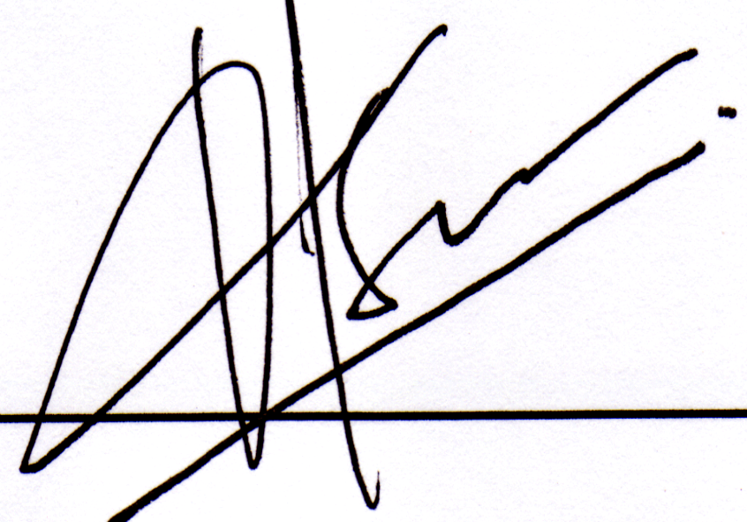

M.Darsono
AUTHORSHIP STATEMENT

We wish to submit an original research article entitled “Design of Monopole Antena Shaped-Star for Communication Ultra-Wideband Application” for consideration by SINERGI.

All persons who meet authorship criteria are listed as authors, and all authors certify that they have participated sufficiently in work to take public responsibility for the content, including participation in the concept, design, analysis, writing, or revision of the manuscript.

Author 1
Name | : | M.Darsono
Affiliation | : | Universitas Darma Persada
Email Address | : | emdarunsanda@gmail.com
Author 2
Name | : | Muhammad Rega Aditama
Affiliation | : | Universitas Darma Persada
Email Address | : | regaaditama28@gmail.com
Author 3
Name | :
Affiliation | :
Email Address | :
Author 4
Name | :
Affiliation | :
Email Address | :

POTENTIAL REVIEWERS

Please submit 3 (three) potential reviewers (that have not listed in SINERGI) to speed up the review process that competent for the topic and has a good reputation in that area.

Reviewer 1
Name | : | Prof.Iskandar Fitri
Affiliation | : | Universitas Siber Asia / Universitas Nasional
Email Address | : | tektel2001@yahoo.com
Reviewer 2
Name | : | Dr. M.Fauzan Edy Purnomo
Affiliation | : | Universitas Brawijaya
Email Address | : | mfauzanep@ub.ac.id
Reviewer 3
Name | : | Syah Alam, MT
Affiliation | : | Universitas Trisakti
Email Address | : | Syah.alam@trisakti.ac.id

