The traditional village as a part of a cultural landscape: the development of cultural agriculture tourism in Catur, Bali | 

I Dewa Gede Agung Diasana Putra,
Department of Architecture, Faculty of Engineering, Universitas Udayana, Indonesia

Abstract  The Covid-19 pandemic has highlighted the importance of the agriculture sector, which has been abandoned by some people, most notably in certain cultural tourism zones of Bali. Balinese culture, which is inextricably linked to agricultural operations and in which agrarian culture adds its aspects to the community's everyday cultural activities, has enormous potential for future tourism expansion. However, certain resort zones in Bali have abandoned the agricultural sector, threatening food and culture. This occurrence has prompted concerns about whether the tourism economy's agriculture practices can continue to serve their roles. Could agriculture meet Balinese cultural and home needs in this tourism-based economy? In this case, the Balinese engage in agricultural undertakings and offer their agricultural produce to their ancestors and God. Conversely, people worship God by praying for a bountiful harvest with farm products. However, as a community, this agricultural activity has begun to decline, which is expected to limit future efforts to conserve the culture. Through field study and descriptive analysis, this paper seeks to investigate various agricultural and cultural potentials in a rural cultural environment as a tourist attraction while conserving agrarian culture to save the local culture. By juxtaposing agricultural, cultural, and tourism activities in a balanced manner, local communities will benefit not only economically, but also in efforts to preserve local culture.  This is an open access article under the CC BY-NC license   | Keywords:  Tourism;  Agricultural culture; cultural landscape; traditional settlement  Preservation ;  Article History:  Received: May 2, 2019  Revised: May 29, 2019  Accepted: June 2, 2019  Published: June 2, 2019  Corresponding Author:  I Dewa Gede Agung Diasana Putra  Department of Architecture, Universitas Udayana, Indonesia  Email: diasanaputra@unud.ac.id

INTRODUCTION
The extended Covid-19 pandemic, which has had a huge impact on the global economy, has made awareness of the importance of the agricultural sector in rural areas. As a part of cultural landscape of Bali, this sector can be a pillar for economic growth in Indonesia and Bali, and become an architectural challenge to support cultural tourism. In this context, the traditional rural setting supported by the agriculture sector has provided significant opportunities for tourism development, particularly in developing countries with limited economic alternatives [1], [2]. The countryside has three major tourism categories: ecotourism, cultural tourism, and agrotourism [3]. In this case, agricultural expansion supported by cultural activities remains the focal point of economic development through contributing to tourism promotion.
However, certain tourism regions in Bali have begun to forsake the agricultural sector, offering a problem and issue not just in terms of providing food for the people but also in terms of preserving local culture. This phenomenon has risen to the questions about to what extend the present agricultural practices in tourism economy can still perform its traditional functions including agricultural production and cultural practices. Could the agriculture support the domestic and cultural need for the Balinese in this tourism economy?
It is necessary to seek a paradigm shift in thinking to enhance the economy, one of which can be accomplished by expanding agricultural operations in rural areas with the natural and geographical potential to be developed as sites of integrated cultural tourism. The development of vital agricultural areas is expected to result in economic growth hubs that will have a rippling effect on nearby regions. Regarding tourism development associated with agricultural operations, impact analysis methodologies are often used, where tourism activities are quantified in terms of their direct and indirect effects on community economic activities [4]. In this case, an analysis model is being developed that stresses the tourist sector's links with other sectors, both those associated with activities that are inputs to tourism activities (backward linkage) and those connected to activities that output (forward linkage) [5]. In this case, the development of tourism in an agricultural activity in the region must be meticulously planned, taking into account the linkages of the agricultural activities to be developed, both forward and backward linkages, as well as the need for supporting infrastructure and facilities, such as road networks, clean water.
Previous researches stated that tourism is seen globally as a tool of national development since it increases employment opportunities and possibilities, earns foreign currency, secures balance of payments benefits, and helps to construct infrastructure [6], [7]. Tourism accounts for 35% of worldwide service exports and more than 70% in emerging countries [8]. The growing worldwide competition among tourism locations has driven governments to build unique tourism resources as a draw [9]. Several low-income countries have begun to see tourism as their primary economic growth option, owing to their natural, historical, and cultural richness [10], [11]. Tourism is a source of national development since it reduces poverty and increases employment opportunities. Other options include earning foreign currency, improving the balance of payments, and developing infrastructure [1], [12].
In term agriculture and tourism’s integration, many studies found that agriculture has been regarded as the economic backbone of developing countries [13], combining agriculture and tourism strengthens developing countries’ economies. Agro-tourism agricultural operations have grown throughout Europe due to the development of a tourism-agriculture combination [14]. Increasing variety in agricultural and rural landscapes provides huge opportunities for tourism growth, particularly in locations where economic options are limited [2]. As global competition for destinations intensifies, countries are leveraging their unique tourism resources to gain a sustainable competitive advantage in the tourism industry [15], [16].
Agro-tourism combined with the traditional architecture and settlements is a fantastic opportunity to boost the local economy by using agricultural activities as the main attraction in various ways. Coffee estates in hilly places with stunning rural landscapes could offer a fresh approach to regional development [17]. Agrotourism on plantations will provide educational and economic benefits to tourists and farmers, resulting in more money for rural communities and other multiplier effects [14].
Based on these previous studies and the challenge for the Balinese to gain economy benefit from tourism without produce negative impacts to their cultural landscape, this paper aims to investigate the issues connected with agrotourism in a traditional settlement of Catur, Kintamani Bali, which may then be utilized to develop and extend the Kintamani cultural environment's agrotourism market niche.
Since the cultural landscape is a specific entity that difference with others, the presence of a cultural landscape in the coffee plantation area of Catur Village, where farmers have passed down traditional settlements from generation to generation, promote new idea of specific agricultural tourism that makes unique attractions. This paper examines the unique attractions that offer not only natural beauty of Catur Village but also the cultural beauty of the people, including the uniqueness of the architecture and traditional settlements.

METHOD
This study established a two-tiered method. The first stage is to collect data and investigate agricultural and cultural prospects in the Kintamani cultural setting, notably in Catur Village. This phase is the first phase in assessing a region's tourism potential, which includes agricultural potential, natural beauty potential, cultural potential including traditional architecture and settlement (Figure 1). Architectural documentation is essential in all phases [18]. Architectural documentation is used not just as an afterthought but also as a tool for graphical analysis. Interviews reinforce field investigations to investigate the existence of the topic.
The sampling location was chosen using purposeful sampling by analyzing characteristics such as the existence and potential production of religious tourism artefacts. In the second phase, this review emphasizes the distinctiveness or beauty of architecture, traditional settlement, and agricultural sector production practices. Primary data was gathered through observation, interviews, and dialogue with members of the community, both individually and in groups, as well as with regional agencies such as the Agriculture and Food Service, the Development Planning Agency, the Public Works and Spatial Planning Office, the Kintamani Subdistrict Head, and the Catur Village Head. Meanwhile, secondary data was acquired from sources such as the Central Statistics Agency, the Agriculture and Food Service, and the Catur Village monograph. A qualitative descriptive technique is employed to handle the data, which comprises identifying and analyzing all field-collected data and information relevant to the problem and research objectives.

Data collection
Collecting data and investigating agricultural and cultural prospects
architectural documentation and analysis
Natural beauty
agriculture
culture
Sampling location
Interview, questionnaire and focus group disccussion
Agriculture, traditions and artifacts characteristic
the distinctiveness or beauty of architecture, traditional settlement, and agricultural sector production practices
Tourism attraction: Integration among agriculture, cultural practices and natural beauty
Problem and uniqueness of place
Literature and references
fieldwork
The First Phase
The second Phase
Figure 1. The method: the block diagram

RESULTS AND DISCUSSION
The Traditional Spatial Concept and Tourism Village
In Indonesia, tourism is defined as a travel activity involving visiting a certain location for recreation, personal development, or research into the uniqueness of the tourist item visited within a specific period. Spatial tourism frequently takes advantage of the landscape's beauty and the community's cultural activities. The mix of natural beauty and cultural activities is a benefit of tourism activities in Indonesian villages, particularly in Bali and the form of tourism villages.
Village tourism is the enjoyment of natural beauty and rural village life. Tourists are drawn to a community's traditions and way of life [19]. Groups of visitors stay in local communities or faraway villages to gain new insights into traditional village life and the surrounding environment in this type of tourism [20]. This concept combines attractions, hotels, and traditional amenities into a daily community life system interwoven with existing processes and customs [21].
Culture- and nature-based development is often distinguished by using original arrangements of traditional forms previously intended primarily for local community activities and not tourism. The uncontrolled installation of tourism facilities has added to the physical landscape's load. This development negatively impacts the environment, socio-cultural traditions, and traditional human habitation patterns [22], [23]. Furthermore, the current development paradigm does not address the needs of unique tourist destinations [24] and ignores community involvement [25]. This structure has the potential to transform cultural and natural settings into traditional identity features that contribute to tourism growth.
A cultural landscape is defined as cultural activity over landscapes [26], [27]. The environment typifies the cultural landscape, culture, and economics (Figure 2), all related to food production and whose constituents coexist peacefully [28]. These elements have interacted and amalgamated to form an arrangement that can be considered an evolutionary sequence influenced by human cultural interaction [29]. Cultural landscape behaviors change continuously over time [30]. As a result, the cultural landscape can be regarded as an evolutionary image of people's capabilities and abilities to use and transform the environment in various biophysical and sociocultural ways within ecological cycles [31]
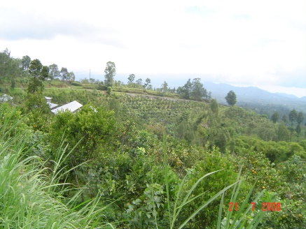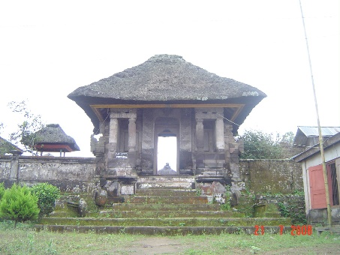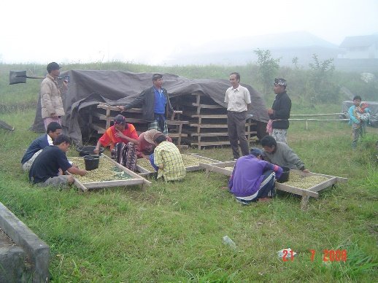
Figure 2. Cultural landscape between nature (upper), a holy place as the embodiment of God (middle) and humans with their activities including the economy (lower)

The interaction of people's culture and the natural environment in landscapes has resulted in various cultural landscapes. People and landscapes exist because of each other in this unique interdependence [32], with landscapes mirroring culture [33]. Cultural landscapes represent people's daily lives by displaying people's stories, events, and locations throughout history [34]. This cultural landscape is incorporated into Bali's religious worldview, where the physical environment is a natural manifestation of human tradition and culture [35].
The Balinese believe that the land belongs to God and their ancestors, which promotes a harmonious connection between God, humans, and the environment. This relationship embodies the Hindu religious idea known as tri hita karana [36]. The tri hita karana philosophy then encourages other ideas associated with the Balinese landscape, such as the physical division of the world, which includes houses, villages, and territorial patterns, and the physical division of people, which includes people, building details, and building composition [37]. This concept illustrates a significant link between agricultural systems and religious traditions (Figure 3). Agricultural products are used in rituals to ensure a successful harvest and to thank God in this system. Individuals in this system have modified, classified, and interpreted their surroundings to build their identity [31]. The combination of natural elements, human belief systems, and human beings gives a location its identity. This system is represented in the Balinese way of life and farming method. Balinese home and religious habits, as well as their desire to maintain peaceful connections with God, other people, and the environment, are thus linked to agricultural prosperity. The variety of agricultural products reflects the complexity of Bali's microclimate, resulting in a diverse range of cultural activities. This system highlights how the richness of the Balinese cultural landscape is mirrored in three main elements: culture, nature, and the economy, which are present in the natural environment and agricultural land, temples, settlement patterns, marketplaces, and cultural activities.

Human

Enviroment
God (belief System
Tri Hita Karana
Tradition (culture)
Landscape and environment
Living culture (economy)
Residential activities
Cultural Agricultural
Agricultural activities
Belief system
domestic activities of people
Cultural and tradition practices
Figure 3. The Balinese cultural landscape system based on tri hita karana philosophy

Agricultural potential in Catur Kintamani Village

Catur is a coffee and citrus agriculture center in the Bangli Regency. According to crop density and quantity, Catur Area, Kintamani District, is the center of coffee production in the Bangli Regency. Arabica coffee is the most widely farmed type of coffee. The marketing scope of coffee products includes the local market, the national market, particularly Java, and the international market. The aroma of orange in Kintamani coffee must be balanced with the coffee's ability to reach a large market. The shade used in Kintamani's coffee fields enhances Arabica coffee's zesty flavor. Citrus plants (Citrus grandis) are put around coffee plants to provide shade. The public believes that this contributes to the orange-like sourness of Kintamani coffee. In this case, the Kintamani region is known not only for its coffee plantations but also for its citrus orchards [38]. Such typical production outcomes are supported by a favorable agro climate and soil nutrient content, which only some locations provide. Kintamani coffee has a Geographical Indication (GI) that distinguishes it from coffee in other areas [39].
Kitamani's coffee has been sold in various locales throughout Bali, Indonesia, and the world. This coffee industry includes beans and a processing plant, most notably in Dusun Mabi (Figure 4). Arabica coffee processing on a large scale is confined to drying the beans. On a small scale, the local community uses common ways to convert coffee beans into ready-to-sell coffee powder.
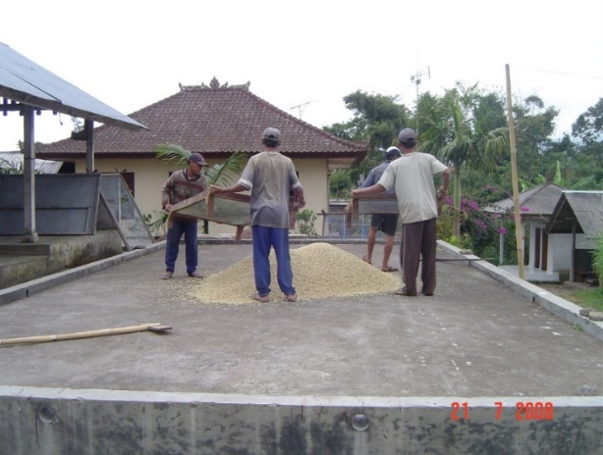
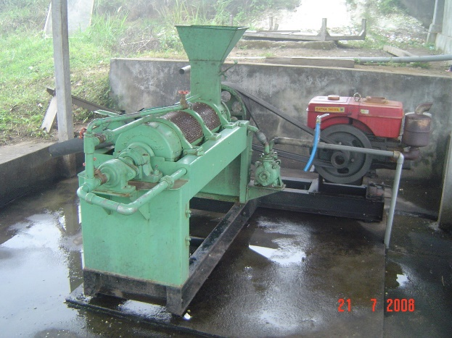
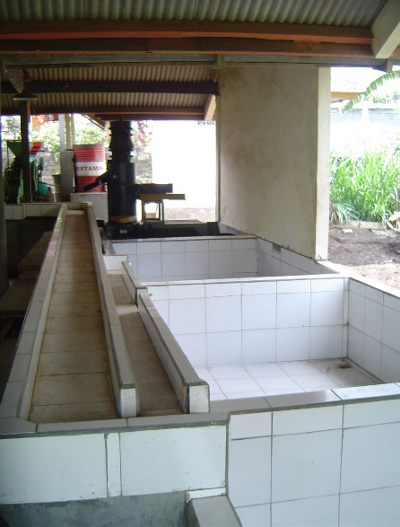

Figure 4. Coffee Bean Processing Facility

Coffee is a great product since it was produced and cultivated by society. This product is also because the creation of this better item generates income for the community's life and well-being, resulting in a surplus over the region's necessities. Furthermore, the benefits of these improved items raise regional income. Only commodities have been marketed outside the producing region and can even be shipped abroad. Most people may only plant top commodities if their production provides foreign exchange and profits for farmers and agribusiness firms. Leading commodities in this context compete in local, national, and international markets, contributing to regional and national economies [40].
Mainstay commodities, on the other hand, are products with a high added value, the ability to generate income quickly, offer distinct market niches, are moderately competitive, and are managed by a qualified and competent team [41]. Additional supportive elements include prospective land space, an appropriate market, the number of workers that can be employed. Based on consultations with a range of institutions, agencies, and associated parties, the following are the primary characteristics of a mainstay commodity: (1) natural advantages; (2) comparative advantages; (3) competitive advantages; and (4) long-term viability Based on the criteria as mentioned above, oranges and coffee are the cornerstone and main commodities in the Catur Village.
An agribusiness or agricultural business system called sistem usaha pertanian (SUP) must be established to create agricultural areas where agricultural sustainability can be maintained. This agribusiness manages biological resources to meet community needs related to pre-production operations, commodity crop cultivation and harvesting, post-harvest production activities and outcomes, distribution, and marketing. Activities in an integrated system are interconnected and influence one another from start to finish. The upstream agribusiness subsystem provides or manufactures items required for production activities, such as seeds/nurseries, fertilizers, pesticides, agricultural gear, and equipment such as land processing tractors, hand sprayers, and supporting industries [42]. The nursery business is rapidly expanding in Catur Village. However, the only reason for upstream agribusiness activity in the Kintamani Region is to meet local needs. Clove, rambutan, coffee, and orange nurseries are among those in the nursery sector (Figure 5).
Other production facilities, such as fertilizers and pesticides, have been made available by several manufacturing facilities enterprises in this area, in addition to expanding the nursery industry. The community uses organic fertilizers made from cow manure to stimulate the growth and development of plants, notably oranges. In addition to cow manure, cow pee is turned into spray fertilizer in this neighborhood. This method is known as bio urine. Cow urine is collected in a holding tank and fermented by adding a reagent medicine and allowing it to run down the steps leading to a tank.

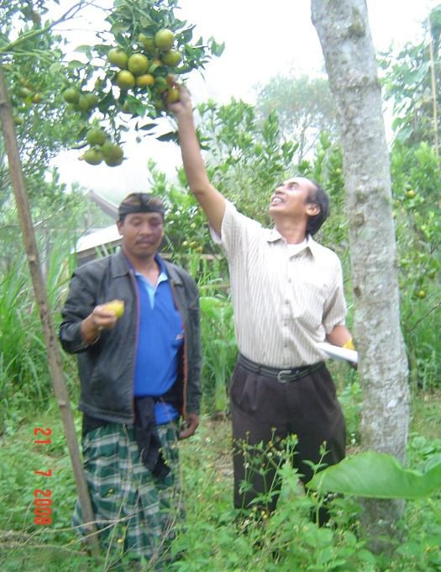
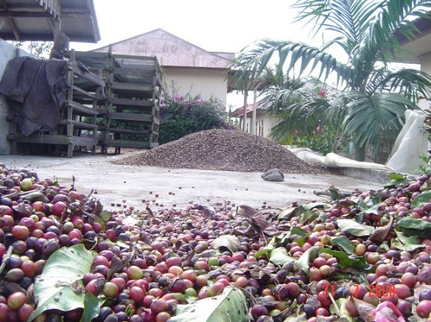
Figure 5. Regional agricultural commodities

Furthermore, agribusiness farming (on-farm agribusiness) is growing in this region, where community agricultural operations are concentrated on a region's advantages and qualities for producing primary horticulture commodities. In this case, the farming process will generate agricultural products or crops, which can form fruits and vegetables in agriculture. According to regional commodities, most of the planning area's population works as farmers, specializing in agricultural food production and plantations such as coffee, a superior and necessary commodity. Coffee is grown on property that is either owned or leased. The costs incurred for each managed land differ according to the cultivated area (based on the number of plants). The retrieved products generally only guarantee a year of continuous availability. Farmers recruit fruit pickers from the local village or its environs during harvest, with the amount of labor necessary determined by the number of plants owned and the area of land being processed or planted.
This agribusiness subsystem is linked to the primary subsystem, which comprises marketing and production processing operations aimed at increasing the value of agricultural production. Subsystems of downstream agriculture or processing that focus on commodity processing and marketing. This agricultural commodity underwent industrialization and diversification into several types of processing, both finished and semi-finished, to improve its bargaining power and provide advantages over other regional output.
Farmers' commodities are typically exposed to price volatility and usually fail to meet production costs. Farmers are frequently able to accept offers from purchasers in this situation, compelling them to sell their produce at a low price. This situation happens because agricultural products are typically perishable, and farmers must use them promptly to survive. Farmers must therefore process their crops so that unsold goods can be turned into products with a higher market value and greater durability. Agricultural products can be processed in the food and beverage, medical, and agrotourism industries. Even though the agricultural processing business is now a small-scale domestic industry, this processing will allow farmers to charge a greater price for their agricultural products.
This small sector has the potential to grow mostly due to the abundance of locally generated agricultural raw materials. In order to flourish, this little industry requires aid from the industrial and commercial sectors, as well as the health element of snack food production. In the interim, other agricultural goods are sold as unprocessed, unfinished, or semi-finished commodities.

The traditional settlement of Bali Aga
In this cultural landscape region of Bali, traditional residential districts with a long history coexist with agricultural operations. One of the hamlets in this region is a Bali Aga village, which existed before Majapahit's cultural influence in Bali. The Bali Aga villages and the Balinese plain villages are well-known in Bali. The traditional Balinese house architecture or composition reveals the numerous village forms in Bali. The geographical conditions of each type of village influence this distinction, as the Bali Aga villages are generally located in the highlands, whereas the Balinese plains villages have a different historical background, with the influence of the Majapahit culture visible in the form of housing structures [43]. Some researchers call these villages on Bali's lowlands apanage or apanase [44], [45].
The Majapahit civilization influenced a power center and civilization and cultural standards [46]. The Majapahit Kingdom was deposed by Islamic political forces in Java, prompting the Hindu Javanese aristocracy to migrate to Bali [47], [48]. Gelgel imposed a centralized power structure on the Majapahit civilization's social life and ceremonies. In contrast, the indigenous Balinese, mainly excluded from Balinese society, gained a new status as Bali Aga [49].
Although the number of Bali aga villages is modest, cultural norms differ greatly. Bali Aga villages, on the other hand, are typically identified by the presence of a central core-orientated kaja (towards the mountains) - kelod (towards the sea) [43]. The main physical feature of the Bali Aga community is a communal open area with a linear layout of various services. This location is critical for carrying out social rituals and celebrations in the community. A temple, traditional swing, village meeting hall (bale agung), wooden bell tower (bale kulkul), granary (jineng), a pavilion as a venue for ceremonial events (bale lantang), and youth meeting hall (bale teruna) are all part of Tenganan's communal space [43].
Residents in these facilities participate in most sociocultural activities related to the community and the human life cycle. These are the most important locations for holding ceremonies, such as the ten-couple wedding held at the local temple in Pengotan. Ngaben in Bayung Gede is another example of festivities in particular areas inside village facilities (bale agung temple, tegal suci, and setra gede) [50]. Such rituals bring together cultural practices because they are considered local activities and are carried out by committees based in village facilities.

Tourism development plan
Aside from agriculture, the natural beauty of this tourist area must be improved. Agro-tourism, a tourism type involving tourists in the agricultural sector, was designed to combine these two elements. The existence of rural inhabitants who have occasionally engaged in agricultural operations is inextricably linked to the emergence of agrotourism in this area. Combining agriculture and tourist businesses in rural regions can help to enhance rural living conditions. With this strategy, a rural area can be changed into a tourist village by using agricultural and cultural activities as the major resource for tourism development.
These initiatives include creating a tourist village model in which rural communities' agricultural culture and daily cultural activities serve as the core tourism development components [37], [51]. In order to construct a typical and sustainable tourist village, rural development and growth of a village as a tourist attraction must innovate. This tourism community, which uses village facilities and empowers residents, is a promising strategy to encourage sustainable development in rural areas, including the sustainability of traditional architecture [52].
Regional development, in this case, is focused on promoting agrotourism, which capitalizes on high-quality agricultural products, particularly oranges and coffee. Agriculture and culture in the region's cultural environment could be used as a draw for expanding tourism activities in this case. Agricultural production activities, both during the production and post-production phases, are tourism activities with educational connections; this is one of the advantages of a tourist town based on agricultural culture activities.
This agricultural potential is enhanced by the community's distinct traditions and culture to attract tourists. This attraction is a distinct creative hotspot [53] that will draw tourists. Many existing cultural tourist items, such as temples, traditional dwellings, and cultural events in the agricultural region, support this cultural tourism activity. Agricultural and rural culture activities are tourism activities that can be combined with other products or trip packages, such as picture activities (photography) and recreational/picnic activities. Other recreational activities include enjoying rural scenery (scenic activities) such as motorbike riding (motorcycling), bicycle riding (cycling), and walks in plantation areas and fields (walking); sightseeing (sightseeing) to the countryside and the coffee processing process, as well as observing the lives of the farmers as they care for and maintain their gardens and fields.
The development of rural agricultural areas as a potential tourism niche is based on the interests and needs of visitors who want to participate in rural activities such as agricultural activities [54]. Furthermore, rural tourism will increase the advantages received by rural people from rural tourist activities and ensure the link between rural tourism development and biodiversity conservation [55] and cultural preservation [56]. In this case, agricultural and cultural tourism growth includes agricultural tours of the countryside and lodgings with various activities, such as festivals, gastronomy, outdoor leisure items, and sales of handicrafts and agricultural products [57]. In rural tourism, regional development must begin in rural landscapes by bringing together rural residents and other rural stakeholders. Because there is a trend for people to return to nature and experience authentic agricultural processes, agricultural activities and associated facilities can be transformed into recreational activities.
The socio-cultural environment and rural community environment support the development of tourism villages [58], where community settlements and infrastructure occupy only a small portion of the overall cultural landscape, which is dominated by agricultural areas, forests, rivers, and mountains [59]. Nonetheless, residential areas are an important component in the development of a tourist town, where the shape of buildings and residential areas, as well as the activities that take place within them, symbolize a distinct identity of a community that can provide tourists with a unique experience.
The overall topography of the steep Catur cultural terrain tends to produce a linear village plan, as shown in Dusun Mabi (Figure 6), one of the Catur Region's iconic Bali Aga settlements [45], [60]. Mabi, like a Bali Aga hamlet, has a discrete residential area with different dwellings that do not share the same lineage. Traditionally, structures are built with locally available materials such as bamboo, wood, and mud floors.

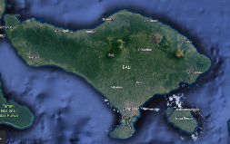

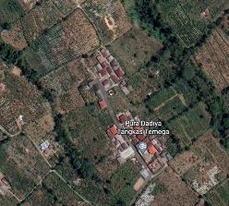
Figure 6. Location of Mabi Hamlet, Catur Bangli Village

Mabi's settlement system is unique in that it is a linear system used not only for settlement patterns but also for residential patterns [61]. (See Figure 7). The holy site is located in the most important region, namely in the direction of kaja, which means towards the mountain; the structures where people live extend facing each other on the core parcels in the direction of kelod, and the enclosures and entrance rooms are on the kelod side. Meanwhile, the service area is positioned at the back of the building, the furthest away from the courtyard. Therefore, the courtyard, called natah, have the most value [45], [60].

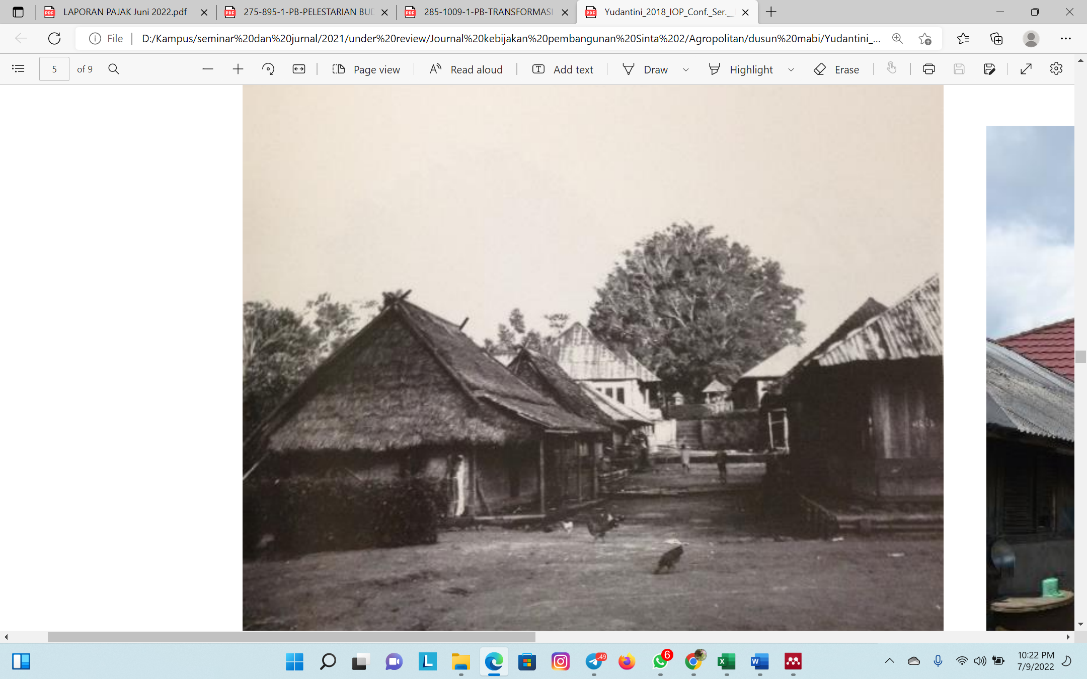
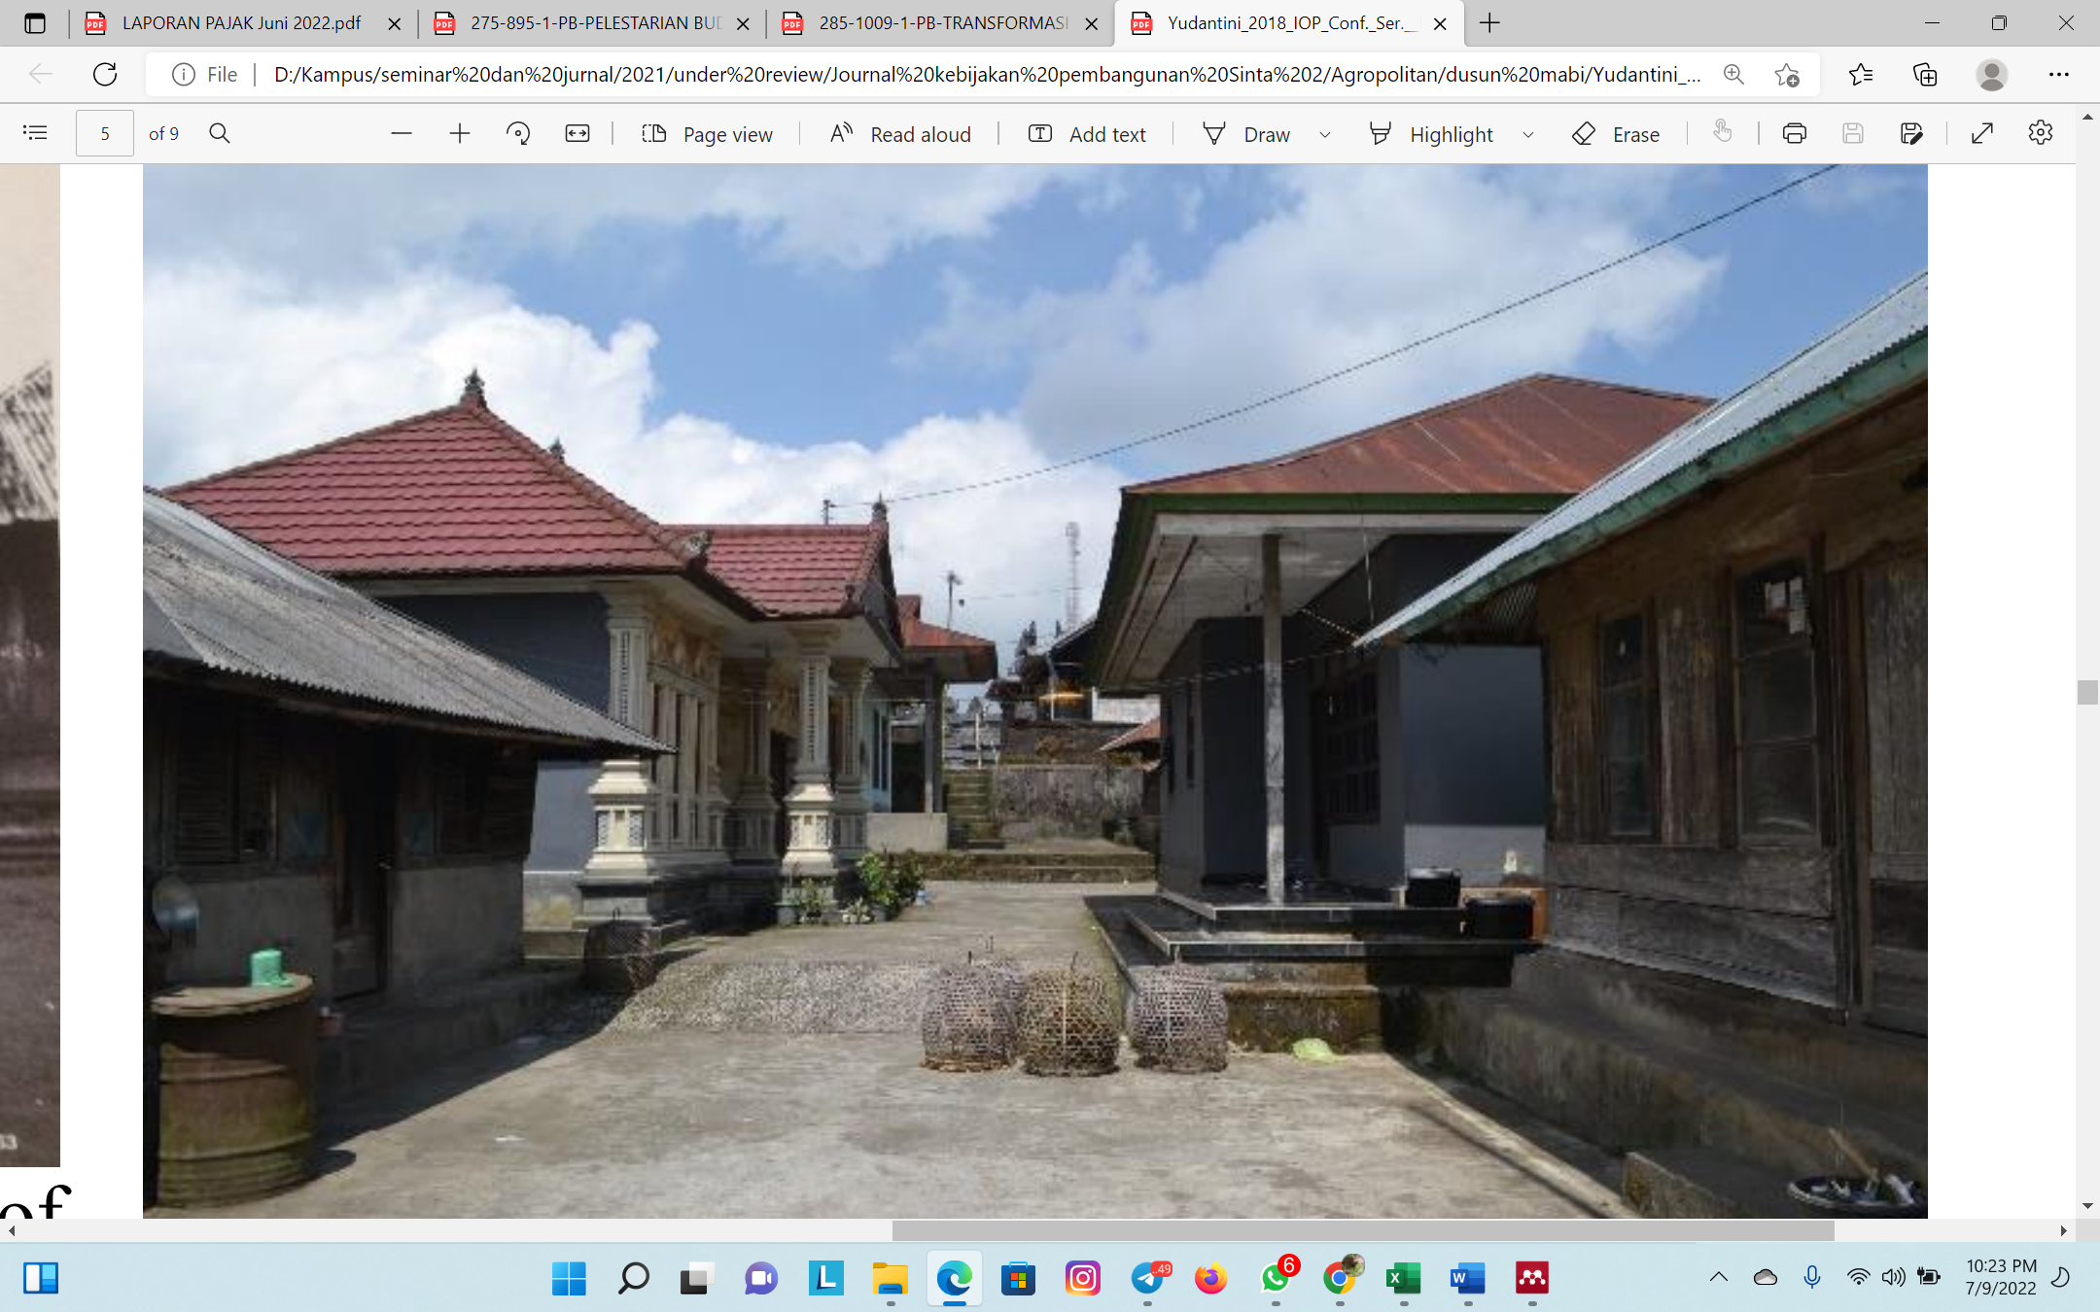
Figure 7. The linear pattern of Mabi hamlet settlement in Catur Village in the 1980s [upper] (Source: Muller, 2011) and the current linear pattern (below) (source Yudantini, 2018)

The distinctiveness of the building's shape and the presence of many cultural activities substantially aid the growth of the tourism business in agricultural districts. This potential must be kept as a historical architectural work through preservation, adaptation, or reconstruction [62]. This agricultural sector gains added value, which benefits the local economy and helps preserve the local culture, which is immensely popular with domestic and international tourists [56], [63]. Creating an agricultural area as an integrated area between agricultural culture and the daily lives of the community is an important component of the growth of tourism that is different and has its personality so that visitors will be enticed to visit and will return in the future.

CONCLUSSION
Rural areas' cultural environment, supported by the agricultural sector, has provided significant opportunities for tourism development, particularly in developing countries. The development of the agricultural sector, which is linked to the community's cultural activities, is the focal point of economic development through tourism enhancement. On the other hand, tourism operations have significantly shifted agricultural activities, which, given their close relationship with cultural activities, can be expected to result in a shift and blurring of local culture gradually.
The potential of a cultural landscape in a mountainous area such as Catur Village, Kintamani Bangli, which is a center for the development of coffee and citrus farming, necessitates comprehensive planning so that the agricultural, cultural, and tourism sectors can complement efforts to develop the community's economy without overlooking cultural aspects. Agricultural activities must be carried out using the most recent technological breakthroughs to provide economically viable additional value for the community, allowing it to continue to rely on agriculture. To supplement this, agricultural activities and other local cultures must be fostered so that agricultural operations do not deviate from their cultural origins, i.e., where agricultural activities are linked and mutually supportive.
The presence of a traditional village in the Catur region can also contribute to developing a broad mix of agricultural and tourism sectors, where the uniqueness of a traditional town is a major pull for the general public, including both local and international tourists. Integrating agricultural, cultural, and tourism activities is critical to achieving sustainable agriculture, culture, and tourism. Residential, agricultural, and community cultural activities can be a big tourist draw.
Agriculture, culture, and tourism in a rural mountainous setting have the greatest potential to strengthen the economy of mountainous rural towns. In this case, the mix of agricultural and cultural activities, as well as countless artifacts from the past, such as traditional village locations, represents the greatest potential and resource for the growth of the tourism business. The development of agricultural areas prioritizes how to create great products and market them and how to preserve the agricultural culture that the community has fostered. Agricultural activities based on traditional agricultural processes can aid modern agricultural processes in cases where the two are mutually beneficial. This agricultural culture will be able to help the cultural tourist business by adding value to agricultural activities and inspiring future generations to undertake agricultural pursuits.

ACKNOWLEDGMENT
The author would like to thank the residents of Catur for their collaboration during the research, as well as their colleagues in the Architecture Study Program at Udayana University's Faculty of Engineering for their contributions to the creation of this work.

REFERENCES

[1] G. O. Hossein, H. Alipour, and S. Dalir, “An Entrepreneurial Tourism Project through Agro-Tourism Farm in Iran,” J. Sustain. Dev. Stud., vol. 6, no. 1, pp. 48–63, 2014.
[2] Phelan & Sharpley, “Exploring agritourism entrepreneurship in the UK. Tourism Planning & Development,” Tour. Plan. Dev., vol. 8, no. 2, pp. 121–136, 2011, [Online]. Available: https://research.edgehill.ac.uk/ws/files/20745103/Phelan_Sharpley_Exploring_Agritourism_Entrepreneurship_in_the_UK_Author_Post_Print.pdf
[3] H. Shushma, “Agri tourism in Karnataka-issues constraints and possibilities." 2.7 (2012): 106-111.,” Int. J. Res. Commer. Econ. Manag., vol. 2, no. 7, pp. 106–111, 2012.
[4] J. E. Fletcher, “Input-Output Analysis,” in Tourism Marketing and Management Handbook, 2 nd., S. F. Witt and L. Moutinho, Eds. New York: Prentice Hall Inc, 1994, pp. 480–487.
[5] J. Cai, P. Leung, and J. Mak, “Tourism ’ s Forward and Backward Linkages,” J. Travel Res., vol. 45, no. 1, pp. 36–52, 2006.
[6] R. Klamár, “Tourism and the visit rate in the tourism regions in Eastern Slovakia from the point of selected indicators,” Bull. Geogr. Socio-Economic Ser., vol. 23, pp. 99–118, 2014, doi: 10.2478/bog-2014-0007.
[7] A. Pizam and Y. Mansfeld, Consumer Behavior in Travel and Tourism. New York: Routledge, 2000. [Online]. Available: http://marefateadyan.nashriyat.ir/node/150
[8] L. L. Reed and T. E. Kleynhans, “Agricultural land purchases for alternative uses - Evidence from two farming areas in the Western Cape province, South Africa,” Agrekon, vol. 48, no. 3, pp. 332–351, 2009, doi: 10.1080/03031853.2009.9523830.
[9] S. J. Page and J. Connell, Tourism a Modern Synthesis. London: Thomson Learning., 2006.
[10] G. Eshun, Ecotourism and Social Research. VDM: Germany, 2011.
[11] R. G. Sunaryo, A. Pudianti, and Y. D. Purbadi, “Pattern and type permanence in the Kasongan area: Typo-morphology study towards a sustainable Pottery Tourism Village,” ARTEKS J. Tek. Arsit., vol. 7, no. 2, pp. 183–196, Aug. 2022, doi: 10.30822/arteks.v7i2.1400.
[12] C. Barbieri, “Assessing the sustainability of agritourism in the US: A comparison between agritourism and other farm entrepreneurial ventures,” J. Sustain. Tour., vol. 21, no. 2, pp. 252–270, 2013.
[13] S. Phillip, C. Hunter, and K. Blackstock, “A typology for defining agritourism,” Tour. Manag., vol. 31, no. 6, pp. 754–758, 2010.
[14] G. Eshun and C. Tettey, “Agrotourism development in Ghana: A study of its prospects and challenges at adjeikrom cocoa tour facility,” Bull. Geogr., vol. 25, no. 25, pp. 81–99, 2014, doi: 10.2478/bog-2014-0031.
[15] A. Fleischer and A. Tchetchik, “Does rural tourism benefit from agriculture?,” Tour. Manag., vol. 26, no. 4, pp. 493–501, 2005, doi: 10.1016/j.tourman.2003.10.003.
[16] G. Schroth and C. A. Harvey, “Biodiversity conservation in cocoa production landscapes: An overview,” Biodivers. Conserv., vol. 16, no. 8, pp. 2237–2244, 2007, doi: 10.1007/s10531-007-9195-1.
[17] B. Acquaah, “Cocoa development in West Africa: the early period with particular reference to Ghana,” Accra, 1999.
[18] M. Z. Umar, M. Arsyad, S. Santi, and A. Faslih, “Principles of Sustainable Architecture in The Production of Bamboo Woven Wall Materials (Dendrocalamus Asper),” SINERGI, vol. 24, no. 1, p. 57, Jan. 2020, doi: 10.22441/sinergi.2020.1.008.
[19] R. G. Soekadijo, “Tourism Anatomy,” Gramedia Pustaka Utama. Jakarta, 2000.
[20] E. Inskeep, Tourism planning: an integrated and sustainable development approach. Van Nostrand Reinhold, 1991.
[21] W. Nurhayanti, Heritage, Tourism and Local Communities. Yogyakarta: UGM Press., 1999.
[22] P. M. Burns, “Tourism planning: a third way? ,” Ann. Tour. Res., vol. 31, no. 1, pp. 24–43, 2004.
[23] I. D. G. A. D. Putra, M. Lozanovska, and R. Fuller, “From spiritualistic toward more pragmatic pattern: Re-ordering Balinese houses and viability of the household traditions in tourism economy,” J. Archit. Urban., vol. 43, no. 1, 2019, doi: 10.3846/jau.2019.3692.
[24] C. Tosun and C. . Jenkins, “Tosun, C. & Jenkins C.L. (1996). Regional planning approaches to tourism development: the case of Turkey. Tourism Management, 17(7), 519-531.,” Tour. Manag., vol. 17, no. 7, pp. 519–531, 1996.
[25] D. Kala and S. C. Bagri, “Barriers to local community participation in tourism development: Evidence from mountainous state Uttarakhand, India,” Turiz. međunarodni Znan. časopis, vol. 66, no. 3, pp. 318–333, 2018.
[26] H. H. Birks, H. J. B. Birks, P. Kaland, and D. Moe, The cultural landscape: Past, present and future. Cambridge: Cambridge University Press, 1989.
[27] M. Domosh, “Cultural landscape in environmental studies ,” in International Encyclopaedia of the Social and Behavioural Sciences , N. Smelser and P. Bates, Eds. Newyork: Elsevier, 2004, pp. 3081–3086.
[28] A. Farina, “The cultural landscape as a model for the integration of ecology and economics,” Bioscience, vol. 50, no. 4, pp. 313–320, 2000.
[29] U. Myga-Piątek, “ Cultural landscape of the 21st Century: Geographical Consideration between Theory and Practice,” Hrvat. Geogr. Glas., vol. 73, no. 2, pp. 129–140, 2011.
[30] M. Conzen, “Cultural landscape in geography,” in International encyclopaedia of the social and behavioural sciences , N. Smelser and P. Bates, Eds. New York: Elsevier, 2004.
[31] R. Chaparro González, “Some Insights into the Theory and Practice of Heritage Ecology: Grasping the Bio-physical and Socio-historical Dynamism of the Cultural Landscape of Hangzhou,” Doc. d’Anàlisi Geogràfica, vol. 66, no. 1, pp. 133–158, Jan. 2020, doi: 10.5565/rev/dag.533.
[32] R. Buckley, C. Ollenburg, and L. Zhong, “Cultural landscape in mongolian tourism,” Ann. Tour. Res., vol. 35, no. 1, pp. 47–61, Jan. 2008, doi: 10.1016/j.annals.2007.06.007.
[33] R. Zhang and K. Taylor, “Cultural landscape meanings. The case of West Lake, Hangzhou, China,” Landsc. Res., vol. 45, no. 2, pp. 164–178, Feb. 2020, doi: 10.1080/01426397.2019.1589438.
[34] K. Taylor, “Cities as cultural landscapes,” in Reconnecting the City: The Historic Urban Landscape Approach and the Future of Urban Heritage , F. Bandarin and R. van Oers, Eds. UK Oxford.: Wiley-Blackwell, 2015, pp. 179–202.
[35] M. Covarrubias, Island of Bali. Singapore: Periplus Editions, 2015.
[36] F. Eiseman Jr, Sekala and niskala: essays on religious, ritual and art, vol. I. Singapore: Periplus Editions, 1989.
[37] I. D. G. A. D. Putra, I. B. G. Wirawibawa, and M. W. Satria, “Spatial orientation and the patterns of the traditional settlement in the eastern Bali: Investigating new tourism atractions,” Geoj. Tour. Geosites, vol. 29, no. 2, 2020, doi: 10.30892/gtg.29218-493.
[38] N. L. Suastuti, “Tourist Satisfaction Towards Arabica Coffee at Catur Village Kintamani Bangli - Bali,” Adv. Econ. Bus. Manag. Res., vol. 111, pp. 85–89, 2020, doi: 10.2991/icoborot-18.2019.13.
[39] S. Mawardi, “Advantages, constraints and key success factors in establishing origin-and tradition-linked quality signs: the case of Kintamani Bali Arabica coffee geographical indication, Indonesia Case study on quality products linked to geographical origin in Asia,” 2009. [Online]. Available: http://www.fao.org/fileadmin/templates/olq/documents/documents/Kintamani.pdf
[40] A. Setiyanto, “Approach and Implementation of the Development of Main Agricultural Commodity Areas,” Forum Penelit. Agro Ekon., vol. 31, no. 2, p. 171, 2013, doi: 10.21082/fae.v31n2.2013.171-195.
[41] G. D. Dwisetyo, “The Existence of Reyog Art Instrument Craftsmen in Ponorogo Regency,” Universitas Muhamadiyah Ponorogo, 2018.
[42] C. Nuraini, M. Masyhuri, J. Jamhari, and D. Hadi Darwanto, “Institutional Model in Organic Rice Agribusiness in Tasikmalaya Regency,” Agrar. J. Agribus. Rural Dev. Res., vol. 2, no. 1, pp. 9–16, 2016, doi: 10.18196/agr.2121.
[43] A. P. Parimin, “Fundamental study on spatial formation of island village: environmental hierarchy of sacred-profane concept in Bali,” 大阪大学, 1986.
[44] J. S. Lansing, The three worlds of Bali. Praeger Publishers, 1983.
[45] N. M. Yudantini, “Bali Aga Traditional Residential House in Belantih Village, Kintamani,” Semin. Ikat. Peneliti Lingkung. Binaan Indones., vol. 3, no. October, pp. A101–A109, 2018, doi: 10.32315/sem.3.a101.
[46] C. Geertz, Negara. Princeton University Press, 1980.
[47] R. Goris and W. Spies, The island of Bali: its religion and ceremonies. Royal Packet Navigation Company, 1931.
[48] H. G. C. S. Nordholt, “Bali: Colonial conceptions and political change 1700-1940. From shifting hierarchies to’fixed’order,” 1986.
[49] T. Reuter, The house of our ancestors: precedence and dualism in highland Balinese society. Brill, 2002.
[50] N. K. A. Dwijendra, Ancient Balinese Architecture and Culture. Denpasar: Udayana University Press dan CV Bali Media Adhikarsa, 2009.
[51] I. D. G. A. D. Putra, I. M. Adhika, and A. A. G. A. Yana, “Reviving Cultural Tourism in Kendran Bali Indonesia : Maintaining Traditional Architecture and Developing Community-based Tourism,” Civ. Eng. Archit., vol. 9, no. 2, pp. 328–338, 2021, doi: 10.13189/cea.2021.090206.
[52] R. R. Tobing, A. K. Sakti, and Hanny, “Physical form sustainability of Huta Siallagan Samosir architecture in supporting Toba Caldera Geopark cultural tourism,” ARTEKS J. Tek. Arsit., vol. 5, no. 3, pp. 459–468, Dec. 2020, doi: 10.30822/arteks.v5i3.599.
[53] R. Sobandi, B. Tyagitha, and D. Davin, “Transformation and Creative Branding of Areas for Urban Sustainability Case Study of Pulogadung Creative Node Design C@ P,” J. Permukim., vol. 13, no. 2, pp. 112–126, 2018.
[54] S. S. Pattiyagedara and P. I. N. Fernando, “On Rural Community: Reference to Hiriwadunna Village,” Sri Lanka J. Manag. Stud., vol. 2, no. 1, pp. 87–103, 2020.
[55] R. C. Aziz, “Development of Sustainable Rural Tourism at Sungai Sedim Amenity Forest, Kedah: from a tourism stakeholder perspective,” University Putra Malaysia, 2018.
[56] I. M. Adhika and I. D. G. A. D. Putra, “Reinvigorating cultural landscapes for planning cultural tourism in Bali,” Geoj. Tour. Geosites, vol. 33, no. 4, pp. 1462–1469, 2021, doi: 10.30892/gtg.334spl03-594.
[57] M. S. M. Aslam and K. W. Awang, “Enterprising rural tourism for sustainable rural development in Sri Lanka,” Int. J. Econ. Financ. Issues, vol. 5, pp. 27–33, 2015.
[58] F. Randelli, P. Romei, and M. Tortora, “An evolutionary approach to the study of rural tourism: The case of Tuscany,” Land use policy, vol. 38, pp. 276–281, 2014, doi: 10.1016/j.landusepol.2013.11.009.
[59] R. Okech, M. Haghiri, and B. George, “Rural Tourism as a Sustainable Development Alternative: An Analysis with Special Reference to Luanda, Kenya,” Cult. Rev. Cult. e Tur., vol. 6, no. 3, pp. 36–53, 2012.
[60] N. M. Yudantini and D. Jones, “The role of traditional regulation in the indigenous villages for conservation of village pattern,” in Proceedings of 21st International Sustainable Development Research Society Conference, International Sustainable Development Research Society, Geelong, Victoria, 2015, pp. 10–12.
[61] C. Muller, Bali aga villages : field work in the 1980s. Walsh Bay Press, 2011.
[62] M. D. Adiyudha and A. Suryono, “Preservation of Lampung culture in contemporary architecture in the Siger Tower and Astounding Agung Bumi Gayo buildings,” J. Permukim., vol. 13, no. 1, pp. 31–40, 2018.
[63] I. D. G. A. D. Putra, M. Lozanovska, and R. Fuller, “The Transformation of the Traditional Balinese House in Tourist Villages: Maintaining the Culture and Obtaining Economic Benefit,” Appl. Mech. Mater., vol. 747, 2015, doi: 10.4028/www.scientific.net/amm.747.68.

