DRUG FORECASTING AND SUPPLY MODEL DESIGN USING ARTIFICIAL NEURAL NETWORK (ANN) METHOD AND CONTINUOUS REVIEW (r, Q) TO MINIMIZE TOTAL SUPPLY COST IN MENTAWAI KEPULAUAN REGENCY HOSPITAL | 

Inaya Izzati^{1*}, Iphov Kumala Sriwana¹, Sri Martini¹
¹Department of Industrial Engineering, Faculty of Industrial Engineering, Universitas Telkom, Indonesia

Abstract  The Regional General Hospital (RSUD) of the Mentawai Islands Regency is located on North Sipora Island, West Sumatra Province. The problem faced by the Mentawai Islands Hospital is overstock of 83% of the total demand for Medical Consumables so that there is a buildup that has an impact on the total cost of high inventory. The accumulation of Medical Consumables can cause damage to Medical Consumables inventory and expiration because the maximum shelf life is only one year from purchase. the number of Medical Consumables with expired percentage is 15% of the total inventory which exceeds one percent (1%) of the pharmaceutical drug storage standards set by SK. Ministry of Health No. 1197/SK/X/2004. The purpose of this research is to optimal forecast future demand and minimize total inventory costs. The first stage is to do demand forecasting using Artificial Neural Network (ANN). The second stage is to calculate the order quantity and reorder point, the results of (r, Q) with continuous review are used to calculate the total inventory cost. The results of forecasting are 10036 units of Medical Consumables demand for the future, the results of demand forecasting obtained will be used to calculate the order quantity and reorder point values where the optimal order quantity of Medical Consumables-1 is 1900 units, reorder point 630 units, Medical Consumables-2 optimal order quantity 50 units and reorder point 10 units, Medical Consumables-3 optimal order quantity 100 units, reorder point 55 units, Medical Consumables-4 optimal order quantity 2050 units, reorder point 345 units, then the results of the optimal order quantity obtained are used to determine the total cost of inventory, the results of the calculation of inventory costs show the optimal amount of inventory costs of Rp. 140,313,424 with a reorder point of 345 units. 140,313,424 with a savings of 8.7% from the initial conditions. This research has the novelty of forecasting demand with ANN where the results of the forecasting will be used to calculate the optimal order quantity and reorder point to calculate the total cost of Medical Consumables inventory with Continuous Review (r, Q) where the cost components consist of purchasing cost, holding cost, shortage cost, order cost, outdating cost and inspection cost. With the design of demand and inventory forecasting models, it is hoped that inventory management will run more efficiently, control costs more optimally and can improve patient services.  This is an open access article under the CC BY-SA license   | Keywords:  Overstock; continuous review; artificial neural network; order quantity; reorder point  Article History:  Received: May 2, 2019  Revised: May 29, 2019  Accepted: June 2, 2019  Published: June 2, 2019  Corresponding Author:  Andi Adriansyah  Electrical Engineering Department, Universitas Mercu Buana, Indonesia  Email: inayaizzati88@gmail.com

INTRODUCTION (R: 31, G: 78, B: 121)
Mentawai Islands Regency Hospital has a Pharmaceutical Logistics division in charge of providing medicines needed by patients of the Mentawai Islands Regency Hospital. The drugs available in the pharmacy of the Mentawai Islands Hospital are Tablets, Syrups, Ointments, Injections, Liquids, Medical Consumables, reagents, Dentistry materials. Drugs are an essential component that must be available in health services, drugs become a link between patients and health care facilities, because the availability or absence of drugs in health care facilities will have a positive or negative impact on the quality of service [1] Therefore, good and correct drug management is needed to ensure the continuity of availability and affordability of drug services. Damaged drugs can no longer be used because of damage accompanied by changes in shape, color, odor, taste or consistency.

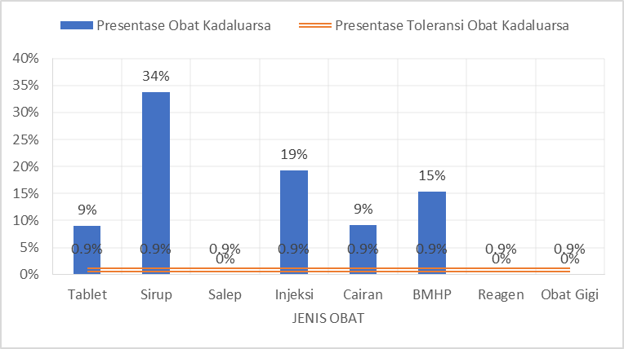
Figure 1. Percentage of Expired Medicines in 2022
Figure 1 shows the percentage of expired drugs in 2022 where there are five types of drugs whose percentage is above the tolerance limit, namely Tablets 9%, Syrup 34%, Injection 19%, Liquid 9% and Medical Consumables 15%. According to the pharmaceutical drug storage standards set by the Ministry of Health Decree No. 1197/SK/X/2004, the percentage of expired drugs is still acceptable if the percentage value of expired drugs is below 1% of the total inventory. If the percentage of expired drugs is above 1%, it indicates ineffectiveness and efficiency in managing drug supplies. This happens because drug evaluation is still not optimal, drug stock data collection is not accurate, where when collecting drug data there is information about drugs that has not been inputted such as how many drugs have entered and left, so that the data is incomplete, lack of supervision and monitoring of drugs that are about to expire or do not report them in a timely manner, making purchases when supplies are still available, excessive purchase amounts. The occurrence of expired drug stocks can cause material losses. Material losses in drug supplies are losses that occur physically or materially that cause financial losses to the Mentawai Islands Hospital, one of the factors causing material losses in drug supplies is expiration, if the drug is not used before the expiration date, then the drug is considered ineffective and must be disposed of.
Table 1 Disadvantages of Expired Medicine
Type of Medicine | Loss | Percentage Expired
Tablet | IDR3,620,814.11 | 9%
Syrup | IDR7,481,544.30 | 34%
Ointment | IDR 0 | 0%
Injection | IDR24,693,892.74 | 19%
Fluids | IDR1,468,575.05 | 9%
Medical Consumables | IDR45,033,866.95 | 15%
Reagents | IDR 0 | 0%
Dentistry Materials | IDR 0 | 0%

Table 1 shows the financial loss because drugs that are still suitable for use cannot be utilized. The largest loss occurred in the type of drug Consumable Medical Materials which amounted to Rp 45,033,866.95, Consumable Medical Materials had the largest loss due to the high cost or purchase price compared to other types of drugs. Medical consumables are medical devices intended for single use (single use) (PMK N0. 58 of 2014). The cause of expired Medical Consumables with a percentage of expiration above 1% is 15% due to overstock of 83%, The difference between total inventory and usage can cause damage to Medical Consumables inventory because these items have an expiration time. In mathematical modeling for perishable goods (food, vegetables, grains, etc.), the rate of deterioration plays an important role in the optimal policy. Inefficient procurement problems can affect the inefficiency of drug procurement [2] [3], Fluctuating demand is one of the factors that cause inefficiency [4] [5], It is necessary to do accurate demand forecasting in planning [6] [7] [8] [9]. Based on research conducted by [10] determine the amount of hospital and pharmacy supplies where there is an imbalance between demand and supply. In addition, research with the aim of reducing inventory costs also applies a cosntinuous review inventory system [11][12][13][14][15], because the actual condition considers fixed lifetime and normally distributed demand.
Based on the problems described earlier, the solution to this problem is to design a drug demand and inventory forecasting model using artificial neural networks and continuous review to reduce total inventory costs. Table 2 shows the contribution of this research, which integrates several theories, namely the integration of ANN and Continuous Review methods, as well as the addition of purchase cost, holding cost, order cost, outdate cost, shortage cost, inspection cost component variables, with the objective function of reducing total inventory cost.

Table 2 Literature Review
Research |  | 1 | 2 | 3 | 4 | 5 | 6
 |  | [16] | [17] | [18] | [19] | [20] | Proposal models
Product Type | Perishable
Demand Forecasting (ANN) | yes
Demand Forecasting (ANN) | no
Method | Continuous review
Method | Periodic review
Method | FEFO
Method | EOQ
Objective Function | Minimization of Total Inventory Cost
Objective Function | Increase Profit
Decision Variable | Optimal reorder point
Decision Variable | Optimal Order Quantity
Decision Variable | Inventory Level
Decision Variable | Cycle length
Demand | Probabilistic
Demand | Stochastic
Demand | Deterministic
Leadtime | Probabilistic
Leadtime | Stochastic
Leadtime | Deterministic
Leadtime | Zero
Lifetime | Probabilistic
Lifetime | Stochastic
Lifetime | Deterministic
Number of products | Single item
Number of products | Multi item
Inventory cost | Ordering cost
Inventory cost | Holding cost
Inventory cost | Purchase cost
Inventory cost | Shortage cost
Inventory cost | Outdate cost
Inventory cost | Cost motivation strategy
Inventory cost | Commuting cost
Inventory cost | Inspection cost
Inventory cost | Emergency cost

METHOD
Material
Consumable Medical Materials are medical devices intended for single use, the list of products of which is regulated in laws and regulations including: Sterile Handscoon 7.5/Tro - sensosurge (Medical Consumables-1), sterile surgical glove 7.5/2020 (Medical Consumables -2), Handscoon No Sterile/2020 (Medical Consumables-3), Supercare Surgical Face Mask/Earloop 3 Ply/2020 (Medical Consumables-4).
Methods
The methods used in this study are artificial neural networks (ANN) to forecast the demand for Consumable Medical Materials and continuous review (r, Q) to determine the order quantity and reorder point. An Artificial Neural Network (ANN) is a mathematical model inspired by the workings of the nervous system in the human brain. ANN are used to model and process complex data with the ability to learn from patterns or relationships contained in the data.In the context of demand forecasting, ANN are used to predict the amount of future demand based on input data such as sales history or previous orders [21]. The process of forecasting with ANN involves several stages, including data processing, model training, and evaluation. The reason for choosing the artificial neural network method for forecasting is because it has a smaller error value compared to other forecasting models [22][23][24]. While the reason for choosing the continuous review method (r, Q) is because the existing conditions have a fixed lifetime and fixed leadtime and are perishable products [25]

Research Stages
Stages 1
Figure 2 is a block diagram that explains the stages of the research process carried out. First, in conducting this research, namely collecting input data for demand forecasting with JST, the data used is secondary data including data on remaining stock at the end of each month, data on the number of expired Consumables at the end of 2021-2022, data on demand for Consumables in 2021-2022, data on the amount, of Consumables in 2021-2022. The data that has been collected will be normalized to facilitate calculations by transforming the values of all input and output data into the range of zero and one, using the normalization formula.

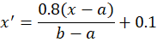
( )
After the data is normalized, then determining the parameters in MATLAB where the parameters used are the training function, activation function, performance function and learning function.
Table 3 Experiment Parameters and Settings Data
Parameters | Experiment Set
Training function | Traingd
Activation function | Tansig
Performance function | Mean Squared Error
Learning function | Learngd
Maximum Epoch | 3000

After the parameter set is run, then conduct validation and evaluation, the regression value will be checked, if the regression value is close to one, the related variables are correlated.
Furthermore, the results of demand forecasting for the next 12 months will be denormalized.

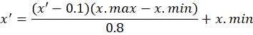
( )

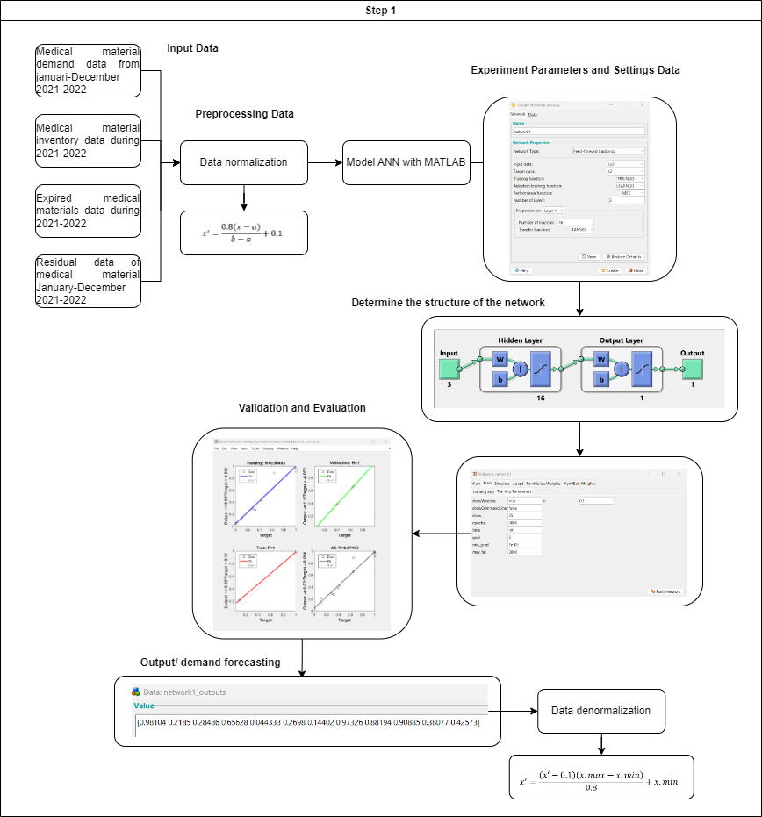
Figure 2. Block Diagram ANN

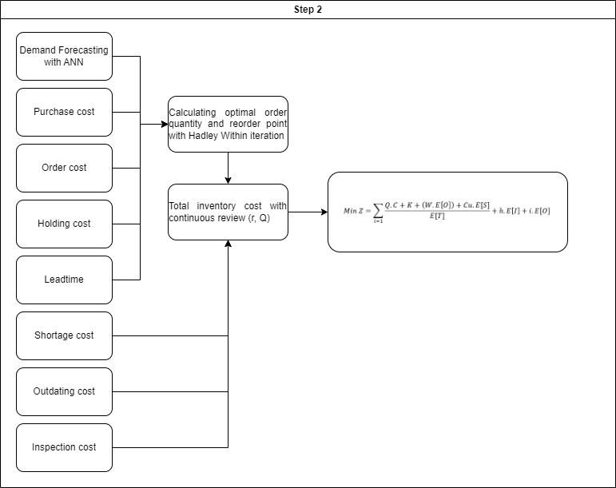
Figure 3. Block Diagram Continuous Review

Stages 2
Figure 3 is an explanation of the second stage of this research, data collection to calculate the value of order quantity and reorder point, namely data on the price of Consumable Medical Materials, which is used in this study in accordance with the price list of consumable medical materials in 2022, data on the results of demand forecasting with ANN, Leadtime data, is the waiting time required by the hospital when ordering products from suppliers until the product is received, this data is obtained from sources responsible for hospital pharmacy, Component Cost data, which is used in research includes order costs, storage costs, shortage costs, expiration costs and inspection costs [14][15][16][17]. After collecting data, then calculate the optimal order quantity and reorder point with the hadley-within iteration model, the formula is as follow:
- Perform optimal order quantity calculations
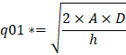
( )
- This process involves two main steps. First, we need to determine the magnitude of the inventory shortage (α). Once the value of α has been determined, the next step is to calculate the reorder point (r1).
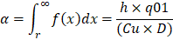
( )
( )

- Once r1 is obtained, the qo2 value can be calculated using the following formula

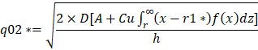
( )
- This process involves two main calculations: calculating the value of alpha and calculating the value of r2.
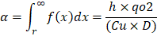
( )
( )
- Do a Comparison the values of r1 and r2, Compare the values of r1 and r2, if the relative price is equal to r1 the iteration is complete and will obtain r1= r2 and q1=q2. Otherwise, go back to step 3 by replacing the values of r1= r2 and q1=q2.
then calculate the total cost of inventory with continuous review (r, Q) with the following conditions normal distributed demand with the aim of reducing total inventory costs. The results of the proposed inventory will be compared with the existing inventory conditions. For the number of Consumable Medical Materials of 23 units displayed only four, as a limitation in this study.
RESULTS AND DISCUSSION
Results of forecasting model with ANN
The design of the architecture of the artificial neural network (ANN) model developed is adjusted to the pattern of inputs or inputs that will become outputs or outputs. To perform forecasting of demand for consumable medical materials. The first step in creating an artificial neural network is to determine the inputs and outputs that will be entered during the training process using MATLAB. Table 4 is the determination of the symbol on the input-output.
Table 4 Input and Output Variables of Forecasting with ANN
Input-Output Model ANN (xn) | Description
X1 | Medical material demand data from January-December 2021-2022
X2 | Medical material inventory data during 2021-2022
X3 | Expired medical materials data during 2021-2022
X4 | Residual data of medical materials January-December 2021-2022
Y’ | The output of the ANN model is the target demand for the next month.

The input data is normalized so that it produces numbers from zero to one, can be seen in Table 5 Data normalization.

Table 5 Data Normalization

Medical Material Preparation | Input | 1 | 2 | 3 | 4 | 5 | 6 | 7 | 8 | 9 | 10 | 11 | 12
Medical Consumables -1 | x1 | 0.86 | 0.00 | 0.71 | 0.00 | 0.00 | 0.14 | 0.57 | 0.29 | 1.00 | 0.29 | 0.57 | 0.00
Medical Consumables -1 | x2 | 1.00 | 0.85 | 0.81 | 0.68 | 0.64 | 0.60 | 0.55 | 0.43 | 0.36 | 0.19 | 0.11 | 0.00
Medical Consumables -1 | x3 | 0.00 | 0.00 | 0.00 | 0.00 | 0.00 | 0.00 | 0.00 | 0.00 | 0.00 | 0.00 | 0.00 | 0.00
Medical Consumables -1 | x4 | 2.00 | 1.96 | 1.81 | 1.77 | 1.72 | 1.66 | 1.53 | 1.45 | 1.26 | 1.17 | 1.04 | 1.00
Medical Consumables -2 | x1 | 1.00 | 0.11 | 0.29 | 0.64 | 0.00 | 0.32 | 0.11 | 1.00 | 0.64 | 1.00 | 0.39 | 0.43
Medical Consumables -2 | x2 | 1.00 | 0.83 | 0.80 | 0.74 | 0.63 | 0.62 | 0.56 | 0.53 | 0.36 | 0.24 | 0.07 | 0.00
Medical Consumables -2 | x3 | 0.00 | 0.00 | 0.00 | 0.00 | 0.00 | 0.00 | 0.00 | 0.00 | 0.00 | 0.00 | 0.00 | 1.00
Medical Consumables -2 | x4 | 2.00 | 1.97 | 1.91 | 1.78 | 1.77 | 1.70 | 1.67 | 1.48 | 1.36 | 1.17 | 1.09 | 1.00
Medical Consumables -3 | x1 | 0.10 | 0.49 | 0.04 | 0.00 | 0.62 | 0.74 | 0.23 | 0.46 | 0.42 | 1.00 | 0.36 | 0.36
Medical Consumables -3 | x2 | 1.00 | 0.97 | 0.86 | 0.85 | 0.85 | 0.71 | 0.55 | 0.49 | 0.39 | 0.30 | 0.08 | 0.00
Medical Consumables -3 | x3 | 0.00 | 0.00 | 0.00 | 0.00 | 0.00 | 0.00 | 0.00 | 0.00 | 0.00 | 0.00 | 0.00 | 0.00
Medical Consumables -3 | x4 | 2.00 | 1.90 | 1.88 | 1.88 | 1.75 | 1.60 | 1.55 | 1.45 | 1.36 | 1.15 | 1.08 | 1.00
Medical Consumables -4 | x1 | 1.00 | 0.00 | 0.43 | 0.00 | 0.00 | 0.14 | 0.43 | 0.29 | 0.00 | 0.29 | 0.43 | 0.00
Medical Consumables -4 | x2 | 1.00 | 0.79 | 0.74 | 0.63 | 0.58 | 0.53 | 0.47 | 0.35 | 0.26 | 0.21 | 0.12 | 0.00
Medical Consumables -4 | x3 | 0.00 | 0.00 | 0.00 | 0.00 | 0.00 | 0.00 | 0.00 | 0.00 | 0.00 | 0.00 | 0.00 | 0.00
Medical Consumables -4 | x4 | 2.00 | 1.94 | 1.81 | 1.75 | 1.69 | 1.61 | 1.47 | 1.36 | 1.31 | 1.19 | 1.06 | 1.00

After the input data is processed, it will produce demand forecasting for the next 12 months, Table 6 shows the results of forecasting four Consumable Medical Materials for 12 months.
Table 6 Demand Forecasting Results with ANN
Month | Medical Consumables -1 | Medical Consumables -2 | Medical Consumables -3 | Medical Consumables -4
1 | 838 | 31 | 4 | 885
2 | 174 | 3 | 36 | 182
3 | 741 | 8 | 1 | 441
4 | 177 | 23 | 0 | 184
5 | 178 | 1 | 51 | 184
6 | 236 | 9 | 65 | 240
7 | 617 | 3 | 13 | 449
8 | 338 | 31 | 37 | 331
9 | 919 | 23 | 33 | 187
10 | 350 | 32 | 82 | 335
11 | 643 | 12 | 28 | 459
12 | 190 | 13 | 29 | 190

Figure 4 shows a comparison of the total demand in 2022 with the ANN forecast results.
Figure 4. Comparison of 2022 Demand with Forecasting results
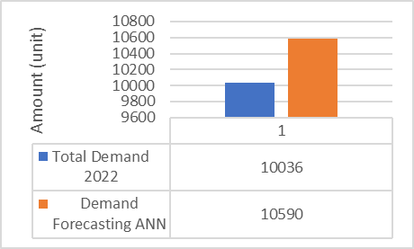
After the demand forecasting results are obtained, data testing is carried out to evaluate whether the prediction results of the model built using training data produce accurate results by calculating the forecasting error.

Figure 5. Regression Results

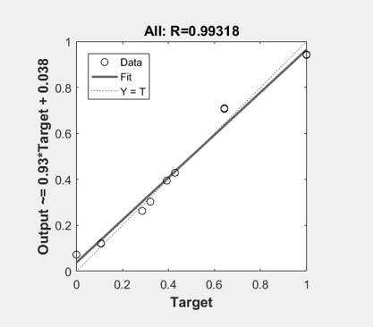
Figure 5 shows a regression of 0.99318 which means that the actual variables with the artificial neural network in the test have a good correlation. The correlation size of 0.99318 indicates a high degree of association between the related variables, namely medical material demand data for 2022, medical material demand data from January-December 2022, medical material inventory data for a year, expired medical material data for a year, remaining medical material data January-December 2022.
Inventory model results with continuous review (r, Q)
The results of the calculation of optimal order quantity and reorder point using Hadley-within can be seen in Table 7.
Table 7. Optimal Order Quantity dan Reorder Point
Medical Material Preparation | Medical Consumables-1 | Medical Consumables -2 | Medical Consumables -3 | Medical Consumables -4
Optimal Order Quantity | 1900 unit | 50 unit | 100 unit | 2050 unit
Reorder point | 630 unit | 10 unit | 55 unit | 345 unit

Table 7 explains the Medical Consumables-1 replenishment policy will be ordered as many as 1900 units if the stock is between 630 units. The basic formulation used to minimize total inventory costs is to divide the expected cycle cost by the expected cycle length.
( )
Expected cycle cost is a cost expectation consisting of order cost (K) is the cost incurred when ordering medical materials in one order, purchase cost (c) is the cost incurred to buy medical materials in the optimal order quantity, lost sales cost (p) is the cost incurred in the event of a shortage of medical materials, the expected number of shortages E[S], Outdating cost (w) is the cost incurred due to expired medical materials, the expected number of expirations E[O]. E[T] is the expected cycle length, holding cost (h) is the cost of storing medical materials, expected inventory level E[I]. For the proposed formulation model, it adds a cost variable, namely inspection cost (i) which is the cost incurred to handle expired medical materials, this cost consists of destroying medical materials by means of high temperature incineration.
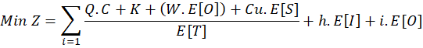
( )

Table 8. Total Cost of Proposed Inventory
Medical Material Preparation | Medical Consumables -1 | Medical Consumables -2 | Medical Consumables -3 | Medical Consumables -4
Holding Cost (Hs) | IDR 297,498.03 | IDR 290,437.00 | IDR 293,292.10 | IDR 143,203.35
Order Cost (Op) | IDR 73,333.33 | IDR 135,206.56 | IDR 129,823.11 | IDR 85,714.29
Shortage Cost (Ok) | IDR 4,836,333.33 | IDR 1,565,990.91 | IDR - | IDR 1,413,214.29
Outdating cost (Otc) | IDR 19,785.00 | IDR - | IDR - | IDR 19,785.00
Purchasing Cost (Pc) | IDR 36,272,500.00 | IDR 33,059,808.10 | IDR 32,000,000.00 | IDR 29,677,500.00
inspection cost (Ic) | IDR - | IDR - | IDR - | IDR -
Total Cost | IDR 41,499,449.70 | IDR 35,051,442.57 | IDR 32,423,115.21 | IDR 31,339,416.92

Table 9. Total Cost of Existing Inventory
Medical Material Preparation | Medical Consumables -1 | Medical Consumables -2 | Medical Consumables -3 | Medical Consumables -4
Holding Cost (Hs) | IDR 2,901,800.00 | IDR 2,783,983.84 | IDR 3,200,000.00 | IDR 2,374,200.00
Order Cost (Op) | IDR 20,000.00 | IDR 20,000.00 | IDR 20,000.00 | IDR 20,000.00
Shortage Cost (Ok) | IDR - | IDR - | IDR - | IDR -
Outdating cost (Otc) | IDR - | IDR 1,739,989.90 | IDR - | IDR -
Purchasing Cost (Pc) | IDR 36,272,500.00 | IDR 34,799,798.00 | IDR 40,000,000.00 | IDR 29,677,500.00
inspection cost (Ic) | IDR - | IDR 5,000.00 | IDR - | IDR -
Total Cost | IDR 39,194,300.00 | IDR 39,343,771.74 | IDR 43,220,000.00 | IDR 32,071,700.00

Table 8 is the total cost of inventory of four proposed Consumable Medical Materials using forecasting, which is Rp. 140,313,422, while Table 9 is the total cost of existing inventory of four Consumable Medical Materials, which is Rp. 153,829,771, where after determining the order quantity and reorder point, the Mentawai Head Hospital can save 8.7% of inventory costs. The difference in total inventory costs of Rp. 13,516,349 is influenced by the number of Medical Material shortages and expiration expectations at the end of the period. The explanation for each component of inventory costs in Table 10.
Table 10. Cost of Inventory Components
Cost Component | Existing | Proposal
Holding Cost | IDR 11,259,983 | IDR 1,024,430
Order Cost | IDR 80,000 | IDR 424,077
Shortage Cost | IDR - | IDR 7,815,538
Outdating cost | IDR 1,739,989 | IDR 39,570
Purchasing Cost | IDR 140,749,798 | IDR 131,009,808
inspection cost | IDR 5,000 | IDR -
Total | IDR 153,834,771.74 | IDR 140,313,424.40

Table 7 explains the gap between the components of inventory costs where the coding cost has decreased by 90%, this occurs because when the proposed inventory conditions the amount of storage of Consumable Medical Materials is less than the existing conditions. The order cost has increased from Rp. 80,000 to Rp. 424,077.29 because when the existing conditions only make one order, while the proposed conditions have a frequency of ordering more than once, because previously the optimal number of orders has been determined in one message to meet demand. The shortage cost from Rp.0 to Rp. 7,815,538.53 occurred because in the existing condition there was no shortage of Consumable Medical Materials because the amount of inventory exceeded demand, after calculating the optimal order quantity inventory policy, there was an expectation of a shortage. Expiry costs when the existing conditions are Rp. 1,739,989 have decreased by Rp. 39,570, this is because there has been a determination of the order quantity in the proposed inventory so as to minimize the number of expired medical materials. Purchasing costs have decreased by Rp. 9,739,990, this is because the optimal order quantity has been determined in the proposed conditions so that it can save on purchasing costs.
CONCLUSION
The problem that occurs at the Mentawai Islands Hospital is that there are expired drugs, namely Medical Consumables 15% of the total inventory, which results in losses, this happens because the amount of inventory exceeds demand so that the overstock is 83%, so the researcher designs a demand and inventory forecasting model using JST and Continuous Review (r, Q) to solve the problem at hand. With the design of demand and inventory forecasting models, it is hoped that inventory management will run more efficiently, control costs more optimally and can improve patient services.
Based on the results of research to forecast the demand for Consumable Medical Materials with the JST model, a gap of 554 units of Consumable Medical Material inventory with a demand of 2022 is obtained, where the results are accurate because the correlation value is 0.99. The results of determining the order quantity and reorder point with continuous review (r, Q) can reduce inventory costs, the results show that the amount of inventory costs has decreased by 8.7% from the existing conditions. In addition to reducing inventory costs, this continuous review inventory system also considers shortage costs and expiration costs.
ACKNOWLEDGMENT
This research was supported/partially supported by [supervisor Industrial Engineering]. We thank our colleagues from [Public Hospital] who provided insight and expertise that greatly assisted the research, although they may not agree with all of the interpretations/conclusions of this paper.

REFERENCES
[1] | K. Maeda, A. Hisaka, K. Ito, Y. Ohno, A. Ishiguro, R. Sato and N. Nagai, "Classification of drugs for evaluating drug interaction in drug interaction in drug development and clinical management," Drug Metabolism and Pharmacokinetics, pp. 1-19, 2021.https://doi.org/10.1016/j.dmpk.2021.100414
[2] | Y. M. Matei, S. Grover, D. R. Masire, S. D. Peterson, L. N. Shulman and N. Tapela, "Availability of WHO Essential Medicines for Cancer Treatment in Botswana," Journal of Global Oncology, 2023. DOI: https://doi.org/10.1200/JGO.17.00063
[3] | Q. Zhang, B. Xin, L. Li, T. Li, T. Liu, Y. Liu and Z. Li, "Influence of national centralized drug procurement policy on the use of antibiotics in pediatric inpatients," Intelligent Pharmacy, pp. 1-5, 2023, https://doi.org/10.1016/j.ipha.2023.05.002
[4] | M. Sahin, F. Eldemir and A. Turkyilmaz, "Inventory Cost Minimization of Spare Parts in Aviation Industry," Transportation Research Procedia, pp. 29-37, 2021.https://doi.org/10.1016/j.trpro.2021.11.094
[5] | M. Ifraz, A. Aktepe, S. Ersoz and T. Cetinyokus, "Demand forecasting of spare parts with regression and machine learning methods: Application in a bus fleet," Journal of Engineering Research, pp. 1-10, 2023.https://doi.org/10.1016/j.jer.2023.100057
[6] | M. Seyedan, F. Mafakheri and C. Wang, "Order-up-to-level inventory optimization model using time-series demand forecasting with ensemble deep learning," Supply Chain Analytics, pp. 1-13, 2023.https://doi.org/10.1016/j.sca.2023.100024
[7] | A. Orzechowski, L. Lugosch, H. Shu, R. Yang and W. Li, "A data-driven framework for medium-term electric vehicle charging demand forecasting," Energy and AI, pp. 1-11,2023,https://doi.org/10.1016/j.egyai.2023.100267
[8] | Y. Tadayonrad and A. B. Ndiaye, "A new key performance indicator model for demand forecasting in inventory management considering supply chain reliability and seasonality," Supply Chain Analytics, pp. 1-15, 2023, https://doi.org/10.1016/j.sca.2023.100026
[9] | K. Altendorfer and T. Felberbauer, "Forecast and production order accuracy for stochastic forecast updates with demand shifting and forecast bias correction," Simulation Modelling Practice and Theory , pp. 1-15, 2023.https://doi.org/10.1016/j.simpat.2023.102740
[10] | M. Akbarpour, S. A. Torabi and A. Ghavamifar, "Designing an integrated pharmaceutical relief chain network under demand uncertainty," Transportation Research Part E: Logistics and Transportation Review, 2020.https://doi.org/10.1016/j.tre.2020.101867
[11] | J. A. Santos, J. M. Sousa, S. M. Vieira and A. F. Ferreira, "Many-objective optimization of a three-echelon supply chain: A case study in the pharmaceutical industry," Computers & Industrial Engineering 173, 2022.https://doi.org/10.1016/j.cie.2022.108729
[12] | J. Noble, K. John and B. Paul, "Inventory management of perishable products with fixed shelf life for a single echelon system," Materials Today: Proceedings, pp. 2863-2868,2023.https://doi.org/10.1016/j.matpr.2022.07.299
[13] | S. KHOUKHI, C. BOJJI and Y. BENSOUDA, "Optimal inventory control policy for a hospital case," IEEE, 2019.DOI: 10.1109/ICOA.2019.8727707
[14] | S. Transchel and O. Hansen, "Supply Planning and Inventory Control of Perishable Products Under Lead-Time Uncertainty and Service Level Constraints," Procedia Manufacturing, pp. 1666-1672, 2019.https://doi.org/10.1016/j.promfg.2020.01.274
[15] | R. Mousavi, M. Bashiri and E. Nikzad, "Stochastic production routing problem for perishable products: Modeling and a solution algorithm," Computers and Operations Research, pp. 1-16, 2022.https://doi.org/10.1016/j.cor.2022.105725
[16] | A. H. Tai, Y. Xie, W. He and W.-K. Ching, "Joint inspection and inventory control for deteriorating items with random maximum lifetime," International Journal of Production Economics, pp. 144-162, 2019.https://doi.org/10.1016/j.ijpe.2018.03.020
[17] | Z. Azadi, S. D. Eksioglu, B. Eksioglu and G. Palak, "Stochastic optimization models for joint pricing and inventory replenishment of perishable products," Computers & Industrial Engineering, pp. 1-18, 2019.https://doi.org/10.1016/j.cie.2018.11.004
[18] | H. A. Syawal and H. K. Alfares, "Inventory Optimization for Multiple Perishable Products with Dynamic Pricing, Dependent Stochastic Demand, and Dynamic Reorder Policy," 2020 Industrial & Systems Engineering Conference, 2020, DOI: 10.1109/ISEC49495.2020.9230165
[19] | C. Franco and E. A. Lizarazo, "Optimization under uncertainty of the pharmaceutical supply chain in Hospital," Computers and Chemical Engineering, pp. 1-13, 2020.https://doi.org/10.1016/j.compchemeng.2019.106689
[20] | J. N. Kohnen, M. Amirdadi and E. Teimoury, "An optimization framework for COVID-19 vaccine allocation and inventory management: A case study," Applied Soft Computing, pp. 1-14, 2023.https://doi.org/10.1016/j.asoc.2022.109801
[21] | C. Tarmanini, N. Sarma, C. Gezegin and O. Ozgonenel, "Short term load forecasting based on ARIMA and ANN approaches," Energy and Electrical Engineering, pp. 550-557,2023, https://doi.org/10.1016/j.egyr.2023.01.060
[22] | A. Kozuch, D. Cywicka and K. Adamowicz, "A Comparison of Artificial Neural Network and Time Series Models for Timber Price Forecasting," forest, pp. 1-23, 2023. https://doi.org/10.3390/f14020177
[23] | A. Arachchige, R. Sugathadasa, I. Herath and A. Thibbotuwawa, "Artificial Neural Network Based Demand Forecasting Integrated With Federal Funds Rate," Applied Computer Science, pp. 34-44, 2021. DOI: https://doi.org/10.35784/acs-2021-27
[24] | S. Ramadhani, A. Dhini and E. Laoh, "Airline Passenger Forecasting using ARIMA and Artificial Neural Networks Approaches," IEEE, pp. 1-5, 2020. DOI: 10.1109/ICISS50791.2020.9307571
[25] | A. Mansur , D. I. Handayani, I. D. Wangsa, D. M. Utama and W. A. Jauhari, "A mixed-integer linear programming model for sustainable blood supply chain problems with shelf-life time and multiple blood types," Decision Analytics Journal, pp. 1-16, 2023.https://doi.org/10.1016/j.dajour.2023.100279

