|  |  |
| --- | --- |
| A FLC-ABC-Optimized IAE-Adaptive SVSF for Localization of Wheeled Mobile Robot | download |

**Heru Suwoyo1, Muhammad Hafizd Ibnu Hajar1*, Prastika Indriyanti2, Arafat Febriandirza3**

1Department of Electrical Engineering, Faculty of Engineering, Universitas Mercu Buana, Indonesia

2Department of Informatic Engineering, Faculty of Computer Science, Universitas Mercu Buana, Indonesia

3Department of Informatic Engineering, Faculty of Computer Scince, Universitas Muhammadiyah Prof. Dr. Hamka, Indonesia

|  |  |
| --- | --- |
| ***Abstract***  *The objective of solving feature-based localization problems is to estimate the path of the robot referring to a given map. Thus, it is not surprising that robust estimators such as Smooth Variable Structure Filter are often used to handle this problem. Basically, its use is highly dependent on an accurate system model and known statistical noise. Where neither of these are available by definition. Therefore, the conventional way is not recommended and the use of an adaptive filter approach can be involved. Based on this and although only partially, Innovation Adaptive Estimation has been considered to have a positive influence on improving the performance of the estimator. But not infrequently the solutions offered by this approach also lead to divergences due to unmapped dynamic conditions. Moreover, in this proposal, IAE is enhanced by applying Artificial Bee Colony-Tuned Fuzzy Logic. The hope is that there is quality control for the process noise covariance Q and R measurements by updating them based on the output of this ABC-Tuned FLC.*  *This is an open access article under the* [*CC BY-SA*](http://creativecommons.org/licenses/by-sa/4.0/) *license* | ***Keywords:***  *Mobile Robot;*  *Feature-Based Localization;*  *Adaptive Filter;*  *IAE;*  *Fuzzy Logic Controller;*  *Artificial Bee Colony;*  ***Article History:***  *Received: May 2, 2019*  *Revised: May 29, 2019*  *Accepted: June 2, 2019*  *Published: June 2, 2019*  ***Corresponding Author:***  *Andi Adriansyah*  *Electrical Engineering Department, Universitas Mercu Buana, Indonesia*  *Email:* [*andi@mercubuana.ac.id*](mailto:andi@mercubuana.ac.id) |

**INTRODUCTION (R: 31, G: 78, B: 121)**

Localization is a problem where by solving it the robot can find out its position on a given map [1]–[3]. Solving this problem becomes important when the robot is required to complete a task based on certain coordinate information on the map. In simple terms, of course this work can be completed with the help of the built-in sensors. However, actually due to poor sensor readings accompanied by uncertainty, the robot cannot directly do this job. For this reason, filtering methods are often applied with the aim of removing uncertainty from the sensor. And robust estimators such as Smooth Variable Structure Filter (SVSF) are relevant to be applied in this case [4]–[6].

Nevertheless, the use of SVSF naturally requires knowledge of the characteristics of the statistical noise as well as the accuracy of the system model. These characteristics include knowledge of the mean and covariance of both process noise and measurement noise when the system is modeled Gaussian [7]–[10]. While in the system model, the accuracy in question is the precision value of each variable that has the potential to cause the situation to change. Judging from this analogy, it is certainly impossible for both of them to be perfectly fulfilled. This is due to the unpredictable noise state, and the approach used in system modeling is kinematic [11]–[13]. Due to these two things, defining noise up front and holding it constant across all iterations is no longer recommended. Instead of getting convergence, the application of this conventional method will actually make SVSF provide a state of divergence when applied to real conditions [4], [14], [15]. Therefore, it is obvious that SVSF needs to be enhanced before it is implemented.

Referring to the previous description, the objective of this improvement is how to define the statistical noise that is conventionally determined and then can be replaced with a quantity that is adjusted to the dynamic conditions and the system itself. In short, this is called the adaptive approach. There are several types of adaptive approaches, and one of them will be applied to this proposal, namely Batch estimation of parameters [15], [16]. This adaptation method is to apply an offline calculation technique to estimate the system and measurement noise based on a batch of adaptation. And in this paper, Maximum Likelihood Estimation [13], [17], [18] will be involved in the initial process. As reported in [12], by utilizing the information of the predicted error covariance, the estimated error covariance of the process and measurement can be determined. Regarding to this principle, the approach named Innovation Adaptive Estimation. Although this process has significantly provided updated covariance values for $Q$ and $R$, the quality is still lacking. This is indicated by a significant difference between the theoretical and the actual of the covariant state. So that corrective action is needed before this covariance is applied to the next iteration. In this paper, corrections are made by utilizing the degree of mismatch information from the two measurement error covariance conditions. Whenever adaptive SVSF is performed and adaptive determination is conducted at the last process, the diversity will then be used as a reference for determining the scale of the modifier. However, because of the level of complexity contained in this determination, a Fuzzy Logic Controller [19]–[22] is applied. Although the level of complexity has decreased, theoretically the use of FLC can only be improved by optimization. And referring to the principle of how FLC is applied in this case, namely online, the appropriate and relevant types of optimizations are metaheuristic and evolutionary algorithms. And in this research, the tuning algorithm involved is Artificial Bee Colony [23]–[25]. Two factors underlying the selection of the tuning method are the better convergence rate compared to Genetic Algorithm (GA) [26]–[29] and low computational cost similar to Particle Swarm Optimization [11], [22], [24], [30] and Differential Evolution (DE) [23], [24], [31]. Thus, adaptive SVSF is scaled up and ready to deploy. In this paper, the application of the proposed method is a localization algorithm. Thus, it is called A FLC-ABC-Optimized IAE-Adaptive SVSF for Localization. This use will also be used as a prefix in validating the effectiveness of the method. By jointly solving the problem of localization of mobile robots, the proposed method will be compared with its predecessors, such as the IAE-ASVSF algorithm, SVSF-based Localization Algorithm. The observed variable used is the Root Mean Square Error which represents the level of deviation between the reference and the estimated result.



**METHOD**

According to the previous section, it is clear to state that there are some materials and methods applied to support the algorithm enhancement. Therefore, through this section the theoretical are presented.

**IAE-ADAPTIVE SVSF**

The dominant problem solving of localization in this research case is the use of filtering. Thus, in this subsection adaptive filtering of SVSF is given. SVSF itself is a type of robust filtering that utilizes a sliding mode concept in making estimates. It is relatively considered to meet the shortcomings of its predecessor, the EKF, especially in the stability and robustness of the estimate. Although it is also a predictor-corrector such as EKF, this advantage is supported by the presence of gain based on discontinuous gain and limits the state estimation around the true state of the trajectory. The adaptive itself is a recursive ability to provide estimation parameters by adding several formulations that represent knowledge about noise statistics in each process. Here the Innovation Adaptive Estimation (IAE) of Adaptive SVSF [12] is presented. Given the dynamic model of nonlinear system

|  |  |
| --- | --- |
| $$\left\{\begin{aligned}x_{k}=f\left(x_{k-1},u_{k}\right)+ω_{k-1} \\ z_{k}=h\left(x_{k}\right)+ν_{k}\end{aligned}\right.$$ | (1) |

and the characteristic of its noise statistic

|  |  |
| --- | --- |
| $$\left\{\begin{aligned}E\left[ω_{k}\right]=0, Cov\left[ω_{k},ω_{j}\right]=Q_{k}δ_{kj} \\ E\left[v_{k}\right]=0, Cov\left[v_{k},v_{j}\right]=R_{k}δ_{kj} \\ E[ω_{k},ν_{k}]\end{aligned}\right.$$ | (2) |

the formulation of adaptive SVSF determined by applying Innovation Adaptive Estimation can be summarized as follows.

|  |  |
| --- | --- |
|  | (3) |
|  | (4) |

Since the system is Gaussian, (3) and (4) represent the mean and covariance for the predicted state, respectively. Where, $f\left(.\right)$ is transition function applying the motion model, and F its Jacobean matrix calculated as determining partial derivative of $f\left(.\right)$ with respect to the state. Moreover, by knowing the actual measurement $z_{k}$ the process is continued by calculating the innovation error $e_{k|k-1}$. This error shows deviation between the actual and predicted measurement

|  |  |
| --- | --- |
|  | (5) |
|  | (6) |

Then the corresponding covariance of innovation error given in (6) can be computed as follows

|  |  |
| --- | --- |
|  | (7) |

Where H is Jacobean matrix as determined by calculating the partial derivative of measurement values with respect to the predicted state ${\hat{x}}_{k|k-1}$ . As note, the measurement mean is computed by utilizing the measurement function h(.) as given in (5). Up to this point, the prediction and conjunction stage are done. Next, aiming to get the mean and covariance of the state for the next iteration, the correction stage needs to conduct. The essential of correction stage is to determine the gain of ASVSF utilizing the saturation function $sat[ψ^{-1} ̅ \overline{\overline{e_{k|k-1}}}]$, and other parameters

|  |  |
| --- | --- |
|  | (8) |

where

|  |  |
| --- | --- |
|  | (9) |
|  | (10) |

Once (8) – (10) are obtained, the ASVSF’s gain $K^{ASVSF}$ can be computed as follows

|  |  |
| --- | --- |
|  | (11) |

and the correction step, producing the posterior mean and covariances, is sequentially conducted as follows

|  |  |
| --- | --- |
|  | (12) |
|  | (13) |

where $e_{k|k}$ is updated by the following equation

|  |  |
| --- | --- |
|  | (14) |

And the last step of ASVSF is enclosed by recursively adding it with covariance matrix of the process $\hat{Q}$ and measurement $\hat{R}$

|  |  |
| --- | --- |
| $$\hat{Q}=K_{k}C_{k}K_{k}^{T}$$ | (12) |
|  | (13) |

where $C_{k}$ represents moving average of error expectation

|  |  |
| --- | --- |
| $$C_{k}=\frac{1}{N}\sum_{j=k-N+1}^{k}{e_{j}e_{j}^{T}}$$ | (12) |

**Fuzzy Logic Controller**

Fuzzy Logic Controller is a type of controller that can be applied as a closed-loop controller [22], [32], [33]. As the name suggests, this controller not only utilizes the setpoint as its input but also feedback which is a representation of the output. Fuzzy logic is used in some controllers because it does not require an accurate system model to control. Fuzzy logic works by executing rules that relate the controller input to the desired output. These rules are usually created through the designer's intuition or knowledge of the operation of the controlled system. Whatever the system, there are three basic steps that characterize all fuzzy logic controllers. These steps include fuzzification of controller input, execution of controller rules, and defuzzification of output to firm values for the controller to implement.

**Artificial Bee Colony (ABC)**

The ABC algorithm is a newcomer to the area of swarm-based optimization. ABC, like any other population-based optimization technique, starts with a set of possible solutions. According to ABC, potential options include honey bee food sources. The quality (nectar quantity) of the food supply is used to determine fitness. In the colony, there are three categories of bees: spectator bees, employed bees, and scout bees. The food sources are equal to the number of employed or onlooker bees. Employed bees are linked to food sources, whereas spectator bees remain in the hive and use the information obtained by employed bees to determine the food source [23]. Meanwhile, one of the employed bees' food sources is depleted, she becomes a scout bee, searching for a new food source at random

ABC is an iterative procedure, similar to the other swarm-based algorithms. The evolution of an ABC population is derived from two key processes: the variation process, which allows for exploration of different areas of the search space, and the selection process, which facilitates the exploitation of previous experiences. However, even if the population has not converged to a local optimum, ABC has been demonstrated to occasionally halt progressing toward the global optimum. The ABC process is divided into four phases: initialization, employed bees, observer bees, and scout bees, each of which is described below.

Initialization of the population

Initially, the population of N solutions are uniformly generated. In which each solution $x_{i}$ for $i=(1,2, …,N)$ is M-dimensional vector for M representing the number of variables to be optimized. Therefore, $x_{i}$ is representation for the $i$-th food source storing in the population, which can be generated as follows

|  |  |
| --- | --- |
| $$x_{i}^{j}=x_{min}^{j}+rnd[0,1]\left(x_{max}^{j}-x_{min}^{j}\right) ∀ j=1,2, …, M$$ | (12) |

**Employed Bees Phase**

Referring to the information of individual experiences and the fitness value (nectar amount) of the new solution, employed bees then modify the current solution. The modification is done by updating the position of the candidate solution in the population. The update position of $x_{i}^{j}$ is done by following equation

|  |  |
| --- | --- |
| $$v_{i}^{j}=x_{i}^{j}+Φ_{i}^{j}\left(x_{i}^{j}-x_{i}^{k}\right) ∀ k=1,2,…, N and j=1,2,…, M$$ | (13) |

As note, $k$ and $i$ are index that should be different to each other in order to get significant contribution of step size $\left(x_{i}^{j}-x_{i}^{k}\right)$ and $Φ$ is generated randomly [-1,1].

Onlooker Bees Phase

In this phase, the onlooker bees select a solution based on the probability. This selection is done by firstly analyzing the information fitness $fit$ and position of updated solution (food souce) shared by all employed bees previously. In which the probability $p$ calculation for $i$-th can be done as follows

|  |  |
| --- | --- |
| $$p_{i}=\frac{fit_{i}}{\sum_{i=1}^{N}{fit_{i}} }$$ | (14) |

**Scout Bees Phase**

If the position of a food source is not updated for a predefined amount of cycles, it is presumed that the food source has been abandoned, and the scout bees phase begins. During this phase, the abandoned food source's bee transforms into a scout bee, and the abandoned food source is replaced with a randomly picked food source within the search space. The predetermined number of cycles, known as the limit for abandonment in ABC, is a critical control parameter. Assume the abandoned food source is xi, and the scout bee replaces it with fresh xi as follows

|  |  |
| --- | --- |
| $$x_{i}^{j}=x_{min}^{j}+rnd[0,1]\left(x_{max}^{j}-x_{min}^{j}\right) ∀ j=1,2, …, M$$ | (15) |

where $x_{min}^{j}$ and $x_{max}^{j}$ (in (12) and (15)) are bottom and up boundaries for $x_{i}$ in $j$-th direction, respectively.

|  |  |
| --- | --- |
| **Algoritma 1 Artificial Bee Colony** | |
| Initialize Population using (12) | |
| Cycle=1 | |
| while Cycle<MaxCdo | |
| 1 | Produce new solution $v_{i}$ using (13) and evaluate them |
| 2 | Selection Process using Greedy Principle |
| 3 | Calculate the probability value $p_{i}$ using (14) |
| 4 | Produce new solution $v_{i}$ for selected solution $x_{i}$ referring to $p_{i}$ |
| 5 | Selection Process using Greedy Principle |
| 6 | Determine the abandoned solution, if exists, and replace it with a new randomly generated solution $x_{i}$ using (15) |
| 7 | Storing Best Solution for Every Cylcle |
| 8 | Cycle = Cycle + 1 |
| endwhile | |

**Proposed Method**

As mentioned earlier the proposed method is about enhancing the performance of IAE-ASVSF by involving the ABC-tuned FLC. Moreover, the proposed method is further formed as Localization algorithm of mobile robot. In which is, the general process can be graphically expressed as in Fig. 1 below

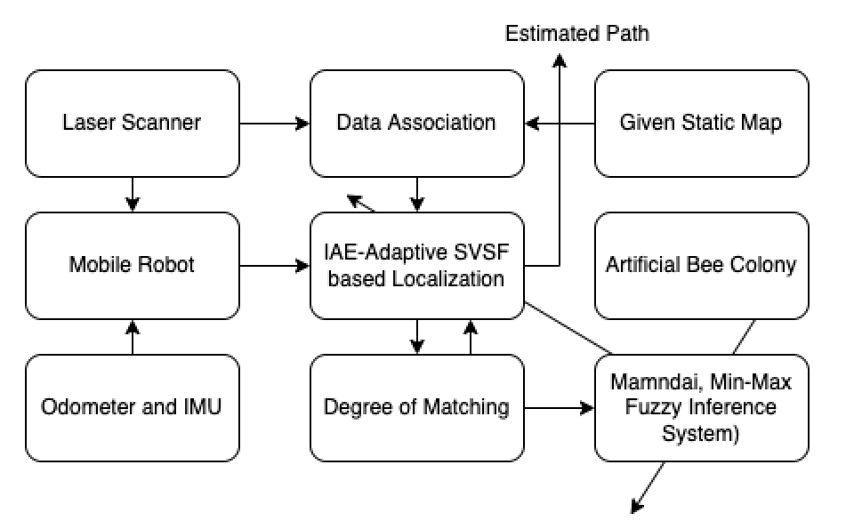

Figure 1. Flowchart of the Proposed Algorithm

As shown in Figure.1, the enhancement is started by tuning the IAE-Adaptive SVSF. It is done as follows

Given the static cartesian map, the robot in its perception start to estimate the coordinate for every feature. The process is initially conducted by predicting the state vector, the representation of all marginalized pose of the robot, using the motion model in form of transition function in (3). Sequentially, the corresponding covariance is also computed as in (4). Next, the error innovation is calculated by firstly forming the given map as $z_{k}$ and involving the predicted measurement ${\hat{z}}_{k}$ . As note, this predicted measurement is computed by applying the direct point-based observation [7], [13]. Meeting all the rest procedure of localization then candidate solution, estimated pose, is obtained. Supposing that, these sequential processes happen in each step, therefore, the theoretical covariance of error measurement is given as in (7). Together with this value, the updated covariance of the process $Q$ and measurement $R$ are available. In this point, the materials used for tuning are ready.

Degree of Matching

The update $Q$ and R might potensially diverges from the need of next iteration. Since both of them are related to the actual covariance $C_{k }$ of the error measurement computed in (12) and (13) respectively, diversity from the theoretical one is possible. It is clear since $C_{k }$ is produced according only to expectation values of innovation error. And this diversity is called Degree of Matching ($DoM$). Mathematically, it is described as follows

|  |  |
| --- | --- |
| $$DoM=C_{k}-S_{k}$$ | (16) |

Normally, it should be zero in every iteration of ASVSF. Therefore, the objective of this enhancement is to maintain DoM to always be zero. It is done by continuously rescaling $Q$ and $R$ based on the factor/adjuster obtained from DoM itself. Noting that, the adjuster $Adj$ is the variable used for rescaling $Q$ and $R$ as given in (17) and (18), respectively.

|  |  |
| --- | --- |
| $$Q=Q*Adj$$ | (17) |
| $$R=R+Adj$$ | (18) |

Referring to (16) then DoM will be positive whenever $S_{k}$ is smaller to $C_{k}$. Thus, in case of enhancement, $S_{k}$ needs to be upscaled. To satisfy this requirement, based on (7) $S_{k}$ can be changed by upscaling $R$. This relation shows that $Adj$ in (18) should be positive when DoM is positive or vice versa. However, Q and R should be positive definite matrices. Therefore, $Adj$ cannot be set as negative when the DoM is negative. For this reason, $Adj$ is always be positive.

**IAE-SVSF Tuned-FLC**

As known that DoM is dynamically given every iteration, it means adjuster $Adj$ should be determined online. And through this paper, the FLC is used to online producing the proper $Adj$. Knowing the relationship of $DoM$ and $Adj,$ as basis the membership function of the input and output of FLC is given as follows.

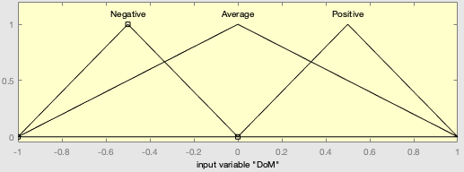

(a)

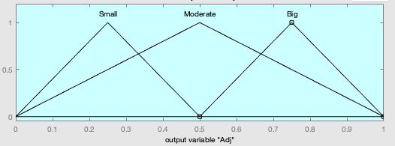

(b)

Figure 2 Input and Output Following Triangular Membership Function. (a) shows the DoM values in [-1,1] with linguistic term of “Negative”,”Average”,”Positive” (b) (a) shows the DoM values in [0,1] with linguistic term of “Small”,”Moderate”,”Big”.

And FIS used for this work is Mamdani Min-Max principle with the following rule connected by operator “and”. it can be seen as follows:

|  |
| --- |
| If(DoM is Positive) then (Adj is Big) (1) |
| If(DoM is Negative) then (Adj is Small) (1) |
| If(DoM is Average) then (Adj is Moderate) (1) |
| If(DoM is Average) then (Adj is Big) (1) |
| If(DoM is Negative) then (Adj is Big) (1) |
| If(DoM is Average) then (Adj is Small) (1) |
| If(DoM is Positive) then (Adj is Small) (1) |

And defuzzification method applied for this project in centroid which mathematically presented as follows

|  |  |
| --- | --- |
| $$x_{centroid}=\frac{\sum_{i}{μ\left(x_{i}\right)}x_{i}}{\sum_{i}{μ\left(x_{i}\right)}}$$ | (19) |

Where $μ\left(x_{i}\right)$ represents the membership value of the point $x_{i}.$

**ABC Tuned-FLC**

As can be seen in Fig. 2, the normal DoM and Adj is designed based only on theoretical side. However, the dynamicity of DoM is unpredictable. So that, the representation of the output cannot be linear as shown in Figure. 2(b). For this reason, by globally evaluating the performance IAE-ASVSF tuned by FLC, the ABC is involved. Shortly, the ABC with its heuristic ability finds the proper adjustment for input and output membership function.

Considering the DoM will always give two different condition which is positive and negative, the up and bottom boundary are set. This is intended to force the DoM value in the range [-1, 1]. So, the objective in finding the right setting is only focused on the membership function of the output. Furthermore, consider that there are 3 optimization variables, namely mb1, mb2, and mb3. Where these variables are the top of the triangle of "Small", "Moderate", and "Big" in the output membership function. In order to maintain the estimation process, all three are also given limits, namely [0 0.5] for "Small", [0 1] for moderate, and [0.5 1] for "Big". This restriction applies to applications (12) and (15). The reason for this limitation is to keep the membership representation triangular.

Apart from that described in Algorithm 1, the transfer of each optimization from generation to generation will only occur when the generation provides a better fitness value than the previous one. And in research, the number of generations is maximized by setting it to 200. However, to reduce computational costs, N which is the number of populations is set sufficiently, which is 15. Next for the fitness function is the performance of the IAE-Adaptive SVSF FLC with flexible settings on the output membership function. And the value that reflects the fitness of each setting is the RMSE value of the estimated heading. This is based on the understanding that the inaccuracy of the robot in estimating its position can be seen from the perception of the heading. Simply put, a deviated heading is bound to give the wrong position. And conversely, the wrong position is not necessarily caused by the position estimation. And the following is the search for variables performed by ABC which is represented by the fitness value in radians for each generation/cycle.

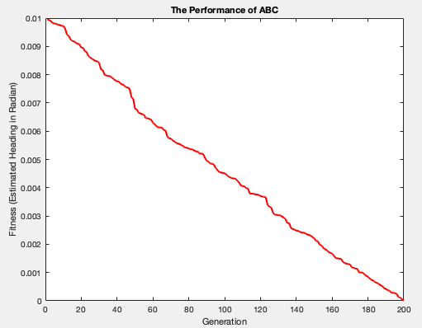

Figure 3 Optimization Process using ABC

Based on this optimization process in Figure 3, the best fitness value is 0.001672 with the determining variables or the best solution representing mb1, mb2, and mb3 are 0.0711, 0.3512, 0.6423, respectively. Therefore, the membership function of the output ($Adj$) can be shown as in Figure 4.

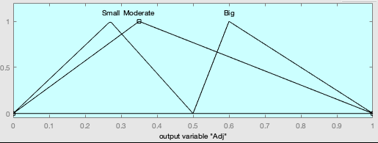

Figure 4 Optimized Output Membership Function Given By ABC

**RESULTS AND DISCUSSION**

In order to validate the effectiveness of the proposed method, some numbers of different methods are performed to solve the localization problem of mobile robot. Once it is done, they are analyzed and compared to each other in term of RMSE. The methods going to be compared with the proposed method are SVSF, IAE-ASVSF. In order to get the proportional comparison, the following set are set as initial step of parameterization.

|  |
| --- |
| $$q_{0}=[0.3, 0.4]$$ |
| $$Q_{0}=diag\left(q_{0}\right)$$ |
| $$r_{0}=[0.85,1π/180]$$ |
| $$R_{0}=diag(r_{0})$$ |

The initial hypothesis is that the robot knows for sure its location in the global environment. Therefore, the following parameters are given before all algorithms are performed.

|  |
| --- |
| $$x_{0}={\left[0 0\frac{35π}{180}\right]}^{T}$$ |
| $$P=\left[\begin{matrix}0 & 0 & 0 \\ 0 & 0 & 0 \\ 0 & 0 & 0\end{matrix}\right]$$ |

The other parameters that are equally set at the beginning are $γ$ and $e_{0}$ which are respectively given as follows

$$γ=0.2 \\ e_{0}={\left[0 0\right]}^{T}$$

Both of them are going to be fixed whole the estimation process.

Moreover, as the localization case, it means the robot is also initially with a knowledge of the static map. It is then used as the reference during each method’s work. The reference map is given as follows

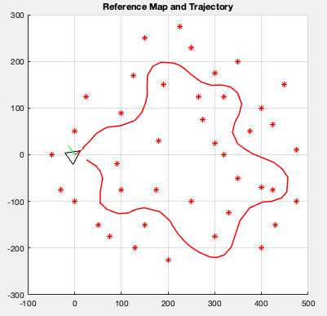

Figure 5 Reference Map and Trajectory

As note, the reference trajectory in Figure 5 is assumed given by the global camera mounted on the top of robot during its movement and the correspondent to any measurement are assumed to be known.

According to this scenario of simulation, SVSF, IAE-ASVSF, and proposed method are then simulated. The result can be seen as follows

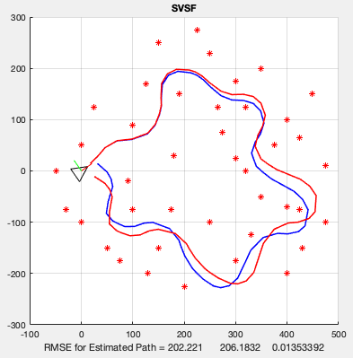

Figure 6 The Performance of SVSF-based Localization Algorithm

As can be seen from Figure 6, Even though it doesn't deviate much from the reference, it can be seen that the RMSE value of this performance is still very high. This clearly occurs because of the influence of significant dynamic conditions that cannot be responded to accurately with a precise and accurate representation for statistical noise both in the process and in its measurement. Meanwhile, the performance of IAE-SVSF-based localization algorithm is presented as follows.

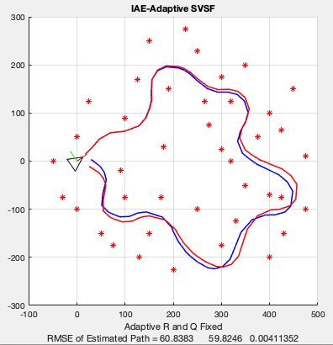

(a)

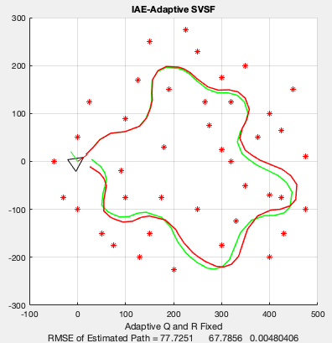

(b)

Figure 7 The Performance of SVSF-based Localization used to solve Localization Problem of Mobile Robot (a) Its performance in the case that Q is fixed and R is adaptive (b) Its Performance in the case that R is fixed and Q is adaptive

Referring to Figure 7, it is clear that the deviation of the estimated path from the reference given by SVSF can be reduced. Although not so significant, the effect of the recursive quantities in the form of Q and R is sufficient to explain the level of effectiveness of the adaptive approach. This is also evidenced by the size of the path estimation which is already very good. At last, the performance of the proposed method is presented.

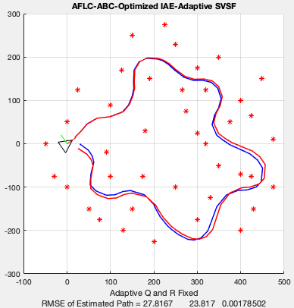

(a)

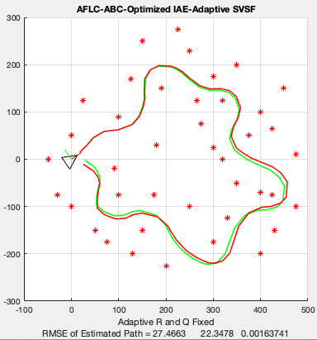

(b)

Figure 8 The Performance of A FLC-ABC-Optimized IAE-ASVSF used to solve Localization Problem of Mobile Robot. (a) Its performance in the case that Q is fixed and R is adaptive (b)Its Performance in the case that R is fixed and Q is adaptive

As shown in Figure 6, the influence given by ABC in determining membership function settings has helped improve the previous algorithm. This increase is also marked by a very significant decrease in RMSE referring to the performance of the SVSF. Different from the IAE-ASVSF which is presented graphically in Figure 7, the consistency in maintaining the performance value remains stable in the exchange conditions between Q and R. As shown in Figure 8, the influence given by ABC in determining membership function settings has helped improve the previous algorithm. This increase is also marked by a very significant decrease in RMSE referring to the performance of the SVSF. Different from the IAE-ASVSF which is presented graphically in Figure 7, the consistency in maintaining the performance value remains stable in the exchange conditions between Q and R. Furthermore, to clarify the differences between the three algorithms and also the clarity of the improvements provided by the proposed method, Table 1 and Table 2 are sequentially given as follows

**Table 1 Comparative Result of Different** Algorithm in Case R is Fixed

|  |  |  |  |
| --- | --- | --- | --- |
| Algorithm | RMSE | | |
| Estimated-x (cm) | Estimated-y (cm) | Estimated- $θ (rad)$ |
| SVSF-Based Localization | 202.221 | 206.1832 | 0.013533 |
| IAE-Adaptive SVSF-Based Localization | 77.7251 | 67.7856 | 0.0048 |
| FLC-ABC-Optimized IAE Adaptive SVSF-Based Localization | 27.8267 | 23.817 | 0.00179 |

**Table 2 Comparative Result of Different** Algorithm in Case Q is Fixed

|  |  |  |  |  |
| --- | --- | --- | --- | --- |
| Algorithm | RMSE | | | |
| Estimated-x (cm) | Estimated-y (cm) | Estimated- $θ (rad)$ |
| SVSF-Based Localization | 202.221 | 206.1832 | 0.013533 |
| IAE-Adaptive SVSF-Based Localization | 60.8383 | 59.8246 | 0.0041 |
| FLC-ABC-Optimized IAE Adaptive SVSF-Based Localization | 27.4663 | 22.3478 | 0.00164 |

**CONCLUSION**

The main contribution of this paper is to enhance the IAE-ASVSF by utilizing the ABC-tuned FLC method. Knowing the diversity between the actual and theoretical of the error measurement covariance, the adjuster is recursively gained aiming to rescale the process and measurement noise statistic. Since the degree of match is dynamic caused by the IAE-ASVSF producing scaling factor can optimally be done online. For this reason, FLC is involve. Moreover, this level is also unpredicatable because of uncertainty so that generating scaling factor should also approaching the heuristic algorithm, ABC.

**ACKNOWLEDGMENT**

This research was supported by Universitas Mercu Buana

**REFERENCES**

1. R. Siegwart and I. R. Nourbakhsh, Introduction to Autonomous Mobile Robots, vol. 23. 2004.
2. [2] R. Kuemmerle, “State Estimation and Optimization for Mobile Robot Navigation,” pp. 1–191, 2013.
3. H. J. S. Feder, J. J. Leonard, and C. M. Smith, “Adaptive mobile robot navigation and mapping,” Int. J. Rob. Res., vol. 18, no. 7, pp. 650–668, 1999, doi: 10.1177/02783649922066484.
4. S. A. Gadsden and H. H. Afshari, “A review of smooth variable structure filters: Recent advances in theory and applications,” ASME Int. Mech. Eng. Congr. Expo. Proc., vol. 4A-2015, 2015, doi: 10.1115/IMECE2015-50966.
5. F. Demim, A. Nemra, and K. Louadj, “Robust SVSF-SLAM for Unmanned Vehicle in Unknown Environment,” IFAC-PapersOnLine, 2016, doi: 10.1016/j.ifacol.2016.10.585.
6. S. A. Gadsden, M. El Sayed, and S. R. Habibi, “Derivation of an optimal boundary layer width for the smooth variable structure filter,” Proc. Am. Control Conf., pp. 4922–4927, 2011, doi: 10.1109/ACC.2011.5990970.
7. Y. Tian, H. Suwoyo, W. Wang, and L. Li, “An ASVSF-SLAM Algorithm with Time-Varying Noise Statistics Based on MAP Creation and Weighted Exponent,” Math. Probl. Eng., vol. 2019, pp. 28–34, 2019, doi: 10.1155/2019/2765731.
8. Y. Liu and C. Wang, “A FastSLAM Based on the Smooth Variable Structure Filter for UAVs,” 2018 15th Int. Conf. Ubiquitous Robot. UR 2018, pp. 591–596, 2018, doi: 10.1109/URAI.2018.8441876.
9. S. A. Gadsden, S. R. Habibi, D. Dunne, and T. Kirubarajan, “Combined particle and smooth variable structure filtering for nonlinear estimation problems,” Fusion 2011 - 14th Int. Conf. Inf. Fusion, 2011.
10. S. R. H. Mohammed Farag , Mina Attari , S. Andrew Gadsden, “Lithium-Ion Battery State of Charge Estimation Using One State Hysteresis Model with Nonlinear Estimation Strategies,” Int. J. Chem. Mol. Nucl. Mater. Metall. Eng., vol. 11, no. 3, pp. 214–218, 2017.
11. A. Adriansyah, H. Suwoyo, and Y. Tian, “Jurnal Teknologi IMPROVING ROBOT,” vol. 3, pp. 119–126, 2019.
12. H. Suwoyo et al., “Maximum likelihood estimation-assisted ASVSF through state covariance-based 2D SLAM algorithm,” Telkomnika (Telecommunication Comput. Electron. Control., vol. 19, no. 1, pp. 327–338, 2020, doi: 10.12928/TELKOMNIKA.V19I1.16223.
13. Y. Tian, H. Suwoyo, W. Wang, D. Mbemba, and L. Li, “An AEKF-SLAM Algorithm with Recursive Noise Statistic Based on MLE and EM,” J. Intell. Robot. Syst. Theory Appl., 2019, doi: 10.1007/s10846-019-01044-8.
14. U. K. Filters, F. Gustafsson, and G. Hendeby, “Some Relations Between Extended and,” IEEE Trans. Signal Process., vol. 60, no. 2, pp. 545–555, 2012.
15. H. H. Afshari, “The 2nd-Order Smooth Variable Structure Filter (2nd-SVSF) for State Estimation: Theory and Applications,” McMaster University, 2014.
16. S. Chen, Z. Shi, and J. Ding, “Application of the 2nd-order Smooth Variable Structure Filter algorithm for SINS initial alignment,” 2017 Forum Coop. Position. Serv. CPGPS 2017, no. 1, pp. 43–49, 2017, doi: 10.1109/CPGPS.2017.8075095.
17. V. A. Bavdekar, A. P. Deshpande, and S. C. Patwardhan, “Identification of process and measurement noise covariance for state and parameter estimation using extended Kalman filter,” J. Process Control, vol. 21, no. 4, pp. 585–601, 2011, doi: 10.1016/j.jprocont.2011.01.001.
18. S. Yu, B. D. Van Veen, and R. T. Wakai, “Detection of T-wave alternans in fetal magnetocardiography using the generalized likelihood ratio test,” IEEE Trans. Biomed. Eng., vol. 60, no. 9, pp. 2393–2400, 2013, doi: 10.1109/TBME.2013.2256907.
19. K. Al-Mutib, M. Faisal, M. Alsulaiman, F. Abdessemed, H. Ramdane, and M. Bencherif, “Obstacle avoidance using wall-following strategy for indoor mobile robots,” 2016 2nd IEEE Int. Symp. Robot. Manuf. Autom. ROMA 2016, pp. 1–6, 2017, doi: 10.1109/ROMA.2016.7847817.
20. E. A. Elsheikh, M. A. El-Bardini, and M. A. Fkirin, “Dynamic path planning and decentralized FLC path following implementation for WMR based on visual servoing,” 2016 3rd MEC Int. Conf. Big Data Smart City, ICBDSC 2016, pp. 148–154, 2016, doi: 10.1109/ICBDSC.2016.7460359.
21. Fahmizal and C. H. Kuo, “Development of a fuzzy logic wall following controller for steering mobile robots,” iFUZZY 2013 - 2013 Int. Conf. Fuzzy Theory Its Appl., pp. 7–12, 2013, doi: 10.1109/iFuzzy.2013.6825401.
22. M. Collotta, G. Pau, and V. Maniscalco, “A Fuzzy Logic Approach by Using Particle Swarm Optimization for Effective Energy Management in IWSNs,” IEEE Trans. Ind. Electron., vol. 64, no. 12, pp. 9496–9506, 2017, doi: 10.1109/TIE.2017.2711548.
23. C. Chen, H. Du, and S. Lin, “Mobile robot wall-following control by improved artificial bee colony algorithm to design a compensatory fuzzy logic controller,” ECTI-CON 2017 - 2017 14th Int. Conf. Electr. Eng. Comput. Telecommun. Inf. Technol., pp. 856–859, 2017, doi: 10.1109/ECTICon.2017.8096373.
24. O. Bozorg-Haddad, M. Solgi, and H. A. Loáiciga, Meta-Heuristic and Evolutionary Algorithms for Engineering Optimization. 2017.
25. A. Chatterjee and F. Matsuno, “A neuro-fuzzy assisted extended kalman filter-based approach for simultaneous localization and mapping (SLAM) problems,” IEEE Trans. Fuzzy Syst., vol. 15, no. 5, pp. 984–997, 2007, doi: 10.1109/TFUZZ.2007.894972.
26. H. Wang, W. Liu, F. Zhang, S. X. Yang, and L. Zhang, “A GA-fuzzy logic based extended Kalman filter for mobile robot localization,” 2015 12th Int. Conf. Fuzzy Syst. Knowl. Discov. FSKD 2015, pp. 319–323, 2016, doi: 10.1109/FSKD.2015.7381961.
27. N. Lu, Y. Gong, and J. Pan, “Path planning of mobile robot with path rule mining based on GA,” Proc. 28th Chinese Control Decis. Conf. CCDC 2016, vol. 1, no. 1, pp. 1600–1604, 2016, doi: 10.1109/CCDC.2016.7531239.
28. F. Al-Turjman, H. Zahmatkesh, and L. Mostarda, “Quantifying uncertainty in internet of medical things and big-data services using intelligence and deep learning,” IEEE Access, vol. 7, pp. 115749–115759, 2019, doi: 10.1109/ACCESS.2019.2931637.
29. [29] J. C. Bansal, Evolutionary and Swarm Intelligence Algorithms, vol. 779. 2019.
30. [30] F. Fei, H. Hongjie, and G. Zhongtong, “Application of genetic algorithm PSO in parameter identification of SCARA robot,” Proc. - 2017 Chinese Autom. Congr. CAC 2017, vol. 2017-Janua, pp. 923–927, 2017, doi: 10.1109/CAC.2017.8242898.
31. [31] F. S. Elkazzaz, M. A. H. Abozied, and C. Hu, “Hybrid RRT/DE algorithm for high performance UCAV path planning,” ACM Int. Conf. Proceeding Ser., pp. 235–242, 2017, doi: 10.1145/3171592.3171618.
32. [32] M. R. H. Al-Dahhan and M. M. Ali, “Path tracking control of a mobile robot using fuzzy logic,” 13th Int. Multi-Conference Syst. Signals Devices, SSD 2016, pp. 82–88, 2016, doi: 10.1109/SSD.2016.7473656.
33. [33] J. Berisha, X. Bajrami, A. Shala, and R. Likaj, “Application of Fuzzy Logic Controller for obstacle detection and avoidance on real autonomous mobile robot,” 2016 5th Mediterr. Conf. Embed. Comput. MECO 2016 - Incl. ECyPS 2016, BIOENG.MED 2016, MECO Student Chall. 2016, no. v, pp. 200–205, 2016, doi: 10.1109/MECO.2016.7525740.