CASCADED SQUARE LOOP BANDPASS FILTER WITH TRANSMISSION ZEROS FOR LTE

Iis Andini¹, Dian Widi Astuti², Muslim³
^{1,2,3}Departement of Electrical Engineering, Universitas Mercu Buana
Jl. Raya Meruya Selatan, Kembangan, Jakarta 11650

Email: iisandini12@gmail.com, dian.widiastuti@mercubuana.ac.id, muslim@mercubuana.ac.id

Abstract –In this paper, we present a bandpass filter that passed frequency of 1.7 GHz – 1.8 GHz. It is applied for an uplink frequency in 4G 1800MHz. This filter is created by using substrate PCB TMM-10i and is designed with cascade square loop resonator method. The bandpss filter is designed by adding an external resonator on each square of the resonator loop and a patch to the inside of the square loop resonator. The parameter performances is simulated by HFSS. The parameter performances for return loss value is 14.24 dB and insertion loss value is 0.65 dB. By using VNA Anritsu MS 2026A, prototype bandpass filter is measured. The measurement results for return loss value is 6.8 dB and insertion loss value is 2.2 dB

Keywords: filter, bandpass filter, cascaded square loop, LTE, BPF

INTRODUCTION
LTE or Long Term Evolution is a new service that has high ability in communication systems moving and is the 4th generation (4G) of previous radio technology (3G) which is designed to increase the capacity and speed of mobile phone networks. A filter is one of the important circuits in a wireless telecommunication system because it is used to pass or reject the frequency for further process. There is a microstrip technology to produce the filter by implementing transmission lines. The transmission lines of microstrip is used to miniaturize high frequency (RF) and microwave (MIC / Microwave Integrated Circuit and MMIC / Monolithic Microwave Integrated Circuit) circuits. The advantage of integrating passive and active components are easy integration, low profile, cheap for mass production. (Mudrik Alydrus, 2017).
Selectivity is the important parameter when the bandpass filter is designed. Selectivity of the bandpass filter can be obtained by using coupled method between two resonators as investigated by (Dian, Juwanto, Mudrik, 2013), (Quan Xue, 2017) and (Wangshuxing Ieu, 2017). It produces transmission zeros response for sharper at the transition between bandpass and bandstop region. In the research of (Dongcheng Zang, 2012) the realization of a filter is done by zeros transmission approach on one resonator. The filter is designed by using cascaded square loop resonator on the coupling between feeding microstrip channel with resonator. This method gives compact size and selective response. The compact size or miniaturized of bandpass filter can be generated by using Defected Ground Structure (DGS) resonator method as shown at (Feng Wei, 2017) and (Z-H Zhang X Jin, 2016). (Jimmy Gautam, 2016) showed the design of bandpass filter by using interdigital method, and the result shown that the filter is applied on the LTE frequency.
A bandpass filter is designed by using transmission zeros approach with cascade square loop resonator method that is applied at 1.75 GHz frequency. The frequency is applied for the uplink frequency in the cellular network of 4G 1800MHz. We used Roger TMM-10i substrate with thickness of 1.27 mm, permittivity of 9.8 and loss tangent of 0.002.

BANDPASS FILTER DESIGN
Table 1 shows the specification of bandpass filter design.

Table 1. Specification of bandpass filter
No | Parameter | Specification
1 | Center Frequency | 1,75 GHz
2 | Bandwidth | 100 MHz
3 | Insertion Loss | 1 dB
4 | Return Loss | ≥ 12 dB
5 | Out of rejection band | 1710 MHz < f < 1785 MHz
6 | Impedance | 50 Ohm

The bandpass filter is designed to fulfill the specifications filter as shown in Table 1. The substrate selection is done by considering the permittivity value of a dielectric material as it relates to the wavelength of the resonator of a filter (Dian, Juwanto, Mudrik, 2013).

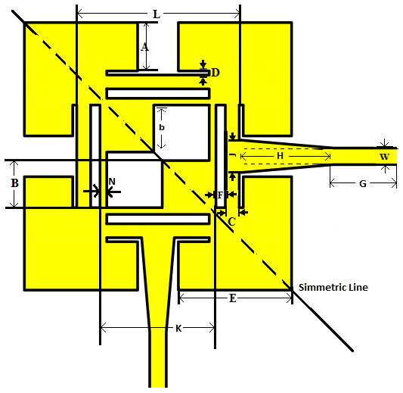
Fig 1. Bandpass filter design

The length and width of resonator input/output are shown on (Dian Widi Astuti, 2013) and (Hong-J-S, 2011). The width input/output transmission line or w, is 1.2 mm as shown in Figure 1. Figure 1 shows a bandpass filter design with a cross-sectional patch (Dongcheng Zang, 2012) with patch B.

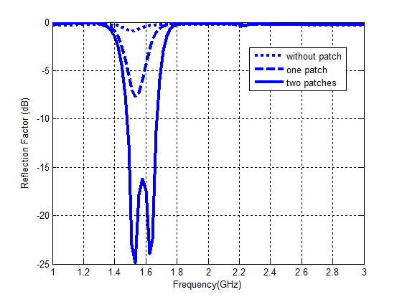
(a)
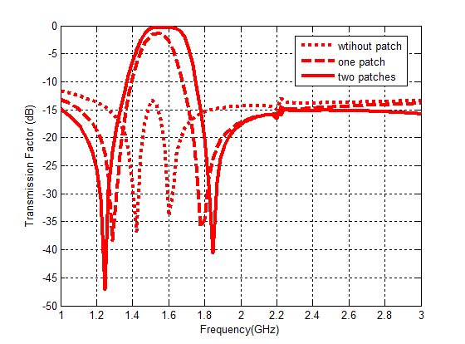
(b)
Fig 2. (a) Simulation result of S11 additional patch; (b) Simulation result of S21 additional patch.

The study parameter of patch B is shown in Figure 2, to get the best response of filter. As shown in Fig 2, the addition of patch to the square resonator gives better selectivity results with near-zero insertion loss and wider bandwidth. The Filter without patch B has insertion loss value 13.32 dB, return loss 1.5 dB and 40 MHz bandwidth. The filter with one patch B has an insertion loss value 1.4 dB, 7.5 dB return loss and 160 MHz bandwidth. It means that it is better than omit rather than without patch B. The filter with two patches B gives the best response because the insertion loss value is 0.5 dB, return loss value is 25 dB and bandwidth 180 MHz.
Filter with two patches gives good insertion loss and return loss values, but the frequency response and the bandwidth width still did not meet the initial specifications of filter manufacture. Therefore, the addition of N variable or second square loop resonator as shown in Figure 1 is investigated by varying the dimensions.
The simulation design used HFSS simulator as shown in Figure 3. The optimization of N parameter is 0.5 mm, because it gives a suitable frequency at 1.75 GHz for LTE application. It also has bandwidth value 100 MHz, insertion loss value 0.65 dB and return loss value 14.24 dB.

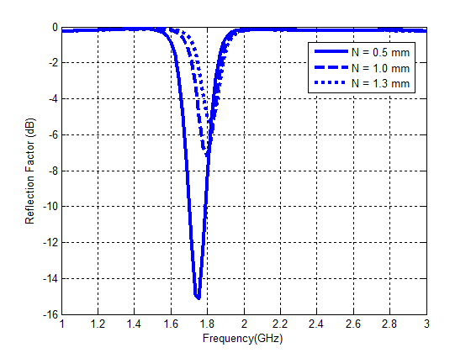
(a)

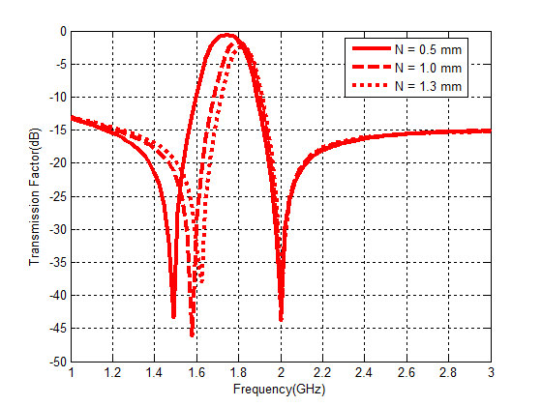
(b)
Fig 3. (a) Simulation result of S11 respon S11 with variabel N; (b) Simulation result of S11 respon S21 with variabel N

As shown in Figure 3, it can be concluded that the changing the N variables from N = 1.3 mm (dot line) to N = 0.5 mm (solid line) causes the bandpass filter shift to smaller frequency. The bandwidth becomes wider, and the insertion loss values will be better. The insertion loss and return loss values are shifting from 2.5 dB to 0.6 dB and from 5.5 dB to 0.6 dB
The optimization of A parameter as the external resonator is shown in Figure 1. It is investigated to get the best S11 and S21 response as well as the appropriate of the frequency and bandwidth. The external resonator also has been investigated by (Dongchen Zang, 2012). By adding a resonator to the four outside corners of the resonator, the simulation result shown in Figure 4 with the parameters in Table 2.

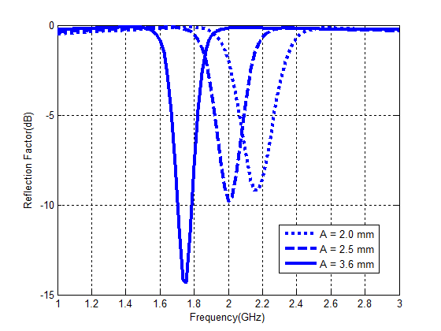
(a)
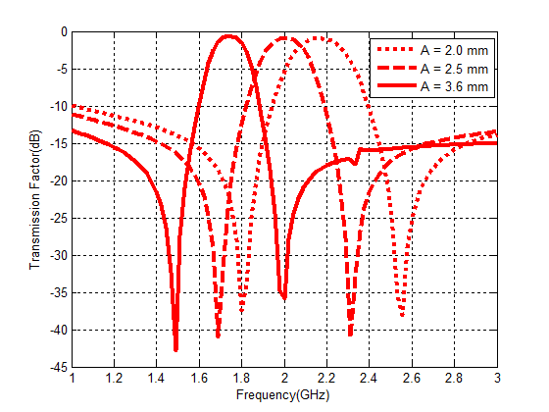
(b)
Fig 4. (a) Comparison graph of S11 result; (b) Comparison graph of S21 result.

The optimization of bandpass filter parameters (B, N, and A variables) are shown in Table 2.

Table 2. Parameter size of BPF Model 2
Parameter | Size  (mm)
L | 12
w | 1,2
A | 3,6
B | 3,5
b | 3,5
C | 1
D | 0,3
E | 8,4
F | 0,7
G | 8
H | 7
J | 2,4
K | 8,6
N | 0,5
M | 2,3

Figure 4 shown, if the A parameter is increased (from 2 mm to 3.6 mm), the frequency response will shift from higher frequency to the lower frequency. It also achieves better return loss (14.24 dB), insertion loss (0.65 dB), and narrow bandwidth (170 MHz). It could be concluded that A parameter as the frequency control.

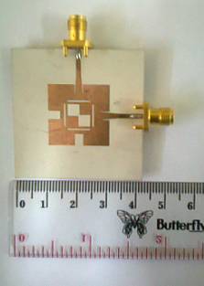
Fig 5. Prototype Filter

The cascaded square loop bandpass filter with transmission zeros for LTE is fabricated as shown in Figure 5. By using Anritsu MS 2026A for 1 - 6 GHz frequency, the prototype of filter is measured. The comparison between the simulation and measurement result is shown in Figure 6.
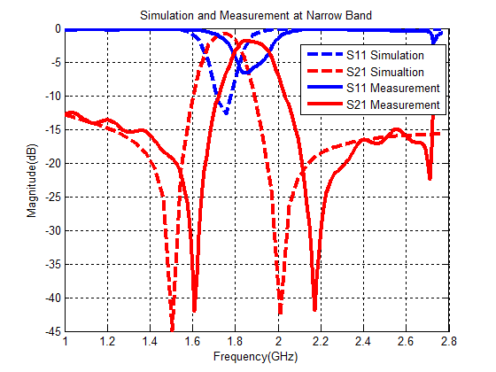
(a)

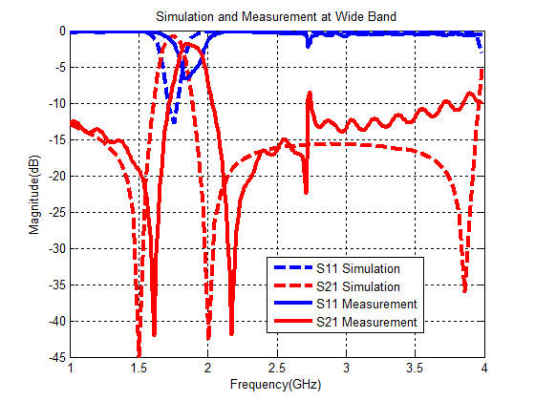
(b)

Fig 6. (a) The comparison of simulation and measurement result for narrow band; (b) The comparison of simulation and measurement results for wide band;

The simulation results as shown in Figure 6 give the return loss value 14.24 dB, and the insertion loss value 0.65 dB for the frequency center at 1.75 GHz. After the design of filter is fabricated, the measurement results gives the return loss value 6.8 dB and insertion loss 2.2 dB. It occurs the increasing of the insertion loss value, the decreasing of return loss value and the widening of bandwidth.

CONCLUSION
The additional a patch inside of the square resonator BPF improves the value of insertion loss and return loss on the filter. It give a good insertion loss and return loss response results, but the bandwidth is too wide and the frequency does not meet the initial specification criteria. Therefore, the N layer or second square loop resonator is added to the inside then set the width of A parameter or the outer resonator of the BPF. Modifications are made to make the filter work at center frequency of 1.75 GHz with bandwidth width 100 MHz, insertion loss 0.65 dB and return loss 14.24 dB.
The insertion loss (S11) of measurement results are 6.8 dB and the return loss (S21) is 2.2 dB with working frequency at 1.85 GHz and the bandwidth 150 MHz, there is a working frequency shift of 100 MHz as well as widening the bandwidth by 50 MHz. The results obtained are still not close to the tolerance limit of the filter which the insertion loss approaching the 0 dB and the return loss approaching minus infinity. Differences in response results are influenced by several factors, including unsuitable manufacturing factors and the connector solder process that can damage the etching filter results.

REFERENCES
Alaydrus, Mudrik. Telecommunication Transmission Line. Yogyakarta. Indonesia. 2009. 261-277
Dian Widi Astuti, Juwanto and Mudrik Alaydrus. “A Bandpass Filter Based On Square Open Loop Resonators at 2.45 GHz”, 5th ICICI-BME, November 7-8, 2013.
Dian Widi Astuti, Juwanto and Mudrik Alaydrus, “Design of Bandpass Filter at 2.448 GHz with Transmission Zeros”. SMAP 2013, vol. 2 pp 92-95, Oktober 2013.
Gautam, Jimmy. Taneja, Shiv. Sharma, Jahneva. “Design And Performance Analysis of 2.5 GHz Microstrip bandpass filter for LTE”. Second International Conference on Computational Intelligence & Communication Technology. IEE Conference Publications.549 – 553. 2016.
Ieu, Wangshuxing. Zhang, Dewei. Zhou, Dongfang. “High-selectivity dual-mode dual-band microstrip bandpass filter with multi-transmission zeros”. Electronic Letter. Vol.53 pp 482-484. Maret 2017.
J. -S. Hong, Microstrip Filters for RF/Microwave Applications, 2nd ed. New Jersey: Wiley, 2011.
X Jin. Z-H Zhang, L. Wang. B-R Guan. “Compact dual-band bandpass filter using single meander multimode DGS resonator”. Electronic Letters. Vol.49. no.17. Agustus 2013.
Xue, Quan. Jin, Jun Ye. “Bandpass Filters Designed by Transmission Zeros Resonator pair With Proximity Coupling”. IEEE Transactions on Microwave Theory and techniques. Vol.65.no 11. 4103-4110. 2017.
Wei, Feng. Qin, Pei-Yuan. Guo, Jay. Shi, Xiao-Wei. “Design of multi-band bandpass filters based on stub loaded stepped-impedance resonator with defected microstrip structure”. IET Microwave Antennas Propagation. Vol.10. pp 230-236. 2016
Zang, Dongchen. Chen, Weiwei. Yin, Zhiping. “A Novel Dual-Mode BPF using Cascades Square Loop resonator for TD-LTE Apliccation”. 8th International Conference on Eireless Communication, Networking and Mobile Computing. IEEE Conference Publication. 1-4. 2012.

