|  |  |
| --- | --- |
| Effect of Curing Temperature on the Soil Physical and Mechanical Properties on Clay Shale Geopolymer Fly Ash Stabilization |  |

**Edi Hartono1*, Willis Diana1, Agus Setyo Muntohar1, Muhammad Azhar2, Lia Indriani1**

1Department of Civil Engineering, Faculty of Engineering, Universitas Muhammadiyah Yogyakarta, Indonesia

2Department of Road and Bridge Contruction Engineering, Politeknik Negeri Tanah Laut, Indonesia

|  |  |
| --- | --- |
| ***Abstract***  *Clay shale is an easily degraded mudrock when exposed to weathering. The reduced strength due to degradation can be mitigated through soil stabilization. In recent years, soil stabilization using geopolymers has become one of the latest popular methods due to its economic benefits and lower carbon footprint. A widely used cementitious material for this method is fly ash-based geopolymer. The relationship between curing temperatures and the performance of clay shale stabilized with fly ash-based geopolymer has yet to be studied for the purpose of identifying a more effective stabilization method. In this study, clay shale was stabilized using geopolymer. The geopolymer was made of fly ash and an activator. Sodium hydroxide (NaOH) and sodium silicate (Na2SiO3) as activators. The activator is diluted with water to create a 12 M mixture. Before the unconfined compressive strength test, the specimens were subjected to various curing temperatures from 26oC to 60oC. The test result shows that, in general, higher curing temperatures increased the dry density from 1.66 g/cm3 to 1.84 g/cm3. While, the unconfined compressive strength multiply about 3.5 times. Furthermore, the the moisture content are decrease after the curing process from 19% to 2.5%. This lead to the specimen volume experiencing decreament due to the shrinkage during the curing veriod. The volume reduce from 67.7 cm3 to 63.5 cm3. In general, temperature plays a significant role in enhancing the strength of clay shale stabilized using fly ash-based geopolymer.*  *This is an open-access article under the* [*CC BY-SA*](http://creativecommons.org/licenses/by-sa/4.0/) *license.* | ***Keywords:***  *Clay Shale; Curing Temperature; Fly Ash; Unconfined Compressive Strength.*  ***\*Corresponding Author:***  *Edi Hartono*  *Civil Engineering Department, Universitas Muhammadiyah Yogyakarta, Indonesia*  *Email:* [*edi.hartono@umy.ac.id*](mailto:edi.hartono@umy.ac.id) |

**INTRODUCTION**

As a type of mudrock, clay shale is a big problem in construction due to its unstable properties. Clay shale is a 50% to 70% sedimented rock formed mainly by clay minerals, claystone, soil, dust, or rock with cementation [1]. Clay shale is a highly sturdy sedimentation rock. However, clay shale will easily be degraded when exposed to the atmosphere or moistened by water [2]. The degradation altered the geotechnical characteristics and reduced the strength and durability of clay shale [2, 3, 4, 5, 6].

In a construction project, slake deterioration on the surface becomes a major problem in the future when the clay shale is exposed due to the excavation [6]. Alatas et al. [4] reported a landslide event caused by the deterioration process at the Sports Training Center in Hambalang Sentul and on the Bawen-Semarang toll road, precisely, at Bawen-Semarang toll road KM. 32+000, the clay shale was exposed to the atmosphere due to the slope-cutting works, leading to a collapse on the clay shale slope.

Soil stabilization is widely adopted to improve physical and geotechnical properties. The conventional method is to replace the in-situ soil with material that has suitable properties, such as concrete, or utilize mechanical reinforcement with geogrids or geotextile [7]. Aside from the conventional method, the soil stabilization method arises by mixing the soil with poor engineering properties with cementitious material to improve the soil strength and ductility, reduce swelling potential, permeability, deformation, and settlement, and increase the weathering resistance [1, 2, 8, 9]. The cementitious material will initiate chemical reactions for cation exchange, carbonation, and pozzolanic activity, thereby enhancing the overall structure of the soil [7, 8].

Recently, geopolymers have become a popular option as an environmentally friendly material for improving soil properties. Murmu et al. [10] utilized a 5M NaOH solution mixed with fly ash geopolymer as a material to stabilize black soil. The results demonstrated that ash-based geopolymer is a viable option for stabilization, particularly in preparing highway subgrade and sub-base. Similar findings were reported by Nguyen and Phan [11], who employed geopolymer for soil stabilization in road construction. Compared to cement, fly ash exhibits a significantly lower global warming potential (GWP), with cement ranging from 0.82 to 0.948 kg CO2 eq/kg, while fly ash ranges from 0.00526 to 0.027 kg CO2 eq/kg [10]. Nath et al. [12], reported a 36-43% reduction in carbon footprint by replacing Portland cement with fly ash. Furthermore, fly ash-based geopolymer cement production is reported to have a lower carbon footprint, up to 25% less than that of Portland cement [13].

Fly ash has been utilized as a stabilization material for clay shale, and numerous researchers have studied it with different variables and methods [14, 15, 16]. Sumiyanto et al. [14] employed an injection method to stabilize clay shale using a fly ash-based geopolymer. A mixture of fly ash and alkali was injected into compacted clay shale, resulting in a significant fivefold increase in the unconfined compressive strength of the compacted clay shale. A chemical is needed to activate the fly ash. The activator's type, quantity, and condition are essential in stabilizing the soil. Fly ash with a calcium content <5% (classified as fly ash type F by ASTM) is unable to form a cementitious product [17]. In contrast to type F fly ash, type C fly ash has high amounts of calcium and produces cementitious products [18]. Cristelo et al. [19] used sodium silicate (SiO2) and sodium hydroxide (NaOH) as activators for type C and F fly ash to stabilize marlstone, which contains high calcium carbonate

Besides fly ash type, other factors such as geopolymer content, molarity, alkali ratio, and curing temperature are significant contributors to the strength of soil stabilized with fly ash-based geopolymer [20]. Hartono et al. [16] investigated the concentration of alkali used as an activator for fly ash-based geopolymer. The study suggests that 12-15M Na2SiO3+NaOH concentration is optimal for stabilizing clay shale. However, the correlation between curing temperatures and the performance of clay shale stabilized using fly ash-based geopolymer has not been analyzed. Mapping the interrelation among the influencing factors can specify a more effective stabilization method. This study will utilize a fly ash-based geopolymer to stabilize clay shale and examine the effect of different curing temperatures on the unconfined compressive strength.

**RESEARCH METHOD**

**Soil Sample**

The clay shale used in this study was obtained from the Bawen-Semarang toll road, Central Java. This type of clay shale has a high mechanical property; however, when exposed to water, it quickly degrades. The soil was collected in large boulders and fractured into smaller fragments until passing through sieve No. 4. Figure 1 shows the clay shale used in this study. Smectite clay minerals dominate the soil sample, followed by Illite, Kaolinite, and Chlorite [2]. The soil consists of 93% silt/clay and 7% sand. The grain size distribution of the soil sample is shown in Figure 2. The soil is classified as CH based on the Unified Classification System (USCS), with plastic and liquid limits of 57.9% and 28.4%, respectively. The properties of the soil are presented in Table 1.

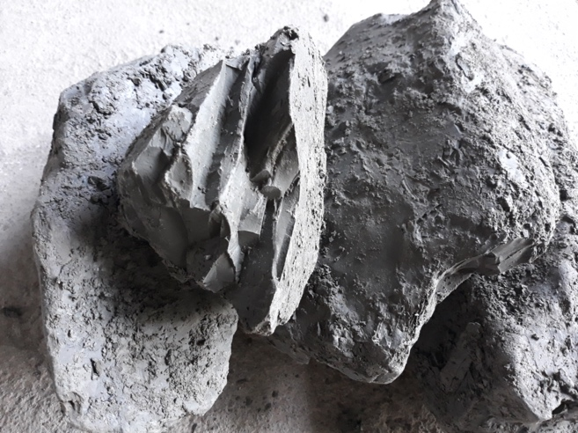

Figure 1 The Clay Shale from Bawen-Semarang Toll Road, Central Java

Table 1 Soil Properties of Clay Shale

|  |  |
| --- | --- |
| Soil Properties | Values |
| Grand size distribution |  |
| Sand | 7% |
| Silt/Clay | 93% |
| Specific gravity, *Gs* | 2.65 |
| Atterberg limits: |  |
| Liquid limit, LL | 58% |
| Plastic limit, PL | 28% |
| Plasticity index, PI | 30% |
| Optimum moisture content, OMC | 19% |
| Maximum dry density, MDD | 1.66 (g/cm3) |

**Fly Ash and Alkali Activator**

A fly ash-based geopolymer is used as a stabilization material to replace cement. The fly ash, a by-product of coal combustion from coal-fired power plants, is classified into N, F, and C types according to ASTM C 618-22 [17]. Fly ash type F is often chosen as a stabilization material due to its pozzolanic properties, containing more than 70% SiO2+Al2O3+Fe2O3 and less than 10% CaO. This study considered using the F-type Fly Ash since it is widely used as a stabilization material for soil; thus, it will be easier to provide in bulk.

Table 2 The sample details.

|  |  |  |  |  |  |
| --- | --- | --- | --- | --- | --- |
| Sample Code | Activator Ratio (NaOH/Na2SiO3) | Molarity | Curing Temperature | Curing Time (days) | Number of Specimens |
| A26 | 1 : 2.0 | 12 | 26 | 7 | 3 |
| A40 | 1 : 2.0 | 12 | 40 | 7 | 2 |
| A50 | 1 : 2.0 | 12 | 50 | 7 | 3 |
| A60 | 1 : 2.0 | 12 | 60 | 7 | 3 |

A combination of sodium silicate (Na2SiO3) and sodium hydroxide (NaOH) was used for the activator. The activator mixture is diluted with water to create a 12M mixture, as suggested by Hartono et al. [16]. The ratio of NaOH to Na2SiO3 for the activator is 1:2 for each specimen made.

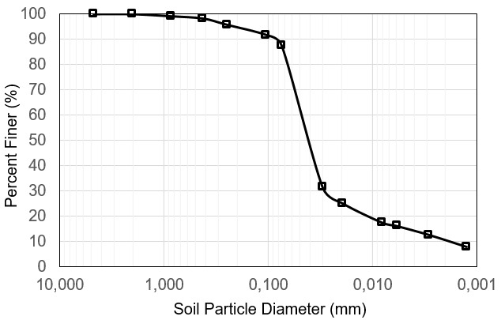

Figure 2 Grain Size Distribution of Clay Shale

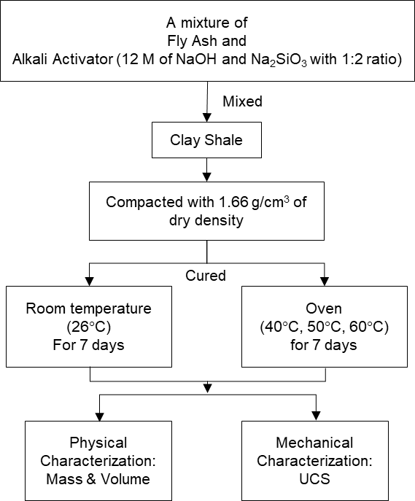

Figure 3 The block diagram of test methods.

**Specimen Preparation and Curing Conditions**

Four sets of samples are prepared to evaluate the effect of curing temperature. The samples were prepared by using NaOH and Na2SiO3 with a 1:2 ratio as activators. Each set of samples was treated with a different curing temperature. The details of the samples are listed in Table 2. The two numbers in the sample number represent the respective sample curing temperatures

A boulder of clay shale was crushed until it passed through sieve No. 4 and mixed with fly ash (15% of the total weight). The activator was then added to the mixture (19% of the total weight, considering the optimum moisture content of natural clay shale). The soil-geopolymer mixture was then compacted into a cylindrical mold of 76 mm in height and 38 mm in diameter with a dry density of 1.66 g/cm3.

After compaction, the sample was dismantled from the mold. The compacted samples were cured at different temperatures. The first set of samples were cured at room temperature (26°C) for 7 days, while another set undergoes curing in an oven at temperatures of 40°C, 50°C, and 60°C, also for 7 days. The samples are cured in an oven with a controlled temperature, so it does not exceed the target temperature. The planned temperature topped at 60°C as the precaution to prevent strength reduction and crack development associated with higher temperatures [21, 22].

**Unconfined Compressive Strength Test**

The unconfined compression strength (UCS) [23] test was used to determine the mechanical properties of the stabilized soil. After seven days of curing, the specimen was tested on a compression machine. The specimen was loaded until it reached maximum load and failure. The shearing rate of loading was 0.76 mm/min. The unconfined compressive strength of the sample *qu* is calculated by dividing the maximum axial load (*Fmax*) by the shearing test by the cross-section area (*A*), as shown in Equation 1.

|  |  |
| --- | --- |
|  | (1) |

Overall, the soil preparation and test procedure are illustrated in the flowchart depicted in Figure 3.

**RESULTS AND DISCUSSION**

**Effect of temperature on the physical properties**

All samples have been successfully stabilized with fly ash-based geopolymer. Figure 4 shows the condition of the samples after seven days of curing. The dry density of soil increases with the increase of curing temperature. A noticeable increment is shown between the room temperature curing (26°C) and 40°C with 0.08 g/cm3. However, the increase until the sample reaches a 60°C curing temperature. The result indicates that the maximum density in this test series is obtained after curing the sample at 60°C.

Specimens with higher curing temperatures have a lower moisture content after the curing process, leading to specimen shrinkage, thus reducing the volume. The initial average water content of samples is 19% and decreased to 12.5%, 4.7%, 2.9%, and 2.5% for the curing temperatures of 26°C, 40°C, 50°C, and 60°C respectively. Furthermore, the volume are decrease to 67.7 cm3, 65.5 cm3, 64.9 cm3, 63.5 cm3 for 26°C, 40°C, 50°C, and 60°C respectively.

|  |  |
| --- | --- |
|  |  |
| (a) | (b) |
|  | |
| (c) | |

Figure 4 Variation of physical properties of soil stabilized with fly ash-based geopolymer with temperature change (a) dry density, (b) water content (c) volume.

The decrement rate tends to be gentler as the temperature increases. The most significant moisture content drops between 26°C and 40°C are inversely proportional to the dry density results. The average density increased from 1.66 g/cm3 to 1.84 g/cm3. The similar behavior also observed in volume changes where the drastic shrinkage are happen between 26°C and 40°C. After 40°C, no more significance chance were observed

|  |  |
| --- | --- |
|  |  |
| (a) | (b) |
|  |  |
| (c) | (d) |

Figure 5 The UCS test result for (a) sample curing at 26°C, (b) sample curing at 40°C, (c) sample curing at 50°C, and (d) sample curing at 60°C.

**Effect of temperature on the unconfined compressive strength**

Figure 5 shows the stress and strain curves from the UCS test. The UCS test results show almost identical results for each group of samples, with an exception for the samples cured at 50°C. In general, the *qu* increases as the curing temperature increases. However, as shown in Figure 5 (c), sample A50-1 has a more rapid increment in the strain for the early loading stage. The peak stress reached 5.8% of strain, the highest value among all specimens. The average *qu* is 2.67 MPa, 6.32 MPa, 8.79 MPa, and 9.28 MPa for specimens A26, A40, A50, and A60. The *qu* increases multiply about 3.5 times by increasing the temperature from 26oC to 60oC.

**Discussion**

As shown in Figure 4, the dry density increased as the curing temperature increased. The increment of soil dry density is related to polymer gel formation, which bonds the soil particles and fills the pores and cracks. It is also possible that the loss of moisture content in the polymerization reaction, which becomes more active in higher temperatures, leads to more rapid moisture loss due to evaporation and causes a volumetric shrinkage [21]. Both polymerization and evaporation cause the sample to become denser.

The process mentioned above is also responsible for the enhancement of mechanical properties. The UCS test results in Figure 5 show that the increment *qu* has the same trend as the increment of curing temperature. Leong et al. [24] and Phetchuay et al. [25] mentioned that treating fly ash-based geopolymer in an environment with higher temperatures will lead to a more rapid polymerization reaction in the early stage, resulting in higher early strength. Dissimilar to cement usage as a stabilization material, geopolymers do not form calcium-silicate-hydrates in the soil matrix. Geopolymers utilize an endotherm reaction that absorbs heat from the environment, resulting in polycondensation. Polycondensation is the polymer formation process involving silica and alumina, which leads to the bonding between small molecules and forming alumina-silicate-hydrates. A higher curing temperature and more silica and alumina available to react will lead to more polymerization, thus increasing the number of polymer gels and the bonding strength [26].

The curve shapes are almost identical, with a larger strain at the peak point for samples prepared under different temperatures. However, this trend is negated in samples cured at 50°C. Moreover, specimen A50-1 shows a more considerable deformation before reaching the peak stress, and it fails. Compared to specimen A50-2, specimen A50-1 has a higher dry density, smaller volume, and smaller water content. In this case, the difference in the initial stiffness might be related to the cracks formed during the curing process. Although many cementitious bonds are formed, the rapid moisture loss during curing also makes the sample prone to tension cracks during shrinkage. These cracks were compressed in the initial loading stage, leading to a larger strain. However, the re-structured dried clay shale and the weakened cementitious bonds could still withstand the applied load, even though the additional NaOH do not produce any noticeable positive influence. In addition, the variation in stress-strain behavior might also happen due to the non-optimal mixing process of soil-fly ash-alkali, leading to a non-homogenic mixture.

In general, as summarized in Figure 6

, temperature plays a significant role in enhancing the strength of clay shale stabilized using fly ash-based geopolymer. The incrementation of curing temperature shows a stagnancy in the strength development at 50°C or higher. A more rapid polymerization demands more silica and alumina to react. Thus, involving more activators is required to achieve higher strength. It should be noted that this outcome is the result of an early period of stabilization. The performance of the samples might be different in the later stage after curing (up to 28 days).



Figure 6 Variation of *qu* with temperature

**CONCLUSION**

The study investigates the effect of curing temperature and alkali activator ratio on clay shale stabilization. The unconfined compression test has been successfully conducted. Based on the result and discussion in the earlier section, several notes can be pointed out as follows:

1. The dry density of soil is positively correlated with temperature. There is a significant increase of 0.08 g/cm3 in density between the curing process at ambient temperature (26°C) and 40°C. Nevertheless, the temperature gradually rises until it reaches a curing temperature of 60°C. The test results demonstrate that the highest density in this series of tests is achieved by curing the sample at 60°C.
2. Higher curing temperatures lowered the moisture content after the curing process, leading to specimen shrinkage and thus reducing the volume.
3. The unconfined compressive strength increases as the curing temperature increases. The *qu* increases multiply about 3.5 times by increasing the temperature from 26oC to 60oC.

**ACKNOWLEDGMENT**

The authors thank the Ministry of Education, Culture, Research, and Technology of the Republic of Indonesia for funding this research through a Fundamental Research Grant with contract number 181/E5/PG.02.00.PL/2023. The assistance from the Soil Mechanics Laboratory of the Universitas Muhammadiyah Yogyakarta is highly appreciated.

**REFERENCES**

[1] W. Diana, E. Hartono, and A. Muntohar, "The permeability of Portland cement-stabilized clay shale," in *IOP Conference Series: Materials Science and Engineering*, 2019, vol. 650, no. 1: IOP Publishing, p. 012027.

[2] E. Hartono, S. P. R. Wardani, and A. S. Muntohar, "The behavior of the clay shale stabilized by dry and wet cement mixing method," *Journal of GeoEngineering,* vol. 16, no. 3, 2021.

[3] P. Agung, B. MA Damianto, and Y. Yuwono, "A critical state approach to stability of clay shale for design structures of the Sentul hill, west Java, Indonesia," in *EACEF-International Conference of Civil Engineering*, 2013, vol. 1, no. 1, pp. 027-027.

[4] I. M. Alatas, S. A. Kamaruddin, R. Nazir, M. Irsyam, and A. Himawan, "Shear strength degradation of Semarang Bawen clay shale due to weathering process," *J. Teknol,* vol. 77, no. 11, pp. 109-118, 2015.

[5] S. K. Haldar, *Introduction to mineralogy and petrology*. Elsevier, 2020.

[6] I. A. Sadisun, H. Shimada, M. Ichinose, and K. Matsui, "Study on the physical disintegration characteristics of Subang claystone subjected to a modified slaking index test," *Geotechnical & Geological Engineering,* vol. 23, pp. 199-218, 2005.

[7] L. Sharma, N. Sirdesai, K. Sharma, and T. Singh, "Experimental study to examine the independent roles of lime and cement on the stabilization of a mountain soil: A comparative study," *Applied Clay Science,* vol. 152, pp. 183-195, 2018.

[8] P. G. Nicholson, *Soil improvement and ground modification methods*. Butterworth-Heinemann, 2014.

[9] E. Adeyanju and C. Okeke, "Clay soil stabilization using cement kiln dust," in *IOP conference series: materials science and engineering*, 2019, vol. 640, no. 1: IOP Publishing, p. 012080.

[10] A. L. Murmu, N. Dhole, and A. Patel, "Stabilisation of black cotton soil for subgrade application using fly ash geopolymer," *Road Materials and Pavement Design,* vol. 21, no. 3, pp. 867-885, 2020.

[11] D. Nguyen and V. Phan, "Engineering properties of soil stabilized with cement and fly ash for sustainable road construction," *International Journal of Engineering,* vol. 34, no. 12, pp. 2665-2671, 2021.

[12] P. Nath, P. K. Sarker, and W. K. Biswas, "Effect of fly ash on the service life, carbon footprint and embodied energy of high strength concrete in the marine environment," *Energy and Buildings,* vol. 158, pp. 1694-1702, 2018.

[13] C. C. Chan, D. Thorpe, and M. Islam, "An evaluation carbon footprint in fly ash based geopolymer cement and ordinary Portland cement manufacture," in *2015 IEEE International Conference on Industrial Engineering and Engineering Management (IEEM)*, 2015: IEEE, pp. 254-259.

[14] Sumiyanto, S. P. R. Wardani, and A. S. Muntohar, "Stabilisation Of Degraded Clay Shale With The Geopolymer Injection Method," *GEOMATE Journal,* vol. 24, no. 104, pp. 19-26, 2023.

[15] Sumiyanto, S. P. R. Wardani and A. S. Muntohar, "The Effect of Soil Porosity and Geopolymer Viscosity on Spreading Grouting in Weathered Clay Shale," in *IOP Conference Series: Materials Science and Engineering*, 2021, vol. 1144, no. 1: IOP Publishing, p. 012095.

[16] E. Hartono, W. Diana, and F. N. Bahti, "Unconfined compressive strength test on geopolymer fly ash stabilized clay shale," in *E3S Web of Conferences*, 2023, vol. 429: EDP Sciences, p. 04025.

[17] *Standard specification for coal fly ash and raw or calcined natural pozzolan for use in concrete*, A. C. C.-o. Concrete and C. Aggregates, 2023.

[18] G. Ferguson, "Use of self-cementing fly ashes as a soil stabilization agent," *Fly Ash For Soil Improvement. ASCE Geotechnical Special Publication No. 36,* 1993.

[19] N. Cristelo, S. Glendinning, L. Fernandes, and A. T. Pinto, "Effect of calcium content on soil stabilisation with alkaline activation," *Construction and Building Materials,* vol. 29, pp. 167-174, 2012.

[20] M. M. A. B. Abdullah, H. Kamarudin, M. Bnhussain, K. N. Ismail, A. Rafiza, and Y. Zarina, "The relationship of NaOH molarity, Na2SiO3/NaOH ratio, fly ash/alkaline activator ratio, and curing temperature to the strength of fly ash-based geopolymer," *Advanced Materials Research,* vol. 328, pp. 1475-1482, 2011.

[21] P. Ghadir and N. Ranjbar, "Clayey soil stabilization using geopolymer and Portland cement," *Construction and Building Materials,* vol. 188, pp. 361-371, 2018.

[22] Z. Zhang, J. Qian, C. You, and C. Hu, “Use of circulating fluidized bed combustion fly ash and slag in autoclaved brick”, *Construction and Building Materials*, vol. 35, pp. 109-116.

[23] *D 2166; Standard Test Method for Unconfined Compressive Strength of Cohesive Soil*, ASTM, 2016.

[24] H. Y. Leong, D. E. L. Ong, J. G. Sanjayan, and A. Nazari, "Strength development of soil–fly ash geopolymer: Assessment of soil, fly ash, alkali activators, and water," *Journal of Materials in Civil Engineering,* vol. 30, no. 8, p. 04018171, 2018.

[25] C. Phetchuay, S. Horpibulsuk, C. Suksiripattanapong, A. Chinkulkijniwat, A. Arulrajah, and M. M. Disfani, "Calcium carbide residue: Alkaline activator for clay–fly ash geopolymer," *Construction and Building Materials,* vol. 69, pp. 285-294, 2014.

[26] A. Palomo, M. Grutzeck, and M. Blanco, "Alkali-activated fly ashes: A cement for the future," *Cement and concrete research,* vol. 29, no. 8, pp. 1323-1329, 1999.