|  |  |
| --- | --- |
| Advanced Shooting Target with Bullet Collector, Semi-Automatic Bulls-Eye Paper Positioning and Automatic Shooting Score |  |

**Dena Hendriana1*, Yunita Umniyati1, Erikson Ferry Soonggalon1, Isaac Hansen Averino1, Mohammad Rizky Gartina1, Rakhmad Aryo2, Iwan2, Prima Kharisma Indra Yahya2**

1Swiss German University, Tangerang, Indonesia

2PT. Pindad (Persero), Bandung, Indonesia

|  |  |
| --- | --- |
| ***Abstract***  *Most of shooting exercise in Indonesia is using simple bulls-eye paper stapled to a wooden board using manual setting and a mountain of sand behind it to catch the bullets. The shooting scores are calculated by operators manually using visual inspection. Manual bulls-eye setting and manual score calculation are quite inconvenient especially for long range shooting as the operators need to walk quite far to the target area. Also, in the current setup, bullets cannot be recycled easily as they are imbedded in the mountain of sand. In this project, advanced shooting target with bullet collector, semi-automatic bulls-eye paper setting, automatic shooting score and target monitoring is developed. System with such complete features is not available in the market. This target system has a roll of bulls-eye paper and the roller is powered by a servo motor controlled by a switch to command for a fresh new page of bulls-eye and its positioning is helped by an infra-red sensor to detect marker in the paper for correct positioning. This system is equipped with bullet collector system by directing the bullet to a container using 450 angled armor and layer of sand in the container to stop the bullet. This system is also equipped with camera pointing to the bulls-eye paper and its output is transmitted to a monitor close to the shooter to identify bullet tracks for evaluating his shooting performance and to improve his shooting strategy. The image from the same camera is used for image processing with OpenCV library and Python scripts to calculate the shooting score automatically. Several physical tests have been conducted and the system proves to perform well in the tests and the automatic shooting score is working well for single bullet holes and simple multiple bullet holes.*  *This is an open access article under the* [*CC BY-SA*](http://creativecommons.org/licenses/by-sa/4.0/) *license* | ***Keywords:***  *Shooting exercise;*  *Bulls-eye;*  *automatic shooting score;*  *image processing;*  *bullet collector;*  *target monitoring;*  *multiple bullet holes*  ***Article History:***  *Received: May 2, 2024*  *Revised: May 29, 2024*  *Accepted: June 2, 2024*  *Published: June 2, 2024*  ***Corresponding Author:***  *Dena Hendriana*  *Master of Mechanical Engineering, Swiss German University, Indonesia*  *Email:* [*d*ena.hendriana*@sgu.ac.id*](mailto:dena.hendriana@sgu.ac.id) |

**INTRODUCTION**

Shooting exercise is regularly performed by military, law enforcement and even civilians to improve their shooting skill. For military and law enforcement officers, shooting skill is essential to prepare for combat situation while for civilians, there are national and international shooting competition that they can participate which requires shooting skill as part of their hobby or self-defense. To improve the accuracy of shooting skill, bulls-eye target is usually used where the area of the target is split into 10 regions associating with different scores depending on the distance to the center of the target. Center of the target is set to have the score of 10 and the outer most region is 1 as standard for 25 m precision and 50 m pistol target [1].

In most of shooting exercise setup in Indonesia, the target paper is placed on a wooden board using staples done manually and the shooting score is calculated manually as well. The process of preparation can take a while especially for long range shooting such as 50 meter or above. More automatic setup is needed to speed up the preparation and calculation process. This automation will also improve the safety of shooting exercise because there will be no person will come close to the shooting target [10], [13], [22].

Shooting exercise facilities usually have mountain of sand to catch the bullet behind the shooting target for safety reason. After a while, a lot of bullets will be accumulated inside the sand. It is not easy to separate the bullets from the sand in the purpose of trying to recycle the bullets and to reduce the risk of lead poisoning as described in handbook [2]. Therefore, some kind of bullet collector is needed for the purpose of recycling the bullets [25], [26].

For long range of shooting exercise and when telescope is not used in the rifle, the shooter cannot see the impact of the bullet on the target paper after pulling the trigger. This situation will prevent the shooter for knowing how to improve the shooting strategy and pose. The score is known after the shooting session is over when the officer calculates the hits. To improve the learning process for the shooter, monitoring is needed to show the impact of the bullet right after the shooter pulls the trigger.

Automatic shooting score is based on the image processing of detected bullet holes on the target paper. The bullet holes will be identified in different regions of different scores and then summed up to get the total score. For image processing, some works [9], [16], [20] developed using AI-based neural network while others [10], [18], [22], [24] used OpenCV library with Python scripts and MATLAB. Analysis on multiple bullet holes were discussed in [17], [21]. Vilchez et. al. [12] compared several methods of image processing for bullet detection.

In [10], [15], [17], air guns were used in their tests while [14] used a lab test. Automatic shooting score were also used for training using laser gun [13] and in some sport games [11]. Aryan et. al. [19] used the automatic shooting score in mobile shooting range.

In this paper, advanced shooting target with bullet collector, automatic bulls-eye paper setting, automatic shooting score and target monitoring is developed. System with complete features is not available in the market. The automatic shooting score uses OpenCV library with Python scripts. Single and multiple bullet holes will be analyzed and discussed. Novelty of this paper is that the improved image processing can detect multiple bullet holes and each bullet center is identified using *HoughCircles* and *kmeans* procedures. This method proves to be fast and accurate. Real bullets are used in the tests using rifle 5.56 mm bullet and pistol 9 mm bullet to validate the image processing method developed. This paper also analyses the bullet impacts in the bullet collector system showing different type of bullet resulting different deflection angle after the impact. This is then compared with impact theory.

**DESIGN**

The design of advanced shooting target is shown in Fig.1 and 2. Camera di installed at the upper hood in front of the bulls-eye paper so the view is quite slanted from the top. All front part of the frames is covered by armor to protect from astray bullets. Upper hood with rear and side covers are designed to protect the structure from rain and sun. Electronic components are placed behind the plate armor.

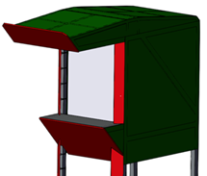

Figure 1. Shooting target outer design; front view

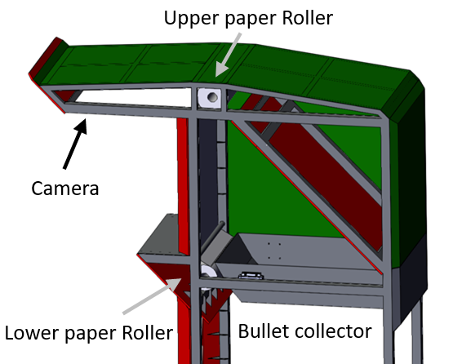

Figure 2. Interior design; side view

**Bullet Collector system**

Schematic diagram of bullet collector system is shown in Fig.3. Behind the target paper, plate armor is installed with the angle of 45 degree to the vertical plane. This plate will deflect the incoming bullet downward to the bullet collector bucket filled with around 25 cm thickness of sand. In the sketch, bullet is deflected with ideal deflection such that when the incoming bullet angle is 450 then the leaving bullet after impact is 450 angle. The sand should reduce speed of the bullet and the bottom of the container is protected with a horizontal plate armor to completely stop the bullet. The combination of layer of sand with stopper armor should safely stop and retain the bullet.

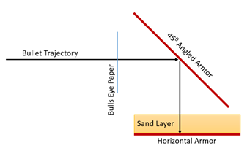

Figure 3. Schematic diagram of ideal bullet collector system

**Semi-Automatic Bulls-Eye Paper Setting**

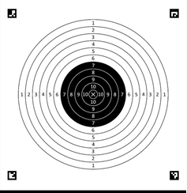

Figure 4. Bulls-eye target design

Bulls-eye target paper is in the format of 50 meter rolling paper consisting around 55 bulls-eyes. Each of the bull eye is shown as in Fig.4 following the standard of International Shooting Sport Federation and USA Shooting [1]. In the setup, this paper is supported by upper and lower rollers as shown in Fig.2 and both rollers are powered by servo motors to roll the paper for refreshing the bulls-eye target when new shooting session starts. Fresh new roll will be set on the upper roller and then the paper is connected to the lower roller. The lower servo motor will act to pull the paper while the upper servo motor will provide rolling resistance to straighten the paper.

Each bulls-eye will be accompanied by four corner markers and one horizontal line marker as shown in Fig.4. These corner markers are ArUco markers [3], [4] which are very robust binary square fiducial markers. The line marker is used to set the vertical position of the bulls-eye using infra-red sensor TCRT5000 to detect the line marker.

Camera is used to monitor the shooting target to let the shooter know the impact of the bullet on the target. This information is very useful for the shooter to correct the aim of the shooting to improve the score. Camera image is sent by using long-range Wi-Fi connection to the PC controller and then the image is displayed by a monitor to the shooter. Wi-Fi connection was provided by high power wireless dual band router which can cover more than 100-meter range in open space.

**Automatic Scoring**

Automatic shooting score developed in this paper is based on computer vision method using OpenCV [5] library and Python language programming [6] which are open sources. Input image is coming from the camera and then processed to calculate the score. The flow diagram of the step by step for image processing is shown in Fig.5. In the image processing, the first step is to normalize the image in order to reduce the effect of ambient lighting during the tests. Next step is to detect 4 corner ArUco markers which will be used to transform the original image from the camera. This process is needed since the camera is placed located at upper front of the bulls-eye therefore the view is from slanted upper. Then the image is transform using OpenCV library *warpPerspective* to make the image view square from the front. The image is cropped to keep only the bulls-eye area. Next step is to detect the center of the bulls-eye and all circular regions for different scores using circular feature line detection using OpenCV library *threshold*, *findContours* and *boundingRect* of the contours.

Next is to detect the sizes and positions of all the bullet holes in the target paper using the same OpenCV library as for detecting the center of the bulls-eye but the value of *threshold* is different to catch holes only which are darker. This image processing works well for all single bullet holes with no overlap bullet holes. Ruolin et al. [8] developed bullet detection anywhere in the image using AI in a vector machine. In this paper, bullet holes are found only in the bulls-eye target area and less searching process is required. A hole with multiple bullets is quite challenging for image processing to detect and analysis for multiple bullet holes will be discussed later.

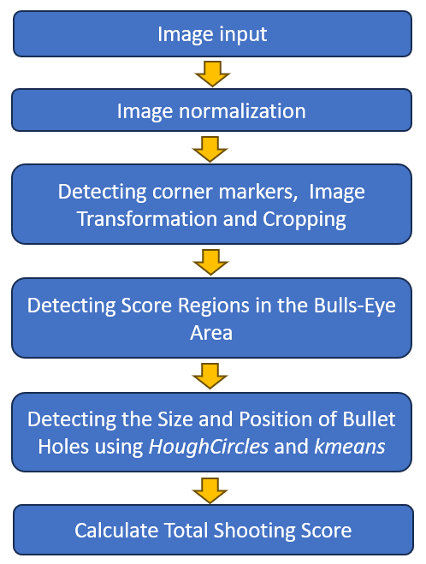

Figure 5. Flow diagram to calculate total shooting score

Last step is to calculate the total shooting score based on the detection of bullet center and the distance of bullet center to the center of the bulls-eye similar method to [10], [15]. The bullet track will be identified in different regions for different scores and then summed up to get the total score.

**Test results and analysis**

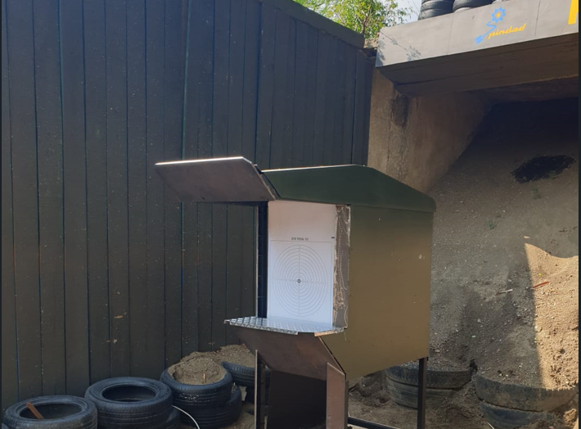

Figure 6. Shooting target system in shooting range area

Shooting test was performed in an official shooting range facility with well protection behind the target by mountain of sand and concrete walls as shown in Fig.6. Although the shooting target system has bullet protectors, sand protection is still needed to protect from the shots outside the target.

In this test, rifle with 5.56 mm ammunition and pistol with 9 mm ammunition were used. Rifle shooting was performed for 50-meter range to the target while pistol shooting was for 15-meter range.

**Bullet Collector Test Results and Analysis**

Test result of the bullet collector system is quite well. All the bullets that pass through the target paper hit the 45-degree armor and are deflected to the container filled with sand. All the bullets were caught and collected in the container and there is no bullet bouncing out the container. However, the test results showed that the bullets were not deflected following ideal deflection. The rifle bullets were deflected with larger angle to the normal line than the ideal deflection as schematically shown in Fig.7. This was shown in the test by tracking the bullet marks in the angled armor and the sand mark locations as shown in Fig.8.

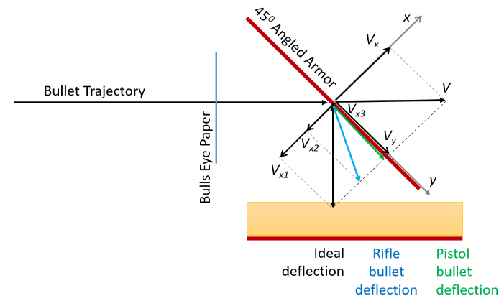

Figure 7. Schematic of ideal deflection vs. rifle and pistol bullet actual deflections

Pistol bullet deflection is quite different. The bullets seemed to be disintegrated after the impact with angled armor then the bullet debris slid along the armor surface and entered the container. This result of bullet ricochet aligns with other study of bullet ricochet from different wood objects [23].

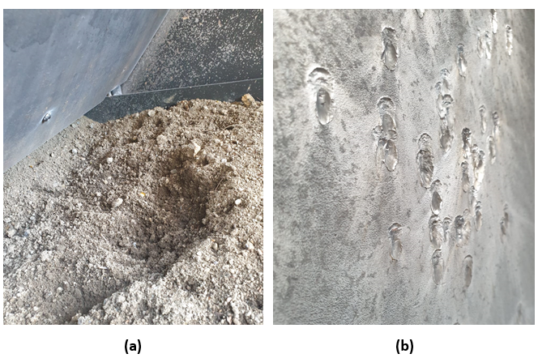

Figure 8. Bullet tracks, (a) Sand marks from rifle bullets. (b) Bullet marks on angled armor

The impact of bullet to the angled armor can be analyzed using oblique impact theory as explained in [7]. The incoming bullet velocity is decomposed into x and y *axis* components as shown in Fig. 7 and the *x-axis* is acting as the line of impact. *Vx = V Cos 450* and *Vy = V Sin 450*. Momentum in *y-axis* reminds conserved while the impact happens in the *x-axis* direction. Before and after the impact, the velocity of each object in *x-axis* will follow the coefficient of restitution formula as stated in the following equation [7]:

$e=\frac{{(v_{Bx})}_{2}- {(v_{Ax})}_{2}}{{(v_{Ax})}_{1}- {(v_{Bx})}_{1}}$*Eqn. (1)*

where the upper components are the velocity difference after the impact while the lower components are the velocity difference before the impact. If B is the angled armor, then *(VBx)2 = (VBx)1 = 0* because it is stationary. Then Eqn.(1) becomes *(VAx)2 = - e (VAx)1*. The negative sign is indicating that the velocity direction after the impact is in the opposite direction before the impact. The value *e*, coefficient of restitution, is controlling the magnitude of deflection velocity. For different values of *e*, oblique impact for different bullets can be described in the following table:

|  |  |
| --- | --- |
| **Velocity of Bullet After Impact** | |
| *Perfect deflection (e=1)* | $${(v_{Ax})}_{2}=-{(v_{Ax})}_{1}$$ |
| *Rifle bullets (e ~ 0.5)* | $${(v_{Ax})}_{2}= -0.5 {(v_{Ax})}_{1}$$ |
| *Pistol bullets (e=0)* | $${(v_{Ax})}_{2}=0$$ |

Table 1. Bullet deflected velocity for different value of coefficient of restitution

From the test results, pistol bullets follow the coefficient of restitution *e = 0* while the rifle bullets follow the coefficient of restitution around *e = 0.5*. Perfect deflection follows *e = 1*.

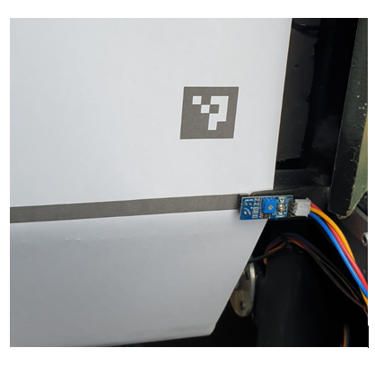

Figure 9. Infra-red sensor to detect correct position of the bulls-eye target paper

**Bulls-Eye Positioning Test Result**

Target paper in the format of paper roll consisting of around 55 bulls-eye is controlled by upper and lower rollers powered by servo motors. After a switch button is pressed by the operator for requesting new and fresh bulls-eye, these servo motors start to roll the target paper. The servo motors will stop when the infra-red sensor detects the black line marker in the paper as an indication for correct position of the target paper as shown in Fig.9. The test results indicated that the infra-red sensor needed to have consistent distance to the paper in order to work properly. A custom designed bracket was used for this purpose.

**Automatic Scoring Test Result**

Image processing from the camera with slanted upper view is transformed into perfect front view using OpenCV library *warpPerspective* and then rotated and cropped to just keep the bulls-eye area as shown in Fig.11. Due to camera position closer to the upper part, the quality of image is better in the upper region than in the lower.

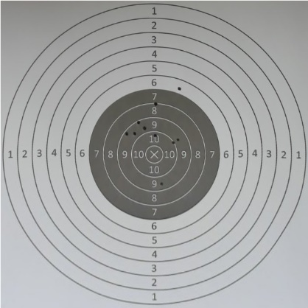

Figure 11. Bulls-eye image after transformation and cropping

Next step is to detect the center of the bulls-eye from the circular lines. Smaller circle is better to define the center of the bulls-eye, however care need to be taken that bullet holes might ruin the small circular edge. The circular lines were detected using binary image processing from OpenCV library *threshold* and then *findContours*. With some kind of conditioning, the center of bulls-eye is defined based on the circular contours using *boundingRect*.

Then bullet hole detection was performed using OpenCV libraries by converting the cropped image into gray scale image, then using *threshold* to highlight the bullet holes and then clean the image using *morphologyEx*. The outcome after performing these libraries is shown in Fig.12 and it shows all the bullet holes in the target paper. Then *findContours* is performed to find the contour of each bullet holes.

Each hole is identified using its contour to find its center using *boundingRect*. This process works well for holes from single bullet. Challenging identifications happen for hole from multiple bullets which means a hole from overlapping or connecting 2 or more bullets.

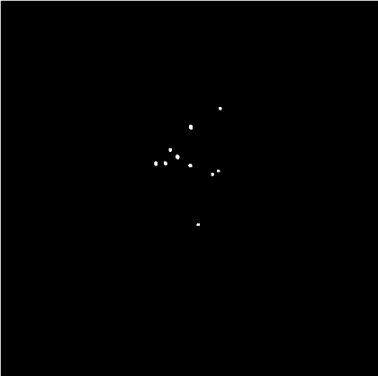

Figure 12. Bulls-eye image after thresholding and cleaning

Multiple bullet hole needs to be defined mainly based on its area which is 40% larger than average hole area which means 60% overlapping area. Hou et al. [16] analyzed multiple bullet holes however in this paper, simpler but accurate method is performed. The area of hole is calculated using OpenCV library *contourArea*. Individual multiple bullet hole is investigated more details by masking other holes and then apply OpenCV library *HoughCircles* to identify 2 or more bullet centers. Based on contour of the hole the *HoughCircles* can find centers outside the hole therefore only centers inside the hole are kept by using OpenCV library *pointPolygonTest*. The *HoughCircles* can give multiple centers which then they are grouped into correct number of bullets using OpenCV library *kmeans*. This process is shown in Fig.13 (a-e).

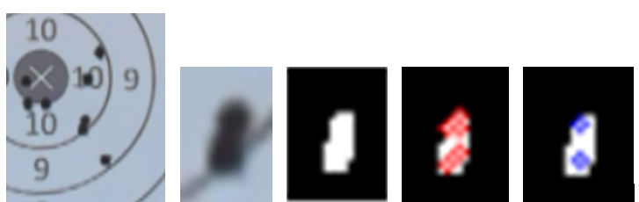



Figure 13. Identification the centers of bullet in a 2-bullet hole. (a) original image. (b) zoomed image on 2-bullet hole. (c) after binarization for contour detection. (d) 6 centers from *HoughCircles* identification. (e) 2 centers after grouping using *kmeans*

The same procedure is applied for 3-bullet hole. In regular shooting with 10 bullet session in 1 bulls-eye, 3-bullet hole rarely happens. The identification of 3-bullet is based on area of the hole and on the characteristic length of the hole. Example of 3-bullet hole identification process is shown in Fig.14.

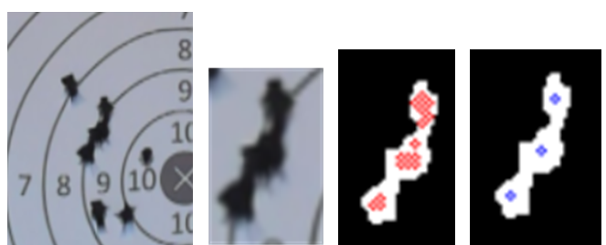



Figure 14. Identification the centers of bullet in a 3-bullet hole. (a) original image. (b) zoomed image on 3-bullet hole. (c) 17 centers from *HoughCircles* identification. (d) 3 centers after grouping from *kmeans*

From the tests, possible error for identification of multiple bullet holes mainly due to extra tearing of target paper which will enlarge the area of hole and can lead to incorrect bullet number identification. Care needs to be taken to define the area for multiple bullet identification. Another source of error is background color. A hole in area with black background color seems to be identified larger than a hole in white background color area. More study is required to make the size of the hole consistent regardless the background color. Lastly, ambient lighting might also be source of error as expected. Normalization of the image should be performed carefully to minimize the effect of different ambient lighting. This image processing procedure has been applied to more than 500 bullets with minimum errors so far.

**Conclusions**

Bullet collector system works well. Bullet deflection is not following perfect deflection angle. Rifle bullets follow the impact deflection with coefficient of restitution *e = 0.5* while pistol bullets follow the impact deflection for *e = 0* and the bullets are completely disintegrated after impact.

Bulls-eye paper rolling and positioning system works well when the infrared sensor equipped with paper holder to maintain the distance of paper from the sensor.

Automatic shooting score using *HoughCircles* and *kmeans* works well for single bullet holes and simple multiple bullet holes.

**ACKNOWLEDGMENT**

The authors would like to acknowledge the financial support of the Ministry of Education, Culture, Research, and Technology of the Republic of Indonesia through the Matching Fund Kedaireka 2023 program. We also would like to thank PT. Pindad to provide fund for conducting test and support during the research.

**REFERENCES**

1. International Shooting Sport Federation (ISSF) and USA Shooting, “General Technical Rules”, Edition 2013. https://usashooting.org/app/uploads/2022/04/2013_USAS_GTR.pdf, pp 204.
2. Association of European Manufacturers of Sporting Ammunition (AFEMS), “Shooting Ranges and the Environment, A Handbook for European Range Managers”, FITASC, https://www.fitasc.com/, 2002.
3. Francisco J. Romero-Ramirez, Rafael Muñoz-Salinas, Rafael Medina-Carnicer, “Speeded up detection of squared fiducial markers”, Image and Vision Computing, vol 76, pp 38-47, 2018
4. S. Garrido-Jurado, R. Muñoz Salinas, F.J. Madrid-Cuevas, R. Medina-Carnicer, “Generation of fiducial marker dictionaries using mixed integer linear programming”, Pattern Recognition vol 51, pp 481-491, 2016
5. Kenneth Dawson-Howe, “A Practical Introduction to Computer Vision with OpenCV”, 1st Edition, Wiles, 2014.
6. Eric Matthews, “Python Crash Course”, 3rd Edition, No Starch Press, 2022
7. R.C. Hibbeler, “Engineering Mechanics Dynamics”, 14th Edition, Pearson Prentice Hall, 2016
8. Zhu Ruolin, Liu Jianbo, Zhang Yuan, Wu Xiaoyu, “Recognition of Bullet Holes Based on Video Image Analysis”, IOP Conf. Series: Materials Science and Engineering 261, 2017.
9. Rezoanul Hafiz Chandan, Nusrat Sharmin, Muhaimin Bin Munir, Abdur Razzak, Tanvir Ahamad Naim, Tasneem Mubashshira, Mokhlesur Rahman, “AI-based small arms firing skill evaluation system in the military domain”, Defence Technology, Vol. 29, pp 164-180, November 2023.
10. Parama D. Widayaka, Hendra Kusuma, Muhammad Attamimi, “Automatic Shooting Scoring System Based on Image Processing”, IOP Conf. Series: Journal of Physics: Conf. Series 1201, 2019.
11. Abbas H. Issa, Sundus D. Hasan, Wisam H. Ali, “Automation of Real-time Target Scoring System Based on Image Processing Technique”, Journal of Mechanical Engineering Research and Developments, Vol. 44, No. 2, pp. 316-323, 2021.
12. R. Fernández Vílchez and D. Mauricio, "Bullet Impact Detection in Silhouettes Using Mask R-CNN," in IEEE Access, vol. 8, pp. 129542-129552, 2020, doi: 10.1109/ACCESS.2020.3008943.
13. Sumit A. Guthe, P. M. Soni, “Target Shooting Training and Instructive System Model using Python”, International Journal of Engineering Research & Technology, Vol. 5, No. 05, May 2016.
14. Faizan Ali, Atif Bin Mansoor, “Computer Vision based Automatic Scoring of Shooting Targets”, Proceedings of the 12th IEEE International Multitopic Conference, December 23-24, 2008.
15. Xinnan Fan, Qianqian Cheng, Penghua Ding, Xuewu Zhang, “Design of Automatic Target-Scoring System of Shooting Game Based On Computer Vision”, Proceedings of the IEEE International Conference on Automation and Logistics, Shenyang, China, August 2009.
16. D. J. Hou, Q. Song, Y. C. Soh, “Computerised Auto-Scoring System Based Upon Feature Extraction and Neural Network Technologies”, Journal of Intelligent and Robotic Systems 29, pp 335–347, 2000.
17. S. -C. Hsia, S. -H. Wang, W. -C. Cheng and C. -Y. Chang, “Intelligent Blowgun Game Scoring Recognition System Based on Computer Vision”, in IEEE Access, vol. 9, pp. 73703-73712, 2021, doi: 10.1109/ACCESS.2021.3081457.
18. Rudzinski, J., Luckner, M. (2013). “Low–Cost Computer Vision Based Automatic Scoring of Shooting Targets”. In: Graña, M., Toro, C., Howlett, R.J., Jain, L.C. (eds) Knowledge Engineering, Machine Learning and Lattice Computing with Applications. KES 2012. Lecture Notes in Computer Science, vol 7828. Springer, Berlin, Heidelberg. https://doi.org/10.1007/978-3-642-37343-5_19
19. P. R. Aryan, “Vision based automatic target scoring system for mobile shooting range”, 2012 International Conference on Advanced Computer Science and Information Systems (ICACSIS), Depok, West Java, Indonesia, pp. 325-329, 2012.
20. Md Rezoanul Hafiz Chandan, Tanvir Ahamad Naim, Md Abdur Razzak, and Nusrat Sharmin. “Image Processing based Scoring System for Small Arms Firing in the Military Domain”. In Proceedings of the 4th International Conference on Image Processing and Machine Vision (IPMV '22). Association for Computing Machinery, New York, NY, USA, 57–63, 2022. https://doi.org/10.1145/3529446.3529456
21. Bijan G. Mobasseri, “Automatic target scoring system using machine vision”, Machine Vision and Applications 8, pp. 20-30, 1995.
22. C. Ye and H. Mi, "The Technology of Image Processing Used in Automatic Target-Scoring System," 2011 Fourth International Joint Conference on Computational Sciences and Optimization, Kunming and Lijiang City, China, pp. 349-352, 2011. doi: 10.1109/CSO.2011.287.
23. Mohd Najib Sam, Glenna Tan Jie Yee, Noor Hazfalinda Hamzah, Mohd Zulkarnain Embi, Ahmad Zamri Md Rejab, Gina Francesca Gabriel, Khairul Osman, “Effects of Shooting Angles and Ricochet Angles on Bullet Weight Upon Impact on Three Types of Woods (Balau, Resak, and Seraya)”, Pertanika Journal of Science and Technology. 31 (3): 1475 – 1491, 2023.
24. Wenya Li, Bing Xu, “Design and Implementation of Shooting Contest Ring Number Automatic Identification System Based on Image Processing”, International Journal of Signal Processing, Image Processing and Pattern Recognition, Vol.9, No.6, pp.407-418, 2016.
25. Finney, Mark A.; Maynard, Trevor B.; McAllister, Sara S.; Grob, Ian J. “A study of ignition by rifle bullets”. Res. Pap. RMRS-RP-104. Fort Collins, CO: U.S. Department of Agriculture, Forest Service, Rocky Mountain Research Station. 31 p.
26. Spencer Lambert, Kyle Bateman, Thomas Marshall, “Bullet Trap”, U.S. Patent No. 7,194,944 B2, Washington, DC: U.S. Patent and Trademark Office. 2007.