|  |  |
| --- | --- |
| Assessment of Revetment Performance Against Wave Overtopping for Mitigating Tidal Flooding at Lebih Beach | download |

**I Gusti Agung Putu Eryani1*, Ni Nyoman Yulleta Andini1, Ni Komang Armaeni1, Odilia Belija Do Carmo Araújo4**

1 Department of Civil Engineering, Warmadewa University, Indonesia

2 Department of Civil Engineering, Universidade da Paz, Timor Leste

|  |  |
| --- | --- |
| ***Abstract***  *As one of the largest archipelagic nations, Indonesia faces significant coastal erosion challenges, particularly in Gianyar Regency, Bali, where erosion rates have reached -11.12 m annually. To combat this issue, the Indonesian government has implemented revetment structures along the coastline, notably at Lebih Beach. This research aims to evaluate the performance of the existing revetment against contemporary wave conditions and assess its effectiveness in mitigating wave overtopping, which has disrupted local community activities and damaged infrastructure. A comprehensive methodological approach was adopted, incorporating field surveys, topographic and bathymetric data, and wave hydraulic analyses using the CMS-Wave model in SMS 10.1. The study involved dividing the Lebih Beach coastline into six segments for evaluation. The existing revetment structure's physical condition and functional performance evaluation showed that segments 1, 2, 3, and 4 need reexamining against the current wave. The reexamination was carried out by evaluating the peak elevation of the existing revetment (+5.00 m) with the reexamination results in each segment. The evaluation results in segments 1, 2, 3, and 4 showed that the revetment still undergoes overtopping. Continuous monitoring and evaluation of coastal protection structures is needed to ensure the integrity of coastal communities and infrastructure in the face of ongoing environmental changes.*  *This is an open-access article under the* [*CC BY-SA*](http://creativecommons.org/licenses/by-sa/4.0/) *license.* | ***Keywords:***  *Lebih Beach;*  *Overtopping;*  *Evaluation;*  ***Article History:***  *Received:*  *Revised:*  *Accepted:*  *Published:*  ***Corresponding Author:***  *I Gusti Agung Putu Eryani*  *Department of Civil Engineering, Warmadewa University, Indonesia*  *Email:* [*eryaniagung@gmail.com*](mailto:eryaniagung@gmail.com) |

**INTRODUCTION**

Indonesia, recognized as one of the largest archipelagic nations globally, comprises approximately 17,504 islands, encompassing a maritime area of about 6,400,000 km² and a coastline extending 108,000 km. [1]. Omara [1] It underscores the scale of the problem in Indonesia, detailing its vast maritime territory and extensive coastline, emphasizing the urgency of effective coastal protection measures. Among these regions, Bali is notable for its coastal dynamics, with a coastline measuring 633 km. [2]. The studies conducted by Suhendra et al. [3] Gianyar Regency, one of Bali's regencies, has experienced significant coastal erosion, quantified at -46.27 m and an average annual erosion rate of -11.12 m. In response to this critical issue, the Indonesian government has initiated the construction of revetment structures along the coastline of Gianyar Regency, including at Lebih Beach, to mitigate the impacts of coastal erosion.

Revetments are sloping structures designed to protect coastal slopes from erosive forces, thus playing a crucial role in the management of shoreline integrity [4]. Studies conducted by Shrestha et al. [5] show that these coastal protection infrastructures not only prevent erosion but also substantially benefit the economy, public health, safety, and community well-being. In both riverine and coastal environments, revetments are essential in defending against flood events and storm-induced wave action, highlighting their significance in coastal engineering practices [6].

Severe coastal flooding occurred at Lebih Beach in 2019 and 2022, resulting in substantial wave overtopping of the revetment structures. [7], [8]. Wave overtopping is water overflow beyond the crest of coastal protective structures, primarily due to wave run-up. [9]Multiple factors can influence coastal flooding, particularly in coastal regions, including shoreline geometry, sea level rise, wave climate dynamics, and climate change-related impacts. [10], [11], [12]. The structural integrity of revetments may be compromised if the crest height is inadequately designed, leading to excessive overtopping that adversely affects both the top and the rear side of these structures. [13]. The consequences of wave overtopping can manifest under three scenarios: (1) when water levels exceed the crest elevation of the structure, (2) when waves surge over the crest, and (3) when the coastal structure is breached or otherwise compromised. [14], [15]. At Lebih Beach, wave overtopping has disrupted local community activities, detached the revetment's armour layer and damaged adjacent pedestrian pathways.

The issue of wave overtopping has attracted significant academic interest, prompting extensive investigations through various methodologies, including the multitude of methodologies explored by Kreyenschulte et al.[16], Vieira et al. [17] Others present a robust foundation for understanding wave overtopping. However, while theoretical and experimental studies provide valuable insights, a comprehensive synthesis of these approaches could yield more effective predictive models. The experimental work by Capel [18] Others illustrate the complexities of wave interactions with coastal structures, yet these studies often lack long-term data that could enhance their applicability to real-world scenarios.

The integration of numerical modelling techniques, as discussed by Alcérreca-Huerta & Oumeraci [19] And Cao et al. [20] Represents a significant advancement in the field. However, the potential for model calibration using local conditions at Lebih Beach is often overlooked. Such calibration could significantly improve the accuracy of predictions regarding wave overtopping and structural integrity, aligning with the findings of Jin et al. [13] Regarding the critical role of revetment crest height.

Despite significant progress in understanding coastal protection in the form of revetments and wave overflows, there is still an alarming level of erosion in Gianyar Regency. This is exacerbated by climate change causing tidal flooding and the absence of a comprehensive evaluation of the performance of existing embankment structures in a specific context such as Lebih Beach.

Therefore, this research aims to evaluate the existing revetment structure at Lebih Beach comprehensively. This research evaluates the performance of the existing revetment structure at Lebih Beach against contemporary wave conditions, focusing on its physical and functional effectiveness in mitigating wave overtopping. This study seeks to assess the adequacy of the revetment in safeguarding the coastline and to recommend requisite adjustments or enhancements. A novel methodological approach will be employed, integrating structural evaluation results from field surveys with comprehensive wave hydraulic analyses utilizing the CMS-Wave model in SMS 10.1. This dual methodology will facilitate the determination of the optimal revetment height necessary to mitigate wave overtopping and coastal flooding effectively.

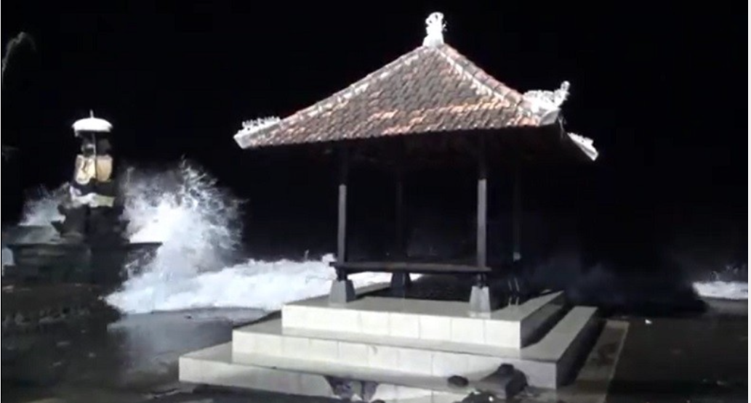

Figure 1 Tidal flood in Lebih Beach in 2022

**METHOD**

**Research Location**

Lebih Beach is located in Lebih village, Gianyar Regency, Bali, Indonesia. The coastline was divided into six segments because the revetment structure in each segment has different conditions, as shown in Figure 2.

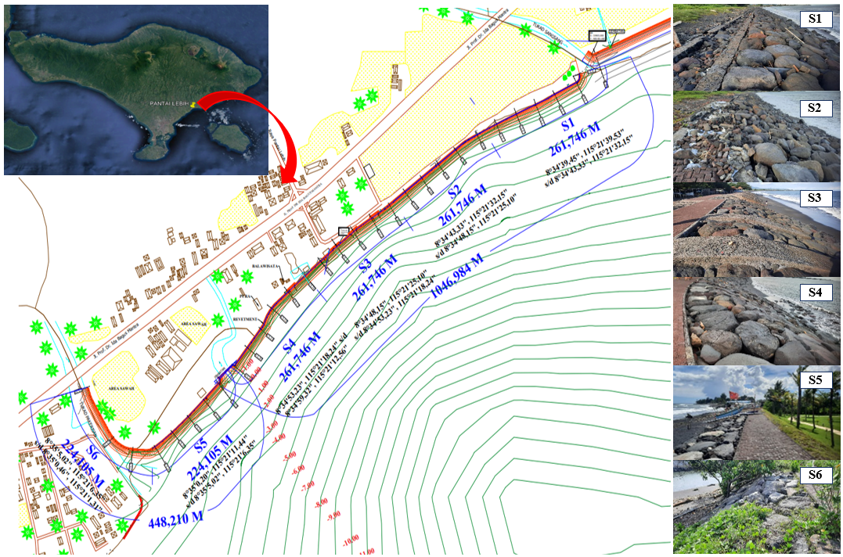

Figure 2 Research the location and conditions of each segment.

**Research Data**

The data used in this study are: (1) Condition of the existing revetment (2) Topographic and bathymetric maps; (3) Wind data for the period from 2014 to 2023; (4) Tides data; (5) Bali Island map.

**Methods**

Figure 3 illustrates the methodology for evaluating a coastal revetment structure's physical and functional performance. This detailed and systematic approach integrates field-based observations and advanced data analysis techniques.

The process begins with the study's initiation, where an initial survey is conducted to gather preliminary information about the revetment structure and the surrounding coastal environment. This survey helps to identify key issues such as erosion, wave overtopping, and any visible structural damage that may need to be addressed.

Following the survey, the next step is problem identification, where the specific challenges related to the revetment structure are clearly defined. This could include problems like severe erosion at the toe of the structure, frequent wave overtopping events, or signs of structural fatigue or failure. Identifying these problems sets the stage for targeted data collection and analysis.

The primary data is gathered through on-site documentation and field surveys focusing on the revetment's physical condition. This involves detailed inspections of the revetment’s structure, including the armour layer, slope stability, signs of material degradation, and any visible structural damage. Photographs, measurements, and detailed notes are taken to document the structure's current state.

This primary data is then used to evaluate the revetment's physical condition and functional performance. The evaluation seeks to determine whether the revetment protects the coastline from erosion and wave overtopping and whether it is in good structural condition.

A comprehensive map of Bali Island is obtained, which includes geographical features, land use patterns, population density, and the location of the revetment and other critical coastal infrastructure. This map provides context for the study and helps understand the broader coastal dynamics.

Wind data spanning from 2014 to 2023 is collected from meteorological stations. This dataset includes information on wind speed, direction, and variability, which is crucial for understanding the generation and direction of waves that impact the revetment.

Topographic and Bathymetric Maps provide detailed information on the elevation of the land and underwater topography around the revetment. Topographic maps show the shape and features of the coastal landscape, while bathymetric maps illustrate the depth and contours of the seabed. These are essential for modelling how waves approach and interact with the revetment.

Tidal data is collected to understand the sea-level variations over time, including the timing and magnitude of high and low tides. This data helps assess how tidal fluctuations contribute to wave overtopping and the overall stress on the revetment.

With the collected secondary data, the next phase involves Wave Generation modelling. This step uses the wind, topographic, bathymetric, and tidal data to simulate the waves the revetment will likely encounter. The wave generation model predicts waves' height, direction, and energy as they approach the shoreline.

Subsequently, current waves were simulated using SMS 10.1 to create wave transformations. Data that needed input in the simulation were topography and bathymetry maps, tide data, wave direction, significant wave height, and significant wave period.

The data output from the wave transformation simulation is the wave height at the existing revetment location that will be used to calculate run-up. The results of the run-up calculation are used as one of the parameters for calculating the peak elevation of the revetment, along with the design water level and freeboard parameters.

The evaluation results of the reexamined segments were obtained by comparing the current wave analysis's peak elevation revetment with the existing peak elevation revetment, which was +5.00 m.

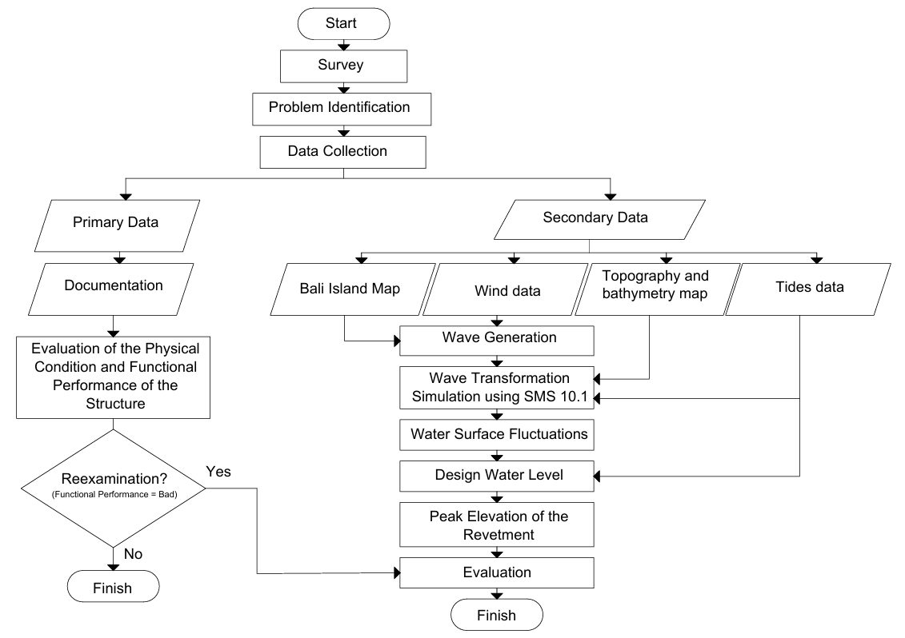

Figure 3 Flowchart of the research

**Evaluation of the Physical Condition and Functional Performance of the Structure**

Evaluation of the structure's physical condition and functional performance includes physical component index calculation, component values calculation, index condition value calculation, and functional performance of the structure assessment. [21].

A value called the structure condition index indicates the physical condition of the structure. The value is determined by entering condition component index values from indicators observed and recorded during the survey. In the context of the coastal structure, a value scale from 1 to 4 is used to calculate the physical component index. A value of 1 indicates the best condition, while a value of 4 indicates the worst condition of each part of the coastal structure [21].

Subsequently, component values are calculated using (1)

Component value = index value x weight (1)

The weight of the physical component of the structure is different according to the type of coastal structure that will be evaluated, as shown in Table 1 [21].

Table 1 Weight of the physical component of the structure

|  |  |  |  |  |
| --- | --- | --- | --- | --- |
| **Type of Structure** | **Weight of the Physical Component** | | | |
| **Peak** | **Body** | **Foundation** | **Material** |
| Revetment | 30 | 20 | 10 | 40 |
| Scalloped Revetment | 10 | 30 | 20 | 40 |
| Seawall | 20 | 10 | 30 | 40 |
| Retaining wall | 10 | 10 | 40 | 40 |
| Breakwater | 20 | 20 | 20 | 40 |
| Groin | 10 | 10 | 40 | 40 |
| Jetty | 10 | 10 | 40 | 40 |

After calculating the component index, calculate the index condition value using (2) [21].

Index condition = $\frac{\sum{Component value }}{\sum{Weight }}$ (2)

Functional performance values can be variable but simplified to “Good” or “Bad,” as shown in Table 2 [21].

Table 2 Structure Function Performance

|  |  |  |
| --- | --- | --- |
| **Protected Object** | **Structure Function Performance** | |
| **Good** | **Bad** |
| Outer Island | The beach doesn’t erode or may even widen. The coastline can recede at times but advance again, maintaining a balance throughout the year. | The coastline consistently recedes over time. Trees along the shore topple, and some roots are exposed due to water erosion. |
| National Road/ Province Road/ District Road/City | The road is intact and stable. However, it could be covered by sand thrown by large tidal waves, extending far behind the structure. | Cracks appear due to the disturbed road foundation. The road experiences sinking or subsidence. The road shoulders appear eroded and are getting closer to the roadbed. |
| Settlement Area | The settlement is safe from wave threats. Dunes can form along the coastline. | The settlement is affected by waves, with the coastline advancing closer to the residential areas, causing breaking waves to reach the houses closest to the beach. |
| Tourist Area | The tourist area is safe from wave disturbances. On steep beaches, coastline walls are not eroded, and cliff collapses no longer occur. On wide sandy beaches, the shoreline is maintained or even expanded. | Wave energy and waves still disturb the tourist area. Erosion and cliff collapse still occur on steep beaches. On sandy beaches, the amount of sand is decreasing, and the width of the beach is shrinking, making the tourist area increasingly narrow. |
| Public/Social Facilities | Public facilities are in safe and operational condition. The wave height reaching the location doesn’t exceed the planned estimates, thus not disrupting activities. | The coastal structures are unable to improve the situation. The size of the incoming wave disrupts activities at the facility, and the facilities may even suffer damage due to the waves. |

The action advice is based on the structure's index value and functional performance, as shown in Table 3 [21].

Table 3 Action advice

|  |  |  |  |
| --- | --- | --- | --- |
| **Functional Performance** | **Structure Physical Condition** | | **Action Advice** |
| **Index Value** | **Condition** |
| Good | 0.0 < value ≤ 1.5 | Good | Monitoring |
| 1.5 < value ≤ 2.5 | Good Enough | Monitoring |
| 2.5 < value ≤ 3.5 | Damaged | Maintenance |
| >3.5 | Heavily Damaged | Rehabilitation |
| Bad | 0.0 < value ≤ 1.5 | Good | Reexamination |
| 1.5 < value ≤ 2.5 | Good Enough |
| 2.5 < value ≤ 3.5 | Damaged |
| >3.5 | Heavily Damaged |

**Wave generation**

The wind stress factor (UA), effective fetch, and duration of sea wind speed were required to determine the wave height. [22].

The wind speeds in different directions are plotted into a windrose diagram, as shown in Figure 4 [23].The wind data and analysis were utilized to forecast the wave [24].

Wind-stress factor (UA) is calculated using (3) [25].

$U_{A} = {{0.71 U}_{w}}^{123}$ (3)

Where:

UA = wind speed correction (m/s)

UW = wind speed at sea (m/s)

Fetch is the length of the area where the wind blows with constant speed and direction that can generate a wave. [22]. Effective fetch is calculated using (4) [25].

$Feff= \frac{\sum{x_{i} cos α}}{\sum{cos α}}$ (4)

Where:

Feff = effective fetch length

Xi = fetch length on each segment

α = deviation on both sides from the wind

direction, by adding 6˚- 42˚ on both

sides from the wind direction.

Significant wave height and wave period are calculated using (5) and (6) [25].

$Hs= 0,0016 x \sqrt{\frac{gFeff}{{U_{A}}^{2}} }x \frac{{U_{A}}^{2}}{g}$ (5)

$Ts= 0,2857 x {\left(\frac{gFeff}{{U_{A}}^{2}}\right)}^{\frac{1}{3}}x \frac{U_{A}}{g}$ (6)

Where:

Hs = significant wave height (m)

Ts = significant wave period (s)

UA = wind speed correction (m/s)

Feff = effective fetch (m)

g = earth gravity acceleration (9,81 m/s2)

The return wave is calculated using the Gumbel method, which uses (7) and (8).

$H_{t} =\overline{Hs}+ \frac{σH}{σn}\left(Y_{t}-Y_{\overline{n}}\right)$ (7)

$T_{t}= 0.33x\sqrt{\frac{H_{25}}{0.0056}}$ (8)

Where:

$\overline{Hs}$ = average wave height (m

$σH$ = standard deviation

$t$ = return period (year)

Yt = Reduced variance as a function of the

return period

$Y_{\overline{n}}$ = Reduced variance as a function of the

amount of data (N)

$σn$ = Reduced variance deviation as a

function of the amount of data

Ht = wave height of the return period (m)

Tt = wave period of the return period (s).

**Simulation of wave transformation using SMS 10.1**

For the simulation of wave transformation performed using the CMS-Wave model in SMS 10.1. The data to be input in the simulation of wave transformation in SMS 10.1 are topographic and bathymetric contour data, wave height, wave period, dominant wave generation direction, and highest water level (HWL) [26]The output of this simulation is the wave height at the existing revetment location, which is later used in the run-up calculation.

**Water Surface Fluctuations**

Water surface fluctuations include wave set-up, wind set-up and sea level rise.

Wave set-up is the time-averaged extra water level elevation by breaking waves. [27]. Wave set-up is calculated using (9) [25].

$S_{w}=0,19\left[1-2,82\sqrt{\frac{Hb}{gT^{2}}}\right]Hb$ (9)

Where :

Sw = wave set-up (m)

T = wave period (s)

Hb = height of the wave breaking (m)

g = earth gravity acceleration (9,81 m/s2)

Wind set-up calculated using (10) [25].

∆h = $F_{c}\frac{V^{2}}{2gd}$ (10)

Where :

$∆h$ = wind set-up (m)

F = effective fetch length (m)

c = constant (3,5 x 10-6);

v = wind speed (m/s);

d = water depth (m)

g = earth gravity acceleration (9,81 m/s2)

Global coastal flood production is still significantly influenced by rising sea levels [28]. Sea level rise is calculated using graphics, as shown in Figure 4 [25].

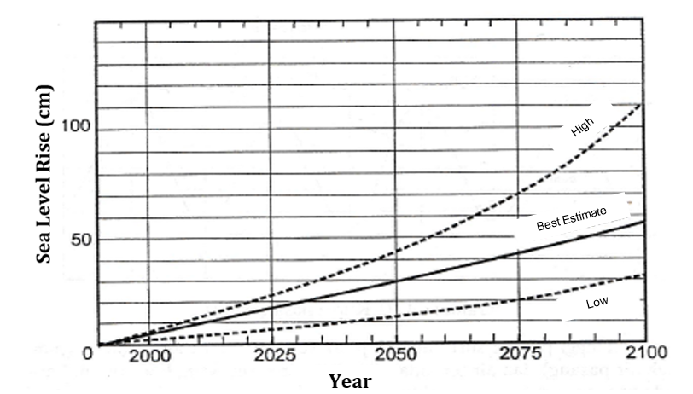

Figure 4 Sea level rise

**Design Water Level (DWL)**

To guarantee that the revetment structure can endure the water pressure brought on by gradual variations in water levels, especially during floods or strong waves, the design water level was calculated using (11) [25], [29].

DWL = HWL + ∆h + Sw + SLR (11)

Where:

DWL = design water level

$∆h$ = wind set-up (m)

SW = wave set-up

SLR = sea level rise.

**Revetment Crest Elevation**

Overtopping happens when the run-up at the structure is higher than the crest freeboard. [30]. Run-up calculated using (12) [31].

Ir = $\frac{tgθ}{{(\frac{H}{L_{0}})}^{0,5}}$ (12)

Where:

Ir = Irribaren number

$θ_{r}$ = slope

H = wave height at the structure (m)

L0 = wavelength at the deep sea (m).

The crest elevation of the revetment structure was calculated using (13) [25].

Elrevetment = DWL + Ru + Fb (13)

Where:

DWL = design water level (m)

Ru = run-up (m)

Fb = freeboard (0.5 – 1.0 m)

**RESULTS AND DISCUSSION**

**Result of the Evaluation of the Physical Condition and Functional Performance of the Structure**

Using a survey approach to the site, the current revetment structure at Lebih Beach is evaluated for its functional performance and physical state. The value of the physical component index is based on the physical condition of each part of the revetment structure, and then the component value is calculated using (1), as shown in Table 4. Subsequently, the index condition value was calculated using (2), as shown in Table 5, and the functional performance results, as shown in Table 6, were specified accordingly in Table 2. After that, the action advice results in every segment, as shown in Table 7, were specified accordingly in Table 3 [21].

Table 4 The physical component index of each segment

|  |  |  |  |  |
| --- | --- | --- | --- | --- |
| **Segment** | **Physical Component Index Value** | | | |
| **Crest** | **Body** | **Foundation** | **Material** |
| S1 | 1 | 2 | 1 | 3 |
| S2 | 4 | 4 | 2 | 4 |
| S3 | 1 | 1 | 1 | 1 |
| S4 | 1 | 2 | 2 | 1 |
| S5 | 1 | 1 | 1 | 1 |
| S6 | 1 | 1 | 1 | 1 |

Table 4 provides a detailed assessment of the physical condition of various segments (S1 to S6) of a revetment structure, focusing on four key components: the crest, body, foundation, and material. The index values, which range from 1 to 4, indicate the condition of each component, with 1 representing the poorest state and 4 representing the best.

Segment S2 emerges as the most structurally sound part of the revetment, with high index values of 4 across the crest, body, and material components and a slightly lower but solid foundation rating of 2. This suggests that S2 is well-maintained effectively resists wave forces, and prevents erosion. In contrast, segments S1, S3, S4, S5, and S6 show significantly lower index values, with most components rated 1. This indicates that these segments are potentially vulnerable to damage from wave action and may be compromised in their ability to protect the coastline.

Segment S1 has a slightly better condition regarding its material (index value of 3) and body (index value of 2), but it still shows weaknesses in the crest and foundation, rated at 1. This suggests that while the material used in S1 might be relatively robust, the overall structural integrity could be enhanced with targeted improvements. Segments S3, S4, S5, and S6 are consistently rated at one across almost all components, indicating significant deterioration or inadequate conditions that require urgent attention.

Table 5 The component value and index component value of each segment

|  |  |  |  |  |  |  |
| --- | --- | --- | --- | --- | --- | --- |
| **Segment** | **Component Value** | | | | **Total** | **Index Condition Value** |
| **Crest** | **Body** | **Foundation** | **Material** |
| S1 | 30 | 40 | 10 | 120 | 190 | 2.1 |
| S2 | 120 | 80 | 20 | 160 | 1360 | 4.0 |
| S3 | 30 | 20 | 10 | 40 | 100 | 1.0 |
| S4 | 30 | 40 | 20 | 40 | 110 | 1.3 |
| S5 | 30 | 20 | 10 | 40 | 100 | 1.0 |
| S6 | 30 | 20 | 10 | 40 | 100 | 1.0 |

Table 5 is a detailed evaluation of the structural condition of different segments (S1 to S6) of a revetment structure, focusing on four key components: the crest, body, foundation, and material. Each component is assigned a specific value, reflecting its condition within each segment. These values are then summed to provide a total component value for each segment, subsequently used to calculate an index condition value. This index is an overall metric of the segment's structural health, with higher values indicating better conditions.

Segment S2 stands out as the most robust section of the revetment, with high component values across the board—120 for the crest, 80 for the body, 20 for the foundation, and 160 for the material—resulting in a total value of 1360 and an index condition value of 4.0. This indicates that S2 is in excellent condition and likely performing well in protecting the coastline. In contrast, segments S3, S5, and S6 are in the poorest condition, each with identical low component values—30 for the crest, 20 for the body, 10 for the foundation, and 40 for the material—resulting in a total value of 100 and an index condition value of just 1.0. These low values suggest that these segments are vulnerable to structural failure and require maintenance or reinforcement.

Segment S1, with a total value of 190 and an index condition value of 2.0, falls into a moderate condition category. While the material component is relatively strong, with a value of 120, the foundation is weaker, which may compromise the overall structural integrity of this segment. Segment S4, with slightly better component values than S3, S5, and S6, particularly in the body and foundation, has a total value of 110 and an index condition value of 1.3. Although slightly better, the S4 reflects a relatively poor condition, necessitating improved reliability.

Table 6 Functional Performances of each segment

|  |  |  |  |
| --- | --- | --- | --- |
| **Segment** | **Functional Performance** | | |
| **Protected object** | **Description** | **Function Performance** |
| S1 | Tourist area | Overtopping | Bad |
| S2 | Tourist area | Overtopping | Bad |
| S3 | Tourist area and public/social facilities | Overtopping | Bad |
| S4 | Tourist area and public/social facilities | Overtopping | Bad |
| S5 | Tourist area | Non-overtopping | Good |
| S6 | Tourist area | Non-overtopping | Good |

Table 6 presents the functional performances of different segments of a coastal protection structure, specifically focusing on their ability to prevent overtopping during tidal events. Segments S1, S2, S3, and S4 are all located in areas with significant tourist and public/social facilities, and they are reported to have poor performance due to overtopping, indicating that these segments are failing to adequately protect the areas they serve from flooding and wave impacts. In contrast, Segment S5, which also serves a tourist area, has demonstrated good performance by effectively preventing overtopping, highlighting its reliability in safeguarding the designated location. This disparity in performance among the segments suggests an urgent need for improvements in the segments experiencing overtopping to ensure adequate protection for tourists and public facilities.

Table 7 Recapitulation of the evaluation of the physical condition and functional performance

|  |  |  |  |  |
| --- | --- | --- | --- | --- |
| **Segment** | **Physical Structure** | | **Functional Performance** | **Action Advice** |
| **Index Value** | **Condition** |
| S1 | 2.0 | Good enough | Bad | Reexamination |
| S2 | 3.8 | Heavily damaged | Bad | Reexamination |
| S3 | 1.0 | Good | Bad | Reexamination |
| S4 | 1.3 | Good | Bad | Reexamination |
| S5 | 1.0 | Good | Good | Monitoring |
| S6 | 1.0 | Good | Good | Monitoring |

Based on Table 7's result, segments 1, 2, 3, and 4 needed to be reexamined against current waves, and segments 5 and 6 needed to be monitored.

**Wave analysis results**

Wave analysis starts with making a windrose that contains wind speed in all directions at Lebih Beach. Figure 5 shows the sequence of presentations of winds at Lebih Beach. The dominant wind direction is from the southeast (42.86%). Subsequently, the wind speed correction (UA) was analyzed using dominant wind data and using (3), as shown in Table 11 [32].

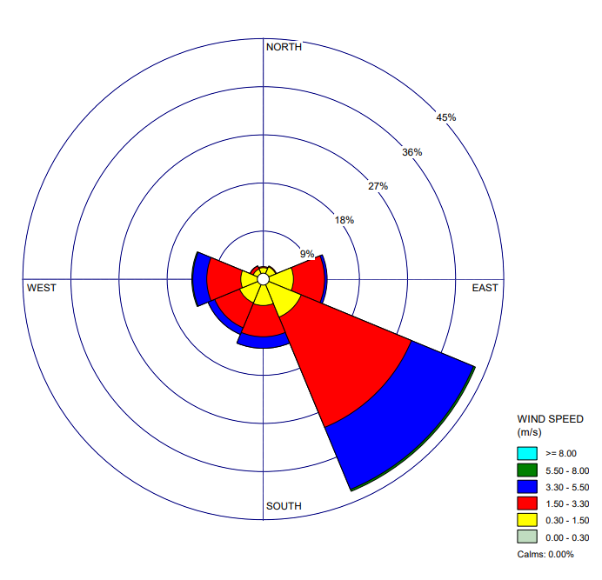

Figure 5 The wind rose at Lebih Beach.

The Fetch line is drawn at intervals of every 6˚- 42˚[22]. The fetch length is assumed to be 1000 km if not encountering land [33]. Effective fetch is calculated using (4) in the south-east direction according to the dominant wind direction.

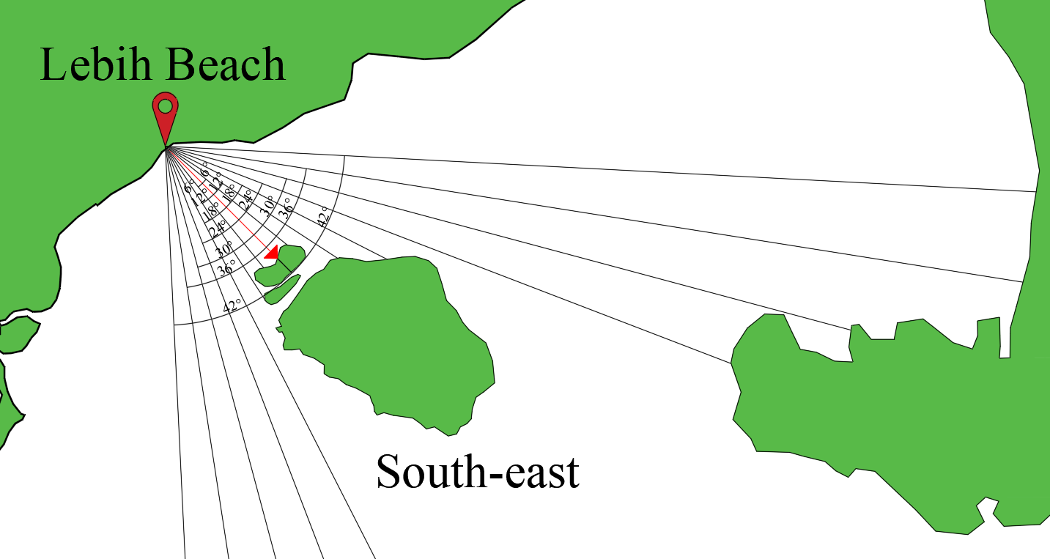

**Figure 6** Fetch di Pantai Lebih

$Feff=\frac{\sum{x_{i} cos α}}{\sum{cos α}}= \frac{4612,257 km}{13,511}$ = $341,373 km$

After that, the significant wave height of each year was calculated using (5), and the maximal significant period wave of each year was calculated using (6), with results as shown in Table 8.

Table 8 Significant wave height and duration (2014-2023)

|  |  |  |  |  |  |
| --- | --- | --- | --- | --- | --- |
| **Year** | **Ua** | **Direction** | **Feff** | **Hsmax** | **Tsmax** |
| **(m/s)** | **(m)** | **(m)** | **(s)** |
| 2014 | 10.584 | SE | 341372.6 | 3.159 | 9.567 |
| 2015 | 9.632 | SE | 341372.6 | 2.875 | 9.271 |
| 2016 | 9.145 | SE | 341372.6 | 2.730 | 9.112 |
| 2017 | 10.407 | SE | 341372.6 | 3.106 | 9.513 |
| 2018 | 9.946 | SE | 341372.6 | 2.969 | 9.370 |
| 2019 | 10.802 | SE | 341372.6 | 3.224 | 9.632 |
| 2020 | 11.457 | SE | 341372.6 | 3.420 | 9.823 |
| 2021 | 8.899 | SE | 341372.6 | 2.656 | 9.029 |
| 2022 | 11.200 | SE | 341372.6 | 3.343 | 9.749 |
| 2023 | 11.433 | SE | 341372.6 | 3.412 | 9.816 |

Subsequently, the return wave was calculated using the Gumbel method, as shown in Table 9.

Table 9 Wave height and wave duration of the return period

|  |  |  |  |
| --- | --- | --- | --- |
| **No** | **Return Period (Year)** | **Hs (m)** | **Ts (m)** |
| 1 | 2 | 3.079 | 7.738 |
| 2 | 5 | 3.170 | 7.851 |
| 3 | 10 | 3.230 | 7.926 |
| 4 | 25 | 3.314 | 8.028 |
| 5 | 50 | 3.363 | 8.086 |
| 6 | 100 | 3.419 | 8.154 |

The height and duration of the plan used are 25 years, with Hs = 3.314 m and Ts = 8.028 s.

**Simulation of Wave Transformation Results**

To simulate current wave transformation, required data such as topography and bathymetry contour of Lebih Beach, the highest water level at Gianyar Regency (HWL = +2.795 m), wave height (H25 = 3.314 m), wave duration (T25 = 8.028 s) and wind direction (south-east) [26].

Figure 8 is the resulting model of the wave transformation at Lebih Beach using the CMS-Wave model. As shown in Figure 7, an observation line is drawn on each segment to determine the wave transformation.

To get the wave height at the revetment location, the distance of the existing revetment from the starting point of each observation line must be measured. Subsequently, the wave height used for run-up analysis is at the distance of the existing revetment location because, as shown in Figure 9, the wave height parameter results are based on the particular distance.

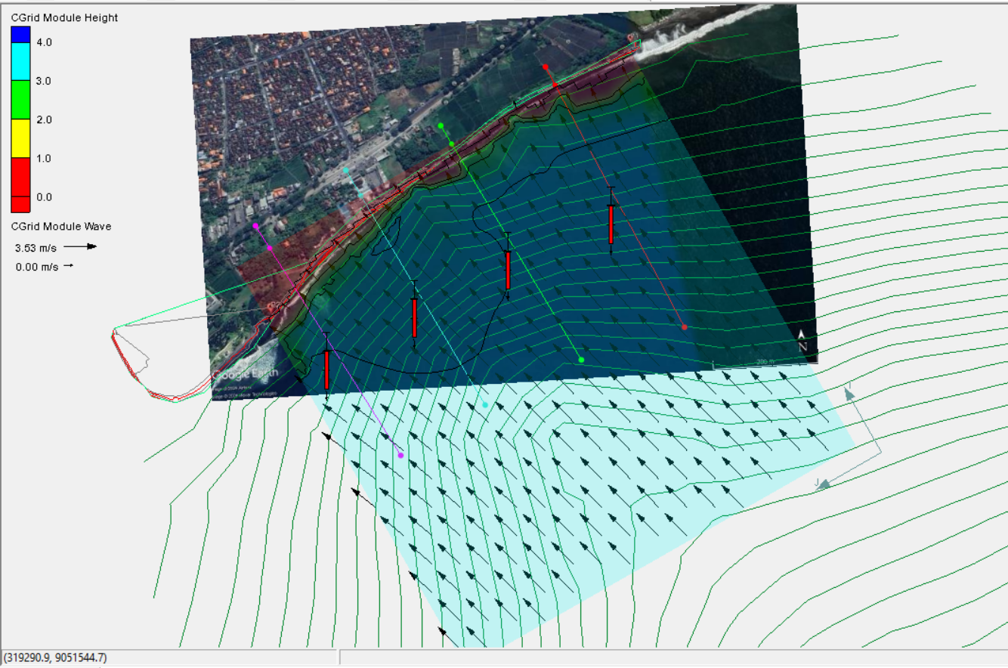

Figure 7 Observation line on each segment

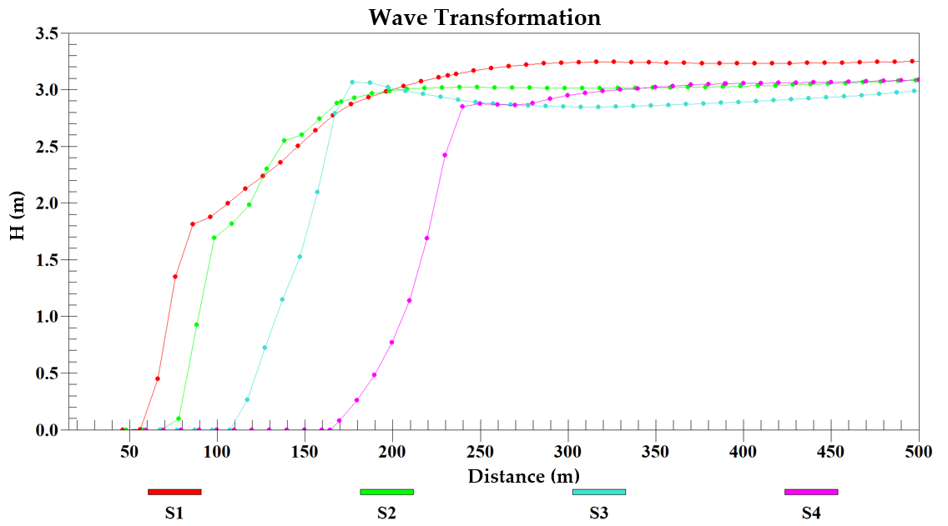

Figure 8 Wave transformation on each segment

Based on the wave transformation results from Figure 8, wave height at the existing revetment can be seen in Table 10.

Table 10 Wave height at the revetment location

|  |  |  |
| --- | --- | --- |
| **No** | **Segment** | **H (m)** |
| 1 | S1 | 1.249 |
| 2 | S2 | 1.694 |
| 3 | S3 | 1.148 |
| 4 | S4 | 1.140 |

The wave height at the existing revetment location will be used to calculate run-up using (12), as shown in Table 12.

**Evaluation results**

The parameter to be evaluated was the elevation of the revetment crest. The elevation of the revetment crest was calculated using the design water level, run-up, and freeboard parameters. The design water level was calculated using (11); the result is shown in Table 11.

Table 11 Design water level

|  |  |  |
| --- | --- | --- |
| **No** | **Parameter** | **Value (m)** |
| 1 | Highest water level | 2.795 |
| 2 | Wind set-up | 0.165 |
| 3 | Wave set-up | 0.536 |
| 4 | Sea level rise | 0.12 |
| **DWL (HWL+Sw+∆h+SLR)** | | **3.616** |

Table 12 Peak elevation of the revetment each segment

|  |  |  |  |  |  |
| --- | --- | --- | --- | --- | --- |
| **Segment** | **DWL** | **H** | **Ru** | **Fb** | **Elrevetment** |
| **(m)** | **(m)** | **(m)** | **(m)** | **(m)** |
| S1 | 3.616 | 1.249 | 1.549 | 0.5 | +5.666 |
| S2 | 3.616 | 1.694 | 1.990 | 0.5 | +6.107 |
| S3 | 3.616 | 1.148 | 1.424 | 0.5 | +5.540 |
| S4 | 3.616 | 1.140 | 1.425 | 0.5 | +5.541 |

The Crest elevation of the revetment was calculated using (13), and the result is shown in Table 12.

Table 13 Evaluation results

|  |  |  |  |
| --- | --- | --- | --- |
| **Segment** | **Peak Elevation of the Revetment (m)** | | **Result** |
| **Existing** | **Reexamination** |
| S1 | +5.000 | +5.666 | Overtopping |
| S2 | +5.000 | +6.107 | Overtopping |
| S3 | +5.000 | +5.540 | Overtopping |
| S4 | +5.000 | +5.541 | Overtopping |

The evaluation was carried out by comparing the crest elevation of the existing revetment (+5.00 m) with reexamination results in each segment. Based on Table 13, segments 1, 2, 3, and 4 are still overtopping because the reexamination crest elevation result is bigger than the existing one.

Several strategies can be implemented to mitigate the issue of tidal flooding and wave overtopping in the existing revetment where the crest elevation is insufficient. The most direct solution is to raise the crest height of the revetment to meet or exceed the reexamined required elevation, potentially in phases if budget constraints exist. Additionally, reinforcing the revetment with wave return walls or stronger armour layers can help reduce overtopping by deflecting waves and absorbing more energy. Additional coastal structures, such as seawalls, bulkheads, or offshore breakwaters, can reduce wave energy before reaching the shore. Improving drainage systems and constructing overflow channels behind the revetment will help manage any water that does overtop the structure. [34]. Natural defenses, like planting salt-tolerant vegetation or enhancing the beach before the revetment, can also provide a buffer against waves. Regular monitoring and maintenance of the revetment are crucial for ensuring its long-term effectiveness, while advanced engineering solutions, including numerical modelling and adaptive management, can optimize the design and response to changing conditions.

**CONCLUSION**

The evaluation of the existing revetment structure's physical condition and functional performance revealed significant concerns regarding segments 1, 2, 3, and 4, which require reexamination in light of current wave conditions. The reexamination process involved a comprehensive assessment of the peak elevation of the existing revetment relative to updated wave analysis results for each segment.

Findings from this evaluation indicated that segments 1, 2, 3, and 4 continue to experience overtopping events as the peak elevations of the existing revetment structures fall short of the heights predicted by the latest wave analysis. Specifically, the analysis demonstrated that the wave heights impacting these segments exceed the revetment's design parameters, leading to insufficient protection against coastal erosion and wave overtopping.

This urgent situation necessitates immediate interventions to mitigate ongoing wave attacks, which are expected to persist and potentially worsen due to climate change and rising sea levels. Various coastal protection solutions can be explored to address the overtopping issue effectively. These include implementing hard structures (such as seawalls and groins), soft structures (like beach nourishment and dune restoration), or modifications to existing infrastructure to enhance resilience against wave impacts.

Compared to previous studies on the same revetment segments, this evaluation highlights a critical evolution in wave behaviour, possibly linked to environmental changes and increased storm intensity. Prior assessments may not have accounted for these dynamic factors, emphasizing the necessity for continuous monitoring and adaptive management strategies to ensure the long-term effectiveness of coastal protection systems. Integrating updated wave data into the assessment process provides a more accurate representation of current risks, guiding more informed decision-making for future interventions.

**REFERENCES**

[1] A. Omara, “The Importance of Institutional Arrangement to Safeguard Maritime Security and Safety in Indonesia: The Case of Marine Security and Safety Agency,” *Sasi*, vol. 30, no. 1, p. 56, 2024, doi: 10.47268/sasi.v30i1.1789.

[2] A. H. S. Putro and J. L. Lee, “Analysis of longshore drift patterns on the littoral system of nusa dua beach in bali, indonesia,” *J. Mar. Sci. Eng.*, vol. 8, no. 10, pp. 1–19, 2020, doi: 10.3390/jmse8100749.

[3] S. Suhendra, C. A. Setiawan, T. A. Wibawa, and B. B. Borneo, “Coastline Change Analysis on Bali Island Using Sentinel-1 Satellite Imagery,” *Int. J. Remote Sens. Earth Sci.*, vol. 18, no. 1, p. 63, 2021, doi: 10.30536/j.ijreses.2021.v18.a3611.

[4] S. Sanitwong-Na-Ayutthaya, C. Saengsupavanich, E. H. Ariffin, A. S. Ratnayake, and L. S. Yun, “Environmental impacts of shore revetment,” *Heliyon*, vol. 9, no. 9, p. e19646, 2023, doi: 10.1016/j.heliyon.2023.e19646.

[5] A. Shrestha, G. J. Howland, and C. M. Chini, “A review of climate change-induced flood impacts and adaptation of coastal infrastructure systems in the United States,” *Environ. Res. Infrastruct. Sustain.*, vol. 3, no. 4, 2023, doi: 10.1088/2634-4505/ad097b.

[6] J. Zhang, N. Zhang, Q. Zhang, F. Jiao, L. Xu, and J. Qi, “Numerical Simulation of Wave Overtopping of an Ecologically Honeycomb-Type Revetment with Rigid Vegetation,” *J. Mar. Sci. Eng.*, vol. 10, no. 11, 2022, doi: 10.3390/jmse10111615.

[7] I. W. E. Gunarta, “Tidal Flood Inundates Residents’ Stalls on Lebih Beach, Gianyar, Center Urged to Build Tunnel,” Gianyar, Apr. 23, 2019.

[8] N. Indrajaya, “Tidal Flood Hits Gianyar Beach, 6 Boats and Stalls Damaged,” *detikBali*, Gianyar, Oct. 29, 2022.

[9] N. B. Kerpen, T. Schoonees, and T. Schlurmann, “Wave overtopping of stepped revetments,” *Water (Switzerland)*, vol. 11, no. 5, pp. 1–17, 2019, doi: 10.3390/w11051035.

[10] A. H. Alshahri and M. S. Elbisy, “Prediction of Wave Overtopping Discharges At Coastal Structures Using Artificial Neural Networks and Support Vector Machine Techniques,” *Int. J. GEOMATE*, vol. 23, no. 99, pp. 56–72, 2022, doi: 10.21660/2022.99.3582.

[11] A. Koosheh, A. Etemad-Shahidi, N. Cartwright, R. Tomlinson, and M. R. A. van Gent, “Individual wave overtopping at coastal structures: A critical review and the existing challenges,” *Appl. Ocean Res.*, vol. 106, 2021, doi: 10.1016/j.apor.2020.102476.

[12] T. Navid and C. Luca, “Relative Sea Level Rise Impacts on Storm Surge Flooding of Transportation Infrastructure,” *Nat. Hazards Rev.*, vol. 22, no. 1, p. 4020045, Feb. 2021, doi: 10.1061/(ASCE)NH.1527-6996.0000412.

[13] Y. Jin, W. Wang, A. Kamath, and H. Bihs, “Numerical Investigation on Wave-Overtopping at a Double-Dike Defence Structure in Response to Climate Change-Induced Sea Level Rise,” *Fluids*, vol. 7, no. 9, 2022, doi: 10.3390/fluids7090295.

[14] M. Lima, C. Coelho, and F. Jesus, “Wave Overtopping and Flooding Costs in the Pre-Design of Longitudinal Revetments,” *Water (Switzerland)*, vol. 15, no. 7, pp. 1–22, 2023, doi: 10.3390/w15071434.

[15] D. Xie, Q. P. Zou, A. Mignone, and J. D. MacRae, “Coastal flooding from wave overtopping and sea level rise adaptation in the northeastern USA,” *Coast. Eng.*, vol. 150, no. May, pp. 39–58, 2019, doi: 10.1016/j.coastaleng.2019.02.001.

[16] M. Kreyenschulte, D. Schürenkamp, B. Bratz, H. Schüttrumpf, and N. Goseberg, “Wave run-up on mortar-grouted riprap revetments,” *Water (Switzerland)*, vol. 12, no. 12, 2020, doi: 10.3390/w12123396.

[17] F. Vieira, F. Taveira-Pinto, and P. Rosa-Santos, “Novel time-efficient approach to calibrate VARANS-VOF models for simulation of wave interaction with porous structures using Artificial Neural Networks,” *Ocean Eng.*, vol. 235, p. 109375, 2021, doi: https://doi.org/10.1016/j.oceaneng.2021.109375.

[18] A. Capel, “Wave run-up and overtopping reduction by block revetments with enhanced roughness,” *Coast. Eng.*, vol. 104, pp. 76–92, 2015, doi: https://doi.org/10.1016/j.coastaleng.2015.06.007.

[19] J. C. Alcérreca-Huerta and H. Oumeraci, “Wave-induced pressures in porous bonded revetments. Part I: Pressures on the revetment,” *Coast. Eng.*, vol. 110, pp. 87–101, 2016, doi: https://doi.org/10.1016/j.coastaleng.2016.01.008.

[20] D. Cao, J. Yuan, and H. Chen, “Towards modelling wave-induced forces on an armour layer unit of rubble mound coastal revetments,” *Ocean Eng.*, vol. 239, p. 109811, 2021, doi: https://doi.org/10.1016/j.oceaneng.2021.109811.

[21] Kementrian Pekerjaan Umum dan Perumahan Rakyat Direktorat Jenderal Sumber Daya Air, “SE NO 11-SE-D-2021 KP PANTAI,” 2021.

[22] V. Prasita and I. Permatasari, “Characteristics of Wind and Wave along the Kenjeran Beach Tourism Areas in Surabaya, Indonesia,” no. December, pp. 219–230, 2021, doi: 10.5220/0010060802190230.

[23] E. Oktariyanto Nugroho, B. Arie Moniaga, F. Suciaty, A. Chrysanti, D. Harlan, and M. Syahrial Badri Kusuma, “Comparative study on wave hindcasting using wind downscaling data at Bojong Salawe Beach,” *MATEC Web Conf.*, vol. 270, p. 04024, 2019, doi: 10.1051/matecconf/201927004024.

[24] N. Rahman Wahyudi, S. I. Wahyudi, and F. Husni, “Wave Simulation to Compare Existing and Extended Jetty in River Estuary, Pekalongan, Central Java, Indonesia,” vol. 187, no. IcoSITE, pp. 127–131, 2019, doi: 10.2991/icosite-19.2019.25.

[25] B. Triatmodjo, *Perencanaan Bangunan Pantai*. Yogyakarta: Beta Offset, 2020.

[26] M. Mera and D. Chrisnatilova, “Numerical Simulation to Determine the Effectiveness of Groynes and Breakwaters as Protective Structures for Gandoriah Beach, Pariaman City,” *IOP Conf. Ser. Mater. Sci. Eng.*, vol. 1041, no. 1, p. 012001, 2021, doi: 10.1088/1757-899x/1041/1/012001.

[27] C. Dalinghaus, G. Coco, and P. Higuera, “A predictive equation for wave setup using genetic programming,” *Nat. Hazards Earth Syst. Sci.*, vol. 23, no. 6, pp. 2157–2169, 2023, doi: 10.5194/nhess-23-2157-2023.

[28] J. Johnston, F. Cassalho, T. Miesse, and C. M. Ferreira, “Projecting the effects of land subsidence and sea level rise on storm surge flooding in Coastal North Carolina,” *Sci. Rep.*, vol. 11, no. 1, pp. 1–13, 2021, doi: 10.1038/s41598-021-01096-7.

[29] M. Aldhiansyah, R. Fauzi, M. G. Indra, A. Fadlun, and H. Martino, “Study Re-Analysis of High Wave Deformation in Re-Design Coastal Revetment Protection of Rajabasa Beach Kalianda,” vol. 8, no. February, pp. 24–37, 2024, doi: 10.35472/jsat.v8i1.1754.

[30] M. N. Adibhusana, J. I. Lee, Y. T. Kim, and Y. Ryu, “Study of Overtopping Flow Velocity and Overtopping Layer Thickness on Composite Breakwater under Regular Wave,” *J. Mar. Sci. Eng.*, vol. 11, no. 4, 2023, doi: 10.3390/jmse11040823.

[31] B. Triatmodjo, *Teknik Pantai*. Beta Offset, 1999.

[32] G. R. P. A. S. Ni Nyoman Pujianiki, Gusti Ngurah Kerta Arsana, “Tegal Besar Beach Rehabilitation With Scalloped Concrete Block Revetment,” *J. Ilm. Tek. Sipil Fak. Tek. Univ. Udayana*, vol. 25, no. 1, pp. 75–82, 2021.

[33] Coastal Engineering Research Center, *Shore Protection Manual*. Washington D. C: US Army Corps of Engineers, 1984.

[34] A. H. M. Rashidi, M. H. Jamal, M. Z. Hassan, S. S. M. Sendek, S. L. M. Sopie, and M. R. A. Hamid, “Coastal structures as beach erosion control and sea level rise adaptation in malaysia: A review,” *Water (Switzerland)*, vol. 13, no. 13, pp. 1–34, 2021, doi: 10.3390/w13131741.