HANDLING OF COAL DUST AT COAL HANDLING FACILITY IN COAL POWER PLANT USING SOFT SYSTEM METHODOLOGY (SSM) APPROACH
(Case Study at Coal Power Plant Indramayu)

Akhyar Zuniawan¹
¹Program Studi Magister Teknik Industri, Fakultas Teknik, Universitas Mercu Buana
Jl. Raya Meruya Selatan, Kembangan, Jakarta 11650
Email: akhyar.zuniawan@gmail.com

ABSTRACT - Currently many coal power plants are built to supply electrical energy needs in Indonesia because the raw materials are relatively cheap and are widely available in Indonesia. Coal handling is mostly done at the Coal Power Plant using a coal handling facility consisting of ship unloaders, conveyor belts, stock piles, silos or bunkers. The problem that arises in the coal handling facility is dust from coal which is felled or floated in the air so that it can disrupt the environment and health for both workers in the Coal Power Plant and residents around the Coal Power Plant. Soft System Methodology (SSM) is a system approach used to analyze and solve problems in complex and messy situations. SSM uses "system thinking" in the cycle of research, learning and reflection to help understand the various perceptions that exist in the minds of different people involved in the situation. This paper examines the benefits of applying SSM to knowledge management problems in handling coal dust at the Coal Power Plant, especially situations that are challenging to understand and difficult to act. This includes case studies of their use in the face of confusing situations that combine human, organizational and technical aspects.

Keywords: coal power plant, coal handling, belt conveyor, coal dust, soft system methodology.

INTRODUCTION
Coal power plant is a power plant that uses coal as its main fuel. To meet the relatively large amount of coal fuel needed, a special handling is called the Coal Handling Facility.
The Coal Handling Facility functions to handle starting from coal unloading from the unloading area to the landfill or storage area in the stock area or directly charging to the bunker in the power plant, which is then used for combustion in the boiler. Transportation used with conveyor belt systems. On the way to transfer coal from the ship unloading to the bunker, there were many problems regarding coal dust flying in the air.
Soft System Methodology (SSM) is a system approach used for analysis and problem solving in complex and messy situations. SSM uses "system thinking" in the cycle of research, learning and reflection to help understand the various perceptions that exist in the minds of different people involved in the situation. This is especially suitable for complex management systems, and seeks to evaluate as many different choices as possible. This approach applies to many domains; including change management, health and medical system planning, information system planning, human resource management, logistics system analysis, and expert system development.

SOFT SYSTEM METHODOLOGY
Soft system thinking seeks to explore situations that are "messy" that arise in human activities. However, rather than reducing the complexity of "chaos" so that it can be mathematically modeled (hard system), soft systems try to learn from various perceptions that exist in the minds of different people involved in a situation (Andrews, 2000).
This interpretive approach is strongly influenced by Vickers' (1968, p. 59, 176) Description of the importance of the system of respect in dealing with human complexity. Checkland (1999), and Checkland and Scholes (1990) have attempted to turn ideas from system theory into practical methodologies called Soft System Methodology (SSM). The Checkland premise is that system analysts need to apply their craft to problems of complexity that are not well defined, and that the SSM seeks to understand complex organizations that are evil and vague. This is achieved by the core paradigm of learning (Checkland, 1999, p. 258).
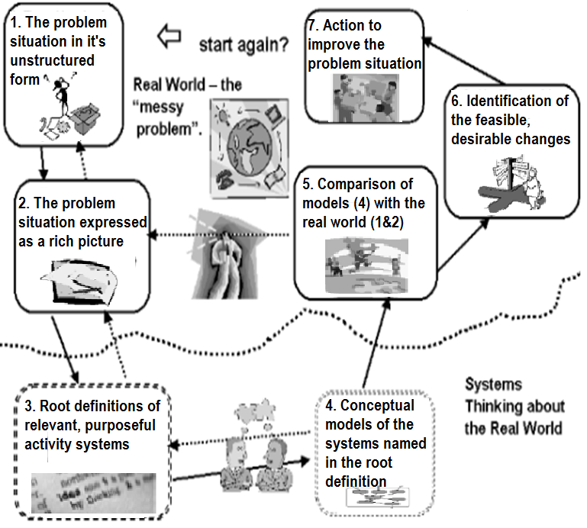
Figure 1. Summary os SSM as a seven stage process.
Source: (Checkland, 1999: pp 163, and Checkland & Scholes, 1990: oo: 28)

Soft Systems Methodology (SSM) can be used to analyze problems or situations, but most precisely where the problem "cannot be formulated as the search for efficient means reaches a determined end; a problem where the ends, goals, objectives are themselves problematic" (Checkland, 1999, p. 316). Soft System Methodology, in its ideal form, is described as a logical sequence of seven steps (Checkland, 1999, pp. 162-183). This is illustrated in figure 2.
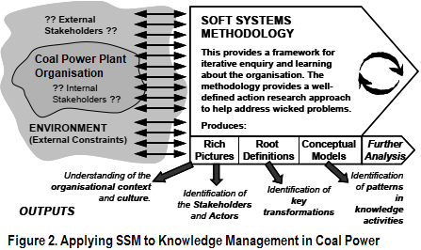
Figure 2. Applying SSM to knowledge Management in Coal Power Plant.

The most important thing to note is that the sequence is not forced on practitioners; a study can begin at each stage, with iterations and backtracking as important components. SSM encourages investigators to view organizations from a cultural perspective. Therefore the component which is human determines the important characteristics of the Organization. These "people" can attribute meaning to their situation and determine their own goals for the organization.

IDENTIFICATION OF THE PROBLEM
In its application in handling coal dust at the coal power plant, we can use this 5W1H Method to collect information and analyze the problems that occur so that we can take the right solution to overcome them.

Table1. 5W1H Method to analyze the coal dust problems at the coal power plant.

5W1H | Coal dust problems at the Coal Power Plant
WHAT | 1. Dust can damage the coal handling system equipment.  2. Risk of fire.  3. Dangers to health (eyes, lungs, skin irritation).  4. Coal dust flying in the Coal Power Plant area and settlements around it.
WHERE | 1. Coal Power Plant area, Coal Handling facility (ship unloading, conveyor belt, transfer tower).  2. Residential area around the Coal Power Plant.
WHEN | 1. Since the government has built a lot of power plants from 2010 to the present.  2. Until now, the problem of dust in coal power plants is still a lot.
WHY | 1. The design of a Conveyor Belt system that is less effective.  2. Dust collector / dust suppression equipment is not functioning properly.  3. Very minimal maintenance for conveyor belts.
WHO | 1. Employee or Opeartor Coal Powe Plant.  2. Residents around the Coal Power Plant.  3. The environment around the Coal Power Plant.
HOW | 1. Installing dust collector equipment in the conveyor belt area.  2. Re-engineering belt conveyor equipment in accordance with CEMA standards.  3. Dust suppression installation in the area of ​​ship unload and stock pile.  4. Installation of Doom and wind blocking nets in the stockpile area to minimize the spread of dust.
Source: (Akhyar Zuniawan, 2019)

RICH PICTURE DIAGRAM
Rich picture diagrams are one way that can be used to describe a particular situation. The picture Richard is a cartoon image that describes the entire complex system so that it is easy to read from various angles with all aspects contained in it instantly. Rich picture contains an overall picture of people, objects, processes, structures, and problems in the entire business process in the company. The usefulness of Rich picture is:
1. The ideal tool for communicating about complicated and problematic situations.
2. Linkages between elements and relationships that are interwoven, directly or not are easier to see.
3. Facilitate identification of problem owners and help identify potential problems and conflicts.
4. Assist in making limits and scope of problems.

Figure 3. Application of Rich Picture Diagram of coal dust problems at the Coal Power Plant.
Source: (Akhyar Zuniawan, 2019)

ROOT DEFINITION - COAL DUST IN COAL POWER PLANT
Coal dust which flies and is widely found in the PLTU area as well as to residential areas is more dominant due to coal transportation activities from ship unloading, transferred through conveyor, passing some tower transfers and being temporarily placed in the stock pile area and then transferred to several equipment such as crusher and seizer to get to the bunker or silo area.
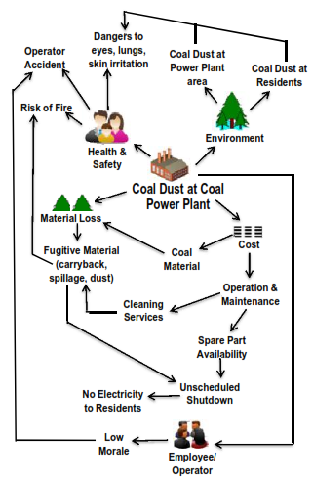
As a result of the spread of coal dust has a profound impact on health problems for workers and residents around the plant (breathing, lungs, eyes), safety or safety problems in the plant (work accidents, fire), cost loss problems (damaged equipment, cleaning service, coal material loss, sudden plant shut down) and environmental problems (pollution or air pollution that can damage crops or agricultural products).

CATWOE – COAL DUST AT COAL POWER PLANT
This next step is to formulate root definitions. This stage is known as naming, and selecting relevant systems and we can formulate with CATWOE. This stage is like that determine, because at this stage, the core or root of the definition faced selected and named (selecting and naming). The CATWOE acronym is used to formulate root definition appropriately and relevantly. It is used to check that root definition has been well formulated. CATWOE is stands for: customer, actor, transformation, weltanshauung / worldview, owner and environmental constraint.
Table 2. CATWOE for element and question
Element | Question
Customers | Who are the system beneficiaries?
Actors | Who transform inputs to outputs?
Transformation | What transformation exist?
Worlview | What is the reason for this transformation?
Owners | Who can stop or change this transformation?
Environment | What constrains are there in the immediate surroundings of this transformation?

[C] Customers: Coal Power Plant operators / workers, residents around the plant.
[A] Actor: Engineering department, maintenance department.
[T] Transformation: With 3 pillars discussing: Knowledge, Technology, Commitment, so that it is expected to overcome the difficulties of coal at the Coal Power Plant.
[W] Weltanschauung; To appreciate the feasibility of making improvements in handling coal dust at the Coal Power Plant, understanding the solutions to be taken is based on experience and knowledge about handling coal dust at the previous Coal Power Plant.
[O] Owner: Management of Coal Power Plant.
[E] Environmental Limits: Health, environment, costs, safety.
CONCEPTUAL MODEL – COAL DUST AT COAL POWER PLANT
The conceptual model that originates is a method of analyzing the activities that need to be done to clearly determine what the perpetrator must do in order to achieve transformation. Don't include activities carried out by anyone other than the actors you have named in the root definition (and if possible, Limit actors to one group of people - Monitoring activities are very complicated when more than one group is involved).
Again, thinking discipline is needed — a list of activities needed to achieve the objectives of the system. This is also important to include activities that monitor the system and results of feed backs, so that system activities can be carried out effectively.

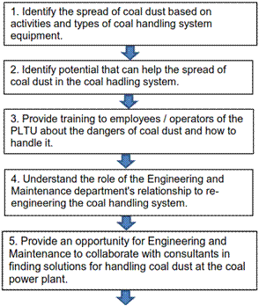

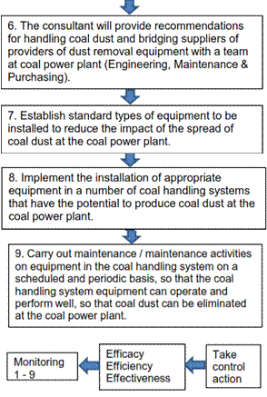

Figure 4. Application of Conceptual Model for handling coal dust at the Coal Power Plant.
Source: (Akhyar Zuniawan, 2019)

COMPARE MODELS WITH THE REAL WORLD
The next step is where we return to the real world and compare the reality that we experience with those captured in the model. The purpose of the comparison is to start a discussion from which changes to improve the situation that can be identified. This approach uses a model to provide a means of understanding different views of reality, by testing assumptions that may exist but are difficult to implement. This is the difference between what happens in reality and a logical model that raises questions that will eventually cause change.
The way I do this step is to build a table with three columns. The first contains activities in the conceptual model. The second contains what happens in reality and the third what we can do to bring reality closer to the conceptual model that can be maintained logically.

Table1. Conceptual model compare with real world and what could we do.
Conceptual  Model  Activities | Real World | What Could We Do
Identify the causes of coal dust based on activities and types of coal handling system equipment. | Workers at the coal power plant only see coal dust without identifying the cause of the coal dust. | Conduct inspections and investigate the causes of coal dust in the coal handling system.
Identify potential that can help spread coal dust in the coal handling system equipment. | It has never been thought of by coal power workers to identify potential that can help spread coal dust in the coal handling system equipment. | Conduct a study (book / literature, brainstorming / discussion) relating to the potential for coal dust to arise in the coal handling system equipment.
Provide training to employees / operators of the PLTU about the dangers of coal dust and how to handle it.  Understand the role and relationship of the engineering and maintenance departments to re-engineering (refining) the coal handling system equipment and its maintenance.  Providing opportunities for engineering and maintenance teams to collaborate with consultants in finding solutions to handling coal dust at the coal power plant.  The consultant will provide recommendations for handling coal dust and bridge the supply of equipment suppliers for handling dust with the engineering and maintenance team.  Set the standard type of equipment that will be installed in the coal handling system to reduce the impact of the spread of coal dust at the coal power plant. | There has never been any training regarding the dangers of coal dust and its handling to coal power plant workers.  There has been no synchronization between the engineering department and maintenance in handling coal dust at the coal power plant.  Workers at the coal power plant are still trying to deal with the dust problem itself, where with the limited knowledge of handling coal dust, the handling is not maximal.  Not yet implemented  Not yet implemented | Do training by calling on expert trainers from outside parties to share knowledge about the dangers of coal dust and its handling to workers at the coal power plant.  A special committee for handling coal dust was formed at the PLTU by declaring engineering to re-design the equipment and maintenance for maintenance of the equipment in the coal handling system.  Invite consultant/ specialists (experts) to handle dust in the coal handling system.  The report contains recommendations on the type of equipment that is right for dealing with coal dust and helps provide the right supplier for the procurement of these equipment.  Together with a special committee (engineering and maintenance) team to make a standard type of equipment in the coal handling system for handling coal dust at the coal power plant.
Execute installation of standard equipment in several places in the coal handling system that has the potential to generate coal dust at the coal power plant.  Conducting regular maintenance and maintenance activities for the installed equipment can perform well and coal dust can be eliminated at the coal power plant.  Monitor operational activities.  Take control measures. | The equipment installed is not in accordance with the appropriate standards.  Maintenance activities are carried out only occasionally and not scheduled.  Not yet implemented  Not yet implemented | Re-install by replacing equipment that is not in accordance with the standard.  Create a standard schedule for maintenance of coal handling system equipment by placing workers who are highly dedicated to performing maintenance / maintenance.  Management and its staff regularly schedule meetings to discuss progress regarding the impacts that occur after the equipment is installed in the coal handling system.  Evaluate and take action (repair and maintenance of coal handling system equipment) if the problem of the spread of coal dust still occurs in the coal power plant.
Source: (Akhyar Zuniawan, 2019)

RESULT
This journal has illustrated the approach of applying SSM to problems in the handling of coal dust in the coal power plant, especially the problem of knowledge management that is challenging to understand and difficult to act on these conditions. This includes handling coal dust at the coal power plant which is used in dealing with confusing situations that combine human, organizational and technical aspects. SSM encourages group learning and is ideal as a group decision-making approach. This is reinforced by active participation by different participants and stakeholders, and encourages shared ownership of the problem solving process. Finally, SSM is recommended where an organization strives to achieve change in culture and the transformation of the workplace into a learning organization.

REFERENCES
Checkland P. Systems Thinking, Systems Practice, 1999, Wiley, ISBN 0-471-98606-2.
Forbes, P. and Checkland, P.B. (1987). ‘Monitoring and control in systems models’, Internal Discussion Paper 3/87, Department of Systems, University of Lancaster.
Andrews, C.L. (2000). “Restoring legitimacy to the systems approach,” IEEE Technology and Society. 19 (4), 38-44.
Barry, M. and Fourie McIntosh, C. (2001). “Wicked problems, soft systems and cadastral
systems in periods of uncertainty”. Proceedings of CONSAS, Cape Town, South Africa, 12-14 March,2001, 7 pages.
Bryson, J.M., Cunningham, G.L. & Lokkesmoe, K.J. (2002). “What to do when stakeholders
matter: The case of problem formulation for the African American men project of Hennepin County, Minnesota”. Public Administration Review, Vol. 62, No. 5, 568- 584.
Buckingham Shum, S. (1997). “Representing Hard-to-Formalise, Contextualised, Multidisciplinary, Organisational Knowledge”. AAAI Spring Symposium on Artificial Intelligence in Knowledge Management, Stanford University, Palo Alto, CA, Mar. 24- 26, 1997, 12 pages.
Checkland, P.B. & Scholes, J. (1990) Soft Systems Methodology in Action. Chichester: John Wiley & Sons.
Checkland, P.B. (1999). Systems Thinking, Systems Practice. Chichester: John Wiley & Sons.
Checkland, P. 1981. Systems Thinking, Systems Practice. Chichester: John Wiley & Sons Ltd.
Checkland, P. 1985. Achieving ‘Desirable and Feasible’ Change: An Application of Soft Systems Methodology. Journal of the Operational Research Society 36 (9):821-831.
Cox, Glenda, 2010 Defining innovation: Using soft systems methodology to approach the complexity of innovation in educational technology, International Journal of Education and Development using Information and Communication Technology (IJEDICT), Vol. 6.
Khisty, C. Jotin, 1995, Soft-System Methodology, as Learning and Management Tool. Journal of Urban Planning and Development, Vol, 121. No 3 September 1995.
Konis, Costas Y, 1994, A Soft System Management Approach to Energy Management and Conservations for the Hotel Industry of Cprus. International System Dynamics Conference.
Miller, G. A, 1968, The Psycology of communications, London: Allen Lane, The Pinguin Press.
Patel, Nandish V, 1995, Application of soft systems methodology to the real world process of teaching and learning. International Journal of Educational Management, Vol. 9 No. 1.
Staker R. J, 1999, An Application of Checkland’s Soft Systems Methodology to the Development of a Military Information Operations Capability for the Australian Defence Force. DSTO Electronics and Surveillance Research Laboratory Australia
Wilson, Brian, 1990, Systems: Concepts, Methodologies and Applications, England: John Wiley & Sons Ltd.
Checkland, P. 2001. Soft Systems Methodology. In J. Rosenhead, and J. Mingers (eds.), Rational Analysis for a Problematic World Revisited. (2nd ed.), (pp. 61-89). Chichester: John Wiley & Sons Ltd.

