EFFECT OF CUTTING SPEED IN THE TURNING PROCESS OF AISI 1045 STEEL ON CUTTING FORCE AND BUE CHARACTERISTICS OF CARBIDE CUTTING TOOL

Sobron Lubis, Sofyan Djamil ,Yehezkiel Kurniawan Zebua
Mechanical Engineering Study Program, Engineering Faculty Universitas Tarumanagara
Jl. Let.Jen S. Parman No.1 Jakarta 11440, Indonesia
Email: Sobronl@ft.untar.ac.id sofyand@ft.untar.ac.id yehezkiel.515150044@stu.untar.ac.id

Abstract - In the process of cutting metal, cutting tools are the main things that must be considered. Using improper cutting parameters can cause damage to the cutting tool. The damage is BUE. This is undesirable in the metal cutting process because it can interfere with machining and the surface roughness value of the workpiece becomes higher. This study aimed to determine the effect of cutting speed on BUE that occurred and the cutting strength caused. Five cutting speed variants are used. Observation of the occurrence of BUE is done visually and measurements are carried out using a digital microscope. If a cutting tool occurs BUE, then the cutting process is stopped and measurements are made. This study using variations in 3 levels of cutting speed with 2 experiments consisting of cutting speed 141 m/min, 148 m / min, 169 m/min in the first experiment and cutting speed of 142 m/min, 157 m/min, 163 m/min and cutting depth of 0.4 mm. From the results of the study were obtained The biggest feeding force is at cutting speed (Vc) 141 m/min at 347 N and the largest cutting force value is 239 N the dimension of BUE length:1.56 mm, width:1.35 mm, high:0.56mm.

Keywords: Tool wear, coated carbide, cutting force, AISI 1045 steel, built-up edge.

INTRODUCTION

In the metal forming manufacturing industry, the metal cutting process is one of the activities that is often carried out, especially when producing machine components. The metal cutting process is a process that is used in forming basic metals into machine components by using the cutting tool as its main component. The machining process is the process of producing a product by cutting the workpiece using cutting tools and machine tools.
Turning is one of the most widely used metal cutting operations in engineering industries. In the machining process using parameters namely, spindle speed, feeding, and depth of cut. (Sobron, 2016). During machining, the cutting tool directly interacts with a work material. Chip is generated by shearing the work material while the generated heat from plastic deformation of the work material and the interfacial friction between work material and cutting tool transfers into a cutting tool.
The temperature in both work material and cutting tool increases substantially as the cutting condition becomes more severe. The cutting tool must withstand more stringent thermal loading and thus eventually will wear down. In a machining process, there is always the emergence of great cutting forces, friction and high temperatures due to continuous and intensive contact between the active cutting part surface and the workpiece machined surface. This obviously generates wear on the tool faces leading to damage on surface quality and decrease in precision in the machined workpiece. The generated wear is very complex as it is followed by chemical phenomena appearing on the contact surfaces between tool, workpiece, and chip. In other words, the wear is a destructive process of surface layers of the active tool part leading to progressive modifications in machined forms of the workpiece and surface quality, through changes in tool geometrical parameters (tool angles and nose radius), temperature, cutting force, macro and micro geometrical precision of the machined surface. (Aruna, 2010).
The cutting process is, therefore, accompanied by severe tool wear and tool deterioration, which often leads to the generation of forced and self-excited vibrations in a broad frequency range. Already high cutting forces are further increased by tool wear and cutting-edge rounding. If this occurs, the amplitude of vibrations may increase drastically, resulting in chatter. The generation and stability of the chatter are driven by a complex mix of tool-workpiece interactions and chip formation processes. (Oleksandr, 2017).
The occurrence of BUE on the cutting tool is undesirable, because this is a damage that occurs on the cutting tool, the effect of which can affect the surface of the workpiece produced and the cutting tool's short life and will certainly increase machining costs.Inaccuracy in the machining process can also be experienced with a buildup of growls attached to the cutting tool called the built-up edge (BUE).The built-up edge is a problem that is very influential in the machining process that makes inaccuracies in the workpiece but it can also damage the surface of the cutting tool because the results of the attached chips become peeled off. (Atlati, 2015). One of the built-up edge problems occurs with AISI 1045 steel workpieces with coated carbide cutting tools.
Along with environmental problems in the present, the process machining is expected to not use coolant. Machining without coolant or known as dry cutting aims to avoid environmental pollution caused by residual use of the coolant, but one of the effects arising from the dry cutting process is the emergence of a built-up edge (BUE) ie a new cutting surface is formed at the tip of the tool because the chip or growl is happening at the end of the cutting tool, so the cutting tool cannot be used properly anymore, and must be cleaned first. The emergence of BUE has caused many problems among small industries, because the use of cutting tools has become more numerous, or has often sharpened cutting tools, and of course, has caused an increase in the cost of machining processes that are being carried out (Atlati, 2015).Their low thermal conductivity leads to heat concentration in the cutting zone that results in high localized temperatures. Also, their high work hardening leads to high adhesion of the workpiece material to the cutting tool, resulting in unstable chip and built-up edge (BUE) formation (Diniz,2006). A BUE consists of highly deformed material layers, which are bonded to the tool surface and can lead to change the tool geometry and the mechanics of the process (Atlati, 2015). BUE is not permanently situated on the cutting edge, but periodically becomes detached, sometimes adhering to the machined surface, and sometimes to the chip (Herda, 2011). The stability of a BUE as a structure is low and the breakage of it can cause cracks and damages on the tool surface. At the same time, a thin and stable BUE can be used to protect the tool from wear by reducing the friction between the cutting tool and workpiece.(Kuznetsov, 1966). The demand for high-quality products during the production has its attention in the workpiece surface properties, especially in the surface ﬁnish and the residual stress of the machined surfaces, due to its effects in the acting of the components and reliability (Fox-Rabinovich, 2016; Jang, 1996). Fatigue, creep, and stress cracking leads to product failure. Therefore, it is of extreme importance to characterize the inﬂuence of the BUE formation in the surface integrity (Saoub, 1999). Coated carbide is a cutting tool suitable for use in turning processes with workpieces such as steel, iron and stainless with very hard steel particles and increasing wear resistance in high temperatures. (Oleksandr, 2017). AISI 1045 steel metal material is often used in the manufacturing industry because of its good machinability, weldability, and high strength (Diniz,2006).
This research was conducted to analyze the effect of cutting speed on cutting force and the occurrence of BUE on the carbide cutting tool, so that the characteristics of BUE dimensions that occur for each use of cutting speed can be known, and can be known to avoid the occurrence of BUE.

MATERIALS AND METHODS
The cutting process was carried out using a Microtara Turnmaster 35 lathe.

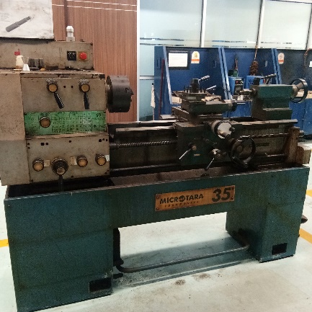
Figure 1. Lathe Machine Microtara Turnmaster 35
Materials
The workpiece materials are AISI 1045 steel.
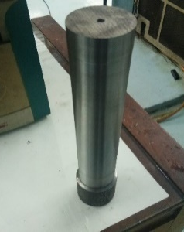
Composition (%) | Weight
C | 0.42-0.50
Mn | 0.50-0.80
Mn Si maximum | 0.40
S maximum | 0.40
Cr + Mo + Ni Max | 0.63

- (b)
Figure 2. (a) AISI 1045 Steel (b) Chemical Composition of AISI 1045 Steel

Observation and measurement of cutting force in the turning process are carried out using the following force dynamometer:
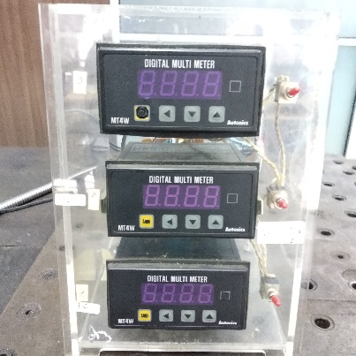
Figure 3. Force Dynamometer

The cutting tool is coated carbide cutting tool TNMG 331MA type
Specification
Cutting speed (Vc) : 110 – 200 m/min
Surface feed per minute (SFM): 0.50-0.80
Feeding : 0.14-0.28 mm/rev
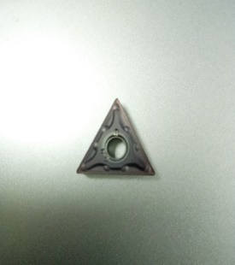
- (b)
Figure 4. (a) Coated Carbide cutting tool type TNMG 331MA (b) specification coated carbide

BUE observations and measurements that occur in cutting tools using a digital microscope
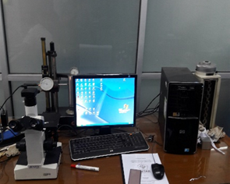
Figure 4. Digital Microscope

Methods
The research step is to cut AISI 1045 steel material with a size of ∅ 2.5 "x 120 mm, determine five variations of cutting speed are 141, 142, 148, 157, 163, and 169 m/min, depth of cut of 0.4 mm and setting the cutting force measurement tool. The cutting process is done by using a cutting tool carbide, while the machining process is carried out observing the cutting tool and the cutting force that occurs. The dynamometer tool measures the cutting force that occurs on the cutting tool consisting of two (2) axis, i.e. X and Z axis, for X axis is measured at workpiece diameter and Z axis direction in feeding direction. Tip cutting tool is observed, if BUE occurs, machining is stopped and its dimensions are measured. When cutting temperatures increase, between objects work and cutting tools produce chips with high temperature, then the lathe is off. The built-up edge is observed and measured using a digital microscope to determine the length of the lathe. length, width and height.
The cutting mechanism for observing flank wear and cutting force in the machining process is shown in Figure 5

.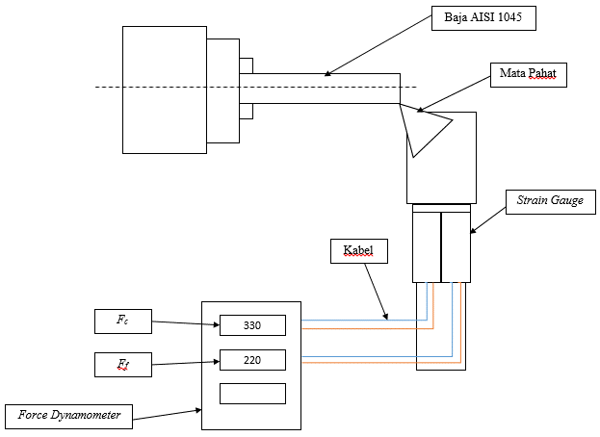
Figure 5. Schematic of the equipment test

RESULT AND DISCUSSION
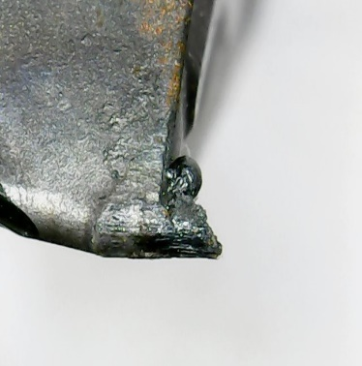
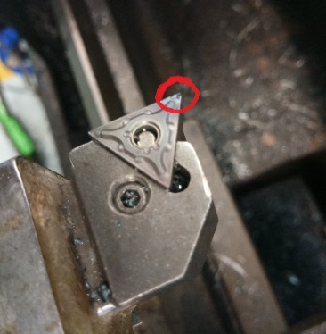
From the experiments conducted, the built-up edge that occurs in the cutting tool is as follows
(a) (b)
Figure 6. (a) Built-up edge attached to the cutting tool (b) Built-up edge visible from the microscope

The results of observing and measuring the cutting force using variations in cutting speed are as follows:

Figure 7. Cutting speed Vs Cutting Force

Based on the graph above it can be seen that the value of the cutting force can vary and shows a decrease when the cutting speed increases. Figure 7 shows that the cutting speed of 141 m / min, the value of the cutting force (Fc) and feeding force (Ff) produced is large. Then increasing the cutting speed, causing cutting force that decreases. This happens if the cutting speed increases based on the speed of feeding the workpiece which is getting bigger which causes the chip to partially adhere to the angle of the cutting tool. This is caused by high cutting temperatures which have an impact on the formation of built up edge on the cutting tool angle and the increase in cutting force also causes cutting power to increase.
From observations made during the machining process, BUE can occur at any cutting speed, but the BUE shape that occurs includes varying lengths, widths, and thicknesses as presented in the following figure:
Figure 8. Effect of Cutting Speed on Built-Edge Size
Based on Figure 8, it can be seen that the BUE that occurs does not depend on the cutting speed (Vc) in the machining process. However, due to the release of cutting temperature that does not take place properly so that some of the heat is still stored on the chip and finally attached to the corner of the cutting tool. BUE size is different at each cutting speed. In Figure 8 it can be seen that the cutting speed of 141 m / min in experiment 1 produces a size larger than BUE than the cutting speed of 142 m / min in experiment 2 which results in a smaller size than BUE .
Figure 9. Cutting Force on the Built-Up Edge dimensions
Based on Figure 9. The effect of increasing cutting speed affects the cutting force, with the occurrence of BUE on the cutting tool, the cutting force that occurs in the cutting process is greater, because the angle of cutting tool no longer performs its function for metal cutting but the BUE is rubbing so it requires a force greater to do a metal cutting process, other effects arising from the presence of this BUE, the surface condition of the workpiece becomes more rough, and cracks occur on the cutting tool faster because BUE shifts and peels off the surface of the cutting tool attached to the BUE. Based on Figure 9 it can be seen that the increase in the length and width of BUE is greater than the height of BUE, this is especially true for the cutting force of 397 N.
The size of the built-up edge is also influenced by increased cutting force. The built-up edge that occurs in the cutting tool affects the cutting of uneven workpieces. From these results, it can also form large chips due to changes in the force produced and a high temperature when rubbing between the cutting tool and the workpiece, so that the surface conditions of the workpiece produced are high roughness.

CONCLUSION
In general, the built-up edge that occurs in the cutting tool when the cutting process temperature is high and results in a large chip size and can be seen from a higher cutting force than the cutting process. The biggest feeding force is at cutting speed (Vc) 141 m/min at 347 N and the largest cutting force value is 239 N the dimension of BUE length:1.56 mm, width:1.35 mm, high:0.56mm. While the minimum feeding force occurs at a cutting speed of 142 m/min at 265 N, BUE length : 0.8 mm, width:0.57 mm, high:0.47 mm, and the value the smallest cutting force at a cutting speed of 157 m / min with a value of 170 N, BUE length: 0.64 mm, width: 0.51, high:0.72 mm. With a cutting speed (Vc) of 141 m / min at machining time of 43 minutes. Cutting speed (Vc) does not directly influence the occurrence of BUE. At a cutting speed of 141 m / min, the BUE dimension that occurs is greater than the speed compared to the cutting speed of 142 m / min.

REFERENCES
Sobron. Lubis, S. Darmawan, Rosehan. and T.
Tanuwijaya.(2016). Analisa pertumbuhan
keausan pahat karbida coated dan uncoated
pada alloy steel AISI 4340,Jurnal Energi dan
Manufaktur, vol. IX, no. 2, pp. 117.
Aruna, M. V. Dhanalakshmi, S. Mohan. (2010).
Wear Analysis of Ceramic Cutting Tools in
Finish Turning of Inconel 718 International
Journal of Engineering Science and Technology
Vol. 2(9), pp. 4253-4262
Oleksandr Gutnichenko, Volodymyr Bushlya,
Jinming Zhou, Jan-Eric Ståhl. (2017).Tool wear
and machining dynamics when turning high
chromium white cast iron with pcBN tools. Wear,
http://dx.doi.org/10.1016/j.wear.2017.08.005.
Diniz, A.E.; Marcondes, F.C.; Coppini, N.L.
(2006).The Performance Evaluation of Ceramic
and Carbide Cutting Tools in Machining of
Stainless Steels. Tecnologia da Usinagem dos
Materiais, [Technology of Machining of Materials],
5th ed.; Artliber Editora: São Paulo, Brazil.
Atlati, S.; Haddag, B.; Nouari, M.; Moufki, A.(2015).
Effect of local friction and contact nature on the
Built-Up Ed]ge formation process in machining
ductile metals. Tribol. Int. 90, 217–227.
Herda Agus P, Purwadi Joko Widodo, Muhammad
Nizam. (2011).Pengaruh Parameter Permesinan
Bubut Terhadap Munculnya Built-Up Edge (BUE)
Dalam Proses Pembubutan Aluminium. Mekanika
Volume 10 Nomor 1.
Kuznetsov, V.D. (1966).Metal Transfer and Build up
in Friction and Cutting; Gostekhizdat: Moscow,
Russia.
Fox-Rabinovich, G.S.; Paiva, J.M.; Gershman, I.;
Aramesh, M.; Cavelli, D.; Yamamoto, K.;
Dosbaeva, G.; Veldhuis, S.C.(2016). Control of
self-organized criticality through adaptive
behavior of nano-structured thin ﬁlm coatings.
Entropy, 18, 290. [CrossRef]
Jang, D.Y.; Watkins, T.R.; Kozaczek, K.J.;
Hubbard, C.R.; Cavin, O.B. (1996).Surface
residual stresses in machined austenitic stainless
steel. Wear, 194, 168–173. [CrossRef]
Saoubi, R.M.; Outeiro, J.C.; Changeux, B.; Lebrun,
J.L.; Dias, A.M. (1999).Residual stress analysis in
orthogonal machining of standard and
resulfurized AISI 316L steels. J. Mater. Process.
Technol, 96, 225–233.
Cassier , Y. Prato and P. M. Escalona.(2004).
Built-Up Edge Effect on Tool Wear When Turning
Steels at Low Cutting Speed," Journal of
Materials Engineering and Performance, vol.
Volume 13, pp.542.
M. J. Mir and M. W.(2017).Performance evaluation
of PCBN, coated carbide and mixed ceramic
inserts," Centre for Tribology, Department of
Mechanical Engineering, National Institute of, pp.
11-12, 2017.
V. Nagandran, T. V. Janahiraman and N.
Ahmad.(2017). Modeling and Optimization of
Carbon Steel AISI 1045 Surface Roughness in
CNC Turning Based on Response," American
Journal of Neural Networks and Applications, vol.
3, pp. 57.
Rosehan, Sobron, Lubis and M.Firmansyah.(2014).
Analisis Parameter Pemesinan Terhadap Gaya
Potong Pada Proses Pembubutan Logam
S45C.Prosiding SNMI, vol. IX, no. 1, pp.
303-304.
Tool-life testing with single-point turning tools.
(1993).Switzerland: International Organization for
Standardization 3685.
R. Suresh, S. Basavarajappa,G.L. Samuel.(2012).
Some studies on the hard turning of
AISI 4340 steel using multilayer. Department of
Mechanical Engineering, Canara Engineering
College, Mangalore 574 219, Karnataka, India, p.
1872, 2012.
K. Orra and S. K. Choudhury.(2018). Mechanistic
modeling for predicting cutting forces in
machining considering the effect of tool nose
radius on chip formation and tool wear land.
International Journal of Mechanical Sciences.
Sauvage, X.; Le Breton, J.M.; Guillet, A.; Meyer, A.;
Teillet. (2003).J. Phase transformation in surface
layers of machined steels investigated by X-ray
diffraction and Mössbauer spectrometry. Mater.
Sci. Eng. 362, 181–186. [CrossRef]
Y. Seid Ahmed, G. Fox-Rabinovich, J. M. Paiva, T.
Wagg, and S. C. Veldhuis.(2017). Effect of Built-
Up Edge Formation during Stable State of Wear
in AISI 304 Stainless Steel on Machining
Performance and Surface Integrity of the
Machined Part," Department of Mechanical
Engineering, 2017.

