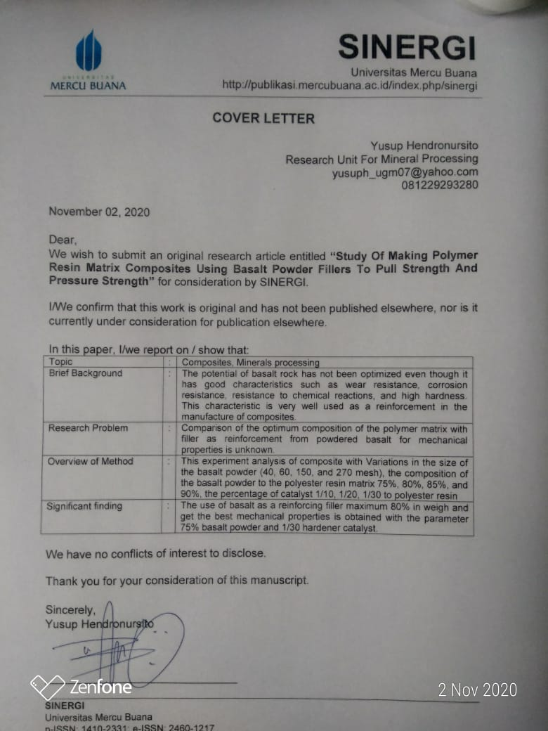
AUTHORSHIP STATEMENT

I/We wish to submit an original research article entitled “Study Of Making Polymer Resin Matrix Composites Using Basalt Powder Fillers To Pull Strength And Pressure Strength” for consideration by SINERGI.

All persons who meet authorship criteria are listed as authors, and all authors certify that they have participated sufficiently in work to take public responsibility for the content, including participation in the concept, design, analysis, writing, or revision of the manuscript.

Author 1
Name | : | David Candra Birawidha
Affiliation | : | 1st.  Research Unit for Mineral Technology - Indonesian Institute of Sciences  Jl. Ir. Sutami KM. 15 Tanjung Bintang Lampung, 35361, Indonesia  2nd.  Physics Department, Faculty of Mathematics and Natural Science - Lampung University  Kota Bandar Lampung, Lampung 35141, Indonesia
Email Address | : | Davi001@lipi.go.id
Author 2
Name | : | Kusno Isnugroho
Affiliation | : | 1st.  Research Unit for Mineral Technology - Indonesian Institute of Sciences  Jl. Ir. Sutami KM. 15 Tanjung Bintang Lampung, 35361, Indonesia  2nd.  Physics Department, Faculty of Mathematics and Natural Science - Lampung University  Kota Bandar Lampung, Lampung 35141, Indonesia
Email Address | : | Kusn005@lipi.go.id
Author 3
Name | : | Yusup Hendronursito
Affiliation | : | 1st.  Research Unit for Mineral Technology - Indonesian Institute of Sciences  Jl. Ir. Sutami KM. 15 Tanjung Bintang Lampung, 35361, Indonesia  2nd.  Departement of Mechanical Engineering, Faculty of Engineering, Lampung University  Kota Bandar Lampung, Lampung 35141, Indonesia
Email Address | : | Yusuph_ugm07@yahoo.com
Author 4
Name | : | Muhammad Amin
Affiliation | : | Research Unit for Mineral Technology, Indonesian Institute of Sciences  Jl. Ir. Sutami KM. 15 Tanjung Bintang Lampung, 35361, Indonesia
Email Address | : | Muha047@lipi.go.id
Author 5
Name | : | Muhammad Al Muttaqii
Affiliation | : | Research Unit for Mineral Technology, Indonesian Institute of Sciences  Jl. Ir. Sutami KM. 15 Tanjung Bintang Lampung, 35361, Indonesia
Email Address | : | Muha047@lipi.go.id

POTENTIAL REVIEWERS

Please submit 3 (three) potential reviewers (that have not listed in SINERGI) to speed up the review process that competent for the topic and has a good reputation in that area.

Reviewer 1
Name | : | Dr.Eng. Shirley Savetlana, M.Met
Affiliation | : | Lampung University
Email Address | : | Shirley.savetlana@eng.unila.ac.id
Reviewer 2
Name | : | Prof. Ir. Jamasri, Ph.D.
Affiliation | : | Gadjah mada University
Email Address | : | jamasri@ugm.ac.id
Reviewer 3
Name | : | Dr. Erik Prasetyo M.T., Ph.D
Affiliation | : | Indonesian Institue of Sciences
Email Address | : | erik005@lipi.go.id

