DESIGN AND DEVELOPMENT OF SMART LOCK SYSTEM BASED QR-CODE FOR LIBRARY'S LOCKER AT FACULTY OF ENGINEERING, UNIVERSITAS RIAU

Abstract  A security system is needed to prevent theft or other criminal acts. One of the implementations of a popular security system today is the Smart Lock System. This study discusses the design of an intelligent lock system using QR Code scanning as a locker key at the Library of the Faculty of Engineering, Universitas Riau. The design of the device system consists of one piece of ESP8266 Node MCU module, one piece of 12V Power Switch Adapter, one piece of AMS 1117 module with 3.3V and 5V output voltages, three pieces of 5V Relays, and three pieces of 12V Solenoids. The security system has been improved compared with existing security systems such as verification for personal data, email notification, and level log in to get theft to treat notification. This paper also measured the delay of the device system. Based on measurement results, the average delay obtained is 1.66 seconds.  This is an open-access article under the CC BY-NC license.   | Keywords:  Smart Lock Systems, QR-code, security, library's locker  Article History:  Received: May 2, 2019  Revised: May 29, 2019  Accepted: June 2, 2019  Published: June 2, 2019  Corresponding Author:

INTRODUCTION
The security system is essential to prevent theft or other criminal acts from preventing theft crime rate increases from year to year [1]. However, having many keys and maintaining entry to authorized only persons is a problem. Besides the costs involved in fabrication, duplication, and distribution of keys, there are security concerns in case of lost keys. A keyless entry unit will address these problems and add additional features [2].
Smart Lock System usually consists of three parts. First is the key controller as a lock, central controller, or database as a key control center to open, close, or execute crucial commands in the system and mobile application as interface and place of command to unlock the device and register members or guests[2].
Several studies on the Smart Lock System have been carried out. For example, Ha [3] research discusses digital door locks with enhanced security functions designed to work with the Internet of Things. This research uses cameras, keypads, ultrasonic, and motion detection sensors. Each sensor installed serves to validate the user in 2 seconds. For example, the ultrasonic sensor can read and validate the user within 1.6 seconds to 1.8 seconds. Therefore, this device has an average of 1.4 seconds to validate the user, capture the image, and send it to the mobile device. However, this tool has a weakness; when an invalid user enters the wrong password, the user can close the camera with their hands or move their face to take pictures on the camera are inaccurate.
Meanwhile, a study conducted by Rasid [4] discussed the design and construction of an automatic door security system using Radio Frequency Identification (RFID) technology. This study uses two RFID tags to distinguish each user, both of which have been programmed beforehand. Both of these tags can work and are recognized by the system so that the door can be opened automatically in less than 4 seconds, while the scanning process can only be done within 5 cm. However, RFID tags require special scanners that either need to be attached to the phone or used independently [5]. In addition, the existing system that utilizes RFID technology is costly and complex [6].
The two methods and studies above are already quite good regarding security. However, it is ineffective if used in public spaces where many users use door access. Moreover, the security method using biometric sensors like fingerprints, eyes, voice, and facial recognition has weaknesses such as requiring high costs to have a scanner with high sensitivity and accuracy. Meanwhile, security methods using RFID, digital pins, or conventional physical keys have drawbacks because there is a risk of losing keys and forgotten passwords. So apart from maintenance costs, there is also the risk of additional costs for fabrication, duplication, and distribution of lost keys.
This research will be used a Quick Response (QR) code as a key to access the lockers. QR-code technology is also a quick and easy way to share authorization data between users and information systems [7]. QR Code has several features such as large-capacity data encoding, dirt and damage resistance, high-speed reading, small print outsize, 360-degree reading, and structural flexibility of application [8]. QR codes can represent text used by a mobile device to act. Code can be generated to link directly to a Uniform Resource Locator (URL), create a Virtual Card (VCard), or initiate a phone call, text or email, and other functions [9]. The QR code structure is too complicated for humans to solve, but the machine can easily read and decode QR codes [10].
Some studies regarding the implementation of QR codes have been discussed by Rao et al. [11], which explains the use of QR codes as car door security. This research was conducted by adding Atmega328P to the Arduino Uno as a microcontroller and the HC-05 Bluetooth module as a wireless communication tool. The system can rotate the servo motor (Micro servo DXW90) about 180 degrees (90 degrees per rotation) which are used to open and lock the car door. The last door lock has been programmed with encrypted data and will later be matched with the lock application; thus, it is challenging to hack while the application design is done using the MIT App inventor [11]. Also, a study from Al-Ghaili et al. [12] researched the use of QR codes for the Smart Verification Algorithm (SVA) on the Internet of Things (IoT). The proposed application carries out verification procedures to activate the user request authorization feature to access the smart system with the help of Encrypted QR tags [12].
The access and services of the library are continuously evolving and changing based on the current technology available in the market. Traditional lockers exist on university campuses, but they are neither convenient nor secure[13][14].
The current security system in the locker's library of engineering faculty, Universitas Riau, uses a conventional or physical key. A physical key is a standard security system because it is very cheap and easy to use. Still, if it is implemented in a public space like a library, physical keys have several weaknesses, such as when visitors bring the key, there is a risk of losing it or being carried home. Furthermore, there is no verification for visitors' data to access lockers. The keys can be duplicated easily, making this current security system vulnerable to theft if applied in public spaces. For this reason, in this research is very necessary to add some new improvements to the security system to prevent something terrible from happening in the future.
So this research will be using the android application provided for users to scan QR codes and create and validate an account to prevent door access by irresponsible parties. This process can only be accessed on the user's mobile device. Then, an additional security login level and an email notification are also added. This research is located in the library of engineering faculty, Universitas Riau.

Methods

- QR code
QR codes can hold data in two horizontal and vertical dimensions, enabling them to hold an enormous amount of data. Statistically, a QR code can store 4296 alphanumeric characters in it, which is 20 characters more than what can be stored in a traditional barcode[15]. An example of a QR code image is shown in Figure 1.

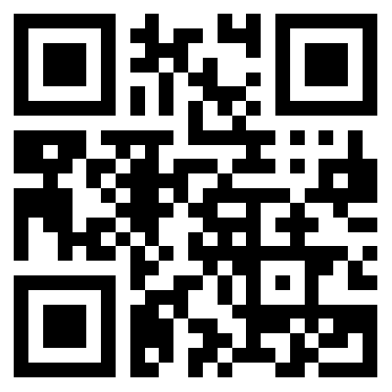
Figure 1. QR code

QR codes have several structures to protect that data. The structure of the QR code is shown in Figure 2.

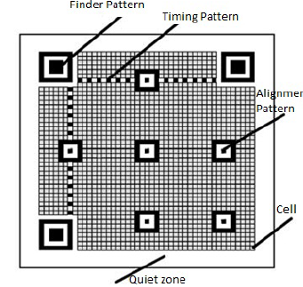
Figure 2. QR code structure [16]

Based on Figure 2, it can be explained as follows [16]:
- Finder Pattern
The position of the QR code has been detected using this pattern. It is also used to correctly identify the angle and dimension of the Quick Response Code Symbol.
- Timing Pattern
These are the more supportive patterns, which help identify the cell's central coordinates, if there exists, any error pitch.
- Quiet Zone
This is more a form of identifying the QR from its more complex backgrounds and simplifies the data embedding technique.
- Data Area
This is the area where it embeds secret information. Suppose the QR code is in its binary format, the zeros in the black module and the corresponding white module, which conveniently helps information hiding. Reed-Solomon codes have been incorporated for the embedding data and the corresponding error correction functionality.

- Smart Lock System
This smart lock system is designed to control the locker lock using a QR code as the key. To make a QR code is available to access, an android application and database are needed. The database uses Mysql, which has many tables for user data and controls the locker system. Android application is needed for user interface and scanning QR code.
The QR code will be pasted in front of the locker door. Before scanning, students must register themselves in the application and verify their data by submitting their Student Identity Card to the library officer to verify their identity as a student. It will prevent irresponsible parties from getting access to the lockers, and in some cases, if something terrible happens, the library officer can contact the student immediately. The proposed design of the smart lock system is illustrated in Figure 3.

Figure 3. The proposed smart lock system

This design begins with activating and ensuring internet access at the Wi-Fi access point used, then NodeMCU ESP8266 can connect to the database. After the device and database are connected, the User (Student) needs to register their account by submitting their data at the registration page in the provided application. Although students still can not access the locker at this stage, they must verify their data by manually showing their student identity card to the library officer.
The lockers can be accessed by scanning the QR code posted on the locker. Then when the scanning process is successful, the data will be sent to the database to be updated and stored.
After the data in the database is stored, the data will be sent to NodeMCU ESP8266. The relay and solenoid will react according to the command data that the database has sent. For example, if the data value is "close," the solenoid will be closed, and if it is "open," the solenoid will be opened.
Suppose the user has already finished accessing the locker. In that case, the user can press the "end access" button in the application. The locker usage data will be deleted automatically in the database, and the locker can be used again by a different user.

- Device System Design
The design of the device system is presented in Figure 4. this device requires several main components such as NodeMCU ESP8266 module, solenoid, power switching adapter (PSA) 12V, DC-DC step down (module AMS1117) with outputs of 3.3V and 5V as well as relays of 5V and Solenoid 12V.

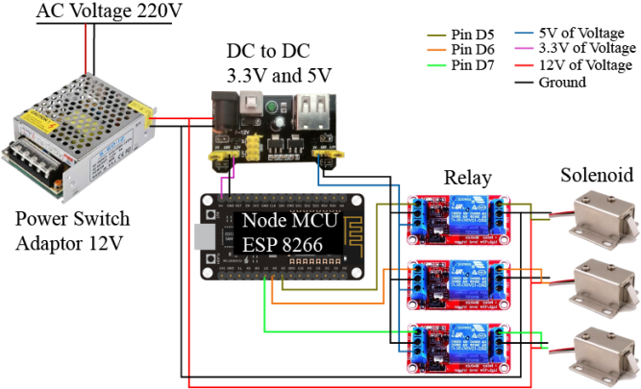
Figure 4. Design of Device System

Power Switching Adapter (PSA) 12V is used as an adapter that converts the AC voltage from the 220V into 12V DC voltage, then DC to DC step down serves to reduce the 12V Voltage to 3.3V & 5V using the AMS1117 module. This 3.3V will be used as a voltage source on the NodeMCU ESP8266 board and 5V as a relay voltage source.
NodeMCU ESP8266 functions as a microcontroller that will receive command data from the database to control components such as relay and solenoid and connect to a Wi-Fi access point for internet access. A relay will function as a switch and has a condition normally open where the current circuit on the relay will be open or disconnected. If it is in a standby state, the electric current cannot flow and will act otherwise if an electric current is applied. Last is the solenoid as a tool to lock the door when the solenoid is given a voltage trigger through the relay. The coil on the solenoid will form a magnetic field around the iron core inside the solenoid so that the iron core will be pulled in and the locker will be open.

- Additional Security System
The additional security elements in this research are as follows:
- Using QR codes
QR codes are complicated to read by humans and only can be read by computers or smartphones. Meanwhile, to access the locker, scanning QR codes only can be done by the application that has been provided. This can eliminate losing keys because visitors no longer need to carry keys wherever they go.
- Verification Personal Data
Visitors cannot access the locker before finishing the personal data verification process. This stage is to make sure personal user data that has been previously filled on the registration page in the application is correct. This verification process only can be done by showing the Student Identity Card to the library officer.
- Email Notification
Email notifications will notify users of several features such as personal data verification, password change, notification of accessed lockers, and blocking account notification. In addition, this email will also function as a media report from the library if something unexpected happens in the future.
- Level Login
Login level aims to block accounts automatically if any visitor fails to log in by entering the correct data more than three times. It will be indicated as a suspicious action because irresponsible parties are trying to access lockers with data from other users in some cases. Every blocking action will be sent an email notification automatically, so the user must to changes his password as a security method procedure to prevent irresponsible parties from getting access to his account.

3. Delay Measurement
This Measurement aims to measure the device's effectiveness, whether there is an increasing delay value on the device. At the same time, the number of lockers that are also accessed simultaneously increases. There is three measurement scenario to get the delay value of this device such as:
- When one locker is accessed
- When two lockers are accessed
- When three lockers are accessed
The difference is only in the number of accessed lockers because this scenario might be happening at peak hours or the level of visitors is high. Measuring delay's value on the device requires additional components such as push-button connected to pins D1, D2, and D3 on the NodeMCU ESP8266 microcontroller. These pins would act as input pins to calculate the delay's value on the device when the push button is pressed. To calculate the average delay, can use equation (1) below:

$Average Delay=\frac{Total Delay}{Total Packet Recieved }$ (1)

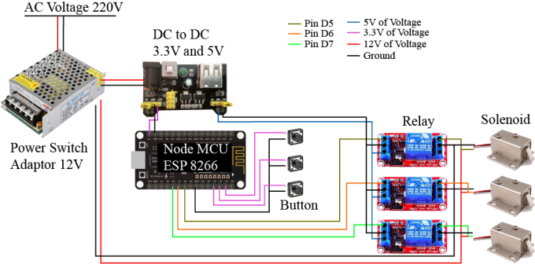
Figure 5. Design of circuit device for measure delay's value

Figure 5 illustrates the device circuit to measure the delay's value. Delay measurements start to calculate by pressing the push button when the QR code on the locker is successfully scanned. Then as soon as the solenoid on the locker is open, the push button needs to be pressed again, so the delay's value will be automatically displayed on Arduino serial monitor. Finally, it is obtained by subtracting the last time value when the push button was pressed with the first time value at the beginning. Then all the obtained delay data will be calculated as the average per day and hour based on the library's operational schedule. According to the TIPHON standard, there are several categories for the delay in measuring the qualities. Table 1 shows delay index quality based on TIPHON [17].

Table 1. Delay index quality
Delay Category | Delay (ms) | Index
Very Good | <150 | 4
Good | 150-300 | 3
Medium | 300-450 | 2
Bad | >450 | 1

RESULTS AND DISCUSSION
- Functional System Testing
The proposed device system has already been tested as a prototype. This device has been done and working well to be implemented in the library. Each component works according to its function; therefore, a functionality test has been performed in Table 2. Figure 6 shows the prototype's implementation based on the component requirement.

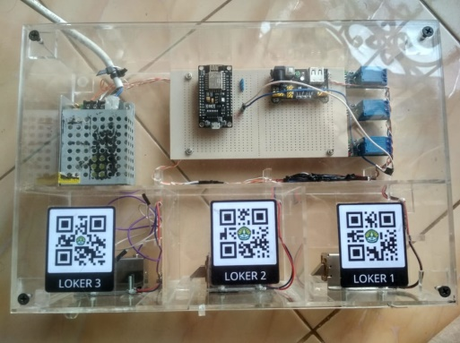
Figure 6. implementation of device system
Table 2. Functionalities test on the proposed device system

No | Component | Function | Indicator | Status
1. | NodeMCU ESP 8266 | NodeMCU ESP8266 can connect to the existing internet network on the Wi-Fi access point and destination database. | The serial monitor on Arduino software contains information about the IP Address of the Wi-Fi and response data from the user database. | Success
2. | PSA | Converting 220V AC Voltage to 12V DC Voltage | When this component is connected to a solenoid without a relay, the solenoid automatically opens. | Success
3. | AMS1117 | Lowering the 12V Voltage to 3.3V to be used as a voltage source on the NodeMCU ESP8266 | When this component is connected to NodeMCU ESP8266, NodeMCU ESP8266 can work properly. | Success
4. | Relay | Relay usually is open and connected to the NodeMCU ESP8266. Relays can supply and break an electric current. | When the relay gets a trigger from the NodeMCU, the solenoid will open on the other side. | Success
5. | Solenoid | A solenoid is connected to the relay and power switching adapter. A solenoid can open and close the locker door. | When the relay conducts an electric current, the solenoid will open, and if not, the solenoid will be closed. | Success

- Comparison of Security System
This proposed security system has already added some improvements using QR codes as a key to unlock the library's locker. However, it is hard for humans to understand and read it. Therefore, solenoid as a component to lock and unlock the door's locker is placed inside the locker. In addition, verification for personal data and theft threat notification is already added to the application provided by this proposed system. Both of these two systems are compared in Table 3.

Table 3. Comparison of security system
No | Security Feature | Conventional | Smart Lock System
1. | Risk of losing key | Yes | No
2. | User | Everybody | Only verified user
3. | Verification of personal data | No | Yes
4. | Theft threat notification | No | Yes

- Delay Results
Delay testing measurement was done from Monday to Friday (working days). Three lockers are used in the scenario. From measurement results, the overall average delay value is around 1.66 seconds. The lowest delay occurs on Thursday when two lockers are accessed simultaneously, with a delay of about 0.8 seconds. On Thursday, the highest delay occurs when three lockers are accessed simultaneously with 3.36 seconds delay value. Figure 7 presents the average delay per day.

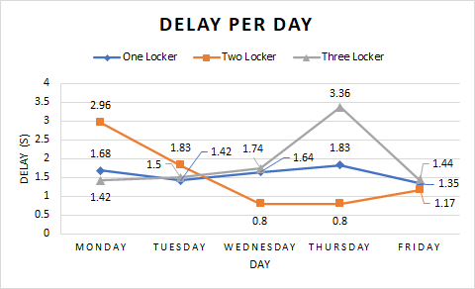
Figure 7. Average delay per day

Meanwhile, suppose average delay is measured by hours. In that case, the average delay is around 1.66 seconds. The highest average delay value occurs when three lockers are accessed simultaneously with a delay's value of about 3.15 seconds at 02.00 PM. The lowest average delay occurs when two lockers are accessed simultaneously with a delay's value of about 0.86 seconds at 01.00 PM. Figure 8 is shown the average delay per hour.

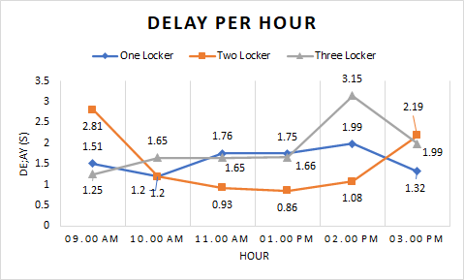
Figure 8. Average delay per hour

The average delay is around 1.66 seconds from the two methods above, where the delay value is still categorized as bad by the TIPHON standard. The time value of the delay will also affect the time in reading the QR-code. The higher the delay value, the longer it will take to read the QR-code on the device. Besides, significant issues while measuring delay data are that the quality of Wi-Fi networks at the library is unstable, affecting the measurement results because it is a public network. Moreover, during lunch break time, delay's value is higher than other times caused by heavy traffic on Wi-Fi networks.
The solution to reducing delay's value is using a private network or a priority network for the devices separated from the public network, so the load on the traffic network can be reduced and obtained delay's value.

CONCLUSION
The proposed security system has been done and working correctly. On the security side, some improvements such as using QR codes, verification for personal data, and theft treat notification has been added successfully.
For the delay results, if measured by day, the lowest delay occurs on Thursday around 0.8 seconds with two lockers are accessed and the highest around 3.36 seconds when three lockers are accessed. This delay happens on the same day. While if delay measured by the hour, the lowest delay is measured about 0.86 seconds at 01.00 PM with two lockers are accessed, and the highest is 3.15 seconds at 02.00 PM with three lockers are accessed.
The delay on the device is still categorized as "Bad," with an average delay time of 1.66 seconds. This will affect the length of time it takes to scan the QR code. The higher the delay time, the longer it will take to read the QR code.

ACKNOWLEDGMENT
This research was supported by the Laboratory of Basic Electrical Engineering and the Library of Engineering Faculty. We hope this finding will be used as a reference to improve the library's locker facility. In addition, we also thank to research institute and community service (LPPM) Universitas Riau for the research motivation and award.

REFERENCES
[1] R. H. Subrata and F. Gozali, “Sistem Keamanan Ruangan Berbasis Internet Of Things Dengan Menggunakan Aplikasi Android,” 2018.
[2] A. Kassem, S. El Murr, G. Jamous, E. Saad, and M. Geagea, “A smart lock system using Wi-Fi security,” 2016 3rd Int. Conf. Adv. Comput. Tools Eng. Appl. ACTEA 2016, pp. 222–225, 2016, doi: 10.1109/ACTEA.2016.7560143.
[3] I. Ha, “Security and usability improvement on a digital door lock system based on internet of things,” Int. J. Secur. its Appl., vol. 9, no. 8, pp. 45–54, 2015, doi: 10.14257/ijsia.2015.9.8.05.
[4] S. M. R. Rasid, F. Rashid, A. A. Sabri, and R. Islam, “Design and Construction of an Automatic Security System of a Door Using RFID Technology,” vol. 9, no. 9, pp. 1067–1073, 2018.
[5] A. Gadekar, A. Kandoi, G. Kaushik, and S. Dholay, “QR scan based intelligent system for school bus tracking,” Proc. 3rd Int. Conf. Smart Syst. Inven. Technol. ICSSIT 2020, no. Icssit, pp. 1074–1080, 2020, doi: 10.1109/ICSSIT48917.2020.9214161.
[6] A. F. M. Fauzi, N. N. Mohamed, H. Hashim, and M. A. Saleh, “Development of Web-Based Smart Security Door Using QR Code System,” 2020 IEEE Int. Conf. Autom. Control Intell. Syst. I2CACIS 2020 - Proc., no. June, pp. 13–17, 2020, doi: 10.1109/I2CACIS49202.2020.9140200.
[7] V. Susukailo and Y. Lakh, “Access control system based on encryption in QR-Code technology,” Proc. 2018 IEEE 4th Int. Symp. Wirel. Syst. within Int. Conf. Intell. Data Acquis. Adv. Comput. Syst. IDAACS-SWS 2018, pp. 158–161, 2018, doi: 10.1109/IDAACS-SWS.2018.8525779.
[8] K. Saranya, R. S. Reminaa, and S. Subhitsha, “Modern applications of QR-Code for security,” Proc. 2nd IEEE Int. Conf. Eng. Technol. ICETECH 2016, no. March, pp. 173–177, 2016, doi: 10.1109/ICETECH.2016.7569235.
[9] L. Parabhoi, N. Bhattacharya, and R. Dhar, “Use of QR Code in Library,” Appl. Mod. tools Technol. Libr. Serv., no. January, pp. 237–243, 2017.
[10] T. Marktscheffel et al., “QR code based mutual authentication protocol for Internet of Things,” WoWMoM 2016 - 17th Int. Symp. a World Wireless, Mob. Multimed. Networks, 2016, doi: 10.1109/WoWMoM.2016.7523562.
[11] . P. P. R., “Qr Code for Safety and Security Applications,” Int. J. Res. Eng. Technol., vol. 06, no. 06, pp. 15–18, 2017, doi: 10.15623/ijret.2017.0606003.
[12] A. M. Al-Ghaili, H. Kasim, F. A. Rahim, Z. A. Ibrahim, M. Othman, and Z. Hassan, “Smart verification algorithm for IoT applications using QR tag,” Lect. Notes Electr. Eng., vol. 481, no. 9, pp. 107–116, 2019, doi: 10.1007/978-981-13-2622-6_11.
[13] J. Suhartono, S. Karya, and S. Candra, “The utilize of NFC technology for campus library services management,” Proc. 2017 Int. Conf. Inf. Manag. Technol. ICIMTech 2017, vol. 2018-Janua, no. November, pp. 60–64, 2018, doi: 10.1109/ICIMTech.2017.8273512.
[14] J. Sa-Ngiampak et al., “LockerSwarm: An IoT-based smart locker system with access sharing,” 5th IEEE Int. Smart Cities Conf. ISC2 2019, pp. 587–592, 2019, doi: 10.1109/ISC246665.2019.9071664.
[15] P. S. Vaidhyesh, M. W. N, S. V. G, and D. N. Harini, “SECURING IoT DEVICES BY GENERATING QR CODES,” Int. J. Pure Appl. Math., vol. 119, no. 12, pp. 13743–13749, 2018, [Online]. Available: http://www.ijpam.eu.
[16] G. G. V. Ramya, “Review On Quick Response Codes In The Field Of Information Security (Analysis Of Various Imperceptibility Characteristics On Grayscale And Binary QR code),” IEEE - Int. Conf. Adv. Eng. Technol., no. Icaet, 2014.
[17] Y. A. Pranata, I. Fibriani, and S. B. Utomo, “Analisis Optimasi Kinerja Quality of Service Pada Layanan Komunikasi Data Menggunakan Ns-2 Di Pt. Pln (Persero) Jember,” Sinergi, vol. 20, no. 2, p. 149, 2016, doi: 10.22441/sinergi.2016.2.009.

