Supporting File – Ilmenite recovery from mining tailing

Layout of Tin Ore in Amang Plant, Bangka, South of Sumatera, Indonesia

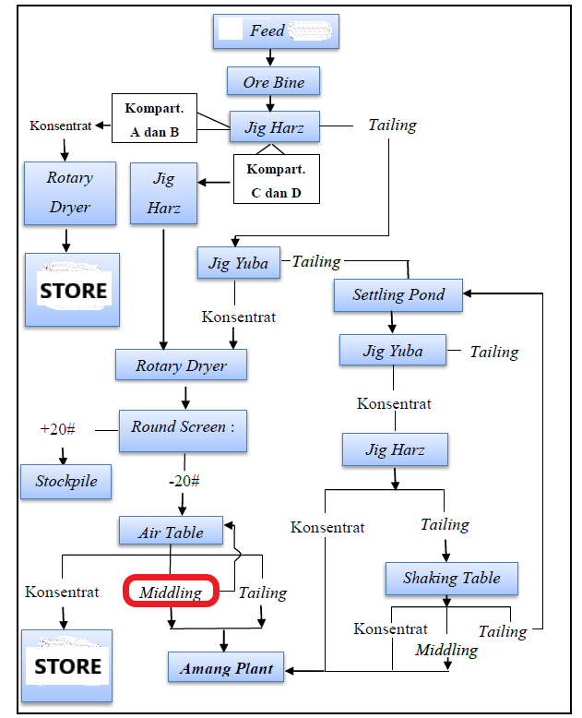
Figure 1
Note: (i) This study used Middling from Air Table for ilmenite recovery; (ii) Tin ore processing in Mineral Process Unit Metalurgy Muntok (PT Timah Tbk. 2014).

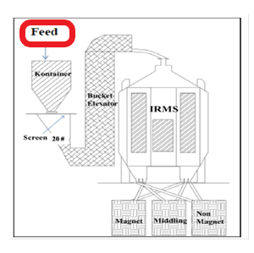
Figure 2
Note: (i) IRMS = Induced Roll Magnetic Separator; (ii) the Feed is the Middling from Air Table (see Figure 1)

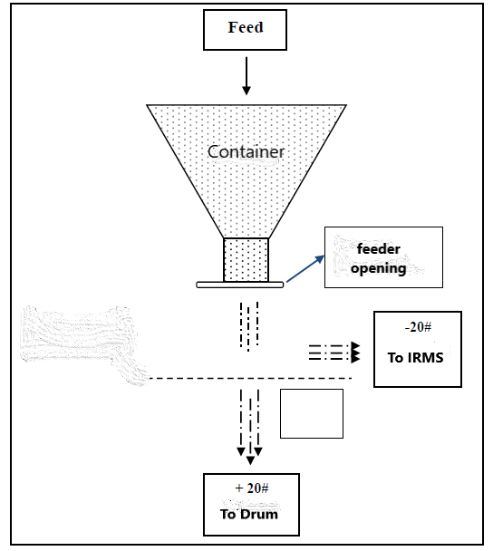
Figure 3 Particle size screen
Figure 3
- Single splitter integrated to IRMS
- This study used single splitter 1.0 cm and single splitter 4.25 cm

Figure 4
Mineral recovery inversely proportional to mineral concentration (Wills, B.A. Mineral Processing Techmology, 7th ed., Elsevier Science & Technology Books, Australia, 2006)

Tabel 1 Physical properties of minerals.
Mineral | Chemical formula | color | density | hardness | Magnetic properties | Electrical properties
cassiterite | SnO2 | Brown, red, yellow | 6.9 – 7.1 | 6.0 – 7.0 | Non magnetic | Conductor
quartz | SiO2 | White, yellow | 2.6 – 2.7 | 7 | Non magnetic | Non conductor
pyrite | FeS2 | Copper yellowish | 4.8 – 4.9 | 6.0 – 6.5 | Non magnetic | Conductor
ilmenite | FeTiO3 | Black ferrous | 4.5 – 5.0 | 5.0 – 6.0 | Magnetic | Conductor
Rutile | TiO2 | Reddish brown | 4.1 – 4.3 | 6.0 – 6.5 | Non magnetic | Conductor
Siderite | FeCO3 | Brown, reddish brown | 3.8 – 3.9 | 3.5 – 4.0 | Magnetic | Non conductor
Monazite | (CeLaYTh) PO4 | Yellowish brown | 4.9 – 5.3 | 5.0 – 5.5 | Magnetic | Non conductor
Xenotime | YPO4 | Yellowish, reddish | 4.5 – 4.6 | 4.0 – 5.0 | Magnetic | Non conductor
Zircon | ZrSiO4 | Pale yellow, green | 4.6 – 4.7 | 7.5 | Non magnetic | Non conductor
Tourmaline | (NaMg)FeAl6 BO3(Si6)18 (OH)14 | Black, Brown black | 3.0 – 3.2 | 7.0 – 7.5 | Magnetic | Non conductor
Topaz | Al2SiO4 (OH2F)2 | Yellow, orange, white | 3.4 – 3.6 | 8 | Non magnetic | Non conductor

Table 2 Specification of IRMS equipment.

Calculation

- Example: determination of mineral weight (%) of 20 mesh fraction, as follows:
Total weight of mineral sample (all fractions) = 166 g
Weight of mineral sample (20 mesh) = 2 g
Thus, weight of mineral (20 mesh) = 2 g / 166 g x 100% = 1.20 %
- Determination of ilmenite concentration at each mesh fraction using the method of Grain Counting Analysis microscope (approach method).
Example: determination of ilmenite concentration at 70 mesh.
Total grains = Grain I + Grain II = 10 + 15 = 25 (Table 3)
Density of ilmenite = 4.5 g/grain
Weight of ilmenite = 25 grain x 4.5 g/grain = 113 g
Total mineral weight (70 mesh) = 633 g
Ilmenite concentration (70 mesh) = (weight of ilmenite) / (total mineral weight) x 100% = 17.85 %.

- Determination of ilmenite concentration at Feed, as follows:
Weight of mineral (70 mesh) = 43 g
Total weight of mineral sample (all fractions) = 166 g
Ilmenite concentration (70 mesh) = 17.85%
At 70 mesh, ilmenite conc. x weight of mineral = 17.85% x 43g = 767.61 g%
For all mesh fractions, total (ilmenite conc. x weight of mineral) = 3546.57 g%
Thus, ilmenite concentration at Feed =
[ total (ilmenite conc. x weight of mineral) / Total weight of mineral sample (all fractions) ] x 100 = [3546.57 g% / 166 g] x 100 = 21.36%

Keywords: ilmenite; mineral; feed; IRMS, each fraction (mesh); all fractions (mesh); ilmenite concentration (%); ilmenite recovery(%); magnetic product; non magnetic product; middling.
MG = magnetic grain; NMG = non magnetic grain; MDL = middling

- Determination of Recovery of magnetic product at 8 Ampere (1.0 cm opening) called as sample 8.1, the following steps are:
- Determination of ilmenite concentration in IRMS.
From Grain counting analysis for sample 8.1 for MG,
Total grains = Grain I + Grain II = 125 + 120 = 245 (Table 3)
Density of ilmenite = 4.5 g/grain
Weight of ilmenite = 245 grain x 4.5 g/grain = 1103 g (round off)
Total mineral weight (- 20 mesh) = 1285 g
$$ilmenite concentration=\frac{weight of ilmenite}{total mineral weight} x 100\%= \frac{1103 }{1285} x100\%=85.84\%$$
- Determination of magnetic product rate at IRMS for sample 8.1 as follows:
Duration of sampling = 10 sec
Weight of sample = 134.8 g = 0.1348 kg
$$nagnetic product rate of sample 8.1=weight of sample x \frac{3600 }{10 }=0.1348 x 360=48.528 kg/h$$

- Determination of ilmenite recovery at IRMS for sample 8.1 as follows:
The product rate for magnetic (MG), non magnetic (NMG), and middling (MDL), respectively:
MG = 48.528 kg/h ; NMG = 296.1 kg/h ; MDL = 169.38 kg/h
From 4 (i) above, ilmenite concentration at IRMS = 85.84% → c = 85.84 %
From 3 above, ilmenite concentration at Feed = 21.36% → f = 21.36%
F = MG + NMG + MDL = [48.528 + 296.1 + 169.38] kg/h = 514.008 kg/h → check for mineral feed rate in Table 1 in the Article file = 514.01 kg/h
From 4 (ii) above, magnetic product rate of sample 8.1 = 48.528 kg/h → C = 48.528 kg/h → check for ilmenite IRMS rate in Table 1 in the Article file = 48.53 kg/h
$$ilmenite recovery for sample 8.1=\frac{C.c}{F.f} x 100\%= \frac{48.528\frac{kg}{h} x 85.84\%}{514.008\frac{kh}{h} x 21.36\%} x 100\%= 37.93\%$$
The results of ilmenite concentration and ilmenite recovery for sample 8.1 can be cross checked at Tabel 1 in the Article file.

Table 3 Grain counting analysis for MG, NMG, and MDL for sample 8.1
 |  | 8.1 MG |  |  |  | 8.1 NMG |  |  |  | 8.1 MDL
mineral | density | grain |  | Total grain x density | Mineral conc. at IRMS (%) | grain |  | Total grain x density | Mineral conc. at IRMS (%) | grain |  | Total grain x density | Mineral conc. at IRMS (%)
 |  | I | II | Total grain x density | Mineral conc. at IRMS (%) | I | II | Total grain x density | Mineral conc. at IRMS (%) | I | II | Total grain x density | Mineral conc. at IRMS (%)
cassiterit | 6.9 | 2 | 2 | 28 | 2.18 | 80 | 85 | 1139 | 75.78 | 20 | 40 | 414 | 22.92
ilmenite | 4.5 | 125 | 120 | 1103 | 85.84 | 1 | 4 | 23 | 1.53 | 62 | 48 | 495 | 27.41
rutile | 4.5 |  |  |  | 0.00 |  |  |  | 0.00 |  |  |  | 0.00
monazit | 4.8 | 10 | 20 | 144 | 11.21 | 7 | 6 | 62 | 4.13 | 75 | 72 | 706 | 39.09
xenotim | 4.8 |  |  |  | 0.00 |  |  |  | 0.00 |  |  |  | 0.00
Pyrite / marcasi | 4.8 |  | 2 | 10 | 0.78 | 15 | 11 | 125 | 8.32 | 10 | 12 | 106 | 5.87
zircon | 4.7 |  |  |  | 0.00 | 13 | 18 | 146 | 9.71 | 4 | 11 | 71 | 3.93
topaz | 3.5 |  |  |  | 0.00 |  |  |  | 0.00 |  |  |  | 0.00
tourmal | 3.1 |  |  |  | 0.00 |  |  |  | 0.00 | 2 | 1 | 9 | 0.50
quartz | 2.6 |  |  |  | 0.00 | 2 | 1 | 8 | 0.53 | 1 | 1 | 5 | 0.28
anatas | 3.9 |  |  |  | 0.00 |  |  |  | 0.00 |  |  |  | 0.00
spinel | 3.8 |  |  |  | 0.00 |  |  |  | 0.00 |  |  |  | 0.00
siderit | 3.8 |  |  |  | 0.00 |  |  |  | 0.00 |  |  |  | 0.00

