Application of Capacity Spectrum Method (CSM) for Non-Symmetrical Reinforced Concrete High Rise Buildings (as a Tool for Seismic Design) | 

Ayuddin
Department of Civil Engineering, Faculty of Engineering, Universitas Negeri Makassar, Indonesia

Abstract  The Development of earthquake resistance design of structures in the last decade has been critically changing from strength and ductility to become performance criteria where the structure is decided for various levels of structure performance. To know the structure performance because when at time receive a big earthquake load on the structure will experience a structural yielding so it will be done non linier analysis with the capacity spectrum method. The relationship between the roof displacement and base shear force is described in a curve that describes the structure capacity is called capacity curve. To know the behavior of structures under review for a given earthquake intensity, capacity curve is then compared with the performance demand by the various earthquake intensity. The results of the case studies for reinforced concrete portals non-symmetrical 3D concluded that convergence obtained at the point of the structure performance is $a_{p}=0.236g$ and $d_{p}=189 m$. Displacement results for actual structure ($∆_{roof}$) is 286.71 mm and building base shear coefficient is 15.46 %.  This is an open access article under the CC BY-NC license   | Keywords:  Performance based design;  Capacity spectrum method;  Article History:  Received: January 11, 2023  Revised: March 15, 2023  Accepted:  Published:  Corresponding Author:  Ayuddin  Civil Engineering Department, Universitas Negeri Makassar, Indonesia  Email: ayuddini@unm.ac.id

INTRODUCTION
Indonesia is the zone region often experience the earthquake, so that the building will be built must be able to survive when an earthquake occurs [1, 2]. The building was built with reinforced concrete have shown damage to buildings due to earthquake. Background Reinforced Concrete (RC) buildings with no seismic design exhibit degrading behavior under severe seismic loading due to non ductile brittle failure modes [3, 4]. Some special Engineering firms are taken for rehabilitation by Performance based seismic design [5]. Thus, damage that occurs most often caused by design errors and the quality of materials is very low. Current codes and provisions cannot cover all structures located in active seismic zone and these structures are not capable of withstanding seismic action [6]. Finally, the overall seismic safety of the building suffers from the level of damage seen from the deformation capacity that occurs [7].
The recent development of structural design philosophy tends to focus on the performance-based design concept. This method is oriented to the performance required for future user needs of a building, then evaluates and verifies building assets [8]. Probabilistic Seismic Analysis which is often implemented in the first generation of performance-based seismic engineering quantifies the seismic behavior of structures with desired demand parameters considering all anticipated earthquakes [9].

Structural Engineers realize that structural safety does not merely depend on the quantitative strength but it also depends on the performance based ductility demand and energy dissipation involving the corresponding major earthquake. An improved capacity-demand-diagram method that uses the well-known constant-ductility design spectrum for the demand diagram is developed and illustrated by examples [10].
Performance Based Design (PBD) primarily on ductility demand under major earthquake has been considered as a criterion for measuring safety of a structure. Seismic Performance Evaluation of Steel Buildings with Oil Dampers Using Capacity Spectrum Method [11, 12, 13]. This performance-based design using nonlinear analysis techniques based on computer to analyze the of the various ground motion intensity, and an approach based on approaches based on the equivalent linearization concept the capacity spectrum [14, 15, 16]. So that it can be seen in a critical condition performance and it can be anticipated if it does not meet the necessary requirements. ATC-40 rules that applied in this paper to determine the performance of the building structure because the rules have not formulated the equation SNI 1726-2002.
To check the structures performance in nonlinear so nonlinear static analysis is required to predict the lateral displacement accurate and conservative. One way of nonlinear static analysis has been proposed that the most popular today is the Capacity Spectrum Method (CSM) [17].
The capacity spectrum method (CSM) is a nonlinear static analysis method, which compares the global force-displacement capacity curve of a structure with a earthquake response spectrum in a graphical shape [18]. For this, both the capacity curve and the response spectra have to convert into a spectral acceleration Sa spectral displacement SD graph. Due to this transformation, the global building will be reduced to an equivalent SDF-structure. By using a trial and error procedure one can estimate the performance point, which describe the spectral displacement of the building due to the given earthquake [19]. Deformation has been used as a key indicator in the seismic performance assessment of building structures [20].

Capacity Spectrum Method Procedure
Describe Capacity Spectrum Method is a graph technique to determine the structure response by finding the intersection diagrams from analysis of nonlinear static pushover and acceleration response spectra curves– displacement [21]. Analysis of nonlinear pushover is one component of performance based design that can be used as a means of determining the capacity of a structure [22, 23]. Structure is subjected to specified load pattern to reach a target displacement [24].
In the CSM method, structural capacity curve (force vs displacement) and response spectra curves [25, 26]. It must be converted to acceleration spectra (SA) and displacement spectra (SD). Conversion pushover capacity curve is calculated based on the mass coefficient of effective modal and modal participation factor. Because the CSM method is a combination of several techniques or procedures for seismic analysis so it will be too broad to discuss in detail the whole. Therefore the description below is given only a general description given in the method with the required number of equations.
The procedure can be summarized by the following:

Capacity Curve
Estimate or calculate the capacity curve in terms of roof displacement, $∆_{R}$ and base shear, V, (i.e. total lateral force at base).
The capacity curve is determined by statically loading the structure with realistic gravity loads combined with a set of lateral forces to calculate the roof displacement $∆_{R}$ and base shear V that defines first significant yielding of structural elements. The yielding elements are then relaxed to form plastic hinges and incremental lateral loading is applied until a nonlinear static capacity curve is created. The curve is created by superposition of each increment of displacement and includes tracking displacements at each story (ATC 1982). This procedure is sometimes referred to as the pushover analysis.

Dynamic characteristics
Estimate or calculate modal vibrational characteristics :.
Factor Participation Modal $\left(Γ\right)$
Factor Participation Modal (MPF) was calculated for each vibration mode using (1) :

$PF_{m}$ = $\left[\frac{\sum_{i=1}^{N}{ \frac{w_{iϕ_{im}}}{g}}}{\sum_{i=1}^{N}{ \frac{w_{i}ϕ_{im}^{2}}{g}}}\right]$ (1)
Where :
$PF_{m}$ = Factor Participation Modal for mode
to-m
$w_{i}ϕ_{im}$/g = floor mass to-i
$ϕ_{im}$ = mode amplitude to-m for floor to-i
N = floor N, The top floor of the structure

While factor participation modal for certain floors (modal story participation factor) :

$PF_{m}= PF_{m}ϕ_{im}$ (2)
Coefficient of Effective Mass $\left(α_{m}\right)$
Coefficient of Effective Mass is calculated for each vibration mode using (3):

$α_{m}$ = $\frac{{\left[\sum_{i=1}^{N}{\frac{w_{i}θ_{im}}{g}}\right]}^{2}}{\left[\sum_{i=1}^{N}{\frac{w_{i}}{g}}\right]\sum_{i=1}^{N}{\frac{w_{i}ϕ_{im}^{2}}{g}}}$ (3)
Acceleration of Capital Floor $\left(a_{im}\right)$
Acceleration of Capital Floor is calculated for each vibration mode using (4) :

$a_{im}= {PF}_{m}ϕ_{im}S_{Am}$ (4)

Where :
$a_{im}$ = acceleration of the floor at the level to-i for the mode to-m
$ϕ_{im}$ = amplitude at the level to-i for the mode to-m
$S_{Am}$ = spectra acceleration for the mode to-m

Lateral force of modal floor $F_{im}$
Force lateral (mass x acceleration) is calculated for each vibration mode using 5 :

$F_{im}$ = ${PF}_{m}ϕ_{im}S_{Am}m_{i}$ (5)
Where :
$F_{im}$ = floor lateral force to-i for the mode to-m
$m_{i}$ = floor mass at the level to-i
$S_{Am}$ = spectra acceleration for the mode to-m

Modal Shear Force $\left(V_{m}\right)$
Modal Shear Force is calculated for each vibration mode using (6), Amount of lateral force floor $F_{im}$ will equal $V_{m}$ :

$V_{m}$= $α_{m}S_{Am}M$ (6)
Where :
$V_{m}$ = total lateral force for the mode to-m
$α_{m}$ = Effective mass coefficient for the mode
to-m
$M$ = structure total mass

Spectra capacity engineering applications require a response spectra and capacity curve are plotted in the format of ADRS (Acceleration-Displacement). Further below illustrates some of the parameters to determine the factors reducing the capacity spectra.
$S_{di}$ = $\frac{{T_{i}}^{2}}{4π^{2}} S_{ai} g$ (7)
Modal Shear Force $\left(V_{m}\right)$
Factor Participation Modal (MPF) was calculated for each vibration mode using (6).
Modification of the damping factor (κ) is the size of the hysteresis behavior of the price of building these parameters are determined by the assessment of the quality system structure under earthquake loads in a certain time interval. In this paper, the structures were analyzed using the lateral control system of the beam column resistant frame so Modification of the damping factor :
$κ$ = 0.67,${ β}_{eff}$25% (8)
$κ$=0.845– $\frac{0.4461 \left(a_{y}d_{pi}- d_{y}a_{pi}\right)}{a_{pi}d_{pi}}β_{eff}$
$>$ 25% (9)
Effective Damping $\left(β_{eff}\right)$
Effective damping is the modified hysteresis damping with the damping modification factor $\left(κ\right).$ While hysteresis damping is the damping in a structure inelastic. Common method used to determine the equivalent viscous damping is to balance the energy dissipation in a cycle of vibration of a system inelastik with an equivalent linear system in Figure1.
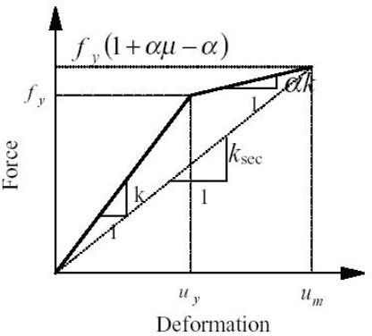
Figure 1. Equivalent viscous damping relation hysteresis energy dissipation

The ideal hysteresis damping based on this concept is calculated as :
$β_{0}= \frac{1}{4π} \frac{E_{D}}{E_{s_{0}}}$ (10)
Where :
$E_{D}$ = disipation of energy by damping
$E_{s_{0}}$ = the maximum strain energy

From broad equality of calculation $E_{D}$ dan $E_{s_{0}}$, equivalent viscous damping (hysteresis damping) is given as :
$β_{0}$ = $\frac{63.7κ\left(a_{y}d_{pi}-d_{y}a_{pi}\right)}{a_{pi}d_{pi}}$ (11)
Taking into account the viscous damping inherent in reinforced concrete structures by 5% so the total equivalent viscous damping :
$β_{eq}$ = $β_{0}+5$ = $\frac{63.7κ\left(a_{y}d_{pi}-d_{y}a_{pi}\right)}{a_{pi}d_{pi}}$+5 (12)
Modification of the damping factor should be given to calculate imperfect hysteresis loops so that the effective structural damping is expressed in (12) $\left(β_{eff}\right)$ :
Acceleration reduction factor $\left(S_{RA}\right)$ and Velocity reduction factor $\left(S_{RV}\right)$ :
In this capacity spectrum method, the reduction factors for the equivalent elastic system is given as:

${SR}_{A}$ = $\frac{3.21-0.68\ln\left(β_{eff}\right)}{2.12}$ (14)
${SR}_{A}$ = $\frac{3.21-0.41\ln\left(β_{eff}\right)}{1.65}$ (15)
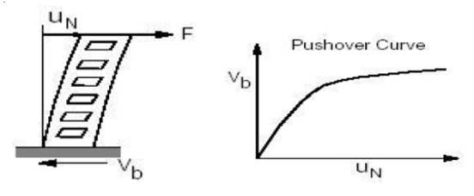
Capacity spectra peak acceleration (SA) and Angle period (TS) :
Capacity spectra peak acceleration related hearing with trial performance point $a_{pi , }$ $d_{pi},$given as:

$S_{A}$ = 2.7065 $S_{RA}{ C}_{A}$ (16)
“(Equation 16)” using factor "2.7065" because responsive design spectra constructed using Newmark-Hall procedure. When using the design response spectrum normalized average factor "2.5" is used (ATC-40). Capacity spectra angle period is given :
$T_{s}$ = $\frac{S_{RV}C_{V}}{2.5 S_{RA}C_{A}}$ (17)
Determining the loading capacity of the Lateral Displacement Structure (Non-Linear Static Pushover Analysis)
After the configuration of static lateral load was applied to the structure with the intensity gradually increasing load (push-over). Capacity curve is then generated as the structure of the scheme is given in Figure 2. In Pushover curve should be determined by 4 points (Point A - Point D) which represents the relationship of roof floor displacement $\left(Δ_{roof}\right)$ and lateral shear force (V).
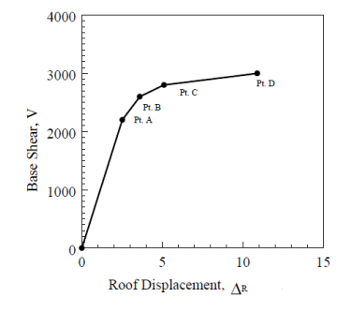

Figure 2. Capacity Curve with
the performance point

Pushover capacity curves conversion and Spectra Response AT
To superimpose structure capacity diagram on diagram spectra so abscissa (X-axis and Y axis) in pushover capacity and Spectral response curve must be converted to spectrum displacement (SD) and spectra acceleration (SA).
Transformation of the structure capacity curve using equation (2-3) as shown in Figure 3. The transformation of this response spectra using eq 7 and shown in Figure 4.

(a). Shear force relationship
curve – displacement

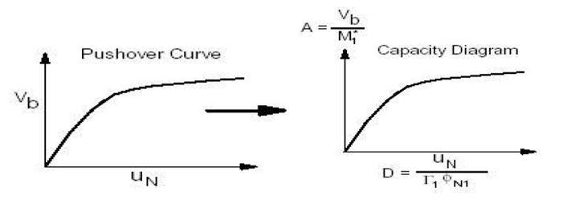

(b) Capacity transformation
curve to capacity

Figure 3. Capacity spectra method:
Capacity curve transformation

Figure 4. Spectra capacity Method:
Response spectra conversion

Each point on the spectrum response curve represents the unique values of the acceleration spectra, $S_{ai}$, velocity, $S_{vi}$, and dispacement, $S_{di}$. For changing the spectra from conventional form $S_{A}$ vs T become ADRS form then every point on the curve SA vs T needs to be changed to SD.

Determine the point of structural performance
Performance Point is determined by plotting the capacity diagram and the amount of spectrum capacity of ADRS format. The capacity diagram intersection and the spectrum capacity of a damping value represents a strong demand on the structural response due to lateral earthquake loading. Point performance calculation process is basically the procedure repeated try and error mode or use a graphical approach in Figure 5.

Figure 5. Spectra capacity Method:
Response spectra conversion

METHOD
The method used in this research is to analyze with design parameters of reinforced concrete structure non symmetric with three-dimensional portal review can be seen in Figure 6 below. Structural dimensions : 4@8m x 3@8 in plane and 3m in height for each story, fc’=30 Mpa and F_{y} = 350 MPa. Table 1 shows the section of the structural elements of the building. Typically, all storeys of the building have constant three meters height. These structures were analyzed using the spectrum capacity method.

Table 1. Detail of the Frame Structure
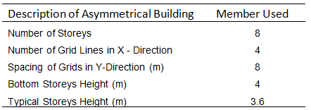

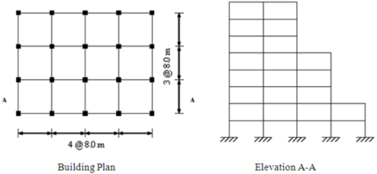

Figure 6. Typical Building Plan

In this analysis will be found an intersection between the demand curve and the capacity curve for the largest top displacement. The main procedures of the analyzis are shown in Figure 7.
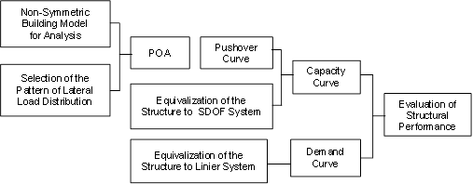
Figure 7. The Procedure chart of the analysis by method of capacity demand curve

RESULTS AND ANALYSIS
In the analysis of the asymmetric building under review, the calculation of dynamic characteristics is carried out using the principle of mass distribution in the structure of the software application, which is shown in Table 2 and the calculation of dynamic characteristics is also completed using the Lumped Mass principle, known as the Holzer or Stodola method, which is shown in Table 3. Then, distribution of static seismic forces on the joints in Table 4. While the distribution of lateral static forces along the height of the building of mass and height of each floor can be seen in Figure 8.

Table 2. Distributed Mass Vibration Mode
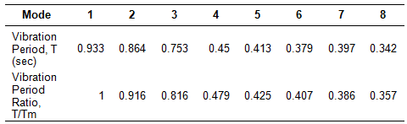

Table 3. Lumped Mass Vibration Mode
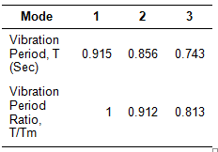

Table 4. Distribution of Static Seismic Forces on the Joints
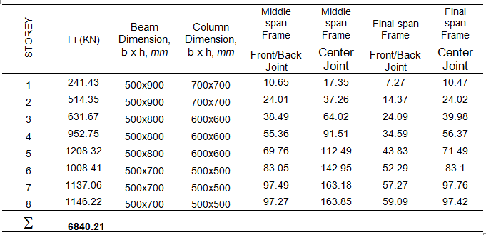

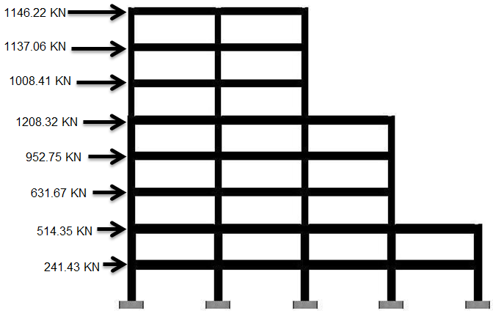

Figure 8. Static Earthquake Diagram for each Floor

From the application of the design total base shear force Vb = 6840.21 KN which is distributed over 124 joints with the load intensity increasing gradually through pushover analysis, the displacement capacity curve of the structure is produced as shown in Figure 9.
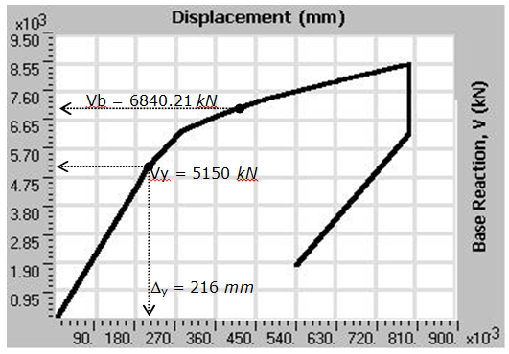

Figure 9. Vertical Non-Symmetric Structural Capacity Curve (V vs Δ)

In the capacity analysis does not indicate the collapse mechanism or plastic joint destruction occurs only at the bottom of the column base floor. This means that the structural design has been accommodated the capacity concept of weak beam-strong column. Structure maximum performance, $∆_{maks}$ is 792 mm, and the next will be shown in Figure 10 stages of the collapse mechanism.
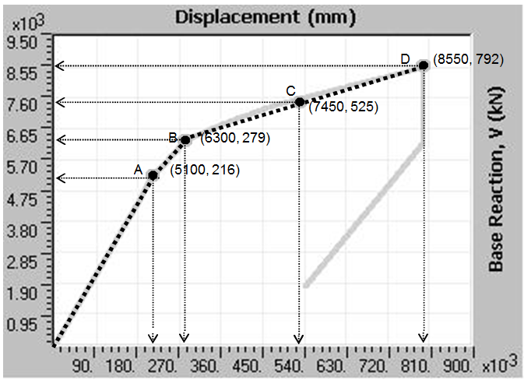

Figure 10. Force Curve vs Displacement
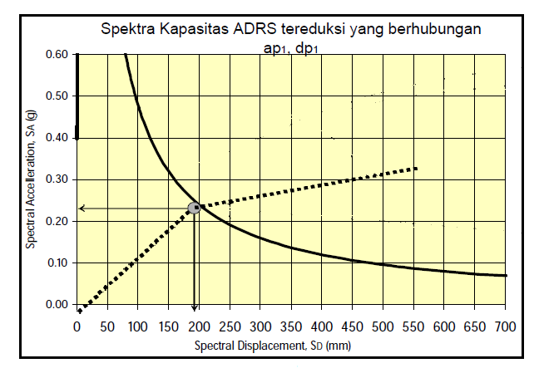
At point A (V= 5100 KN, Δ = 216 mm) indicates the beginning of the plastic hinge mechanism, then at point B (V= 6300 KN, Δ = 279 mm) the initial failure occurs on some structural elements. While point C (V= 7450 KN, Δ = 525 mm) occurs where the midpoint of strain hardening. For point D (V= 8550 KN, Δ = 792 mm) indicates the displacement limit occurs where the structure is on the verge of collapse or is undergoing local collapse or reaching maximum curvature. Then, structure performance intersection results can be seen in Figure 11.

Figure 11. Structure performance
intersection result.
The performance point has been derived from the intersection diagram of capacity structure and spectra capacity curve. The results of the spectrum capacity method in Figure 11 shows that the convergence performance derived at the structure performance point,$a_{p}$ is 0.23g and displacement spectra is 189 mm. Based on the displacement spectra value will be derived of structure actual displacement is 286.71 mm and the building base shear coefficient is 15.46 %

CONCLUSION
Results for model Reinforced concrete structure non symmetric in this paper is the category of Immediate Occupancy performance level. It means that the structure is designed to secure conditions. Thus, the Capacity spectrum method is able to show the performance of seismic resistance structure. The concept of structure performance design with capacity spectrum method is basically a procedure done to get the actual displacement of the building structure. Actual displacement is obtained from these results show a structure floor displacement. Thus, this method can be used as an alternative design of seismic resistance structure.

ACKNOWLEDGMENT
The author would like to thank for all member of the Universitas Negeri Makassar especially for Civil Engineering Department for their support in this paper.
REFERENCES

[1] Ayuddin, “Global Structural Analysis of High Rise Hospital Building Using Earthquake Resistant Design Approach,” SINERGI Vol. 24, No. 2, February 2020: pages 95-108. [Online]. Available: Academic OneFile, http://doi.org/10.22441/sinergi.2020.2.003. [Accepted February 2, 2020].

[2] Ayuddin, ”Konstruksi Tahan Gempa, Indonesia, Badan Penerbit UNM, 2017.

[3] Ayuddin, “Struktur Beton Bertulang, Indonesia, Badan Penerbit UNM, 2022.

[4] N. Kyriakides, A. Sohaib, K. Pilakoutas, K. Neocleous, C. Chrysostomou, E. Tantele, and R. Votsis, “Evaluation of Seismic Demand for Substandard Reinforced Concrete Structures,” The Open Construction and Building Technology Journal, 2018, 12. pp. 9-33, DOI: 10.2174/1874836801812010009.

[5] B. Ahmed and S. M. Zahurul Islam, “Seismic Performance and Retrofitting of Steel Building,” Science Publishing Group, Vol 3, No. 1, January 2019, DOI: 10.11648/j.ie.20190301.11.

[6] B. Ahmed, S. M. Z. Islam, “Seismic Performance and Retrofitting of Steel Building,” Industrial Engineering, Vol. 3, No. 1, 2018, pp. 1-10. DOI: 10.11648/j.ie.20190301.11.

[7] C. Michel, A. Karbassi, P. and Lestuzzi, “Evaluation of the seismic retrofitting of a reinforced masonry building using numerical modeling and ambient vibration measurements,” Article in Engineering Structures, 158 (2018) 124–135, March 2018. DOI:10.1016/j.engstruct.2017.12.016.

[8] M. A. Zubritskiy, O. Y. Ushakov, L. S. Sabitov, “Performance-based seismic evaluation methods for the estimation of
inelastic deformation demands,” IOP Conference Series: Materials Science and Engineering, 570 (2019) 012108, 9 November 2020. DOI. 10.1088/1757-899X/570/1/012108.
[9] M. Kia, A. Amini, M. Bayat, and P. Ziehl, “Probabilistic Seismic Demand Analysis of Structures Using Reliability Approaches,” Journal of Earthquake and Tsunami, Vol. 15, No. 03, 2150011 (2021), [Online]. Available: Academic OneFile, https://doi.org/10.1142/S1793431121500111. [Accepted December 24, 2020].

[10] K. Chopra, M. EERI and R. K. Goel, M. EERI, “Capacity Demand Diagram Methods Based on Inelastic Design Spectrum,” SAGE Journal, vol. 15, Issue. 4, 27 December 2019. DOI.10.1193/1.1586065.

[11] A. Naqi, T. Saito, Seismic Performance Evaluation of Steel Buildings with Oil Dampers Using Capacity Spectrum Method,” Appl. Sci. 2021, 11(6), 2687, [Online]. Available: Academic OneFile, https://doi.org/10.3390/app11062687. [Accepted March 13, 2021].
[13] G. Guerrini, S. Kallioras, S. Bracchi, and F. Graziotti, “Displacement Demand for Nonlinear Static Analyses of Masonry Structures: Critical Review and Improved Formulations,” Buildings, 16 March 2021, 11 (3), 118. DOI.10.3390/buildings11030118.

[14] Y. Lu, I. Hajirasouliha, A. M. Marshal, “Direct displacement-based seismic design of flexible-base structures subjected to pulse-like ground motions,” Engineering Structures, Vol. 168, August 2018, Pages 276-289, [Online]. Available: Academic OneFile,https://doi.org/10.1016/j.engstruct.2018.04.079. [Accepted August 1, 2018].

[15] A. T. Dohadwala, R. K. Sheth, And I. N. Patel, “Comparison Of Base Shear For Forced-Based Design Method And Direct Displacement-Based Design Method,” Int. J. Adv. Eng. Res. Dev., Vol. 1, No. 06, Pp. 1–10, 2018, file:///C:/Users/User/Downloads/1455-73-7221-1-10-20200331.pdf

[16] S. Swathi, K. Venkataramana, C. Rajasekaran, “Evaluation of Performance Point of Structure Using Capacity Spectrum Method,” Applied Mechanics and Materials, Vol. 877, pages 299-304, February 2018, [Online]. Available: Academic OneFile, https://www.scientific.net/AMM.877.299. [Accepted February 2, 2018].

[17] S. Swathi, K. Venkataramana, C. Rajasekaran, “Evaluation of Performance Point of Structure Using Capacity Spectrum Method,” Applied Mechanics and Materials, Vol. 877, pages 299-304, February 2018, [Online]. Available: Academic OneFile, https://www.scientific.net/AMM.877.299. [Accepted February 2, 2018].

[18] N. Ramadhani and A. Rosyidah, “Direct Displacement Based Design and Capacity Spectrum Method for Special Moment,” Journal of Engineering Design and Technology, Vol. 20 No. 1 March 2020; p. 6 – 12, http://ojs.pnb.ac.id/index.php/LOGIC.

[19] RFEM and RF-DINAM Pro, “Evaluate the Capacity Curve for Pushover Analysis,” Dlubal Software GmbH Version January 2019, Germany, https://www.dlubal.com.
[20] H. G. Kim and K. H. Kim, “ A Simple Analysis Method for Estimation of
Required Damping Ratio for Seismic Response Reduction,” Journal of Asian
Architecture and Building Engineering Taylor and Prancis Group, 17:3, 465-472, DOI: 10.3130/jaabe.17.465.

[21] A. V. Bergami, C. Nuti, D. Lavorato, G. Fiorentino, and B. Briseghella, “Proposal of a non linear static analysis procedure for bridges: the Incremental Modal Pushover Analysis for bridges (IMPAβ),” Appl. Sci. 16 February 2020, 10, 4287. DOI.10.3390/app10124287.

[22] Masrilayanti, R. Kurniawan, A. L. Budi, and S. H. Sourkan, “Pushover Analysis of 10-Floors Reinforced Concrete Building (Case study: Mahkota Majolelo
Sati Bautique Hotel),” IOP Conference Series: Materials Science and Engineering 1041 (2021) 012003, DOI:10.1088/1757-899X/1041/1/012003.

[23] R. Patle, S. S. Shiwarkar, R. L. Gathe, A. V. Ghate, and M. P. Wandile, A. Bhambulkar, and V. Yerpude, ”A Review On Pushover Analysis on RCC works,” International Journal of Advance Research and Innovative Ideas in Education, vol. 7, Issue. 3, 2021.

[24] A. Fakhraddini, M. J. Fadaee, and H. Saffari, “A Target Displacement for Pushover Analysis to Estimate Seismic Demand of Eccentrically Braced Frames,” Journal of Rehabilitation in Civil Engineering, 14 July 2018.DOI:10.22075/JRCE.2018.13427.1245.

[25] N. M. Rahbari, J. Dowling, D. Kennedy, and G. Fraser, “Comparison of Commonly-Used Pushover and Modal Pushover Analysis of Granville Bridge,” 12th Canadian Conference on Earthquake Engineering, Quebec City, June 17-20, 2019. https://www.caee.ca/12CCEEpdf/192-1BER-149.

[26] S. Erlicher, O. Lherminier, and M. Huguet, “The E-Dva Method: A New Approach for Multi Modal Pushover Analysis Under Multi Component Earthquakes,” Soil Dynamics and Earthquake Engineering, 1 May 2020, [Online]. Available: Academic OneFile, http://www.semanticscholar.org/. [Accepted May 1, 2020].

