Battery Energy Storage System
as a Voltage Control at Substation
based on the Defense Scheme Mechanism

Zainal Arifin,
Engineering and Technology Division, PT. PLN (Persero), Jakarta, Indonesia
Aditya Firmanto,
Transmission Unit Service of Cawang, PT. PLN (Persero), Jakarta, Indonesia
Sirilius Dwirawan, Dede Rilwan Alwani
Department of Power and Renewable Energy, Institut Teknologi PLN, Jakarta, Indonesia

Abstract – Battery Energy Storage Systems (BESS) are able to use for improving power quality by integration of various energy resources into the grid and being ability to adjust the supply of power plants and demand for loads to maintain a more stable, reliable, and resilient of power system. Connected to the grid, BESS can respond quickly as a voltage regulator on the grid in the event of a voltage drop during peak load or when a disturbance occurs. To overcome these problems, the equipment has implemented a voltage regulation scheme to prevent voltage drop and power quality due to some very fast voltage fluctuation. This study is to investigate the role of BESS as a voltage control combining with a defence scheme mechanism at a high voltage network in Jakarta. Several indicators of the voltage regulation scheme with BESS at the substation has been examined through ETAP modelling software. The results showed that the BESS at Substations can improve the quality of the voltage on the grid through voltage regulation.

Keywords — Battery Energy Storage System; Voltage Regulator; Under Voltage Relay; Power Quality

INTRODUCTION
The Battery Energy Storage System (BESS) was developed to improve the quality of the electricity network and the electric power services integration of various sources of electrical energy generation, and also to balance the power suppy with the load so that the operating system becomes more stable and more reliable. BESS can increase the operating voltage of the system when the voltage is low especially during peak load. It also can be operated faster than other devices, because BESS only requires quick response time of operation compared to other devices. This makes BESS is able to control voltage fluctuations when faults occur. BESS control the voltage by releasing electric power to the system when the voltage is lower than the normal setting so the system voltage that can increase rapidly, both under normal and fault conditions.
The main function of BESS is to store the electrical energy reserves. By its ability to store large amounts of energy in the operating system and then release it quickly, BESS can be used to improve power quality, reliability and load stabilization in the event of a disturbance, thereby improving power quality through voltage regulation. While the power system generally uses Under Voltage Relay (UVR) to regulate the voltage in a power system.
Therefore, the role of BESS to contol the voltage in the power system by combining the UVR mechanism is needed, to analysis whether it will affect the reliability of the grid or not. Based on the defence scheme mechanism at the grid system, the study analyzes how the UVR will be able to be supported by BESS at the substation and what are the most significant factors of it.

UVR AND BESS MECHANISM
When the voltage drops due to disturbances coming from the power plant, it causes a voltage drop outside the voltage regulation. Then it causes a decrease in power quality at all locations of the substation. In some cases, the voltage regulation scheme has worked well to repair the system in the event of a disturbance. However, it still harms the performance of the voltage regulation scheme in the form of low operating voltage in some locations. [1] Therefore, BESS is needed for a voltage regulation, so it can stabilize the voltage and improve power quality in certain areas on grid. This study starts with a hyphothesis that BESS combined with UVR can regulate voltage and improve power quality.

A. Under Voltage Relay
Under Voltage Relay is a voltage regulation scheme used to regulate the system when abnormal conditions occur in the operating system. [2] To secure and maintain the power quality of the operating system, dispatchers must continually balance supply (power generation) and demand (load) requirements. [3] The imbalance between supply and demand will cause an abnormal operating system. This abnormality is described as follows:
1. If one or more power generators failed, it will decrease power supply to the system causing a sudden drop in voltage and frequency (power supply is lower than load demand).
2. If there is a large load coming out of the system, it will increase power supply to the system so that may cause a rising voltage and frequency suddenly (power supply is higher than load demand). [4]

B. Battery Energy Storage System
BESS could be very important in regulating the voltage in the electric power system in the future. By generating and absorbing power in quick response to change the nominal voltage and to balance between generator and load (supply and demand), BESS's fast response will provide reliability to the network. [5] With a better quick charge and discharge if there is a disturbance, BESS will have a good response in improving the quality of power. Additionaly, BESS can release stored electrical energy and supply it to the grid system during the shortage or peak load by the cheaper elctricity cost so the operating system on that grid can be more efficient. [6] The basic working scheme of BESS can be seen at the figure 1.
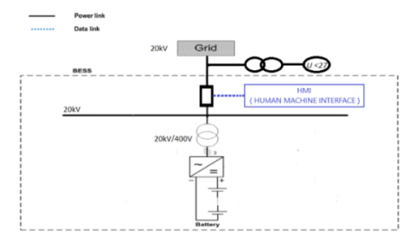
Figure 1. BESS working scheme as a voltage regulator.
BESS equipment is grouped according to its function: battery system, converter system, control system and GIS system. The battery system consists of various battery components that have the function of storing power, inverters, and converters to convert DC to AC or vice versa which are useful during the charging and discharge process. [7] [8] The control system is required to operate the BESS that consists of a Potential Transformer which its function is to read voltage and frequency, Under Voltage Relay as a control to enter and exit the BESS system from the system automatically, while for manual use the Human Machine Interface (HMI). The GIS system itself consists of various types of high and medium voltage equipment such as Step-up Transformers which are useful for increasing the voltage from low voltage AC 400V to AC medium voltage 20kV, Circuit Breakers to connect and disconnect BESS to the load, and power transformers 150kV / 20kV which one function is to connect BESS to the grid. [9]

C. Voltage Regulation
Voltage regulation describes the rules and procedures applied to ensure reliability and efficiency in power system operation. In Indonesia power grid, the voltage regulation is at 150 kV. This system is stated to be in good operating condition when the voltage is within the normal operating range (150 kV +5% and -10% ), except for short time deviations allowed in the range (150 kV + 10% and -20%). Meanwhile, during interference conditions, the voltage may be 120 kV and 165kV.
According to the Regulation of the Minister of Energy and Mineral Resources number 03 year 2007, concerning the Regulation of the Java-Madura-Bali Operating System in the Operational Rules section, some clauses of this part has summarized the operating principles for a safe and reliable system that must be followed. Part of it also establishes the fundamental obligation of all network users to contribute to safe and reliable operation. It contains voltage regulation limits under normal circumstances as well as voltage limits in case of disturbance.
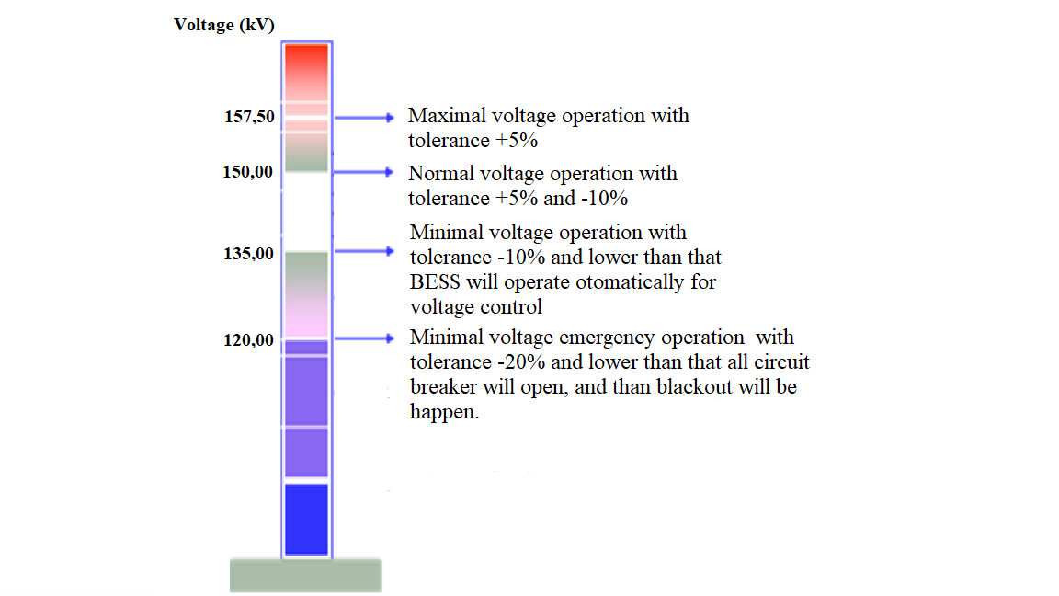
Figure 2. Under voltage relay as control operation for BESS
The control system will be on when a disturbance occurs in the generator or several generators or IBT (Inter Bus Transformer 500kV/150kV) which create a fluctuating voltage at the system, then UVR will measure the voltage drop that occurs. It measures and records mainly voltages that have dropped and reached 135kV. Then UVR will command the CB (Circuit Breaker) on the BESS to connect the network directly, thus making the operating system get a better voltage. [10]
When the operating system is stable again the generator or IBT is operating normally. The voltage will slowly increase and reach a voltage of 150 kV, then the VR (Voltage Relay) will instruct the CB towards BESS to disconnect from the network automatically, so the CB direction of BESS can be disconnected manually via HMI. For this case, the voltage has not reached 150 kV yet.
When the 500 kV operating system or generator falls into blackout, the voltage gets worse and reaches 135kV, VR will work. To overcome voltage fluctuations, BESS is installed as a voltage regulator that can adjust the voltage quickly and still at the permissible limit so that power quality degradation can be avoided. [11]
The UVR function for controlling BESS is drawn as the figure 2. In addition, BESS can be combined with the UVR mechanism. Besides that, BESS can be operated manually via HMI so it can improve the system voltage and the power quality especially during peak load.

METODOLOGI
This study was conducted quantitatively by collecting data, modelling and testing the model. The data was collected from the daily records of 21 Substations in Jakarta grid system. This is obtained from each substation for 3 months. Based on the one-line diagrams available in the operator control room, equipment data can be obtained for each Substation. Data assets and basic data such as name plates on generators, transformers, main equipment, and transmission equipment as well as other related information have been recorded by the Data Management Team at PT. PLN (Persero) West Java Transmission Unit or UITJBB, Duri Kosambi Service Unit. Then the data is used to run a power system tool, in this case, ETAP, to test BESS combined with the UVR mechanism at the Substation in Duri Kosambi, West Jakarta. Figure 3.1 describes how the research was carried out step by step.
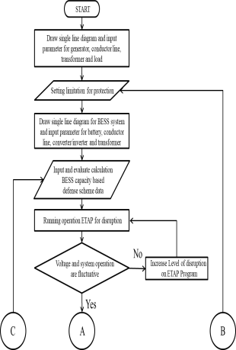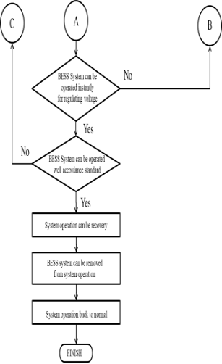
Figure 3. Research flow chart
The flowchart also explains how to calculate BESS capacity based on load loss and source estimation when a fault occurs, thereby making BESS capacity in line with operating system requirements. When the BESS capacity is greater than the system requirement, it is not efficient because BESS will not work at maximum capacity. On the other hand, if the capacity is lower than the requirement, it will cause a decrease in power quality and BESS cannot support the system as a voltage regulator well.

A. Diagram Single Line
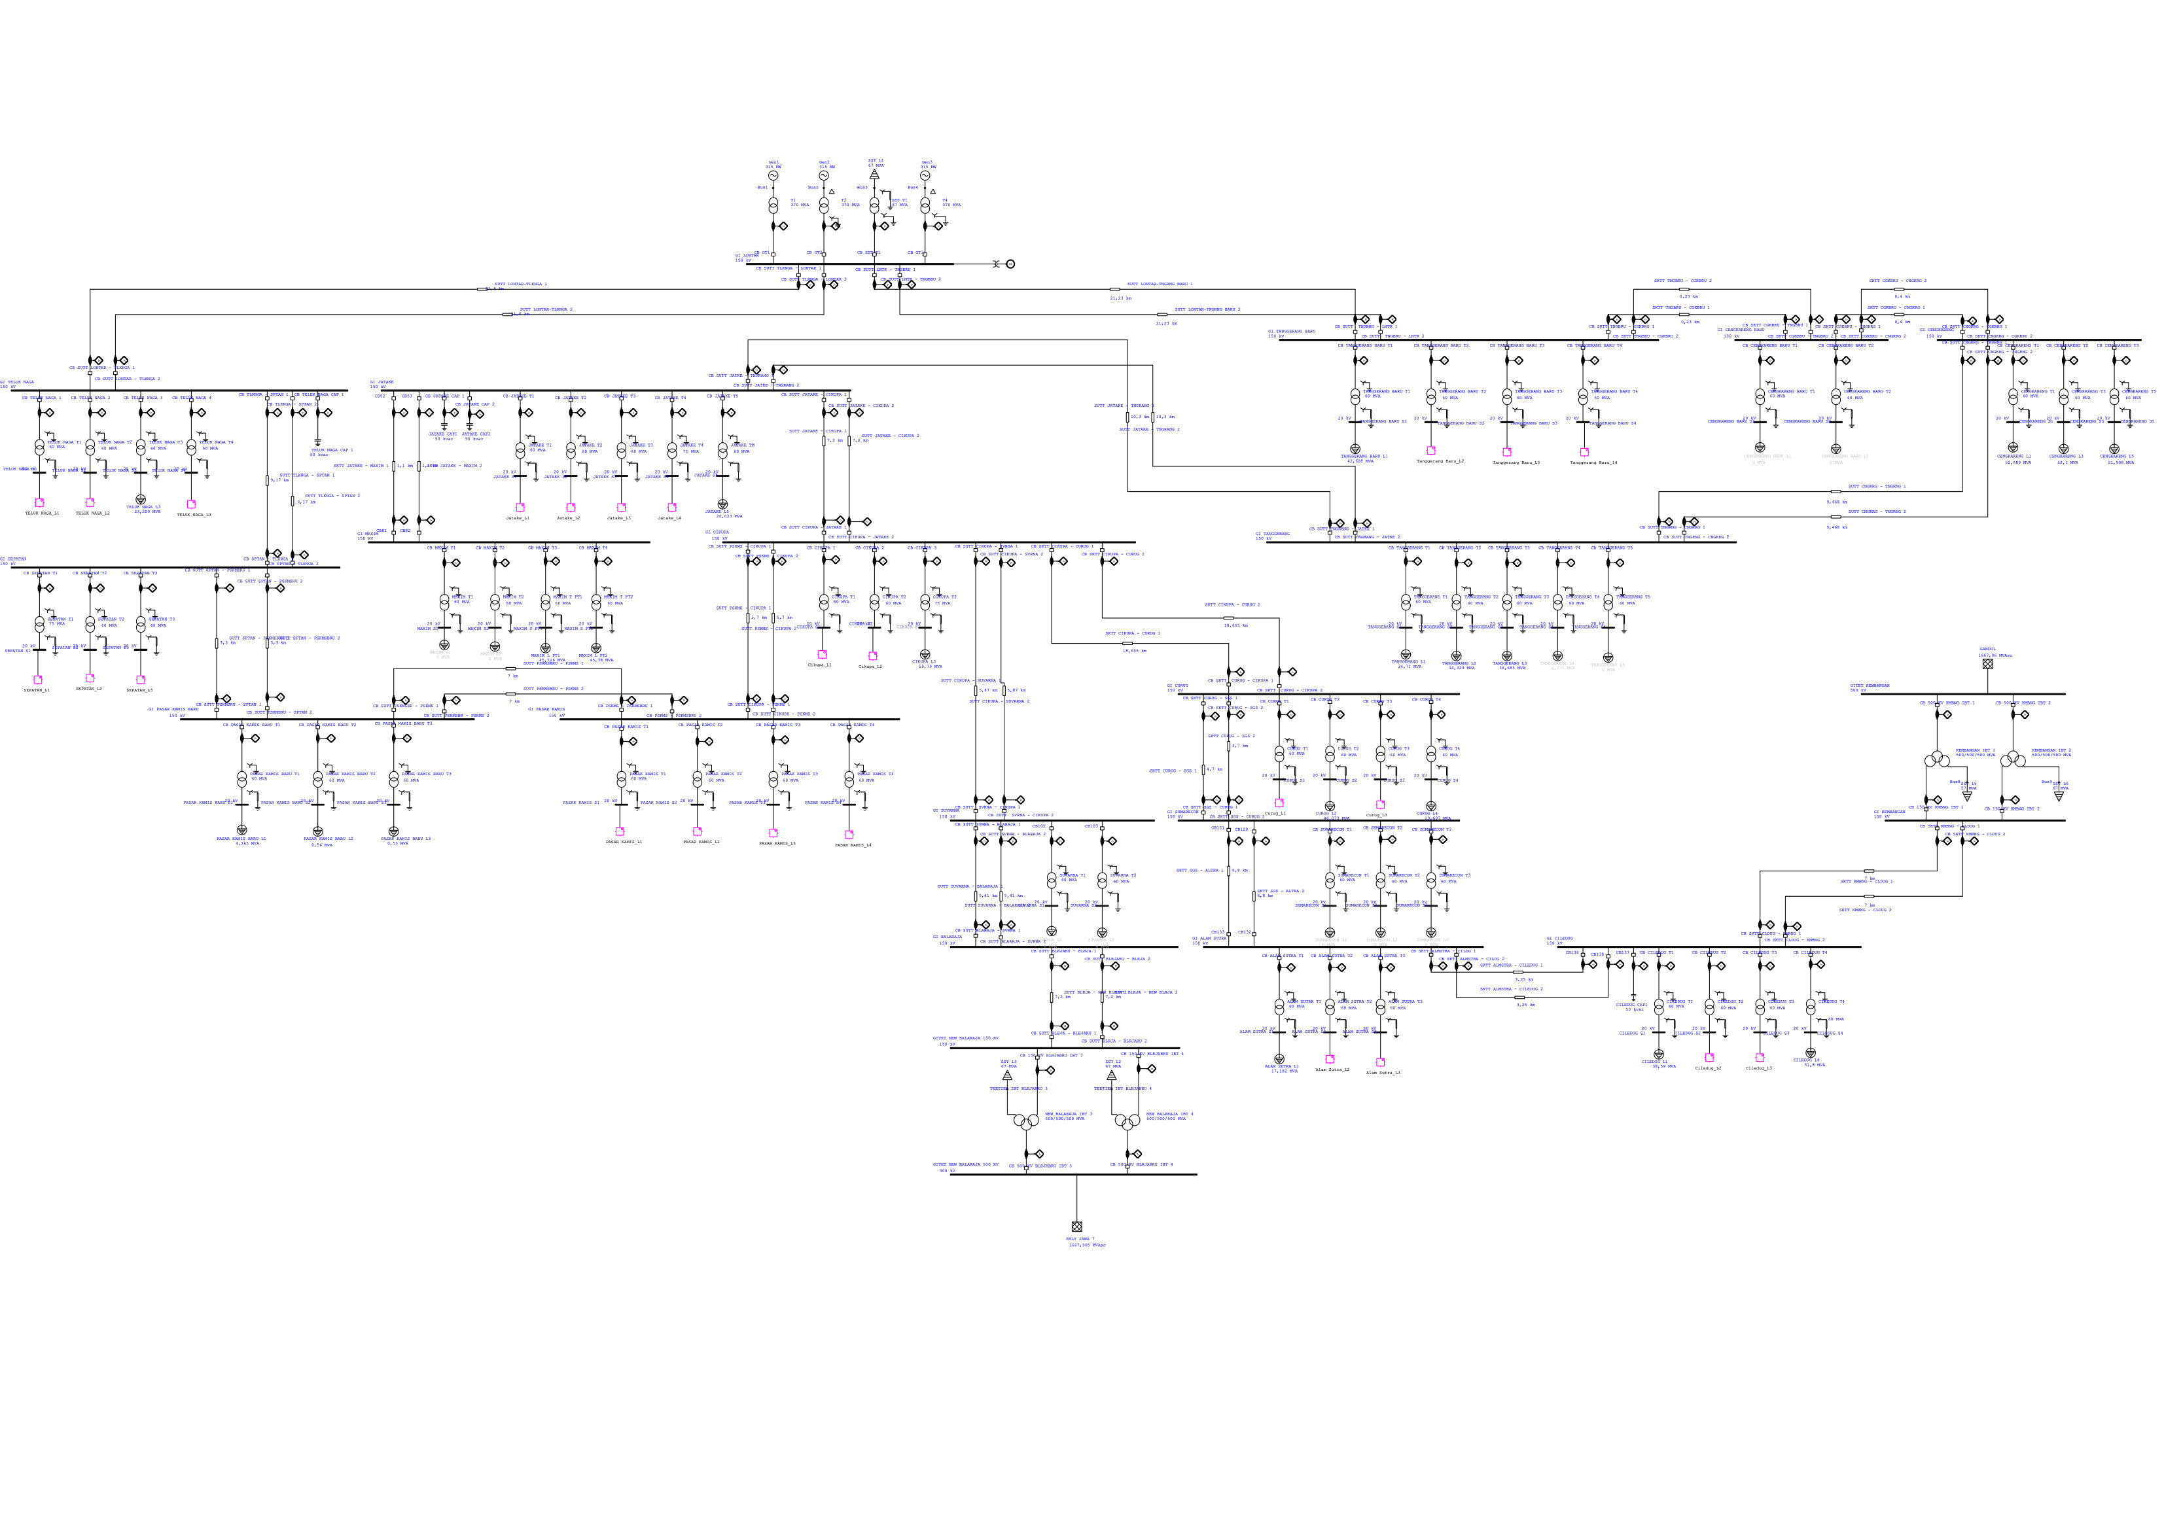
Figure 4. Single Line Diagram of Lontar-Balaraja Sub-System 3,4 - Kembangan 1,2 [12]
Figure 3.2 describes the Java – Madura – Bali operating system which focuses on the Lontar-Balaraja 3,4 – Kembangan 1,2 Sub-system which is operated by PT. PLN (Persero) P2B – Regional Load Operator of Jakarta and Banten. There are 3 generating units (power plants) and 21 substations operating at 150kV and 4 IBT 500/150kV located in Balaraja and Kembangan. The generating units are Lontar Generator unit 1, unit 2, and unit 3 serving West Jakarta City, Tangerang City, Tangerang Regency, and South Tangerang City which have an average load of 1900MW at peak season.

B. BESS Single Line
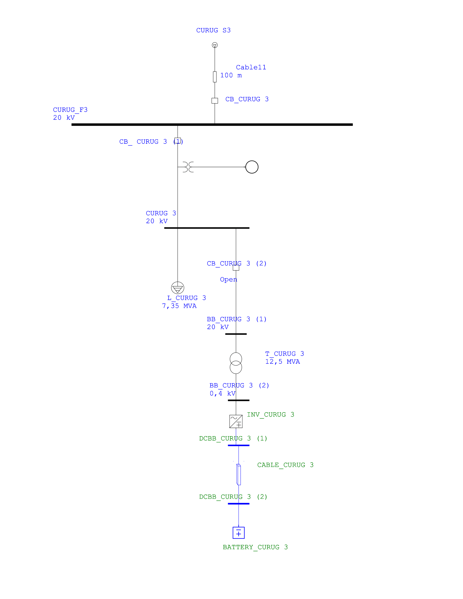
Figure 5. Single line BESS using the ETAP program on Transformer 3 at the Curug Substation.
Figure 4 shows a model of how BESS is placed at sub-stations in the Lontar-IBT Balaraja 3 and 4 – IBT Kembangan 1 and 2 sub-systems to facilitate the placement and installation of BESS. BESS can be obtained with the existing capacity at the market without adjusting BESS and maximizing land use at the substation operated by PT. PLN (Persero) UITJBB - Duri Kosambi. [13]
BESS is installed for feeders in the 20 kV distribution section to maximize the BESS function in addition to voltage control, it can also operate as a backup supply to the transformer. If the disturbance worsens and the voltage drops more than 135 kV, the UVR will enter the BESS direction CB and BESS will supply the load so there is no decrease in that power quality. [14]
After the system voltage becomes normal at 150 kV by re-operation of the IBT on the Balaraja and Kembangan Substations or Lontar power plant, BESS will be off. It will exit the system which is automatically controlled by setting VR to 150 kV and adding a Time Delay Relay which ensures that the frequency is stable. For this study when the voltage value has not met the 150 kV VR setting, the BESS will be issued manually by the HMI.
SIMULATION AND ANALYSIS
The testing and simulation at the substation has been analyzed using the ETAP program to get a more precise calculation of the Stability and Transient Analyst values. Hopefully it become a better test model that can be proposed with a better research conclusions, especially for the impact of the power system.

A. Normal Operating System with BESS

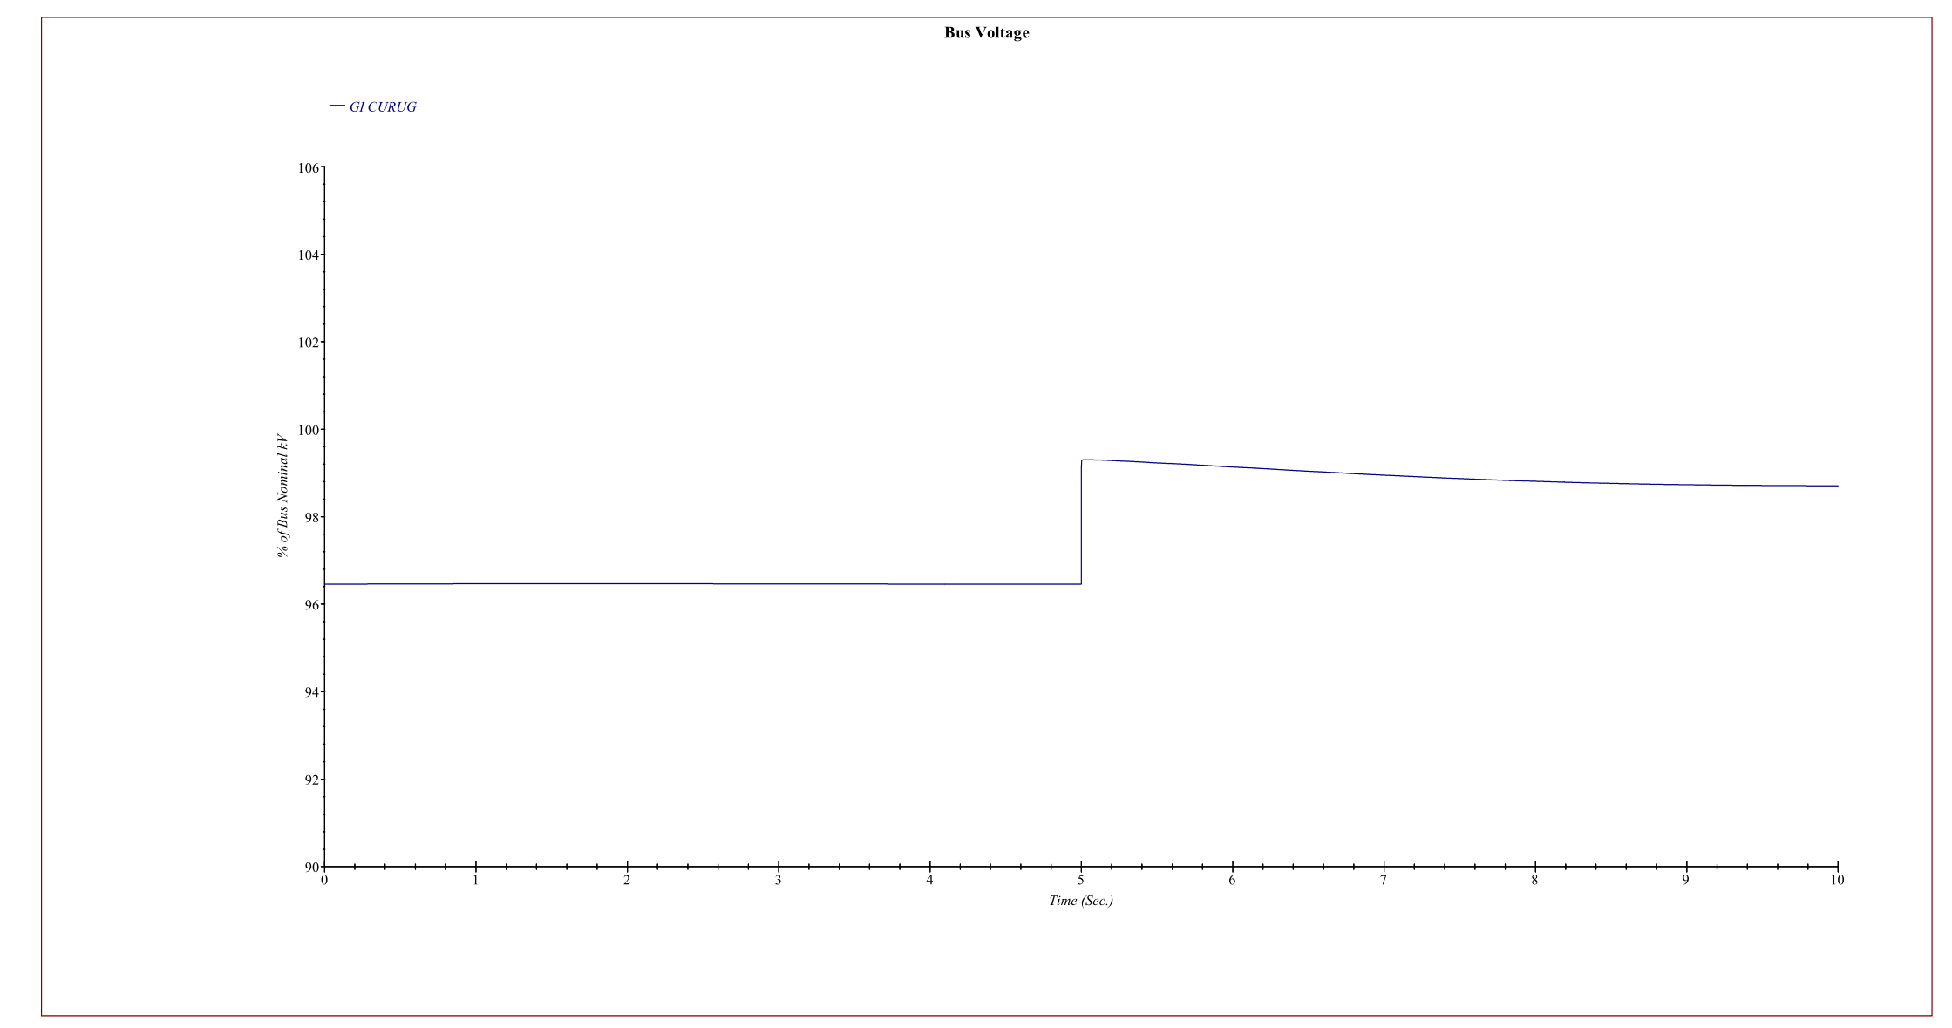
Figure 6. Graph of the voltage on the ETAP in testing the normal scheme of system operation with BESS at the Curug Substation.
When the VR tested by the ETAP program using a temporary simulation for about 9 seconds, for the VR test at variable voltage, the initial voltage before BESS enters is at a voltage of 144.7 kV. Then when BESS enters the grid via manual control of HMI, the initial voltage is up to 144.7 kV or 100% and then rises to 148.1 kV. In this condition, the system experiences improvement in voltage and power quality, so the system becomes more reliable and stable.
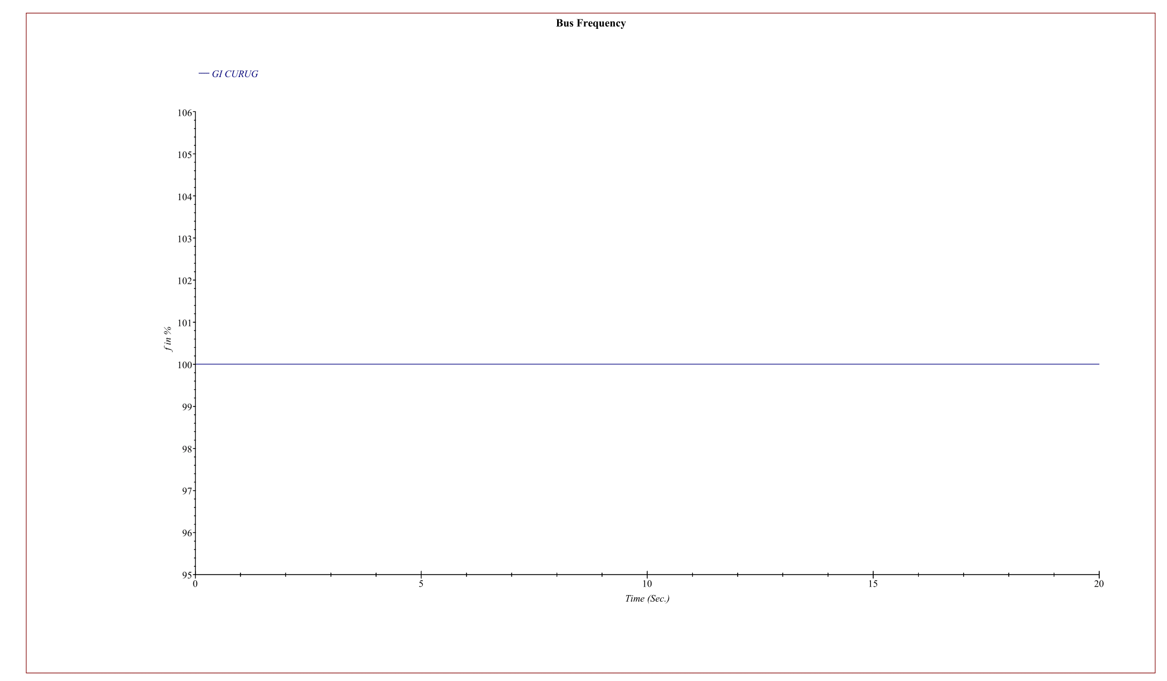
Figure 7. Graph of the frequency on the ETAP in testing the normal scheme of system operation with BESS at the Curug Substation.
When the VR tested by the ETAP program calculates a temporary simulation for about 9 seconds, for the VR test on variable frequencies, the initial voltage before BESS enters is at a frequency 50 Hz. Then when BESS enters the grid through manual control of HMI, the frequency remains at 50 Hz. There is no change in frequency in the use of BESS. So that BESS is safe to use without adversely affecting the system.

B. System Operation When Disturbance Without BESS
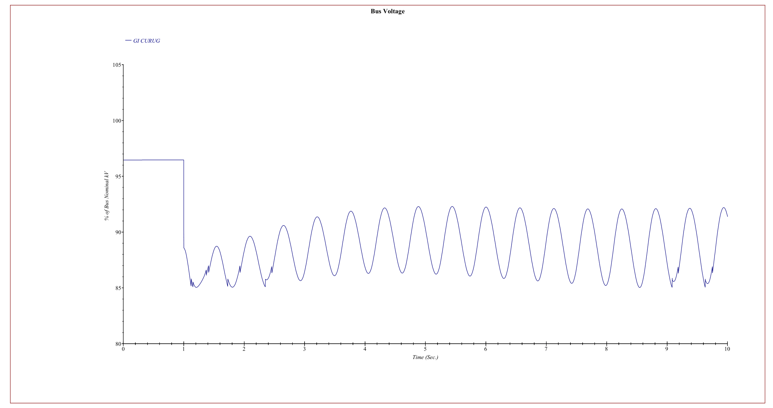
Figure 8. Graph of the stress voltage on the ETAP in the voltagre test system operation when interference without BESS at the Curug Substation.
When the VR tested by the ETAP program calculates a temporary simulation for about 9 seconds, for UVR tests on variable voltages, the initial voltage before interference is at a voltage of 144.7kV kV. Then when a disturbance occurs the voltage begins to fluctuate, the voltage decreases to 130.8kV. In this condition, all loads get a drop in power quality.
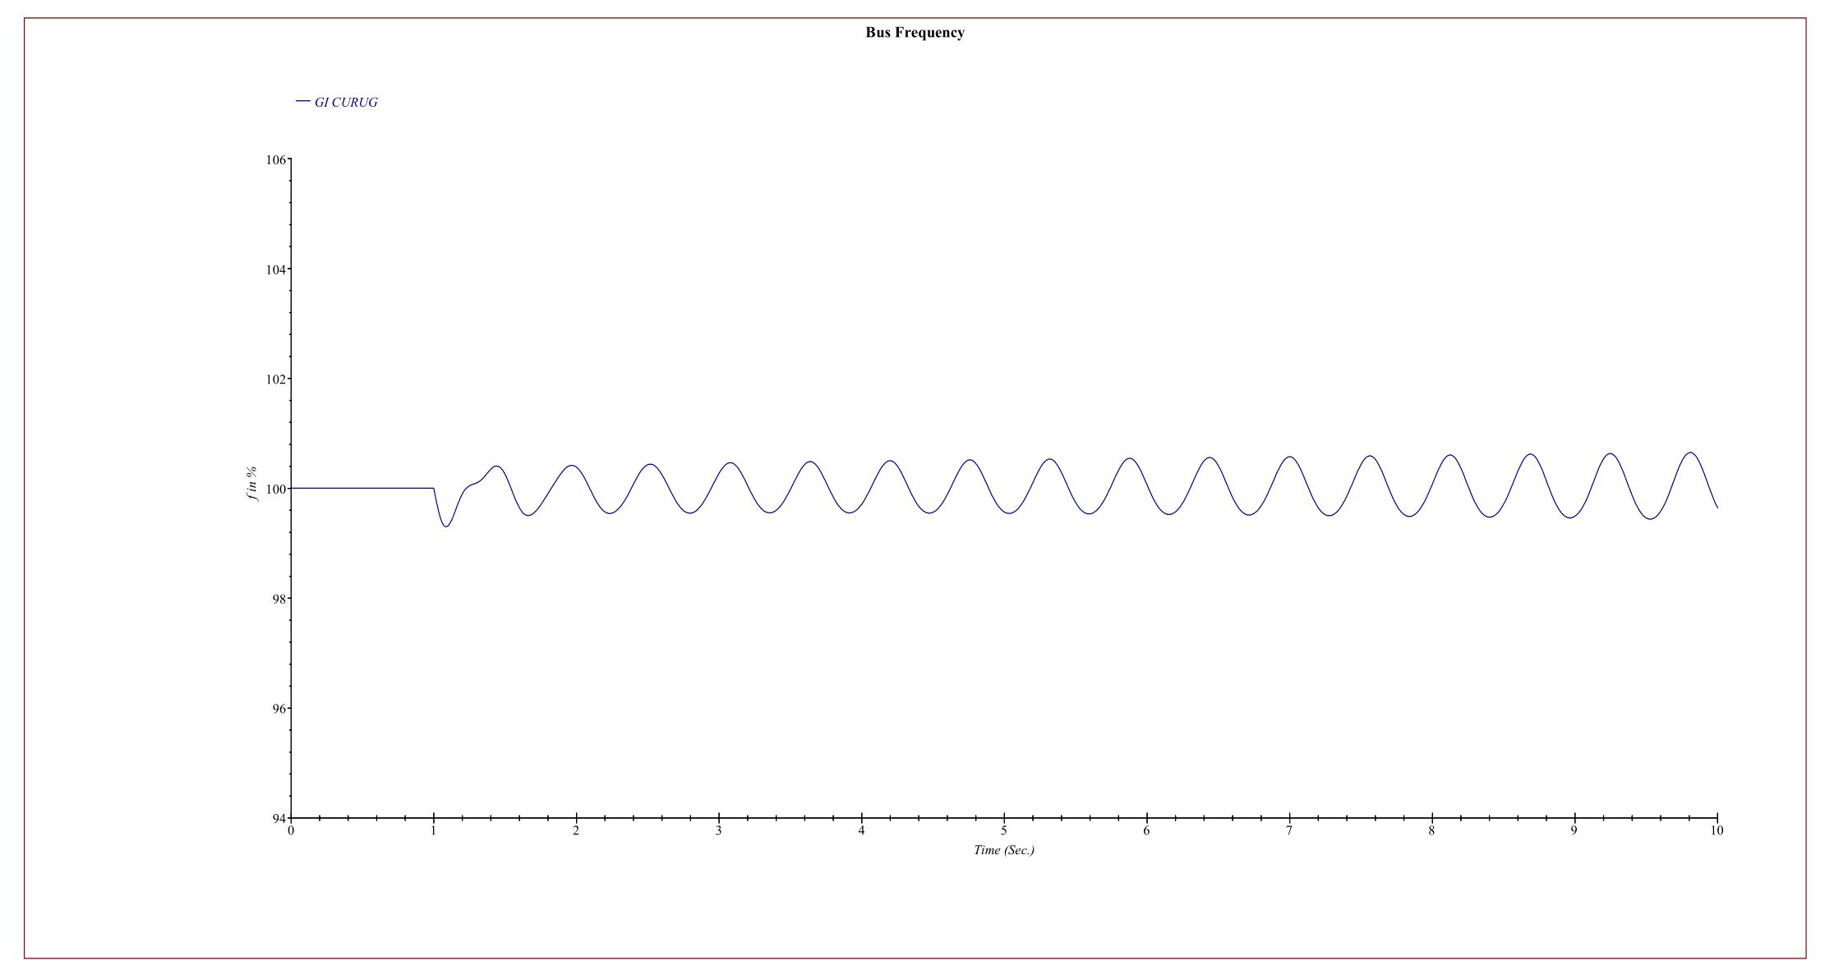
Figure 9. Graph of the stress frequency on the ETAP in the voltagre test system operation when interference without BESS at the Curug Substation.
When the VR tested by the ETAP program calculates a temporary simulation for about 9 seconds, for UVR tests on variable frequency, the initial frequency before interference is at a frequency of 50Hz. Then when a disturbance occurs the frequency begins to fluctuate, the frequency decreases to to 49.75 Hz. In this condition, all loads get a drop in power quality.
C. System Operation When Interrupted With BESS
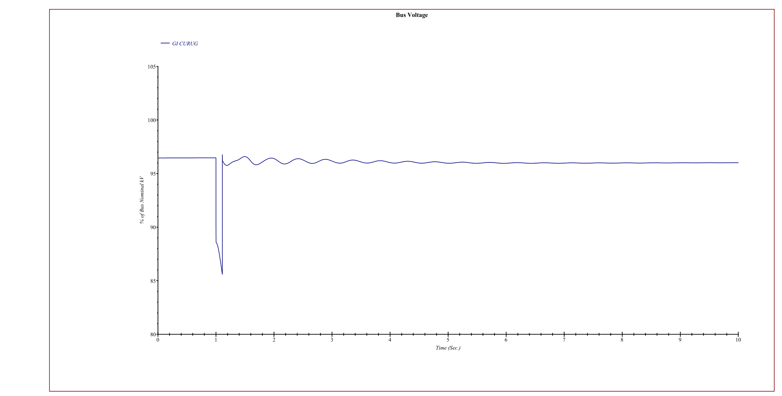
Figure 10. Graph of the voltage on the ETAP in testing the system operating scheme when faulting with BESS at the Curug Substation.
When the VR tested by the ETAP program using Transient Simulation for 9 seconds, for the VR test on a voltage variable, the initial voltage before the disturbance was at a voltage of 144.7 kV. Then when the disturbance occurred in the first second of time, the voltage began to drop and the voltage drops to 130.8kV. This triggers the VR operation and triggers the CB on the BESS to connect the BESS to the load then the voltage is stabilized at 144.0 kV. As a result, the burden of power quality degradation on the grid system can be avoided.
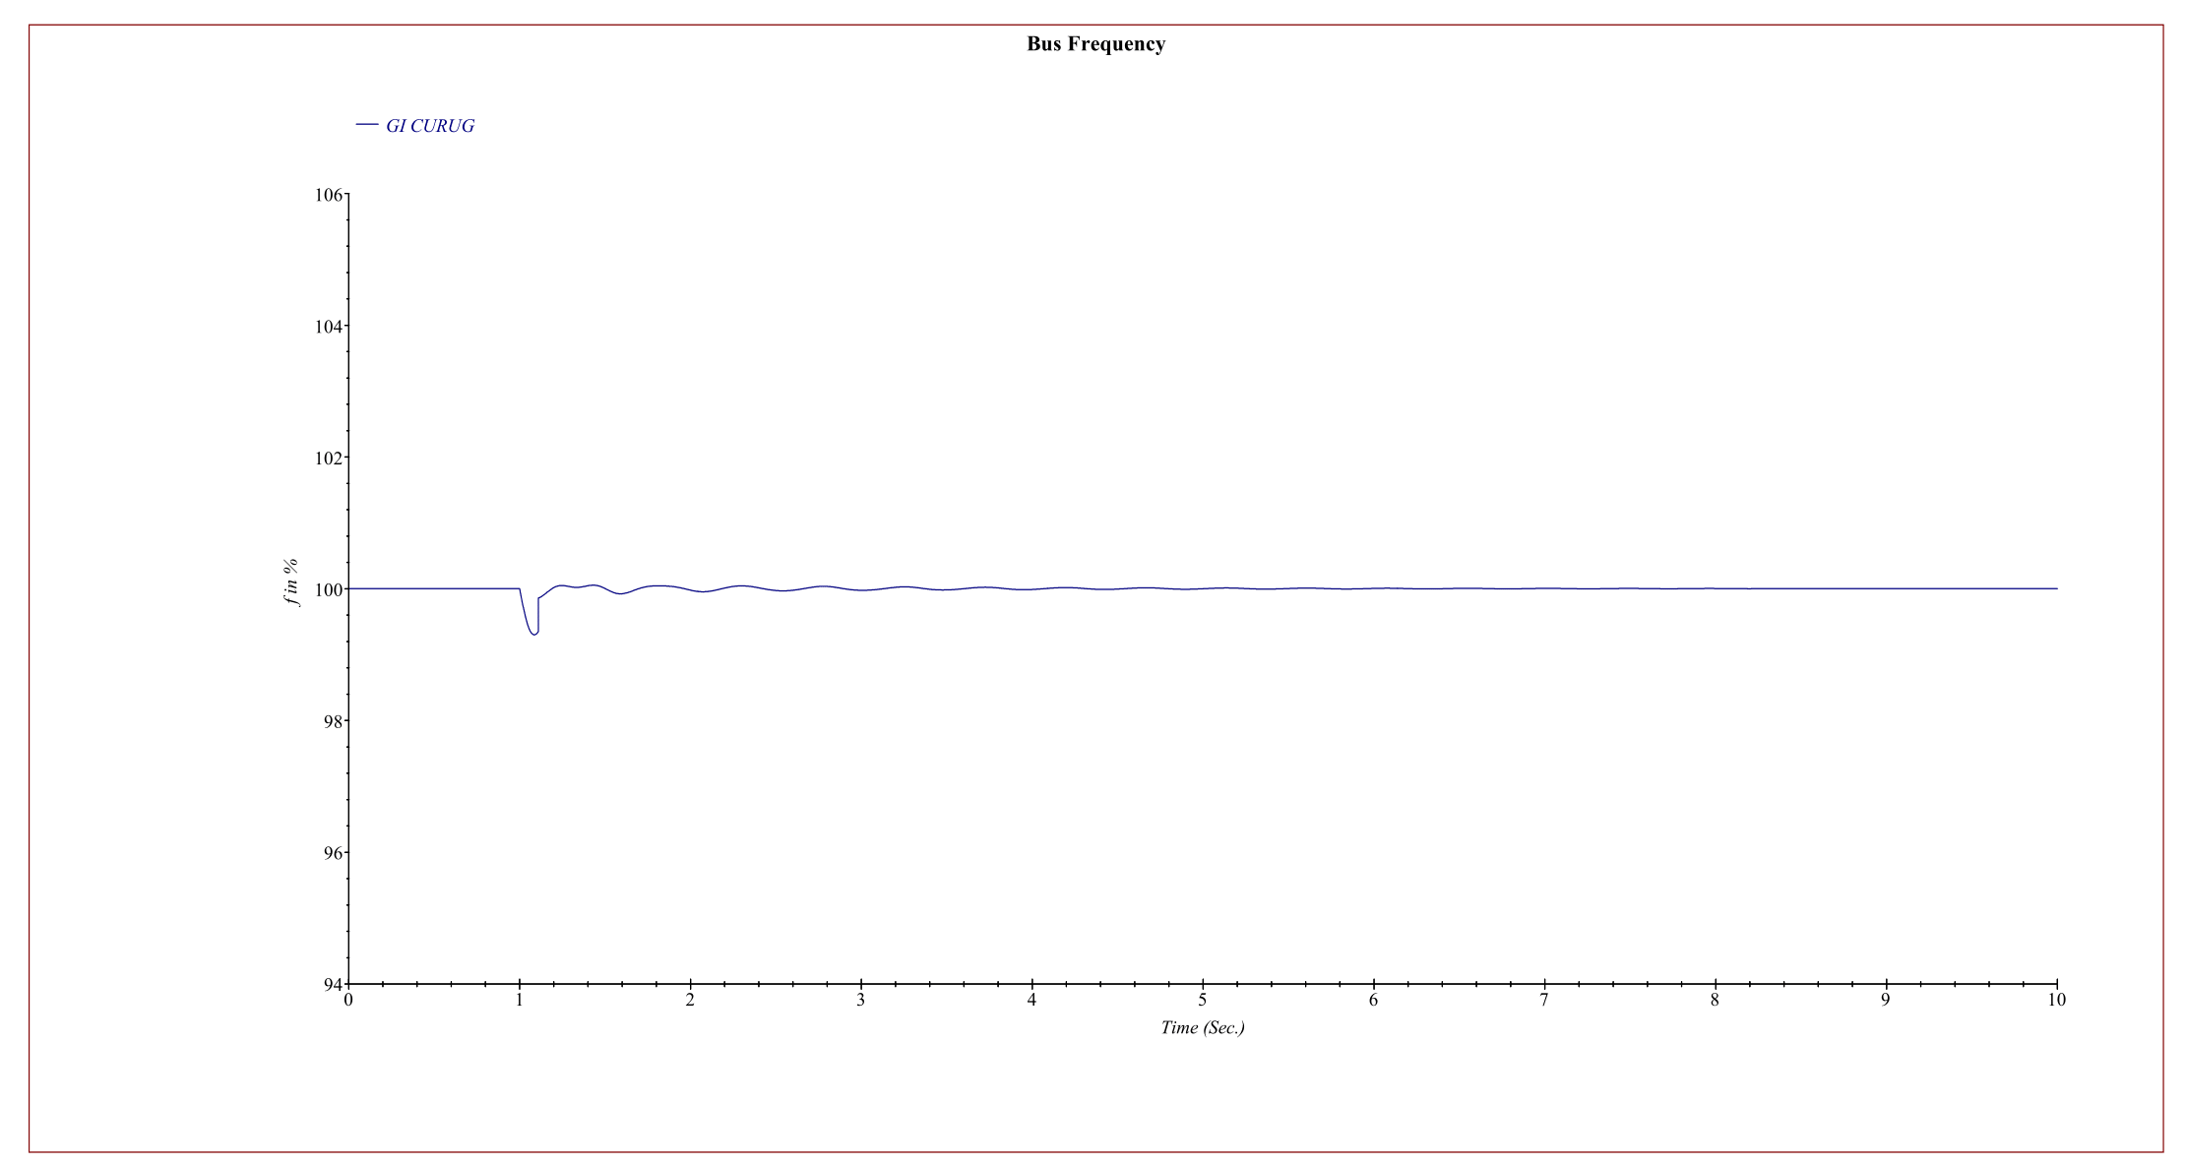
Figure 11. Graph of the frequency on the ETAP in testing the system operating scheme when faulting with BESS at the Curug Substation.
When the VR tested by the ETAP program using Transient Simulation for 9 seconds, for the VR test on variable frequency, the initial frequency before the disturbance was at a frequency of 50Hz. Then when the disturbance occurred in the first second of time, the frequency began to drop and the frequency drops to 49.75 Hz. This triggers the VR operation and triggers the CB on the BESS to connect the BESS to the load then the frequency is stabilized at 50 Hz. As a result, the burden of power quality degradation on the grid system can be avoided.

D. System Operation When Troubleshooting With BESS
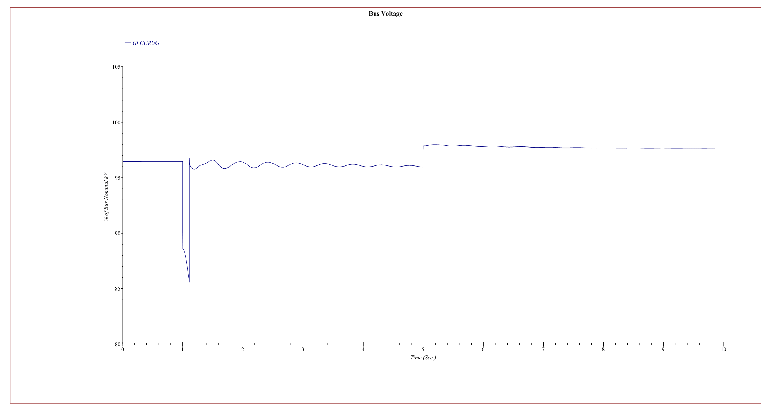
Figure 12. Graph of the voltage on the ETAP in testing the system operating scheme when fault recovery with BESS at the Curug Substation
When the test of VR is conducted by the ETAP tool using Transient Simulation for 9 seconds, while the VR test on a voltage variable, the initial voltage before the disturbance was at a voltage of 144.7 kV. When the disturbance occurred in the first second of time, the voltage began drop to 130.8kV. It command the work of VR and instruct the CB of BESS to connect the BESS to the network, so the voltage becomes stable at 144.0 kV. Then at the 5th-second of time, the generator on the operating system starts normally so the voltage becomes that stable at 146.5 kV. When the generator starts normally and system back to normal, BESS ready to came out from the system.
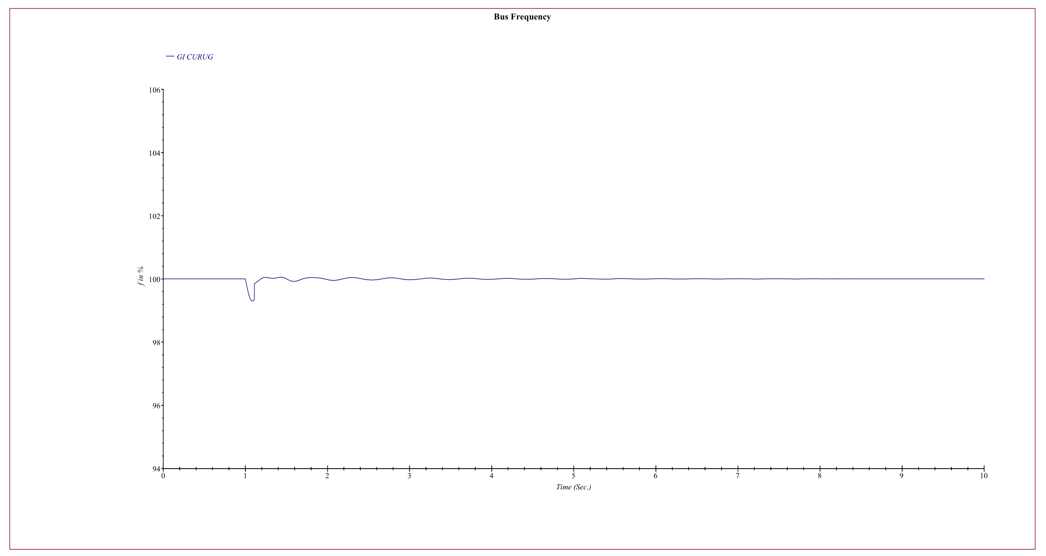
Figure 13. Graph of the frequencyon the ETAP in testing the system operating scheme when fault recovery with BESS at the Curug Substation
When the test of VR is conducted by the ETAP tool using Transient Simulation for 9 seconds, while the VR test on a frequency variable, the initial frequency before the disturbance was at a frequency of 50Hz. When the disturbance occurred in the first second of time, the frequency began drop to 49,75Hz. It command the work of VR and instruct the CB of BESS to connect the BESS to the network, so the frequency becomes stable at 50 Hz. Then at the 5th-second of time, the generator on the operating system starts normally so the frequency becomes that stable at 50Hz. When the generator starts normally and system back to normal, BESS ready to came out from the system.
E. System Operation when Troubleshooting with BESS Normalization
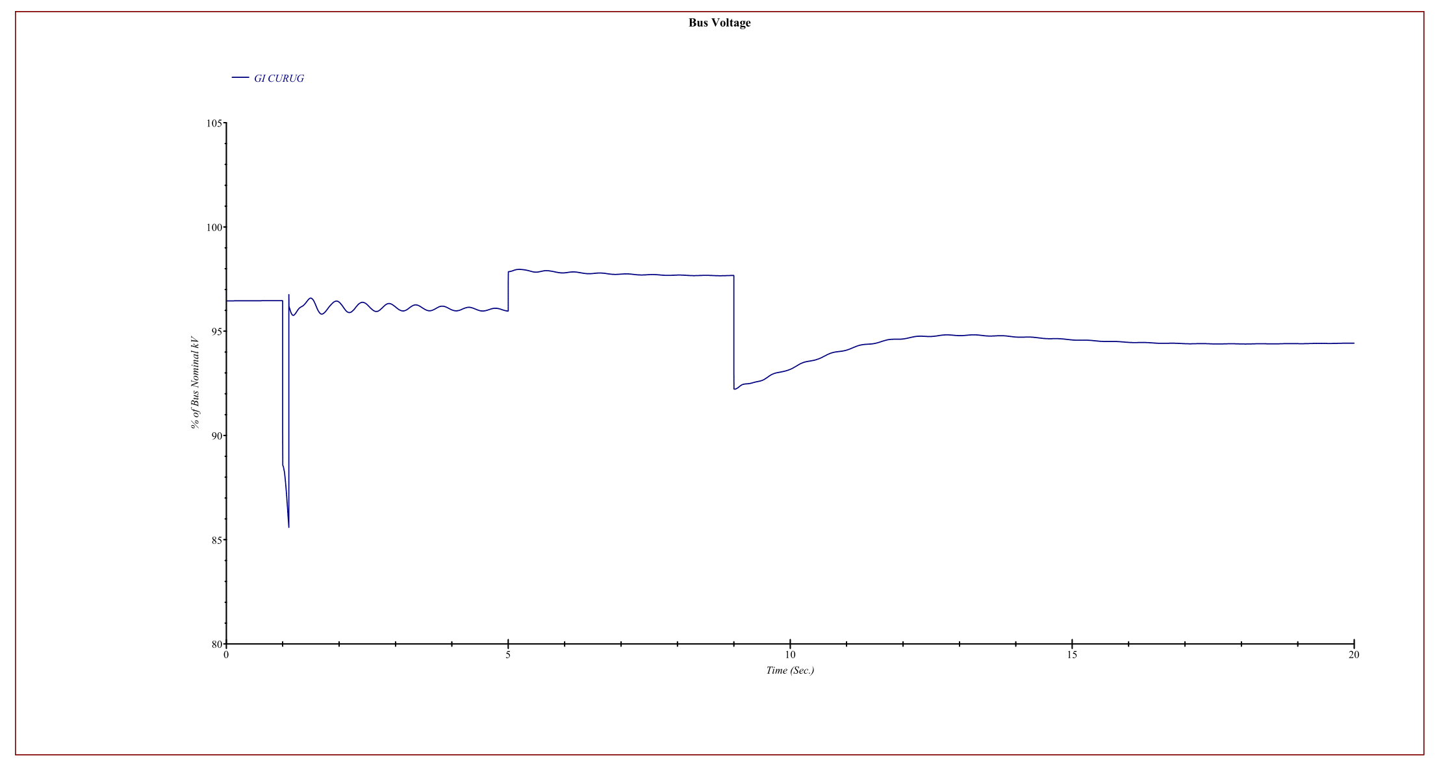
Figure 14. Graph of the ETAP voltage in testing the system operating scheme when fault recovery with normalization BESS at the Curug Substation
When the VR tested by the ETAP program using Transient Simulation for 20 seconds, while the VR test on variable voltage, the initial voltage before the disturbance was at a voltage of 144.7 kV. In case the disturbance occurred in the first second of time, the voltage began to drop until 130.8kV. This initiated the VR in operation mode and started the CB of BESS to connect the BESS to the power network, so the voltage becomes stable at 144.0 kV. At the 5th second, the power generation on the grid starts normally to stabilize the voltage at 146.5 kV. Then at the 9th second, BESS came out when the system was back normal so the voltage dropped astray and became that stable at a voltage of 141.6kV. BESS have come out from the system and the voltage goes back to normal.
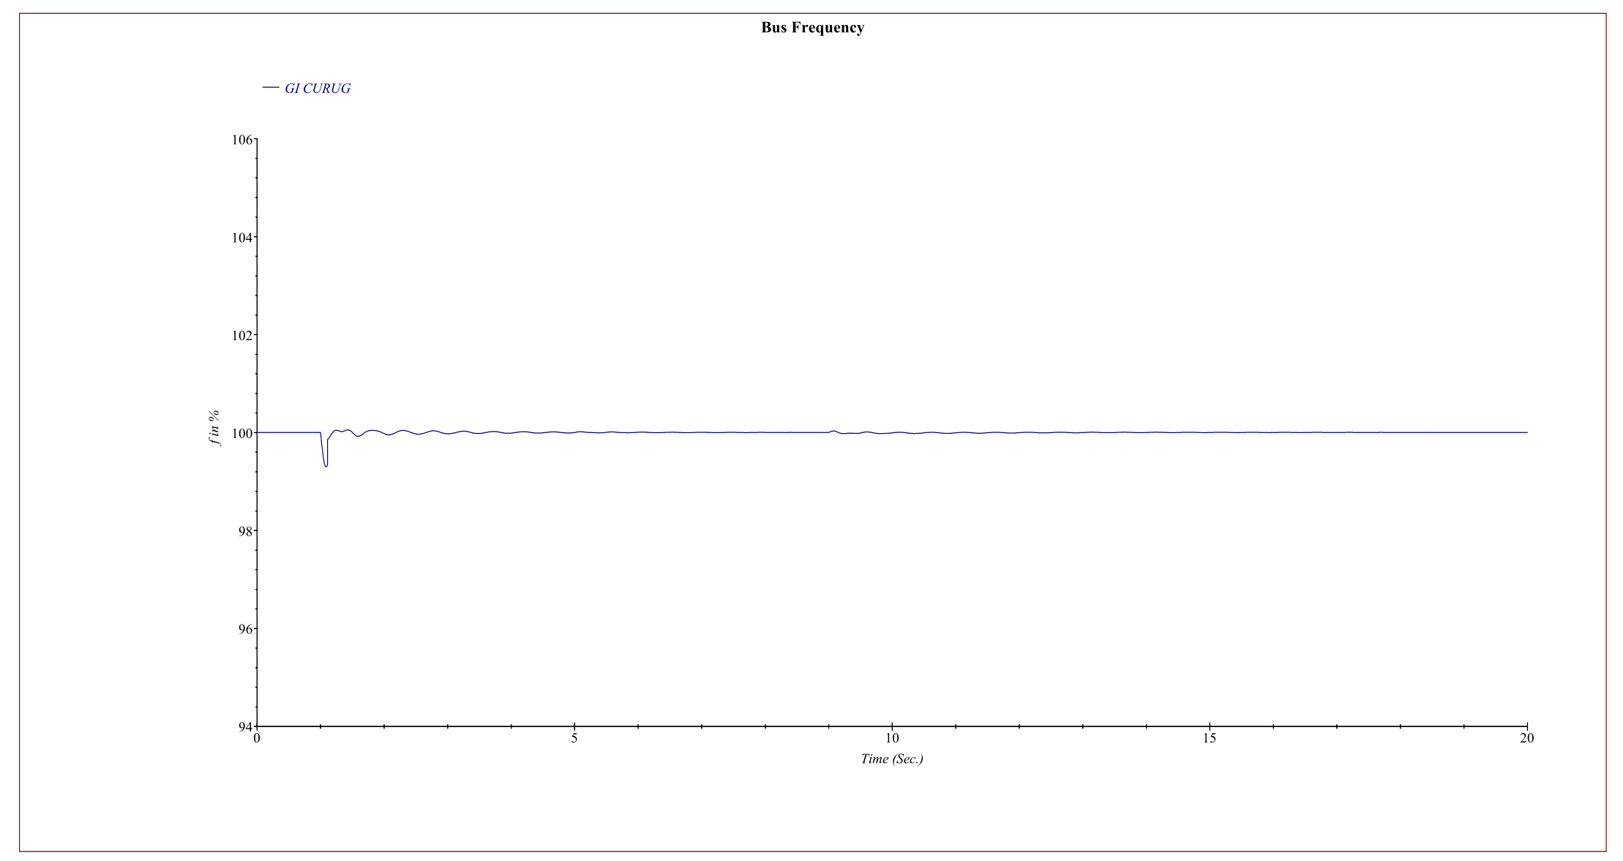
Figure 15. Graph of the ETAP frequency in testing the system operating scheme when fault recovery with normalization BESS at the Curug Substation
When the VR tested by the ETAP program using Transient Simulation for 20 seconds, while the VR test on variable frequency, the initial voltage before the disturbance was at frequency of 50Hz. In case the disturbance occurred in the first second of time, the frequency began to drop until 49,75Hz. This initiated the VR in operation mode and started the CB of BESS to connect the BESS to the power network, so the frequency becomes stable at 50Hz kV. At the 5th second, the power generation on the grid starts normally to stabilize the frequency at 50Hz. Then at the 9th second, BESS came out when the system was back normal so the frequency still stable at frequency of 50Hz.
The results of all ETAP modelling test can be seen and summarized at the table 1 below.

Table 1. Test results before and after using BESS at the Curug Substation
Gardu Induk Curug 150kV | Frequency before Disruption | Voltage before Disruption | Frequency after Disruption | Voltage after Disruption
Operation System without BESS | 50 Hz | 144,7kV | 50Hz | 148,1kV
Operational BESS as Frequency Regulator test | 50 Hz | 144,7kV | 49,75 Hz | 130,8kV
Operational BESS as Back Up test | 50 Hz | 144,7 kV | 50 Hz | 144,0kV
Normalization Source testing | 50 Hz | 144,7kV | 50 Hz | 146,5kV
Normalization BESS testing | 50 Hz | 144,7kV | 50 Hz | 141,6kV
Refer to table 1. BESS is installed at the substation (in this case at the GI Curug busbar) with the pre-fault voltage at 144.7 kV and the pre-interference frequency at 50Hz. Then to regulate and increase the voltage under normal circumstances, BESS can increase the voltage from 144.7kV to 148.1kV. Before using BESS, tests show that when there is a disturbance the voltage and frequency drop to 130.1kV and 49.7Hz. Then after using BESS as a voltage control, the voltage and frequency are stable at 144.0kV and 50Hz when there is a major disturbance in the grid system. Then after the source of normalization of power generation, the voltage and frequency are stable at 146.5kV and 50Hz. Then after the BESS comes out of the grid system, the voltage and frequency are stable at 141.6kV and 50Hz. By adding BESS to the network, the power quality of the system becomes stable and reliable under peak load as well as when overcoming interruptions.
CONCLUSION
Based on the modelling simulation tests, this study has proven that BESS can work well as a voltage regulator in a power system. BESS can operate quickly to increase the voltage on the grid system so the decreasing in power quality in that grid system can be minimized and even avoided. This supports several previous studies focusing on Battery Energy Storage Systems for Primary Frequency Response. [15]
Simulations to test BESS as a voltage booster when normal conditions in the network have been carried out. In this scenario, the HMI can work manually at an initial voltage of 144.7kV then BESS increases the voltage at the grid with a voltage and frequency of 148.1 kV. In this condition, the voltage and power quality is improved to be more reliable and stable.
In addition, this study shows that the application of BESS can support the UVR mechanism at the Substation by increasing the power quality initiated by the UVR control when a disturbance occurs on the grid. The UVR can operate well at the voltage of 135kV and BESS can control the voltage to recover the system at 144.0 kV. For source normalization test in case of disturbance, BESS can work well as a voltage regulator to push back both voltage and frequency to the original seeting at 5 seconds after the disturbince exist. .
This study also shows that BESS can work well as a frequency controller in the BESS Normalization test in case of interference, after the 5th second of power interruption. BESS operation as frequency control is still within the standard limits under the Regulation of the Minister of Energy and Mineral Resources number 03 year 2007 concerning the Java-Madura-Bali Operating System rules so the power quality of that operating system can still operate properly using BESS. [16]
Indeed, this simulation and modelling study still has some limitation. The test results can be compared with other software modelling for achieve an external validity and accurate measurement. This research is conducted only at one location of the power grid with certain operational characteristics. Further research is recommended to study BESS in several locations, different substation technologies, various loads and demands, and other BESS capacities. To obtain a comprehensive result and an action plan for its implementation, it is necessary to conduct a financial review of the implementation of BESS as a frequency regulation on the grid.
REFERENCES _
[1] F. U. Ahmed and M. H. Chowdhury, “An asynchronous reconfigurable switched capacitor voltage regulator,” Midwest Symp. Circuits Syst., vol. 2018-Augus, pp. 1110–1113, 2019, doi: 10.1109/MWSCAS.2018.8623895.
[2] H. Bielokha and Y. Samcheleev, “Electromagnetic compliant of voltage source with relay control,” Proc. Int. Conf. Mod. Electr. Energy Syst. MEES 2017, vol. 2018-Janua, pp. 32–35, 2017, doi: 10.1109/MEES.2017.8248921.
[3] A. F. Bin Abidin and A. Mohamed, “On the use of voltage stability index to prevent undesirable distance relay operation during voltage instability,” 2010 9th Conf. Environ. Electr. Eng. EEEIC 2010, no. 1, pp. 384–387, 2010, doi: 10.1109/EEEIC.2010.5489947.
[4] Mohamad Tresna Wikarsayang, "STUDY OF UNDER FREQUENCY RELAY, JAVA BALI ELECTRICITY SYSTEMS," PT PLN PENYALURAN DAN Pus. LOAD CONTROL JAVA BALI , 2013.
[5] R. Hidalgo-Leon et al. , “A survey of battery energy storage system (BESS), applications and environmental impacts in power systems,” 2017 IEEE 2nd Ecuador Tech. Chapters Meet. ETCM 2017 , vol. 2017-January, pp. 1–6, 2018, doi:10.109/ETCM.2017.8247485.
[6] Asian Development Bank, Handbook on Battery Energy Storage System , no. December. 2018.
[7] Z. Arifin, “Optimal Sizing and Performance Assessment of a Hybrid Diesel and Photovoltaic with Battery Storage Limited by a Take-or-Pay Contract of Power Purchase Agreement in Nusa Penida Island , Indonesia,” vol. 11, no. 3, 2021.
[8] B. Ge et al., “An Active Filter Method to Eliminate DC-Side Low-Frequency Power for a Single-Phase Quasi-Z-Source Inverter,” IEEE Trans. Ind. Electron., vol. 63, no. 8, pp. 4838–4848, 2016, doi: 10.1109/TIE.2016.2551680.
[9] B. Kasztenny et al., “Exploring the IEEE C37.234 guide for protective relay application to power system buses,” 2011 64th Annu. Conf. Prot. Relay Eng., pp. 29–36, 2011, doi: 10.1109/CPRE.2011.6035602.
[10] S. Xiao, W. Qiu, G. Miller, T. X. Wu, and I. Batarseh, “An active compensator scheme for dynamic voltage scaling of voltage regulators,” IEEE Trans. Power Electron., vol. 24, no. 1, pp. 307–311, 2009, doi: 10.1109/TPEL.2008.2005773.
[11] D. I. Panfilov, M. I. Petrov, and M. G. Astashev, “Analysis of Voltage Regulators with Boost Voltage,” Proc. - 2019 IEEE Int. Conf. Environ. Electr. Eng. 2019 IEEE Ind. Commer. Power Syst. Eur. EEEIC/I CPS Eur. 2019, pp. 1–6, 2019, doi: 10.1109/EEEIC.2019.8783879.
[12] P. P2B, “Up2b dki jakarta dan banten,” 2019.
[13] T. Thien, H. Axelsen, M. Merten, H. Axelsen, S. Zurmùhlen, and M. Leuthold, “Planning of Grid-Scale Battery Energy Storage Systems: Lessons Learned from a 5 MW Hybrid Battery Storage Project in Germany,” Battcon - Int. Station. Batter. Conf. 2015, no. 03, p. 10, 2015.
[14] E. Sosnina, A. Asabin, A. Kralin, and R. Bedretdinov, “Research of voltage and power solid-state regulator in 6-20 kV network,” 2016 2nd Int. Conf. Ind. Eng. Appl. Manuf. ICIEAM 2016 - Proc., pp. 16–20, 2016, doi: 10.1109/ICIEAM.2016.7911001.
[15] Z. Arifin and A. Firmanto, “Battery Energy Storage System as Frequency Control at Substation based on Defense Scheme Mechanism,” pp. 153–160, 2021, doi: 10.1109/isitia52817.2021.9502263.
[16] K. Minister et al. , "Minister of Energy and Mineral Resources of the Republic of Indonesia," vol. 2009, pp. 1–8, 2012.

