Performance of Speech Enhancement Models in Video Conferences: DeepFilterNet3 and RNNoise | 

M. Iqbal Maulana^{1*}, Muhammad Fadhlillah Raisul Akbar¹, Zendi Iklima^{1*}
¹Department of Electrical Engineering, Faculty of Engineering, Universitas Mercu Buana, Indonesia

Abstract  As remote work and online education continue to gain prominence, the importance of clear audio communication becomes crucial. Deep Learning-based Speech Enhancement has emerged as a promising solution for processing data in noisy environments. In this study, we conducted an in-depth analysis of two speech enhancement models, RNNoise and DeepFilterNet3, selected for their respective strengths. DeepFilterNet3 leverages time-frequency masking with a Complex Mask filter, while RNNoise employs Recurrent Neural Networks with lower complexity. The performance evaluation in training revealed that RNNoise demonstrated impressive denoising capabilities, achieving low loss values, while DeepFilterNet3 showed superior generalization. Specifically, "DeepFilterNet3 (Pre-Trained)" exhibited the best overall performance, excelling in intelligibility and speech quality. RNNoise also performed well in subjective quality measures. Furthermore, we assessed the real-time processing efficiency of both models. Both RNNoise variants processed speech signals almost in real-time, whereas DeepFilterNet3, though slightly slower, remained efficient. The findings demonstrate significant improvements in speech quality, with "DeepFilterNet3 (Pre-Trained)" emerging as the top-performing model. The implications of this study have the potential to enhance video conference experiences and contribute to the improvement of remote work and online education.  This is an open access article under the CC BY-SA license   | Keywords:  Speech Enhancement;  DeepFilterNet3; RNNoise;  Accuracy Metrics; Speed Metrics;  Article History:  Received: May 2, 2023  Revised: May 29, 2023  Accepted: June 2, 2023  Published: June 2, 2023  Corresponding Author:  Zendi Iklima  Electrical Engineering Department, Universitas Mercu Buana, Indonesia  Email: zendi.iklima@mercubuana.ac.id

INTRODUCTION
As the world embraces remote work, video conferences have become essential communication tools [1]. They enable seamless connection and collaboration, overcoming physical distance in today's fast-paced world [2]. However, audio quality often suffers due to background noise, echo, and poor microphones, impacting clear communication [3]. While noise in online learning moderately affects students' task performance, overall noise levels don't significantly impact perceived performance difficulties [4].
Speech Enhancement techniques have gained significance [5] as they tackle the challenge of improving sound quality in video conferences. However, traditional noise reduction methods have limitations, leading to speech signal distortions. Therefore, there is a growing need for new and innovative approaches to ensure a better user experience [5].
Recent advancements in Deep Learning-based Speech Enhancement [6] have demonstrated promising results in addressing challenges related to processing data in noisy environments [7]. Complex value processing, particularly through the technique of time-frequency masking using a Complex Mask (CM) filter, has significantly improved Deep Learning for Speech Enhancement and signal extraction [8]. Unlike real-valued filters, CM allows phase modification, leading to enhanced signal quality [9]. The application of CM in speech enhancement and signal extraction tasks has shown better outcomes [10].
Through the comparative study of various models for speech quality enhancement, including RNNoise [11], DCCRN [12], NSNet2 [13], FullSubNet+ [14], GaGNet [15], FRCRN [16], DeepFilterNet [7], DeepFilterNet2 [17], and DeepFilterNet3[18], two models, RNNoise and DeepFilterNet3, were specifically chosen for in-depth analysis in this research due to their promising performance in different aspects. RNNoise was selected as a lightweight and efficient solution, while DeepFilterNet3 demonstrated state-of-the-art speech quality enhancement with a good balance between computational efficiency and superior results.
DeepFilterNet is an algorithmic model [19] that enhances speech quality using CM for speech enhancement through Deep Filtering. It consists of two stages: one for enhancing the spectral envelope with human frequency perception modeling [17], and another for enhancing periodic speech components using deep filtering. The approach leverages speech's perceptual nature and enforces network sparsity through separable and extensive grouping in linear and recurrent layers [7]. The same researchers extended the model to create DeepFilterNet2, optimized for real-time video conference Speech Enhancement, achieving better performance and running on embedded devices like Raspberry Pi 4 with a real-time factor of 0.42 [17]. This makes DeepFilterNet2 ideal for speech enhancement in video conferences and real-time applications. The model was further refined into DeepFilterNet3, improving noise suppression performance, fixing bugs, and introducing attenuation limiting at the implementation level using the LADSPA plugin [18].
In other way RNNoise, which shares the same function but relies on Recurrent Neural Networks (RNN) with lower complexity [11]. While DeepFilterNet3 and RNNoise has shown promising results in offline scenarios [18], its real-time performance, especially in video conferences for remote learning, remains understudied. This study aims to comprehensively evaluate both performance in real-time speech enhancement during video conferences through simulation. The assessment will cover training, validation, and final testing using selected samples. The model will be compared against Both models will be trained on the Voicebank + DEMAND dataset, containing multi person speech and noise samples [20], for comparative analysis. Additionally, the MIT IR Survey dataset of Room Impulse Responses (RIR) [21] will be used for training DeepFilterNet3.
The evaluation will compare two models in Speech Enhancement using samples from the JL Corpus dataset [22] for Clean Speech and the ESC 50 dataset [23] for background sounds. Key metrics include PESQ [24], STOI [25], "CSIG" (Signal-to-Noise Ratio improvement), "CBAK" (distortion introduced), and "COVL" (coherence) [26]. Additional metrics are SegSNR [27] and SiSDR [28]. Model parameters (Params[M]) [29], computational complexity (MACS[G]) [30], and Real-Time Factor (RTF) [31] will also be considered. These comparisons will identify each model's strengths and weaknesses for specific applications.
In conclusion, this research aims to analyze the performance of Speech Enhancement in audio for video conferences using the DeepFilterNet3 model and RNNoise as the tested implementation in online learning cases. The study has the potential to enhance video conference experiences and improve remote work and online education.

MATERIALS
This chapter explores the selected speech enhancement models and the datasets used in our study.

DeepFilterNet3
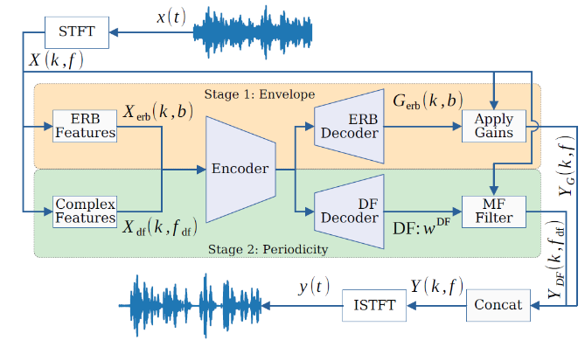
Figure 1. DeepFilterNet3 Block Diagram

DeepFilterNet3 [18] is an advanced real-time speech enhancement model, an evolution of the DeepFilterNet framework (presented in Figure 1). It utilizes deep filtering to estimate complex filters in the frequency domain, effectively leveraging short-term correlations in speech signals. By combining domain knowledge of speech production and psychoacoustic perception, the model achieves high efficiency while providing comparable performance to state-of-the-art speech enhancement benchmarks. DeepFilterNet3 has been trained on a multilingual dataset, delivering improved results on objective evaluation metrics. The model's real-time capabilities enable users to experience enhanced audio directly, with the flexibility to dynamically configure noise suppression settings. Additionally, DeepFilterNet3 can be applied for direct noise reduction during activities like video calls, making it a valuable tool for various speech processing and communication systems.

RNNoise
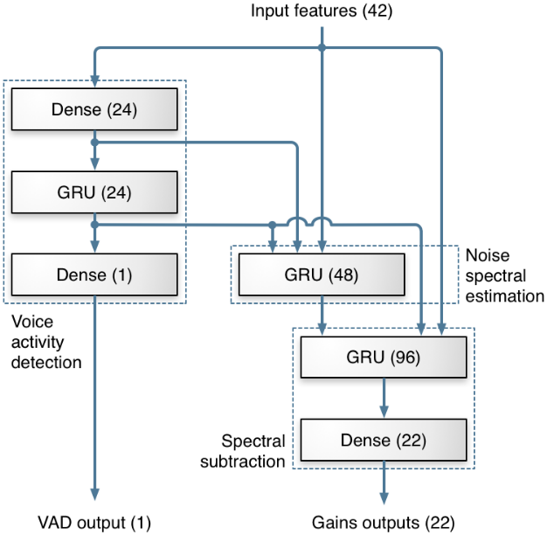
Figure 2. Topology of the RNNoise

The RNNoise [11] speech enhancement model is a real-time noise suppression algorithm that combines classic signal processing with deep learning techniques. It utilizes Gated Recurrent Units (GRUs), a type of recurrent neural network, to model time sequences, enabling effective noise estimation and suppression. The input to the neural network consists of cepstral coefficients based on the Bark scale, along with derivatives, pitch period, pitch gain, and a non-stationarity value. The neural network computes per-band gains to attenuate noise while preserving the speech signal. The model's deep architecture comprises three GRU layers, which map to the traditional steps of noise suppression (presented in Figure 2). Training data is generated by combining separate recordings of clean speech and various types of noise. The design and training of the neural network are performed in Python using Keras, while the runtime code is implemented in C to achieve real-time processing. The resulting model is small and efficient, making it suitable for deployment on resource-constrained devices like the Raspberry Pi.

Datasets
The study makes use of the following datasets:
- Clean Speech Training Dataset [20] (Voicebank): This dataset comprises 23,074 samples collected from 56 different speakers, with a combined size of 6.12 GB.
- Noise Training Dataset [20] (DEMAND): The noise training dataset consists of 272 samples obtained from 17 distinct environmental scenarios, totaling 7.29 GB.
- Room Impulse Response (RIR) Training Dataset [21] (MIT IR Survey): This dataset contains 271 samples recorded at 14 different locations, with a total size of 16.4 MB.
- Clean Speech Test Dataset [22] (JL Corpus): For the purpose of testing, 6 random samples (951 KB) are selected, featuring 3 female and 3 male voices.
- Noise Test Dataset [23] (ESC 50): Also for testing purpose, The noise test dataset, named ESC 50, includes 6 random samples (2.52 MB) of environmental background noises.
The carefully selected datasets are vital for conducting research experiments and evaluations. They provide a wide variety of speech and noise samples, crucial for training and evaluating the proposed models.

METHODS
The research process is outlined through a system flowchart diagram (Figure 3), simplifying the steps in studying Speech Enhancement models, specifically DeepFilterNet3 and RNNoise. It begins with model selection based on dataset characteristics and research objectives. The source code is obtained from the official repository and uploaded to Google Drive, accessible through Google Colab for development and training. The dataset is preprocessed, organized, and converted to hdf5 format before training the selected model using default hyperparameters. In order to ensure consistency and fair comparison between the models, common hyperparameters are set, such as a maximum epoch of 120 and a batch size of 32. The dataset is preprocessed, organized, and converted to hdf5 format before training the selected model using these shared hyperparameters.
During the evaluation phase, the models' effectiveness is compared using relevant performance metrics, and the default model are among those compared to identify areas that require improvement. The research findings are then interpreted, leading to conclusive observations and recommendations for future investigations in Speech Enhancement. Throughout the research, cloud resources, including an Intel E5-2686 v4 CPU, GPU T4, and GPU V100, handle computational demands efficiently. This ensures comprehensive exploration and analysis of selected models, optimizing productivity and yielding valuable insights for the study.
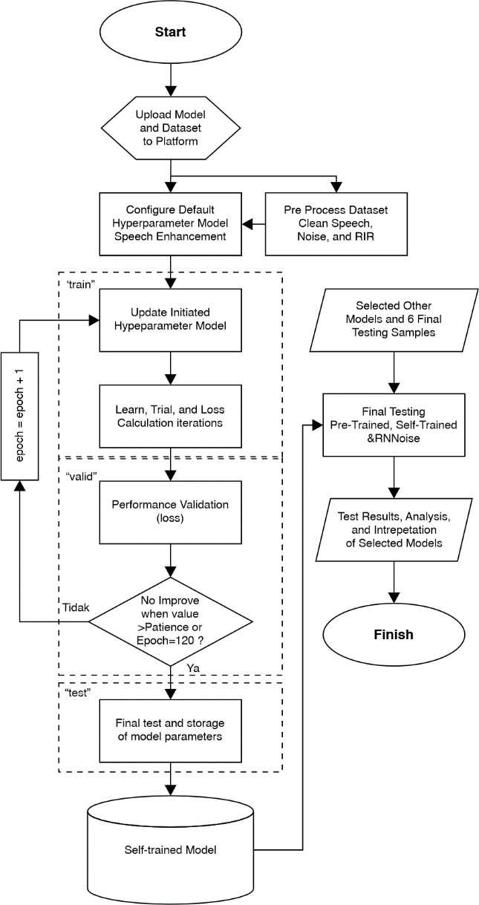
Figure 3. Research Flowchart Diagram

To enhance overall efficiency, a block diagram (Figure 4) represents research components and their interconnected flow. The visual representation aids in identifying potential obstacles and streamlining the research process. These diagrams combination facilitates a thorough investigation of Speech Enhancement models.

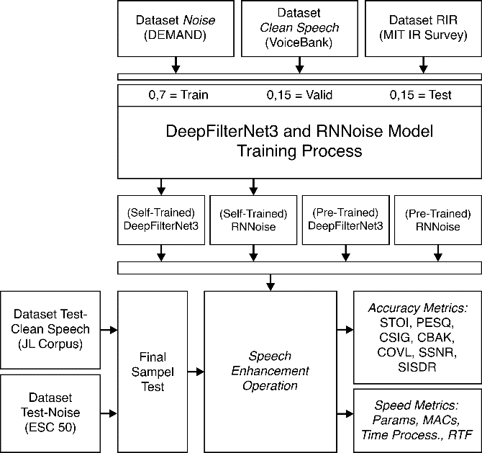
Figure 4. Research Block Diagram

RESULTS AND DISCUSSION
This chapter thoroughly discusses the training process and performance metrics of the chosen speech enhancement model. The goal is to examine the training results and evaluate the models’ accuracy and speed in speech enhancement operations.

Models Training Result
In this technical comparison of training results, we assess two speech enhancement models: RNNoise and DeepFilterNet3. It's crucial to acknowledge that directly comparing their "loss" results might lead to misconceptions as their respective authors interpret these values differently. To ensure a fair evaluation using common data, both models were trained on the combined dataset of Voicebank and DEMAND. The obtained results are depicted in Figure 5.
RNNoise underwent training for 120 epochs, accomplishing this in an impressive 21 minutes, with an average epoch time of 10.8 seconds. The model achieved remarkably low loss values, ranging from 0.0014 to 0.000446118, indicating effective denoising according to its specific loss function. However, it also displayed signs of overfitting in the early epochs.
On the other hand, DeepFilterNet3 also underwent 120 epochs of training, but this process took significantly longer, lasting 15 hours and 8 minutes. Throughout the training, both the training and validation losses consistently decreased, although a slight validation loss increase was observed towards the end, indicating a potential issue with overfitting. It's crucial to remember that the interpretation of loss values is unique to DeepFilterNet3's loss function.
Despite the differing interpretations of loss, both models demonstrated improved speech quality on the common dataset. RNNoise proved to be particularly adept at denoising, while DeepFilterNet3 exhibited better generalization with a lower validation loss. For a comprehensive assessment of practical speech enhancement, it is advisable to consider additional metrics and conduct real-world testing on various datasets. This aspect will be explored in the next two sections.
Table 1. Summary of Accuracy Metrics Before and After Speech Operations
Model | STOI | PESQ | CSIG | CBAK | COVL | SegSNR | SiSDR
DeepFilterNet3 (Pre-Trained) | 0,810 | 1,553 | 2,786 | 2,423 | 2,081 | 5,711 | 7,717
DeepFilterNet3 (Self Trained) | 0,653 | 1,145 | 2,167 | 1,870 | 1,565 | 1,511 | 0,545
RNNoise (Pre-Trained) | 0,743 | 1,233 | 2,228 | 1,586 | 1,620 | -2,800 | -10,637
RNNoise (Self-Trained) | 0,719 | 1,095 | 1,765 | 1,273 | 1,333 | -7,401 | -1,776
Before Speech Enhancement | 0,727 | 1,101 | 2,001 | 1,613 | 1,444 | -2,461 | -0,885
Theoritical Upper Limit | 1,000 | 4,644 | 5,000 | 5,000 | 5,000 | 35,000 | 80,681

Table 2. Summary of Speech Enhancement Speed Metrics
Model | Params (M) | MACS (G) | Average Sampel Time (sec) | Average Process Time (sec) | RTF_{avg}
DeepFilterNet3 (Pre-Trained) | 2,135 | 0,340 | 2,175 | 0,175 | 0,081
DeepFilterNet3 (Self-Trained) | 2,135 | 0,340 | 2,175 | 0,189 | 0,088
RNNoise (Pre-Trained) | 0,060 | 0,040 | 2,175 | 0,003 | 0,001
RNNoise (Self-Trained) | 0,060 | 0,040 | 2,175 | 0,002 | 0,001

Figure. 5 RNNoise and DeepFilterNet3 Model Training Result

Accuracy Metrics Analysis
Both Accuracy and Speed testing is done through 5 synthetic samples created using random selected sample from JL Corpus and ESC 50. Accuracy metrics result can be analyze from the data presented in Table 1. The first model, "DeepFilterNet3 (Pre-Trained)," demonstrates promising results across various metrics. It achieves a high Short-Time Objective Intelligibility (STOI) score of 0.810, indicating that the enhanced speech is highly intelligible compared to the original. Moreover, the Perceptual Evaluation of Speech Quality (PESQ) score of 1.553 suggests that the quality of the enhanced speech is good. The model also performs well in terms of the Subjective Mean Opinion Scores (CSIG and CBAK), which measure the subjective quality of speech and background noise, respectively. Additionally, it yields respectable results in terms of the Overall Mean Opinion Score for Listening Quality (COVL) and the Segmental Signal-to-Noise Ratio (SegSNR).
On the other hand, the "DeepFilterNet3 (Self Trained)" model exhibits comparatively lower performance across all metrics. The STOI score drops to 0.653, indicating a decrease in intelligibility compared to the pre-trained version. The PESQ score of 1.145 also suggests a decline in speech quality. Furthermore, both CSIG and CBAK scores decrease, reflecting a reduction in subjective quality for speech and background noise. The Overall Mean Opinion Score for Listening Quality (COVL) and the Segmental Signal-to-Noise Ratio (SegSNR) also show a decrease, indicating a drop in the overall listening experience and increased noise interference.
Figure 6. Qualitative Example in Spectogram of Before and After Speech Enhancement Operation

Moving on to the "RNNoise (Pre-Trained)" model, we observe mixed results. While the STOI score of 0.743 indicates reasonably good intelligibility, the PESQ score of 1.233 suggests that the speech quality is acceptable but not exceptional. However, the model's performance in terms of subjective quality (CSIG and CBAK) is still decent. Interestingly, the Segmental Signal-to-Noise Ratio (SegSNR) and the Scale-Invariant Signal-to-Distortion Ratio (SiSDR) for this model are negative, indicating that the speech enhancement process has introduced some distortion and noise to the speech signal, leading to a worse listening experience.
The "RNNoise (Self-Trained)" model also faces challenges in performance. Its STOI score of 0.719 indicates a decrease in intelligibility compared to the pre-trained version. The PESQ score of 1.095 suggests a reduction in speech quality, and the subjective quality scores (CSIG and CBAK) also show a decline. Similar to the pre-trained RNNoise model, the Segmental Signal-to-Noise Ratio (SegSNR) and the Scale-Invariant Signal-to-Distortion Ratio (SiSDR) are negative, indicating introduced distortion and noise.
Comparing the model results to the "Before Speech Enhancement" state reveals that the speech enhancement process generally improves intelligibility (STOI increases) but may not consistently improve speech quality (mixed results in PESQ). The subjective quality scores (CSIG and CBAK) vary across models, suggesting that different models may excel in enhancing certain aspects of the speech signal.
Finally, the "Upper Limit" represents an ideal performance achievable with perfect speech enhancement. The scores are significantly higher across all metrics, with maximum values for CSIG, CBAK, COVL, SegSNR, and SiSDR. This upper limit serves as a reference for the best possible performance that current models should aim to approach. Figure 6 show how all speech enhancement model operation affect the spectrogram of a sample.
In conclusion, the "DeepFilterNet3 (Pre-Trained)" model demonstrates the best overall performance among the evaluated models, achieving higher scores in most metrics. However, there is still room for improvement, as all models fall short of the ideal upper limit.

Speed Metrics Analysis
Each model in this section was tested on a total of 5 different speech samples to ensure a comprehensive evaluation across various scenarios. For each speech sample, the testing process was repeated 5 times, and the times taken for each run were recorded. The recorded times were then averaged to obtain the "Average Sample Time" and "Average Process Time" metrics. This approach of averaging over multiple runs and samples helps mitigate the impact of any outliers or random variations, resulting in more reliable and representative performance metrics. Speed metrics result can be analyze from the data presented in Table 2.
Starting with the architecture, both DeepFilterNet3 and RNNoise models seem to have a relatively small number of parameters and operations (MACS), which indicates their efficiency in terms of memory and computational requirements. The fact that they have similar values for parameters and MACS suggests that they might share some similarities in design or complexity. However, without more detailed information on the model architectures, it is challenging to make direct comparisons.
Moving on to the computational efficiency, the provided metrics show the average sample time and average process time. The average sample time, which represents the time taken to process a single sample, is consistent at 2.175 seconds for all models. This indicates that the models process each input sample in approximately the same amount of time, regardless of their complexity or the type of training.
The most critical metric for real-time applications is the Real-Time Factor (RTF_{avg}). This metric reveals how well the models perform in real-time scenarios, with values close to 1 indicating real-time processing. Both Pre-Trained and Self-Trained RNNoise models achieve remarkable RTF_{avg} values of around 0.001, which implies that they can process speech signals nearly in real-time. This is a highly desirable feature, particularly for applications that require immediate feedback, such as live communication systems or voice assistants.
On the other hand, the DeepFilterNet3 models, both Pre-Trained and Self-Trained, have slightly higher RTF_{avg} values, around 0.081 and 0.088, respectively. While these values are not as impressive as RNNoise, they still suggest that DeepFilterNet3 models can process speech in a reasonably efficient manner, being roughly 8 to 9 times slower than real-time.
To further analyze the trade-offs between these models, more information about their architectures, training data, and specific use cases is needed. Additionally, it would be beneficial to compare their speech enhancement performance in terms of objective metrics like signal-to-noise ratio (SNR) improvement and subjective evaluations with human listeners.
In conclusion, the provided deep technical analysis indicates that both RNNoise models (Pre-Trained and Self-Trained) demonstrate exceptional computational efficiency, enabling them to process speech signals almost in real-time. The DeepFilterNet3 models, while slightly slower, still exhibit reasonably efficient speech enhancement capabilities. Depending on the specific application requirements and performance considerations, choosing the most suitable model would require a more in-depth investigation and evaluation.

CONCLUSION
This comprehensive analysis of two speech enhancement models, RNNoise and DeepFilterNet3, has provided valuable insights into their training process, accuracy metrics, and speed performance. Both models demonstrated improvements in speech quality on a common dataset, with RNNoise excelling at denoising and DeepFilterNet3 exhibiting better generalization. The accuracy metrics highlighted that the "DeepFilterNet3 (Pre-Trained)" model achieved the best overall performance, with high scores in intelligibility and speech quality, while the "RNNoise (Pre-Trained)" model also showed reasonable performance in subjective quality measures. However, all models fell short of the ideal upper limit in terms of performance. On the speed front, the RNNoise models showcased exceptional computational efficiency, enabling them to process speech signals nearly in real-time, while DeepFilterNet3 models, though slightly slower, demonstrated reasonable efficiency.

ACKNOWLEDGMENT
The authors extend their heartfelt gratitude to our esteemed colleagues from the Electrical Engineering Department and Research Center of Mercu Buana University, Jakarta, Indonesia, whose unwavering support and collaboration were instrumental in successfully completing this research paper.

REFERENCES
[1] A. Hassan, S. Aftab, R. Khan, and H. Asim, “The Analysis on the usage of the Video Conferencing Rooms using Classification,” KIET Journal of Compu ng & Informa on Sciences, vol. 2, p. 72, 2019, [Online]. Available: https://www.cs.waikato.ac.nz/ml/weka/
[2] G. A. Strouse et al., “Zooming through development: Using video chat to support family connections,” Hum Behav Emerg Technol, vol. 3, no. 4, pp. 552–571, Oct. 2021, doi: 10.1002/hbe2.268.
[3] R. S. Oeppen, G. Shaw, and P. A. Brennan, “Human factors recognition at virtual meetings and video conferencing: how to get the best performance from yourself and others,” British Journal of Oral and Maxillofacial Surgery, vol. 58, no. 6, pp. 643–646, Jul. 2020, doi: 10.1016/j.bjoms.2020.04.046.
[4] J. A. Piamonte, E. A. Gabrielle Reyes, K. Z. Ein Saguibo, C. M. Ann Verdeflor, and M. J. Janice Gumasing, “Effects of Noise Sources on the Perceived Task Performance of Students during Online Class,” in the 5th European International Conference on Industrial Engineering and Operations Management, Rome, Italy: IEOM Society International, Jul. 2022, pp. 2700–2709.
[5] N. Das, S. Chakraborty, J. Chaki, N. Padhy, and N. Dey, “Fundamentals, present and future perspectives of speech enhancement,” Int J Speech Technol, vol. 24, no. 4, pp. 883–901, Dec. 2021, doi: 10.1007/s10772-020-09674-2.
[6] D. Michelsanti et al., “An Overview of Deep-Learning-Based Audio-Visual Speech Enhancement and Separation,” IEEE/ACM Trans Audio Speech Lang Process, vol. 29, pp. 1368–1396, Aug. 2021, [Online]. Available: http://arxiv.org/abs/2008.09586
[7] H. Schröter, A. N. Escalante-B., T. Rosenkranz, and A. Maier, “DeepFilterNet: A Low Complexity Speech Enhancement Framework for Full-Band Audio based on Deep Filtering,” ICASSP 2022-2022 IEEE International Conference on Acoustics, Speech and Signal Processing (ICASSP), pp. 7407–7411, Feb. 2022, [Online]. Available: http://arxiv.org/abs/2110.05588
[8] D. Yin, C. Luo, Z. Xiong, and W. Zeng, “PHASEN: A Phase-and-Harmonics-Aware Speech Enhancement Network,” in AAAI Conference on Artificial Intelligence, 2020, pp. 9458–9465. [Online]. Available: www.aaai.org
[9] J.-M. Valin, U. Isik, N. Phansalkar, R. Giri, K. Helwani, and A. Krishnaswamy, “A Perceptually-Motivated Approach for Low-Complexity, Real-Time Enhancement of Fullband Speech,” Aug. 2020, [Online]. Available: http://arxiv.org/abs/2008.04259
[10] K. Tan and D. L. Wang, “Complex spectral mapping with a convolutional recurrent network for monaural speech enhancement,” IEEE International Conference on Acoustics, Speech and Signal Processing (ICASSP), pp. 6865–6869, 2019, doi: doi: 10.1109/ICASSP.2019.8682834.
[11] J.-M. Valin, “A Hybrid DSP/Deep Learning Approach to Real-Time Full-Band Speech Enhancement,” 2018 IEEE 20th international workshop on multimedia signal processing (MMSP), pp. 1–5, Aug. 2018, [Online]. Available: http://arxiv.org/abs/1709.08243
[12] Y. Hu et al., “DCCRN: Deep Complex Convolution Recurrent Network for Phase-Aware Speech Enhancement,” Aug. 2020, [Online]. Available: http://arxiv.org/abs/2008.00264
[13] S. Braun, H. Gamper, C. K. A. Reddy, and I. Tashev, “Towards efficient models for real-time deep noise suppression,” in In ICASSP 2021-2021 IEEE International Conference on Acoustics, Speech and Signal Processing (ICASSP), Jan. 2021, pp. 656–660. [Online]. Available: http://arxiv.org/abs/2101.09249
[14] J. Chen, Z. Wang, D. Tuo, Z. Wu, S. Kang, and H. Meng, “FullSubNet+: Channel Attention FullSubNet with Complex Spectrograms for Speech Enhancement,” in ICASSP 2022-2022 IEEE International Conference on Acoustics, Speech and Signal Processing (ICASSP), Mar. 2022, pp. 7857–7861. [Online]. Available: http://arxiv.org/abs/2203.12188
[15] A. Li, C. Zheng, L. Zhang, and X. Li, “Glance and Gaze: A Collaborative Learning Framework for Single-channel Speech Enhancement,” Applied Acoustics, vol. 187, p. 108499, Jun. 2021, [Online]. Available: http://arxiv.org/abs/2106.11789
[16] S. Zhao, B. Ma, K. N. Watcharasupat, and W.-S. Gan, “FRCRN: Boosting Feature Representation using Frequency Recurrence for Monaural Speech Enhancement,” in In ICASSP 2022-2022 IEEE International Conference on Acoustics, Speech and Signal Processing (ICASSP), Jun. 2022, pp. 9281–9285. [Online]. Available: http://arxiv.org/abs/2206.07293
[17] H. Schröter, A. N. Escalante-B., T. Rosenkranz, and A. Maier, “DeepFilterNet2: Towards Real-Time Speech Enhancement on Embedded Devices for Full-Band Audio,” 2022 International Workshop on Acoustic Signal Enhancement (IWAENC), pp. 1–5, May 2022, [Online]. Available: http://arxiv.org/abs/2205.05474
[18] H. Schröter, A. N. Escalante-B, T. Rosenkranz, and A. Maier, “DeepFilterNet: Perceptually Motivated Real-Time Speech Enhancement,” Interspeech 2023, Apr. 2023, Accessed: Jul. 04, 2023. [Online]. Available: https://github.com/rikorose/deepfilternet
[19] H. Schröter, T. Rosenkranz, A. N. E. B., M. Aubreville, and A. Maier, “CLCNet: Deep learning-based Noise Reduction for Hearing Aids using Complex Linear Coding,” Jan. 2020, [Online]. Available: http://arxiv.org/abs/2001.10218
[20] C. Valentini-Botinhao, “Noisy speech database for training speech enhancement algorithms and TTS models.” University of Edinburgh. School of Informatics. Centre for Speech Technology Research (CSTR), Edinburgh, Aug. 21, 2017.
[21] J. Traer and J. H. McDermott, “Statistics of natural reverberation enable perceptual separation of sound and space,” Proc Natl Acad Sci U S A, vol. 113, no. 48, pp. E7856–E7865, Nov. 2016, doi: 10.1073/pnas.1612524113.
[22] J. James, L. Tian, and C. I. Watson, “An open source emotional speech corpus for human robot interaction applications,” in Proceedings of the Annual Conference of the International Speech Communication Association, INTERSPEECH, International Speech Communication Association, 2018, pp. 2768–2772. doi: 10.21437/Interspeech.2018-1349.
[23] K. J. Piczak, “ESC: Dataset for environmental sound classification,” in MM 2015 - Proceedings of the 2015 ACM Multimedia Conference, Association for Computing Machinery, Inc, Oct. 2015, pp. 1015–1018. doi: 10.1145/2733373.2806390.
[24] J. Kim, M. El-Khamy, and J. Lee, “End-to-End Multi-Task Denoising for joint SDR and PESQ Optimization,” ArXiv, Jan. 2019, [Online]. Available: http://arxiv.org/abs/1901.09146
[25] R. E. Zezario, S.-W. Fu, C.-S. Fuh, Y. Tsao, and H.-M. Wang, “STOI-Net: A Deep Learning based Non-Intrusive Speech Intelligibility Assessment Model,” in Asia-Pacific Signal and Information Processing Association Annual Summit and Conference (APSIPA ASC), 2020, pp. 482–486.
[26] P. Krishnamoorthy, “An overview of subjective and objective quality measures for noisy speech enhancement algorithms,” IETE Technical Review (Institution of Electronics and Telecommunication Engineers, India), vol. 28, no. 4, pp. 292–301, Jul. 2011, doi: 10.4103/0256-4602.83550.
[27] R. Kashyap, R. H. Laskar, and N. Shome, “Non-negative Frequency-Weighted Energy-Based Speech Quality Estimation for Different Modes and Quality of Speech,” Circuits Syst Signal Process, vol. 41, pp. 6788–6826, 2022.
[28] J. Le Roux, S. Wisdom, H. Erdogan, and J. R. Hershey, “SDR - half-baked or well done?,” Nov. 2018, [Online]. Available: http://arxiv.org/abs/1811.02508
[29] S. Badillo et al., “An Introduction to Machine Learning,” Clin Pharmacol Ther, vol. 107, no. 4, pp. 871–885, Apr. 2020, doi: 10.1002/cpt.1796.
[30] M. A. Nahmias, T. F. De Lima, A. N. Tait, H. T. Peng, B. J. Shastri, and P. R. Prucnal, “Photonic Multiply-Accumulate Operations for Neural Networks,” IEEE Journal of Selected Topics in Quantum Electronics, vol. 26, no. 1, pp. 1–18, Jan. 2019, doi: 10.1109/JSTQE.2019.2941485.
[31] T. Saeki, Y. Saito, S. Takamichi, and H. Saruwatari, “Real-time, full-band, online DNN-based voice conversion system using a single CPU,” INTERSPEECH: Show & Tell Contribution, pp. 1021–1022, Aug. 2020.

