Redesign Wheelchair for Stroke Sufferers Using the Quality Function Deployment Method | 

Ratna Agil Apriani^{1*}, Hari Purnomo²
¹Master of Industrial Engineering, Faculty of Industrial Technology, Universitas Islam Indonesia
²Department of Industrial Engineering, Faculty of Industrial Technology, Universitas Islam Indonesia

Abstract  The value of prevalence of stroke in Indonesia continues to increase, so there is a need for supporting mobility. In today's modern era, high mobility is necessary to live correctly with free activities, but this is still not felt by stroke sufferers in achieving comfort when using this mobility, namely wheelchairs. The author conducted research in making a redesign of a wheelchair design that can be adjusted to the needs of stroke sufferers. This research was conducted using the Quality Function Deployment method to obtain information on the needs of stroke sufferers and the Wilcoxon Difference Test method to determine the level of difference between old wheelchair designs and improvement. The results showed that the wheelchairs needed by stroke sufferers were multifunctional, ergonomic, flexible, safety, and material. In the results of the Wilcoxon Difference Test, which was carried out based on the hypothesis, it is known that only the flexible attribute has no difference compared to the previous wheelchair design product. In contrast, the other four attributes have different values ​​for the old wheelchair design and the improved design. So that redesigning wheelchairs is done by obtaining design specifications that suit the needs of stroke sufferers.  Copyright ©2023 Universitas Mercu Buana  This is an open access article under the CC BY-NC license   | Keywords:  Stroke; Wheel Chair;  Quality Function Deployment; Wilcoxon;  Article History:  Received: May 2, 2019  Revised: May 29, 2019  Accepted: June 2, 2019  Published: June 2, 2019  Corresponding Author:  Ratna Agil Apriani  Master of Industrial Engineering Faculty of Industrial Engineering, Universitas Islam Indonesia  Email: 22916006@students.uii.ac.id

INTRODUCTION
Nationally, the prevalence of stroke in Indonesia in 2018, based on a doctor's diagnosis in the population aged ≥ 15 years, reached 10.9% or an estimated 2,120,362 people. The results of the 2018 Riskesdas data nationally show that the prevalence value of stroke in Indonesia has increased from 7% in 2013 to 10.9% in 2018, or an estimated 2,120,362 people. The total number of stroke sufferers in Indonesia is estimated at 500,000 every year, and around 2.5% or 250,000 people die, and the rest are either mildly or severely disabled. The limitations of stroke sufferers require mobility to support them. Until now, wheelchairs are still an alternative tool commonly used by stroke sufferers. The wheelchair is an interface mobility device between the user and the environment [1]. Not only for stroke sufferers, wheelchairs are commonly used by persons with disabilities for rehabilitation [2]. Together, the wheelchair and the human body constitute an anthropotechnical system [3] [4]. The wheelchair-user population needs to have special requirements that must be met [5]. In today's modern era, high mobility is a necessity to be able to live correctly. Unfortunately, this is difficult for stroke sufferers. Manual wheelchairs are necessary assistive devices that enhance locomotion for individuals with limited mobility [6]. However, previous users of wheelchair products reported a high degree of pain and shoulder pathology from using a wheelchair [7]. Based on this, there are problems experienced by wheelchair users, one of which is stroke sufferers who still do not get the right wheelchair mobility according to their expected needs.
A stroke is a complex medical emergency that requires a well-functioning treatment system to optimize the care provided [8]. Stroke is not a single disease but can be caused by various risk factors; 85% of strokes are caused by tiny blood vessel arteriolosclerosis [9]. There are several disorders, such as muscle weakness (hemiparesis), which generally occurs after a person has had a stroke, and this disorder primarily affects one side of the body more than the other [10]. Hemiparesis is partial weakness on one side of the body due to certain hemispheric vascular disorders or severe motor disorders and affects about 65% of stroke patients [11]. Someone who suffers from hemiparesis will have a feeling of muscle weakness which results in difficulty making movements in the body and loss of balance. The potential for hemiparesis occurs because of the movement between the wheelchair and the bed, which is done manually and not carefully in stroke patients, so stroke sufferers can fall and experience hemiparesis. As a result of the occurrence of a stroke or post-stroke patient, it can cause several other diseases that attack, such as broken bones, minor injuries, major injuries, and open wounds. Caregivers are needed who support the activities of stroke sufferers so that they can realize safe movements [12].
Based on previous research, it is known that the Activity of Daily Living for stroke sufferers is by moving from a wheelchair to a bed, so this has the potential to fall, this study some information was obtained about the subtask difficulties experienced by stroke sufferers, one of which was the difficulty in getting a chair that could be converted into a bed [13]. In addition, it is also known that nurses and caretakers of stroke sufferers can be exposed to the risk of musculoskeletal disorders due to manual lifting and handling of patients by moving them from a bed to a wheelchair, the results this study obtained were wheelchairs that were adjusted to better comfort, but no different tests were carried out on the results obtained based on the size of the previous wheelchair [14].
This research was conducted to redesign the mobility design by creating wheelchairs that can be adjusted to the needs of stroke sufferers to minimize the unwanted things that stroke sufferers have. In the current or future product development process, consumers must be the top priority aspect, with several needs based on consumer desires so that consumers are satisfied with the products provided. The wheelchair development process will use the Quality Function Deployment method. The reason the method was chosen is because in this study it will focus on designs that are in accordance with the specifications of the information needs obtained directly from caregivers or stroke sufferers. Quality Function Deployment is an information medium to find out several wishes that follow the needs of stroke sufferers in using wheelchairs through the voice of the customer. Improving the prospects for comfort in designs using the Anthropometric method to understand the difference in performance between the two groups so that it can be used in designing more effective mobility [15]. In addition, a Difference Test was carried out to validate the results of the proposed designs to ensure that the products made had been focused on user needs.

METHOD
Research Subjects and Objects
The subjects in this study were related parties from stroke sufferers with the problem of the lack of mobility of stroke sufferers in using wheelchair according to the needs of sufferers. At the same time, the object is a wheelchair by redesigning it according to the needs of stroke sufferers.

Population and Sample
The population in this study were stroke sufferers and caregivers on Java Island. The sample of the population used is 30 people based on random data collection. The data collection technique for the sample used was by distributing questionnaires to encourage information about the needs of wheelchair users through the Quality Function Deployment approach. In addition, data collection for the Wilcoxon Difference Test was carried out by distributing questionnaires to determine the differences between the previous and proposed products.

Research procedure
The research flow is used to be a writer's guide in researching so that the results cannot deviate from predetermined goals. The following is the flow of research conducted in this study.

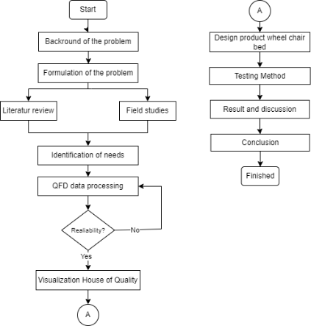

Figure 1. Research flow
Design Method
The analysis outlines the results of data processing that has been done before to find the root of the problem. Data analysis was also carried out to implement the Quality Function Deployment (QFD) method in this study. Quality Function Deployment (QFD) is a method for translating consumer perceptions and needs of the matrix and interpreting them into a technical specification [16]. The QFD method can support implementing the philosophy of TQM (Total Quality Management) [17]. The following is the flow of quality function deployment method.

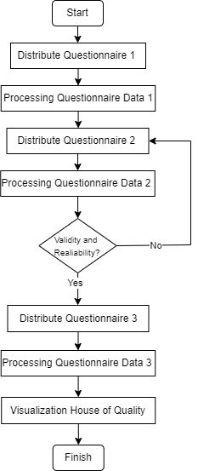

Figure 2. Quality Function Deployment Flow

The process of implementing this method is to use the voice of the customer. The design method used in QFD is as follows:
- Distribute Questionnaire 1 (Open Questionnaire). This questionnaire aims to determine the wishes or needs of stroke sufferers from wheelchairs to be evaluated and repaired.
- Processing Questionnaire Data 1, where the researcher summarizes the questionnaire results and groups them into several attributes.
- Distribute Questionnaire 2 (Closed), where this questionnaire aims to find the Important Rating of each attribute that has been grouped. This second questionnaire asks the importance of the adjusted attributes of the first questionnaire.
- Processing Questionnaire 2 Data (Validity Test). Where this validation test is carried out aims to validate the answers to each of the attributes asked.
- If the validation test results are successful or valid in the second questionnaire, you can continue with the following questionnaire. However, the validity test results are invalid, and you have to repeat the data collection in the second questionnaire.
- Distributing the third questionnaire is used to compare existing products and products to be designed.
- Process Questionnaire 3 Data (Calculating Customer Competitive Evaluation) for comparison of each attribute of existing products with products to be designed.
- Make a House of Quality concerning Important Rating, Customer Competitive Evaluation, and Benchmarks of each attribute. Then make a HOQ to see the attributes that need attention or must be maintained.

Anthropometry
Anthropometry is one of the methods for testing anthropology [18]. Anthropometry was used in this study because it can provide information about an individual's body composition [19]. Anthropometry does not require a high level of technical skills, so it is crucial to understand the accuracy of anthropometric measurements [20].

Testing Method
The difference test aims to perform statistical analysis helpful for seeing the relationship between variables. In this study, the test authors compared the old wheelchair design with the results of improvements to several attributes needed by stroke sufferers in using wheelchair products. Figure 3 is the flow of the testing method used in this research.

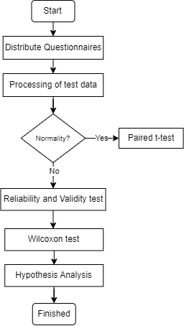

Figure 3. Testing Method Flow

The design method for the different tests is as follows:
- Distribute Closed Questionnaires. This questionnaire aims to determine the differences in the attributes of the two wheelchairs, namely the old design and the remedial design for stroke sufferers.
- Processing Questionnaire Data (Validity & Reliability Test)
- The Wilcoxon Difference test is useful in comparing paired observations from two populations [21]. A different test was carried out on each attribute/aspect by knowing the resulting level of significance, whether p < 0.05 or p > 0.05.
- Hypothesis testing is a way of making decisions based on data analysis, either from controlled trials or observation (uncontrolled). After knowing the results obtained in the previous different tests, the next step is to determine the hypothesis that will be made based on needs.

Method of collecting data
The data collection techniques used in this study for primary and secondary data types follow. Secondary data is the information used to complete objectives [22]. Secondary data is taken indirectly, and this data is usually obtained through several references such as journals, books, research literature, and other data that can support research data sources.

Table 1. Secondary Data Collection
No. | Data Source | Required Data | Data Collection Techniques
1. | Previous research related to the design of wheelchairs in general and specifically for stroke patients. | The use of the method is carried out to determine the novelty that will be carried out and improvements to the design aspects that are carried out | Information about the method used and the results of studies related to redesigning wheelchair design
2. | Books or reference literature related to the Quality Function Deployment, and Wilcoxon Test method | parameters on using the QFD method and the Wilcoxon Test | The study results are related to the results obtained from the QFD method and the Wilcoxon test

Meanwhile, primary data is obtained directly from the source or subject used. The following are some of the primary data needed in the research based on the technical data collection.

Table 2. Primary Data Collection
No | Data Source | Required Data | Data Collection Techniques
1 | Caregivers/  stroke sufferers | Evaluation of previous wheelchair use | Questionnaire
2 | Caregivers/  stroke sufferers | Stroke survivors' problems when transitioning from a wheelchair to a bed | Questionnaire
3 | Caregivers/  stroke sufferers | Distributing questionnaires to find out the voice of customers on QFD and test data | Questionnaire
4 | Caregivers/  stroke sufferers | The need for product design for stroke sufferers | Questionnaire

Research Tools
Research aids used in processing and analyzing data in this study include:
- Microsoft Excel
Microsoft Excel is a spreadsheet worksheet application program. Microsoft Excel is used in processing questionnaire data using the Quality Function Deployment (QFD) method.
- Sigma XL
Sigma XL is a statistical analysis software designed to simplify the measurement process. This report was used to visualize the House of Quality on the QFD method at the time of writing.
- Statistical Package for the Social Science (SPSS)
SPSS is a complete software alternative for quantitative data analysis [23]. This study used SPSS to conduct several tests for Normality, Validity, and Reliability to Wilcoxon

RESULTS AND DISCUSSION
At this stage, data processing is carried out using the Quality Function Deployment method and the Difference Test in redesigning the wheelchair. Here are the stages.

Quality Function Deployment
In the first stage, the Voice of Customer is carried out. Consumer voices are collected and written in a product's attributes. The following is the result of the identification of needs regarding the level of importance of attributes in product design:
Table 3. Needs Attributes
No | Attribute | Criteria | Important Rating
1 | Multifunction | Can be transformed into a bed | 3.40
2 | Ergonomic | All wheelchair cushions are made of soft foam | 3.61
3 | Flexible | Easy to carry | 3.20
4 | Safety | There is a secure armrest | 3.70
5 | Material | Using hollow stainless steel material, it can be strong up to 120 kg | 3.70

After obtaining the value of the importance of the attribute, the researcher then carried out the initial proposed design. The following is a 3D design of the proposed wheelchair product.

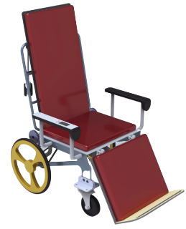 | 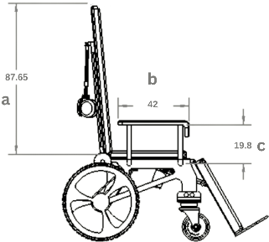
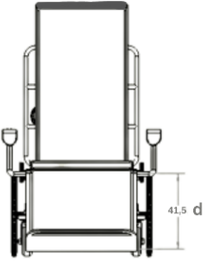 | 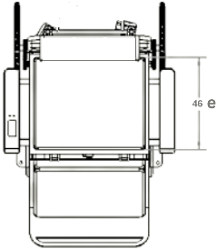

Figure 4. Proposed Design

The wheelchair design above is a proposed wheelchair design based on the results of several attributes obtained in the previous questionnaire, where the wheelchair has the following attribute criteria.
- Multifunction, the wheelchairs proposed above have been equipped with additional features where the wheelchair can be transformed into a bed.
- Ergonomic, previous wheelchairs did not have comfort in the bearings used. Therefore, an evaluation was given to the proposed design by procuring all cushions made of soft foam to increase the user's comfort.
- Flexible, the flexibility owned by the above design is simple, with many needs fulfilled for stroke sufferers.
- Safety, on the armrest is provided as a secure and comfortable support. In addition, this safety is also to meet the needs of stroke users, so there is no need to move between wheelchairs and beds.
- Material, the material used is hollow stainless steel, so it is believed to be able to withstand loads of up to 120 kg.
After knowing the importance of the attributes that consumers have asked and designing the initial proposed design, the next step is to look for the relationship between technical response and user needs, which is done by distributing questionnaires back to users. So values ​​will be obtained that can determine how strong the relationship between technical response and consumer needs.

Table 4. Customer Competitor Evaluation
No | Attribute | n | Proposed Product |  | Competitor Product
No | Attribute | n | Total score | CCE | Total score | CCE
1 | Multifunction | 30 | 100 | 3.8 | 58 | 2.83
2 | Ergonomic | 30 | 105 | 3.43 | 75 | 3.40
3 | Flexible | 30 | 87 | 3.27 | 82 | 3.33
4 | Safety | 30 | 105 | 3.53 | 83 | 3.50
5 | Material | 30 | 104 | 3.60 | 85 | 3.27

The table above showsn the comparison between the CCE values ​​obtained on the product with the initial proposed design and competitor products. In the next stage, benchmarking on customer needs is carried out. At this stage, a comparison is made between the customer needs of each attribute so that each value is seen from the smallest value to the most significant value. The value represents each attribute that is not important to very important.

Table 5. Improvement Ratio
Need | Important Rating | Goals | Improvement Ratio
Multifunction | 3.40 | 3.70 | 1.11
Ergonomic | 3.61 | 3.60 | 1.03
Flexible | 3.20 | 3.00 | 1.03
Safety | 3.70 | 3.60 | 1.03
Material | 3.70 | 3.50 | 1.01

Do Benchmark on Metric. Making comparisons with technical quantitative and qualitative forms. This comparison is made with similar products so that it can be seen from the various dimensions or attributes needed in the developed product.

Table 6. Benchmark on Metric Competitor
No | Need | Metrics | Wheel Chair Bed | OneMed
1 | 2 | Wheel Chair Size(cm) | 180 x 59 | 94 x 28
2 | 2,3 | Risk of Body Injury
3 | 1 | Transform into a bed
4 | 1 | Backrest adjustment
5 | 2,4,5 | Comfortable pillows
6 | 3 | Easy to carry
7 | 4, 5 | Wheel chair weight resistance (kg) | 120 | 100
8 | 3,5 | Wheel chair weight (kg) | 45 | 1.7

Based on the data processing results, the final metric selection is determined according to the benchmark metric for wheelchair bed products.

Table 7. Final Metric Design
No | Metrics | Wheel Chair Bed
1 | Wheel Chair Size(cm) | 180 x 59
2 | Risk of Body Injury
3 | Transform into a bed
4 | Backrest adjustment
5 | Comfortable pillows
6 | Easy to carry
7 | Wheel chair weight resistance (kg) | 120
8 | Wheel chair weight (kg) | 45 kg

House of Quality
House of Quality (HOQ) aims to find a correlation between consumer needs and engineered characteristics of the focused significance [24]. The following is the HOQ of wheelchair products.

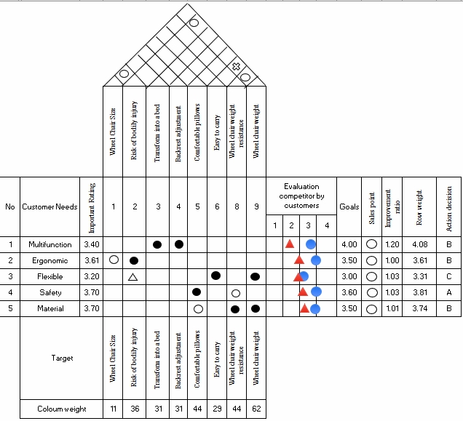

Figure 5. House of Quality

Based on the results of the visualization above, it can be seen that the output is based on the index of the actions that need to be taken on each existing attribute. the Safety attribute obtains an action index A, which means that the Safety attribute in the initial proposed design needs to be improved (improve) the quality of the product, while the Multifunction, Ergonomic, and Material attributes with an action index B means that these three attributes need to maintain product quality and innovate products sustainably. Finally, the Flexible attribute obtains an action index C, meaning it is necessary to maintain the quality of its existing products.
Evaluation of Proposed Design
Evaluation is feedback or feedback given by the user to the designer. The evaluation aims to maximize the adjustment of the wheelchair design according to the needs of the users. Consumers evaluate products to show considerable variability in how much they actively express particular meanings [25].
Based on the results of observations on the visualization of the House of Quality matrix, it is known that the Safety attribute needs to be improved in quality on this attribute. Therefore, a questionnaire is distributed again to determine what specific aspects need to be evaluated from the Safety attribute. Based on the results of distributing the questionnaires, improvements to the initial design proposals are evaluated, including the following.

Table 8. Evaluation Proposed Design
No | Evaluation | Solution
1 | There is no safety on the headboard wheelchair bed | Adding safety in the form of a rebuttal limit at the top end of the wheelchair bed
2 | Using tire parts with a rough base | Changing the wheelchair bed tires with a rougher surface mat
3 | There is no control section to push the wheelchair | Adding a push handle on the back of the wheelchair

Based on the evaluation carried out, an existing solution is obtained based on the results obtained. Therefore, it is necessary to design the addition based on the evaluation received.

Anthropometry
The dimensional measurements used in the proposed wheelchair product are taken based on the dimensions of a conventional wheelchair. So that anthropometric ergonomics have not been applied. The process of improving the redesign of wheelchairs needs to be done to increase comfort according to stroke sufferers, along with the comparison sizes used after applying anthropometric ergonomics through Indonesian anthropometric data with the following dimensions and percentages.

Table 9. Anthropometric Data
Measurement | Percentile | Improvement |  | Proposed design (cm)
Measurement | Percentile | Anthropometry Size (cm) | Rounding  (cm) | Proposed design (cm)
Chair
Sitting Height (a) | 95 | 95.28 | 96 | 87.65
Forearm Length (b) | 95 | 54.4 | 55 | 42
Sitting Elbow Height (c) | 5 | 10.84 | 10 | 19.8
Knee Height (d) | 5 | 36.16 | 36 | 41.5
Popliteal length (e) | 95 | 49.65 | 50 | 46
Bed
Shoulder Width (f) | 95 | 47.19 | 48 | 48
Height (g) | 95 | 187.63 | 188 | 196.5

Table 10. Design Size Comparison
Before | After
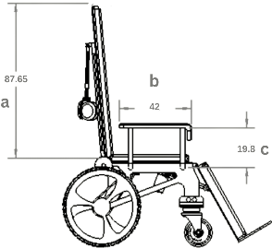 | 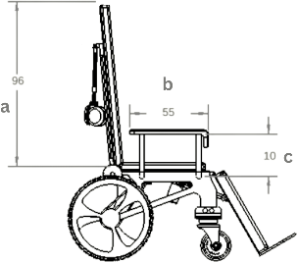
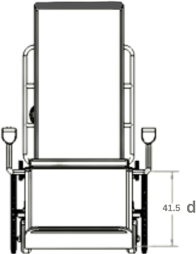 | 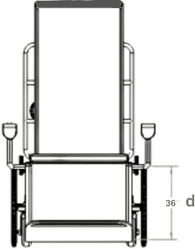
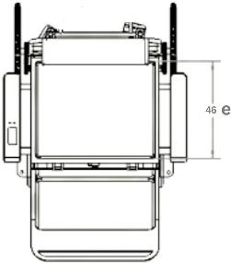 | 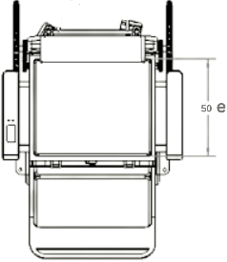
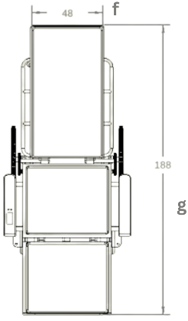 | 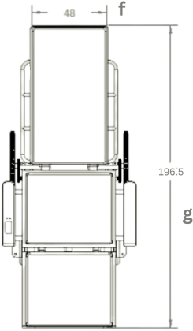

Improvement Design
Based on the evaluation that has been carried out, design improvements and additional safety features are provided according to the needs desired by the users. Following are some additional 3D designs on the Wheel Chair Bed design based on the evaluation that has been carried out.

Table 11. Proposed Design Evaluation
No | Solution | Visualization
1 | Adding safety in the form of a rebuttal limit at the top end of the wheelchair bed | 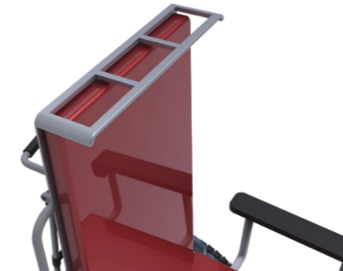
2 | Changing the wheelchair bed tires with a rougher surface mat | 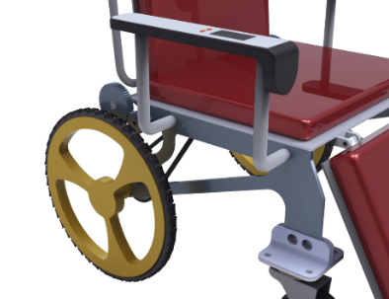
3 | Adding a push handle on the back of the wheelchair | 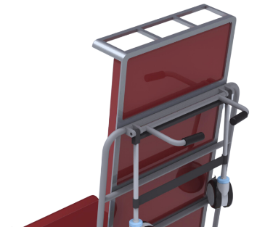

With several evaluations of the design carried out, the following is the result of the final Wheel Chair Bed design that can meet the needs of stroke sufferers.

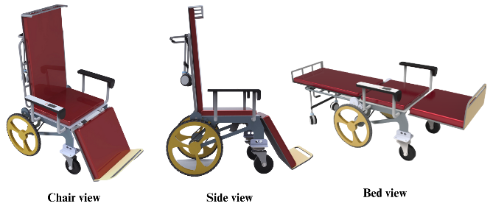
Figure 6. Wheelchair Bed Improvement Design

Difference Testing
In the wheelchair design that has been designed, then a different test is carried out to increase some of the attributes needed by stroke sufferers. The purpose of this assessment is to determine the level of difference in stroke patients by comparing the old wheelchair design and the proposed wheelchair design. Normality, Validity, Reliability, and Wilcoxon tests were conducted using closed questionnaires. This questionnaire has the following scale details: (1) Disagree, (2) Agree, (3) Disagree, and (5) Strongly agree.
The normality test shows that the data set is clean from invalid sub-samples [26]. Based on the distribution of the questionnaires that have been carried out, the following are the results of the questionnaires given to a sample of 30 existing caregivers/stroke sufferers. From the results of distributing the questionnaire, the Shapiro-Wilk normality test was carried out using tools from SPSS software, it is known that the Significant value obtained from all the attribute requirements is worth 0.000, where the value is below (<0.05), so it can be interpreted that the data obtained is not normally distributed. Therefore, the Wilcoxon test is used for different perceptions based on acquired data that are known to be not normally distributed.
The next step is to test the validity of the values ​​used for the next test. It is known that the rtable used as a parameter for this hypothesis is 0.361, taken from a significance rtable of 5% with a total of n, namely 30 data.

Table 12. Validity Test Result
No | Attribute | Pearson Correlation
1 | Multifunction | 0.069
2 | Ergonomic | 0.811
3 | Flexible | 0.644
4 | Safety | 0.799
5 | Material | 0.500

Based on the correlation values ​​obtained for all attributes, it is known that the rcount value of each attribute is greater than the rtable value of 0.361, so it can be concluded that all attributes are defined as valid.
Then a reliability test was carried out to determine the level of reliability of several valid questions. According to Imam Ghazali, data can be reliable if Cronbach's alpha value is > 0.7. In the calculation results, it is known that the reliability value obtained is 0.734, which is known to be> 0.7. So, it can be interpreted that the data is reliable.
Then the Wilcoxon differential test was carried out to measure the significance of the two groups of paired data, namely old products with improved designs. The Wilcoxon test is used for non-parametric data is not normally distributed. The critical limit used in this study is 0.05. Wilcoxon test of difference was used. The critical limit value used in this study is 0.05 using the following hypothesis:

H0: | There is no change from the old wheelchair product design to the improved design
H1: | There are design changes to old wheelchair products with improvements

Based on the required attributes obtained, the following are the results of the Wilcoxon different test on each required attribute.

Table 13. Wilcoxon Test Result
No | Attribute | Asympt. Sig (2-tailed)
1 | Multifunction | 0.000
2 | Ergonomic | 0.011
3 | Flexible | 0.599
4 | Safety | 0.011
5 | Material | 0.037

The above results show that the Significance value obtained from the Multifunction, Ergonomic, Safety, and Material attributes is <0.05 and is interpreted based on the hypothesis that H1 is accepted. At the same time, H0 is not sufficient evidence to be accepted. So, with these results, it can be seen that there are differences in the attributes of Multifunction, Ergonomic, Safety, and Material on old wheelchairs with improvement. Whereas the Flexible attribute obtains a Significance value of > 0.05, it means that H0 is accepted, while H1 is not sufficient evidence to be accepted. So with the results of the hypothesis, there is no difference in the Flexible attribute on old wheelchairs with improvement.

CONCLUSION
The conclusion obtained based on this research is regarding the design of a wheelchair that fits the needs of stroke sufferers. Based on the results of the Quality Function Deployment method, it is found that the wheelchair needed is a wheelchair that can be transformed into a bed (multifunction), has a soft/comfortable wheelchair cushion (ergonomic), is flexible, has a safe armrest (safety), has a frame with substantial weight (material). In addition, the researcher suggested that future researchers could use the design in this study in developing the Wheel Chair Bed design. In addition, further research must include and pay attention to the cost aspects used in research.

ACKNOWLEDGMENT
This research was supported/partially supported by Direktorat Jenderal Pendidikan Tinggi, Riset, dan Teknologi, Kementerian Pendidikan, Kebudayaan, Riset, dan Teknologi. In addition, we thank to Master of Industrial Engineering, Universitas Islam Indonesia, which provided insight and expertise that greatly assisted the research.

REFERENCES

[1] | F. Chenier, E. Marquis e M. F. Rousseau, “Tracking the whole-body centre of mass of humans seated in a wheelchair using motion capture,” ELSEVIER Science Direct, vol. 156, pp. 1-10, 2023.
[2] | L. Wargula e A. Marciniak, “The Symmetry of the Muscle Tension Signal in the Upper Limbs When Propelling a Wheelchair and Innovative Control Systems for Propulsion System Gear Ratio or Propulsion Torque: A Pilot Study,” Symmetry, 2022.
[3] | B. Wieczorek e L. Wargula, “Problems of dynamometer construction for wheelchairs and simulation of push motion,” MATEC Web of Conferences, 2019.
[4] | B. Wieczorek, L. Wargula e D. Rybarczyk, “Impact of a Hybrid Assisted Wheelchair Propulsion System on Motion Kinematics during Climbing up a Slope,” Applied Sciences, 2020.
[5] | S. Braganca, C. Ignacio , E. Costa, P. Arezes e M. Carvalho, “Anthropometric data for wheelchair users: a systematic literature review,” International Journal of Occupational Safety and Ergonomics (JOSE), vol. 26, nº 1, p. Page 149–172, 2020.
[6] | R. Khowaja, A Low-Cost Approach to Estimate Crucial Biomechanical Parameters of Manual Wheelchair Propulsion Technique, McGill University (Canada) : ProQuest Dissertations , 2021.
[7] | J. M. Leonardis, A. J. Schnorenberg, L. C. Vogel, G. F. Harris e B. A. Slavens, “The Influence of Age at Pediatric-Onset Spinal Cord Injury and Years of Wheelchair Use on Shoulder Complex Joint Dynamics During Manual Wheelchair Propulsion,” American Congress of Rehabilitation Medicine, vol. 4, nº 4, pp. 1-10, 2022.
[8] | P. Langhorne, H. J. Audebert , D. A. Cadilhac, . J. Kim e P. Lindsay, “Stroke systems of care in high-income countries: what is optimal,” The LANCET, vol. 396, nº 10260, pp. 1433-1442, 2022.
[9] | S. J. Murphy e D. J. Werring, “Stroke: Causes and Clinical Features,” ACUTE NEUROLOGY, pp. 561-566, 2020.
[10] | R. T. Johnson, N. . A. Bianco e J. M. Finley, “Simulated hemiparesis increases optimal spatiotemporal gait asymmetry but not metabolic cost,” bioRxiv, 2021.
[11] | A. Dutta, S. Singh, S. Saha, P. Rath, N. Sehrawat e N. K. Singh, “Efficacy of individualized homeopathic medicines in treatment of post-stroke hemiparesis: A randomized trial,” ELSEVIER Science Direct, vol. 19, nº 2, p. 243–250, 2023.
[12] | J. Kato, G. Deguchi, J. Inoue e M. Iwase, “Improvement of Performance of Navigation System for Supporting Independence Rehabilitation of Wheelchair - Bed Transfer,” Journal of Physics, vol. 1487, 2020.
[13] | S. Kitamura, Y. Otaka, Y. Murayama, K. Ushizawa, Y. Narita, N. Nakatsukasa, D. Matsuura, K. Kondo e S. Sakata, “Difficulty of the subtasks comprising bed-wheelchair transfer in patients with subacute strokes: A cohort study,” Journal of Stroke and Cerebrovascular Diseases, vol. 31, nº 10, pp. 1-9, 2022.
[14] | M. J. J. Gumasing, A. C. Villapando e K. C. Pernia, “An Ergonomic Design of Wheelchair Bed Transfer for Post Stroke Patients,” ResearchGate, p. 275–279, 2019.
[15] | V. Cavedon, C. Zancanaro e C. Mila, “Anthropometry, Body Composition, and Performance in Sport-Specific Field Test in Female Wheelchair Basketball Players,” Frontiers in Physiology, vol. 8, nº 3, pp. 1-10, 2018.
[16] | G. Zhigerbayeva e M. Yang, “A Safety Function Deployment Approach to Risk Management of HazMat Highway Transportation,” ACS Chemical Health & Safety, pp. 348-357, 2021.
[17] | K.-C. Shang, S. T. Huang, E. Buchari, T.-C. Lirn e R. H. Della, “Integration of safety quality function deployment in ferry services: Empirical study of Indonesia,” ELSEVIER Science Direct, 2023.
[18] | Yuldasheva, Fayzulin e Karimova , “Study the Anthropometric Parameters of People Living in the Same Area and Engaged in the Same Activities,” Central Asian Journal of Medical and Natural Sciences, vol. Volume: 02, nº Issue: 01, pp. 167-171, 2021.
[19] | J. M. R. Romero, E. J. F. Ozcorta, J. G. Gonzalez, M. R. Martín, J. G. Salgado e C. R. Frutos, “Anthropometric Measures as Predictive Indicators of Metabolic Risk in a Population of “Holy Week Costaleros”,” International Journal of Environmental Research and Public Health, 2019.
[20] | N. Nakanishi, K. Okura, M. Okamura, K. Nawata, A. Shinohara, K. Tanaka e S. Katayama, “Measuring and Monitoring Skeletal Muscle Mass after Stroke: A Review of Current Methods and Clinical Applications,” ELSEVIER Science Direct, vol. Volume 30, nº Issue 6, 2021.
[21] | M. Ohyver, J. V. Moniaga, I. Sungkawa, B. E. Subagyo e A. I. Chandra, “The Comparison Firebase Realtime Database and MySQL Database Performance using Wilcoxon Signed-Rank Test,” ELSEVIER Science Direct, p. 396–405, 2019.
[22] | A.-F. Naher, C. N. Vorisek, S. A. I. Klopfenstein, M. Lehne, S. Thun, S. Alsalamah, S. Pujari, D. Heider, W. Ahrens, I. Pigeot, G. Marckmann, M. A. Jenny, B. Y. Renard, M. v. Kleist, L. H. Wieler, B. Felix e L. Grabenhenrich, “Secondary data for global health digitalisation,” Health Policy, pp. 93-101, 2023.
[23] | A. Rahman e M. G. Muktadir, “SPSS: An Imperative Quantitative Data Analysis Tool for Social Science Research,” International Journal of Research and Innovation in Social Science (IJRISS), pp. 300-302, 2021.
[24] | N. Angie, E. M. Tokit, N. A. Rahman e N. M. M. Mitan, “House of quality method in preliminary design of kitchen food waste composter,” Proceedings of Mechanical Engineering Research Day, pp. 279-280, 2020.
[25] | M. Koller, T. Salzberger, A. Floh, A. Zauner, M. Saaksjarvi e H. N. J. Schifferstein, “Measuring individual differences in active smelling to evaluate products –The ENFAS-Instrument,” ELSEVIER Science Direct, vol. 110, pp. 1-12, 2023.
[26] | V. B. Rico e B. Nielsen, “Normality testing after outlier removal,” ELSEVIER Science Direct, 2023.

