Heat Transfer and Pressure Characteristics of Triethylene Glycol/Water and Ethylene Glycol/Water Mixtures in Copper Pipe Heated Flow Systems | 

Sukarman^{1,2*}, Khoirudin^{1,2}, Nazar Fahrizin¹, Muhamad Taufik Ulhakim, Renata Lintang Azizah³
¹Department of Mechanical Engineering, Faculty of Engineering, Universitas Buana Perjuangan Karawang, Indonesia
²Centre of Research and Innovation in Energy Conversion and Nanoparticle Technology, Universitas Buana Karawang, Indonesia.
³Department of Mechanical Engineering Education, Faculty of Technology and Vocational Education Universitas Pendidikan Indonesia, Indonesia.

Abstract  Improving the pressure management and heat transfer efficiencies of copper pipe flow systems is a crucial component in the advancement of cooling technology. The heat and pressure transfer characteristics of triethylene glycol/water (TEG/water) and ethylene glycol (EG)/water) mixtures in a copper pipe flow system are compared in this study. A series of experiments were conducted to assess and compare the heat transfer coefficient and pressure properties of the two mixtures utilized in the system. The experiments investigated the impact of varying fluid flow rates of EG/water and TEG/water on heat transfer and pressure drop. The experimental findings indicate notable distinctions in the heat transfer characteristics of the two mixtures. Specifically, the TEG/water mixture exhibited a heat transfer coefficient increase of around 2.0% and a pressure reduction of around 1.0% within the system. This state is attained with a Reynolds number of approximately 37.0%. Meanwhile, there is a decrease in pressure drop when using TEG/water in the piping system, which is caused by the lower viscosity of the EG/water fluid. This comparative analysis offers valuable insights into the performance attributes of the two mixtures in the context of copper pipe flow applications. Such knowledge can serve as a crucial reference when it comes to optimizing large-scale cooling and heating systems.  This is an open access article under the CC BY-SA license   | Keywords:  Heat transfer; pressure drop; Triethylene Glycol/Water; Ethylene Glycol; Copper Pipe Heated.  Article History:  Received: May 2, 2019  Revised: May 29, 2019  Accepted: June 2, 2019  Published: June 2, 2019  Corresponding Author:  Sukarman  Department of Mechanical Engineering. Unuversitas Buana Perjuangan Karawang, Indonesia  Email: sukarman@ubpkarawang.ac.id

INTRODUCTION
In the realm of cooling and heating systems, where understanding the heat transfer mechanism between copper tubes and the fluids in motion is critical, heat transfer assumes a critical position in a multitude of thermal implementations [1]. The manner in which heat is transferred significantly influences the overall operation of a system. The utilization of a solution composed of ethylene glycol (EG), triethylene glycol (TEG) and water in diverse cooling systems is a prevalent method employed to optimize the thermal characteristics and viscosity of the fluid, both of which have a substantial impact on the heat transfer system [2]. Therefore, it is imperative to investigate the most effective and efficient mixture proportions in order to further the development of such systems. Determining the capacity of a fluid to transfer heat requires the heat transfer coefficient, an indispensable metric. Determining the manner in which the EG/Water and TEG/water ratio influences the heat transfer coefficient in that blend is thus crucial. Additionally, the viscosity and flow properties of the fluid may be modified by employing the EG/Water and TEG/water mixture, which may subsequently impact the pressure necessary to force the fluid within the piping system. [3]. Therefore, comprehending the consequences that these mixtures have on the pressure drop inside the pipe assumes considerable importance.
The heat transfer coefficient is a crucial quantitative parameter when determining the rate at which heat is transferred from a fluid medium to a surface [4, 5]. It signifies the thermal conductivity of the fluid and is a critical determinant in evaluating the efficiency of heat transfer mechanisms [6, 7]. In addition to fluid properties, conditions of flow, and surface characteristics, numerous other variables affect the heat transfer coefficient [8, 9]. It is affected by parameters such as density [10] fluid velocity [11-13], , viscosity [14], thermal conductivity[15], and the presence of nanoparticles throughout the fluid [16]. An accurate understanding of the heat transfer coefficient is essential when designing and optimizing cooling systems [17], heat exchangers [16], and other heat transfer devices, as it has an immediate effect on the overall heat transfer rate [18] and efficiency [19].
Heat exchangers have widespread applications in various industrial and residential settings, including power plant boilers and vehicle and building air conditioning systems [20]. Precise correlations are necessary for engineers to optimize the design of these heat exchangers and guarantee the effective operation of these systems. In order to attain optimal performance, it is necessary to maintain a careful equilibrium between rapid heat transfer rates and negligible pressure drop [21]. Engineers are presented with the decision throughout the design phase to select between two flow regimes: turbulent flow, characterized by higher pressure drops and heat transfer rates, or laminar flow, which results in reduced pressure drops and heat transfer rates [22]. Although it is customary to examine pressure drop and heat transfer independently, it is critical to acknowledge that these two variables have a direct and often overlooked relationship [23]. The EG and TEG are commonly employed as heat transfer factors in various applications, such as industrial processes, HVAC systems, and automotive engines. The performance of TEG/water-based and EG/water fluids can be impacted by the EG-to-water and TEG-to-water ratio, which is also referred to as the EG and TEG ratio in the mixture. The ratio chosen may vary based on the particular requirements of the implementation, such as freeze protection or the intended operational temperature range.
Numerous studies have explored the performance of EG/Water mixtures [24]. For instance, Manik et al. [25] investigated a 40:60 volume ratio of EG/Water for serving as the cold fluid and Water as the hot fluid in a heating/cooling system. The investigation explored using a radiator with various discharge rates for the hot fluid, ranging from 6.7 LPM to 27 LPM. In a different investigation, Abolarin et al. researched the heat transfer and pressure drop performance when using alternating twisted tape inserts in section tests with various flow regimes (Figure 1). The experiments utilized Water as fluid and were controlled under constant heat flux parameters, ranging from 1.35 kW/m² to 4 kW/m², covering Reynolds numbers from 300 to 11,404. This extensive range encompassed turbulent flow, laminar, and transitional regimes [26].
Furthermore, various researchers in the field have carried out by Ghozatloo et al. [27] explored nanofluids with EG/Grn ratios, encompassing varying volume concentrations from 0.1% to 1.5%. They tested heat transfer
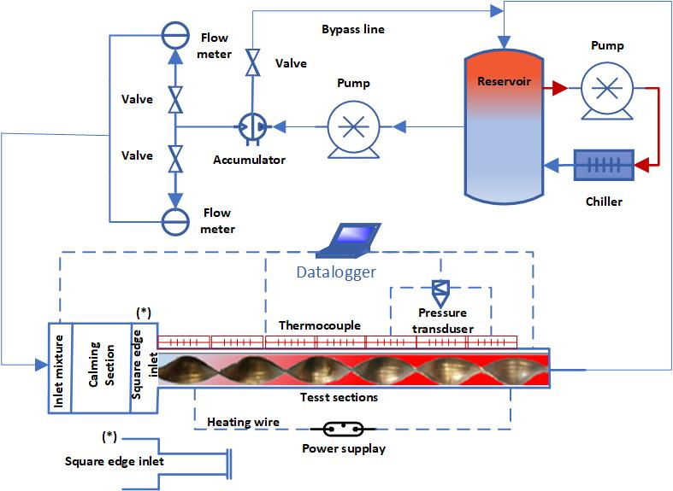
Figure 1. A visual representation of the experimental configuration adapted from [26].

coefficients using a shell and tube heat exchanger (STHE), where EG/Grn and EG were used as cold and hot fluids. The data derived from their analysis were compared with EG-based nanofluids. Azari et al. [28] conducted a study that specifically focused on heat transfer coefficients and overall heat transfer coefficients utilizing a 40:60 EG/Water ratio. An experimental methodology was employed, wherein a test section equipped with a compact heat exchanger was utilized. The outcomes of their experimental data analysis were contrasted with the performance of a fluid based on water.
The primary objective of this study is to conduct an initial inquiry into the optimization of a primary fluid mixture consisting of tri ethylene glycol/water (TEG/water) and ethylene glycol/water (EG/water). This investigation aims to determine the correlation between fluid flow rate, pressure drop, and heat transfer coefficient. The present research endeavor possesses the capacity to make a substantial contribution to the ongoing inquiry into fluids containing EG and water. Emphasizing the need for a thorough examination in the current body of literature concerning heat transfer coefficients and friction factors in single-pipe systems utilizing EG/water and TEG/water mixtures is critical. The objective of this research is to analyze the relationship between fluid flow rate and the friction factor (Fr) and heat transfer coefficient (HTC) for EG/water and TEG/water in a volumetric manner, with operating temperatures of 30°C and 40:60, respectively. By conducting experimental investigations that incorporate diverse fluctuations in fluid flow rates, this research has the potential to provide innovative perspectives on improving the performance of heat transfer systems that utilize mixtures of EG/water and TEG/water fluids. The integration of additives, such as nanoparticles, exhibits considerable potential in augmenting heat transfer characteristics, and it becomes especially apparent when migrating from configurations with comparatively low heat transfer rates to ones with higher efficiency.

METHOD
Properties of Ethylene Glycol and Triethylene Glycol
The thermal and physical characteristics of fluid mixtures play a crucial role in various industrial and scientific applications, particularly in heat transfer and fluid dynamics [29]. The melting point of ethylene glycol is -13°C, while its boiling point is 197.3°C. Ethylene glycol exhibits remarkable heat transfer characteristics at a temperature of 20°C. It is attributed to its substantial specific heat capacity of approximately 2430 J/kg.K, notable thermal conductivity of 0.25 (W/m.K), and density of 1113.4 kg/m³ [30]. On the contrary, water demonstrates exceptional performance as a heat storage medium at identical temperatures due to its substantial thermal energy retention capability, a relatively elevated density of 998.2 kg/m3, and a specific heat capacity of approximately 4180 J/kg.K.
Furthermore, its commendable thermal conductivity of 0.606 W/m.K. further enhances its viability. When developing systems that utilize TEG/water and EG/water as heat transfer fluids, coolants, or for diverse industrial purposes, it is imperative to possess an extensive comprehension of these properties. Table 1 presents the thermophysical properties of TEG.

Experimental Set up
The test section is constructed of pure copper pipe with a thickness and inner diameter of 1.5 mm and 18 mm, respectively. T₁-T₁₀ K-type thermocouples are strategically placed along the copper test section, with two at the inlet (T_{i}) and outlet (T_{o}). Pressure sensors are installed to measure the difference in pressure between the inlet (P_{i}) and outlet (P_{o}). A centrifugal pump is integrated to facilitate the EG/Water mixture flow through the copper test section. The data logger recorded pressure and temperature data with an accuracy of 0.1 psi and 0.25°C, respectively. The heater is controlled by a Voltage Regulator with input voltage specs of 220VAC, 50/60Hz, and an output voltage range of 0-250VAC. Two tubular heater units heat the copper pipes, each with a 1500 W power capacity. Throughout data collection, calibration is initially conducted on each measurement instrument. Following filling a 20-liter tank with a 40:60 EG/water mixture, the solution is circulated through the experimental system in hoses and pipes until it is completely saturated. Water samples were subjected to comparable conditions in order to facilitate comparisons. It undergoes circulation while being driven by a centrifugal pump. One second has been designated as the data logging interval. Heaters are activated concurrently with the initiation of data recording regarding fluid flow rate, temperature, and pressure when the inlet temperature reaches 60°C.
Table 1. The thermophysical properties of TEG/water mixture with a volume ratio of 40:60 [30, 31].

Temperature (K) | Density (kg/m³) | Viscosity (Pa.s) | Heat Specific (J/kg. K) | Thermal conductivity (W/m. K)
273 | 273 | 0.0110 | 3457 | 0.416
278 | 278 | 0.0084 | 3487 | 0.417
283 | 283 | 0.0070 | 3517 | 0.417
288 | 288 | 0.0059 | 3546 | 0.418
293 | 293 | 0.0051 | 3575 | 0.418
298 | 298 | 0.0043 | 3603 | 0.418
303 | 303 | 0.0037 | 3631 | 0.419
313 | 308 | 0.0032 | 3657 | 0.420
323 | 313 | 0.0028 | 3683 | 0.420
333 | 318 | 0.0024 | 3708 | 0.420
343 | 323 | 0.0021 | 3733 | 0.421
353 | 328 | 0.0019 | 3757 | 0.422
363 | 333 | 0.0016 | 3781 | 0.422
373 | 338 | 0.0015 | 3803 | 0.422
393 | 343 | 0.0013 | 3825 | 0.423
413 | 348 | 0.0012 | 3847 | 0.424
433 | 353 | 0.0010 | 3869 | 0.424
453 | 358 | 0.0009 | 3888 | 0.424
473 | 363 | 0.0008 | 3907 | 0.425

In order to maintain the inlet temperature within predetermined parameters and at 60 degrees Celsius, the chiller of this system operates as a heat exchanger. Accuracy estimates of 0.01 LPM for flow rate, 0.01 PSI for pressure, and 0.01°C for temperature were obtained using a data logger to record these parameters. In order to facilitate comparison, water and TEG samples were subjected to comparable conditions.
The relationship between a parameter input, such as a flow rate, temperature, or pressure, and fully developed conditions, which are controlled conditions, is established through experimental methods. Precise management of experimental settings and the occurrence itself is of utmost importance. Including a control group in experimental studies is essential to ensure effective variable control. Figure 2 provides a schematic test section in this study.

Heat transfer coefficient (HTC), h
The HTC quantifies the heat transfer capability of a surface or material between two locations. Unitary to W/m2K is frequently represented by the symbol "h." The HTC value is contingent on several variables, such as fluid flow, object shape, temperature difference, and material selection. This coefficient is especially valuable when calculating heat transfer in processes like convection or phase changes between liquids and solids. Equation 1 is typically used to determine its value [32].
$h=\frac{Q}{Ts-Tm}$ (1)
In this context, the temperature denoted as Ts​ represents the means temperature (K) of the surface being tested for suction. Its value is determined using Equation 2, as referenced in [25]
$T_{s}=\frac{\left(\sum_{i=1}^{8}{T}\right)}{10}$ (2)
In this context, T_{m}​ stands for the bulk temperature (K) of the fluid, and its value is determined using Equation 3.
$T_{m}=\frac{T_{in}-T_{out}}{2}$ (3)
The heat transfer rate (W) in this study is determined through the use of Equation (4), as specified in [25].

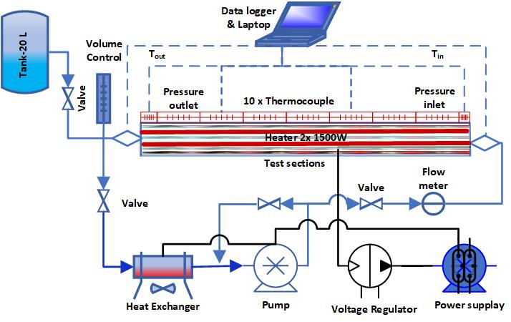
Figure 2. Experimental set up

$Q=\frac{Q_{1}+Q_{2}}{2}$ (4)
In this context, Q₁​ represents for heat transfer rate (W) originating from the power utilized, and it is determined using Equation (5). On the other hand, Q2​ is the heat transfer rate associated with the fluid's performance and is determined employing Equation (6), as indicated in reference [33].
$Q_{1}=VI$ (5)
$Q_{2}=\dot{m}C_{p}\left(T_{o}-T_{i}\right)$ (6)
where V donated for voltage (volts), I donated for current (Amperes), m˙ for mass flow rate (kg/s), and Cp​ for specific heat capacity (J/kg-K). Heat flux measures how quickly heat moves across a surface. It's expressed in watts per square meter (W/m²), which tells us how much heat flows through each square meter of that surface. To find heat flux using Equation 7, researchers usually measure these variables, and the specific method might differ based on the situation or the study's requirements. The equation and what exactly needs to be measured can be found in the specific reference or study being used.
$q''=\frac{Q}{πDL}$ (7)
Where D, represented for inner diameter (m) of the pipe and L, which stands for the length of the pipe (m).

Determination of Reynold Number (Re) and Nusselt number (Nu)
The Reynolds number is a dimensionless parameter that encapsulates the relationship between two critical forces within a particular flow situation. It is calculated using Equation (8). Reynolds numbers serve as a valuable tool for categorizing various types of flow, including laminar, turbulent, and transitional flow. Engineers and scientists can determine the dominant flow regime in a given situation by evaluating the Reynolds number. It is crucial for understanding fluid behavior and optimizing designs in different applications [34].
$Re=\frac{ρvD}{μ}$ (8)
Where Re represents the Reynolds number, v represents fluid velocity (m/s),), μ represents the absolute viscosity of the fluid (mPs), and ρ denotes fluid density (kg/m³) [35].
The Nusselt number (Nu) is a parameter that characterizes convection heat transfer at a surface by quantifying the non-dimensional temperature gradient. In this experiment, the Nusselt number was determined using Equation 9 [36]. This parameter helps us understand how efficiently heat is being transferred at the surface, which is crucial in various heat transfer and fluid dynamics studies [37].
$Nu=\frac{hD}{k}$ (9)
Equation 10 was used to calculate the Nusselt number (Nu). Moreover, the Nusselt numbers gained in this study were compared employing Bottler's Disstut formula (Equation 10) and Notter & Rouse's Equation 11. These evaluations and estimations aid in evaluating the system's efficiency and heat transfer coefficient under consideration, revealing valuable information about heat transfer performance [38].
$Nu=0.023{Re}^{0.8}{Pr}^{0.4}$ (10)
$Nu=5+0.015{Re}^{0.856}{Pr}^{0.347}$ (11)

Pressure drops and friction factor
Pressure drop is the energy reduction when a fluid encounters resistance while flowing through a pipe or channel. This resistance can result from factors like friction between the fluid and the pipe walls, flow velocity alterations, or pipe geometry shifts. Pressure drop is typically quantified in pressure units (Pascal). On the other hand, the friction factor gauges the impact of friction between the fluid and the pipe wall on fluid flow. It is commonly denoted as "f" and plays a role in pressure drop calculations. The value of the friction factor fluctuates based on the regime type (and the pipe's geometry.
The pressure drop is determined by subtracting the differences between the system's inlet and outlet. The pressure drop (P) is usually determined by employing Equation (12) [32].
$ΔP= P_{in}-P_{out}$ (12)
The Darcy friction factor is dimensionless for assessing frictional losses in pipes. Equation (13) can be used to calculate the experimental friction factor. This parameter is critical for comprehending and quantifying fluid flow resistance, essential for various engineering and fluid dynamics applications, particularly when determining pressure drops and losses in pipes [39].
$f=\frac{∆P}{\left(\frac{L}{D}\right)\left(ρ_{f}\frac{v^{2}}{2}\right)}$ (13)
Equations (14) and (15) show how to calculate the friction factor using the Petukhov and Blasius equations [35]. These alternative formulas provide ways of calculating the friction factor in specific flow conditions, providing valuable tools for analyzing and predicting the behavior of fluids in different situations.
$f=(0.79\ln{{Re-1.64)}^{-2}}$ (14)
$f=\frac{0.3164}{{Re}^{0.25}}$ (15)

RESULTS AND DISCUSSION

Analysis of Heat Transfer Coefficient (HTC), h
To assess the effect of EG/Water and TEG/water fluid flow rate, the HTC (h) was calculated using Equation (1) from experimental data, and the resulting averages were analyzed. As the Re of the fluid increases, the analysis demonstrates that h also increases. The impact of fluid flow rate on the HTC was examined. As the fluid flow increases, the HTC rises, as the results demonstrate. At a fluid flow rate of 4 LPM, the minimum HTC is observed, whereas the maximum HTC is attained when Re exceeds 12 LPM. The HTC values for TEG/water and EG/water are determined by the linear equations HTC=160.1+84.24 flowrate and HTC=163.1+82.32 flowrate, respectively. The results of this study consistently support the basic theory, which indicates that the heat transfer rate is positively related (directly proportional) to the HTC, as reported by [25]. The findings of this investigation consistently corroborate this fundamental assumption. It is widely acknowledged that the heat transfer rate positively correlates with the fluid flow rate [29]. A direct proportionality (positive correlation) was observed between the fluid mass flow rate and the fluid flow rate employed within the scope of this study [27, 40]. A direct proportionality (positive correlation) was observed between the fluid mass flow rate and the fluid flow rate employed within the scope of this study. Figure 4 provides a clear visualization of the impact of variations in fluid flow rate on the HTC.
The fluid flow rate will affect the value of the Re number, where the higher the fluid flow rate will increase the Re number. Therefore, further analysis was carried out to obtain the phenomenon of increasing the Re number for HTC. The HTC is greatest at Re values in excess of 5500 for TEG/water and 9000 for EG/water. The minimum HTC is observed at Re values in the range of 2000. 81.9+0.2893Re for TEG/water and 81.3+0.2793Re for EG/water, respectively, indicate a significant increase in HTC as predicted by the linear equation as shows in Figure 4a. The identical phenomenon is observed in the impact of reduced pressure on HTC as shown in Figure 4b. In both instances, the evaluated fluids demonstrated a concurrent rise in HTC and Re. This phenomenon is represented in the present study by the linear equations HTC=416.7+0.4228 ΔP and 414.3 + 0.4092 ΔP. Equations corresponding to this phenomenon are (1), (8), (9) (10), and (11) [32, 34, 35, 37, 38]. The impact of Re variation on the HTC is illustrated visually in Figure 4.

Pressure drops, friction factor and Reynold number analysis
The calculations for pressure drop (ΔP) and friction factor (f) were executed utilizing Equation 12. The calculated ΔP results were then averaged and analyzed to comprehend the impact of Re variations in EG/Water fluid flow. Figure 5 illustrates the Re increases as the ΔP rises. The minimum value of Re is identified at approximately 500 Pa for pressure drops (ΔP), whereas the maximum value of Re achieved at approximately 5500 for TEG/water and 9000 for MEG/water. As per equation (8), which establishes a direct relationship between speed and the Reynolds number according to Bernoulli's principle, the flow rate will also be directly proportional to the pressure difference (ΔP) mentioned in equation (16) [41].

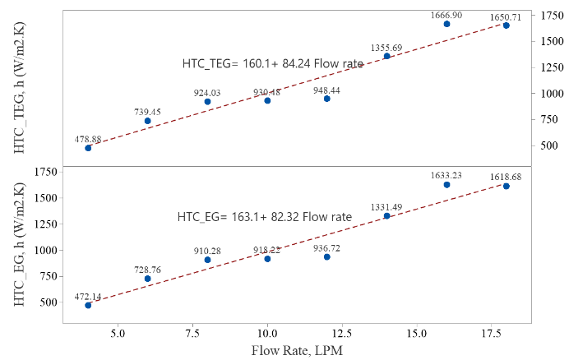
Figure 3. The effect of the EG/Water fluid flow rate on the heat transfer coefficient

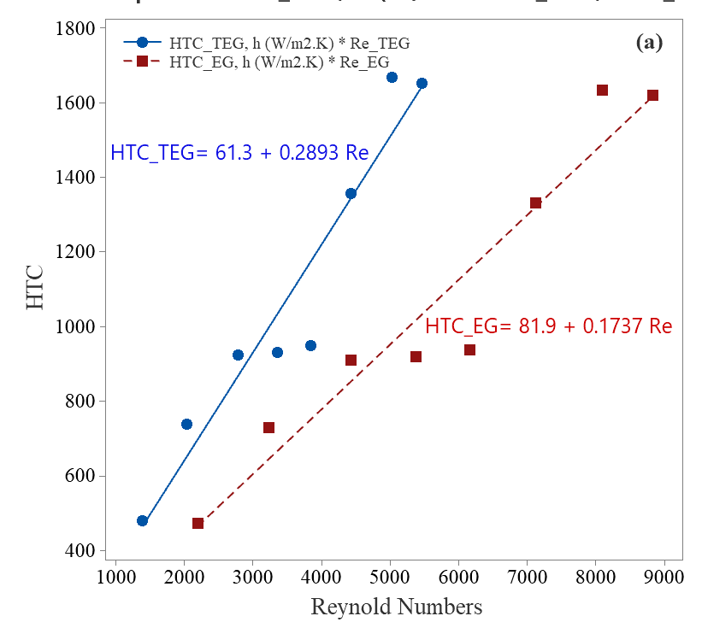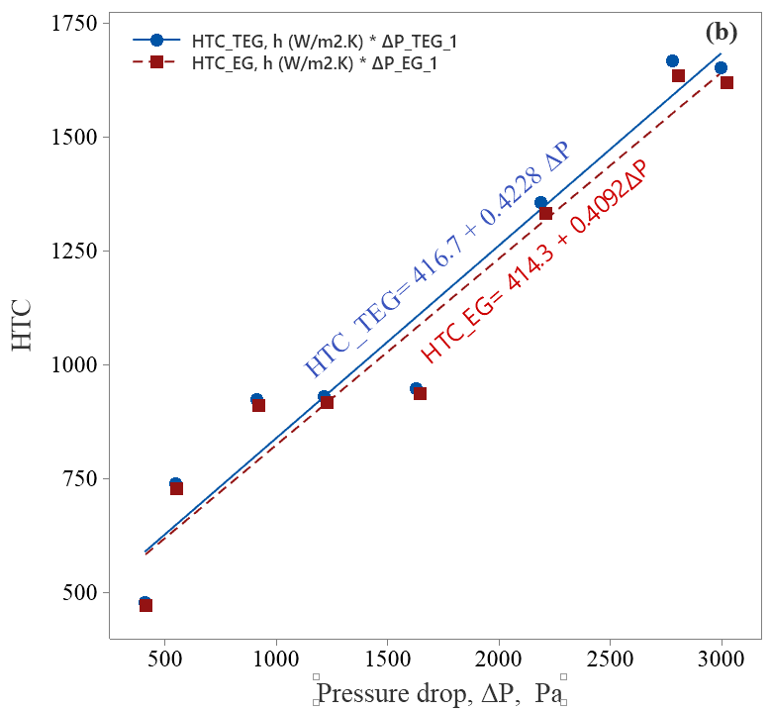
Figure 4. The effect of EG/Water fluid flow rate on the Nusselt number

$∆P=P_{1}-P_{2}= \left(\frac{ρv_{2}^{2}}{2}+ ρgh_{2}\right)-\left(\frac{ρv_{1}^{2}}{2}+ ρgh_{1}\right)$ (16)
Given that h1 equals h2, equation (16) can be rewritten as equation (17).
$∆P=P_{1}-P_{2}= \left(\frac{ρv_{2}^{2}}{2}\right)-\left(\frac{ρv_{1}^{2}}{2}\right)$ (17)

The friction factor (f) was calculated using experimental data and compared to the Petukhov and the Blasius equation. Equation 13 was used to calculate the experimental friction factor, while Equations 14 and 15 were used to apply the direction of the Petukhov and Blasius formula [33]. Figure 6 depicts the effect of changes in the Re on the friction factor. The data show that as the Re in EG/Water fluid flow increases, so does the friction factor. The results of the friction factor calculations based on experimental data closely align with the Petukhov and Blasius formulas.
Figure 6 illustrates that the friction factor diminishes with escalating Re in the TEG/Water and EG/water fluid flow. The findings indicate that the highest friction factor is observed at a Re around 2000, while the lowest is recorded at a Re exceeding 5500 for TEG/water and 9000 for EG water. It suggests that, in the context of TEG/Water and EG/water fluid flow, the friction factor tends to decrease as the Re rises, reflecting the fluid flow characteristics within the system.

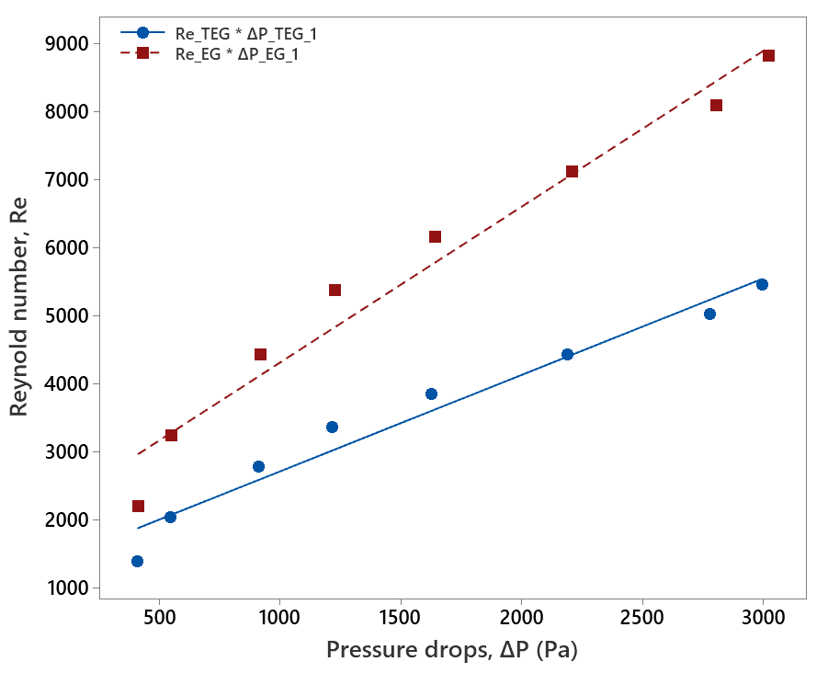
Figure 5. Effect of Reynolds number on Pressure drops.

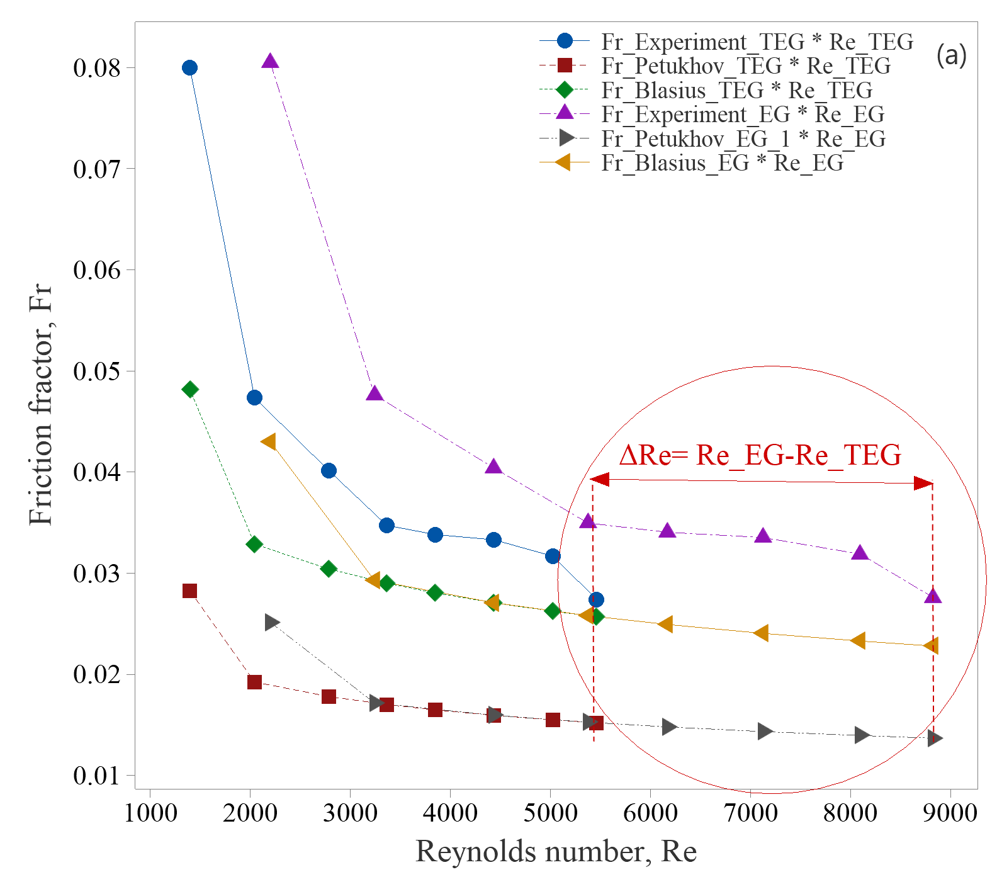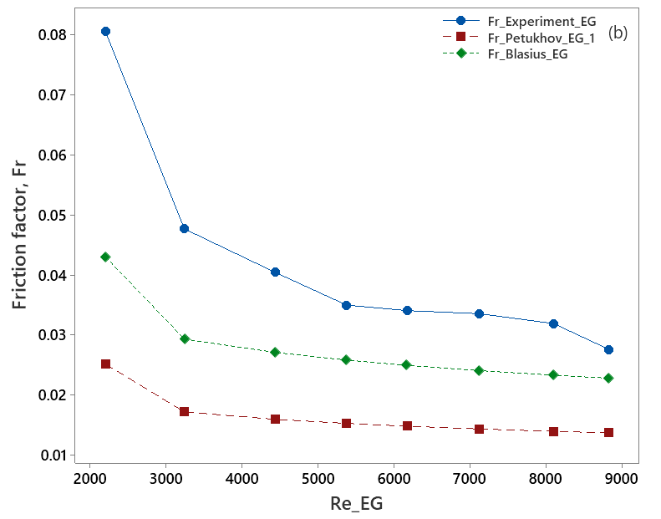
Figure 6. Effect of Reynolds number on Friction factor.

The outcomes of this research consistently affirm the fundamental theory, as corroborated by references [34] and [35], which establish a positive correlation (direct proportionality) between the friction factor value and both pressure drop and Reynolds number (Re). It is widely acknowledged that the Reynolds number is influenced by velocity, as noted in reference [30], and fluid flow rate, as cited in reference [29]. In the specific context of this study, it was observed that fluid velocity and flow rate also exhibit a positive correlation (direct proportionality) with the Reynolds number. Consequently, the friction factor tends to decrease as the Reynolds number increases, signifying that an increase in fluid flow velocity and flow rate reduces the resulting pressure.

Analysis of Reynolds number (Re) and Flow rate correlations
The Nu number evaluation is then compared with the Disstut Bottler (10) and Notter & Rouse (11) equations, with fluid flow rate considerations. Figure 7(a) depicts these comparative outcomes. The calculated results are then averaged and analyzed to determine the effect of flow rate on the Nusselt number. The results show that the Nu rises with flow rate, with the lowest value at 4 LPM and the highest at 18 LPM. The experimental data closely matches the Nu number calculation based on the Disstut Bottler equation but outperforms the Notter and Rouse formula. The Nu number, as per equation (9) outlined in reference [32], demonstrates a positive correlation (direct proportionality) with the Heat Transfer Coefficient (HTC), in line with the findings in reference [25]. Furthermore, the Nu number is closely linked to the Reynolds number (Re), as reference [33] indicates. It is well-established that the Nu number value is influenced by the fluid flow rate, as acknowledged in reference [29]. In this research, we have determined that the Nu number value of the fluid also exhibits a positive correlation (direct proportionality) with the fluid's flow rate, it’s confirmed reported by [42]. Therefore, an increase in the fluid flow rate leads to a corresponding increase in the Nu number, indicating a heightened heat transfer rate through the fluid.
Meanwhile, the correlation between flow rate and pressure drops is presented in Figure 7(b), which indicates that there is an increase in pressure drop along with an increase in flow rate. This phenomenon is related to Bernoulli's principle, which follows equations (16) and (1).

CONCLUSION
A successful research study analyzing heat transfer coefficients and pressure drop in copper pipe flow systems using TEG/water and EG/water fluids with a 40:60 ratio at 30°C succinctly summarized the impact of varying fluid flow rates on HTC and ΔP:
- The rising heat transfer coefficient (HTC) observed in both the TEG/water and EG/water fluids passing through the copper pipe in conjunction with increased flow rates can be attributed to the corresponding increase in Reynolds number, directly proportional to higher flow rates. As a result, the TEG/water fluid has a greater HTC than the EG/water fluid.

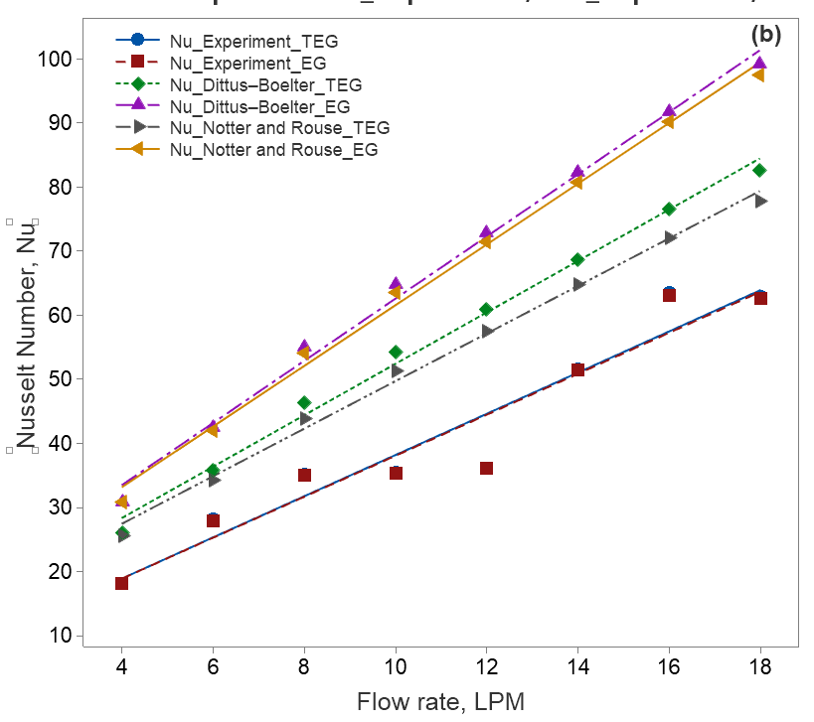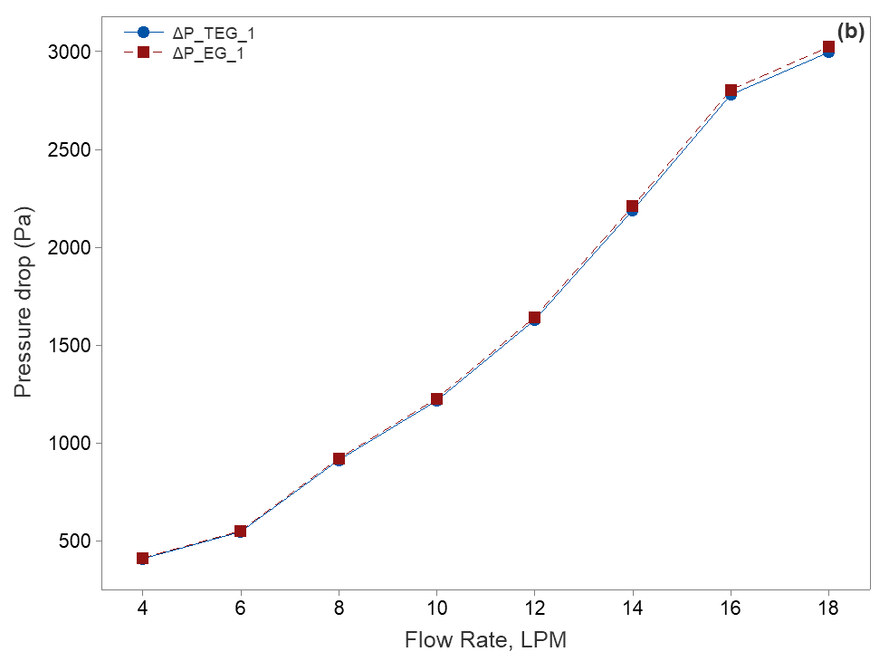
Figure 7. Effect of fluid flow rate on the Nusselt number and pressure drops

- ΔP within the fluid in the copper pipe shows a direct increase with the flow rate, while notably, the friction factor in the TEG/water and EG/water fluid decreases as flow rates rise.
- The Reynolds number of the fluid within the copper pipe maintains a direct proportional relationship with the fluid flow rate throughout the study.

ACKNOWLEDGMENT
Thanks to "The Ministry of Research, Technology, & Higher Education" who has fully funded this research through the "Penelitian Dosen Pemula" program with contract number 053/SPH2H/RT-MONO/LL42023/and 02/LPPM /PDP/VII/2023. The author sincerely thanks the dedicated team at Buana Perjuangan University's Energy Conversion Laboratory in Karawang. Their invaluable assistance in data collection throughout the experimental process is greatly appreciated.

REFERENCES
[1] M. S. Liu, M. C. C. Lin, I. T. Huang, and C. C. Wang, "Enhancement of thermal conductivity with CuO for nanofluids," Chemical Engineering and Technology, vol. 29, no. 1, pp. 72-77, 2006.
[2] M. A. Khattak, M. A, and S. Kamran Afalaq, "Application of nanofluids in heat exchangers: A review," Journal of Advanced Research in Materials Science, vol. 66, no. 1, pp. 5625-5638, 2020.
[3] A. I. Ramadhan, W. H. Azmi, R. Mamat, and K. A. Hamid, "Experimental and numerical study of heat transfer and friction factor of plain tube with hybrid nanofluids," Case Studies in Thermal Engineering, vol. 22, no. April, pp. 100782-100782, 2020.
[4] S. Sukarman and Y. S. Gaos, "Optimasi Desain Alat Penukar Kalor Gas Buang untuk Pemanas Air Degreaser," Jurnal Ilmiah TEKNOBIZ, vol. 8, no. 3, pp. 94-100, 2018.
[5] M. Mehrpooya, M. Dehqani, S. A. Mousavi, and S. M. A. Moosavian, "Heat transfer and economic analyses of using various nanofluids in shell and tube heat exchangers for the cogeneration and solar-driven organic Rankine cycle systems," International Journal of Low-Carbon Technologies, vol. 17, no. November, pp. 11-22, 2022.
[6] E. Borri et al., "Phase Change Slurries for Cooling and Storage: An Overview of Research Trends and Gaps," Energies, vol. 15, no. 19, 2022.
[7] R. LeSar and R. LeSar, "Materials selection and design," Introduction to Computational Materials Science, pp. 269-278, 2013.
[8] H. Ibrahim, N. Sazali, A. S. M. Shah, M. S. A. Karim, F. Aziz, and W. N. W. Salleh, "A review on factors affecting heat transfer efficiency of nanofluids for application in plate heat exchanger," Journal of Advanced Research in Fluid Mechanics and Thermal Sciences, vol. 60, no. 1, pp. 144-154, 2019.
[9] A. Ghozatloo, A. Rashidi, and M. Shariaty-Niassar, "Convective heat transfer enhancement of graphene nanofluids in shell and tube heat exchanger," Experimental Thermal and Fluid Science, vol. 53, pp. 136-141, 2014.
[10] W. Zheng, H. Zhang, S. You, and T. Ye, "Numerical and experimental investigation of a helical coil heat exchanger for seawater-source heat pump in cold region," International Journal of Heat and Mass Transfer, vol. 96, pp. 1-10, 2016.
[11] M. Bayareh, A. H. Pordanjani, A. A. Nadooshan, and K. S. Dehkordi, "Numerical study of the effects of stator boundary conditions and blade geometry on the efficiency of a scraped surface heat exchanger," Applied Thermal Engineering, vol. 113, pp. 1426-1436, 2017.
[12] B. C. Pak and Y. I. Cho, "Hydrodynamic and Heat Transfer Study of Dispersed Fluids With Submicron Metallic Oxide," Experimental Heat Transfer : A Journal of , Thermal Energy Transport , Storage , and Conversion, vol. 11, no. 2, pp. 151-170, 2007.
[13] L. Godson, K. Deepak, C. Enoch, B. R. Jefferson Raja, and B. Raja, "Heat transfer characteristics of silver/water nanofluids in a shell and tube heat exchanger," Archives of Civil and Mechanical Engineering, vol. 14, no. 3, pp. 489-496, 2014.
[14] W. H. Azmi, K. V. Sharma, P. K. Sarma, R. Mamat, S. Anuar, and V. Dharma Rao, "Experimental determination of turbulent forced convection heat transfer and friction factor with SiO2 nanofluid," Experimental Thermal and Fluid Science, vol. 51, pp. 103-111, 2013.
[15] Z. Said, S. M. A. Rahman, M. El Haj Assad, and A. H. Alami, "Heat transfer enhancement and life cycle analysis of a Shell-and-Tube Heat Exchanger using stable CuO/water nanofluid," Sustainable Energy Technologies and Assessments, vol. 31, no. December 2018, pp. 306-317, 2019.
[16] M. Hojjat, "Nanofluids as coolant in a shell and tube heat exchanger: ANN modeling and multi-objective optimization," Applied Mathematics and Computation, vol. 365, pp. 124710-124710, 2020.
[17] M. Setiyo, S. Soeparman, N. Hamidi, and S. Wahyudi, "Caractéristiques de l'effet refroidissant d'un système frigorifique à demi-cycle sur un système au GPL," International Journal of Refrigeration, vol. 82, pp. 227-237, 2017.
[18] I. M. Shahrul, I. M. Mahbubul, R. Saidur, S. S. Khaleduzzaman, M. F. M. Sabri, and M. M. Rahman, "Effectiveness study of a shell and tube heat exchanger operated with nanofluids at different mass flow rates," Numerical Heat Transfer; Part A: Applications, vol. 65, no. 7, pp. 699-713, 2014.
[19] M. W. Tian, A. Abidi, S. R. Yan, D. Toghraie, and M. Degani, "Economic cost and efficiency analysis of the employment of inserting rods with helical fins in a shell and tube heat exchanger under magnetic field and filled with nanofluid," Ain Shams Engineering Journal, vol. 13, no. 4, pp. 101651-101651, 2022.
[20] N. Tamilselvan, M. Thirumarimurugan, and E. Sudalai Manikandan, "Study on various control strategies of plate type heat exchanger for non-Newtonian fluids," Journal of Ambient Intelligence and Humanized Computing, vol. 12, no. 7, pp. 7253-7261, 2021.
[21] R. Andrzejczyk and T. Muszyński, "Performance analyses of helical coil heat exchangers. the effect of external coil surface modification on heat exchanger effectiveness," Archives of Thermodynamics, vol. 37, no. 4, pp. 137-159, 2016.
[22] M. H. Rostami, G. Najafi, B. Ghobadin, and A. Motevali, "Thermal performance investigation of SWCNT and graphene quantum dots nanofluids in a shell and tube heat exchanger by using fin blade tubes," Heat Transfer, vol. 49, no. 8, pp. 4783-4800, 2020.
[23] S. P. Louis, S. Ushak, Y. Milian, M. Nemś, and A. Nemś, "Application of Nanofluids in Improving the Performance of Double-Pipe Heat Exchangers—A Critical Review," Materials, vol. 15, no. 19, 2022.
[24] E. M. Go, E. Shin, J. H. Cha, and S. K. Kwak, "Estimation of heat transfer coefficient of water and ethylene glycol mixture in nanopipe via non-equilibrium coarse-grained molecular dynamics," Journal of Industrial and Engineering Chemistry, vol. 77, pp. 128-134, 2019.
[25] T. U. H. S. G. Manik, G. Sudrajat, and T. B. Sitorus, "The experimental study of the coolant flow rate of an ethylene glycol-mixed water to the heat transfer rate on the radiator," vol. 505, pp. 0-8.
[26] S. M. Abolarin, M. Everts, and J. P. Meyer, "Heat transfer and pressure drop characteristics of alternating clockwise and counter clockwise twisted tape inserts in the transitional flow regime," International Journal of Heat and Mass Transfer, vol. 133, pp. 203-217, 2019.
[27] A. Ghozatloo, M. Shariaty-Niasar, and A. M. Rashidi, "Investigation of Heat Transfer Coefficient of Ethylene Glycol/ Graphenenanofluid in Turbulent Flow Regime," Int. J. Nanosci. Nanotechnol, vol. 10, no. 4, pp. 237-244, 2014.
[28] N. Azari, I. Chhaya, Y. Ghamat, D. Kanthariya, M. Patel, and F. Bodiwala, "Experimental Investigation of Heat Transfer in Compact Heat Exchanger using Water-Ethylene Glycol," vol. 8, no. 04, pp. 666-669, 2019.
[29] L. Karikalan, S. Baskar, N. Poyyamozhi, and K. Negash, "Experimental Analysis of Heat Transfer by Using Nanofluid and Impact of Thermophysical Properties," Journal of Nanomaterials, vol. 2022, 2022.
[30] D. TEG, "Dynalene TEG."
[31] S. Tongfan and A. S. Teja, "Density, Viscosity, and Thermal Conductivity of Aqueous Ethylene, Diethylene, and Triethylene Glycol Mixtures between 290 K and 450 K," Chemical engineering data, vol. 48, pp. 198-202, 2003.
[32] B. Kristiawan, S. Kamal, Suhanan, and Yanuar, "Thermo-hydraulic characteristics of anatase titania nanofluids flowing through a circular conduit," Journal of Nanoscience and Nanotechnology, vol. 16, no. 6, pp. 6078-6085, 2016.
[33] B. Kristiawan, A. I. Rifa'i, K. Enoki, A. T. Wijayanta, and T. Miyazaki, "Enhancing the thermal performance of TiO2/water nanofluids flowing in a helical microfin tube," Powder Technology, vol. 376, pp. 254-262, 2020.
[34] N. Kumar and S. S. Sonawane, "Experimental study of Fe2O3/water and Fe2O3/ethylene glycol nanofluid heat transfer enhancement in a shell and tube heat exchanger," International Communications in Heat and Mass Transfer, vol. 78, pp. 277-284, 2016.
[35] N. Arora and M. Gupta, "An experimental study on heat transfer and pressure drop analysis of Al2O3/water nanofluids in a circular tube," Materials Today: Proceedings, no. xxxx, pp. 2-7, 2022.
[36] T. Thiyana, J. Ahmad, A. R. Muhammad, S. Sukarman, K. Khoirudin, and R. l. Azizah, "Heat Transfer Coefficient in a Copper Pipe Flow System Using a 40/60 Volume Ratio Ethylene Glycol/Water (EG/H2O) Blended Fluid," Jurnal Teknik MesinMechanical Xplore (JTMMX), vol. 1, no. 2, pp. 37-46, 2023.
[37] A. Alimoradi, M. Olfati, and M. Maghareh, Numerical investigation of heat transfer intensification in shell and helically coiled finned tube heat exchangers and design optimization. Elsevier B.V., 2017, pp. 125-143.
[38] M. R. Salem, R. K. Ali, R. Y. Sakr, and K. M. Elshazly, "Effect of γ-Al2O3/water nanofluid on heat transfer and pressure drop characteristics of shell and coil heat exchanger with different coil curvatures," Journal of Thermal Science and Engineering Applications, vol. 7, no. 4, pp. 1-9, 2015.
[39] R. Barzegarian, A. Aloueyan, and T. Yousefi, "Thermal performance augmentation using water based Al2O3-gamma nanofluid in a horizontal shell and tube heat exchanger under forced circulation," International Communications in Heat and Mass Transfer, vol. 86, pp. 52-59, 2017.
[40] W. H. Azmi, K. V. Sharma, P. K. Sarma, R. Mamat, and G. Najafi, "Heat transfer and friction factor of water based TiO2 and SiO2 nanofluids under turbulent flow in a tube," International Communications in Heat and Mass Transfer, vol. 59, pp. 30-38, 2014.
[41] H. Chanson, "Applications of the Bernoulli equation to open channel flows," in Hydraulics of Open Channel Flow An Introduction Basic Principles, Sediment Motion, Hydraulic Modelling, Design of Hydraulic Structures, vol. 4: ELSEVIER, 2004.
[42] M. Sharifpur, A. B. Solomon, T. L. Ottermann, and J. P. Meyer, "Optimum concentration of nanofluids for heat transfer enhancement under cavity flow natural convection with TiO2 – Water," International Communications in Heat and Mass Transfer, vol. 98, no. October, pp. 297-303, 2018.

