Preference Technique: Deceptive Visual Representations in the Digital Realm | 

Niccolas Troy Putra Heriyanto¹, Arina Hayati^{2*}, Didit Novianto³
¹Department of Architecture, Faculty of Civil Planning and Geo Engineering, Institut Teknologi Sepuluh Nopember, Indonesia
²Department of Architecture, Faculty of Civil Planning and Geo Engineering, Institut Teknologi Sepuluh Nopember, Indonesia
³Department of Architecture, Faculty of Civil Planning and Geo Engineering, Institut Teknologi Sepuluh Nopember, Indonesia

Abstract  In the digital era, architectural designs can be quickly visualized. However, the material abstraction from digital visualization tools may reduce immersion and make it hard to recognize design intention. This paper discusses how architectural students acknowledge the design representation, despite various ways of visualization. Material is key to visualizing architecture in ways of adding realism, depth, and texture. People create mental concepts of material beyond words. Thus, design representations can have positive or negative impacts depending on how effectively the idea is delivered to the audience. This study uses a quantitative method to investigate the extent to which the preference technique of students represents the design’s idea. The main objective of the study is to identify the criteria for representation that effectively convey the designer's intentions while minimizing visual deception. The analyzed data is classified into three archetypes consisting of (1) the student’s previous knowledge about representation, (2) the intention of design representation, and (3) mass and material in representation. The result shows that there is no strict correlation between previous knowledge and the preferred technique to represent an idea. Yet, the result indicates that there is the correlation between previous knowledge and technique to represent material. Photorealism technique is preferable in representing the clarity of material in representation. There are advantages to using photorealism in showing the quality of shade in the material. On the other hand, to show information about scale and mass, respondents tend to choose to use sketches. The research comprehensively explains this phenomenon in the context of positive theory, particularly in design communication and representation  This is an open-access article under the CC BY-SA license   | Keywords:  Representation; Visual Perception;  Material; Technique;  Article History:  Received:  Revised:  Accepted:  Published:  Corresponding Author:  Arina Hayati  Architecture Department, Indonesia  Email: arina_h@arch.its.ac.id

INTRODUCTION
There are limitations of non-digital visualization tools that can affect perception and lead to deceptive side effects [1]. The visualization tools may result in having different interpretations perceived by users. This research aims to bring visual perception and materiality into digital visualization by adopting the non-digital visualization tools. With the advancements in technology, many styles of representation have emerged [2]. However, these new styles sometimes prioritize creativity over clarity, which can be misleading. To ensure that visualizations are not biased, it is important to understand the designer's intention and preference for visualization methods. The ideal representation should not be biased and can be identified by simulating the abstraction of material in visualization and confirming it with the designer [3]. The study's invention helps students expand their knowledge of visualization tools. Therefore, understanding the designer's intent and preference for visualization methods can help extend the range of digital representation tools, ensuring that the visualization is not biased. Although technology has greatly aided the design process, it also affects how architects approach design thinking, and sometimes comes at the cost of losing certain sensory experiences [4]. With digital representation revolutionizing the design process, it bridges the architect's imagination with the physical realm, making ideas tangible and facilitating feedback for future design [5]. The process of translating an idea into a product is part of the design process, which consists of the production process and the creativity process.
Nowadays, technology greatly aids the design process with software for modelling and evaluating buildings. However, this also impacts how architects approach design thinking with software. Previously used for representation, the software now generates entire concepts and not only shows how a building looks in real life but also represents the process of constructing it. While software helps streamline the design process, it does come at the cost of losing certain sensory experiences, such as haptic feedback. As architecture is fabricated digitally, the engagement with materials is diminished [2], [4].
Digital representation revolutionizes the design process by bridging the architect's imagination with the physical realm, making ideas tangible, and facilitating feedback for future design [3]. There are two main aspects of representation: translating design ideas into a medium and interpreting the representation to understand design concepts. These two processes constantly interact, conveying and comprehending design ideas through representation.
Perception is the process of interpreting what is observed, specifically representation. It is derived from reactions to physical objects that have been observed and accumulated into mental images and experiences [6]. Some individuals who predominantly use the left hemisphere of the brain may not easily create visual images in their imagination. However, they are still able to distinguish one object from others. This recognition of distinguished objects necessitates a detailed comparison of visual images stored in the mind. Visual images can reshape the mind and stimulate creative thought. Visualization plays a crucial role in design thinking, as it helps in generating ideas and understanding design data. It is an integral part of the theoretical design thinking process, which combines design tools, methods, and perspectives from outside of architectural syntax to solve user-acknowledged problems [7]. Architectural images also can evoke responses and provide insight into the built environment, thus later influencing people’s perception of space [8].
When communicating design, especially through images, a deceptive side can emerge [9]. Visualization can change how a client perceives a concept, making it appear more realistic than an actual landscape. The scale and dimensions may appear different from the final project. The lack of effectiveness in communicating visualizations can cause bias in representation [5]. The paper highlights how visualization is misused as a business strategy rather than an honest representation and how it relies on direct experience for comparison with perception. Although there are two impacts as a result of perceived information, this research emphasizes on negative impact of biased representation. Design should be communicated through visualization, allowing users to perceive as intended. Ultimately, visualization should be viewed as an extension of the designer's ability to communicate ideas to clients. While it may not be able to portray reality exactly, it still must convey a clear and truthful concept to the user. Any ambiguity or deception is unacceptable [5].
The research aims to identify the factors that affect the recognition of specific materials and the extent of their visualization. The purpose is to help people understand how they can identify different types of materials using various visualization techniques. Through an intersubjective paradigm, the study acts as a bridge to the gap in previous research and addresses the following statement: “How architecture student’s knowledge can alter the preference for representing architecture ideas, in the context of materiality”.

METHOD
The research focuses on the representation of architecture during the conceptual design phase, using tools such as orthographic and perspective drawing. Each tool has a specific purpose, with orthographic projection providing accurate information in the form of elevation. Perspective drawing creates a two-dimensional drawing of a three-dimensional object from a subjective viewpoint, mimicking human vision.

Material
To answer the research questions, the preferable approach is using sorting images. Two major variables can be utilized, representation and visual perception. The question is answered by creating images that represent both variables. The image is sorted into two sections, the first section is used for collecting information, and the second section acts as a further explanation of answering the research question. Both sections are shown respectively in figure 1 and 2. The image that is used is controlled by several variables, such as the position, using the shape, object, and background to avoid a biased perception.
Each of the image sections (Fig. 3,4) consists of seven drawing styles, which are pencil sketches, watercolour, ink sketches, oil painting, vector/illustration, collage, and photorealism. The first section uses using simple cube form and one type of material to control the other intervention of material (Fig 1). The second section uses a more complex form, consisting of the arrangement of several three-dimensional blocks with several types of material (Fig 2). The purpose of the second section is to know the intervention of other materials in shaping perception and the awareness of the designer in representing ideas. The second section of the image focused more on the complex information of the first section.
In creating the image from the first section, the geometrical cube is shaped using Rhinoceros software and rendered using the in-built rendering software (a). The texture of the material that is used in creating images comes from the free online platform (b). The light that is used is manipulated, simulating real sunlight. The image is exported into PNG format with 300 dpi quality (c). The same process is repeated to create the second section of the image, although the cube is changed into a complex arrangement of cubes with several types of material, such as bricks, masonry, steel, and timber.

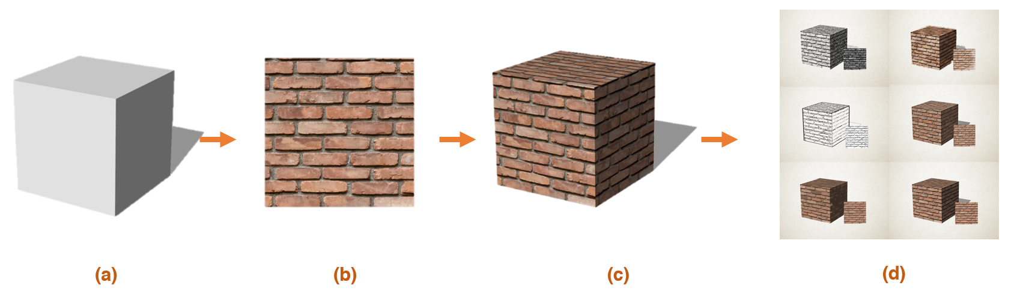
Figure 1. Cube with Brick Textured Material: (a) Cube (b) Material Texture (c) Base Unedited Image (d) Edited Image)

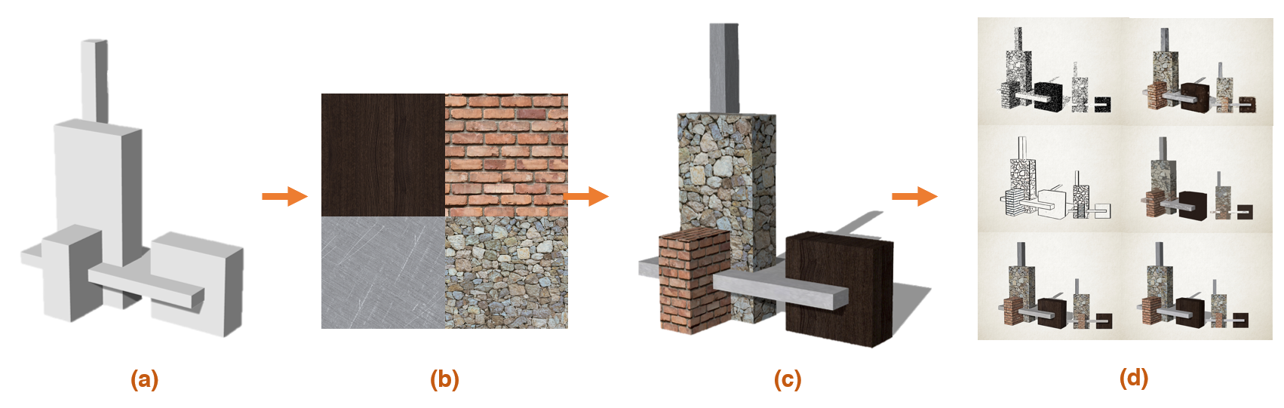
Figure 2. Complex Arrangement of Blocks with Several Types of Material: (a) Cubes (b) Material Texture (c) Base Unedited Image (d) Edited Image.
After that, the basic geometrical form is edited in Adobe Photoshop to create an imitated effect on several drawing styles in digital representation (d). All the drawing styles are mainly utilizing the feature of filter gallery in Adobe Photoshop. For example, a sketch style uses using graphic pen filter with 4 points of stroke length, 6 points of light/dark balance, and a right diagonal stroke direction (Fig. 3). All the images that contain sketch filters use the same treatment. Vector/illustration type utilizes the cutout filter in Adobe. The only drawing that does not use any filter is a collage drawing, which is more on how technique to create a collage to represent the drawing. Collage drawing uses seamless texture and collages it into the intended shape. Photorealism drawing uses the same original render that already previously applied. The materials are used in image sorting as an approach to understanding the perception of students in representing the idea [10]–[18]

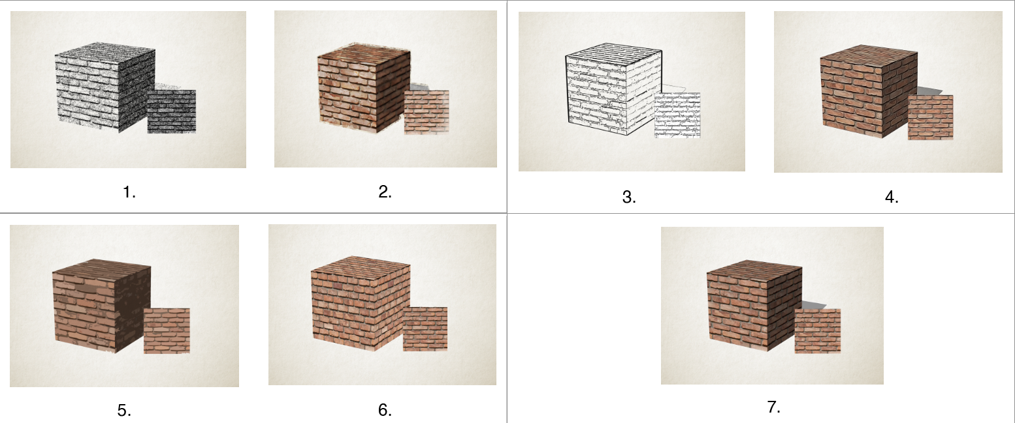
Figure 3. First Section of Image Sorting: (1) Sketch (2) Watercolour (3) Oil Paint (4) Ink Sketch (5) Illustration/Vector (6) Collage Drawing (7) Photorealism).

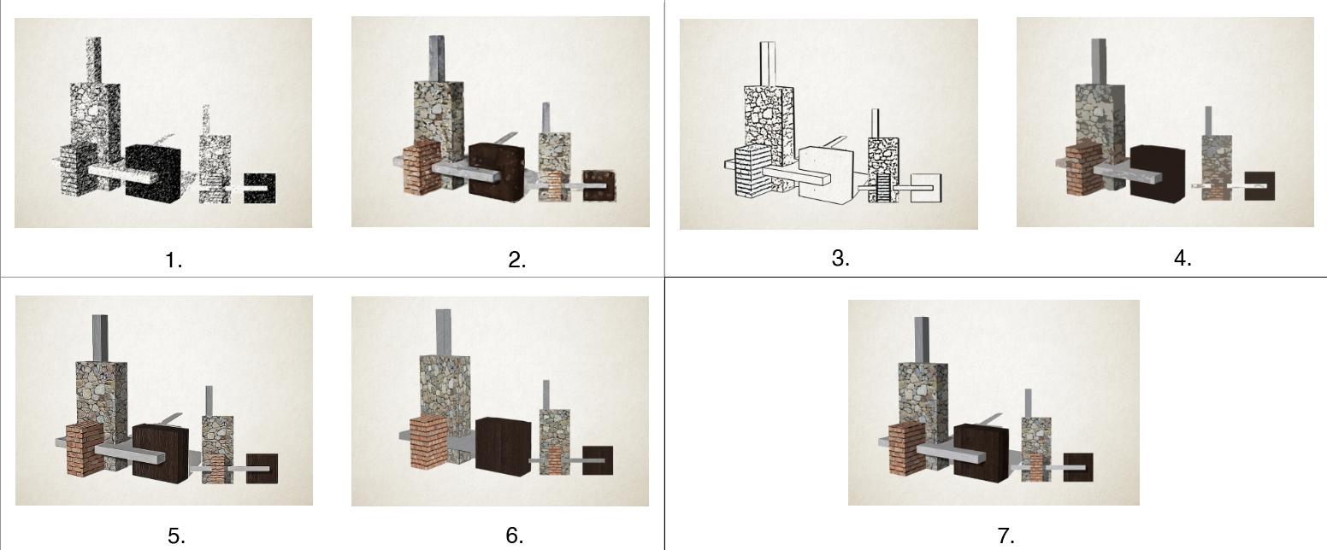
Figure 4. Second Section of Image Sorting: (1) Sketch (2) Watercolour (3) Oil Paint (4) Ink Sketch (5) Illustration/Vector (6) Collage Drawing (7) Photorealism).

Methods
In this research, the context of architectural representation is focused on materiality. As material is mainly used as a construction factor in architecture, the characteristic of space is defined using the material’s composition [19]. By contrasting each type of architectural representation style and techniques, visual attributes that create bias are determined. The spectrum of favourable architectural representation that suits the intention of the designer and is grasped fully by the client is generated from the analysed visual attribute earlier.
For this research, orthographic drawings, including elevation and perspective drawings are used as tools. Elevation is advantageous in delivering facade information, such as mass, texture, shape, and material, while perspective drawing provides a comprehensive understanding of the building and its surrounding context [20].
To ensure consistency among the respondents, only architecture students are selected. The level of student knowledge becomes a variable affecting visual perception, and the intention of the students is limited to communicating their conceptual ideas. The purpose of selecting students as respondents is to consider their explorative nature in conveying their ideas. Architects tend to be stuck in their chosen paradigm, style, and ideology. This behavior creates a bias in research, thus first to fourth-year architecture and post-graduate students are included in the study.
Respondents are selected from institutes in Surabaya that have architecture majors. The knowledge of architecture students plays a crucial role in data collection. To control the diversity of knowledge, only schools with an A accreditation were selected, in this test case, Institut Teknologi Sepuluh Nopember is selected. The university selection also considers the accessibility and acceptability of the respondents.
Respondents consisted of first to fourth year and post-graduate architecture students. Each year is expected to have increased knowledge about architecture visualization, making them eligible for the study. According to studies, design studio plays a fundamental role in enhancing student creativity in architectural education [21], [22]. Design studios enable students to experiment with different design solutions to design problems, providing flexibility in exploring the problem and creating a design approach based on their engagement. The design studio is vital because it sets a course for students to gain knowledge about practical and theoretical design and creativity. The respondents are chosen from various year grades for diverse viewpoints and generalizability concerns purpose. This questionnaire is distributed every academic year and post-graduate year in college.
The variable is used to define the element of shaping the image for data collection (image sorting) (Table. 1). Physical attributes in architectural representation consist of mass, structure, surface, and materials. A sense of mass is created by the composition of the conceived solid form. Volume of solid form can be achieved from addition or subtractive. Material is the designer’s instrument for creating textural manipulation. Scale is relative as it is only defined by the relation of something and heavily depends on context. Scale can be measured by physical or perceptual engagement. Physical engagement is related to the dimension of the human body, while perceptual is related to the visual perception of the observer. Light creates the possibility of illumination that later enriches the spatial experience [23]. Three dimensionality related to the depth perception that emerge from perceiving two-dimensional image as if the image in three dimensions [24].

Table 1. Variables in Research
Parameter | Variable | Sub Variable
Representation | Attribute  Drawing Styles  Tools | Mass  Light  Surface  Material  Scale  Sketching  Watercolour  Oil Painting  Digital/Photorealism  Painting  College  Illustration/Vector  Photorealism  Elevation drawing  Perspective drawing
Visual Perception | Material | Mass  Massiveness  Heaviness/Lightness  Hardness/Softness  Transparency  Light/shade  Three Dimensionality

Architectural technique in architectural representation related to media for producing the image. However, in this research, the architectural technique is more on the unique quality of the image, not on the technique itself. Architectural techniques consist of sketching (both pencil and ink), painting (both watercolour and oil painting), vector or illustration, and photorealism (digital render). The attributes of the material consisted of mass and massiveness, the weight of the material, the quality of the surface, the information of illumination, and volumetric information [19].
To ensure the respondent knows how the knowledge about representation helps represent the idea, the respondent is asked before filling the first and second sections. After that, the bias from drawing needs to be reduced first by asking the respondents if they can distinguish the different types of visualization. All sections of the image are then included in the Questionnaire form utilizing Microsoft Forms as a platform to distribute questionnaires. The design of the questionnaire consisted of three sections, the first part of the questionnaire asks to identify the knowledge of the respondent, and the second and third part is used to rank the sorted image, to each of the questions that are based on variables already been discussed. Data is collected in the cloud and can be processed and displayed anytime. The question is quantified by the Likert scale and ranking system. The scale is ranged from Very Disagree (1), Disagree (2), Agree (3), and Very Agree (4).

RESULTS AND DISCUSSION
There are at least thirty-three respondents who participated in answering the questionnaire, with the distribution of 8 males and 25 females. Respondents were distributed among 9 students from the second year, 8 students from the third year, 4 students from the fourth year, 4 students from the first year, and 8 students from the postgraduate (Fig. 5). This distribution means that there is a representative for each year's grade.
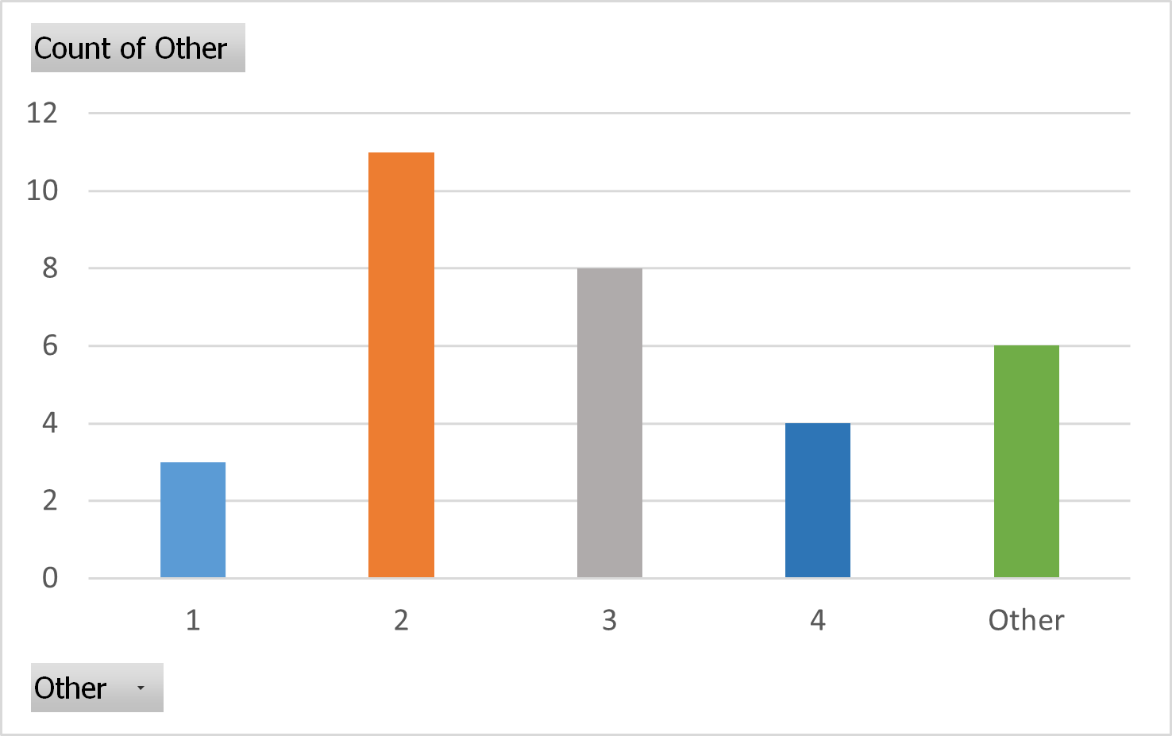
Figure 5. The Distribution of the Academic Year among Respondents

There are three questions to check the knowledge about representation. The first question is to check if the respondent has already gained knowledge about architectural representation. Data shows that 87.9% of respondents have achieved the knowledge, while 12,1% already know, but not that enough (Fig.6). The second question also comes with the same distribution, with the question about how the knowledge about representation helps respondents in creating an architectural representation. From the gathered data can be concluded that all respondents already gained knowledge about architectural representation, so the answer for the next section is not biased. Respondents also include which software they usually use in producing architectural representation, consisting of Adobe Illustrator, Adobe Photoshop, Figma, Canva, PowerPoint, and other software mainly for modeling and rendering such as Sketchup, Rhinoceros, Lumion, and Enscape.

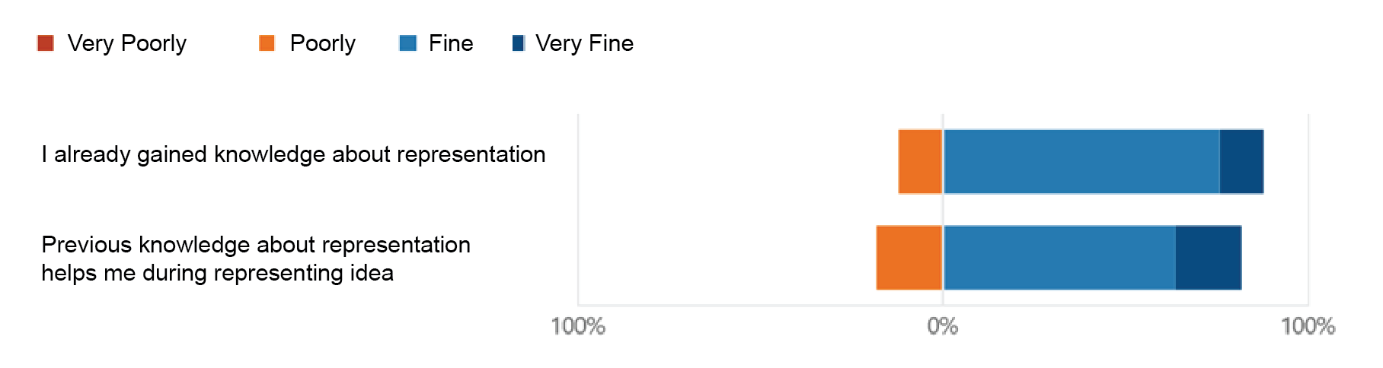
Figure 6. The Distribution of Previous Knowledge
The third question in this section is to check the bias from the image itself. From the data itself can be concluded that while many respondents can distinguish the differences among styles, still there are 33.3% of respondents that can’t easily see the differences (Fig.7). This problem will be addressed later in the next discussion. However, based on several responses, the problem arising from the images from the first section is incomparable, since they only show one material embodied in a simple cube, instead of the second section which consists of different types of material in a complex arrangement.

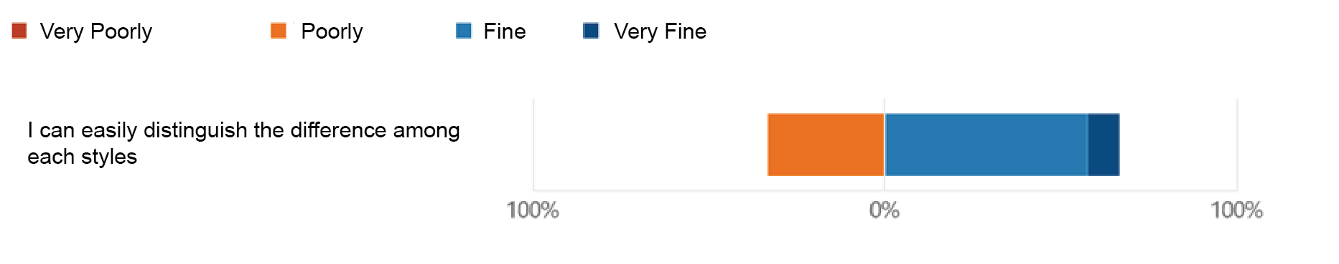
Figure 7. The Distribution of Distinctive Style
The result is processed using SPSS by table analysis, cross the academic year and previous knowledge as shown in Figure 8. It doesn’t show a strong correlation between both variables since the respondent distribution is not the same. However, it still can be concluded that most respondents in academics received good previous knowledge about representation.
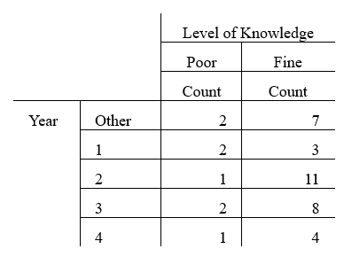
Figure 8. Crosstab Analysis Between Academic Year and Previous Knowledge
Based on the result, the sketch is preferable in showing the quality of creativity to the client, followed by ink sketch, vector/illustration, and watercolour. Both sketches are more favourable than others can be the result of the personal creativity that the designer put into drawing. On the other hand, to get to know the intention of the designer, respondents preferred to choose vector/illustration to represent the idea, followed by photorealism. This phenomenon shows that vector/illustration is a way to present abstract ideas to students with poor knowledge of representation to make sure they understand common knowledge. By reducing a set amount of detail, people tend to grasp the idea faster than the complicated detailed image. This reason is strengthened by the fact that the least favourable style is college drawing and oil painting. College drawing is constructed by juxtaposing several images into one big image, while oil paint has some amount of detail and has a unique texture.
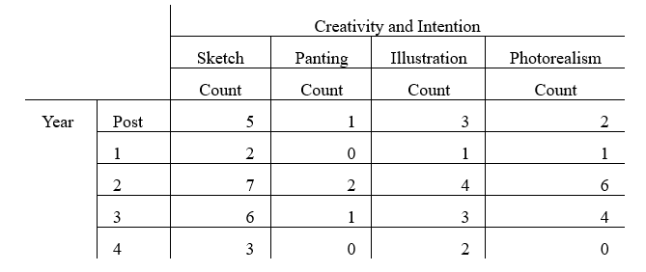
Figure 9. Crosstab Analysis between Academic Year and Chosen Technique to Represent Idea
Figure 9 shows that there is no strict correlation about which academic year in choosing preference technique, although most of the respondent seems to show choosing sketches as the most preferable. Further analysis is shown in Figure 10, which also shows that the majority of respondents, choose sketches as a favorable technique, although they haven’t got good previous knowledge about representation. Sketches can easily spark creativity intention and create a deeper understanding of architecture as both constructed and construed [25], [26]. Photorealism is not the most preferable technique to choose. This finding correlates with a previous study [27], which shows concern that overemphasizing photorealism may overshadow the intended architectural message.
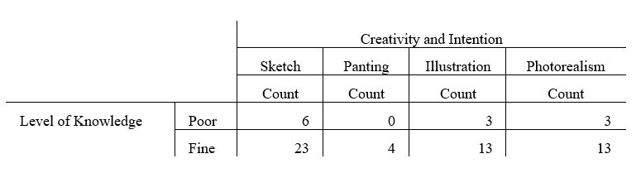
Figure 10. Crosstab Analysis between Previous Knowledge and Chosen Technique to Represent the Idea
Mass is constructed by the shape of mass itself, the scale of mass, and the three-dimensionality of mass. Based on the data gathered from respondents, each of the variables constructing the mass is represented by different favourable styles. Illustration is shown to be the most preferable style to deliver the clarity of mass. Then followed by photorealism and both sketches, while both painting style and college technique are left behind. This phenomenon shows that the outline of mass holds a significant factor in forming the shape. In both painting and collage drawings, the shape is rather blurry since they didn’t strictly form the image using the direct line, rather than the uniqueness of technique.
Respondents tend to use photorealism to show the spatial quality in architectural representation, while to show the scale of mass, the sketch is the most favourable. The information about light and shade holds significant factors in enriching spatial experience, which is provided by using photorealism style. On the other hand, to show the information about the scale of mass in representation, respondents tend to choose to use sketches.
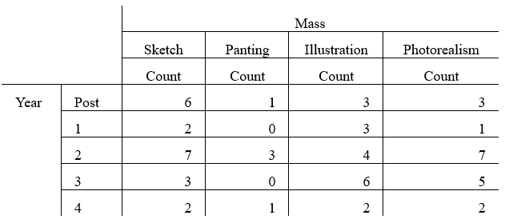
Figure 11. CrossTab Analysis between Academic Year and Chosen Technique to Represent Mass
The results from Figures 11 and 12 show that there is no strong correlation between year and level of knowledge to represent mass (mass itself, three-dimensionality of mass, and scale of mass). Analyzed data shows that the majority of respondents tend to choose sketches, illustrations, and photorealism and leave the painting as not a favorable technique. Preferable techniques are also diverse into many types, although it can be concluded that variables related to light/shade and urgency to represent reality are preferred using photorealism. On the other hand, the variable of mass, which is related to scale and form is preferred to be represented using illustration and sketch.
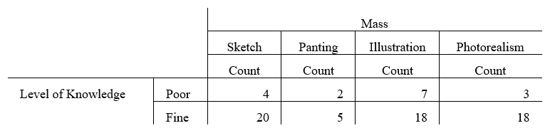
Figure 12. CrossTab Analysis between Previous Knowledge and Chosen Technique to Represent Mass
Most respondents chose photorealism as the preferred style for showing the material and its attributes. For example, the clarity of the material is shown using a photorealism style, as respondents want to present the importance of the material to the client. This phenomenon is further strengthened by the fact that the least favorable style is sketched since the client is not guaranteed to know about the node, hatch, or pattern used in architectural representation to show different types of material [12].
Based on Figures 13 and 14, show a strong correlation between academic years in choosing photorealism as the most preferable technique to represent material (texture, roughness, weight, and light/shade). Photorealism is also preferable in representing that quality, with a significant difference from other styles. Both sketches also sit on the least favorable, since the client can't perceive those qualities as the same as the designer intended to show. The difference in each material is not visible using sketches. Photorealism can deliver the idea to laypeople as they see it in the real world, which sketches can't easily deliver. There are limitations to using sketches since it's limited to the media that is being used.
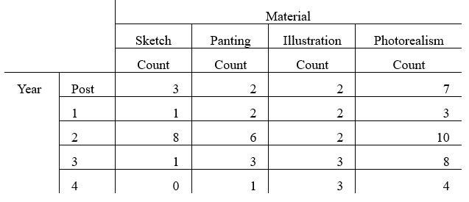
Figure 13. CrossTab Analysis between Academic Year and Chosen Technique to Represent Material
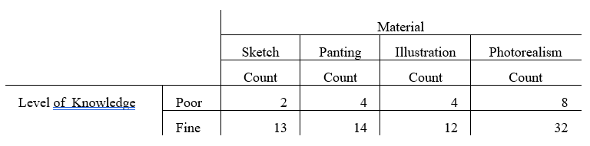
Figure 14. CrossTab Analysis between Previous Knowledge and Chosen Technique to Represent Material
When it comes to delivering information about material, light and shade, color, and overall atmosphere, photorealism provides those advantages. Photorealism accommodates the immense value of visual information that is easily digested by users (people with poor knowledge about representation, which can bridge the gap between architect and designer (Fig 15 & 16). With all these findings, there is a contrast with the previous study [28], as images with depth realism demonstrated a relatively insignificant impact on users’ immersive understanding.
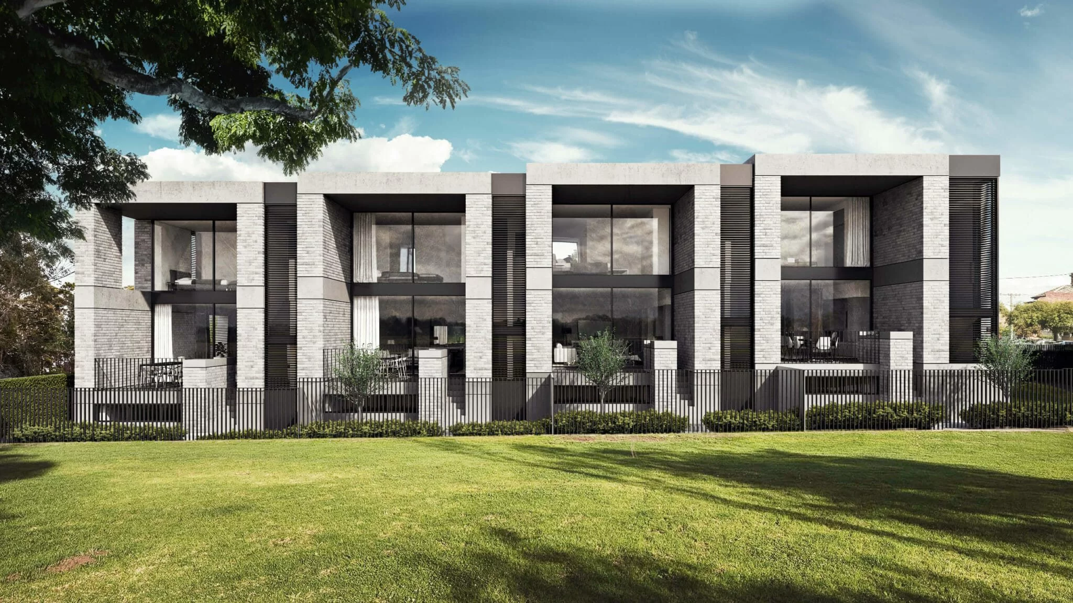
Figure 15. Exterior Photorealism (ArchCGI)
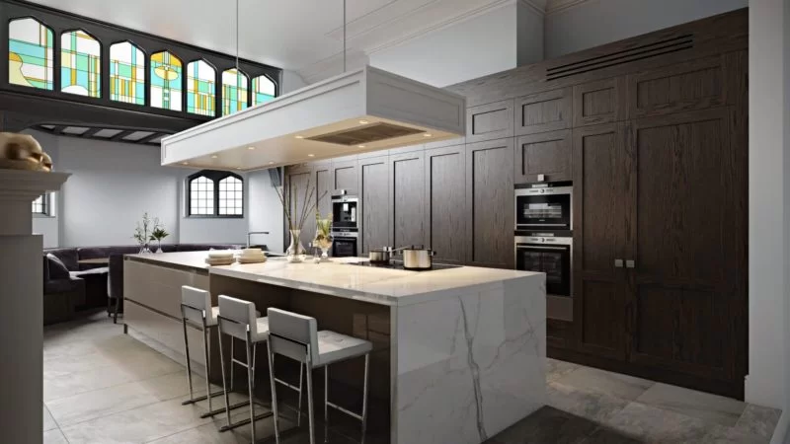
Figure 16. Interior Photorealism (ArchCGI)
CONCLUSION
This research exposes three aspects of analyzed data which are design knowledge, architectural mass, and material. The students also tend to use different drawing style of representation based on the design intention i.e. sketch, illustration and photorealism. Information about mass consists of three aspects which are mass volume, three-dimensionality, and scale to deliver information about the mass volume and scale, prefer using sketch and vector. This correlates with a previous study [29], which shows that sketches stimulate active participation by facilitating wider variety of interpretation. In contrast to photorealism, sketch exhibits less details. This nature allows users to fill the absence of details with their own imagination.
The exact phenomenon happens when students want to deliver information about the material (clarity, weight, and roughness). Photorealism is the most picked representation to communicate the information that users see as their eyes see in real life. This includes the information of three-dimensionality. The conclusion that can be drawn is two major types of representation are preferable, both sketches are used the most for delivering the information about shape and mass, while photorealism is used the most for showing the texture and clarity of material.

REFERENCES
[1] M. Christenson, THEORIES AND PRACTICES OF ARCHITECTURAL REPRESENTATION. 2019. doi: 10.4324/9781351677790.
[2] C. Bardt, Material and Mind. 2019. doi: 10.7551/mitpress/12199.001.0001.
[3] R. Castelo-Branco, I. Caetano, and A. Leitão, “Digital representation methods: The case of algorithmic design,” Frontiers of Architectural Research, vol. 11, no. 3, pp. 527–541, Jun. 2022, doi: 10.1016/J.FOAR.2021.12.008.
[4] C. Bardt, “Recapturing meaning: Toward a new material-based design theory for architecture,” Frontiers of Architectural Research, vol. 11, no. 4, 2022, doi: 10.1016/j.foar.2022.03.005.
[5] N. Wergles and A. Muhar, “The role of computer visualization in the communication of urban design—A comparison of viewer responses to visualizations versus on-site visits,” Landsc Urban Plan, vol. 91, no. 4, pp. 171–182, Jul. 2009, doi: 10.1016/J.LANDURBPLAN.2008.12.010.
[6] M. Ashby and K. Johnson, “Materiality, Design, and Creativity,” Mater Des, pp. 34–60, Jan. 2014, doi: 10.1016/B978-0-08-098205-2.00003-2.
[7] A. Sahli, E. Pei, A. Manohar, and R. Evans, “Knowledge Visualization: A Design centered Framework,” Procedia CIRP, vol. 109, pp. 629–634, Jan. 2022, doi: 10.1016/J.PROCIR.2022.05.305.
[8] J. A. E. Shields, “Phenomenology and Architecture: Examining Embodied Experience and Graphic Representations of the Built Environment,” in Contributions to Phenomenology, vol. 122, Springer Nature, 2023, pp. 285–304. doi: 10.1007/978-3-031-26074-2_15.
[9] M. Downes and E. Lange, “What you see is not always what you get: A qualitative, comparative analysis of ex-ante visualizations with ex-post photography of landscape and architectural projects,” Landsc Urban Plan, vol. 142, pp. 136–146, Oct. 2015, doi: 10.1016/J.LANDURBPLAN.2014.06.002.
[10] A. Skulmowski and G. D. Rey, “Realism as a retrieval cue: Evidence for concreteness‐specific effects of realistic, schematic, and verbal components of visualizations on learning and testing,” Hum Behav Emerg Technol, vol. 3, Aug. 2020, doi: 10.1002/hbe2.209.
[11] A. Skulmowski, “Is there an optimum of realism in computer-generated instructional visualizations?” Educ Inf Technol (Dordr), vol. 27, no. 7, pp. 10309–10326, 2022, doi: 10.1007/s10639-022-11043-2.
[12] A. Skulmowski and G. D. Rey, “Realism as a retrieval cue: Evidence for concreteness‐specific effects of realistic, schematic, and verbal components of visualizations on learning and testing,” Hum Behav Emerg Technol, vol. 3, Aug. 2020, doi: 10.1002/hbe2.209.
[13] D. Menendez, K. S. Rosengren, and M. W. Alibali, “Detailed bugs or bugging details? The influence of perceptual richness across elementary school years,” J Exp Child Psychol, vol. 213, p. 105269, Jan. 2022, doi: 10.1016/J.JECP.2021.105269.
[14] A. Skulmowski, “Do concreteness fading and guidance fading aid learning from perceptually rich visualizations? Changes in style lead to more cognitive load and interfere with learning,” Current Research in Behavioral Sciences, vol. 4, p. 100112, Jan. 2023, doi: 10.1016/J.CRBEHA.2023.100112.
[15] D. Menendez, K. S. Rosengren, and M. W. Alibali, “Detailed bugs or bugging details? The influence of perceptual richness across elementary school years,” J Exp Child Psychol, vol. 213, p. 105269, Jan. 2022, doi: 10.1016/J.JECP.2021.105269.
[16] A. Skulmowski and G. D. Rey, “The realism paradox: Realism can act as a form of signaling despite being associated with cognitive load,” Hum Behav Emerg Technol, vol. 2, no. 3, pp. 251–258, Jul. 2020, doi: 10.1002/HBE2.190.
[17] A. Skulmowski, “Is there an optimum of realism in computer-generated instructional visualizations?” Educ Inf Technol (Dordr), vol. 27, no. 7, pp. 10309–10326, Aug. 2022, doi: 10.1007/S10639-022-11043-2.
[18] A. Skulmowski, “Shape distinctness and segmentation benefit learning from realistic visualizations, while dimensionality and perspective play a minor role,” Computers & Education: X Reality, vol. 2, p. 100015, Jan. 2023, doi: 10.1016/J.CEXR.2023.100015.
[19] A. Deplazes, “Constructing Architecture: Materials, Processes, Structures,” 2015.
[20] P. D. Plowright, Revealing architectural design: Methods, frameworks, and tools. 2014. doi: 10.4324/9781315852454.
[21] O. Tošković, V. Kovač, and D. Sovilj, “Lost in projection – Implicit features experience of 3D architectural forms and their projections,” Acta Psychol (Amst), vol. 213, p. 103239, Feb. 2021, doi: 10.1016/J.ACTPSY.2020.103239.
[22] B. Kalantari, A. Nourtaghani, and M. Farrokhzad, “An Educational model of Creativity Enhancement in Design Studios Using Prior Research,” Space Ontology International Journal, vol. 9, no. 3, 2020.
[23] A. Simitch and V. K. Warke, The language of architecture : 26 principles every architect should know. Beverly: Rockport Publishers, 2014
[24] G. S. Hubona, G. W. Shirah, and D. G. Fout, “The effects of motion and stereopsis on three-dimensional visualization,” Int J Hum Comput Stud, vol. 47, no. 5, pp. 609–627, Nov. 1997, doi: 10.1006/IJHC.1997.0154.
[25] O. Harrison, “Freehand drawing – a learning and teaching perspective,” Compass: Journal of Learning and Teaching, vol. 16, no. 1, pp. 144–166, Mar. 2023, doi: 10.21100/compass.v16i1.1406.
[26] H. Budiman, I. Numan, and N. C. Idham, “Freehand Drawing and Architectural Expression,” Journal of Architectural Research and Design Studies, vol. 5, no. 1, 2021, doi: 10.20885/jars.vol5.iss1.art5.
[27] V. López-Chao and M. Rodríguez-Grela, “Architectural graphics and the experience of space. Freehand drawing and photograph to deepen on communicative qualities in linear perspective,” Frontiers of Architectural Research, vol. 12, no. 5, pp. 855–866, Oct. 2023, doi: 10.1016/J.FOAR.2023.05.012.
[28] D. Paes, J. Irizarry, M. Billinghurst, and D. Pujoni, “Investigating the relationship between three-dimensional perception and presence in virtual reality-reconstructed architecture,” Appl Ergon, vol. 109, p. 103953, May 2023, doi: 10.1016/J.APERGO.2022.103953.
[29] J. Park, Y. Jin, S. Ahn, and S. Lee, “The impact of design representation on visual perception: Comparing eye-tracking data of architectural scenes between photography and line drawing,” Archives of Design Research, vol. 32, no. 1, 2019, doi: 10.15187/ADR.2019.02.32.1.5.

