Fuzzy Logic-Based Control for Robot-Guided Strawberry Harvesting: Visual Servoing and Image Segmentation Approach | 

Tresna Dewi^{1*}, Muhammad Refo Bambang¹, RD Kusumanto¹, Pola Risma¹, Yurni Oktarina¹, Takahiro Sakuraba², Ahmad Fudholi³, Rusdianasari⁴
¹Department of Electrical Engineering, Politeknik Negeri Sriwijaya, Indonesia
²Department of Creative Engineering, National Institute of Technology Tsuruoka College, Japan.
³Solar Energy Research Institute, Universiti Kebangsaan Malaysia, Bangi, Selangor, 43600, Malaysia,
Research Centre for Electrical Power and Mechatronics LIPI, Bandung, Indonesia
⁴Department Department of Renewable Energy Engineering, Politeknik Negeri Sriwijaya, Indonesia

Abstract  The concept of digital farming can help the farmer to increase the production yield in agriculture. One of the technologies to support digital farming is robotics, which can be utilized to complete a redundant task efficiently for 24 hours. This paper presents a simple and effective harvesting robot applied to harvest a ripe strawberry. The mechanical and electrical design is kept simple to ensure it reproducible. The input from a proximity sensor and image detection by a Pi camera is utilized by FLC to improve the effectiveness of the harvesting task. The image processing method in this study is image segmentation that is fit with the limited source of the microcontroller available in the market. The experiment included 60 times (20 times center, left, and right position) harvesting using FLC algorithm and 60 times without FLC to show the effectiveness of the proposed method. From 60 times experiment of without FLC experiment, 80% hit rate for strawberry positioned in the middle of an image plane, 55% for left and right strawberry. From 60 times of FLC experiment, 95% hit rate for strawberry positioned in the middle of an image plane, 80% for left and right strawberry. The average time required to finish the task without FLC for strawberry in the middle is 13.51 s, the left side is 11.04 s, and the right side is 17.28 s. While the average time required to finish the task with FLC for strawberry in the middle is 12.90 s, the left side is 11.71 s, and the right side is 10.93 s. This study is intended to show the simple design can be useful and affordable when applied to greenhouse farming in Indonesia.  This is an open access article under the CC BY-SA license   | Keywords:  Digital farming; Fuzzy Logic Controller; Image Segmentation; Visual Servoing  Article History:  Received: May 2, 2019  Revised: May 29, 2019  Accepted: June 2, 2019  Published: June 2, 2019  Corresponding Author:  Andi Adriansyah  Electrical Engineering Department, Universitas Mercu Buana, Indonesia  Email: andi@mercubuana.ac.id

INTRODUCTION
Indonesia is located in an equatorial climate with favorable weather for agriculture all year, making agriculture a significant economic growth factor. However, in some parts of Indonesia, young people gradually leave agriculture; hence, farmers must contend with a labor shortage and low-quality product expectations. These concerns can be solved by utilizing digital farming technologies. Digital farming is defined as using an automated system in agriculture, such as automatic greenhouse [1][2]. The digital farming concept promises a better farming performance [1]-[8].
Robotics application in agriculture is one of the technologies to achieve digital farming. Robot can be employed as an automatic harvesting device, and the most suitable robot type is the arm robot manipulator since its arm can be customized imitating humans [9]-[16].
The robotics system is made possible for the farmers due to the lower components price needed to build a robot. The applied robot in agriculture does not have to be sophisticated [17], an arm robot equipped with some sensors (camera and proximity sensors) is sufficient for a harvesting robot. Therefore, it is possible to design a simple and affordable robot to assist a farmer in agriculture working conditions. Sensors are the necessary components required to build a robot, and an agriculture robot needs a camera to see the fruit to be harvested. Image processing is one of the crucial things to be considered. The problem with image processing is that it requires a high computational resource to complete the task [18]-[22]; hence the challenge is how to design an image processing system that can fit into a limited memory of current microcontrollers.
Visual servoing is controlling robot motion by using the feedback from image detection given by the camera[12][18]-[20]. Image detection provides the information with fruit distance, and position. The problem is that fruit position is dynamic from plant to plant, and lighting is also a problem in target detection. Image processing techniques were applied by research to overcome the problem of uncertainty of target position [21]-[22]. However, sophisticated methods require longer computational time, and more resources, while in this agriculture application, simple yet effective robot is more desired. Simplicity is necessary to ensure that the robot is reproducible by the farmers and reliable in long term.
This paper presents a simple and effective harvesting robot applied to pick the ripe strawberry. The robot mechanical and electrical design is kept simple and yet sufficiently complex to complete the harvesting task. The image processing method considered in this study is image segmentation whose computational time fits the limited source of the current microcontroller available in the market. The application of the Fuzzy Logic Controller (FLC) is also considered to enhance the efficiency of the proposed method [23]. The kinematics design is also discussed to achieve an ideal model of the robot. Experiments are conducted to demonstrate the effectiveness of the proposed method, which shows the hit and miss of strawberries harvesting. This study is intended to show the simple design can be useful and affordable when applied in greenhouse farming in Indonesia. The robot design is presented in this paper to show the affordability and reproducibility of the proposed robot.

METHOD
The harvesting robot prototype proposed in this study implements the method shown in Figure 1. The image processing conducted in this study is image segmentation. The result of image processing is the strawberry coordinate position. As the robot detects the target position, the microcontroller moves the servo motors attached to the base, joints, and end-effector. The servo motions speeds are regulated based on the distance between the end-effector and target, which is indicated by proximity sensor detection. The servo motor speeds are controlled by the input from the Fuzzy Logic Controller (FLC).

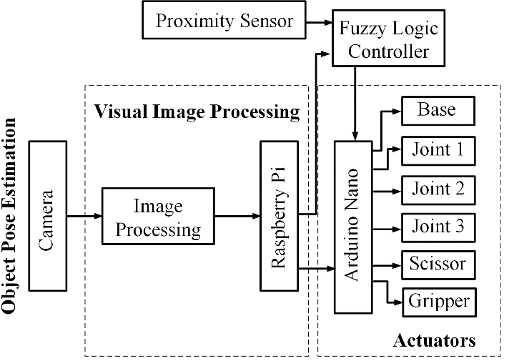
- Diagram block of the proposed method

Robot Mechanical and Electrical and Design
The robot considered in this study is a 3DOF arm robot which design to harvest strawberries in a greenhouse setting. The robot design is shown in Figure 2 and 3. The mechanical design is in Figure 2a, which shows the servos to move the joints and end-effector.

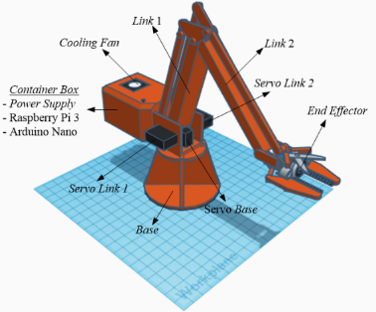 | 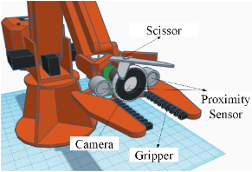
(a) Mechanical design | (b) End-effector design
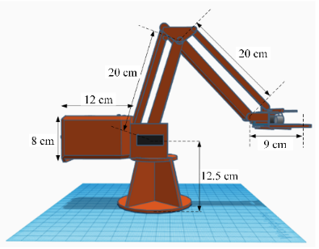
(c) Robot dimension
Figure 2. Robot’s mechanical design

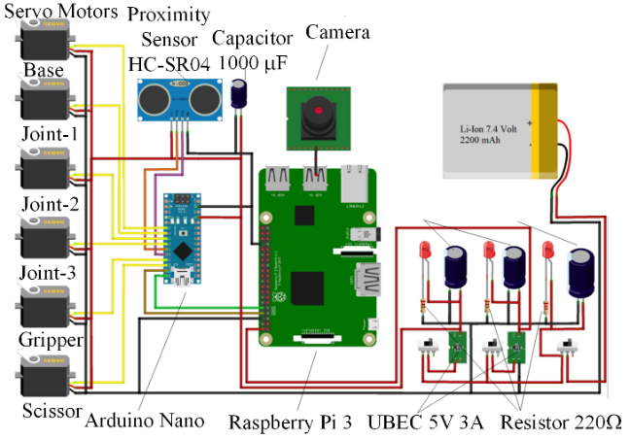
Figure 3. Electrical design of robot in figure 2.

The robot is moved by six motor servos, for the base, joint 1, joint 2, the wrist of end-effector, scissor, and gripper. The scissor and gripper positions are adjusted to imitate the human hand while harvesting fruits. The end-effector consists of a scissor to cut the fruit and a gripper to grab the fruit, and Figure 2b shows the position of scissor, camera, and gripper. The camera is attached to the end-effector that makes this robot is an eye to hand robot type. This type of robot vision gives a better view of target detection without concerning the occurrence of occlusion during robot motion. Figure 2c shows the dimensions of the robot, which is designed based on the size of a strawberry plant. Figure 3 shows the electrical connection of components discussed in Figure 2, and the electronics components to build the proposed robot. By looking at Figure 3, it is expected that the reader gets a rough calculation of robot cost and difficulty.
The camera applied in this project is a Pi camera to detect the fruit (strawberry), and the detection is conducted online to get the target coordinate position. The detected strawberry position is achieved by the image segmentation process in Raspberry Pi. The position is sent to the microcontroller in Arduino Nano to set and govern the robot motion. The motor servo to move the base is designed to have a range of 15º to 165º. The second servo is the actuator to move joint 1 within motion range of 25º to 105º, and servo for joint2 within motion range of 135º to 175º. The joint between link 2 and end-gripper is designed to move in the range of 135º to 175º. The gripper servo moves within motion range of 5º to 80º and scissor servo is within motion range of 0º to 180º.
The proximity sensor senses the distance between the end-effector and the fruit. The range is set to be 9 cm, and when the end-effector is positioned 9 cm from the strawberry, the harvesting processes are starting by gripper grabs the fruit, and scissor cut the stalk. The 9 cm distance is chosen as the safe distance between the strawberry stalk and the end-effector. The gripper in Figure 2(b) is made of serrated rubber which can hold the stalk safely without crushing it.

Robot Kinematics Modeling
Kinematics modeling is the process of modeling the robot by analyzing the robot motion without considering the force and torque applied to the robot [24]. Modeling is necessary to design robot motion and to get the ideal robot dimension, and workspace. The proposed robot adopts the famous industrial arm robot manipulator with 3DOF, and the arm is customized to imitate the human arm. The first step is to solve the joint angles from actuator positions, and next is to address the Cartesian positions and orientations [24]. The linkage and actuators arrangement are designed to follow the robot's function.

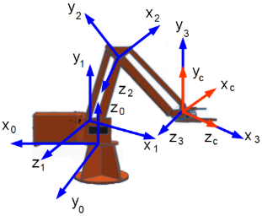 | 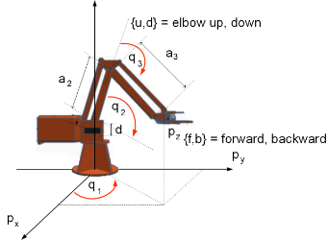
(a) Assigned frames | (b) Assigned parameters
Figure 4. Link frames for the robot considered in this study shown in Figure 2.

Kinematics modeling is started by transferring the robot's links and joints in Figure 4 into the Denavit-Hartenberg (DH) Table (Table 1) to find the best parameters for the robot. The 3R robot's and end-effector's frame is shown in Figure 4. The camera attached in the robot end-effector is an eye-in-hand camera given a typical frame associated with this type of camera installation.

Table 1. DH Convention for the robot in Figure 4.
i | $$α_{i}$$ | $$d_{i}$$ | $$a_{i}$$ | $$θ_{i}$$
1 | $$\frac{π}{2}$$ | d | 0 | $$q_{1}$$
2 | 0 | 0 | $$a_{2}$$ | $$q_{2}$$
3 | 0 | 0 | $$a_{3}$$ | $$q_{3}$$

The constant rotation of the camera attached to the end-effector shown in Figure 4(a) is
$${}_{c}^{3}R=\left[\begin{matrix}0 & 0 & 1 \\ 0 & 1 & 0 \\ -1 & 0 & 0\end{matrix}\right]$$ | (1)
The transformation matrix ${}_{0}^{3}T$ is given by ${}_{1}^{0}T\left(q_{1}\right)$, ${}_{2}^{1}{T\left(q_{2}\right)}$, and ${}_{3}^{2}T\left(q_{3}\right)$, which are resulted to rotation matrices as follow:
${}_{1}^{0}R=\left[\begin{matrix}c_{1} & 0 & s_{1} \\ s_{1} & 0 & {-c}_{1} \\ 0 & 1 & 0\end{matrix}\right]$, ${}_{2}^{1}R=\left[\begin{matrix}c_{2} & {-s}_{2} & 0 \\ s_{2} & c_{2} & 0 \\ 0 & 0 & 1\end{matrix}\right]$, and ${}_{3}^{2}R=\left[\begin{matrix}c_{3} & {-s}_{3} & 0 \\ s_{3} & c_{3} & 0 \\ 0 & 0 & 1\end{matrix}\right],$ | (2)
where $c_{1}$ is $\cos{q_{1}}$, $s_{1}$ is $\sin{q_{1}}$, $c_{2}$ is $\cos{q_{2}}$, $s_{2}$ is $\sin{q_{2}}$, $c_{3}$ is $\cos{q_{3}}$, and $s_{3}$ is $\sin{q_{3}}.$
Therefore, the position ($p={\left[\begin{matrix}p_{x} & p_{y} & p_{z}\end{matrix}\right] }^{T}$) of the origin $O_{3}$ of frame 3 is given by
$\left[\begin{matrix}p \\ 1\end{matrix}\right]={}_{1}^{0}T\left(q_{1}\right) {}_{2}^{1}{T\left(q_{2}\right)}{}_{3}^{2}T\left(q_{3}\right)\left[\begin{matrix}0 \\ 1\end{matrix}\right]$, | (3)
and resulted in
$$p=f\left(q\right)=\left[\begin{matrix}c_{1}\left(a_{2}c_{2}+a_{3}c_{23}\right) \\ s_{1}\left(a_{2}c_{2}+a_{3}c_{23}\right) \\ d+a_{2}s_{2}+a_{3}s_{23}\end{matrix}\right],$$ | (4)
or $p_{x}$ is $c_{1}\left({a_{2}c}_{2}+{a_{3}c}_{23}\right)$, $p_{y}$ is $s_{1}\left({a_{2}c}_{2}+{a_{3}c}_{23}\right)$, and $p_{z}$ is $d+a_{2}s_{2}+a_{3}s_{23}$.
The inverse kinematics solution is achieved multiplying both side from Eq. 4 as follow
$p_{x}^{2}+p_{y}^{2}+{\left(p_{z}-d\right)}^{2}=c_{1}^{2}{\left(a_{2}c_{2}+a_{3}c_{23}\right)}^{2}+s_{1}^{2}{\left(a_{2}c_{2}+a_{3}c_{23}\right)}^{2}+{\left(a_{2}s_{2}+a_{3}s_{23}\right)}^{2}$, | (5)
then
$$p_{x}^{2}+p_{y}^{2}+{\left(p_{z}-d\right)}^{2}=a_{2}^{2}+a_{3}^{2}+2a_{2}a_{3}\left(c_{2}c_{23}+s_{2}s_{23}\right)=a_{2}^{2}+a_{3}^{2}+2a_{2}a_{3}c_{3},$$ | (6)
and by rearranging Eq. 6, yield
$c_{3}=\frac{\left(p_{x}^{2}+p_{y}^{2}+{\left(p_{z}-d\right)}^{2}{-a}_{2}^{2}-a_{3}^{2}\right)}{2a_{2}a_{3}}$, | (7)
where $c_{3}∈\left(-1,1\right)$ to ensure the robot inside its workspace, and
$s_{3}=±\sqrt{1-c_{3}^{2}}$, | (8)
in which resulted to $q_{3}=atan\left(s_{3},c_{3}\right)$ for positive (+) result and $q_{3}=atan\left({-s}_{3},c_{3}\right)$ for negative one.
The angle $q_{1}$ generates by the base motion and to get real solutions, $p_{x}^{2}+p_{y}^{2}>0$, otherwise $q_{1}$ is undefined and infinite solutions. Therefore,
$c_{1}=\frac{p_{x}}{±\sqrt{p_{x}^{2}+p_{y}^{2}}}$, and $s_{1}=\frac{p_{y}}{±\sqrt{p_{x}^{2}+p_{y}^{2}}}$, | (9)
where two solutions occurs; for positive solution $q_{1}=atan2\left(p_{y},p_{x}\right)$, and $q_{1}=atan2\left(-p_{y},{-p}_{x}\right)$ for negative.
The angle $q_{2}$ is solved by considering forward, backward, up, and down motion of the elbow, shown in Figure 4(b). By rearranging Eqs. (5) and (6), yields
$c_{1}p_{x}+s_{1}p_{y}=a_{2}c_{2}+a_{3}c_{23}=\left(a_{2}{+a}_{3}c_{3}\right)c_{2}-a_{3}c_{3}s_{2}$, | (10)
and
$p_{z}-d=a_{2}s_{2}+a_{3}s_{23}=a_{3}c_{3}c_{2}+\left(a_{2}{+a}_{3}c_{3}\right)s_{2}$. | (11)

Taking Eqs. (10) and (11) and rewriting in matrix form, resulted in
$$\left[\begin{matrix}a_{2}{+a}_{3}c_{3} & {-a_{3}s_{3}}^{\left(+,-\right)} \\ {a_{3}s_{3}}^{\left(+,-\right)} & a_{2}{+a}_{3}c_{3}\end{matrix}\right]\left[\begin{matrix}c_{2} \\ s_{2}\end{matrix}\right]=\left[\begin{matrix}{c_{1}}^{\left(+,-\right)}p_{x}+{s_{1}}^{\left(+,-\right)}p_{y} \\ p_{z}-d\end{matrix}\right]$$ | (5)

If the matrix $\left[\begin{matrix}a_{2}{+a}_{3}c_{3} & {-a_{3}s_{3}}^{\left(+,-\right)} \\ {a_{3}s_{3}}^{\left(+,-\right)} & a_{2}{+a}_{3}c_{3}\end{matrix}\right]$ is $\left[A\right]$, then to achieve real define $q_{2}$ the matrix determinant for the left side is $det A =p_{x}^{2}+p_{y}^{2}+{\left(p_{z}-d\right)}^{2}>0$. Therefore, the fours solutions for $q_{2}$ are ${q_{2}}^{\left\{\left\{f,b\right\},\left\{u,d\right\}\right\}}=atan2\left({s_{2}}^{\left\{\left\{f,b\right\},\left\{u,d\right\}\right\}},{c_{2}}^{\left\{\left\{f,b\right\},\left\{u,d\right\}\right\}}\right)$.
The Jacobian related to the linear velocity (${}_{}^{0}v={}_{3}^{0}v$) of the origin of frame 3 and expressed in the base frame is obtained as
${}_{}^{0}{J\left(q\right)}=\frac{∂f\left(q\right)}{∂q}=\left[\begin{matrix}{-s}_{1}\left(a_{2}c_{2}+a_{3}c_{23}\right) & -c_{1}\left(a_{2}s_{2}+a_{3}s_{23}\right) & a_{3}c_{1}s_{23} \\ c_{1}\left(a_{2}c_{2}+a_{3}c_{23}\right) & {-s}_{1}\left(a_{2}s_{2}+a_{3}c_{23}\right) & -a_{3}s_{1}s_{23} \\ 0 & a_{2}c_{2}+a_{3}c_{23} & a_{3}c_{23}\end{matrix}\right]$. | (5)

The Jacobian matrix from camera frame ${}_{}^{c}{J\left(q\right)}$ gives
${}_{}^{c}{J\left(q\right)={}_{c}^{0}{R^{T}}}{}_{}^{0}{J\left(q\right)}={}_{c}^{3}{R^{T}}\left({}_{3}^{2}{R^{T}}\left(q_{3}\right)\left({}_{2}^{1}{R^{T}}\left(q_{2}\right)\left({}_{1}^{0}{R^{T}}\left(q_{1}\right){}_{}^{0}{J\left(q\right)}\right)\right)\right)$,  ${}_{}^{c}{J\left(q\right)}=\left[\begin{matrix}a_{2}c_{2}+a_{3}c_{23} & 0 & 0 \\ 0 & a_{3}+a_{2}c_{2} & a_{3} \\ 0 & a_{2}c_{2} & 0\end{matrix}\right]$, | (6)
where the relating joint velocity ${}_{}^{c}v$ is given by ${}_{}^{c}{J\left(q\right)}\dot{q}$ as the linear velocity of camera frame origin expressed in the camera frame. Therefore, the linear velocity of robot’s end-effector is ${}_{}^{c}{v={}_{}^{c}{J\left(q\right)}\dot{q}}$.
The end-effector angular velocity is given by ${}_{}^{0}{ω\left(t\right)}$, and to find the angular velocity, rotation matrix associated to the $\left(α,β,γ\right)$ angles in the $\left(Z, X, Y\right)$ Euler presentation.

Image Segmentation for Target Detection
The process of controlling the robot by using the image input from the camera is called visual servoing. The image detection must through image processing to get the target position in Cartesian coordinates. The method for image processing conducted in this study is Image Segmentation, shown in Figure 5. The image sensor applied is a webcam with a CMOS sensor connected to Raspberry Pi. The output of this image processing is the target position in $x$ and $y$ Coordinates axis, and this process is conducted online. The target detection is achieved by image processing in differentiating the target from the background. The steps of image segmentation are as follow:
- Camera captures the raw image of strawberry as the target to be detected.
- The raw image is partitioned into multiple segments or set of pixels to define the representation of an image. The assigned pixels are labeled into color, intensity, and texture. The segmentation also separates the foreground from the background. The raw image in RGB format is converted into grayscale.
- The gray image is processed with HSV (Hue, Saturation, Value) which gives the advantage of isolating color. Hue determines the desired color, saturation is how intense the color is, and value determines the lightness in an image.
- Multiple masks are applied to isolate the desired color, including low and high threshold mask for H, S, and V. The ideal HSV value in this study is given by H = 0, S = 90, and V = 160. The value of H is set to be 0 for the reddish color.
- The masking was conducted by clustering in pattern recognition by partitioning a set of pattern vectors into subsets or clusters. After converting to grayscale, the image format is transferred into a binary image within balanced histogram thresholding. The thresholding method replaces each pixel that has image intensity ($I_{i,j}$) lower than thresholding value ($I_{i,j}<T$) with black and white if the pixel has the image intensity more significant than the thresholding value ($I_{i,j}>T$), as shown in Figure 5c. The next masking is replacing the white with the original HSV color model; in this study, the white is replaced with a reddish color and considered the target.

Fuzzy Logic Controller (FLC) Design
FLC design starts by identifying the inputs for fuzzification. FLC is to move the robot to cut and grip the target based on the target detection. The data inputs are achieved from the target detection by image processing in 2.3 and distance approximation by proximity sensor attached to the gripper. The inputs and output relationship are translated into a rules-based in table 3 as the reasoning process, and the grades of membership functions of inputs and output. How far the robot can extend to reach the target is defined by the angles of each joint presented in kinematics analysis, including considering the position of target which are defined as the object position in x, y, and z-axis. The end-effector velocity is also defined by the kinematics analysis. FLC design sets robot motion based on the target position in the by $x$ and $y$-axis. The target detection position presented in rules is only for middle detection; other position rules are not presented in this paper in avoiding the excessive lengthy table.

Table 2. The rules-based to show the relationship between input and output.
No | Input |  | Output
No | Obj | d | X | Y | Z | Grip | Sci
1 | N | F | S | S | S | Off | Off
2 | LN | F | LS | S | S | Off | Off
3 | LM | F | LM | S | S | Off | Off
4 | LF | F | LF | S | S | Off | Off
5 | RN | F | RS | S | S | Off | Off
6 | RM | F | RM | S | S | Off | Off
7 | RF | F | RF | S | S | Off | Off
8 | UN | F | S | US | S | Off | Off
9 | UM | F | S | UP | S | Off | Off
10 | UF | F | S | UF | Stop | Off | Off
11 | DN | F | S | DS | Stop | Off | Off
12 | DM | F | S | DM | Stop | Off | Off
13 | M | F | S | S | FM | Off | Off
14 | M | N | S | S | S | On | On

The membership function considered in this study is given by
$A\left(x\right)=\left\{\begin{aligned}0, &x<0 \\ \frac{x-a}{m-a}, &x≥0 \\ \frac{b-x}{b-m}, &x≥0 \\ 0, &x≥0\end{aligned}\right.$, | (16)

where $a$, $m$, and $b$ is based on$x$ and $y$ -position achieved online during the task.

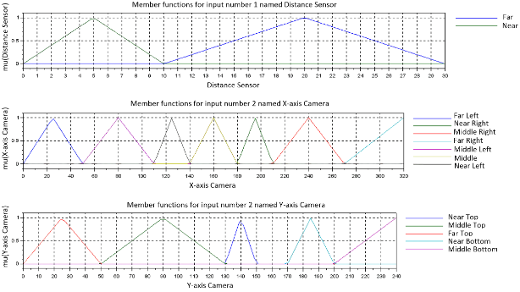
(a) Membership function of input
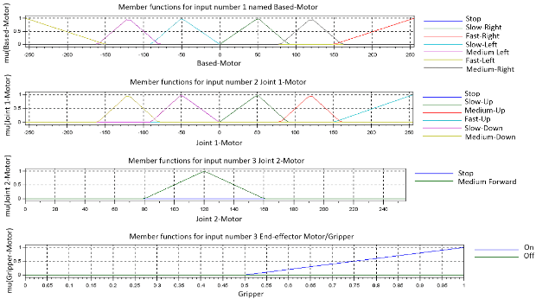
(b) Membership function of output
Figure 5. Membership function of input and output considered in this study.
Robot motion is based on the rules stated in Table 2, and these rules are translated into the membership function of the input (in Figure 5a) by using Eq. 16 in SCILAB [25]. The membership output (Figure 5b) results from membership output based on the output rules in Table 3. The $x$ and$y$ axis positions detection are achieved by image segmentation, while the $z$-axis position is achieved by proximity sensor detection.

RESULTS AND DISCUSSION
Experiments are undertaken to validate the efficacy of the proposed visual servoing method coupled with Fuzzy Logic Control (FLC) by deploying the robot for strawberry harvesting. Details regarding the robot's specifications are illustrated in Figure 2, while the experimental setup is depicted in Figure 6.

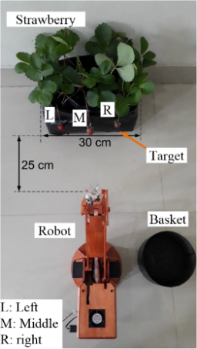
Figure 6. Strawberry harvesting’s experimental Setup.
The robot is set to cut (using scissors) and grab (using gripper) 3 strawberries marked as left, middle, and right, one at the time. The robot can work for 3 hours without stopping supported by a 2200 mAh battery. The experiment was conducted 120 times, 60 times without FLC, and 60 times with FLC. 60 times are divided into 20 times for harvesting the middle, 20 times for the left side, and 20 times for the right-side strawberry.
Robot is activated as the camera detects the position of strawberries. The microcontroller moves the joints and end-effector accordingly. The end-effector consists of scissors to cut the strawberry and gripper to grab it, and motor servo in base moves the robot to put the strawberry inside the prepared basket, as shown in Figure 6. The considered image plane in this study has a resolution of $320×240$ pixel within the speed of 30fps; therefore, $x$-axis starts from $0-320$ pixels and $y$-axis is $0-240$ pixel. Table 3 shows the relation between strawberry detection and position in the image plane, and robot motion due to the strawberry position relative to robot end-effector. Target position in tables 2 and 3 are represented by $x$ and $y$ coordinates position in the image plane, which is divided into Near (N), Far (F), Middle (M), Left-Near (LN), Left-Medium (LM), Left-Far (LF), Right-Near (RN), Right-Medium (RM), Right-Far (RF), Up-Near, Up-Medium (UM), Up-Far (UF), Down-Near (DN), Stop (S) and Down-Medium (DM).
Table 3. The relationship between target position and end-effector motion.
$x$ and $y$ axis Position | Target Position | End-effector Motion
$x≥140$ & $x≤180$ & $y≥150$ & $x≤170$ | Middle | Forward
$x>110$ & $x<140$ | Left-Near | Left-Slow
$x>50$ & $x≤110$ | Left-Medium | Left-Medium
$$x≤50$$ | Left-Far | Left-Fast
$x>180$ & $x≤210$ | Right-Near | Right-Slow
$x>210$ & $x<270$ | Right-Medium | Right-Medium
$$x≥270$$ | Right-Far | Right-Fast
$y>130$ & y$<150$ | Up-Near | Going Up-Slow
$y>50$ & y$≤130$ | Up-Medium | Going Up-Medium
$$y≤50$$ | Up-Fast | Going Up-Fast
$y>170$ & y$<200$ | Down, Near | Going Down-Slow
y$≥200$ | Down-Medium | Going Down-Medium

Figure 7 is the result of strawberry detection using image processing in this study. The target position in x and y coordinates becomes the input to the microcontroller to control the end-effector's direction and speed in reaching the target before cutting and gripping it as shown in Table 3. The process of picking the object starts from the strawberry located in the middle of the image place since it is the closest one to the robot. The robot is set to process image data with the most significant pixel first or the closest one.

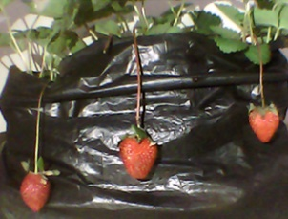 | 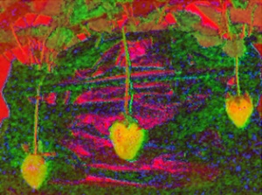
(a) Raw image | (b) HSV setting
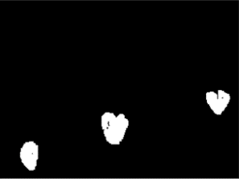 | 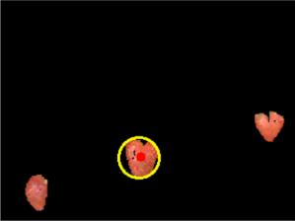
(c) Thresholding processed | (d) The closest detected strawberry
Figure 7. Image segmentation process for strawberry detection in this study.
Figure 6 illustrates the multiple image segmentation procedures carried out in this research. The identified strawberry with greater prominence is considered closer to the end-effector, while smaller targets are positioned on either side of the image plane. Figure 8 showcases the image detection relevant to robot motion and workspace conditions, depicting the robot's position relative to the strawberries, which serve as targets. The target position can be adjusted within the positions given in Table 3, and the robot can still accurately recognize it.

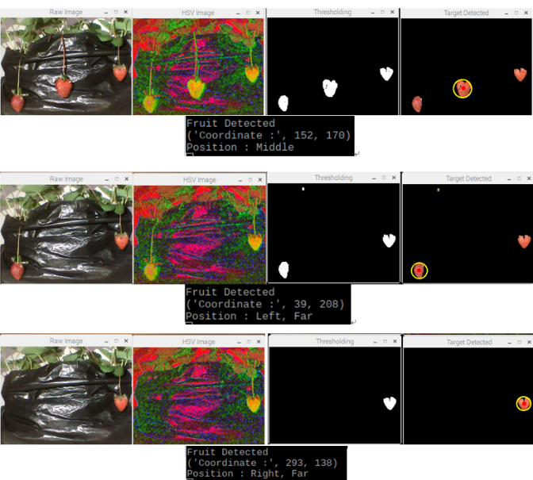
Figure 8. Various strawberry detection during harvesting, starting from the closest one.

The robot moves based on the input of the target (strawberry) position detection achieved from the image segmentation process conducted in real-time by Raspberry Pi. The strawberry position is sent to the microcontroller in Arduino Nano to set and govern the robot motion. The Arduino Nano calculates mathematically to get the right angle for each servo motor to achieve the desired end-effector position according to the command sent by the Raspberry Pi. The robot is moved by six servos, namely servo base, servo joint-1, joint-2, and joint 3 to direct the end effector to the point of detected strawberry position coordinates, and two servos attached to end-effector to move scissor and gripper. The process of harvesting strawberries is shown in the screenshot in Figure 9. Figure 9 only shows the robot harvesting the strawberry located in the middle since it is the most significant detected object. The robot goes to the shortest target, first indicated by the most significant detected object.

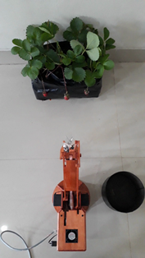 | 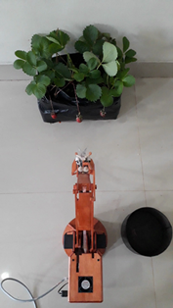 | 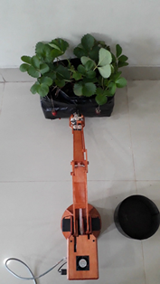
(a) | (b) | (c)
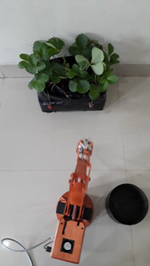 | 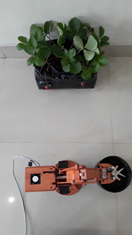 | 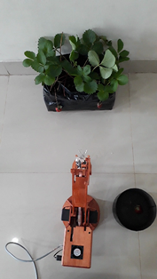
(d) | (e) | (f)
Figure 9. Strawberry picking process when the detected strawberry located in the middle of image plane.
Image processing depends on the lighting during the experiment, and the difference lighting can create noise during the process and create false detection. Image segmentation is more tolerable with the changing light and to prove the effectiveness of this method. The harvesting experiment was conducted 20 times for each criterion and recorded in Table 4, and this experiment is also to show the effectiveness of applying FLC compared to without FLC. Table 4 shows that the hit rate comparison between without and with FLC where “Ο” indicates “hit” and “✖” is “miss.” For both with and without FLC, the robot tends to pick the closest strawberry. Since the robot position is in the middle of the experimental setup, it will harvest the middle strawberry first, and this condition causes the hit rate for middle strawberry is higher than the left and right ones (80% hit for without FLC and 95% with FLC). The effectiveness of the FLC application is proven by the increment of hit rate compared to without FLC, as shown in Table 4.
Table 4. The hit rate comparison between without FLC and with FLC
nth-Experiment | Target Position
nth-Experiment | Without FLC |  |  | With FLC
nth-Experiment | L | M | R | L | M | R
1 | ✖ | Ο | Ο | Ο | Ο | Ο
2 | ✖ | Ο | ✖ | Ο | Ο | Ο
3 | ✖ | Ο | Ο | Ο | Ο | Ο
4 | ✖ | ✖ | ✖ | Ο | ✖ | Ο
5 | ✖ | Ο | ✖ | Ο | Ο | Ο
6 | Ο | ✖ | Ο | ✖ | Ο | Ο
7 | ✖ | Ο | ✖ | ✖ | Ο | Ο
8 | Ο | Ο | ✖ | ✖ | Ο | Ο
9 | Ο | Ο | Ο | Ο | Ο | Ο
10 | ✖ | Ο | Ο | Ο | Ο | Ο
11 | ✖ | Ο | Ο | Ο | Ο | Ο
12 | Ο | Ο | Ο | Ο | Ο | ✖
13 | Ο | Ο | ✖ | Ο | Ο | Ο
14 | Ο | Ο | Ο | Ο | Ο | ✖
15 | Ο | Ο | ✖ | Ο | Ο | Ο
16 | Ο | ✖ | Ο | Ο | Ο | ✖
17 | Ο | Ο | ✖ | Ο | Ο | Ο
18 | Ο | Ο | Ο | Ο | Ο | Ο
19 | ✖ | Ο | ✖ | ✖ | Ο | Ο
20 | Ο | ✖ | Ο | Ο | Ο | ✖
Total Hit Rate | 11 | 16 | 11 | 16 | 19 | 16
% Hit rate | 55% | 80% | 55% | 80% | 95% | 80%
Overall Hit Rate | 38 or 63% |  |  | 51 or 85%

The time required for the robot to accomplish its task in harvesting strawberries is presented in Table 5. $T_{1}$ is the time needed from detection to the target cutting process, $T_{2}$ is the time from detection, target cutting, and placing the target to the basket, and $T_{3}$ is the time from completing the task and returning to initial position. The harvesting time for the middle strawberry is faster due to the end-effector directly moving forward and pick. In contrast, for the left and right-side strawberry picking, the robot must make a circular motion before harvesting. The application of FLC improves the harvesting time since the robot refers to rules-based stated in Table 3. The rules make the robot move systematically and precisely with three-speed modes (slow, medium, and fast) to reach the fruit efficiently. When the distance between end-effector and target is far, then the robot moves fast, as the end-effector is getting closer to the target, the speed gradually decreases into medium and slow to ensure end-effector position of harvesting.
Table 5. Time comparison in completing the task with and without FLC.
Pose | nth-Ex. | Without PLC (s) |  |  | With PLC (s)
Pose | nth-Ex. | T₁ | T₂ | T₃ | T₁ | T₂ | T₃
Left | 1 | 6.52 | 8.86 | 10.45 | 8.5 | 10.96 | 12.49
Left | 2 | 7.52 | 9.79 | 11.39 | 9.47 | 11.79 | 13.31
Left | 3 | 7.77 | 10.16 | 11.87 | 8.48 | 10.75 | 12.27
Left | 4 | 6.8 | 9.34 | 10.93 | 9.01 | 11.36 | 13.02
Left | 5 | 6.74 | 8.93 | 10.56 | 9.39 | 11.84 | 13.44
Left | Average | 7.07 | 9.42 | 11.04 | 8.97 | 11.34 | 12.91
Middle | 1 | 9.35 | 11.48 | 13.18 | 7.12 | 9.51 | 11.1
Middle | 2 | 9.3 | 12.03 | 13.69 | 9.09 | 11.56 | 13.61
Middle | 3 | 10.19 | 12.77 | 14.34 | 7.45 | 9.97 | 11.48
Middle | 4 | 9.54 | 11.8 | 13.39 | 7.48 | 9.77 | 11.29
Middle | 5 | 9.08 | 11.53 | 12.97 | 7.13 | 9.79 | 11.11
Middle | Average | 9.49 | 11.92 | 13.51 | 7.65 | 10.12 | 11.72
Right | 1 | 9.55 | 11.83 | 13.39 | 6.79 | 8.99 | 10.52
Right | 2 | 16.07 | 18.36 | 19.88 | 7.32 | 9.64 | 11.09
Right | 3 | 19.64 | 21.84 | 23.34 | 7.13 | 9.51 | 10.89
Right | 4 | 10.63 | 12.8 | 14.31 | 7.11 | 9.46 | 10.92
Right | 5 | 11.76 | 13.97 | 15.48 | 7.45 | 9.81 | 11.25
Right | Average | 13.53 | 15.76 | 17.28 | 7.16 | 9.48 | 10.93

The duration required to move from the basket position to the initial default position is relatively the same between without FLC and with FLC since the robot returns to the initial position without requiring the detection process; it just used the predetermined coordinate points.

CONCLUSION
This paper presents an FLC design combined with image segmentation for a strawberry harvesting robot. The robot is assigned to cut and grab a strawberry and place it into a basket. The process of identifying the target is by using image segmentation, a relatively simple image processing that does not require much computational time. Therefore, the limited memory of Raspberry Pi can handle the image segmentation. Robot mechanical and electrical design is also presented to show robot simplicity that every farmer can build this robot to help in harvesting seasonal fruit. FLC is applied to enhance robot performance. The effectiveness of the proposed method is proven by a more hit rate and shorter harvesting time. From 60 times experiment without FLC, 80% hit rate for strawberry positioned in the middle of an image plane, 55% for left and right strawberry. From 60 times of FLC experiment, 95% hit rate for strawberry positioned in the middle of an image plane, 80% for left and right strawberry. The average time required to finish the task without FLC for strawberry in the middle is 13.51 s, the left side is 11.04 s, and the right side is 17.28 s. While the average time required to finish the task with FLC for strawberry in the middle is 12.90 s, the left side is 11.71 s, and the right side is 10.93 s. The shorter harvesting time leads to more strawberries picked in a day; therefore, it can improve daily production yield. The proposed method is proven effective in controlling a strawberry harvesting robot to be applied in agriculture.

ACKNOWLEDGMENT
The authors would like to thank Politeknik Negeri Sriwijaya for the funding and the supporting academic atmosphere.

REFERENCES

- Y. Oktarina, Z. Nawawi, B. Y. Suprapto and T. Dewi, Digitized Smart Solar Powered Agriculture Implementation in Palembang, South Sumatra, 2023 10th International Conference on Electrical Engineering, Computer Science and Informatics (EECSI), Palembang, Indonesia, 2023, pp. 60-65, doi: 10.1109/EECSI59885.2023.10295805.
- Y. Oktarina, Z. Nawawi, B. Y. Suprapto and T. Dewi, Solar Powered Greenhouse for Smart Agriculture, 2023 International Conference on Electrical and Information Technology (IEIT), Malang, Indonesia, 2023, pp. 36-42, doi: 10.1109/IEIT59852.2023.10335599.
- T. Duckett, S. Pearson, S. Blackmore, and B. Grieve, Agriculture Robotics: The Future of Robotic Agriculture, UK-RAS Network Robotics & Autonomous System. ISSN 2391-4414, 2018.
https://doi.org/10.48550/arXiv.1806.06762
- R. R. Shamshiri, R. R., et. al., Research and Development in Agricultural Robotics: A Perspective of Digital Farming, Int. J. Agric & Biol Eng., Vol. 11, No 4, pp. 1-14, 2018. DOI: 10.25165/j.ijabe.20181104.4278
- M., Stoelen, K. Krzysztof., V. F. Tejada., N. Heiberg., C. Balaguer, and A. Korsaeth, 2015. Low-Cost Robotics for Horticulture: A Case Study on Automated Sugar Pea Harvesting, 10th European Conference on Precision Agriculture (ECPA), 2015. DOI: 10.3920/978-90-8686-814-8_34.
- Y. Mases, T. Dewi and Rusdianasari, Solar Radiation Effect on Solar Powered Pump Performance of an Automatic Sprinkler System, 2021 International Conference on Electrical and Information Technology (IEIT), Malang, Indonesia, 2021, pp. 246-250, doi: 10.1109/IEIT53149.2021.9587360.
- E. V. Novaldo, T. Dewi and Rusdianasari, Solar Energy as an Alternative Energy Source in Hydroponic Agriculture: A Pilot Study, 2022 International Conference on Electrical and Information Technology (IEIT), Malang, Indonesia, 2022, pp. 202-205, doi: 10.1109/IEIT56384.2022.9967806.
- D. A. Nugraha, T. Dewi and Y. Bow, The Concept of Energy Generation by Solar Panel and Pico Hydro in Household Application, 2023 International Conference on Electrical and Information Technology (IEIT), Malang, Indonesia, 2023, pp. 31-35, doi: 10.1109/IEIT59852.2023.10335531.
- M. H. Dairath, M. W. Akram, M. A. Mehmood, H. U. Sarwar, M. Z. Akram, M. M. Omar, M. Faheem, Computer vision-based prototype robotic picking cum grading system for fruits, Smart Agricultural Technology, Vol. 4, 100210, 2023. https://doi.org/10.1016/j.atech.2023.100210.
- R. Barth., J.Hemming., and E. J. van Henten., Design of an Eye-in-Hand Sensing and Servo Control Framework for Harvesting Robotics in Dense Vegetation, Biosystems Engineering,146, 71-84, 2016. http://dx.doi.org/10.1016/j.biosystemseng.2015.12.001.
- T. Dewi., S. Nurmaini., P. Risma, and Y. Oktarina., Inverse Kinematic Analysis of 4 DOF Pick and Place Arm Robot Manipulator using Fuzzy Logic Controller, International Journal of Electrical and Computer Engineering (IJECE), 10(2), 1376-1386, 2020. DOI: http://doi.org/10.11591/ijece.v10i2.pp1376-138
- M. F. Reis., A. C. Leite., P. J. From., L. Hsu., and F. Lizzaralde., Visual Servoing for Object Manipulation with a Multifingered Robot Hand, IFAC-PapersOnLine, 48(19), 1-6, 2015. https://doi.org/10.1016/j.ifacol.2015.12.001.
- Ji. W., et al. Automatic Recognition Vision System Guided for Apple Harvesting Robot Computers and Electrical Engineering, Computers & Electrical Engineering, 38(5), 1186–1195, 2012. https://doi.org/10.1016/j.compeleceng.2011.11.005
- S.S. Mehta and T. F. Burks., Robust Visual Servo Control in the Presence of Fruit Motion for Robotic Citrus Harvesting, Computers and Electronics in Agriculture, 123, 362–375, 2016. http://dx.doi.org/10.1016/j.compag.2016.03.007.
- S. Amatya, M. Karkee, Q. Zhang, and M. D. Whiting., Automated Detection of Branch Shaking Locations for Robotic Cherry Harvesting Using Machine Vision, Robotics, 6(4), Pages 31, 2017. https://doi.org/10.3390/robotics6040031.
- G. Feng, C. Qixin., and M. Nagata., Fruit Detachment and Classification Method for Strawberry Harvesting Robot, International Journal of Advanced Robotic Systems, 5(1), 41–48, 2018. https://doi.org/10.5772/5662.
- T, Dewi., P. Risma., and Y. Oktarina, Fruit Sorting Robot based on Color and Size for an Agricultural Product Packaging System, Bulletin of Electrical Engineering, and Informatics (BEEI), 9(4), 1438-1445, 2020. doi: 10.11591/eei.v9i4.2353.
- A. Al-Shanoon, and H. Lang, Robotic manipulation based on 3-D visual servoing and deep neural networks, Robotics and Autonomous Systems, Vol. 152, p. 104041, 2022. https://doi.org/10.1016/j.robot.2022.104041.
- Y. He, J. Gao, and Y. Chen, Deep learning-based pose prediction for visual servoing of robotic manipulators using image similarity, Neurocomputing, Vol. 491, pp. 343-352, 2022. https://doi.org/10.1016/j.neucom.2022.03.045.
- A. Jokić, M. Petrović, Z. Miljković, Semantic segmentation based stereo visual servoing of nonholonomic mobile robot in intelligent manufacturing environment, Expert Systems with Applications, Vol. 190, 116203, 2022. https://doi.org/10.1016/j.eswa.2021.116203
- C. Xiong., X. Xiaoman., X. Zou. A Method for Identification and Matching of the Picking Point for Mature Litchi under Structural Environment, Journal of Applied Biotechnology & Bioengineering, 3(6), 4, 2017. Retrieved: http://medcraveonline.com.
- T, Dewi., P. Risma., Y. Oktarina., and S. Muslimin., Visual Servoing Design and Control for Agriculture Robot; a Review, Proc. 2019 ICECOS, 2-4 Oct. 2018, Pangkal Pinang: Indonesia, 57-62, 2018. doi: 10.1109/ICECOS.2018.8605209.
- T. Dewi., P. Risma., and Y. Oktarina., Fuzzy Logic Simulation as Teaching-Learning Media for Artificial Intelligence Class, Journal of Automation, Mobile Robotics & Intelligent Systems, 12(3), 59-65, 2018. DOI: 10.14313/JAMRIS_3-2018/13. (http://www.jamris.org/archive/59-issue-03-2018).
- J. Craig, Introduction to Robotics, Pearson, 3ed, ISBN-10: 0201543613, 2004.
- https://www.scilab.org/, accessed on October 12, 2017.

