Analysis Flood Water: A Case Study of the “Tukad Buluk Poh” River. | 

Acep Hidayat^{1*}, Riska Dwi Praptoyo², Suprapti¹, Muhammad Isradi¹
¹Civil Engineering Study Department, Faculty of Engineering, Universitas Mercu Buana, Jakarta, Indonesia
²Graduates of Civil Engineering Study Department, Faculty of Engineering, Universitas Mercu Buana, Jakarta, Indonesia

Abstract  One of the main causes of flooding is disruption of river flow, due to silting or narrowing of the river basin. With the high volume of water in rivershed, it will overflow and cause flooding in the surrounding area of the river. The object of this research is the Tukad Biluk Poh river, which is a river in the Jembrana district, Bali, which has 28 km in long and empties into the Indian Ocean. The purpose of the study is to measure a flood water level limit at the river bridge that crossed the National Highway Gilimanuk-Denpasar, so flooding on that section can be avoided. The analysis of this quantitative descriptive research use the Nakayasu HSS (Synthetic Unit Hydrograph of Nakayasu) method for a time period in 2, 5, 10, 25, 50, 100, 200, and 1000 years. Next, a hydraulics analysis to determine the flood water level limit is using the HEC-RAS model and result in MAB heights for a similar period of time. In the resaerch results the height at the pavement section and at the bottom of girder section were revealed. At the end part of this paper the height of bridge that need to elevated at the bottom of the bridge's upper structure and a guard height for a certain repeat time period are discussed. Therefore, it is believed that the research outcome will make an importatnt contribution for the local gowernment in issuing policy related with the Tukad Biluk Poh rivershed.  This is an open access article under the CC BY-SA license   | Keywords:  Flood,  Synthetic Unit Hydrograph of Nakayasu,  Flood Discharged,  Flood Water Level,  HEC-RAS Introduction.  Article History:  Corresponding Author:  Acep Hidayat  Civil Engineering Department, Universitas Mercu Buana, Indonesia  Email: acep_hidayat@mercubuana.ac.id

INTRODUCTION (R: 31, G: 78, B: 121)
Floodings are one of the disasters that cause huge losses, according to the Global Forest Watch report, one of the causes by deforestation. It causes evaporation levels to be disrupted, decreases soil infiltration of water, and end up with increases soil erosion. In this way, all the rainwater will enter the river, thereby immediately raising the river water level which will ultimately overflow out of the river because the river water discharge exceeds capacity and the river flowing is not smoothly. This results in flooding in the area surrounding the watershed.
Tukad Biluk Poh is one of the rivers in Jembrana district, Bali, empties into the Indian Ocean, has a length of approximately 28 km with a river basin area of approximately 84 km², and has a high potential for flooding with the Perennial River type. Floodings in this river have occurred quite frequently and the worst occurred at the beginning of 2018 which was caused considerable losses to the people living around Tukad Biluk Poh. The Gilimanuk – Denpasar national road was also at that time hit by the overflowing waters of Tukad Biluk Poh, causing several houses in this residential area to be flooded. Previously, there have been several floodings in this area. Flooding often occurs on the inbound bridge, due to the high intensity of rain and water discharge being hampered by the low level of the bridge girder which affects to the lack of free board height, which hampers the flow of river water.
The need for this research was triggered by indications that there are several causes of flooding in the area around the National Highway that crossed the Tukad Biluk Poh river. Firstly because of deforestation which causes a lack of infiltration in the watershed. Deforestation is mainly caused by illegal logging in protected forest areas around the rivers. The second thing is because of the design structure of the bridge itself. The bridge girder and the bridge span is not height and long enough, hence when the stream gets higher and the water level reaches above the bridge girder it will restrain the flow of water. Data from the Jembrana Regional Government Forestry Service indicated almost three-quarters of the forest is damaged and denuded, with an area of 383 hectares of production forest and 299 hectares of protected forest. This condition causes the water not to seep into the ground but flows directly into the main river, so that the water discharge at the surface is greater than normal condition. In this case, the bridge is no longer effective for being refurbished and need to be dismantled. They need to have a new one with a better design structure and based on current and future river water discharge, to ensure the smoothness flowing water that passes underneath.
Up to here it is clear that to reduce the risk damage due to flooding, flood control efforts are needed. Flood control planning in a watershed can be done if the planned flood discharge is known. Therefore, this research aims to conduct a hydrological analysis of flood discharge in the watershed area. Also analyzing the cross-sectional capacity of Tukad Biluk Poh river in the National Highway surounding area where this river hydraulic analysis is intended to analyze the profile of flood water levels in the river with various return periods of time from the planned flood discharge. It is believed that the research outcome will make a positive contribution for the local gowernment in stating policy related to flood control at the Tukad Biluk Poh river.

METHOD
This descriptive quantitative research is based on a case study on the Tukad Biluk Poh river in the Jembrana region, Bali. This research method uses the rational method and the Nakayasu synthetic unit hydrograph method to analyze flood discharge. While, the flood water level simulation uses the HEC-RAS program. The research location is on the National Road bridge that crosses Tukad Biluk Poh. The bridge is on Gilimanuk - Denpasar Highway that located in Tegal Cangkring Village, Mendoyo District, Jembrana Regency. The exact location is at coordinates 50L 247077.00 m E, 9072639.44 m S and an elevation of 12 m above sea level.
In general, flow chart for hydrology and hydraulics analysis.
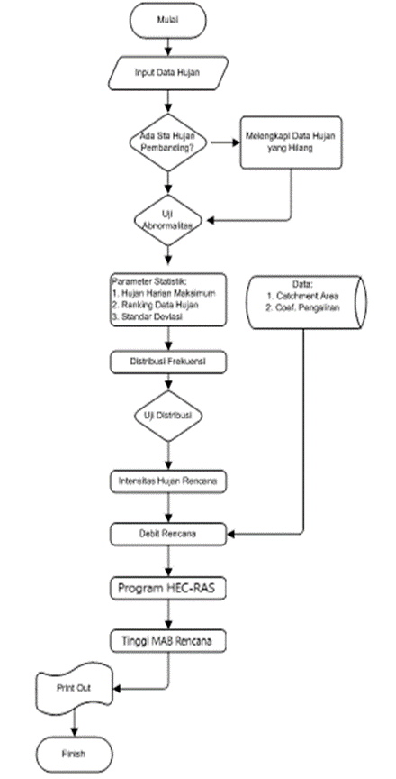

The primary data gathered in this research is based on a direct observation of the river location on September 2020 when the river was in normal condition. The data survey was taken directly from the river bridge and up to three kilometers to upstream direction. During data being collected, it was informed by the two local residents from the interview that the flood occurred in Tukad Biluk Poh mostly at night when there was a heavy and long rain. Also, according to sources, the flood reached as height as one meter above the bridge girder.
As a seconcary data the topographic map of the earth was obtained directly from the official website of the Geospatial Information Agency with a scale of 1: 50,000. The topographical map data obtained is in the form of shp, which needs to converted to become autoCAD and Google Earth formats, using using Global Mapper. While rainfall data withdrawed from the official website of the National Meteorology, Climatology and Geophysics Agency. [9][10]

Data processing stages
Basically there are four major process stages in this research, i.e.:
- Daily Rain Data Processing.
The data that gathered from the Meteorology, Climatology and Geophysics Agency, the daily rainfall data is converted into maximum rainfall data.
- Rainfall Analysis
In this analysis, some tools are being used to analyze rainfall, which are include:
  - Abnormality Test.
  - Statistical Frequency Distribution.
  - Distribution Suitability Test.
  - Rain Intensity Analysis.
- Hidrology Analysis
The approaches that being used to do Hidrology Analysis are:
- Rational Methods
- Synthetic Unit Hydrograph Methods
- Hydraulic Analysis
The purpose of hydraulic analysis is to determine the ability of the cross section to accommodate water discharge in the river. As previously explained, one of the causes of flooding is the inability of the cross section to accommodate flood discharge. Hydraulics analysis in this study used the HEC-RAS program. Tukad Biluk Poh is categorized as a steady current river, which is eligible as an input in HEC-RAS model. The analysis was based on an input of the length of the river for about one kilometer upstream and two hundred meters downstream from the bridge. [11] [12].

RESULTS AND DISCUSSION
Hydrological Analysis of Catchment Area (DAS)
The data needed to process watershed boundaries (DAS) is in the form of DEMNAS data which can be obtained by downloading files from the official website of the Information and Geospatial Agency. DEMNAS data that has been processed using the Global Mapper software is then exported into dwg format, which will be processed again with the help of AutoCAD software.
From the data that has been converted into a dwg file, an analysis is then carried out manually to determine the watershed boundaries in Tukad Biluk Poh. The method used is an analysis of topographical contours, the peak contours will be connected to each other to determine the flow boundaries in Tukad Biluk Poh itself. [13].

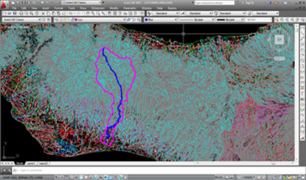
Figure.1. Determination of Watershed Boundaries and River Length

The results obtained from processing the topographic data are as follows:
a. Catchment Area (DAS) = 84704146.4166 m² / 84.704146 km ²
b. River Length = 28009.2752 m / 28.0092752 km

Maximum Daily Rainfall Data
The rainfall data used for hydrological analysis of Tukad Biluk Poh is the closest station to Tukad Biluk Poh, namely the Jembrana Climatology station. The rainfall data used is rain data for 10 years from 2009 to 2018.
The daily rainfall data was obtained from the Meteorology, Climatology and Geophysics Agency (BMKG) Database Center. Maximum daily rainfall data is as follows:

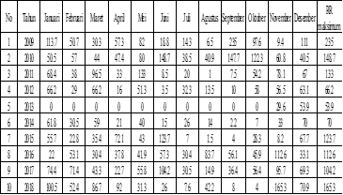
Table 1. Maximum daily rainfall

Table 2. Maximum Annual Rainfall.
No | Tahun | RR maks (mm)
1 | 2009 | 235
2 | 2010 | 148.7
3 | 2011 | 133
4 | 2012 | 66.2
5 | 2013 | 53.9
6 | 2014 | 70
7 | 2015 | 123.7
8 | 2016 | 112.6
9 | 2017 | 104.2
10 | 2018 | 165.3

The planned flood discharge is calculated using the Rational method, using the following formula:

Q = f x α x I x A

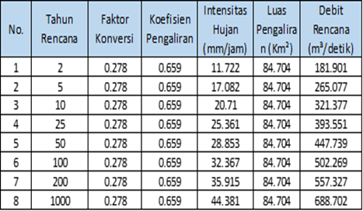

Nakayasu Synthetic Unit Hydrograph equation with hydrograph curve as follows:

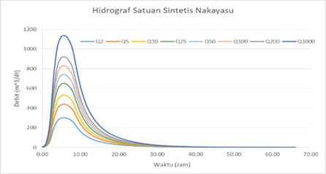
Figure 2. Kurva HSS Nakayasu

Design flood that will be used to determine the flood water level at Tukad Biluk Poh is HSS Nakayasu because in SNI 2415:2016 concerning procedures for

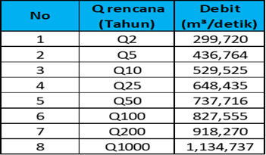

calculating flood plans, the Rational method cannot be used for catchment areas of more than 5000 hectares. The design flood discharge data using the HSS Nakayasu method will then be used as a basic reference for hydraulic calculations using HEC-RAS.

Hydraulics Analysis
The results of the calculation of the flood water level can be seen in the following figures:
The river profile and flood water level from each return period are presented in an image from the results of the HEC-RAS program running [14].
In the picture below the flood water level rises at the 50-year return period due to the influence of the bridge which blocks the flood discharge that occurs

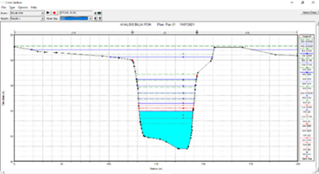
Figure 2. Floodwater Profile

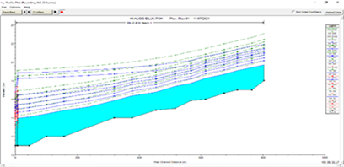
Figure 3. Flood Water Level Upstream of the Bridge

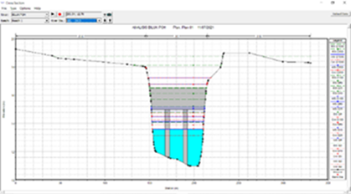
Figure 4. Flood Water Level on the Axle of the Bridge

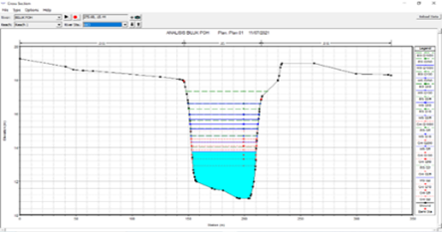
Figure 5. Flood Water Level Downstream on the Bridge

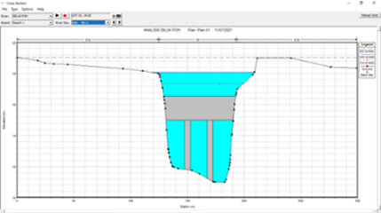
Figure 7. Flood Water Level Upstream of the 1000 Year Return Period Bridge

It can be seen from the simulation that starting from the 50 year anniversary of the bridge which crosses Tukad Biluk Poh at the bottom of the girder has been affected by the flooding that occurred in the river. Moreover, when the bridge was 1000 years old, it was flooded, and the upstream section even experienced runoff on the right side of the bridge. In 2018 there was also a flood which submerged the bridge connecting Gilimanuk with Denpasar. Data obtained from the field shows that the flood has reached residential areas. The flood water level in the simulation using HEC-RAS at a return period of 1000 years is 1.55m from the bridge floor plate and the flood water level from the river bed is 6.2m. The planned flood return period regulation according to SNI 03–2415–1991 is Q100 or 100 year planned discharge, but for security reasons several hydrologists from the Ministry of PUPR are advised to calculate the magnitude of the flood discharge at the 1000 year return period to be used as a comparison for the safety of bridge structures against future floods. Recently, river flood discharge has been greater than usual.

CONCLUSIONS
After analyzing and calculating the design flood discharge and plan water level from the data obtained both primary data and secondary data at Tukad Biluk Poh, the following conclusions:
A. The largest annual maximum rainfall occurred in 2018, namely 165.3mm when a major flood occurred in Tukad Biluk Poh which cut off access to the Gilimanuk – Denpasar National Road.
B. The design flood discharge at Tukad Biluk Poh using the HSS Nakayasu method with each return period is as follows:
1. 2 year return period 299,720 m³/second
2. 5 year return period 436.764 m³/second
3. 10 year return period 529.525 m³/second
4. 25 year return period 648.435 m³/second
5. 50 year return period 737.716 m³/second
6.The 100 year birthday is 827.555 m³/second
7. 200 year return period 918,270 m³/second
8. The 1000 year return period is 1134.737 m³/second
C. The results of the analysis of the design flood water level for return periods of 2, 5, 10, 25, 50, 100, 200 and 1000 years using HEC-RAS software measured from the river land surface are as follows:
1. at 2 years birthday 1.78 m
2. at 5 years birthday 2.31 m
3. at 10 year anniversary 2.64 m
4. at 25 years old 3.03 m
5. at 50 years old 3.34 m
6. at 100 years birthday 3.51m
7. at 200 years return 5.76 m
8. at 1000 year anniversary 6.21m
The flood water level in the analysis and actual is not much different, namely at the 200 year return period it is 1m from the pavement on the bridge. The 1000 year return period is used for control and safety factors for bridges against flooding.
D. The height of the MAB with a design discharge of 1000 years 6.21 from the surface of the river and the height of the guard or freeboard in accordance with SNI 03-3424-1994 is 1.5m
E. The flood water level designed with a return period of 50 years with a height of 3.34m has already hit the girders on the bridge so that it is no longer effective in channeling the flow to Tukad Biluk Poh and is also dangerous for the structure of the bridge itself. At the design flood water level with a return period of 200 years and 1000 years, the pavement on the bridge has been flooded so that it can no longer be passed by vehicles.
F. The height of the bridge from the ground level is 4.65m by measuring from the bridge pavement, while the height of the ground surface with girders or the lowest position of the bridge is 3.10m.

ACKNOWLEDGMENT
This research was supported/partially supported by [Menara Bhakti, Grant maker, Donor]. In addition, we thank our colleagues from [department of civil engineering] who provided insight and expertise that greatly assisted the research.

REFERENCES
- Kodoatie, R.J. dan Sugiyanto, (2002). “Banjir, Beberapa Penyebab dan Metode
- Pengendaliannya dalam Perspektif Lingkungan”, Pustaka Pelajar, Yogyakarta.
- Anastasya F M, Lambertus T, Eveline W 2017 Planning for a clean water supply system for Soyowan Village, Ratatotok District, Southeast Minahasa Regency (Manado: Sam Ratulangi University)
- Suripin, (2003). “Sistem Drainase Perkotaan Yang Berkelanjutan”, Andi, Yogyakarta.
- Singh, P. V, (1992). “Elementary Hydrology”. Prentice-Hall Englewood Cliffs, New Jersey.
- Martha dan Adidarma. (1983). “Mengenal Dasar-Dasar Hidrologi”. Bandung
- Linsley, Ray., Kohler, Max., and Paulhus, Joseph, (1986-1996, “Hidrologi untuk Insinyur edisi ketiga”, diterjemahkan oleh Yandi Hermawan, Erlangga, Jakarta
- Restu Wigati, Sudarsono, Intan Dwi Cahyani (2016), “ANALISIS BANJIR MENGGUNAKAN SOFTWARE HEC-RAS 4.1 (Studi kasus sub DAS Cisimeut hilir HM 0+00 Sampai dengan HM 69+00)”, vol 5, no 1
- Utami Sylvia Lestari (2016), “Kajian Metode Empiris Untuk Menghitung Debit Banjir Sungai Negara Di Ruas Kecamatan Sungai Pandan (Alabio)”, vol 8, no 2
- Nastasia F. Margini, Danayanti A. D. Nusantara, M. Bagus Ansori (2017), “Analisa Hidrograf Satuan Sintetik Nakayasu Dan ITB Pada Sub DAS Konto, Jawa Timur”, vol 2, no 1
- Rico Sihotang, Miftah Hazmi, Debby Rahmawati (2011), Analisis Banjir Rancangan Dengan Metode Hss Nakayasu Pada Bendungan Gintung”, vol 4 Oktober 2011
- [SNI 03-3424.(1994). “Tata Cara Perencanaan Drainase Permukaan Jalan”.
- Suprapti (2022).” Drainage System Capacity Analysis with Storm Water Management Model (SWMM) at Cemarajaya Housing, Karawang Regency West Java, International Journal of Entrepreneurship and Business Development) Vol 05 N0 02 March 2022
- Acep Hidayat (2022).” Analysis of Flood Peaks Using The Mean Annual Flood Method,International Journal of Engineering,Science& Technology (IJESTY) Vol 2 No.2 (2022)

