Analysis of the Effectiveness of the Customer Base Method and Branching Method in Designing the Fiber to the Home Network | 

Yusnita Rahayu^{1*}, Muhammad Raihan Azhary¹, Razali Ngah², Arbiansyah Ali³
¹Department of Electrical Engineering, Universitas Riau, Indonesia
²Wireless Communication Centre (WCC), Faculty of Electrical Engineering, Universiti Teknologi Malaysia, Malaysia
³PT.PLN Icon Plus Strategic Business Unit Central Sumatra Regional, Riau Regional Office, Indonesia.

Abstract  One communication medium that is well-known for its outstanding and reliable performance is fiber optic. A social example of its application is the fiber-to-the-home (FTTH) network. The goal of this study is to evaluate the customer base method and the branching method, two FTTH-building techniques based on the PT.PLN Icon Plus standards, to identify the most practical approach for use in the Air Hitam 2 cluster. Two scenarios were used in this study at the Fiber Access Terminal (FAT) with 1:8 and 1:16 splitters. The fiber optic cable path design findings demonstrate that the branching approach is a wise decision, utilizing optical fiber cables for a total of 9 km, with the greatest cable distance being 2.5 km from the Optical Line Terminal (OLT) to the end FAT. According to theory, in the 1:16 splitter situation and the 1:8 splitter scenario, the optical power received by the Optical Network Terminal (ONT) is -19.13 dBm and -16.03 dBm, respectively, with an OLT transmit power of 3 dB. For these cases, the simulation results are -17.98 dBm and -20.27 dBm. Additionally, the budget value for the rising time reaches 0.253 ns. The bit error rate values in the 1:16 and 1:8 splitter scenarios are 3,1 ×10^(-10), and 11.014, respectively, while the Q factor values are 6.18233 and 11.014, respectively. Based on theory and simulation, these findings suggest that the branching strategy can deliver good performance.  This is an open access article under the CC BY-SA license   | Keywords:  Fiber to the Home  GPON  Customer Base  Branching  feasibility Parameters  Article History:  Received: May 2, 2019  Revised: May 29, 2019  Accepted: June 2, 2019  Published: June 2, 2019  Corresponding Author:  Yusnita Rahayu  ¹Department of Electrical Engineering, Universitas Riau, Indonesia.  Email: yusnita.rahayu@lecturer.unri.ac.id

INTRODUCTION
The social, political, and economic domains are only a few of the areas in which the Internet is vital in today's digital era. With the number of internet users continuously increasing every year, having access to the internet has now become a basic requirement for people all over the world. For example, it is projected that Indonesia will have up to 136.2 million users by 2020 and that the country will continue to develop in the years to come [1].
New technologies emerged and were implemented by utilizing fiber, which made it possible to multiply threads while optimizing resources. Designing and deploying cost-effective fiber networks is critical to delivering benefits to companies and communities [2]. One application of fiber optics in society is the Fiber to the Home (FTTH) network, It is an architectural concept of a data transmission network from the source (transmitter) to the client (receiver) [3]-[4]. The FTTH networks have developed to discover affordable fixes [5]. One major advancement is the ability to use fiber optic for both downlink and uplink paths. These networks are point-to-multipoint, and their name, Passive Optical Network (PON), comes from the connection of fiber optic to passive optical splitters [6]-[7].
With an area of ​​11,289.28 km² and a population of around 847,236 people, Kampar Regency is located in Riau Province, Indonesia. This research will focus on the Air Hitam 2 cluster which is located in Karya Indah Village, Tapung District, Kampar Regency which has an area of ​​57.57665 km² and is home to around 12,657 residents.
Air Hitam Cluster 2 is a continuation project of the Air Hitam 1 cluster, which is located on Garuda Sakti Street Km 4 to Km 7. There are around 8 housing complexes that will be equipped with an FTTH network. Currently, part of the Air Hitam 2 Cluster area is connected to the FTTH network through other service providers, but there are still areas that are not yet connected. The main objective in designing this FTTH network is to serve new customers from the people of Karya Indah Village.
According to Designing FTTH is an important step in ensuring the optical link's best performance. This research focuses on developing and analyzing an FTTH-GPON network's performance utilizing optical link power and rise time budgets. A minimum of eight feeder cable cores, as well as the related Optical Distribution Cabinet (ODC) and Optical Determination Point (ODP), are required for the 254 user households. The design follows to the power link budget, with the narrowest power margins of 2.826 dB and 2.469 dB downlink and uplink at the greatest distance. The system's highest rising time is 0.2236 ns.
During the FTTH GPON network design [8], the measurements yielded the downlink Power Link Budget of -18.283 dBm for the furthest location. Similarly, the Rise Time Budget was assessed at this distant point, with a value <70%, measuring the Downlink as 0.363 ns and the Uplink as 0.251 ns.
This research [9] designs an expansion of the FTTH network with a distance of 0.86 km between the existing ODC and the Fiber Access Terminal (FAT) plan. However, between the existing ODC and the FAT plan, there is FAT-Existing which is 0.44 Km away. By applying the Branching Technique to the FAT can reduce work completion time and optimize material use. Branching on existing FAT uses idle cores on distribution cables. Simulations using the Opti System using a transmit power on the Optical Line Terminal (OLT) of 7 dB, show that the value obtained by the optical power meter (OPM) on the new FAT produces an optical power of -19.48 dBm. The theoretical calculation of the Power Link Budget produces an optical power value of -20.40 dBm. It was found that the longer the cable used between the ODC and the FAT, the greater the loss value.
This research has a target to cover the entire area of ​​the Air Hitam 2 Cluster which contains around 8 housing complexes with a population density of around 0.454 people/km² with a total cable usage of not exceeding 22 Km for the Customer Base Method and 16 Km for the Branching Method where both methods are design methods fiber to the home network owned by PT. PLN Icon Plus. Using an OLT transmit power of 3 dB, ensures that the power link budget value on the Optical Network Terminal (ONT) is > -26 dBm, rise time budget < 0.26 ns, Q Factor > 6, bit error rate ${<10}^{-9}$. This research will carry out a comparison between two methods, the Customer Base Method and the Branching Method, using a comparison of the total use of fiber optic cables and feasibility parameters, power link budget, rise time budget, Q Factor, and bit error rate by theory and simulation.

METHOD
Figure 1 shows the flow of work during the carrying out of research starting from Literature Study and Guidance, Data Collection, Needs Analysis, Determining the Cluster Location, determining the GPON components that will be used, designing the Cluster, calculating feasibility parameters, finalizing the design to the Development Team and Making a report.

A survey was conducted at PT. PLN Icon Plus Riau Regional Office, which is the basis of this research, researchers have identified needs that must be met in FTTH design. In designing the FTTH Cluster Air Hitam 2, researchers aimed to connect internet services to 512 customer homes, in accordance with GPON standards and requirements set by PT. PLN Icon Plus. However, an important note in the research is that this design must also be scalable so that it can handle an increase in the number of customers in the future which may exceed 512 homes with optimal network performance.

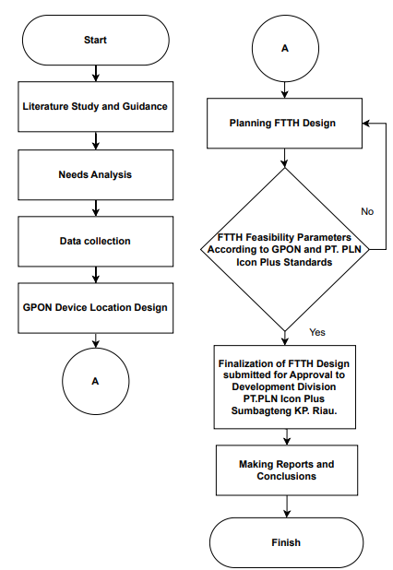

Figure 1. Flowchart

Customer Base Method
The Customer Base method is a method for designing the FTTH network at PT. PLN Icon Plus, where this method is ideal for covering a wide FTTH design area. In this method, the maximum limit for the total use of fiber optic cables permitted is 22 km with a maximum cable length from OLT to FAT of 7 km to ensure that FTTH development costs remain controlled within the predetermined budget.

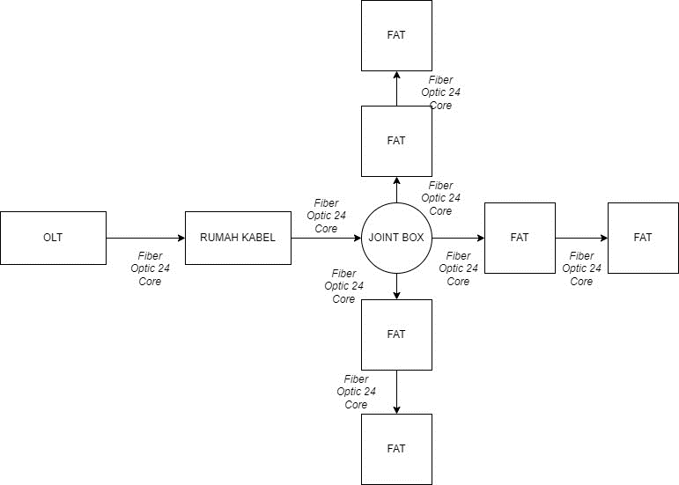

Figure 2. Block diagram of the Customer Base method

Information:
1. OLT
2. Cable House (RK)
3. Joint Box (JB)
4. FAT
Figure 2 is a block diagram of the Customer Base method. In designing the Customer Base method, using JB as a branching point before the fiber optic cable is connected to the FAT is an effective solution for covering long distances. JB is a box where fiber optic connections are placed. For example, if a fiber optic cable is disconnected or damaged, the cable will be reconnected through a splicing process, and the splicing results are placed in the JB. JB has various capacities, ranging from 6 cores to 256 cores [9]. A Joint Box in FTTH network design can be used as branching distribution cables which are used as branching fiber optic cables to save on the use of fiber optic cables in the joint box there are more than 2 holes where 1 hole is used as distribution cable input and the other hole is used as output cable splicing of distribution cable branches which will continue to FAT. JB which has 6 holes, where 5 holes are used as cable output to FAT, allows efficient cable management and distribution. With JB, the FTTH network can be expanded effectively and meet customer needs in all regions while adhering to predetermined cable length limitations. The fiber optic cable that connects JB to FAT is called a distribution cable [10].

Branching Method
The Branching method used in designing the FTTH Network at PT. PLN Icon Plus is ideal for coverage areas that are not too wide and has optical power values ​​that tend to be better when compared to the Customer Base Method. In this method, the total cable length used is not allowed to exceed 16 km, with a maximum cable length from OLT to FAT of 7 km.

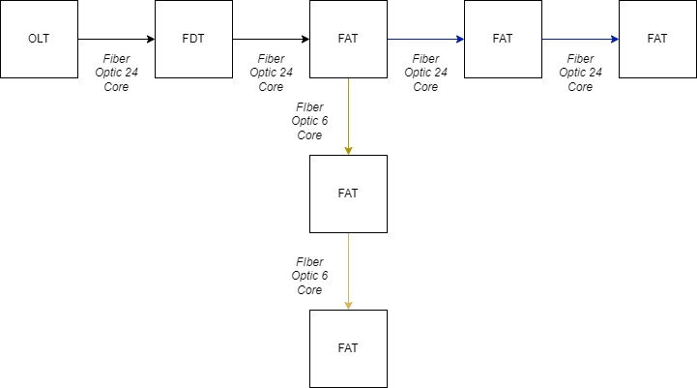

Figure 3. Block diagram of the Branching method

Information:
1. OLT
2. Fiber Determination Terminal (FDT)
3. FAT
Figure 3 is a block diagram of the branching method. The branching method uses FDT as a replacement for RK. The use of FDT can affect the total cable usage and total attenuation. FAT which consists of an optical pigtail, connectors, and a splitter room. This type of device is an optical network termination placed at several locations that use a splitter to connect distribution cable and drop cable [11]. On FAT, there is a 1:8 splitter, and if all the ports on the splitter are used, it can be upgraded to a 1:16 splitter. Fiber Optic cable branching in this method is centered on the FAT which has three holes, where one hole is used as the distribution cable input, while the other two holes function as the distribution cable output. In the two FAT output holes, the use of Fiber Optic cables can be adjusted to the needs of the cores that will be used after the FAT which functions as a branch point, using either 6-core or 24-core cables.

Geographical Conditions
Geographically, Air Hitam 2 Cluster is in Karya Indah Village, Tapung District, Kampar Village, Riau.

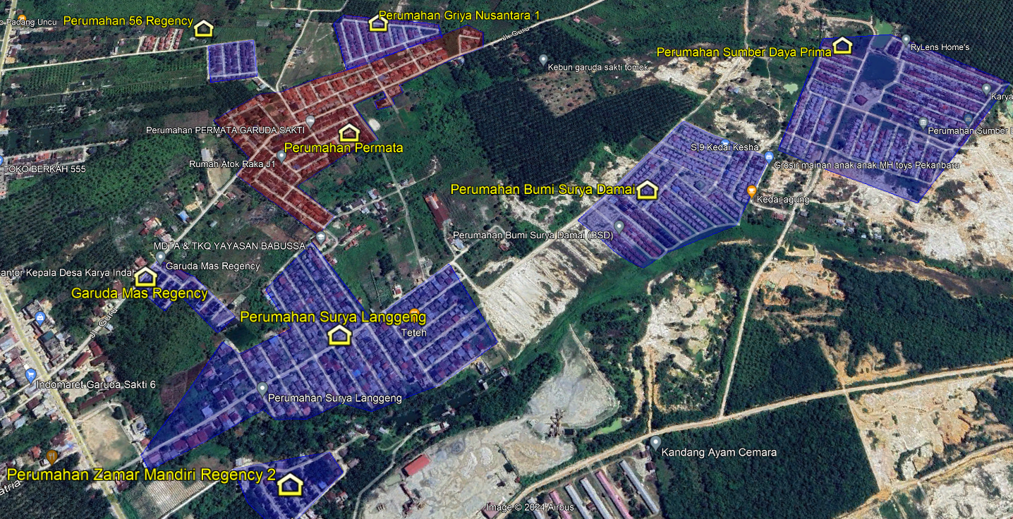

Figure 4. Housing in Air Hitam 2 Cluster

A housing for the Air Hitam 2 Cluster is illustrated in Figure 4. Surya Langgeng Housing, Bumi Surya Damai Housing, Zamar Mandiri Regency 2 Housing, Garuda Mas Regency, Permata Housing, 56 Regency Housing, Sumber Daya Prima Housing, and Griya Housing are the eight housing complexes consisting of the area. Nusantara No. 1. In the Air Hitam 2 cluster, housing is represented by the yellow house-shaped insignia, while the area of each housing complex is denoted by the blue and red polygons. A total of 1146 residential units are anticipated to have been sold in the Air Hitam 2 Cluster by 2023.

Existing Infrastructure
Existing infrastructure refers to the pre-existing physical structures and systems in the designated area where the FTTH architecture will be implemented. The current infrastructure consists of a low-voltage network pole and a medium-voltage network owned by PT. PLN, with PT. PLN Icon Plus is a subsidiary of PT. PLN.

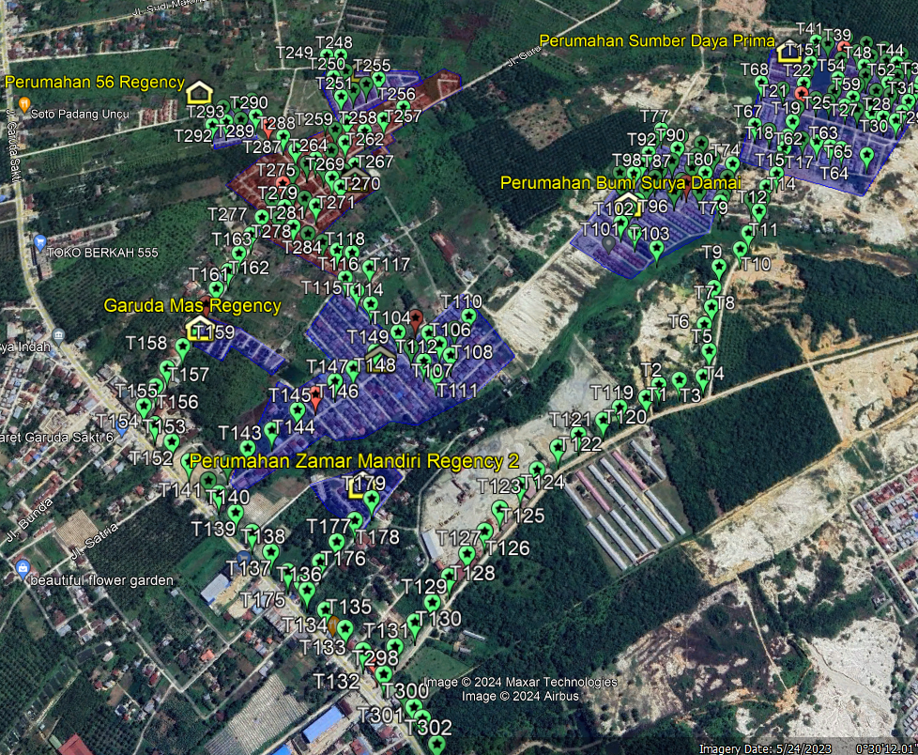

Figure 5. The existing pole belongs to PT. PLN

Figure 5 depicts an infrastructure pole, which is indicated by a green pin. Additionally, a red pin is used to symbolize the transformer located on the pole. When using the current infrastructure, there are certain limitations in place to ensure safety. For instance, it is prohibited to install GPON devices on poles that already have electrical equipment. The objective is to mitigate potential hazards during the process of installing and maintaining new customers. The identification of safe poles for crossing fiber optic cables has been accomplished by employing a tagging procedure utilizing Google Earth software. For instance, a red pin designates a transformer pole where installation of GPON equipment is prohibited. The outcomes of this tagging procedure enable the meticulous selection of poles that satisfy the safety criteria for fiber optic cable lines.

Feasibility Parameters Calculation
The feasibility parameters will be analyzed by considering the downstream direction, which refers to the transmission of data from the transmitter to all end-points (receivers) using fiber optic media ) [12]-[13]. The examination of feasibility parameters in the downstream direction is utilized for the computation in FTTH design planning [14]-[15]. To assess the calculation of the power link budget, rise time budget, Q Factor, and Bit error rate using both techniques, we will focus on the longest route from the OLT to the FAT. When constructing this FTTH network, we will examine two scenarios: one involving a 1:8 splitter and another involving a 1:16 splitter. The purpose is to ensure that if the 1:8 splitter is replaced with a 1:16 splitter, the optical power remains within the PT.PLN Icon Plus standard.

Power Link Budget
Power Link Budget is a method used to evaluate and compute the power allocation in a communication system. The power budget is crucial for maintaining a received power level at the receiver that is above the minimum sensitivity threshold. This threshold is set to ensure optimal performance in communications and to provide adequate signal power at the client location, in line with the specified performance criteria [16].
The GPON standard is used in this computation, which also considers the restrictions imposed by PT. PLN Icon Plus, which provide for a transmission distance of less than 7 km and a total loss of no more than -26 dBm. In the G.984 standard series, the GPON standard established by ITU-T is referred to as the PT.PLN Icon Plus standard [17].
The amount of power left over from the transmit power after losses experienced during transmission is referred to as the power margin. The safety margin and receiver sensitivity are lessened by these losses [12]. M > 0 is the usual Power Margin value. The following formula [18]-[13] can be used to calculate power link budgets:

Power Link Budget
$$Prx=Ptx-Total Loss$$ | (1)

Where:

$P_{rx}= Receiver sensitivity (dBm)$

$P_{tx}= Transmitter power (dB)$

$αtotal= Total loss (dB)$

Total loss
$$αtotal=L.αf+Nc.αc+Ns.α+Nsp.αsp$$ |  | (2)

Where:

$L= Fiber optic cable length (Km)$

$αf= Loss fiber optic (dB)$

$Nc= Number of Connectors$

$αc=loss Connector (dB)$

$Ns= Number of Splicing$

$αs=loss Splicing (dB)$

$Nsp= Number of Splitters$

$αsp= loss Splitter (dB)$
Power Margin
$M=\left(P_{tx}-P_{rx}\right)-αtotal- M_{s}$ | (3)

Where:
$M= Power Margin (dB)$
$M_{s}= System Margin (4-8 dB)$

Rise Time Budget
The Rise Time Budget calculation serves to estimate the dispersion limits within a fiber optic network. It is particularly effective in evaluating digital transmission networks. The objective of this calculation is to assess the overall network performance while ensuring that it does not exceed the channel capacity. The total rise time must remain below 70% of one NRZ bit period, then total rise time must below maximum rise time[1]-[19]. Rise time budget calculations can use the equation [20]-[21]:

Total Rise Time
$t_{sys}=\sqrt{{t_{tx}}^{2}+{t_{chromatic}}^{2}+{t_{modal}}^{2}+{t_{rx}}^{2}}$ | (4)

Where:

$t_{sys}= Total rise time (ns)$

$t_{tx}= Rise time transmitter (ns)$

$t_{rx}= Rise time reciever (ns)$
$t_{chromatic}=Chromatic dispersion (ns)$
$t_{modal}= value 0 for single mode$

Chromatic Dispersion
$Dt= D \left(λ\right).S. L$ | (5)

Where:

$Dt=Total chromatic dispersion (ns)$

$D\left(λ\right)=CD Coefficient (ps/nm.km)$

$S=Spectral width (nm)$
$L= Fiber Optic Length (Km)$

Maximum Rise Time
$T_{r}=\frac{0,7}{B_{r}}$ | (5)

Where:

$T_{r}=Maximum Rise Time (ns)$

$B_{r}=Bit rate (Gbps)$
Q-Factor
Q-factor, an optical signal quality measure, should be between 4 and 6, with an exceptional value beyond 6. SNR is related to this Q-factor. Quality Factor (Q-factor) is the decision circuit SNR as voltage or current [21].

Bit Error Rate
When sending a digital signal, the Bit Error Rate measures the amount of incorrect bits. A digital system's BER is the percentage of bit errors for all bits transferred. In optic communication systems, the standard bit error rate is < 10^(-9) [22].

GPON devices specifications
The GPON devices that will be used for this research include the following:

Table 1. The component's value
Characteristics | Value
Transmitter Power | 3 dB
Max Rx Sensitivity | -26 dBm
Wavelength | 1490 nm
Bit Rate Downstream | 2.488 Gbps
Rise time transmitter | 200 ps
Rise time receiver | 150 ps
Connector Loss | 0.15 dB
Splitter 1:4 | 7 dB
Splitter 1:8 | 10.2 dB
Splitter 1:16 | 13.5 dB
Splicing | 0.05 dB
Feeder and distribution cables attenuation @1490 nm | 0.21 dB/Km
Drop cable attenuation @1490 nm | 0.30 dB/Km

To begin calculating the feasibility parameters for the design of a fiber optic system, it is important to have an accurate understanding of the numerous characteristics value. These parameters include factors such as the distance of transmission, types of fiber optic cables used, attenuation characteristics, dispersion effects, and the specific requirements of the intended applications. Such information forms the foundation for accurate and efficient analysis, ensuring the optimal performance and reliability of the fiber optic network [20].

Opti system simulation
Table 2 is the component quantity used for the Customer Base method in calculating feasibility parameters both theoretically and in simulation.

Table 2. Components Quantity the Customer Base Method
Component | Qty | Unit
OLT | 1 | Unit
Feeder cable | 0.463 | Km
Distribution cable | 2.599 | Km
Drop cable | 0.35 | Km
Connector | 6 | pcs
Splicing | 6 | pcs
Splitter 1:4 | 1 | pcs
Splitter 1:8 | 1 | pcs
Splitter 1:16 | 1 | pcs

Figure 6 is a circuit of customer-base method simulations

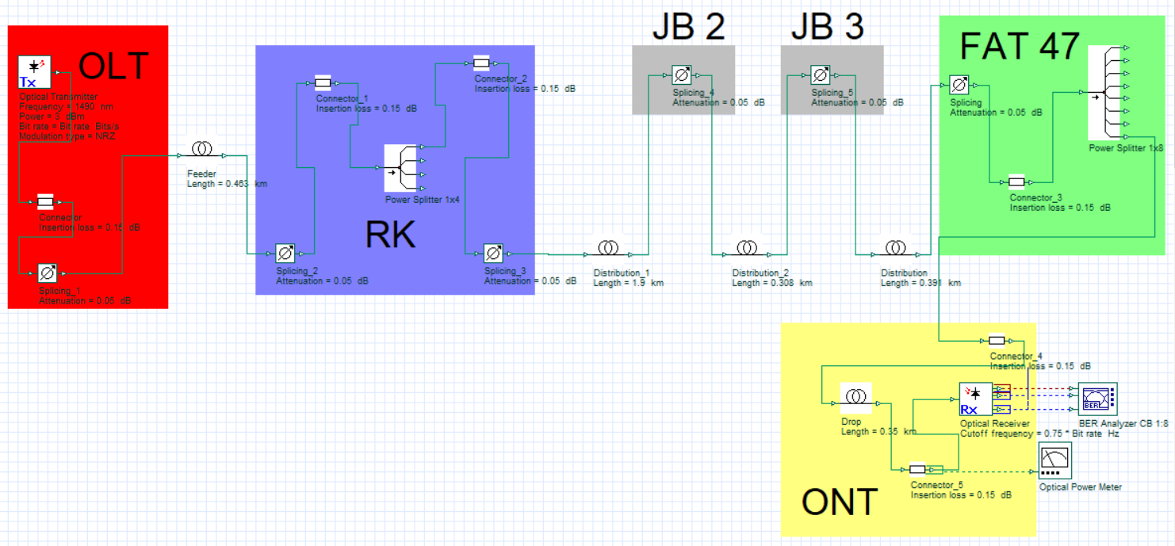

Figure 6. Customer Base simulation circuit

The value of each component in the simulation adheres to the characteristic values specified in Table 1. Figure 6 depicts a set of customer base method simulations for the situation when a 1:8 splitter is employed on FAT. In the 1:16 splitter scenario, the 1:8 splitter component on FAT 47 is replaced. The customer base technique utilizes the joint box as a repository for spliced cores between distribution cables. The joint box can be symbolized by a splicing attenuation component due to its exclusive presence of splicing attenuation.
Table 3 shows the Branching method component quantity for theoretical and simulation calculations.

Table 3. Component quantity the Branching Method
Component | Qty | Unit
OLT | 1 | Unit
Feeder cable | 1.4 | Km
Distribution cable | 1.1 | Km
Drop cable | 0.35 | Km
Connector | 6 | pcs
Splicing | 6 | pcs
Splitter 1:4 | 1 | pcs
Splitter 1:8 | 1 | pcs
Splitter 1:16 | 1 | pcs

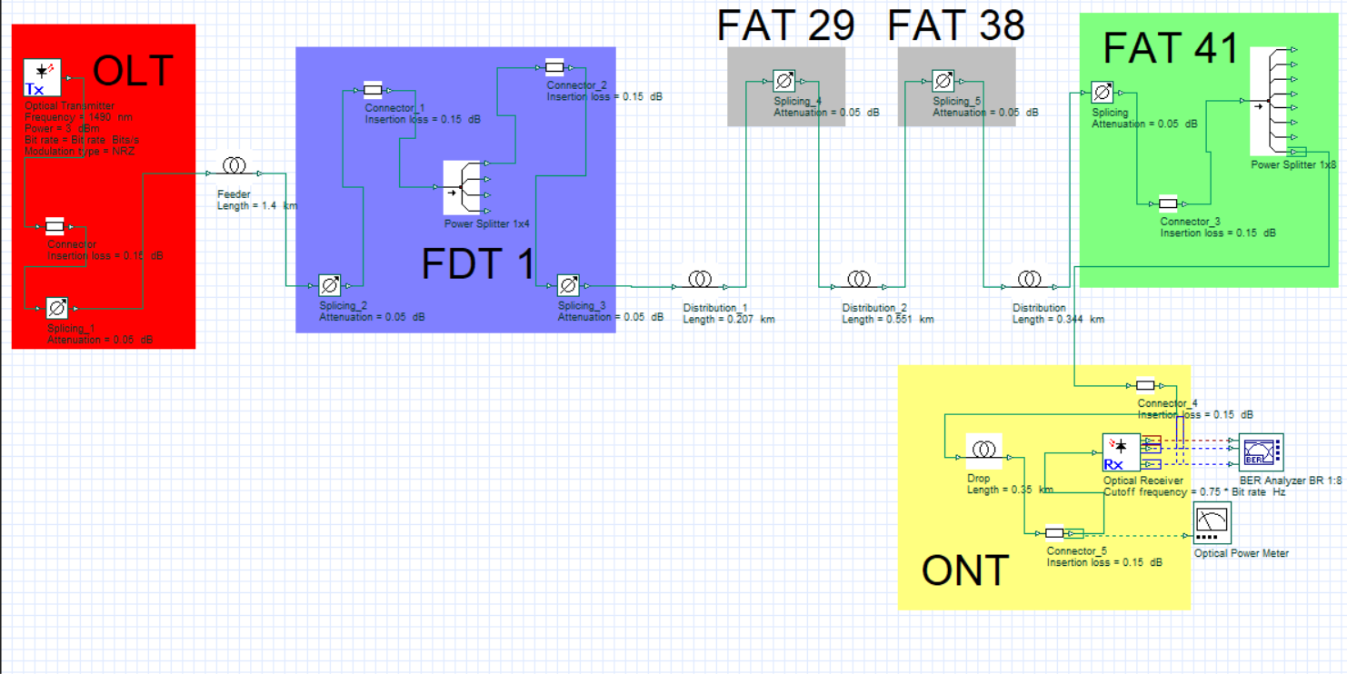

Figure 7. Branching simulation circuit

Figure 7 depicts a sequence of simulations using the Branching method. The feasibility parameters of a sample Branching method, which will be calculated, are applied to the FAT Branching. The FAT Branching serves as a connection point for distribution cables, similar to a joint box. However, it also functions as a connection point for the internet to customers and can serve as a branching location. The FAT Branching can be represented by a splicing attenuation component, with a value of 0.05 dB, as it only experiences splicing attenuation.
OPM and BER analyzers are visualizer devices for analyzing attenuation, bit error rate, and Q-factor [6]-[23].

RESULTS AND DISCUSSION
The Fiber Optic cable routing process is carried out using Map Source Software. Existing pole coordinates and FAT coordinates were obtained via Google Earth. Next, the coordinate data from Google Earth is converted into a Map Source file to ensure precision in determining the location and routing of Fiber Optic cables. The routing of fiber optic cables on Map Source is very precise and very easy to review the route.
To analyze the calculation of the power link budget, rise time budget, Q Factor, and Bit error rate from both methods, the sample that will be taken is the longest route from the OLT to the FAT. In the Customer base method, the OLT path to FAT 47 will be analyzed and in the Branching method, the OLT path will be analyzed to FAT 41.
In calculating the feasibility parameters, each method will obtain an additional cable length from FAT to ONT of 0.35 Km, this cable length is the standard set by PT. PLN Icon Plus regarding the maximum installation cable length from FAT to the customer (ONT).
Calculating the feasibility parameters with theoretical and simulation, Calculation of feasibility parameters will be carried out by theory and simulation. power link budget will be calculated using theory and simulation, rise time budget will be calculated using theory, bit error rate, and Q factor will be calculated using simulation.
2 scenarios will be calculated, the 1:8 FAT splitter scenario and the 1:16 FAT splitter scenario. These two scenarios are calculated to ensure that if the FAT upgrades the splitter to a 1:16 splitter, the feasibility parameter value is still categorized as feasible.

Fiber Optic Cable Routing
In designing fiber optic cable routes using the Customer Base method, the total cable used reaches 11.8 km, with the longest distance between OLT and FAT being around 3 km. In this method, 7 JBs will be used to connect a total of 64 FAT units. The cable house (CH) is the termination point for feeder cables and distribution cables. The distribution cable on RK has 4 output cables which will then be distributed to JB before going to FAT.

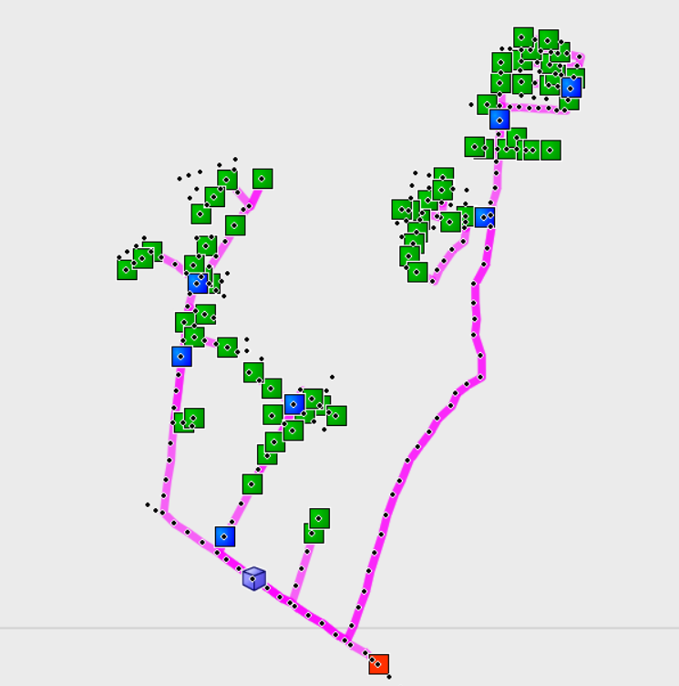

Figure 8. Cable Route Customer Base Method

In Figure 8, the OLT is symbolized by a red square icon, the Cable House is symbolized by a blue cube icon, the Joint Box is symbolized by a blue square icon, the FAT is symbolized by a green square and the black dot is an existing pole.

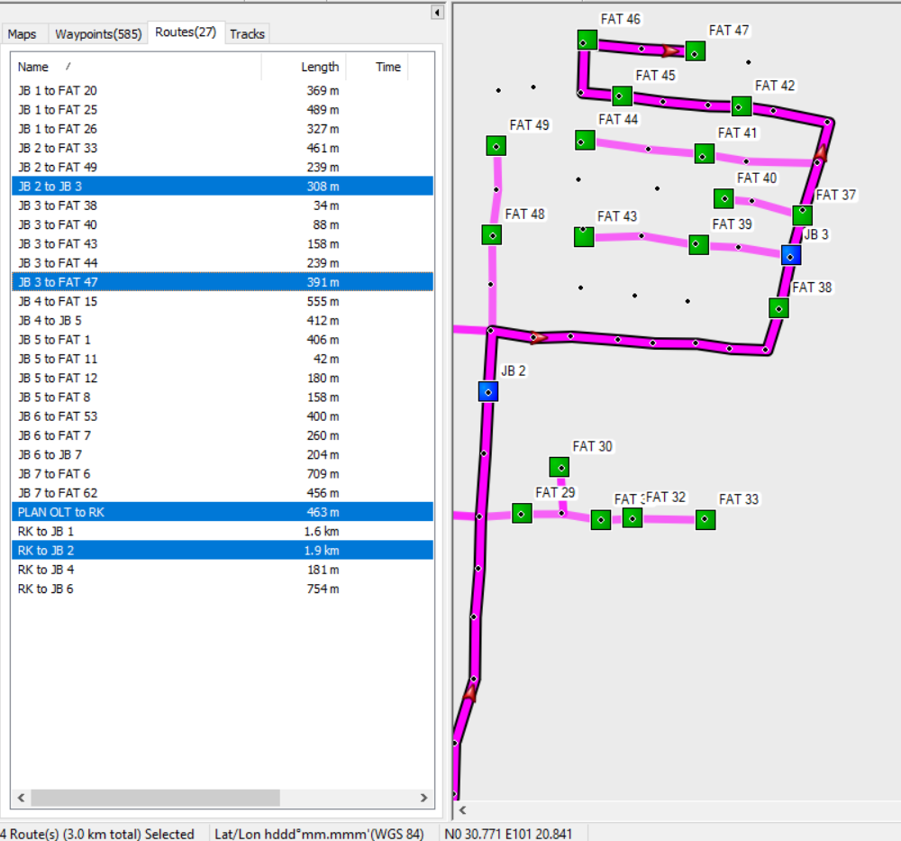

Figure 9. Longest path route Customer Base Method

In Figure 9 is the fiber optic cable route to FAT 47, where FAT 47 is the furthest FAT in the Customer Base Method. This route starts from OLT to RK with a cable length of 0.46 km, then the fiber optic cable from RK is distributed to JB 2 with a cable length of 1.9 km. For efficient use of cables, there is an additional 1 JB unit located 0.308 km from JB 2 to distribute 11 FAT fiber optic cables. With the length of the JB 3 cable to FAT 47 being 0.391 Km, then FAT 47 is the final FAT with the total cable length from OLT to FAT 47 being 3 Km.
In designing fiber optic cable routes using the Branching method, the total cable length used reaches 9 km, with the farthest distance between the OLT and FAT being around 2.5 km. In this method, the termination point for the feeder cable and distribution cable occurs at the FDT. The FDT used in this method is 2 units, where FDT 1 connects 33 FAT and FDT 2 connects 31 FAT. Of the 64 FATs designed, there are 24 FATs that are used as branching points.

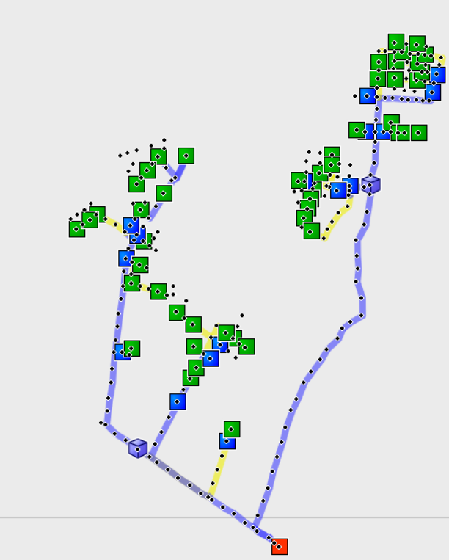

Figure 10. Branching Method Cable Route

In Figure 10, OLT is symbolized by a red square icon, FDT is symbolized by a blue cube icon, FAT is symbolized by a green square, FAT branching is symbolized by a blue square and the black dot is an existing pole. The branching method uses 2 types of fiber optic cables, 6-core and 24 core fiber optic cables where the 6 cores are marked in yellow and the 24 cores are marked in blue. The choice of using 6-core and 24-core fiber optic cables is influenced by the need for cores to be connected to the FAT where 1 core can only connect 1 FAT.
In Figure 11, this is the fiber optic cable route to FAT 41, where FAT 41 is the farthest FAT in the Branching Method.
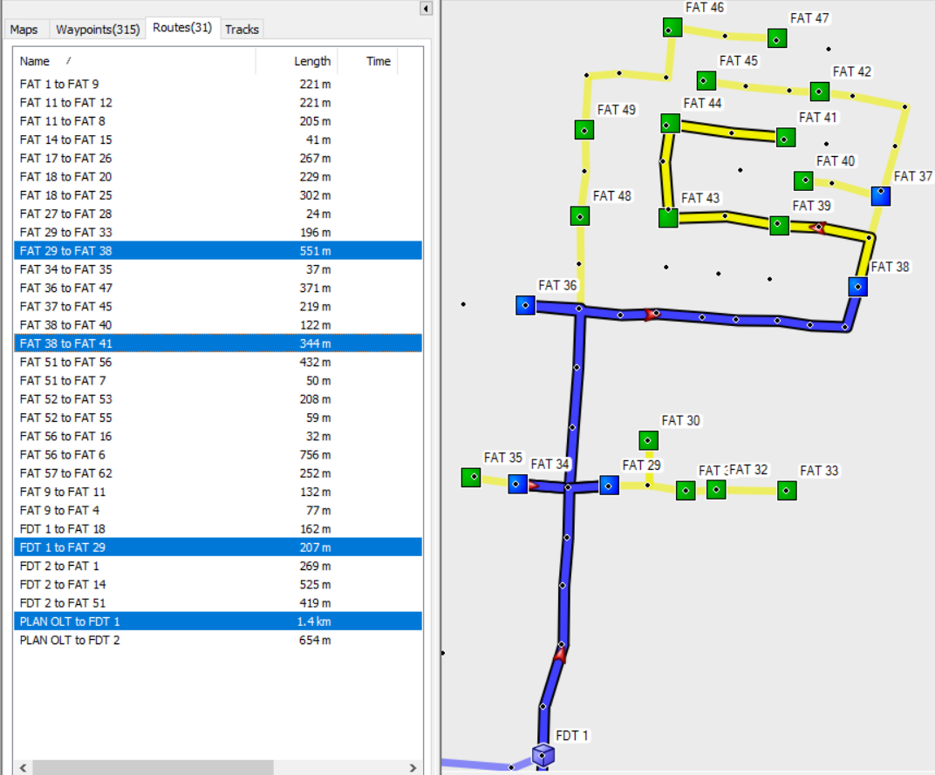

Figure 11. Longest path route Branching Method

This route starts from OLT and is connected to FDT 1 using a 1.4 km long fiber optic cable. Then the fiber optic cable is distributed from FDT 1 to FAT 29 for 0.207 km, at FAT 29 a branch occurs, FAT 29 to FAT 38, and FAT 29 to FAT 33. After branching to FAT 38, the fiber optic cable is connected again from FAT 38 towards FAT 41 along 0.344 Km. therefore FAT 41 is the furthest FAT from OLT to FAT 41 which is 2.5 Km.

Power Link Budget Analysis
Power link budget calculations are carried out theoretically (1), (2), and (3) and simulations using an Opti system with the following results:

Table 4. Optical power values ​​from both design methods
Design Method |  |  | Optical Power On ONT
Customer Base | Theory | Splitter 1:8 | -16.15 dBm
Customer Base | Theory | Splitter 1:16 | -19.25 dBm
Customer Base | Simulation | Splitter 1:8 | -18.09 dBm
Customer Base | Simulation | Splitter 1:16 | -20.41 dBm
Branching | Theory | Splitter 1:8 | -16.03 dBm
Branching | Theory | Splitter 1:16 | -19.13 dBm
Branching | Simulation | Splitter 1:8 | -17.98 dBm
Branching | Simulation | Splitter 1:16 | -20.27 dBm

Based on data from Table 4, both methods have met the power link budget feasibility standards in the scenario of using a 1:8 splitter and a 1:16 splitter, not exceeding -26 dBm. The optimal optical power from both methods is the branching method both in theoretical calculations and in simulation with a theoretical value of -16.13 dBm on a 1:8 splitter and -19.23 dBm on a 1:16 splitter. The simulated value obtained is -17.9 dBm on a 1:8 splitter and -20.27 dBm on a 1:16 splitter.
The power margin calculations that have been carried out theoretically from both methods, can be summarized as follows:

Table 5. The power margin of both design methods
Design Method |  | Power margin
Customer Base | Splitter 1:8 | 5.85 dB
Customer Base | Splitter 1:16 | 2.75 dB
Branching | Splitter 1:8 | 5.97 dB
Branching | Splitter 1:16 | 2.87 dB

Based on data in Table 5, both methods have met the power margin feasibility standards, M > 0 in the scenario of using a 1:8 splitter and a 1:16 splitter. The optimal power margin from both methods is the branching method with a value of 5.97 dB on a 1:8 splitter and 2.87 dB on a 1:16 splitter.

Rise Time Budget Analysis
To analyze the rise time budget, calculations are required using (4), (5) and (6). After collecting the entire rise time value, it will be compared to the maximum rise time to determine the standard rise time budget ${(T}_{sys}>T_{r})$. The calculation of this equation is carried out theoretically.

Table 6. Values for Rise time budget
Component | Value | Unit
Ttx | 200 | ps
Trx | 150 | ps
$D\left(λ\right)$ | 12.9041 | ps/nm.Km
$S$ | 1 | nm
$L Customer Base$ | 3.35 | Km
$L Branching$ | 2.85 | Km
Br | 2.488 | Gbps

Table 6. Shows the values ​​that will be used to find the total rise time, chromatic dispersion, and maximum rise time values. The difference in the values ​​of the two methods in calculating the rise time budget is only in the cable length of each link. This will have an impact on the chromatic dispersion value which will affect the total rise time value.

Table 7. The rise time budget for both design methods
Design Method | Total rise time
Customer Base | 0.254 ns
Branching | 0.253 ns

Based on data from Table 7, the customer base method and branching method have met the rise time budget standard where the total rise time value for both methods does not exceed the maximum rise time value, 0.281 ns. The optimal total rise time value of the two methods is the branching method with a value of 0.253 ns.

Q-Factor and Bit error rate
The Bit Error Rate (BER) analyzer serves as a quantitative tool for assessing the digital communication performance [24]. The eye diagram is a tool utilized to assess signal quality in the time domain. It involves overlaying numerous sequences in real time using a fast oscilloscope synchronized with the clock signal of the data. By examining the eye diagram, signal quality can be readily identified. An open eye indicates distinct levels between symbols "1" and symbols "0" [25].

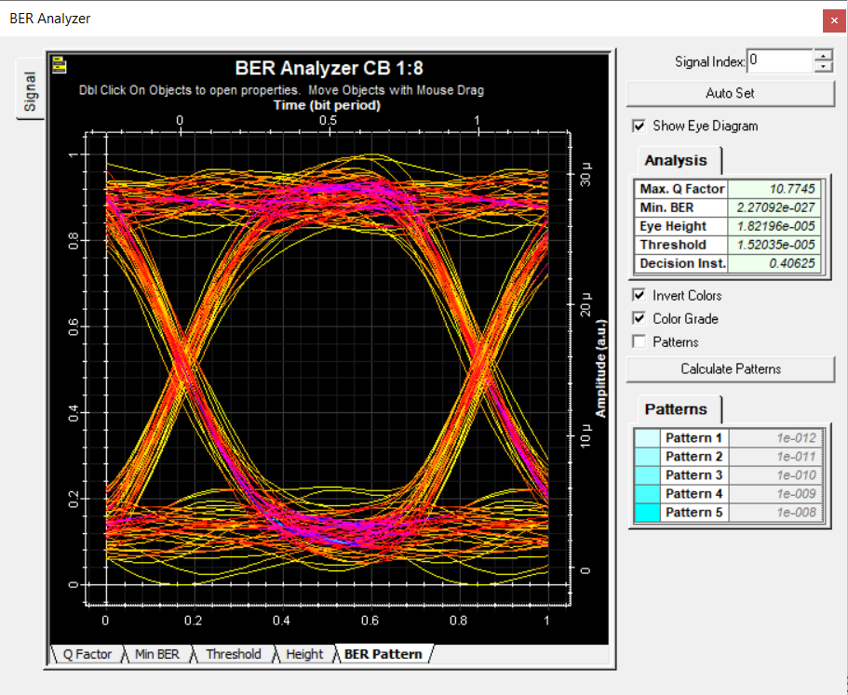

Figure 12. BER analyzer customer base method splitter scenario 1:8

Figure 12 shows the shape of the eye diagram in the customer base method splitter scenario 1:8 with the Q Factor value of 10.7745 where this value meets the Q Factor standard, a minimum value of 6. The bit error rate value also meets the standard value with the value on the BER analyzer being $2.27092 ×{10}^{-27}$ the standard value is the minimum value, which is${10}^{-9}$. If the OLT transmits ${10}^{27}$ bit, then 2.27092 bit has an error.

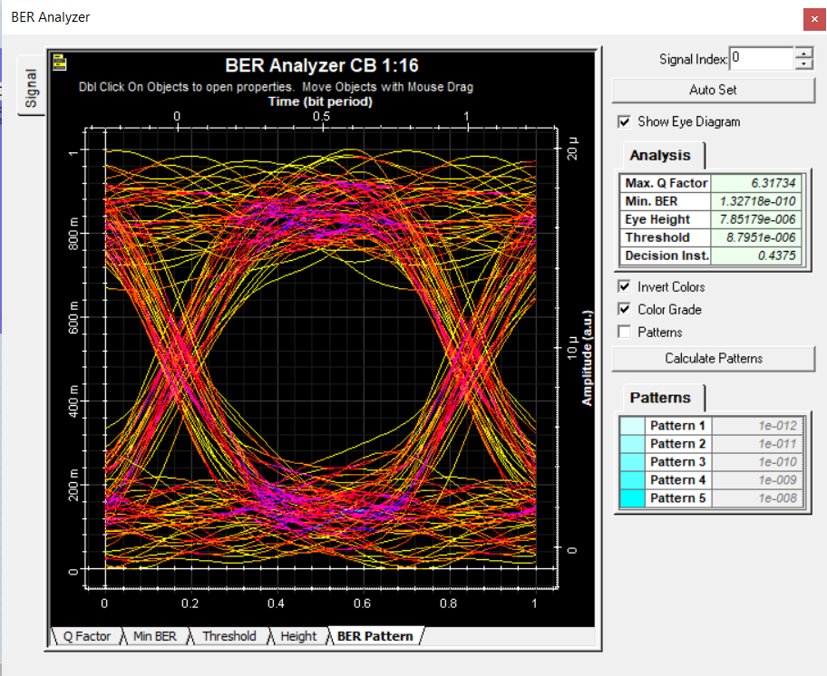

Figure 13. BER analyzer customer base method splitter scenario 1:16

Figure 13 shows the shape of the eye diagram in the customer base method splitter scenario 1:16 with the Q Factor value of 6.41734 where this value meets the Q Factor standard, a minimum value of 6. The bit error rate value also meets the standard value with the value on the BER analyzer being $1.32718 ×{10}^{-10}$ and the standard value is the minimum value, which is ${10}^{-9}$. If the OLT transmit ${10}^{10}$ bit, then 1.32718 bit has an error.

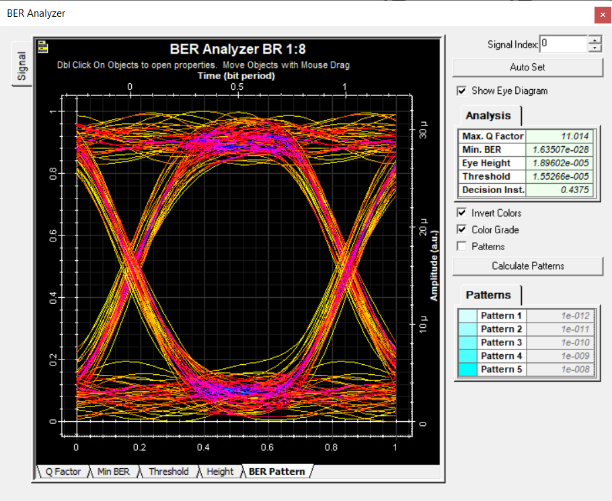

Figure 14. BER analyzer branching method splitter scenario 1:8
Figure 14 shows the shape of the eye diagram in the branching method splitter scenario 1:8 with the Q Factor value of 11.014 where this value meets the Q Factor standard, a minimum value of 6. The bit error rate value also meets the standard value with the value on the BER analyzer $1.63507 ×{10}^{-28}$ and the standard value is a minimum value ${10}^{-9}$. If the OLT transmits${10}^{28}$ bit then 1.63507 bit have an error.

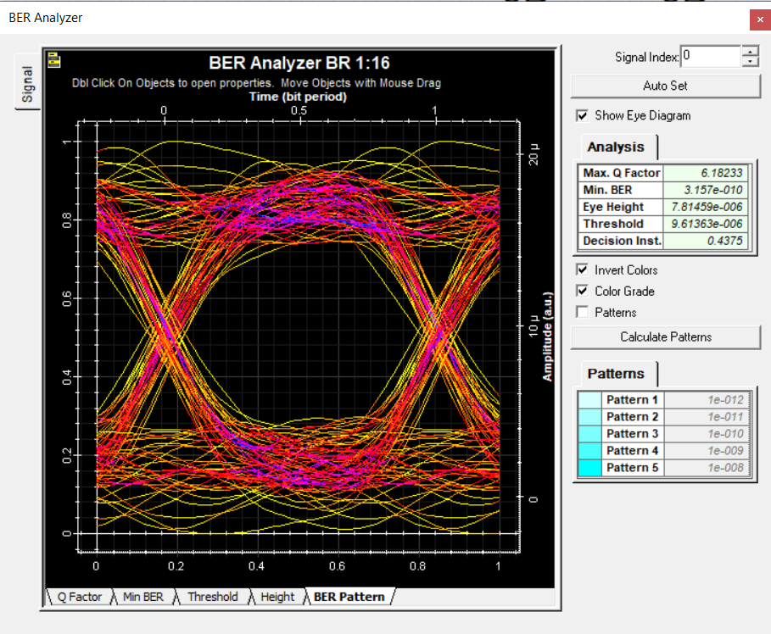

Figure 15. BER analyzer branching method splitter scenario 1:16

Figure 15 shows the shape of the eye diagram in the branching method splitter scenario 1:16 with the Q Factor value is 6.18233 where this value meets the Q Factor standard, a minimum value of 6. The bit error rate value also meets the standard value with the value on the BER analyzer$3.157 ×{10}^{-10}$and the standard value is a minimum value ${10}^{-9}$. If the OLT transmits ${10}^{10}$ bit, then 3.157 bit has an error.

CONCLUSION
Based on the results of the proposed research, it can be concluded that the FTTH network design in the Air Hitam 2 cluster is more effective using the branching method, where the results obtained are Based on the results of designing fiber optic cable lines using Map Source, the branching method uses 9 Km of fiber optic cable and a cable length of The furthest OLT to FAT is 2.5 Km. The power link budget obtained on the ONT with 2 scenarios calculated based on theory in the 1:8 splitter and 1:16 splitter scenarios is -16.03 dBm and -19.13 dBm. The values ​​obtained based on simulations in the 1:8 splitter and 1:16 splitter scenarios are -17.98 dBm and -20.27 dBm. where the standard value of the power link budget does not exceed -26 dBm. The rise time budget obtained by the branching method is 0.253 ns. This value is included in the feasible category because the total rise time value does not exceed the maximum rise time value, 0.281 ns. The Q factor value obtained from both scenarios is in the feasible category with a standard Q factor value > 6. In the 1:8 splitter scenario, the Q factor value is 11.014 and in the 1:16 splitter scenario, the Q factor value is 6.12833. The Bit error rate values ​​obtained from both scenarios are in the appropriate category with standard bit error rate values ${10}^{-9}$. In the 1:8 splitter scenario, the bit error rate value is $1.63507 ×{10}^{-28}$ and in the 1:16 splitter scenario the bit error rate value is $3.157 ×{10}^{-10}$.

ACKNOWLEDGMENT
This work was supported by the Department of Electrical Engineering, Universitas Riau, Indonesia, and PT.PLN Icon Plus Strategic Business Unit Central Sumatra Regional, Riau Regional Office, Indonesia.

REFERENCES
[1] M. A. K. Adhi et al., ‘Design of Fiber to the Home (FTTH) for Urban Housing of Griya Mukti Residence’, Proc. - IEIT 2021 1st Int. Conf. Electr. Inf. Technol., pp. 257–262, 2021, doi: 10.1109/IEIT53149.2021.9587339.
[2] L. Hernandez, J. Albas, J. Camargo, C. D. La Hoz, F. Kurniawan, and A. Pranolo, ‘Design of an FTTH (Fiber To The Home) network for improving voice, broadband, and television services in hard-to-reach areas the Colombian case’, Sci. Inf. Technol. Lett., vol. 3, no. 2, pp. 88–104, 2022, doi: 10.31763/sitech.v3i2.1001.
[3] A. Echraibi, J. Flocon-Cholet, S. Gosselin, and S. Vaton, ‘Deep Infinite Mixture Models for Fault Discovery in GPON-FTTH Networks’, IEEE Access, vol. 9, pp. 90488–90499, 2021, doi: 10.1109/ACCESS.2021.3091328.
[4] F. Mazzenga, R. Giuliano, and F. Vatalaro, ‘Effective strategies for gradual copper-to-fiber transition in access networks’, Comput. Networks, vol. 174, p. 107225, 2020, doi: 10.1016/j.comnet.2020.107225.
[5] F. R. de Almeida, G. S. da Silva, F. S. R. Pinheiro, and A. P. Fernandes Neto, ‘Studies and Solutions for Provision of an FTTH Network Infrastructure in a Multicondominial Residential Area’, Themes Focus. Interdiscip. Sustain. Dev. Worldw. V.1, 2023, doi: 10.56238/tfisdwv1-018.
[6] Z. Abdellaoui, Y. Dieudonne, and A. Aleya, ‘Design, implementation and evaluation of a Fiber To The Home (FTTH) access network based on a Giga Passive Optical Network GPON’, Array, vol. 10, no. July 2020, p. 100058, 2021, doi: 10.1016/j.array.2021.100058.
[7] T. Thangappan, B. Therese, A. Suvarnamma, and G. S. Swapna, ‘Review on Dynamic Bandwidth Allocation of GPON and EPON’, J. Electron. Sci. Technol., vol. 18, no. 4, pp. 297–307, 2020, doi: 10.1016/j.jnlest.2020.100044.
[8] N. B. P. Siahaan, S. Aryza, and S. Anisah, ‘Analysis and Design FTTH (Fiber to the home) Network with GPON Technology at PT.Telkom , Tbk’, vol. 10, no. 3, pp. 526–530, 2022.
[9] A. Adila Asril, P. Maria, Y. Antonisfia, and R. Hadi, ‘Fiber to The Home (FTTH) Network Design with Addition of Optical Distribution Point (ODP) Using the Branching Method’, Int. J. Adv. Sci. Comput. Eng., vol. 5, no. 2, pp. 95–107, 2023.
[10] A. Naeem, S. S. Qurashi, Y. Khan, S. Ahmed, and N. Safwan, ‘Fiber to the Home (FTTH) Automation Planning, Its Impact on Customer Satisfaction & Cost-Effectiveness’, Wirel. Pers. Commun., vol. 117, no. 2, pp. 503–524, 2021, doi: 10.1007/s11277-020-07880-4.
[11] A. A. Shabaneh and M. L. Melhem, ‘Execution Simulation Design of Fiber-to-thehome (FTTH) Device Ingress Networks Using GPON with FBG Based on OptiSystem’, Int. J. Electron. Telecommun., vol. 68, no. 4, pp. 783–791, 2022, doi: 10.24425/ijet.2022.143886.
[12] M. S. Ab-Rahman, Z. A. Manaf, I. H. Kaharudin, and I. S. Hwang, ‘Customer Edge Downstream Detection for Automatic Restoration Scheme in FTTH-PON Distribution Network’, Photonics, vol. 9, no. 8, 2022, doi: 10.3390/photonics9080560.
[13] R. F. Adiati, A. Kusumawardhani, and H. Setijono, ‘Design and Analysis of an FTTH-GPON in a Residential Area’, J. Pendidik. Fis. dan Teknol., vol. 8, no. 2, pp. 228–237, 2022, doi: 10.29303/jpft.v8i2.4233.
[14] A. Usman, N. Zulkifli, M. R. Salim, K. Khairi, and A. I. Azmi, ‘Optical link monitoring in fibre-to-the-x passive optical network (FTTx PON): A comprehensive survey’, Opt. Switch. Netw., vol. 39, p. 100596, 2020, doi: 10.1016/j.osn.2020.100596.
[15] K. Ghimire and H. Chaulagain, ‘Official Journal of Nepal Engineers ’Association ( NEA ) Engineering Issues and Solutions (formerly known as Nepal Engineers Associations’ Technical Journal)’, no. April, pp. 184–196, 2021.
[16] N. Ikhwan, H. Rubiani, N. B. T. A. Ghofur, and Y. Zhu, ‘Fiber to The Home (FTTH) Network Design Using Gigabit Passive Optical Network (GPON) Technology Using Link Power Budget and Rise Time Budget Analysis in Cibeber Village Tasikmalaya’, Int. J. Quant. Res. Model., vol. 4, no. 1, pp. 30–36, 2023, doi: 10.46336/ijqrm.v4i1.400.
[17] H. A. Bakarman, A. Alsaqaf, M. Ba’Afiah, F. Baqhoom, and M. Baraja, ‘Planning, Design and Simulation of a Network Access Based on FTTH-EPON for Hadhramout University’, J. Phys. Conf. Ser., vol. 1962, no. 1, 2021, doi: 10.1088/1742-6596/1962/1/012004.
[18] A. M. Parenreng, Dewiani, and A. Achmad, ‘Core Management Methods and Power Link Budget Analysis for New Optical Fiber Expansion’, 2020 IEEE Int. Conf. Commun. Networks Satell. Comnetsat 2020 - Proc., pp. 159–164, 2020, doi: 10.1109/Comnetsat50391.2020.9328983.
[19] B. P. A. Mahatmanto, A. S. Nasution, R. Madina, and C. Apriono, ‘Design and Analysis of Optical Fiber Network for Railway Communication Lines’, 7th Int. Conf. Inf. Technol. Comput. Electr. Eng. ICITACEE 2020 - Proc., pp. 267–271, 2020, doi: 10.1109/ICITACEE50144.2020.9239159.
[20] H. M. Azmi, N. Syadzwina Effendi, F. A. Afrida, F. Adzikri, and C. Apriono, ‘Optical Fiber Backbone Network Design and Analysis in the Mentawai Islands’, 2021 Int. Conf. Green Energy, Comput. Sustain. Technol. GECOST 2021, no. November, 2021, doi: 10.1109/GECOST52368.2021.9538736.
[21] G. D. M. Pane, M. A. Rizky, C. I. Putri, and A. Hambali, ‘Construction of Fiber Optical Communication System Infrastructure for 3T (Terdepan, Terluar dan Tertinggal) Areas Using Fiber to the Area Network System’, Influ. Int. J. Sci. Rev., vol. 5, no. 2, pp. 383–396, 2023, doi: 10.54783/influencejournal.v5i2.167.
[22] M. N. Ismael, A. Al-Dawoodi, S. Alshwani, A. Ghazi, and A. M. Fakhrudeen, ‘SDM over hybrid FSO link under different weather conditions and FTTH based on electrical equalization’, Int. J. Civ. Eng. Technol., vol. 10, no. 1, pp. 1396–1406, 2019.
[23] D. K. Verma and A. K. Garg, ‘Analysis with gain and power for better coverage of FTTH network using WDM-PON architecture’, J. Opt., vol. 52, no. 4, pp. 1903–1911, 2023, doi: 10.1007/s12596-023-01098-w.
[24] S. Thuneibat, ‘Design and Simulation of Fiber to the Home (FTTH) Network’, Ijcsmc, vol. 8, no. 4, pp. 35–50, 2019.
[25] F. N. Bassoung, E. A. Ndanga, and J. Ndoumbe, ‘Performance Analysis of a Passive FTTH-PON System Using Hybrid OTDM / WDM Multiplexing’, vol. 11, no. 5, pp. 14–20, 2021, doi: 10.9790/9622-1105071420.

