Inventory Optimization Model Using Artificial Neural Network Method And Continuous Review (s,Q) | 

Hanny Setyaningrum^{1*}, Iphov Kumala Sriwana¹, Ilma Mufidah²
¹Department of Industrial Engineering, Faculty of Industrial Engineering, Universitas Telkom, Indonesia

Abstract  The medical device industry company experienced a problem of prolonged accumulation of finished goods in the warehouse, causing one of the safety box items to be deformed and damaged. Therefore, this study aims to plan demand forecasting and design inventory policies that consider repair items caused during the buildup of finished goods in the warehouse to minimize total inventory costs using ANN and Continuous Review (s,Q) methods. The first stage is demand forecasting for the next 20 months using the ANN model with total forecasting results obtained on inner items of 17936 units and outer items of 3370 units. After that, the calculation of the inventory model with the Continuous Review (s,Q) method is carried out by calculating the order quantity and reorder point to minimize the total inventory cost. From the results of the order quantity and reorder points, there was a decrease in the total inventory cost on inner items by 84% from the initial total inventory cost of Rp6,745,333/year and outer items decreased by 68% with a proposed total inventory cost of Rp12,032,254/year. After demand forecasting, there was also a decrease from the initial total inventory cost on inner items by 83%, namely Rp7,026,213/year and outer items by 77% with a total inventory cost of Rp8,635,571/year. This research develops an inventory optimization model that considers repair items due to the accumulation of goods in the warehouse by integrating the variables of holding cost, ordering cost and repair cost to develop an inventory policy to be more effective and efficient and can utilize damaged products for repair and resale. This research is expected to help companies and other researchers who focus on repair items caused by the accumulation of finished goods in the warehouse.  This is an open access article under the CC BY-SA license   | Keywords:  Overstock; ANN; Continuous Review (s,Q); EOQ;  Article History:  Received: May 2, 2019  Revised: May 29, 2019  Accepted: June 2, 2019  Published: June 2, 2019  Corresponding Author:  Andi Adriansyah  Electrical Engineering Department, Universitas Mercu Buana, Indonesia  Email: andi@mercubuana.ac.id

INTRODUCTION (R: 31, G: 78, B: 121)
Repairable products will be an investment for the company. Because improved products can balance the supply chain in reducing the amount of waste generated, resource efficiency, lower production costs, responsiveness to changes in market demand, and companies do not have to rely on the supply of raw materials. The medical device industry cannot be separated from the care industry, so it is necessary to improve supply chain efficiency in the medical device industry to improve services in the health care industry [1].
This research focuses on the medical device industry which is a safety box assembling company. In its management, the company experienced a buildup of finished goods in the warehouse due to the covid pandemic that occurred previously. There are several industries that have experienced production and logistics disruptions due to instability in the global supply chain caused by the pandemic [2]. In the Covid-19 pandemic, medical device consumption increased sharply [3] [4] because the vaccination program must be spread evenly to break the covid-19 chain, so the demand for safety boxes for sharp meds waste is also greatly increased. However, in 2023 the covid pandemic began to decline and the spread of vaccinations had spread so that the consumption of medical devices had begun to stabilize again. The problem that occurs is that safety box products that have been produced to support the logistics of medical devices in health facilities then accumulate in the warehouse because the demand for safety boxes has dropped significantly. Therefore, the supply and demand in this company experienced the gap shown in Figure1.
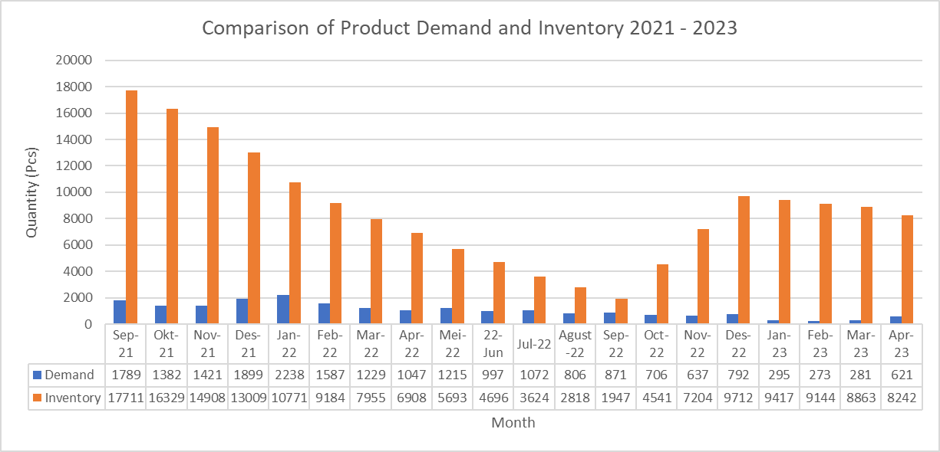

Figure 1 Comparison of Product Demand and Inventory 2021 – 2023
Based on Figure 1, it can be seen that the gap that occurs is due to higher inventory than demand, causing a buildup of finished goods in the warehouse. The prolonged accumulation of finished goods in the warehouse caused one of the safety box items to deform. Since the relevant cost is influenced by the present value of time and some products experience a decrease in quality over time, it can be seen that the gap is caused by the high inventory compared to demand [5]. There are several damaged products that cause losses to the company, amounting to Rp. 13,635,000.00. The total cost of losses is one component of the total inventory cost that needs to be taken into account in inventory control. This loss cost is due to the accumulation of goods so that the product becomes damaged or shrinks. The company prefers to repair products rather than make new products, because the cost of processing new products is more expensive than repairing repair costs [6]. Items that can be or are repaired are becoming an increasing trend to invest in [7]. According to [8] The core operational component of supply chain control is to provide accurate, complete, and timely information for when to order or issue, how to maintain acceptable stock levels of all products to reduce shortages and excess stock. Therefore, inventory needs to be managed in such a way as to avoid the possibility of lost sales or excessive costs due to inventory buildup. [9] [10] [11] [12] [13]. With the aim of minimizing the total cost of inventory there are several studies [14] [15] [16] [17] [18] [19] By implementing a continuous review inventory system, using this system, monitoring will be carried out continuously and in real time of inventory levels and demand, companies can maintain inventory levels that match actual needs, avoid overstock, and reduce overall inventory costs.
Based on the problems previously described, the solution provided is to plan demand forecasting and design a continuous review inventory system to reduce total inventory costs. In this study, the contribution made is to integrate and add variables of holding cost, ordering cost and repair cost caused by the accumulation of finished goods in the warehouse, where the objective function is to reduce the total inventory cost. Planning demand forecasting and designing inventory policies that consider repair items caused during the buildup of finished goods in the warehouse is an important step for industrial management to develop inventory policies to be more effective and efficient in accounting for and utilizing damaged products for repair and resale. It can also help companies minimize total inventory costs and increase profits. In addition, there has been no research that focuses on designing inventory policies that consider repair items caused by the accumulation of finished goods in the warehouse. Therefore, this research is expected to help companies and other researchers who focus on considering repair items caused by the accumulation of finished goods in the warehouse.
METHOD
Material
PT BEM Industry has a sharp medical waste container product or often called a Safety Box. Where the safety box product has two items, namely inner and outer. However, the repair of the item only focuses on the outer item because the outer item is made of aluminum which causes the item to deform easily. In addition, the inner item is inserted into the outer item so that it can protect the inner.
Methods
In the study, a quantitative approach was used, where inventory planning and design were carried out due to the accumulation of finished goods in the warehouse to minimize the total cost of inventory at PT BEM Industry. The method used in this study to plan demand forecasting is the ANN method and design inventory control in determining the optimal number of orders and minimizing the total cost of inventory is Continuous Review which is a popular continuous review policy [20] [21] [22] [23] [24]. The ANN method is a popular method with fast and reliable computational techniques that produce accurate forecasts [25] [26] [27] [28] [29]. According to [30] [31] ANN method can provide accurate results and provide a smaller MAPE value than the ARIMA method. In addition, basically the principle of Continuous Review (s,Q) is that inventory must be continuously monitored checked periodically to ensure that the availability of products and raw materials is sufficient with no excess or shortage of inventory. In repairable items, a control tower is needed that has two different functions, namely generating warnings for future stock-outs and making decisions to accelerate product repair [32]. The selection of the Continuous Review (s,Q) method was carried out because the assumptions that must be met in accordance with company conditions such as normally distributed demand data, constant order lot size (q0), and constant leadtime in accordance with this study.

Research Stages

Stages 1
The first stage carried out in this study is the collection of data used for demand forecasting using ANN. Before demand forecasting is carried out, normal distribution testing is carried out using the Kolmogorov Smirnov test on the demand data for each item to qualify the Continuous Review (s,Q) method, so that to facilitate the calculation, testing is carried out before forecasting. In demand forecasting, input data is required which will be processed as output or demand forecasting results. The ANN model used is multilayer perception with a backpropagation algorithm. There are several parameters that must be determined to adjust the conditions in this study which are described in Table 1.
Table 1. ANN Model Parameters
No | Parameters | Parameter Selection
1 | Training Function | Traingd
2 | Adaption Learning Function | Learngd
3 | Performance Function | MSE
4 | Transfer Function | Tansig
5 | Epoch | Max 3000
After that, it will be processed using the ANN method with Matlab software tools to display the network and processing results.

Stages 2
Calculating the order quantity value is the price data for each product item in 2023, demand data from 2021-2023, leadtime data which is the duration required by customers when ordering safety box products until the product is received, standard deviation, cost data used are ordering costs, storage costs, shortage costs and repair costs as shown in Figure 2. This data is obtained from the source responsible for inventory at the PT BEM Industry warehouse with the assumptions used in the calculation are as follows.
D : Total product demand (Units)
S : Standard Deviation Product demand (Unit)
m : Remaining inventory
h : Holding cost (Rp/unit)
A : Ordering Cost (Rp/unit)
C : Unit price of product items (Rp/unit)
f : Ordering Frequency
Cu : Product shortage cost (Rp/unit)
L : Leadtime
P : Repairing Cost (Rp/unit)
Q_{p} : Number of improvements per unit product item (unit)
O_{A} : Ordering Cost (Rp/unit)
O_{h} : Holding Cost (Rp/unit)
O_{Cu} : Shortage Cost (Rp/unit)
O_{p} : Repairing Cost outer item(Rp/unit)
O_{T} : Total Cost Inventory (Rp/unit)

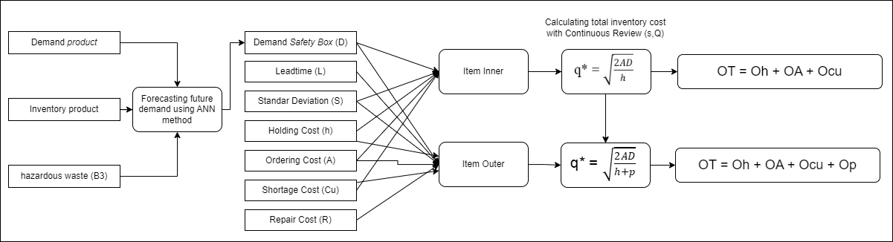

Figure 2 Process Stages

After that, the data that has been collected is used to calculate the optimal order quantity with the Q item repair model according to the Wilson model and Continuous Review (s,Q) according to the Wilson model [33] [17].
- In calculating the optimal order quantity considering repair items, it is assumed that products that can be repaired are p = ∞ [33]. This is assumed, because the damage to the product may not be the same and requires different repair costs. Therefore, for the calculation of the optimal order quantity (q₀), the equation becomes as follows.
qo₁* = $\sqrt{\frac{2AD}{h+p}}$
- Based on the qo₁* that has been obtained, it can then determine the magnitude of the possible inventory shortage (α). Then the reorder point can be calculated using the following Continuous Review (s,Q) equation.
α = $\frac{hqo1*}{CuD+hqo1*}$
r₁* = DL + Zα S$\sqrt{L}$
- After the value of r1 has been obtained, we can find the value of qo₂ which can be calculated using the following equation.
qo₂* = $\sqrt{\frac{2D[A+Cu\int_{r1}^{∞}{\left(x-r1\right)\left(fx\right)dx}}{h+p}}$
Where,
$\int_{r1}^{∞}{\left(x-r1\right)\left(fx\right)dx}$ – SL[f(Zα) – Zα ψ(Zα)] = N
The values of f(Zα) and ψ(Zα) are found by using the normal distribution table and partial expectation, so the equation becomes as follows.
N = SL[f(Zα) – Zα ψ(Zα)]

- Then, recalculate the values of α and r₂ using the following equation.
α = $\frac{hqo2*}{CuD+hqo2*}$
r₂* = DL + Zα S$\sqrt{L}$

After getting the result r₂ compare it with r₁, if the value of r₁ is relatively the same as r₂ then the iteration is complete and will be obtained r₁*=r₂* and qo₁*=qo₂*. If the values of r₁ and r₂ are not the same then return to stage iii by changing the values of r₁*=r₂* and qo₁*=qo₂*.
After obtaining the optimal ordering value q₀ *, the maximum inventory level, Safety stock, Service level and total inventory cost can be calculated to minimize the total inventory cost with the following equation.
O_{T} = O_{A} + O_{h} + O_{cu} + O_{p}
RESULTS AND DISCUSSION
Results of demand forecasting using ANN
The data used is safety box product demand data from September 2021 - April 2023. In addition, in using the Continuous Review method, there are assumptions that must be met, namely that the demand data must be normally distributed. The normal distribution test is carried out using the Kolmogorov Smirnov Test with IBM SPSS tools to qualify the Continuous Review policy which requires normally distributed demand data shown in Figures 2 and 3 with the following hypotheses.
Hypothesis
H0 : Raw material demand data is normally distributed
H1 : Raw material demand data is not normally distributed
Decision Making:
If Sig.(p) > 0,05 then H0 is not rejected (accepted)
If Sig.(p) <= 0,05 then H0 is rejected


Figure 3 Kolomogorov Smirnov Test Outer Item


Figure 4 Kolomogorov Smirnov Test Inner Item
Based on the distribution test on raw material demand data using the Kolmogorov-Smirnov test, Asymp. Sign (2-tailed) has a value of sig. > 0,05, then H0 is not rejected. So it can be concluded that the raw material demand data is normally distributed.

In forecasting demand using the ANN method, the first step is to determine the input and output data. Input and output data will be explained using Table 1. In the input data, there is demand and inventory data taken from the beginning of the company's establishment, but the company was established during the covid 19 pandemic, so the data is considered less relevant. Therefore, additional data is needed such as B3 waste data for 2018-2019 which is the demand for safety boxes which is converted into product capacity so that it can be used as a safety box product requirement for B3 waste. In addition, B3 waste data can assist companies in providing an overview of demand patterns before the covid pandemic occurred.

Table 1 Input dan Output ANN
Neuron |  | Description
X1  (Inner Item Layer Input) | X1 | Historical Demand Data of Inner Items from September 2021-April 2023
X1  (Inner Item Layer Input) | X2 | Actual Inventory Data of Inner Item Finished Goods
X1  (Inner Item Layer Input) | X3 | Hazardous Waste Data for 2018-2019
X2  (Outer Item Layer Input) | X1 | Historical Demand Data of Outer Items from September 2021-April 2023
X2  (Outer Item Layer Input) | X2 | Actual Inventory Data of Outer Item Finished Goods
X2  (Outer Item Layer Input) | X3 | Hazardous Waste Data for 2018-2019
y’  (Output) | y1' | Forecasting Demand for Inner Goods for the next 20 months
y’  (Output) | y2' | Forecasting Demand for Outer Goods for the next 20 months

After that, data normalization is carried out to facilitate faster calculations with a range of 0 to 1 which can be seen in Table 2.

Table 2 Normalization Data
Item | Input | 1 | 2 | 3 | 4 | 5 | 6 | 7 | 8 | 9 | 10 | 11 | 12 | 13 | 14 | 15 | 16 | 17 | 18 | 19 | 20
Inner | x1 | 0.885 | 0.815 | 0.670 | 0.844 | 0.900 | 0.644 | 0.396 | 0.319 | 0.204 | 0.533 | 0.430 | 0.389 | 0.256 | 0.448 | 0.363 | 0.337 | 0.119 | 0.100 | 0.141 | 0.207
Inner | x2 | 0.900 | 0.807 | 0.727 | 0.632 | 0.531 | 0.453 | 0.400 | 0.353 | 0.317 | 0.251 | 0.194 | 0.141 | 0.100 | 0.145 | 0.199 | 0.255 | 0.227 | 0.201 | 0.171 | 0.135
Inner | x3 | 0.100 | 0.100 | 0.100 | 0.100 | 0.100 | 0.100 | 0.100 | 0.100 | 0.100 | 0.100 | 0.100 | 0.100 | 0.900 | 0.900 | 0.900 | 0.900 | 0.900 | 0.900 | 0.900 | 0.900
Outer | x1 | 0.697 | 0.520 | 0.555 | 0.752 | 0.900 | 0.634 | 0.501 | 0.428 | 0.519 | 0.379 | 0.426 | 0.309 | 0.355 | 0.256 | 0.235 | 0.309 | 0.109 | 0.101 | 0.100 | 0.247
Outer | x2 | 0.900 | 0.834 | 0.763 | 0.666 | 0.551 | 0.470 | 0.406 | 0.352 | 0.285 | 0.238 | 0.184 | 0.145 | 0.100 | 0.246 | 0.396 | 0.535 | 0.522 | 0.510 | 0.499 | 0.468
Outer | x3 | 0.100 | 0.100 | 0.100 | 0.100 | 0.100 | 0.100 | 0.100 | 0.100 | 0.100 | 0.100 | 0.100 | 0.100 | 0.900 | 0.900 | 0.900 | 0.900 | 0.900 | 0.900 | 0.900 | 0.900

After normalization, the data can be processed for iteration using the ANN method with Matlab tools. The demand forecasting results obtained have been adjusted to the conditions of the predetermined parameters and the results will be described using Table 3.

Table 3 Forecasting Results
Item | 1 | 2 | 3 | 4 | 5 | 6 | 7 | 8 | 9 | 10 | 11 | 12 | 13 | 14 | 15 | 16 | 17 | 18 | 19 | 20
Inner | 0.7412 | 0.499 | 0.5824 | 0.768 | 0.766 | 0.6775 | 0.5072 | 0.3921 | 0.587 | 0.348 | 0.4359 | 0.2755 | 0.3474 | 0.2583 | 0.232 | 0.2972 | 0.1529 | 0.1487 | 0.1478 | 0.2452
Outer | 0.85283 | 0.81638 | 0.61798 | 0.81964 | 0.85005 | 0.60767 | 0.34321 | 0.29799 | 0.26029 | 0.57648 | 0.46478 | 0.43549 | 0.30567 | 0.42151 | 0.34136 | 0.28459 | 0.12292 | 0.12316 | 0.15166 | 0.23215

Table 4 Forecasting Results After Denormalization
Item | 1 | 2 | 3 | 4 | 5 | 6 | 7 | 8 | 9 | 10 | 11 | 12 | 13 | 14 | 15 | 16 | 17 | 18 | 19 | 20
Inner | 1599 | 1069 | 1251 | 1658 | 1654 | 1460 | 1087 | 835 | 1262 | 738 | 931 | 579 | 737 | 542 | 484 | 627 | 311 | 302 | 300 | 513
Outer | 278 | 268 | 215 | 269 | 278 | 212 | 141 | 128 | 118 | 204 | 173 | 166 | 131 | 162 | 140 | 125 | 81 | 81 | 89 | 111

Based on Table 3 and Table 4, the demand forecasting results are tested by finding the higher regression value and the smallest MSE indicator to evaluate the results that have been obtained from the model built. Because by showing a greater correlation value, it will show that the dependent and independent variables have a strong correlation and the MSE value will show the level of accuracy in the calculation.
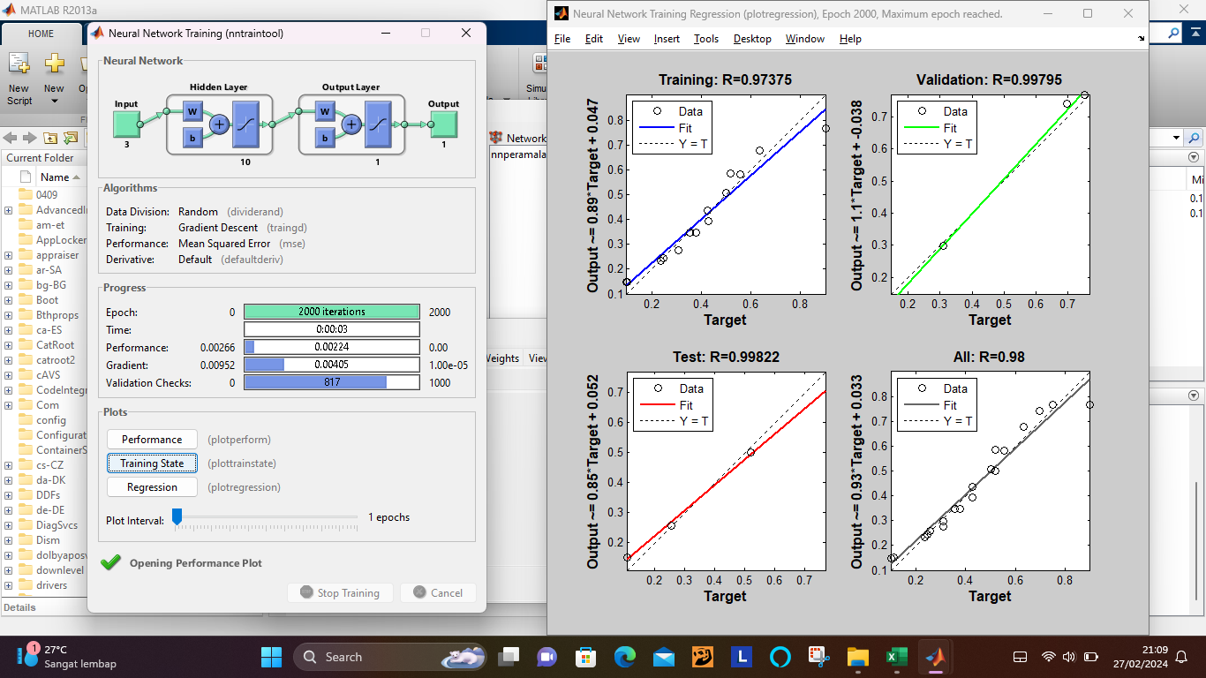

Figure 5 Item Input Regression Results
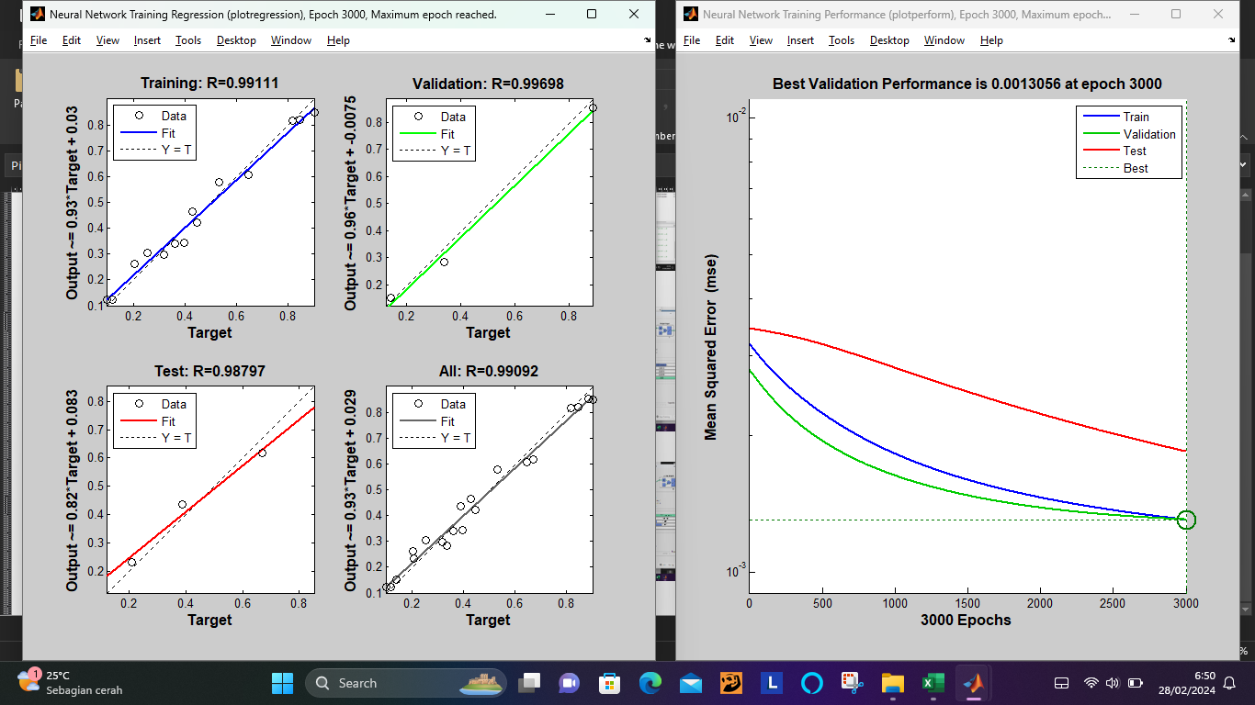

Figure 6 Item Output Regression Results
Figure 5 and Figure 6 are the regression results on the inner and outer items. Figure 5 shows that the regression value on the inner item that has been built is 0.98. While in Figure 6 shows that the regression value on the outer item produces 0.99092, from these two values it explains that the level of correlation between demand data variables, inventory data and hazardous waste data is high in each item.
Results of Inventory Model use Continuous Review (s,Q)
- Product Price Data

There are 2 product items sold at different prices as shown in Table 5.

Table 5 Product Price
No | Item | Price
1 | Inner | Rp. 20,000
2 | Outer | Rp. 99,000
- Ordering Cost
The costs incurred by the company in meeting the needs of operational activities used for storage in the warehouse are shown in Table 6.

Table 6 Ordering Cost
No | Cost Type | Cost
1 | Unloading | Rp. 200,000
2 | Questionnaire Paper Cost | Rp. 2,000
Total |  | Rp 202,000
- Holding Cost
Storage costs incurred by the company include electricity costs, cleaning costs, and land rental costs which are included in the percentage of 25% of the product price per item.
- Shortage Cost
Shortage costs incurred due to damage to goods when stored in the warehouse due to the accumulation of finished goods in the warehouse for too long.

Table 7 Shortage Cost
No | Item | Shortage (Unit) | Shortage Cost (/unit)
1 | Inner | 260 | Rp. 3,715,000
2 | Outer | 121 | Rp. 9,920,000
- Repairing Cost
Repair costs are incurred from the need for spare parts that need to be replaced on damaged outer items. There are several spare parts needed as follows.

Table 8 Repairing Cost
No | Cost Type | Amount | Cost | Total Cost
1 | Key | 1 | Rp. 12,000 | Rp. 12,000
2 | Rivet Nails | 6 | Rp. 100 | Rp. 600
3 | Depresiasi Rivet Pliers (3 Years) | 1 | Rp. 20,000 | Rp. 20,000
Total Overall Cost |  |  |  | Rp. 32,600
Repair costs are assumed to be fixed, where each repaired item will spend the same repair cost. Damaged products are caused by keys that do not fit or nails that are worn out, so in making repairs, rivet pliers are needed to replace the nails or keys. Therefore, if a product is damaged by one of these damages, the remaining cost will be included in the depreciation of the rivet pliers.
In the initial inventory calculation, actual demand and inventory data from September 2021 to April 2023 and cost data are used. In the initial inventory, repair costs are not taken into account, because the addition of repair costs is a proposal from this study. Thus, the total inventory cost is obtained as follows.
- Holding Cost (O_{h})
O_{h(inner)} = Rp 5,000 x 7232
O_{h(inner)}= Rp 36,160,000/year
O_{h(outer)} = Rp 24,750 x 1010
O_{h(outer)}= Rp 24,997,500/year

- Ordering Cost (O_{A})
O_{A} = Rp 202,000 x 3
O_{A} = Rp 606,000/year

- Shortage Cost(O_{cu})
O_{k(inner)} = Rp 20,000 x 260
O_{k(inner)}= Rp 5,200,000/tahun
O_{k(outer)} = Rp 99,000 x 121
O_{k(outer)}= Rp 11,979,000/tahun

- Total Initial Inventory Cost (O_{T})
O_{T} = O_{h} + O_{A} + O_{k}
O_{T(inner)} = Rp 36,160,000 + Rp 606,000 + Rp 5,200,000
O_{T(inner)}= Rp 41,966,000/year
O_{T(outer)} = Rp 24,997,500+ Rp 606,000 + Rp 11,979,000
O_{T(outer)}= Rp 37,582,500/year
Based on the calculation, the total initial inventory cost incurred by the company on inner items is IDR 41,966,000 / year and on outer items is IDR 37,582,500 / year.
In addition, the calculation of the proposed inventory using the Continuous Review (s,Q) method is carried out by entering the number of requests before forecasting and after forecasting. This is done by comparing the calculation results before forecasting and after forecasting to see if there is a change in the order lot and total inventory cost using the Continuous Review (s,Q) method with the hadley-within model in the proposed total inventory cost equation. Where the total inventory cost on the proposed outer items considers the repair cost. The cost of product repair is included in the shelf cost because the cost is related to maintaining inventory to remain in a saleable condition [33]. Damaged products on outer items are caused by prolonged storage, so the cost of repairing outer items is considered part of storage costs. Repair costs arise when there are a number of damaged products due to prolonged accumulation in the warehouse (b) and repair costs per unit (p).
Op = b x p (1)
Thus, the equation for the expected total inventory cost considering repair items is obtained as follows.
Min Z = $\frac{AD}{qo}+h(\frac{1}{2} qo$+r–DL) + $\frac{CuD}{qo} x 1$ + P x Q_{p} (2)
From the results of calculations using the Continuous Review (s,Q) method, the company experienced a decrease in total inventory costs on each product item shown in Figure 7. The decrease in total inventory costs occurs based on the results of the decision variables, namely order quantity and reorder point described in Table 9.

Table 9 Result Decision Variables
Decision Variables | Proposed Condition Before Demand Forecasting |  | Proposed Condition After Demand Forecasting
Decision Variables | Inner | Outer | Inner | Outer
Order Quantity | 1257 | 189 | 1318 | 189
Reorder Point | 239 | 42 | 235 | 41

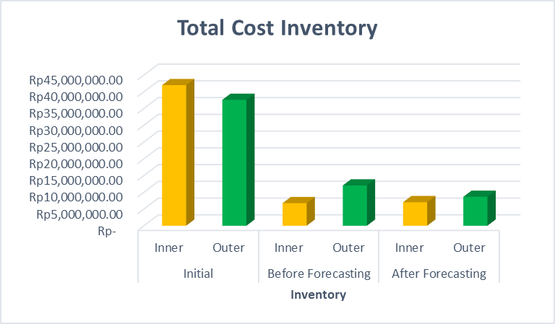

Figure 7 Comparison Results of Total Overall Inventory Cost
Based on Table 9, it can be seen that there is a difference between the proposed reorder point value and the optimal order quantity that has been designed. Existing conditions are the results of calculations before forecasting is carried out. In the existing condition, it can be seen that before forecasting using the Continuous Review (s,Q) method, the resulting reorder point value for Inner items is 239 units and Outer items is 42 units. After that, the optimal order quantity value generated for Inner items is 1257 units and Outer items are 189 units in the existing condition. Then in the proposal with forecasting using the Continuous Review (s,Q) method, the resulting reorder point value for inner items is 235 units and outer items is 41 units. After that, the optimal order quantity value generated for Inner items is 1318 units and outer items are 189 units under forecasting conditions. This reorder point value will be used to determine when the company will reorder the product.
In addition, in Figure 7 the calculation of the initial total inventory cost is IDR 41,966,000 / year while the results before forecasting on inner items are IDR 6,745,333 / year and after forecasting are IDR 7,062,213 / year, where there is a decrease from the initial total inventory cost to the total inventory cost before forecasting by 84% and the total inventory cost after forecasting by 83%. In the outer items, the total inventory cost has decreased by 68% and 77% from the initial total inventory cost to the total inventory cost before forecasting and the total inventory cost after forecasting, where the initial total inventory cost was IDR 37,582,500/year and the total inventory cost before forecasting was IDR 12,032,254/year and the total inventory cost after forecasting was IDR 8,635,571/year. Savings occur due to a decrease in storage costs, shortage costs and repair costs on each item. The total inventory cost that considers repair items caused by the accumulation of finished goods in the warehouse is a different research from the research [33] [24] which considers repair products caused during the production process and during the delivery of product raw materials. The calculation of product improvements made can reduce shortage costs and replace them with repair costs so as to reduce lost sales on each item.

CONCLUSION
The medical industry company has a overstock of goods in the warehouse which causes damaged products and high total inventory costs. Where the number of presentations of total inventory costs in each year rises and falls, for inner items the total inventory cost averages 63% and inner items 37%. Therefore, demand forecasting and inventory policy design that considers repair items is carried out during the buildup of finished goods in the warehouse.
Based on the results of demand forecasting calculations using the ANN method, the amount of future demand is obtained with a high correlation value and the smallest MSE value, namely for inner items of 0.98 and MSE value of 0.00078 for outer items of 0.99092 and MSE value of 0.0013 which explains that each variable has a strong correlation. In addition, the results calculation of order quantity and total inventory costs using the Continuous Review (s,Q) method experience considerable savings. The decrease that occurs is due to the addition of repair cost variables to the calculation of the order quantity and total inventory cost for repairing usable items, so that future shortage costs and repair costs will experience a decrease in the total inventory cost of each item. For the results of the calculation of the total cost of the proposed inventory on goods in before and after forecasting, where there is a decrease in the total cost of the proposed inventory from the initial total cost of inventory to 84% and 83%. In the total cost of inventory proposed before forecasting and after forecasting for outside items, there was a decrease of 68% and 77% from the initial total inventory cost. From the results of reducing the total cost of inventory will increase profits and increase cost efficiency for the company.

ACKNOWLEDGMENT
We would like to thank the company partners who have helped and provided the data needed in this research. In addition, to the management of the company who have provided support in launching the data collection process.

REFERENCES

[1] | S. Xu and H. K. Chan, "Demand forecasting of medical device with online big data," IET Doctoral Forum on Biomedical Engineering, Healthcare, Robotics and Artificial Intelligence 2018 (BRAIN 2018), vol. 21, no. 3, pp. 1604-1611, 2018. 10.1049/cp.2018.1725
[2] | S. M. Lee and D. Lee, "Opportunities and challenges for contactless healthcare services in the post-COVID-19 Era," Technological Forecasting and Social Change, vol. 167, no. 120712, pp. 1-10, 2021. https://doi.org/10.1016/j.techfore.2021.120712
[3] | O. A. G. Junior, D. Carvalho, C. Maria, M. Jadel and Caio, "Safety-Stock: Predicting the demand for supplies in Brazilian hospitals during the COVID-19 pandemic," Knowledge-Based Systems, vol. 247, no. 108753, pp. 1-10, 2022. https://doi.org/10.1016/j.knosys.2022.108753
[4] | B. Balkhi, A. Alshahrani and A. khan, "Just-in-time approach in healthcare inventory management : Does it really work?," Sausi Pharmaceutical Journal, vol. 30, no. 12, pp. 1830-1835, 2022. https://doi.org/10.1016/j.jsps.2022.10.013
[5] | H.-L. Yang, "An optimal replenishment cycle and order quantity inventory model for deteriorating items with fluctuating demand," Supply Chain Analytics, vol. 3, no. 100021, pp. 1-18, 2023. https://doi.org/10.1016/j.sca.2023.100021
[6] | Y. Lin, J. M. Leung, L. Zhang and J.-W. Gu, "Single-item repairable inventory system with stochastic new and warranty demands," Transportation Research Part E: Logistics and Transportation Review, vol. 142, no. 102035, pp. 1-17, 2020. https://doi.org/10.1016/j.tre.2020.102035
[7] | B. K. Hallak, W. W. Nasr and M. Y. Jaber, "Re-ordering policies for inventory systems with recyclable items and stochastic demand – Outsourcing vs. in-house recycling," Omega, vol. 105, no. 102514, pp. 1-14, 2021. https://doi.org/10.1016/j.omega.2021.102514
[8] | S. T. O. K. Bakele Boche, "Inventory management performance for laboratory commodities and their challenges in public health facilities of Gambella Regional State, Ethopia:A mixed cross-sectional study," Heliyon, vol. 8, no. 11, pp. 1-9, 2022. https://doi.org/10.1016/j.heliyon.2022.e11357
[9] | B. F. Rambitan, J. S. Sumarauw and A. H. Jan, "Analysis of Application of the Inventory Management on CV. Indospice," EMBA, vol. 6, no. 3, pp. 1448-1457, 2018. https://doi.org/10.35794/emba.6.3.2018.20228
[10] | H. Zhou, K. Chen and S. Wang, "Two-period pricing and inventory decisions of perishable products with partial lost sales," European Journal of Operational Research, vol. 310, no. 2, pp. 611-626, 2023. https://doi.org/10.1016/j.ejor.2023.03.010
[11] | J. H. Rios and J. R. Vera, "Dynamic pricing and inventory control for multiple products in a retail chain," Computers & Industrial Engineering, vol. 177, no. 109065, 2023. https://doi.org/10.1016/j.cie.2023.109065
[12] | X. Yan, X. Chao and Y. Lu, "Optimal control policies for dynamic inventory systems with service level dependent demand," European Journal of Operational Research, vol. 314, no. 3, pp. 935-949, 2024. https://doi.org/10.1016/j.ejor.2023.11.005
[13] | A. A. Taleizadeh, K. Tafakkori and P. Thaichon, "Resilience toward supply disruptions: A stochastic inventory control model with partial backordering under the base stock policy," Journal of Retailing and Consumer Services, vol. 58, no. 102291, pp. 1-19, 2021. https://doi.org/10.1016/j.jretconser.2020.102291
[14] | G. Karakatsoulis and K. Skouri, "Optimal reorder level and lot size decisions for an inventory system with defective items," Applied Mathematical Modelling, vol. 92, pp. 651-668, 2020. https://doi.org/10.1016/j.apm.2020.11.025
[15] | D. E. P. A. S. Mohamad Toha, "A Comparison of Continuous and Periodic Review on Inventory Components of Dump Trucks," in 2019 International Conference on Sustainable Engineering and Creative Computing (ICSECC), Bandung, Indonesia, 2019. 10.1109/ICSECC.2019.8907169
[16] | P. Li and D. Wu, "Optimization of ( R , Q ) Policies for Assembly Inventory Systems With Operating Flexibility," IEEE Access (Volume: 7), vol. 7, pp. 139097 - 139108, 2019. 10.1109/ACCESS.2019.2941513
[17] | E. A. Silver, D. F. Pyke and D. J. Thomas, Inventory and Production Management in Supply Chain : Fourth Edition, New York: CRC Press, 2017. https://doi.org/10.1201/9781315374406
[18] | K. Ghafour, "Multi-objective continuous review inventory policy using MOPSO and TOPSIS methods," Computers & Operations Research, vol. 163, no. 106512, 2024. https://doi.org/10.1016/j.cor.2023.106512
[19] | R. N. A. Reka and E. Aryanny, "Policy Making in Optimizing Inventory Control with Continous and Periodic Review Method at PT. XYZ," PROZIMA (Productivity, Optimization and Manufacturing System Engineering), vol. 5, no. 2, pp. 93-99, 2022. https://doi.org/10.21070/prozima.v5i2.1452
[20] | J. W. Baek, Y. H. Bae, H. W. Lee and S. Ahn, "Continuous-type (s,Q) -inventory model with an attached M/M/1 queue and lost sales," Performance Evaluation, vol. 125, pp. 68-79, 2018. https://doi.org/10.1016/j.peva.2018.07.003
[21] | J. P. Saldanha, "Estimating the reorder point for a fill-rate target under a continuous review policy in the presence of non-standard lead-time demand distributions," Transportation Research Part E: Logistics and Transportation Review, vol. 164, no. 102766, 2022. https://doi.org/10.1016/j.tre.2022.102766
[22] | Z. L. H. X. Min Gong, "Inventory control policy for perishable products under a buyback contract and Brownian demands," International Journal of Production Economics, vol. 251, p. 108522, 2022. https://doi.org/10.1016/j.ijpe.2022.108522
[23] | P. Cao and D. Yao, "Optimal pricing and inventory control strategy for a continuous-review system with product return," Operations Research Letters, vol. 50, no. 3, pp. 295-302, 2022. https://doi.org/10.1016/j.orl.2022.03.002
[24] | J. Zhou, S. Zhang and Y. Li, "A Deep Q-Learning Approach for Continuous Review Policies with Uncertain Lead Time Demand Patterns," in 2018 11th International Symposium on Computational Intelligence and Design (ISCID), Hangzhou, China, 2018. 10.1109/ISCID.2018.00067
[25] | P. Viswanathan, J. S. Gosukonda, S. H. Sherman, N. Joshee and R. M. Gosukonda, "Prediction of In vitro organogenesis of Bacopa monnieri using artificial neural networks and regression models," Heliyon, vol. 8, no. e11969, pp. 1-8, 2022. 10.1016/j.heliyon.2022.e11969
[26] | M. Soori, B. Arezoo and R. Dastres, "Artificial neural networks in supply chain management, a review," Journal of Economy and Technology, vol. 1, pp. 179-196, 2023. https://doi.org/10.1016/j.ject.2023.11.002
[27] | S. Mateo-Barcos, D. Ribó-Pérez, J. Rodríguez-García and M. Alcázar-Ortega, "Forecasting electricity demand of municipalities through artificial neural networks and metered supply point classification," Energy Reports, vol. 11, pp. 3533-3549, 2024. https://doi.org/10.1016/j.egyr.2024.03.023
[28] | G. Rumbe, M. Hamasha and S. A. Mashaqbeh, "A comparison of Holts-Winter and Artificial Neural Network approach in forecasting: A case study for tent manufacturing industry," Results in Engineering, vol. 21, p. 101899, 2024. https://doi.org/10.1016/j.rineng.2024.101899
[29] | X. Zeng, N. Abdullah and B. Liang, "A widely applicable and robust LightGBM - Artificial neural network forecasting model for short-term wind power density," Heliyon, vol. 9, no. 12, p. e23071, 2023. https://doi.org/10.1016/j.heliyon.2023.e23071
[30] | C. Tarmanini, N. Sarma, C. Gezegin and O. Ozgonenel, "Short term load forecasting based on ARIMA and ANN approaches," Energy Reports, vol. 9, pp. 550-557, 2023. https://doi.org/10.1016/j.egyr.2023.01.060
[31] | N. Jaisumroum and J. Teeravaraprug, "Forecasting uncertainty of Thailand's electricity consumption compare with using artificial neural network and multiple linear regression methods," in 2017 12th IEEE Conference on Industrial Electronics and Applications (ICIEA), Siem Reap, Cambodia, 2018. 10.1109/ICIEA.2017.8282862
[32] | M. Hekimoğlu, A. G. Kök and M. Şahin, "Stockout risk estimation and expediting for repairable spare parts," Computers & Operations Research, vol. 138, no. 105562, 2022. https://doi.org/10.1016/j.cor.2021.105562
[33] | R. Teunter, "Lot-sizing for inventory systems with product recovery," Computers & Industrial Engineering, vol. 46, no. 3, pp. 431-441, 2004. https://doi.org/10.1016/j.cie.2004.01.006

