Spatial Decision-Making Model for Priority Development of Indonesia Coast Guard Stations | 

Novianto Hary Adiatmaja¹, Winnie Septiani^{1*}, Triwulandari Satitidjati Dewayana¹, Martino Luis²
¹Industrial Engineering Department, Faculty of Industrial Technology, Universitas Trisakti, Indonesia
²College of Engineering, Mathematics and Physical Sciences, University of Exeter, United Kingdom

Abstract  Indonesia Coast Guard (IDNCG) is a paramilitary agency in charge of security and safety patrols in Indonesian maritime waters. A total of 35 IDNCG Stations are expected to be constructed within 3 years and are considered priority project to face the increasing threats at sea. However, there is presently no system to provide support for the scientific solutions to prioritize station development despite the need for immediate decisions. This research was used to design model for determining station development priorities using the integration method of Geographic Information Systems (GIS), Analytical Hierarchy Process (AHP), and Technique for Order of Preference by Similarity to Ideal Solution (TOPSIS). GIS was used as an effective tool for identifying and taking measurements in certain areas. Meanwhile, multi-criteria decision-making (MCDM) methods such as AHP and TOPSIS provided structural and pairwise quantification, as well as comparisons between elements and criteria for ranking station construction priorities. The most suitable alternative stations to be prioritized were determined by integrating the three methods which were classified as cost-effective for decision-making. Model was based on four criteria, including distance to Archipelagic Sea Lanes (ASL), Distance to the port, vulnerability coverage, and vessel density coverage. Stations were ranked based on a three-year development plan. The first year was for 12 stations ranked 1 to 12, the second was for another 12 ranked 13 to 24, and the third was for 11 ranked 25 to 35. Moreover, the location ranking was later expressed in map form to be used by policymakers in prioritizing development of IDNCG Stations.  This is an open-access article under the CC BY-SA license   | Keywords:  Indonesia Coast Guard (IDNCG),  Decision,  Geographic Information Systems (GIS),  Analytic Hierarchy Process (AHP),  Technique for Order of Preference by Similarity to Ideal Solution (TOPSIS).  Article History:  Received: March 15, 2024  Revised: March 30, 2024  Accepted: April 2, 2024  Published: May 2, 2024  Corresponding Author:  Winnie Septiani  Industrial Engineering Department, Faculty of Industrial Technology, Universitas Trisakti, Indonesia  Email: winnie.septiani@trisakti.ac.id

INTRODUCTION
Indonesia is one of the largest archipelagic countries in the world covering an estimated area of 7.81 million km² with 17,499 islands. The analysis of the region shows that 3.25 million km² is ocean and 2.55 million km² is the Exclusive Economic Zone (EEZ) while only approximately 2.01 million km² is land. The sea area shows that the country has enormous potential in the marine sector. Indonesia has a vision of the World Maritime Axis (WMA) which is directed towards becoming a sovereign, advanced, independent, and strong maritime country. The purpose is to be capable of contributing positively to regional and world security and peace in accordance with national interests. The achievement of this objective requires implementing an independent and strong Security and Safety Early Warning System (EWS) in Indonesian waters and jurisdiction based on national interests. The intention led to the formulation of the Indonesia Coast Guard (IDNCG) or BAKAMLA RI to conduct maritime security and safety patrols within the jurisdiction of the country.
The World Maritime Axis Policy (WMA) focuses on Indonesia's national development activities at sea, strengthening and developing maritime connectivity [1]. This has led to development of 14 stations supported by early static and dynamic detection technologies by IDNCG as part of the EWS for marine security and safety [2]. The strategic plan of IDNCG for 2020-2024 is to build 35 stations in three years. The determination of stations was based on a survey conducted by the Land Task Force team to fill the monitoring gaps at locations with heavy ship traffic. One of the inputs suggested for the operation was the ability to receive and analyze all events occurring at sea based on the relay time which was measured in minutes. Moreover, the relay time was explained as the time to convey verified incidents at sea in order to provide immediate response by other sub-organizations and related stakeholders. This is necessary because the management of a safe sea traffic system is important in terms of economic competition and national integrity. However, the process required the existence of complete facilities constructed with large costs to ensure easy accessibility of resources.
Stations in the strategic plan are state facilities expected to be placed on the outermost outpost of Indonesian marine security and safety. Several efforts have been made from 2020 up to the present time to determine the appropriate locations for these stations to be constructed in stages for a period of 3 years. The prioritization of stations to be developed has been based on expert judgment such as the directions and policies implemented by the leadership. This shows there is presently no scientifically proven decision support system. Therefore, the urgency of this research is to overcome decision-making problems associated with prioritizing stations to be developed.
A spatial decision model was proposed through the integration of the Geographic Information System (GIS), Analytic Hierarchy Process (AHP), and Technique for Order of Preference by Similarity to Ideal Solution (TOPSIS). The purpose was to assist policymakers in ranking, describing, classifying, and grouping alternative stations. This was expected to be based on some problems such as location selection, resource allocation, network routing, location-allocation, and service coverage [3]. A spatial decision model “can translate science into policy and vice versa and ultimately integrate the exploration of ideas with participatory and direct evaluation” [4]. The problem-solving method used was based on previous research conducted on location selection through the application of GIS and Multiple Criteria Decision Making (MCDM) procedures. It is important to state that GIS is a set of computer hardware, software, and geographic data designed to efficiently acquire, store, modify, manage, analyze, and show all forms of geographic information [5]. However, the key challenges around the uptake of spatial decision-making are data issues, challenges of accessibility, availability, accuracy, consistency, manageability, and integration of data [6]. GIS is normally used to solve spatial data measurement problems. This shows the possibility of using the method to map the distance between stations and areas prone to maritime security and safety, determine the density of passing ships, and monitor the range of each station. Meanwhile, AHP method was used to determine the weight of selection criteria for each station. TOPSIS was applied to evaluate priority ranking of stations. The aim was to ensure decision makers select the most appropriate priorities to avoid wasting a lot of time and money [7]. Moreover, this research was expected to serve as input for IDNCG's top management in the process of deciding on stations to be prioritized for development. The intention is to ensure empty gaps identified at choke points are filled as soon as possible in order to provide benefits for sea users in particular and the Indonesian nation in general.
The determination of the best alternative location to develop some facilities often requires considering several criteria [1]. This has led to the implementation of GIS in several cases to obtain geographic information needed for spatial analysis to offer in-depth assessments such as the application to determine the suitability locations. GIS was used in this research to solve the problem of measuring spatial data with a focus on the distance from stations to the Indonesian Archipelagic Sea Lanes (ASL) and ports, coverage of vulnerabilities and density of passing ships.
The integration of GIS and MCDM is considered an ideal method to solve problems containing several factors. These include the evaluation of spatial suitability of wind farms sites [8], [9], [10], to assess drought risk [11] and determination of shipyard locations [12]. Moreover, GIS, AHP, and TOPSIS had been previously combined to assess the danger of flooding in Vietnam [13], rank potential station locations for expanding the bicycle sharing system [14], evaluate suitable locations for development of industrial areas [15], selection of multipurpose utility tunnel, [16] and solving ammunition distribution network design problem [17]. The combination of these methods was considered appropriate to analyze the selection of alternatives in development priorities of the IDNCG stations.
This research was used to produce priority selection model for development of the IDNCG stations. Model was achieved using GIS for spatial data measurement while MCDM was for decision-making through theories, processes, and analytical methods associated with uncertainty, dynamics, and multi-criteria aspects. The combination of the two methods has received more attention in recent years due to the ability to provide more precise and practical results [14].

METHOD
The three main methods used in conducting this research were GIS, AHP, and TOPSIS [18], [19], [20]. These are explained further as follows:

Spatial data measurement using GIS
The term GIS is generally understood as a special type of information system that works with information related to positional or geographical characteristics. The concept was further explained by ESRI company as "a collection of computer hardware, software and geographic data designed to obtain, store, modify, manage, analyze and show all forms of geographic information efficiently" [5]. Some of the characteristics of GIS are stated as follows:
a) A sub-system for input to accommodate and process spatial data from different sources such as contour maps and elevation points.
b) A sub-system for storing and recalling which allows spatial data to be updated, recalled, and edited.
c) A sub-system for analysis to determine data roles, separation and grouping, estimate parameters and constraints, and perform modeling functions.
d) A sub-system for reporting which can present part or all of the database in the form of maps, tables, and graphics.

Calculating criteria weighting using the AHP
AHP is a method that simplifies complex and unstructured problems through a series of pairwise comparisons by arranging decision criteria in a hierarchical structure and connecting them with weights related to the contribution made to the desired goal [21]. It was popularized by Thomas L. Saaty around the 1970s followed by a partnership with Ernest Forman around 1983 to develop Expert Choice software. The process led to the extensive research and refinement of AHP since then [22].
The method is considered fairly accurate in measuring the weight of criteria for decision. Moreover, the process of estimating the relative magnitude of factors through pairwise comparisons requires the experience of experts. This is usually achieved by allowing each respondent to compare the relative importance of each pair of items using a specially designed questionnaire. However, AHP has some limitations which include ineffectiveness when used in a case with many criteria and alternatives Another is the dependence on the main input which is experts, leading to subjectivity of the results. Furthermore, AHP is a mathematical method without statistical tests and this shows a lack of confidence limit to determine the truth of model formed. The limitation shows the need to include other methods in the process to produce more effective results. The stages of implementing AHP are stated as follows:
a) Develop a hierarchical structure,
b) Prepare a pairwise comparison matrix of criteria and alternatives,
c) Conduct consistency tests and,
d) Determine the weight of the criterion indicators.

Determine development priority preferences using the TOPSIS
TOPSIS is a MCDM method compiled by Yoon and Hwang in 1981. It was developed further by Yoon around 1987 and Hwang, Lai, and Liu in 1993. The scheme requires the selected alternative to be at the farthest distance from the negative ideal solution and the closest to the positive. This is normally achieved from a geometric perspective using Euclidean distance to determine the relative closeness of an alternative to the optimal solution. Moreover, TOPSIS has been widely used in several research to practically solve complex decision-making problems [23]. The stages often involved are stated as follows:
a) Develop a decision matrix,
b) Prepare a normalized decision matrix,
c) Formulate a weighted normalized decision matrix,
d) Determine the positive and negative ideal solution matrix,
e) Determine the distance between the value of each alternative and the positive and negative ideal solutions,
f) Calculate the closeness of alternatives to the ideal solution.

Research Methodology
A model was produced in this research to prioritize development of IDNCG stations. There are three phases to the methodology’s execution, the first stage is analysis of existing conditions which includes analysis of 35 candidate stations, identify criteria, discussion and verification with Focus Group Discussion (FGD). Following that, data processing stage involved spatial data measurement using GIS, determining the level of importance of criteria using AHP and calculating development priority preferences using TOPSIS. Finally, priority station mapping based on priority ranking which is the result of calculations in previous stages.

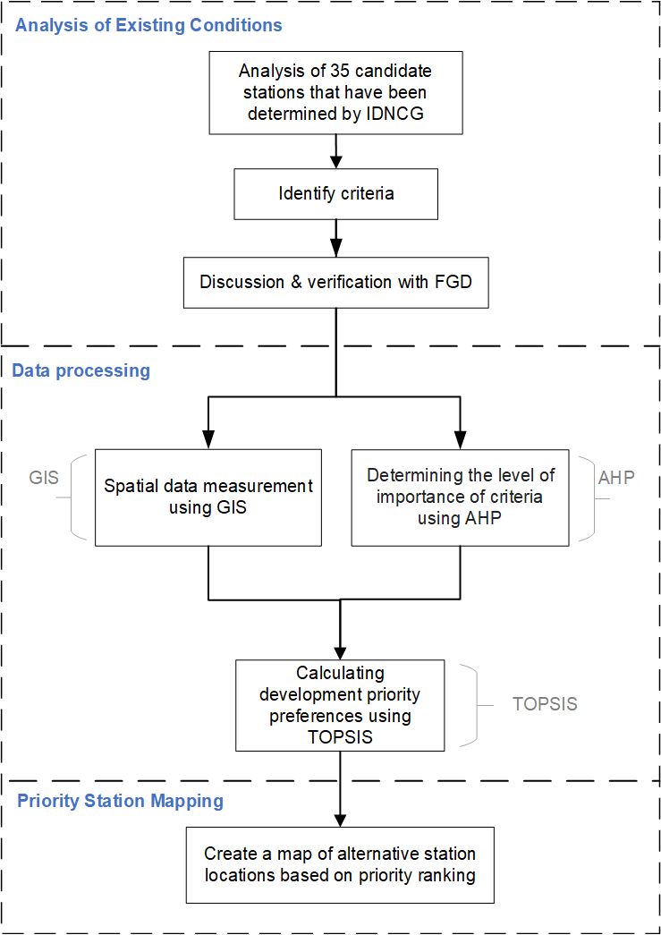
Figure 1. Research methodology
Figure 1 shows the flowchart of the research used in solving the problems associated with prioritizing the location to develop stations. Initial data were collected after the issuance of a permit to conduct the research from the partner organization, IDNCG, on April 6 2023. The focus was on the following:
a) Data on the 35 IDNCG Stations with a focus on location coordinates, addresses, permit status, and land task force team survey.
Secondary data on the vulnerability of territorial waters in Indonesia over the last 5 years
b) Data on the density of ships passing through Indonesian waters, Indonesian Archipelagic Sea routes, and docks spread throughout Indonesia. The data were obtained from different sources including:
c) Secondary data from the data and information directorate of IDNCG.
d) Direct interviews and discussions with members of the land task force team that conducted direct field surveys in the past year to ensure the compliance of the location points with the permits granted by the local regional government.
e) Focus Group Discussion with 5 experts from IDNCG on August 30, 2023.

RESULTS AND DISCUSSION
Analysis of Existing Conditions
Analysis of 35 candidate stations
The data analysis process was initiated through the confirmation of the 35 candidate locations previously determined by IDNCG based on the Bappenas Green Book to be developed in stages for a period of 3 years as presented in Table 1. The street view feature on Google Maps was used to match coordinate points with address and survey data and was further confirmed directly by the land task force team. The location of prospective stations along with the surveillance system at each station are presented in Figure 2. Moreover, long-range cameras were used to visually monitor locations around station. AIS receivers were also applied to capture signals from passing ships using transponders. Coastal radar was used to sweep and identify objects around station while GMDSS radio was applied to conduct security communications with passing ships.
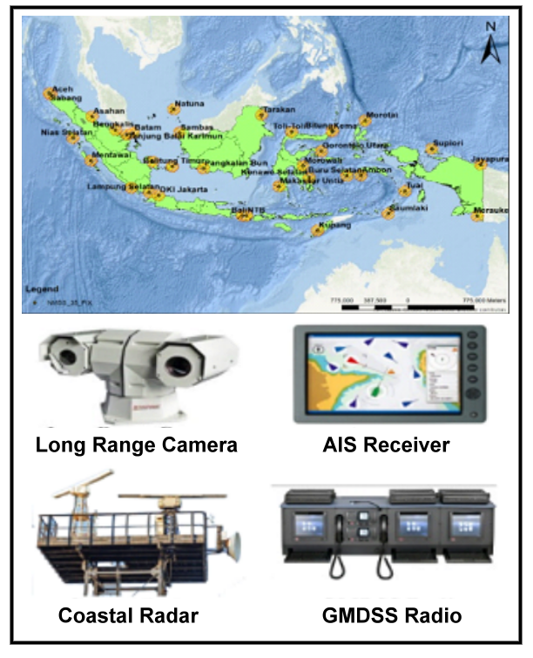
Figure 2. Confirmed Candidate Locations for IDNCG Stations
The research was conducted to map outstations to be prioritized based on a larger scale of importance. This was determined through the assessment of the criteria measured using GIS.
Table 1. Identification of the 35 IDNCG Candidates
No | Location | Zone | Coordinate
1 | Aceh | West | 5°38'55.4"N 95°26'23.7"E
2 | Natuna | West | 3°57'56.6"N 108°23'54.6"E
3 | Batam | West | 1°11'06.4"N 104°06'58.4"E
4 | Bangka Belitung | West | 2°11'6.6"S 106°10'43.2"E
5 | Sambas | West | 1°11'44.5"N 108°59'18.0"E
6 | Tanjung Balai Karimun | West | 0°59'45.7"N 103°26'43.8"E
7 | Sabang | West | 5˚51’3.34” N 95˚15’32.17 E
8 | Asahan | West | 3°06'36.5"N 99°46'46.7"E
9 | Nias Selatan | West | 0°35'42.8"N 97°45'10.0"E
10 | Bengkalis | West | 01°33'4,6"N 102°14'54,2"E
11 | Belitung Timur | West | 2°43'54.2"S 108°14'27.1"E
12 | Pesisir Barat Lampung | West | 5°13'37.2"S 103°55'12.9"E
13 | Lampung Selatan | West | 5°44'48"S 105°47'53"E
14 | DKI Jakarta | West | 6°06'06.6"S 106°47'55.8"E
15 | Mentawai | West | 2°03'36.2"S 99°39'36.8"E
16 | Tarakan | Central | 3°16'26.3"N 117°39'06.2"E
17 | Bali | Central | 8°27'39.6"S 115°38'03.9"E
18 | Kema | Central | 1°22'01.7"N 125°04'40.4"E
19 | Bitung | Central | 1°25'08.4"N 125°07'09.1"E
20 | Konawe Selatan | Central | 4°02'11.7"S 122°40'17.8"E
21 | Makassar | Central | 5°03’58”S 119° 28’22”E
22 | NTB | Central | 08°27’64” S 116°2’17”E
23 | Pangkalan Bun | Central | 2°58'31.3"S 111°31'19.7"E
24 | Toli-Toli | Central | 1°19’13” N 120°48’29”E
25 | Morowali | Central | 2°40’07” S 122°01’07”E
26 | Gorontalo Utara | Central | 0°55’35” S 123°55’59”E
27 | Ambon | East | 3°46'40.8"S 128°06'21.7"E
28 | Kupang | East | 10°10'33.4"S 123°32'09.5"E
29 | Tual | East | 5°36'04.6"S 132°45'32.6"E
30 | Jayapura | East | 2°31'05.4"S 140°44'19.6"E
31 | Merauke | East | 8°30'15.3"S 140°22'29.2"E
32 | Buru Selatan | East | 3°49'16.8"S 126°37'39.7"E
33 | Morotai | East | 2°38'4.08"N 128°33'25.5"E
34 | Saumlaki | East | 8°13’54.3“S 130°59‘32.7"E
35 | Supiori | East | 0°40'04.0"S 135°35'42.6"E

Identify criteria
The criteria used to select the appropriate location were based on the review of similar previous research as well as brainstorming and verification of data from Focus Group Discussions with experts. The literature review included journals, books, and articles about location selection. The four criteria used in this research are presented as follows:
- Distance to ASL

The implementation of Indonesian ASL is affecting the security and safety of ships crossing the channel. This is due to the status of ASL as an open area and a route required to be passed by the ships. Therefore, a suitable location for station should be close to shipping lanes to improve the response time to a distress signal from an incident at sea.
- Distance to port

Ports are considered very important to maritime security and safety. This is because the distress signals sent by sea users need to be immediately broadcast and received by station. An immediate response is required from station by providing information to the ship elements at the port. This shows that the distance to the port can also affect coordination time and speed of rescue to the location.
- Coverage with vulnerable areas

The vulnerability data for the last 5 years obtained from secondary sources were represented as a heatmap using GIS and later measured using the "Clip (Coverage)" analysis feature with candidate stations. The results showed a wider coverage of stations with vulnerability led to more reach into other vulnerable areas. Therefore, it was considered more appropriate to build stations first in order to maintain the security and safety of sea users.
- Coverage with ship density

Ship density data is very important in determining a suitable location for stations. This is necessary because a location with a large coverage area for passing ships is considered more useful for sea users. The consideration is based on the usage of the location as a source of information and also to provide a sense of security. For example, density has been used as a criterion to select multipurpose tunnel locations in multi-criteria spatial analysis research [16].

Discussion and verification with FGD
The criteria designed to be used are presented in Table 2 based on the references from previous research. Moreover, the range, level of suitability, and score were determined through the discussion and validation by experts during the FGD session held on August 30 2023 at the Aston Kartika Grogol Hotel. A total of 5 experts from IDNCG and 7 academics from Universitas Trisakti participated in the discussion with a focus on three main parts, including confirmation of 35 candidate IDNCG Stations, selection of appropriate research methods, and ratification of the criteria.
Table 2. Criteria for IDNCG priority development
Crit | Range | Suitability | Score | Ref
Dist. to ASL (Nm) |  |  | 5  4  3  2  1 | [10], [13], [14], [15], [16], [17], [24], [25]
  0-200
  200-400
  400-600
  600-800
  >800
  High
  Suitable
  Moderately
  Marginally
  Not suitable
Dist. to Port (Nm) |  |  | 5  4  3  2  1 | [1], [8], [9], [25]
  0-10
  10-20
  20-30
  30-40
  >40
  High | Highly suitable
  Suitable | Suitable
  Moderately | Moderately suitable
  Marginally | Marginally suitable
  Not suitable | Not suitable
Cov with Vuln Area (%) |  |  | 5  4  3  2  1 | [8], [9], [10], [16], [25]
  >80
  70-80
  60-70
  50-60
  <50
  High | Highly suitable
  Suitable | Suitable
  Moderately | Moderately suitable
  Marginally | Marginally suitable
  Not suitable | Not suitable
Cov with Ship Dens (%) |  |  | 5  4  3  2  1 | [9], [12], [14], [16], [17], [24]
  >40
  30-40
  20-30
  10-20
  0-10
  High | Highly suitable
  Suitable | Suitable
  Moderately | Moderately suitable
  Marginally | Marginally suitable
  Not suitable | Not suitable

The questions asked during the FGD session and the answers provided are presented in Table 3. It is important to state that all the questions were answered and became a common understanding for the research.

Table 3. Questions and answers in the FGD
No | Questions | Answers
1 | Has the selection of the 35 locations been adapted to similar facilities owned by stakeholders? | All selected locations have been adjusted to fill monitoring gaps in Indonesia
2 | Is the use of the Cut-off Point method appropriate for this research? | The Cut-off Point method can be used to filter if there are quite a lot of criteria in this research
3 | Are the 8 criteria in this research able to accommodate IDNCG's needs in solving priority problems for station development? | The aim of this research is to propose a model to solve this problem, but in the future, this research can be developed further by exploring criteria that are appropriate to IDNCG conditions.

Data Processing
Spatial data measurement using GIS
The locations of the prospective IDNCG stations were compared based on the nearest distance to the ASL and the Port. This was followed by the assessment of the coverage with the vulnerable area. Stations with a wide coverage were considered more suitable to be prioritized for development. The last stage was the consideration of the coverage with ship density. The locations closer to busy ship traffic were considered ideal for the handling of security and safety disturbances in Indonesian seas.
The results obtained from measuring the distance of prospective stations to the ASL using ArcGIS are presented in Figure 3. Moreover, the closest distance to the port was South Lampung Station with 17.6 Nm while the farthest was Sabang Station with 2140.39 Nm as shown in Figure 4. ASL was also compared to a toll road at sea to ensure high ship traffic in the area. This was necessary because proper station placement could provide a sense of security and reduce disruptions to maritime security and safety.
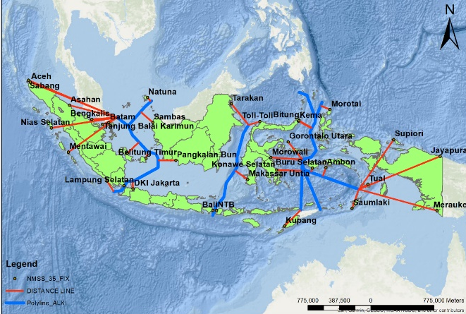
Figure 3. Distance map of prospective locations to the ASL

The measurement of the distance between the prospective locations and the nearest port showed that DKI Jakarta Station was the closest at 0.14 Nm while the furthest was Morotai Station at 38.39 Nm. However, the survey conducted showed that the local government was planning to develop the IDNCG Morotai Station soon.
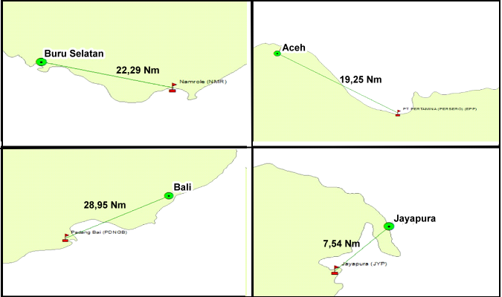
Figure 4. Distance map of prospective locations to the port

Vulnerability coverage measurement results showed that North Gorontalo Station had the highest coverage of 94.78%. This shows that the location has high vulnerability and exists within the monitoring range. Meanwhile, the lowest, 38.47 %, was recorded for Pangkalan Bun Station. The value showed the low vulnerability of the location and existence beyond coverage as presented in Figure 5. The existing data further showed that the vulnerability was lesser in eastern Indonesia and this was associated with the busier traffic factor in western Indonesia.
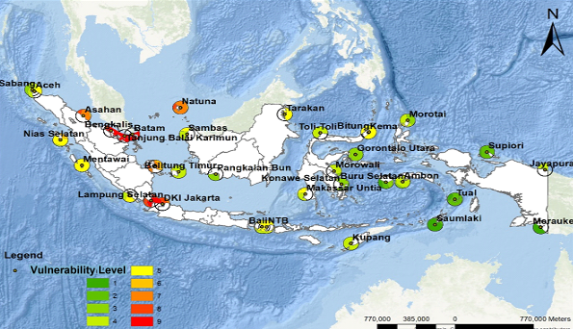
Figure 5. Vulnerability coverage

The coverage of prospective stations was examined based on the density of passing ships. The results showed that Morotai Station had the highest figure of 63.97% while the lowest, 5.69%, was in Tanjung Balai Asahan Station as presented in Figure 6. This shows that traffic is outside the 40 Nm range of station or the path of small ships without an automatic identification system (AIS).
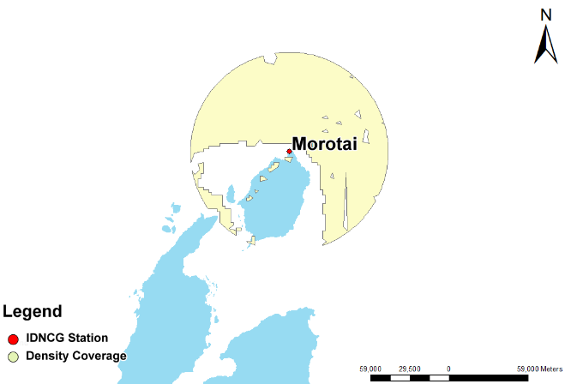
Figure 6. Ship density coverage

The summary of the results from GIS measurement is presented in Table 4. The data obtained were converted into scores determined during the FGD conducted with experts and processed further using the MCDM, including AHP and TOPSIS.

Table 4. Recapitulation of calculation results using GIS method
No | Location | ASL | Score | Port | Score | Vulnerable | Score | Density | Score
1 | Aceh | 2091.3 | 1 | 19.25 | 4 | 71.78 | 4 | 27.72 | 3
2 | Natuna | 117.75 | 5 | 4.35 | 5 | 89.83 | 5 | 29.14 | 3
3 | Batam | 221.29 | 4 | 4.55 | 5 | 85.75 | 5 | 9.95 | 1
4 | Bangka Belitung | 356.26 | 4 | 20.01 | 3 | 53.79 | 2 | 12.08 | 2
5 | Sambas | 364.77 | 4 | 13.47 | 4 | 53.04 | 2 | 42.64 | 5
6 | TBK | 358.74 | 4 | 32.2 | 2 | 75.81 | 4 | 12.08 | 2
7 | Sabang | 2140.3 | 1 | 13.32 | 4 | 84.94 | 5 | 24.88 | 3
8 | Asahan | 1098.1 | 1 | 29.29 | 3 | 53.49 | 2 | 5.69 | 1
9 | Nias Selatan | 1494.8 | 1 | 55.8 | 1 | 83.70 | 5 | 28.43 | 3
10 | Bengkalis | 566.86 | 3 | 3.39 | 5 | 61.71 | 3 | 9.24 | 1
11 | Belitung Timur | 150 | 5 | 65.2 | 1 | 75.89 | 4 | 41.93 | 5
12 | Lampung Barat | 284.64 | 4 | 137.4 | 1 | 50.08 | 2 | 36.25 | 4
13 | Lampung Selatan | 17.6 | 5 | 46.94 | 1 | 62.75 | 3 | 12.79 | 2
14 | DKI Jakarta | 164.3 | 5 | 0.47 | 5 | 42.11 | 1 | 7.11 | 1
15 | Mentawai | 1335 | 1 | 182.8 | 1 | 93.44 | 5 | 29.14 | 3
16 | Tarakan | 605.34 | 2 | 11.64 | 4 | 52.55 | 2 | 27.72 | 3
17 | Bali | 34.38 | 5 | 28.95 | 3 | 67.48 | 3 | 12.08 | 2
18 | Kema | 340.4 | 4 | 26.73 | 3 | 74.87 | 4 | 39.80 | 4
19 | Bitung | 338.02 | 4 | 14.66 | 4 | 76.75 | 4 | 41.22 | 5
20 | Konawe Selatan | 566.62 | 3 | 16.92 | 4 | 54.37 | 2 | 19.19 | 2
21 | Makassar | 348.77 | 4 | 19.25 | 4 | 49.76 | 1 | 9.24 | 1
22 | NTB | 41.44 | 5 | 53.38 | 1 | 66.96 | 3 | 16.35 | 2
23 | Pangkalan Bun | 399.02 | 4 | 32.95 | 2 | 38.47 | 1 | 17.77 | 2
24 | Toli-Toli | 265.51 | 4 | 54.08 | 1 | 70.21 | 4 | 42.64 | 5
25 | Morowali | 705.84 | 2 | 183.7 | 1 | 47.69 | 1 | 21.32 | 3
26 | Gorontalo Utara | 505.73 | 3 | 86.88 | 1 | 94.78 | 5 | 54.02 | 5
27 | Ambon | 206.9 | 4 | 22.1 | 3 | 84.24 | 5 | 51.88 | 5
28 | Kupang | 504.55 | 3 | 5.18 | 5 | 70.22 | 4 | 26.30 | 3
29 | Tual | 233.04 | 4 | 7.29 | 5 | 92.80 | 5 | 49.04 | 5
30 | Jayapura | 1958.4 | 1 | 7.54 | 5 | 60.79 | 3 | 35.54 | 4
31 | Merauke | 1795.7 | 1 | 6 | 5 | 47.01 | 1 | 19.90 | 2
32 | Buru Selatan | 98.81 | 5 | 22.29 | 3 | 60.47 | 3 | 41.22 | 5
33 | Morotai | 226.98 | 4 | 129.3 | 1 | 86.52 | 5 | 63.97 | 5
34 | Saumlaki | 442.65 | 3 | 31.76 | 2 | 90.62 | 5 | 60.41 | 5
35 | Supiori | 1352.4 | 1 | 142.4 | 1 | 87.45 | 5 | 37.67 | 4

Determining the level of importance of criteria using AHP
AHP was conducted through four steps with the first focused on designing a hierarchy of decision-making problems. The hierarchy consisted of the goals at the top, other criteria or options in the central position, and the alternatives at the bottom [26]. The second step was to develop a pairwise comparison matrix based on the recommendation of experts as follows:
$B=\left[\begin{matrix}1 & x_{12} & … & x_{1m} \\ x_{21} & 1 & … & x_{2m} \\ ⋮ & ⋮ & ⋱ & ⋮ \\ x_{m1} & x_{m2} & … & 1\end{matrix}\right]$ | (1)
where, $x_{ij}$ (1 ≤ i ≤ m, 1 ≤ j ≤ m) is the relative importance provided for criterion i to j by the experts. This was based on the rules proposed by Buckley to select $x_{ij}$ through nine linguistics ranging from 1 to 9 as explained in the following Table 5.

Table 5. Assess the level of importance
Intensity | Remark
1 | Both elements are equally important
3 | One element is less important than the others
5 | One element is more important than the others
7 | One element is clearly more important than the others
9 | One element is absolutely more important than the others
2, 4, 6, 8 | Values between two adjacent considerations

The paired comparison questionnaire was provided for 5 experts to determine the weight of each criterion. Moreover, the third step was the consistency test which was achieved by calculating the maximum eigenvalue, λ, followed by the counting of consistency index CI = $\frac{λ-m}{m-1}$.
The random consistency index (RI) for 4 criteria was found to be 0.90 which was relative to the number of M indicators. This was followed by the determination of consistency ratio based on the suggestion of Saaty that only values smaller or equal to 10% were acceptable while those higher were considered random and needed to be corrected. Furthermore, the fourth step was to determine the weights of the indicators.
The process showed that the criterion with the highest importance in AHP calculation was distance to ASL with a value of 0.484 followed by vulnerability coverage at 0.249, density coverage at 0.183, and distance to the port at 0.084 as shown in Table 6. Moreover, the Consistency Ratio (CR) was 0.00752 which was considered consistent according to the Random Consistency Index table because the value was below 0.90.

Table 6. Criteria importance level values
Criteria | Score | Order
ALS | 0.484 | 1
Vulnerable | 0.249 | 2
Density | 0.183 | 3
Port | 0.084 | 4

Calculating development priority preferences using TOPSIS
TOPSIS was conducted generally through six stages which are stated as follows:
Step 1: Formulate a decision matrix based on the recommendation of experts as follows:
$$V=\left[\begin{matrix}p_{11} & p_{12} & … & p_{1n} \\ p_{21} & p_{22} & … & p_{2n} \\ ⋮ & ⋮ & ⋱ & ⋮ \\ p_{m1} & p_{m2} & … & p_{mn}\end{matrix}\right]$$ | (2)
where, p_ij (1 ≤ i ≤ m, 1≤ j ≤ n) is the value of the ith alternative assessed from the jth factor. Moreover, the suitability ranking of the alternatives for each criterion was evaluated based on a 1 to 5 scale as presented in the following Table 7.
Table 7. Importance Scale
No | Importance
1 | It is not in accordance with
2 | Not Appropriate
3 | Just Appropriate
4 | In accordance
5 | Very suitable
Step 2: Develop a normalized decision matrix R = ${\left[r_{ij}\right]}_{mxn}$, where $r_{ij}$ can be calculated as follows:
$$r_{ij}=\frac{p_{ij}}{\sqrt{\sum_{i=1}^{m}{{p_{ij}}^{2}}}}$$ | (3)
Step 3: Design a weighted normalized decision matrix Y = ${\left[y_{ij}\right]}_{mxn}$where $y_{ij}$ can be obtained by multiplying $r_{ij}$ with the weights, $w_{i}$, determined for the criteria using AHP.
$$y=w_{i}×r_{ij}$$ | (4)
Step 4: Determine the positive and negative ideal solutions
$$A^{+}=\left\{{y_{1}}^{+},{y_{2}}^{+},{y_{3}}^{+} ,…, {y_{i}}^{+}\right\}$$ | (5)
$$A^{-}=\left\{{y_{1}}^{-},{y_{2}}^{-},{y_{3}}^{-} ,…, {y_{i}}^{-}\right\}$$ | (6)
where, ${y_{i}}^{+}$ is maximum $y_{ij}$ if j is the profit and minimum attribute$y_{ij}$ if j is a cost attribute. Meanwhile. ${y_{i}}^{-}$ is minimum $y_{ij}$ if j is the profit attribute and is maximum $y_{ij}$ if j is the cost attribute.
Step 5: Calculate the distance to the positive and negative ideal solutions using the following formulas:
$${S_{i}}^{+}=\sqrt{\sum_{j=1}^{m}{{\left({y_{i}}^{+}-y_{ij}\right)}^{2}}}$$ | (7)
$${S_{i}}^{-}=\sqrt{\sum_{j=1}^{m}{{\left(y_{ij}-{y_{j}}^{-}\right)}^{2}}}$$ | (8)
Step 6: Calculate the preference value $V_{i}$ for each alternative using the following formula:
$$V_{i}=\frac{{S_{i}}^{-}}{{S_{i}}^{+}+{S_{i}}^{-}} , i=1, 2,…, m$$ | (9)
A larger $V_{i}$ value shows the preference for the specific alternative $A_{i}$. Therefore, the ranking of the alternatives to be prioritized for development as IDNCG Station based on the $V_{i}$ value is presented in the following table.

Table 8. Station ranking based on TOPSIS
Station | Zone | D+ | D- | Vi | Rank
Natuna | West | 0.0082 | 0.1104 | 0.9311 | 1
Tual | East | 0.0230 | 0.0933 | 0.8025 | 2
Batam | West | 0.0282 | 0.0919 | 0.7652 | 3
Buru Selatan | East | 0.0304 | 0.0981 | 0.7637 | 4
Bitung | Central | 0.0275 | 0.0842 | 0.7536 | 5
Bali | Central | 0.0328 | 0.0969 | 0.7473 | 6
DKI Jakarta | West | 0.0375 | 0.1048 | 0.7365 | 7
Ambon | East | 0.0341 | 0.0824 | 0.7071 | 8
Kema | Central | 0.0354 | 0.0786 | 0.6895 | 9
Sambas | West | 0.0364 | 0.0808 | 0.6890 | 10
Belitung East | West | 0.0512 | 0.0967 | 0.6538 | 11
Makassar | Central | 0.0458 | 0.0786 | 0.6321 | 12
NTB | Central | 0.0546 | 0.0935 | 0.6312 | 13
Lampung Selatan | West | 0.0546 | 0.0935 | 0.6312 | 14
Bangka Belitung | West | 0.0442 | 0.0740 | 0.6258 | 15
TBK | West | 0.0467 | 0.0746 | 0.6149 | 16
Kupang | East | 0.0474 | 0.0733 | 0.6071 | 17
Morotai | East | 0.0555 | 0.0785 | 0.5858 | 18
Bengkalis | West | 0.0516 | 0.0703 | 0.5768 | 19
Toli-Toli | Central | 0.0561 | 0.0752 | 0.5727 | 20
Pangkalan Bun | Central | 0.0570 | 0.0702 | 0.5517 | 21
Pesisir Barat Lampung | West | 0.0611 | 0.0705 | 0.5356 | 22
Konawe Selatan | Central | 0.0553 | 0.0603 | 0.5214 | 23
Saumlaki | East | 0.0595 | 0.0606 | 0.5046 | 24
Gorontalo Utara | Central | 0.0683 | 0.0593 | 0.4649 | 25
Tarakan | Central | 0.0749 | 0.0458 | 0.3795 | 26
Jayapura | East | 0.0935 | 0.0546 | 0.3688 | 27
Sabang | West | 0.0931 | 0.0514 | 0.3557 | 28
Merauke | East | 0.0987 | 0.0507 | 0.3393 | 29
Aceh | West | 0.0935 | 0.0463 | 0.3312 | 30
Supiori | East | 0.1049 | 0.0359 | 0.2550 | 31
Mentawai | West | 0.1052 | 0.0347 | 0.2483 | 32
Nias Selatan | West | 0.1052 | 0.0347 | 0.2483 | 33
Asahan | West | 0.0999 | 0.0266 | 0.2104 | 34
Morowali | Central | 0.0922 | 0.0244 | 0.2091 | 35

The ranking presented in the table 8 based on TOPSIS calculations showed that Natuna Station was the first to be developed with a preference value of 0.9311. This was significantly in line with the current status of North Natuna waters as the center of national and global attention. Moreover, the claiming of the Nine Dash Line by China has led to the loss of approximately 83,000 km² or 30 percent of Indonesian waters in Natuna. A similar trend was observed in other countries such as the Philippines, Malaysia, Vietnam, and Brunei Darussalam. Some areas included in the Nine Dash Line, such as the Paracel Islands, are also observed to have been claimed by Vietnam and Taiwan. Meanwhile, China is currently in a dispute with the Philippines, Malaysia, Vietnam, and Brunei Darussalam over the sea in the Spratly Islands.

Priority station mapping
Create a map of alternative station locations based on priority ranking
The division of development process into 3 years led to the formulation of the ranking map in Figure 7 as a suitable reference for leaders to make appropriate decisions. Stations ranked 1 to 12 were required to be developed in the first year consisting of 5 in the West zone, 4 in the Central, and 3 in the East. Those proposed for the second year were from 13 to 24 with the same composition as the first year, including 5 in the West, 4 in the Central, and 3 in the East. The third year was designed to develop 25 to 35 with a composition of 5, 3, and 3 respectively.

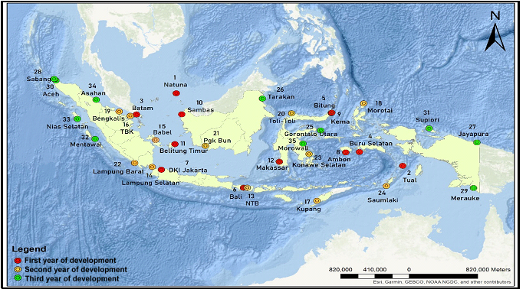
Figure 7. Ranking Map for the IDNCG Stations

CONCLUSION
The conclusions from the series of research conducted, model prepared, and the analysis of data retrieved are presented as follows:
1. A spatial multi-criteria decision model produced by combining GIS with AHP and TOPSIS methods led to the determination of four criteria, including distance to ASL, vulnerability coverage, ship density coverage, and distance to the port. A total of 35 potential stations were used as alternative locations for development process. The results divided the plan into three years consisting of 12 stations including Natuna, Tual, Batam, Buru Selatan, Bitung, Bali, Jakarta, Ambon, Kema, Sambas, East Belitung, and Makasar in the first year. Another set of 12 stations proposed to be developed in the second year 12 stations were NTB, South Lampung, Bangka Belitung, Tanjung Balai Karimun, Kupang, Morotai, Bengkalis, Toli-toli, Pangkalan Bun, Pesisir Barat Lampung, South Konawe and Saumlaki, Moreover, 11 stations were proposed for the third year and these included North Gorontalo, Tarakan, Jayapura, Sabang, Merauke, Aceh, Supiori, Mentawai, South Nias, Asahan and Morowali. This priority preference map can be used by policymakers in prioritizing development of RI Bakamla Station.
2. The final result was priority preference map produced for development of IDNCG Stations. The map was projected to be used by the leadership as a reference to solve decision-making problems through the determination of stations to be prioritized for development with the period of 3 years.

ACKNOWLEDGMENT
This research was funded by the Ministry of Research, Technology, and Higher Education Indonesia through a postgraduate research grant scheme in collaboration with Universitas Trisakti Research and Community Service Institute. The authors appreciate colleagues from the IDNCG and Universitas Trisakti for providing the data, insight, and expertise needed despite possible disagreement with all the interpretations or conclusions. Moreover, it is recommended that further research be conducted on other criteria as well as the addition of the Cut-off Point method for the purpose of refinement.

REFERENCES
[1] O. S. Suharyo, A. R. Prabowo, and E. Krisdiono, “Decision Making of Maritime Development Scenario on The Impact of Naval Base for Supporting Navy Ships Operations,” Decis. Sci. Lett., Vol. 11, No. 1, pp. 81–90, 2022, doi: 10.5267/j.dsl.2021.8.002.
[2] Rasiddin Leo, L. Yudho Prakoso, and R. Sutanto, “Strategy of Marine Security Agency (Bakamla) In Security and Safety in Indonesian Marine Areas,” J Stra Hanla, Vol. 7, No. 3, 2021.
[3] P. B. Keenan and P. Jankowski, “Spatial Decision Support Systems: Three Decades On,” Decis. Support. Syst., Vol. 116, pp. 64–76, 2019, Doi: 10.1016/j.dss.2018.10.010.
[4] J. H. Hyun, J. Y. Kim, C. Y. Park, and D. K. Lee, “Modeling Decision-Maker Preferences for Long-Term Climate Adaptation Planning Using a Pathways Approach,” Sci. of the Total Envi., Vol. 772, 2021, doi: 10.1016/j.scitotenv.2021.145335.
[5] L. Vankova, Z. Krejza, G. Kocourkova, and J. Laciga, “Geographic Information System Usage Options in Facility Management,” In Procs Comp Sci., Elsevier B.V., 2021, pp. 708–716. Doi: 10.1016/J.Procs.2021.12.067.
[6] M. Schindler, R. Dionisio, and S. Kingham, “Challenges of Spatial Decision-Support Tools in Urban Planning: Lessons from New Zealand’s Cities,” J Urban Plan Dev, Vol. 146, no. 2, 2020, doi: 10.1061/(Asce)Up.1943-5444.0000575.
[7] A. Çalış Boyacı and M. Çağrı Tüzemen, “Multi-Criteria Decision-Making Approaches for Aircraft-Material Selection Problem,” Int. J. Material and Prod Tech, Vol. 64, No. 1, pp. 45–68, 2022.
[8] L. Albraheem and L. Alawlaqi, “Geospatial Analysis of Wind Energy Plant in Saudi Arabia Using a Gis-Ahp Technique,” Energy Rep., Vol. 9, Pp. 5878–5898, Dec. 2023, doi: 10.1016/J.Egyr.2023.05.032.
[9] S. Rekik and S. El Alimi, “Optimal Wind-Solar Site Selection Using a Gis-Ahp Based Approach: A Case of Tunisia,” Energy Conv and Mng., Vol. 18, 2023, doi: 10.1016/J.Ecmx.2023.100355.
[10] J. Huang, X. Huang, N. Song, Y. Ma, and D. Wei, “Evaluation of The Spatial Suitability of Offshore Wind Farm—A Case Study of The Sea Area of Liaoning Province,” Sustainability., Vol. 14, No. 1, 2022, doi: 10.3390/Su14010449.
[11] J. Penny, D. Khadka, P. B. R. Alves, A. S. Chen, and S. Djordjević, “Using Multi Criteria Decision Analysis in A Geographical Information System Framework to Assess Drought Risk,” Water Res X, Vol. 2023, doi: 10.1016/J.Wroa.2023.100190.
[12] H. I. Caner and C. C. Aydin, “Shipyard Site Selection by Raster Calculation Method and Ahp in Gis Environment, İskenderun, Turkey,” Mar Policy., Vol. 127, 2021, doi: 10.1016/J.Marpol.2021.104439.
[13] H. X. Nguyen Et Al., “A Hybrid Approach Using Gis-Based Fuzzy Ahp–Topsis Assessing Flood Hazards Along the South-Central Coast of Vietnam,” App Sci., Vol. 10, No. 20, pp. 1–21, 2020, doi: 10.3390/App10207142.
[14] M. S. Bahadori, A. B. Gonçalves, and F. Moura, “A Gis-Mcdm Method for Ranking Potential Station Locations in The Expansion Of Bike-Sharing Systems,” Axioms, Vol. 11, No. 6, 2022, doi: 10.3390/Axioms11060263.
[15] S. Ramya and V. Devadas, “Integration of Gis, Ahp and Topsis in Evaluating Suitable Locations for Industrial Development: A Case of Tehri Garhwal District, Uttarakhand, India,” J Clean Prod, Vol. 238, 2019, doi: 10.1016/J.Jclepro.2019.117872.
[16] T. K. Genger, Y. Luo, and A. Hammad, “Multi-Criteria Spatial Analysis for Location Selection of Multi-Purpose Utility Tunnels,” Tunnel and Und Space Tech, Vol. 115, 2021, doi: 10.1016/J.Tust.2021.104073.
[17] İ. Akgün and H. Erdal, “Solving an Ammunition Distribution Network Design Problem Using Multi-Objective Mathematical Modeling, Combined Ahp-Topsis, And Gis,” Comput Ind Eng, Vol. 129, pp. 512–528, Mar. 2019, Doi: 10.1016/J.Cie.2019.02.004.
[18] I. G. A. P. Eryani, M. W. Jayantari, and S. Ramli, “Determination of Flood Vulnerability Level Based on Different Numbers of Indicators Using Ahp-Gis,” Sinergi., Vol. 28, No. 1, pp. 13–22, 2024, Doi: 10.22441/Sinergi.2024.1.002.
[19] N. T. Laurentia, W. Septiani, and N. Tamara, “Ybm University Tourism Building Location Selection with A Combination of Cut Off Point and Ahp Topsis Method,” Aip Conf Proc., Vol. 2485, No. 1, 2023.
[20] K. Suroto and H. Hasbullah, “Selection Lead Logistics Provider in Consumer Goods Using Ahp – Topsis Approach,” Sinergi., Vol. 27, No. 2, pp. 185–192, 2023, Doi: 10.22441/Sinergi.2023.2.006.
[21] D. S. Costa, H. S. Mamede, and M. M. Da Silva, “A Method For Selecting Processes For Automation With Ahp And Topsis,” Heliyon., Vol. 9, No. 3, 2023, doi: 10.1016/j.heliyon.2023.e13683.
[22] M. H. Manik, “Addressing The Supplier Selection Problem By Using The Analytical Hierarchy Process,” Heliyon., Vol. 9, No. 7, 2023, doi: 10.1016/j.heliyon.2023.E17997.
[23] O. F. Atenidegbe and K. A. Mogaji, “Modeling Assessment Of Groundwater Vulnerability To Contamination Risk In A Typical Basement Terrain Using Topsis-Entropy Developed Vulnerability Data Mining Technique,” Heliyon., Vol. 9, No. 7, 2023, doi: 10.1016/J.Heliyon.2023.E18371.
[24] M. M. Zewdie and S. M. Yeshanew, “Gis Based Mcdm for Waste Disposal Site Selection in Dejen Town, Ethiopia,” Envi and Sust Indicators, Vol. 18, 2023, doi: 10.1016/J.Indic.2023.100228.

[25] A. T. Mlepo and J. Zheng, “Shipping to A Landlocked Country: Maritime Port Choice Decision from a Consignee’s Perspective,” Int J of Ship and Transp Logs., Vol. 16, No. 1–2, pp. 194–209, 2023, doi: 10.1504/Ijstl.2023.10050599.
[26] K. Li, T. Duan, Z. Li, X. Xiahou, N. Zeng, and Q. Li, “Development Path of Construction Industry Internet Platform: An Ahp–Topsis Integrated Approach,” Buildings, Vol. 12, No. 4, 2022, doi: 10.3390/Buildings12040441.

