Innovative Bio-Inspired Solar Cells using Fly Ash-Based Dye-Sensitized Cells with Fruit Extract Enhancements and Averrhoa bilimbi electrolyte | 

Retyo Wizi Nafa Utami¹, Tresna Dewi^{2*}, Indrayani³
¹Applied Master of Renewable Energy Engineering Department, Politeknik Negeri Sriwijaya, Indonesia
²Electrical Engineering Department, Politeknik Negeri Sriwijaya, Indonesia
³Civil Engineering Department, Politeknik Negeri Sriwijaya, Indonesia

Abstract  Climate change and the energy crisis have led Indonesia to prioritize renewable energy sources like solar power. Solar energy is now being used in various sectors, including agriculture, households, and industries. However, the efficiency of current silicon-based photovoltaic (PV) cells has plateaued at 27%, and thin-film PV cells, which use rare metals, are even less efficient. Therefore, it is crucial to develop solar cell technologies that are more affordable, sustainable, and customizable to specific needs, such as local solar irradiance and aesthetic requirements. Dye-sensitized solar cells (DSSCs) offer distinct advantages, including low production costs, flexibility, good performance in diffuse light, and aesthetic versatility. This paper explores a DSSC design that uses iron (Fe) and magnesium (Mg) extracted from fly ash for the counter electrode, combined with a natural binder from dragon fruit peels and an electrolyte booster from Averrhoa bilimbi. UV-Vis testing indicates that the binder absorbs light in the 360-700 nm range, making it an effective sensitizer for wide band gap semiconductors, with a peak absorption of around 550 nm in the visible spectrum. Electrical generation experiments show that Fe-based DSSCs produce a higher voltage ($V_{max}=406$mV) than Mg-based DSSCs (163 mV), attributed to Fe's superior conductivity.  This is an open-access article under the CC BY-SA license   | Keywords:  DSSC, Fly Ash, Natural dye, Solar Energy  Article History:  Received: May 2, 2019  Revised: May 29, 2019  Accepted: June 2, 2019  Published: June 2, 2019  Corresponding Author:  Tresna Dewi  Electrical Engineering Department, Politeknik Negeri Sriwijaya, Indonesia  Email: tresna_dewi@polsri.ac.id

INTRODUCTION
Climate change and the energy crisis have prompted Indonesia to shift and prioritize renewable energy[1]. This has become government policy, and all sectors of society, including education, state-owned enterprises, and the general public, actively support this policy[2]-[4]. This implementation is possible in every sector, such as agriculture, households, industry, or hospitals, and Palembang and South Sumatra generally have considerable solar energy potential[5]-[10], such as solar-powered automatic greenhouse by Yurni et al., and sprinkler systems by Mases et al.and Putra et al.
The current most applied PV technology is silicon-based solar cells with the highest efficiency of 27% and also known as the first generation [11]-[14] where Zullah et al. implemented polycrystalline PV panels to power electronics in a pilot. The second generation of solar cell technology is a thin film, which refers to solar cells built from materials other than silicon, such as Indium Gallium Selenide (CIGS), Cadmium Eggride (CdTe), and Gallium Arsenide (GaAs), that use band gap energy settings between semiconductor elements[15]. Thin film technology is more expensive than silicon-based solar cells, and the ingredients required are more difficult to obtain. Moreover, silicon and other semiconductor material-based solar cell production processes are not environmentally friendly and still contribute significantly to CO2 emissions. Hence, the more environmentally safe and truly renewable PV cell is still required, and dye-sensitized solar cells (DSSCs) have emerged as promising candidates, offering a cost-effective and environmentally friendly alternative to traditional silicon-based photovoltaic systems[16][17], where Abdelaal et al. shows the economically practical DSSC design. DSSCs utilize organic dyes to absorb sunlight and convert it into electricity, making them versatile and adaptable for various applications.
DSSC's production expenses are relatively low [16][19]. Materials utilized in DSSC, such as titanium dioxide (TiO₂), are very inexpensive and readily available. Nature-based dyes and electrolytes have contributed greatly to developing DSSC, which has a wide range of design possibilities, including color, flexibility, and appealing design. This includes setting the ability of the solar cell produced to facilitate low-light regions by adjusting the type of dye and electrolyte used[18]-[20].
Another environmental issue contributing to nature destruction is manufacturing waste such as Fly Ash as the product of coal combustion. However, when investigated further, the fly ash composition still has useful metals that can be utilized as the counter electrode, such as Fe, Mg, Si, Al, and Na. Hence, this abundance of waste could create an environmentally friendly electric source[23].
Dye choice is crucial in PV cell design due to the ability to capture photo energy from solar irradiance[24]-[31]. Anthocyanin is a pigment that captures and binds photon energy to generate electricity. It can easily be found in reddish fruits such as dragon fruit and pomegranate, as investigated by Erande et al.[25] Fereira et al. extracted dye from different flower petals[28]. Dragon fruit is a type of fruit famous locally in Palembang that can be consumed as a beverage or other delicacies. Dragon fruit peels contain high anthocyanin and, therefore, can be utilized more as the source of dye for DSSC.
Electrolytes play a critical role in the operation of DSSCs by facilitating the movement of charge carriers between the dye-sensitized semiconductor and the counter electrode. Averrhoa bilimbi, commonly known as belimbing wuluh or bilimbi, offers a sustainable and environmentally friendly alternative to conventional electrolytes, providing an eco-friendly solution for enhancing the performance and stability of DSSCs[32][33].
This paper discusses the PV cell design using Fe and Mg extracted from Fly Ash as the counter electrode, the natural binding extracted from dragon fruit, and the electrolyte booster from Averrhoa bilimbi. The novelty of this paper is combining the natural power of Averrhoa bilimbi and dragon fruit anthocyanin with Fe and Mg electrodes to create a nature-friendly solar cell as the way to contribute to the advancement of renewable energy technologies and pave the way towards greener and more sustainable future.

METHOD
This study proposes the fabrication of DSSC using Fe and Mg from fly ash waste as the counter electrode and natural dye color from dragon fruit peel as the binding agent. The method proposed in this paper is shown in Figure 1, where the fly ash extraction produces Fe and Mg. Averrhoa Bilimbi extraction is implemented as the electrolyte or booster to improve the conductivity of DSSC produced in this study.

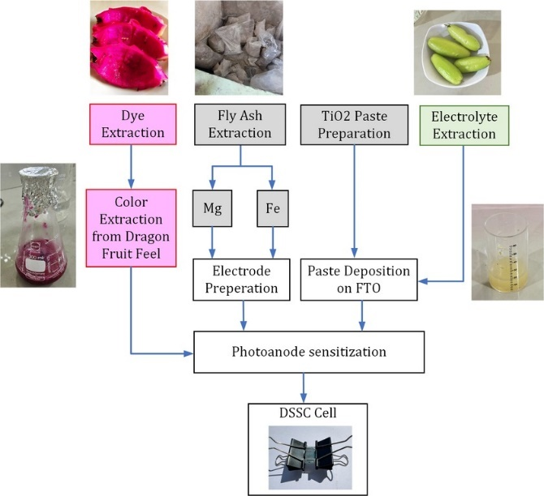
- DSSC fabrication proposed in this study

Material
DSSC consists of layers of material to form a solar cell, including semiconductors, counter electrodes, natural dye as the binder, electrolytes, and glass. Figure 2 shows how those material are stacked together to form a PV cell and used to generate electricity. The materials used in this study are Fe and Mg as the counter electrode, TiO2 as the semiconductor, natural dye extracted from dragon fruit, and electrolyte extracted from Averrhoa bilimbi.

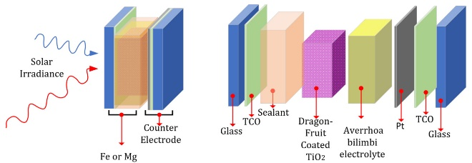
- Materials used for DSSC fabrication in this study.

- Semiconductor Material
Semiconductors are essential in solar cell fabrication. Electric generation using the photovoltaic effect is known as direct generation due to electricity generated as the solar irradiance excites the negative electrons inside the semiconductor material from the valance band to the conduction band and leaves the positive holes. The semiconductor for DSSC needs to have a high surface area and be porous, which is characteristic to match the sensitizer to increase the efficiency of DSSC, resulting in more electricity generated. Titanium Oxide (TiO₂) is the semiconductor used in this study.

- Dragon Fruit Peels as Sensitizer
Utilizing natural dragon fruit as a sensitizer in solar cells presents several benefits. Firstly, dragon fruit contains pigments such as anthocyanins, demonstrating light-absorbing properties suitable for photovoltaic applications. These pigments efficiently absorb sunlight across a broad spectrum of wavelengths, enabling effective solar energy conversion into electricity. Secondly, natural dragon fruit sensitizers offer environmental advantages. They are derived from a renewable source, reducing reliance on non-renewable resources typically used in synthetic sensitizers. Their production typically involves fewer harmful chemicals and processes, contributing to lower environmental impact and improved sustainability.

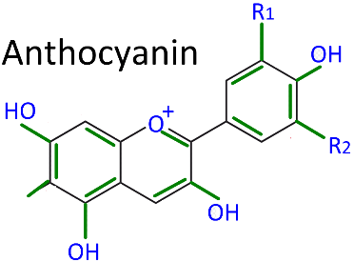
- Anthocyanin is the pigment responsible for capturing photon energy from solar irradiance.

Furthermore, using dragon fruit sensitizers may offer economic benefits by reducing manufacturing costs associated with synthetic sensitizers. Overall, natural dragon fruit sensitizers promise to enhance the efficiency, sustainability, and affordability of solar cell technology.

- Fe and Mg as the Counter Electrode
Using iron (Fe) and magnesium (Mg) as counter electrodes in specific electrochemical devices like dye-sensitized solar cells (DSSCs) offers significant advantages. Fe and Mg are abundant and cost-effective materials, making them economically favorable compared to noble metals such as platinum, commonly used in counter electrodes. Additionally, Fe and Mg possess excellent electrical conductivity and catalytic activity, facilitating efficient electron transfer processes within the DSSC. This promotes rapid and effective regeneration of dye molecules, which is crucial for sustaining photocurrent generation in the solar cell. Moreover, Fe and Mg are environmentally friendly elements compared to other metals, thereby reducing the ecological impact of DSSCs. Their use aligns with the principles of green chemistry and sustainable development, making them appealing choices for environmentally conscious applications. Overall, selecting Fe and Mg as counter electrodes in DSSCs balances performance, cost-effectiveness, and environmental sustainability, making them promising candidates for advancing solar energy conversion technologies.

- Averrhoa bilimbi as an electrolyte
Using Averrhoa bilimbi (commonly known as bilimbi or cucumber tree) as an electrolyte in specific electrochemical applications offers several advantages. Firstly, Averrhoa bilimbi is rich in organic acids, particularly oxalic acid and ascorbic acid, which can contribute to its ionic conductivity. These organic acids can facilitate the movement of ions within the electrolyte, enabling efficient charge transfer processes. Secondly, Averrhoa bilimbi is readily available in tropical regions where it is commonly grown. Its accessibility makes it a cost-effective and sustainable option for electrolyte materials, particularly in regions where other electrolyte sources may be scarce or expensive.
Additionally, Averrhoa bilimbi is known for its antioxidant properties, which can enhance the stability and longevity of electrochemical devices. Antioxidants may help mitigate degradation processes within the electrolyte, leading to improved device performance and durability. Furthermore, Averrhoa bilimbi is a natural and environmentally friendly material, aligning with the growing interest in green and sustainable technologies. Its use as an electrolyte can reduce reliance on synthetic and potentially harmful electrolyte materials, promoting eco-friendly practices in electrochemical applications. Overall, selecting Averrhoa bilimbi as an electrolyte offers a combination of ionic conductivity, availability, sustainability, and environmental friendliness, making it a promising candidate for various electrochemical devices and applications.
Methods
The methods of DSSC fabrication in this study are shown in Figure 1.

- Extraction and purification procedures for Mg and Fe from Fly Ash
The process of preparing fly ash begins with drying a 10-gram sample in an oven at 110°C for 24 hours to remove organic matter. Next, the dried fly ash is combined with 100 mL of HCl in a 1:10 ratio. This mixture is then stirred using a magnetic stirrer at a speed of 250 rpm for 24 hours. Subsequently, the solution is filtered through filter paper to separate the filtrate from the residue. The filtrate is then analyzed using Atomic Absorption Spectroscopy (AAS) to determine the iron content dissolved in it due to the extraction process using HCl.

- Creating Dye Extract From Red Dragon Fruit
The first step involves peeling and chopping the skin of the red dragon fruit into small fragments. These fragments are then crushed using a mortar to achieve a smoother consistency. The resulting material is transferred into an Erlenmeyer flask, where it is combined with a solution consisting of 21 ml of distilled water, 25 ml of 1% methanol-HCL, and 4 ml of acetic acid. The mixture is allowed to stand overnight at a cool temperature. Subsequently, the mixture is filtered using filter paper to separate the liquid portion (filtrate) from the solid residues.

- Creating a Booster From Averrhoa Bilimbi Extract, Preparing TiO2 Paste, and Coating With TiO2 Paste
Cut the star fruit into small pieces and mash them using a mortar. Place the mashed fruit in an Erlenmeyer flask with 21 ml of distilled water, 25 ml of 1% methanol-HCl, and 4 ml of acetic acid. Leave the mixture overnight in a cold environment. Filter the mixture to separate the liquid (filtrate) from the solid residue (dregs).
First, to prepare the TiO2 paste, dissolve 1.5 grams of PVA in 13.5 ml of distilled water at 40°C for 30 minutes until it forms a uniform thick mixture. Then, combine 7.5 ml of the PVA solution with 0.5 grams of TiO2 to form a paste. Store the paste in a bottle.
To coat with the TiO₂ paste, mark a 1.5 x 1.5 cm area on FTO glass using scotch tape. Apply the TiO2 paste to the marked area using a doctor's blade. Finally, dry the coating in a furnace at 450°C for 1 hour to enhance the bond and create pores.

- Dye Coating of Dragon Fruit Peel Waste on TiO2 Working Electrodes to Test Light Intensity
The dye coating on the TiO2 electrode was performed by soaking TiO2-coated FTO glass in a red dragon fruit peel dye extract for 24 hours, which resulted in the absorption of anthocyanins onto the TiO2 surface and changed its color to red. Five drops of electrolyte solution were then added to the dye-coated FTO glass. The components were assembled into a DSSC cell by sandwiching the dye-coated FTO glass (working electrode) with a counter electrode-coated FTO glass, secured with a paper clip. Fly ash was analyzed using XRF to determine oxide content and SEM-EDX to examine morphology and particle size. The dye extract's absorption and functional groups were identified using a UV spectrophotometer. DSSC testing included measuring the I-V characteristics with voltage variations using a multimeter and potentiometer and determining efficiency from the I-V curve. Light intensity, voltage, and current of the DSSC were tested every 30 minutes from 11:00 to 13:30 using an irradiance mere.

- UV-Vis for Data Analysis Method
Ultraviolet-visible (UV-Vis) spectroscopy is a powerful analytical technique used to measure a sample's absorbance or transmittance of UV and visible light. It is widely utilized for analyzing the optical properties of materials, especially in the field of dye-sensitized solar cells (DSSCs. By employing UV-Vis spectroscopy, researchers can gain valuable insights into the optical properties of natural dye extracts and their interactions with semiconductor materials, thereby optimizing the design and performance of dye-sensitized solar cells.

- DSSC Electric Generation Analysis
DSSC can be modeled as an ideal diode, as shown in Figure 4. This model is achieved when the PN Junction semiconductor is wired and electricity is applied; the electrons go to the positive side, and holes go to the opposing side. During this motion, in the middle of the junction, the number of electrons and holes are the same, creating a neutral barrier. The generated current (I) is given by
$$I=I_{ph}-I_{0}\left(e^{q\left(\frac{V+IR_{s}}{AkT}\right)}-1\right)-\frac{V+IR_{s}}{R_{sh}}$$ | (1)
where $I_{ph}$ is the photocurrent, $R_{s}$ is series resistance, $R_{sh}$ is shunt resistance, $I_{D}$ is voltage-dependent current due to recombination, and $V$ is voltage. The maximum power produced by a solar cell ($P_{MP}$) is given by the IV curve in Figure 1b, which is the function of short-circuit current ($I_{sc}$) and open-circuit voltage ($V_{oc}$). The efficiency of a solar panel is
$$η=\frac{ρ_{out}}{ρ_{in}}x100\%, = \frac{I_{mp}∙V_{mp}}{P_{in}}x 100\%,=\frac{I_{sc}V_{oc}FF}{P_{in}} x 100\%,$$ | (2)
where $I_{mp}$ and $V_{mp}$ are the maximum current and voltage, E is the solar energy, and FF is the fill factor.

- Modeling PV cell as an ideal diode.

RESULTS AND DISCUSSION
An experiment was conducted to show the effectiveness of the proposed method. This study produced two DSSC types: Fe-induced and Mg-induced DSSC.
The first test is the UV-Vis test to show the effectiveness of the natural dye binder extracted from dragon fruit peels proposed in this study, and the test result is shown in Figure 5.
- UV-Vis absorption spectra of dragon fruit dye considered in this study.
UV-Vis test results are the UV-Visible absorption spectra of the dragon fruit dye evaluated in this study. Absorption spectra offer essential insights into the transitions between the dye's ground state, excited state, and the range of solar energy the dye can absorb. Typically, anthocyanins and their derivatives exhibit a broad absorption band within the visible light spectrum, attributed to charge transfer transitions from the highest occupied molecular orbital (HOMO) to the lowest unoccupied molecular orbital (LUMO). Anthocyanins that come in vibrant colors of dragon fruit peels have absorption maxima around 520 nm. Figure 5 shows the absorption range of 360-700 nm, making it an effective sensitizer for wide-band gap semiconductors. The absorption peak is around 550 nm in the visible region. The binding dragon fruit extracted dye on the TiO2 surface increased solar irradiance absorption, facilitated by carbonyl and hydroxyl groups in the anthocyanins.
The effectiveness of solar cells produced by the proposed method in Figure 1 should be shown in how much electricity is generated by the produced DSSC. Figure 6 shows the process of measuring voltage produced by DSSC in this study. The experiment was conducted for five days for both Fe-induced and Mg-induced DSSC. During 5 days experiment, the weather conditions varied that are: Days 1 and 2 were cloudy (823 W/m2 and 889 W/m2), day 3 was overcast (865 W/m2), day 4 was rainy (714 W/m2), and day 5 was very sunny with high solar irradiance (1039 W/m2)
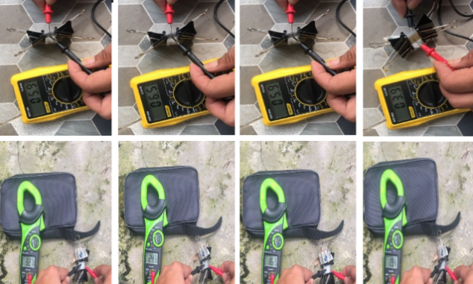
- Experiments on electricity generation by DSSC produced in this study.

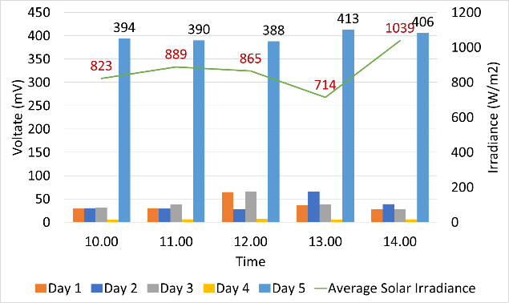
- Fe-induced DSSC electricity generation test.

The first experiment is to test the Fe-induced DSSC, as shown in Figure 7. The highest voltage produced was 406 mV for one DSSC cell on day 5 at 2 PM. Figure 8 shows the voltage generated by Mg-induced DSSC. The experiment was conducted parallel with Fe-induced DSSC; hence, the solar irradiance captured was the same. However, the highest voltage generated is 163 mV at 2PM, when the irradiance was at its highest.

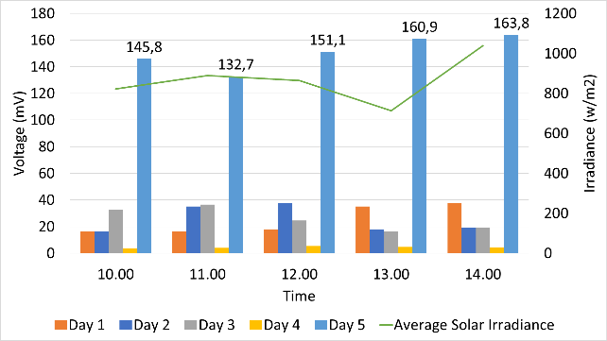
- Mg-induced DSSC electricity generation test.

Figures 7 and 8 show that the Fe and Mg-induced DSSC has the potential to be developed further for creating a bio-PV cell. The experiment was conducted using natural light to simulate the possible implementation of PV panels; hence, the produced electricity relied heavily on the amount of irradiance the cell was exposed to.
A further test was conducted by testing with serial and parallel connections of the produce Fe and Mg-induced DSSC.
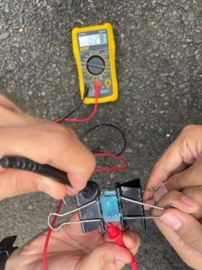
- Measurement
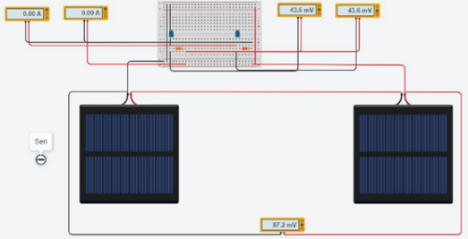
- Serial Fe
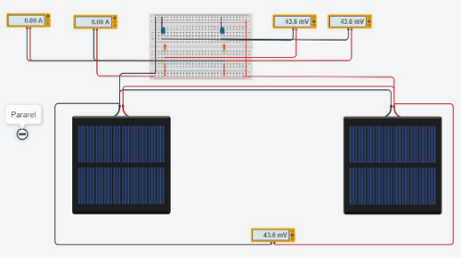
- Parallel Fe
- Fe-induced Serial and parallel connection test
Figures 9 and 10 show the serial and parallel connection test for Fe and Mg-induced DSSC, respectively, and the results are shown in Table 1.
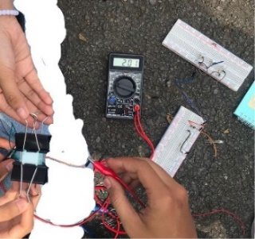
- Measurement
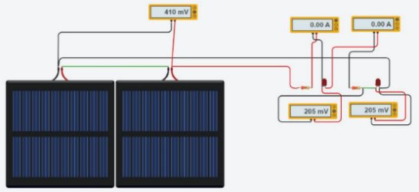
- Serial Mg
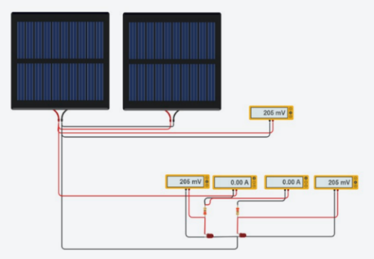
- Parallel Mg
- Mg-induced serial and parallel connection test.
Table 1. Serial and parallel test results
No | Voltage Serial (mV) |  |  |  | Voltage Parallel mV)
No | Fe |  | Mg |  | Fe |  | Mg
No | V1 | V2 | V1 | V2 | V1 | V2 | V1 | V2
1 | 43.6 | 43.6 | 43.6 | 43.6 | 205 | 205 | 205 | 205
2 | 43.6 | 43.6 | 43.6 | 43.6 | 205 | 205 | 205 | 205

In a PV system installation, panels are connected either in series or parallel to increase voltage and current. Conducting experiments with these connections is essential to confirm their feasibility. Connecting panels in series raises the voltage, while connecting them in parallel increases the current. Figures 8 and 7, and Table 1 shows that that Fe-induced DSSC generated more voltage than Mg-induced DSSC. This is due to Fe being a better conductor than Mg. The Fe level in fly ash is larger than Mg, so it is possible to recover Fe from fly ash for large-scale DSSC manufacture.
The experimental results also show that the proposed method is effective in producing DSSC with a natural dye binder from dragon fruit and electrolyte from Averrhoa bilimbi. The proposed DSSC has the potential to be developed locally in Palembang, South Sumatra that has high potential of fly ash as the waste from coal combustion plant, such as Steam Power Plant and Cement Manufacturing Plant.

CONCLUSION
Solar energy is an environmentally friendly energy source that has a high potential to be developed in Palembang, Indonesia. The current silicon-based PV cell has reached its maximum efficiency of 27%. Thin film, which is still using less abundant material than silicon, is not purely renewable. DSSCs offer unique advantages in low production costs, flexibility, performance in diffuse light, and aesthetic versatility. This paper presents the DSSC design utilizing the Fe and Mg extracted from fly ash for counter electrode with natural binder from dragon fruit peels and electrolyte booster extracted from Averrhoa bilimbi. The UV-Vis test shows the binder absorption range of 360-700 nm, making it an effective sensitizer for wide band gap semiconductors, and the absorption peak around 550 nm in the visible region. The experiment for electricity generation testing shows that Fe-induced DSSC generates more voltage ($V_{max}=406$ mV) than Mg-induced DSSC ($163$ mV). This result is due to the fact that Fe is a better conductor than Mg. Future research will investigate the best composition of DSSC material design.

ACKNOWLEDGMENT
The authors would like to acknowledge the Renewable Energy Engineering Department, Politeknik Negeri Sriwijaya, and PPM Dit. APTV through Contract No. 55/SPK/D.D4/PPK.01.APTV/III/2024 for funding supports this Master's Thesis Research. The authors also would like to thank Politeknik Negeri Sriwijaya for the supporting academic atmosphere.

REFERENCES

- IRENA, Renewable Energy Prospects: Indonesia, a REmap analysis, International Renewable Energy Agency (IRENA), Abu Dhabi, 2017. [Online]. Available: www.irena.org/remap.
- Peraturan Presiden Republik Indonesia, Nomor 22, Tentang Rencana Umum Energi Nasional, Tahun 2017. (Indonesian).
- H. M. Yudha, T. Dewi, P. Risma, and Y. Oktarina, "Life Cycle Analysis for the Feasibility of Photovoltaic System Application in Indonesia," in IOP Conf. Series: Earth and Environmental Science, vol. 124, 2018, doi: 10.1088/1755-1315/124/1/012005.
- T. Dewi, P. Risma, and Y. Oktarina, "A Review of Factors Affecting the Efficiency and Output of a PV system Applied in Tropical Climate," in IOP Conf. Series: Earth and Environmental Science, vol. 258, 2019, doi: 10.1088/1755-1315/258/1/012039.
- Sarwono, T. Dewi, and R. D. Kusumanto, "Geographical Location Effects on PV Panel Output - Comparison Between Highland and Lowland Installation in South Sumatra, Indonesia," Technology Reports of Kansai University, vol. 63, no. 2, pp. 7229-7243, 2021. ISSN: 04532198.
- K. Junaedi, T. Dewi, and M. S. Yusi, "The Potential Overview of PV System Installation at the Quarry Open Pit Mine PT. Bukit Asam, Tbk Tanjung Enim," Kinetik: Game Technology, Information System, Computer Network, Computing, Electronics, and Control, vol. 6, no. 1, pp. 41-50, 2021, doi: 10.22219/kinetik.v6i1.114.
- Y. Oktarina, Z. Nawawi, B. Y. Suprapto and T. Dewi, Digitized Smart Solar Powered Agriculture Implementation in Palembang, South Sumatra, 2023 10th International Conference on Electrical Engineering, Computer Science and Informatics (EECSI), Palembang, Indonesia, 2023, pp. 60-65, doi: 10.1109/EECSI59885.2023.10295805.
- Y. Oktarina, Z. Nawawi, B. Y. Suprapto and T. Dewi, Solar Powered Greenhouse for Smart Agriculture, 2023 International Conference on Electrical and Information Technology (IEIT), Malang, Indonesia, 2023, pp. 36-42, doi: 10.1109/IEIT59852.2023.10335599.
- T. Sujati, T. Dewi, and Rusdianasari, "Charging System Design of a Solar Powered Mobile Manipulator," in Proc. 2021 Int. Conf. on Electrical and Information Technology (IEIT), 2021, pp. 179-184.
- F. Septiarini, T. Dewi, and Rusdianasari, "Design of a solar-powered mobile manipulator using fuzzy logic controller of agriculture application," Int. J. Comput. Vis. Robot., vol. 12, no. 5, pp. 506-531, 2022, doi: 10.1504/IJCVR.2022.125356.
- Y. Mases, T. Dewi, and Rusdianasari, "Solar Radiation Effect on Solar Powered Pump Performance of an Automatic Sprinkler System," in Proc. 2021 Int. Conf. on Electrical and Information Technology (IEIT), 2021, pp. 246-250.
- P. P. Putra, T. Dewi, and Rusdianasari, "MPPT Implementation for Solar-powered Watering System Performance Enhancement," Technology Reports of Kansai University, vol. 63, no. 1, pp. 6919-6931, 2021. ISSN: 04532198.
- B. Junianto, T. Dewi, and C. R. Sitompul, "Development and Feasibility Analysis of Floating Solar Panel Application in Palembang, South Sumatra," in Proc. Journal of Physics: Conf. Series, 3rd Forum in Research, Science, and Technology, Palembang, Indonesia, 2020.
- F. Setiawan, T. Dewi, and S. Yusi, "Sea Salt Deposition Effect on Output and Efficiency Losses of the Photovoltaic System; a case study in Palembang, Indonesia," in Proc. Journal of Physics: Conf. Series, vol. 1167, 2019.
- T. Dewi, A. Taqwa, Rusdianasari, R. D. Kusumanto, and R. S. Sitompul, "The Investigation of Sea Salt Soiling on PV Panel," in Proc. 4th Forum in Research, Science, and Technology (FIRST-T1-T2-2020), vol. 4, no. 1, pp. 141-147, 2021.
- A. Zullah, T. Dewi, Rusdianasari, "Performance Analysis of Ship Mounting PV Panels Deployed in Sungsang Estuary and Bangka Strait, Indonesia," Sinergi, Vol 28, No. 1, 2024. DOI: http://dx.doi.org/10.22441/sinergi.2024.1.017.
- B. O’Regan and M. Grätzel, "A low-cost, high-efficiency solar cell based on dye-sensitized colloidal TiO2 films," Nature, vol. 353, pp. 737-740, 1991.
- A. F. Abdelaal, M. Younas, R. N. Iman, A. Damdam, A. M. Al-Amri, and T. N. Baroud, "Fabrication of efficient and economical dye-sensitized solar cells using carbon-coated nanotextured silicon wafers counter electrodes," Synthetic Metals, vol. 301, p. 117537, 2024. Available: https://doi.org/10.1016/j.synthmet.2023.117537. [Accessed: May 16, 2024].
- R. S. Shaikh, R. B. Rajput, R. B. Kale, Inexpensive green synthesis of natural dye-sensitized solar cells with aqueous solution as a Bi2S3 counter electrode, Next Materials, Vol. 3, 100051, 2024. https://doi.org/10.1016/j.nxmate.2023.100051.
- S. Singh, I. C. Maurya, A. Tiwari, P. Srivastava, and L. Bahadur, "Green synthesis of TiO2 nanoparticles using Citrus limon juice extract as a bio-capping agent for enhanced performance of dye-sensitized solar cells," Surf. Interfac., vol. 28, 2022, Art. no. 101652, doi: 10.1016/j.surfin.2021.101652.
- P. Prakash, J. Balasundaram, A. M. Al-Enizi, M. Ubaidullah, and B. Pandit, "Effect of photovoltaic performance of plant-based cocktail DSSCs and adsorption of nano TiO2 onto the solvent-influenced dye sensitizers," Opt. Mater., vol. 133, 2022, Art. no. 113031.
- G. G. Ninan, M. Varghese, M. Balachandran, Performance of DSSC with green synthesized and thermodynamically sintered Bi-phase TiO2 with various sensitizers, Optical Materials, Vol. 149,115004, 2024. https://doi.org/10.1016/j.optmat.2024.115004.
- N. Mir and M. Salavati-Niasari, "Effect of tertiary amines on the synthesis and photovoltaic properties of TiO2 nanoparticles in dye sensitized solar cells," Electrochim. Acta, vol. 102, pp. 274-281, 2013.
- W. Moloto et al., "Photoinduced electrochemical effect of porous BiPOM on TiO2 photoanode performance for dye-sensitized solar cells application," Mater. Today Commun., vol. 30, 2022, Art. no. 103001.
- J. M. Lim, J. Park, J. T. Park, S. Bae, Preparation of quasi-solid-state electrolytes using a coal fly ash derived zeolite-X and -A for dye-sensitized solar cells, Journal of Industrial and Engineering Chemistry, Vol. 71, pp. 378-386, 2019. https://doi.org/10.1016/j.jiec.2018.11.049.
- N. Hindryawati, I. A. Hiyahara, M. Syaiful Arief, and Y. Yunistira, "Utilization of urang-aring (Eclipta prostrata L.) leaf as natural pigments for sensitizers TiO2 based dye-sensitized solar cells," in AIP Conference Proceedings, AIP Publishing, 2022, doi: 10.1063/5.0111706.
- K.B. Erande, P.Y. Hawaldar, S.R. Suryawanshi, B.M. Babar, A.A. Mohite, H.D. Shelke, S.V. Nipane, U.T. Pawar, Extraction of natural dye (specifically anthocyanin) from pomegranate fruit source and their subsequent use in DSSC, Materials Today: Proceedings, Vol. 43, No 4, pp. 2716-2720, 2021. https://doi.org/10.1016/j.matpr.2020.06.357.
- F. C. Ferreira et al., "Photoelectric performance evaluation of DSSCs using the dye extracted from different color petals of Leucanthemum vulgare flowers as novel sensitizers," Spectrochim. Acta Mol. Biomol. Spectrosc., vol. 233, 2020, Art. no. 118198.
- M. Erdoğdu, A. Atilgan, Y. Erdogdu, A. Yildiz, Natural dyes extracted from Ligustrum vulgare, Juniperus sabina, and Papaver rhoeas for novel DSSC applications, Materials Letters, Vol. 358, 135811, 2024. https://doi.org/10.1016/j.matlet.2023.13581
- U. Mahajan, K. Prajapat, M. Dhonde, K. Sahu, P. M. Shirage, Natural dyes for dye-sensitized solar cells (DSSCs): An overview of extraction, characterization and performance, Nano-Structures & Nano-Objects, Vol. 37, 101111, 2024. https://doi.org/10.1016/j.nanoso.2024.101111.
- T. G. V. Prabhu et al., "Fabrication and performance analysis of set standard natural dye-sensitized solar cell (N-DSSC) using extracted Terminalia kattapa (Red), Azadirachia indica (Green), and Clitoria ternatea (Blue) dyes with virgin Degussa p25 photo-anode," J. Mater. Sci. Mater. Electron., vol. 33, pp. 17331-17341, 2022.
- A. S. Teja et al., "Optimal processing methodology for futuristic natural dye-sensitized solar cells and novel applications," Dyes Pigments, vol. 210, 2023, Art. no. 110997.
- E. Guo and L. Yin, "Tailored SrTiO3/TiO2 heterostructures for dye-sensitized solar cells with enhanced photoelectric conversion performance," J. Mater. Chem. A, vol. 3, pp. 13390-13401, 2015.
- F. M. M. dos Santos, et al., "Effect of bandgap energies by various color petals of Gerbera jamesonii flower dyes as a photosensitizer on enhancing the efficiency of dye-sensitized solar cells," J. Mater. Sci. Mater. Electron., vol. 33, no. 25, pp. 20338-20352, 2022.
- L. R. B. da Conceição, et al., "Evaluation of solar conversion efficiency in dye-sensitized solar cells using natural dyes extracted from alpinia purpurata and alstroemeria flower petals as novel photosensitizers," Colorants, vol. 2, no. 4, pp. 618-631, 2023.

