COVER LETTER

[Tresna Dewi]
[Politeknik Negeri Sriwijaya]
[tresna_dewi@polsri.ac.id]
[+6285669232799]

[June 13, 2024]

Dear,
I/We wish to submit an original research article entitled “[Innovative Bio-Inspired Solar Cells using Fly Ash-Based Dye-Sensitized Cells with Fruit Extract Enhancements and Averrhoa bilimbi electrolyte]” for consideration by SINERGI.

We confirm that this work is original and has not been published elsewhere, nor is it currently under consideration for publication elsewhere. We promise not to withdraw this article after it has been processed by the Editorial Team. If there is a withdrawal, we are willing to pay a penalty of USD 150 (IDR 2000K) to the SINERGI Editorial Team.

In this paper, I/we report on / show that:
Field | : | Renewable Energy
Topic | : | Dye-sensitized solar cell
Brief Background | : | Climate change and the energy crisis have driven Indonesia to prioritize renewable energy. Currently, the most commonly used PV technology is silicon-based solar cells, known as the first generation, with a maximum efficiency of 27%. The second generation consists of thin-film solar cells, which are more expensive and require harder-to-obtain materials than silicon-based cells. There is still a need for a more environmentally friendly and truly renewable PV cell, and dye-sensitized solar cells (DSSCs) have emerged as promising candidates, offering a cost-effective and environmentally friendly alternative. Additionally, manufacturing waste such as fly ash, a byproduct of coal combustion, contains useful metals like Fe, Mg, Si, Al, and Na that can be used as counter electrodes. This research aims to create an eco-friendly solar cell by combining Fe and Mg extracted from fly ash, using dragon fruit peels as a binder, and Averrhoa bilimbi as the electrolyte, to contribute to the advancement of renewable energy technologies and pave the way toward a greener and more sustainable future.
Research Problem | : | The urgency to find the substitute for silicon based solar cell with bio-inspired component that truely environmentally friendly and in the long term applicable in Indonesia.
Overview of Method | : | This study proposes the fabrication of DSSC using Fe and Mg from fly ash waste as the counter electrode and natural dye color from dragon fruit peel as the binding agent. The method proposed in this paper is shown in Figure 1, where the fly ash extraction produces Fe and Mg. Averrhoa Bilimbi extraction is implemented as the electrolyte or booster to improve the conductivity of DSSC produced in this study.
  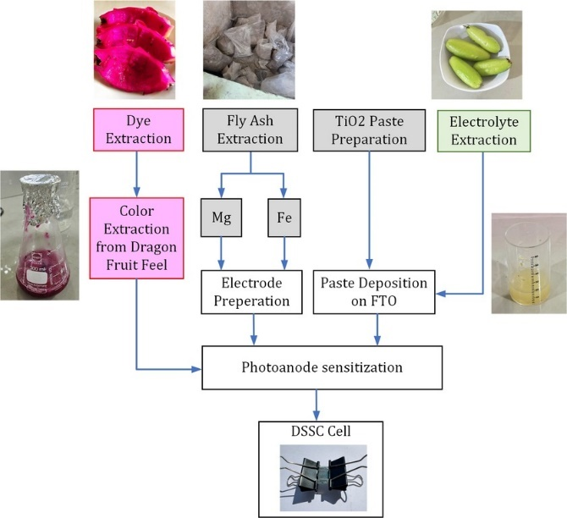
  - DSSC fabrication proposed in this study
Significant finding | : | The UV-Vis test shows the binder absorption range of 360-700 nm, making it an effective sensitizer for wide band gap semiconductors, and the absorption peak around 550 nm in the visible region. The experiment for electricity generation testing shows that Fe-induced DSSC generates more voltage ($V_{max}=406$ mV) than Mg-induced DSSC ($163$ mV). This result is due to the fact that Fe is a better conductor than Mg.

We have no conflicts of interest to disclose.

Thank you for your consideration of this manuscript.

Sincerely,

[Tresna Dewi]

______________________________

AUTHORSHIP STATEMENT

I/We wish to submit an original research article entitled “[Innovative Bio-Inspired Solar Cells using Fly Ash-Based Dye-Sensitized Cells with Fruit Extract Enhancements and Averrhoa bilimbi electrolyte]” for consideration by SINERGI.

All persons who meet authorship criteria are listed as authors, and all authors certify that they have participated sufficiently in work to take public responsibility for the content, including participation in the concept, design, analysis, writing, or revision of the manuscript.

Author 1
Name | : | Retyo Wizi Nafa Utami
Affiliation | : | Politeknik Negeri Sriwijaya
Email Address | : | rwznafa@gmail.com
Author 2
Name | : | Tresna Dewi
Affiliation | : | Politeknik Negeri Sriwijaya
Email Address | : | tresna_dewi@polsri.ac.id
Author 3
Name | : | Indrayani
Affiliation | : | Politeknik Negeri Sriwijaya
Email Address | : | iin_indrayani@polsri.ac.id

POTENTIAL REVIEWERS

Please send 3 (three) prospective reviewers (who are not yet registered in SINERGI) to speed up the review process who are competent for the topic and have a good reputation in the field. Please ensure that they are willing to review this paper.

Reviewer 1 | :
Name | : | Dr. Ir. Afritha Amelia, S. T., M. T., IPM
Affiliation | : | Politeknik Negeri Medan
Email Address | : | afrithaamelia@polmed.ac.id
Scopus url | : | https://www.scopus.com/authid/detail.uri?authorId=57195984241
Google Scholar url | : | https://scholar.google.com/citations?user=PPnSnK0AAAAJ&hl=en
Reviewer 2 | :
Name | : | Dr. Ir. Syarifa Fitria,S.T
Affiliation | : | Universitas Sriwijaya
Email Address | : | syarifafitria@ft.unsri.ac.id
Scopus url | : | https://www.scopus.com/authid/detail.uri?authorId=57206721700
Google Scholar url | : | https://scholar.google.com/citations?user=gY85DwsAAAAJ&hl=id
Reviewer 3 | :
Name | : | Prof. Dr. Ratna Ika Putri
Affiliation | : | Politeknik Negeri Malang
Email Address | : | ratna.ika@polinema.ac.id
Scopus url | : | https://www.scopus.com/authid/detail.uri?authorId=46461783800
Google Scholar url | : | https://scholar.google.co.id/citations?user=uxrs-MkAAAAJ&hl=id

