Forecast of Sugar Demand in Retail Using SARIMA and Decomposition Models  Study Case: A Retail Store in Indonesia | 

Titi Sari^{1*}
¹Industrial Engineering Study Program, Universitas Islam Negeri Sunan Kalijaga, Indonesia

Abstract  Forecasting at the retail level has been gaining attention because of its challenge due to the high sales variability This study discusses forecasting demand in a retail store, focusing on sugar as the research object. Every country consumes sugar and it is one of the staple foods in Indonesia. Despite its importance, not much research has been done on sugar at the retail level, especially in Indonesia. This study aims to find the most suitable forecast model that can capture data patterns well to give a good prediction of sugar sales in a retail store in Indonesia by comparing ARIMA and decomposition models. This study uses stationary test and ACF pattern analyses to prepare the data, a residual test to avoid forecast bias, cross-validation to check the forecast model performance, and MAPE as the performance indicator. SARIMA(0,0,0)(0,1,1)8 and multiplicative decomposition with 3 periods of double-moving average models are the best models among other possible SARIMA and decomposition models. Both models have similar patterns but different slopes because the decomposition model is more sensitive to data patterns, resulting in different MAPEs, which are 15.22% and 13.64%. Despite the popularity of ARIMA or SARIMA, decomposition can be an interesting alternative to be used since it can capture the data pattern better.  This is an open-access article under the CC BY-SA license   | Keywords:  Forecast;  SARIMA; Decomposition;  Retail; Sugar  Article History:  Received:  Revised:  Accepted:  Published:  Corresponding Author:  Titi Sari  Industrial Engineering  Study Program,  Universitas Islam Negeri Sunan Kalijaga (Islamic State of University), Indonesia  Email: titi.sari@uin-suka.ac.id

INTRODUCTION (R: 31, G: 78, B: 121)
Forecasting or demand prediction for retail has been receiving a lot of attention for a long time due to its difficulty because of the high variability of demand [1], [2]. Ma and Fildes [3] and Veiga et al. [4] show that having a good forecast can improve service level and demand satisfaction rate; it can also reduce total cost operations in retail. This is because retail can anticipate the change in demand better. Thus, forecasting can serve as a tool for decision-making in operating retail [2] and be an important part of retail to ensure the sustainability of retail operations.
Despite much research conducted about forecasts, a recent study done by Kumar et al. [5] mentioned there is still a limitation of good forecasting in retail because the forecast methods fail to capture the pattern of the demand, such as the trend and seasonal pattern. To have a good prediction, the forecast model should be able to capture and accommodate the data patterns.
Based on this concern, this study aims to discuss forecasting in retail using ARIMA or SARIMA and decomposition models. These models are used because both models are built to analyze and treat the pattern of the data before proceeding with the forecast [6]. Forcing the forecast models can not neglect the trend and seasonal data pattern.
Moreover, Almeida and Veiga [2], Hyndman and Athanasopoulos [6], and Hasan et al [7], mentioned that ARIMA or SARIMA is widely used because it can forecast demand well even when compared to more recent forecast models. It is worth noting that SARIMA is the extension of the ARIMA model for accommodating seasonal data patterns.
Despite the similar way of proceeding with the forecast, there is still a lack of study that compares both models to find the model that is more sensitive to the data pattern. Based on the writer's knowledge, only one study analyzed the comparison of SARIMA and decomposition forecast models; that was done by Guarnaccia et al. [8]. The result describes that both models perform well, but decomposition is better than SARIMA.
Several improvements can be made from previous study. Guarnaccia et al. [8] use basic statistics to analyze the residual forecast to compare the performance of both models. However, a deeper analysis of residual testing can be implemented to improve the analysis and avoid bias. Both SARIMA and decomposition have residual assumptions that should be fulfilled and part of the model characteristics [6], [9], which are not discussed deeply in the previous study. Furthermore, the previous study does not state which decomposition model is used, whether additive or multiplicative model. There are two types of decomposition models; those are additive and multiplicative decomposition models. The decision to choose between both models is based on the data graph or residual testing [9]. Considering this condition, this study does two residual analyses. First, check both the residual test for ARIMA or SARIMA and decomposition models to avoid bias. Second, compare both residual models as the performance comparison to find the most suitable forecast model.
The research object of this study is sugar demand or sales in retail. Sugar is chosen in this study because every country consumes sugar and it is part of the staple foods in Indonesia. Furthermore, in general, the research that discusses sugar at the retail level is limited, especially, since the studies related to sugar in Indonesia are not many.
Indonesia's sugar consumption value is fluctuating; however it keeps increasing and to meet this demand, Indonesia has been importing sugar since 1967 [10], [11]. This high consumption makes Indonesia the sixth country that has the highest sugar consumption in the world [12].
Indonesian government regards sugar as one of the staple foods and this decision is written down in the Presidential Degree of Republic Indonesia (Perpres Republik Indonesia) No. 59 Year 2020 about the government arrangement and storage of staple goods [13]. This consideration is because a lot of household expenses are spent on sugar and its availability impacts national inflation.
Sugar consumption is divided into two groups, sugar consumption for industry and sugar consumption for households. The household can buy sugar directly from retail. Based on the Central Statistics Agency [14], Indonesian people consume around 31.5 grams of sugar per capita weekly for household consumption in 2023. It means that there is a certain demand for sugar in the retail. Therefore, retail should provide sugar and maintain its stock efficiently so that it can achieve customer satisfaction due to the stock availability and avoid high inventory because of excessive stock. To achieve this, retail should have a good prediction for sugar demand.
Despite the importance of the sugar demand prediction in retail, there are no studies discussed it worldwide; instead, several studies about a prediction of sugarcane production [15], [16], sugar price [17], [18], and sugar consumption [19] have been done outside Indonesia. Mishra et al. [15] and Tyagi et al. [16] discuss the prediction of sugarcane production in India. Both studies use ARIMA to forecast; however Tyagi et al. [16] also use other forecasting methods; those are the naive, holt’s, and simple exponential smoothing models. The result describes that ARIMA performs the best among other methods. In line with Almeida and Veiga [2], Hyndman and Athanasopoulos [6], and Hasan et al [7], these studies also strengthen that ARIMA forecast gives good forecast results and can compete with other forecast models.
Limited studies regarding sugar also have been done in Indonesia. However, all of those studies do not discuss sugar at the retail level. Instead, the studies were done at the manufacturer [20], [21] and at national levels [22].
This information shows that the study that focuses on sugar demand or sales in retail has not been widely discussed. Most of the studies about sugar focus on a higher supply chain level or national level. Considering this research gap and its importance, this study discusses the forecast of sugar demand for retail.
In conclusion, this study aims to find the most suitable forecast model that can capture data patterns well to give a good prediction of sugar sales in a retail store in Indonesia using ARIMA or SARIMA and decomposition models. This research takes a study case of a retail store in Yogyakarta Province, Indonesia. This study discussed the comparison of both models, through the forecast result and how the models treat the data, which has not been pointed out yet.
This study helps to fill the research gaps. First, about a lack of research that analyzes the comparison of ARIMA or SARIMA with the decomposition forecast model. This comparison is done to find the forecast model that can capture data patterns better. Second, about a lack of studies on sugar-related topics at the retail level in general, especially for the Indonesia case study.
In this study, data preparation is done by using stationary test and pattern analysis. Later, residual testing for both models is analyzed to ensure there is no result bias, which was missing in the previous study. To ensure the forecast performance, the cross-validation method is used by dividing the data into training and testing data sets. This study uses MAPE as a performance indicator to check and compare the forecast error of both models.

METHOD
Research Design
The retail store for this study is located in one of the strategic areas in Yogyakarta Province, Indonesia. The retail lies near universities and other stores leading the surrounding area to be highly populated. There are a total of 72 monthly data about the sugar sales from 2018 until 2023 for a one-kilogram-package white sugar product.
The numbers of data fulfill the minimum data requirement for ARIMA. The ARIMA forecast model needs quite a lot of data, around 40 to 50 observation data [23]. The SARIMA model might require a bit more data compared to ARIMA to capture the seasonality component. It might even require more data if the seasonal length is long.
Picture 1 shows the research design of this study. Basic statistics is used to understand the data and stationary test is used to add information about the data and as the requirement to perform ARIMA or SARIMA. Stationer data means that its statistical properties such as mean, variance, etc. do not change or depend over time [24], [25]. It means that if the data is not stationer, it has some patterns, such as seasonal and trend.
If the data is stationer, ARIMA can be used directly to predict sales. However, if the data is not stationer, the data pattern such as trend and seasonality pattern should be checked using Autocorrelation Function (ACF). Only if the data pattern is known, the data can be transformed to be stationer.
For data that has a trend pattern, after the trend data is moved out from the data, the ARIMA model can be used to predict future sales. However, if the data has a seasonal pattern, SARIMA should be used to predict future sales.
There are usually several possible ARIMA or SARIMA models; however, not all of these possible models can be used to predict. To avoid bias, there are several ARIMA or SARIMA model assumptions should be fulfilled. The models that pass all assumptions, can be used to forecast future sales without bias. The best ARIMA or SARIMA model is the one that has the smallest forecast error among the models that fulfill the assumptions.
For non-stationary data, after ACF analysis is performed to find out the seasonality pattern, the data can be forecast directly using an additive or multiplicative model. The pattern of the data, such as the trend and seasonality should be moved out from the data. Later, the residual assumptions of additive and multiplicative are checked to choose the most suitable model among both of the models. After the model is chosen, a double-moving average model is used to predict the trend pattern in the data. Thus, the forecast model is a combination of decomposition and double moving average model. The period of double moving average is decided by comparing the forecast error of several periods used in the forecast model. The model that has the smallest forecast error is chosen to represent decomposition with a double-moving average forecast model.
To check the performance of the forecast model, this study uses cross-validation by splitting the observed data into two groups; those are training and testing data sets. The purpose of the training data set is to make the forecast model; while for testing data set is to see the performance of that built model by analyzing the forecast error. Because ARIMA and SARIMA need a lot of data to build the model, we only use the last 10 data, or around 14% of data, as the testing data set.
This study uses Mean Absolute Percentage Error (MAPE) to see the forecast performance. MAPE formula is:
$$MAPE=100x\frac{1}{n}\sum_{t=1}^{n}{\left|\frac{A_{t}-F_{t}}{A_{t}}\right|}$$ | (1)
With n is number of data, $A_{t}$ is the actual or observed data of period t, and $F_{t}$ is the forecast value of period t.

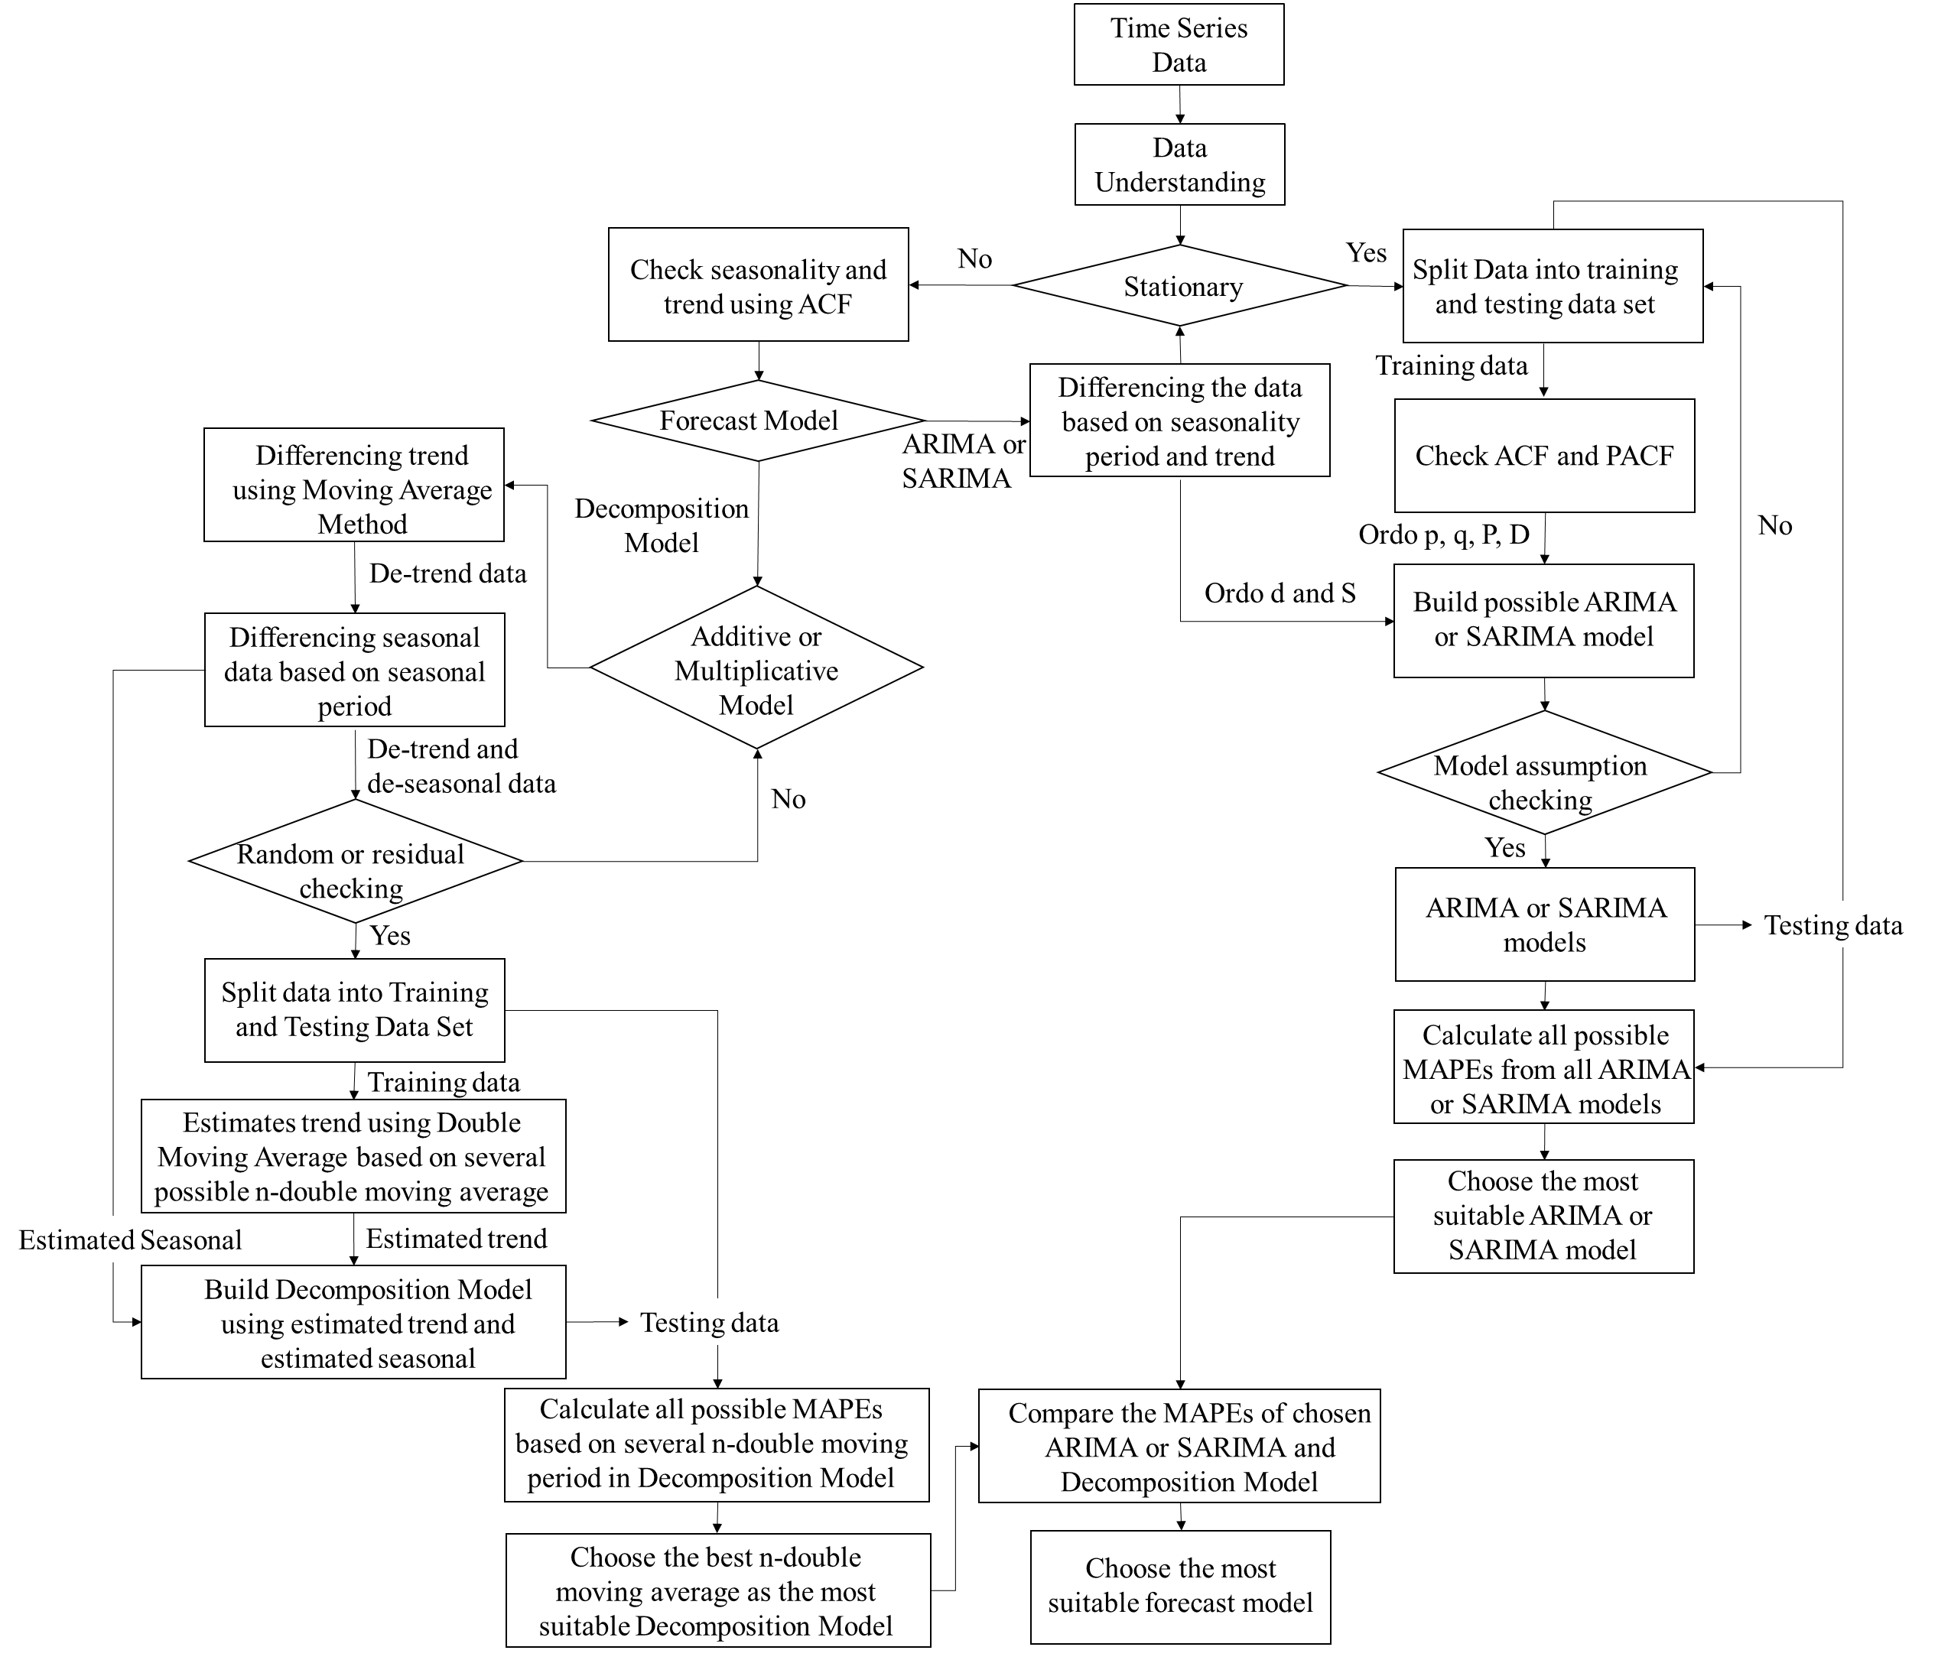

Figure 1. Research Design

ARIMA or SARIMA Forecast Model
SARIMA (p, d, q)(P, D, Q)s model is the seasonal adjustment of the ARIMA (p,d,q) model. The (p, d, q) in SARIMA correspond with ARIMA (p, d, q) with p as the order of autoregressive (AR), d as the order of differencing (I) to take the trend out of the data for achieving stationary data, and q is the order of moving average (MA). The (P, D, Q)s in SARIMA correspond with seasonal adjustment, where P, D, and Q are the order of seasonal autoregressive, seasonal differencing, and seasonal moving averages respectively, while s is the seasonal length. Order p and P are attained from the analyses of the number of significant spikes of Partial Autocorrelation Function (PACF), while order q and Q are attained from the analyses of the numbers of significant spikes of Autocorrelation Function (ACF). The significant spikes are the values that are out of the control line of the PACF or ACF graph.
The formula of ARIMA and SARIMA are [26]:
ARIMA:
$$∅_{p}\left(B\right){\left(1-B\right)}^{d}Y_{t}=θ_{0}+θ_{q}(B)e_{t}$$ | (2)
SARIMA:
$$∅_{p}\left(B\right)Φ_{p}{(B}^{s}){\left(1-B\right)}^{d}{\left(1-B^{s}\right)}^{D}Y_{t}$$  $$=θ_{0}+θ_{q}(B)Θ_{Q}(B^{s})e_{t}$$ | (3)
With $Y_{t}$ as the real or observed data value, $∅_{p}\left(B\right)$ is the order of p, $\left(1-B\right)$ is a differencing operator for non-seasonal patterns, d as the number of differencing, t as the period at t, $θ_{0}$ the constant term, $θ_{q}(B)$ as the order of q, and $e_{t}$ as the error at time t. These symbols are used both in ARIMA and SARIMA. For SARIMA there are more symbols in the formula. With $Φ_{p}{(B}^{s})$ in order of P, ${\left(1-B\right)}^{d}$ in order of Q, s as the seasonal period length, D as the seasonal differencing, $(1-B^{s})$ as a seasonal differencing operator.
There are several residual requirements for both ARIMA and SARIMA; so that the model can be considered valid or not biased. Those are the residuals of the model should be independent or not have autocorrelation, should be homoscedasticity, and have a normal distribution [27]. The autocorrelation and homoscedasticity can be checked by ACF and PACF graphs [2], [23], [27]. If no value surpasses the control line on those graphs, these assumptions are satisfied [23]. In addition, the Ljung-Box Statistics Test can also be used to check the autocorrelation [2].

Decomposition Forecast Model
The concept of the decomposition model is to break down the data composition to understand data and to help the forecast. For non-stationary data, the data can consist of trend, seasonal, and residual or error data.
There are two types of decomposition models, those are additive and multiplicative decomposition models. We use an additive decomposition if there is a considerably constant variability in the data over time and choose the other one for the opposite condition [9]. However, if it is difficult to decide which decomposition model is used, we can try to do both models and check the error assumption for both models. Later we can choose the model that satisfies this assumption.
The formula for decomposition models are [9]:
Additive Decomposition Model:
$$Y_{t}=T_{t}+S_{t}+e_{t}$$ | (4)
With the sum of seasonal component values is 0 or $\sum_{j=0}^{s}{S_{j}}=0$ and $e_{t}$ or error or residual component has Gaussian N(0, $σ^{2}$).
Multiplicative Decomposition Model:
$$Y_{t}=T_{t} x S_{t} x e_{t}$$ | (5)
With the sum of seasonal component values is the total of the seasonal length or $\sum_{j=0}^{s}{S_{j}}=s$ and $e_{t}$ has Gaussian N(1, $σ^{2}$).
Where $Y_{t}$ is the real data, $T_{t}$ is trend component value at period t, $S_{t}$ is the seasonal component value at period t, $e_{t}$ is error or residual or random component value at period t and j is the duration of the seasonal period.
It is worth noting that $S_{t}$ is constant for the same t for each seasonal period. Thus, after choosing the decomposition model, we can know the estimate of seasonal data.
For the trend data, we still need to do the other estimation. In this study, we use double moving average method to estimate it. Double moving average forecast model can help to predict trend patterns in the data [28]. The double moving average model is [29]:

Single Moving Average (S’) of period t:
$${S^{'}}_{t}=\frac{Y_{t}+Y_{t-1}+Y_{t-2}+…+Y_{t-n+1}}{n}$$ | (5)
Double Moving Average (S’’) of period t:
$${S''}_{t}=\frac{{S'}_{t}+{S'}_{t-1}+{S''}_{t-2}+…+{S'}_{t-n+1}}{n}$$ | (6)
The value of the constant or intercept of period t:
$$a_{t}=2{S'}_{t}-{S''}_{t}$$ | (7)
The value of the trend of period t:
$$b_{t}=\frac{2}{n-1}\left({S'}_{t}-{S''}_{t}\right)$$ | (8)
The forecast value of period t+m:
$$F_{t+m}=a_{t}+b_{t}m$$ | (9)
Where $Y_{t}$ is the input data and n is the number of periods chosen to make the average period.
This n period can be picked from a minimum of two periods. In this study, to decide the best n period to fit the forecasting model, several n periods are run to predict trend composition data, and this trend prediction is combined with the seasonal decomposition period to get the final decomposition forecast value. The best-fitted n period is chosen based on the smallest MAPE of the testing data set.

RESULTS AND DISCUSSION
Data Exploration and Understanding
To understand the data, we should see the graph of sugar sales data and know the basic statistics of the data. Figure 7 of the observed data part shows the sugar sales, while Table 1 shows the basic statistics to understand the data further. Table 1 shows that the retail can sell more than 100 packages of sugar every month. There is high variability of the sales shown by the coefficient of variability (CV). The CV is 27,44. That is higher than the variability severity threshold, which is 15% [30]. The high variability can lead to the difficulty of sales prediction. In line with this analysis, Figure 7 also shows that the sugar sales look very fluctuative.

Table 1. Basic Statistics of Data
Basic Statistics | Value
Total Data | 72
Mean | 185.46
Median | 179.5
Variance | 2589.6
Standard Deviation | 50.89
Coefficient of Variance | 27.44%
Maximal | 389
Minimal | 103
P-value of Kolmogorov-Smirnov Test | >0.15 (normal distribution)
Kwiatkowski-Phillips-Schmidt-Shin (KPSS) value | 0.4419 (non-stationer)

Another data exploration that should be done is checking the stationary of data. To check it, we can use the Kwiatkowski-Phillips-Schmidt-Shin (KPSS) test [6], [25] in R Software. KPSS results show that the KPSS test value of this data is 0.44, which is higher than the critical value of 10% significant level, which is 0.34. Thus, the data is not stationer.
Because of this finding, the seasonality and trend pattern are checked using ACF. Figure 2 shows the ACF Graph from analysis done in Minitab Software. The data is considered to have a seasonality pattern if there is a repetition of a high number or spikes of ACF value in the same multiple periods [31], while a trend pattern is considered if the ACF scores decrease over time gradually.

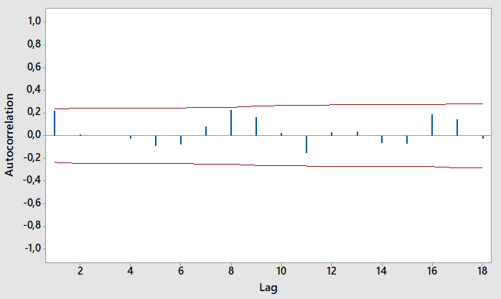
Figure 2. ACF Graph of Sugar Sales

Figure 2 indicates that there are spikes in periods 1, 8, and 16 months. Thus the sales of sugar tend to have seasonal data with a seasonal length of 8 months. The seasonality of sugar sales is quite long, thus it requires a lot of data to analyze so that it can capture the seasonality pattern. Furthermore, by knowing there is a seasonal pattern, we should use the SARIMA model instead of the ARIMA model to forecast.

SARIMA (p, d, q)(P, D, Q)s Forecast
Since the sales are not stationary, the data should be transformed first. This transformation is done in the training data set by taking out the seasonal pattern by seasonal differencing. This differencing is done by subtracting the data on each same seasonal period from its previous observation data. The KPSS test shows that this transformed data has a value of 0.12. This value indicates that the transformed data is stationer since the KPSS value is under the critical values of 10% significance level, which is 0.34. This result explains that there is no need to differencing the trend pattern. Thus, this new data is ready to analyze.
Since we know there is no need to do trend differencing, we can write trend order in (p,d,q) as (0,0,0). We should find out the seasonal order (P, D, Q)s. Because the seasonal length is 8, we can write s=8 and we know that we do one-time seasonal differencing, therefore, D=1.
To find P and Q, we need to see PACF and ACF graphs. The numbers of PACF and ACF values that exceed the control line in PACF and ACF graphs are considered the maximum number of order P and Q possibilities, respectively. These spikes happen in the corresponding number of lag values that same as the seasonal period length or its multiplication length [6].

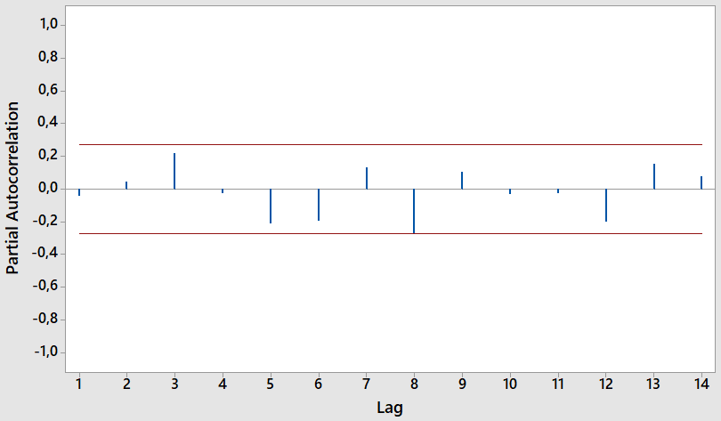
(a)

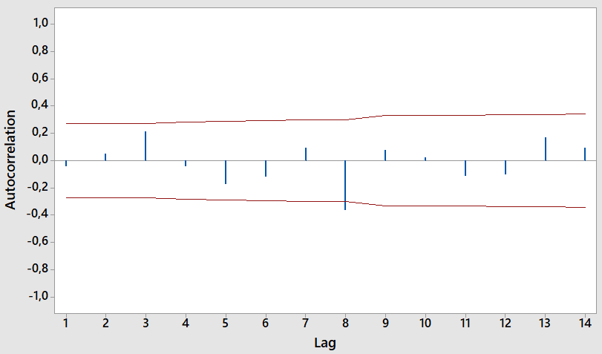
(b)
Figure 3. Graph of Transformed Training Data After Seasonal Differencing (a) PACF and (b) ACF

Figure 3 (a) describes the PACF and Figure 3 (b) explains ACF graphs of the stationer data. Both figures show that there is a spike in lag 8 for each graph so that P=1 and Q=1. Based on these figures, there are three possible SARIMA models, those are SARIMA (0,0,0)(0,1,1)8, SARIMA (0,0,0)(1,1,0)8, and SARIMA (0,0,0)(1,1,1)8. Those three models are run in the training data to see whether the SARIMA assumptions are satisfied. If more than one model can satisfy the residual requirements, we need to compare the performance of those forecast models by choosing the smallest MAPE from testing data.
After running all possible SARIMA models, there is only one model that satisfies residual assumptions; the model is SARIMA (0,0,0)(0,1,1)8. The residual of the forecast should be independent, homoscedasticity, and have a normal distribution. These assumptions can be checked using ACF, PACF, Ljung-Box test, and normal distribution tests.
Figure 4 shows these residual tests of SARIMA (0,0,0)(0,1,1)8. Figures 4 (a) and (b) indicate that there is no value of each PACF and ACF graph that is out of the control line, concluding that the residuals are independent or have no autocorrelation. These figures also indicate that the residuals are homoscedasticity. Strengthening this analysis, Figure 4 (c) also explains that the P-value of the Ljung-Box test is above 0.05; indicating that the residuals are independent. Figure 4 (d) shows that the residual also has a normal distribution.
After we find the forecast model, we need to see the performance of this model by calculating MAPE. Based on the testing data, the MAPE of this forecast model is around 15.22%.

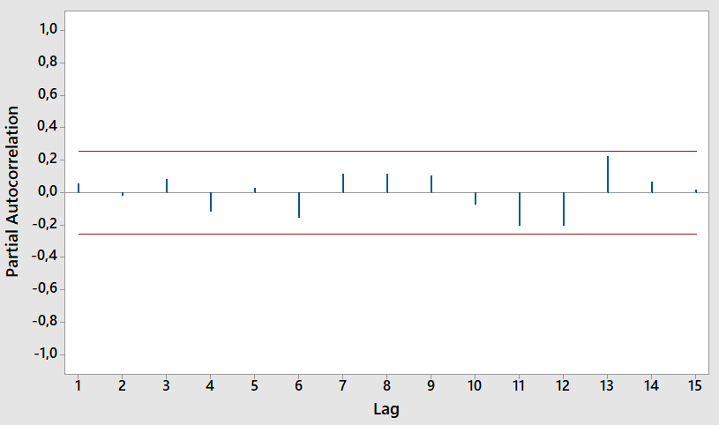 | 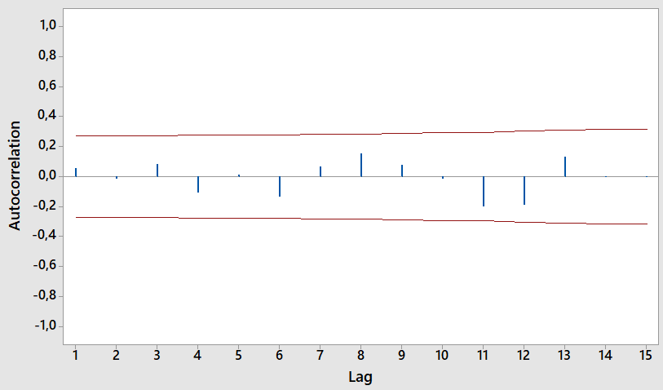
(a) | (b)
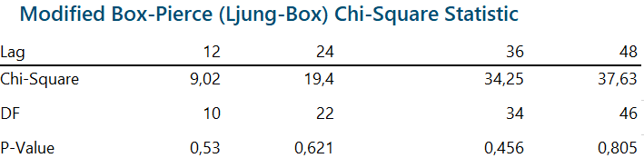 | 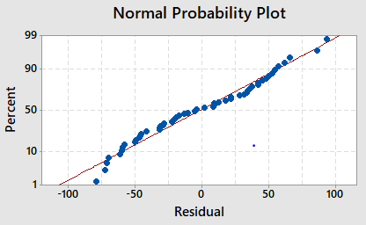
(c) | (d)
Figure 4. Residual Testing of SARIMA(0,0,0)(0,1,1)8 Model (a) PACF, (b) PACF, (c) Normal Probability Plot, (d) Ljung-Box Test

Decomposition Forecast

After running additive and multiplicative decomposition models based on the formula (4) and (5), and later checking the residual or random assumptions for both models, only the multiplicative model meets this assumption. Figures 5 and 6 give information about the test of both decomposition models using Kolmogorov-Smirnov Test. Figure 6 shows that the distribution of residual in the multiplicative model is normal and its mean is nearly 1, which fulfills the residual assumption for the multiplicative decomposition model. Figure 5 shows that the residual test for additive decomposition can not meet its residual assumption. Although the residual distribution is normal, its mean is around -1.47, which is far from 0. Consequently, the residual assumption of the additive model is not satisfied. Hence we only use the multiplicative to forecast.

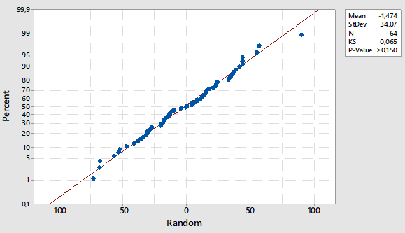
Figure 5. Additive Decomposition Residual Test

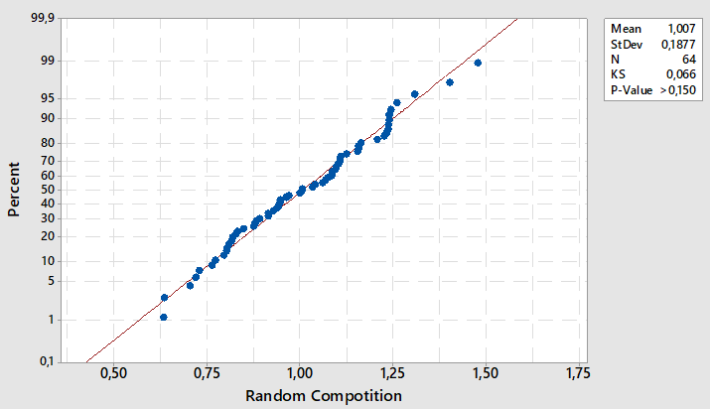
Figure 6. Multiplicative Decomposition Residual Test

Figure 7 shows the result of multiplicative decomposition in sugar sales. This figure has not shown the forecast value yet, but it shows each decomposition pattern of the data. The decomposition not only can be used to help forecast but also can be used to explore and understand the data pattern. From Figure 7 in the observed data, it can be seen that the initial data does not have constant variability over time; thus it makes sense that the multiplicative decomposition serves better than additive decomposition [9].
Figure 7 explains that there is a declining trend in sales of sugar. However, this trend is only little and almost not noticeable. This slight downward trend might be the reason for SARIMA does not consider it in the model. For the seasonal data, after decomposition is done, the estimation of seasonal data can be known, and the values are fixed for each of the same t periods in different seasonal times.

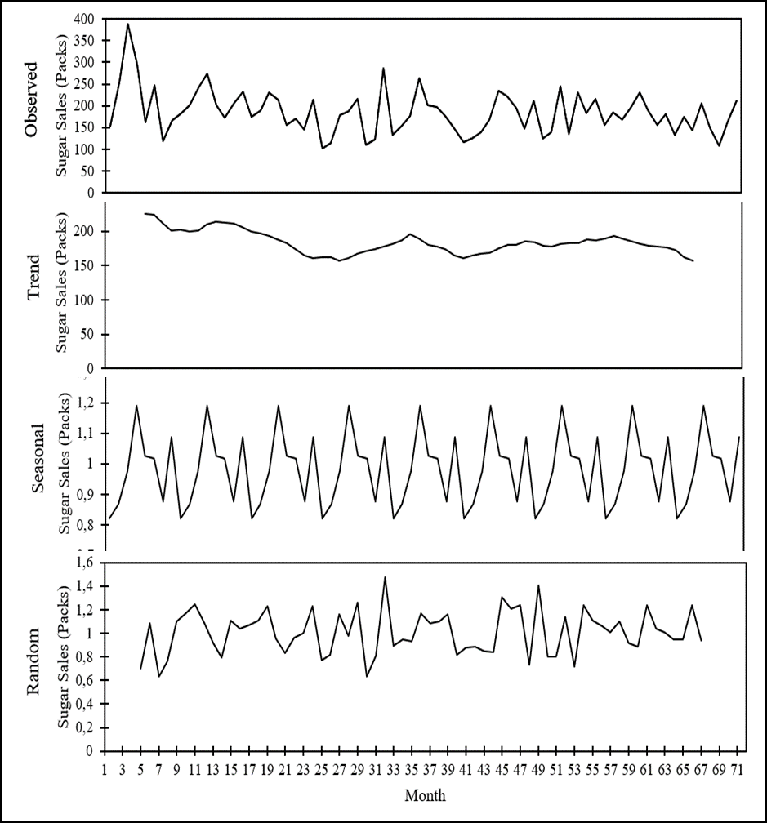
Figure 7. Multiplicative Decomposition of Sugar Sales
This research estimates the trend data by using a double-moving average. To find the period in a double-moving average that has the minimum MAPE, the simulation using several periods in a double-moving average with a multiplicative decomposition forecast model is done. Figure 8 informs the MAPE comparison of several possible periods. This figure shows that MAPE has a U-shape graph with MAPE forecast going down from period two to period three and later it keeps increasing. The minimum MAPE for this model is 13.64%, which happens in period three. Hence, we use multiplicative decomposition with 3 periods of double moving average forecast model.

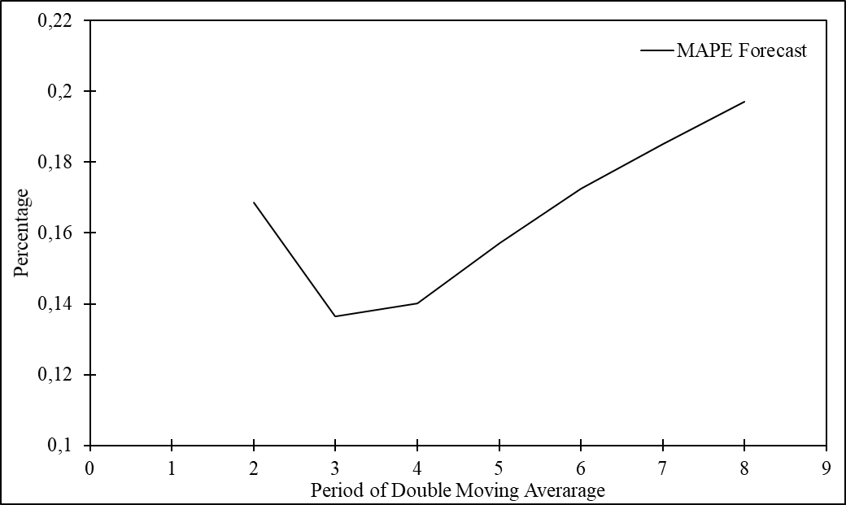
Figure 8. MAPE Comparison of n Period from Double Moving Average for Multiplicative Decomposition Forecast Model

Discussion
This study aims to find the most suitable forecast model that can capture and accommodate data patterns well to give a good prediction of sugar sales in a retail store using ARIMA or SARIMA and decomposition models. This study does two residual analyses. First, check both the residual test for ARIMA and decomposition models to avoid bias. Second, compare both residual models as the performance comparison to find the most suitable forecast model.
Based on the pattern analysis for ARIMA, which are shown in Figure 2 and Figure 3 previously, and also the residual testing in Figure 4. SARIMA(0,0,0)(0,1,1)8 is the only possible model of ARIMA for prediction. For the decomposition model, after running both additive and multiplicative models and checking both residual properties or assumptions, the multiplicative model is the model that fulfills the assumptions. Moreover, based on the observed sales graph in Figure 7, it can be seen that the sales do not have constant variability over time. For this type of data, the multiplicative is mentioned to be the suitable decomposition model [9]. Later, based on the MAPEs comparison of several periods of double moving average in Figure 8, multiplicative decomposition with 3 periods of double moving average forecast model is chosen to represent the most suitable decomposition model.
Table 2 shows the MAPEs of SARIMA(0,0,0)(0,1,1)8 and multiplicative decomposition using 3 periods of double-moving average forecast models to compare the forecast performance in the testing data set. Both models have good prediction abilities since both have MAPEs under 20% [32], [33]. However, the later forecasting model performs better by 1.58%. Although both forecast models do not have MAPE under 10% to get an excellent prediction ability standard [32], [33], this result can be considered good enough since the sales of sugar have high variability based on the coefficient of variation (CV) that is above the accepted standard. The CV of this sales is 27.44%, while the CV standard is 15%. The CV of sugar sales can be seen in Table 1 previously. This high volatility in retail is similar to what has been mentioned in previous studies by Badorf and Hoberg [1] and Almeida and Veiga [2].

Table 2. MAPE Comparison of Forecast Models
Possible Forecast Models | MAPE
SARIMA (0,0,0)(0,1,1)8 | 15.22%
Multiplicative Decomposition Using Double Moving Average | 13.64 %

This result is in line with Guarnaccia et al. [8] research. As mentioned previously, in the study of Guarnaccia et al. [8], there is no clear explanation of which decomposition type is used and no residual test of decomposition. If the residual test for the decomposition model is not performed, there will be a possibility of bias in the result. Resulting in a problem for far future forecasts, in which the data is not analyzed in the study. This is because the forecast model is rigid or very sensitive to the data.
This problem is tackled in this study by analyzing the residual testing for the decomposition model, which was missing in the previous study. However, unexpectedly, the results of both research are the same; which shows that the decomposition model performs better than SARIMA. This condition might be because the decomposition model is more sensitive and can accommodate the data pattern better.
There is a significant difference in how both models treat the data pattern. The crucial difference for both models is that SARIMA depends on the stationary test every time the differencing is done to treat the data pattern, either seasonal or trend differencing. Further, differencing is needed if the stationary test shows the data has not been stationary yet. Different from SARIMA, the decomposition model only depends on the stationary test for initial data checking. If the stationary test shows that the data is not stationary and shows there is seasonal data in the ACF, both the seasonal and trend differencings will always be performed, without checking the seasonality test again. Thus, no matter how small the trend pattern is, the decomposition will always treat it as a significant pattern to be considered. Making the decomposition model more sensitive to trend pattern.
Based on many previous studies, ARIMA or SARIMA is a forecast model that is widely known and used for prediction [2], [6], [7], [15], [16]. However, based on this analysis, the decomposition model can be a good alternative to be used for prediction at the retail level because it can capture and accommodate data patterns better than ARIMA or SARIMA. As mentioned in a previous study by Kumar et al. [5], a forecast model that can capture the trend and seasonal patterns is important and still lacking at the retail level.
Figure 9 shows the forecast result of SARIMA and decomposition models for the testing and the next 10 periods in the future to see the forecast and the comparison between real data and both forecasts. The pattern of the forecast is quite similar, but there is a difference in the level or number of sales forecasted. This similarity is because those forecast methods use the same approach to predict, which moves out the considered significant data pattern by using differencing, before performing a forecast.
If we only considered MAPE for the forecasting performance, we tend to choose the model that has the smallest MAPE, which is multiplicative decomposition using the double moving average forecast model for this case. However, we need to understand that the longer the forecast is used, the lower the number of the forecast result is. This is because the slightly inclined trend from observed sales is considered in the decomposition model. For the SARIMA forecast, this condition does not occur. The forecast for a long period will fluctuate at the same level because SARIMA does not consider the trend. To avoid a deep slope for the long forecast in the decomposition model, it is better to not forecast for a long period and try to observe new data to adjust the forecast model. Moreover, since the double moving average period is only three, the forecast result is highly affected by the recent sales; thus making the long period forecast is not preferable.
It is worth mentioning that for the decomposition model, the method for predicting the trend pattern contributes to the quality of the decomposition forecast result. Hence, different methods to predict the trend such as linear regression and others can lead to different MAPEs. It can be an interesting topic to find the most suitable method to predict the trend in the decomposition model.
It is also worth noting that it is impossible to use both forecast models in Software R with the available package because R needs more input data since the seasonal period is quite long. Therefore, the calculation forecast in this study is majorly used Minitab and M.S. Excel. This also indicates the necessity to have more input data.

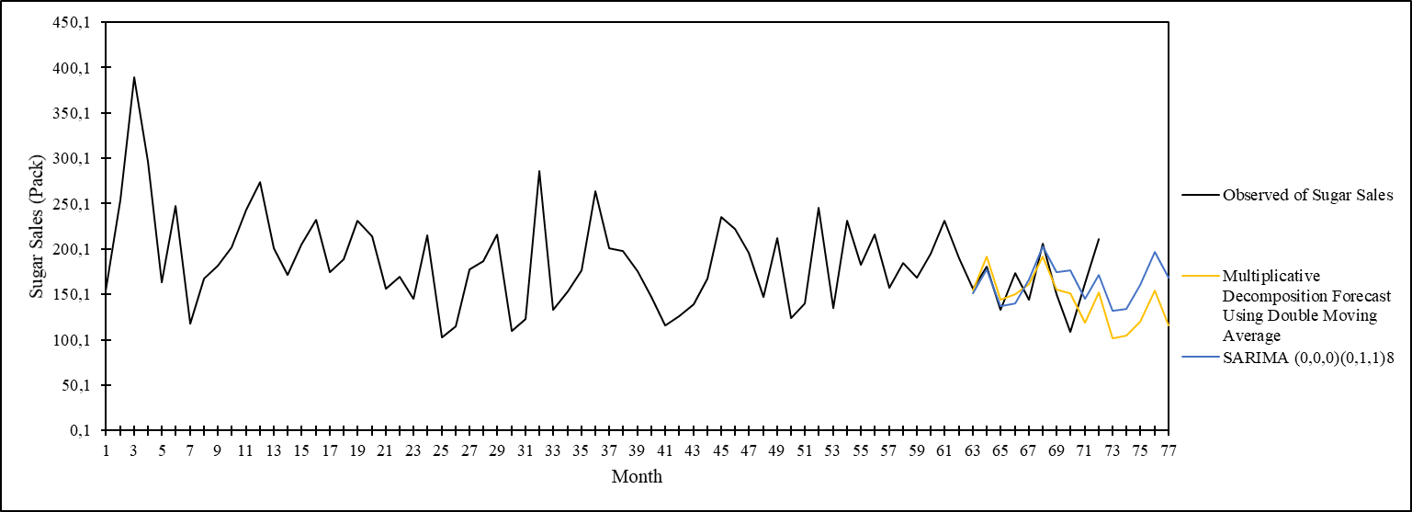
Figure 9. Comparison of Forecast Result

CONCLUSION
This study focuses on finding the most suitable forecast model that can capture data patterns well to give a good prediction of sugar sales in a retail store using ARIMA or SARIMA and decomposition models. This research takes a study case of a retail store in Yogyakarta Province, Indonesia.
This research tries to fill two research gaps. First, about a lack of studies that analyze the comparison of SARIMA with the decomposition forecast model. Second, about a lack of studies on sugar-related topics at the retail level in general, especially for the Indonesia case study. By filling the first research gap, this study aims to contribute to finding the forecast method that can capture the trend and seasonal pattern well at the retail level. In a recent study [5], the lack of a suitable method to accommodate the data pattern at the retail level is mentioned as a concern.
Sugar sales in this retail store have high volatility, which is shown by the coefficient of variability (CV). The CV of these sales is 27.44%, which is almost twice as high as the maximum standard of accepted CV. Therefore, it is quite difficult to get good forecast results. It is also known that sugar sales in retail have only a slight downside trend with a seasonal pattern that has a high seasonal length, which is 8 months. This condition leads to the need for big numbers of input data needed.
Despite these challenges, both SARIMA and multiplicative decomposition with double moving average forecast models achieve good forecast results, which is indicated by small MAPE. The MAPEs of both models are 15.22% and 13.64% respectively.
Both models have similar forecast patterns but with different slopes. This is because both models consider the seasonal pattern in the data but only the decomposition model considers the trend pattern. The decomposition model is forced to consider the trend pattern as a significant pattern to be treated, no matter how small the trend pattern is, but this is not the case for the SARIMA model. This condition makes the decomposition model to be more sensitive and can accommodate trend pattern better compared to SARIMA.
The duration of the forecast also becomes another concern. Based on the smallest MAPE, this study uses multiplicative decomposition with 3 periods of double moving average as the most suitable forecast model for this case. This short period of double moving average means the forecast can not be done for a long duration because the forecast is heavily affected by recent sales.
The quality decomposition forecast result heavily depends on the trend prediction. This study uses a double-moving average to predict the trend. However, different trend prediction models can lead to different MAPEs. Therefore, it might be interesting to find other models to predict trend pattern that are more suitable to be combined with the decomposition model and can be used for longer forecast periods.
It is worth noting that no forecasting model works well for all other cases, without exception. Because the suitable forecast model depends on the characteristics of the data. Therefore, other retail stores might need a different approach to forecast their sugar demand.

REFERENCES
[1] F. Badorf and K. Hoberg, “The impact of daily weather on retail sales: An empirical study in brick-and-mortar stores,” J. Retail. Consum. Serv., vol. 52, no. March 2019, p. 101921, 2020, doi: 10.1016/j.jretconser.2019.101921.
[2] W. M. de Almeida and C. P. da Veiga, “Does demand forecasting matter to retailing?,” J. Mark. Anal., vol. 11, no. 2, pp. 219–232, 2023, doi: 10.1057/s41270-022-00162-x.
[3] S. Ma and R. Fildes, “Retail sales forecasting with meta-learning,” Eur. J. Oper. Res., vol. 288, no. 1, pp. 111–128, 2021, doi: 10.1016/j.ejor.2020.05.038.
[4] C. P. da Veiga, C. R. P. da Veiga, W. Puchalski, L. dos S. Coelho, and U. Tortato, “Demand forecasting based on natural computing approaches applied to the foodstuff retail segment,” J. Retail. Consum. Serv., vol. 31, pp. 174–181, 2016, doi: 10.1016/j.jretconser.2016.03.008.
[5] A. Kumar, R. Shankar, and N. R. Aljohani, “A big data driven framework for demand-driven forecasting with effects of marketing-mix variables,” Ind. Mark. Manag., vol. 90, no. November 2018, pp. 493–507, 2020, doi: 10.1016/j.indmarman.2019.05.003.
[6] R. J. Hyndman and G. Athanasopoulos, Forecasting : Principles and Practice, 3th ed. Melbourne, Australia, 2021.
[7] M. R. Hasan, M. A. Kabir, R. A. Shuvro, and P. Das, “A Comparative Study on Forecasting of Retail Sales,” arXiv, pp. 1–14, 2022, [Online]. Available: http://arxiv.org/abs/2203.06848.
[8] C. Guarnaccia, J. Quartieri, and C. Tepedino, “Deterministic decomposition and seasonal ARIMA time series models applied to airport noise forecasting,” AIP Conf. Proc., vol. 1836, 2017, doi: 10.1063/1.4982019.
[9] B. O. Emmanuel, D. Enegesele, and C. O. Arimie, “Additive Decomposition with Arima Model Forecasts When the Trend Component Is Quadratic,” OALib, vol. 07, no. 07, pp. 1–20, 2020, doi: 10.4236/oalib.1106435.
[10] W. Muhaimin and D. Sari, “Factors Affecting the Demand and Import of Indonesian Sugar,” J. Glob. Econ., vol. 7, no. 2, pp. 1–3, 2019, [Online]. Available: https://ssrn.com/abstract=3458678.
[11] W. P. Inayaturrohmah, I. Istiqomah, and R. S. Gunawan, “Determinants of Indonesian Sugar Import,” Signifikan J. Ilmu Ekon., vol. 12, no. 2, pp. 275–286, 2023, doi: 10.15408/sjie.v12i2.28044.
[12] F. A. S. United States Department of Agriculture, “Sugar : World Markets and Trade Guatemala Sugar Exports are Down While Domestic Demand Continues to Grow Guatemala is a Top 5 Exporter,” 2024. [Online]. Available: https://apps.fas.usda.gov/psdonline/circulars/sugar.pdf.
[13] J. Widodo, “(1) Undang-Undang,” Jakarta, Indonesia, 2020. [Online]. Available: https://peraturan.bpk.go.id/Details/136174/perpres-no-59-tahun-2020.
[14] B. P. Statistik, “Subjek Tabel Terkait Rata - Rata Konsumsi Perkapita Seminggu Menurut Kelompok Bahan Makanan Lainnya Per Kabupaten / Kota Rata - Rata Konsumsi Perkapita Seminggu Di Daerah Pedesaan Menurut Komoditi Makanan Dan Golongan Pengeluaran Per Kapita Seminggu Rata,” 2023. [Online]. Available: https://www.bps.go.id/id/statistics-table/1/OTUwIzE=/rata-rata-konsumsi-per-kapita-seminggu-beberapa-macam-bahan-makanan-penting--2007-2023.html.
[15] P. Mishra et al., “Modeling and Forecasting of Sugarcane Production in India,” Sugar Tech, vol. 23, no. 6, pp. 1317–1324, 2021, doi: 10.1007/s12355-021-01004-3.
[16] S. Tyagi, S. Chandra, and G. Tyagi, “Statistical modelling and forecasting annual sugarcane production in India: Using various time series models,” Ann. Appl. Biol., vol. 182, no. 3, pp. 371–380, 2023, doi: 10.1111/aab.12825.
[17] E. M. Amrouk and T. Heckelei, “Forecasting International Sugar Prices: A Bayesian Model Average Analysis,” Sugar Tech, vol. 22, no. 4, pp. 552–562, 2020, doi: 10.1007/s12355-020-00815-0.
[18] J. Zhang, Y. Meng, J. Wei, J. Chen, and J. Qin, “A Novel Hybrid Deep Learning Model for Sugar Price Forecasting Based on Time Series Decomposition,” Math. Probl. Eng., vol. 2021, 2021, doi: 10.1155/2021/6507688.
[19] A. Kantasaard, A. Bekrar, A. Aitelcadi, and Y. Saliez, “Artificial intelligence for forecasting in supply chain management: A case study o White Sugar consumption rate in Thailand,” IFAC-PapersOnLine, vol. 52, no. 13, pp. 725–730, 2019, doi: 10.1016/j.ifacol.2019.11.201.
[20] S. Wardah, N. Nurhasanah, and W. Sudarwati, “Integration models of demand forecasting and inventory control for coconut sugar using the ARIMA and EOQ modification methods,” J. Sist. dan Manaj. Ind., vol. 7, no. 2, pp. 127–138, 2023, doi: 10.30656/jsmi.v7i2.6500.
[21] A. W. A. Wibowo and F. Maimunah, “Sugar Demand Forecasting in Pt Xyz With Winqsb Software,” BAREKENG J. Ilmu Mat. dan Terap., vol. 17, no. 3, pp. 1631–1640, 2023, doi: 10.30598/barekengvol17iss3pp1631-1640.
[22] B. R. I. Rosari, R. Sarno, M. S. Filsafan, and A. T. Haryono, “Indonesia White Sugar Supply and Demand Forecast Using Machine Learning,” 2023 1st Int. Conf. Adv. Eng. Technol. ICONNIC 2023 - Proceeding, pp. 18–23, 2023, doi: 10.1109/ICONNIC59854.2023.10467262.
[23] G. Perone, “Using the SARIMA Model to Forecast the Fourth Global Wave of Cumulative Deaths from COVID-19: Evidence from 12 Hard-Hit Big Countries,” Econometrics, vol. 10, no. 2, 2022, doi: 10.3390/econometrics10020018.
[24] G. E. P. Box, G. M. Jenkins, G. C. Reinsel, and G. M. Ljung, Time Series Analysis: Forecasting and Control, 5th ed., vol. 11. Hoboken, New Jersey: John Wiley & Sons, Inc., 2016.
[25] U. M. Sirisha, M. C. Belavagi, and G. Attigeri, “Profit Prediction Using ARIMA, SARIMA and LSTM Models in Time Series Forecasting: A Comparison,” IEEE Access, vol. 10, no. October, pp. 124715–124727, 2022, doi: 10.1109/ACCESS.2022.3224938.
[26] C. C. Nwokike and E. W. Okereke, “Comparison of the Performance of the SANN, SARIMA and ARIMA Models for Forecasting Quarterly GDP of Nigeria,” Asian Res. J. Math., vol. 17, no. 3, pp. 1–20, 2021, doi: 10.9734/arjom/2021/v17i330280.
[27] W. Hu, S. Tong, K. Mengersen, and D. Connell, “Weather Variability and the Incidence of Cryptosporidiosis: Comparison of Time Series Poisson Regression and SARIMA Models,” Ann. Epidemiol., vol. 17, no. 9, pp. 679–688, 2007, doi: 10.1016/j.annepidem.2007.03.020.
[28] D. Febrian, S. I. Al Idrus, and D. A. J. Nainggolan, “The Comparison of Double Moving Average and Double Exponential Smoothing Methods in Forecasting the Number of Foreign Tourists Coming to North Sumatera,” J. Phys. Conf. Ser., vol. 1462, no. 1, pp. 0–10, 2020, doi: 10.1088/1742-6596/1462/1/012046.
[29] D. M. Khairina, R. Khairunnisa, H. R. Hatta, and S. Maharani, “Comparison of the trend moment and double moving average methods for forecasting the number of dengue hemorrhagic fever patients,” Bull. Electr. Eng. Informatics, vol. 10, no. 2, pp. 978–987, 2021, doi: 10.11591/eei.v10i2.2711.
[30] O. Shechtman, “The Coefficient of Variation as an Index of Measurement Reliability,” in Methods of Clinical Epidemiology, no. Springer Series on Epidemiology and Public Health, S. A. R. Doi and G. M. Williams, Eds. Verlag Berlin Heidelberg: Springer, 2013, pp. 39–49.
[31] H. Musbah, M. El-Hawary, and H. Aly, “Identifying seasonality in time series by applying fast fourier transform,” 2019 IEEE Electr. Power Energy Conf. EPEC 2019, vol. 3, pp. 3–6, 2019, doi: 10.1109/EPEC47565.2019.9074776.
[32] P. Xu, “Analysis and Prediction of Total Retail Sales of Consumer Goods Based on Multiple Regression and SARIMA Model,” 2020 Int. Conf. Big Data Appl. Econ. Manag., no. Icbdem, pp. 136–149, 2020, doi: 10.25236/icbdem.2020.021.
[33] T. Falatouri, F. Darbanian, P. Brandtner, and C. Udokwu, “Predictive Analytics for Demand Forecasting - A Comparison of SARIMA and LSTM in Retail SCM,” Procedia Comput. Sci., vol. 200, no. 2019, pp. 993–1003, 2022, doi: 10.1016/j.procs.2022.01.298.

