Forecast of Sugar Demand in Retail Using SARIMA and Decomposition Models  Study Case: A Retail Store in Indonesia | 

Titi Sari^{1*}
¹Industrial Engineering Study Program, Universitas Islam Negeri Sunan Kalijaga, Indonesia

Abstract  Sugar is one of the staple foods in Indonesia and its importance has been widely known worldwide. Many studies have been conducted related to sugar; however, most of them focus on the higher level supply chain, such as manufacturer and national level. Furthermore, only a small number of studies discuss sugar in Indonesia. This paper tries to fill the research gap by discussing sugar at the retail level by focusing on the time series forecast for sugar demand in a retail store in Indonesia. This study also aims to understand the pattern of sugar demand for retail in Indonesia, see how volatile the sugar demand pattern is for retail, understand the challenge of predicting it, and the most suitable forecast model to estimate it. SARIMA(0,0,0)(0,1,1)8 and multiplicative decomposition with double moving average models are used to predict sugar sales. Despite the high volatility of data, which is almost twice as high as the acceptable volatility standard, both models can be classified as good forecast models by having MAPEs of 15.22% and 13.64%. After comparing the forecast pattern, it is shown that both models have a similar pattern but have a different slope due to the nature of how the models treat the data.  This is an open access article under the CC BY-SA license   | Keywords:  Forecast;  SARIMA; Decomposition  Retail; Sugar  Article History:  Received:  Revised:  Accepted:  Published:  Corresponding Author:  Titi Sari  Industrial Engineering  Study Program,  Universitas Islam Negeri Sunan Kalijaga (Islamic State of University), Indonesia  Email: titi.sari@uin-suka.ac.id

INTRODUCTION (R: 31, G: 78, B: 121)
Sugar is one of the important foods in the world since every country consumes sugar, including Indonesia. Indonesia's sugar consumption value is fluctuating; however it keeps increasing and to meet this demand, Indonesia has been importing sugar since 1967 [1], [2]. This high consumption makes Indonesia the sixth country that has the highest sugar consumption in the world [3].
Indonesian government regards sugar as one of the staple foods and this decision is written down in the Presidential Degree of Republic Indonesia (Perpres Republik Indonesia) No. 59 Year 2020 about the government arrangement and storage of staple goods [4]. This consideration is because a lot of household expenses are spent on sugar and its availability impacts national inflation.
Sugar consumption is divided into two groups, sugar consumption for industry and sugar consumption for households. The household can buy sugar directly from retail. Based on the Central Statistics Agency [5], Indonesian people consume around 31.5 grams of sugar per capita weekly for household consumption in 2023. It means that Indonesian people consume sugar daily and there is a certain demand for sugar in the retail. Therefore, retail should provide sugar and maintain its stock efficiently so that it can achieve customer satisfaction due to the stock availability and avoid high inventory because of excessive stock. To achieve this, retail should predict the sugar demand effectively.
Despite the importance of understanding the pattern and the prediction of sugar demand in retail, there are still limited studies discussing this topic; instead, several studies about a prediction of sugarcane production, sugar price, and sugar consumption have been done. Mishra et al. [6] and Tyagi et al. [7] discuss the prediction of sugarcane production in India. Both studies use ARIMA to forecast; however Tyagi et al. [7] also use other forecasting methods; those are the naive, holt’s and simple exponential smoothing models. The result describes that ARIMA performs the best among other methods. Different from those studies, Amrouk and Heckelei [8] and Zhang et al. [9] estimate the sugar price in London and international sugar prices. Another research is done by Kantasaard et al. [10] who forecast about white sugar consumption rate in Thailand using regression and neural network methods.
In addition, studies about sugar in Indonesia have also been done. Wardah et al. [11] and Wibowo and Maimunah [12] predict sugar demand for manufacturers. Wardah et al. [11] forecast coconut sugar demand using ARIMA and combine it with EOQ policy to help inventory management; while Wibowo and Maimunah [12] compare white sugar demand forecast of linear regression, single and double exponential smoothing models. Rosari et al. [13] forecast the demand for sugar in Indonesia too; additionally, they include a sugar supply forecast to analyze the supply-demand balance. Muhaimin and Sari [1] and Inayaturrohmah [2] also analyze the factors affecting sugar import in Indonesia. In general, studies about sugar in Indonesia are limited; however other related studies have been done on sugar-sweetened beverages, such as the studies that have been done by Sanjaya and Sadono [14] and Widarjono et al. [15].
This information shows that the study that focuses on sugar demand or sales in retail has not been widely discussed. Most of the studies about sugar focus on a higher supply chain level or national level. Furthermore, the topic of forecasting for retail has been receiving a lot of attention for a long time due to the difficulty because of the high variability of demand [16], [17]. Considering this research gap and its importance, this study discusses the forecast of sugar demand for retail. This research takes a study case of a retail store in Yogyakarta Province, Indonesia. This study held the assumption that sugar sales represent the sugar demand.
This study uses the ARIMA or SARIMA forecast model. SARIMA is the extension of the ARIMA model. Based on several studies, the ARIMA forecast model performs well in estimating sugar production and manufacturer sugar demand [6], [7], [12]. This might be because ARIMA can capture the volatility pattern of sugar data well. ARIMA also has been widely used in many forecasting cases because it can get a very low error forecast [18]. Furthermore, both ARIMA and SARIMA prove to forecast retail demand well even when compared to more recent forecast models [17], [19].
As a comparison, this study also uses another forecast model, which is the decomposition forecast model. There are two types of decomposition forecasting models; those are additive and multiplicative decomposition models. The decision to choose between both models is based on the data analysis. Both forecasting models for this study are chosen because of their ability to capture the trend and seasonal pattern of data.
Based on the writer's knowledge, only one study analyzed the comparison of SARIMA and decomposition forecast models; that was done by Guarnaccia et al. [20]. The result describes that both perform well, but decomposition is better than SARIMA. However, it is not clear which decomposition model is used, whether additive or multiplicative model. Furthermore, the forecast result is heavily affected by the characteristics of input data, thus it becomes a question of whether decomposition also works better than ARIMA or SARIMA for sugar sales prediction.
This study helps to increase the research that discusses both forecast models mentioned before. Besides, there will be clear data analysis to decide which decomposition model is used.
In conclusion, this study discusses the prediction of sugar sales in retail to help fill the research gap in sugar-related studies; since based on the writer's knowledge, there has not been any research discussed about it. In addition, we also improve the research discussion by comparing ARIMA or SARIMA with the decomposition forecast model with a clear analysis of which decomposition model is chosen. Moreover, we can understand the pattern of sugar demand for retail in Indonesia, see how volatile the sugar demand pattern is for retail, understand the challenge of predicting it, and know the suitable forecast model to estimate it. Besides, it can be considered as the first step to help retail manage sugar stock.

METHOD
Research Design
The retail store for this study is located in one of the strategic areas in Yogyakarta Province, Indonesia. The retail lies near universities and other stores leading the surrounding area to be highly populated. There are a total of 72 monthly
data about the sales of sugar from 2018 until 2023 for a one-kilogram-package white sugar product.
The numbers of data fulfill the minimum data requirement for ARIMA. The ARIMA forecast model needs quite a lot of data, around 40 to 50 observation data [21]. The SARIMA model might require a bit more data compared to ARIMA to capture the seasonality component. It might even require more data if the seasonal length is long.
To check the performance of the forecast model, this study uses cross-validation by splitting the observed data into two groups; those are training and testing data groups or sets. The purpose of the training data set is to make the forecast model; while for testing data set is to see the performance of that built model by analyzing the forecast error. Because ARIMA and SARIMA need a lot of data to build the model, we only use the last 10 data, or around 14% of data, as the testing data set.
With n is number of data, $A_{t}$ is the actual or observed data of period t, and $F_{t}$ is the forecast value of period t.
This study uses Mean Absolute Percentage Error (MAPE) to see the error of forecast. The best forecast has the smallest MAPE. MAPE formula is:
$$MAPE=100x\frac{1}{n}\sum_{t=1}^{n}{\left|\frac{A_{t}-F_{t}}{A_{t}}\right|}$$ | (1)
The MAPE comparisons are done to choose the most suitable forecast model among ARIMA or SARIMA possible models, among the possible decomposition models, and between the chosen ARIMA or SARIMA and the decomposition model. Picture 1 shows the research design of this study.

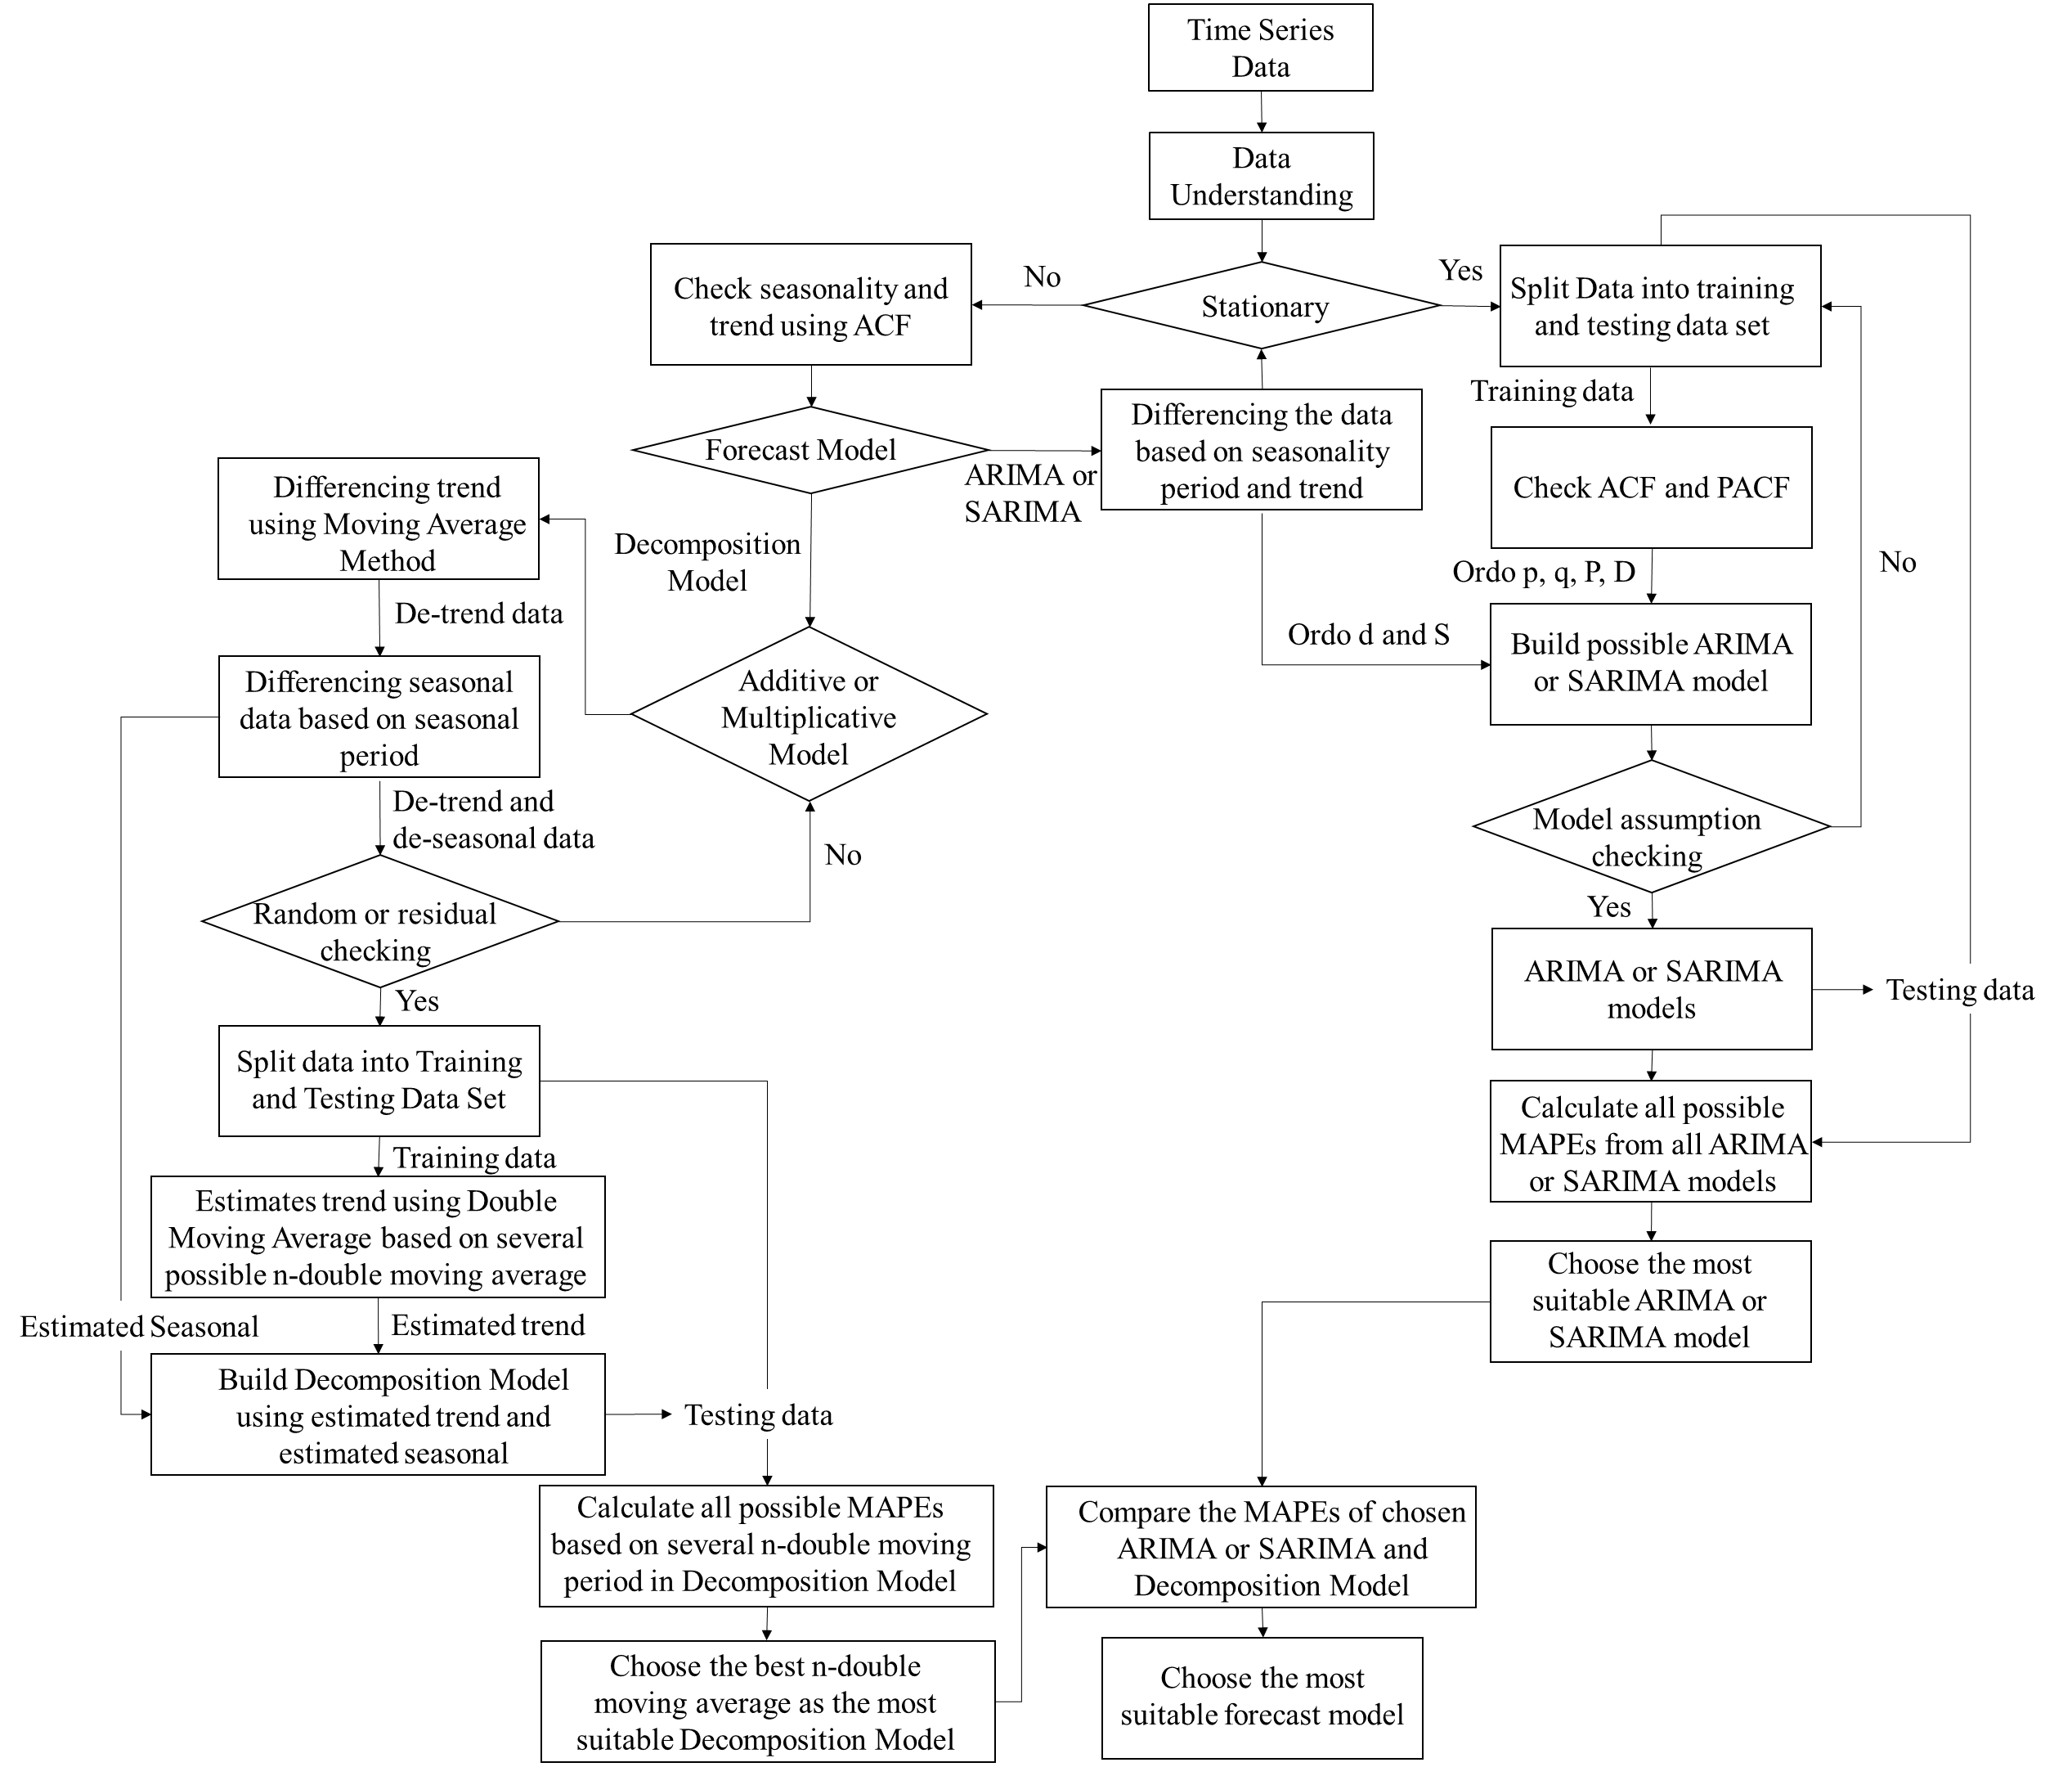

Figure 1. Research Design

ARIMA or SARIMA Forecast Model
SARIMA (p, d, q)(P, D, Q)s model is the seasonal adjustment of the ARIMA (p,d,q) model. The (p, d, q) in SARIMA correspond with ARIMA (p, d, q) with p as the order or ordo of autoregressive (AR), d as the order of differencing (I) to take the trend out of the data for achieving stationary data, and q is the order of moving average (MA). While the (P, D, Q)s in SARIMA correspond with seasonal adjustment, where P, D, and Q are the ordo of seasonal autoregressive, seasonal differencing, and seasonal moving average, while s is the seasonal length. Order p, q, P, and Q are attained by the analyses of the Autocorrelation Function (ACF) and Partial Autocorrelation Function (PACF) of data.
The formula of ARIMA and SARIMA are [22]:
ARIMA:
$$∅_{p}\left(B\right){\left(1-B\right)}^{d}Y_{t}=θ_{0}+θ_{q}(B)e_{t}$$ | (2)
SARIMA:
$$∅_{p}\left(B\right)Φ_{p}{(B}^{s}){\left(1-B\right)}^{d}{\left(1-B^{s}\right)}^{D}Y_{t}$$  $$=θ_{0}+θ_{q}(B)Θ_{Q}(B^{s})e_{t}$$ | (3)
With $Y_{t}$ as the real or observed data value, $∅_{p}\left(B\right)$ is the ordo of p, $\left(1-B\right)$ is a differencing operator for non-seasonal pattern, d as the number of differencing, t as the period at t, $θ_{0}$ the constant term, $θ_{q}(B)$ as the order of q, and $e_{t}$ as the error at time t. These symbols are used both in ARIMA and SARIMA. For SARIMA there are more symbols in the formula. With $Φ_{p}{(B}^{s})$ in order of P, ${\left(1-B\right)}^{d}$ in order of Q, s as the seasonal period length, D as the seasonal differencing, $(1-B^{s})$ as a seasonal differencing operator.
There are several residual requirements for both ARIMA and SARIMA; so that the model can be considered valid or not biased. Those are the residuals of the model should be independent or not have autocorrelation, should be homoscedasticity, and have a normal distribution [23]. The autocorrelation and homoscedasticity can be checked by ACF and PACF graphs [17], [21], [23]. If no value surpasses the control line on those graphs, these assumptions are satisfied [21]. In addition, the Ljung-Box Statistics Test can also be used to check the autocorrelation [17].

Decomposition Forecast Model
There are two types of decomposition models, those are additive and multiplicative decomposition models. We use an additive decomposition if there is a considerably constant variability in the data over time and choose the other for the opposite condition. However, if it is difficult to decide which decomposition model is used, we can try to do both models and check the error assumption for both models. Later we can choose the model that satisfies this assumption.
The formula for decomposition models are [24]:
Additive Decomposition Model:
$$Y_{t}=T_{t}+S_{t}+e_{t}$$ | (4)
With the sum of seasonal component values are 0 or $\sum_{j=0}^{s}{S_{j}}=0$ and $e_{t}$ or error or residual component has Gaussian N(0, $σ^{2}$).
Additive Decomposition Model:
$$Y_{t}=T_{t} x S_{t} x e_{t}$$ | (5)
With the sum of seasonal component values is the total of the seasonal length or $\sum_{j=0}^{s}{S_{j}}=s$ and $e_{t}$ has Gaussian N(1, $σ^{2}$).
Where $Y_{t}$ is the real data, $T_{t}$ is trend component value at period t, $S_{t}$ is the seasonal component value at period t, $e_{t}$ is error or residual or random component value at period t and j is the duration of the seasonal period.
It is worth noting that $S_{t}$ is constant for the same t for each seasonal period. Thus, after choosing the decomposition model, we can know the estimate of seasonal data.
For the trend data, we still need to do the other estimation. In this study, we use double moving average method to estimate it. Double moving average forecast model can help to predict trend patterns in the data [25]. The double moving average model is [26]:

Single Moving Average (S’) of period t:
$${S^{'}}_{t}=\frac{Y_{t}+Y_{t-1}+Y_{t-2}+…+Y_{t-n+1}}{n}$$ | (5)
Double Moving Average (S’’) of period t:
$${S''}_{t}=\frac{{S'}_{t}+{S'}_{t-1}+{S''}_{t-2}+…+{S'}_{t-n+1}}{n}$$ | (6)
The value of the constant or intercept of period t:
$$a_{t}=2{S'}_{t}-{S''}_{t}$$ | (7)
The value of the trend of period t:
$$b_{t}=\frac{2}{n-1}\left({S'}_{t}-{S''}_{t}\right)$$ | (8)
The forecast value of period t+m:
$$F_{t+m}=a_{t}+b_{t}m$$ | (9)
Where $Y_{t}$ is the input data and n is the number of periods chosen to make the average period.
This n period can be picked from a minimum of two periods. In this study, to decide the best n period to fit the forecasting model, several n periods are run to predict trend composition data, and this trend prediction is combined with the seasonal decomposition period to get the final decomposition forecast value. The best-fitted n period is chosen based on the smallest MAPE of the testing data set.

RESULTS AND DISCUSSION
Data Exploration and Understanding
To understand the data, we should see the graph of data. Figure 6 of the observed data part shows the sugar sales. Based on the analysis, the retail can always sell more than 100 packages of sugar every month. There is high variability of the sales shown by the coefficient of variability (CV). The CV is 27,44. That is higher than the variability severity threshold, which is 15% [27]. This condition might lead to the difficulty of sales prediction. Further information can be found in Table 1.

Table 1. Basic Statistics of Data
Coefficient of Variance | Value
Total Data | 72
Mean | 185.46
Median | 179.5
Variance | 2589.6
Standard Deviation | 50.89
Coefficient of Variance | 27.44
Maximal | 389
Minimal | 103
P-value of Kolmogorov-Smirnov Test | >0.15 (normal distribution)
Kwiatkowski-Phillips-Schmidt-Shin (KPSS) value | 0.4419 (non-stationer)

Another data exploration that should be done is checking the stationary of data. Stationer data means that its statistical properties such as mean, variance, etc. do not change or depend over time [28], [29]. It means that if the data is not stationer, it might have some patterns, such as seasonal, trend, or cyclic.
To check it, we can use the Kwiatkowski-Phillips-Schmidt-Shin (KPSS) test [29], [30] in R Software. KPSS results show that the KPSS test value of this data is 0.44, which is higher than the critical value of 10% significant level, which is 0.34. Thus, the data is not stationer.
Because of this finding, the seasonality and trend pattern are checked using ACF. The data is considered to have a seasonality pattern if there is a repetition of a high number or spikes of ACF value in the same multiple periods [31], while a trend pattern is considered if the ACF scores decrease over time gradually. This score is calculated in Minitab Software. Figure 2 shows the ACF Graph.

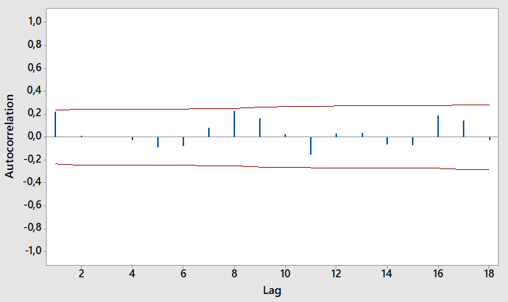
Figure 2. ACF Graph of Sugar Sales

Figure 2 indicates that there are spikes in periods 1, 8, and 16 months. Thus the sales of sugar tend to have seasonal data with a seasonal length of 8 months. The seasonality of sugar sales is quite long, thus it requires a lot of data to analyze so that it can capture the seasonality pattern. Furthermore, by knowing there is a seasonal pattern, we should use the SARIMA model instead of the ARIMA model to forecast.

SARIMA (p, d, q)(P, D, Q)s Forecast
Since the sales are not stationary, the data should be transformed first because SARIMA needs stationer data as input. This transformation is done in the training data set by taking out the seasonal pattern by differencing. This differencing is done by subtracting the data on each same seasonal period from its previous observation data. The KPSS test shows that this transformed data has a value of 0.12. This value indicates that the transformed data is stationer since the KPSS value is under the critical values of 10% significance level, which is 0.34. This result explains that there is no need to differencing the trend pattern. Thus, this new data is ready to analyze.
Since we know there is no need to do trend differencing, we can write trend order in (p,d,q) as (0,0,0). We should find out the seasonal order (P, D, Q)s. Because the seasonal length is 8, we can write s=8 and we know that we do one-time seasonal differencing, therefore, D=1.
To find P and Q, we need to see PACF and ACF graphs. The numbers of PACF and ACF values that exceed the control line in PACF and ACF graphs are considered as the maximum number of order P and Q possibilities. These spikes happen in the corresponding number of lag values that same as the seasonal period length or its multiplication length [30]. Figure 3 describes that in both the PACF and ACF graphs of the stationer data. There is a spike in lag 8 for each graph so that P=1 and Q=1.

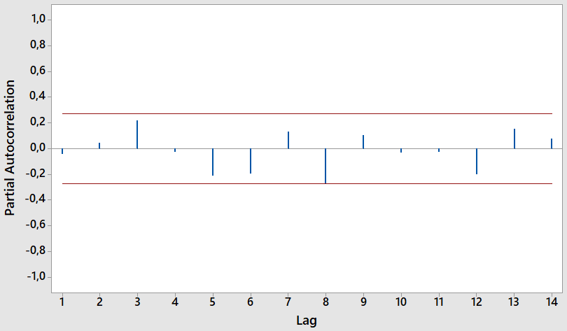
(a)
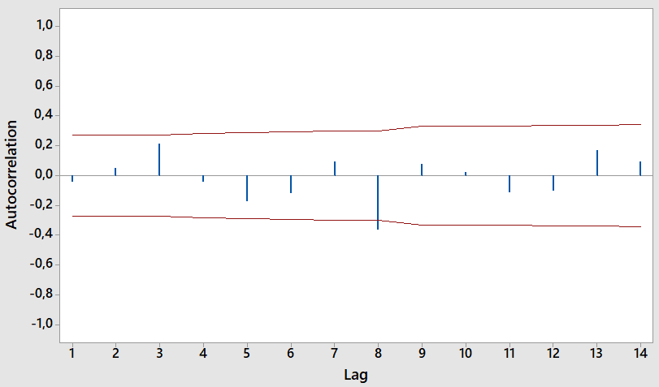
(b)

Figure 3. Graph of Transformed Seasonal Differencing of Training Data (a) PACF and (b) ACF
There are three possible SARIMA models, those are SARIMA (0,0,0)(0,1,1)8, SARIMA (0,0,0)(1,1,0)8, and SARIMA (0,0,0)(1,1,1)8. Those three models are run in the training data to see whether the SARIMA assumptions are satisfied. If more than one model can satisfy the residual requirements, we need to compare the performance of those forecast models by choosing the smallest MAPE from testing data.
After running all possible SARIMA models, there is only one model that satisfies residual assumptions; the model is SARIMA (0,0,0)(0,1,1)8. These assumptions can be checked using ACF, PACF, and normal distribution tests of SARIMA residual. Figure 4 shows these tests of SARIMA (0,0,0)(0,1,1)8. Since no value of ACF and PACF is out of the control line, the residuals are independent or have no autocorrelation and are homoscedasticity. In addition to that, the P-value of the Ljung-Box test is above 0.05; thus the residuals are independent. The residual also has a normal distribution. After we find the forecast model, we need to see the performance of this model by calculating MAPE. Based on the testing data, the MAPE of this forecast model is around 15.22%.

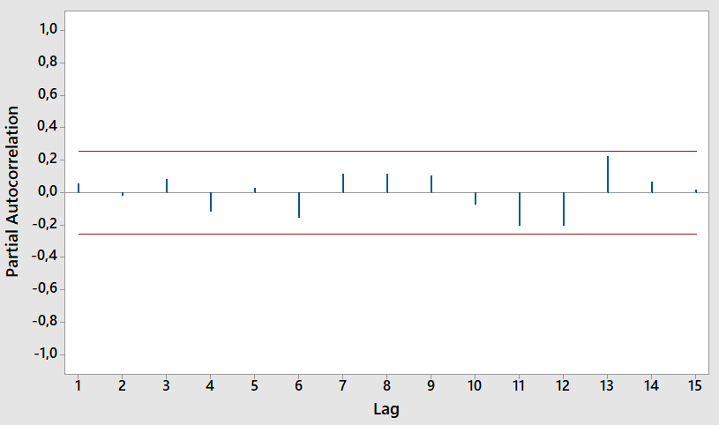 | 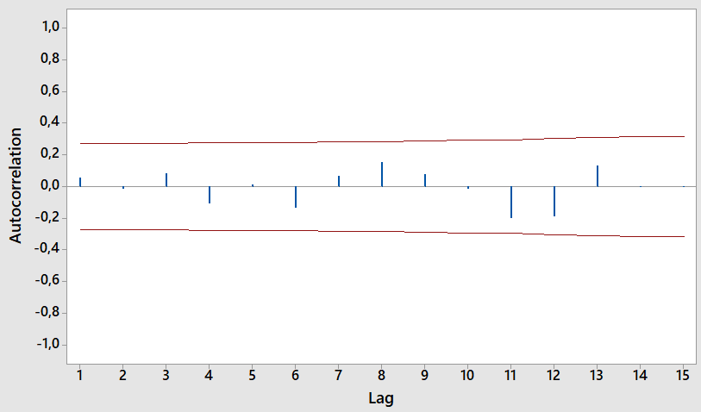
(a) | (b)
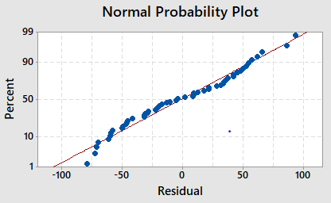 | 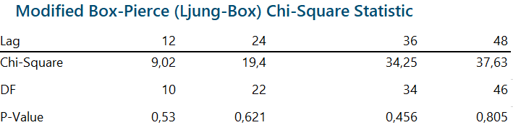
(c) | (d)

Figure 4. Residual Testing of SARIMA(0,0,0)(0,1,1)8 Model

Decomposition Forecast

After running additive and multiplicative decomposition models and checking the residual or random assumptions, only the multiplicative model meets this assumption. Figures 5 and 6 give information about the test of both decomposition models using Kolmogorov-Smirnov Test.
The distribution of residual in the multiplicative model is normal and its mean is nearly 1. For the additive model, although the residual distribution is normal, its mean is around -1.47. Consequently, making the assumption is not satisfied. Hence we only use the multiplicative to forecast.
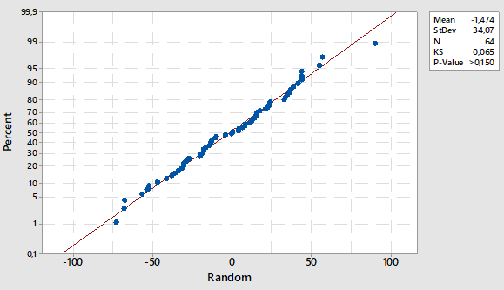
Figure 5. Residual Test of Additive Decomposition Model

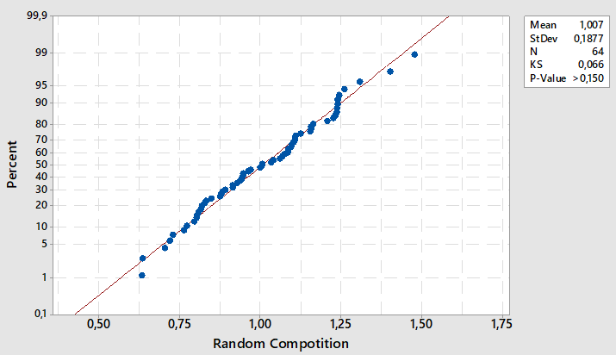
(b)

Figure 6. Residual Test of Multiplicative Decomposition Model

Figure 7 shows the result of multiplicative decomposition in sugar sales. This figure has not shown the forecast value yet, but it only shows each decomposition pattern of the data. The decomposition not only can be used to help forecast but also can be used to explore and understand the data pattern.

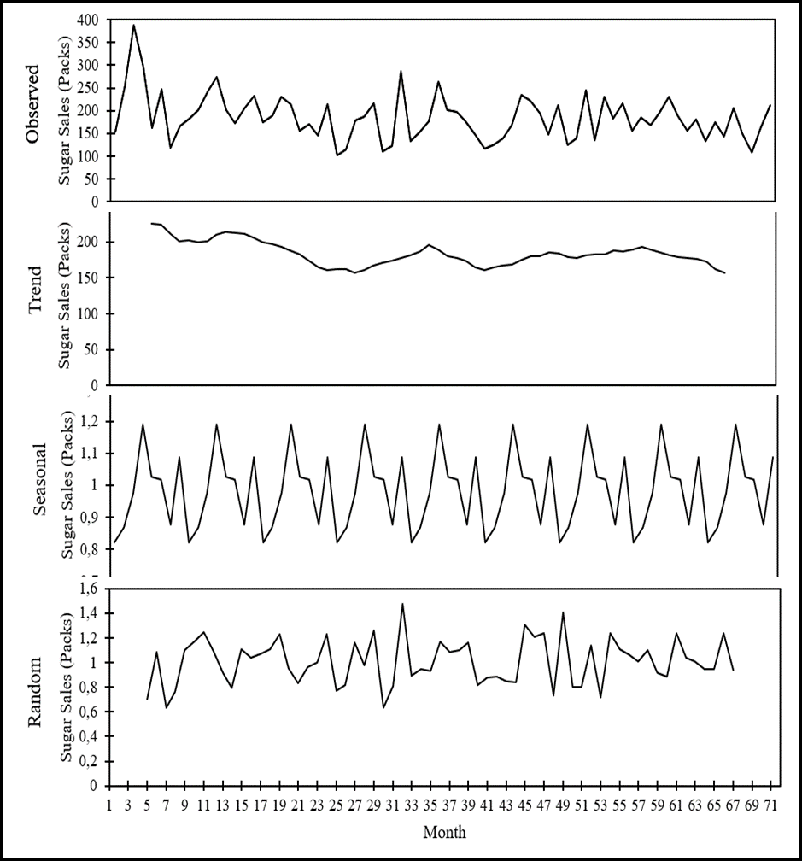

Figure 7. Multiplicative Decomposition of Sugar Sales
Based on this figure, there is a declining trend in sales of sugar. However, this trend is only little and almost not noticeable. This slight downward trend might be the reason for SARIMA does not consider it in the model. For the seasonal data, after decomposition is done, the estimation of seasonal data can be known, and the values are fixed for the same t period in different seasonal times.
This research estimates the trend data by using a double moving average. After running several periods in a double moving average, the result shows that the optimal period for a double moving average is 3 periods. Figure 8 informs the MAPE comparison of several possible n-period for double moving averages in the decomposition forecast model. MAPE forecast goes down from period two to period three and later it keeps increasing. The minimum MAPE for this model is around 13.64%. Thus, we use multiplicative decomposition with 3 periods of double moving average forecast model.

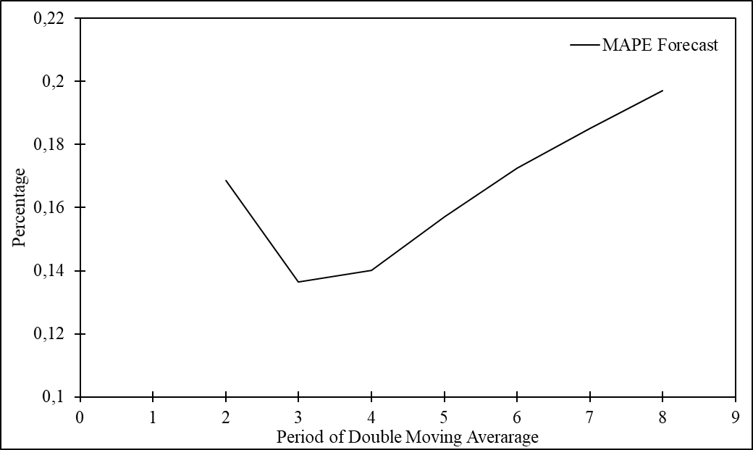

Figure 8. MAPE Comparison of n Period from Double Moving Average for Multiplicative Decomposition Forecast Model

Discussion
SARIMA(0,0,0)(0,1,1)8 and multiplicative decomposition using double moving average forecast models have good prediction abilities since both have MAPEs under 20% [32], [33]. Table 2 shows the MAPE comparison of both models. However, the later forecasting model performs better by 1.58%. Although both forecast models do not have MAPE under 10% to get an excellent prediction ability standard [32], [33], this result can be considered good enough since the sales of sugar have high variability based on the coefficient of variation that is above 15%.
Table 2. MAPE Comparison of Forecast Models
Possible Forecast Models | MAPE
SARIMA (0,0,0)(0,1,1)8 | 15.22%
Multiplicative Decomposition Using Double Moving Average | 13.64 %

This result is in line with Guarnaccia et al. [20] research. However, in this study, it is clear that we use the multiplicative decomposition model based on the data analysis. While in the previous study, there is no clear statement regarding the decomposition model chosen.
There is a significant difference for both models. For SARIMA, since the stationary data has been obtained by seasonal differencing, the slight trend from observed sales is not considered since the deseasonal data has been proven to be stationary. However, for decomposition forecasting, the trend pattern is considered no matter how small the trend shows.
Figure 9 shows the forecast result of SARIMA and decomposition models for the testing and the next 10 periods in the future to see the forecast and the comparison between real data and both forecasts. We know that the pattern of the forecast is quite similar, but there is a difference in the level or number of sales forecasted. This similarity is because those forecast methods use the same approach to predict, which considers splitting the pattern such as trend and seasonal patterns from observed data. If we only considered MAPE for the forecasting performance, we tend to choose inclined the smaller MAPE, which is multiplicative decomposition using the double moving average forecast model. However, we need to understand that the longer the forecast is used, the lower the forecast result because of the slightly inclined trend from observed sales, which is not considered in SARIMA. Thus, it is better to not forecast for a long period and try to observe new data to adjust the forecast model. Moreover, since the double moving average period is only three, the forecast result is highly affected by the recent sales; thus making the long period forecast is not preferable.
It is also worth noting that it is impossible to use both forecast models in Software R with the available package because R needs more input data since the seasonal period is quite long. Therefore, the calculation forecast in this study is majorly used Minitab M.S. Excel. This also indicates the necessity to have more input data.

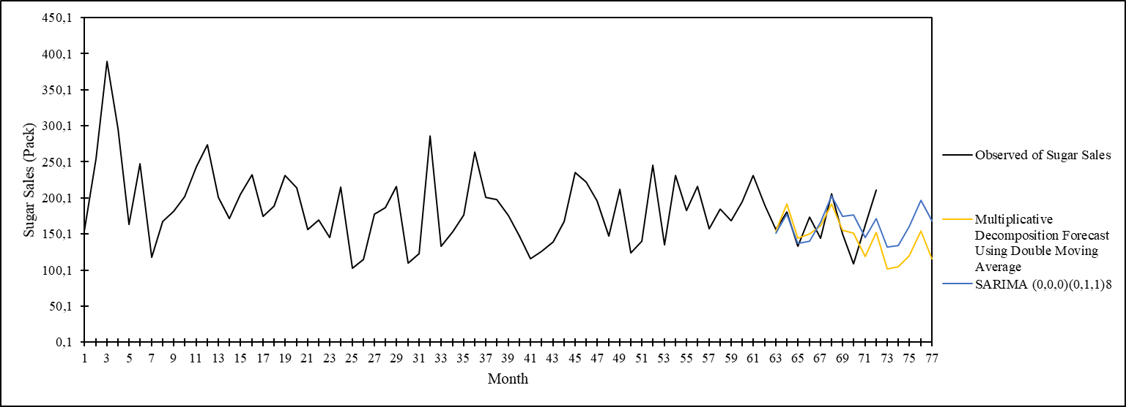

Figure 9. Comparison of Forecast Result

CONCLUSION
Despite the importance of sugar for household consumption, there is no study has been done at the retail level, where the households usually get their sugar. Furthermore, not much research conducted about sugar in Indonesia. This study tries to fill this research gap by analyzing the sugar demand prediction at the retail level in a retail store located in Indonesia. In addition, we also improve the research discussion comparing SARIMA with the decomposition forecast model.
Sugar sales in retail have only a slight downside trend with high volatility, which is shown by the coefficient of variability (CV) of the sales is almost twice as high as the maximum standard of accepted CV. Therefore, it is quite challenging to get good forecast results. It is also known that the sugar sales in retail have a seasonal pattern with a high seasonal length, which is 8 months. This condition leads to the need for big numbers of input data needed.
Despite these conditions, both SARIMA and multiplicative decomposition with double moving average forecast models achieve good forecast results. Both models have similar forecast patterns but with different slopes. This is because both models consider the seasonal pattern in the data but only the decomposition model considers the trend pattern. The decomposition model is forced to consider the trend pattern no matter how small the trend pattern is, but this is not the case for the SARIMA model.
The duration of the forecast also becomes another concern, since multiplicative decomposition with a double moving average uses 3 periods of moving average. This short period of moving average makes the forecast can not be done for a long duration because the forecast is heavily affected by recent sales.
It is worth noting that no forecasting model works well for all other cases, without exception. Hence it might not always be the case that decomposition performs better than SARIMA. Because the suitable forecast model depends on the characteristics of the data. Therefore, other retail stores might need a different approach to forecast their sugar demand.

REFERENCES
[1] W. Muhaimin and D. Sari, “Factors Affecting the Demand and Import of Indonesian Sugar,” J. Glob. Econ., vol. 7, no. 2, pp. 1–3, 2019, [Online]. Available: https://ssrn.com/abstract=3458678.
[2] W. P. Inayaturrohmah, I. Istiqomah, and R. S. Gunawan, “Determinants of Indonesian Sugar Import,” Signifikan J. Ilmu Ekon., vol. 12, no. 2, pp. 275–286, 2023, doi: 10.15408/sjie.v12i2.28044.
[3] F. A. S. United States Department of Agriculture, “Sugar : World Markets and Trade Guatemala Sugar Exports are Down While Domestic Demand Continues to Grow Guatemala is a Top 5 Exporter,” 2024. [Online]. Available: https://apps.fas.usda.gov/psdonline/circulars/sugar.pdf.
[4] J. Widodo, “(1) Undang-Undang,” Jakarta, Indonesia, 2020. [Online]. Available: https://peraturan.bpk.go.id/Details/136174/perpres-no-59-tahun-2020.
[5] B. P. Statistik, “Subjek Tabel Terkait Rata - Rata Konsumsi Perkapita Seminggu Menurut Kelompok Bahan Makanan Lainnya Per Kabupaten / Kota Rata - Rata Konsumsi Perkapita Seminggu Di Daerah Pedesaan Menurut Komoditi Makanan Dan Golongan Pengeluaran Per Kapita Seminggu Rata,” 2023. [Online]. Available: https://www.bps.go.id/id/statistics-table/1/OTUwIzE=/rata-rata-konsumsi-per-kapita-seminggu-beberapa-macam-bahan-makanan-penting--2007-2023.html.
[6] P. Mishra et al., “Modeling and Forecasting of Sugarcane Production in India,” Sugar Tech, vol. 23, no. 6, pp. 1317–1324, 2021, doi: 10.1007/s12355-021-01004-3.
[7] S. Tyagi, S. Chandra, and G. Tyagi, “Statistical modelling and forecasting annual sugarcane production in India: Using various time series models,” Ann. Appl. Biol., vol. 182, no. 3, pp. 371–380, 2023, doi: 10.1111/aab.12825.
[8] E. M. Amrouk and T. Heckelei, “Forecasting International Sugar Prices: A Bayesian Model Average Analysis,” Sugar Tech, vol. 22, no. 4, pp. 552–562, 2020, doi: 10.1007/s12355-020-00815-0.
[9] J. Zhang, Y. Meng, J. Wei, J. Chen, and J. Qin, “A Novel Hybrid Deep Learning Model for Sugar Price Forecasting Based on Time Series Decomposition,” Math. Probl. Eng., vol. 2021, 2021, doi: 10.1155/2021/6507688.
[10] A. Kantasaard, A. Bekrar, A. Aitelcadi, and Y. Saliez, “Artificial intelligence for forecasting in supply chain management: A case study o White Sugar consumption rate in Thailand,” IFAC-PapersOnLine, vol. 52, no. 13, pp. 725–730, 2019, doi: 10.1016/j.ifacol.2019.11.201.
[11] S. Wardah, N. Nurhasanah, and W. Sudarwati, “Integration models of demand forecasting and inventory control for coconut sugar using the ARIMA and EOQ modification methods,” J. Sist. dan Manaj. Ind., vol. 7, no. 2, pp. 127–138, 2023, doi: 10.30656/jsmi.v7i2.6500.
[12] A. W. A. Wibowo and F. Maimunah, “Sugar Demand Forecasting in Pt Xyz With Winqsb Software,” BAREKENG J. Ilmu Mat. dan Terap., vol. 17, no. 3, pp. 1631–1640, 2023, doi: 10.30598/barekengvol17iss3pp1631-1640.
[13] B. R. I. Rosari, R. Sarno, M. S. Filsafan, and A. T. Haryono, “Indonesia White Sugar Supply and Demand Forecast Using Machine Learning,” 2023 1st Int. Conf. Adv. Eng. Technol. ICONNIC 2023 - Proceeding, pp. 18–23, 2023, doi: 10.1109/ICONNIC59854.2023.10467262.
[14] M. R. Sanjaya and E. D. Sadono, “Consumption Patterns of Sugar-Sweetened Beverages in Indonesia,” Southeast Asian J. Econ., vol. 10, no. 2, pp. 181–208, 2022.
[15] A. Widarjono, R. Afin, G. Kusnadi, M. Zulfiqar Firdaus, and O. Herlinda, “Taxing sugar sweetened beverages in Indonesia: Projections of demand change and fiscal revenue,” PLoS One, vol. 18, no. 12 December, pp. 1–11, 2023, doi: 10.1371/journal.pone.0293913.
[16] F. Badorf and K. Hoberg, “The impact of daily weather on retail sales: An empirical study in brick-and-mortar stores,” J. Retail. Consum. Serv., vol. 52, no. March 2019, p. 101921, 2020, doi: 10.1016/j.jretconser.2019.101921.
[17] W. M. de Almeida and C. P. da Veiga, “Does demand forecasting matter to retailing?,” J. Mark. Anal., vol. 11, no. 2, pp. 219–232, 2023, doi: 10.1057/s41270-022-00162-x.
[18] Q. Mehmood, M. H. Sial, S. Sharif, A. Hussain, M. Riaz, and N. Shaheen, “Forecasting the Fisheries Production in Pakistan for the Year 2017-2026, using Box-Jenkin’s Methodology,” Pakistan J. Agric. Res., vol. 33, no. 1, pp. 140–145, 2020, doi: 10.17582/journal.pjar/2020/33.1.140.145.
[19] M. R. Hasan, M. A. Kabir, R. A. Shuvro, and P. Das, “A Comparative Study on Forecasting of Retail Sales,” arXiv, pp. 1–14, 2022, [Online]. Available: http://arxiv.org/abs/2203.06848.
[20] C. Guarnaccia, J. Quartieri, and C. Tepedino, “Deterministic decomposition and seasonal ARIMA time series models applied to airport noise forecasting,” AIP Conf. Proc., vol. 1836, 2017, doi: 10.1063/1.4982019.
[21] G. Perone, “Using the SARIMA Model to Forecast the Fourth Global Wave of Cumulative Deaths from COVID-19: Evidence from 12 Hard-Hit Big Countries,” Econometrics, vol. 10, no. 2, 2022, doi: 10.3390/econometrics10020018.
[22] C. C. Nwokike and E. W. Okereke, “Comparison of the Performance of the SANN, SARIMA and ARIMA Models for Forecasting Quarterly GDP of Nigeria,” Asian Res. J. Math., vol. 17, no. 3, pp. 1–20, 2021, doi: 10.9734/arjom/2021/v17i330280.
[23] W. Hu, S. Tong, K. Mengersen, and D. Connell, “Weather Variability and the Incidence of Cryptosporidiosis: Comparison of Time Series Poisson Regression and SARIMA Models,” Ann. Epidemiol., vol. 17, no. 9, pp. 679–688, 2007, doi: 10.1016/j.annepidem.2007.03.020.
[24] B. O. Emmanuel, D. Enegesele, and C. O. Arimie, “Additive Decomposition with Arima Model Forecasts When the Trend Component Is Quadratic,” OALib, vol. 07, no. 07, pp. 1–20, 2020, doi: 10.4236/oalib.1106435.
[25] D. Febrian, S. I. Al Idrus, and D. A. J. Nainggolan, “The Comparison of Double Moving Average and Double Exponential Smoothing Methods in Forecasting the Number of Foreign Tourists Coming to North Sumatera,” J. Phys. Conf. Ser., vol. 1462, no. 1, pp. 0–10, 2020, doi: 10.1088/1742-6596/1462/1/012046.
[26] D. M. Khairina, R. Khairunnisa, H. R. Hatta, and S. Maharani, “Comparison of the trend moment and double moving average methods for forecasting the number of dengue hemorrhagic fever patients,” Bull. Electr. Eng. Informatics, vol. 10, no. 2, pp. 978–987, 2021, doi: 10.11591/eei.v10i2.2711.
[27] O. Shechtman, “The Coefficient of Variation as an Index of Measurement Reliability,” in Methods of Clinical Epidemiology, no. Springer Series on Epidemiology and Public Health, S. A. R. Doi and G. M. Williams, Eds. Verlag Berlin Heidelberg: Springer, 2013, pp. 39–49.
[28] G. E. P. Box, G. M. Jenkins, G. C. Reinsel, and G. M. Ljung, Time Series Analysis: Forecasting and Control, 5th ed., vol. 11. Hoboken, New Jersey: John Wiley & Sons, Inc., 2016.
[29] U. M. Sirisha, M. C. Belavagi, and G. Attigeri, “Profit Prediction Using ARIMA, SARIMA and LSTM Models in Time Series Forecasting: A Comparison,” IEEE Access, vol. 10, no. October, pp. 124715–124727, 2022, doi: 10.1109/ACCESS.2022.3224938.
[30] R. J. Hyndman and G. Athanasopoulos, Forecasting : Principles and Practice, 3th ed. Melbourne, Australia, 2021.
[31] H. Musbah, M. El-Hawary, and H. Aly, “Identifying seasonality in time series by applying fast fourier transform,” 2019 IEEE Electr. Power Energy Conf. EPEC 2019, vol. 3, pp. 3–6, 2019, doi: 10.1109/EPEC47565.2019.9074776.
[32] P. Xu, “Analysis and Prediction of Total Retail Sales of Consumer Goods Based on Multiple Regression and SARIMA Model,” 2020 Int. Conf. Big Data Appl. Econ. Manag., no. Icbdem, pp. 136–149, 2020, doi: 10.25236/icbdem.2020.021.
[33] T. Falatouri, F. Darbanian, P. Brandtner, and C. Udokwu, “Predictive Analytics for Demand Forecasting - A Comparison of SARIMA and LSTM in Retail SCM,” Procedia Comput. Sci., vol. 200, no. 2019, pp. 993–1003, 2022, doi: 10.1016/j.procs.2022.01.298.

