Investigation on mechanical properties and microstructural characteristic of rice hush ash based geopolymer mortar as patch repair | 

..*, ..¹, ..¹, ..²
¹Department of Civil Engineering, .
²Department of Civil Engineering,

Abstract  The rapid expansion of the construction sector is increasing cement use, which significantly impacts the environment due to CO₂ emissions. Geopolymers are eco-friendly construction materials designed to reduce cement use and potential to be the patching material to rehabilitate the concrete structure. Among these, pozzolanic materials like rice husk ash, rich in aluminosilicate, are abundant and suitable for geopolymer binders. This study explores using rice husk ash and alkali activators (NaOH/Na₂SiO₃) with different activator percentages (40%, 45%, and 50%) to evaluate their mechanical properties and potential applications as patch repair materials. The research involved formulating an optimal mix design through trial and error in a laboratory setting, followed by curing at 70°C and testing at room temperature. XRF and SEM-EXD analyses were performed to determine the chemical composition and microstructure of the specimens. The activators, NaOH and Na₂SiO₃, were used in a 1:3.5 ratio with 14M molarity and 2% superplasticizer to enhance workability. Results showed that the geopolymer mortar's highest compressive strength was 8.14 MPa at a 40% activator variation, while the highest split tensile and flexural strengths were 2.50 MPa and 1.00 MPa, respectively, both at a 50% variation. These findings suggest that the mortar is suitable for patch repairs on concrete substrates with compressive strengths below 8 MPa. The mechanical properties of the rice husk ash geopolymer mortar are influenced by the silica, calcium, and alkali activator content, which affect the mortar's strength and density.  This is an open access article under the CC BY-SA license   | Keywords:  compressive strength;  durability;  microstructure;  patch repair;  rice hush ash  Article History:  Received: May 2, 2019  Revised: May 29, 2019  Accepted: June 2, 2019  Published: June 2, 2019  Corresponding Author:  ..  Department of Civil Engineering, Universitas .. Indonesia  Email: ..

INTRODUCTION
The construction sector in Indonesia has had a notable yearly growth rate of about 7-8%, mostly fueled by the escalating need for infrastructure and amenities to accommodate the rapidly expanding population. However, this expansion has worsened environmental problems, particularly because of the significant release of carbon dioxide during the production of cement [1], [2]. The manufacture of cement is a substantial source of global greenhouse gas emissions. Additionally, as the worldwide consumption of concrete continues to increase at a rate of 8.8% year, the demand for cement is projected to do the same [3], [4], [5], [6], [7]. There is an urgent need to tackle the environmental consequences of cement use in the building industry. Building engineers and academics have been investigating several approaches to reduce the environmental impact of building operations in recent years. An encouraging strategy is the use of alternative materials that may provide environmentally friendly construction materials while maintaining the strength and stability of structures. Geopolymers have emerged as a feasible substitute for traditional cement. Geopolymers are inorganic polymers that may be created by combining various aluminosilicate materials, such as industrial by-products and agricultural waste [4], [8], [9], [10], [11], [12]. The materials mentioned, including fly ash [5], [9], [13], [14], rice husk ash [9], [15], [16], sugarcane bagasse ash, and eggshells, contain significant amounts of silica (Si) and alumina (Al), which are crucial elements for the synthesis of geopolymers.
Geopolymers provide a significant benefit in mitigating the release of carbon dioxide during construction. Research has shown that geopolymers have the potential to decrease carbon dioxide emissions by as much as 80% when compared to conventional Portland cement [6]. This reduction is accomplished by using industrial and agricultural waste materials, which not only redirects these wastes from landfills but also reduces the dependence on energy-intensive cement manufacturing processes [6]. Geopolymers provide a sustainable answer to the environmental difficulties presented by the building sector.
Indonesia's extensive agriculture industry offers a unique chance to create and use environmentally friendly building materials. In 2020, the Central Bureau of Statistics reported that the total land area of Indonesia is 191.09 million hectares, out of which about 9.81 million hectares are specifically used for agricultural. Rice is considered one of the most important agricultural commodities. Rice production produces significant quantities of trash, such as rice husk, which is often unused. The country's daily rice production averages 350 tons, which yields 250 tons of rice, 50 tons of bran, and 50 tons of rice husk. Rice husk ash (RHA) is a byproduct of burning rice husk and has a high concentration of silica, ranging from 87% to 97% [7], [17], [18]. The high silica concentration of RHA makes it very suitable for usage as a pozzolan. Pozzolans are substances that, when combined with lime, have cementitious characteristics. In order to be classified as a pozzolan, a material must have a collective amount of silicon dioxide (SiO₂), iron oxide (Fe₂O₃), and aluminum oxide (Al₂O₃) that is more than 70%. Due to its composition, RHA fulfills these requirements and may be efficiently used in geopolymer compositions.
Although there are plenty of pozzolan resources in Indonesia, their use in the building sector is still restricted [19], [20]. The main reason for this underutilization is a lack of research and understanding on the possible uses of these environmentally beneficial materials. In order to fill this need, it is essential to carry out extensive research to assess the viability and efficacy of geopolymers made from pozzolan.
The aim of this study is to investigate the feasibility of using agricultural waste, primarily rice husk ash, as a pozzolan material in geopolymer binders. The research will examine several combinations of agricultural waste and activators, using three particular ratios (60%:40%, 55%:45%, and 50%:50%). The research will entail conducting a sequence of tests to examine the chemical composition (using X-ray fluorescence, XRF), microstructure (using scanning electron microscopy with energy-dispersive X-ray spectroscopy, SEM EDX), and mechanical properties of the geopolymer mortar. These properties include flowability, compressive strength, splitting tensile strength, and flexural strength.
This study seeks to establish the feasibility of using rice husk ash as an environmentally friendly building material by analyzing the characteristics and effectiveness of geopolymer mortars. If this invention is effectively implemented, it has the potential to greatly reduce the environmental footprint of the building sector in Indonesia and make a valuable contribution to global endeavors in addressing climate change.
Currently, there has been no academic study undertaken to examine the use of rice husk ash as a pozzolan in geopolymer binders, particularly for building applications. Despite the existence of many studies that have proven the efficiency of using waste materials to produce eco-friendly building components and their related environmental advantages, there is a noticeable lack of empirical data regarding the mechanical characteristics of rice husk ash when used as a substitute for conventional cement in geopolymer formulations. This study seeks to fill this void by providing comprehensive analysis of the physical characteristics of geopolymers made from rice husk ash, specially to find the patch repair mortar formulation [21], [22], [23], [24], [25]. This presents a unique method for reducing the ecological impact of the building sector.

MATERIAL AND METHODS
The experimental procedure were summarized in Figure 1 and the details were explained in the sub-section below.

Material
This study employs an experimental methodology, involving direct experimentation to collect data linked to the variables under investigation. The research aims to analyze the potential of agricultural waste, specifically rice husk ash, as a substitute in mortar mixtures, with the cement replacement ratios being 40%, 45%, and 50%. The mixtures also include tap water and chemical compounds such as NaOH and Na₂SiO₃. The experimental tests are designed to determine the compressive strength, splitting tensile strength, and flexural strength of the geopolymer mortar specimens.
The fine aggregate utilized for testing in this research was Merapi sand, which was obtained from the Mount Merapi Sand Mine in Yogyakarta. The rice husk ash used as a cement alternative is produced from burnt and crushed rice husk trash. It is sourced from the Pajangan District, Bantul Regency, Yogyakarta Province, and goes through a No. 200 sieve. For this experiment, tap water was used as the mixing water to prepare the mortar. The alkali activator is a chemical substance that combines with silica (Si) and alumina (Al). It is usually composed of a mixture of sodium hydroxide (NaOH) or potassium hydroxide (KOH) and sodium silicate (Na₂SiO₃). NaOH is used as an activator for the alumino-silicate (Al-Si) reaction in geopolymers, whereas Na₂SiO₃ acts as a catalyst to speed up the polymerization process in geopolymer mortar. The superplasticizer used in this test functions as a water reducer, allowing the mixture to achieve a thinner consistency with minimal water addition. The pictures of fine aggregate, rice husk ash, Na₂SiO₃, and NaOH were demonstrated in Figure 2(a-d).

Mix proportion and specimen design of mortar
The mix design calculation involves a comparative analysis of rice husk ash, sand, water, and superplasticizer materials within a 1 m³ volume. This test utilizes mix design calculations to determine the optimal composition for creating the test specimens. The results of these mix design calculations are detailed as follows. Table 1 presents the mix design proportions for three different ratios: (a) 60%:40%, (b) 55%:45%, and (c) 50%:50%. Additionally, extra water amounting to 25% of the volume of the alkali activator is included in the mixture.

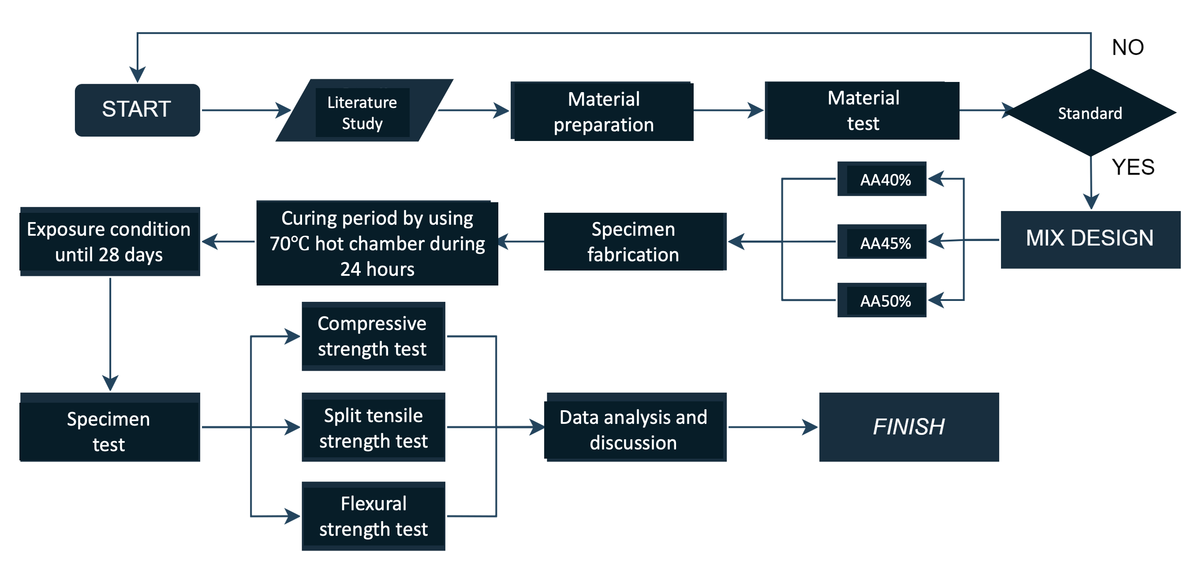
Figure 1. The experimental flowchart

Table 1. Mix design of geopolymer mortar specimens
Material | 40% Alkali Activator | 45% Alkali Activator | 50% Alkali Activator
Fine aggregate (grams) | 1680 | 1680 | 1680
Rice Husk Ash (grams) | 432 | 468 | 432
NaOH (grams) | 44.8 | 50.4 | 56
Na₂SiO₃ (grams) | 80 | 176.4 | 196
Water (grams) | 59.7 | 90 | 100
Superplasticizer (grams) | 6 | 6 | 6

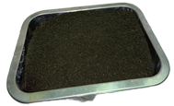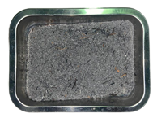
- (b)
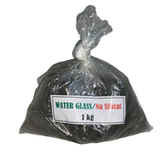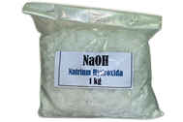
- (d)
Figure 2. The materials used in the experiment, (a) fine aggregate, (b) rice husk ash, (c) Na₂SiO₃, and (d) NaOH

Curing method
The process of retaining the moisture content of the concrete surface occurs throughout the curing phase, which begins with the compaction phase and continues through the hydration phase. The minimum curing time for conventional concrete is seven days, whereas the minimum curing time for concrete with high early compressive strength is three days. This information is derived from the standards established by SNI 03-2847-2002. There is a significant relationship between the hydration process and the risk of concrete cracking, and the humidity and temperature of the concrete play a significant effect in the hydration process. The curing procedure will be carried out for a total of twenty-eight days in this investigation. In the beginning, the concrete will be exposed to room temperature after being oven-cured for one day at a temperature of 70 degrees Celsius. The concrete mortar will be coated in aluminum foil and plastic wrap in order to keep the moisture in the mortar from escaping during this room exposure period.
Fresh and hardened properties tests of mortar
The flow table test is used to evaluate the fresh qualities of the mortar. This test is aimed to examine the consistency of the material as well as its ability to be worked. The technique involves depositing a predetermined quantity of mortar onto a flow table, followed by raising and lowering the table in a way that is consistent with the procedure specifications. In order to determine the flowability of the mortar, the spread of the mortar is measured. In the case of geopolymer mortar, it is essential to do this test in order to evaluate the comfort level with which the mixture may be manipulated and applied, so guaranteeing that it contains the proper consistency for practical application.
The compressive strength, split tensile strength, and flexural strength of the mortar are going to be evaluated as part of the testing process for the mortar's hardened characteristics. It is possible to determine the material's maximal load-bearing capacity before it fails by measuring its compressive strength, which is the ability of the material to endure axial loads. When evaluating the mortar's resistance to tensile pressures and its potential to resist breaking under load, split tensile strength is the metric that is used. The capacity of the mortar to withstand bending or flexural stress is evaluated using flexural strength, which determines how well the mortar performs when subjected to structural stresses. Insights into the mechanical qualities and durability of the hardened mortar are provided by these tests, which give complete information.
RESULTS AND DISCUSSION
Characteristics of the mortar constituent materials
The analysis results of the grain gradation test adhere to SNI ASTM C136: 2012, which outlines the test methods for sieve analysis of fine and coarse aggregates. The fine aggregate material tested, sourced from Merapi, complies with the ASTM 2014 standard requirements, which specify a value range of 1.5 – 3.8. The fine grain modulus of sand from Mount Merapi is 2.908, placing it in gradation area 2. The gradation graph for the Merapi River fine aggregate is illustrated in Figure 3.
The results of the moisture content test for fine aggregates from the Merapi River show a value of 4.715%. This average moisture content falls within the specified range according to SNI 1971:2011. In the mud content test on fine aggregate Progo sand, the mud content was found to be 3%. SNI 03-4142-1996 (BSN, 1996) sets the requirement for mud content in aggregates used to be less than 5%, thus Merapi sand also meets the specified requirements.
In the X-ray fluorescence test of rice husk ash, it was found that the material contains chemical elements such as silica (SiO₂), calcium oxide (CaO), phosphorus pentoxide (P₂O₅), potassium oxide (K₂O), ferric oxide (Fe₂O₃), sulfur trioxide (SO₃), and others. The results indicate that rice husk ash has a high silica (SiO₂) content of 85.6%. Therefore, rice husk ash is used as the primary reference material in this study.

Flowability of mortar
Flowability testing was conducted using the flow table test method. This test aims to assess the ease of workability for different variations of pozzolan geopolymer mortar, which is categorized as good due to the use of 2% superplasticizer. The test results showed that the flow diameters for samples with 40%, 45%, and 50% alkali activator variations were 14.7 cm, 13.65 cm, and 13.5 cm, respectively. These values fall within the normal and good workability range for field applications.

Compressive strength
The compressive strength test was conducted in accordance with SNI 1974:2011, which outlines the procedures for assessing the compressive strength of geopolymer mortar. The objective of the test was to determine the compressive strength values of the geopolymer mortar samples. The results are illustrated in Figure 4, showing an average compressive strength ranging from 2.88 MPa to 8.18 MPa, with 8.18 MPa being the highest recorded value. It was observed that the variant with 60% rice husk ash demonstrated the highest compressive strength. This higher strength is likely attributed to the greater proportion of binder and alkali activator, particularly rice husk ash, compared to the other variants. Previous studies indicated that rice husk ash contains higher concentrations of silica (SiO₂) and calcium oxide (CaO) due to its production process. Silica, a major component of rice husk ash, significantly contributes to the mortar's compressive strength. When silica reacts with water, it forms silica gel, which has excellent binding properties and enhances the mortar's density by filling its pores.

Split tensile strength
The split tensile strength test was conducted to determine the split tensile strength of geopolymer mortar, following SNI 03-2491-2002, which specifies the method for testing the tensile strength of concrete. The results showed that the highest split tensile strength was 2.45 MPa, while the lowest was 1.49 MPa. These results are illustrated in Figure 5. The split tensile strength of geopolymer mortar is influenced by the chemical composition of the pozzolan materials. The highest split tensile strength of 2.4959 MPa was observed in the AA50% variant, attributed to the increased concentration of alkali activator, which enhances the split tensile strength by forming more robust silica-alumina polymer bonds. Conversely, the lowest split tensile strength of 1.49 MPa was found in the AA40% variant, where an excess of rice husk ash may reduce strength due to excessive silica release, leading to a decrease in strength.

Flexural strength
The flexural strength test was performed using a central point loading method on the midpoint of the mortar beam span, applying maximum load until optimal failure was achieved. This test followed the guidelines of SNI 4154:2014, which specifies the method for testing the flexural strength of mortar with a central point load. The highest flexural strength recorded was 1.00 MPa for the AA50% variation, while the lowest was 0.52 MPa for the AA45% variation. These results are shown in Figure 6. The higher flexural strength in the AA50% variation is attributed to the higher content of alkali activator compared to other variations. Increased alkali activator content is directly proportional to the density of the test specimens, due to the enhanced binding process. Higher specimen density results in improved strength and durability. However, excessive alkali content can lead to overreactions, causing expansion or cracking in the test specimens, which reduces flexural strength. Additionally, an excessive amount of rice husk ash particles in the mixture can negatively impact flexural strength due to their relatively brittle amorphous nature.
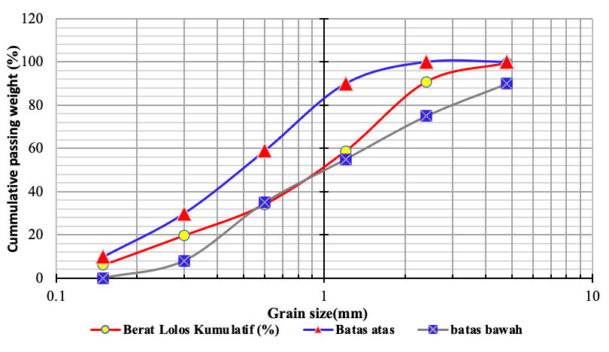
Lower limit
Upper limit
Cummulative passing weight (%)

Figure 3. Grain size distribution of the fine aggregate

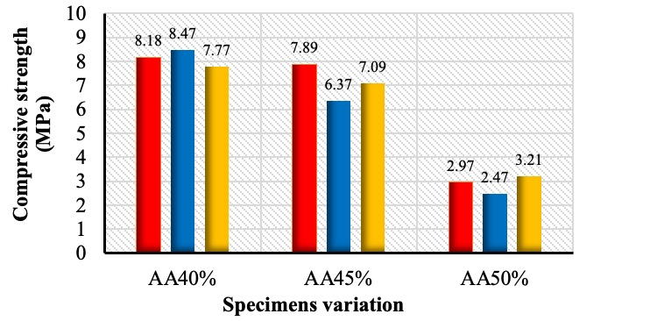
Figure 4. Compressive strength test result of geopolymer mortar
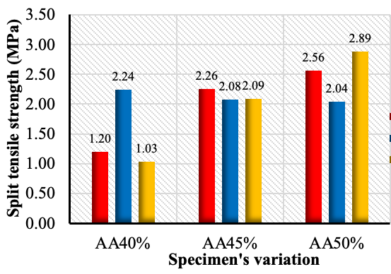
Figure 5. Split tensile strength test result of geopolymer mortar

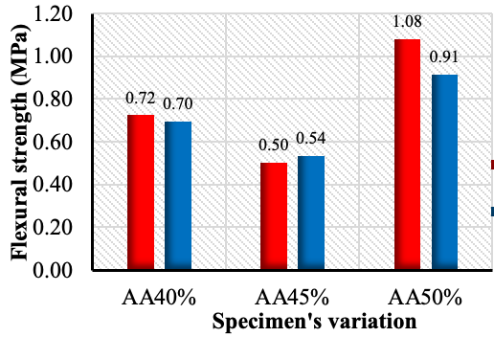
Figure 6. Flexural strength test result of geopolymer mortar

Microstructural appearance
Microstructural element testing was conducted using scanning electron microscope – energy despersive x-ray (SEM – EDX) on geopolymer mortar specimens to reveal the microstructure of rice husk ash. The purpose of this test was to examine the microstructure of rice husk ash-based geopolymer mortar, as shown in Figure 7. The optimal SEM-EDX test analysis focused on identifying microstructures such as pores, microvoids, and air bubbles within the rice husk ash geopolymer mortar.
Figure 8, at 10,000x magnification, clearly shows large pores and microcracks in the rice husk ash geopolymer mortar, with sizes not exceeding 10 μm. Additionally, needle-shaped Ettringite particles are visible, caused by the deposition of unreacted alkali with the precursor. At 1,000x magnification, the SEM-EDX analysis reveals a homogeneous microstructure, indicating uneven mixing in some microstructures.
Figure 8 shows the elemental analysis at 10,000x magnification, revealing that the highest elements are oxygen (O), carbon (C), silica (Si), and sodium (Na). Additionally, aluminum (Al), calcium (Ca), potassium (K), and iron (Fe) are present in smaller quantities. These elements result from the polymerization process, acting as binding agents between the rice husk ash and the aggregate. The low calcium (Ca) content in the geopolymer mortar tends to affect the mechanical strength properties, as the presence of calcium aids in hardening and increasing the density of the geopolymer mortar.

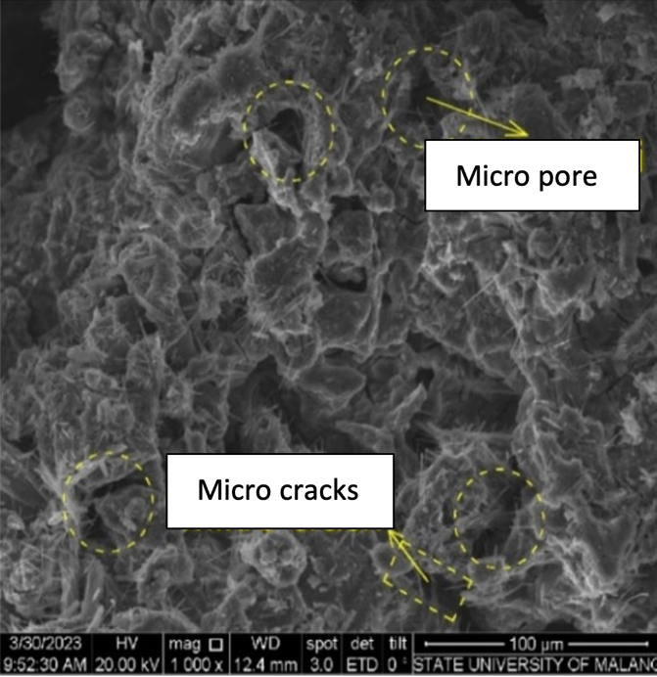
Figure 7. The microstructure of mortar geopolymer by using rice husk ash based on the SEM-EDX in 1000 magnification

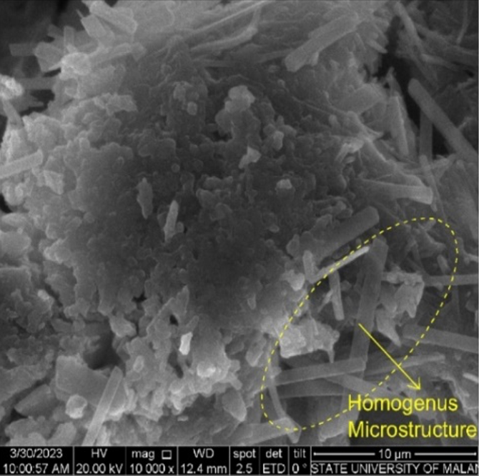
Figure 8. The microstructure of mortar geopolymer by using rice husk ash based on the SEM-EDX in 10000 magnification

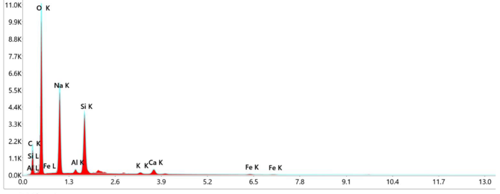
Figure 9. The chemical component of the mortar based on SEM-EDS mapping analysis

Comparison to the mechanical properties of normal mix design
This study includes a comparison of the mechanical properties of geopolymer mortar with normal mortar. The purpose of this comparison is to understand the differences in the mechanical strength properties between geopolymer mortar and normal mortar. The results indicate that rice husk ash-based geopolymer mortar has lower mechanical properties than normal mortar. The mechanical properties of normal mortar were obtained from previous research. This comparison can be seen in the values of compressive strength, split tensile strength, and flexural strength. The results of the mechanical property tests are shown in Figure 10 (compressive strength graph), Figure 11 (split tensile strength graph), and Figure 12 (flexural strength graph).
Based on the Figure 10, 11, and 12, it is evident that rice husk ash-based geopolymer mortar exhibits lower mechanical properties compared to normal mortar. This is apparent in each test conducted. In the compressive strength test, the highest result for the AA40% variation is 8.14 MPa, whereas normal mortar achieves 22.8 MPa. In the split tensile strength test, the highest result for the AA50% variation is 2.5 MPa, while normal mortar reaches 5.27 MPa. In the flexural strength test, the highest result for the AA50% variation is 1.00 MPa, in contrast to normal mortar's 4.18 MPa.
The lower mechanical properties of geopolymer mortar are attributed to incomplete hydration reactions within the mortar mix, leading to cracks in the mortar paste and resulting in weaker structural bonds [26]. Additionally, rice husk ash has lower reactivity, which affects the effectiveness of the chemical reactions. Several factors influence the variability in the quality of rice husk ash and, consequently, the quality of geopolymer mortar. These factors include the burning technique of the rice husk ash and the type of rice used. Therefore, it is crucial to optimize these processes to ensure high-quality rice husk ash for geopolymer mortar production.
In conclusion, while rice husk ash-based geopolymer mortar currently exhibits lower mechanical properties compared to normal mortar and it was a good aggrement to the previous research [6], [7], there is potential for improvement. By optimizing the burning techniques and selecting appropriate types of rice, the quality of rice husk ash can be enhanced, leading to better performance of geopolymer mortar. With further research and development, rice husk ash-based geopolymer mortar could become a viable alternative to traditional mortar, offering a sustainable and eco-friendly option for construction. Additionally, rice husk ash-based geopolymer mortar can be used for repairing structures where only low-quality concrete, equivalent to the quality of rice husk ash-based mortar, is required. This application could make use of the available material while still adhering to the structural needs of specific low-demand projects.

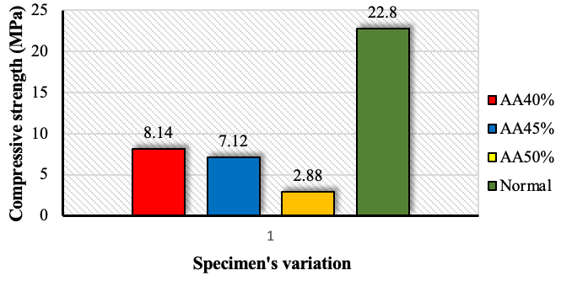
Figure 10. Comparison of the compressive strenth of geopolymer mortar to the normal mortar
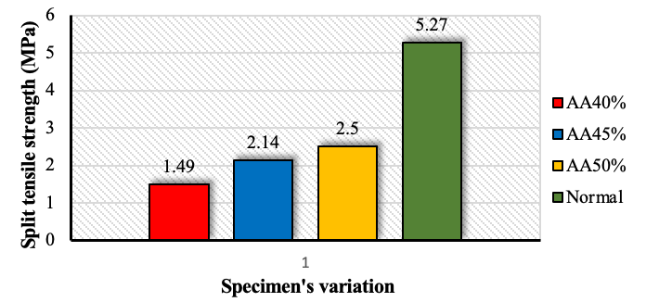
Figure 11. Comparison of the split tensile strenth of geopolymer mortar to the normal mortar

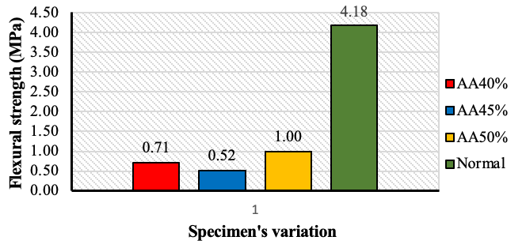
Figure 12. Comparison of the flexural strenth of geopolymer mortar to the normal mortar

CONCLUSION
In conclusion, the study highlights that rice husk ash, with a high silica content of 85.6%, plays a crucial role in the mechanical properties of geopolymer mortar. The mechanical tests reveal that the highest compressive strength (8.14 MPa) is achieved with 40% alkali activator, while the optimal split tensile and flexural strengths (2.50 MPa and 1.00 MPa, respectively) occur with 50% alkali activator. These strengths are linked to the high silica content and effective formation of silica-alumina polymer bonds. However, current limitations arise from incomplete hydration reactions and the lower reactivity of rice husk ash, which result in weaker structural bonds. Factors such as the burning technique and the type of rice used impact the quality of the mortar. Optimizing these processes can enhance the performance of rice husk ash-based geopolymer mortar. While it may not yet match the strength of traditional mortar, it presents a sustainable and eco-friendly alternative. This material is particularly suitable for applications where lower-strength mortar is acceptable, such as repairing structures and large-scale casting in extreme weather conditions, thereby making effective use of available materials while meeting the structural needs of low-demand projects.

ACKNOWLEDGMENT
The author would like to extend their gratitude to the ……………………… for their assistance with the research as well as the publishing.

REFERENCES
[1] K. L. Scrivener, V. M. John, and E. M. Gartner, “Eco-efficient cements: Potential economically viable solutions for a low-CO2 cement-based materials industry,” Cem Concr Res, vol. 114, pp. 2–26, Dec. 2018, doi: 10.1016/j.cemconres.2018.03.015.
[2] M. Reza Nadi Abiz, M. Reza Esfahani, A. Tanhadoust, M. L. Nehdi, and S. Mohammad Banijamali, “Magnesium nanoparticle modified cement-based composites: Performance and compatibility in repair applications,” Constr Build Mater, vol. 400, p. 132781, Oct. 2023, doi: 10.1016/J.CONBUILDMAT.2023.132781.
[3] E. A. Anisa, R. Afriansya, J. Randisyah, and P. Astuti, “Studi Pemanfaatan Prekursor Fly Ash Lokal pada Self Compacting Geopolymer Concrete (SCGC),” Semesta Teknika, vol. 24, no. 2, pp. 111–119, Nov. 2021, doi: 10.18196/st.v24i2.13075.
[4] P. Astuti, R. Afriansya, E. A. Anisa, and J. Randisyah, “Mechanical properties of self-compacting geopolymer concrete utilizing fly ash,” 2022, p. 020028. doi: 10.1063/5.0094463.
[5] R. Afriansya, E. A. Anisa, P. Astuti, and M. D. Cahyati, “Effect of polypropylene fiber on workability and strength of fly ash-based geopolymer mortar,” E3S Web of Conferences, vol. 429, p. 05006, Sep. 2023, doi: 10.1051/e3sconf/202342905006.
[6] R. Afriansya, P. Astuti, V. S. Ratnadewati, J. Randisyah, T. Y. Ramadhona, and E. A. Anisa, “Investigation of setting time and flowability of geopolymer mortar using local industry and agriculture waste as precursor in Indonesia,” International Journal of GEOMATE, vol. 21, no. 87, 2021, doi: 10.21660/2021.87.j2325.
[7] P. Astuti, R. Afriansya, E. A. Anisa, S. D. Puspitasari, and A. Y. Purnama, “The potential use of agriculture pozzolan waste as supplementary cementitious materials by integrating with biomass,” 2022, p. 040017. doi: 10.1063/5.0104926.
[8] P. Chindaprasirt, C. Jaturapitakkul, W. Chalee, and U. Rattanasak, “Comparative study on the characteristics of fly ash and bottom ash geopolymers,” Waste Management, vol. 29, no. 2, pp. 539–543, Feb. 2009, doi: 10.1016/j.wasman.2008.06.023.
[9] Z. A. Alrowaili, M. M. Alnairi, I. O. Olarinoye, A. Alhamazani, G. S. Alshammari, and M. S. Al-Buriahi, “Radiation attenuation of fly ash and rice husk ash-based geopolymers as cement replacement in concrete for shielding applications,” Radiation Physics and Chemistry, vol. 217, p. 111489, Apr. 2024, doi: 10.1016/J.RADPHYSCHEM.2023.111489.
[10] J. Tashan, “Flexural behavior evaluation of repaired high strength geopolymer concrete,” Compos Struct, vol. 300, p. 116144, Nov. 2022, doi: 10.1016/J.COMPSTRUCT.2022.116144.
[11] Md. Zia ul haq, H. Sood, R. Kumar, P. Chandra Jena, and S. Kumar Joshi, “Eco-friendly approach to construction: Incorporating waste plastic in geopolymer concrete,” Mater Today Proc, Sep. 2023, doi: 10.1016/j.matpr.2023.09.037.
[12] X. Wang, C. Cheng, and D. Wang, “Effect of rice husk ash on mechanical properties of rubber doped geopolymer recycled concrete,” Case Studies in Construction Materials, vol. 20, p. e03406, Jul. 2024, doi: 10.1016/J.CSCM.2024.E03406.
[13] M. Babaee, M. S. H. Khan, and A. Castel, “Passivity of embedded reinforcement in carbonated low-calcium fly ash-based geopolymer concrete,” Cem Concr Compos, vol. 85, pp. 32–43, Jan. 2018, doi: 10.1016/j.cemconcomp.2017.10.001.
[14] Herwani, I. Pane, I. Imran, and B. Budiono, “Compressive Strength of Fly ash-based Geopolymer Concrete with a Variable of Sodium Hydroxide (NaOH) Solution Molarity,” MATEC Web of Conferences, vol. 147, p. 01004, Jan. 2018, doi: 10.1051/matecconf/201814701004.
[15] R. C. Kaze, A. Naghizadeh, L. Tchadjie, Ö. Cengiz, E. Kamseu, and F. U. Chinje, “Formulation of geopolymer binder based on volcanic-scoria and clay brick wastes using rice husk ash-NaOH activator: Fresh and hardened properties,” Sustain Chem Pharm, vol. 40, p. 101627, Aug. 2024, doi: 10.1016/J.SCP.2024.101627.
[16] J. Zou, X. Ma, M. Zhao, Q. Guan, D. Chen, and Y. Chao, “Ternary geopolymer synthesized using self-made rice husk ash-based water glass for removing Cu2+ and Cr3+ from wastewater,” Mater Lett, vol. 367, p. 136556, Jul. 2024, doi: 10.1016/J.MATLET.2024.136556.
[17] S. Feng, C. Ge, Q. Sun, W. Zheng, G. Li, and C. Hu, “Valorization of agriculture waste: Preparation of alkoxysilanes from mixed rice straw and rice husk ash,” Chemical Engineering Journal, vol. 495, p. 153377, Sep. 2024, doi: 10.1016/J.CEJ.2024.153377.
[18] M. K. A. Talib, S. N. H. Arifin, A. Madun, M. F. M. Dan, and F. Pakir, “Effect of Rice Husk Ash (RHA) as a Pozzolan on the Strength Improvement of Cement Stabilized Peat,” Journal of Advanced Research in Applied Mechanics, vol. 114, no. 1, pp. 83–93, 2024.
[19] L. Dembovska, D. Bajare, I. Pundiene, and L. Vitola, “Effect of Pozzolanic Additives on the Strength Development of High Performance Concrete,” Procedia Eng, vol. 172, pp. 202–210, Jan. 2017, doi: 10.1016/J.PROENG.2017.02.050.
[20] K. Bhatrola, N. C. Kothiyal, and S. Kumar Maurya, “Durability &amp; mechanical properties of functionalized multiwalled carbon nanotube incorporated pozzolana portland cement composite,” Mater Today Proc, Jul. 2023, doi: 10.1016/j.matpr.2023.07.178.
[21] E. Lozinguez, J. F. Barthélémy, V. Bouteiller, and T. Desbois, “Contribution of Sacrificial Anode in reinforced concrete patch repair: Results of numerical simulations,” Constr Build Mater, vol. 178, pp. 405–417, Jul. 2018, doi: 10.1016/J.CONBUILDMAT.2018.05.063.
[22] M. S. Ali, E. Leyne, M. Saifuzzaman, and M. S. Mirza, “An experimental study of electrochemical incompatibility between repaired patch concrete and existing old concrete,” Constr Build Mater, vol. 174, pp. 159–172, Jun. 2018, doi: 10.1016/J.CONBUILDMAT.2018.04.059.
[23] P. Astuti, R. S. Rafdinal, H. Hamada, Y. Sagawa, D. Yamamoto, and K. Kamarulzaman, “Effectiveness of Rusted and Non-Rusted Reinforcing Bar Protected by Sacrificial Anode Cathodic Protection in Repaired Patch Concrete,” in IOP Conference Series: Earth and Environmental Science, 2019. doi: 10.1088/1755-1315/366/1/012013.
[24] K. Kawaai, T. Nishida, A. Saito, and T. Hayashi, “Application of bio-based materials to crack and patch repair methods in concrete,” Constr Build Mater, vol. 340, p. 127718, Jul. 2022, doi: 10.1016/J.CONBUILDMAT.2022.127718.
[25] P. Astuti et al., “Engineering Properties of Seawater-Mixed Mortar with Batching Plant Residual Waste as Aggregate Replacement,” SINERGI, vol. 28, no. 2, pp. 381–394, 2024.
[26] Saloma, Hanafiah, D. O. Elysandi, and D. G. Meykan, “Effect of Na2SiO3/NaOH on mechanical properties and microstructure of geopolymer mortar using fly ash and rice husk ash as precursor,” 2017, p. 050013. doi: 10.1063/1.5011552.

