Port Perspectives in a Changing Climate: Strategies for Enduring Impact | 

Astina Tugi¹, Nazirah Mohamad Abdullah^{2*}, Ami Hassan Md Din³, Najhan Md Said⁴, Badrul Hisham Ismail⁵
¹Faculty of Civil Engineering and Built Environment, Universiti Tun Hussein Onn Malaysia, Malaysia
²Faculty of Applied Science and Technology, Universiti Tun Hussein Onn Malaysia, Malaysia
³Faculty of Built Environment and Surveying, Universiti Teknologi Malaysia, Malaysia
⁴National Hydrographic Centre, Malaysia
⁵Port Klang Authority, Malaysia

Abstract  More than 50% of the world's trade happens via seaborne line. The sustainability of the ports is crucial as it boosts economic growth. However, climate change and its effects have disturbed the port's activities. This paper highlighted the possibility of climate change effects threatening some ports worldwide. A systematic literature review has been conducted, and 12 resources are used to summarize their impact on port activities. The climate change effects encountered by the ports and their authorities' adaptation measures are underlined. Ports worldwide are considered. As a result, sea level rise (SLR), storm surges, typhoons, and flooding are some threats that can affect port activities. Adaptation plans can be more successfully implemented with excellent knowledge of the factors leading to increased exposure. From the port expansion to creating a new location of ports, the other mitigation and adaptation plan towards the sustainable ports is by providing an accurate topographic map, a good simulation software, and a good resilience infrastructures and adaptation framework. The related ports have suggested and implemented adaptation and mitigation approaches to resolve the problem and sustain their ports and harbours activities. Adaption and mitigation measures taken will respond to the effects of climate change.  This is an open access article under the CC BY-SA license   | Keywords:  climate change; port and harbours; sea level rise; mitigation and adaptation (consist of 3-5 words, separated with semicolon, sort Ascending, 9 Italic)  Article History:  Received: May 2, XXXX  Revised: May 29, XXXX  Accepted: June 2, XXXX  Published: June 2, XXXX  Corresponding Author:  Nazirah Mohamad Abdullah  Applied Science and Technology  Universiti Tun Hussein Onn Malaysia, Malaysia  Email: nazirah@uthm.edu.my

INTRODUCTION
The sustainability of the maritime sector is important and there are many parties and stakeholders involved in the maritime sector as highlighted by [1]. According to the report of the [2], more than 80% of international trading takes place via maritime routes, while the rest are through land routes [3]. In addition, the criticality of the maritime transport atmosphere at ports and harbours is crucial to their operation sustainability [4]. Relatively, by sustaining the port's development, operational cost, efficiency, and recognition could be augmented. Figure 1 and Figure 2 acknowledge the distribution of ports around the world according to the world's largest port and major container ports, respectively, in the year 2016 (adapted from [5]). Figure 3 illustrates the world’s major container ports volume for the year 2014 until 2020, meanwhile, Table 1 shows the top 20 world ports according to the [6] and [7]. Almost 50% of the ports listed had growth in the volume of container supply from years 2014 to 2020.
According to Table 1, most ports experienced an increase in container volume from 2014 to 2020, except for the following ports:Hong Kong, China; Jebel Ali, United Arab Emirates; Los Angeles, United States of America; Rotterdam, Netherlands; Singapore; and Hamburg, Germany.

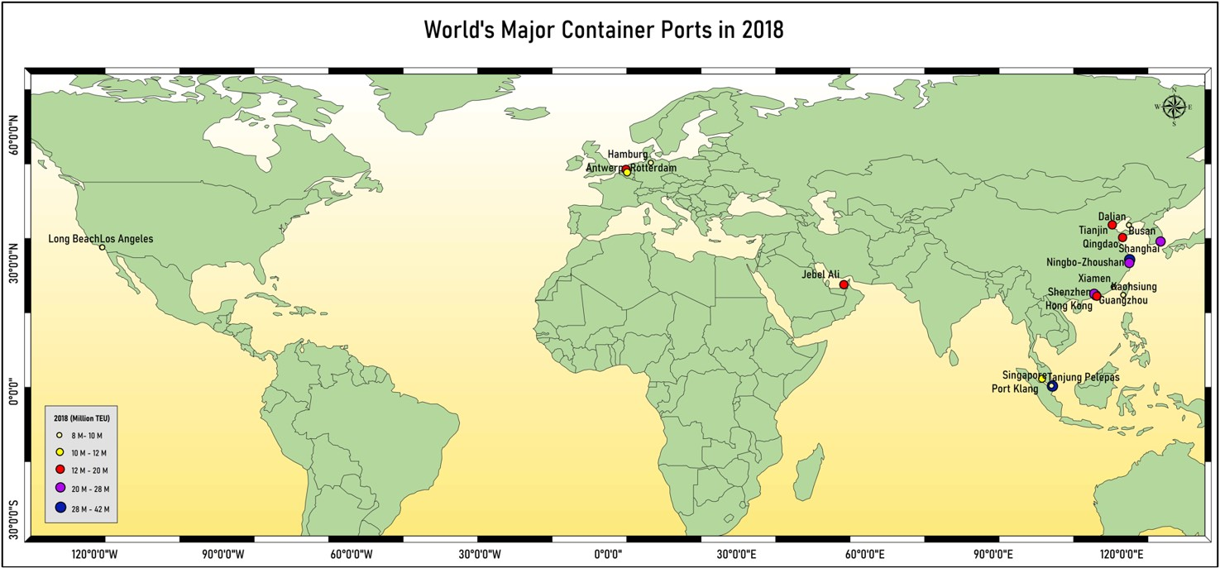
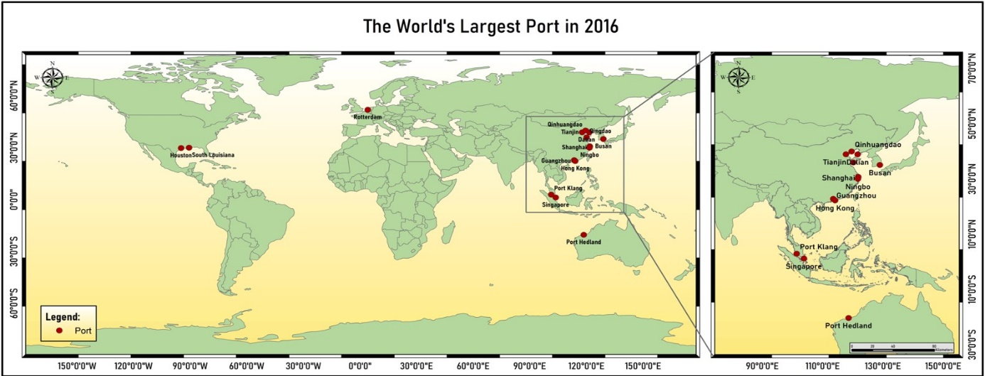
ddsds

Figure 2. The world’s major container ports in 2016 (Adapted from [5])
Figure 1. The world’s largest ports in 2016 (Adapted from [5])
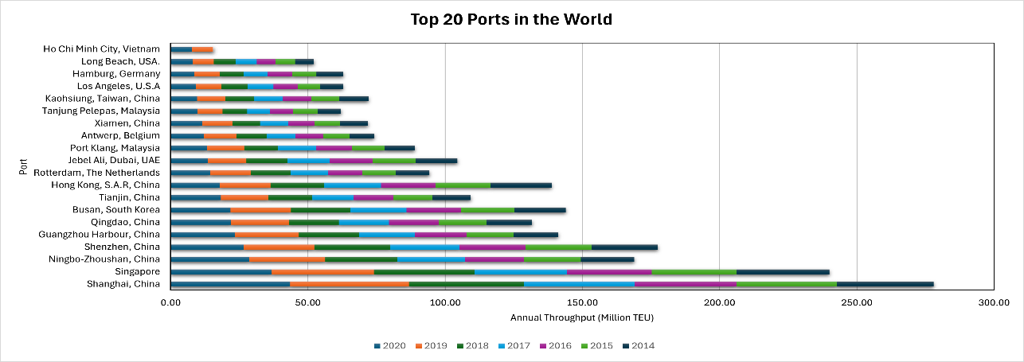

Figure 3. The world’s container ports volume (year 2014 – 2020) (Adapted from [6] and [7])
Rank | Port | 2020 | 2019 | 2018 | 2017 | 2016 | 2015 | 2014
1 | Shanghai, China | 43.50 | 43.30 | 42.01 | 40.23 | 37.13 | 36.54 | 35.29
2 | Singapore | 36.87 | 37.19 | 36.60 | 33.67 | 30.90 | 30.92 | 33.87
3 | Ningbo-Zhoushan, China | 28.72 | 27.53 | 26.35 | 24.61 | 21.60 | 20.63 | 19.45
4 | Shenzhen, China | 26.55 | 25.77 | 27.74 | 25.21 | 23.97 | 24.20 | 24.03
5 | Guangzhou Harbour, China | 23.50 | 23.23 | 21.87 | 20.37 | 18.85 | 17.22 | 16.16
6 | Qingdao, China | 22.01 | 21.01 | 18.26 | 18.30 | 18.01 | 17.47 | 16.62
7 | Busan, South Korea | 21.82 | 21.99 | 21.66 | 20.49 | 19.85 | 19.45 | 18.65
8 | Tianjin, China | 18.35 | 17.26 | 16.00 | 15.07 | 14.49 | 14.11 | 14.05
9 | Hong Kong, China | 17.95 | 18.36 | 19.60 | 20.76 | 19.81 | 20.07 | 22.23
10 | Rotterdam, Netherlands | 14.34 | 14.81 | 14.51 | 13.73 | 12.38 | 12.23 | 12.30
11 | Jebel Ali, United Arab Emirates (UAE) | 13.48 | 14.11 | 14.95 | 15.37 | 15.73 | 15.60 | 15.25
12 | Port Klang, Malaysia | 13.24 | 13.58 | 12.32 | 13.73 | 13.20 | 11.89 | 10.95
13 | Antwerp, Belgium | 12.03 | 11.86 | 11.10 | 10.45 | 10.04 | 9.65 | 8.98
14 | Xiamen, China | 11.41 | 11.12 | 10.00 | 10.38 | 9.61 | 9.18 | 10.13
15 | Tanjung Pelepas, Malaysia | 9.80 | 9.10 | 8.96 | 8.38 | 8.28 | 9.10 | 8.50
16 | Kaohsiung, China | 9.62 | 10.42 | 10.45 | 10.27 | 10.46 | 10.26 | 10.59
17 | Los Angeles, USA | 9.21 | 9.33 | 9.46 | 9.43 | 8.86 | 8.16 | 8.33
18 | Hamburg, Germany | 8.54 | 9.27 | 8.73 | 8.86 | 8.91 | 8.82 | 9.73
19 | Long Beach, USA | 8.11 | 7.63 | 8.09 | 7.54 | 6.80 | 7.19 | 6.82
20 | Ho Chi Minh City, Vietnam | 7.85 | 7.53 | - | - | - | - | -
Table 1. Top 20 World Container Ports (Adapted from [6] and [7])

This indicates that the maritime trading industry continues to emerge and evolve, and this scenario underscores the significant role played by the port industry. Several global climate change challenges might have varying effects on port operations [6]. Therefore, the adaptation measures toward the upcoming climate change effects, such as SLR, are crucial for the management authority of the ports and harbours as they play an essential role in global trading and economic growth. [8] and [9] interpreted climate change as the changes in climate that can be identified by the changes in their property's variability from statistical test evaluation. The changes would continue as consequences of multiple factors such as anthropogenic activity or natural occurrences. [10] indicate that natural events such as solar radiation variations and volcanic eruptions also impair the Earth. In addition, anthropogenic activities of fossil fuel burning cause changes to the climate conditions due to the release of greenhouse gases (GHG) [11]. The increment of the release of four types of gases which are carbon dioxide (CO₂), nitrous oxide (N₂O), methane (CH₄), and fluorinated gases (F-gases), causes global warming. Global warming increases the temperature and leads to extreme events and catastrophic effects such as human and infrastructure losses [1, 12, 13, 14, 15, 16]. According to [17], by 2100, the sea level might increase by up to 2.4 meters, meanwhile [14] annotated that the SLR might increase up to 5 meters by 2100. Port structures' and facilities' foundations deteriorate due to extreme weather occurrences. Elevated sea levels and storm surges wear down buildings, while intense heat and sunlight shorten buildings and other structures' lifespans and damage their texture. Climate change mitigation and adaptation measures should be augmented towards the maritime industries at ports and harbours since it concerns the stakeholders and maritime players due to significant damages that might affect their facilities and activities due to these environmental circumstances [6][18]. The impact of climate-related extremes and trends are affecting port infrastructure [19], port operations, navigable water, protection from wind, waves, floods, storm surges, and temperature increases [1, 14, 20, 21, 22, 23]. Figure 4 highlights the map distribution of tropical storms around the world. Coastal areas are also subject to damage due to the increment of tropical cyclone activity [3]. [24] highlighted that low-latitude regions such as Indonesia and central eastern Asia are more vulnerable to climate variations such as extreme temperature and precipitation changes. Therefore, adaptation and preventive measures are essential.

METHOD
A thorough analysis of the detrimental effects of climate change at ports and harbours is elaborated by adapting the Systematic Literature Review. This technique utilized many kinds of literature, preferable critical materials, and findings interpretation to provide a comprehensive assessment [25]. A systematic literature review is a methodical and evidence-based way to comprehensively search for studies that are relevant to specific research questions. It involves carefully selecting, evaluating, and combining the findings of these studies to provide answers to the research questions. Systematic reviews, in contrast to conventional narrative reviews, often incorporate specific research enquiries, well-defined search methods, criteria for selection, and both qualitative and quantitative summaries [26]. By understanding the idea and the issue, a fair review from multiple sources is executed. The primary flow of the systematic literature review adopted in this study is illustrated in Figure 5.

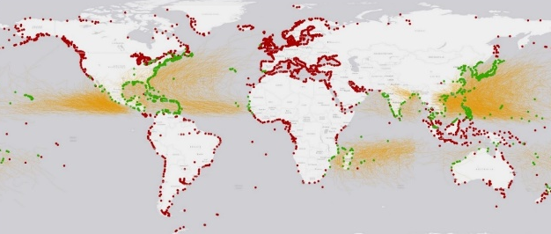

Figure 4. Map showing ~1100 ports (green) out of ~3700 total (red) that have come within 50km of a tropical storm from 1960 - 2016. Storm tracks in orange [18]

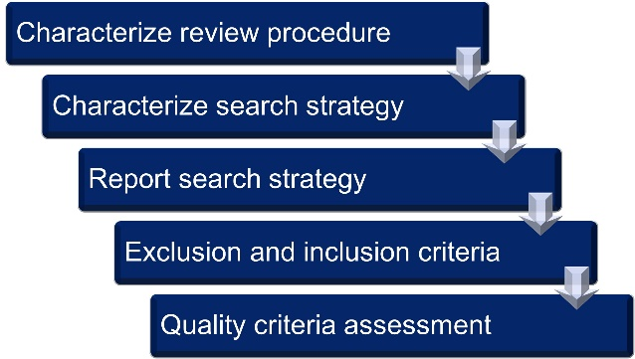

Figure 5. The primary steps of the systematic literature review process [27]

Research Questions
The research question (RQ) is the key to the systematic literature review. These RQs will guide the focus and direction of the study and narrow down its purpose. There are three RQs about the effects of climate change at ports pointed out for the literature review. The RQ are as follows:

- RQ1: What is the climate change scenario affecting the port area?
- RQ2: How does the topography of the port correlate with climate change?
- RQ3: What are the mitigation and adaptation measures taken by the port authority?

Selection of the Study
Parallel with the research questions focus, several sources are selected for the review. The selection of the article varies from the year 2013 until 2023, which consists of multiple types of publications including reports, journal articles and books. 10 years has been chosen to review the climate change impact towards the port industries. Below are the lists of the resources for the literature:
- Google Scholar (https://scholar.google.com/)
- Science Direct (https://www.sciencedirect.com/)
- Scopus (https://www.scopus.com/home.uri)
- Research Gate (https://www.researchgate.net/)

A few keywords string is used in selecting the relevant academic literature through the website mentioned earlier. The keywords string conveys the appropriate reading resources. A Boolean operation such as “AND” or “OR” is used to obtain the required sources of information. The literature search encompassed journal articles, conference papers, book chapters, and other published sources. Figure 6 shows the flowchart for conducting a database search using keywords and source filtering.

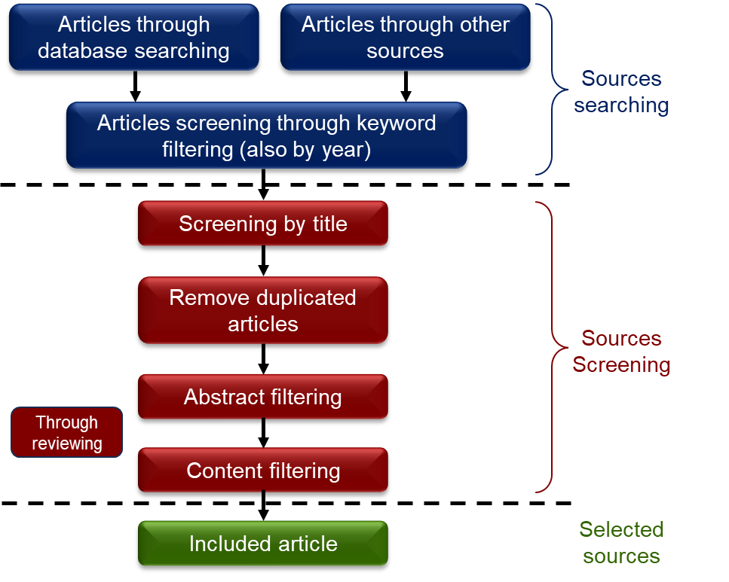

Figure 6. Flowchart of the sources selection (Summarise from [6])
The screening step is conducted once the searching phase has been completed. The articles are being screened using three filtering processes: title filtering, abstract filtering, and content screening. The duplicated article is removed. Final articles are chosen after screening is done.

Quality Assessment
The quality assessment for the selected paper is conducted after the desirable sources are selected. The selected papers are chosen according to their context and information through a review process. The chosen articles were read and examined personally by the researcher, and they must understand the justified RQ. The chosen articles should elaborate and give information to answer the RQ. An analysis of the RQ relevancy throughout this paper is being undertaken by using a percentage analysis. A weightage has been assigned to each RQ. Below is the weightage used in analysing the research question with the selected reference sources:
- 0 when the sources do not offer any material relevant to this question.
- 0.5 for a question that has been partially but thoroughly answered in a paper.
- 1 for a question that was thoroughly explained in the article.

RESULT
The combinations of “climate change” AND “port operation”, “climate change” AND “port adaptation”, “climate change impact” AND “port”, and “port and harbours” AND “climate change variabilities” were performed. Figure 7 shows the flowchart for conducting a database search using keywords in pertinent libraries.

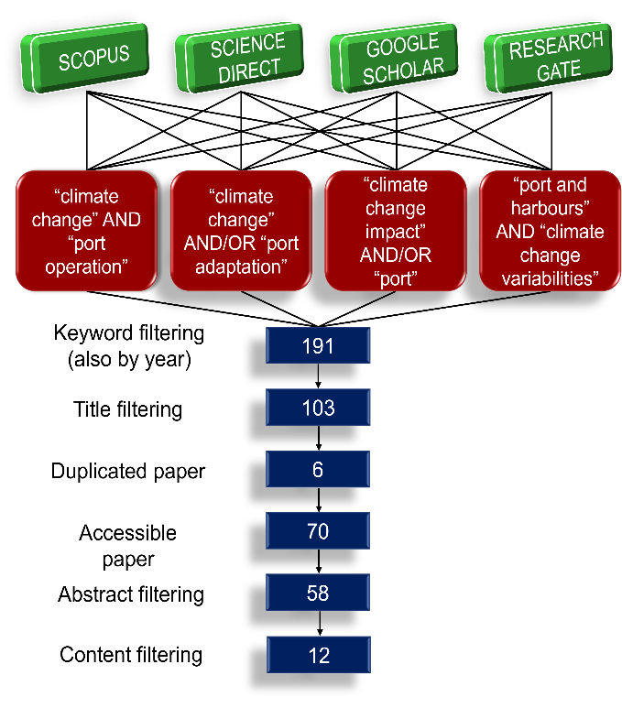

Figure 7. The flowchart for conducting a database search using keywords in pertinent libraries

Figure 7 indicates that a total of 191 items were retrieved using the specified keyword. These articles have been restricted from the year 2013 to 2023. Next, a process of title filtering is carried out, resulting in the removal of 88 papers and the elimination of 6 duplicate articles. In addition, only a total of 70 papers were available for unrestricted access. The abstracts are then carefully filtered, and 58 papers are shortlisted. Finally, content screening is performed manually, and a total of 12 papers are selected for final assessment. Table 2 enlisted the final selected resources for the analysis and Table 3 shows the Journal Impact Factor (JIF) score for all the related articles and reports. The selected papers featured a variety of materials, including books, reports, and journal articles. According to Table 3, the majority of the journal articles are categorized under JIF quartiles 1 and 2 (Q1 & Q2) with six papers. Moreover, two papers are categorized under JIF quartiles 3 and 4 (Q3 & Q4) and the rest are indexed by Scopus. The papers are divided into years; 2023 (2 papers), 2021 (3 papers), 2020 (2 papers), 2019 (2 papers), 2017 (1 paper), 2016 (1 paper) and 2013 (1 paper).

Table 2. Details of the chosen reading sources
Ref | Journal/Publisher | Type
[16] | Reporting Climate Change Impacts on Coastal Ports (NW Iberian Peninsula): A Review of Flooding Extent (2023) | Journal article
[14] | The Impact of Climate Change and EU Green Deal on Port Competitiveness (2023) | Book
[28] | Climate Change and Ports Impacts and Adaptation Strategies: March 2021 (2021) | Report
[29] | A System to Improve Port Navigation Safety and Its Use in Italian Harbours (2021) | Journal article
[6] | Adapting to the impacts of climate change on port operation (2021) | Journal
[30] | Assessing The Impact of Sea Level Rise on Port Operability Using LIDAR-Derived Digital Elevation Models (2019) | Journal article
[31] | Maritime Transport and Regional Sustainability (2020) | Book
[19] | Stakeholder awareness of climate adaptation in the commercial seaport sector: A case study from Ireland (2020) | Journal article
[21] | Sea‑Level Rise in Ports: A Wider Focus on Impacts (2019) | Journal article
[18] | Implications of Climate Change for Shipping: Ports and Supply Chains (2017) | Journal article
[32] | Seaport climate change impact assessment using a multi-level methodology (2016) | Journal article
[33] | Climate Change and Sea Level Rise Impacts at Ports and A Consistent Methodology to Evaluate Vulnerability and Risk (2013) | Journal article
Table 3. JIF of the literature resources
Ref. | Journal/Publisher | JIF
[16] | Journal of Marine Science and Engineering | Q1
[14] | Peter Lang GmbH | -
[28] | HR Wallingford | -
[29] | Applied Sciences | Q2
[6] | Australian Journal of Maritime & Ocean Affairs | Sc
[30] | Remote Sensing of Environment | Q1
[31] | Elsevier | -
[19] | Marine Policy | Q2
[21] | Maritime Economics and Logistics | Q2
[18] | Wiley Interdisciplinary Reviews: Climate Change | Q1
[32] | Maritime Policy & Management | Q3
[33] | WIT Transactions on Ecology and the Environment | Q4

Table 4 shows the percentage of the relevancy of the literature sources with research questions, respectively. Additionally, Figure 8, Figure 9, and Figure 10 show the weightage of RQ1, the weightage of RQ2, and the weightage of RQ3, respectively. Moreover, Figure 11 shows the histogram of the RQ weightage percentage. According to Figure 11, from a total of 12 resources, most of the resources have exceeded 50% of weightage percentage. Moreover, it can be seen from Figure 8 and Figure 10 that most of the resources have high relevancy with the RQ addressed. However, for RQ 2, the topography of the port location is not being explained thoroughly, since most of the ports in the world are in typical areas such as coastal areas and estuaries. Based on the result of the percentage, the articles that comply with all three research questions are from [21].

Table 4. Percentage of the relevancy of the literature sources with research questions
Ref. | RQ1 | RQ2 | RQ3 | Total | Per (%)
[16] | 1 | 1 | 0 | 2 | 66.67
[14] | 1 | 0.5 | 1 | 2.5 | 83.33
[28] | 1 | 0 | 1 | 2 | 66.67
[29] | 1 | 1 | 0.5 | 2.5 | 83.33
[6] | 1 | 0 | 1 | 2 | 66.67
[30] | 1 | 0 | 0.5 | 1.5 | 50.00
[31] | 0.5 | 1 | 1 | 2.5 | 83.33
[19] | 0.5 | 0.5 | 1 | 2 | 66.67
[21] | 1 | 1 | 1 | 3 | 100
[18] | 0.5 | 1 | 1 | 2.5 | 83.33
[32] | 0.5 | 0 | 1 | 1.5 | 50
[33] | 0.5 | 0 | 1 | 1.5 | 50

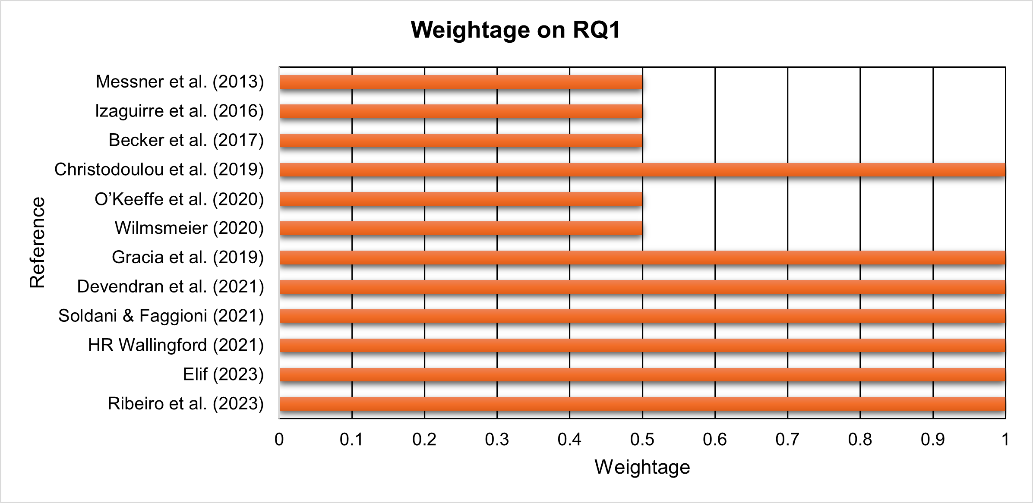

Figure 8. Weightage of RQ1

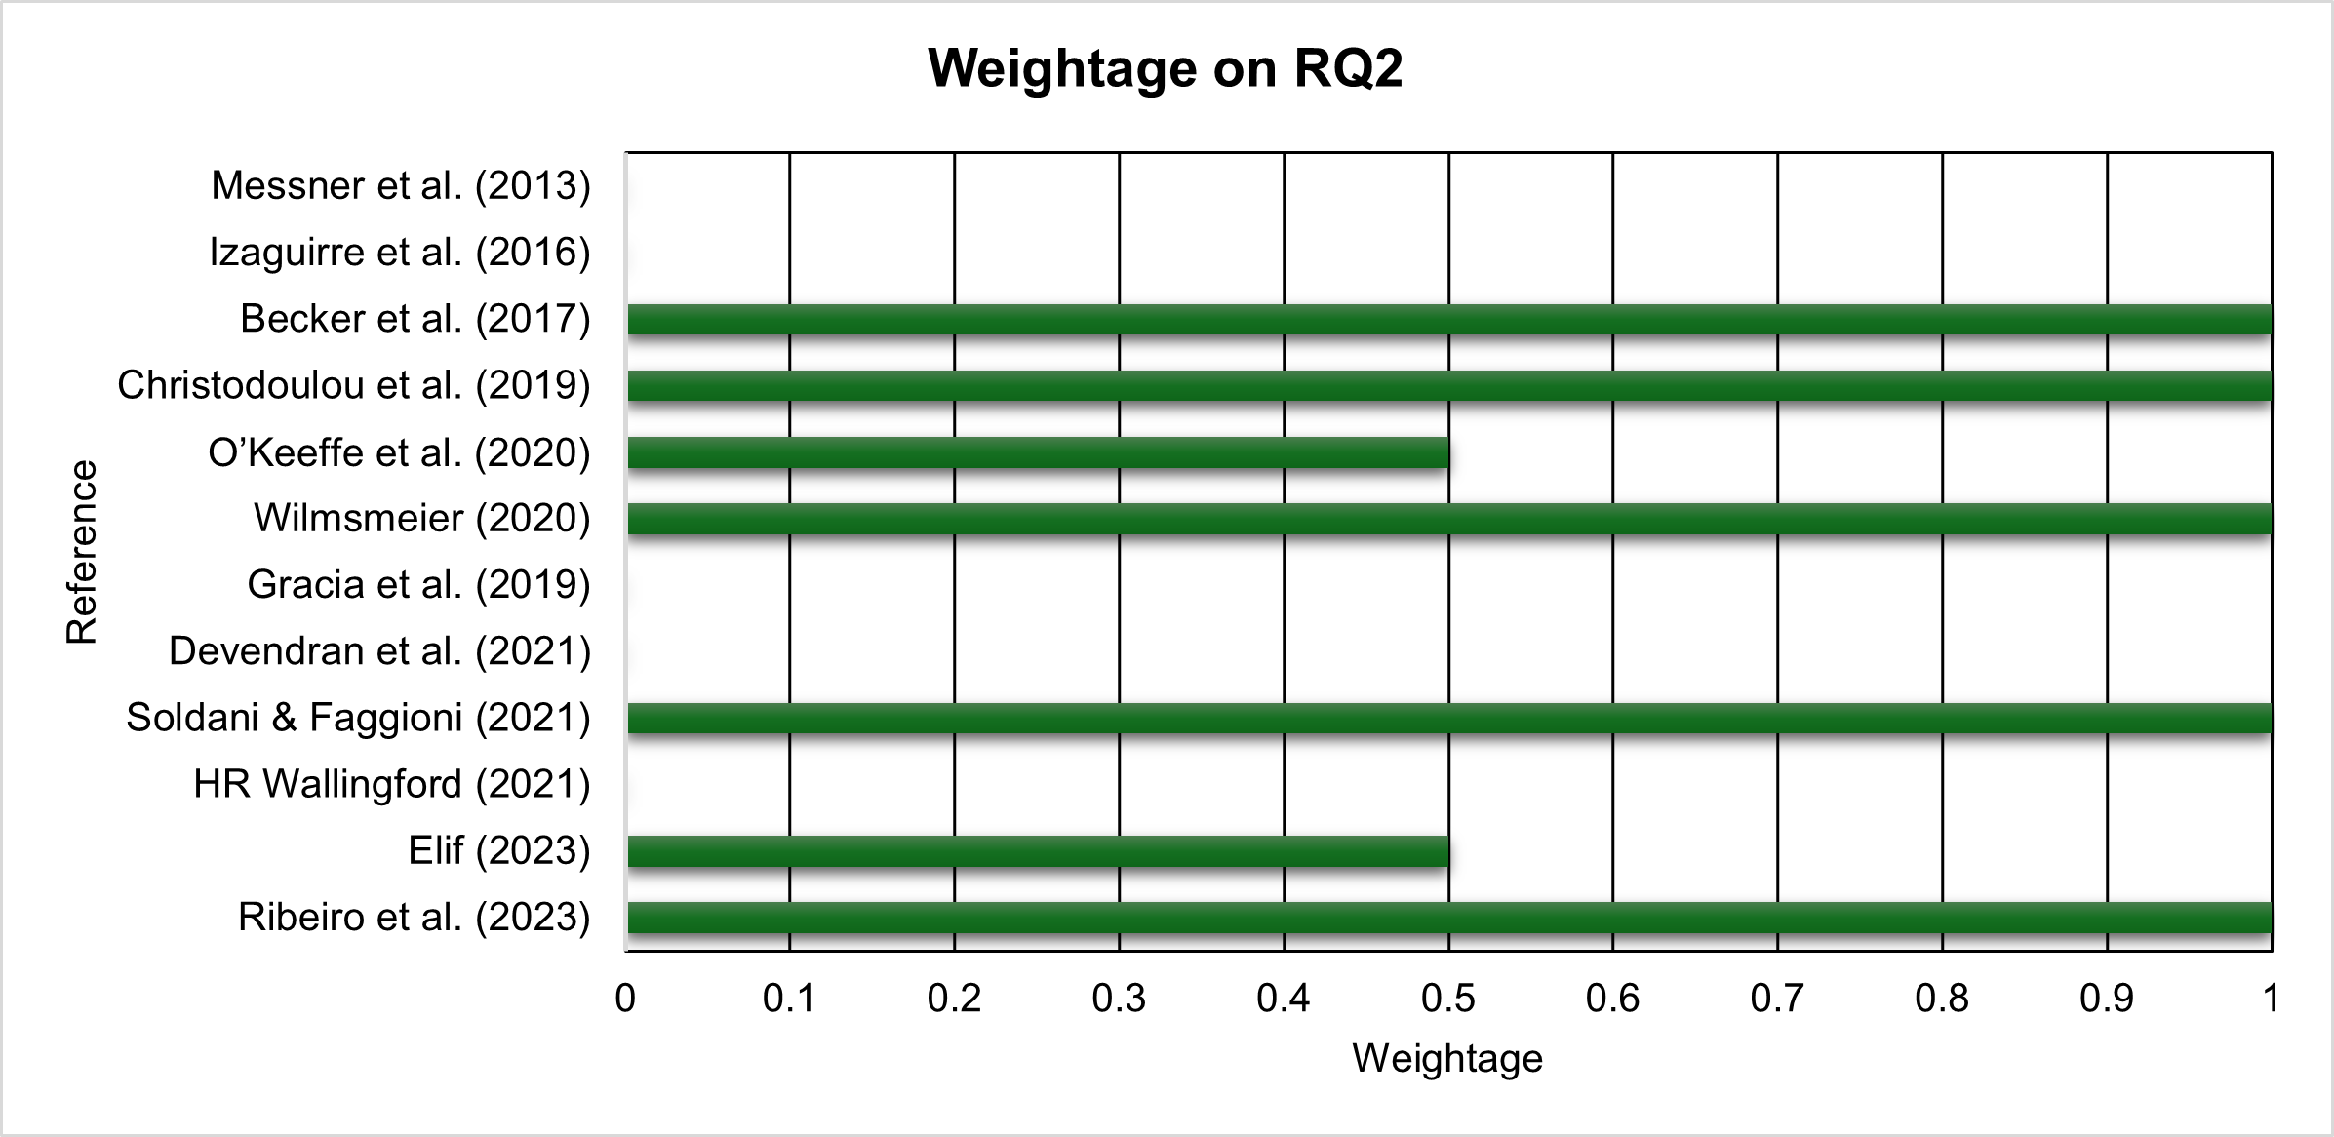

Figure 9. Weightage of RQ2

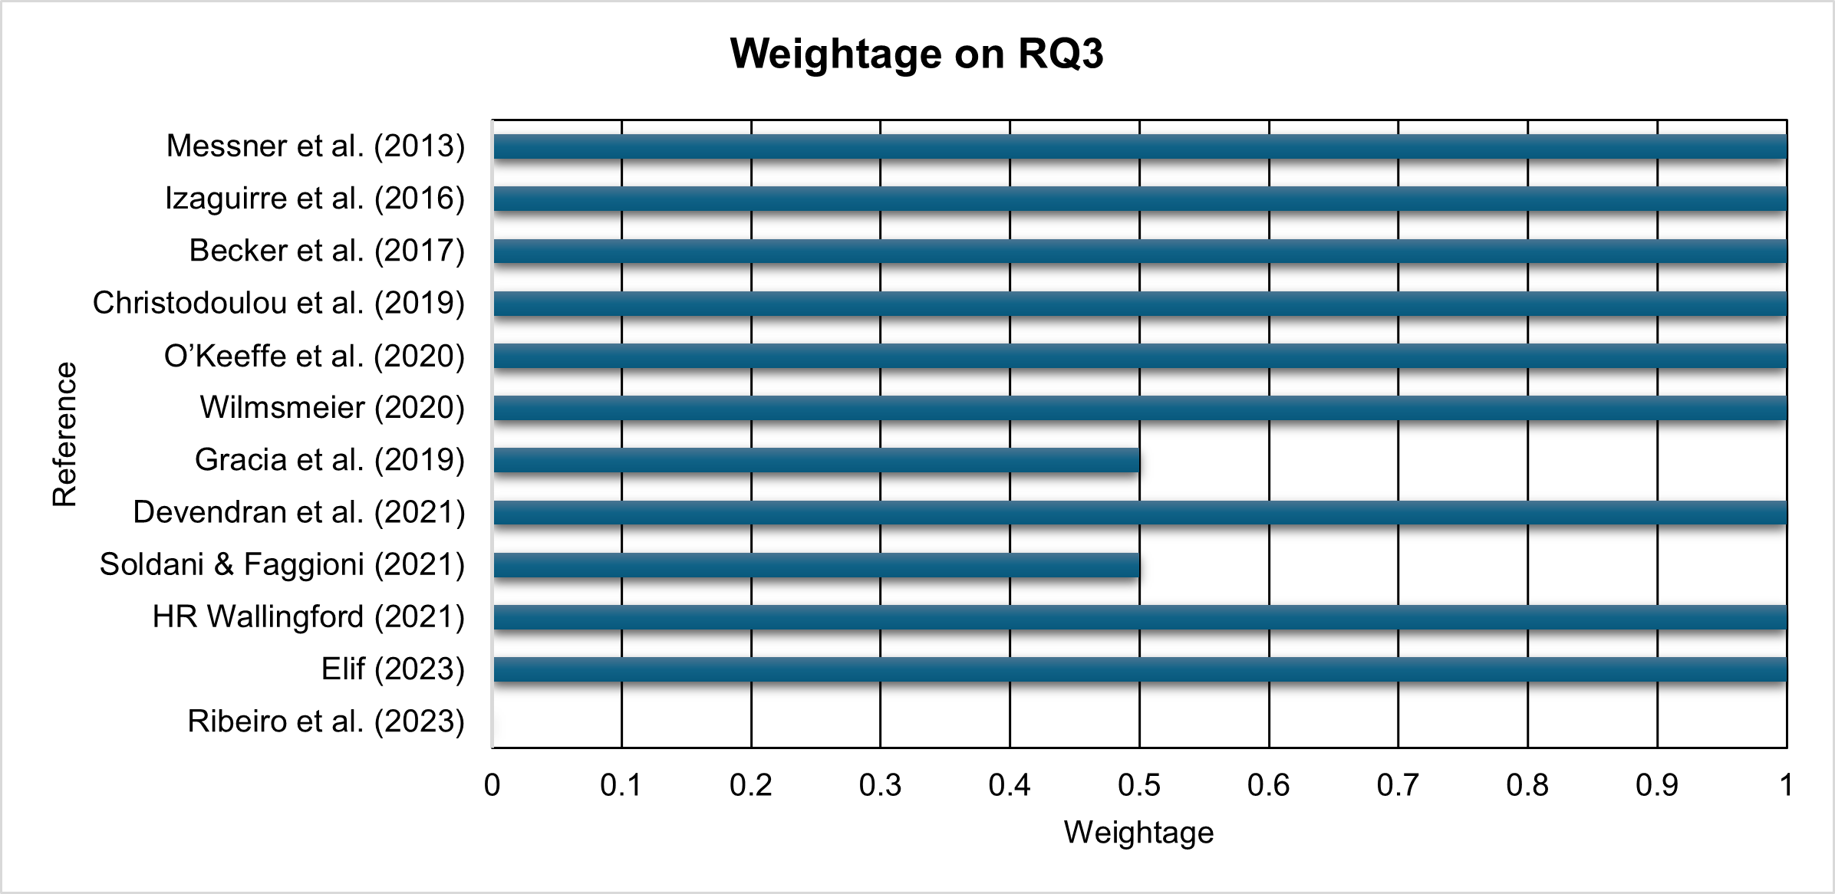

Figure 10. Weightage of RQ3

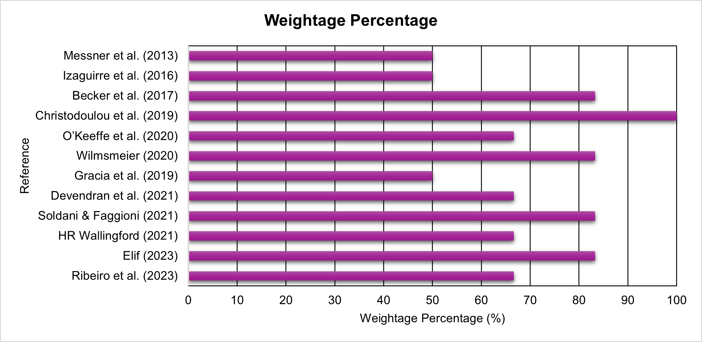

Figure 11. Histogram of the RQ weightage percentage

DISCUSSION
The sub-sections below present a brief discussion of the results of the study and the literature review. One of the primary repercussions of climate change is SLR, storms, and typhoons. These situations may damage coastal regions and impair various facilities, notably seaports and harbours, whose operations may be jeopardized. The following section discussed the climate change scenarios parallel with the consequences on the ports and harbours area.

Climate Change Effect on Ports and Harbours Activities Around the World
The geography of the ports plays an important role in this logistics chain industry [1]. Activities such as shipping [18][34] and international goods trading take place at the port, thus, maintaining the port's reliability and durability is essential. Goods trading through the seaborne line are greater than 50% of the world's trade [19][35]. Consider Vietnam as in England, extreme weather might cause timetabling delays or, even worse, the port's closure. Moreover, because of the regional impacts of climate change, extreme weather, such as short duration of intense storms, might cause urban flood inundation, which has become a concern for the global nation [32][36].
Conversely, several additional factors such as the mean and severe wind and wave conditions, tidal range and currents, water supply pressures, and health hazards associated with hotter summers might impact maritime operations and trade. Thus, it might affect navigation, port operations, and land transport [28]. By some means, climate change has gobbled some ports due to the rise of sea levels, storm surges, and other environmental factors. Figure 12 shows the proportion of regional populations experiencing major heat waves in 2040 around the world [37].

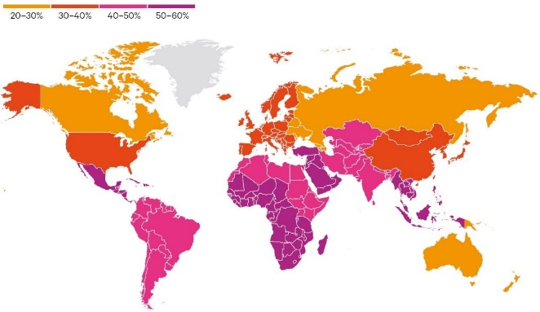

Figure 12. The proportion of regional populations experiencing major heat waves in 2040 around the world [37].

SLR, coastal flooding, storm surge, and extreme sea levels [19] are threats to the port industry. Because ports are situated in lowlands, deltas, and coastal areas, they are susceptible to the impacts of climate change [14][15][16][19][38]. Moreover, because of altered ocean currents brought on by climatic variability, mass, heat, and salt are redistributed, potentially leads to significant fluctuations in sea level [39]. Next, rainfall patterns are anticipated to shift, leading to more intense rainfall events and alterations in monthly average rainfall [16][28][31]. The escalation of sea levels and the occurrence of storm surges have the potential to inundate transportation infrastructure, resulting in costly damages and the cessation of operations within the sector [31]. Additionally, in another review of a range of regions, which is the Mediterranean basin, the fluctuations in sea level are predominantly attributable to astronomical tidal phenomena that are associated with the gravitational interactions among the Earth, the Moon, and the Sun [29].
If we observe on topography of a location, for example, Colombia, a South American country flanked by the Caribbean and Pacific seas, benefits from natural protection against increasing sea levels. Natural ecosystems, comprising coral reefs, mangroves, and coastal beaches, serve as vital protective agents by helping to regulate the climate, manage hydrology, and limit erosion. However, industrialization in this area has slowly destroyed the environment for this ecosystem. As for Columbian seaports, it is analysed that they suffer from gales, floods, erosion, and sea surges. Studies using the General Equilibrium Model Climate Change Computable (MEG4C) by Colombia's National Planning Department stated that the country's GDP would be 0.49% lower each year compared to a scenario without climate change [31]. Moreover, on the other hand, after Hurricane Sandy in 2012, the port in New Jersey, United States of America (USA), was closed for more than eight days, resulting in significant damage.
The ramifications of climate change are exceptionally pronounced in Europe, wherein more than 60% of port traffic is reliant upon linkages with ports that are significantly susceptible to the phenomena of SLR [21]. As that being mentioned, one of the largest ports in the world, which is the Port of Rotterdam, is situated in an extremely vulnerable area where flooding and SLR might occur due to its geographic, deltaic setting. The vulnerability of this European port is increased by the activities and presence of a developing, exposed, and congested populace [19]. Moreover, [16] averred the possibility of the Coruna Outer Port at the Iberian Peninsula and Vigo Port being vulnerable if extreme climate occurs that might lead to higher wave height, wind and currents. Furthermore, with eight ports, Puerto Rico is ranked first in the high-risk category. The USA and Japan are in the medium-risk category, while the Philippines, Cuba, and Indonesia are in the high-risk group. In addition, the Persian Gulf and the Red Sea region (Arabian Peninsula) are predicted to have more danger in the future due to rising temperatures, while the Mediterranean ports are expected to see a shift towards high and extremely high risk. High-risk ports include those in Jakarta, Sapporo, Santo Domingo, and Istanbul [14]. In addition, as mentioned by [40], Southeast Asia falls into one of the most susceptible regions of the world to climate change. Southeast Asia is a region that is comprised of ten sovereign states: Brunei, Cambodia, Indonesia, Laos, Malaysia, Myanmar, the Philippines, Singapore, Thailand, and Vietnam [41]. Furthermore, these nations have been significant contributors to the global emissions of greenhouse gases (GHG) during the period spanning from 1990 to 2010.
This region might suffer a more significant economic loss than other regions due to climate change. As one of the vulnerable countries in Southeast Asia to climate change, Vietnam contemplates the strategy for preventing natural disaster and their mitigation [3]. As for Vietnam, the ports have a unique issue that sets them apart from other infrastructures in that they have a lengthy lifespan, which could lead to under-designed infrastructure in the future. In the past, ports were constructed under the assumption that the temperature and sea level were constant, but this is no longer the case [3]. The authorities have begun to address the issue of climate change. Similarly, extreme weather events in India in 2015 and 2017 seriously damaged the Chennai Port [42]. Along with it, in Southern Taiwan, up to ten ships' moorings were damaged by the Asian Typhoon Meranti, which caused one newly constructed 14,000-teu box ship to go away and collide with a container terminal at Kaohsiung harbour [42]. Apart from this, the Republic of Korea experiences occasional typhoon activity along its east coast during the summer months, spanning from June to October. For example, in September 2020, Typhoon Maysak made landfall on the Korean Peninsula, causing significant damage to numerous ports and the demolition of wave dissipation blocks [38].
Ports and shipping industries are one of the users of maritime space services and the economy relies on this industry as it is one of the important sectors for commerce and trading that boost economic growth [4][10][43]. By 2050, it is anticipated that the damages and disruptions brought about by climate change at the ports will result in economic losses of more than USD 250 billion [44]. The major port authorities in the world rank climate change as one of their top three issues [14]. A study of the port vulnerability caused by climate change has been made by [45] in the Port of Rotterdam, Netherlands. The study concluded that the effects of floods caused by climate change would make the unembanked port areas vulnerable to destruction and damage. Due to the damage caused by the flood events, the possible damage cost in the year 2100 is expected to be 14 times higher than in 2010. [23] revealed that US ports need to bear loss and damage estimation of approximately US$ 46 million and US$ 2.2 billion due to Hurricane Florence in 2018 and Hurricane Katrina in 2005, respectively. Meanwhile, a similar situation occurred at some ports in China, which are the Port of Shanghai and the Port of Dalian, where each suffered a loss of approximately US $10 million and US $65 million due to 2012 Typhoon Haikui and Typhoon Lekima in 2019, respectively.
Additionally, due to the severe drought and the necessity for traffic restrictions, the cost of international shipping has been estimated at between US$ 230 million and US$ 370 million at the Panama Canal in America. The loss of operability owing to the lowering of freeboards in the berthing zones or even dock flooding is another significant possible effect of SLR on ports [30]. SLR will also raise the water depth in and around the harbour. The current wave propagation patterns will alter because of these increasing water depths (shoaling, refraction, and diffraction processes). Additional effects on ports could result from agitation, siltation, or structural stability changes. The results could be favourable or unfavourable, making the port operability better or worse [46]. The wave overtopping at 43 ports along the Catalan coast, associated with climate change by choosing four believable SLR scenarios; Base level (conditions from the year 1985-2005), RCP4.5 (Base level + 0.47 m), RCP 8.5 (Base level + 0.88 m), and high-end scenario (HES, Base level + 1.80 m), respectively. The investigation regarding the implications of SLR has been undertaken to apply the projections of RCP8.5 at the Catalan Ports to model the consequences of sea level alterations on the coastal region [46]. Additionally, [47] stated that the increase in the sea level induced by global warming would decrease the current freeboard on docks and piers, affecting how well the port operates. A study conducted by [16] attests that when mean sea-level rise and storm intensity increase, forecasting these factors becomes crucial to addressing the impact of climate change towards the port industry. It might be vulnerable to flooding because of its location and is influenced by the strength and periodicity of factors such as relative sea level and wave-induced current. Increased hazard is seen when many of these factors hit their maximum values. According to [21], between 2010 and 2100, approximately 200 million tonnes of cargo are vulnerable to the extreme sea level higher than 4.5 m. This might affect the ports located in Norway, Portugal, the United Kingdom, Ireland, and Spain. from ports that are vulnerable to extreme sea level conditions, which is higher than 4.5m. Additionally, most of the European coastline will experience extreme sea level rises of more than 0.5 meters under the high warming scenario. In addition, the North Sea, the Western Baltic Sea, and portions of the British and French Atlantic coasts will experience more than a meter rise. Compared to the North Sea, the Black Sea and the Mediterranean are predicted to see noticeably fewer consequences (lower extreme sea levels). The regional effects on the European hinterland and the European foreland by considering Europe's linkages to major ports globally are considered when evaluating the more significant consequences of possible interruptions in port operations [21].
A study conducted at four Catalan ports, which are Arenys de Mar, Palamos, Cambrils, and Vilanova I la Geltru indicated that if the port authorities take no adaptation measures, there will be a general decline in port operability during the 21st century because of SLR [29]. Moreover, according to [48], by using soft adaptation measures, seaports are robust to SLR and storm surges under 1 m and may continue to function without interruption. According to projections, 185 seaports will be at risk of being overrun by more than 1 million people by 2030, and that figure will rise to 334 by 2080. Seventy seaports are anticipated to experience flood levels greater than 3 m by 2030, which will increase to 109 by 2080. Moreover, Rotterdam Port, Netherlands, is anticipated to the SLR and an increase in water flow from the rivers Meuse and Rhine, due to higher inland precipitation. Therefore, the risk of inundation in Rotterdam harbour is expected to rise in the future [45]. A study by [49] at Jamaica and Saint Lucia Ports shows that the operational interruptions of the ports are anticipated to be caused mainly by temperature increases, with little effect from changes in rainfall and wind. Regarding the coastal inundation, with 1.5°C of warming level, coastal flooding will occur due to the extreme sea levels. This condition will affect the essential transportation assets in both countries and might affect more assets later in the century. The airports and ports in Saint Lucia are usually more susceptible to flooding than in Jamaica. In this context, asset placement in low-lying areas may have been influenced by the absence of suitable alternative locations, notably in Saint Lucia. Based on [33], the inundation of low-lying regions repeatedly and permanently owing to SLR, drought, water scarcity, storm intensification, floods, and temperature rises are some of the effects of climate change that might pose hazards to the port. Therefore, the Port of San Diego is also exposed to the impact of climate change. SLR is the main effect of climate change that will affect the port, according to its location, operating activities, and planning work. The effects of climate change are very ardent to the port industry, and adaptation measures and mitigation measures need to be taken.

Geomorphologically Driven Climate Change
In port construction, it is essential to account for both the location and geomorphology of the port area. The effects of climate change can be location-dependent [19]. Local climatic conditions, shaped by factors such as topography and land use, determine how climate change impacts are felt in specific areas. [16] examine the impact of climate change on different types of geomorphologies in the Atlantic Ocean, including, marine, rias, lagoon, and estuary areas at several ports in the Northwest Iberian Peninsula (NWIP), namely Coruna Outer Port, Vigo Port, Aveiro Port and Lisbon Port, respectively. Climate drivers included for these areas are the increase of mean sea level, extreme sea level, waves and river stream flow. Coastal flooding is susceptible to enclosed areas such as lagoons and estuaries due to the SLR and high river discharge, meanwhile, rias and marine areas are mostly affected by SLR and storm surge combination. On the other hand, [29] highlighted the importance of astronomical tides and meteorological tides in the Mediterranean area in updating sea levels. This is towards establishing and enhancing systems to improve port navigation safety.

Adaptation and Mitigation Measures
Understanding the location-dependent effects of climate change is crucial for developing tailored adaptation and mitigation strategies for different regions. Adaptation involves upgrading existing infrastructure and designing new facilities to endure the primary effects of climate change, such as rising sea levels and floods. On the other hand, mitigation focuses on the reduction of the emissions of greenhouse gases in diminishing future climate change. The adaptation measures for a specific location should be designed using site-specific assessments that consider local and regional characteristics [28]. A few adaptations and mitigation methods need to be implemented for the sustainability of the port activities and to be financially practical now while assuring simplicity of change in the future. It is essential to choose designs that might readily support future adaptation measures. [19] underlined the adaptive measures in reducing the vulnerability of ports incorporating the engineering solutions, changes of technical in port operation and future planning measures.
Uncertainty about climate change and its impact on marine and coastal climates poses challenges for port refurbishment and construction. Traditional engineering uses conservative approaches to address uncertainties, but relying on worst-case scenarios for all aspects can escalate costs and result in over-designed, unaffordable projects. Future adaptation options may include designing structures with robustness for future conditions and incorporating allowances during construction. Investing in assets to enable future upgrades of breakwater crests, quay wall operating levels, and berthing/mooring facilities and planning for replacement structures in case of damage, following the Sendai framework to avoid reactive, like-for-like replacements [28].
A port's resilience system determines its capacity to recover from natural catastrophes, such as hurricanes and severe weather. This system may be said to have high resilience if it can still function flawlessly in terms of logistics and cargo transportation [4]. Some strategies of climate action plans (CAPs) for ports and harbours towards the climate change impact are highlighted in [50] including the development of a management plan by taking anticipatory measures for relocating vulnerable infrastructure in response to SLR, storm surge, and climate change implications, with a specific focus on port and harbour facilities. Additionally, actions addressing climate-induced transformations in port infrastructure, involving engineering assessments of the height, structure, and resilience of harbour breakwaters and seawalls are also important.
A larger port is thought to be more equipped for advanced approaches to innovation and port policy towards environmental management. Rotterdam Climate Initiative (2013) outlines the development of the Rotterdam Climate Proof Programme. The Port of Rotterdam Authority has facilitated collaborative agreements with diverse stakeholders, encompassing municipal services, governmental bodies such as water boards and Rijkswaterstaat, as well as public and private entities including housing corporations, project developers, and utility providers. Intending to make Rotterdam 100% climate-proof by 2025, the Rotterdam Climate Proof Adaptation Programme states that the emphasis is on developing and putting into practice techniques for climate-proofing rather than making predictions [19]. Moreover, Amsterdam Port and London Port which is situated in a region that is especially vulnerable to severe weather occurrences, have already implemented protective strategies against highly intense events [21].
Several indicators need to be defined in the context of the operational and infrastructure of port resilience. The occurrence of flooding events such as at the berthing and storage area; vessels delay, and port damages need to be comprehended [19]. For example, Coruna Outer Port is equipped with a robust breakwater that has been designed by their port authority concerning extreme weather and it serves as an artificial harbour. A 3360m long breakwater with three alignments is responsible for the berthing area of the ships that can withstand the worst weather. As for Vietnam, specific long-term steps for the new port's location and the climate change adaptation strategies are significant. Social and port activities, coastal communities, infrastructures, and financial losses must be considered [3].
Accurate topographic data is required to investigate the potential effects of SLR on coastal locations [51]. Digital Elevation Models (DEMs) are often utilized for the extraction of such data owing to their accessibility and typically low cost (or even complimentary access) when sourced from governmental entities. These DEMs are commonly built using information from remote sensing. LiDAR (Light Detection and Ranging) data has grown in popularity as a source of knowledge from which DEMs can be generated for use in various geoscience applications [52].
As for Aveiro Port, a software package called DELFT3D enables the simulation of outflow and waves in coastal, riverine, and estuarine environments using a multidisciplinary approach. The FLOW and WAVE modules of the DELFT3D package mimic flow and short-wave propagation, respectively. For the Aviero Port, the accuracy of a model simulation is primarily determined by its inputs, necessitating an evaluation of the physical processes involved, particularly regarding the frequency of flooding which is greatly influenced by high sea levels and riverine flows [16].
Moreover, ensuring enough levels of resilience for various future scenarios, including increases when construction or installation is done. Investments in material possessions, such as plans for the future elevation or upgrading of the breakwaters’ crests, the quay walls’ operational level, and the berthing/mooring facilities need to be considered. Moreover, preparing for backup structures in case of damage or malfunction also aids in monitoring and catering to the threats and risks at the ports due to climate change. Monitoring changes in sedimentation patterns, channel movements, and bank shifts, and understanding their affecting elements at a port, will assist in planning and adjusting future port operations [28]. Moreover, elevating the port area with seawalls and dikes or relocating to a higher elevation for future trade is also one of the mitigation measures that can be considered by the port authority [33].
As for the Port of Dover, the design plans for the Dover Western Docks incorporate strategies for flood resilience aimed at enhancing the protective measures around the Wellington Dock, elevating the quay walls, and establishing a novel dock gate mechanism, all of which will help to contain storm surges, avoid flooding, and increased awareness of the flood risk [2]. Moreover, the Port of San Diego initiated the framework for evaluating and making decisions on adaptation to climate change that first considers pertinent historical data and climatic projections to determine the physical vulnerabilities and then considers the financial risk data relevant to ports and marine transportation [33]. The assessment of financial risk recognizes the implementation of a comprehensive Net Ecosystem Services Analysis (NESA) valuation as an effective framework capable of addressing the entire range of pertinent issues when calculating costs and benefits across different land use types, which includes social, economic, and environmental aspects. Future research should consider current and anticipated human activities and land uses when evaluating the extent of flooding [16]. Current international practice for port adaptive measures due to climate vulnerabilities is by reporting the port activities regarding the climate risk assessment [53]. Establishing an evaluation task force that includes all stakeholders and professional assessment bodies in addressing climate change issues is crucial. Moreover, adopting a sustainability policy that focuses on reducing the risks to its facilities caused by climate change, and collaborative measures with the regional stakeholders to help mitigate these risks is important. By analysing and identifying the vulnerabilities, adaptation options can be generalised [19].
Port of Irish is led by the Environmental Protection Agency (EPA) to develop the National Climate Change Adaptation Framework. On the other hand, The Port Authority of New York and New Jersey has a task force assigned to address several issues, including energy, policy, transportation, communication, water, and waste. Eventhough the port authority has conducted a projected vulnerabilities analysis every 30 years (starting the year 2020 until 2080), this analysis was inadequate once they encountered the impact of Hurricane Sandy. However, this incident has become their benchmark in leveraging their long-term planning of the port adaptation [19]. Furthermore, lowering greenhouse gas emissions, a major cause of climate change, can assist in reducing world temperatures [31][33]. As mentioned, Columbia has set a goal of reducing 20% of greenhouse gas emissions by 2030 in its climate action plan [31]. Moreover, emphasising the importance of mangroves for coastal protection and reforesting degraded areas is also an important approach towards the mitigation effort.

CONCLUSION
Around the world, several climate change-related problems might have a variety of effects on port operations. This investigation contributes to the existing corpus of knowledge concerning the implications of climate change on maritime ports by executing a systematic review of the literature that explores the interplay between port operations and climate change. Several publications covering climate change challenges, their effects on port operations and potential strategies to address the systematic literature review have found them. The aftermath of climate change towards the port industries is numerous and ranges from minor to severe. The systematic literature analysis found 12 studies concentrating on climate change concerns, their effects on port operations, and proposed strategies to address these challenges. The literature offers several preventive measures to avoid the consequences of climate change on the activities of the port as a means of overcoming them. Since it is a regional and global concern, initiative and cooperation between several groups, including stockholders and the government, are crucial. To get a better grasp of this topic, several study initiatives are required as there are currently insufficient studies on it, especially in the Southeast Asia region. Moreover, additional references are needed to highlight the importance of port adaptation and mitigation towards climate change effects. The concerns for environmental sustainability and port development should be emphasized in future studies. Collecting all the data in this systematic literature review will be helpful to practitioners and the academic community, and it may stimulate fresh ideas for prospective studies on climate change.

Acknowledgement
This research was supported by the Ministry of Higher Education (MOHE) through the Fundamental Research Grant Scheme (FRGS/1/2021/STG08/UTHM/03/2).

REFERENCES
[1] Y. C. Yang and Y. E. Ge, “Adaptation strategies for port infrastructure and facilities under climate change at the Kaohsiung port,” Transp Policy (Oxf), vol. 97, pp. 232–244, Oct. 2020, doi: 10.1016/j.tranpol.2020.06.019.
[2] Port of Dover, “Climate Change Adaptation Report 2015,” 2015.
[3] N. D. Thao, H. Takagi, and M. Esteban, “Economic Growth and Climate Change Challenges to Vietnamese Ports,” Coastal Disasters and Climate Change in Vietnam: Engineering and Planning Perspectives, no. June, pp. 339–354, 2014, doi: 10.1016/B978-0-12-800007-6.00016-2.
[4] K. Mutombo, A. I. Olçer, and L. Kuroshi, “A System Inter-dependent Approach in Addressing Climate Change in Ports: A Case Study of the Port of Durban, South Africa,” in The Palgrave Handbook of Climate Resilient Societies, Springer International Publishing, 2020, pp. 1–66. doi: 10.1007/978-3-030-32811-5_57-1.
[5] T. Notteboom, A. Pallis, and J.-P. Rodrigue, Port Economics, Management and Policy, 1st ed. Oxon: Routledge, 2022.
[6] L. Devendran, M. Menhat, R. Md Hanafiah, N. I. Yatim, N. Ali, and I. M. Mohd Zaideen, “Adapting to the impacts of climate change on port operation,” Australian Journal of Maritime and Ocean Affairs, vol. 0, no. 0, pp. 1–20, 2021, doi: 10.1080/18366503.2021.2007615.
[7] Linton Nightingale, “Lloyd’s List’s One Hundred Ports,” UK, 2021. [Online]. Available: www.lloydslist.com/topports21
[8] IPCC, Managing the Risks of Extreme Events and Disasters to Advance Climate Change Adaptation. A Special Report of Working Groups I and II of the Intergovernmental Panel on Climate Change. Cambridge, UK, and New York, NY, USA: Cambridge University Press, 2012.
[9] H. A. Rahman, “Climate Change Scenarios in Malaysia: Engaging the Public,” International Journal of Malay-Nusantara Studies, vol. 1, no. 2, 2018.
[10] M. R. Othman, N. A. Noralam, J. Jeevan, M. S. I. Saadon, and T. O. Kowang, “The Sustainability Stimulus of Malaysian Seaport Cluster toward Competitive Vigilance: The Total Quality Management (TQM) Approach,” 2021. [Online]. Available: http://rmk11.epu.gov.my/pdf/strategy-paper/Strategy%20Paper%2014.pdf.
[11] R. J. T. , Klein et al., “Inter-relationships between adaptation and mitigation,” in Climate Change 2007: Impacts, Adaptation and Vulnerability. Contribution of Working Group II to the Fourth Assessment Report of the Intergovernmental Panel on Climate Change, M. L. Parry, O. F. Canziani, J. P. Palutikof, P. J. van der Linden, and C. E. Hanson, Eds., Cambridge, UK: Cambridge University Press, 2007, ch. 18, pp. 745–777.
[12] IPCC, Climate Change 2014: Synthesis Report. Contribution of Working Groups I, II and III to the Fifth Assessment Report of the Intergovernmental Panel on Climate Change, IPCC. Geneva, Switzerland, 2014.
[13] N. P. Juan, V. N. Valdecantos, and J. M. del Campo, “Review of the Impacts of Climate Change on Ports and Harbours and Their Adaptation in Spain,” Sustainability (Switzerland), vol. 14, no. 12, 2022, doi: 10.3390/su14127507.
[14] K. Elif, “The Impact of Climate Change and EU Green Deal on Port Competitiveness,” in Service Sectors Role for Economic Development at Local and National Level, Ç. Basarir and Ö. Yilmaz, Eds., Berlin: Peter Lang GmbH, 2023, ch. 13, pp. 1–278. doi: 10.3726/b20399.
[15] I. Onyekwelu, E. L. Ndulue, J. E. Abon, and R. Singh, “Trends and comparison of climate extreme indices in coastal locations under similar Köppen–Geiger classification using linear modelling approach,” Journal of Earth System Science, vol. 132, no. 3, Sep. 2023, doi: 10.1007/s12040-023-02144-8.
[16] A. S. Ribeiro, C. L. Lopes, M. C. Sousa, M. Gómez-Gesteira, N. Vaz, and J. M. Dias, “Reporting Climate Change Impacts on Coastal Ports (NW Iberian Peninsula): A Review of Flooding Extent,” J Mar Sci Eng, vol. 11, no. 3, Mar. 2023, doi: 10.3390/jmse11030477.
[17] J. L. Bamber, M. Oppenheimer, R. E. Kopp, W. P. Aspinall, and R. M. Cooke, “Ice sheet contributions to future sea-level rise from structured expert judgment,” Proc Natl Acad Sci U S A, vol. 166, no. 23, pp. 11195–11200, 2019, doi: 10.1073/pnas.1817205116.
[18] A. Becker, A. K. Y. Ng, D. McEvoy, and J. Mullett, “Implications of climate change for shipping: Ports and supply chains,” Mar. 01, 2017, Wiley-Blackwell. doi: 10.1002/wcc.508.
[19] J. M. O’Keeffe, V. Cummins, R. J. N. Devoy, D. Lyons, and J. Gault, “Stakeholder awareness of climate adaptation in the commercial seaport sector: A case study from Ireland,” Mar Policy, vol. 111, Jan. 2020, doi: 10.1016/j.marpol.2016.04.044.
[20] K. Y. N. Adolf, B. Austin, C. Stephen, C. Shu-Ling, E. Paul, and Y. Zaili, Climate Change and Adaptation Planning for Ports, 1st ed. New York: Routledge, 2016.
[21] A. Christodoulou, P. Christidis, and H. Demirel, “Sea-level rise in ports: a wider focus on impacts,” Maritime Economics and Logistics, vol. 21, no. 4, pp. 482–496, Dec. 2019, doi: 10.1057/s41278-018-0114-z.
[22] S. E. Hanson and R. J. Nicholls, “Demand for Ports to 2050: Climate Policy, Growing Trade and the Impacts of Sea-Level Rise,” Earths Future, vol. 8, no. 8, Aug. 2020, doi: 10.1029/2020EF001543.
[23] G. Van Houtven, M. Gallaher, J. Woollacott, and E. Decker, “Act Now or Pay Later : The Costs of Climate Inaction for Ports and Shipping Act Now or,” no. March, pp. 1–36, 2022, [Online]. Available: https://www.edf.org/sites/default/files/press-releases/RTI-EDF Act Now or Pay Later Climate Impact Shipping.pdf
[24] M. Turco, E. Palazzi, J. Von Hardenberg, and A. Provenzale, “Observed climate change hotspots,” Geophys Res Lett, vol. 42, no. 9, pp. 3521–3528, May 2015, doi: 10.1002/2015GL063891.
[25] T. Styliadis, J. Angelopoulos, P. Leonardou, and P. Pallis, “Promoting Sustainability through Assessment and Measurement of Port Externalities: A Systematic Literature Review and Future Research Paths,” Sustainability (Switzerland), vol. 14, no. 14, 2022, doi: 10.3390/su14148403.
[26] Q. Gu and P. Lago, “Exploring service-oriented system engineering challenges: A systematic literature review,” Service Oriented Computing and Applications, vol. 3, no. 3, pp. 171–188, 2009, doi: 10.1007/s11761-009-0046-7.
[27] M. Ilyas, W. Ahmad, H. Khan, S. Yousaf, K. Khan, and S. Nazir, “Plastic waste as a significant threat to environment - A systematic literature review,” Dec. 19, 2018, De Gruyter. doi: 10.1515/reveh-2017-0035.
[28] HR Wallingford, “Climate change and Ports Impacts and adaptation strategies,” 2021.
[29] M. Soldani and O. Faggioni, “A system to improve port navigation safety and its use in italian harbours,” Applied Sciences (Switzerland), vol. 11, no. 21, 2021, doi: 10.3390/app112110265.
[30] A. Sánchez-Arcilla, M. García-León, V. Gracia, R. Devoy, A. Stanica, and J. Gault, “Managing coastal environments under climate change: Pathways to adaptation,” Science of the Total Environment, vol. 572, pp. 1336–1352, Dec. 2016, doi: 10.1016/j.scitotenv.2016.01.124.
[31] G. Wilmsmeier, “Climate change adaptation and mitigation in ports: Advances in Colombia,” in Maritime Transport and Regional Sustainability, Elsevier, 2020, pp. 133–150. doi: 10.1016/B978-0-12-819134-7.00008-3.
[32] C. Izaguirre, I. J. Losada, P. Camus, P. González-Lamuño, and V. Stenek, “Seaport climate change impact assessment using a multi-level methodology,” 2016, [Online]. Available: https://orcid.org/0000-0002-1730-0400
[33] S. Messner, L. Moran, G. Reub, and J. Campbell, “Climate change and sea level rise impacts at ports and a consistent methodology to evaluate vulnerability and risk,” in COASTAL PROCESSES III, vol. 169, G. R. Rodriguez and C. A. Brebbia, Eds., Great Britain: Lightning Source UK, 2013, pp. 141–153. doi: 10.2495/13CP0131.
[34] K. Drucker, K. Adler, A. Grambsch, and J. Titus, “DOT Center for Climate Change and Environmental Forecasting The Potential Impacts of Climate Change on Transportation,” Dot, 2002.
[35] O. Z. Ouariti and E. M. Jebrane, “PORTS AND SPATIAL PLANNING: AN EXPLORATORY STUDY IN THE MOROCCAN CONTEXT,” in 13the International Conference on Modeling, Optimization and Simulation - MOSIM’20 –, Morocco, Nov. 2020, pp. 12–14. [Online]. Available: https://hal.archives-ouvertes.fr/hal-03190679
[36] T. Li, G. Lee, and G. Kim, “Case study of urban flood inundation—impact of temporal variability in rainfall events,” Water (Switzerland), vol. 13, no. 23, pp. 1–17, 2021, doi: 10.3390/w13233438.
[37] D. Quiggin, K. De Meyer, L. Hubble-Rose, and A. Froggatt, “Climate change risk assessment 2021,” 2021. [Online]. Available: https://www.chathamhouse.org/2021/09/climate-change-risk-assessment-2021
[38] J. D. Back, Y. S. Chang, K. H. Ryu, H. Y. Cho, H. J. Choi, and W. M. Jeong, “Revised system for shallow-water design wave estimation on the coast of the Republic of Korea based on numerical model data,” Ocean Coast Manag, vol. 244, Oct. 2023, doi: 10.1016/j.ocecoaman.2023.106777.
[39] D. Stammer, A. Cazenave, R. M. Ponte, and M. E. Tamisiea, “Causes for contemporary regional sea level changes,” Ann Rev Mar Sci, vol. 5, pp. 21–46, Jan. 2013, doi: 10.1146/annurev-marine-121211-172406.
[40] D. A. Raitzer, F. Bosello, M. Tavoni, C. Orecchia, G. Marangoni, and J. N. G. Samson, “Southeast Asia and The Economics of Global Climate Stabilization,” Manilla, 2015. [Online]. Available: https://openaccess.adb.org.
[41] S. Seah, H. T. Ha, M. Martinus, and P. T. P. Thao, “The State of Southeast Asia: 2021 Survey Report,” Singapore, 2021. [Online]. Available: www.iseas.edu.sg
[42] C. Izaguirre, I. J. Losada, P. Camus, J. L. Vigh, and V. Stenek, “Climate change risk to global port operations,” Nat Clim Chang, vol. 11, no. 1, pp. 14–20, Jan. 2021, doi: 10.1038/s41558-020-00937-z.
[43] K. V. Gupta and G. Prakash, “Assessment of environmental sustainability issues for South-Asian maritime ports,” Australian Journal of Maritime and Ocean Affairs, 2022, doi: 10.1080/18366503.2022.2038903.
[44] UN, “Factsheet: People and Oceans,” The Ocean Conference of United Nations, New York, 5– 9th June, 2017, 2017.
[45] J. Admiraal, “Flood damage to port industry,” VU University of Amsterdam, 2011.
[46] J. P. Sierra, I. Casanovas, C. Mösso, M. Mestres, and A. Sánchez-Arcilla, “Vulnerability of Catalan (NW Mediterranean) ports to wave overtopping due to different scenarios of sea level rise,” Reg Environ Change, vol. 16, no. 5, pp. 1457–1468, 2016, doi: 10.1007/s10113-015-0879-x.
[47] V. Gracia et al., “Assessing the impact of sea level rise on port operability using LiDAR-derived digital elevation models,” Remote Sens Environ, no. July, 2019, doi: 10.1016/j.rse.2019.111318.
[48] A. Christodoulou and H. Demirel, “Impacts of climate change on transport - A focus on airports, seaports and inland waterways,” 2018. doi: 10.2760/378464.
[49] I. Monioudi et al., “Climate change impacts on critical international transportation assets of Caribbean Small Island Developing States (SIDS): the case of Jamaica and Saint Lucia,” Reg Environ Change, vol. 18, no. 8, pp. 2211–2225, Dec. 2018, doi: 10.1007/s10113-018-1360-4.
[50] M. Szymkowiak, A. Steinkruger, and K. Furman, “Integrating climate adaptation into Gulf of Alaska fishing community planning,” Mar Policy, vol. 156, Oct. 2023, doi: 10.1016/j.marpol.2023.105802.
[51] K. H. Yamamoto, R. L. Powell, S. Anderson, and P. C. Sutton, “Using LiDAR to quantify topographic and bathymetric details for sea turtle nesting beaches in Florida,” Remote Sens Environ, vol. 125, pp. 125–133, Oct. 2012, doi: 10.1016/j.rse.2012.07.016.
[52] T. Goulden, C. Hopkinson, R. Jamieson, and S. Sterling, “Sensitivity of DEM, slope, aspect and watershed attributes to LiDAR measurement uncertainty,” Remote Sens Environ, vol. 179, pp. 23–35, Jun. 2016, doi: 10.1016/j.rse.2016.03.005.
[53] D. Mcevoy, J. Mullett, S. Millin, H. Scott, and A. Trundle, “Understanding future risks to ports in Australia. Work Package 1 of Enhancing the resilience of seaports to a changing climate report series,” National Climate Change Adaptation Research Facility, vol. 77 pp., 2013.

