Flood and landslide exposure awareness for mitigation of road network performance: a community-based approach | 

Abstract  Natural disasters in the form of floods and erosion in remote area road networks pose challenges for the government. The involvement of community-based disaster management can make it easier for stakeholders to carry out disaster mitigation intelligently. Digital technology can provide information about disaster conditions and facilitate coordination between related parties in managing floods and landslides. This research aims to explore the cultural understanding of the local community to encourage community-based involvement in optimizing road infrastructure services that have been disrupted due to floods and landslides. This qualitative research method uses data from surveys, Focus Group Discussions (FGD), and in-depth interviews. Several community leaders, non-government organizations, and the government became sources of data and discussions. The research results are divided into four main results: 1) Based on exploring the cultural understanding of the local community about disasters, the community is very concerned about road safety and accessibility. Communities in the road network area have also understood the causes of floods and landslides that can disrupt road functions; 2) Culturally, the community is accustomed to and actively involved in disaster preparedness; 3) Hereditarily, the community has been an essential part of the disaster mitigation process; 4) The community feels comfortable using social media platforms to accelerate community communication in disaster mitigation and handling.  This is an open access article under the CC BY-SA license   | Keywords:  Community-based;  Flood and landslides;  Mitigation;  Road networks;  Article History:  Received:  Revised:  Accepted:  Published:  Corresponding Author:

INTRODUCTION
Indonesia is one of the countries with a high potential for natural disaster threats. For example, in 2023, there were 1,265 floods, 608 landslides, 70 earthquakes, six volcanic eruptions, 1,290 extreme weather, and 189 droughts [1].⁠ The natural disaster has caused various risks of human loss, such as evacuating 3,781,976 people, injuring 831 people, dying 195 people, and missing as many as 28 people. In addition, the most visible infrastructure damage is 7,765,967 submerged buildings, 270 damaged bridges, 519 educational facilities, 320 worship facilities, 76 health facilities, and various other infrastructures. Quick disaster response can reduce further impacts. Digital technology can be used in disaster management to provide information, facilitate communication, and optimize early action, including the Internet, web-based Geographic Information System (GIS), and Indonesia Network for Disaster Information (INDI). The use of digital technology can help strengthen preparedness and reduce disaster risk. Therefore, developing technology and innovation coupled with using and adopting disaster values is very important to improve disaster management capabilities in Indonesia [2]. Community-based disaster mitigation can be more effective if supported by a digital information technology approach. [3]⁠ [4]⁠. This condition requires an integrated digital technology approach in disaster management to strengthen early warning monitoring, analysis, and mapping [5]⁠ [6]⁠.
Digital technology in disaster mitigation is very much needed to accelerate emergency response. One of them is the delivery of information on floods and landslides that occur on the road network. Delays in sending information can disrupt road connectivity and performance for a long time [7].⁠ Floods and landslides can cause people to lose facilities and infrastructure and disrupt community activities. In disaster mitigation, research needs to be conducted that involves the community. Community wisdom in facing and handling disasters can be an added value to this research. Using simple digital technology by local communities can accelerate community involvement in handling disasters.
Currently, community-based disaster management is constrained by information systems and communication speed [8]⁠ [9]⁠ [10]⁠. Therefore, it is necessary to conduct a study on the potential use of simple digital technology to strengthen the role of the community in increasing the speed of disaster management. Research on community-based flood and landslide disaster management with digital information reinforcement is urgently needed. Rapid disaster mitigation and handling can maintain the performance of the road network to recover more quickly [11] [12]. To overcome the problem of community-based flood and landslide disaster management by mitigating the performance of the road network with digital technology, namely by providing public awareness and education and forming volunteer groups. Through collaboration between the community, government, and other related parties, as well as the use of digital technology, flood and landslide disaster management can be more effective in mitigating the performance of the road network [13]⁠ [14]⁠ [15]⁠.
The state is responsible for handling the impact of disasters and ensuring the community can carry out its activities safely. Handling the effects of disasters that must receive attention, among others, is maintaining the connectivity of the road and bridge network. In addition, it must provide clean water and drinking water facilities, ensuring the availability of sanitation and temporary shelter. Next is to relocate affected victims and coordinate with related parties to ensure the handling of infrastructure damage. Indonesia is an archipelagic country with a tropical climate, so it has a significant risk of weather changes. By conducting this research, appropriate solutions can be found in managing community-based floods and landslides to help mitigate the performance of the road network. It is necessary to increase community capacity building to optimize handling natural disasters, especially floods and landslides. Community-based capabilities can be optimized through disaster-safe education unit programs and disaster-resilient community programs.
This research was conducted to mitigate the performance of the road network with digital technology for reasons of increasing the effectiveness of mitigation, reducing risks and losses, and increasing understanding of the interaction between technology and disaster management so that solutions and recommendations can be found that can be applied in the management of floods and landslides based on communities to improve the performance of the road network in the face of disasters. In community-based flood and landslide disaster management, several innovations can be proposed to mitigate road network performance with digital technology, including sensor-based early warning systems, risk mapping with high-level mapping technology, and mobile applications for disaster reporting. Some actions include data collection and analysis, early warning and communication, and community involvement in training and education. By integrating digital technology in community-based disaster management, road network performance can be improved through accurate monitoring, mapping vulnerable areas, effective communication, and better data collection. By adopting a community-based approach to digital technology, these problems can be tackled more effectively. Several previous studies have been conducted on accurate monitoring, proper risk mapping, good communication, and monitoring of road network performance [16]⁠ [17]⁠. However, based on the literature review, the use of village community wisdom in mitigation has not been well studied.
This research aims to explore the cultural understanding of the local community to encourage community-based involvement in optimizing road infrastructure services that have been disrupted by floods and landslides. Digital technology will be used to facilitate communication between village communities. Community wisdom in the mountainous village area is expected to be a novelty in this paper.
METHOD
The study began with a literature review to determine the issue's parameters. The tools selected were Publish or Perish and Vos Viewer. The data collected and visualized by the two tools were CSV. CSV data, type Analysis, by creating a map based on text data, then reading data from bibliographic data, then selecting the Scopus CSV database, then choosing fields whose fields from which terms will be extracted, namely title and abstract fields with a complete counting method., in selecting the minimum threshold number of occurrences of a term five then of the 2,612 terms, 104 meets the threshold then the number terms to be selected is 62.

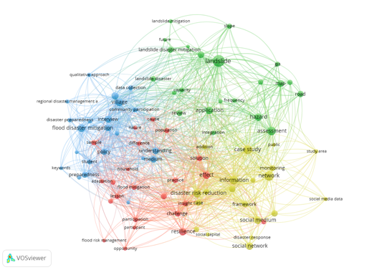
Figure 1. Network analysis CSV data

This CSV Network Analysis can assist in community-based flood and landslide disaster management to mitigate road network performance [17] ⁠[18]⁠. In this VOS Viewer analysis, as seen in Figure 1, users can use this feature to visualize and analyze data networks related to specific research topics. The benefits of Network Analysis CSV Data in VOS Viewer in community-based flood and landslide disaster management for mitigating road network performance, namely Facilitating users in visualizing and analyzing bibliometric networks related to specific research topics so that they can assist in understanding research trends and developments of issues in the field studied.
Figure 2 shows that Overlay Analysis of CSV Data in VOS Viewer is a geospatial analysis technique for mapping flood—and landslide-prone areas. Some information retrieved from search results can be found in VOS Viewer, a software tool for analyzing data networks related to specific research topics. VOS Viewer can be used to visualize and analyze data more effectively and efficiently and can assist in identifying research trends and developments on issues in community-based flood and landslide disaster management to mitigate road network performance.
Using the CSV metadata from Scopus, this file contains information such as article title, author name, journal or book name, volume and page number, year of publication, and DOI (Digital Object Identifier) number or URL. The information will be used to carry out bibliometric analysis, monitor the performance of scientific journals, and create research reports. Users can access and analyze bibliographical data and metadata from thousands of scientific publications indexed on Scopus using the Scopus CSV file, facilitating scientific research and analysis. Scopus CSV file imported into VOS Viewer to help analyze scientific networks and map collaboration between researchers or institutions in a research field. Using a Scopus CSV file in the VOS Viewer, users can create collaborative networks based on author co-authority, keywords, and the journal or book where the article was published. Using Scopus CSV files in the VOS Viewer can assist scientific network analysis and map collaboration between researchers or institutions, make it easier for users to understand patterns of cooperation and developments in specific research fields, and assist decision-making in research and development of science and technology.
Overlay Analysis CSV Data in VOS Viewer is a geospatial analysis technique for mapping flood-prone landslide areas. Some information that can be retrieved from search results can be found in VOS Viewer, a software tool for analysis that visualizes and analyzes data networks related to specific research topics. VOS Viewer can be used to visualize and analyze data more effectively and efficiently and can assist in identifying research trends and developments on issues in community-based flood and landslide disaster management to mitigate road network performance.
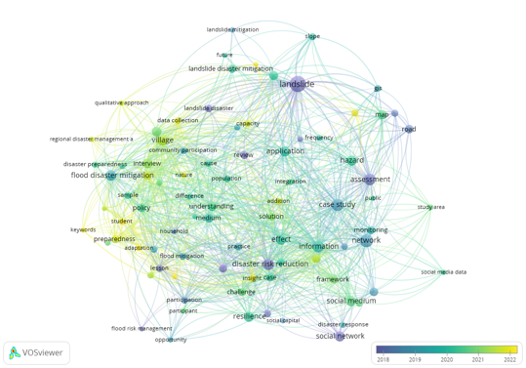
Figure 2. Overlay analysis CSV data

The discussion in this paper focuses on communities along the road network in the districts of Sidrap, Enrekang, Tana Toraja, North Toraja, Palopo, and Luwu of South Celebes Province-Indonesia. Details of the location can be seen in Figure 3. The road network in this area is mainly surrounded by the Latimojong of Celebes mountains, which are young and have unstable geology, steep slopes, and unpredictable climates. Due to meteorological, geographical, and geological conditions and socio-economic characteristics, some areas are vulnerable to flood and landslide disasters. Therefore, this study selected three central communities in the area.
This study considers various aspects during case study selection. This assumes the community has adapted to the flood and slide disaster [19]⁠ [20].⁠ The selection of the road network considers several essential things. First, the road network has a record of frequent flood and landslide disasters, but for hundreds of years, the road network has served the community in the area [21] [22]. Second, it can adapt based on local wisdom identified in the community along the road network. Therefore, this study assumes that the communities along the road network have adapted sustainably to flood and landslide disasters.

Analysis search results
Based on keywords in the Scopus database, community-based AND flood AND landslides AND disaster AND management AND for AND mitigation AND of AND road AND networks AND performance. Documents by Year in VOS Viewer is a feature that displays the year of publication of related documents in bibliometric analysis using VOS Viewer, as seen in Figure 3. This feature allows users to see the distribution of publications over a certain period to help understand research trends and developments of specific topics in the field being studied. By knowing the year of publication of a document, users can obtain information about how new or old a research topic is. They can assist in determining a more effective research strategy. The Documents by Year feature in VOS Viewer can assist users in visualizing and analyzing bibliometric data more effectively and efficiently.
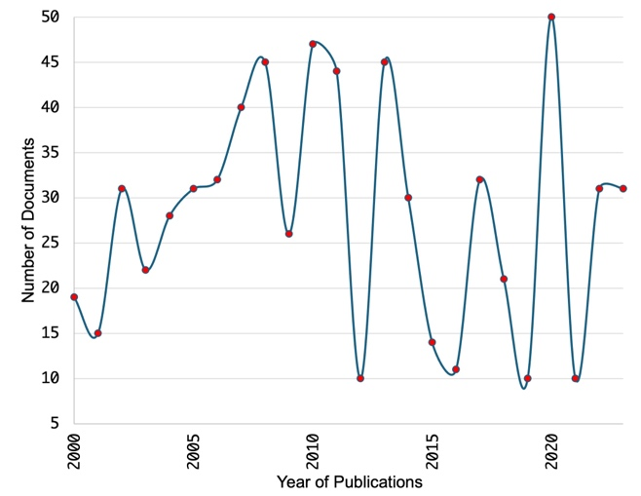
Figure 3. Documents by Year
Documents by Subject Area in the VOS Viewer is a feature that displays the distribution of documents based on a particular subject or topic in a bibliometric analysis using the VOS Viewer, as seen in Figure 4. This feature allows users to visualize and analyze the distribution of documents on various subjects or topics, which can help them understand research trends and developments of specific issues in the field studied.
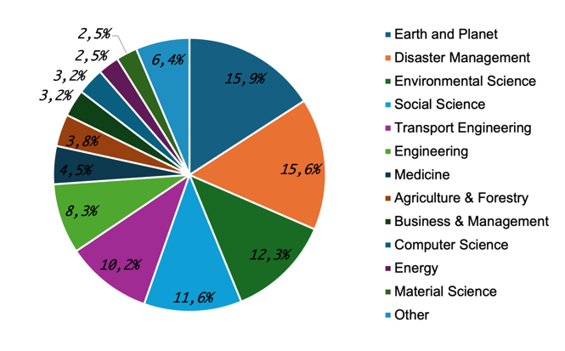
Figure 4. Documents by Subject Area
By examining the distribution of documents by subject or topic, users can learn how much research has been done in a particular field, which can help them determine more effective research strategies. The Documents by Subject Area feature in the VOS Viewer can assist users in visualizing and analyzing bibliometric data more effectively and efficiently. It can also help them identify research trends and developments in specific topics in the studied field.

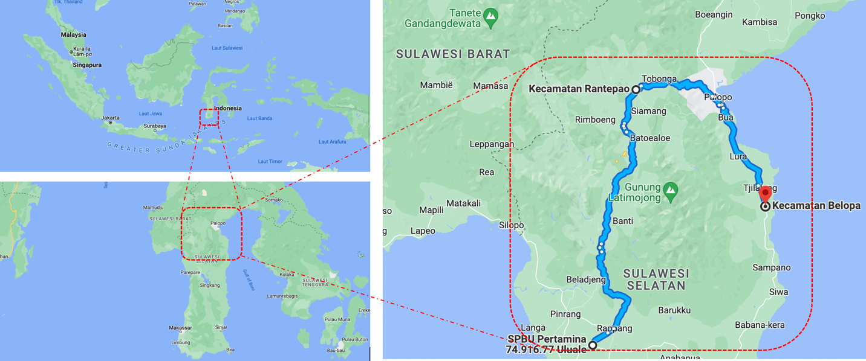
Figure 5. Case Study Area

Data collection and analysis were conducted through surveys, Forum Group Discussion (FGD), and in-depth interviews ⁠at flood and landslide disaster locations, as seen in Figure 5. FGDs were held in 3 central locations, Palopo, Rantepao, and Enrekang, from October 2023 until June 2024. FGD participants included the national government, local government, contractors, consultants, local communities, and non-government organizations (NGOs). As in other qualitative studies, the researcher must approach the area and its people. Therefore, two field visits were carried out in this study, and a preliminary field survey was conducted in October 2023 and May 2024. A field survey is an essential initial stage in planning a work planning activity. The location survey stage can determine the location of the field and environmental conditions so that a more detailed analysis can be carried out. The results of this survey can be used to plan in-depth interviews and FGDs to the maximum to find better disaster mitigation potential. Documentation of survey activities can be seen in Figure 6.
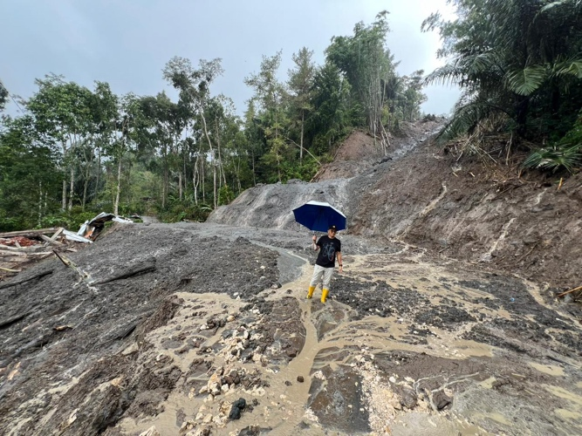
Figure 6. Survey activities at disaster locations
Some of the benefits of FGD are obtaining quality qualitative data in a short time, creating ideas for more in-depth research, cross-checking data from other methods, and identifying and exploring information from certain groups. FGD is one of the methods used in this study to collect data to gain in-depth insights into community views and experiences related to disasters. FGD is integral in exploring an in-depth understanding of various aspects of mitigation, handling, and other disaster response techniques. So, from this FGD, the local wisdom and values of the community in dealing with disasters along the road network corridor will be obtained.
During the discussion, each participant listened to their opinion and considered what other FGD participants said. The last part of the FGD will focus on the community's views and ideas about using digital technology in disaster management. In the discussion, it was simulated that digital technology can assist in managing community-based floods and landslides. The simulation is expected to provide an overview of road network performance management. In addition, it was tested to improve the monitoring function to achieve performance and accelerate flood control based on community opinions [23]. Thus, the truth of information is no longer subjective but becomes intersubjective.
RESULTS AND DISCUSSION
The research results through FGD, in-depth interviews, and surveys resulted in two main things: the flood and landslide disaster mitigation approaches based on the community on the road network. The second is the factors that influence the success of flood and landslide disaster management in a community-based road network. The former comprised three phases: pre-disaster, during-disaster, and post-disaster. The preparation of the mitigation program needs to be supported by data and information regarding regional conditions and the local community's characteristics. The availability of appropriate data and information is expected to maximize the use of local resources, including labor, materials, and organization. One method that can be used to explore the community's understanding and perception of flood and landslide disasters on the road network is the FGD method. This qualitative data collection technique has produced several issues. This technique is intended to obtain data from the community based on the results of discussions that focus on a particular problem.

Community-based flood disaster management approaches for road network area
The FGD with the Community results explained that a flood disaster is a seasonal threat that occurs when a body of water overflows from an existing channel and inundates the surrounding area. Floods are the most common natural threat and are detrimental to humanity and the economy. Ninety percent of natural disasters are related to floods. Flooding often occurs as immediate floods or deliveries and is influenced by tides in low-lying areas.
According to the survey results, the causes of flood disasters are primarily due to long-term rain or heavy daily rainfall. Next is the result of soil erosion, which leaves rocks that cause rainwater to flow over the ground without infiltration. In addition, there needs to be better handling of waste that clogs waterways so that bodies of water overflow and flood the surrounding area. The phenomenon in the road network of the case study location shows that the construction of the residential regions, namely vacant land, is converted into a house or place of business, which causes loss of rainwater absorption. The construction of residential areas can increase the risk of flooding up to 6 times compared to open land, which usually has a high water absorption capacity. This problem often occurs in cities or tourist areas with poorly planned development.
At the time of the second FGD, as in Figure 7, six districts in South Sulawesi were hit by floods and landslides. This happened because of the high rain intensity, so several large rivers overflowed and submerged several areas. The districts affected by the flood and landslide disaster were Luwu, Sidrap, North Luwu, Enrekang, Wajo, and Soppeng Regencies. According to data from the National Disaster Management Agency (BNPB), 13 fatalities were caused by floods and landslides. The fatalities were spread across several areas. Eleven victims were found dead in Luwu Regency, one died in Sidrap Regency, and one died in Wajo Regency.
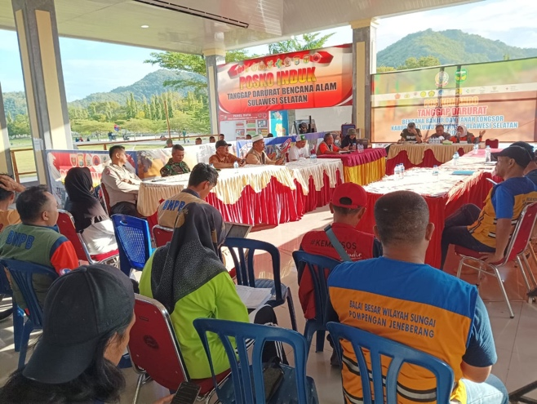
Figure 7. Second-FGD activities post a disaster
The FGD found that the natural disasters that hit several areas were due to unmaintained natural conditions. Based on satellite monitoring results, high-intensity rain in the highlands caused tributaries to overflow. These conditions are increasingly uncontrollable due to land conversion factors in the mountainous areas, especially in Latimojong District, Luwu Regency. Massive land clearing in the upstream and buffer zones of the district (Luwu) intersects with the districts of Enrekang, Toraja, Sidrap, and Wajo, which are high-risk disaster zones. The community's involvement in disaster management was revealed in the second FGD activity, which was carried out almost simultaneously with the flood and landslide incident in Luwu. Disaster management carried out by stakeholders is a series of efforts to deal with disasters by implementing prevention, mitigation, preparedness, emergency response, and recovery. In this case, the Luwu Watershed is included in the pre-during-post disaster management model. This management model consists of stages before a disaster occurs, during a disaster, and after a disaster. The government and the community have carried out a series of programs and activities covering disaster management stages. Several communities involved in the FGD stated that digital technology is very much needed to handle floods and landslides in the area. Technology includes mapping, visualization, information exchange, and precise evacuation route management.
The result from FGD describes the connection between long-term and short-term risk management strategies for flood and landslide hazards, as well as examples from land-use planning and emergency management in four European case studies. An integrated approach suggests combining long-term and short-term measures and the interaction between the actors involved in policy agreements to implement risk strategies successfully. This has also been stressed by the European Union, which underlines the requirement of linking the actors involved in developing and implementing measures that can have signiﬁcant impacts on disaster prevention [24]⁠. Some argue that damage to dams and waterways can cause flooding. The risk of flooding can increase when heavy rain is high intensity [25]. In addition to rainfall, the type of land cover and road pavement can trigger flood events. The rocky area causes less water absorption and can cause shipping or flash floods.

Community-based landslide disaster management approaches for road network area
Based on the summary of the FGD, most community members understand that a landslide is a collapse of the ground or the sudden or gradual movement of large amounts of soil or rocks, which generally occurs in steep and unstable areas. The impact of erosion can partially or entirely affect the road network's performance. Factors considered to have influenced the occurrence of this disaster were bare slopes and fragile soil and rock conditions. Heavy rain is the main trigger for landslides. However, landslides can also be caused by earthquakes or volcanic activity. In addition, human activities can also cause landslides, such as uncontrolled mining of soil, sand, and stones.
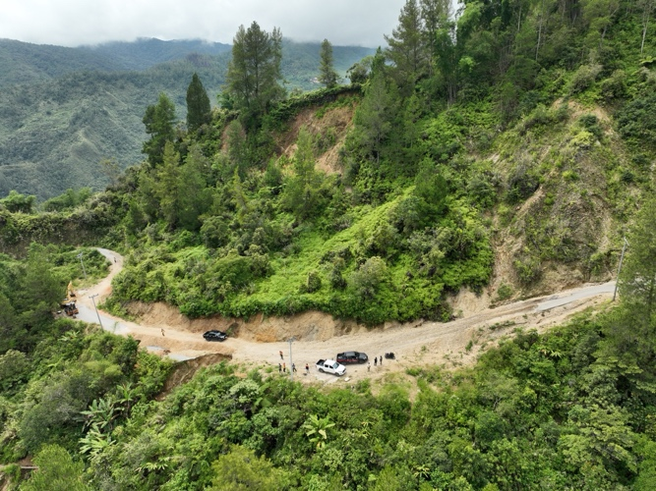
Figure 8. Potential landslides in the road network area
In Figure 8, various things can cause landslides in the road network area. Landslides can be triggered by multiple factors that interact in a complex manner, including earthquakes, which can trigger landslides by destabilizing slopes or initiating the movement of unstable soil masses; the nature and type of soil, certain soil types are more prone to landslides than others. For example, clay soils cannot drain water, so they tend to retain more water within them, increasing the risk of landslides. Slope: Slopes with steeper or unstable slopes tend to be more prone to landslides. The gravitational pressure on the soil mass will increase with increasing slope, which can overcome the soil's carrying capacity. High rainfall: Intense and prolonged rains are the leading cause of landslides. Rainwater that falls to the ground can fill in the cracks and reduce the carrying capacity of the soil, causing movement of soil masses and other things that may occur, for example, natural changes and geological conditions.
According to the results of in-depth interviews, it is summarized that the initial symptoms of landslides in the road network area are four. First, cracks appear on the slope parallel to the cliff's direction. Second, there was a sudden emergence of water from the ground surface in the new location. The third is that the healthy water around the slope becomes cloudy. Finally, fragile cliffs and gravel began to fall, interfering with the road network's performance. Survey data collection shows areas prone to erosion on the road network. First, erosion disasters usually occur in the area. Second, the area is steep and barren area. Third, areas with the potential for landslides are where rainwater flows. Finally, there is a tendency to have thick or very loose soils on slopes that receive high rainfall.
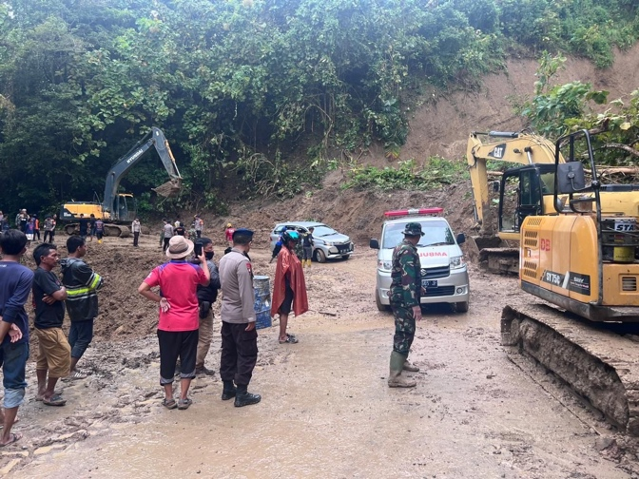
Figure 9. Landslide disaster in the road network area
According to the community, the landslide disaster's impact on the road network area was detrimental to their activities. The fall of soil material blocking the road, as shown in Figure 9, can cause traffic flow to stop. Therefore, quick action is needed so those community activities can recover quickly.
The community usually took several preparedness actions to minimize landslides. First, they did not cut down or destroy forests and planted plants with strong roots on bare slopes. Second, the road network had to be tidy and make rainwater channels. Third, they built retaining walls on steep slopes, checked soil conditions regularly, and measured rain levels.

Preparedness measures
In the FGD, several things about preparedness to prevent floods and erosion were conveyed. First, it is better to build buildings in safe areas such as highlands and take precautions for areas at risk of flooding. When planning and implementing the construction of a road network, it is better to understand the threat of flooding, including floods that have occurred, and know whether the area is high enough to avoid flooding. Other knowledge that must be understood is training, preparation, and safe evacuation routes. Everyone must know where to evacuate and where to go in a flood.
Communities around the road network need to develop outreach programs to increase awareness of the threat of flooding. Furthermore, it is necessary to raise public awareness to consider the danger of floods and landslides in future developments. First, it was installing ominous signs on low bridges so as not to be crossed by people at the time of the flood. Second, immediate repairs to bridges and supporting structures should be made if necessary. Third, the flow of water out of the area on the road network area that is at risk of flooding should be regulated. The last is to put a water level sign on waterways, canals, rivers, or streams that can indicate at what height the flood will occur or the depth of the puddle. If some of these actions are carried out properly, the more significant impact of the flood disaster can be avoided.
The results of in-depth interviews with several community leaders and NGOs show that educational steps are needed for residents in disaster areas. Communities living in landslide-prone areas to change their behavior from passive responsive to active anticipatory. For this, government and NGOs must provide empowerment training for communities living in landslide-prone areas. Forming a disaster-aware community is one of the keys to successful disaster management, and empowerment should be carried out by building an integrated community between the government, community, and private sector around disaster-prone locations. As we have done so far, this preparedness implies the community as a subject rather than an object. Later, there will be integration between the exposed community, the government, and the private sector. Community empowerment is critical to increase resilience in facing disasters, considering that every time a disaster occurs, there are always some isolated villages, and because they have been equipped with knowledge, isolated communities can survive with the supplies they have. Some preparedness steps are to ensure evacuation routes and logistics are immediately open. Activities supported by the community can be seen in Figure 10.
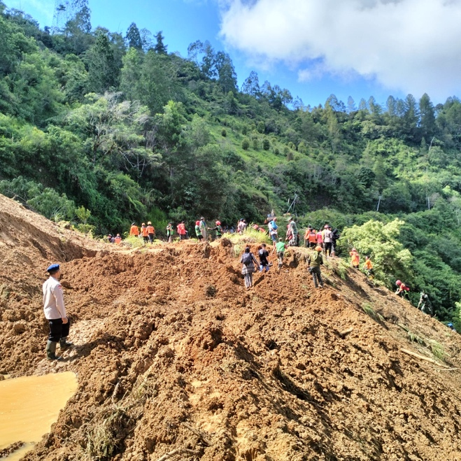
Figure 10. Activities supported by the community for landslide disaster⁠
The community's ability to identify and locate disaster information is excellent. Even from the information they have obtained, they can already prepare themselves for disasters that can occur at any time, especially in areas that have experienced or frequently experienced disasters [26]. The low ability of the community to organize and integrate new information will also be significantly influenced by the environment in which they live. Suppose the living environment supports or has a positive influence, for example. If many people are educated and understand disaster, more or the ability to organize and integrate information into existing understanding will be better. Conversely, in a less supportive environment, most people need help understanding the new information so that the results will be inversely proportional to the first statement.

Mitigation program
The discussion participants certainly influenced the results of the FGD on the mitigation program. The community and government have made various efforts to reduce the potential for flood and landslide disasters in the road network area. One of these efforts is to mitigate disaster by increasing life's safety and comfort, especially for people who live in disaster-prone locations or regions. Therefore, it is necessary to have a disaster-prone map so that the community can be prepared to prevent and reduce casualties and damage to public facilities and infrastructure.
One of the results of the FGD is that it requires computer-based data input using a Geographic Information System (GIS). Areas prone to flood and erosion will be more easily identified using GIS. The level of vulnerability is easy to know because GIS can display records of the earth's surface conditions obtained without direct contact. In addition, it is easier to update if there is a data update, so faster and more accurate information can be generated. The community can be optimized by visualizing spatial data in its attributes and efficiently producing thematic maps [27]⁠ [28].⁠ Using geographical information systems is beneficial because of the advantages of intercepting information without directly contacting the field or research area and spending much money. Communities with sufficient capacity can be given access to GIS to provide data for processing control parameter data and efforts to minimize disaster.
Validation must be carried out for the digital data submitted by the community to be used. Data validation is an integral part of this qualitative disaster management activity. This is because validation is closely related to handling data collection techniques in a disaster-prone field to collect information, analyze data, and prepare data presentations. In the FGD, it was agreed that data validation must be carried out in two ways: content validation and external validation. Content Validity is a test relevant to the experience, abilities, and knowledge or background of the person who inputs the data. Community capabilities must be standardized so that they have minimum qualifications. The second is external validity, correlating new input data with external benchmarks in the form of valid measurement inputs.
Based on the results of in-depth interviews, field visits to the community showed that they hoped to gain more knowledge about anticipating flood and landslide disasters. Suppose there is training on landslide disaster mitigation⁠. In that case, the community will understand and be aware of the importance of disaster management so that community participation in helping each other and maintaining the surrounding environment will increase. The government can conduct socialization with the community regarding the potential and vulnerability of disasters. Proper socialization can reduce the negative impact of disaster events. Next, the community will be educated by the national disaster management agency or regional disaster management agency.

Optimization of social media communication
An early warning system for natural disasters is necessary for disaster management. The goal of this early warning is that people can live and do activities safely in an area and that an area is organized. A community-based early warning system for disasters is a series of systems to notify the occurrence of natural events, such as disasters or other natural signs. Early warning to the community for disasters is providing information in a language easily understood by the community. In critical situations, early warnings, which are the delivery of this information, are manifested in the form of sirens, traditional alarms, and other tools. In this study, through a series of FGDs, these conventional methods can be complemented with digital technology.
The need for information about the location, assistance, and data collection on road network damage and disruption is increasingly important as the disaster area expands [29] [30]⁠. With various digital conveniences, today's community has begun to channel information, assistance, and personnel virtually, only to convey it to those who need it in real terms. Many community groups participate in disaster management through various social media platforms such as Facebook, Twitter, Instagram, WhatsApp, and others social media. Disaster management becomes more effective through the system's openness, all information on handling, raising aid, and providing organized information, especially during emergency response.
According to the results of in-depth interviews with the community, social media offers many benefits. Reports submitted via the platform are responded to very quickly. Based on data from FGD results, the average response time for handling landslides is 30 minutes at maximum. For example, an inter-community Whatsapp group (WAG) comprises the Community, NGOs, Government, and Police. The most straightforward social media platform is WAG, as seen in Figure 11 (in Bahasa).
Like other social media, WAG users can network with the community. The platform is used to disseminate information and solicit responses from community members. Besides that, they can discuss trending topic issues immediately and become part of the issue. Existing technology makes it easier for human survival in various aspects of life. One example of technological developments is the development of media, from writing, print, and electronic to social media. This technology affects people's lives with technology, especially on social media. Digital technology can be used to facilitate the delivery of disaster mitigation directives in residential areas, including road network planning.
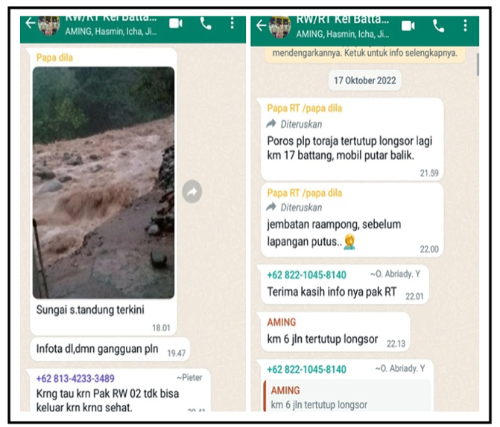
Figure 11. Example of Social Media Communication for Disaster Management Respond (in Bahasa)
Optimal use of WAG can encourage the success of disaster mitigation. Meanwhile, the community uses social media to meet their information needs regarding natural disasters. Disseminating information through WAG is technically practical and efficient because, technically, it does not require significant capital, and it follows from the times. From the side of the community, it becomes useful if people disseminate disaster information, and then the information or news can be accepted by the community.
The community can use other social media, such as Facebook and Instagram, so the public cannot access and accept the information or news [31]. Information communicated through various social media platforms concerns more than disaster events. In addition, the platform is optimized to be part of the communication and information mitigation tool. Optimal communication can support the mitigation stages from preparation and handling to post-disaster recovery. Utilizing digital monitoring in community-based flood and landslide disaster management to mitigate road network performance is expected to increase effectiveness and efficiency in disaster mitigation and help reduce road network damage due to floods and landslides.

CONCLUSION
Based on the results of FGD, in-depth interviews, and surveys, this study's results can be divided into four main results: 1) Based on exploring the cultural understanding of the local community about disasters, the community is very concerned about road safety and accessibility. Communities in the road network area have also understood the causes of floods and landslides that can disrupt road functions; 2) Culturally, the community is accustomed to and actively involved in disaster preparedness; 3) Hereditarily, the community has been an essential part of the disaster mitigation process; 4) The community feels comfortable using social media platforms to accelerate community communication in disaster mitigation and handling.

REFERENCES
[1] National Disaster Management Authority, 31 12 2023. [Online]. Available: https://dibi.bnpb.go.id. [Accessed 20 01 2024].
[2] M. R. Alfarizi, A. I. Rifai, I. Indrastuti, and J. Prasetijo, “Bibliometric Analysis of Cost and Time Management in Handling Avalanches on National Roads In Mountainous Areas Using BIM,” Asian Journal of Social and Humanities, vol. 2, no. 9, pp. 1952–1966, Jun. 2024, doi: 10.59888/ajosh.v2i9.337.
[3] D. Shukla, H. K. Azad, K. Abhishek, and S. Shitharth, “Disaster management ontology-an ontological approach to disaster management automation,” Scientific Reports, vol. 13, no. 1, May 2023, doi: 10.1038/s41598-023-34874-6.
[4] A. Kurniadi, “Analysis of Community Participation based Approach to Disaster Mitigation Reduction,” Disaster Advances, vol. 17, no. 2, pp. 31–39, Dec. 2023, doi: 10.25303/172da031039.
[5] R. Raman and U. Datta, “The Role of ‘Unmanned Aerial Vehicles’ in Smart City Planning and Management,” Proceedings of UASG 2021: Wings 4 Sustainability, pp. 99–120, 2023, doi: 10.1007/978-3-031-19309-5_8.
[6] E. E. Holdeman, “Emergency Management’s Journey with Technology,” Disaster Management and Information Technology, pp. 3–23, 2023, doi: 10.1007/978-3-031-20939-0_1.
[7] K. Ndue and G. Pál, “Life Cycle Assessment Perspective for Sectoral Adaptation to Climate Change: Environmental Impact Assessment of Pig Production,” Land, vol. 11, no. 6, p. 827, May 2022, doi: 10.3390/land11060827.
[8] M. Niyazi and J. Behnamian, “Application of Emerging Digital Technologies in Disaster Relief Operations: A Systematic Review,” Arch. Comput. Methods Eng., vol. 30, no. 3, pp. 1579–1599, 2023, doi: 10.1007/s11831-022-09835-3.
[9] B. Tomaszewski, “Geographic Information Systems and Disaster Mitigation,” Geographic Information Systems (GIS) for Disaster Management, pp. 357–406, Oct. 2020, doi: 10.4324/9781351034869-9.
[10] E. Fazzini, M. Zichichi, S. Ferretti, and G. D’Angelo, “Keyword-Based Multimedia Data Lookup in Decentralized Systems,” 2023 International Conference on Information and Communication Technologies for Disaster Management (ICT-DM), vol. 105, pp. 1–6, Sep. 2023, doi: 10.1109/ict-dm58371.2023.10286930.
[11] K. Konagai, “More than just technology for landslide disaster mitigation: signatories to The Kyoto Landslide Commitment 2020—No. 1,” Landslides, vol. 18, no. 1, pp. 513–520, 2021, doi: 10.1007/s10346-020-01588-z.
[12] C. Ibeanu, M. Ghadiri Nejad, and M. Ghasemi, “Developing Effective Project Management Strategy for Urban Flood Disaster Prevention Project in EDO State Capital, Nigeria,” Urban Science, vol. 7, no. 2, p. 37, Mar. 2023, doi: 10.3390/urbansci7020037.
[13] M. TOZAWA, “Road slope disaster management and technical cooperation in Republic of Tajikistan,” Journal of the Japan Landslide Society, vol. 58, no. 6, pp. 260–262, 2021, doi: 10.3313/jls.58.260.
[14] C. Bianchi, G. Nasi, and W. C. Rivenbark, “Implementing collaborative governance: models, experiences, and challenges,” Public Manag. Rev., vol. 23, no. 11, pp. 1581–1589, 2021, doi 10.1080/14719037.2021.1878777.
[15] K. A. Widodo and B. R. P. Dian Palevi, “LoRa Network Performance Analysis on Landslide Monitor for Landslide Disaster Mitigation in the Greater Malang Area,” SISTEMASI, vol. 13, no. 2, p. 447, Mar. 2024, doi: 10.32520/stmsi.v13i2.3896.
[16] A. I. Rifai, “Data Mining Applied for Community Satisfaction Prediction of Rehabilitation and Reconstruction Project (Learn from Palu Disasters),” Artificial Intelligence. IntechOpen, Mar. 30, 2022. doi: 10.5772/intechopen.99349.
[17] D. Rivera-Royero, G. Galindo, M. Jaller, and J. Betancourt Reyes, “Road network performance: A review on relevant concepts,” Comput. Ind. Eng., vol. 165, p. 107927, 2022, doi: https://doi.org/10.1016/j.cie.2021.107927.
[18] S. Loreti, E. Ser-Giacomi, A. Zischg, M. Keiler, and M. Barthelemy, “Local impacts on road networks and access to critical locations during extreme floods,” Sci. Rep., vol. 12, no. 1, p. 1552, 2022, doi: 10.1038/s41598-022-04927-3.
[19] F. Laurien, S. Hochrainer-Stigler, A. Keating, K. Campbell, R. Mechler, and J. Czajkowski, “A typology of community flood resilience,” Reg. Environ. Chang., vol. 20, no. 1, p. 24, 2020, doi: 10.1007/s10113-020-01593-x.
[20] F. Dottori, L. Mentaschi, A. Bianchi, L. Alfieri, and L. Feyen, “Cost-effective adaptation strategies to rising river flood risk in Europe,” Nature Climate Change, vol. 13, no. 2, pp. 196–202, Feb. 2023, doi: 10.1038/s41558-022-01540-0.
[21] S. Sulejmanovic, Ž. Ljevo, M. Pozder, A. Šarić, and S. Albinović, “Methodology of flood risk assessment on the main road network in the Federation of Bosnia and Herzegovina,” Road and Rail Infrastructure VII, vol. 7, pp. 619–629, May 2022, doi: 10.5592/co/cetra.2022.1484.
[22] S. Tachaudomdach, A. Upayokin, N. Kronprasert, and K. Arunotayanun, “Quantifying Road-Network Robustness toward Flood-Resilient Transportation Systems,” Sustainability, vol. 13, no. 6, p. 3172, Mar. 2021, doi: 10.3390/su13063172.
[23] Q. Li and Y. Lin, “How Can Community-Based Organizations Improve Flood Risk Communication? A Case Study of China Based on Grounded Theory,” Systems, vol. 11, no. 2, p. 53, Jan. 2023, doi: 10.3390/systems11020053.
[24] M. Gimenez-Maranges, J. Breuste, and A. Hof, “Sustainable Drainage Systems for Transitioning to sustainable urban flood management in the European Union: A Review,” Journal of Cleaner Production, vol. 255, p. 120191, May 2020, doi: 10.1016/j.jclepro.2020.120191.
[25] N. L. J. Dolojan, S. Moriguchi, M. Hashimoto, N. X. Tinh, H. Tanaka, and K. Terada, “Hydrologic-geotechnical modelling of shallow landslide and flood hazards caused by heavy rainfall,” Engineering Geology, vol. 323, p. 107184, Sep. 2023, doi: 10.1016/j.enggeo.2023.107184.
[26] A. I. Rifai, E. Prasetyo, and Rhismono, “Analysis of Community Satisfaction Level on the Road Rehabilitation and Reconstruction Project (Learn from Palu Disasters Area),” Proceedings of the 5th International Conference on Rehabilitation and Maintenance in Civil Engineering, pp. 297–309, Jul. 2022, doi: 10.1007/978-981-16-9348-9_27.
[27] L. B. L. da Silva, J. S. Humberto, M. H. Alencar, R. J. P. Ferreira, and A. T. de Almeida, “GIS-based multidimensional decision model for enhancing flood risk prioritization in urban areas,” International Journal of Disaster Risk Reduction, vol. 48, p. 101582, Sep. 2020, doi: 10.1016/j.ijdrr.2020.101582.
[28] M. Itair, M. Owda, and K. Lhamidi, “GIS-Based Model for Urban Flood Assessment: An Approach to Assess Urban Fragility and Risk,” Sustainable Development and Geospatial Technology, pp. 213–236, 2024, doi: 10.1007/978-3-031-65683-5_12.
[29] M. Warnier, V. Alkema, T. Comes, and B. Van de Walle, “Humanitarian access, interrupted: dynamic near real-time network analytics and mapping for reaching communities in disaster-affected countries,” OR Spectrum, vol. 42, no. 3, pp. 815–834, Mar. 2020, doi: 10.1007/s00291-020-00582-0.
[30] A. Mostafavi and F. Yuan, “Smart Flood Resilience: Harnessing Community-Scale Big Data for Predictive Flood Risk Monitoring, Rapid Impact Assessment, and Situational Awareness,” Mar. 2022, doi: 10.5194/egusphere-egu22-781.
[31] E. N. Sharp and H. Carter, “Examination of how social media can inform the management of volunteers during a flood disaster,” Journal of Flood Risk Management, vol. 13, no. 4, Sep. 2020, doi: 10.1111/jfr3.12665.

