Performance Analysis of a Micro Underwater Remotely Operated Vehicle (ROV) | 

Fauzal Naim Zohedi^{1*}, Chan Yeow Chuan¹, Mohd Shahrieel Mohd Aras¹, Alias Khamis¹, Zairi Ismael Rizman²
¹Faculty of Electrical Technology and Engineering, Universiti Teknikal Malaysia Melaka, Malaysia
²School of Electrical Engineering, College of Engineering, Universiti Teknologi MARA, Terengganu, Malaysia

Abstract  Underwater Remote Operated Vehicle (ROV) is a tethered marine robot that are widely employed for scientific and commercial applications. Several industries are working on underwater robots to increase the productivity, monitoring and surveillance especially in the petroleum and gas industries. These operations are often performed by human divers; however, the underwater environment poses hazards and pressure-related limits, making them costly and risky. As a result, ROVs have been designed to replace divers themselves. It is a tethered underwater robot that the operator controls manually using a PS2 controller. This project is to design and develop a micro underwater ROV for monitoring applications. The ROV are designed to withstand pressure underwater by selection of suitable material for its frame and other components will be equipped including pressure/depth sensor, MPU6050 IMU sensor and waterproof endoscope camera. Standard testing procedures are employed to assess the ROV's performance in buoyancy and control efficiency tests for the propulsion system in real environment, including laboratory pool. The developed ROV prototype shows promising performance with achieved 90% negative buoyancy is crucial for the ROV to perform effective submerge and raise operations and also with stable velocity and acceleration in forward, backward, and submerging. The steering tests highlighted that the ROV is more flexible and faster in maneuvering concerning turning performance as the horizontal thrusters’ configurations are positioned at 45° at the back of the ROV. The outcomes of this project are anticipated to bring substantial advantages to industries associated with underwater applications.  This is an open access article under the CC BY-SA license   | Keywords:  Buoyancy:  Maneuver;  Remotely operated underwater vehicle (ROV);  Stability;  Underwater inspection  Article History:  Received: May 2, 2019  Revised: May 29, 2019  Accepted: June 2, 2019  Published: June 2, 2019  Corresponding Author:  Fauzal Naim Zohedi  Faculty of Electrical Technology and Engineering, Universiti Teknikal Malaysia Melaka, Malaysia  Email: fauzal@utem.edu.my

INTRODUCTION
Over the past few decades, there has been significant advancement in the design and development of underwater Remotely Operated Vehicles (ROVs), which addressing various challenges in underwater exploration, monitoring, and maintenance. ROVs have become essential vehicles for scientific research, commercial applications, and defence operations because of their ability to carry out activities in challenging and inaccessible underwater environments [1][2]. Nevertheless, the task of designing an underwater ROV that can be cost-effective and accessible for monitoring purposes remains to be a substantial obstacle. The problem is particularly acute in applications where high costs and limited maneuverability of traditional ROVs impede their widespread adoption and utility. According to Shah et al. (2021), traditional ROVs frequently encounter limitations in maneuverability, cost, and ease of deployment​[3]. The objective of this project is to design and develop a micro underwater remotely operated vehicle (ROV) that overcomes these limits by emphasizing a tiny, affordable, and highly maneuverable design that may be used for many monitoring purposes.
Multiple studies have highlighted the crucial challenges encountered by existing ROV designs. The challenges associated with these systems include high manufacture and operational expenses, limited battery life, integrates advanced thruster systems, operational distance and insufficient control systems for accurate maneuvering. For instance, Neira et al. (2021) reviewed the structural designs and materials used in underwater robotics, identifying cost and complexity as major hurdles in broader ROV deployment [4]. Similarly, Singh et al. (2022) focused on the limitations of micro ROVs, particularly in power management and control accuracy, underscoring the need for more refined solutions [5]. In addition, current remotely operated vehicles (ROVs) require significant maintenance and lack flexibility in supporting various mission parameters [6]. In order to tackle these issues, proposed solutions include the integration of advanced thruster systems [7], the utilisation of more efficient power management systems [8], and the implementation of modular design principles to enhance flexibility and optimise maintenance [8]. This study combines these technologies to develop a compact Remotely Operated Vehicle (ROV) that is both cost-efficient and highly versatile for different underwater monitoring operations [9].
Recent developments in remotely operated vehicle (ROV) technology encompass the creation of increasingly effective propulsion mechanisms, sophisticated control algorithms, and the use of robust, lightweight materials in construction [5][11]. This research introduces several innovative contributions, including the incorporation of a novel thruster configuration to better manoeuvrability, a small design for convenient deployment, and an enhanced control system to improve the operational capabilities of the ROV. A comprehensive literature review indicates that although there have been significant developments in ROV technology, there remains a need for the development of smaller and more affordable ROVs tailored for specific monitoring purposes [12]. Previous research has primarily focused on expensive and large-scale remotely operated vehicles (ROVs), resulting in a gap for cost-effective and adaptable alternatives [11][13].
Literature from numerous sources supports current advancements and gaps in the field of study. Research on the BlueROV2, BabyROV, and other university projects are significant because they have shown the potential and limitations of current ROV technologies [14][15]. BlueROV2, developed by BlueRobotics is well known for its user-friendliness and modular construction, but its cost keeps it out of reach for smaller research projects [16]. An initiative by university students called BabyROV shows that small-scale ROVs can be used for instructional reasons, but it lacks the resilience needed for heavy applications [17, 18, 19]. Conversely, some of university-led initiatives have concentrated on developing inexpensive ROVs, but these frequently lack manoeuvrability and sensor integration [20, 21, 22, 23].

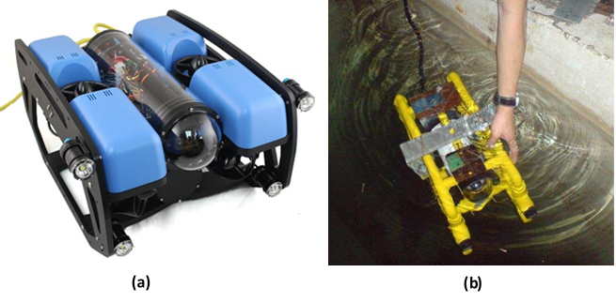
(a) | (b)
Figure 1. (a) BlueROV 2 [16] (b) BabyROV [17]

The novelty of this research lies in its integrated approach to ROV design, combining advanced propulsion systems, compact architecture, and sophisticated control algorithms, all grounded in established theories of fluid dynamics and control systems. By leveraging these theoretical foundations, the proposed ROV aims to enhance maneuverability and operational efficiency in ways that have not been fully explored in previous studies. The innovative aspects of this research are not merely incremental improvements but represent a significant advancement in the conceptualization and practical deployment of micro ROVs.
The objective of this research is to design, develop, and evaluate a micro underwater ROV that overcomes the limitations of existing models. This ROV is intended to provide a cost-effective, maneuverable, and versatile solution for underwater monitoring, with applications ranging from environmental protection to industrial inspection. The findings from this study are expected to contribute valuable insights to the ongoing development of underwater robotic technologies and to offer practical solutions for real-world challenges in underwater environments.

METHODOLOGY
Mechanical Design
The mechanical design of the ROV is informed by the principles of fluid dynamics and structural mechanics. The structural framework of the ROV is designed to minimize hydrodynamic drag, enhancing maneuverability and stability during underwater operations. The frame body can be act as the backbone of the ROV which used to hold all component parts and is usually made from strong materials such as aluminum or Polyvinyl Chloride (PVC) in consideration for the harsh underwater environment [24, 25, 26]. Some of the essential features of buoyancy control include ballast system or buoyancy tanks that aids in stability and control during maneuvers. The propulsion system involves the utilization of thrusters that are arranged such that they can facilitate movement in forward, backward, sideward, raise and submerge motions.

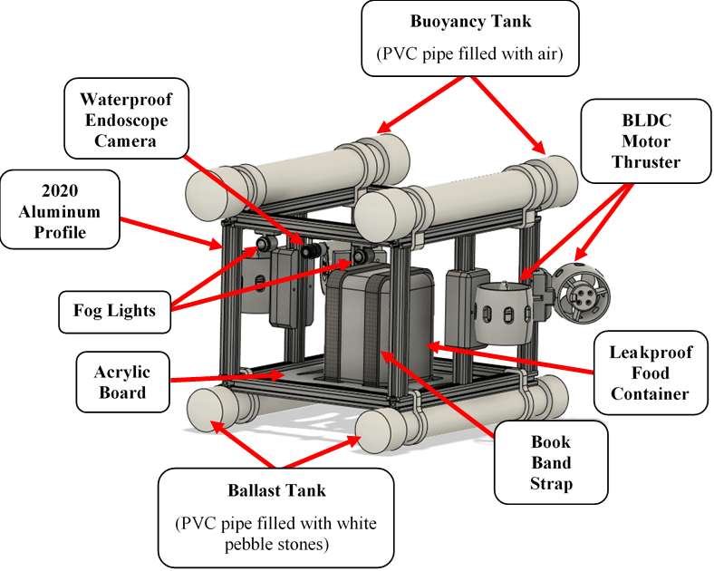
Figure 2. Isometric View of the Prototype Design of Underwater ROV

Buoyancy control is crucial in the stability and maneuverability underwater in designing ROV prototype. This is usually done by employing ballast systems or buoyancy tanks to help the ROV prototype in achieving negatively buoyant underwater. In this specific model of the ROV, buoyancy is controlled by PVC pipes, which are mounted on top and bottom sides of the ROV [25].
Figure 3 shows the upper PVC pipes are filled with air which act as a buoyancy tank. The air-filled PVC pipe produces an upthrust buoyancy force to counteract the weight of the ROV making it float and maintain at a stable position during underwater operation. The positive buoyancy helps in balancing the weight of ROV to avoid sinking uncontrollably.

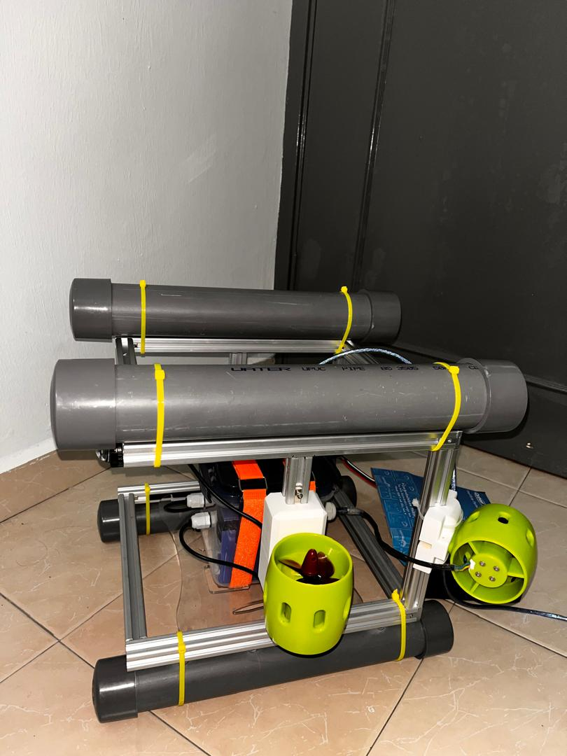
Figure 3. Upper PVC Pipe (Buoyancy Tank)

The bottom PVC pipes are drilled with some small holes and filled with white pebble stones that serve as ballast as shown in Figure 4. The small holes at the PVC pipes allows air bubbles to escape so that the buoyancy of ROV prototype will not be affected. These ballast tank enable the provision of negative buoyancy which in this case is a necessity as it helps to offer weight to the ROV to counteract the buoyantly forces produced by the top of PVC pipes that filled with air. In addition, the overall weight from the pebbles aids in lowering the center of gravity of the ROV prototype and reduces the probability of the ROV tipping or rolling.

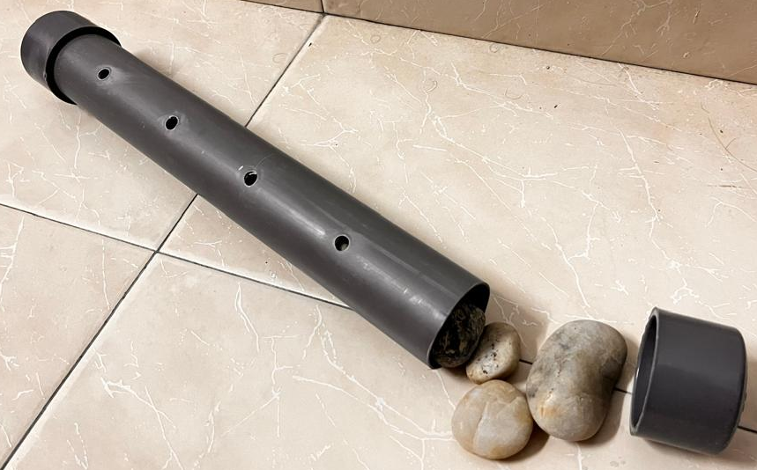
Figure 4. Bottom PVC Pipe (Ballast Tank)
This concept is based on Archimedes' principle, which states that the buoyant force on a submerged object is equal to the weight of the fluid displaced by the object. The bottom PVC pipes, filled with pebble stones, served as ballast tanks, providing negative buoyancy and lowering the center of gravity to improve stability and prevent tilting or rolling. The combined forces from the buoyancy tanks and ballast system ensured the ROV remained neutrally or slightly negatively buoyant, as required for effective underwater operation.
The design also incorporates the center of gravity theory, which plays a critical role in ensuring the ROV's stability. The combination of the air-filled upper PVC pipe and the weighted bottom PVC pipe forms a balanced buoyancy system, ensuring that the ROV prototype remains negatively buoyant during underwater operations. The upward force from the buoyancy tank and the downward force from the ballast provides a stabilizing effect, reducing undesirable tilting or drifting.

Electrical Design
The electrical design of the ROV prototype involves the function of devices and components used in the ROV prototype, circuit connection and flowchart of the ROV prototype control system. The Arduino Uno controls all the operations of ROV including sensors, motor thrusters, and control inputs while the circuit connection guarantees that all the components are correctly powered and connected. The flow chart of the control system reveals the logical process of operation which enhances the execution of the ROV’s task.
This section explains the electrical devices and components which are installed in the ROV prototype. From Table 1 shows the devices and components used to suffice the needs in design and development of a micro underwater ROV for monitoring applications.

Table 1. List of Devices and Components Used in ROV Prototype
Devices/Components | Function
Arduino Uno | - serves as the main control unit for the ROV  - manages the overall operation, executing programmed instructions to control the ROV's movement, depth, orientation and other functionalities.
Brushless Motor Thrusters | - to maneuver the ROV during underwater operation
ZMR 30A Bidirectional ESC | - control the speed and direction of the thrusters based on the commands received from the microcontroller
Bar02 Pressure/Depth Sensor | - to detect real-time depth, pressure and temperature during underwater operation
MPU6050 Accelerometer and Gyroscope Sensor | - to determine the ROV's orientation and motion dynamics, allowing for stable and controlled movements.
Waterproof Endoscope Camera | - captures video footage of the underwater environment  - provides a visual feed to the operator, allowing for real-time monitoring and navigation
Fog Lights | - illuminate the area around the ROV in dark underwater environments
PS2 Controller | - to control the ROV's movements, depth, and lights.  - to send commands to the Arduino Uno for maneuvering the ROV
12V/8AH Sealed Lead Acid Battery | - provide power to all the ROV's components including lights and motor thrusters.

All electronic devices and components mentioned previously were connected as shown in Figure 5.

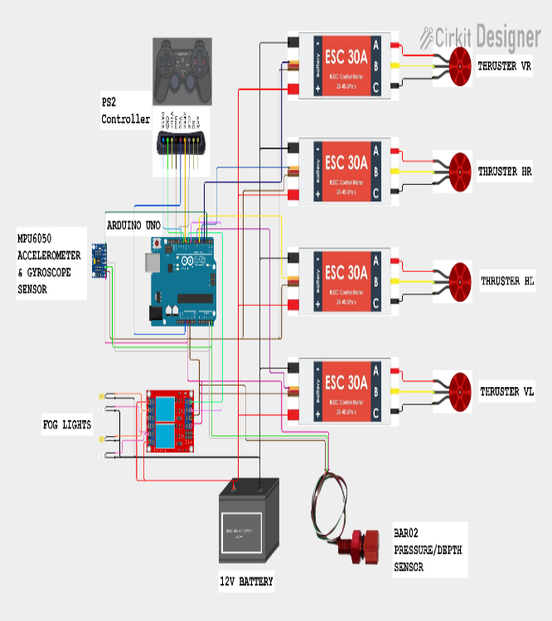
Figure 5. Schematic Circuit Wiring Connection Diagram

The detailed description of the ROV prototype control system schematic flowchart is presented in Figure 6.

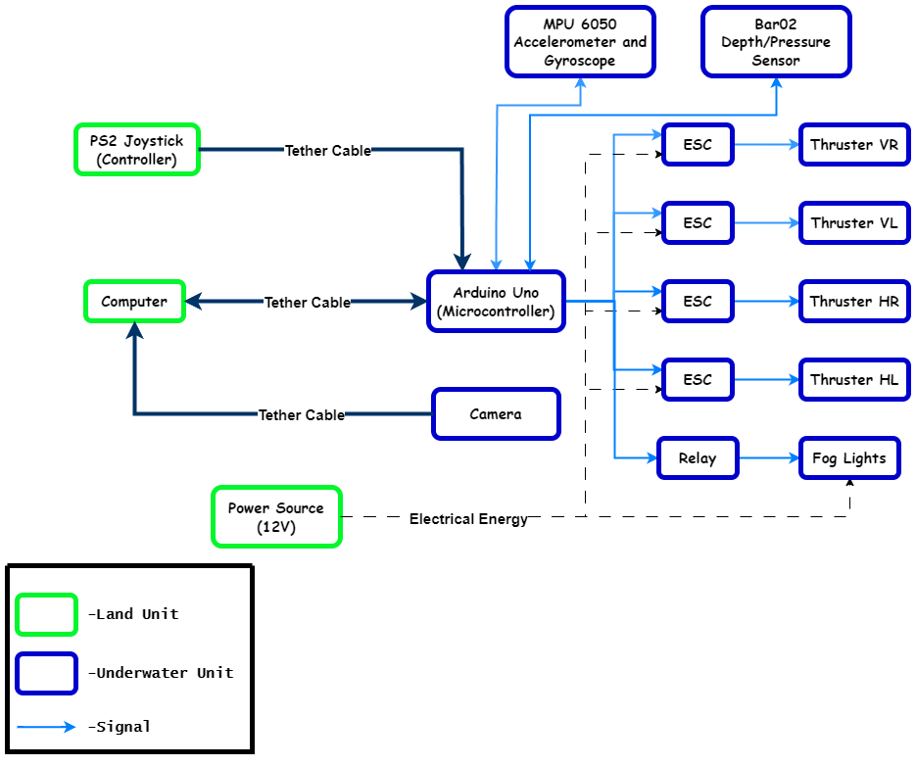
Figure 6. Schematic Flowchart Diagram for ROV Prototype Control System

Software Design
The design of the software involves the control algorithms for the execution of operations, the graphic user interface (GUI) and data analysis management. The software design of the developed ROV prototype entails programming of the control algorithms using Arduino Integrated Development Environment (IDE). Arduino IDE is a user-friendly platform for programming Arduino Uno microcontroller using C/C++ languages that is best suited for real-time control systems and can easily allow users to type and upload instructions to the devices. It also has several libraries and utilities that enable the controllers, sensors and other equipment to be interfaced with the ROV control system.
The GUI is designed using the Processing software. Processing is open-source and free to download. It is useful for developing a GUI for ROV prototype. This study uses processing to communicate data between a microcontroller and an operator. Processing receives input data from PS2 controller and then sends commands to the microcontroller. The microcontroller sends sensor data to the processing, including rotation angle, compass, pressure, depth, temperature and altitude and then display the data to monitor. The operator can observe the ROV prototype's behaviour. Figure 7 displays the horizon, compass, rotation angle, depth, temperature, etc. The user can observe the movement and surrounding environment of ROV prototype in real-time.

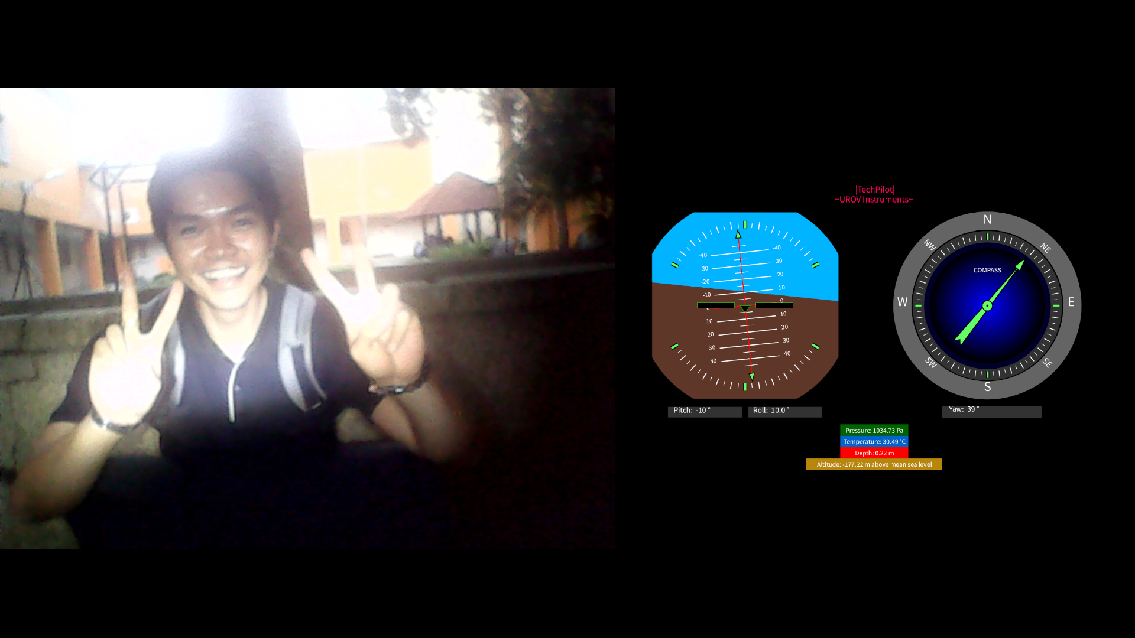
Figure 7. GUI Display for ROV Prototype

One major consideration when operating an ROV is the video feed from the camera mounted on the vehicle. A waterproof endoscope camera is fixed on the ROV prototype to provide live video images which are useful in maneuvering the ROV prototype, inspection and implementation of tasks. OBS Studio receives this video feed from the camera directly and ensures that the operator is given a very good view of the feed without blurring or lagging. This configuration makes it possible for the operator to view what the ROV is viewing, helping to maneuver the vehicle and accomplish complex tasks in the water. The high flexibility in OBS Studio in managing multiple video inputs guarantees that the camera feed is transmitted frequently, and the quality is optimal for precise operations. The combination of OBS Studio to show the ROV’s camera feed and the Processing GUI brings an efficient, reliable, and friendly UX/UI to control the operations underwater. This setup improves the operator real-time control and manipulation of the ROV since important operational information is displayed at the operator’s fingertips in a single intuitive interface. The functions of OBS Studio like recording and streaming enhance the facility of using the ROV system in real-time as well as in post operation use.

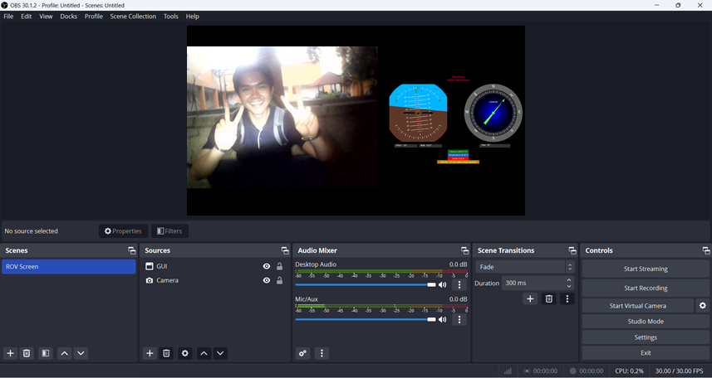
Figure 8. ROV Screen Display in OBS Studio

Finite Element Analysis (FEA)
Finite Element Analysis (FEA) is a computational tool designed to identify the behavior of physical systems or components under certain conditions or loads. It is a numerical technique that has been used in the simulation and analysis of structural or component behavior due to diverse load input situations as well as boundary conditions.
There are some main objectives of FEA include:
- To predict the response and behavior of a physical system or component when subjected to specific conditions, loads or external forces.
- To test the designs and materials to reduce costs and improve performance before the design of a component or structure is built.
- To determine potential regions of stress concentration, failure, or deformation that may occurs in a structure or component.
- To optimize the design structure of component in order to reduce weight, improve efficiency and reliability.
- To evaluate the performance of a design under various loads, temperatures, and other environmental factors.

In this experiment, FEA will be used to determine the behavior of the design prototype as shown in Figure 9 under an applied working pressure when submerged at a desired depth in water.

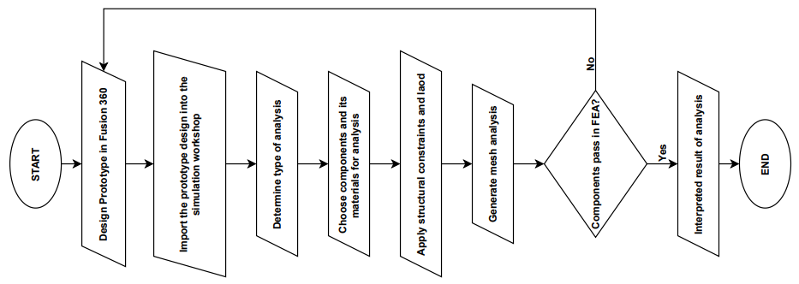
Figure 9. Flowchart of Finite Element Analysis

Water Pressure Estimation
The water pressure exerted on the ROV at a certain depth can be calculated by using Pascal’s Law. This principle states that a pressure change at any point in a confined incompressible fluid is transmitted equally in all directions. The equation to calculate pressure exerted at certain depth is given by:

 | $$P=ρgh$$ | (1)

where
P is the pressure at the given depth,
ρ is the density of the fluid (1000kg/m³ for water)
g is the acceleration due to gravity (9.81m/s²)
h is the depth below the surface of the water.

Assume the underwater ROV is submerged into water with depth of 15 meters, and given that the density of water ρ = 1000 kg/m³ and the acceleration due to gravity g=9.81 m/s²

$$P= ρgh \\ =\left(1000kgm^{-3}\right)\left(9.81ms^{-2}\right)\left(15m\right) \\ =147.15kPa \\ ≈150kPa$$

Thus, the water pressure exerted on the underwater ROV is about 150kPa.

RESULTS AND DISCUSSION
In this section, we will evaluate the preliminary result of finite element analysis of the design prototype of the micro underwater ROV using Fusion 360 and overall construction of the ROV prototype as shown in Figure10. After that, we will discuss the result of design and development of the micro underwater ROV prototype for monitoring applications by conducting experiments to test its performance in underwater conditions. The procedure includes deploying the ROV prototype in underwater environment, observing its buoyancy, maneuverability, stability and data collection capabilities. The results will be recorded and analyzed to make necessary adjustments to improve the system's performance, and the experiment will be repeated periodically to ensure the ROV prototype operates efficiently in real-world conditions.

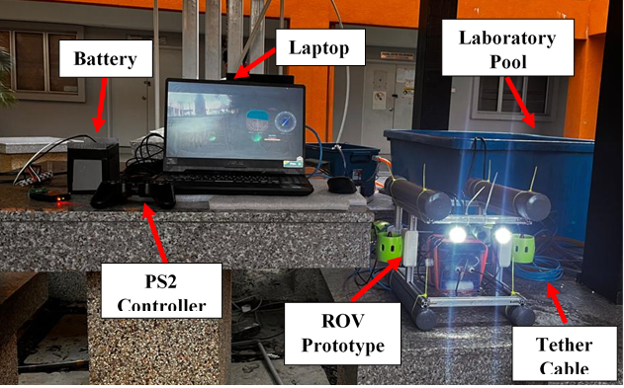
Figure 10. Micro Underwater ROV Prototype

Finite Element Analysis
The preliminary result will be discussed the FEA for the design prototype of the micro underwater ROV. FEA enables the simulation of water pressure on the ROV's structure by analyzing how the components, such as the buoyancy tank and frame, respond to the static pressure exerted by water at required depths. The static stress study, safety factor and displacement of deformation analysis for the essential components of the design prototype of the ROV will be conducted. 2020 aluminum profile was chosen as the material for the underwater ROV's frame. It has a yield strength of 240 MPa. If the greatest pressure applied to the component is less than its yield strength of 240 MPa, the prototype design component is safe and durable. Furthermore, if the number for the safety analysis factor is much greater than one, it indicates that the component is resistant to failure. This analysis spectrum resembles a rainbow, with blue being the lowest value and red being the highest. Based on (2), the pressure exerted on the underwater ROV is about 150kPa when submerged into water at depth of 15 meters.

Table 2. Finite Element Analysis of the Component of ROV
Component | Type of Analysis |  | Result | Figure
Frame | Stress Analysis |  | Applied pressure = 150 kPa  Max. stress value: 2.446 MPa  Min. stress value: 0 MPa | 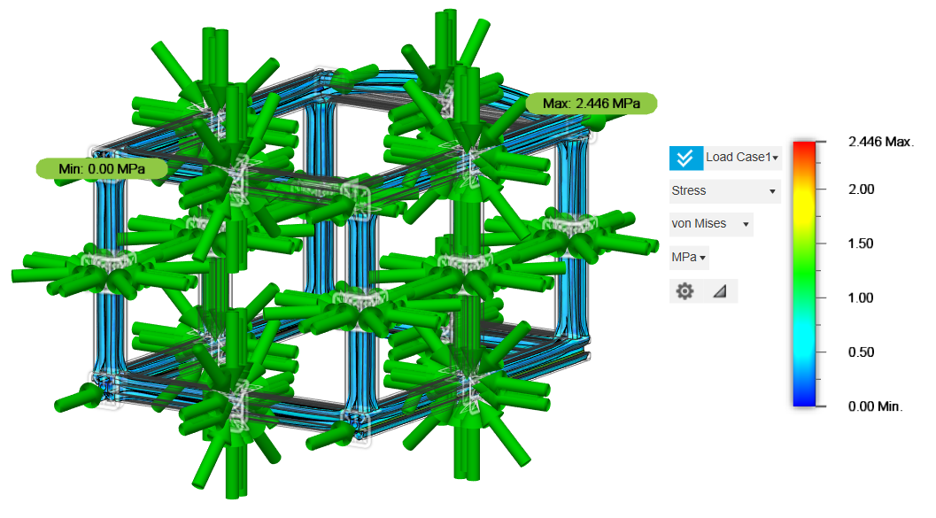
Frame | Displacement of Deformation Analysis |  | Max. displacement:$8.432×{10}^{-4}$mm  Min. displacement: 0 mm | 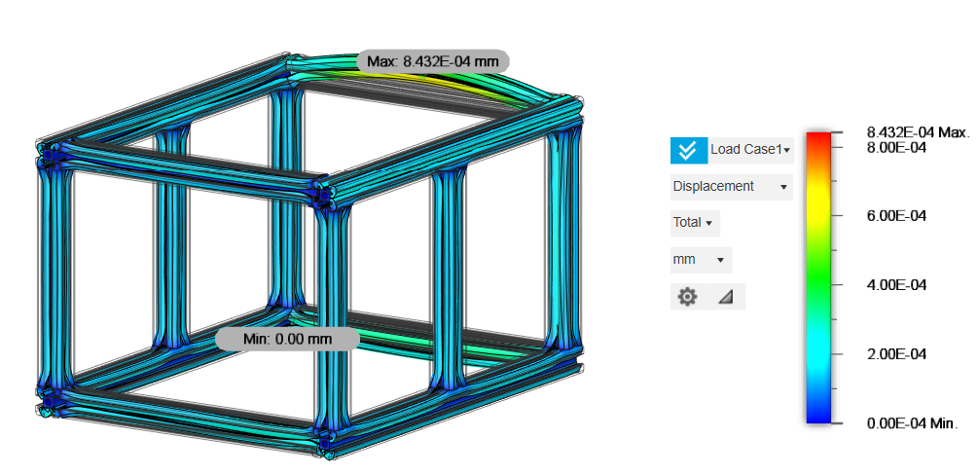
Frame | Safety Factor Analysis |  | Max safety factor: 15 | 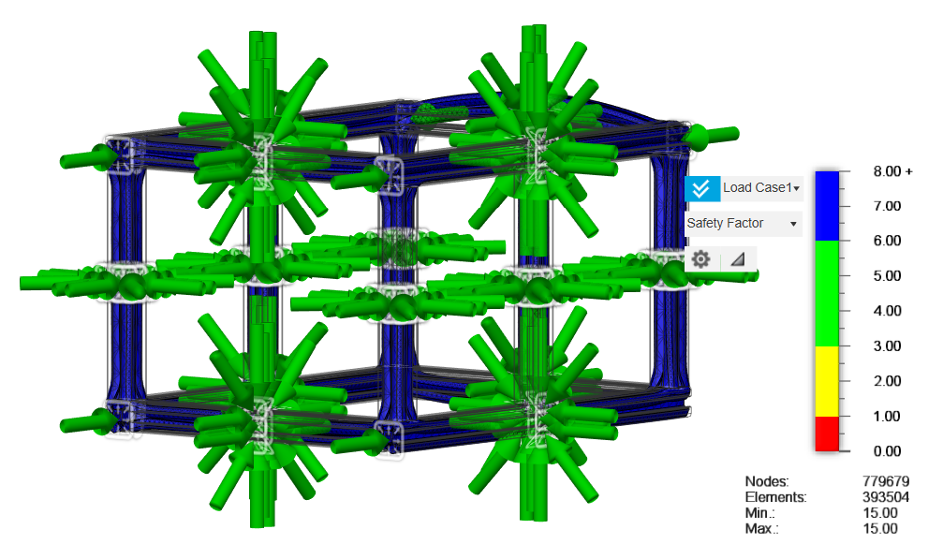
Frame with Buoyancy Tank and Ballast Tank | Stress Analysis |  | Applied pressure = 150 kPa  Max. stress value: 5.627 MPa  Min. stress value: 0 MPa | 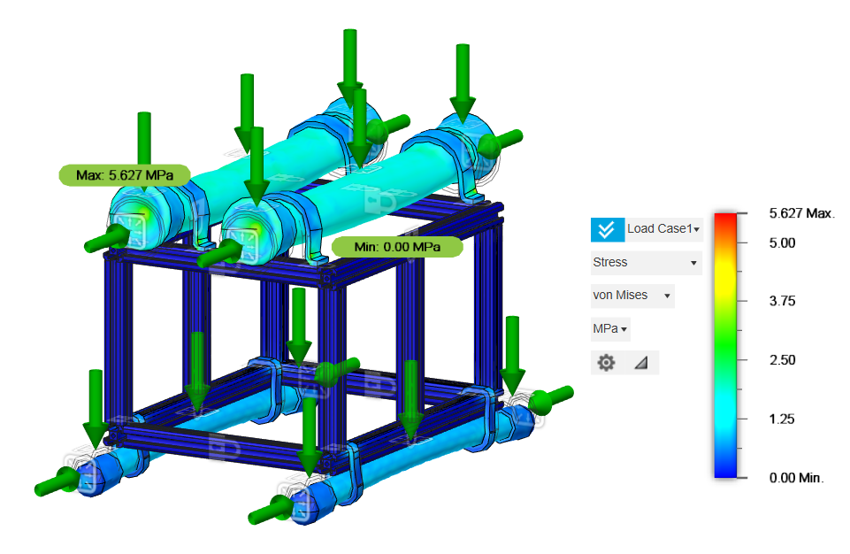
Frame with Buoyancy Tank and Ballast Tank | Displacement of Deformation Analysis |  | Max. displacement: 0.088 mm  Min. displacement: 0 mm | 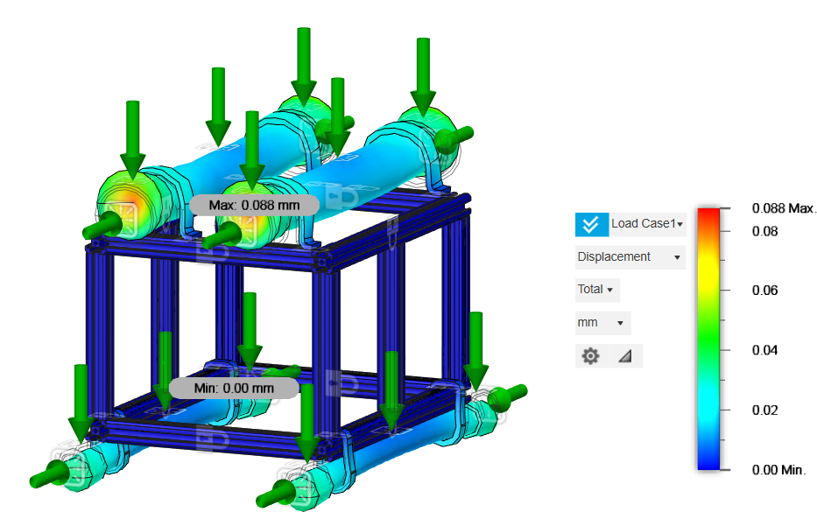
Frame with Buoyancy Tank and Ballast Tank | Safety Factor Analysis |  | Max safety factor: 8.27 | 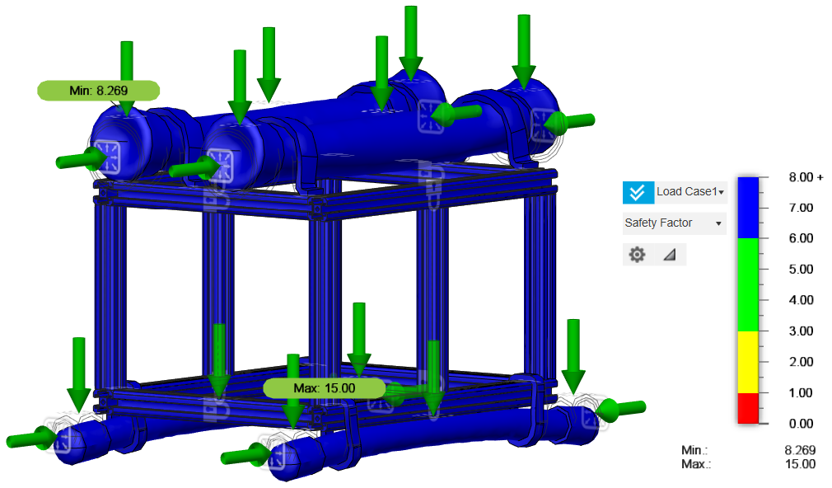

In summary, the finite element analysis results show that the forces applied to the material do not exceed its yield strength, indicating that the material can withstand the forces without deformation or failure. Furthermore, the factor of safety analysis revealed that all of the materials utilised in the design have a factor of safety greater than one, suggesting that they can sustain the applied forces without breaking or causing damage. This is a good conclusion since it confirms that the materials used in the design are appropriate for the intended use and will operate as expected under the given conditions.

Mechanical Prototype Design

The mechanical aspect plays a vital role in developing an underwater ROV with key considerations including size, stability, material, and buoyancy to ensure efficient underwater performance. The ROV prototype design was initially designed by drawing a sketch first as shown in Figure 3-8 with dimensions of frame 280mm (L) × 300mm (W) × 230mm (H). This preliminary design was then refined using Fusion 360 software. The main purpose of the frame is to give support to the waterproof enclosure, thrusters and any trimming weights. Aluminum will be selected for the frame material of ROV due to its robustness and toughness compared to PVC pipes and ease of construction. The ROV prototype body structure is shown as Figure 11.

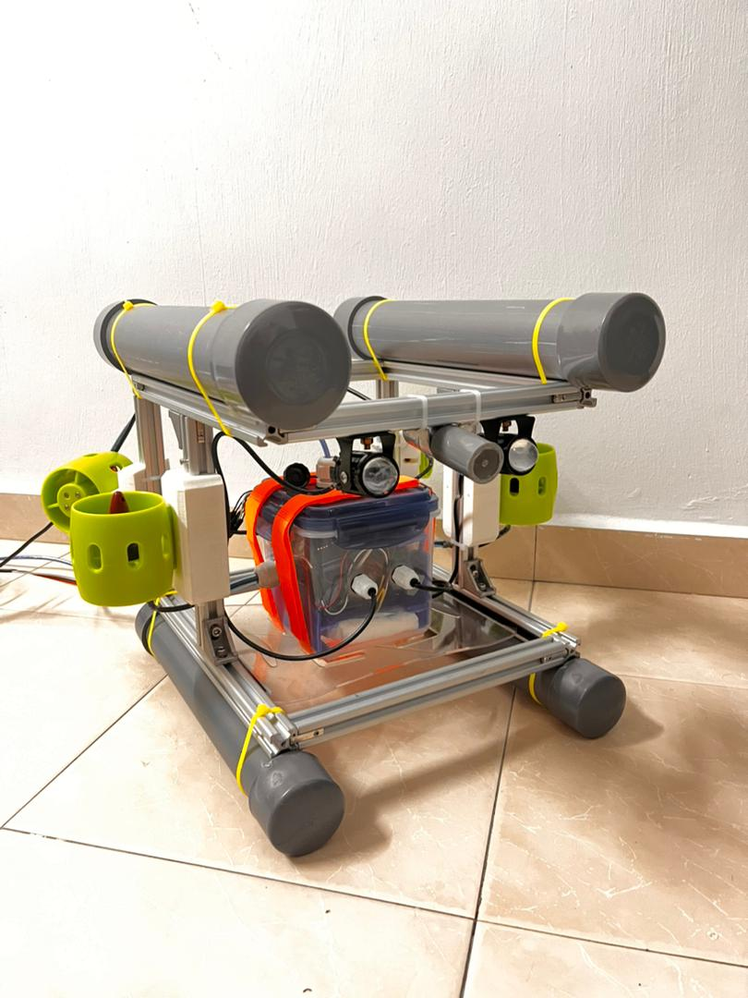
(a)
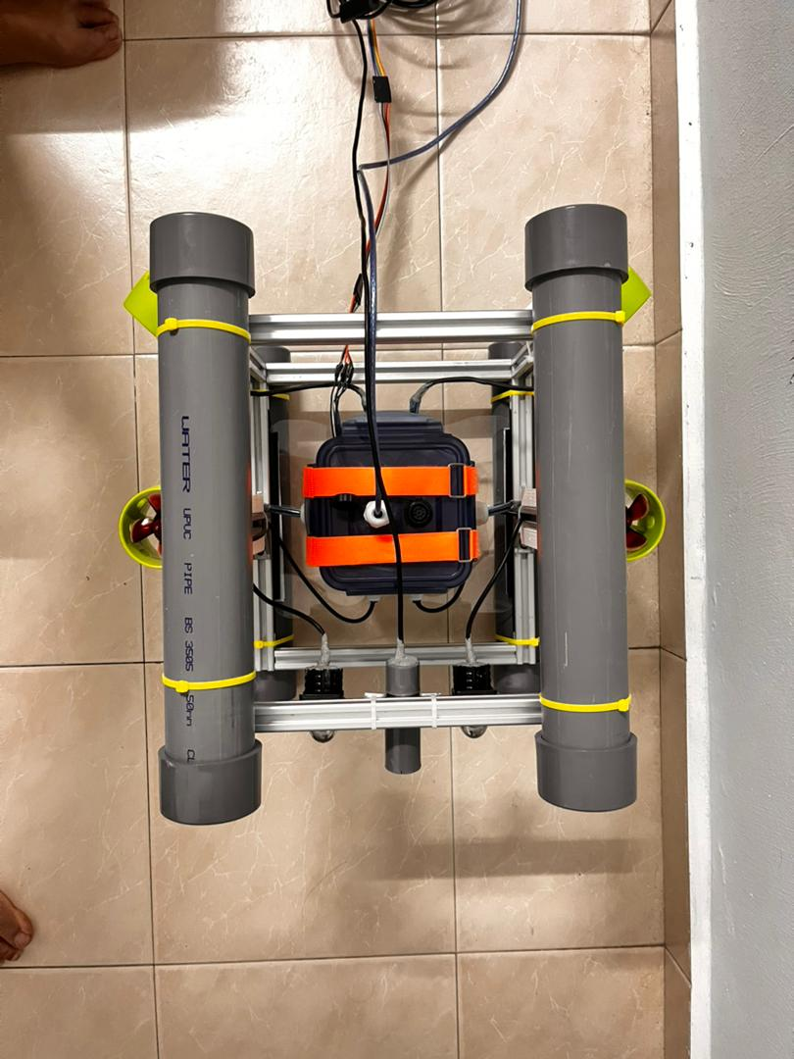
(b)
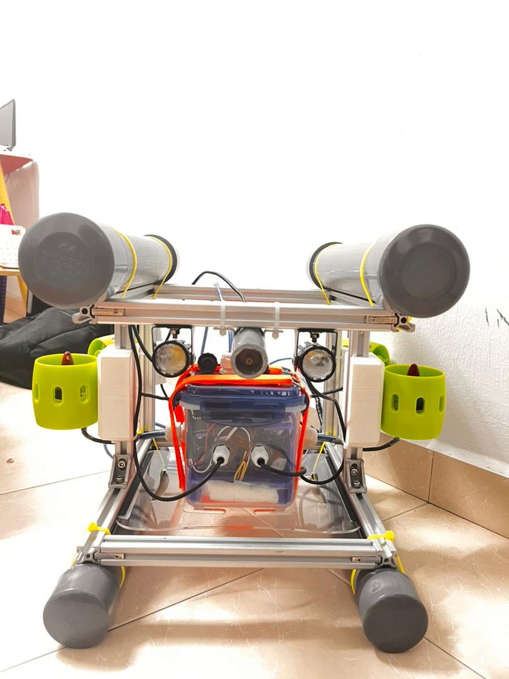
(c)
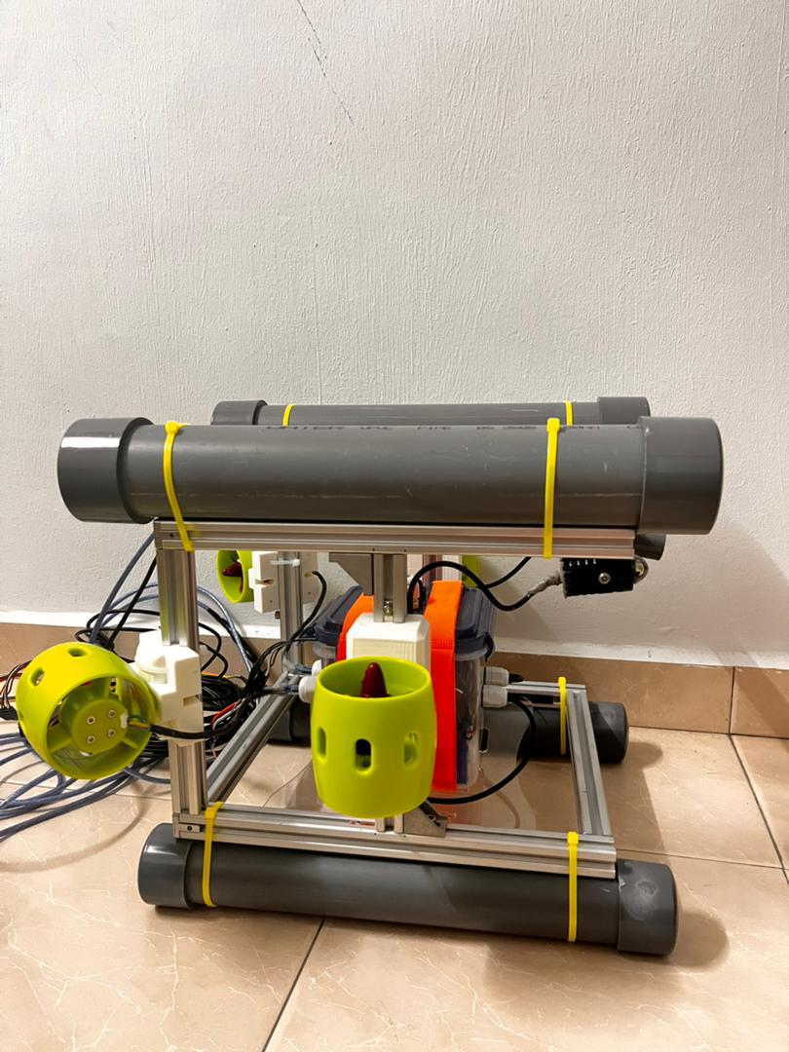
(d)
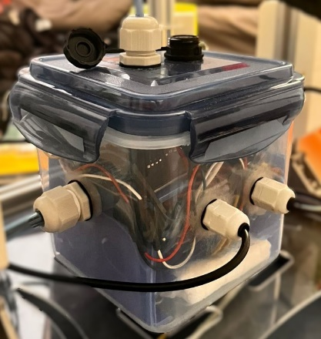
(e)
Figure 11. Overall View of ROV Prototype

Figure 15 shows the leakproof container has been chosen as the pressure hull of the ROV prototype due to its waterproof, accessible, modifiable and uncompressible design structure. All electronic components and wire will be stored inside the pressure hull. This type of food container used silicone ring to hold the cover and body tight by interlocking at 4 sides the container waterproof. Few holes have been drilled at the food container for the thruster wires and tethered cable wires. The nylon plastic IP 68 waterproof cable glands will be installed to the holes in the container allowing the wire cables to pass through while protecting the electronics components from water invasion. The most challenging aspect of this part is how to keep water out of this container at all times. Thus, highly absorbent pads and several packs of silica gel will be placed inside the container. These materials will assist absorb water that might enter and offering an extra layer of protection to the electronic components. This technique seeks to keep the pressure hull dry, which improves the reliability and long-term of the ROV's internal systems.

Experiment Results
Buoyancy of ROV
Total height of ROV prototype = 335mm
$$Percentage of ROV prototype immersed = \frac{Height of ROV prototype immersed}{Total height of ROV body}$$ | (2)

Table 3. Buoyancy Test Data
Mass of White Pebble Stones (g) | First Trial  (Negative Buoyancy) |  | Second Trial  (Negative Buoyancy)
Mass of White Pebble Stones (g) | Height of ROV Prototype Immersed (mm) | Percentage of ROV Body Immersed (%) | Height of Body Immersed (mm) | Percentage of Body Immersed (%)
0 | 278 | 82.99 | 278 | 82.99
200 | 284 | 84.78 | 288 | 85.97
400 | 293 | 87.46 | 297 | 88.66
600 | 301 | 89.85 | 306 | 91.34
800 | 310 | 92.54 | 315 | 94.03

In this experiment, achieving above 90% negative buoyancy is crucial for the ROV to perform effective submerge and raise operations. To accomplish this, additional external load using white pebble stones is required. It was determined 800g of white pebble stones is filled into bottom PVC pipe to achieve above 90% negative buoyancy. In the first trial, attaching only 200g of white pebble stones resulted in the ROV achieving 84.78% negative buoyancy. As more white pebble stones are added, the percentage of negative buoyancy increased until it reached the target above 90%. The second trial yielded similar results, indicating consistency and reliability in the findings. Therefore, it can be concluded that 800g of white pebble stones are necessary to achieve above 90% negative buoyancy for optimal ROV performance as shown in Figure 12.

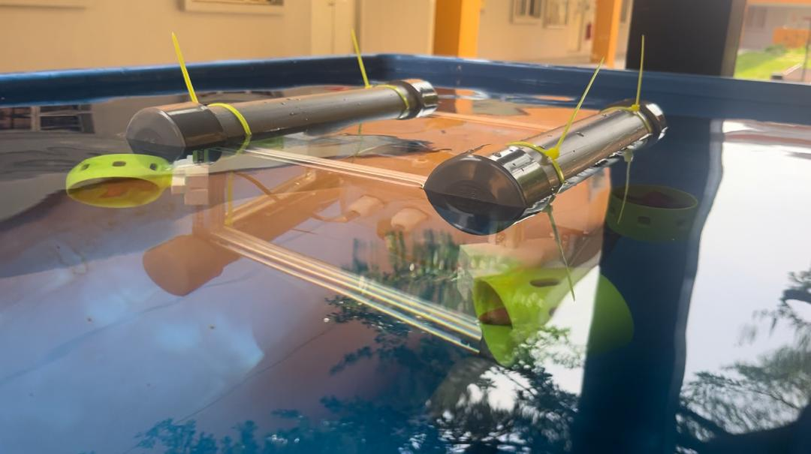
Figure 12. ROV Prototype Achieve Above 90% Negatively Buoyant

Underwater operation
To manoeuvre the ROV in horizontal movement, two horizontal thrusters at the back of the ROV prototype were used simultaneously. Both propellers of the horizontal thrusters must be turn clockwise to move the ROV forward and vice versa for moving backward. Therefore, the speed of ROV moves forward and backward will be determined.

Table 4. Forward Performance of ROV
Distance (m) | Average Time Taken (s) | Velocity (m/s) | Acceleration (m/s²)
0 | 0 | 0 | 0
0.2 | 0.7633 | 0.2620 | 0.3432
0.4 | 1.5567 | 0.2570 | 0.1651
0.6 | 2.3800 | 0.2521 | 0.1059
0.8 | 3.2133 | 0.2490 | 0.0775
1 | 3.9533 | 0.2530 | 0.0640
1.2 | 4.5533 | 0.2635 | 0.0579
1.4 | 4.9800 | 0.2811 | 0.0565
1.6 | 5.4833 | 0.2918 | 0.0532
1.8 | 6.0067 | 0.2997 | 0.0499
2 | 6.4933 | 0.3080 | 0.0474
2.2 | 6.8133 | 0.3229 | 0.0474
2.4 | 7.0700 | 0.3395 | 0.0480

Table 5. Backward Performance of ROV
Distance (m) | Average Time Taken (s) | Velocity (m/s) | Acceleration (m/s²)
0 | 0 | 0 | 0
0.2 | 0.7767 | 0.2575 | 0.3316
0.4 | 1.6233 | 0.2464 | 0.1518
0.6 | 2.5633 | 0.2341 | 0.0913
0.8 | 3.4700 | 0.2305 | 0.0664
1 | 4.1567 | 0.2406 | 0.0579
1.2 | 4.7367 | 0.2533 | 0.0535
1.4 | 5.2700 | 0.2657 | 0.0504
1.6 | 5.7467 | 0.2784 | 0.0484
1.8 | 6.1133 | 0.2944 | 0.0482
2 | 6.5733 | 0.3043 | 0.0463
2.2 | 6.8000 | 0.3235 | 0.0476
2.4 | 7.0167 | 0.3420 | 0.0487

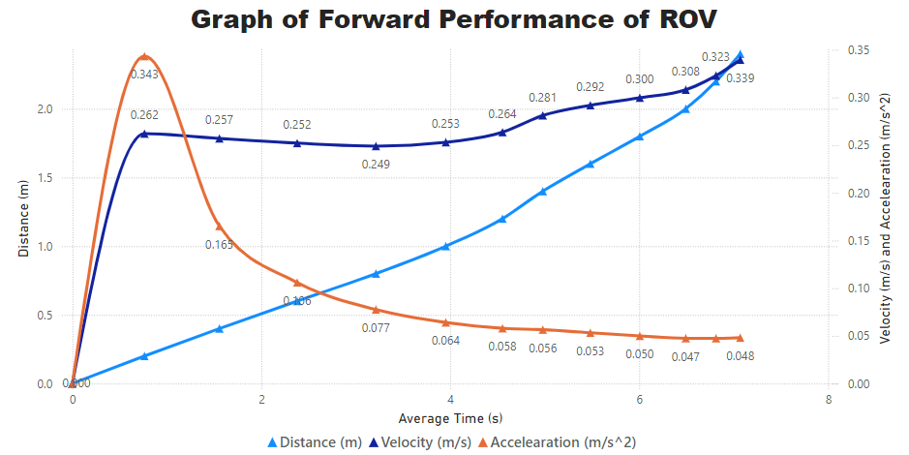
Figure 13. Graph of Forward Performance of ROV

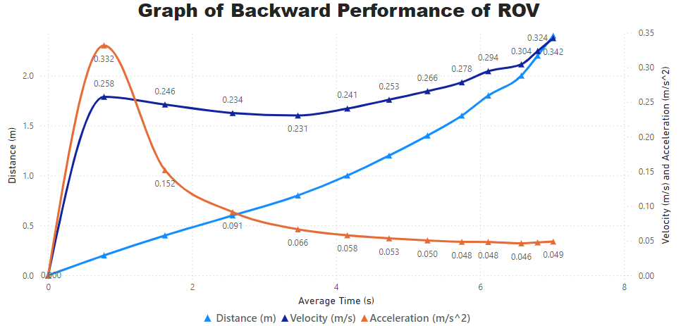
Figure 14. Graph of Backward Performance of ROV

From the results obtained while testing the performance of the ROV, it is observed that the average time taken when moving forward and backward is directly proportional to distance. In the forward test, velocity started at 0.2620 m/s at 0.2m and slightly decreased to 0.3395 m/s at 2.4m, while acceleration began at 0.3432 m/s2 and dropped to 0.0480 m/s2, showing the ROV's propulsion system stabilizes speed over longer distances. In the backward test, velocity ranged from 0.2575 m/s to 0.3420 m/s, and acceleration declined from 0.3316 m/s² to 0.0487 m/s2. These both forward and backward performance trend indicates that the ROV maintains a consistent speed initially, but slight variations in velocity may occur due to underwater resistance or changes in buoyancy. Furthermore, the ROV performs slightly better in forward direction compared to backward direction.
For horizontal movement, both propellers of the horizontal thrusters rotate in the opposite direction to allows ROV steer right or left.

Table 6. Turn Right Performance of ROV
Degree (°) | Average Time Taken (s) | Angular Velocity (rad/s) | Angular Acceleration (rad/s²)
0 | 0 | 0 | 0
45 | 1.3367 | 0.5876 | 0.4396
90 | 1.7933 | 0.8759 | 0.4884
135 | 2.1500 | 1.0959 | 0.5097
180 | 2.6533 | 1.1840 | 0.4462

Table 7. Turn Left Performance of ROV
Degree (°) | Average Time Taken (s) | Angular Velocity (rad/s) | Angular Acceleration (rad/s²)
0 | 0 | 0 | 0
45 | 1.0667 | 0.7363 | 0.6903
90 | 1.4600 | 1.0759 | 0.7369
135 | 1.9500 | 1.2083 | 0.6196
180 | 2.3933 | 1.3126 | 0.5485

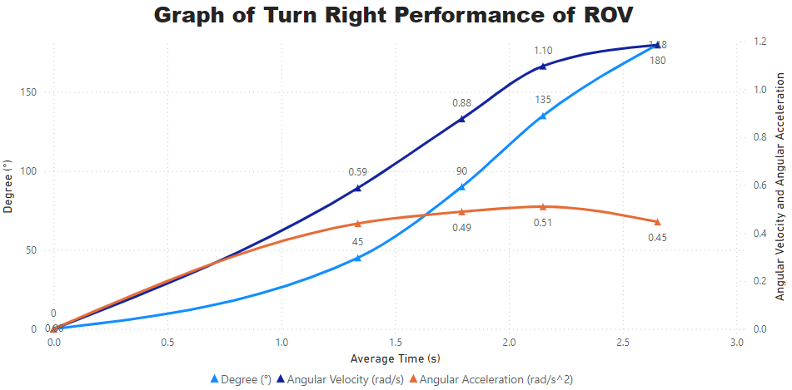
Figure 15. Graph of Turn Right Performance of ROV

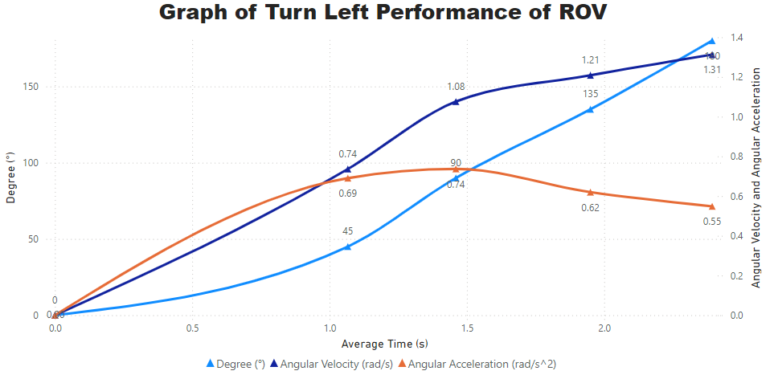
Figure 16. Graph of Turn Left Performance of ROV

The ROV's steering performance shows that it takes longer to complete turns as the angle increases. For example, a 45-degree right turn takes an average of 1.34 seconds with an angular velocity of 0.59 rad/s, while the same turn to the left takes only 1.07 seconds with an angular velocity of 0.74 rad/s. This trend continues with increasing angles, where the ROV shows higher angular velocities and accelerations for right and left turn compared to forward and backward, indicating better maneuverability due to asymmetries in the thruster configuration.

Table 8. Raise Performance of ROV
Distance  (m) | Average  Time Taken  (s) | Velocity  (m/s) | Acceleration  (m/s²)
0 | 0 | 0 | 0
0.05 | 0.3633 | 0.1376 | 0.3788
0.1 | 0.8867 | 0.1128 | 0.1272
0.15 | 1.2200 | 0.1230 | 0.1008
0.2 | 1.3967 | 0.1432 | 0.1025
0.25 | 1.6567 | 0.1509 | 0.0911
0.3 | 1.8633 | 0.1610 | 0.0864
0.35 | 2.0500 | 0.1707 | 0.0833
0.4 | 2.2700 | 0.1762 | 0.0776
0.45 | 2.5067 | 0.1795 | 0.0716

Table 9. Submerge Performance of ROV
Distance (m) | Average Time Taken (s) | Velocity  (m/s) | Acceleration  (m/s²)
0 | 0 | 0 | 0
0.05 | 0.1800 | 0.2778 | 1.5432
0.1 | 0.7733 | 0.1293 | 0.1672
0.15 | 1.3533 | 0.1108 | 0.0819
0.2 | 1.6467 | 0.1215 | 0.0738
0.25 | 1.9100 | 0.1309 | 0.0685
0.3 | 2.1700 | 0.1382 | 0.0637
0.35 | 2.4000 | 0.1458 | 0.0608
0.4 | 2.7167 | 0.1472 | 0.0542
0.45 | 2.8933 | 0.1555 | 0.0538

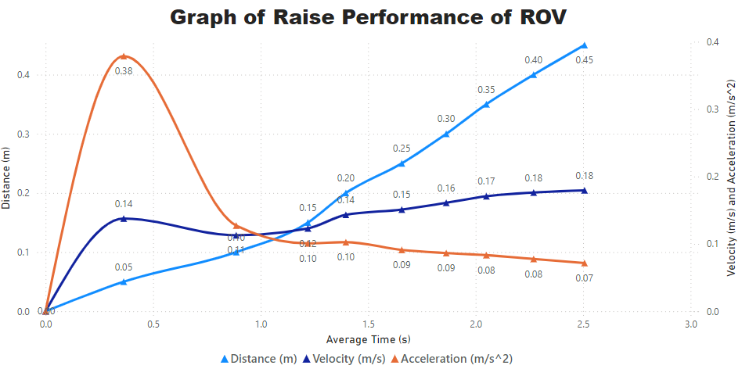
Figure 17. Graph of Raise Performance of ROV

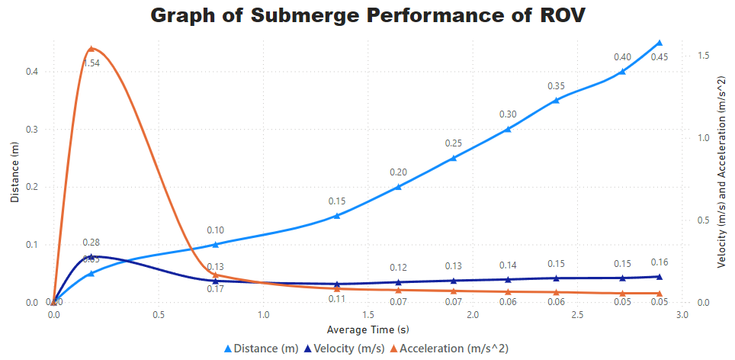
Figure 18. Graph of Submerge Performance of ROV

From Figure 21 and Figure 22, the ROV's raise and submerge performance shows expected trends with increasing average time and varying velocities over distance. During the raise test, velocity starts at 0.1376 m/s at 0.05 meters and increases to 0.1795 m/s at 0.45 meters, while acceleration decreases from 0.3788 m/s² to 0.0716 m/s2, indicating initial acceleration and subsequent stabilization. In the submerge test, velocity starts higher at 0.2778 m/s at 0.05 meters but decreases to 0.1555 m/s at 0.45 meters, with acceleration dropping from 1.5432 m/s2 to 0.0538 m/s2, reflecting strong initial propulsion and later stabilization. In contrast, acceleration and velocity at the start of the submerging are higher at the ROV due to buoyancy and gravity forces. In summary, the use of the ROV is characterized by well-coordinated and stable vertical movements, the provision of which is mandatory when working in the underwater environment.

- Overall Performance of ROV
Direction | Average Velocity (m/s) | Average Acceleration (m/s²)
Forward | 0.2600 | 0.0858
Backward | 0.2516 | 0.0801
Submerge | 0.1357 | 0.2167
Raise | 0.1355 | 0.1112

- Overall Turning Performance of ROV
Direction | Average Angular Velocity (rad/s) | Average Angular Acceleration (rad/s²)
Left | 0.8666 | 0.7487
Right | 0.5191 | 0.3768

It is depicted from Table 10 that the forward and backward movements have comparatively significantly higher values of average velocities that is, 0.2600 m/s and 0.2516 m/s respectively compared to vertical movements which submerge and elevate having approximately 0. 1357 m/s and 0. 1355 m/s. This implies that the design of the ROV suggests that it is designed for horizontal movement rather than vertical movement. The average accelerations adhere to this, with the maximum acceleration measured during sinking at 0.2167 m/s², implying a higher initial propulsion force against buoyancy. The forward and backward accelerations are almost similar, at 0.0858 m/s² and 0.0801 m/s², demonstrating consistent propulsion power in horizontal movements. The raise operation has a moderate acceleration of 0.1112 m/s², ensuring a calm ascent.
Referring to Table 11, the turning performance of the ROV for both the left and the right shows that the average velocity and acceleration are different as compared to Table 10. This could imply that the ROV is more flexible and faster in maneuvering concerning turning performance as the horizontal thrusters’ configurations are positioned at 45° at the back of the ROV.
In conclusion, the ROV has good horizontal control and is balanced vertically; the maneuverability demonstrated by how the ROV turns is impressive, making it useful in all sorts of underwater operations.

Summary
Several finite element analysis and experimental tests conducted on the developed ROV prototype shows that the performance is promising. It is verified from the finite element analysis that the materials used for the construction of the ROV are capable of withstanding the applied force without deformation or failure. All of the materials have a factor of safety larger than one, suggesting that they are appropriate for the intended use.
In the buoyancy experiment, the ROV prototype was critical to attain above 90% negative buoyancy to effectively submerge and rise. Thus, the goal was achieved by adding 800g of white pebble stones to the bottom PVC pipe for the best performance of the ROV. There were the several experiments being done for the purpose of credibility of all the information that were obtained.
According to the experiments of the forward and backward movements of the ROV had significantly greater average velocities (0.2600 m/s and 0.2516 m/s respectively) than the vertical motions of sinking and elevating (0.1357 m/s and 0.1355 m/s respectively). The effective propulsion force against buoyancy was highlighted by the greatest acceleration of 0.2167 m/s2 that was recorded during 94 submerging. The raise operation experienced a moderate acceleration of 0.1112 m/s², whereas the forward and backward accelerations were consistent at 0.0858 m/s² and 0.0801 m/s² respectively.
The ROV's turning performance data showed that its 45°-angled horizontal thrusters at the rear of the vehicle enable more efficient and rapid turning maneuvers. Overall, the ROV has outstanding horizontal control, balanced vertical movement, and impressive maneuverability, making it ideal for a variety of underwater applications.

CONCLUSION
In conclusion, the goal of this project is to design and develop an affordable micro underwater ROV for monitoring application, optimize the structural integrity and buoyancy for underwater ROV and analyze a performance of underwater ROV in terms of stability, velocity and acceleration. This project had successfully achieved in design and develop a low-cost underwater ROV for monitoring application as it only required less than RM 1000 to build the whole ROV prototype. This design of ROV prototype is capable to do monitoring and surveillance application. Otherwise, this design also waterproof body structure with optimal size which built by aluminum.
The ROV prototype can successfully move in four degrees of freedom controlled by PS2 controller. The design can perform to submerge less than 15m depth and perfectly stable at neutral buoyancy. The Arduino Uno which act as the microcontroller that been attach to the electronic circuit capable to send command from the operator to control either forward, reverse, turn right, left, submerge and raise. The challenging part in assembly procedure are to make all component waterproof to cover the electronic part inside the pressure hull.
Furthermore, the BLDC motor thruster was required ZMR 30A ESC to run, therefore the circuit must capable to withstand high current flow without burn or short circuit. The horizontal thruster was attached 45° to the body frame in order to enhance the turning moment of underwater ROV prototype during operation and the other two thrusters will be mounted vertically on the side of the ROV prototype. Therefore, the SMART ROV has ability of better maneuver controlling system.
For the sensors and equipment of the ROV prototype, the Bar02 pressure/depth sensor and MPU6050 IMUs were selected due to their high performance and suitability for use in the ROV’s environment. The Bar02 pressure/depth sensor provided accurate measures of the pressure, temperature, depth and altitude during the operation of the ROV prototype, while the MPU6050 accelerometer and gyroscope sensors offered 96 stability and control of the orientation of the underwater robot. The performance of the system was confirmed over the multiple tests due to its increased reliability and ability to provide the proper depth and maneuvering range for the operation. Moreover, integration with OBS Studio for streaming the video feed of ROV prototype from waterproof endoscope camera and GUI from Processing which assists the enhancement of the instantaneous control for optimum user interface and operation control.
Regardless, there is a little issue that occurs during underwater operation due to a water leak inside the pressure hull that affects the electronic components, thus an appropriate technique is required by inserting highly absorbent pads and several packs of silica gel to keep the pressure hull dry, which improves the reliability and long-term of the ROV's internal systems.

ACKNOWLEDGMENT
We wish to express our gratitude to the honorable Universiti Teknikal Malaysia Melaka (UTeM) for sponsoring this work under grant no. PJP/2022/FKE/S01858. Special appreciation and gratitude especially for Faculty of Electrical Technology and Engineering (FTKE) and Underwater Technology Research Group (UTeRG), Center for Robotics and Industrial Automation (CERIA) for supporting this research.

REFERENCES
- J. Monk et al., Field manual for imagery based surveys using remotely operated vehicles (ROVs). In Field Manuals for Marine Sampling to Monitor Australian Waters, Version 2. Przeslawski R, Foster S (Eds). National Environmental Science Programme (NESP), 2020.
- A A Priyanka et al., “Contriving of ROV,” International Journal of Engineering Research & Technology, Vol. 8, No. 11, pp. 186-191, 2020.
- S. I. Ali Shah et al., "Design, Development, and Fabrication of a Low Cost Remotely Operated Unmanned Underwater Vehicle," IEEE International Conference on Robotics and Automation in Industry, pp. 1-5, Oct. 2021. doi: 10.1109/ICRAI54018.2021.9651355
- J. Neira et al., “Review on Unmanned Underwater Robotics, Structure Designs, Materials, Sensors, Actuators, and Navigation Control,” Journal of Robotics, Vol. 2012, No. 1 , pp. 5542920, Jul. 2021. doi: 10.1155/2021/5542920
- R. Singh et al., “Review of low cost micro remotely operated underwater vehicle,” Ocean Engineering, Vol. 266, pp. 112796, Dec. 2022. doi: 10.1016/j.oceaneng.2022.112796
- M. Tadros et al., “A nonlinear optimization tool to simulate a marine propulsion system for ship conceptual design,” Ocean Engineering, Vol. 210, pp. 107417, Aug. 2020. doi: 10.1016/j.oceaneng.2020.107417
- T. Gülgün et al., “Low-Cost Unmanned Underwater Vehicle Design,” Avrupa Bilim Ve Teknoloji Dergisi, Special Issue, pp. 363-367, 2020. doi: 10.31590/ejosat.804610
- G. N. A. H. Yar et al., "Low Cost Assembly Design of Unmanned Underwater Vehicle (UUV)," IEEE International Bhurban Conference on Applied Sciences and Technologies, pp. 829-834, Jan. 2021. doi: 10.1109/IBCAST51254.2021.9393178
- M. Vasileiou et al., "A low-cost 3D printed mini underwater vehicle: Design and Fabrication," IEEE 20th International Conference on Advanced Robotics, pp. 390-395, Dec. 2021. doi: 10.1109/ICAR53236.2021.9659412
- H. Muzammal et al., "Design and Fabrication of a Low-Cost 6 DoF Underwater Vehicle," IEEE European Conference on Mobile Robots, pp. 1-5, Aug. 2021. doi: 10.1109/ECMR50962.2021.9568805
- M. Alfattah et al., “A Review Analysis of Corrosion Rate on Stainless Steel Pipe in Sea Water Media,” Sinergi, Vol. 28, No. 3, 2024 (Article in press).
- Z. Smolder and J. Yi, “Cost-Effective Remote Operated Vehicle,” Aresty Rutgers Undergraduate Research Journal, vol. 1, no. 3, pp. 1-14, Dec. 2021. doi: 10.14713/arestyrurj.v1i3.167
- D. B. Duraibabu et al., “An optical fibre depth (pressure) sensor for remote operated vehicles in underwater applications,” Sensors, vol. 17, no. 2, pp. 406, Feb. 2017. doi: 10.3390/s17020406
- A. Wilby and E. Lo, "Low-Cost, Open-Source Hovering Autonomous Underwater Vehicle (HAUV) for Marine Robotics Research based on the BlueROV2," IEEE/OES Autonomous Underwater Vehicles Symposium,, pp. 1-5, Sep. 2020. doi: 10.1109/AUV50043.2020.9267913
- J. S. Willners et al., "From market-ready ROVs to low-cost AUVs," OCEANS 2021: San Diego – Porto, pp. 1-7, Sep. 2021. doi: 10.23919/OCEANS44145.2021.9705798
- L. Zhao et al., "Modifying an Affordable ROV for Under-ice Sensing," OCEANS 2021: San Diego – Porto, pp. 1-5, Sep. 2021. doi: 10.23919/OCEANS44145.2021.9705886
- A. A. Yusof et al., “Open-Source Platform Comparison for Research and Development in Underwater Drones,” 12th National Technical Seminar on Unmanned System Technology, pp. 139-151, Sep. 2020. doi: 10.1007/978-981-16-2406-3_12
- P. Tarwadi et al., “Design and Development of a Robotic Vehicle for Shallow-Water Marine Inspections,” Australasian Conference on Robotics and Automation, pp. 1-8, Jan. 2020. doi: 10.48550/arXiv.2007.04563
- M. S. M. Aras et al., “Study of the effect in the output membership function when tuning a Fuzzy logic controller,” IEEE International Conference on Control System, Computing and Engineering, pp. 1-6, Nov. 2011. doi: 10.1109/ICCSCE.2011.6190485
- M. S. M. Aras et al., “Depth control of an underwater remotely operated vehicle using neural network predictive control,” Jurnal Teknologi, vol. 74, no. 9, pp. 85-93, Jun. 2015. doi: 10.11113/jt.v74.4811
- M. T. M. Zaidi et al., “PSO Fine-Tuned Model-Free PID Controller with Derivative Filter for Depth Control of Hovering Autonomous Underwater Vehicle,” 10th National Technical Seminar on Underwater System Technology, pp. 3-13, Feb. 2019. doi: 10.1007/978-981-13-3708-6_1
- M. S. M. Aras et al., “Auto Depth Control for Underwater Remotely Operated Vehicles using a Flexible Ballast Tank System”, Journal of Telecommunication, Electronic and Computer Engineering, vol. 7, no. 1 pp. 57-64, Jun. 2015.
- J. Betancourt et al., “An integrated ROV solution for underwater net-cage inspection in fish farms using computer vision,” SN Applied Sciences, vol. 2, no. 12, pp. 1946, Dec. 2020, doi: 10.1007/s42452-020-03623-z
- M. S. M. Aras et al., “Analysis of an improved Single Input Fuzzy Logic Controller designed for depth control using Microbox 2000/2000c interfacing,” International Review of Automatic Control, vol. 6, no. 6, pp. 728-733, Nov. 2013. doi: 10.15866/IREACO.V6I6.4160
- B. Bartlett et al., "Dynamic Positioning System for low-cost ROV," IEEE OCEANS 2023 - Limerick, pp. 1-5, Jun. 2023. doi: 10.1109/OCEANSLimerick52467.2023.10244643
- F. Campagnaro et al., “Wireless Remote Control for Underwater Vehicles,” Journal of Marine Science and Engineering. Vol .8, No. 10:pp. 736, Sep. 2020. doi: 10.3390/jmse8100736

