A Review of Rock Slope Failures in Malaysia: Exploring Types, Cases, Causes, and Consequences | 

Abstract  Certain Malaysian regions demonstrate varying geological formations. Nevertheless, rock slope failure occurrences are a primary concern. This review investigated the significant challenges of examining catastrophic Malaysian rock slope failure incidents. Notably, different rock slope failure types (rock failures, rock slides, rock falls, and rock avalanches) and several case studies [Bukit Lanjan (Selangor), Kinta Valley (Perak), and Mount Kinabalu (Sabah)] were assessed to comprehend the causes and implications of the negative impacts. This review employed two primary search techniques in the methodology framework: manual (handpicking, snowballing, citation tracking, and reference tracking) and advanced techniques (search strings using keywords integrated by Boolean operators in Scopus, Science Direct, and Google Scholar databases). Consequently, the rock slopes in Malaysia were prone to collapse due to severe rains, human activity, and natural events (earthquakes). Although these components could operate separately, their combined effect significantly increased the failure risk. This risk was even more prominent when heavy rainfall was involved. Infrastructure failures also exacerbated the implications alongside immediate casualties, injuries, and property damage, generating economic hardships due to transportation delays, maintenance expenses, and decreased productivity. Therefore, sustainable mitigation techniques were necessary to address the environmental damage. This review highlighted significant rock slope failure issues in Malaysia caused by various geological formations, requiring immediate solutions to resolve these concerns.  This is an open access article under the CC BY-SA license   | Keywords:  Rock slope failure;  Slope failure;  Rock slide;  Rockfall;  Rock avalanche.  Article History:  Received: August XX, 2024  Revised: August XX, 2024  Accepted: August XX, 2024  Published: August XX, 2024  Corresponding Author:

INTRODUCTION
Complex and uncertain natural disasters cause profound effects on the human population. A significant geological hazard example is landslides, which produce high fatalities annually. Hence, this phenomenon emphasizes the crucial requirement for improved forecasting and prevention methods. Landslide susceptibility is also closely associated with natural slope instability, existing geological vulnerabilities, and human-induced modifications (cut slopes) [1]. Recent studies provide comprehensive insights into this phenomenon across different regions, emphasizing the importance of robust prediction models and prevention strategies. For instance, a study in Yemen's Wadi Dhahr area evaluated factors such as slope angle, weathering, and rainfall, producing a landslide susceptibility map that aids slope management [2]. In Turkey, researchers utilized GIS and frequency ratio methods to assess landslide susceptibility, identifying geology, slope, and proximity to rivers as key factors [3]. Similarly, in India, logistic regression models were used to understand the impact of anthropogenic activities on slope stability, highlighting the role of rainfall and soil type [4].
These factors primarily contribute to the widespread occurrence of rock slope failures, a critical issue in geology and environmental studies. Rock slope failures are sudden and potentially catastrophic failures of rock masses, substantially impacting natural terrains and human activities. This process mainly occurs in regions with various geological formations. [5], [6], [7], [8]. Rock slope stability is essential due to its direct influence on infrastructure safety and durability, and slope failures can lead to severe outcomes. These outcomes include significant financial losses, permanent environmental harm, destruction of essential infrastructure, increased safety risks, and significant disruptions to transportation systems [6], [8], [9].
The Malaysian terrain, characterized by deep tropical weathering, poses significant challenges for infrastructure development. This complexity arises due to a combination of steep slopes, high rainfall, and diverse geological formations, which increase the risk of landslides and ground instability. According to a study on Malaysian infrastructure, the government faces numerous challenges in recognizing and measuring infrastructure assets due to the unique features of the terrain, such as long useful life and being part of an asset system or network [10]. Additionally, the rapid urbanization and transportation growth in areas like Greater Kuala Lumpur and Klang Valley further complicate infrastructure development, necessitating the adaptation of state-of-the-art construction technology and intelligent transportation systems to achieve sustainable growth [11].
Advanced technologies, such as Unmanned Aerial Vehicles (UAVs) and Light Detection and Ranging (LiDAR), have shown promise in improving infrastructure project outcomes. UAVs offer benefits in surveying and monitoring, but their implementation faces barriers such as regulatory restrictions, industry reluctance, and technical challenges related to data acquisition and quality control. Effective utilization of UAVs could greatly enhance construction efficiency and safety, provided these challenges are addressed [12]. Similarly, LiDAR technology, which provides precise terrain mapping, encounters issues like mismatches with ground survey data and a lack of standardization for data quality in Malaysia. Overcoming these technical hurdles is crucial for the widespread adoption of LiDAR in infrastructure projects [13].
In addition to technological challenges, Malaysia's construction industry must adapt to demographic changes, such as an aging population. This demographic shift impacts building design, workforce dynamics, and construction. Preparing for an aging nation involves ensuring that infrastructure is accessible and suitable for senior citizens, which requires additional costs and modifications to current construction practices [14]. The combined effect of these factors underscores the complexity and urgency of addressing infrastructure development challenges in Malaysia’s diverse and rapidly changing landscape.

Government Policies
Malaysia has initiated the National Slope Master Plan 2009–2023 (NSMP) [15] in response to the significant increase in slope-related disasters. This plan provides a comprehensive framework to reduce landslide damages nationwide by equipping key authorities with the essential tools and information for all phases of the disaster management process. Additionally, key authorities are provided with instructions and concrete resources to enhance their emergency preparedness, response, and recovery capacity. For example, 3D scanners can improve search and rescue, easing rugged terrain-based travel and victim identification. This plan can also establish numerous provisions, such as slope management procedures integrating risk-reduction strategies and improved infrastructure development. Hence, failures are effectively prevented when addressing issues related to slope-related disasters.
The vulnerability of Malaysia to various natural disasters (floods, landslides, and earthquakes) has been acknowledged in the Twelfth Malaysia Plan 2021–2025 (RMKe-12) [16]. Consequently, disaster risk management (DRM) at the national policy level has been elevated to a prominent position. This feature aids in safeguarding the capability and infrastructure of Malaysian individuals. A detailed structure concerning proactive strategies is also outlined in the DRM of the RMKe-12. These approaches include early warning technologies and community readiness-related programs in constructing vital infrastructure for disaster prevention measures. For example, these methods are utilized in designing and constructing important structures (buildings and highways). This plan also focuses on capacity building, training, and providing resources to local authorities with emergency responders to handle crisis scenarios successfully.
The 2023 Mid-Term Review [17] of the RMKe-12 has highlighted the dedication of the Malaysian government to landside disaster management prevention using two key initiatives: a landslip early warning system and a National Geological Disaster Centre. Approximately RM 563,000,000 has also been allocated in the 2024 Malaysian budget to enhance landslide readiness. This allocation signifies the significant dedication of the Malaysian government to take preemptive actions to restore and stabilize more than 2,000 high-risk slopes and implement improved monitoring and preventive actions [18].

METHOD
This review initially evaluated relevant studies to identify the correlations between rock slope failure and factors affecting rock stability in Malaysia. A study by [19] proposed using several search algorithms to improve the likelihood of discovering related studies. The study revealed two primary search techniques: manual (handpicking, snowballing, citation tracking, and reference tracking) [19], [20] and advanced techniques [constructing queries or search strings using Boolean operators in multiple databases (such as Scopus and Web of Science)] [19], [21] Meanwhile, [22] created a Literature Review Protocol (LRP) detailing databases, languages covered, keywords, and search methods.
The relevant studies in this review were initially retrieved from numerous search engines (Science Direct, Scopus, Google Scholar, Mendeley, and the databases of the University for journals, books, and proceedings). Several Boolean operators ("OR", "AND", and "NOT") were then employed to integrate multiple related terms for targeted search results ("Factor", "Rock slope failure", "Rock slope instability", "Cliff collapse", "Slope failure", "Rock Fall", "Rock Slide", "Rock Avalanches", and "Malaysia"). This review also broadly examined studies from the past 20 years, focusing on slope stabilization procedures in Malaysia and Southeast Asia. Subsequently, the data were gathered from their websites or portals for statistical reference. The inter-library lending and document delivery service of the University was also utilized for offline and closed-access articles employing manual methods. Even though the search process in this review yielded numerous articles, only the most pertinent English studies were used.

MAJOR ROCK SLOPE FAILURE TYPES IN MALAYSIA
Material written here is only a main ingredient and must be equipped with the brand and its purity (for example, H₂SO₄ (Merck, 99%)). Equipment written in this section only contains the main equipment fitted with the brand (for example, electric Furnace (Carbonite)).
Ancillary equipment components do not need to be written. The main toolsets that should be presented in this section are equipped with image captions. Image captions are placed to be part of the figure caption instead of being part of the picture.

ROCK SLIDES
The predominant rock slope instability type in Malaysia is rock slides. This instability occurs as sliding movements along discontinuities in rock masses and is categorized based on the motion and fracturing of the rock mass. Numerous movement sub-types are observed in the slide, such as rotational, planar, wedge, compound, and regular slides. A study by [23] grouped these slides based on their speed, rock characteristics, and movement patterns. The characteristics of the slides are as follows:
- Rotational slides: Slow and involve a weak rock rotating like a cylinder.
- Planar slides: Fast and possess a flat, breaking surface.
- Wedge slides: Extremely fast and possess a triangular shape.
- Compound slides: Vary in speed and demonstrate several breaking surfaces.
- Irregular slides: Sudden and occur in rugged, uneven rock structures.

Another study by [8] conducted a study defining a rock slide as an abrupt and frequently unforeseeable occurrence in which substantial rock masses detach and slide down slopes. Nonetheless, these descriptions were simplified, and real-world rock slides could be more intricate. The intricacy of real-world rock slides is highlighted through various case studies and analyses that reveal the complexities beyond simplified descriptions. For instance, investigations of rock slides in British Columbia that evolved into flow-like landslides highlight the dynamic nature of debris avalanches and flow deposits influenced by ground saturation levels and topographic gradients [24]. Additionally, discussions on advanced monitoring and modeling techniques for rock structures emphasize technological advancements in understanding rock mass stress and deformation [25]. Furthermore, examinations of the hydrology of active rock glaciers in the Austrian Alps demonstrate the impact of weather conditions and meltwater flow on rock glacier discharge patterns [26].
Figure 1 illustrates two sliding failure types on rock slopes: a planar sliding failure observed in an abandoned quarry and a wedge sliding failure on a road-cut slope. The rock layers were shifted along a noticeable plane, implying its planar nature (see Figure 1(a)). Meanwhile, the rock displacement occurred along two parallel planes, creating a wedge (see Figure 1(b)). Thus, these images aided in classifying the typical rock slope failures.

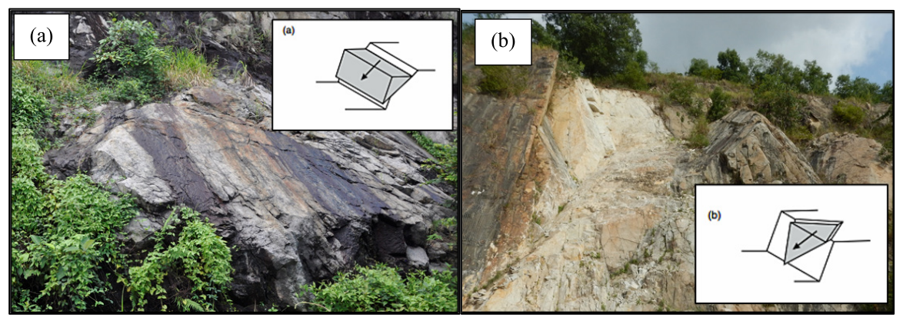
Figure 1. (a) The observed sliding failure on a rock slope (including planar sliding on an abandoned quarry) and (b) the wedge sliding on a road-cut slope [8].

Case Study 1: Bukit Lanjan, Selangor
On November 26, 2003, Malaysia experienced a rock slide at the 21.8-km point of the Bukit Lanjan Interchange on the New Klang Valley Motorway (NKVE) (see Figure 2). This area falls within the authority of the Petaling Jaya district in Selangor, Malaysia. Approximately 35,000 m³ of rock debris fell onto the motorway and blocked the road, mainly comprising different angular block sizes. A study by [27] documented that the rock slope failure in Bukit Lanjan was attributed to geological conditions and triggering events. The study revealed that the pre-existing rock mass structure containing steep dipping faults and unfavorable joint orientations contributed to instability. Conversely, the extended period of heavy rainfall likely triggered the incident.

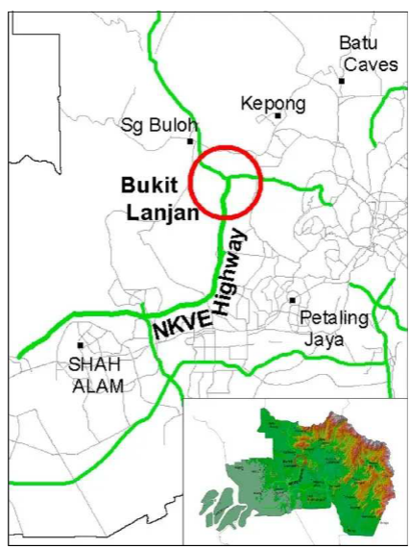
Figure 2. The location map of the Bukit Lanjan rock slope incident on November 26, 2003 [27].

The failure is confirmed to be caused by a large wedge block formed by the intersection of three key planes as follows [27], [28]:
- A steeply dipping fault plane F1 (dip/dip direction: 80º/225º)
- A gently dipping joint plane J1 (dip/dip direction: 60º/070º)
- A release plane F2 (dip/dip direction: 78º/327º)

The factor of safety (F.O.S.) also decreased below 1 when simulated water-filled faults and joints from the hydrostatic pressure conditions were integrated into the analysis, suggesting imminent failure. Therefore, the significant impact of high-water pressure on this occurrence was demonstrated. This outcome was reinforced by the unusually high rainfall in November 2003, surpassing records dating back to 1966 [27].
Although the Bukit Lanjan incident did not cause fatalities, the economic repercussions were significant. Figure 3 portrays the massive granite boulders obstructing completely the NKVE highway due to the failed rock mass [27]. This incident cost the Malaysian government approximately RM 836,000,000 (economic cost) due to lost revenues and required corrective actions [15]. The extended traffic disruptions resulting from this incident also substantially impacted businesses and residents in the Klang Valley, exacerbating the economic strain.

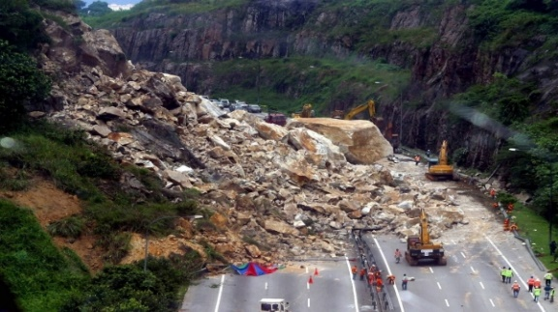
Figure 3. The rock slope failure incident at the Bukit Lanjan Interchange (KM 21.8 of NKVE) on November 26, 2003. The entire expressway was closed to the public due to the failure materials obstructing the road [15].

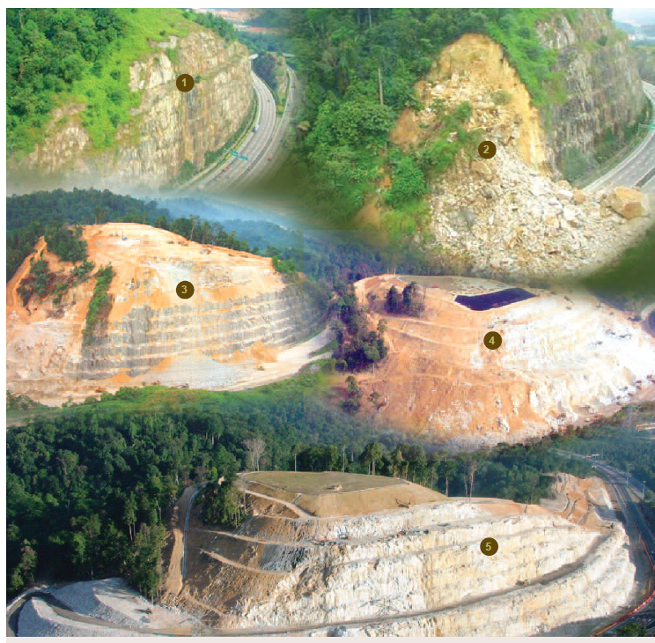
Figure 4. A detailed Bukit Lanjan rockslide incident timeline and the corresponding repair efforts [15]
Figure 4 depicts a detailed Bukit Lanjan rockslide incident timeline and the following rehabilitation actions. The initial image depicted a peaceful green mountainside before the rockslide incident, showcasing stability and lush vegetation. Subsequently, the second image highlighted the immediate aftermath, displaying major collapse and scattered debris modifying the terrain. The third image then conveyed the beginning of repair work, featuring machinery and terracing efforts to stabilize the hillside. Likewise, the fourth image demonstrated continued advancements in the restoration process involving enhanced terracing and erosion prevention methods. Finally, the fifth image presented the finished repair work, featuring clearly defined terraces, regrown flora, and preventive measures (stabilizing nets to reduce the risk of future landslides). This process indicated a successful restoration of the site.

ROCKFALLS
Compared to rock slides that typically entail large-scale mass movements, the detachment descent distinguishes rock falls and bounce of individual rock or ice fragments. Despite this phenomenon frequently occurring individually or in clusters, the pieces in motion mainly interact with the ground rather than with one other to produce minimal fragmentation. Generally, rock falls contain small amounts of debris [23]. Nonetheless, this phenomenon can present substantial dangers owing to their rapid speed and erratic paths. Even though artificial slopes are prone to rock falls, natural rock faces in karst landscapes are commonly affected by weathering and erosion, causing discontinuities.

Case Study 2: Kinta Valley, Perak
The NSMP has stated that the rapid development in Perak (Ipoh area) has led to higher land demands. This finding has resulted in residential and industrial buildings near steep limestone cliffs [15]. A study by [29] noted that considerable advancements occurring near certain limestone hills were observed. The study revealed that residential with industrial complexes and temples were situated near the hills. Quarrying processes were also ongoing to extract high-quality limestone aggregates in the limestone hill regions. Thus, multiple rock fall-related incidents were documented in the Kinta Valley between 2004 and 2023 (see Table 1).

Table 1. Significant incidents in Kinta Valley, Perak from 2004 to 2023
Location of incident | Date of event |  | Reported Damage/  fatalities |  | Source
Mount Bercham, Perak |  | Dec 12, 2004 |  | Structure damage, two deaths, & five injured |  | [29]  [30]  [31]
Mountain Pass, silver border-Pahang |  | April 2006 |  | A mega-sized failure covered 1/4 of the rock body on this mountain. |  | [29]  [30]
Gunung Karang Besar, Keramat Pulai |  | June 5, 2008 |  | Vehicle damage & one death |  | [29]  [31]
Yee Lee Edible Oils Factory (Gunung Lang, Ipoh) |  | Feb 13, 2012 |  | Structural damage and no fatalities |  | [29]  [31]  [32]
Gua Tempurung, Kampar |  | April 11, 2012 |  | No reports of structural damage or fatalities |  | [29]  [31]  [32]
Quarry at Keramat Pulai, Simpang Pulai |  | July 1, 2019 |  | Vehicle damage & one death |  | [33]  [34]
 |  | March 8, 2022 |  | Two deaths &  two injured |  | [35]  [36]
 |  | Sept 5, 2023 |  | Vehicle damage and one injured |  | [37]

Table 1 shows that between 2004 and 2023, the Kinta Valley, Perak, Malaysia, experienced multiple significant rockfall incidents, highlighting the hazards presented by its limestone-dominated landscape. Casualties and damage effects from events like the 2004 Mount Bercham rockfall and the 2006 Mountain Pass failure, which highlighted deployment scales of catastrophic collapses, present an important risk to life and property. Adding to the public threat, the 2008 Gunung Karang Besar rockfall halted transport, and since then, significant structural damage near services such as the Yee Lee Edible Oils Factory and quarry-related deaths in 2019 stress the occupational danger. Such active and passive monitoring technologies capable of carrying out 3D modeling and lineament density studies can be implemented in areas of at-risk and highly prone to landslides, which would've been used in recent deaths and damage cases such as the 2022 rockfall incident in Simpang Pulai, and another extreme-damage incident to other vehicles in 2023. This has shown how urgent it is to implement sustainable risk management in Kinta Valley to protect lives and properties.
Even though several aspects could influence the rock fall incidents in Kinta Valley, rainwater was the primary component causing these events. The rainwater in the region dissolved the limestone, promoting instability within the rock structure [32], [38]. Subsequently, the cohesiveness of rocks at joints and cracks was further exacerbated by chemical weathering and quarrying activities. These aspects also occurred alongside other factors, including wind-related plant movement, earthquakes, and vibrations [39]. Another study also discovered numerous elements substantially contributing to rock fall incidents in Kinta Valley, such as seismic activities, water dissolution, and broad joints with faults [40].

ROCK AVALANCHES
A study by [23] found that rock avalanches were remarkable and destructive natural events. The study described that rock avalanches were distinguished by their exceptional speed, enormous size, and the fluid-like movement of fragmented rock. A rock avalanche typically occurs from significant rock slides or collapses, in which large masses (millions of m³) abruptly break away from a mountainside. The large amount and speed of the sliding rock turn these masses into a fluid-like stream resembling a massive waterfall made of stone. Although the precise mechanisms are still unknown, rock avalanches often result from substantial rock slides or falls caused by different sources. Specific examples that can trigger these catastrophic events include earthquakes, volcanic eruptions, heavy rainfall, and human activities.
The precise mechanisms driving rock avalanches remain poorly understood. Numerous studies have investigated potential causes and contributing factors. Research on the Nyixoi Chongco rock avalanche suggests that shear forces and internal stress differences, evident in sedimentary deformation structures, are key contributors. Liquefaction, however, is not a primary factor [41]. Rather than the rock mass itself, the nature of the terrain the avalanche travels over significantly influence its movement, highlighting the complex and variable nature of these events [42].

Case Study 3: Mount Kinabalu, Sabah
Rock avalanches are usually uncommon in Malaysia. Nevertheless, a rare rock avalanche incident occurred in 2015 on the rock face of Mount Kinabalu. This mountainous region is situated in Sabah, which is the first United Nations Educational, Scientific and Cultural Organization (UNESCO) World Heritage Site in Malaysia [43]. On June 5, 2015, a 6.0 magnitude earthquake caused rock avalanches on the rocky flanks of Mount Kinabalu, producing noticeable marks on the surface [43], [44], [45], [46], [47]. This earthquake was documented as one of the most powerful natural phenomena following the 6.2 magnitude Lahad Datu earthquake on July 26, 1976 [47]. Consequently, a significant boulder avalanche on the slopes of the mountain caused 18 immediate fatalities [44], [46], [48].
Seven pupils and two teachers from the Tanjong Katong Primary School (TKPS), Singapore, and a Singaporean adventure guide who were reported missing following the earthquake have been discovered deceased. Meanwhile, six Malaysians (including four mountain guides) perished. Two tourists (one Chinese and one Japanese nationals) were also killed (Straits Times, 2015). This major incident demonstrated that the implications of the earthquakes, rock falls, and debris flow could heighten the exposure and risk levels due to the mountainous terrain and popular tourist activities (climbing, camping, and tourism) [43].
Figure 5 illustrates the earthquake distribution in Sabah between 1973 and 2016, obtained from the United States Geological Survey (USGS) database. The map depicted different colored dots, each indicating the location of an earthquake. Additionally, the colors represented the depth of the earthquakes, and a yellow star implied a notable earthquake incident with a magnitude of 6 or higher.

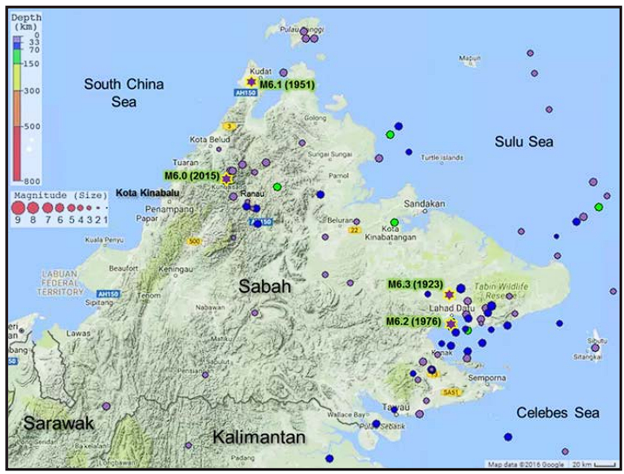
Figure 5. The earthquake distribution in Sabah between 1973 to 2016. The yellow star on the map indicates an earthquake of 6 or higher magnitude. This data was extracted from the USGS database [47].
DISCUSSION
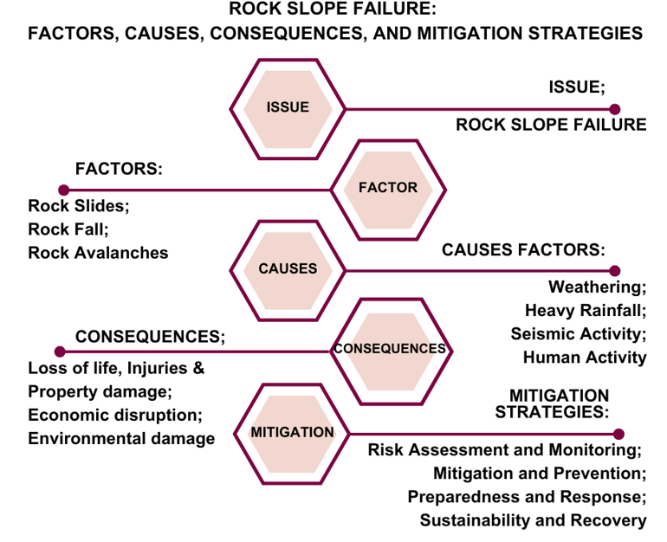
Figure 6. A flowchart indicating the rock slope failure aspects involving factors, causes, consequences, and mitigation strategies.

Figure 6 illustrates the critical factors, causes, consequences, and mitigation strategies related to rock slope failures, a significant geological risk in Malaysia. This issue was roughly comprehended by categorizing it into two essential aspects: rock movement (failure types: rock slides, rock falls, and rock avalanches) and triggering events (factors generating instability). Each type presents unique challenges based on the movement and volume of rock involved. These failures are often influenced by the geological characteristics of the slope, including the presence of discontinuities such as joints and fractures, the type of rock, and the degree of weathering.
Heavy rainfall has primarily contributed to slope failures in Malaysia over the past five years [49], [50]. Rainfall infiltrating rock formations increases pore pressure, weakening the rock structure and making slopes more susceptible to failure. Additionally, acidic rain accelerates rock deterioration through chemical weathering, further compromising slope stability [49]. These factors underscore the critical role of rainfall in triggering slope failures in Malaysia, emphasizing the need for comprehensive risk assessment and mitigation strategies to address the challenges posed by changing climatic conditions.
Human actions significantly contributed to rock slope failures. For example, deforestation and construction operations disrupted the equilibrium of slopes, leading to destabilization. Inappropriate construction on unsuitable terrain without adequate planning and measures also increased the likelihood of rock slope failures. Weather conditions, like freeze-thaw cycles, exert additional pressure on rock masses, while seismic events like earthquakes can further destabilize already fragile slopes. This type of seismic activity can cause subsidence movements, leading to slope failure as the land gradually sinks, disrupting the balance and stability of rock slopes. Research has shown that seismic activities in Malaysia, notably the earthquake in Ranau in 2015, have highlighted the vulnerability of slopes to landslides [51]. The seismic considerations in structural design, as emphasized after the Sumatera-Andaman earthquake, are crucial to preventing fatalities and injuries caused by structural failures during earthquakes [52]. Studies on bridges in Malaysia have shown varying seismic fragility curves, indicating different probabilities of damage levels based on pier heights and ground motion intensities [53]. Overall, seismic activities can trigger landslides and affect the structural integrity of various types of infrastructure in Malaysia, emphasizing the importance of seismic considerations in design and construction practices.
Due to Malaysia's geographical topography, which features steep hills and densely populated areas, the frequency of rock slope failures could increase. The risk of such failures has also significantly increased, particularly in Malaysia, due to the expansive infrastructure development within and around slopes [54]. There have been various methods in Malaysia to evaluate and reduce slope instability, such as rock mass classification systems, slope mass rating (SMR), including kinematic analysis [55]. Besides, geophysical techniques, including electrical resistivity and remote sensing tools such as light detection and ranging (LiDAR), have also been embraced to enhance rock slope stability investigations in the country [55]. Similarly, applying soil bioengineering techniques, especially on whole plants, has been identified as an alternative approach for slope stabilization, particularly in low to moderate-risk category slopes [54]. The combination of these efforts is germane to addressing the issues related to infrastructure development and natural factors that lead to failures in slope areas within Malaysia.
Rock slope failures can have severe consequences, including human injuries or fatalities and property destruction. If these incidents were not mitigated, a chain reaction of impact could be extended in regions surrounding the rock slope failures. These incidents were also costly to resolve. For example, interruptions of transportation pathways (highways and railways) could produce decreased productivity, freight delays, and higher operational expenses. Another example involved repairing and rehabilitating damaged infrastructure, which created significant financial strain on relevant parties. Therefore, long-term implications could be concerning due to the negative financial impacts, impeding economic expansion and advancement.
Considerable environmental concerns could be presented from rock slope failure incidents, in which waterway sedimentation, loss of habitat, and soil erosion could occur due to natural landscape modifications. These incidents can also lead to the contamination of water sources by releasing dangerous substances, posing threats to human health and aquatic ecosystems. Therefore, introducing sustainability principles in rock slope management strategies is essential to prioritize preventive actions and minimize the ecological impact of failures. This approach allows for the identification of methods to mitigate rock slope failures.
The first step is to monitor and examine areas prone to failure through extensive tests and advanced monitoring technologies. In high-risk slope areas, it is necessary to conduct comprehensive tests and utilize advanced monitoring techniques for both control and examination. Effective methods such as Electrical Resistivity Tomography (ERT) [56] can explore subsurface moisture dynamics, a key driver of slope failure events. Advanced monitoring measures like passive seismic monitoring [57] can detect changes in fundamental resonance frequencies and slope deformation, offering a deeper understanding of slope conditions.
Furthermore, contactless methods like DInSAR [58] can be used cost-effectively and efficiently to survey large areas for potential landslide hazards. Integrating technologies such as the Internet of Things (IoT) and Artificial Intelligence (AI) for monitoring soil hydrological conditions and tracking slope movements [59] will enhance early warning systems and reduce risk. The use of Micro Electro Mechanical Systems (MEMS) tilt sensor arrays in monitoring is another option, providing advances in early warning against potentially dangerous slope movements and enabling timely preventive measures, such as evacuation warnings for high-risk areas [60].
Moreover, incorporating the anticipated probability and timing of future failures should also be acquired in improved prediction models by delivering data regarding geological properties, rainfall, and seismic activity for specific mitigation initiatives. Subsequently, different mitigation and preventative techniques (rock bolting, water infiltration management, and wall retainment) can then be implemented after vulnerable slopes are located.
Strict regulations and geotechnical expertise should be followed and incorporated into the infrastructure framework as preventive measures. Nonetheless, preparedness and response measures are still crucial if an incident occurs. A prompt and efficient response involving search and rescue operations, communication protocols, and evacuation methods can then be utilized. The long-term management should also include sustainability and recovery initiatives, such as replanting and post-failure recovery plans containing environmental factors.

CONCLUSION
This review successfully investigated the rock slope failure incidents in Malaysia by presenting the difficulties in areas with varied geological formations. The factors affecting these incidents were natural events, human activities, and severe rainfall, which collectively elevated the likelihood of rock slope failures (particularly during intense rainfall). Several issues were also determined in this review, such as injuries, fatalities, and property damage. These issues demonstrated infrastructure disruptions, leading to economic expenses involving lower productivity, repair expenses, and transportation delays. Overall, Malaysia should use comprehensive mitigation solutions to achieve resilience and sustainability in dealing with rock slope failures. These solutions should include early warning systems, slope stabilizing techniques, and data-informed land-use planning.

ACKNOWLEDGMENT
This review is supported by the University of Tun Hussien Onn, Malaysia, and the Ministry of Higher Education, Malaysia, for the Hadiah Latihan Persekutuan (HLP) scholarship. The information obtained in this review provides valuable insights into Malaysian disaster management's current and future landscape.

REFERENCES
[1] R. W. M. Cheung and W. H. Tang, “Realistic Assessment of Slope Reliability for Effective Landslide Hazard Management,” 2005.
[2] B. Adnan A., K. Khaled M., A. Amal F., A. Ziad A., and A. Ahmed M., “Slope Stability Assessment and Landslide Susceptibility Map Production of Wadi Dhahr Area, Northwest of Sana’a, Yemen,” Sultan Qaboos University Journal for Science [SQUJS], vol. 23, no. 2, p. 120, Dec. 2018, doi: 10.24200/squjs.vol23iss2pp120-136
[3] A. Gül Yiğittepe, H. Keskin Citiroglu, A. Karakaş, and Ç. Mekik, “Investigation of Slope Movements and Landslide Susceptibility Analysis of Karabük-Yenice Area in NW of Turkey,” Arabian Journal of Geosciences (2021), 2021, doi: 10.1007/s12517-021-06838-5/Published.
[4] E. R. Sujatha and V. Sridhar, “Landslide Susceptibility Analysis: A Logistic Regression Model Case Study in Coonoor, India,” Hydrology, vol. 8, no. 1, 2021, doi: 10.3390/hydrology8010041.
[5] A. M. Mohd Razib et al., “A Systematic Approach of Rock Slope Stability Assessment: A Case Study At Gunung Kandu, Gopeng, Perak, Malaysia,” Sains Malays, vol. 47, no. 7, pp. 1413–1421, Jul. 2018, doi: 10.17576/jsm-2018-4707-08.
[6] M. Marjanovic, B. Abolmasov, Z. Berisavljevic, M. Pejic, and P. Vranic, “Pre-Failure Deformation Monitoring as Rockfall Prediction Tool,” in IOP Conference Series: Earth and Environmental Science, IOP Publishing Ltd, Sep. 2021. doi: 10.1088/1755-1315/833/1/012197.
[7] A. F. Salmanfarsi, H. Awang, and M. I. Ali, “Rock Mass Classification for Rock Slope Stability Assessment in Malaysia: A Review,” in IOP Conference Series: Materials Science and Engineering, Institute of Physics Publishing, Jan. 2020. doi: 10.1088/1757-899X/712/1/012035.
[8] A. F. A. Rahim et al., “A Review of Rock Slope Stability Assessment Practice in Malaysia,” Sains Malays, vol. 52, no. 2, pp. 399–416, Feb. 2023, doi: 10.17576/jsm-2023-5202-07.
[9] H. A. Rahman and J. Mapjabil, “Landslides Disaster in Malaysia: An Overview Article in Health & the,” 2017. [Online]. Available: https://www.researchgate.net/publication/321096764
[10] C. Ruhana Isa, H. Abu Hasan, and Z. Saleh, “Issues and Challenges in Accounting for Infrastructure Assets in the Malaysian Government and the Way Forward,” IPN Journal of Research and Practice in Public Sector Accounting and Management, vol. 14, no. 1, pp. 89–108, 2024, doi: 10.58458/ipnj.v14.01.05.0103.
[11] H. Sazali and I. M. Firdaus, “Highway Infrastructure: Visions & Challenges in The Next Decades,” in IOP Conference Series: Materials Science and Engineering, Institute of Physics Publishing, Apr. 2019. doi: 10.1088/1757-899X/512/1/012047.
[12] T. K. Soon, N. C. Teng, N. T. Wei, C. C. Tiong, N. A. Mukhlas, and M. S. A. Shah, “Challenges and Barriers for Unmanned Aerial Vehicle (UAV) Implementation in Malaysian Infrastructure Projects,” Asean Engineering Journal, vol. 14, no. 1, pp. 237–243, Mar. 2024, doi: 10.11113/aej.V14.20584.
[13] T. R. Ganendra, E. T. Mobarakeh, and S. M. Khalid, “Technical Challenges of Airborne Lidar Surveying Technology in Malaysia,” in IOP Conference Series: Earth and Environmental Science, Institute of Physics Publishing, Aug. 2018. doi: 10.1088/1755-1315/169/1/012011.
[14] A. Rahim Abdul Hamid, N. Muhamad, R. Zakaria, E. Aminuddin, A. Akmal Alwee, and A. Tok, “The Challenges of the Ageing Population on The Malaysian Construction Industry,” In Journal of Physics: Conference Series, Institute of Physics Publishing, Jul. 2018. doi: 10.1088/1742-6596/1049/1/012034.
[15] Malaysia. Kementerian Kerja Raya. Jabatan Kerja Raya., National Slope Master Plan : Kajian Pelan Induk Langkah-Langkah Pembaikan Cerun di Malaysia (Kajian Pelan Induk Cerun Negara) 2009-2023. Jabatan Kerja Raya Malaysia, 2009.
[16] Malaysia. Kementerian Ekonomi, “Twelfth Malaysia Plan 2021-2025,” 2021.
[17] Malaysia. Kementerian Ekonomi, “Kajian Separuh Penggal Rancangan Malaysia Kedua Belas 2021-2025,” Kementerian Ekonomi Malaysia, 2023.
[18] Malaysia. Kementerian Kewangan, “Belanjawan 2024,” 2023.
[19] J. Thomas et al., “Living Systematic Reviews: 2. Combining Human and Machine Effort,” Nov. 01, 2017, Elsevier USA. doi: 10.1016/j.jclinepi.2017.08.011.
[20] IEEE Computer Society, ACM SIGSOFT, and Institute of Electrical and Electronics Engineers., ESEM ’12 : Proceedings of the ACM-IEEE International Symposium on Empirical Software Engineering and Measurement : September 19-20, 2012, Lund, Sweden. 2012.
[21] B. Van Wee and D. Banister, “How to Write a Literature Review Paper?,” Transp Rev, vol. 36, no. 2, pp. 278–288, Mar. 2016, doi: 10.1080/01441647.2015.1065456.
[22] C. E. Scheepers, G. C. W. Wendel-Vos, J. M. den Broeder, E. E. M. M. van Kempen, P. J. V. van Wesemael, and A. J. Schuit, “Shifting from Car to Active Transport: A Systematic Review ff The Effectiveness of Interventions,” Transp Res Part A Policy Pract, vol. 70, pp. 264–280, Dec. 2014, doi: 10.1016/j.tra.2014.10.015.
[23] O. Hungr, S. Leroueil, and L. Picarelli, “The Varnes Classification of Landslide Types, An Update,” 2013, Springer Verlag. doi: 10.1007/s10346-013-0436-y.
[24] A. Dufresne and M. Geertsema, “Rock Slide–Debris Avalanches: Flow Transformation and Hummock Formation, Examples From British Columbia,” Landslides, vol. 17, no. 1, pp. 15–32, Jan. 2020, doi: 10.1007/s10346-019-01280-x.
[25] E. M. da Gama, “Suggestions, Methods and Examples of Monitoring of Rock Structures and Excavation of Rock Mass,” Geomaterials, vol. 10, no. 04, pp. 91–104, 2020, doi: 10.4236/gm.2020.104006.
[26] K. Krainer and W. Mostler, “Hydrology of Active Rock Glaciers: Examples from the Austrian Alps,” Arct Antarct Alp Res, vol. 34, no. 2, pp. 142–149, May 2002, doi: 10.1080/15230430.2002.12003478
[27] I. Komoo, M. Singh, M. Asbi, O. Mohd, and A. Othman, “Bukit Lanjan Rock Slope Failure: Causal Factors and Lessons Learned (Chief Operating Officer, Pengurusan Lebuhraya Berhad) Malaysia,” 2004.
[28] N. Sapari, F. H. Tipol, N. Farah, R. Noor, S. Nurfarhana, and M. Zaid, “Joint Patterns in Granite and its Relationship With its Slope Failure: Bukit Lanjan Rock Slide Revisited,” 2011.
[29] N. Simon et al., “Assessment of Rockfall Potential of Limestone Hills In The Kinta Valley,” J Sustain Sci Manag, vol. 10, no. 1, pp. 24–34, 2015, [Online]. Available: https://www.researchgate.net/publication/292299326
[30] N. Kamaruszaman and T. A. Jamaluddin, “Rock Slope Stability Assessment by Using RMRB and SMR Methods for Future Development Around Gunung Lang, Ipoh, Perak,” in AIP Conference Proceedings, American Institute of Physics Inc., Nov. 2016. doi: 10.1063/1.4966867.
[31] G. T. Lai et al., “Rock Slope Stability Assessment of Limestone Hills in Northern Kinta Valley, Ipoh, Perak, Malaysia,” Geological Behavior, vol. 1, no. 1, pp. 22–26, Jan. 2017, doi: 10.26480/gbr.01.2017.22.26.
[32] R. R. Yassin, S. Haji, and R. F. Muhammad, “Mitigation the Geohazard of Carbonate Karst Features in Construction Sites by Applying of Combined Techniques in (Kinta Valley) Perak-Peninsular Malaysia,” International Journal of Engineering Research & Technology (IJERT) ISSN: 2278-0181, vol. Vol. 9, no. Issue 04, April-2020, 2020, [Online]. Available: www.ijert.org
[33] M. F. A. Ghani, N. Simon, T. R. T. Mohamed, and R. Roslee, “3D Modelling of Rockfall Hazard at Gunung Lang, Ipoh,” in IOP Conference Series: Earth and Environmental Science, Institute of Physics, 2022. doi: 10.1088/1755-1315/1103/1/012028.
[34] H. Hussin, S. Aziz Abdul Ghani, T. Anuar Jamaluddin, and K. A. A. Razab, “‘GEOBAHAYA,’” 2015. [Online]. Available: www.jurnalteknologi.utm.my
[35] M. F. A. Ghani, N. Simon, G. T. Lai, T. R. T. Mohamed, and A. G. Rafek, “Study of Lineament Density in Potential Evaluation of Rock Fall in Kinta Valley,” Sains Malays, vol. 45, no. 12, pp. 1887–1896, Dec. 2016, doi: 10.17576/jsm-2016-4512-13.
[36] The Star, “Rockfall Fatally Crushes Excavator Operator,” The Star Online, 2019, [Online]. Available: https://www.thestar.com.my/news/nation/2019/07/02/rockfall-fatally-crushes-excavator-operator/
[37] The Sun, “The Sun (2019), Falling Rock at Quarry Kill Worker,” The Sun Online, 2019, [Online]. Available: https://thesun.my/local-news/falling-rocks-at-quarry-kill-worker-IB1047802
[38] The Star, “Simpang Pulai Rockfall,” The Star Online, 2022, [Online]. Available: https://www.thestar.com.my/news/nation/2022/03/12/simpang-pulai-rockfall-about-70-of-boulders-cleared-by-saturday-march-12
[39] New Straits Times (2022), “Dog Unit to Help Detect Quarry Workers Buried Under Simpang Pulai Rockfall,” Worker Trapped in Rockfall at Quarry, New Straits Times Online, 2022, [Online]. Available: https://www.nst.com.my/news/nation/2022/03/779090/dog-unit-help-detect-quarry-workers-buried-under-simpang-pulai-rockfall#google_vignette
[40] New Straits Times, “Worker Trapped in Rockfall at Quarry.,” New Straits Times Online, 2023, [Online]. Available: https://www.nst.com.my/news/nation/2023/09/951365/worker-trapped-rockfall-quarry
[41] Y. F. Wang, Q. G. Cheng, A. W. Shi, Y. Q. Yuan, B. M. Yin, and Y. H. Qiu, “Sedimentary Deformation Structures in the Nyixoi Chongco Rock Avalanche: Implications on Rock Avalanche Transport Mechanisms,” Landslides, vol. 16, no. 3, pp. 523–532, Mar. 2019, doi: 10.1007/s10346-018-1117-7.
[42] J. Aaron, S. McDougall, J. R. Moore, J. A. Coe, and O. Hungr, “The Role of Initial Coherence and Path Materials in The Dynamics of Three Rock Avalanche Case Histories,” Geoenvironmental Disasters, vol. 4, no. 1, Dec. 2017, doi: 10.1186/s40677-017-0070-4.
[43] M. I. Rosli, N. A. Mohd Kamal, and K. A. Razak, “Assessing Earthquake-induced Debris Flow Risk in the first UNESCO World Heritage in Malaysia,” Remote Sens Appl, vol. 23, Aug. 2021, doi: 10.1016/j.rsase.2021.100550.
[44] Y. Wang et al., “The 2015 M w 6.0 Mt. Kinabalu Earthquake: An Infrequent Fault Rupture Within the Crocker Fault System of East Malaysia,” Dec. 01, 2017, SpringerOpen. doi: 10.1186/s40562-017-0072-9.
[45] M. I. Rosli et al., “Modelling Debris Flow Runout: A Case Study on The Mesilau Watershed, Kundasang, Sabah,” Water (Switzerland), vol. 13, no. 19, Oct. 2021, doi: 10.3390/w13192667.
[46] M. F. Ferrario, “Landslides Triggered by the 2015 Mw6.0 Sabah (Malaysia) Earthquake: Inventory and ESI-07 Intensity Assignment,” Natural Hazards and Earth System Sciences, vol. 22, no. 10, pp. 3527–3542, Oct. 2022, doi: 10.5194/nhess-22-3527-2022.
[47] F. Tongkul, “Active Tectonics in Sabah-Seismicity and Active Faults,” 2017.
[48] F. Tongkul, “An Overview of Earthquake Science in Malaysia,” ASM Science Journal, vol. 14, pp. 1–12, 2021, doi: 10.32802/asmscj.2020.440.
[49] A. N. C. Ghani, A. M. Taib, and D. Z. A. Hasbollah, “Effect of Rainfall Pattern on Slope Stability,” in Lecture Notes in Civil Engineering, vol. 62, Springer, 2020, pp. 887–892. doi: 10.1007/978-981-15-2184-3_115.
[50] M. D. Zabidi, B. A. Hadi, K. R. Amir, R. Keria, and A. Derahman, “A Preliminary Study on the Slope Failure at Highlands in Peninsular Malaysia,” International Journal of Academic Research in Business and Social Sciences, vol. 11, no. 4, Apr. 2021, doi: 10.6007/ijarbss/v11-i4/9702.
[51] R. A. Abdullah et al., “Dynamic Slope Stability Analysis for Sabah Earthquake,” Warta Geologi, vol. 45, no. 2, Jun. 2019, doi: 10.7186/wg452201904.
[52] H. A. Roslan, M. I. Adiyanto, N. S. H. Harith, A. Faisal, and S. M. S. A. Razak, “Impact of Seismic Design on Cost of Structural Materials for Two Storey Hostel Building in Sabah,” in IOP Conference Series: Earth and Environmental Science, IOP Publishing Ltd, Feb. 2021. doi: 10.1088/1755-1315/682/1/012024.
[53] A. Ghazali, H. Al-Haris Alaydrus, S. C. Alih, and M. Vafaei, “Seismic Fragility of Concrete Box Girder Bridges in Malaysia,” in IOP Conference Series: Materials Science and Engineering, Institute of Physics Publishing, Apr. 2019. doi: 10.1088/1757-899X/513/1/012019.
[54] D. Dorairaj and N. Osman, “Present Practices and Emerging Opportunities in Bioengineering for Slope Stabilization in Malaysia: An Overview,” Jan. 12, 2021, PeerJ Inc. doi: 10.7717/peerj.10477.
[55] A. F. Salmanfarsi, H. Awang, and M. I. Ali, “A Review on The Development of Rock Slope Stability Assessment in Malaysia,” in IOP Conference Series: Earth and Environmental Science, Institute of Physics Publishing, Nov. 2019. doi: 10.1088/1755-1315/365/1/012063.
[56] J. S. Whiteley, J. E. Chambers, S. Uhlemann, P. B. Wilkinson, and J. M. Kendall, “Geophysical Monitoring of Moisture-Induced Landslides: A Review,” Mar. 01, 2019, Blackwell Publishing Ltd. doi: 10.1029/2018RG000603.
[57] P. Bottelin and L. Baillet, “Original Insights into Rock Slope Damage Processes Until Collapse from Passive Seismic Monitoring,” Geophys Res Lett, vol. 51, no. 13, Jul. 2024, doi: 10.1029/2024GL109139.
[58] N. Milev, A. Totsev, and M. Angelova, “Advanced Technologies for Landslide Monitoring,” IOP Conf Ser Mater Sci Eng, vol. 1297, no. 1, p. 012008, Dec. 2023, doi: 10.1088/1757-899x/1297/1/012008.
[59] M. J. Bin Alam, L. S. Manzano, R. Debnath, and A. A. Ahmed, “Monitoring Slope Movement and Soil Hydrologic Behavior Using IoT and AI Technologies: A Systematic Review,” Hydrology, vol. 11, no. 8, p. 111, Jul. 2024, doi: 10.3390/hydrology11080111.
[60] M. Fukuhara et al., “A Risk Evaluation Method of Unstable Slopes Using Multipoint Tilting Sensors,” 2023, pp. 237–246. doi: 10.1007/978-3-031-39012-8_11.

