Assessment of Catchment Area Mapping at Sembrong Dam
by Muhammad Dzikri

Submission date: 14-Jul-2024 01:08PM (UTC+0900)
Submission ID: 2416359693
File name: Turnitin_Checking-Assessment_of_Catchment_Area_Mapping_at_Sembrong_Dam.docx (8.53M)
Word count: 4077
Character count: 23570

Article Error Sp.

Sp. Sp. Missing ","

Sp.

S/V
Article Error Sp.

P/V

Sp. Article Error
Sp.

Missing ","

1

Article Error Article Error

Article Error

Missing "," Article Error

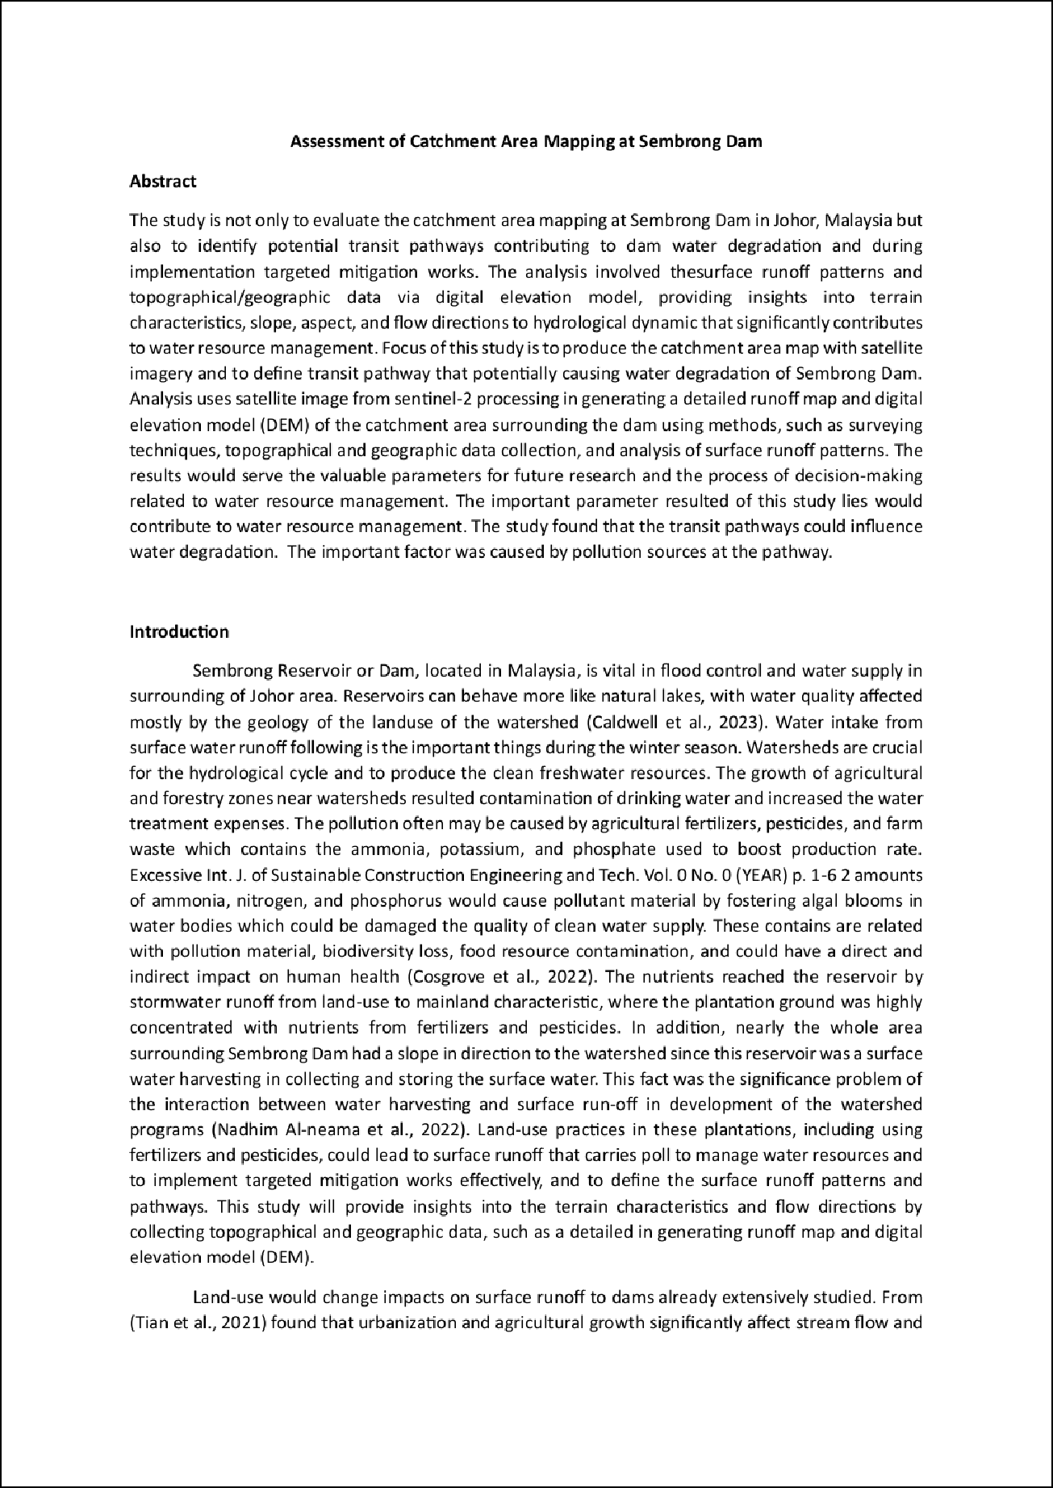





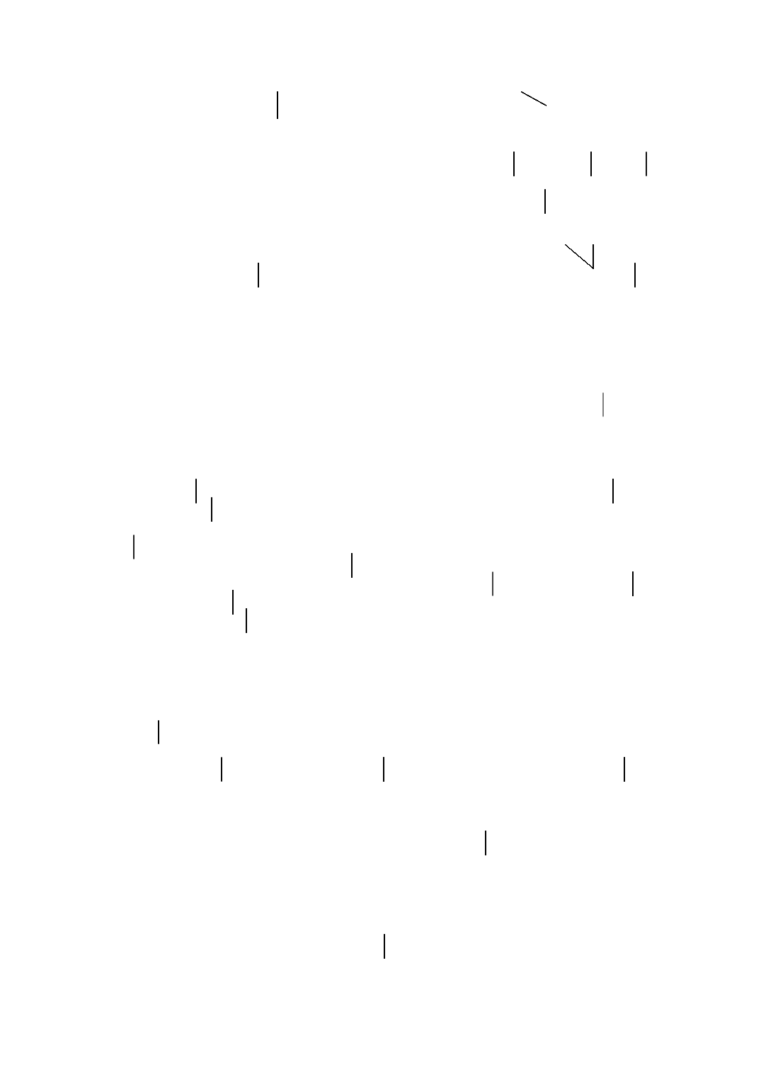

Sp.

Sp. Article Error Article Error

Article Error

Article Error

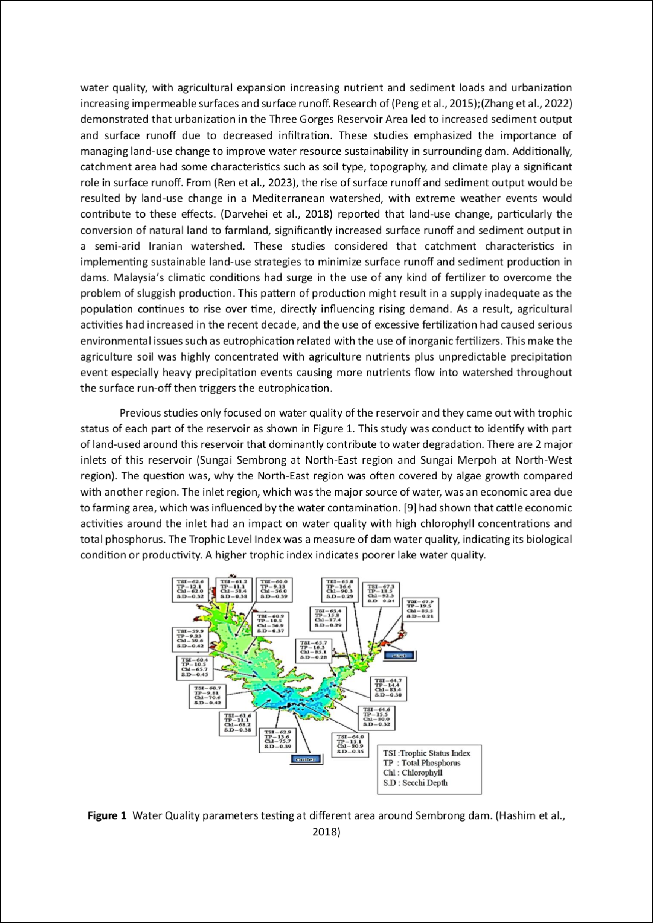

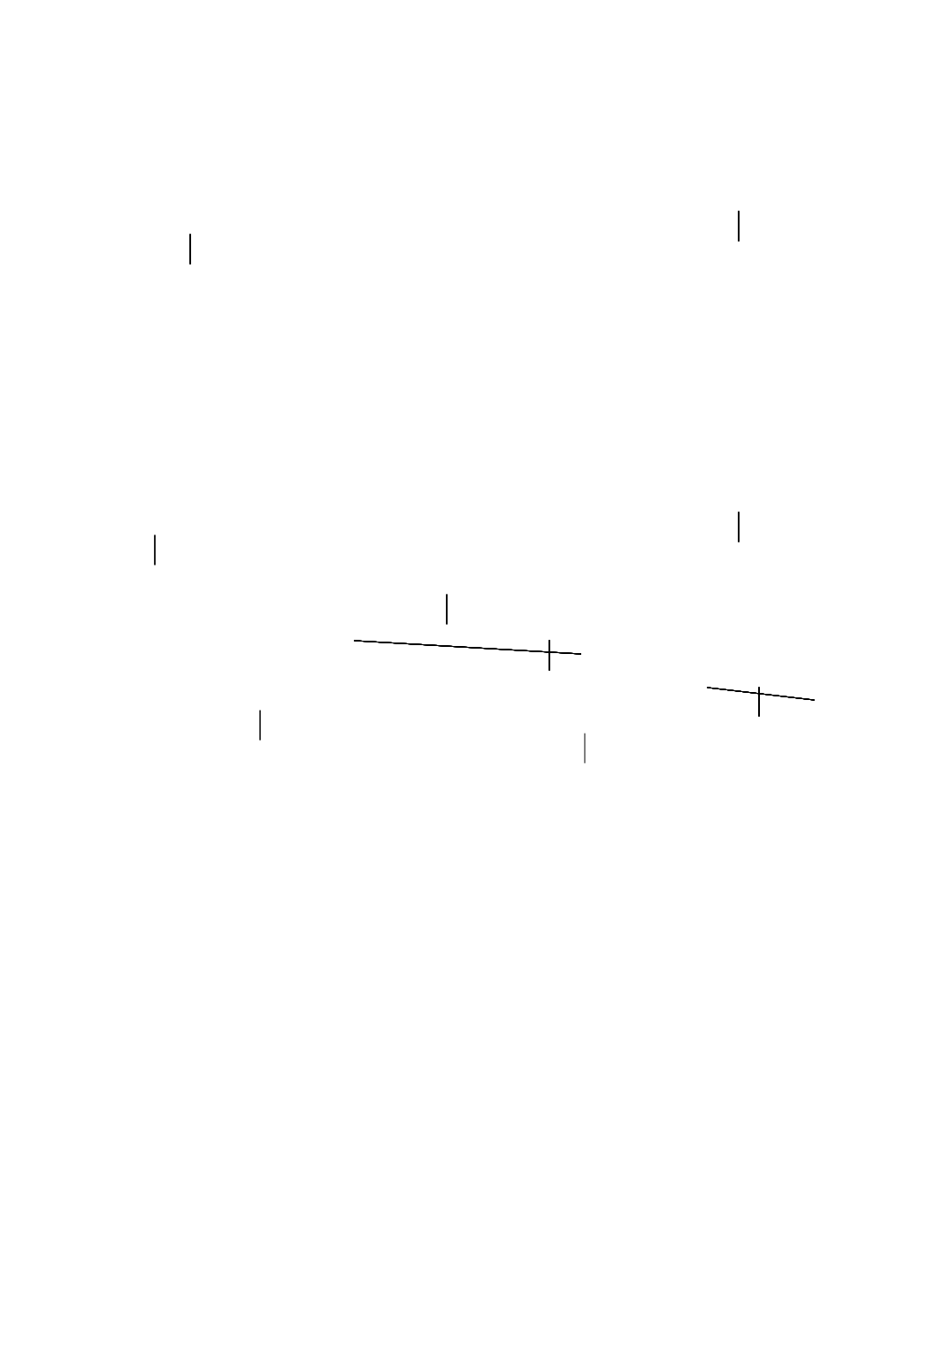

Article Error
Article Error

Article Error
Missing ","

Article Error

S/V
Proofread
P/V
P/V

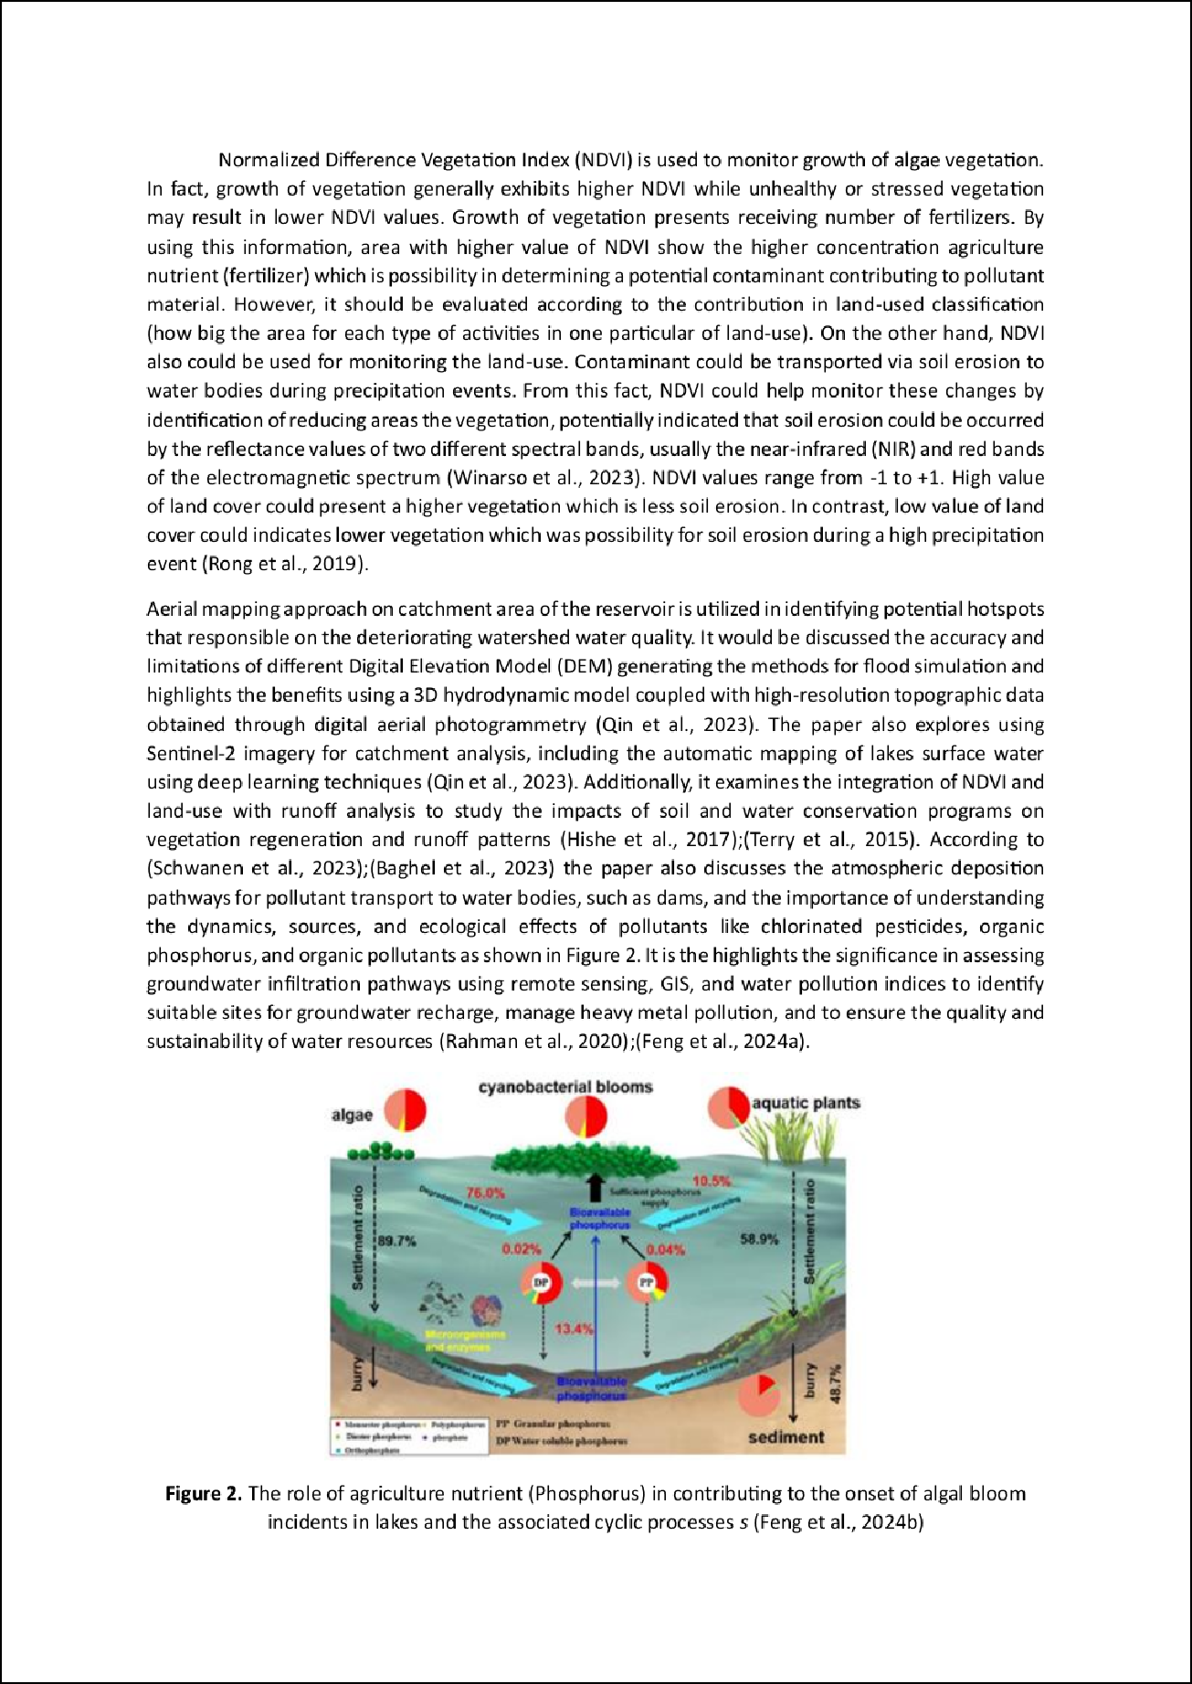

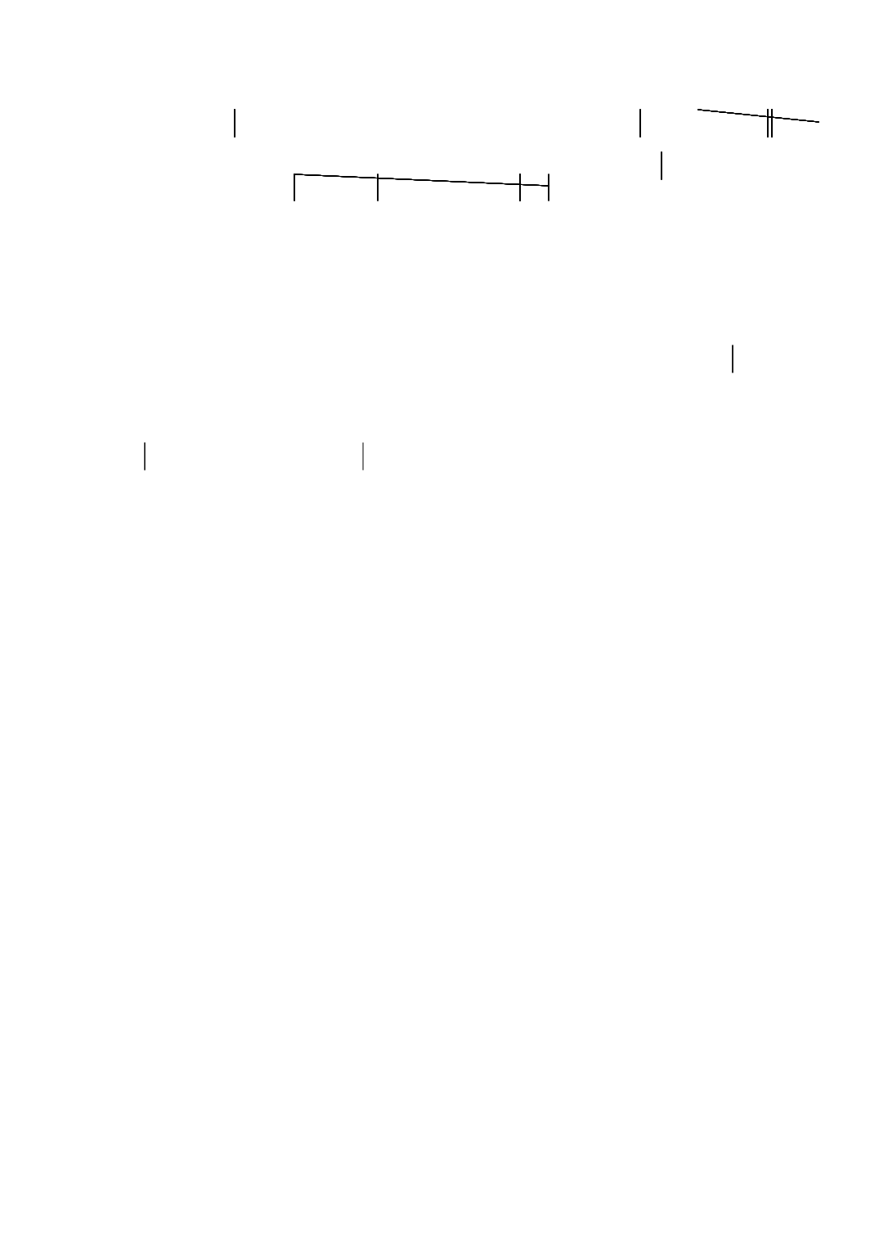

Article Error Article Error PGraorobflreedad

Article Error
Article Error Article Error S/V Article Error

Article Error

Article Error Article Error

Article Error
Article Error
S/V
S/V
Article Error Article Error

Missing ","

Sp.

2 P/V

Article Error

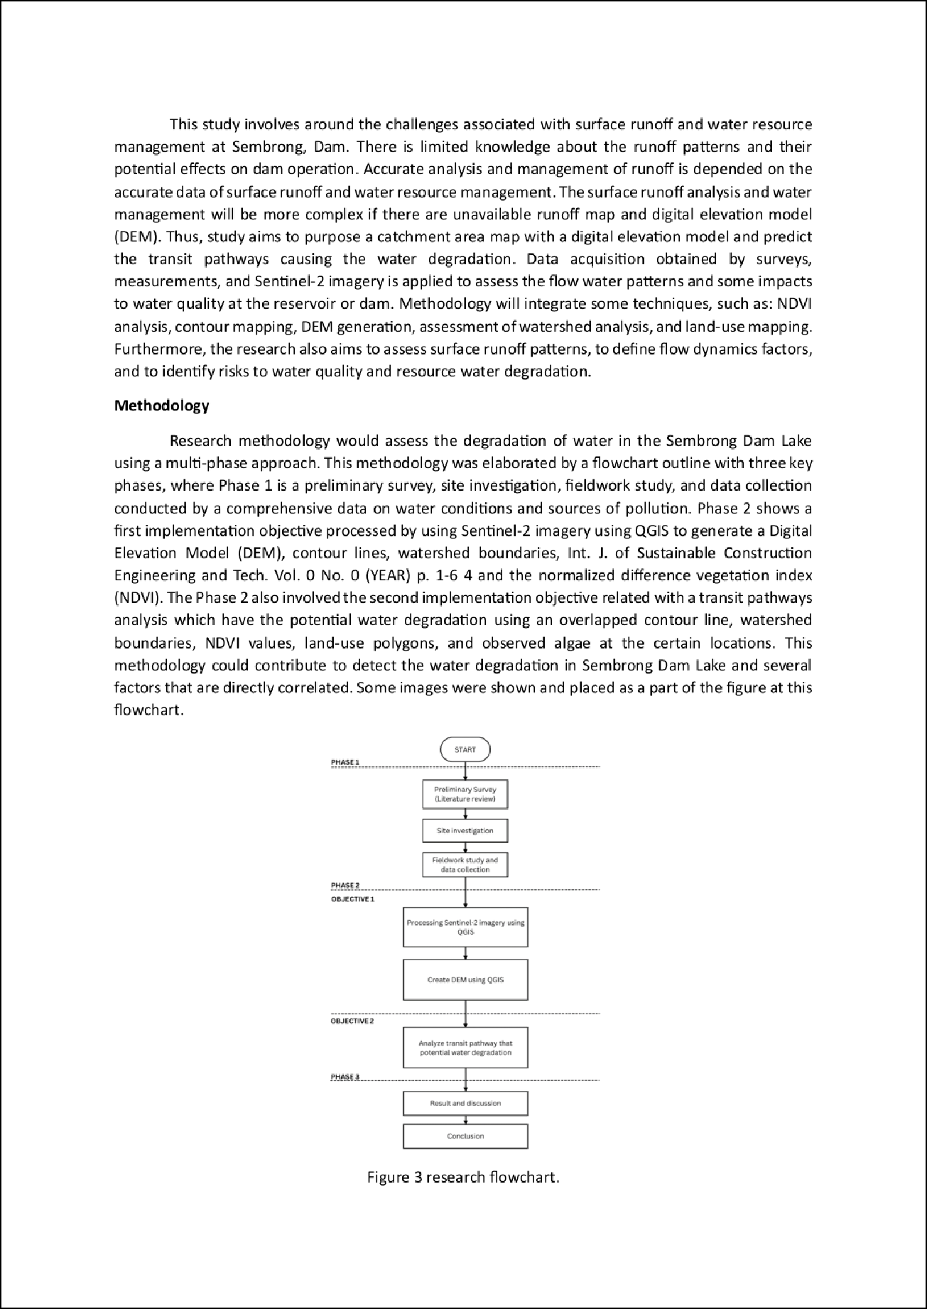

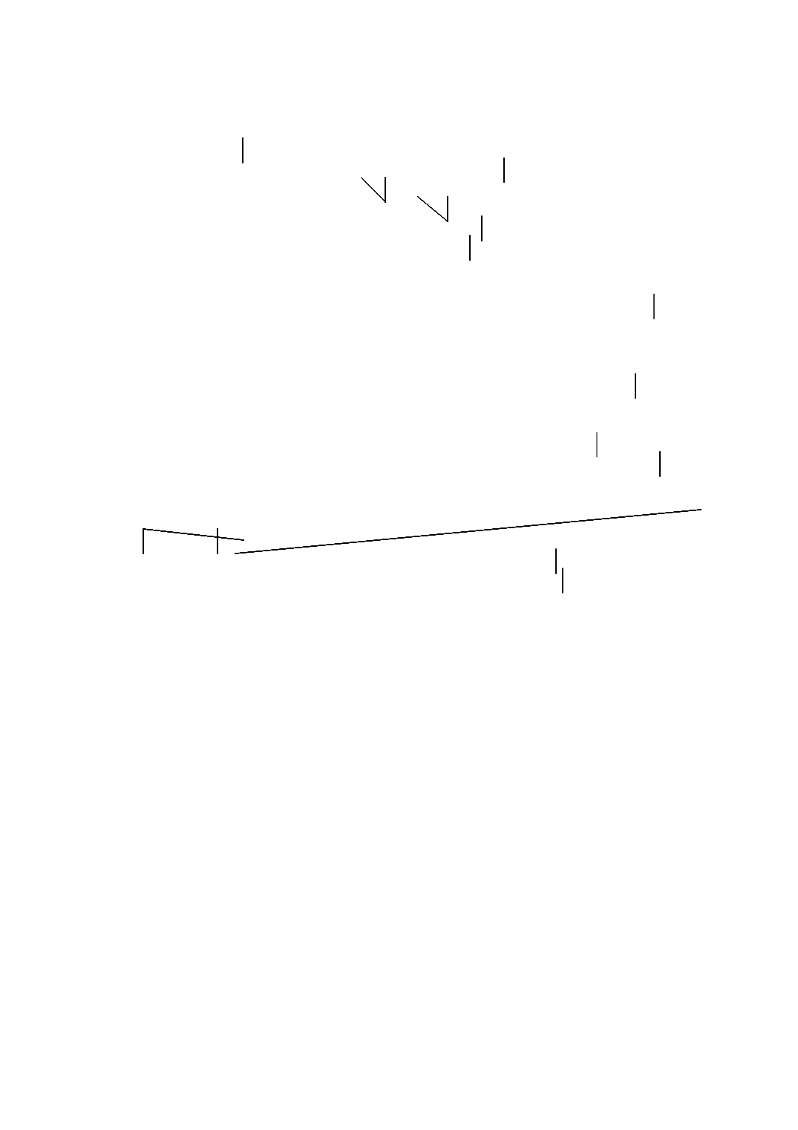
Proofread S/V

Article Error Sp.

Article Error Sp.

Sp.
Sp. Sp. Sp.

Sp.

Sp. Sp. Proper NSopu.ns Article Error

P/V

Article Error

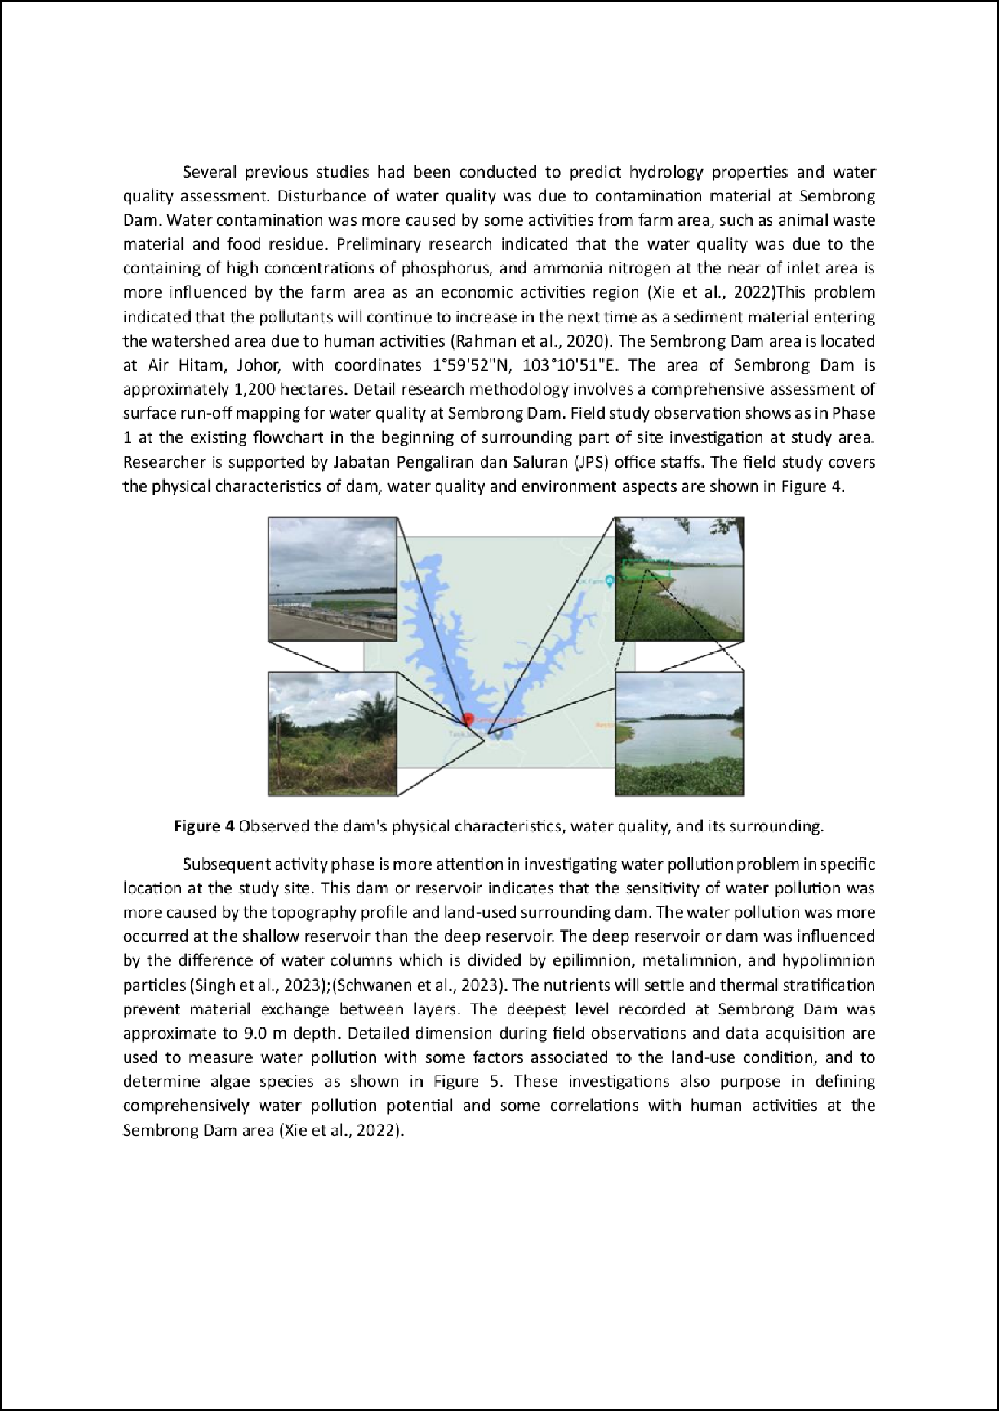

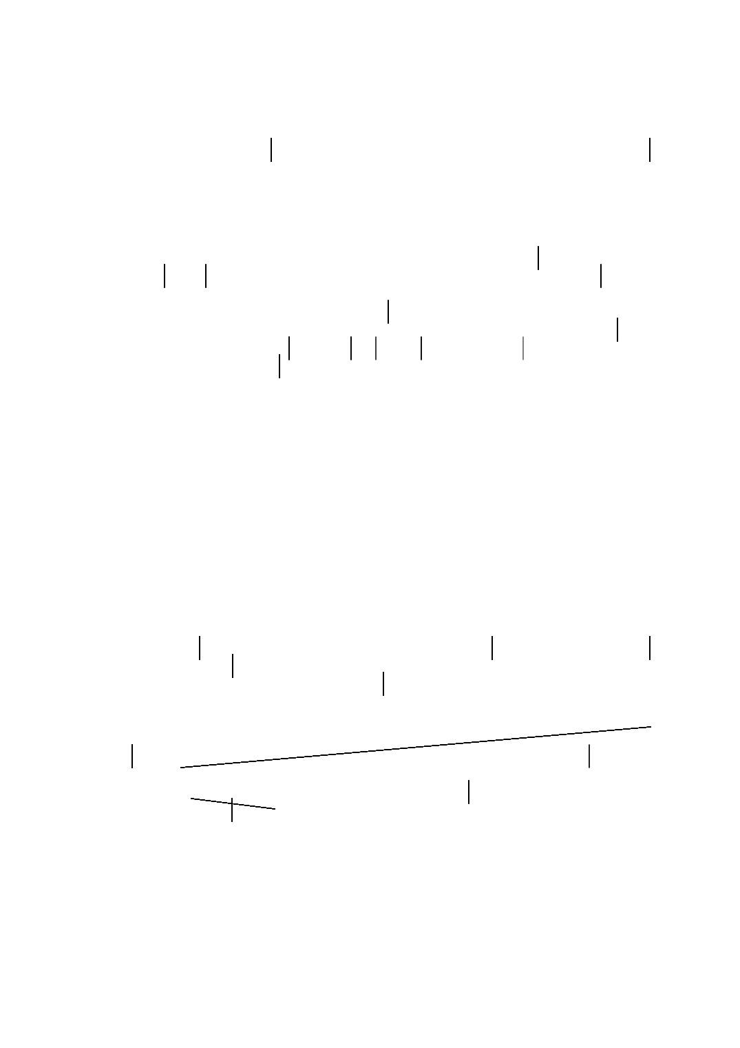

Article Error Article Error Article Error Garbled Article Error

S/V Sp.

Prep.
Proofread

Prep.

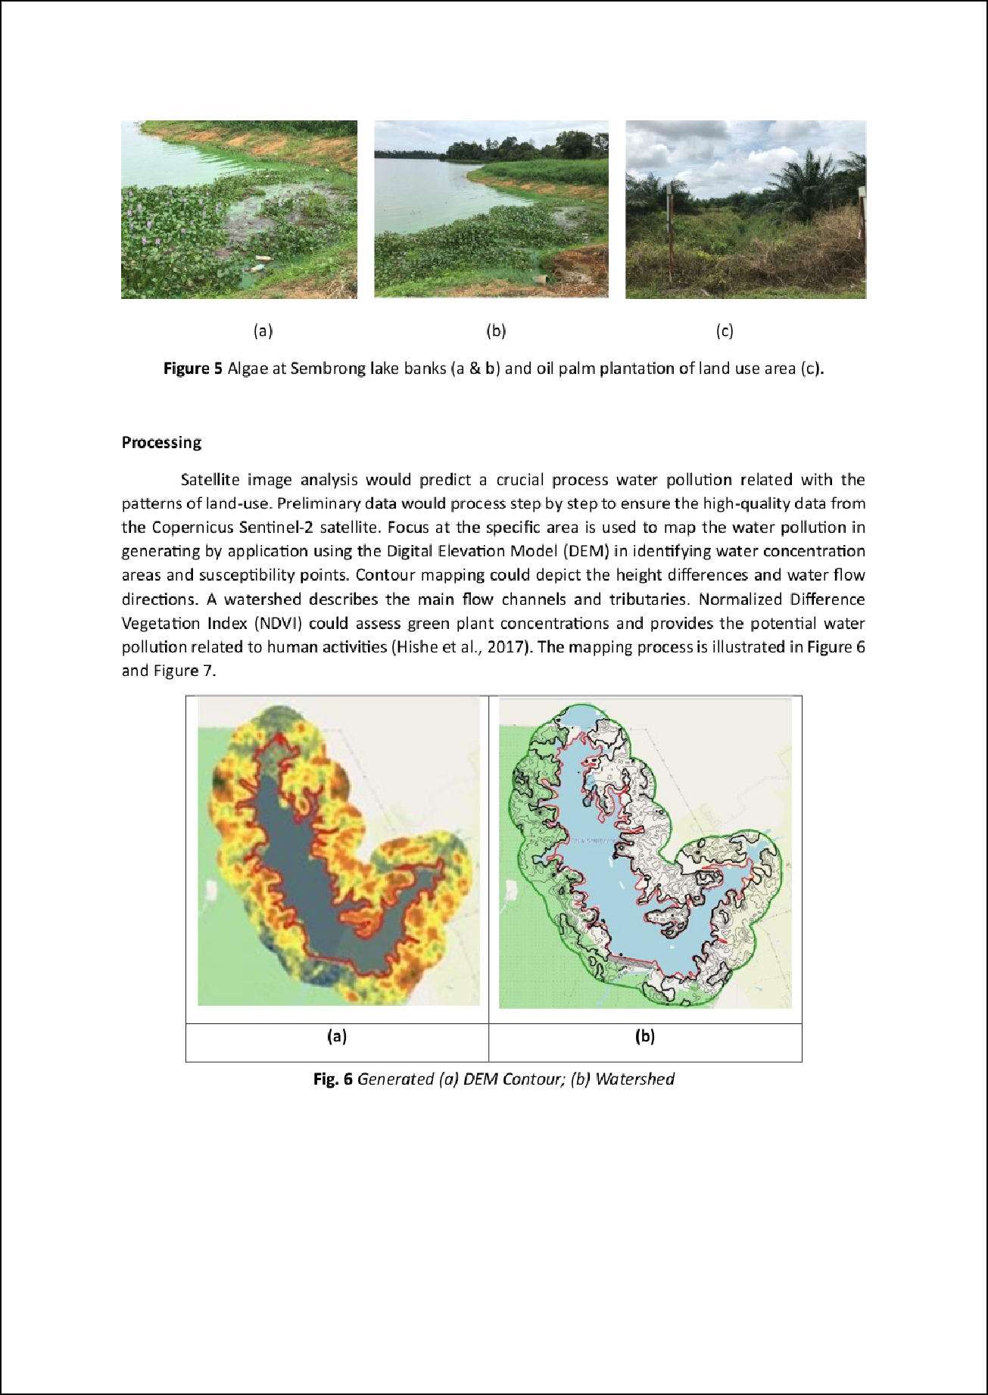


P/V
Prep.
Article Error

Sp.
P/V

Article Error Article Error

ticle Error
Ar
Sp. Proofread
Sp.
Missing "PM,"riossoifnrgea"d,"

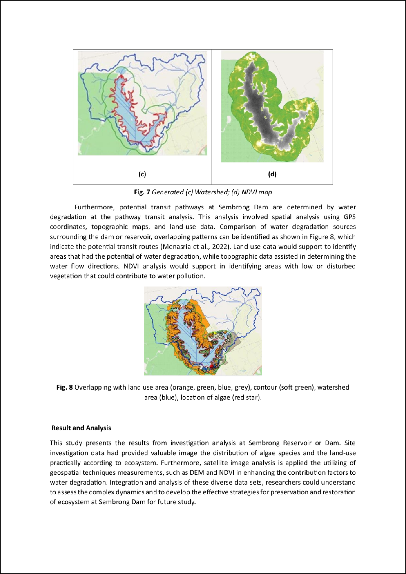
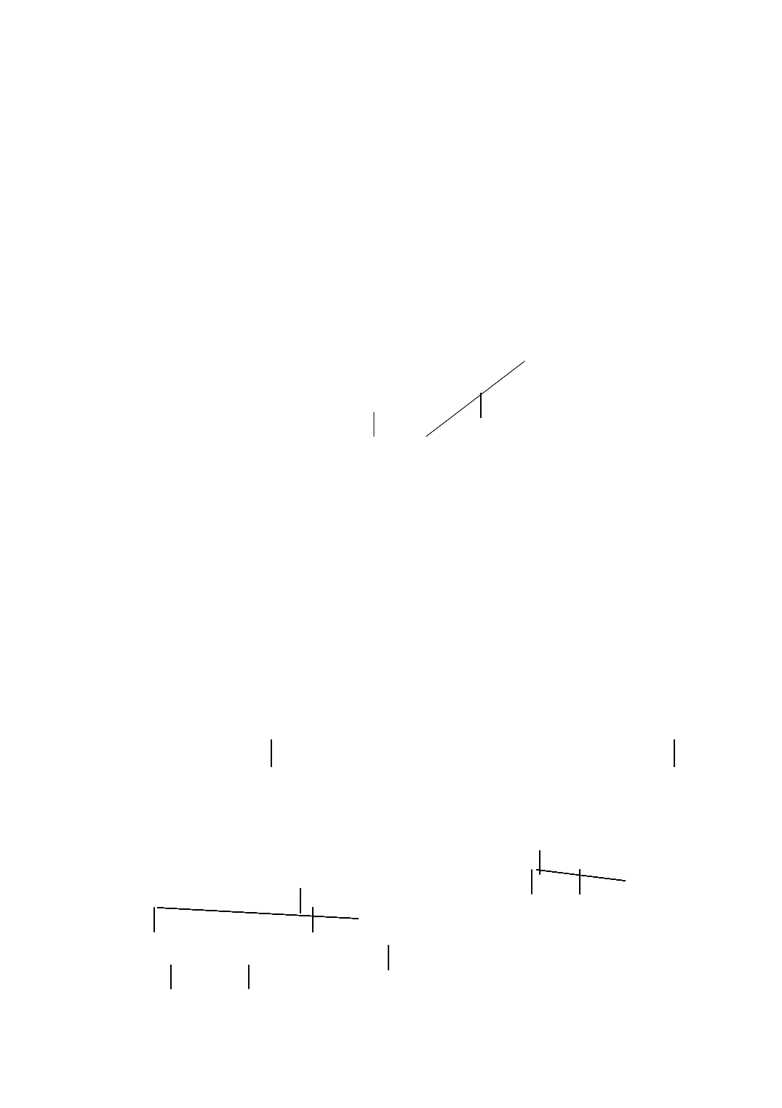
Article Error
Article Error Sp.

Article Error

Article Error

Article Error
Confused

Article Error

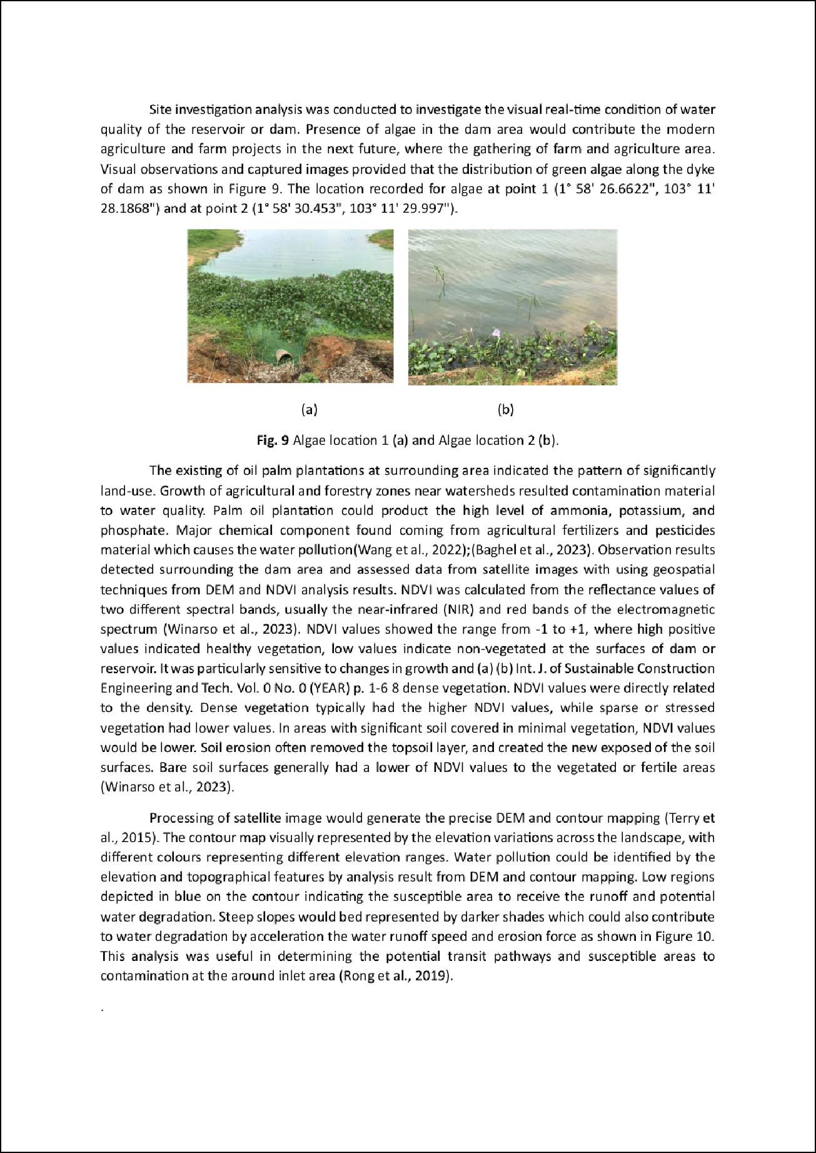
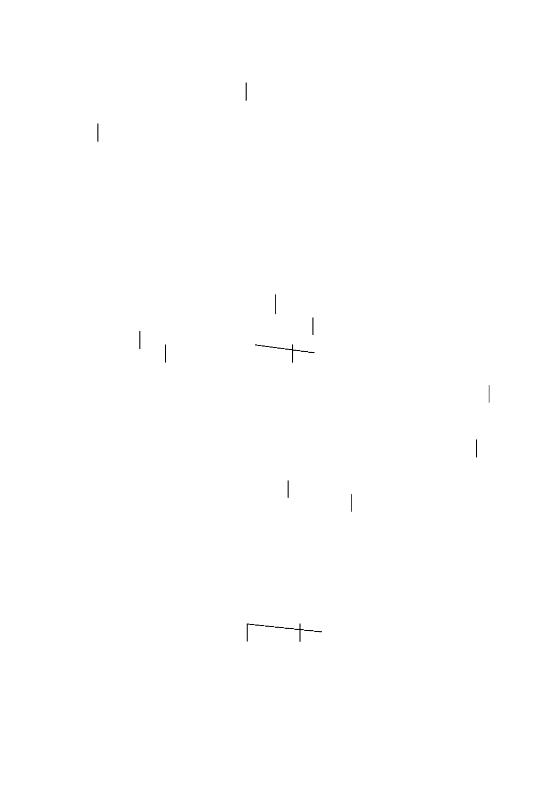
Article Error Verb

Sp.

1
Article Error

Article Error

Prep.

Article Error Verb

Article Error

Article Error

Article Error Sp.

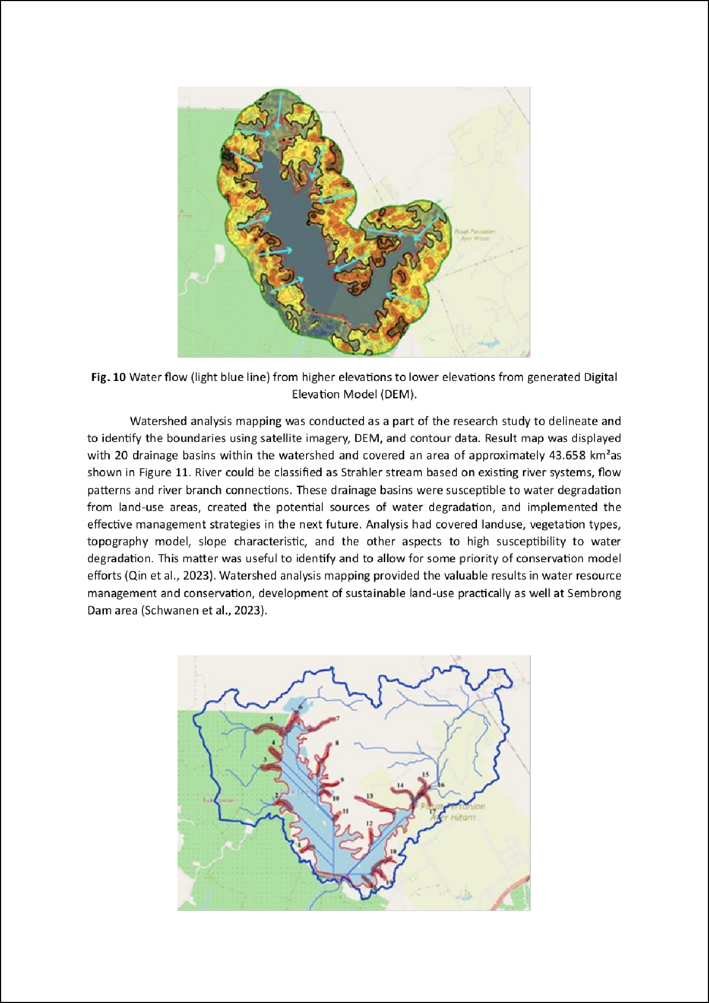
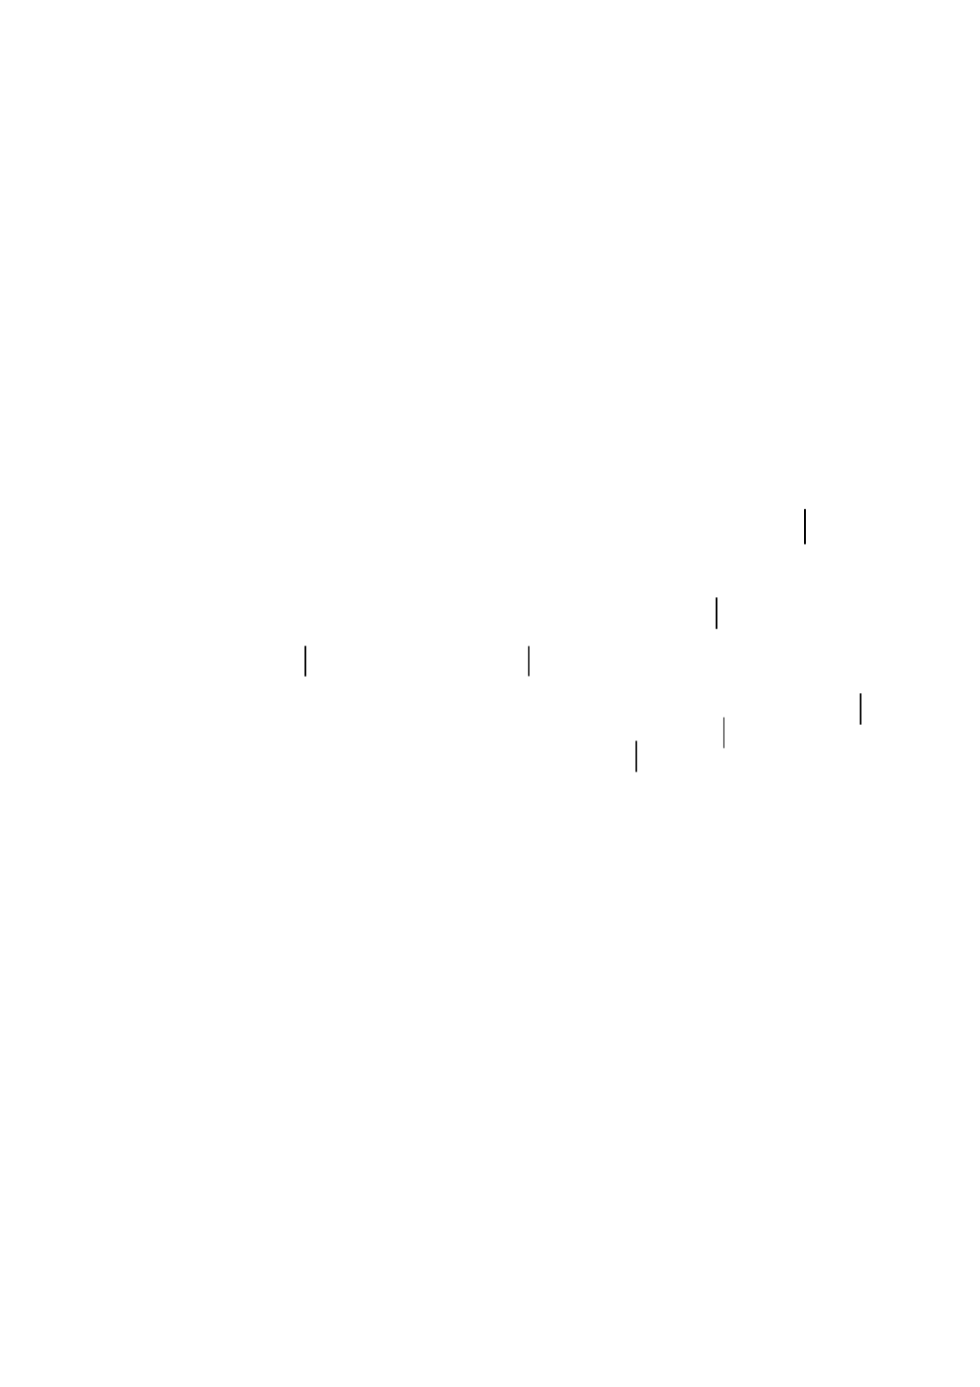

Prep.

Sp.
Article Error

Article Error

Article Error

Sp. 1
S/V Article Error
P/V

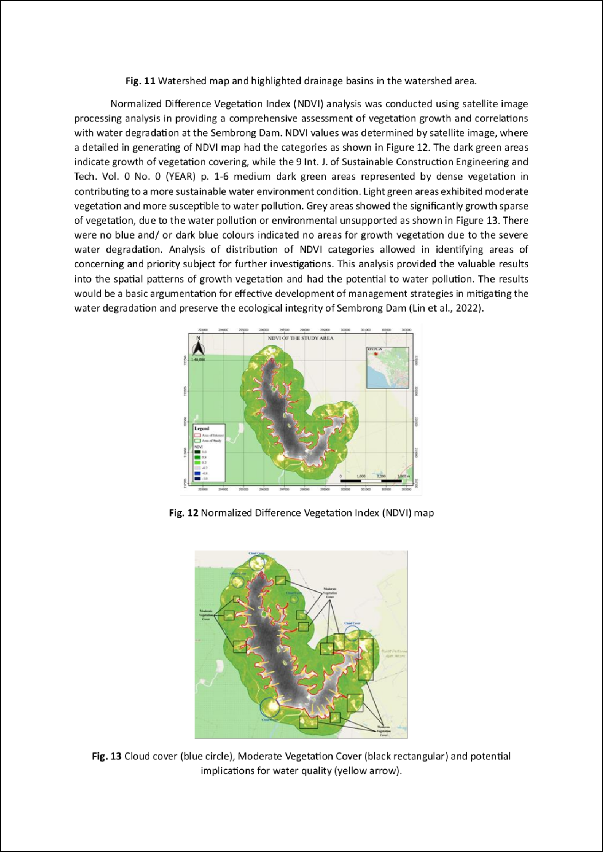


Article Error

3

Sp. Article Error
Article Error
Proofread
Proofread

P/V Proofread

Sp.

Proofread

Prep.
Proofread

Article Error

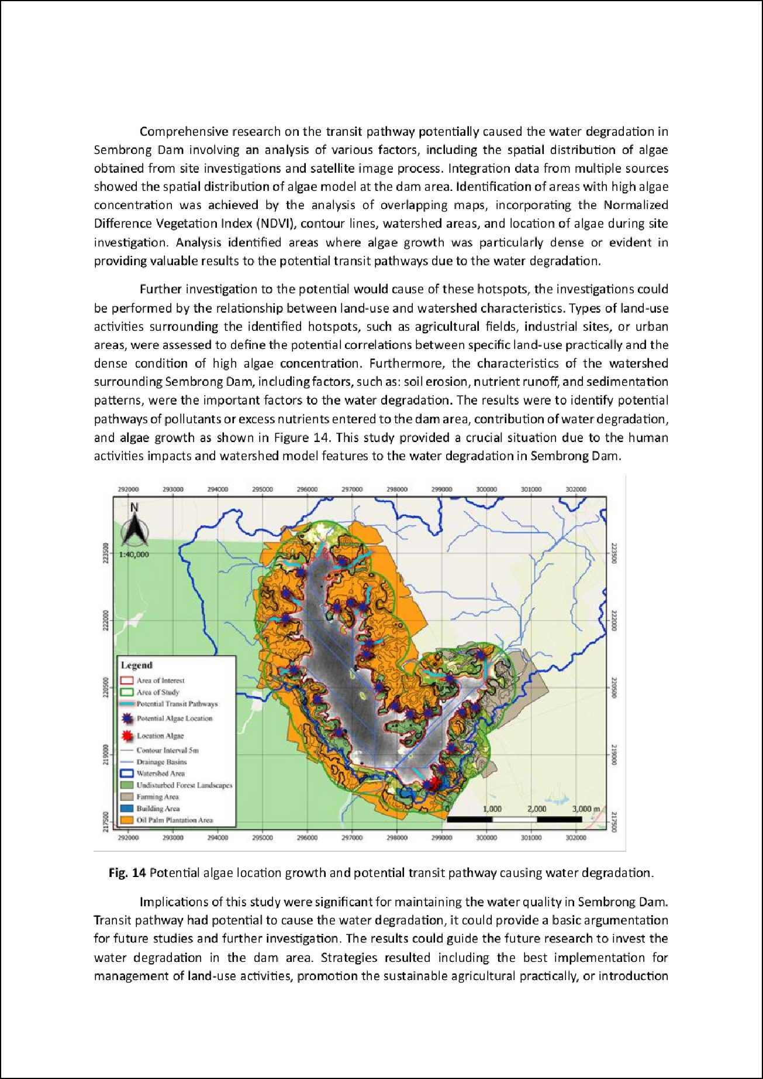
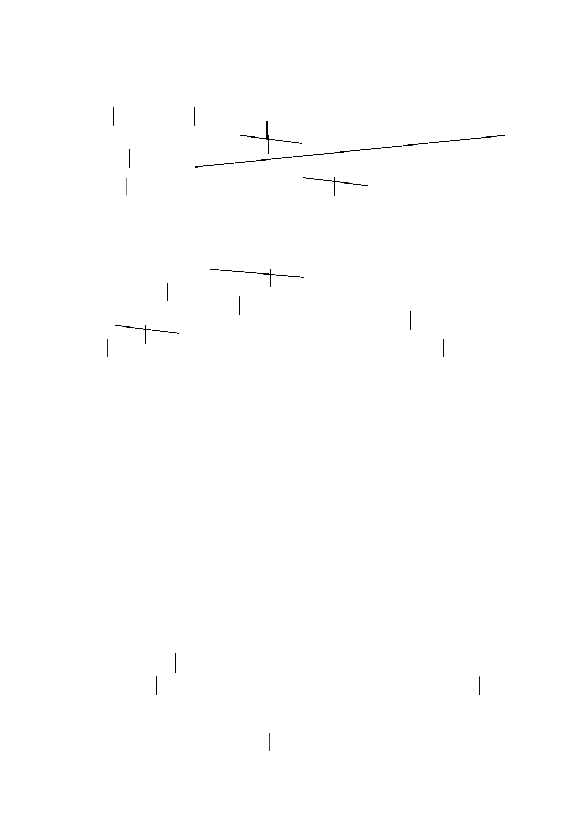
Missing "," Sp.

Possessive

Article Error Sp.

Missing ","

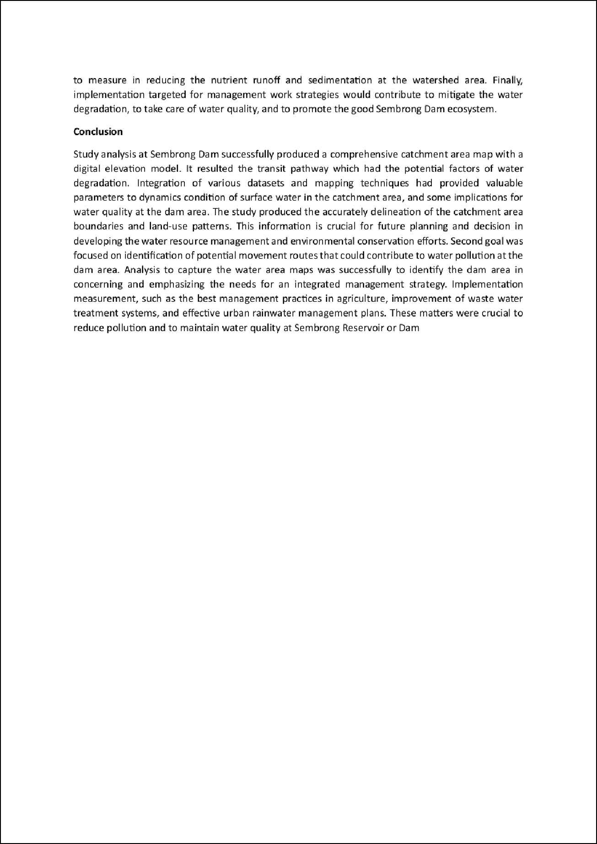
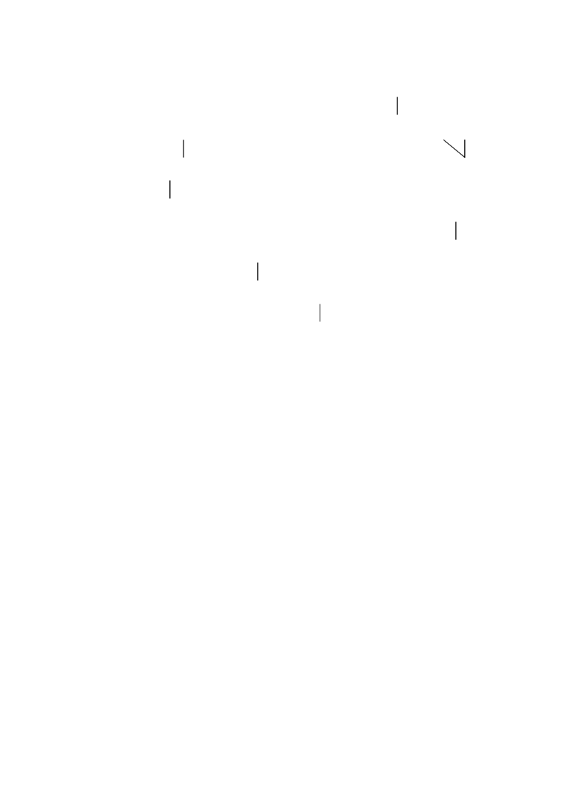

Sp.

Sp. S/V

Article Error

Article Error

Prep.

Sp.

Assessment of Catchment Area Mapping at Sembrong Dam
2

ORIGINALITY REPORT

%

SIMILARITY INDEX
0%

INTERNET SOURCES
0%

PUBLICATIONS
2%

STUDENT PAPERS

PRIMARY SOURCES

Submitted to Universiti Teknologi Malaysia
1
Student Paper

2 Submitted to SSN COLLEGE OF ENGINEERING, Kalavakkam
Student Paper

3 Neha Kureel, Jyoti Sarup, Shafique Matin, Suresh Goswami, Kapil Kureel. "Modelling vegetation health and stress using hypersepctral remote sensing data", Modeling Earth Systems and Environment, 2021
Publication
1%
<1%

<1%

Exclude quotes Off Exclude bibliography Off
Exclude matches Off

Assessment of Catchment Area Mapping at Sembrong Dam

PAGE 1

Article Error You may need to use an article before this word.

Sp. This word is misspelled. Use a dictionary or spellchecker when you proofread your work.

Sp. This word is misspelled. Use a dictionary or spellchecker when you proofread your work.

Sp. This word is misspelled. Use a dictionary or spellchecker when you proofread your work.

Missing "," Review the rules for using punctuation marks.

Sp. This word is misspelled. Use a dictionary or spellchecker when you proofread your work.

S/V This subject and verb may not agree. Proofread the sentence to make sure the subject agrees with the verb.

Article Error You may need to use an article before this word.

Sp. This word is misspelled. Use a dictionary or spellchecker when you proofread your work.

P/V You have used the passive voice in this sentence. You may want to revise it using the active voice.

Sp. This word is misspelled. Use a dictionary or spellchecker when you proofread your work.

Article Error You may need to use an article before this word.

Sp. This word is misspelled. Use a dictionary or spellchecker when you proofread your work.

Missing "," Review the rules for using punctuation marks.

Article Error You may need to remove this article.

Missing "," Review the rules for using punctuation marks.

Article Error You may need to remove this article. Article Error You may need to remove this article. Article Error You may need to remove this article.
Sp. This word is misspelled. Use a dictionary or spellchecker when you proofread your work.

Sp. This word is misspelled. Use a dictionary or spellchecker when you proofread your work.

Article Error You may need to use an article before this word.

Article Error You may need to remove this article.

Article Error You may need to use an article before this word.

Article Error You may need to use an article before this word. Consider using the article
the.

PAGE 2

Article Error You may need to use an article before this word. Article Error You may need to use an article before this word. Article Error You may need to use an article before this word. Missing "," Review the rules for using punctuation marks.
Article Error You may need to use an article before this word. Consider using the article
the.

S/V This subject and verb may not agree. Proofread the sentence to make sure the subject agrees with the verb.

Proofread This part of the sentence contains an error or misspelling that makes your meaning unclear.

P/V You have used the passive voice in this sentence. You may want to revise it using the active voice.

P/V You have used the passive voice in this sentence. You may want to revise it using the active voice.

PAGE 3

PAGE 4

Article Error You may need to use an article before this word. Consider using the article
the.

Article Error You may need to use an article before this word. Consider using the article
the.

Proofread This part of the sentence contains an error or misspelling that makes your meaning unclear.

Garbled This sentence contains several grammatical or spelling errors that make your meaning unclear. Proofread the sentence to identify and fix the mistakes.

Article Error You may need to use an article before this word. Article Error You may need to use an article before this word. Article Error You may need to use an article before this word.
S/V This subject and verb may not agree. Proofread the sentence to make sure the subject agrees with the verb.

Article Error You may need to remove this article.

Article Error You may need to use an article before this word. Article Error You may need to use an article before this word. Article Error You may need to use an article before this word.

Article Error You may need to use an article before this word.

Article Error You may need to remove this article.

S/V This subject and verb may not agree. Proofread the sentence to make sure the subject agrees with the verb.

S/V This subject and verb may not agree. Proofread the sentence to make sure the subject agrees with the verb.

Article Error You may need to use an article before this word.

Article Error You may need to remove this article.

Missing "," Review the rules for using punctuation marks.

Sp. This word is misspelled. Use a dictionary or spellchecker when you proofread your work.

P/V You have used the passive voice in this sentence. You may want to revise it using the active voice.

Article Error You may need to remove this article.

Proofread This part of the sentence contains an error or misspelling that makes your meaning unclear.

S/V This subject and verb may not agree. Proofread the sentence to make sure the subject agrees with the verb.

Article Error You may need to remove this article.

Sp. This word is misspelled. Use a dictionary or spellchecker when you proofread your work.

PAGE 5

Article Error You may need to use an article before this word.

Sp. This word is misspelled. Use a dictionary or spellchecker when you proofread your work.

Sp. This word is misspelled. Use a dictionary or spellchecker when you proofread your work.

Sp. This word is misspelled. Use a dictionary or spellchecker when you proofread your work.

Sp. This word is misspelled. Use a dictionary or spellchecker when you proofread your work.

Sp. This word is misspelled. Use a dictionary or spellchecker when you proofread your work.

Sp. This word is misspelled. Use a dictionary or spellchecker when you proofread your work.

Article Error You may need to use an article before this word. Consider using the article
the.

Sp. This word is misspelled. Use a dictionary or spellchecker when you proofread your work.

Sp. This word is misspelled. Use a dictionary or spellchecker when you proofread your work.

Proper Nouns You may need to use a capital letter for this proper noun.

Sp. This word is misspelled. Use a dictionary or spellchecker when you proofread your work.

P/V You have used the passive voice in this sentence. You may want to revise it using the active voice.

Article Error You may need to use an article before this word. Article Error You may need to use an article before this word. Article Error You may need to use an article before this word. Article Error You may need to use an article before this word.
Garbled This sentence contains several grammatical or spelling errors that make your meaning unclear. Proofread the sentence to identify and fix the mistakes.

Article Error You may need to use an article before this word.

S/V This subject and verb may not agree. Proofread the sentence to make sure the subject agrees with the verb.

Sp. This word is misspelled. Use a dictionary or spellchecker when you proofread your work.

Prep. You may be using the wrong preposition.

Proofread This part of the sentence contains an error or misspelling that makes your meaning unclear.

PAGE 6

Prep. You may be using the wrong preposition. Prep. You may be using the wrong preposition. Article Error You may need to remove this article.
P/V You have used the passive voice in this sentence. You may want to revise it using the active voice.

PAGE 7

Sp. This word is misspelled. Use a dictionary or spellchecker when you proofread your work.

P/V You have used the passive voice in this sentence. You may want to revise it using the active voice.

Article Error You may need to use an article before this word. Consider using the article
a.

Article Error You may need to use an article before this word. Consider using the article
a.

Sp. This word is misspelled. Use a dictionary or spellchecker when you proofread your work.

Missing "," Review the rules for using punctuation marks.

Proofread This part of the sentence contains an error or misspelling that makes your meaning unclear.

Missing "," Review the rules for using punctuation marks.

Article Error You may need to use an article before this word.

Sp. This word is misspelled. Use a dictionary or spellchecker when you proofread your work.

Proofread This part of the sentence contains an error or misspelling that makes your meaning unclear.

Article Error You may need to remove this article.

Article Error You may need to use an article before this word.

Sp. This word is misspelled. Use a dictionary or spellchecker when you proofread your work.

PAGE 8

Article Error You may need to use an article before this word. Consider using the article
the.

Article Error You may need to use an article before this word. Consider using the article
the.

Confused You have used either an imprecise word or an incorrect word.

Article Error You may need to use an article before this word. Consider using the article
the.

Article Error You may need to use an article before this word.

Article Error You may need to use an article before this word.

Verb This verb may be incorrect. Proofread the sentence to make sure you have used the correct form of the verb.

Sp. This word is misspelled. Use a dictionary or spellchecker when you proofread your work.

Article Error You may need to use an article before this word.

Article Error You may need to remove this article.

Prep. You may be using the wrong preposition.

Article Error You may need to use an article before this word.

Verb This verb may be incorrect. Proofread the sentence to make sure you have used the correct form of the verb.

PAGE 9

PAGE 10

Article Error You may need to use an article before this word.

Article Error You may need to use an article before this word. Consider using the article
a.

Article Error You may need to use an article before this word.

Sp. This word is misspelled. Use a dictionary or spellchecker when you proofread your work.

Article Error You may need to remove this article.

Sp. This word is misspelled. Use a dictionary or spellchecker when you proofread your work.

Prep. You may be using the wrong preposition.

Article Error You may need to use an article before this word.

Article Error You may need to use an article before this word. Consider using the article
the.

Sp. This word is misspelled. Use a dictionary or spellchecker when you proofread your work.

S/V This subject and verb may not agree. Proofread the sentence to make sure the subject agrees with the verb.

Article Error You may need to use an article before this word.

P/V You have used the passive voice in this sentence. You may want to revise it using the active voice.

PAGE 11

Article Error You may need to remove this article.

Sp. This word is misspelled. Use a dictionary or spellchecker when you proofread your work.

Article Error You may need to remove this article.

Article Error You may need to use an article before this word.

Proofread This part of the sentence contains an error or misspelling that makes your meaning unclear.

Proofread This part of the sentence contains an error or misspelling that makes your meaning unclear.

P/V You have used the passive voice in this sentence. You may want to revise it using the active voice.

Proofread This part of the sentence contains an error or misspelling that makes your meaning unclear.

Proofread This part of the sentence contains an error or misspelling that makes your meaning unclear.

Sp. This word is misspelled. Use a dictionary or spellchecker when you proofread your work.

Prep. You may be using the wrong preposition.

Article Error You may need to use an article before this word.

Proofread This part of the sentence contains an error or misspelling that makes your meaning unclear.

Missing "," Review the rules for using punctuation marks.

Sp. This word is misspelled. Use a dictionary or spellchecker when you proofread your work.

Possessive Review the rules for possessive nouns.

PAGE 12

Article Error You may need to use an article before this word. Consider using the article
the.

Sp. This word is misspelled. Use a dictionary or spellchecker when you proofread your work.

Missing "," Review the rules for using punctuation marks.

Sp. This word is misspelled. Use a dictionary or spellchecker when you proofread your work.

Sp. This word is misspelled. Use a dictionary or spellchecker when you proofread your work.

S/V This subject and verb may not agree. Proofread the sentence to make sure the subject agrees with the verb.

Article Error You may need to use an article before this word.

Article Error You may need to use an article before this word. Consider using the article
the.

Prep. You may be using the wrong preposition.

Sp. This word is misspelled. Use a dictionary or spellchecker when you proofread your work.

