Figure and Table
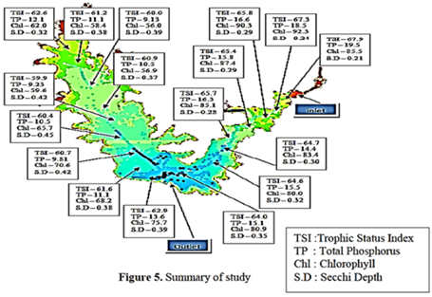

Figure 1 Water Quality parameters testing at different area around Sembrong dam. [12]

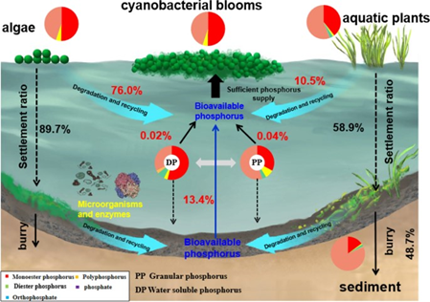

Figure 2 The role of agriculture nutrient (Phosphorus) in contributing to the onset of algal bloom incidents in lakes and the associated cyclic processes [23].

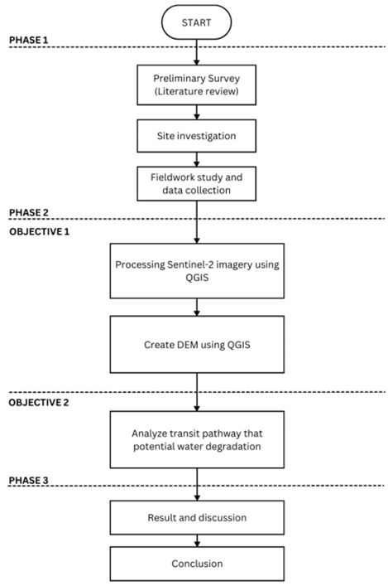

Figure 3 research flowchart.

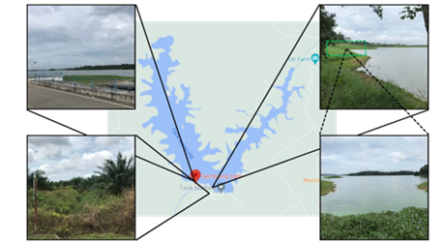

Figure 4 Observed the dam's physical characteristics, water quality, and surrounding environment.

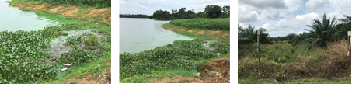
(a) (b) (c)

Figure 5 Algae at Sembrong lake banks (a & b) and oil palm plantation of land use area (c).

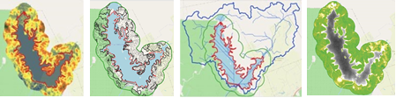
(a) (b) (c) (d)

Figure 6 Generated DEM (a), Contour (b), Watershed (c) and NDVI (d) mapping.

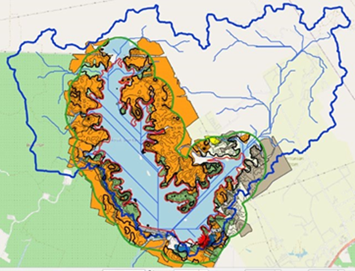

Figure 7 Overlapping with land use area (orange, green, blue, grey), contour (soft green), watershed area (blue), location of algae (red star).

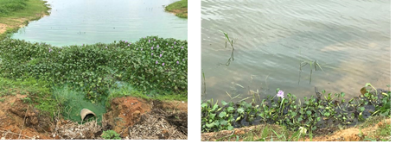
(b) (c)
Figure 8 Algae location 1 (a) and Algae location 2 (b).

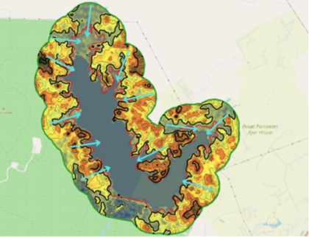

Figure 9 Water flow (light blue line) from higher elevations to lower elevations from generated Digital Elevation Model (DEM).

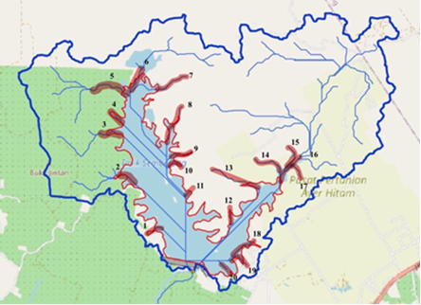

Figure 10 Watershed map and highlighted drainage basins in the watershed area.

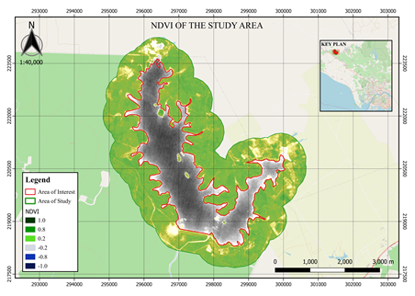

Figure 11 Normalized Difference Vegetation Index (NDVI) map.

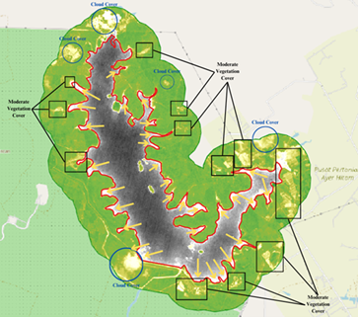

Figure 12 Cloud cover (blue circle), Moderate Vegetation Cover (black rectangular) and potential implications for water quality (yellow arrow).

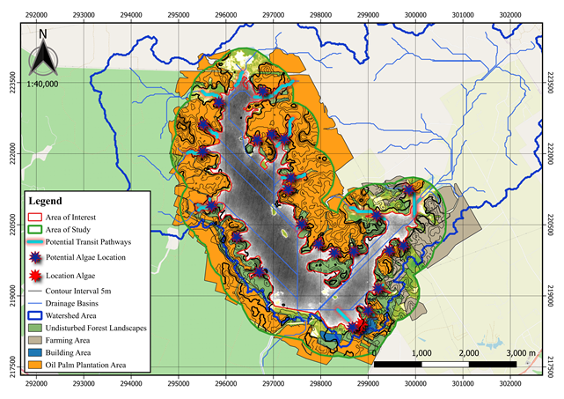

Figure 13 Potential algae location growth and potential transit pathway causing water degradation.

