An intelligent Approach for detection and classification of security attacks in Passive optical Network using Light Gradient Booting Machine | 

Sumayya bibi¹, Nadiatulhuda Zulkifli^{1*,} Sajid Iqbal ², Arnidza Ramli¹, Adam Wong Yoon Khang³
¹Universiti Teknologi Malaysia, 81310 UTM, Johor, Malaysia
²King Faisal University, Saudi Arabia
³Universiti Teknikal Melaka, Malaysia
Abstract  In the past decade, passive optical networks (PONs) have gained prominence as a leading option for next-generation broadband access. Concurrently, machine learning (ML), particularly deep learning, has become a pivotal technology for addressing complex classification and prediction challenges. Generally, major security threats in the network due to malicious ONUs are interception and eavesdropping on data, service disruption through degradation of service (DoS) attacks, impersonation and spoofing, excessive traffic causing network congestion and resource exhaustion, compromising encryption and authentication, and physical layer disruptions. ML has been promoted as a comprehensive solution for intelligently managing network operations and resources to meet demands in PON’s security. However, similar to its other networks, ML can be used in PON to address specific security issues, and several challenges must be overcome to advance machine learning models from research to production. Utilizing the validated efficiency of the Light Gradient Boosting Machine (LightGBM) for managing datasets of high dimensionality along with uneven, we have been effectively developed and optimized a LGBM model to evaluate three performance metrics; accuracy, precision and Matthews confusion matrices (MCC). The dataset exhibits unique distinguishing features. The detection of malicious ONUs revealed that the LGBM and NB algorithms achieved impressive accuracies of 95.27% and 88.53%, respectively.  This is an open access article under the CC BY-SA license   | Keywords:  LightGBM;  Naïve Bayes,  Machine Learning;  Classification;  Attack detection system;  Article History:  Received:  Accepted:  Published:  Corresponding Author:  Nadiatulhuda Zulkifli  Universiti Technologi Malaysia, 81310 UTM, Johor, Malayis  Email: nadiatuhuda@utm.my

INTRODUCTION
Passive Optical Networks (PONs) have emerged as a premier approach for alleviating access congestion challenges in recent years. Their capability to deliver higher transmission speeds, guaranteed consistent quality of service (QoS), and cost effectiveness has solidified their position as the leading fiber-access network option [1-6]. It functions through tree topology. that connects one point to multiple endpoints providing user access. In a standard time-division multiplexing (TDM) PON configuration, an optical fiber is passively branched by an optical power splitter, allowing a single fiber routed traffic exchange in the connection linking the optical line terminal (OLT) and the optical network units (ONUs) [7]. Typically, the communication channels connecting these two elements utilize distinct wavelengths, specifically 1310 nm and 1490 nm are used for transmissions in the upstream direction.
Due to the inherently passive design of the PON network, it offers a high level of security, creating substantial difficulties for any potential attackers attempting to intercept the optical signal [5]. For example, Gigabit PON (GPON) incorporates security measures like data encryption, identity authentication, and key management, along with other functionalities. However, recent studies have shown that attackers have devised multiple techniques, including splitting and bending attacks, to illicitly access a PON network [8]. This setup can potentially be exploited by malicious entities aiming to disrupt the standard operations related to the ONU within the medium access control (MAC) layer. In these scenarios, rogue ONUs might intercept sensitive information intended for other ONUs, which could result in stealing information.
Every ONU is required to comply and function in accordance with the dynamic bandwidth algorithm (DBA) agreement, which might lead to network vulnerabilities that potentially undermine the security of the DBA mechanism. Avoiding this is crucial for optimal GPON functionality. During the DBA process, a degradation attack attempts to acquire additional bandwidth at the expense of other ONUs rather than causing a complete disruption of GPON operations. Nevertheless, countering degradation attacks remains a difficult challenge.
Numerous strategies have been suggested in scholarly literature to counter such network threats. For instance, one method to mitigate the IP spoofing and DOS attack involves labelling network packets and tracking their origin at the perimeter routers. Another method is to block out these spoofed packets at the perimeter routers using hop limit or time to live filter as criteria [9].
Given that PON operates within access networks, whereas its DBA operates primarily within the medium access control layer, a denial of service attack directed within the network and transport layers would notably increase traffic frames in both the downstream and upstream links of a PON [10]. Several other potential attacks include IP Spoofing, routing attacks, selective forwarding attacks, session hijacking attacks, port scanning attacks and distributed denial-of-service attacks. Specifically, an ONU under attack will experience a heightened demand for bandwidth in the upstream shared link. The increased bandwidth demand will decrease the bandwidth available to other normal ONUs. A typical dynamic bandwidth allocation (DBA) scheme for managing upstream bandwidth often falls short in addressing this situation.
The high accuracy of predictions when machine learning methods with real traces are employed in NG-EPON for detecting network traffic have been illustrated in [11]. The proposed approach utilizes a single Long short-term memory (LSTM) model at the location of the Optical line terminal (OLT) for forecasting the bandwidth requirements of all ONUs under various network loads. It was demonstrated that applying machine learning algorithms for traffic prediction enhances performance in the context of NG-EPON. This success was mainly attributable to the ability to gather and utilize knowledge effectively. This method demonstrates that high-performing, intelligent communication strategies can significantly enhance or potentially replace traditional network control in the near future.
Additionally, [12] proposed an intelligent approach for classification and prediction within Passive Optical Networks. The authors introduced an advanced classification technique that autonomously and incrementally predicts and categorizes future traffic into various types using LSTM and GRU models.
Similarly, [13] sought to illustrate the detection and classification of events within the PON applications for network traffic monitoring by incorporating Long Short-Term Memory (LSTM) with (a) an ensemble classifier and (b) a neural network respectively. Also, [14] focused on demonstrating fault detection in Passive Optical Networks by applying a Support Vector Machine (SVM) classifier.
Most traditional Dynamic Bandwidth Allocation (DBA) algorithms, with only a few exceptions, lack security awareness and tend to overlook potential network attacks, hence security has become an emerging topic in optical access networks. For example, notable studies on secure bandwidth allocation algorithms such as Drakulic et al. [15] and Fadila et al. [16] do not incorporate machine learning (ML). Rather, security measures, including threat detection and mitigation techniques rely on collision monitoring per ONU. This approach identifies only the ONU with the least collisions as a measure of potential threat and impose penalties accordingly.
In summary, the results from studies relating to machine learning methods applied in PON models have potentials that are outlined as follows:
- Supervised learning techniques are commonly used. While KNN, SVM, and Bayesian algorithms have witnessed increased research attention given their prevalence in many studies, limited studies are available on PON models.
- Most of the supervised learning methods consistently achieve high mean accuracies, exceeding 90% in detection effectiveness across different assessment criteria.
- In PON implementations, the majority of studies have utilized SVM and DT methods.
- Different kinds of datasets have been employed. Certain studies have utilized data from online sources like Kaggle, whereas some have generated datasets through flow generation methods for use with machine learning algorithms.
- No studies have identified the main attributes of flow records in PON (including priority and action attributes) for all types of datasets employed in existing machine learning approaches.
- Precision, recall, and F1-score are the primary frequently employed evaluation metrics for assessing the performance of ML algorithms in most research. Conversely, accuracy and execution time are rarely utilized performance measures.
These studies provide a detailed overview of various security threats to PON, including eavesdropping, DoS attacks, masquerading, and service theft (ToS). Some DoS attacks on PON involve injecting light signals from a remote node (Splitter/Combiner) at the physical layer which can only be countered with physical layer defense mechanisms. However, these attacks are highly focused and specialized, making them very hard to detect. In this research, we examine the effect of a DDoS attack on upstream direction outcomes. Because Upstream bandwidth is controlled in real-time using a DBA approach, this work presents a protected DBA approach designed to mitigate the effects of DDoS attack on PON that complies with the service level agreement (SLA). These are regarded as the key advantages of PON. However, PON can be affected by various types of security attacks, which may degrade network effectiveness in terms of efficiency and optimization. Additionally, PON security attacks arise from the effect and modification of particular attributes such as priority and action. Furthermore, the application of machine learning algorithms in the identification and classification of ONUs have gained increased importance. However, there are no works that address the identification, classification, and mitigation of different types of security attacks using ML algorithms in PONs.
Additionally, using Borderline-SMOTE after data processing is a novel approach that can further refine a model's performance on imbalanced datasets, especially after an initial model has been trained. This method focuses on adjusting and enhancing the model's predictions by generating synthetic samples specifically in regions where the model misclassifies minority class instances.
It is an effective strategy for handling class imbalance, particularly when the initial model has difficulty with minority class instances near the decision boundary. By generating synthetic samples in these critical regions and re-training the model, better classification performance through improved recall and more balanced precision can be achieved, ultimately leading to a more robust and reliable model.
This paper explores the application of Naïve Bayes (NB) and Light Gradient Boosting Machine (LightGBM) algorithms for the detection, classification, and mitigation of Denial-of-Service attacks in PON. To enhance the performance of the attack detection system, borderline SMOTE is utilized. A range of evaluation metrics is employed to measure the efficiency and effectiveness of the suggested algorithms. The key contributions of this paper are as follows:
- Introduction of Extremely Fast Detection NB and LightGBM ML algorithms for attack detection in PON.
- Application of NB and LightGBM ML algorithms for detecting and classifying DDoS attacks.
- Utilizing varying numbers of ONUs algorithms to pinpoint and categorize malicious ONUs.
- Using execution time, accuracy, precision, F1-score and recall as evaluation criteria to measure the effectiveness of the proposed methods.
- Based on the current understandings, this is the first attempt to use ML methods to identify and classify malicious ONUs.
The rest of this paper is structured as follows: Section II reviews related work on machine learning algorithms applied in the PON domain. The proposed methods are outlined in Section III. Section IV provides a detailed account of the experimental findings and discussion. In the end Section V concludes the paper and highlights future directions.

METHODOLOGY
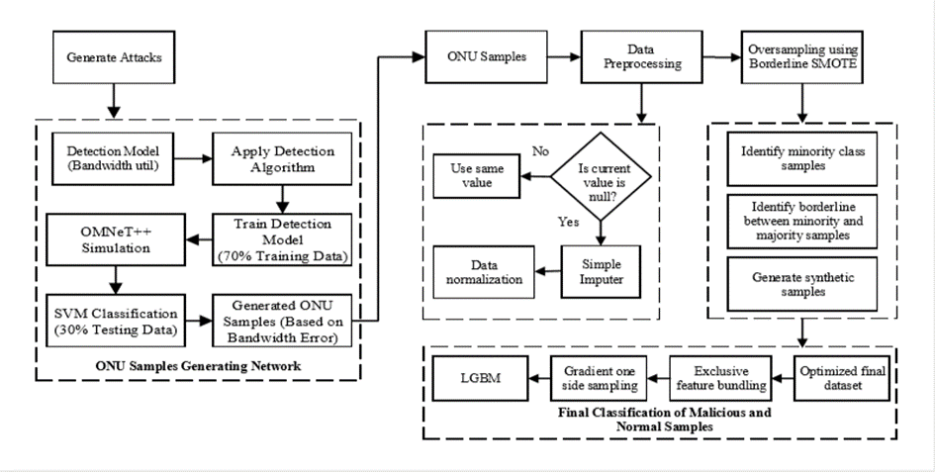
The model proposed throughout the study consists of two primary stages: detection and classification. Figure 1 illustrates the proposed model for identifying and classifying malicious ONUs. The initial phase involves distinguishing between malicious and normal ONUs. In this phase, the algorithms assess the impact of a DDoS attack to monitor the behavior of ONUs. Features of a DDoS attack, such as bandwidth usage, are crucial for distinguishing between normal and malicious ONUs. Consequently, the results from these feature-checking methods determine whether the ONUs are normal or malicious. Normal ONUs is passed directly, while malicious ONUs is sent to the next phase for further classification. The algorithms proposed for detecting malicious ONUs, the SVM algorithms, were developed and implemented to boost their effectiveness regarding accuracy and execution time.

Figure 1. The proposed model for identifying and classifying ONUs
The SVM algorithm was selected because it has demonstrated strong performance in prior research across various PON applications [19]. Figure 1 shows the algorithmic steps employed in detecting malicious ONUs. Additionally, the processes included in the detection stage can be outlined as follows.
- Execute and operate the method.
- The method examines the characteristics of ONUs.
- The method distinguishes between normal ONUs and malicious ONUs.
- The malicious ONUs is forwarded to the classification algorithm.
The second stage of the proposed framework involves the classification of ONUs. In this stage, the DDOS attacks identified during the detection stage are analyzed by an algorithm to assess the behavior of the ONUs. The three characteristics of ONUs are priority, bandwidth, and time. Once the checking process is complete, the ONUs is classified. Figure 1 also shows how the LightGBM algorithm is used to classify malicious ONUs. The procedure involved in the classification stage can be outlined as follows:
- Execute and operate the LightGBM classifier method.
- The method starts by detecting malicious ONUs.
- The method examines the priority and bandwidth usage of each ONU.
It then classifies the types of ONUs based on the features assessed in step 3.

Gradient Boosting Algorithm
Gradient boosting is a type of ensemble learning method. Unlike the Naïve Bayes method, where models are created independently, ensemble boosting builds models sequentially, iteratively reducing the errors of previously learned models [18]. It develops a predictive model by combining M additive tree models (f₀, f₁, f₂, . . ., f_{M}) to forecast the outcomes (Eq.1).
$$f\left(x\right)=\sum_{m=0}^{M}{\left(f_{m}\left(x\right)\right)}$$ | (1)
The tree ensemble model is optimized by minimizing the expected generalization error L, as described in (Eq.2).
$$L=\sum_{i}^{n}{{\left(y- \hat{y}\right)}^{2}}$$ | (2)
L represents a loss function that quantifies the difference between the target value $Y_{i}$ and the predicted value $\hat{Y_{i}}$ for a given data point. There are three main motivations to use an ensemble-based approach.
Statistical: Merging and averaging multiple learners leads to improved simplification in data learning, thereby minimizing the likelihood of selecting unsuitable classifiers.
Computational: Throughout the learning process, it is computationally challenging for a method to find a local optimum to effectively learn the optimal depiction of the data, such as decision boundaries. For example, neural network use gradient descent algorithm to reduce the loss function during training to learn the optimal model. In this scenario, the local search has just a single starting point. Ensemble algorithms provide the benefit of having various initial aspects for the local search. This can offer a more precise estimate of the actual functionality, such as the decision boundary, compared to a single classifier.
Representational: In some instances, a single classifier might find it challenging to grasp a decision boundary that effectively separates different classes, or the decision boundary might be highly complex. This is where ensemble-based learning offers an advantage, as it provides various decision boundaries learned from different classifiers [20]. Hence, employing ensemble gradient boosting enhances the robustness of classifiers and reduces both their variance and bias. Boosting techniques inherently reduce failures by minimizing the shortcomings of individual classifiers while simultaneously enhancing their strengths. As a result, a more robust model may be generated. In this study, we employ the LightGBM , a highly effective gradient boosting algorithm. LightGBM represents an innovative approach in the gradient boosting family.

Light Gradient Boosting Machines
LightGBM [21] is an alternative gradient boosting method that utilizes a leaf-level approach to build trees in a vertical manner. The leaf that achieves the greatest loss reduction is chosen for splitting and expanding the tree. LightGBM employs a method based on histograms to identify the most effective divergent applicants. To enhance the training process, LightGBM employs a sampling technique known as Gradient-based One-Side Sampling (GOSS) to highlight the significance of data samples. The key role is to focus on data samples with larger gradients while disregarding those with smaller gradients [20-26]. The assumption is that data with small gradients have fewer errors and are therefore already well-trained.
Thus, GOSS suggests disregarding these less-informative data points and using the remaining ones to calculate the information gain when determining the best splits. However, this approach can lead to bias towards samples with larger gradients and alter the original data distribution. To tackle this problem, GOSS utilizes random sampling for information with minimal gradients while retaining all data points with significant gradients. As the sample tends to favor Information showing marked gradients, GOSS adjusts by increasing the weights (i.e., using a fixed coefficient) of the information points with minimal gradients while calculating information gain. Additionally, LightGBM employs the distinctive feature grouping algorithm to tackle data sparsity issues. It merges mutually exclusive features in an almost lossless way, thereby reducing the number of features while retaining the most informative ones. It enables handling of unevenly distributed data. Its fundamental design facilitates it to tackle data imbalance through the Gradient-based One-Side Sampling (GOSS) method. GOSS prioritizes information samples with higher error (i.e., challenging cases or minor classes in this context) because it considers that samples with lower error are already well-trained and require no further training. Another benefit of LightGBM is its capability to handle high-dimensional data, which is common in sentiment analysis problems. This is achieved by employing the "Exclusive Feature Bundling" method, which decreases the quantity of features while preserving the efficient ones.
The operation of LightGBM is illustrated by the algorithm depicted in Figure 2. Additionally, it has been shown that LightGBM achieves quicker convergence than other algorithms within the gradient boosting framework. As a part this study, we adopt the identical hybrid method, expected to be detailed in the section on related work. We develop an LightGBM classifier to differentiate between ONUs (i.e., normal and malicious). The performance of classifiers is widely recognized as being highly dependent on the features used for training. Throughout this research, our goal is to accomplish the following.
- Develop a classification model using LGBM to analyze ONUs affected by DDOS attacks in terms of bandwidth utilization.
- Examine how the proposed features perform on our dataset.
- Explore the correlation between normal and malicious ONUs derived from our dataset.
- Compare LightGBM with another classifier, specifically Naïve Bayes.
- Assess the effectiveness of the analysis

We outline the additions of this study as follows.
- Create a cutting-edge LightGBM-based model for analyzing DDOS attacks on ONUs.
- Perform thorough assessments and comparisons of various classification algorithms using various feature subsets through a series of experiments conducted on our dataset.

ALGORITHM: 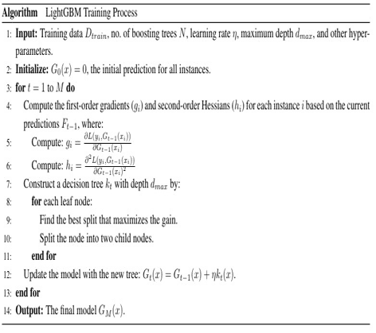

Figure 2 LightGBM Training Procedure
Naïve Bayes
The Naive Bayes algorithm, named after the 18th-century British mathematician Thomas Bayes, is a straightforward probabilistic classifier that determines probabilities by analyzing the occurrence and patterns of attributes in a specified dataset. The algorithm applies Bayes' theorem and supposes that the variables are mutually exclusive when considering the value of the class variable. This assumption of contingent autonomy is seldom true in real-world scenarios, which is why the algorithm is termed "Naive." However, it generally learns quickly across a range of controlled classification tasks [27]. Bayes theorem provides a method for calculating probabilities when certain conditions are known as in Eq 3 and Eq 4.
$P\left(A | B\right)$=$P\left(A\right)P\left(B | A\right)$ | (3)

$$\frac{P\left(A\right) P \left(\left.B\right|A\right) }{P\left(B\right)}$$ | (4)
Where P(A|B) represents the probability of event A occurring given that event B has occurred.
P(A) is the probability of event A occurring.
P(B|A) is the probability of the occurrence of event B when event A occurs,
P(B) is the probability of event B occurring. The concept behind the Naïve Bayes algorithm is to determine the posterior probability of a data instance $t_{i}$ in a class $c_{j}$ in belonging to a class within the data model.
The posterior probability P ($t_{i}$|$c_{j}$) represents the likelihood that t_{i} can be assigned the label c_{j}.
P ($t_{i}$|$c_{j}$) can be determined by multiplying the probabilities of all attributes of the data instance within the data model.
$P\left(t_{i} | c_{j}) \right)$=$\prod_{k=1}^{p }{P (t_{i} |c_{j}) }$ | (5)
Where P represents the number of attributes in each data instance. The posterior probability is computed for all classes, and the class with the maximum probability is assigned as the label for the instance. The flowchart for this algorithm is shown in Figure 3.

ALGORITHM:
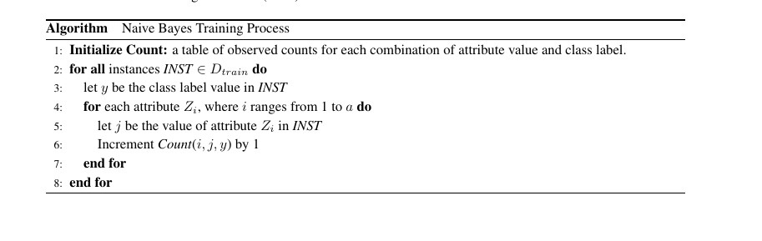

Figure 3 The Naïve Bayes algorithm Training Process
RESULTS AND DISCUSSION
This section discusses the implementation of Naive Bayes and LightGBM and analysis of the performance of these models based on evaluation metrics.

Implementation and Analysis
This work uses OMNET++ simulated data network comprising 64 ONUs and one OLT with a fiber distance of 40 km in the ODN. All the models were trained on a synthetic dataset that was created to train a classifier to detect malicious ONUs within a PON based on their bandwidth usage patterns. This dataset includes bandwidth demand profiles from ONUs recorded under normal conditions and during simulated attacks. The response variable for the binary classification is labeled as 0 for normal ONUs and 1 for malicious ONUs. Predictive features include each ONU's average and peak bandwidth demands. Data cleaning involved removing outliers from the bandwidth data. During the simulation, ONUs was labeled as either malicious or normal based on their behavior in attack scenarios.
The Accuracy, Precision and MCC of the proposed methods are computed using the formula given by Eq. 6, 7 and 8 respectively.
Precision =$\frac{TP}{TP+FP}$ | (6)

Accuracy = $\frac{TP+TN}{\left(TP+TN+FN+FP\right)}$ | (7)

MCC= $\frac{TP×TN-FP×FN}{\sqrt{\begin{aligned}\left(\left(TP+FP\right)\left(TP+FN\right)\left(TN+FP\right)\left(TN+FN\right)\right) \\ \end{aligned}}}$ | (8)
The initial model used for analysis is Naïve Bayes. The model produces predictions based on the validation set. Three distinct metrics were computed for the predictions generated by the model: Precision, MCC, and Accuracy. The Naive Bayes classifier achieved a precision of 81.185%, an MCC of 80.503%, and an accuracy of 88.359% using the validation data. Subsequently, the same trained model was used to estimate the labels for the test data. The values for True Positives (TP), True Negatives (TN), False Positives (FP), and False Negatives (FN) can be determined by plotting the confusion matrix comparing the actual predictions with the values predicted by our model, as shown in the table. The initial model used for analysis is Naïve Bayes. The model produces predictions based on the validation set. Three distinct metrics were computed for the predictions generated by the model: Precision, MCC, and Accuracy. The Naive Bayes classifier achieved a precision of 81.185%, an MCC of 80.503%, and an accuracy of 88.359% using the validation data. Subsequently, the same trained model was used to estimate the labels for the test data. The values for True Positives (TP), True Negatives (TN), False Positives (FP), and False Negatives (FN) can be determined by plotting the confusion matrix comparing the actual predictions with the values predicted by our model, as shown in the table.
The detailed results of the confusion matrix include True Positives (TP=31). The confusion matrix offers a detailed breakdown of the classifier's performance by displaying actual versus predicted classifications, with True Positives (TP=31). The model accurately identified 31 instances as positive. True Negatives (TN=16). The model accurately predicted 16 instances as negative. False Positives (FP=5) were incorrectly predicted as positive, while False Negatives (FN=0) were incorrectly predicted as negative, as illustrated in Figure 4.
The high count of true positives and true negatives indicates that the model is effective at accurately identifying both positive and negative cases. The occurrence of 5 false positives indicates that the model occasionally misclassifies negative instances as positive, highlighting a potential area for improvement. The lack of false negatives strongly indicates that the model is highly effective at identifying all positive cases, which is crucial in scenarios where missing a positive instance could be costly or dangerous (e.g., medical diagnoses).
ROC CURVE: The ROC curve demonstrates the balance between sensitivity and specificity by plotting the true positive rate against the false positive rate at various threshold settings, illustrating the trade-off between sensitivity and specificity.
AUC (Area under Curve=0.88): The AUC value of 0.88 indicates that the model has good discriminative ability as shown in figure 5.A model with an AUC closer to 1 is considered excellent, while an AUC closer to 0.5 suggests no discriminative power.
These Performance Metrics are calculated. The bar charts provide a summary of key performance metrics: Accuracy, Precision, and MCC (Matthews Correlation Coefficient) are shown in Figure 6.
Accuracy: The high accuracy value demonstrates that the model is reliable in its predictions.
Precision: The precision value indicates the model's effectiveness in minimizing false positives, which is particularly important in scenarios where false positives are costly.
MCC: A high MCC score indicates a strong overall performance, accounting for true and false positives and negatives. This is useful for a comprehensive perception of the model’s performance.
From the above discussion it is observed that the LightGBM model demonstrates excellent performance across all evaluation metrics. High TF and TN Rates indicate the model's ability to correctly classify both positive and negative cases. Low FP Rate suggests effective minimization of incorrect positive predictions as shown in Figure 7. No FN highlights the model's reliability in capturing all positive instances. The model’s outstanding discriminative ability is further highlighted by AUC of 0.95 as shown in Figure 8 . High Accuracy, Precision, and MCC Scores as shown in figure 9 Confirm the model’s robust overall performance.
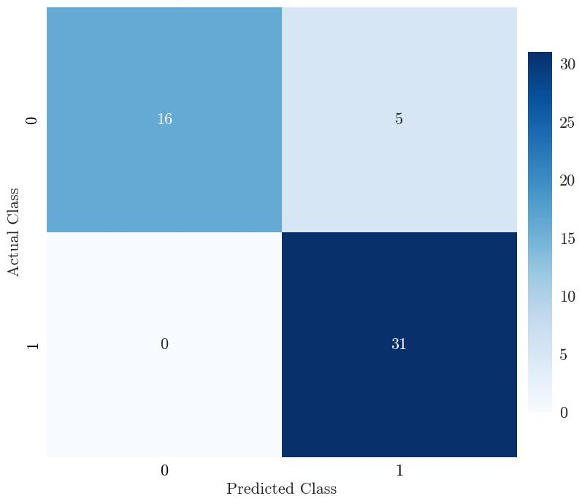

Figure 4 Confusion matrix for actual class and predicted class detection
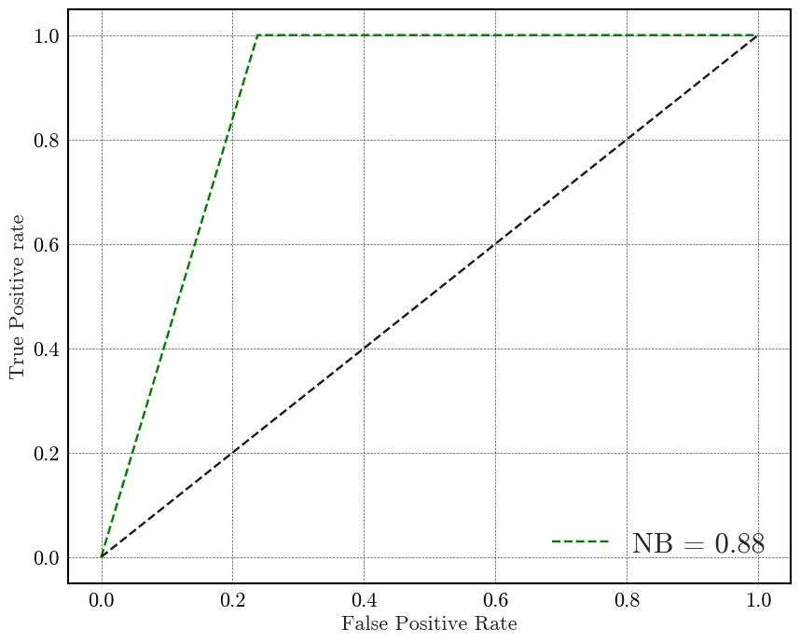

Figure 5 ROC for Naïve Bayes (NB)Classifier with AUC 0.88 for ONU fault
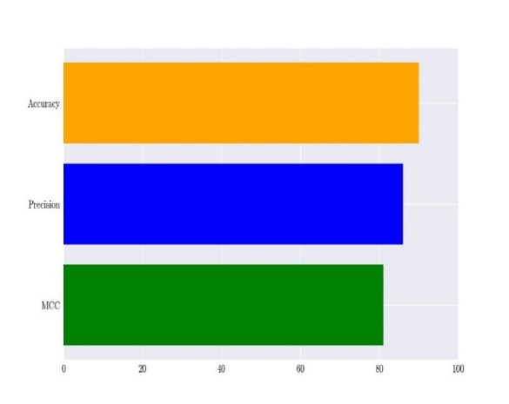

Figure 6 Performance Metrics of Naïve Bayes (NB) Classifier for ONU Fault Detection: Accuracy, Precision, and MCC
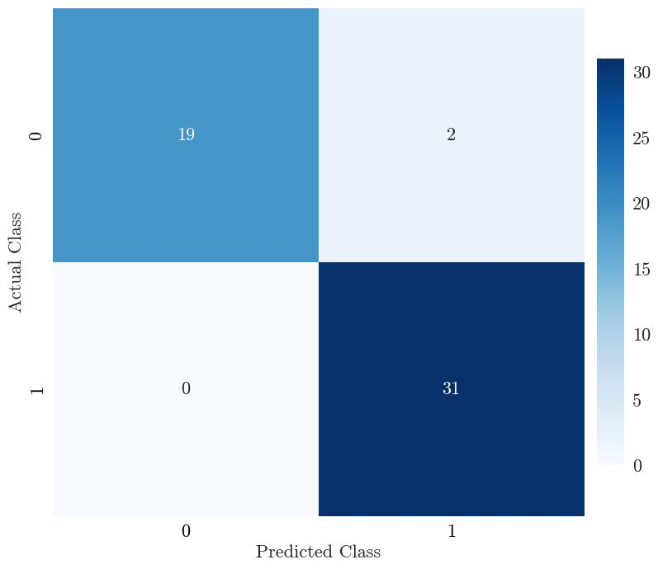

Figure 7 Confusion matrix for actual class and predicted class
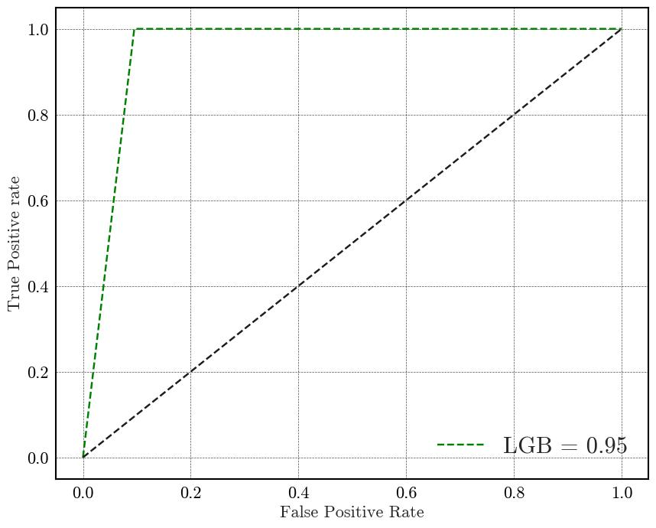

Figure 8 ROC for LightGBM Classifier with AUC 0.95 for ONU fault detection
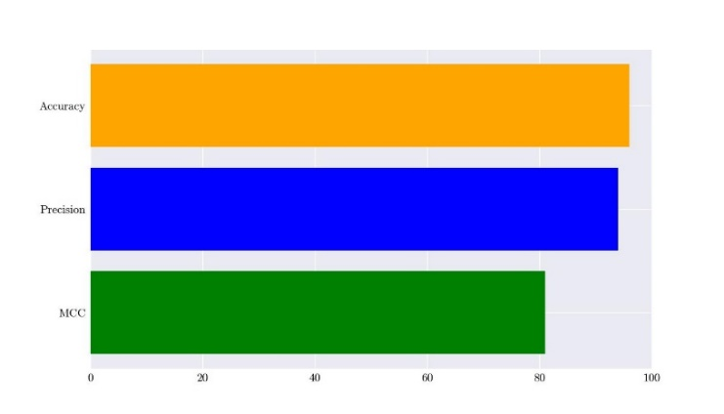

Figure 9 Performance Metrics of LightGBM Classifier for ONU Fault Detection: Accuracy, Precision, and MCC

CONCLUSION
This study evaluates the classification of normal and faulty ONUs using LightGBM and Naive Bayes (NB). It also compares the performance of LGBM, an advanced classification method, against NB, one of the earliest classification algorithms, demonstrating that LightGBM achieved superior scores. The findings indicate that the LGBM classifier outperforms others in terms of accuracy, precision, and Matthews correlation coefficient (MCC). LightGBM excels in addressing class imbalance issues, delivering the best results with a detection accuracy of 98.49%, outperforming NB. LGBM shows robustness in accuracy, precision, and MCC, achieving the highest scores among the evaluated techniques. Future work could explore the impact of varying dosage levels on classification performance. To the best of our knowledge, this is the first effort to apply machine learning algorithms for detecting and classifying the nature of ONUs.

REFERENCES
[1] H. S. Abbas and M. A. Gregory, “The next generation of passive optical networks: A review,” Journal of Network and Computer Applications, vol. 67. Academic Press, pp. 53–74, May 01, 2016. doi: 10.1016/j.jnca.2016.02.015
[2] J. F. Balarezo, S. Wang, K. G. Chavez, A. Al-Hourani, and S. Kandeepan, “A survey on DoS/DDoS attacks mathematical modelling for traditional, SDN and virtual networks,” Eng. Sci. Technol. an Int. J., vol. 31, p. 101065, 2022, doi: 10.1016/j.jestch.2021.09.011.
[3] S. Sinha and G. Kruthi, “Network layer DoS Attack on IoT System and location identification of the attacker,” Proc. 3rd Int. Conf. Inven. Res. Comput. Appl. ICIRCA 2021, pp. 22–27, 2021, doi: 10.1109/ICIRCA51532.2021.9545071.
[4] A. Sarkunavathi and V. Srinivasan, “A Scrutinized study on DoS attacks in Wireless Sensor Networks and need of SDN in Mitigating DoS attacks,” 2021 Int. Conf. Comput. Commun. Informatics, ICCCI 2021, 2021,
[5] R. Singh and M. Kumar, “A comprehensive analysis for the Performance of Next Generation Passive Optical Network,” in 2021 International Conference on Smart Generation Computing, Communication and Networking, SMART GENCON 2021, Institute of Electrical and Electronics Engineers Inc., 2021. doi: 10.1109/SMARTGENCON51891.2021.9645886.
[6] R. Bonk, “The Future of Passive Optical Networks,” 25th Int. Conf. Opt. Netw. Des. Model. ONDM 2021, pp. 1–3, 2021, doi: 10.23919/ONDM51796.2021.9492398.
[7] F. Obite, E. T. Jaja, G. Ijeomah, and K. I. Jahun, “The evolution of Ethernet Passive Optical Network (EPON) and future trends,” Optik (Stuttg)., vol. 167, pp. 103–120, 2018, doi: 10.1016/j.ijleo.2018.03.119.
[8] P. Pinho and D. Camacho, “Analysis tool for passive optical access network,” J. Microwaves, Optoelectron. Electromagn. Appl., vol. 20, no. 2, pp. 395–406, Jun. 2021, doi: 10.1590/2179-10742021V20I21185.
[9] Y. Li, Y. Zhao, J. Li, X. Yu, Y. Zhao, and J. Zhang, “DDoS Attack Mitigation Based on Traffic Scheduling in Edge Computing- Enabled TWDM-PON,” IEEE Access, vol. 9, pp. 166566–166578, 2021, doi: 10.1109/ACCESS.2021.3134671.
[10] A. N. Kadhim and S. B. Sadkhan, “Security Threats in Wireless Network Communication-Status, Challenges, and Future Trends,” in 2021 International Conference on Advanced Computer Applications, ACA 2021, Institute of Electrical and Electronics Engineers Inc., 2021, pp. 176–181. doi: 10.1109/ACA52198.2021.9626810.
[11] J. A. Hatem, A. R. Dhaini, and S. Elbassuoni, “Deep learning-based dynamic bandwidth allocation for future optical access networks,” IEEE Access, vol. 7, pp. 97307–97318, 2019, doi: 10.1109/ACCESS.2019.2929480.
[12] Y. Wang et al., “Dynamic Bandwidth allocation algorithm based on traffic classification with the aid of LSTM and GRU for industrial passive optical networks,” 2023 21st Int. Conf. Opt. Commun. Networks, ICOCN 2023, pp. 1–3, 2023, doi: 10.1109/ICOCN59242.2023.10236158.
[13] T. Horvath, A. Tomasov, P. Munster, P. Dejdar, and V. Oujezsky, “Unsupervised Anomaly Detection Using Bidirectional GRU Autoencoder Neural Network for PLOAM Message Sequence Analysis in GPON,” Int. Conf. Electr. Comput. Commun. Mechatronics Eng. ICECCME 2022, no. November, pp. 1–5, 2022, doi: 10.1109/ICECCME55909.2022.9988508.
[14] A. Usman, N. Zulkifli, M. R. Salim, and K. Khairi, “Fault monitoring in passive optical network through the integration of machine learning and fiber sensors,” Int. J. Commun. Syst., vol. 35, no. 9, Jun. 2022, doi: 10.1002/dac.5134.
[15] S. Drakulic, M. Tornatore, and G. Verticale, “Degradation attacks on Passive Optical Networks,” in 2012 16th International Conference on Optical Networking Design and Modelling, ONDM 2012, 2012. doi: 10.1109/ONDM.2012.6210184.
[16] F. M. Atan et al., “Security enhanced dynamic bandwidth allocation algorithm against degradation attacks in next generation passive optical networks,” J. Opt. Commun. Netw., vol. 13, no. 12, pp. 301–311, Dec. 2021, doi: 10.1364/JOCN.434739.
[17] M. Mohinur Rahaman and M. Azharuddin, “Wireless sensor networks in agriculture through machine learning: A survey,” Comput. Electron. Agric., vol. 197, no. December 2021, p. 106928, 2022, doi: 10.1016/j.compag.2022.106928.
[18] A. Tomasov, M. Holik, V. Oujezsky, T. Horvath, and P. Munster, “GPON PLOAMd message analysis using supervised neural networks,” Appl. Sci., vol. 10, no. 22, pp. 1–12, 2020, doi: 10.3390/app10228139.
[19] R. Barona and E. Baburaj, “An efficient DDoS attack detection and categorization using adolescent identity search-based weighted SVM model,” Peer-to-Peer Netw. Appl., vol. 16, no. 2, pp. 1227–1241, Mar. 2023, doi: 10.1007/s12083-023-01460-6.
[20] F. Alzamzami, M. Hoda, and A. El Saddik, “Light Gradient Boosting Machine for General Sentiment Classification on Short Texts: A Comparative Evaluation,” IEEE Access, vol. 8, pp. 101840–101858, 2020, doi: 10.1109/ACCESS.2020.2997330.
[21] D. Agrawal, S. Minocha, and A. K. Goel, “Gradient boosting based classification of ion channels,” Proc. - IEEE 2021 Int. Conf. Comput. Commun. Intell. Syst. ICCCIS 2021, pp. 102–107, 2021, doi: 10.1109/ICCCIS51004.2021.9397161.
[22] Sarwo and Y. D. Prabowo, “Enhancing Classification Performance Through the Synergistic Use of XGBoost, TABPFN, and LGBM Models,” Proc. - 2023 15th Int. Congr. Adv. Appl. Informatics Winter, IIAI-AAI-Winter 2023, pp. 255–259, 2023, doi: 10.1109/IIAI-AAI-inter61682.2023.00054.
[23] N. Zaeri and R. R. Qasim, “Intelligent Wireless Sensor Network for Gas Classification Using Machine Learning,” IEEE Syst. J., vol. 17, no. 2, pp. 1765–1776, Jun. 2023, doi: 10.1109/JSYST.2023.3238357.
[24] S. Gore, Y. Nagalakshmi, P. Knowles, K. G. Gupta, N. S. Jagtap, and R. P. Sali, “Improvised Ensemble Model for Fast Prediction of DoS/DDoS Attacks in Various Networks,” 2023 1st Int. Conf. Cogn. Comput. Eng. Educ. ICCCEE 2023, pp. 1–5, 2023, doi: 10.1109/ICCCEE55951.2023.10424447.
[25] M. Osman, J. He, F. M. M. Mokbal, N. Zhu, and S. Qureshi, “ML-LGBM: A Machine Learning Model Based on Light Gradient Boosting Machine for the Detection of Version Number Attacks in RPL-Based Networks,” IEEE Access, vol. 9, pp. 83654–83665, 2021, doi: 10.1109/ACCESS.2021.3087175.
[26] M. Karim and R. M. Rahman, “Decision Tree and Na&#239;ve Bayes Algorithm for Classification and Generation of Actionable Knowledge for Direct Marketing,” J. Softw. Eng. Appl., vol. 06, no. 04, pp. 196–206, 2013, doi: 10.4236/jsea.2013.64025.
[27] S. Chen, G. I. Webb, L. Liu, and X. Ma, “A novel selective naïve Bayes algorithm,” Knowledge-Based Syst., vol. 192, p. 105361, 2020, doi: 10.1016/j.knosys.2019.105361.

