Acoustic and Visual Optimization in the Configuration of Exhibition Space Partitioning | 

Thomas Ari Kristianto¹, Sri Nastiti Ekasiwi^{2*}, Dhany Arifianto³
¹Department of Architecture, Faculty of Civil Planning and Geo Engineering, Sepuluh Nopember Institute of Technology, Surabaya, Indonesia
²Department of Architecture, Faculty of Civil Planning and Geo Engineering, Sepuluh Nopember Institute of Technology, Surabaya, Indonesia
³Department of Medical Technology, Faculty of Medicine and Health, Sepuluh Nopember Institute of Technology, Indonesia

Abstract  In exhibition and museum spaces, designers often choose open layouts without side partitions, to enhance visual connectivity between pavilions. However, this approach contradicts acoustic isolation theory, which are essential for ensuring that audio content within pavilions is effectively captured. This study aims to identify the optimal balance between acceptable acoustic conditions for visitors and the spatial advantages provided by visual connectivity.  Employing a mixed-methods approach in three stages, the research investigates three exhibition space prototypes, commonly used in practice. Acoustic simulations were conducted on digital models using CATT software, followed by room acoustic response measurements adhering to standard RIR procedures, across three 1:1 scale pavilion prototypes. Additionally, an intersubjective method was utilized through acoustic exposure experiments with respondents in these prototypes.  The findings indicate that a pavilion with a basic configuration (B) featuring 60-cm-wide side partitions, achieves an optimal acoustic condition. These results provide a foundational basis for developing multimedia exhibition spaces, that effectively balance room acoustics quality and spatial aesthetics.  This is an open access article under the CC BY-SA license   | Keywords:  Acoustic perception; Exhibition Partition; acoustic parameters.  Article History:  Corresponding Author:  Sri Nastiti Ekasiwi  Department of Architecture, Faculty of Civil Planning and Geo Engineering, Sepuluh Nopember Institute of Technology, Surabaya, Indonesia  Email: ekasiwi@its.ac.id

INTRODUCTION
The exhibition space is usually divided into several pavilions, depending on the theme being displayed. The pavilion can be used for various display methods to showcase the exhibition content and accommodate visitors. Pavilions are smaller spaces compared to the architecture of the exhibition. The boundary between a pavilion and an architectural space can be massive or virtual. The interior elements of the pavilion can be related to the architectural space but can also stand independently within the architectural space [1]. The same author also mentions that in the context of the exhibition space, the partitions forming the pavilion are not related to the architectural structure of the hall [1] [2] [3]. Physically, the pavilion is built with a configuration of interior elements such as floors, partition walls, ceilings, and furniture. Within exhibition hall, the pavilion space is a display system that can contain dioramas, vitrines, pedestals, panels, and other panel equipment [4] [5] [6] [7] [8].
The display design in museums and other exhibition spaces influenced the theme and objects of the collection in terms of dimensions, scale, and available space. Many exhibition planners use a module system for the floor, wall, and ceiling components to facilitate planning and implementation.
This research looks at the side vertical partition module as the most common interior element for dividing space. The smallest module size commonly used is 30 cm, with sizes of 60, 90, 120, 150, 180, 210, and 240cm [9]. These considerations indicate the ease of material production and availability. A survey found that partition widths of 120 cm and 240 cm are the most used in exhibitions. Other considerations related to module size led to circulation and visual organization. Partition modules can help organize circulation so that visitors do not feel trapped in a maze while in the museum and accommodate visitor movement so that they can move from one pavilion to another without relying heavily on maps or guidebooks. Visitors rely on the visibility factor, which is especially easy to achieve in museums with open-plan circulation [10]. As conversation groups grow in numbers the space between individuals increases, to allow visual connection [11].
The development of radio in the 1930s led to the addition of audio narration (audial content) to exhibitions. More than 50% of visitors found listening to audio content more practical than reading written content [12]. Using advancements in multimedia computing in the early 2000s, exhibition spaces have also incorporated various content presentation technologies. Audiovisual content such as narrative videos, interactive videos, games, and even virtual reality were introduced to complement the physical artifacts. Exhibition layouts became more dynamic and evocative [13] [12]. The use of audiovisual technology has prompted planners to strive for the design of display systems capable of delivering what is referred to as the experience of memory [13] [14]. One consequence of this shift in exhibition methods is the increased number and intensity of sound sources within exhibition spaces. The mixing of many sound sources can create disruptive noise, affecting visitors’ concentration and ability to absorb content information. This condition is counterproductive relative to implementing audiovisual content. The exhibition hall has noise issues during its operations. In the museum, human noise arising from audio content, footsteps, and visitor activities, especially conversations, is the main source of noise in the hall. In museums with low visitor attendance, noise is more often caused by non-human sources [15].

The principle of acoustic design in an ideal exhibition pavilion is sound isolation (Stocker, 1998). Michael Stocker articulated the basic principle of sound diffusion within a confined exhibition space, which he regarded as the optimal method for localizing sound across the pavilion. The configuration, which refers to a closed model pavilion, prevents most of the sound in the pavilion from seeing other pavilions and isolates most of the sound outside the pavilion. This known as principle of sound insulation [16] [17].

In 2013 and 2014, Carvalho et al. investigated the acoustic performances of museums using several parameter indices. They compared the museum spaces and the acoustic performances of conventional and modern museums. In one of their findings, the pavilion with closed configurations tended to meet the ideal acoustic parameter threshold. The open pavilion spaces with shorter partitions did not tend to meet the ideal museum acoustic quality index [18].

From the perspective of many designers, this contradicts the need to create visually interconnected pavilions, resulting in many open spaces to facilitate visitor circulation. This design tendency has been confirmed by several research reports, one of which was by the author, who found in an exploration of exhibition space design in 2021 that more than 85% of pavilion spaces in Indonesia have an open configuration. Short or no side partitions. [19].

This study determined whether the widely used open-configuration pavilion can still meet the acoustic comfort threshold. This research determines the basic geometry threshold of the open model pavilion elements to meet the acoustic comfort threshold. From this basic geometry, the pavilion partition elements can be developed into various designs according to the content presented.

The research methodology comprises three phases: beginning with computer simulations using CATT-Raytracing, followed by instrumented measurements for experimental validation of the simulations, and concluding with non-random assignment in quasi-experimental intersubjective research. By integrating raytracing simulations, impulse response studies, and intersubjective approaches, this research aims to significantly contribute to the development of more effective and enjoyable multimodal exhibitions for visitors.
This study evaluates the acoustic performance characteristics of different exhibition space partition models in open configurations. Furthermore, it seeks to understand visitors’ perceptions of the acoustic quality within an open-configured multimedia exhibition pavilion. The research focuses on rectangular pavilion configurations, as this shape offers greater flexibility compared to the triangular or hexagonal forms [20]. This flexibility allows the modulation of the rectangular pavilion to be the ideal form when placed in a small or large exhibition space. Side partitions, as elements dividing pavilion spaces, serve several crucial functions, including creating well-defined and functional areas that enhance the exhibit’s impact and ensure a positive visitor experience [12]. This study examines the independent variables, specifically the configurations of a rectangular pavilion without partitions, a rectangular pavilion with 120-cm-wide partitions, and a rectangular pavilion with 240cm-wide partitions. All partitions in the pavilion were 240 cm in height.

METHOD
Research Methods
This research implementation strategy provides a comprehensive understanding of the acoustic performance of various exhibition pavilion configurations. A multi-criteria analysis model to acoustically characterize a specific type of building: museums [21].
The method in this research is carried out in 3 stages starting with Computer Simulation (CATT-Raytracing), followed by instrumented measurements for experimental validation of the simulation, and ending with Non-Random Assignment in Quasi-Experimental Research Intersubjective.

Computer Simulation (CATT-Raytracing)
Raytracing is a technique used to simulate sound propagation in geometric acoustic analysis, where the sound source can be modeled using a finite number of rays, with each ray representing a portion of the energy. [22] [23] The rays then radiate out from the source in a direction based on the directivity of the source and interact with the room. As they encounter planes in the model, the beam values and travel paths are changed based on the angle of the plane (according to Snell's Law), the absorption coefficient, scattering coefficient, and diffraction properties of the material the beam encounters. [24] The bounce, wave deflection, and energy drop of sound waves can be reproduced and even regenerated in 3D visual rendering. [23] This raytracing simulation technique can help describe in detail the propagation pattern of sound waves and their intensity in a digital model. [25]

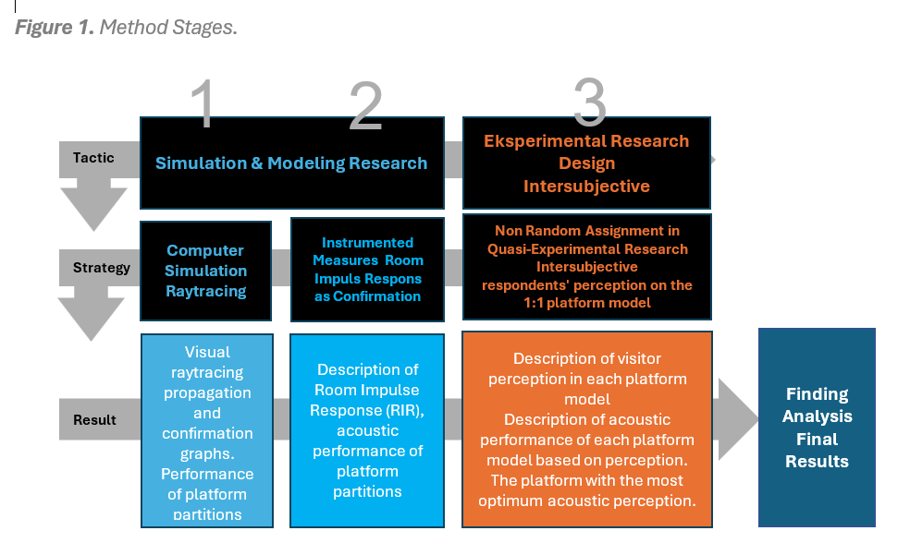
Figure 1. Method Stages.

Simulations were conducted on 3 models obtained from previous research on the observation of 16 exhibitions in East Java. [19].
- Digital depiction of 3 exhibitions using Sketchup software with the material properties of plastered and painted brick walls, gypsum board ceilings, glass windows, double multiplex doors, homogeneous tile floors, and double gypsum board partitions finished with paint and vinyl.
- Calibration of the CATT-Acoustic software with a digital sound level meter and sound generator instrument.
- Acoustic simulations were conducted using the CATT-Acoustic software. The analysis was primarily based on visual observations of sound wave ray tracing. Additionally, the graphs were analyzed for each parameter.
The parameters examined in this simulation encompass SPL (sound pressure level distribution), C80 (music sound clarity), G (sound source strength), Speech Transmission Index (STI), and RT (room reverberation time). This simulation method offers an overview of the propagation characteristics of both direct and reflected sound as influenced by the partitions.

Instrumented Measures for the Experimental Validation of the Simulation
This phase involves a room impulse response test to determine the acoustic response characteristics of the pavilion partition to sound waves. The measurements provide insights into the interaction between the sound source and the room surfaces, which can be illustrated through the time-sequence pattern of the reflected sound energy at a specific point in the room and the attenuation of the sound energy over time with each reflection.

Table 1. Room Dimensions and Material Noise Reduction Coefficients (NRC)
Measurements | Dimensions
Room area | 137.3m2
Room volume | 439.3m3
Material | NRC
Concrete Wall | 0.0675
Floor | 0.085
Glass Window | 0.155
Wood Door | 0.825
Partitioning (gypsum): 12 mm; double-panel thickness: 60 mm. | 0.75-0.8

From the analysis of the sequence pattern and the reduction of sound energy, key acoustic response parameters for enclosed spaces can be derived,

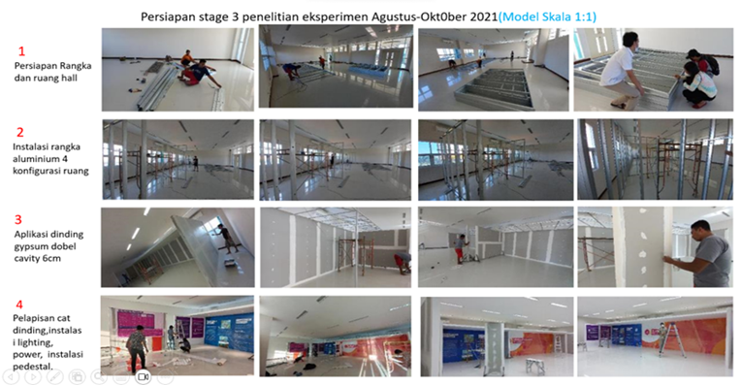
Figure 2. Production Process of the Pavilion Model.

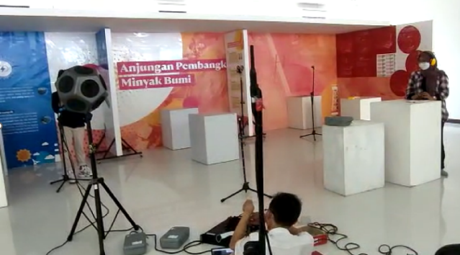
Figure 3. Process of the room impulse response test.

specifically, the reverberation time (RT60) and the Speech Transmission Index (STI).
Impulse response tests were conducted using a full-scale physical model of the pavilion. The materials used for the space and partition surfaces, excluding the aluminum frame, are those commonly used in exhibitions. The properties of these materials are detailed in Table 1.
This stage of the methodology seeks to capture the space’s response to multi-frequency sounds, providing an overview of noise levels and sound intelligibility. This is achieved through the parameters of reverberation time (RT) and the Speech Transmission Index (STI).

Non-Random Assignment in Quasi-Experimental Research Intersubjective Use of Respondent Perceptions on a 1:1 Pavilion Model
This research employs an intersubjective approach through an experimental design study involving respondents within a full-scale pavilion model. This methodology enables researchers to directly observe and measure visitor responses to each pavilion design. By sitting the selected respondents in a 1:1 scale pavilion space within a laboratory setting with some criteria (Table 3), the study ensures that the fixed variables are maintained. This approach is classified as Quasi-Experimental Research [12] [26] [27].

Table 2. Respondent Criteria
Respondents Group | Number of Respondents | Parameter
Nonexpert | 46 | - Gender  - Age  - Hearing test  - Frequency of museum/examination visits in 2023
Expert | 14 | - Gender  - Age  - Hearing test  - Frequency of museum/examination visits in 2023

This research provides a more comprehensive understanding of the acoustic performance of elements within a pavilion. While sections 2.1 and 2.2 followed an objective spatial investigation system based on acoustic parameters, this phase of the research also considers the subjectivity of human acoustic perception within the same space. This study aligns with and reinforces the trends observed by some research [21] [13] [22] [28] which are considered more human-centric. This study aims to uncover how the visual aspects of the partition influence visitors’ acoustic perceptions.
Yang and Kang established that a minimum respondent population of 30 is required. [28] This study involved 60 respondents, divided into two groups: 46 acoustic nonexperts and 14 acoustic experts (Table 2). Nonexperts are typical exhibition visitors without specific knowledge of acoustics, whereas experts are visitors who have studied acoustics or work in an related field.
Respondents were requested to provide feedback on their experiences while visiting the pavilion, enabling researchers to evaluate the effectiveness of each pavilion design configuration. The responses were gathered through a questionnaire
Respondents’ experiences while standing in each pavilion and listening to the 86 dB audio content included perceptions related to: (1) the noise level; (2) the clarity and intelligibility of the audio; (3) the intrusion level from neighboring pavilions; (4) the acoustic comfort; and (5) the visual comfort.
This stage of the methodology seeks to achieve the optimal acoustic performance for each pavilion, considering the subjective experiences of human visitors.

Table 3 Pavilion Physical Criteria

Pavilion Type Configuration | Pavilion Illustration
Pavilion A without a side partition  - Widht 300 cm  - Height of 240 cm  - A diorama on a pedestal  - Visual content through the monitor  - Audio content through a speaker  - Visual Connectivity: Visitors can view the adjacent pavilion simply by turning heads. | 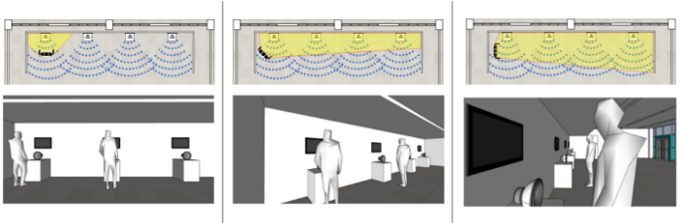
Pavilion B with a 120-cm side partition  - Widht 300 cm  - Height of 240 cm  - A diorama on a pedestal  - Visual content through the monitor  - Visual Connectivity: Visitors can view the adjacent pavilion by moving their bodies back at least 70 cm. | 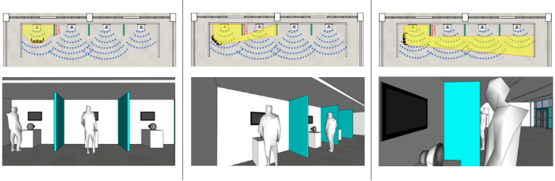
Pavilion C with a 240-cm side partition  - Widht 300 cm  - Height of 240 cm  - A diorama on a pedestal  - Visual content through the monitor  - Visual Connectivity: Visitors cannot view the adjacent pavilion unless they exit. | 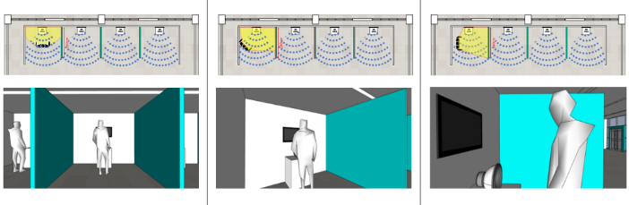

RESULTS AND DISCUSSION
As an objective research characteristic, the results are derived from a rigorous analysis of the physical behavior of sound waves. The ray tracing simulation results for the five parameters mentioned above are presented in direct mapping tables and graphs. (Table 4). Similarly, the RIR test results presented two acoustic parameters (Table 7), In general, the data from both operations are not contradictory.

Computer Simulation (CATT-Raytracing)
A raytracing simulation was conducted using the CATT software to measure the acoustic performance of the proposed pavilion model.

Table 4 Computer Simulation Output (CATT-Raytracing)
 | Pavilion A without a side partition | Pavilion B with a 120-cm side partition | Pavilion C with a 240-cm side partition
Direct Making | 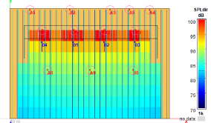 | 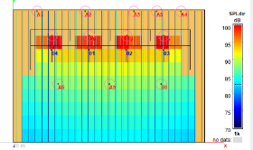 | 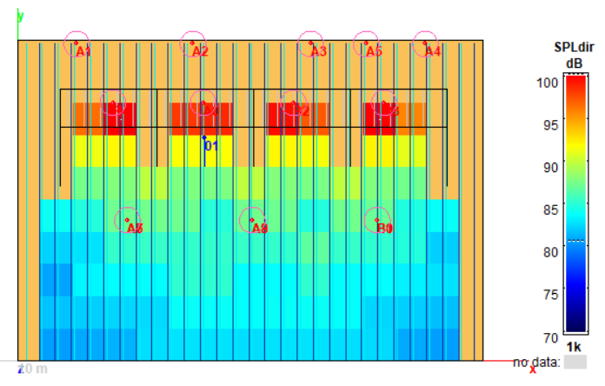
C80 | 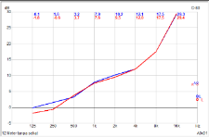 | 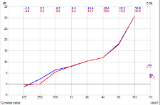 | 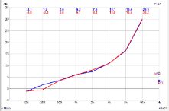
Strength | 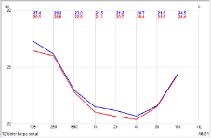 | 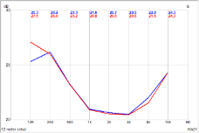 | 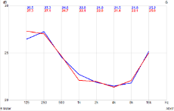
SPL | 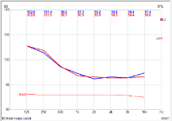 | 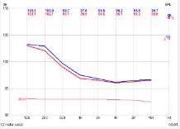 | 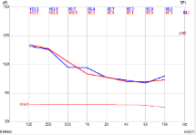
STI | 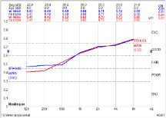 | 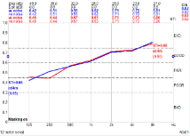 | 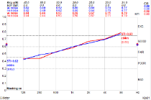
T30 reverberation time (RT) | 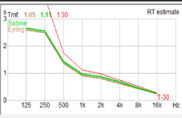  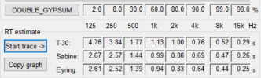 | 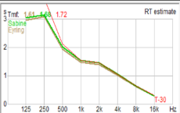  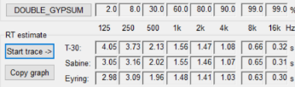 | 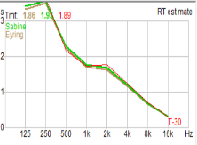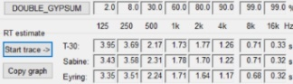

The simulation results. The Clarity parameter (C80) indicates that the audio content remains perceptible to listeners, even under less-than-ideal conditions. The side partitioning shows that visitors can still hear the audio content, although the quality may be compromised. Specifically, the intelligibility levels, ranging from poor to medium, were most effectively achieved within the 120-cm and 240-cm partitioned pavilion setups.

Table 5 Computer Simulation Results Summary (CATT-Raytracing)

SUMMARY OF CATT RAYTRACING OF A, B, C PAVILION
PARAMETER | Definition | A  0cm | B 120cm | C2  40cm | Ideal value for exhibitions | Interpretation
CLARITY (C80) | the level of clarity or sound clarity- intelligibility in the room | 1.6-7.6 | 2.3-8.1 | 1.7-8.1 | 0-5 dB: Poor, low.  5-10 dB: Fair, medium.  >10 dB: Good,  High. | The A, B, and C pavilions under the poor to fair c80 condition. Even the fair index is in the lower half.
STRENGTH (G) | A parameter for sound can be amplified in a room. | 0.2-0.4 | -2.2-0.1 | -0,8-0.7 | 0.5-0.8 | The gains in A and B are not strong enough to last. In C, there is a Gain intensity that is close to sufficient.
SOUND PRESSURE LEVEL (SPL) | A parameter for sound intensity in a room. | 102-97 | 103-96 | 103-99 | 60-80 dB | The A, B, and C pavilions are in a very uncomfortable condition.
SPEECH TRANSMISSION INDEX (STI) | A parameter speech or sound can be clearly understood in an environment. | 0.47-0.64 | 0.42-0.62 | 0.42-0.60 | 0.75-1.00  indicates the better the ability to transmit sound clearly. | The A, B, and C pavilions are in a state in which it is difficult to hear the content sound clearly. The content sound cannot be heard clearly (low intelligence).
REVERBERATION TIME  (T30) | Decay time for 60 dB Illustrate the noise levels. | 1.05  1.11  1.30 | 0.95  1.00  1.20 | 1.61  1.68  1.72 | <1.4 s  Ideal and good audio clarity. | The A, B, and C pavilions have long RTs but not too much. A small amount of material absorption can lower the RT.

The visual graphics also illustrate that the ambient noise, primarily indicated by the Strength (G) and Sound Pressure Level (SPL) parameters, impacts the intelligibility of sound reception, as measured by the Speech Transmission Index (STI). All three parameters exhibit suboptimal measurements across the three partition dimensions. These parameters are interrelated and should be considered as a single phenomenon, such excessive noise has the potential to disrupt users within space [16] [28].
However, in the context of museums and exhibitions, many of these sounds may also be necessary to build the ambience of the exhibition [14].
The Reverberation Time (T30) indicator characterizes the acoustic behavior of the pavilion space and the architecture of the exhibition hall. In pavilions without partitions and those with 120-cm partitions, sound waves propagate to the ceiling, floor, front wall, and architectural surfaces of the hall with sufficient reflection distance, leading to a reduction in sound energy by 60 dB with minimal reverberation. In contrast, the pavilion with 240-cm partitions tended to have a reverberation time (RT) that slightly exceeded the ideal threshold. The parallel partition walls cause significant sound wave reflections. This alignment is noteworthy and merits further investigation in future research (Table 5).

Room Impulse Response Test
This phase entails an impulse response study aimed at characterizing the pavilion partition’s reaction to sound waves. The impulse response test was conducted using a full-scale (1:1) physical model of the pavilion. Employing multi-frequency omnidirectional dodecahedron speakers and omnidirectional microphones facilitates the objective measurement of the acoustic response. The Room Impulse Response measurements were conducted in an experimental room, designed to resemble a typical exhibition pavilion, aligned with the digital simulation results. The two parameters derived from the sound captured by the microphone system positively confirm the digital raytracing simulation outcomes presented in section 3.1. The reverberation time (RT) parameter exceeds the ideal value across all three pavilion types (Table 6).
The partition dimensions do not significantly control the propagation of sound wave reflections to achieve the ideal RT. However, variations in the partition dimensions still influence the RT performance of each pavilion, as evidenced by the gradual decrease in the RT length with increasing partition dimensions. Similarly, the Speech Transmission Index (STI) parameters conform to the digital simulation results, albeit with values further from the ideal. The microphones recorded comparable audial content values.

Table 6. Speaker and microphone points layout
Pavilion A without a side partition | Pavilion B with a 120-cm side partition | Pavilion C with a 240-cm side partition
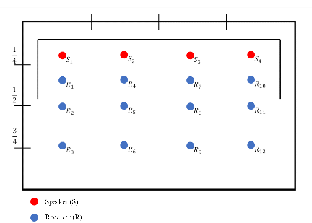 | 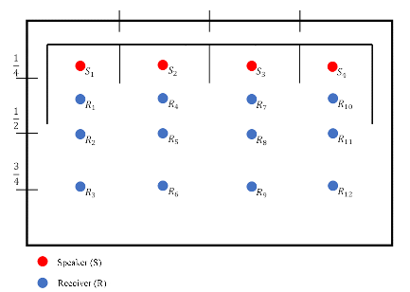 | 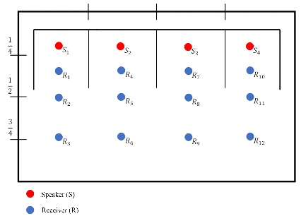

Table 7. RIR results and interpretation
SUMMARY OF ROOM IMPULSE RESPONSE TEST RESULTS (EMPTY EXPERIMENTAL ROOM)
PARAMETER | Pavilion A without a side partition | Pavilion B with a 120-cm side partition | Pavilion C with a 240-cm side partition | Ideal Value | Interpretation
RT60 | 2,63s | 2,03s | 2.02s | 0.8 -1.4s | The RTs in pavilions A, B, and C are very long. Indicated excessive background noise while operating the exhibition.
STI | 0.23 | 0.23 | 0.23 | 0.75-1.00 | STI in pavilions A, B, and C are categorized as poor. Correlation between excessive reflection and high background noise

Non-Random Assignment in Quasi-Experimental Research: Intersubjective Use of Respondent Perceptions in a Full-Scale Pavilion Model
The previous two phases revealed that most acoustic performance metrics for the three partition configurations did not fall within the ideal range for all parameters. However, the values obtained were not significantly far from the ideal. This makes the quasi-experimental analysis based on 60 visitor perceptions particularly intriguing. This study highlights how the subjective human perception of sound within a space can yield different results compared to the two phases of objective investigation. The composition included 57% nonexperts in acoustics and 14% experts, representing the typical conditions of exhibition visitors. The expert respondents also served to maintain the consistency of the responses, as they have a better understanding of the room acoustic phenomena.

The participants were asked questions immediately after the experiment. There were 60 questions in total, divided into 5 topics: noise disturbance, hearing comfort in a pavilion, recognizing sounds from other pavilions, distraction in concentration when other pavilions are visually connected, and the temptation to immediately move to another pavilion. The answers are summarized in 5 boxplots graphs below.
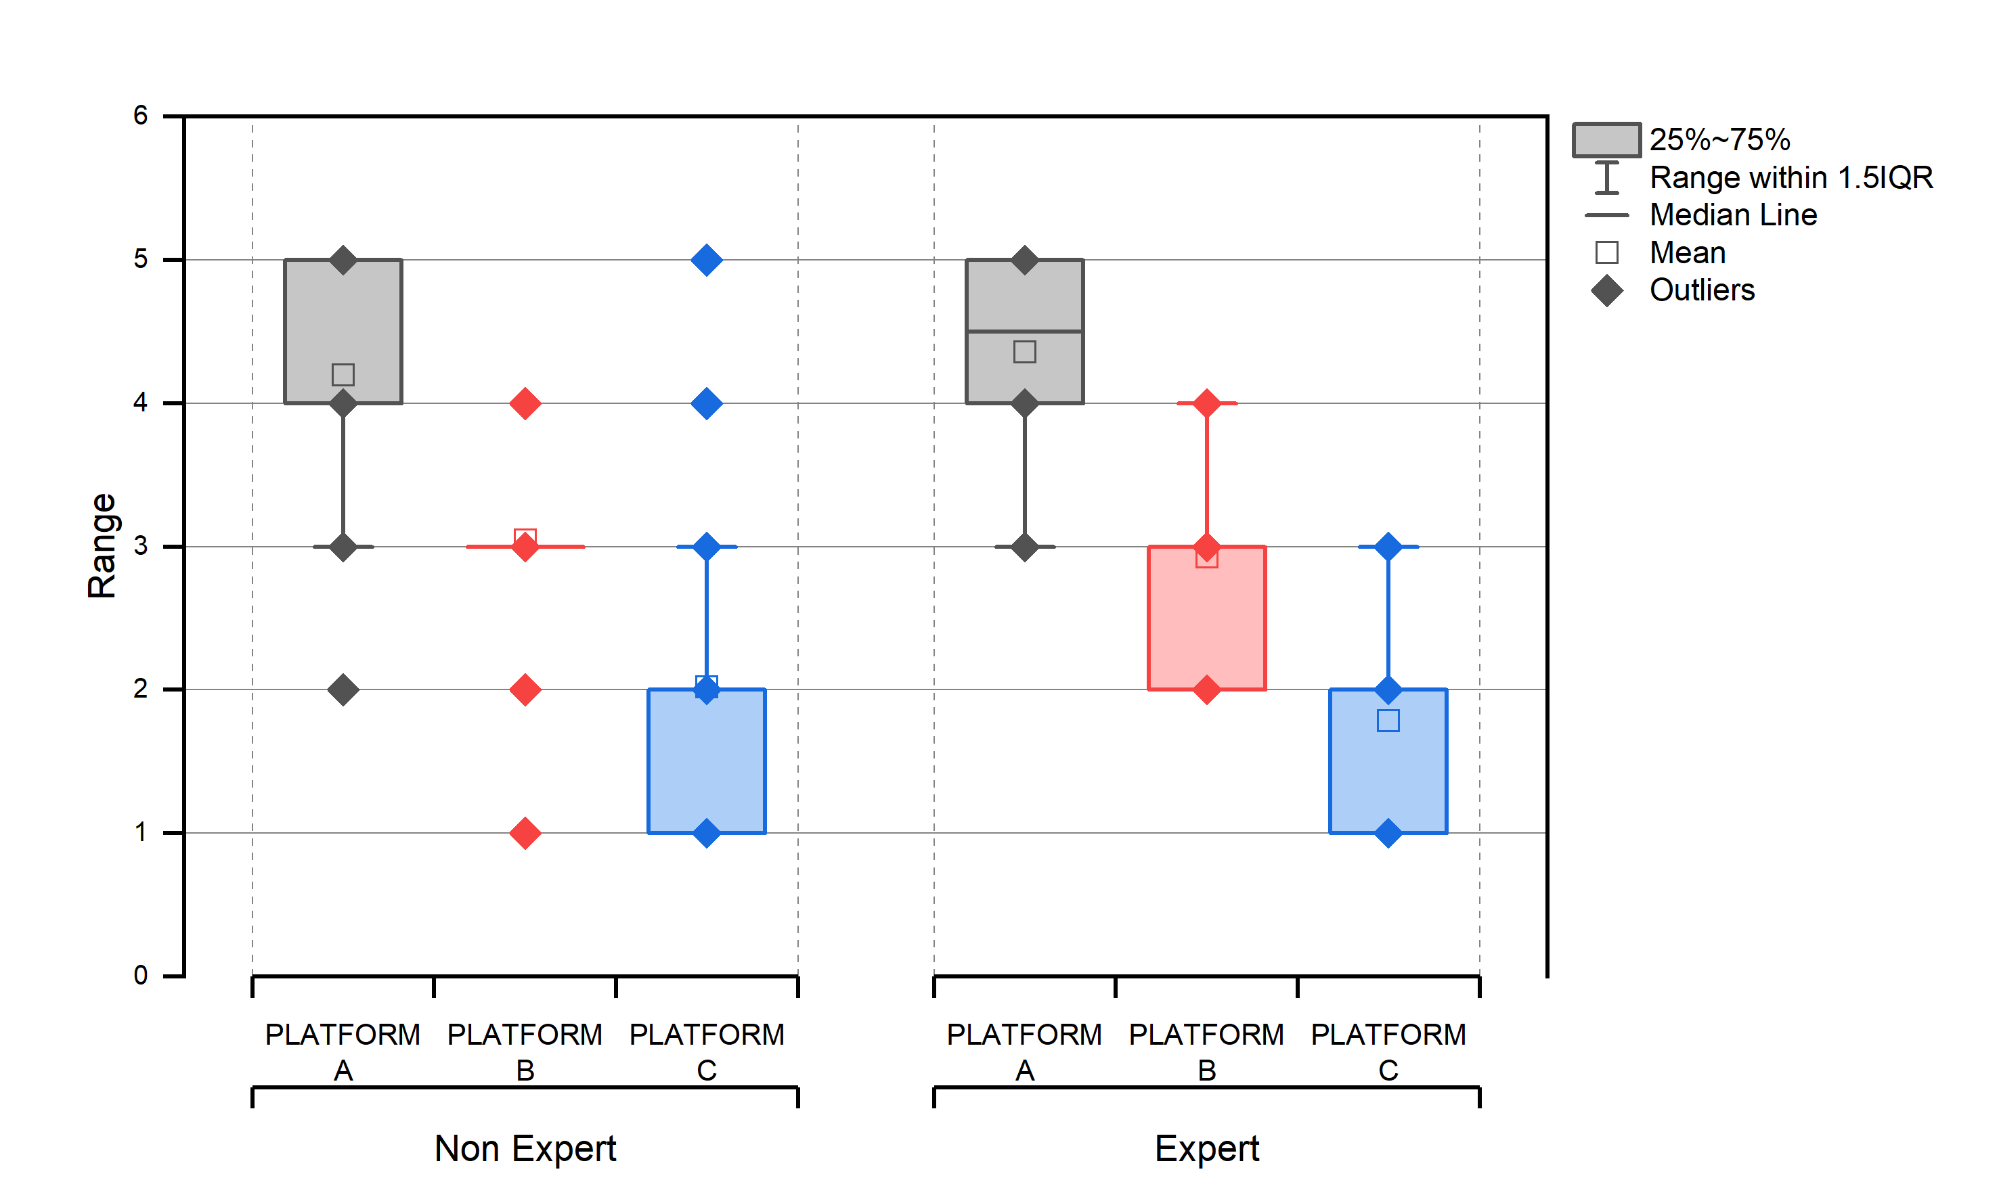
Figure 4. Topic 1 Noise Disturbance.

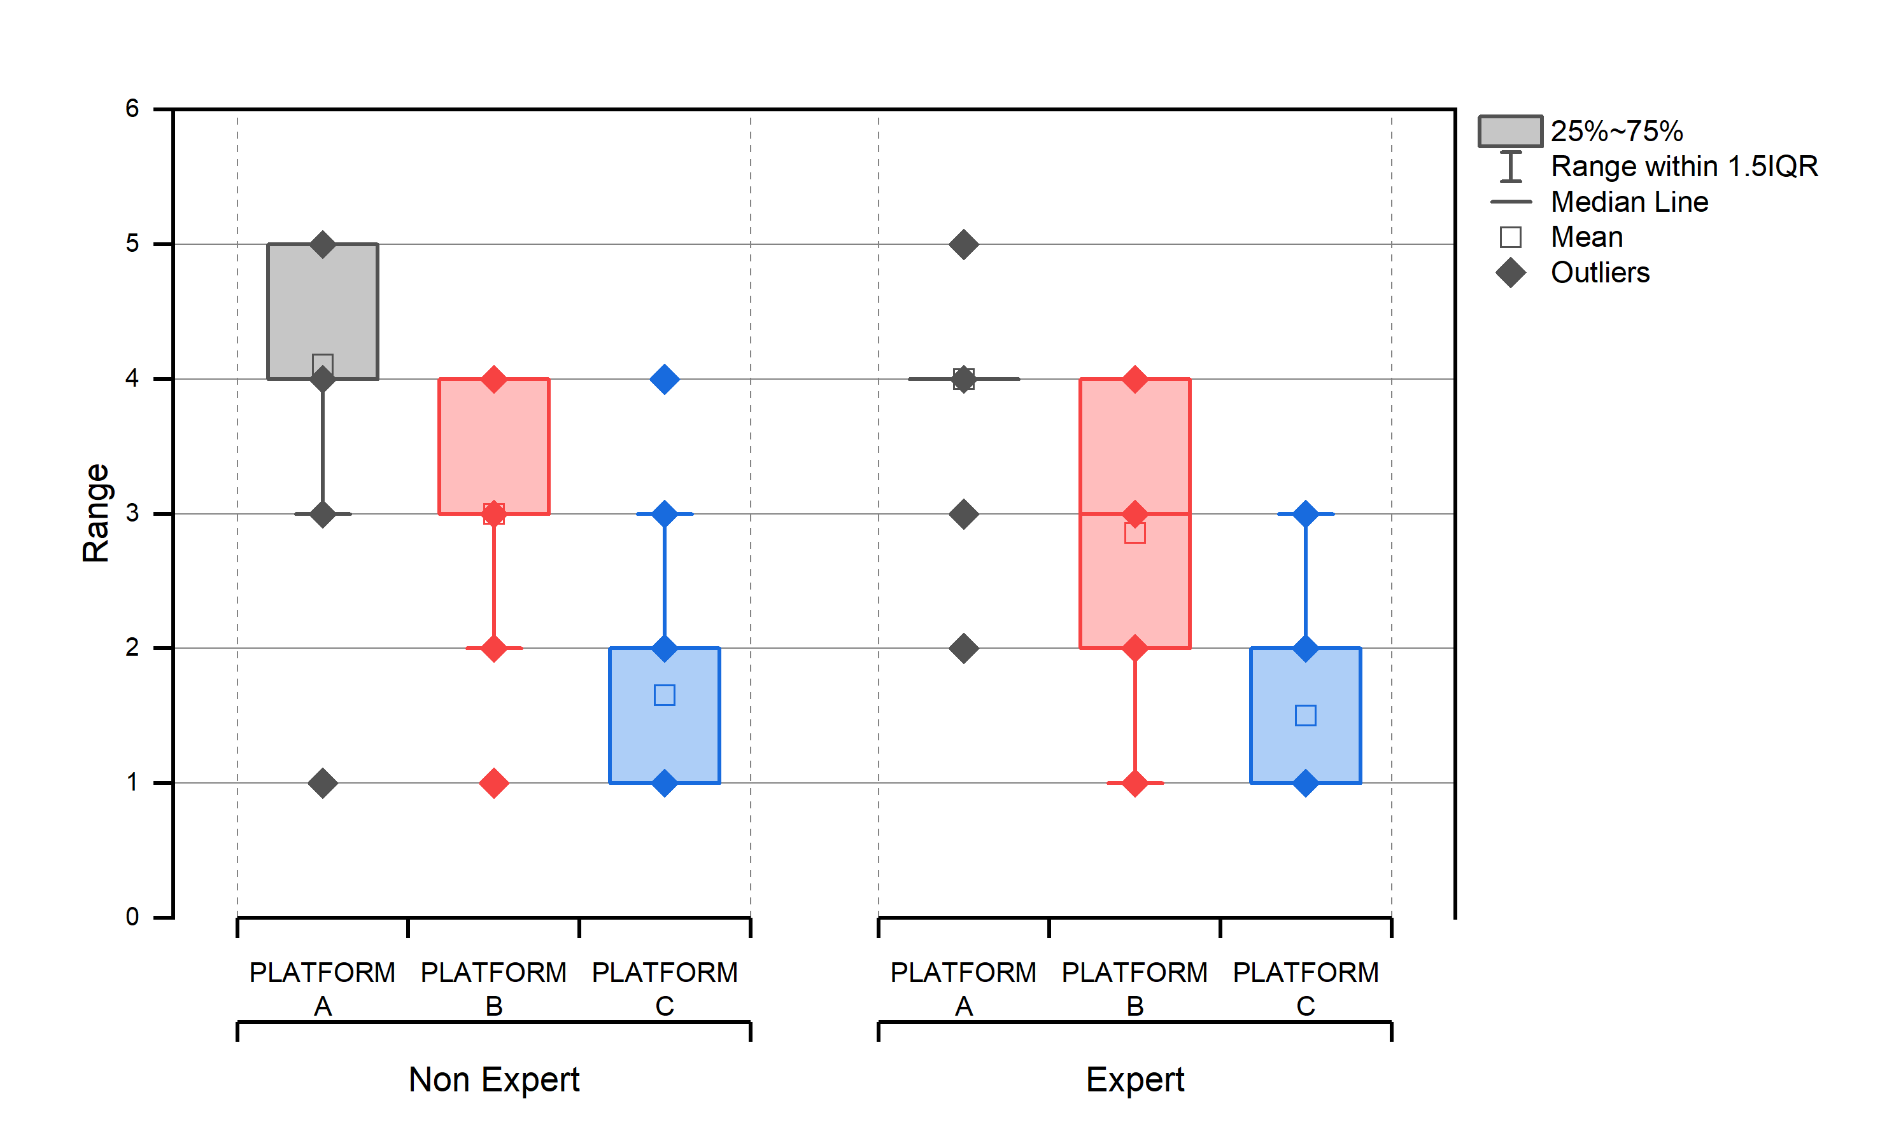
Figure 5. Topic 2 Hearing comfort in a pavilion.

Comfort levels of Non-Experts and Experts while listening to content inside the A, B, and C pavilions for 60 seconds.
In Pavilion A (without side partitions), non-experts perceived the comfort level was relatively low, with a few outliers indicating that some participants felt significantly more comfortable. In contrast, experts generally experienced a higher median comfort level, suggesting that they felt more comfortable overall. Additionally, there were fewer outliers among the expert group.
In Pavilion B (with 120cm side partitions), non-experts reported a moderate median comfort level with a wider interquartile range reflecting varied responses, while experts had a slightly higher median comfort level and a narrower range, indicating more consistent comfort among them.
In Pavilion C (with 240cm side partitions), non-experts reported a median comfort level comparable to that of Pavilion B, albeit with a few outliers, while experts experienced a higher median comfort level with a narrow range, suggesting greater consistency in their comfort levels. Overall, the experts generally reported higher and more consistent comfort levels across all three pavilions compared to the nonexperts. The mean data indicates that Pavilion A is uncomfortable, while Pavilions B and C fall within the range of moderately comfortable to very comfortable.
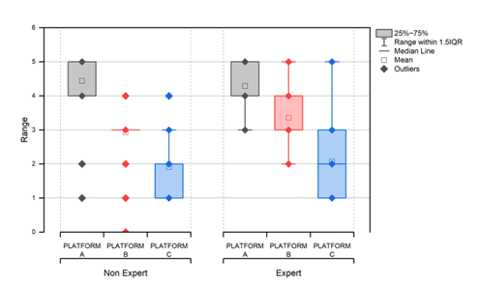
Figure 6. Topic 3. Recognizing content sounds from other pavilions.

The responses of nonexperts and experts regarding whether they could still hear the content sound from the next pavilion while standing in each of the A, B and C pavilions.
In Pavilion A, non-experts reported a median response suggesting that many participants could still hear content from the adjacent pavilion, with some outliers reflecting varied experiences, while experts had a higher median response, indicating they generally found it easier to hear the content, accompanied by fewer outliers that point to more consistent experiences.
In Pavilion B, non-experts reported a moderate median response with a wider interquartile range, indicating varied experiences, while experts had a slightly higher median response with a narrower range, suggesting more consistent experiences and easier hearing of content from the adjacent pavilion.
In Pavilion C, non-experts reported a median response comparable to that of Pavilion B, with some outliers reflecting varied experiences, while experts had a higher median response with a narrow range, indicating consistent experiences and generally noting only minimal noise from the adjacent pavilion.
The levels of distraction experienced by Non-Experts and Experts when the content of the adjacent pavilion is visible while standing in Pavilions A, B, and C.
In Pavilion A, non-experts reported a relatively high median distraction level due to the visibility of adjacent pavilion content, with several outliers indicating varied experiences, while experts had a lower median distraction level and a narrower range, suggesting they found it less distracting and had more consistent experiences.
In Pavilion B, non-experts reported a moderate median distraction level with a wider interquartile range, indicating varied experiences, whereas experts had a slightly lower median distraction level and a narrower range, suggesting more consistent experiences.
In Pavilion C, non-experts reported a lower median distraction level compared to Pavilions A and B, indicating fewer participants found the adjacent pavilion content distracting, with some outliers reflecting varied experiences, while experts also had a low median distraction level and a narrow range, indicating consistent experiences.
Pavilion A had the highest median distraction level. This interpretation shows that the visibility of the adjacent pavilion content can be a source of distraction.
The responses of Non-Experts and Experts regarding their urge to move to the next pavilion when the adjacent pavilion is visible.
In Pavilion A, non-experts showed a moderate to high median level of compulsion to move to the next pavilion, with several outliers indicating varied experiences, while experts had a lower but still high median response.
In Pavilion B, non-experts reported a moderate median response with a wider interquartile range, while experts had a slightly lower median response.
In Pavilion C, non-experts reported a lower median response compared to Pavilions A and B, suggesting that fewer participants felt compelled to move to the next pavilion, with minimal outliers, while experts also had a similarly low median response and a narrow range, indicating a low compulsion to move.
Non-experts consistently reported a greater compulsion to move to the next pavilion than experts across all pavilions, with Pavilion A exhibiting the highest median compulsion level for both groups; additionally, the visibility of the adjacent pavilion notably influenced the urge to move, especially in Pavilion A.
The results showed that pavilion A (without side partitions) was perceived by all respondents as unable to provide sufficient listening conditions. However, it created a good visual relationship with the surrounding space. The acoustic discomfort aspect was linear, with a low visitor concentration at pavilion A. This pavilion provides the most unsatisfactory acoustic conditions for some visitors and the lowest clarity of sound content. However, pavilion A provided the best visual connection with the surrounding environment, although it also made it easy for most visitors to escape from the pavilion. Pavilion A makes it difficult for visitors to concentrate on digesting the content. The opposite condition was found for pavilion C (with 240 cm partitions).
Pavilion B, featuring 120cm side partitions, emerged as a promising configuration. It successfully achieved an acoustic category deemed acceptable by most visitors. Interestingly, Pavilion B allowed visitors to hear external noise and noise from neighboring pavilions. Nonetheless, respondents, particularly experts, could still discern the content quite clearly although not and the clarity score achieved in Pavilion C.
In terms of visual appearance, configuration B offers optimal visual connectivity with the other pavilions and the surrounding spaces. Additionally, the urge to move quickly to the next pavilion was significantly reduced compared to Pavilion A, which lacks partitions. This was particularly noted among the nonexpert group members. This shows that maintaining partitions, with a minimum height of 120 cm, enhances the visitor concentration. According to visitors’ perceptions, a pavilion with narrow partitions can achieve an optimal balance between the visual-spatial and acoustic objectives. Consequently, the proposed pavilion model can be adapted into various design variants to suit different themes.

Based on statistical scores and data consistency, it can be concluded that humans are capable of distinguishing the acoustic conditions of a space through subjective sound perception. Furthermore, it was found that the subjectivity of the acoustic perception of exhibition visitors is influenced by the visual conditions formed by the spatial configuration.

DISCUSSION
The problem of the multimedia exhibition pavilion where designers tend to design pavilions with predominantly open configurations, even though such configurations are not in accordance with the acoustic requirements of an ideal space. This tendency should be investigated more thoroughly to identify its potential. This requires a comprehensive method. Not only digital simulations and instrumentation measurements that are objective but also intersubjective tactics that pay more attention to the human side of visitors.
During the digital simulation and RIR tests, the sound energy adequacy (G and SPL) content was found to be quite good due to the pavilion configuration. The distance between the listener and the speaker was quite short; thus, the direct sound was still quite strong even though it was crushed by the early reflected sound at many frequencies. In some positions, even early reflections from the front and side partitions amplified the sound intensity. Regarding the STI parameter, the two objective assessments tended to be in line with the poor range, but the digital simulation assessment showed results closer to the ideal STI range (0.6, 0.62, 0.64 of the 0.75 limit). In the propagation simulation, the Clarity (C80) was in the poor to fair range. The 3 pavilions can achieve aggregate direct sound in the 5-10dB range, although not at all frequencies. Fair conditions, in which direct sound can be clearly captured, tend to occur at frequencies below 500 Hz. For the reverberation time (RT) parameter that indicates noise, the two objective assessments produced figures above the ideal background noise of 1.4 s at most frequencies. Note that the simulation produced RT values that were closer to the ideal. The two objective assessments showed similar trends but revealed some fair conditions that may further reveal the acoustic potential of space.
The intersubjective experiment showed that pavilion A had poor room acoustics in terms of content intelligibility, noise, and listening concentration. In contrast, pavilion C was close to ideal in terms of these aspects. Optimum results were obtained for pavilion B in almost all aspects. While listening comfort is still achievable, pavilion B tends to be perceived as adequate in terms of distraction and concentration. This result reveals the acoustic potential of the 120-cm-wide partitions, which tend to produce a more spacious visual sense of space than the wider partitions. Another finding from this experiment is the human ability to perceive sounds differently. The subjects were able to distinguish between content sounds and background noise with sound intensity differences of less than 10dB. Theoretically, differences below 15dB would produce overlapping sound wave spectra (graph output), which would make it difficult to distinguish between direct-reflected sounds and content-background noise. This proves that human sensitivity is better than that previously understood through instrumental simulations.

CONCLUSION
The hypothesis is that humans can flexibly perceive sound flexibly. This is proven through mixed research methods, where several parameters that fall into the poor to fair range of measurable objective parameters can still be revealed in more depth through the acoustic perception of respondents. The performance data of the two assessment models tend to be in line, but intersubjective analysis can help reveal indications of weak potential in the objective assessment. The objective-intersubjective methods in room acoustics are compatible and complementary.

The results of this study propose an addition to the logic of acoustic isolation theory, that is, the popular open-configuration exhibition pavilion still has the potential to reach the acoustic threshold of an ideal space, with special attention to the side partitions, especially those with a basic dimension of 120cm wide.

REFERENCES
[1] | Y. Zhang, H. Bu, X. Zhao and S. Cao, "Performance-Based Design of a Main Exhibition Hall and Its Ecological Connectivity with Surroundings," Sustainability, vol. 13, no. 11622, pp. 1-15, 2021.
[2] | K. Lee, "The interior experience of architecture: An emotional connection between space and the body," Buildings 12, vol. 3, no. 326, pp. 1-16, 2022.
[3] | J. H. Rindel, "Preferred dimension ratios of small," JASA Express Letters, vol. 1, no. 2, pp. 1-6, 2021.
[4] | Y. Lu and J. Peponis, "Exhibition visitors are sensitive to patterns of display," Environment and Planning B: Planning and Design, vol. 41, pp. 53-68, 2014.
[5] | H. Elshanwany and Z. El-sayad, "Various classifications for architectural form finding process," The Egyptian International Journal of Engineering Sciences and Technology, vol. 32, pp. 32-42, 12 October 2020.
[6] | B. I. Farahat and K. A. Osman, "Towards a New Vision to Design a Museum in Historical Place," HRBC Journal, pp. 66-78, 2016.
[7] | J. H. Falk, Identity and the Museum Visitor Experience, New York: Routledge, 2016.
[8] | T. Everrett, "A curatorial guide to museum sound design," Curator: The Museum Journal, vol. 62, no. 3, pp. 313-325, 2019.
[9] | H. Han, S. Lee and S. S. Hyun, "Role of internal and external museum environment in increasing visitors," International journal of environmental research and public health , vol. 16, no. 22, pp. 1-15, 2019.
[10] | J. S. Snyder, "Sound perception: Rhythmic brain activity really is important for auditory segregation," Current Biology, vol. 25, no. 24, pp. 1173-1175, 2015.
[11] | R. M. Harahap, I. Santosa and W. Martokusumo, "INTERIORITY OF PUBLIC SPACE IN THE DEAF," SINERGI, vol. Vol. 23, pp. 245-252, 2019:.
[12] | A. Neidhardt, "Perception of the reverberation captured in a real room,," in 22nd Int. Congress on Acoustics (ICA), Buenos Aires, 2016.
[13] | N. Levent and A. Pascual-Leone, The Multisensory Museum: Cross-Disciplinary Perspectives on Touch, Sound, Smell, Memory, and Space, New York: Rowman & Littlefield Publishers, 2014.
[14] | E. Mendelli, "Spectacular Attractions: Museums,Audio-Visuals and the Ghosts of Memory," Acta Universitatis Sapientiae, Film and Media Studies, vol. 11, no. 1, pp. 77-92, 2015.
[15] | D. D'Orazio, F. Montoschi and M. Garai, "Acoustic comfort in highly attended museums: A dynamical model," Building and Environment, vol. 183, pp. 1-10, 2020.
[16] | M. Ermann, Architectural acoustics illustrated, London: John Wiley & Sons., 2015.
[17] | M. Barron and S. Kissner, "A possible acoustic design approach for multi-purpose auditoria suitable for both speech and music," Applied Acoustics, pp. 42-49, 2017.
[18] | A. P. O. Carvalho, L. M. M. Garcia and H. J. S. Gonçalves, "A multi-criteria method to assess the acoustic quality in museum," in National Conference on Noise Control Engineering 2014, Florida, 2014.
[19] | T. A. Kristianto, S. N. N. Ekasiwi and D. Arifianto, "Digital Geometry for Virtual Museum Based on Field Studies," The 20th Sustainable, Environment and Architecture, pp. 1-10, 2021.
[20] | P. Steadman, "Why are most buildings rectangular?," arq: Architectural Research Quarterly, pp. 119 -130, 2006.
[21] | N. R. Syamsiyah, A. Dharoko and S. S. Utami, "Mixed Method Approach towards Acoustic Research on the Grand Mosque of Yogyakarta," in International Seminar in Architecture and Planning “Evolution of Research Method, Yogyakarta, 2016.
[22] | A. N. R. D. K. N. P. D Arifianto, "Noise exposure hazard at supporting facilities of Dr. Soetomo General Hospital, Surabaya, Indonesia," in Regional Conference on Acoustics and Vibration 2017 (RECAV 2017) 27–28 November 2017, Bali, Indonesia, Bali, 2018.
[23] | Y. Chen and P. Fearnside, "Ray-tracing computer-aided-design tools in auditoria design-past and future," in Proceedings of Acoustics 2019, Victoria, 2019.
[24] | S. Mason, Simplified Architectural Models and Affected Acoustic Parameters, Gothenburg: Department of Architecture and Civil Engineering, 2020.
[25] | L. Savioja and U. P. Svensson, "Overview of geometrical room acoustic modeling techniques," The Journal of Acoustical Society of America, vol. 138, no. 708, 2015.
[26] | A. Grames and F. Boubenider, "Acoustic comfort evaluation for a conference room: A case study," Applied acoustics, vol. 18, pp. 39-49, 2016.
[27] | M. Pierrette, E. Parizet, P. Chevret and J. Chatillon, "Noise effect on comfort in open-space offices:," Ergonomics, vol. 58, no. 1, pp. 96-106, 2014.
[28] | T. Yang and J. Kang, "Subjective Evaluation of Sequential Spaces," Applied Acoustics, 2020.

