Water Quality Restoration Effort using Numerical Modelling in the Cikakembang River | 

Steven Kent^{1,2}, Doddi Yudianto^{1*}, Gao Cheng², Finna Fitriana¹, Wang Qian²
¹Department of Civil Engineering, Parahyangan Catholic University, Indonesia
²Institute of Water Science and Technology, Hohai University, China

Abstract  The poor condition of the Citarum River demands more significant pollution control. One alternative for controlling pollution can be limiting the amount of wastewater entering one of the tributaries of the Citarum River, namely the Cikakembang River. This study is a follow-up study that will model heavy metal parameters in the Cikakembang River. Data collection was carried out six times, where the heavy metal parameter detected was copper. Numerical modelling for copper parameters was carried out using MATLAB software with the Runge Kutte-4 discretisation scheme. The study location covers 2.36 km upstream of the Cikakembang River, with 12 textile industry wastewater disposal points. Numerical modelling results for copper parameters show a settling rate of heavy metal particles of 40 day⁻¹, with a maximum RRMSE value of 9.97%. Combining the water quality models for organic and heavy metal parameters created, pollution control simulations can be run in both seasons. The pollution control scenario aims to find the maximum amount that enters the Cikakembang River without passing the class four river water quality standards. The selection of the standard is based on the use of Cikakembang River water, namely for irrigation purposes. Based on the results of pollution control simulations, the pollutant carrying capacity for BOD, COD and copper parameters in the Cikakembang River is 199.43 kg/day, 1103.80 kg/day and 4.06 kg/day, respectively.  This is an open access article under the CC BY-SA license   | Keywords:  Cikakembang River;  Copper;  MATLAB;  Pollutant Carrying Capacity;  Pollution Control  Article History:  Received:  Revised:  Accepted:  Published:  Corresponding Author:  Doddi Yudianto  Civil Engineering Department, Parahyangan Catholic University, Indonesia  Email: doddi_yd@unpar.ac.id

INTRODUCTION
The Citarum River is the largest in West Java province, flowing from the Cisanti spring and emptying into the Java Sea [1]. The large area covered by the Citarum River means that the management of the Citarum watershed is divided into three areas: upper, middle, and lower [2]. Some of the functions supported by the Citarum River are as an electrical energy generator, fulfilling Jakarta's raw water needs by 80%, and supporting irrigation water needs covering an area of 420 thousand hectares [3], [4]. Even though the benefits of the Citarum River are so great, the water quality of the Upstream Citarum River was named one of the most polluted rivers in 2013 [5]. The study conducted by [6] analysed the Water Quality Index (WQI) in the upper Citarum watershed from 2011 to 2019. The WQI value in the upper Citarum watershed ranged from 11,528 to 62,348, so the status was very poor to fair [6].
One factor that has the potential to worsen the water quality of the Citarum River significantly is textile industry wastewater discharge in the Majalaya District. The textile industry in this area accounts for 40% of the total textile industry in Indonesia [7]. The resulting textile industry wastewater is discharged into the Cikakembang tributary, which flows into the Citarum River. The characteristics of textile industry wastewater are that it contains low concentrations of Dissolved Oxygen (DO) with high concentrations of Biological Oxygen Demand (BOD) and Chemical Oxygen Demand (COD) [8], [9], [10]. Some textile industry waste also contains heavy metals, such as zinc, chromium, copper and lead [11], [12]. Concentrations of BOD, COD and heavy metals parameters that exceed standards will damage the local aquatic ecosystem; if consumed by humans, they will be lethal [13], [14].
Previous studies conducted numerical modelling on the Cikakembang River using data-driven models for three organic parameters: DO, BOD, and COD [15]. This study will focus on two things, namely, modelling heavy metal parameters from textile industry wastewater and developing a pollution control program for the detected DO, BOD, COD and heavy metals parameters. Previously, the parameters of heavy metals that are pollutants will be identified. Numerical modelling will be made for the identified heavy metal parameters. Afterwards, the developed model will simulate several pollution control scenarios. This study will limit the pollutant values that the Cikakembang River can accommodate without exceeding the applicable quality standards. The results obtained can be used as a reference to determine more effective pollution control policies for the Citarum River.

METHOD
Study Location
This study covers a modelling area of 2.36 km upstream of the Cikakembang River, as shown in Figure 1. A total of 36 points in the location study were measured bathymetrically to obtain the river cross-sectional area. Then, water sampling was carried out at three locations, with detailed coordinates shown in Table 1. Each sampling location point had its reasons for selecting the location. The first sampling point is the upstream area of the Cikakembang River, where the dominant wastewater entering comes from domestic effluent. The second sampling point is in the middle of the Cikakembang River study location. Meanwhile, the third sampling point is downstream of the river, with the dominant type of wastewater being textile industry effluent.
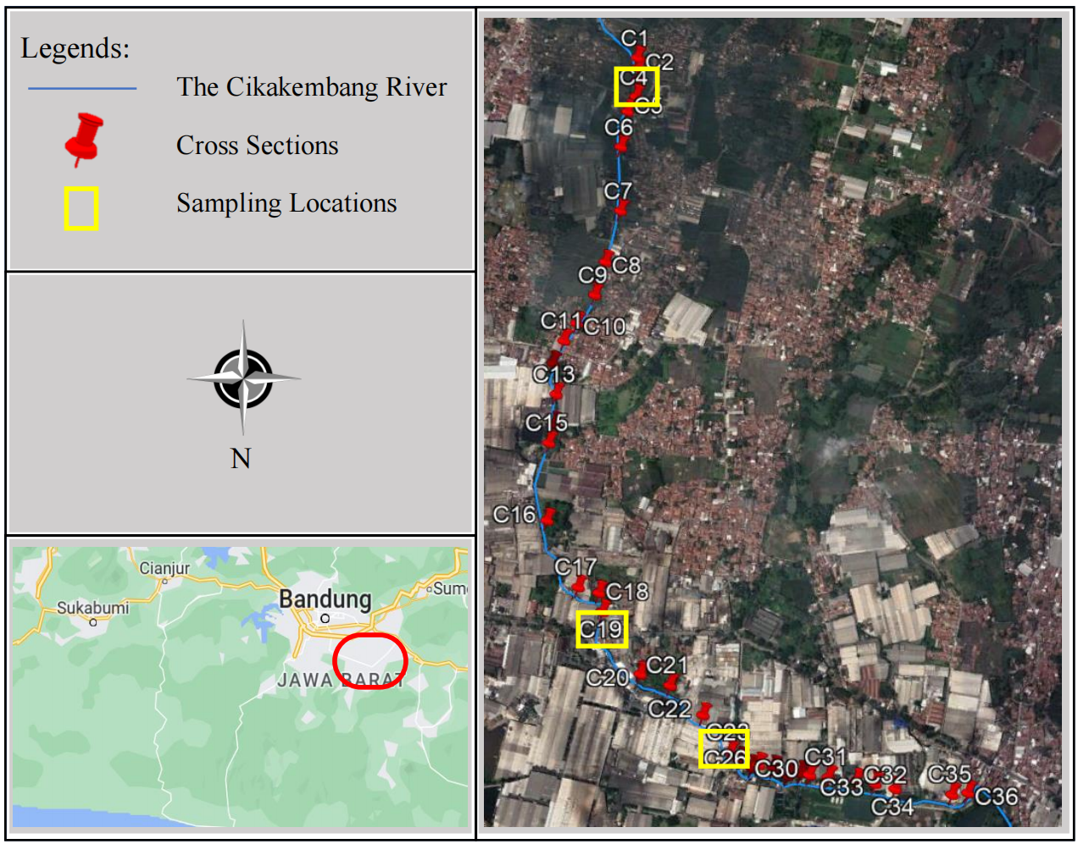
Figure 1. Research area
Table 1. Coordinates of sampling locations
Location Details | Sampling Point | Longitude | Latitude
C4 | S1 | 107.746 | -7.061
C19 | S2 | 107.746 | -7.050
C24 | S3 | 107.743 | -7.047

Research Flowchart
The research flowchart of this study is represented in Figure 2. First, pollutant parameters from heavy metals for textile industry wastewater will be identified. After that, data was collected on three types: water quality data through water sampling, hydraulic parameters, and physical parameters. Data was collected six times from 27 January 2022 to 19 October 2022. Three were taken during the rainy season, and the others were taken during the dry season. Water samples from the Cikakembang River are tested at Parahyangan Catholic University for four parameters: Copper, Iron, Zinc, and Chromium. Hydrodynamic modelling was carried out in the same process using HEC-RAS to obtain hydraulic parameters at 36 points at the study location.
Afterwards, a water quality model for heavy metal parameters was developed using MATLAB. Numerical modelling was carried out using the Runge Kutte-4 explicit discretisation scheme. The calibration and verification process was carried out to obtain the water quality coefficient value for the Cikakembang River. Furthermore, pollution control was developed in the Cikakembang River using the water quality coefficient values obtained. Pollution control simulations are carried out in the rainy and dry seasons with four scenarios. Each scenario will show the impact of the amount of incoming waste on the water quality conditions of the Cikakembang River. Then, limits on the amount of wastewater entering the Cikakembang River during the rainy and dry seasons can be determined.

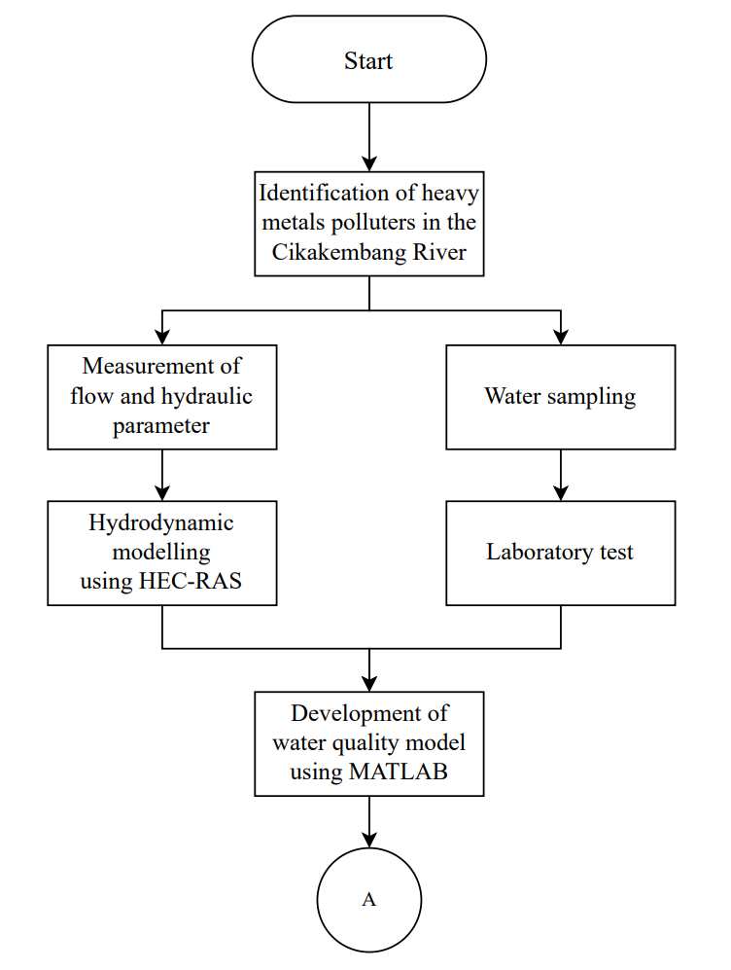 | 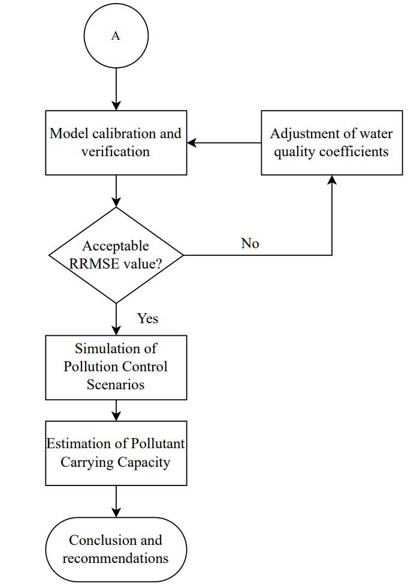
Figure 2. Research Flowchart

Data Availability
This study assumes the rainy season starts from October to April, while the dry season starts from May to September. The results of water samples testing on four heavy metals parameters are shown in Figure 3, with black and red showing data taken during the rainy and dry seasons, respectively. To see how severe the concentration of heavy metals parameters is in the Cikakembang River, river water quality standards according to Indonesian government regulation no. 22 of 2021 are used. Based on the test results, it was found that the Zinc, Chromium and Iron content parameters were often under the range or in the safe range. So, in this study, numerical modelling for heavy metal parameters was only carried out for copper parameters.
Hydraulic and physical parameters of the Cikakembang River are shown in Table 2 and Table 3, respectively. The hydraulic parameters measured are flow velocity and water depth. Measurements for hydraulic parameters were carried out on 19 October 2022 and 24 August 2022. Two data were measured for physical parameters: pH and water temperature. Physical parameter measurements were also carried out on the same date as hydraulic parameter measurements.

(a) | (b) | (c) | (d)
Figure 3. Heavy Metals Concentration for (a) Copper, (b) Zinc, (c) Iron, and (d) Chromium

Table 2. Hydraulic Parameter of the Cikakembang River
Parameter | Sampling Points | 10/19/2022 (Rainy Season) | 8/24/2022 (Dry Season)
Flow rate (m/s) | S01 | 0.56 | 0.63
Flow rate (m/s) | S02 | 1.05 | 0.70
Flow rate (m/s) | S03 | 0.46 | 0.44
Hydraulic depth (m) | S01 | 0.33 | 0.38
Hydraulic depth (m) | S02 | 0.27 | 0.25
Hydraulic depth (m) | S03 | 0.56 | 0.35
Table 3. Physical Parameter of the Cikakembang River
Parameter | Sampling Points | 10/19/2022 (Rainy Season) | 8/24/2022 (Dry Season)
pH | S01 | 7.25 | 6.57
pH | S02 | 6.86 | 6.79
pH | S03 | 7.15 | 6.93
Temperature (˚C) | S01 | 28.00 | 29.00
Temperature (˚C) | S02 | 28.00 | 30.00
Temperature (˚C) | S03 | 28.00 | 29.00

The Governing Equation
Pollutant transport is formulated using the Advection-Dispersion Equation (ADE), with each reaction derived from the parameters considered [16], [17]. ADE for heavy metals parameters can be seen in Equation (1).
(1)
Where:
$C_{u}$ : Copper’s concentration (mg/L)
$u_{x}$ : Advection term (m/s)
$E_{x}$ : Dispersion coefficient (m/s²)
$α$ : Settling coefficient for copper (day⁻¹)
Heavy metal parameters do not decompose like other organic parameters. Heavy metals in the flow can be found in two phases: the dissolved and deposited phases. Sedimentation and erosion processes in channels are the main causes of phase changes experienced by heavy metals parameters. When wastewater containing heavy metals enters a river flow, these parameters will first be found in the dissolved phase. As the flow progresses, heavy metal particles will be absorbed by sediment and sedimented at the bottom of the channel. Heavy metal particles that have been sedimented will be able to return to the dissolved phase if channel erosion occurs. Channel erosion will cause flow fluctuations, releasing heavy metal particles from the sediment back to a dissolved state. This process has been modelled by [18] using a constant that describes the settling coefficient of the heavy metal particles concerned [19]. The settling coefficient values of the heavy metal parameters will be estimated during the calibration and verification process.

Discretization Scheme
ADE for the Copper parameter can be solved using the Runge Kutte-4 explicit discretisation scheme, with mathematical formulas written in Equation 2 to Equation 6. The Runge Kutte-4 discretization scheme is often used to solve differential equations because of its ease of computing [20], [21].

(2)

(3)

(4)

(5)

(6)
Where:
$Cu_{i}^{t}, Cu_{i-1}^{t}, Cu_{i+1}^{t}$ : Copper’s concentration at each spatial step with temporal step-t (mg/L).
$Cu_{i}^{t+1}$ : Copper’s concentration at each spatial step with temporal step-t+1 (mg/L).
$∆t$ : The temporal step (s)
$∆x$ : The spatial step (m)
$k_{1}^{t}, k_{2}^{t}, k_{3}^{t}, k_{4}^{t}$ : Runge Kutte-4 constants

Hydraulic Parameter of the Cikakembang River
Water quality modelling requires Cikakembang River hydraulic parameters to estimate the value of water quality coefficients, such as the dispersion coefficient (E_{x}). Previous research has succeeded in producing hydraulic parameters for the Cikakembang River in the rainy season and dry season, such as longitudinal flow velocity (u_{x}), Froud Number (Fr), water depth (H), and channel's top width (W) [15]. All hydraulic parameters of the Cikakembang River are shown in Figure 4.

(a)

(b)
Figure 4. Existing Hydraulic Parameter of the Cikakembang River in (a) Rainy Season and (b) Dry Season
Point Source Pollution (PSP)
The source of copper parameter pollution that enters the Cikakembang River comes from the textile industry. Twelve PSPs were detected, with detailed locations depicted using the scheme in Figure 5. Prior research has successfully estimated the discharge value at each PSP, ranging from 0.001 m³/s to 0.053 m³/s.
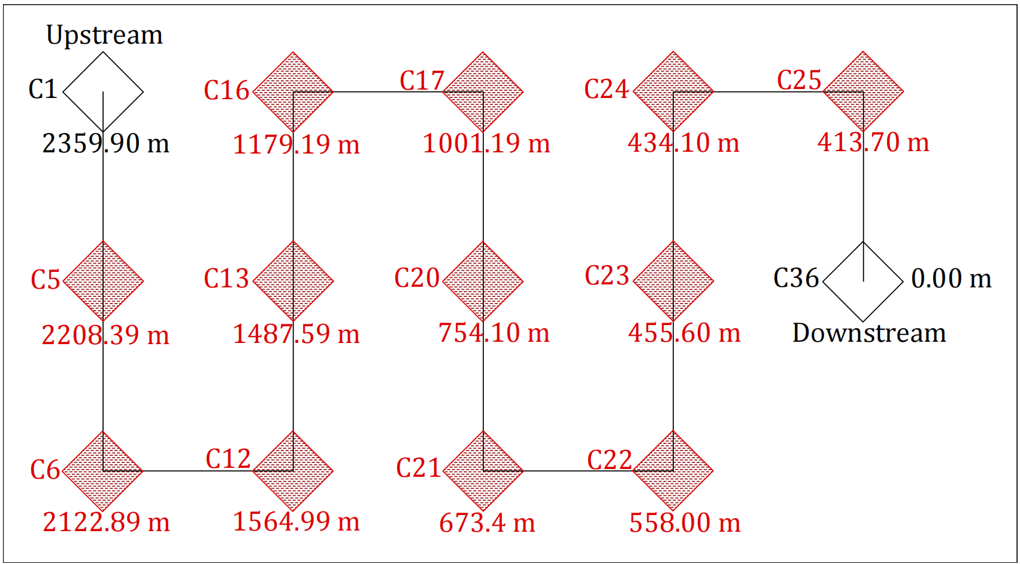
Figure 5. PSP Discharging Scheme of the Cikakembang River

Relative Root Mean Square Error (RRMSE)
Evaluation of modelling results is needed to measure the accuracy of water quality coefficient values in the calibration and verification process. Relative Root Mean Square Error is an objective function measuring the error percentage in the observation data. The mathematical formula for calculating RRMSE can be seen in Equation 7. The error threshold for using RRMSE to declare the model accurate is 10% [22].
(7)
Where:
 | : | Relative Root Mean Square Error (unitless).
 | : | The mean observed data of a particular parameter (mg/L).
 | : | The observed data of a particular parameter (mg/L).
 | : | The model’s result of a particular parameter (mg/L).
 | : | Total amount of observation data (unitless).
Relative Root Mean Square Error (RRMSE)
Estimating the maximum amount of waste load without exceeding river water quality standards to a certain level can be an appropriate pollution control program. The pollutant carrying capacity (PCC) calculate the flowrate that includes variable discharge and effluent concentration discharged into the channel [23]. The mathematical formula for calculating PCC is written in Equation 8 [24].

(8)

Where:
 | : | Pollutant Carrying Capacity of a particular solute (kg/day)
 | : | Industrial effluent discharge (m³/s)
 | : | Industrial effluent’s concentration of a particular solute (mg/L)

The Indonesian Water Quality Regulations
The development of pollution control requires reference regulations to evaluate water quality conditions. This study uses two regulations from Indonesia relating to water quality. The first regulation is the Indonesian River Water Quality Standard No. 22 of 2021. River water quality regulations will be used to assess the pollution level of the Cikakembang River after including a certain level of pollutant load. The second regulation is the Indonesian Textile Industry Wastewater Standard No. 16 of 2019. Textile industry wastewater regulations were used to estimate the Cikakembang River PCC in a trial-and-error process. The copper parameter in the Indonesian textile industry waste regulations has not yet been regulated in terms of its levels, so the chromium parameter is the reference concentration. These two regulations can be seen in Table 4 and Table 5, respectively.
Table 4. River Water Quality Standard No. 22 of 2021 [25]
Parameter | River Water Quality Standards
Parameter | Class 1 | Class 2 | Class 3 | Class 4
DO (mg/L) | >6 | >4 | >3 | >1
BOD (mg/L) | <2 | <3 | <6 | <12
COD (mg/L) | <10 | <25 | <40 | <80
Cu (mg/L) | <0.02 | <0.02 | <0.02 | <0.2
Table 5. Textile Industry Wastewater Standard No. 16 of 2019 [26]
Discharge | BOD | COD | Cr
≤ 100 | 60 | 150 | 1
100 < x < 1000 | 45 | 125 | 1
≥ 1000 | 35 | 115 | 1
m³/day | mg/L | mg/L | mg/L

RESULTS AND DISCUSSION
Model Setup
The water quality model for heavy metals parameters will be simulated three times, namely once in the calibration process and twice in the verification process. The numerical model will be calibrated using observation data on 23 February 2022. Then, the verification process will be carried out using observation data on 24 August 2022. The concentration of copper parameters on 24 August 2022 was only detected at two sampling points. Further validation is needed to assess the accuracy of the modelling results so that observation data on September 7, 2022, will be used in the second verification process.
This study uses Dirichlet's and Neumann's boundary conditions methods at the upstream and downstream channels. Dirichlet's boundary condition determines the magnitude of a parameter. Neumann's boundary condition method assumes that the change in the gradient of a parameter is zero. Using Neumann's boundary condition principle, the numerical computation of a parameter at one point can be written as having the same value as the quantity at the previous point. Details of the boundary condition values used can be seen in Table 6.
Table 6. The Detail of Boundary Conditions Used in Calibration and Verification Processes
Location | Symbol | Process
Location | Symbol | C | V1 | V2
Upstream |  | 0.235 mg/L | 0.155 mg/L | 0.42 mg/L
Downstream
The stability of the water quality model also needs to be considered by setting the Courant Number value. This study set the Courant Number value below one, with a mathematical formula in Equation 9. The temporal step, spatial step and courant number values used in modelling are shown in Table 7.
(9)
Where:
$CN$ : Courant Number (unitless)
$u_{x}$ : Longitudinal flow velocity (m/s)
$∆t$ : The temporal step (s)
$∆x$ : The spatial step (m)

Table 7. Validating the Model's Stability
Variable | Units | Rainy Season | Dry  Season
 | s | 20.00
 | m | 20.40 – 186.60
CN | unitless | 0.03 – 0.83 | 0.03 – 0.90
Water quality modelling will be run for 24 hours starting from 06.00 AM. Domestic wastewater disposal into the Cikakembang River will not be regulated while the model runs. Working hours from 08.00 AM to 05.00 PM are used as textile industry wastewater disposal time. The concentration of copper parameters in the effluent at each PSP point is regulated according to the textile industry wastewater quality standards, namely 1 mg/L.
Calibration and Verification
Two water quality coefficients need to be calibrated: the dispersion coefficient (E_{x}) and the settling coefficient for the copper parameter (α). The dispersion coefficient for the Cikakembang River has been estimated using the regression equation developed by Iwasa and Aya (1991). The dispersion coefficient value ranges from 2.33 m²/s to 7.64 m²/s and 2.31 m²/s to 7.54 m²/s, respectively, in the rainy and dry seasons. The slight difference in the dispersion coefficient value is caused by differences in the hydraulic parameters of the Cikakembang River in the two seasons. The value is calibrated using the trial-and-error method for the settling coefficient for the copper parameter. This study uses an α value of 40 day⁻¹ in the calibration and verification.
The results of numerical modelling for copper parameters are shown in Figure 6. Next, the modelling results are evaluated using the RRMSE objective function. The RMMSE values for the three modelling results are shown in Table 8. The evaluation results of the three simulation results produced RRMSE values below 10%, so the modelling results were declared accurate.

(a)

(b)

(c)
Figure 6. The Numerical Modelling Results of Copper Parameter in (a) Calibration Process, (b) Verification Process-1, and (c) Verification Process-2
Table 8. The RRMSE Values of Copper Numerical Modelling Results
Objective Function | Process
Objective Function | C  (02/23/22) | V1  (08/24/22) | V2  (09/07/22)
RRMSE (%) | 2.30 | 2.41 | 9.97
Pollution Control Scenario
Combining the results of previous research with the current study, the water quality model for the DO, BOD, COD and Cu parameters has been obtained. The pollution control developed focuses on estimating the PCC of the Cikakembang River due to textile industry wastewater without passing class four river water quality standards in the rainy and dry seasons. The selection of the reference standard for class four river water quality standards is based on the function of the Cikakembang River, which is used for irrigation purposes.
In the first step in the pollution control simulation, the upper boundary conditions must be set as the third-class river water quality standard. Then, the PSP discharge value for each textile industry effluent is changed to 1000 m³/day, or the equivalent of 0.012 m³/s by the lower limit in textile industry wastewater regulations No. 16 of 2019.
The selection of the discharge value of 1000 m³/day was based on the similarity of the hydraulic parameter characteristics between the pollution control scenario and the existing condition. All hydraulic parameter values used in the pollution control simulation can be seen in Figure 7.

(a)

(b)
Figure 7. Hydraulic Parameters of the Cikakembang River in Pollution Control Simulations of (a) Rainy Season and (b) Dry Season

Changes in the hydraulic parameters of the Cikakembang River in the pollution control simulation also change several water quality coefficient values. Small changes in water quality coefficient values are found in the reaeration rate (K_{a}), decomposition rate for the COD parameter (K_{c}), and dispersion coefficient (E_{x}). The values of all water quality coefficients used for pollution control simulations can be seen in Table 9.
Table 9. Water Quality Coefficients Used in the Pollution Control Simulations

Water Quality Coefficients | Units | Value Used
Water Quality Coefficients | Units | Rainy Season | Dry Season
Reaeration Rate (K_{a}) | day⁻¹ | 10.13 - 48.27 | 10.21 - 45.92
Deoxygenation Rate (K_{d}) | day⁻¹ | 0.23
Decomposition Rate (K_{c}) | day⁻¹ | 0.27 - 3.77 | 0.27 – 4.31
Dispersion Coefficients (E_{x}) | m²/s | 2.32 - 7.60 | 2.31 – 7.52
Settling Coefficient for Copper Parameter (α) | day⁻¹ | 40.00

The pollution control simulation produces maximum concentration values for the textile industry effluent's BOD, COD and Cu parameters. Meanwhile, the DO parameter concentration is set at one mg/L because the applicable regulations do not state a minimum standard for recovering DO levels. Table 10 shows the value of the effluent load entering the Cikakembang River during the pollution control simulation. Figure 8 and Figure 9 show the effects of entering textile industrial effluent into the Cikakembang River without passing class four river water quality standards in the rainy and dry seasons, respectively. The PCC of the Cikakembang River is calculated for both seasons and is shown in Table 11.

Table 10. Pollution Control Scenario in Rainy and Dry Season
Point | Location (m) | Q_{eff}  (m³/s) | Rainy Season |  |  |  | Dry Season
Point | Location (m) | Q_{eff}  (m³/s) | DO_{eff} | BOD_{eff} | COD_{eff} | Cu_{eff} | DO_{eff} | BOD_{eff} | COD_{eff} | Cu_{eff}
Point | Location (m) | (m³/s) | (mg/L) | (mg/L) | (mg/L) | (mg/L) | (mg/L) | (mg/L) | (mg/L) | (mg/L)
C5 | 2208.39 | 0.012 | 1.00 | 23.00 | 145.00 | 0.54 | 1.00 | 18.95 | 122.00 | 0.42
C6 | 2122.89 | 0.012 | 1.00 | 23.25 | 147.50 | 0.54 | 1.00 | 18.95 | 121.00 | 0.42
C12 | 1564.99 | 0.012 | 1.00 | 22.00 | 97.50 | 0.44 | 1.00 | 19.20 | 93.50 | 0.38
C13 | 1487.59 | 0.012 | 1.00 | 22.00 | 94.75 | 0.43 | 1.00 | 19.20 | 89.50 | 0.38
C16 | 1179.19 | 0.012 | 1.00 | 18.85 | 88.50 | 0.37 | 1.00 | 17.25 | 86.50 | 0.34
C17 | 1001.19 | 0.012 | 1.00 | 18.85 | 88.50 | 0.37 | 1.00 | 17.13 | 86.50 | 0.33
C20 | 754.10 | 0.012 | 1.00 | 15.75 | 85.00 | 0.37 | 1.00 | 14.90 | 84.00 | 0.36
C21 | 673.40 | 0.012 | 1.00 | 15.75 | 85.00 | 0.37 | 1.00 | 14.85 | 84.00 | 0.36
C22 | 558.00 | 0.012 | 1.00 | 15.65 | 85.00 | 0.31 | 1.00 | 14.80 | 84.20 | 0.28
C23 | 455.60 | 0.012 | 1.00 | 15.53 | 85.00 | 0.31 | 1.00 | 14.80 | 84.20 | 0.27
C24 | 434.10 | 0.012 | 1.00 | 15.53 | 85.00 | 0.30 | 1.00 | 14.70 | 84.20 | 0.27
C25 | 413.70 | 0.012 | 1.00 | 15.53 | 85.00 | 0.30 | 1.00 | 14.70 | 84.20 | 0.27
Maximum |  |  | 1.00 | 23.25 | 147.50 | 0.54 | 1.00 | 19.20 | 122.00 | 0.42
Minimum |  |  | 1.00 | 15.53 | 85.00 | 0.30 | 1.00 | 14.70 | 84.00 | 0.27
(a) | (b) | (c) | (d)
Figure 8. Pollution Control Simulations Results in Rainy Season for (a) DO, (b) BOD, (c) COD, and (d) Copper Parameter
(a) | (b) | (c) | (d)
Figure 9. Pollution Control Simulations Results in Dry Season for (a) DO, (b) BOD, (c) COD, and (d) Copper Parameter

Table 11. Pollutant Carrying Capacity of the Cikakembang River
Season | PCC (kg/day)
Season | BOD | COD | Cu
Rainy | 221.68 | 1171.75 | 4.61
Dry | 199.43 | 1103.80 | 4.06
Discussion
This study has carried out water quality modelling for copper parameters in the Cikakembang River. Modelling consists of calibration and verification processes, where all simulation results are evaluated using the RRMSE objective function. The second verification process produced the highest RRMSE value at 9.97%. This value is very close to the error threshold of 10%, which can declare the model acceptable. Nevertheless, all simulation results have RRMSE values below this threshold, so the model is declared accurate.
Cikakembang River water quality modelling for heavy metals parameters was carried out using the assumption that there was no erosion in the channel. The model developed cannot model the parameters of heavy metals from the precipitated phase back to the particulate phase. Further research is needed to develop a hydraulic model so that erosion locations and changes in hydraulic parameters in the channel can be detected.
Pollution control simulation was conducted on DO, BOD, COD and copper parameters. There are changes in hydraulic parameters in the pollution control simulation due to changes in industrial wastewater discharge values at each PSP. Changes in water quality coefficient values in pollution control simulations differ greatly from existing modelling conditions.
The textile industry wastewater quality standards do not contain a DO value limit, so the DO concentration in the textile industry effluent is allowed to be 1 mg/L. Even though the simulation results show DO levels are between class three and class four river water quality standards, stakeholders must propose effluent concentration limits for DO parameters before being discharged into the river. This can be important in overcoming pollution due to BOD and COD parameters in textile industry waste.
As written in Table 11, the PCC of the Cikakembang River is greater in the rainy season than in the dry season. Rivers can better accommodate wastewater during the rainy season because the river's ability to regenerate is better during the rainy season. Establishing a pollution control policy requires a single value that can be used in both seasons. So, the industrial effluent concentration values recommended for use result from dry season pollution control simulations.

CONCLUSIONS
A water quality model for heavy metal parameters, especially copper, in the Cikakembang River has been successfully developed. The developed model can describe the number of copper particles in the particulate phase, which will settle at the bottom of the channel. The heavy metal modelling results were evaluated using the RRMSE objective function, with a maximum value of 9.97%. Based on the threshold error value, namely 10%, the modelling can be said to have good accuracy.
Combining the heavy metal and organic parameters models, pollution control simulations were carried out to estimate the pollutant carrying capacity (PCC) of the Cikakembang River. The main objective of pollution control is to restore the Cikakembang River water to be used for irrigation. If the two PCCs are compared, the simulation results in the dry season are smaller than those in the rainy season. The PCC for BOD, COD and copper parameters is 199.43 kg/day, 1103.80 kg/day and 4.06 kg/day, respectively. Any parameter that exceeds the PCC value will cause the Cikakembang River water condition to exceed class four river water quality standards.
Limiting the Cikakembang River's water quality to at least class four river water quality standards can regenerate the Citarum River, which is the main river, even better. Future research could focus more on investigating other areas that have the potential to pollute the Citarum River from its upstream. Apart from that, in the Majalaya District area, other pollutant parameters, both organic and inorganic, from different industries can be investigated.

REFERENCES

[1] F. F. Fitriana, D. Yudianto, S. Sanjaya, A. F. V Roy, and Y. C. Seo, “The Assessment of Citarum River Water Quality in Majalaya District, Bandung Regency,” Rekayasa Sipil, vol. 17, no. 1, pp. 37–46, Jan. 2023, doi: 10.21776/ub.rekayasasipil.2023.017.01.6.
[2] E. G. A. Sapan, S. A. R. Riandasenya, Yulianingsani, Anisah, M. K. Ilmi, and M. I. Habibie, “Health assessment of the Upper Citarum Watershed, West Java, Indonesia,” in IOP Conference Series: Earth and Environmental Science, Institute of Physics, 2022. doi: 10.1088/1755-1315/1109/1/012082.
[3] H. Jeong et al., “The distributions of microplastics (MPs) in the Citarum River Basin, West Java, Indonesia,” Journal of Environment and Safety, pp. 33–43, 2021, doi: https://doi.org/10.11162/daikankyo.E21RP0102.
[4] L. Lukman, E. S. Kartamihardja, S. Hariyadi, Sunardi, and D. Sumiarsa, “Brief overview of allochtonous phosphorus load on cascade reservoirs in Citarum River Basin, West Java Indonesia,” in IOP Conference Series: Earth and Environmental Science, Institute of Physics, 2022. doi: 10.1088/1755-1315/1062/1/012021.
[5] R. Yokosawa and T. Mizunoya, “Improving Water Quality in the Citarum River through Economic Policy Approaches,” Sustainability (Switzerland), vol. 14, no. 9, May 2022, doi: 10.3390/su14095038.
[6] M. Marselina and N. M. Putri, “Sustainability Analysis of the Upper Citarum Watershed Based on Water quality, Water quantity, and Landuse Indicators,” in IOP Conference Series: Earth and Environmental Science, Institute of Physics, 2022. doi: 10.1088/1755-1315/1065/1/012043.
[7] F. Fitriana, D. Yudianto, A. Polisar, and S. Sanjaya, “Investigation of Deoxygenation Rate Determination in Cikakembang River, West Java, Indonesia,” Journal of the Civil Engineering Forum, pp. 49–58, Jan. 2024, doi: 10.22146/jcef.8377.
[8] A. P. Periyasamy, “Recent Advances in the Remediation of Textile-Dye-Containing Wastewater: Prioritizing Human Health and Sustainable Wastewater Treatment,” Jan. 01, 2024, Multidisciplinary Digital Publishing Institute (MDPI). doi: 10.3390/su16020495.
[9] X. Wang, J. Jiang, and W. Gao, “Reviewing textile wastewater produced by industries: characteristics, environmental impacts, and treatment strategies,” Apr. 01, 2022, IWA Publishing. doi: 10.2166/wst.2022.088.
[10] A. Azanaw, B. Birlie, B. Teshome, and M. Jemberie, “Textile effluent treatment methods and eco-friendly resolution of textile wastewater,” Case Studies in Chemical and Environmental Engineering, vol. 6, Dec. 2022, doi: 10.1016/j.cscee.2022.100230.
[11] M. Khalish, A. Utami, H. Lukito, and S. Herlambang, “Evaluation of Textile Industry Wastewater Treatment as an Effort to Control River Water Pollution in Central Java,” KnE Life Sciences, Jun. 2022, doi: 10.18502/kls.v7i3.11106.
[12] J. M. Bidu, B. van der Bruggen, M. J. Rwiza, and K. N. Njau, “Current status of textile wastewater management practices and effluent characteristics in Tanzania,” Water Science and Technology, vol. 83, no. 10, pp. 2363–2376, May 2021, doi: 10.2166/wst.2021.133.
[13] L. A. Castillo-Suárez, A. G. Sierra-Sánchez, I. Linares-Hernández, V. Martínez-Miranda, and E. A. Teutli-Sequeira, “A critical review of textile industry wastewater: green technologies for the removal of indigo dyes,” Sep. 01, 2023, Institute for Ionics. doi: 10.1007/s13762-023-04810-2.
[14] S. Mitra et al., “Impact of heavy metals on the environment and human health: Novel therapeutic insights to counter the toxicity,” J King Saud Univ Sci, vol. 34, no. 3, Apr. 2022, doi: 10.1016/j.jksus.2022.101865.
[15] S. Kent, D. Yudianto, C. Gao, F. Fitriana, and Q. Wang, “Water Quality Modelling with Industrial and Domestic Point Source Pollution : a Study Case of Cikakembang River, Majalaya District,” Journal of the Civil Engineering Forum, pp. 151–162, Mar. 2024, doi: 10.22146/jcef.11807.
[16] B. F. Yip, N. A. F. Alias, and E. H. Kasiman, “Numerical Modelling of Pollutant Transport in a Straight Narrow Channel using Upwind Finite Difference Method,” IOP Conf Ser Mater Sci Eng, vol. 1153, no. 1, p. 012003, May 2021, doi: 10.1088/1757-899x/1153/1/012003.
[17] C. Tzimopoulos, K. Papadopoulos, C. Evangelides, and B. Papadopoulos, “Analytical solutions of advection–dispersion equation using fuzzy theory,” Desalination Water Treat, vol. 193, pp. 302–312, 2020, doi: 10.5004/dwt.2020.25809.
[18] S. M. Kashefipour and A. Roshanfekr, “Numerical Modelling of Heavy Metals Transport Processes in Riverine Basins,” in Numerical Modelling, InTech, 2012, pp. 91–114. doi: 10.5772/35931.
[19] M. K. Poshtegal and S. A. Mirbagheri, “Simulation and modelling of heavy metals and water quality parameters in the river,” Sci Rep, vol. 13, no. 1, Dec. 2023, doi: 10.1038/s41598-023-29878-1.
[20] W. S. Yirga, F. W. Gelu, W. G. Melesse, and G. F. Duressa, “Efficient Numerical Method for Solving a Quadratic Riccati Differential Equation,” Abstract and Applied Analysis, vol. 2024, 2024, doi: 10.1155/2024/1433858.
[21] R. Ashgi, M. Andhika, A. Pratama, and S. Purwani, “Comparison of Numerical Simulation of Epidemiological Model between Euler Method with 4 th Order Runge Kutta Method,” International Journal of Global Operations Research, vol. 2, no. 1, pp. 37–44, 2021, [Online]. Available: http://www.iorajournal.org/index.php/ijgor/index
[22] M. Despotovic, V. Nedic, D. Despotovic, and S. Cvetanovic, “Evaluation of empirical models for predicting monthly mean horizontal diffuse solar radiation,” Apr. 01, 2016, Elsevier Ltd. doi: 10.1016/j.rser.2015.11.058.
[23] E. D. Okoffo and K. V. Thomas, “Mass quantification of nanoplastics at wastewater treatment plants by pyrolysis–gas chromatography–mass spectrometry,” Water Res, vol. 254, May 2024, doi: 10.1016/j.watres.2024.121397.
[24] C. U. Schwermer and W. Uhl, “Calculating expected effects of treatment effectivity and river flow rates on the contribution of WWTP effluent to the ARG load of a receiving river,” J Environ Manage, vol. 288, Jun. 2021, doi: 10.1016/j.jenvman.2021.112445.
[25] Indonesian Government, “Government Regulations Regarding The Implementation of Environmental Protection and Management,” 2021.
[26] Indonesian Government, “Wastewater Quality Standards for Textile Industry Business and/or Activities.,” 2019.

